**Finite Element Analysis of the Structural Performance of a Specific Wooden-Stool Type and Style**

**Original Research Article**

**Abstract**

The structural performance and safety of wooden furniture, particularly stools, are some of the essential considerations in design. This study utilizes Finite Element Analysis (FEA) to assess the mechanical behavior of a beech wooden stool under typical load conditions. The stool’s design, which includes four cubic legs connected by mortise-and-tenon joints and dowel, was modeled and analyzed for stress and displacement under applied forces. The analysis incorporated beech wood material properties and simulated loads including distributed force. Results indicate that stress concentrations occur at the rail close to the joint. The dowel and mortise-tenon joints presented close behavior. Both joint types exhibited similar stress and displacement values, with mortise-and-tenon joints experiencing slightly higher stresses. The study highlights areas of potential failure and suggests design modifications to enhance the stool's structural integrity and safety even if the results are not critical for failure.

**Keywords:** CATIA, Finite Element Analysis, Stool, Beech

**Introduction**

Wooden stools are a classic and versatile piece of furniture found in a wide variety of environments such as homes, restaurants, bars, kitchens, and workspaces. They are generally designed for sitting but are also used as a stand, footrest, or decorative items. Wooden stools are appreciated for their natural aesthetics, strength, and durability, which come from the unique properties of wood. The design of a wooden stool typically features a simple structure, consisting of a seat and supporting legs, but it can vary significantly in terms of style, size, and functionality.

The basic structure of a wooden stool typically includes a Seat and legs. The seat of a wooden stool is typically made of a flat or slightly contoured piece of wood. The shape of the seat can vary (round, square, or rectangular) depending on the design. The seat provides the surface for sitting and is usually the largest and most prominent part of the stool. The size of the seat typically ranges from 30 to 45 cm in diameter for a round stool and around 30-40 cm for square stools. The thickness of the seat can vary depending on the material used, but it generally ranges between 2 to 5 cm. The stool's legs are typically four in number, although some designs feature three or more (such as tripod stools). The legs are typically cylindrical or rectangular and vary in height. The typical height for a stool ranges between 45 cm to 75 cm.

The legs provide support and stability to the stool. The angle of the legs can influence the stool’s stability and comfort. Some stools may feature angled legs, providing a more ergonomic seating posture.

Wooden stools typically rely on traditional joinery techniques for leg and seat connections. Common joinery types include mortise and tenon, dovetail, and butt joints. These connections ensure the stool’s structural integrity. The choice of joints can affect the durability and stability of the stool, as well as the ease of assembly. For example, some wooden stools, especially those designed for bars or counters, include a footrest. A footrest is typically a horizontal piece of wood placed between the legs for added comfort.

Wooden stools can be made from a variety of wood species, each offering unique aesthetic and functional properties. Commonly used woods include beech, oak, maple, pine, and mahogany or walnut (for premium designs).

Wooden stools are constructed using several common methods that ensure stability and durability: Mortise-and-Tenon, Screws and Dowels, Glue and Staples, Laminating (in some designs):

Ergonomics, stability, portability, durability and maintenance, and aesthetic appeal are the functional considerations for stool. The design of the stool should consider ergonomics to ensure that users are comfortable. The height of the stool should suit the intended use, whether it’s for sitting at a counter, bar, or regular desk. For added comfort, some stools come with a padded seat or backrest, though the classic design is purely wooden. Stability is paramount in the design of a wooden stool. The stool's legs must be sturdy enough to withstand daily use without wobbling or collapsing. Stability is also enhanced by proper leg angles (slightly splayed legs offer better balance) and the inclusion of a footrest in some designs. Stools are often portable and lightweight, which makes them easy to move around. However, some designs may be heavier, particularly those made from solid hardwoods like oak or walnut. Wooden stools made from hardwoods such as oak, beech, or maple are highly durable and can last for many years if cared for properly. However, regular cleaning and occasional refinishing may be required to keep the stool looking good and to protect it from wear and moisture damage. Wooden stools can be found in various styles, from rustic and vintage designs to modern, minimalist, or industrial styles. The wood’s natural grain and finish can enhance the overall aesthetics of the space it occupies.

There are three types of applications and uses of stools: home, commercial, and workshop and studios. Wooden stools are often used in kitchens, living rooms, or bedrooms as seating or decorative elements in a variety of cultures. They can be placed at a dining table, bar, or in front of a vanity. In cafes, restaurants, and bars, wooden stools are a popular choice due to their aesthetic appeal and comfort. They provide versatile seating options in environments where space is limited. Wooden stools are frequently used in places like workshops, studios, or offices where a simple, portable seating solution is required.

Çolakoğlu and Apay [1] evaluated the free drop from two different heights by ANSYS. Ceylan et al. [2] compared the mechanical behavior of chairs produced using beech and pine and numerically analyzed finite element models (FEM). Yılmaz and Güntekin [3] evaluated the mechanical behavior of chair frames constructed using beech wood and compared them with the numerical analysis results obtained by CosmosWorks. Yılmaz Aydın et al. [4] constructed chari frames using red pine and compared its mechanical behavior with numerical analysis results. Hajdarević and Busuladžić [5] performed stiffness analysis of a wood chair frame by mechanical testing and numerical analysis using Matlab. Aydın and Yılmaz Aydın [6] modeled chair frames without stretchers and performed numerical analysis using CATIA. Aydın and Yılmaz Aydın [7] used CATIA for structural analysis. Pandey et al. [8] performed finite element modeling and analysis for metal chairs using Fusion 360. Güray et al. [9] presented weight-strength optimization of wooden chairs using RISA 3D. Gustafsson [10] produced a birch chair and validated it with finite element calculations. Song et al. [11] produced a thin-walled plastic chair and compared the mechanical behavior with the finite element method using ANSYS. Yılmaz Aydın and Aydın [12,13] numerically figured out the 3D compression behavior of oriental beech using ANSYS.

Wang et al. [14] compared the chair frame static and numerical mechanical behavior using ABAQUS. Hu et al. [15] determined the optimum stretcher position of a mortise-tenon joint chair constructed using beech wood by mechanical testing and numerical analysis using ABAQUS.

Xie et al. [16] numerically analyzed stool-like structures using Solidworks SimulationXpress. Mashhour and Zaghloul [17] performed stiffness analysis (using ANSYS) of a stool from ancient Egypt. Tankut et al. [18] provided a bibliographical review of the FEM applied in the analysis of furniture products constructed with wood. Hu and Guan [19] studied semi-rigid mortise-tenon joints constructed using beech wood by mechanical testing and numerical analysis by ABAQUS.

The safety of wooden stools is a major concern, as failure could result in injury or property damage. Traditional testing methods involve constructing physical prototypes, which can be costly and time-consuming. Structural Finite Element Analysis (FEA) provides an efficient alternative for simulating real-world loading conditions and identifying potential failure points before physical testing. This study applies FEA to a beech wooden stool to evaluate its structural behavior under typical loading conditions and proposes improvements for durability. Beech wood was selected due to its widespread use in furniture manufacturing for its balance of strength, weight, and aesthetic qualities. Mechanical behavior of furniture joints depends on wood type and particularly the joinery design. For example, the common failure mechanism of the furniture such as chair or stool starts from the joints. Furthermore, other joinery types are also critical for joint resistance. Therefore, the primary objective of this study is to identify potential weaknesses in stool design, particularly at the joints, and propose design changes to optimize safety and performance.

**Materials and Methods**

Beech wood is known for its hardness, durability, and ability to withstand wear, making it a popular choice for furniture. The material properties of beech wood used in this study are based on typical values: Density = 690 kg/m³, Young’s Modulus = 13500 MPa, Poisson’s Ratio = 0.54 [20], and Yield Strength = 50 MPa. These properties are assumed to be uniform across all stool components. The stool was modeled with four legs without a seat and stretchers in sizes seen in Fig. 1. As can be seen in Figure 1, two different types of leg and rail joints were designed to evaluate their mechanical behavior under loading.

taslak, diyagram, teknik çizim, çizgi içeren bir resim

Figure 1. Technical drawing of the stool.

FEA was carried out using CATIA v5 software to evaluate the stool’s mechanical performance under various load conditions. The process included the following steps: Geometric Modeling: A 3D model of stool was created using CATIA. Material Assignment: The material properties of beech wood were assigned to the legs and joints of the stool. The joints were modeled as perfectly bonded (rigid) to simulate the mechanical behavior of the joints. Boundary Conditions: To simulate real-world usage, the following boundary conditions were applied: The bottom of each leg was fixed to a rigid surface to represent the stool resting on the ground.

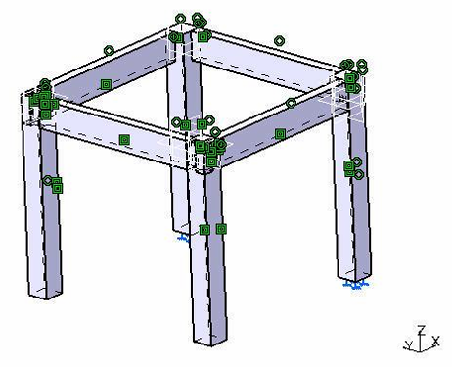

Figure 2. The assembled stool and boundary conditions (dowel side fixed).

A diagonal load of 80 kg was applied, representing the weight of an average person sitting on the stool.

The model was discretized into finite elements using a tetrahedral mesh, with finer mesh refinement applied to critical areas such as the joints where stress concentrations were expected. There were 2163 nodes and 4737 elements in the mesh. Element types were TE4 (89.29%), NSBAR (0.57%), and SPIDER (1.14%).

The system of equations was solved numerically to obtain results for stress, displacement, and deformation. The results were analyzed to identify regions with high-stress concentrations, potential failure points, and overall structural performance.

**Results and Discussion**

The FEA results provided valuable insights into the structural behavior of the beech wooden stool under typical load conditions. Figure 3 presents the deformed mesh under diagonal loading.

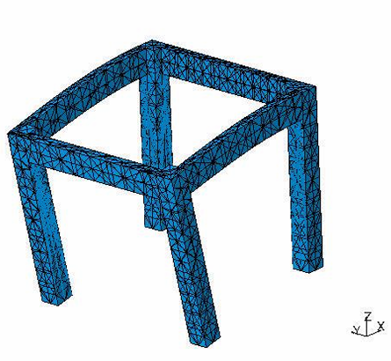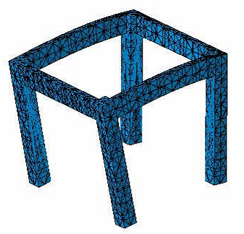

Figure 3. Deformed mesh: left-load applied from the mortise-tenon side, and right-load applied from the dowel side.

Figure 4 presents the Von Mises stress distribution in nodal solution. According to the results, in terms of the load application side, the mortise-tenon joint section presented higher 2.48 MPa maximum stress values than the dowel side as 2.02 MPa. The highest stress concentrations occurred at the mortise-and-tenon joints, where the legs connect to the seat. These two stress concentration values are lower than the yield strength of beech wood. This indicates that the joints are not critical points for potential failure, especially under repeated loading or excessive force. It can be said that there is no critical difference between the two joint types.

The analysis confirms that the mortise-and-tenon joints are the most critical areas in the stool’s design. The stress concentrations observed at these joints suggest that under sustained use or excessive loading, failure may occur at these points. Although the legs are not at immediate risk of failure, the overall structural integrity could be compromised due to the vulnerable joints.

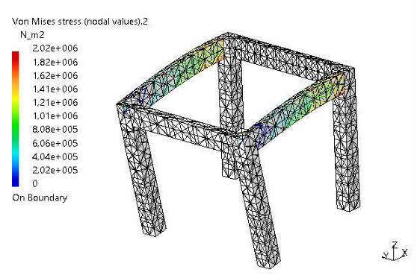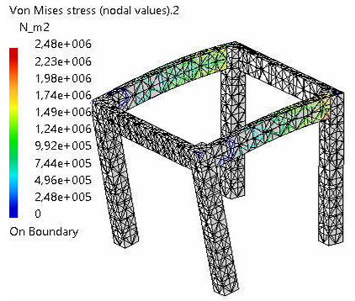

Figure 4. Von Mises stress distribution on the nodes; left-load applied from the mortise-tenon side, and right-load applied from the dowel side.

As can be seen in Figure 5, the maximum displacement occurred at the mortise-tenon side, with a deflection of 0.497 mm under the applied diagonal load. While this level of deflection is relatively small, it could affect the stool’s overall stability and comfort over time. For the dowel-applied construction, the translational displacement is close to mortise-tenon behavior.

The legs exhibited minimal displacement, with less than 1 mm of deflection, indicating they are stiff and well-suited to support the load without significant bending.

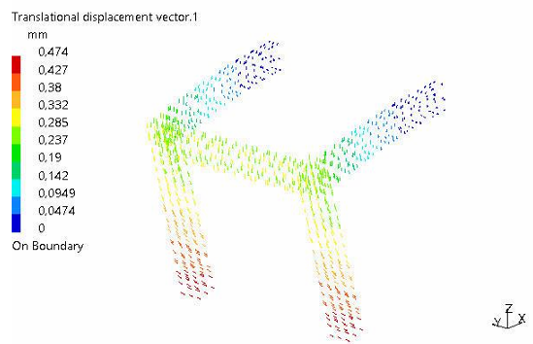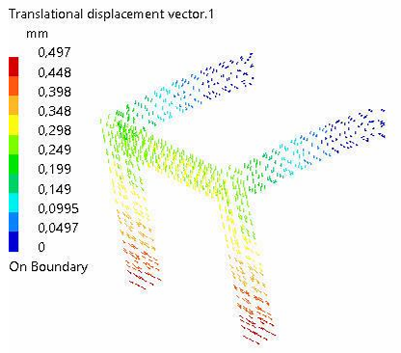

Figure 5. Translational displacement vector. Left-load applied from the mortise-tenon side, and right-load applied from the dowel side.

It can be concluded that the design is marginally safe due to far away the yield strength of the material under typical loading conditions. This suggests that the stool could not fail if subjected to higher or repeated loads.

To improve the stool’s safety and performance, several design modifications are recommended: Reinforcing Joints: Strengthening the mortise-and-tenon joints, possibly by adding dowels or additional support plates, would help distribute the load more evenly and reduce stress concentrations. Material Reinforcement: Using a stronger adhesive or incorporating metal fasteners at the joints could further enhance the stool’s durability. Increasing Leg Diameter: Slightly increasing the diameter of the legs could reduce stress and deflection at the seat, improving the overall stability and safety of the stool.

The energy for the mortise tenon side loading was 0.105J while the dowel side loading was 0.108J.

For wooden stools, there are some contradictions between parameters such as lightweight vs stability, material strength vs weight, and curved shapes vs processing difficulties [21]. Therefore, numerical analysis in stool design may provide valuable data for optimizing these production parameters. On the other hand, except for the traditional form of stool, different forms are designed such as storage functionality under the seat using plywood to prepare sheets instead of legs therefore the joints such as dowel, mortise-tenon as Wessam [22] presented. However, it should be taken into consideration that the traditional craftsmanship of a wooden stool requires rigidity in the joints. Also, some of the stools have three legs instead of four. In such designs, construction requires more precision and quality for durability and stability. In this study, the stool was designed without a seat, and it should be taken into consideration that seat assembly provides extra strength for the structure. Therefore, stress and deformation values may be some amount decreased.

As well known, to test a structure destructively, researchers need material, construction tools and machines and test tools which require not only time but also significant amount of money or investment. However, FEA may provide comparable data obtained by non-destructively or numerically.

Findings of this study may contribute to design and engineering activities for wooden furniture production by expressing comparative data. Furthermore, added value of the wood which is a historically important construction and building material can be better utilized by improving its’ service life by innovative mortise-tenon joint designs as Radkau [23].

**Conclusion**

This study demonstrates the usefulness of Finite Element Analysis in evaluating the structural performance of a beech wooden stool. The FEA results indicate that the stool is generally safe under typical loading conditions, with the most critical stress concentrations occurring at the mortise and tenon joints. By reinforcing these joints and making slight modifications to the design, the stool’s performance and safety could be significantly improved. The study highlights the importance of using FEA as a tool for optimizing furniture designs, reducing the need for costly physical prototypes, and ensuring long-term durability and safety.

When comparing the two joint types, it was observed that there are neglectable differences in stress and displacement values. Therefore, it can be said that mortise-tenon joints are time-consuming, and dowel-type joints can be preferred to reduce the production cost.

This study advances existing research on wooden furniture design and safety by exploring innovative design principles and construction techniques that enhance both the aesthetic appeal and structural integrity of wooden furniture by integrating stability and durability. The results also suggest that while the stool is generally safe for typical use, periodic inspections and proper maintenance may be necessary, especially for joints that are subject to repetitive stress over time.

Disclaimer (Artificial intelligence)

Option 1:

Author(s) hereby declare that NO generative AI technologies such as Large Language Models (ChatGPT, COPILOT, etc.) and text-to-image generators have been used during the writing or editing of this manuscript.

Option 2:

Author(s) hereby declare that generative AI technologies such as Large Language Models, etc. have been used during the writing or editing of manuscripts. This explanation will include the name, version, model, and source of the generative AI technology and as well as all input prompts provided to the generative AI technology

Details of the AI usage are given below:

1.

2.

3.

**References**

[1] M.H. Çolakoğlu, Finite element analysis of wooden chair strength in free drop, International Journal of the Physical Sciences 7 (2012). https://doi.org/10.5897/IJPS11.1229.

[2] E. Ceylan, E. Güray, A. Kasal, Structural analyses of wooden chairs by finite element method (FEM) and assessment of the cyclic loading performance in comparison with allowable design loads, Maderas. Ciencia y Tecnología 23 (2021). https://doi.org/10.4067/S0718-221X2021000100419.

[3] T. Yılmaz, E. Güntekin, Finite element modeling of chair frames, SDU Faculty of Forestry Journal 13 (2012) 134–139.

[4] T. Yılmaz Aydın, E. Güntekin, M. Aydın, Finite Element (FE) Analysis of Chair Frames Constructed with Turkish Red Pine (Pinus brutia Ten.), in: 1st International Mediterranean Science and Engineering Congress, Çukurova University, Adana, 2016: pp. 1919–1925.

[5] S. Hajdarević, I. Busuladžić, Stiffness Analysis of Wood Chair Frame, Procedia Eng 100 (2015) 746–755. https://doi.org/10.1016/j.proeng.2015.01.428.

[6] M. Aydın, T. Yılmaz Aydın, Finite Element Analysis of Chair Frames Using Catia, Journal of Advanced Technology Sciences 6 (2017) 621–631.

[7] M. Aydın, T. Yılmazm Aydın, Use of CATIA for Analysis of Structures Constructed with Sustainable Biomaterial, in: International Conference on Agriculture, Forest, Food Sciences and Technologie, Nevşehir, 2017.

[8] N. Pandey, M. Kumar, A. Kumar, P. Gupta, Finite Element Analysis of Mechanical Chair, Journal of Advanced Research in Mechanical Engineering and Technology 10 (2023) 18–27.

[9] E. Güray, E. Ceylan, A. Kasal, Weight-strength optimization of wooden household chairs based on member section size, Maderas. Ciencia y Tecnología 24 (2022). https://doi.org/10.4067/S0718-221X2022000100431.

[10] S.I. Gustafsson, Finite element modelling versus reality for birch chairs, Holz Als Roh- Und Werkstoff 54 (1996) 355–359.

[11] L. Song, M. Yu, D. Sun, Structural design and experimental verification of a thin-walled plastic chairs based on the finite element method, Sci Rep 14 (2024) 22285. https://doi.org/10.1038/s41598-024-73499-1.

[12] T. Yılmaz Aydın, M. Aydın, Three dimensional finite element analysis of compression behavior of oriental beech, Düzce Üniversitesi İleri Teknoloji Bilimleri Dergisi (2017) 795–803.

[13] T. Yılmaz Aydın, M. Aydın, Three Dımensıonal Fınıte Element Analysıs Of Compressıon Behavıor Of Orıental Beech, in: A. Aytin, S. Çiftçi, İ. Baykal (Eds.), 4th International Furniture and Decoration Congress, Düzce Üniversitesi, Düzce, 2017: pp. 190–197.

[14] Z. Wang, W. Xu, Y. Zhu, Mechanical Analysis of Solid Wood Chair Frame Structure Based on ABAQUS, China Forest Products Industry 60 (2023) 49.

[15] W. Hu, W.-L. Fu, H.-Y. Guan, Optimal design of stretchers positions of mortise and tenon joint chair, Wood Research 63 (2018) 505–516.

[16] W.T.X. Wan Ting Xie, P.L.H. Wan Ting Xie, C.H.C. Po Lun Hou, H.C.L. Chun Hsien Chiang, Finite Element Method Application in Computer-Aided Design for Bio-mimetic Chair Research, 電腦學刊 35 (2024) 095–106. https://doi.org/10.53106/199115992024063503008.

[17] أ.أ. مشهور, ن.ط. زغلول, تحليل الصلابة لمقعد من مصر القديمة باستخدام طريقة العناصر المحددة = Stiffness Analysis of a Stool from Ancient Egypt Using Finite Element Method, مجلة التصميم الدولية 7 (2017) 21–28. https://doi.org/10.12816/0044472.

[18] N. Tankut, A.N. Tankut, M. Zor, Finite Element Analysis of Wood Materials, Drvna Industrija 65 (2014) 159–171. https://doi.org/10.5552/drind.2014.1254.

[19] W. Hu, H. Guan, A finite element model of semi-rigid mortise-and-tenon joint considering glue line and friction coefficient, Journal of Wood Science 65 (2019) 14. https://doi.org/10.1186/s10086-019-1794-4.

[20] E. Guntekin, T. Yılmaz Aydın, M. Aydın, Elastic Constants of Oriental Beech (Fagus Orientalis) And Sessile Oak (Quercus Petraea), in: IFC 2016 International Furniture Congress, Muğla Sıtkı Koçman University, Muğla, 2016: pp. 290–292.

[21] C.-J. Lin, M.-C. Shen, P.-H. Lin, L. Chin-Mei, A Study on the Application of TRIZ in Wooden Stool Design and Manufacturing, Journal of Biomedical Research & Environmental Sciences 5 (2024) 1486–1502. https://doi.org/10.37871/jbres2037.

[22] H. Wessam, Design and fabrication of an ergonomic sitting stool with storage capability, IOP Conf Ser Mater Sci Eng 884 (2020) 012095. <https://doi.org/10.1088/1757-899X/884/1/012095>.

[23] Radkau, J. Wood: A History, Polity Publishing, 1st ed. (2011). 352 p.