PERFORMANCE AND EXHAUST EMISSIONS OF A SINGLE CYLINDER DIESEL ENGINE FUELED WITH DIESEL AND PLASTIC OIL BLENDS

.

ABSTRACT

|  |
| --- |
| **Aims:** To evaluate the Performance characteristics and Exhuast emissions of a Conventional Engine (CE) fueled with various blends of Plastic Oil.  **Study design:** In CI Engines, combustion is the factor that is pivotal in evaluating the Performance parameters and simultaneously measuring the Exhaust emissions. In the quest to improve the performance, without major changes in the design of a Diesel Engine, extensive research has been carried out where alternative fuels like Plastic oil blends and various other Bio-diesels have replaced diesel. To enable the use of Plastic Oils, many researchers have attempted blending these fuels with oxygenated additives like Methyl Ester, Di-ethyl ether (DEE), Zinc-oxide etc. These additives reduce the viscosity and improve the rate of combustion, by reducing increasing the availability of oxygen in the fuel. The addition of these compounds is expected to reduce the Exhaust emissions without compromising the overall operation and performance of the engine  **Methodology:** The plastic oil blends used in this experiment are prepared by mixing different percentages of diesel, plastic oil, and di-ethyl ether, in defined proportions: by % volume. An Optimal Injection Timing (OIT) is determined by evaluating the peak value of brake thermal efficiency (BTE), when the Injection pressure is varied from 190 to 230 bar and the Injection timing from 270bTDC to 310bTDC. The values of performance and exhaust emissions, at different loads are evaluated at the determined OIT and are compared with those of the engine fueled with diesel operating at 190 bar and 270bTDC.  **Results:** Of all the plastic oil blends prepared, the peak performance values and lowest emissions were obtained for the PBO30 blend. The values of BTE, BSFC, EGT, Coolant load and Volumetric efficiency of PBO30 increased by 11.1%, 12.8%, 10.4%,13% and 7.5% respectively in comparison with PBO50 blend. Similarly, the exhaust emissions: Particulate emissions, CO, NOX and UBHC of PBO30 blend decreased drastically and were lower by 23.6%, 46.5%, 30% and 32% when compared with the values of the PBO50 blend.  **Conclusion:** Using the oxygenated additive: di-ethyl ether facilitated the use of plastic oil as an alternative to diesel in CI engines without any design modifications. While the performance characteristics of the blends specifically PBO30 improved considerably and the exhaust emissions also reduced. |

*Keywords: Plastic oil, oxygenated additives, di-ethyl ether, blended fuels, alternative fuels*

1. INTRODUCTION

[1]. Faisal. F et al., concluded that HPD15 performed better or comparable with diesel fuel. Overall, the BP and BTE of HPD15 were higher than diesel fuel by 4.77 % and 3.77 %, respectively.  BSFC of HPD15 was lower at all operating speeds (by 4.66 %) and BSEC was lower in most of the operating speeds (by a maximum of about 3.77 %). This study also revealed that CO2 at some operating speeds and NOx emission at all operating speeds for HPD15 are lower than diesel fuel. However, CO and UHC emissions are slightly higher for HPD15 than diesel at all speeds. Overall, HPD15 can be recommended as a suitable alternative for diesel fuel without any engine modification.

[2]. Pal S et al., analysed the CI engine characteristics when fueled with different blends of PO (PO25D75, PO50D50, PO75D25 and PO100). The engine fueled with neat plastic oil produced 6.90% less BTE than the reference diesel. However, increasing the PO proportion in diesel increased cylinder pressure and the net heat release rate (NHRR). The emissions such as CO, HC, and NOx were higher for all plastic oil blends at a 12 kg engine load, whereas CO2 and smoke opacity were reduced by 21.81% and 4.47% for PO100 at a higher engine load (12 kg) as compared to reference diesel.

[3]. Upendra Rajak et al., tested and compared 3 fuels, BF100PPO0, BF80PPO20, and BF0PPO100 in a single-cylinder, 4-stroke, water-cooled VCR DI-CI engine that ran at five different compression ratios (15.5, 16.5, 17.5, 18.5, 19.5) under low, medium, and high engine loads, concluding that raising the CR from 15.5 to 19.5 did not result in significant changes except for the maximum rate of pressure rise and ignition delay. The results showed that BF80PPO20 produced the maximum BTE (34.4 percent) at CR 15.5 under high engine load, while BF100PPO0 produced the lowest BSFC (738.29 g/kWh) at CR 16.5 under high load. BF80PPO20 was able to produce the lowest smoke emissions at medium load. In addition, at CR 15.5 and low engine load, BF100PPO0 produced the lowest NOx emissions (64.3 ppm). Overall, plastic waste oil mixed with diesel fuel at a rate of up to 20% can be utilized as a promising biofuel to improve diesel engine performance, combustion, and emissions.

[4]. Ravisankar Rajendran et al., explored the output with and without EGR on a retarded timing engine with diesel and karanja oil methyl ester (KOME). As the EGR rate grew, NOx and BTE were reduced marginally with increased HC, CO, and smoke. 24.1 g/kw-hour CO, 10.1 g/kw hour NOx, and 0.55 g/kW-hour HC were registered at 20 % of EGR.

[5]. Manigandan Sekar et al., concluded that the performance and emissions of a single cylinder 4-stroke engine running on Plastic Oil blended with nano-catalyst P25A was found to be better among other fuels. The P25A blend increased the BTE as the loads increased. Further, the BSFC of the P25A blend was increased due to the enormous oxygen presence to improve the combustion process even in fuel rich zones.

[6]. Prabakaran B et al., conducted experiments on a 4-stroke water-cooled single cylinder engine operating at 19: 1 compression ratio, 210 bar of nozzle opening pressure and 29° bTDC of fuel injection timing, fueled with a blend containing 18% of Biobutanol and 82% of plastic pyrolysis oil. Results depicted that the BTE, peak in-cylinder pressure, peak HRR, ignition delay, EGT, NOX, smoke, hydrocarbons, and CO produced is found to be closer to that of diesel at rated power and near to rated power, showing that replacing diesel with 82% waste plastic oil and 18% Biobutanol reduced the impact on the environment.

[7]. J. Thamilarasan et al.,presented the results of a single-cylinder air cooled direct injection diesel engine, fueled with the surplus of plastic oil and Magnesium oxide blended with diesel at different engine loads, plastic and Magnesium oxide mixing ratios and injection pressure. The findings indicate that 10% of PPO can be rated as full load condition; Magnesium oxide mixes with diesel at an injection pressure of 220 bar.

[8]. Mustafa Karagöz et al., focused on the impact of the n-butanol addition into the waste tire pyrolysis oil and diesel fuel (TDF). Tests were performed on a single-cylinder, direct injection diesel engine. The engine load was varied from 500W to 1250W with an interval of 250W. In conclusion, the binary form of waste tire pyrolysis oil and diesel fuel blends can be used in a CI engine with no modification, the emission and performance characteristics can be improved using an alcohol additive into the waste tire oil-diesel blend.

[9]. Murat Kadir et al., evaluated the diesel engine characteristics for various fractions of diethyl ether (DEE) as an oxygenated fuel additive in cottonseed oil biodiesel-diesel fuel blends. Firstly, several tests performed for diesel and B20 blend. Then, 2.5%, 5%, 7.5%, and 10% of DEE by volume was mixed with biodiesel-diesel fuel to prepare the ternary blends. All the fuel samples were run on in a single-cylinder, 4-stroke, and DI diesel engine at 5 different engine loads, fixed engine speed conditions. Hence, DEE can be used to remove the main issues with the usage of cottonseed oil biodiesel. Further, the addition of DEE up to 10% (by vol.) could be considered as a promising technique for the utilization of biodiesel/diesel blend efficiently in the CI engines without any major modifications.

2. materialS and METHODS

The details of the experimental setup, the properties of the fuel(s) used and the process for determining the properties of the blended fuels prepared are presented in the subsequent paragraphs below.

**2.1 Properties of Plastic Oil**

The properties of diesel, plastic oil that are used as a fuel and in the preparation of the blended fuel(s) (wherever applicable) in this experimental work are shown in table below.

**Table 1. ASTM Properties of Diesel and Plastic Oil**

|  |  |  |  |
| --- | --- | --- | --- |
| **Property** | **Test Method** | **Diesel** | **Plastic oil** |
| Density, Mg m-3 | ASTM D1298 | 834 | 823 |
| Kinematic Viscosity at 400C, C St. | ASTM D445 | 3.44 | 3.11 |
| Gross Calorific Value, MJ kg-1 | ASTM D240 | 45.5 | 45.2 |

**2.2 Di-ethyl ether and its properties**

Di-ethyl Ether or Ethoxy-ethane is an organic chemical compound in the ether class with the formula (C2H5)2O and is a colorless, highly volatile, sweet-smelling, and extremely flammable liquid, obtained by the dehydration of ethanol using Sulphuric acid. The properties of di-ethyl ether used are presented in the table 2 below:

**Table 2. ASTM Properties of Di-ethyl ether.**

|  |  |  |
| --- | --- | --- |
| **Property** | **Test Method** | **Value** |
| Density, Mg m-3 | ASTM D1298 | 713 |
| Kinematic Viscosity at 200C, C St. | ASTM D445 | 0.32 |
| Gross Calorific Value, MJ kg-1 | ASTM D240 | 31.7 |

The figure 1 below shows the chemical structure of Di-ethyl Ether (DEE).

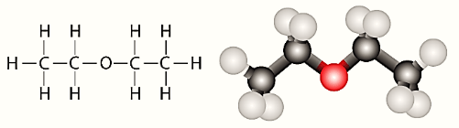

**Figure 1. Chemical Structure of Diethyl Ether.**

**2.3 Plastic Oil Blends and its properties**

An initial blend of plastic oil was preparing by mixing equal volumes of plastic oil and diesel for a quantity of one litre, i.e., 50% Diesel and 50% Plastic oil and is named as PBO50. Further, Di-ethyl ether was added to the initial blend PBO50 at 10% and 20% and the blends prepared are named as PBO40 and PBO30 respectively. The properties of blends prepared are tabulated in table 3 shown below:

**Table 3. Composition of plastic oil blends.**

|  |  |  |  |
| --- | --- | --- | --- |
| **Blended Fuel Name** | **Composition of fuels (by % volume)** | | |
| **Diesel** | **Plastic oil** | **Di-ethyl ether** |
| PBO50 | 50 | 50 | 0 |
| PBO40 | 50 | 40 | 10 |
| PBO30 | 50 | 30 | 20 |

**2.3.1 Specific Gravity of Plastic oil blends**

The specific gravity of different blends of plastic oil at an ambient temperature of 300C, are measured using a Hydrometer with lead balls. The photographic view of a specific gravity Hydrometer (with lead balls) is shown in the figure 2 below.

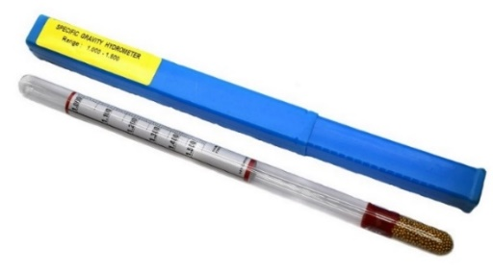

**Figure 2. Photographic view of a Specific Gravity Hydrometer (with lead balls).**

The figure 3 below shows the measurement of specific gravity of the prepared plastic oil blends, PBO50, PBO40 and PBO30 using the Hydrometer.

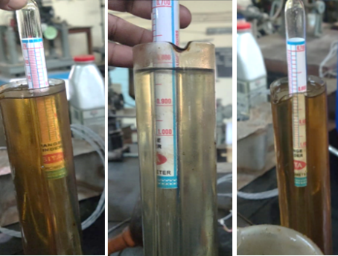

**Figure 3. Specific gravity of Plastic oil blends using Specific Gravity Hydrometer**

The specific gravity measured in gm cc-1 of diesel and the plastic oil blends PBO50, PBO40 and PBO30 are tabulated in the table 4 below

**Table 4. Composition of plastic oil blends.**

|  |  |
| --- | --- |
| **Plastic Oil blend** | **Specific gravity (in gm cc-1)** |
| PBO50 | 0.818 |
| PBO40 | 0.816 |
| PBO30 | 0.806 |

From the above table it can be noted that specific gravities of PBO50 PBO 40 and PBO30 are closer to that of Diesel.

**2.3.2 Kinematic viscosity of Plastic oil blends**

The viscosity of the blends measured by Saybolts viscometer is by calculating the T: time required for the collection of 60ml of fuel at a given temperature. The Kinematic viscosity (in stokes) is calculated by using the formula: $K.V=0.26T- \frac{1.88}{T}$.

Measurement of kinematic viscosity of diesel and plastic oil blends using Saybolts viscometer is shown in figure 4 below.

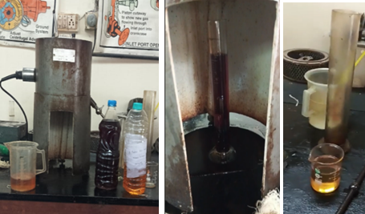

**Figure 4. Measurement of Kinematic Viscosity of Diesel and Plastic oil blends.**

The measured values of Kinematic viscosity of Diesel and Plastic oil blends are presented in the table 5 shown below

**Table 5. Kinematic Viscosity of Diesel and Plastic oil blends***.*

|  |  |  |  |  |
| --- | --- | --- | --- | --- |
| **Fuel** | **Time taken for 60ml of fuel collection – T (in seconds)** | **Kinematic Viscosity**  **(in centistokes)** | **Density**  **(in Kg, m-3)** | **Absolute Viscosity (in stokes)** |
| Diesel | 33 | 3.38 | 834 | 2818.9 |
| Plastic oil | 32 | 3.01 | 823 | 2469 |
| PBO50 | 32 | 3.16 | 818 | 2584.8 |
| PBO40 | 31 | 2.96 | 816 | 2415.3 |
| PBO30 | 31 | 2.94 | 806 | 2345.4 |

**2.3.3 Gross calorific value of Plastic oil blends**

The heat evolved during the combustion is calculated using the temperature change, mass of water, and the calorimeter constant. The calorific value of the plastic oil blend sample is determined by calculating the heat of combustion (***Qcomb***) and is obtained by the following formulae: ***Q = mw x Cp x ΔT****,* where

***Q*** is the heat released, ***mw*** is the mass of water, ***msample​*** is the mass of the sample

***Cp*** is the specific heat of water: constant = **4.187 KJ/ Kg-K,**

***ΔT*** is the temperature change: ***(Tf – Ti)*** and ***Qcomb*** is the heat of combustion.

Now, the heat of combustion ***(Qcomb)*** is given by, ***Qcomb = Q / msample​***

The figure 5 below shows the schematic diagram of a bomb calorimeter that is used to determine the Gross calorific value of Diesel and Plastic oil blends.

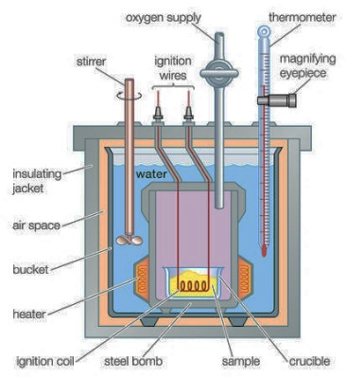

**Figure 5. Schematic of a Bomb Calorimeter.**

The calorific values of the Diesel and Plastic oil blend samples are evaluated and tabulated under the table 6 below

**Table 6. Gross calorific value of Diesel and Plastic oil blends.**

|  |  |  |  |  |  |  |  |  |
| --- | --- | --- | --- | --- | --- | --- | --- | --- |
| **Sample** | **Mass of water** | **ΔT (in0C)** | | | **Q (in KJ Kg -1)** | **Sample Mass (in Kg)** | **Qcomb (in KJ, Kg-1 K-1)** | **Calorific Value (in MJ, KG-1)** |
| **Ti** | | **Tf** |
| Diesel | 1500 | 27 | 34 | | 43963.50 | 0.98 | 45600.01 | 45.6 |
| Plastic oil | 1499 | 27 | 33.7 | | 42071.38 | 0.97 | 43372.55 | 43.37 |
| PBO50 | 1499 | 27 | 33.8 | | 43167.44 | 1.05 | 41111.84 | 41.11 |
| PBO40 | 1501 | 27 | 34.5 | | 47317.60 | 1.02 | 46389.81 | 46.38 |
| PBO30 | 1498 | 27 | 34.6 | | 47905.77 | 1.03 | 46510.45 | 46.51 |

**2.4 Properties of Plastic Oil Blends**

All the evaluated properties of the plastic oil blends are presented under the table 7 shown below

**Table 7. Properties of Diesel and Plastic oil blends.**

|  |  |  |  |  |
| --- | --- | --- | --- | --- |
| **Fuel** | **Density (in Kg, m-3)** | **Kinematic Viscosity (in centistokes)** | **Absolute Viscosity (in Stokes)** | **Calorific value (in MJ, Kg-1)** |
|
| Diesel | 834 | 3.38 | 2818.9 | 45.60 |
| Plastic oil | 823 | 3.01 | 2469 | 43.37 |
| PBO50 | 818 | 3.16 | 2584.8 | 41.11 |
| PBO40 | 816 | 2.96 | 2415.3 | 46.38 |
| PBO30 | 806 | 2.91 | 2345.4 | 46.51 |

From the above table, it can be inferred that the plastic oil blends are a suitable alternative to diesel with minimal design modifications.

3. EXPERIMENTAL PROCEDURE

**3.1 Introduction**

A naturally aspirated, water-cooled single-cylinder, 4-stroke diesel engine is used by maintaining the outlet water at 800C, by adjusting the flow rate. Performance and exhaust emissions are evaluated when fueled with diesel at 190 bar & 270bTDC, and are used as reference values to compare when plastic oil blends are used. Fuel injection pressure is varied from 190 – 230 bar: in steps of 20 bar, using nozzle-testing device. The highest BTE was recorded at 310bTDC and hence considered as the Optimal injection timing (OIT). Electricalload is applied by the means of a GD electrical dynamometer of 180 frame. The capacity of the dynamometer is 3.68KW where the maximum voltage and current were 230 volts and 13.7 amps.

**3.2 Engine Specifications.**

The specifications of the engine used for the experimental work are tabulated in table 8 below:

**Table 8. Specifications of the engine used in the experimental work.**

|  |  |
| --- | --- |
| **Description** | **Specification** |
|
| Engine make and model | Kirloskar (India) AV1 |
| Maximum power output at a speed of 1500 rpm | 3.68 kW |
| Number of cylinders ×cylinder position× stroke | 1 x vertical position × 4-stroke |
| Bore × stroke | 80 mm × 110 mm |
| Method of cooling | Water cooled |
| Rated speed (constant) | 1500 rpm |
| Fuel injection system | In-line and direct injection |
| Compression ratio | 16:1 |
| Aspiration | Natural |
| BMEP @ 1500 rpm | 5.31 bar |
| Manufacturer’s recommended injection timing & pressure | 270 bTDC & 190 bar |
| Dynamometer | Electrical dynamometer |
| Number of holes of injector and size | Three × 0.25 mm |
| Type of combustion chamber | Direct injection type |
| Fuel injection nozzle | Make: MICO-BOSCH,  No- 0431-202-120/HB |
| Fuel injection pump | Make: BOSCH  NO- 8085587/1 |

**3.3 Experimental Setup**

The figure 6 below show the photographic view along with the schematic diagram of the setup of the diesel engine used for this experimental work

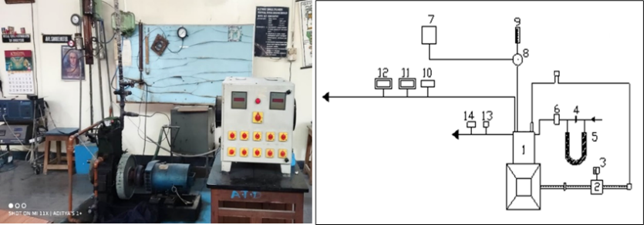

|  |  |  |  |  |  |
| --- | --- | --- | --- | --- | --- |
| 1 | Engine | 2 | Electrical Dynamometer | 3 | Load Box |
| 4 | Orifice meter | 5 | U-tube water manometer | 6 | Air box |
| 7 | Diesel tank | 8 | Three-way valve | 9 | Burette |
| 10 | Exhaust gas temperature indicator | 11 | AVL Smoke meter | 12 | Multi-gas analyzer |
| 13 | Outlet water temperature indicator | 14 | Outlet water flow meter |  |  |

**Figure 6. Photographic and schematic view of the experimental setup.**

4. results and discussionS

**4.1 Performance Parameters**

The Performance parameters of the engine fueled with the plastic oil blends: PBO50, PBO40 and PBO30, at various loads are evaluated at a fuel injection pressure of 230 bar and the determined OIT of 310bTDC and compared with CE fueled with diesel at 190bar and 270bTDC. The parameters along with their units and variance are presented in the table 9 below.

**Table 9 Performance parameters of CE with diesel and with plastic oil blends**

|  |  |  |
| --- | --- | --- |
| **Performance Parameters** | **Units** | **Variance** |
| Brake thermal efficiency (BTE) | % | % Load |
| Brake specific fuel consumption (BSFC) | Kw. Hr. |
| Exhuast Gas Temperature (EGT) | 0C |
| Coolant Load | KW |
| Volumetric Efficiency (Ƞvol) | % |

**4.1.1 Brake thermal efficiency (BTE)**

The BTE (in %) of the engine fueled with plastic oil blends: PBO50, PBO40 and PBO30 at 310bTDC, at different loads and are presented in the table 10 below. A graph is plotted between the BTE of engine with diesel and plastic oil blends, at the various applied loads.

**Table 10 Variation of BTE of diesel and plastic oil blends at various loads**

|  |  |  |  |  |
| --- | --- | --- | --- | --- |
| **Load (in%)** | **BTE (in%) of the engine with** | | | |
| **Diesel** | **PBO50** | **PBO40** | **PBO30** |
| 10 | 9.1 | 4.8 | 6 | 7.1 |
| 25 | 18.6 | 12.3 | 14 | 15 |
| 50 | 23 | 18 | 19.8 | 22.1 |
| 80 | 25 | 23 | 26 | 28 |
| 100 | 26 | 20.5 | 23.6 | 25.8 |

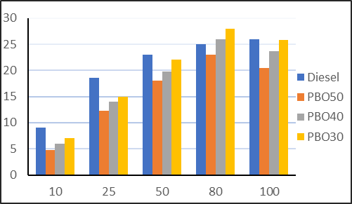

**Figure 7. BTE of engine with diesel and plastic oil blends at different loads**

The blue column in the above chart indicates the variation of BTE of the engine fueled with diesel, the orange column with PBO50, the grey column with PBO40 and the yellow column indicates the variation of BTE of engine fueled with PBO30 respectively. At full load the BTE of all blends declined marginally, due to slight reduction in oxygen-fuel ratio. The BTE of PBO40 and PBO30 improved considerably as compared to PBO50 at all loads, which is because of the addition of Di-Ethyl ether (DEE). DEE improved the combustibility of the blend, coupled with advancing the Injection timing, resulted in reduction of ignition delay, similar to that of CE fueled with diesel.

**4.1.2 Brake specific fuel consumption (BSFC)**

The BSFC (in KWhr.) of the engine fueled with plastic oil blends: PBO50, PBO40 and PBO30 at 310bTDC, at different loads are tabulated in the table 11 below. A graph is plotted between the BSFC of plastic oil blends, at the various applied loads.

**Table 11 Variation of BSFC of diesel and plastic oil blends at various loads**

|  |  |  |  |  |
| --- | --- | --- | --- | --- |
| **Load (in%)** | **BSFC (in KWhr) of the engine with** | | | |
| **Diesel** | **PBO50** | **PBO40** | **PBO30** |
| 10 | 1.69 | 1.76 | 1.54 | 1.2 |
| 25 | 1.96 | 2.61 | 2.2 | 2 |
| 50 | 3.1 | 3.43 | 2.9 | 2.6 |
| 80 | 4.1 | 4.21 | 3.96 | 3.8 |
| 100 | 4.3 | 4.51 | 4.34 | 4.27 |

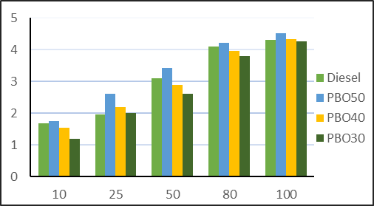

**Figure 8. BSFC of the engine with diesel and plastic oil blends at different loads**

The green column in the above chart indicates the variation of BSFC of the engine fueled with diesel, the blue column with PBO50, the yellow column with PBO40 and the dark green column indicates the variation of BSFC of engine fueled with PBO30 respectively.

At full load, BSFC for PBO50 was 4.51 Kw.hr: 4.65%, 3.77 % & 5.32% higher than diesel, PBO40 and PBO30 respectively. For PBO30 at same load, BSFC was the lowest at 4.27 KW.hr which was 5.3% & 1.6% less than PBO50 and PBO40 respectively. This is due to the higher viscosity and higher hydrocarbons present in the PBO50 blend. In PBO30 the presence of Di-ethyl ether facilitated faster combustion providing better combustibility at all loads.

**4.1.3 Exhuast gas temperature (EGT)**

The temperature of exhaust gases of the engine fueled with plastic oil blends: PBO50, PBO40 and PBO30 at 310bTDC, at different loads and are tabulated in the table 12 below. A graph is plotted between the EGT of plastic oil blends, at the various applied loads.

**Table 12 Variation of EGT of diesel and plastic oil blends at various loads**

|  |  |  |  |  |
| --- | --- | --- | --- | --- |
| **Load (in%)** | **EGT (in 0C) of the engine with** | | | |
| **Diesel** | **PBO50** | **PBO40** | **PBO30** |
| 10 | 168 | 180 | 169 | 152 |
| 25 | 223 | 320 | 309 | 289 |
| 50 | 310 | 396 | 388 | 376 |
| 80 | 425 | 520 | 500 | 475 |
| 100 | 473 | 562 | 521 | 509 |

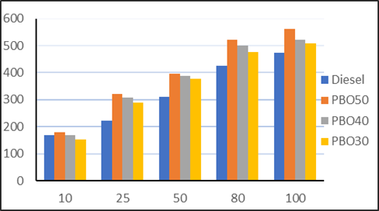

**Figure 9. EGT of the engine with diesel and plastic oil blends at different loads**

The blue column in the above chart indicates the variation of EGT of the engine fueled with diesel, the orange column with PBO50, the grey column with PBO40 and the yellow column indicates the variation of EGT of engine fueled with PBO30 respectively.

At full load, the EGT of blends was highest for PBO50 at 5620C and was lowest for PBO30 at 5090C. At full load, EGT of PBO50 was 15.8%, 9.4% and 7.3% higher than the EGT of diesel, PBO40 and PBO30 respectively, while the EGT for PBO30 was lower by 9.4% and 2.3% than PBO50, PBO40 respectively and was higher than diesel by 7.6%. While the EGT of PBO30 was lower than the rest of the blends, it was slightly higher than diesel. This is because of the increase in higher hydrocarbons of the blends (compared to diesel) which was due to the addition of plastic oil, which can be addressed by using exhaust gas recirculation (EGR) or supercharging or a combination of both.

**4.1.4 Coolant Load**

The coolant load of the engine fueled with plastic oil blends: PBO50, PBO40 and PBO30 at 310bTDC, at different loads and are tabulated in the table 13 below. A graph is plotted between the Coolant load of diesel and plastic oil blends, at the various applied loads.

**Table 13 Variation of Coolant load of diesel and plastic oil blends at various loads**

|  |  |  |  |  |
| --- | --- | --- | --- | --- |
| **Load (in%)** | **Coolant load (in KW) of the engine with** | | | |
| **Diesel** | **PBO50** | **PBO40** | **PBO30** |
| 10 | 1.01 | 1.8 | 1.6 | 1.4 |
| 25 | 1.6 | 2.6 | 2.8 | 2.3 |
| 50 | 2.4 | 3.2 | 3.1 | 2.9 |
| 80 | 4 | 4.6 | 4 | 3.7 |
| 100 | 5.3 | 5.4 | 5 | 4.8 |

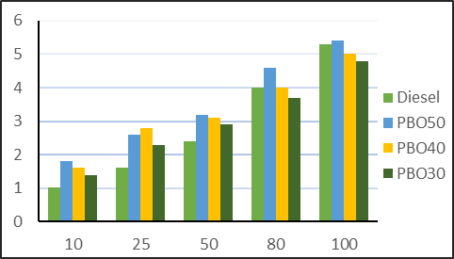

**Figure 10. Coolant load of the engine with diesel, plastic oil blends at different loads**

The green column in the above chart indicates the variation of Coolant load applied on the engine fueled with diesel, the blue column with PBO50, the yellow column with PBO40 and the dark green column with PBO30 respectively. The coolant load complemented the EGT for all blends. From the above figure it can be observed that the coolant load increased for all blends. At full load, the coolant load was found to be the highest for PBO50 at 5.4 which is because of higher hydrocarbons in the blend that increased the overall operating temperature and hotter engine parts, requiring more amount of coolant load.

**4.1.5 Volumetric Efficiency (Ƞvol)**

The Volumetric efficiency of the engine when fueled with plastic oil blends: PBO50, PBO40 and PBO30 at 310bTDC, at different loads and are tabulated in the table 14 below. A graph is plotted between the values of efficiency and the various applied loads.

**Table 14. Volumetric efficiency of diesel and plastic oil blends at various loads**

|  |  |  |  |  |
| --- | --- | --- | --- | --- |
| **Load (in%)** | **Volumetric efficiency (in %) of the engine with** | | | |
| **Diesel** | **PBO50** | **PBO40** | **PBO30** |
| 10 | 81.98 | 79.01 | 82.51 | 83.17 |
| 25 | 78.02 | 74.06 | 77.81 | 80.06 |
| 50 | 76.61 | 68.32 | 75.02 | 77.80 |
| 100 | 68.0 | 63.10 | 69.63 | 72.01 |

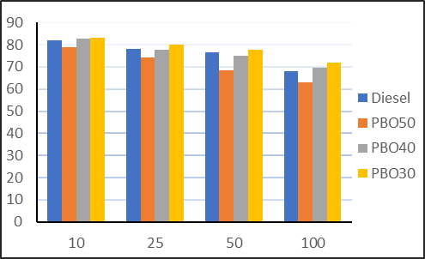

**Figure 11. Ƞvol of the engine with diesel and plastic oil blends at different loads**

The blue column in the above chart indicates the variation of volumetric efficiency of the engine fueled with diesel, the orange column with PBO50, the grey column with PBO40 and the yellow column with PBO30 respectively. At full load, Ƞvol was the highest for PBO30 at 72.01, and was higher by 12.37%, 3.31% and 5.57% than PBO50, PBO40 and diesel respectively and the volumetric efficiency was the lowest for PBO50 and reduced by 7.8%, 10.4% & 14.1% as compared to diesel, PBO40 and PBO30 respectively. Efficient combustion and power generation prevailed in PBO30 blend endorsing the addition of DEE.

**4.2 Exhaust Emissions**

The Particulate matter was measured by AVL smoke meter and levels of NOx, CO and UBHC were measured by multi-gas analyzer. The exhaust emissions along with their units and variance are presented in the table 15 below

**Table 15. Exhaust emissions of CE with diesel and with plastic oil blends**

|  |  |  |
| --- | --- | --- |
| **Exhaust Emissions** | **Units** | **Variance** |
| Particulate Emissions | HSU | % Load |
| Carbon Monoxide (CO) | % |
| Oxides of Nitrogen (NOX) | PPM |
| Unburned Hydrocarbons (UBHC) | PPM |

**4.2.1 Particulate emissions**

The particulate emissions of the engine with plastic oil blends and with diesel evaluated at different loads that are tabulated under the table 16 below. A graph is plotted between the particulate emissions at various loads.

**Table 16. Particulate Emissions of diesel and plastic oil blends at various loads**

|  |  |  |  |  |
| --- | --- | --- | --- | --- |
| **Load (in%)** | **Particulate emissions (in HSU) of the engine with** | | | |
| **Diesel** | **PBO50** | **PBO40** | **PBO30** |
| 25 | 16 | 19 | 13 | 11 |
| 50 | 38 | 33 | 25 | 27 |
| 80 | 45 | 60 | 33 | 29 |
| 100 | 51 | 68 | 38 | 36 |

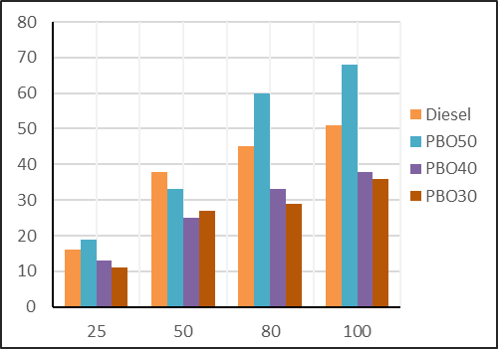

**Figure 12. Particulates of the engine with diesel, plastic oil blends at different loads**

The orange column in the above chart indicates the particulate emissions of the engine fueled with diesel, the blue column with PBO50, the dark blue column with PBO40 and the red column with PBO30 respectively. Particulate emissions severely increased for PBO50, compared to PBO30, PBO40 and diesel. At full load, the particulate emissions were the highest for PBO50 with 68PPM which are 47%, 44% and 25% higher than those of PBO40, PBO30 and diesel respectively, making this blend an unfeasible alternative despite similar performance to diesel. The particulate emissions were the lowest for PBO30 with 36PPM. At full load, the particulate emissions were lower by 47.1%, 5.3% and 29.4% than PBO50, PBO40 and diesel respectively, which ascertains that DEE promoted efficient combustion.

**4.2.2 Carbon Monoxide (CO)**

The CO emissions of the engine with diesel and plastic oil blends at different loads are tabulated under the table 17 below. A graph is plotted between the CO emissions at various loads.

**Table 17. Carbon Monoxide emissions of diesel and plastic oil blends at various loads**

|  |  |  |  |  |
| --- | --- | --- | --- | --- |
| **Load (in%)** | **CO emissions (in %) of the engine with** | | | |
| **Diesel** | **PBO50** | **PBO40** | **PBO30** |
| 25 | 2.7 | 2.9 | 2.1 | 1.6 |
| 50 | 3.3 | 4.8 | 3.0 | 2.0 |
| 80 | 4.2 | 5.8 | 4.2 | 2.7 |
| 100 | 5.1 | 6.2 | 5.6 | 4.8 |

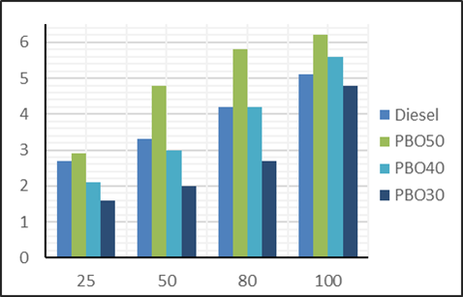

**Figure 13. CO emissions of the engine with diesel and plastic oil blends at different loads**

The blue column in the above chart indicates the variation of CO emissions of the engine fueled with diesel, the green column with PBO50, the sky-blue column with PBO40 and the navy-blue column indicates the CO emissions of engine fueled with PBO30 respectively. From the above figure it can be administered that the CO emissions of the PBO50 blend increased drastically when compared to diesel and PBO40, PBO30, while the CO emissions of PBO40 and PBO30 were considerably lower when compared to both PBO50 and diesel.

At full load, the peak CO emissions were for PBO50 at 6.2% which were higher by 9.7%, 22.6% and 17.7% than that of PBO40, PBO30 and diesel respectively. CO emissions were the lowest for PBO30 at 4.8%, which were lesser by 22.6%, 14.3% and 5.9% than PBO50, PBO40 and diesel respectively.

**4.2.3 Oxides of Nitrogen (NOX)**

The NOX of the engine with diesel and plastic oil blends, at different loads are tabulated under the table 18 below. A graph is plotted between the NOX emissions at various loads.

**Table 18 NOX emissions of diesel and plastic oil blends at various loads**

|  |  |  |  |  |
| --- | --- | --- | --- | --- |
| **Load (in%)** | **NOX emissions (in PPM) of the engine with** | | | |
| **Diesel** | **PBO50** | **PBO40** | **PBO30** |
| 25 | 250 | 391 | 417 | 296 |
| 50 | 630 | 832 | 981 | 790 |
| 80 | 830 | 1223 | 1135 | 830 |
| 100 | 880 | 1287 | 1200 | 1097 |

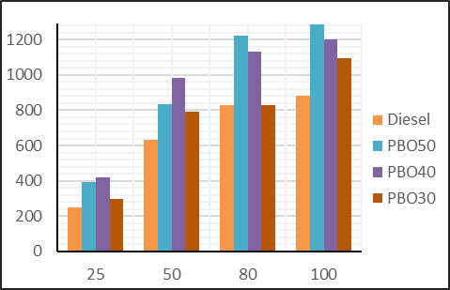

**Figure 14. NOX emissions of the engine with diesel, plastic oil blends at different loads**

The orange column in the above chart indicates the NOX emissions of the engine fueled with diesel, the blue column with PBO50, the dark-blue column with PBO40 and the red column with PBO30 respectively. NOX was the highest for PBO50 and lowest for PBO30.

For PBO50 the NOX emissions were 6.7%, 14.7% and 31.6% higher than the NOX emissions of PBO40, PBO30 and diesel respectively. This is because of the higher EGT and higher hydrocarbons present in PBO50. While the presence of DEE in PBO40 and PBO40 reduced the particulate emissions and CO emissions, it had an adverse effect on the NOX emissions and were lower by 32%, 27% and 20% than PBO50, PBO40 and PBO30 respectively. Supercharging or EGR can be considered to reduce NOX emissions of plastic oil blends.

**4.2.4 Unburned hydrocarbons (UBHC)**

The UBHC emissions of the engine with plastic oil blends and with diesel evaluated at different loads that are tabulated under the table 19 below.

**Table 19. UBHC emissions of diesel and plastic oil blends at various loads**

|  |  |  |  |  |
| --- | --- | --- | --- | --- |
| **Load (in%)** | **Particulate emissions (in HSU) of the engine with** | | | |
| **Diesel** | **PBO50** | **PBO40** | **PBO30** |
| 25 | 310 | 400 | 280 | 210 |
| 50 | 460 | 520 | 380 | 290 |
| 80 | 520 | 610 | 430 | 370 |
| 100 | 570 | 690 | 510 | 410 |

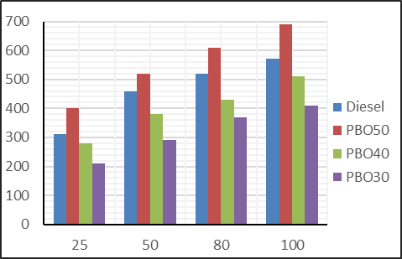

**Figure 15. UBHC of the engine with diesel and plastic oil blends at different loads**

The blue column in the above chart indicates the UBHC emissions of the engine fueled with diesel, the red column with PBO50, the green column with PBO40 and the navy-blue column with PBO30 respectively. While the UBHC emissions of PBO50 increased drastically when compared to diesel, PBO40 and PBO30, they were considerably low in PBO40 and PBO30 when compared to both diesel and PBO50. At full load, the UBHC emissions were the highest at 690 PPM which were higher by 17%, 26%, 41% than diesel, PBO40 and PBO30 respectively. The higher emissions are caused due to incomplete combustion of fuel at all loads. However, at full load the UBHC emissions were the lowest for PBO30 blend at 410PPM, which were lower by 41%, 28% and 20% than PBO50, PBO40 and diesel respectively. The reduction in the UBHC emissions can be attributed to the addition of Di-ethyl ether in the blend. Increasing the percentage of DEE from 10% to 20% played a pivotal role in reducing the UBHC emissions. Also, when compared to diesel and PBO50, the UBHC emissions of PBO30 are substantially low, encouraging the usage of this blend as an immediate and viable alternative to diesel without major modifications in the engine.

4. ConclusionS

1. The optimum injection timing (OIT) for the engine with diesel was found to be 310bTDC.
2. Among the plastic oil blends, PBO30 showed improved performance when compared to diesel, PBO50 and PBO40, while the performance of PBO50 blend was poor and the exhaust emissions were also considerably higher than the other blends and diesel.
3. At full load, among the performance parameters of PBO30: BTE – 25.8%, BSFC - 4.27 Kw.hr were comparable to diesel, while the EGT at 5090C was marginally high and the coolant load at 4.8, the volumetric efficiency at 72% were 9.4% less and 5.6% more respectively when compared with those for diesel.
4. Among the plastic oil blends, the exhaust emissions were highest for PBO50 and were lower for PBO40 and PBO30. Specifically, for PBO30 except for the NOX emissions other emissions were considerably lesser than those of diesel at all loads.
5. The NOX were the lowest for diesel at 880PPM and were the highest for PBO50 at 1287PPM.The other exhaust emissions were lowest for PBO30: Particulate emissions were at 36 HSU, CO at 4.8% and the UBHC emissions were at 410PPM which were lower by 29%, 6% and 28% respectively than those of diesel.
6. If techniques like supercharging or exhaust gas recirculation (EGR) can be administered in reducing the Exhuast gas temperature and the higher NOX emissions thus obtained, PBO30 demonstrates to be a practicable alternative fuel to diesel.

References

Faisal F, Rasul MG, Chowdhury AA, Jahirul MI, Hazrat MA. (2023). Performance and emission characteristics of a CI engine with post-treated plastic pyrolysis oil and diesel blend. Energy Reports, Nov 1; 9:87-92.

Pal S, Kumar A, Ali MA, Gupta NK, Pandey S, Ghodkhe PK, Bhurat S, Alam T, Eldin SM, Dobrota D. (2023). Experimental evaluation of diesel blends mixed with municipal plastic waste pyrolysis oil on performance and emission characteristics of CI engine. Case Studies in Thermal Engineering, Jul 1; 47:103074.

Rajak U, Panchal M, Veza I, Ağbulut Ü, Verma TN, Sarıdemir S, Shende V. (2022). Experimental investigation of performance, combustion and emission characteristics of a variable compression ratio engine using low-density plastic pyrolyzed oil and diesel fuel blends. Fuel, Jul 1; 319:123720.

Ravisankar Rajendran et. al., (2023). “Study on exhaust gas recirculation diesel engine using karanja oil methyl ester with low heat rejection in direct injection”. Journal of Thermal Engineering, vol-10, no-2, PP 396-403.

Manigandan Sekar, Praveenkumar T.R. (2021). Combustion and emission characteristics of diesel engine fueled with Nano catalyst and pyrolysis oil produced from the solid plastic waste using screw reactor. Journal of cleaner production, 318:128-551.

Prabakaran B. (2021) Utilization of Plastic Oil and Bio-Butanol as Fuel for variable Compression Ignition Engine with Modified Fuel Injection Timing and Nozzle Opening Pressure to Replace Diesel. SAE Technical Paper: DOI: 10.4271/2021-01-0565.

J. Thamilarasan, S. Kolappan, R. Pushpakumar. (2021). Investigation of plastic Pyrolysis oil performance on CI engine blended with magnesium oxide nanoparticle using Taguchi method.3rd International journal of conference and advances in mechanical engineering, Nano technology 2021:47:2796-2800.

Mustafa Karagöz. (2020). Investigation of performance and emission characteristics of a CI engine fueled with diesel – waste tire oil – butanol blends. Fuel, vol 282, 118872.

Murat Kadir Yesilyurt and Mustafa Aydin (2020). Experimental investigation on the performance, combustion and exhaust emission characteristics of a compression-ignition engine fueled with cottonseed oil biodiesel/diethyl ether/diesel fuel blends. Energy Conversion and Management, vol. 205, 112355.

Definitions, Acronyms, Abbreviations

**Blended Plastic Oil**: Diesel mixed in defined proportion with Plastic oil, Di-ethyl ether (DEE)

**Abbreviations:**

1. DEE : Di-ethyl Ether
2. PBO : Blended plastic oil
3. PBO50: 50% Volume of diesel mixed with 50% of Plastic oil
4. PBO40: 50% diesel, 40% plastic oil and 10% di-ethyl ether
5. PBO30: 50% diesel, 30% plastic oil and 20% di-ethyl ether

Disclaimer (Artificial intelligence)

The author hereby declares that NO generative AI technologies such as Large Language Models (ChatGPT, COPILOT, etc.) and text-to-image generators have been used during the writing or editing of this manuscript.

APPENDIX

Design of experiments

|  |  |  |  |
| --- | --- | --- | --- |
| **Variables** | | **Parameter** | **Target** |
| Additives | Plastic oil (50%, 40% and 30%) | % Volume Composition | To prepare blended plastic oil | |
| Di- ethyl ether (20%, 10% and 0%) |
| Crank Angle | 270, 290,300 and 310 bTDC | Injection timing | Determine the peak BTE | |
| Additives | Plastic oil (50%, 40% and 30%) | % volume composition | Prepare blended plastic oil | |
| Engine Configuration | Engine fueled with diesel | Diesel fuel | Evaluate performance and exhaust emissions | |
| Engine fueled with plastic oil blends | Plastic oil blends |