**Functional superhard tool coating materials research progress**

**Abstract:** The superhard tool coating has broad applications across various industries, including shielding, oil mining, and coal extraction. This is due to its exceptional wear, fatigue, and impact resistance properties. To mitigate these challenges, the selection of appropriate tool materials is critical to ensure sustained production efficiency. Therefore, it is essential to identify and develop coating materials with superior performance. In this paper, we present a comprehensive review of national and international research reports on tool coatings over the past few years. We summarize the findings from both domestic and international studies, focusing on the latest advancements in commonly used superhard tool coatings, such as diamond coatings and diamond-like carbon coatings. It analyzes their microstructures, phase transformation processes, mechanical properties, and formation mechanisms, while also evaluating properties such as wear resistance, corrosion resistance, and high hardness. Furthermore, we highlight the limitations of current research in this field. This review aims to provide theoretical guidance and reference information for ongoing research and technological development in tool coating materials, offering insights into potential future directions.

**Keywords:** Superhard tool coating; Technological parameters; Microstructure; Mechanical properties

1. **Introduction**

Superhard tools play an important role in manufacturing industry [1], offering exceptional thermal conductivity, a low friction coefficient, remarkable hardness, and superior wear resistance. That can improve machining efficiency, precision, and reduce machining costs [2]. However, problems such as friction and wear, corrosion, oxidation and thermal fatigue are easily caused during tool service [3]. The inherent trade-off between material toughness and hardness poses a significant challenge. Therefore, a coating is usually applied to the surface of the tool to enhance its operational efficiency and overall durability [4,5]. As a result, a variety of tool coatings have been developed and deposited on the surfaces of nitrides, ceramics, and steel substrates [6,7]. These coated tools have found extensive applications in fields such as shield construction, oil extraction, and coal mining [8,9]. With the increasingly harsh cutting environment of tools, tool coating materials need to be updated [10].

In recent years, domestic and foreign scholars have carried out deeper research on superhard tool coating materials, and achieved a series of research results. That mainly includes: (1) How coating preparation affects coating performance. The effect of coating thickness [11], texture structure [12], element doping [13] and other parameters on the mechanical performance and structural evolution of coatings were studied through experiments. (2) Explore new pretreatment methods of the substrate [14,15]: eliminating the undesirable catalytic effect of the bonding agent, etching of the substrate, the deposition of the intermediate layers and others to improve wear resistance of coatings are proposed lately. (3) Coating application research. The coating can play the role of chemical protection and thermal protection. It can not only avoid the direct contact of tools with parts, but also decrease the mutual diffusion between tool and parts. That are also beneficial to enhancing the oxidation resistance, wear resistance and lifespan of tools and increasing efficiency of cutting and surface quality of the workpiece [16].

At present, the review of tool coating materials is relatively fragmented. There has been no systematic review of the three aspects mentioned above. This paper is mainly from the diamond coating and diamond-like coating two types of superhard coating. The article systematically reviews of domestic and foreign research reports and research progress on tool coating, puts forward the current research deficiencies and future development directions of superhard tool coating. It is expected to provide a theoretical basis of reference significance for technical research and application development in related fields of superhard tool coating.

1. **Overview of research on tool coatings**

Throughout the the tool coating research of domestic and foreign scholars, most of them mainly focused on the tool coating wear resistance, thickness, thermal stability, elemental content and other aspects. They aim to explore different factors of high-performance tool coating. According to incomplete statistics, there have been hundreds of articles on the research results of tool coating at home and abroad. According to the superhard tool coating material category and research focus, representative research results are shown in Table 1.

Table 1. Overview of major research on tool coating materials

|  |  |  |
| --- | --- | --- |
| Coating type | Research contents | Research results |
| Diamond Coating | Effect of coating microscopic texture on graphitization and friction coefficient | The microscopic texture area density is positively/negatively correlated with graphitization degree and friction coefficient |
| Effect of diamond content on friction properties of Cu-based composite coatings | The 10 wt.% diamond coating has excellent fracture toughness and the lowest wear rate |
| Effect of pretreatment method on cutting performance of diamond coated WC-Co tools | The optimal method is 250 nm intermediate layer composite pretreatment |
| Effect of boron doping level on diamond coating properties | The best performance is the (110) oriented coating prepared by doping 8000ppm |
| DLC | Effect of doped nano-copper DLC coating on corrosion resistance of Ni-Al bronze alloy | The optimal copper-carbon ratio is 9:1, and the corrosion resistance of pure DLC coating is greatly improved |
| Effect of Si and N co-doping on the high temperature friction properties of DLC coatings | The optimum temperature 500℃ |
| Effect of Si content on friction properties of DLC coatings | DLC + 0.8 wt.% Si is the best coating |
| Effect of temperature variation on frictional properties of microscopic texture coatings | 30-125℃ temperature DLC coating has higher wear resistance |

1. **Superhard tool coating research progress**

At present, the reported superhard tool coatings mainly include diamond coating, diamond-like coating, cubic boron nitride coating, carbon nitride coating and so on. The effect of the texture structure, elemental doping, temperature changes, particle size and other parameters on the overall structural properties of the coating, and studying the improvement of coating bonding force by different treatment methods of matrix etching and interlayer deposition are still emphases. Coating raw materials are developing in the direction of multiple, multi-level and gradient. In actual working process, the tool will be subjected to many factors such as cutting force to produce negative influence, as show in Figure 1. This review provides a detailed examination of the technological parameters and properties of the aforementioned superhard coatings.

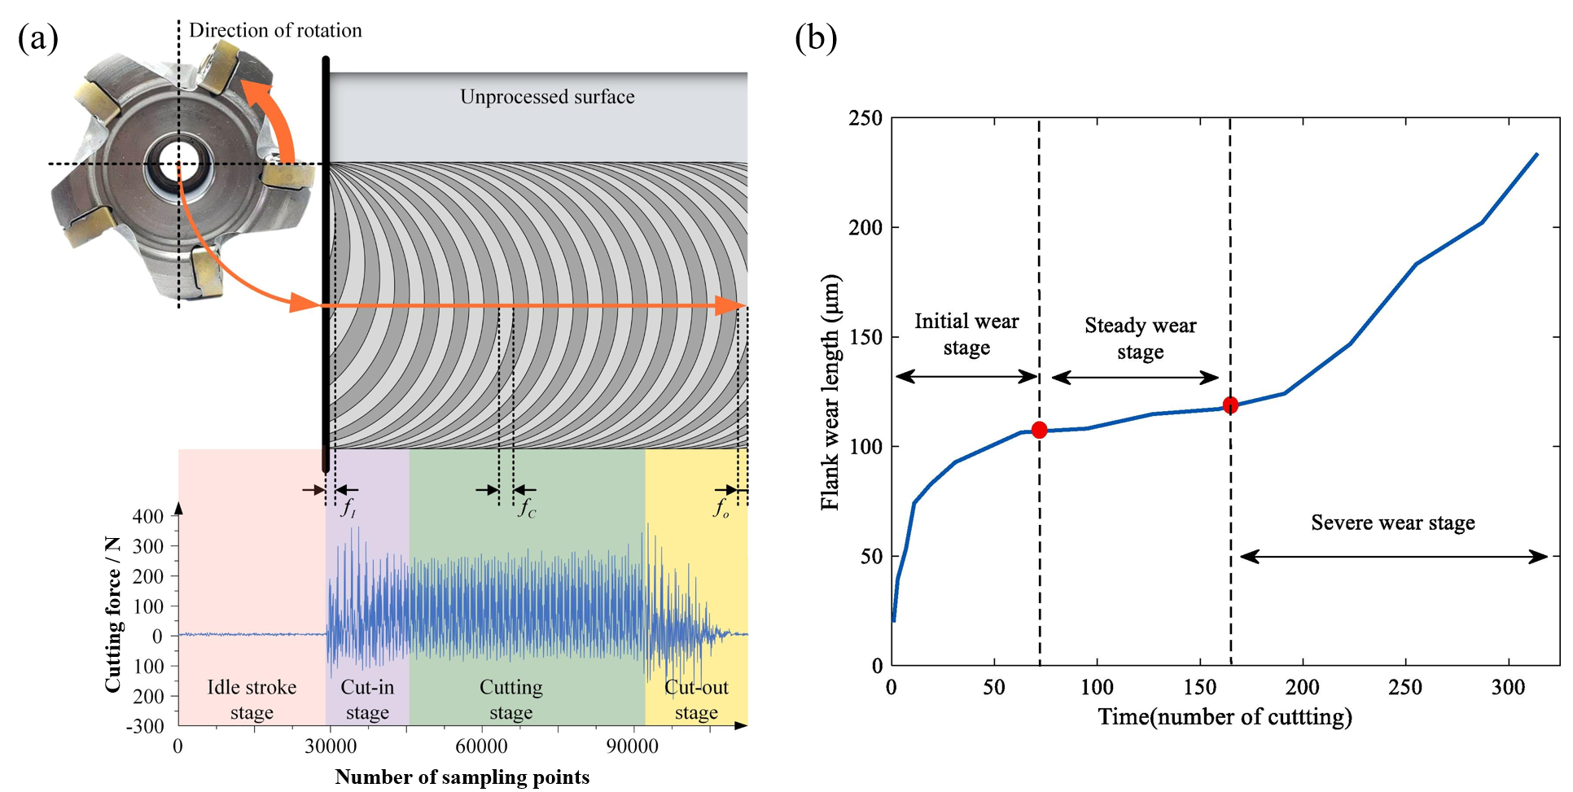

Figure 1. Different tool wear stages [17].

**3.1 Diamond Coating**

Diamond coating has advantages of superior hardness, excellent abrasion resistance and small coefficient of thermal expansion. When deposited on tool surfaces, diamond coatings enhance the tool's performance in terms of wear resistance, corrosion resistance, and high-temperature resistance, thereby prolonging its service life. As an ideal tool material, diamond coatings are widely favored in the cutting tool industry. Domestic and foreign scholars have mainly studied the influence of coating texture structure, thickness, pretreatment method and other parameters on the coefficient of friction and diamond coatings adhesion, having achieved fruitful results.

Texture processing on diamond films can markedly decrease the coefficient of friction, thereby enhancing the wear resistance of coatings. Guo et al. [19] investigated the impact of texture structure on tribological properties of diamond coatings on WC-Co cemented carbide surfaces. The surface texture was fabricated by laser ablation technique. The diamond coating synthesized on the textured substrate perfectly superimposes the texture of base surface. The bearing ball was used under dry friction conditions for the reciprocating friction test. It has been found that as the surface area of the same type of texture increased, the coefficient of friction of the diamond textured coating decreased. Compared to groove textures, elliptical textures further reduced the coating friction coefficient by trapping abrasive particles, as shown in Figure 2. However, the reasons for the slight fluctuation in the friction coefficient curve of diamond coating with or without texture have not been deeply analyzed. Wu et al. [12] studied the effect of the micro-texture of the diamond coating on the graphitization and the coefficient of friction. The degree of graphitization of diamond coating microstructures decreased successively to concentric circles, hexagons and rhombuses. That meant a positive correlation with the surface density of the micro-texture. The graphitization of textured surfaces decreased rapidly and became stable at the first friction stage. The coefficient of friction decreased with graphitization and stabilized with graphite. After stabilisation, the coefficient of friction decreases with the increased of graphitization degree. However, the process of IDiamond/IGraphite without obvious change is not described systematically when the texture depth was in the range of 5~6 μm.

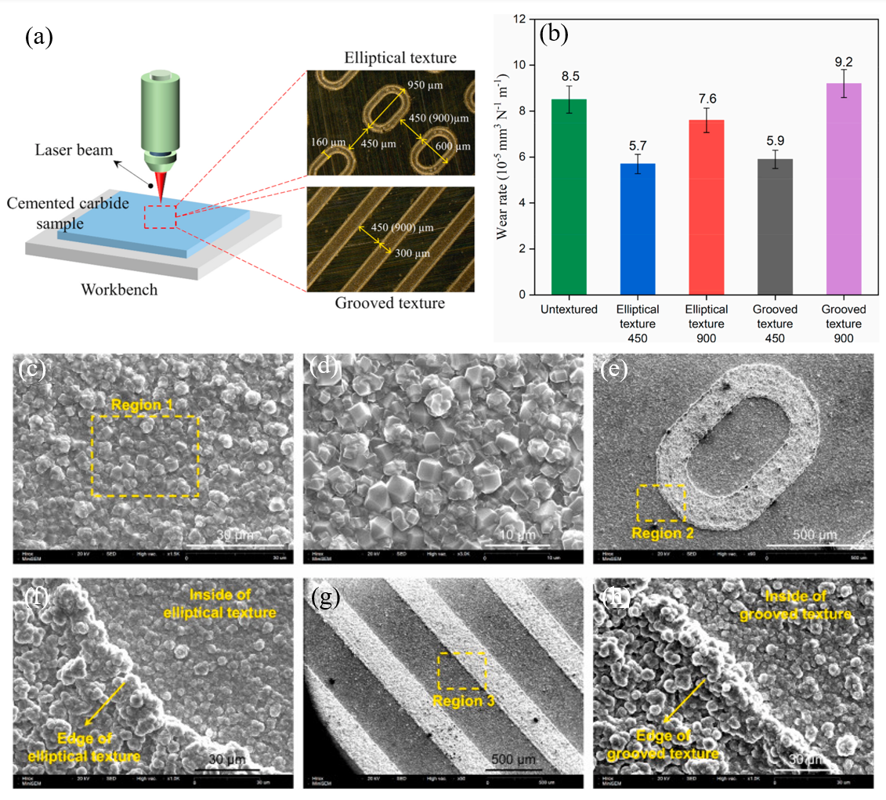

Figure 2. Schematic diagram showing the laser surface texturing to produce elliptical and grooved textures.

Martinho et al[20]. found that the main cutting forces were higher for coated tools and higher feeds significantly increased the main cutting forces. The diamond film is in the vicinity of the edge of the front face of the coated tool. The wear mechanisms of the tool are abrasion, adhesion and diffusion respectively. Diamond coated ceramic inserts have lower flank wear than uncoated ones. During high-speed cutting, high temperatures often occur in the cutting zone. This is caused by chemical and diffusion reactions between the complementary tool and workpiece material. Diamond film graphite forms the cutting zone stimulated by high temperatures[21]. As the cutting speed increases, the cutting end face of the cutting increases and, mainly related to the feed rate.

For the coating of milling cutters, many studies have been done on conventional PVD and PVD [22]. By using these coatings, there is a significant improvement in the performance of the tool life and processing quality. PVD coatings are typically thinner, improving adhesion and increasing wear resistance, thus increasing tool life.

Numerical control machining is quite new and can be seen in its use for cutting force prediction, by using data provided, even from FEM models, to understand chip morphology and tool/workpiece temperature, thus providing a better understanding of tool wear [23,24].

Diamond coating deposited on carbide tools can extend their cutting life. The adhesion strength between diamond coating and substrate is poor. The interface between interlayer and diamond coating is easy to separate. Fan et al. studied the impact of composite pretreatment on the bond strength and cutting performance of diamond-coated cemented carbide cutting tool by hot filament chemical vapor deposition. The pretreatment of diamond WC-Co coating by acid-Murakami-acid chemical etching process treatment or deposition of 500 nm WC intermediate layer can not saliently improve adhesive strength. The coating adhesive strength after composite pretreatment was significantly improved. The cutting performance of coated tool was lifted significantly. However, the reason of pore between diamond coating and matrix has not been deeply analyzed and needs to be studied.

Coating wear resistance and inter-substrate adhesion are affected by coating thickness and diamond content [25]. Kwon et al. investigated the influence of different particle sizes on diamond coatings performance. CH4 coating with 2% concentration had coarser grains and higher adhesion. The best thickness of 13.9 μm for processing carbon fiber reinforced polymers had the longest tool life. However, the changing process of the sum ratio between diamond peak strength and nano-diamond peak was smaller. But the content of nano-diamond is higher. It was found that 10 wt.% diamond coating had high hardness and Young's modulus under pressure conditions of 60 MPa and 80 MPa. 10 wt.% diamond coating 60 MPa had low elastic resistance and the highest wear resistance. However, the mechanism of the effect of the carbide concentration on the hardness and modulus of the coating remains to be further analyzed.

Diamond coated ceramic tools improve their chemical stability and mechanical properties. They are widely used for high-speed machining of various hard and brittle materials. Graphite powder is abrasive in cutting process, resulting in serious tool wear . Li et al. [26] invented a diamond-coated silicon nitride ceramic tool. That can be applied to the high-speed machining of curved mobile phone hot bending glass graphite. It could also better solve the problems such as tool damage, electrical breakage. Slowing processing speed during the processing of graphite electrodes can be achieved, so as to maximize the operation speed of the high-speed machine.

**3.2 Diamond-like coatings**

DLC coating has a bond form similar to diamond sp2 and graphite sp3, both diamond and graphite. That has trait such as high hardness, high wear resistance, chemical stability and other excellent properties. A broad application prospects was expressed in the field of tool cutting. Elementals doping, coating thickness, temperature and other factors have an important effect on the corrosion resistance, thermal stability, oxidation resistance of DLC coatings. The adhesion between DLC and matrix can be improved by adding transitional intermediate layers. Current research has elevated the understanding of improving coating performance to a new level.

High temperature is easy to lead to decomposition of pure DLC coating and reduce oxidation resistance and friction properties [27]. Graphitization and oxidation of DLC coating can be inhibited by element doping. Zia et al. [28] systematically researched on the effect of Si and N co-doping on the structural and mechanical performance of DLC coatings at high temperature friction conditions. The friction behaviors of Si, N-DLC coatings at varied temperature were evaluated by the ball-on-disk module of a high-temperature tribometer. The as-deposited Si, N-DLC coatings are highly uniform without the columnar structure. The thermodynamic stable bonds in Si, N-DLC coatings could increase the oxidation resistance and high-temperature thermal stability of coatings. The coating had lower friction at low temperatures (25–300℃). The order of magnitude lower than at high temperatures (400–600℃). The wear track quickly formed a dense layer of high hardness and elastic recovery, giving the coating low friction characteristics at 500℃ (Figure 3). However, the internal effect of temperature on the ratio of nanometer hardness to elastic modulus has not been deeply analyzed. Shao et al. [29] studied the influence of Cr doping in DLC coatings on the DLC/CrN interfacial bonding strength using the first principles method. It was found that doped interfacial adhesion strength was enhanced. The interfacial Cr-CCr(1) doped Cr atoms inhibited the inter-interfacial electron transfer. That made the primary layer of N atoms and the secondary layer of Cr atoms on the CrN surface participate in the charge transfer. This study provided an important basis for increasing the performance of DLC and expanding its range of applications. Beake et al. [30] conducted micro-scale cyclic wear and impact tests of un-doped, Si-doped and W-doped diamond-like coatings on the surface of hardened steel. The wear track deformation was mainly affected by plastic deformation and hardness. The undoped DLC coating had the highest hardness and elastic modulus but was easy to break. The diamond-like coating doped with Si had the lowest reciprocating impact resistance. However, the change mechanism of friction coefficient at the beginning of wear stage has not been clarified clearly.

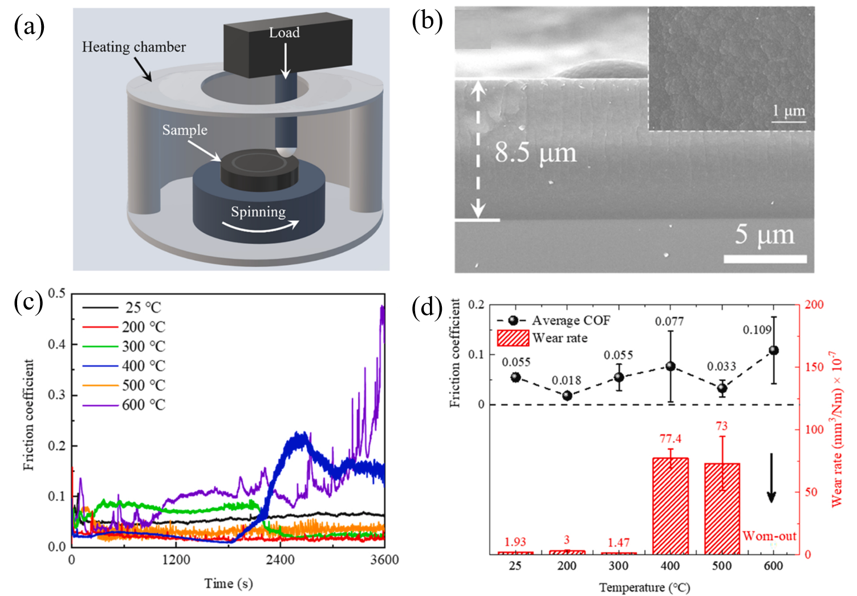

Figure 3. The cross-sectional and surface morphologies of the as-deposited Si, N-DLC coating

Uncut chips thickness directly affects the cutting properties of tools coated with DLC. Wu et al. [31] researched the influence of DLC coating on micro-cutting performance. It was found that with constant uncut chip thickness (UCT), the use of DLC coating on micro-tools increased cutting force. The tip heat of DLC coated tools was less. UCT had the greatest influence on cutter force. What’s more, coating thickness and the coefficient of friction, and appropriate uniform temperature was crucial to obtain the ideal coating performance of the micro-tool, as shown in Figure 4. However, that the mechanism of sudden decreased of normal force of DLC coated tool is not clearly explained when the thickness of uncut chip increases to 5 μm.

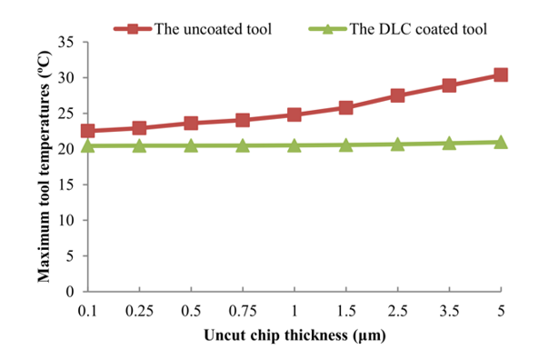

Figure 4. Predicted maximum tool temperatures under various UCT.

The structure and wear resistance of DLC coating are directly affected by temperature. High temperature leads to irreversible changes in the coating structure, and the transformation from sp3 to sp2 ultimately results in unsatisfactory thermal stability of DLC [32]. Kim et al. [33] studied the impact of heat treatment on the tribology of DLC coatings. They found that the DLC coating of M2 steel had the worst performance after annealing at 500℃. As the annealing temperature increased, the corrosion polarization resistance and abrasion resistance of DLC coating on ceramic alumina surface declined. The coefficient of friction of coating under 300℃ increased. The DLC annealing at 600℃ had minimal coefficient of friction and abrasion resistance. However, mechanism of the reduction in the coefficient of friction of the coating in the initial sliding stage has not been deeply analyzed. Huang et al. [34] researched the impact of deposition temperature on the tribological performance of the alloy. The sp3 of Si-DLC coating increased in the deposition temperature range of 60–120℃. It can result in an increase in hardness. However, mechanism of the sudden decrease of wear rate of Si-DLC coating at 150℃ has not been systematically analyzed and needs further study.

Pretreatment process directly affects the growth characteristics of DLC coatings. It can determine the final structure and quality of DLC coatings. Tokuta researched the impact of pretreatment on the tribological performance of DLC film. The coefficient of friction of deposited DLC film was about 0.15, while that of preheated DLC film at 500℃ was about 0.03. As the heat treatment temperature increased, the graphitisation rate on the surface of the film was higher than that in the interior of the film. That originated the increase of hydrogen evolution. However, the reason why the preheating temperature was inversely proportional to the coefficient of friction of the coating. The coefficient of friction of the coating at 400℃ was higher than that at low temperature has not been deeply analyzed. Toboła et al. [35] studied the influence of pretreatment of steel substrate for mechanical and thermochemical tools on the durability of diamond-like coatings. It was found that the abrasion resistance of the tool treated with turning, 160 N polishing, vacuum nitriding and DLC coating was 180 times higher (Sverker 21 substrate). It could reach 10 times higher (Vanadis 8 substrate) than that of the sample after grinding. In the process of nitriding, composite layer and diffusion zone were formed. The diffusion zone comprises a solid solution of nitrogen in martensite and fine nitride precipitate. However, the influence of nitriding treatment on tool fatigue life has not been deeply analyzed. For improvement of DLC adhesion to Ti6Al4V alloy substrate, Yan et al. [36] researched the effects of texturing, carburizing and combination on DLC. The collaborative combination of laser texture and carburizing was the most effective in decreasing internal stress of DLC coating. The bonding strength of laser textured or carburized DLC coating with Ti6Al4V matrix was 8.72 N and 9.18 N, respectively. The bonding strength of laser textured or carburized DLC coating with Ti6Al4V matrix was up to 12.25 N. However, the underlying mechanism of different color shades on the surface of carburized substrates has not been systematically analyzed. Dalibon et al. [37] investigated the corrosion behaviour and bonding of a hard DLC coating on nitrided and non-nitrided AISI 420 stainless steel matrix. DLC hard coating formed on nitrided martensitic stainless steel had better adhesion than that formed on untreated AISI 420 steel matrix. It withstood the rockwell and scratch tests without peeling. Polarization test showed a high reversal potential. The improved adhesion achieved by nitriding pre-treatment had good effect on the corrosion behavior of damaged coatings. However, the explanation of the sudden change in the slope of the anode curve of the coated sample was not detailed enough.

DLC coating has excellent corrosion and friction resistance properties [38]. That can be applied to the surface of tools to enhance their cutting properties. Scendo et al. [39] researched the impact of surface modification on the surface corrosion resistance of 4H13 stainless steel with and without DLC coating. The microhardness of DLC coating was five times superior to uncoated stainless steel. The DLC film with high polarization resistance had low electrical conductivity. However, the underlying mechanism of DLC film adhering to the substrate surface after soaking in chloride corrosion solution is not clearly elucidated. Campos Rubio et al. [40] researched the influence of DLC coating on tribological properties of tungsten carbide micro-tools for precision processing of tantalum. The deposited DLC film could reduce friction coefficient and wear. When the coated tool wears was less, the wear distance was 130% longer than uncoated tools. However, specific cutting force and critical chip thickness were reduced. However, the reason for the sudden increase of cutting force of cutting tools without DLC coating at the feed rate of 0.6 μm/z has not been deeply analyzed and needs to be studied.

Adding a transition intermediate layer is the most effective way to overcome mismatch between substrate and coating. Hao et al. [41] studied mechanical properties and cutting properties of Cr/x/DLC composite coated carbide cutting tool. It was found that the strength ratio, bonding strength and toughness of Cr/x transition structure DLC composite coating were significantly improved. The residual stress was decreased. Service life of the tool was significantly increased, as shown in Figure 5. However, the influence mechanism of multilayer coating to improve the machining surface quality has not been deeply analyzed.

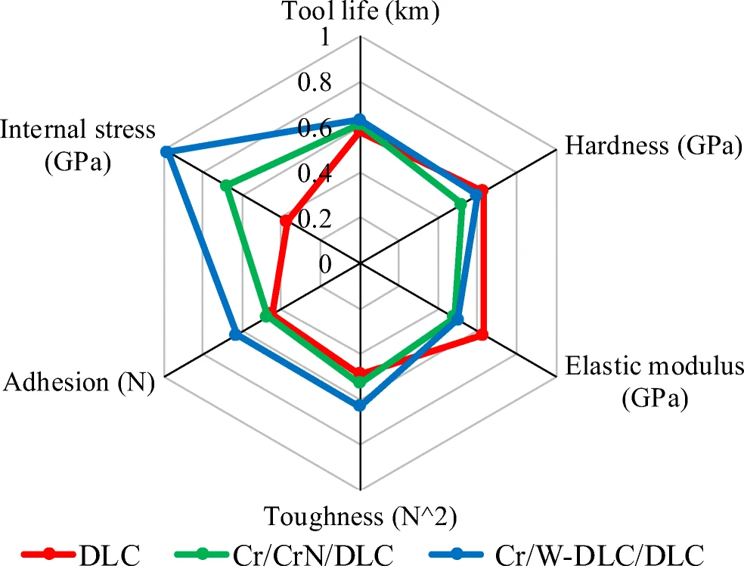

Figure 5. Comprehensive evaluation of composite coating tools based on Radar chart.

The poor adhesion between DLC coating and substrate limits its application in the mold industry [42]. Haji et al. [43] investigated the effect of sintered microstructure of low alloy steel on the performance of DLC coating. With the increase of cooling rate, the roughness and thickness of nitride layer decreased. The mass loss was about 75%. There was no delamination around the indenter effect in As6.8, and it indicated that adhesive strength in As6.8 was acceptable rather than that in Ha6.8. The wear resistance of DLC coating increased, as indicated in Figure 6. Lan et al. [44] prepared DLC coating on the surface of Cr12MoV steel by in-situ duplex plasma nitriding and arc ion plating processes. Hardness of DLC coating was 22.5 GPa, sp3 bond concentration was 29.9%. The bonding strength between DLC coating and matrix was increased from 6.4 N to 15.2 N by in-situ dual-phase process. The coating wear resistance was improved. However, the breakage mechanism of diamond-like coatings treated without nitriding is not clear.

There are few studies on the effect of DLC coating on the coefficient of friction of elastohydrodynamic lubrication under full film condition. Björling et al. [45] researched the influence of DLC coatings on friction coefficient of elastic hydrodynamic lubrication. They found that the surface friction coefficient decreased with the full-film DLC coating. The coefficient of friction decreased less than when two surfaces were coated when only the ball or disc was coated. It was still higher than when no coating was applied. However, the mechanism of the change in the friction coefficient of the DLC coatings was not clearly understood.

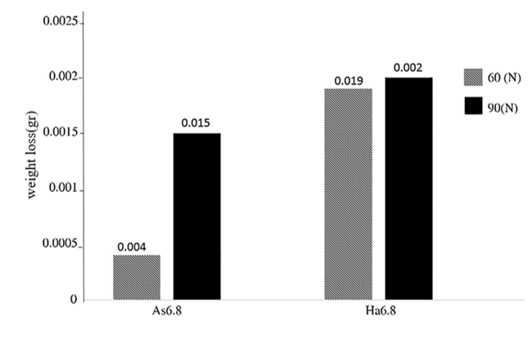

Figure 6. Weight loss of As6.8 and Ha6.8 samples.

1. **Conclusion**

Superhard coatings are widely applied to the surfaces of tool blades in industries such as oil mining, coal extraction, and others. Compared to uncoated tools, superhard tools exhibit enhanced bond strength, wear resistance, corrosion resistance, hardness, oxidation resistance, and thermal stability. These improvements significantly enhance the cutting performance and service life of the tools. The performance of tool coatings is primarily influenced by factors such as thickness, texture structure, element doping, particle size, as well as operational parameters like uncut chip thickness, binder properties, and cutting speed during tool operation. By optimizing these factors, the overall performance of the tool coating can be improved, leading to better cutting performance and extended tool life.

The current selection of materials or additive components often focuses on addressing localized issues rather than providing comprehensive solutions. To enhance tool coating performance, it is essential to emphasize the use of high-wear-resistant compounds. Ideally, coatings should incorporate a diverse range of features, including various chemical bonds and bond types. These characteristics significantly influence material hardness, melting point, and chemical stability. Moreover, the diversity of coating element types plays a crucial role in determining the microstructure and service performance of the coating.With the advancement of digital, automated high-end equipment and intelligent control of production processes, the manufacturing of high-quality super-hard cutting tool coatings has become increasingly feasible. However, achieving stable, large-scale, and standardized preparation of tool coatings remains a technical challenge domestically. Collaborative efforts among industry, academia, research institutions, and application-focused entities are vital for overcoming this hurdle. Joint development by relevant enterprises, universities, and research institutes can foster innovation and progress in this field.Establishing a domestic collaborative innovation center for superhard tool coating preparation technology is critical. This would facilitate the identification of product production characteristics, the formulation of relevant standards, and the adoption of standardized methods to unify and simplify the manufacturing process. Such measures will strengthen standardized production management, improve tool quality, and reduce production costs.

**Declaration (ARTIFICIAL INTELLIGENCE)**

Author(s) hereby declare that NO generative AI technologies such as Large Language Models (ChatGPT, COPILOT, etc) and text-to-image generators have been used during writing or editing of manuscripts.

**References**

1. Monteiro SN, Skury ALD, De Azevedo MG, et al. Cubic boron nitride competing with diamond as a superhard engineering material–an overview. J Mater Res Technol. 2013; 2(1): 68-74.
2. Xiong YF, Wang WH, Jiang RS, et al. Feasibility and tool performance of ultrasonic vibration-assisted milling-grinding SiCf/SiC ceramic matrix composite. J Mater Res Technol. 2022; 19: 3018-3033.
3. Cui X, Duan S, Guo J, et al. Bionic multifunctional surface microstructure for efficient improvement of tool performance in green interrupted hard cutting. J Mater Process Technol. 2022; 305: 117587.
4. Ou YX, Wang HQ, Hua QS, et al. Tribocorrosion behaviors of superhard yet tough Ti-CN ceramic coatings. Surf Coat Technol. 2022; 439: 128448.
5. Gui S Y, Gong H, Sun Y J, et al. Experimental investigation of the EDM tools coated with nano-alumina film. Surf Eng. 2023, 39(4): 506-513.
6. Vereschaka AA, Grigoriev SN, Sitnikov NN, et al. Working efficiency of cutting tools with multilayer nano-structured Ti-TiCN-(Ti, Al) CN and Ti-TiCN-(Ti, Al, Cr) CN coatings: Analysis of cutting properties, wear mechanism and diffusion processes. Surf Coat Technol. 2017; 332: 198-213.
7. Sharma P, Majumdar JD. Microstructural characterization and properties evaluation of Ni-based hardfaced coating on AISI 304 stainless steel by high velocity oxyfuel coating technique[J]. Metall Mater Trans A. 2013; 44: 372-380.
8. Bouzakis KD, Makrimallakis S, Skordaris G, et al. Coated tools' performance in up and down milling stainless steel, explained by film mechanical and fatigue properties. Wear. 2013; 303(1-2): 546-559.
9. Ramkumar T, Selvakumar M, Mohanraj M, et al. Microstructure and corrosion behavior of ZnO-Mg coating on AISI 4140 steel fabricated by spray coating. J Mater Eng Perform. 2020; 29: 5796-5806.
10. Zhang J, Zhang G, Fan G. Effects of tool coating materials and coating thickness on cutting temperature distribution with coated tools. Int J Appl Ceram Technol. 2022; 19(4): 2276-2284.
11. Kwon BC, Ahn DG, Hwang JY, et al. Performance enhancement of diamond-coating on step drill for machining CFRPs. J Manuf Process. 2022; 75: 527-537.
12. Wu F, Liu N, Ma Y, et al. Research on the influence of diamond coating microtexture on graphitization law and friction coefficient. Diamond Relat Mater. 2022; 127: 109153.
13. Wang X, Zhang X, Wang C, et al. High temperature tribology behavior of silicon and nitrogen doped hydrogenated diamond-like carbon (DLC) coatings. Tribol Int. 2022; 175: 107845.
14. Tokuta Y, Kawaguchi M, Shimizu A, et al. Effects of Pre-heat Treatment on Tribological Properties of DLC Film. Tribol Lett. 2012; 49(2): 341-349.
15. Wang L, Nie X, Hu X. Effect of Thermal Annealing on Tribological and Corrosion Properties of DLC Coatings. J Mater Eng Perform. 2013; 22(10): 3093-3100.
16. Wang Q, Hang J, Wang C, et al. Development of PVD Coating for High-Speed Machining Cutting Tool. Aeronautical Manufacturing Technology. 2013; 56(14): 78-83.
17. Li Y, Huang X, Tang J, et al. A steps-ahead tool wear prediction method based on support vector regression and particle filtering. Measurement. 2023: 113237.
18. Frutos E, Richhariya V, Silva FS, et al. Manufacture and mechanical-tribological assessment of diamond-reinforced Cu-based coatings for cutting/grinding tools. Tribol Int. 2023; 177: 107947.
19. Guo Z, Deng F, Zhang L, et al. Fabrication and tribological properties of textured diamond coatings on WC-Co cemented carbide surfaces. Ceram Int. 2021; 47(4): 5423-5431.
20. Martinho R P, Silva F J G, Baptista A P M. Wear behaviour of uncoated and diamond coated Si3N4 tools under severe turning conditions[J]. Wear, 2007, 263(7-12): 1417-1422.
21. Martinho R P, Silva F J G, Baptista A P M. Cutting forces and wear analysis of Si3N4 diamond coated tools in high speed machining[J]. Vacuum, 2008, 82(12): 1415-1420.
22. Sousa V F C, Silva F J G. Recent advances on coated milling tool technology—A comprehensive review[J]. Coatings, 2020, 10(3): 235.
23. Sousa V F C, Silva F J G, Fecheira J S, et al. Cutting forces assessment in CNC machining processes: a critical review[J]. Sensors, 2020, 20(16): 4536.
24. Sousa V F C, Silva F J G. Recent advances in turning processes using coated tools—A comprehensive review[J]. Metals, 2020, 10(2): 170.
25. Chen Y, Xiang D, Feng H, et al. Fabrication and performance of boron doped textured diamond coated tool. Surf Eng. 2020, 36(4): 371-378.
26. Li X, Huang G, Chen X, et al. A review on graphitic carbon nitride (g-C3N4) based hybrid membranes for water and wastewater treatment. Sci Total Environ. 2021; 792: 148462.
27. Nakazawa H, Okuno S, Magara K, et al. Tribological properties and thermal stability of hydrogenated, silicon/nitrogen-coincorporated diamond-like carbon films prepared by plasma-enhanced chemical vapor deposition. Jpn J Appl Phys. 2016; 55(12): 125501.
28. Zia AW, Hussain SA, Baig MMFA. Optimizing diamond-like carbon coatings-From experimental era to artificial intelligence. Ceram Int. 2022; 48(24): 36000-36011.
29. Shao W, Zhou Y, Rao L, et al. Effect of Cr doping on interface properties of DLC/CrN composite coatings: First-principles study. Diamond Relat Mater. 2022; 121: 108721.
30. Beake BD, McMaster SJ, Liskiewicz TW, et al. Influence of Si-and W-doping on micro-scale reciprocating wear and impact performance of DLC coatings on hardened steel. Tribol Int, 2021; 160: 107063.
31. Wu T, Cheng K. An investigation on the micro cutting performance of diamond-like carbon coatings using finite element method. Int J Adv Manuf Tech. 2014; 73(9-12): 1321-1340.
32. Kim DW, Kim KW. Effects of sliding velocity and normal load on friction and wear characteristics of multi-layered diamond-like carbon (DLC) coating prepared by reactive sputtering. Wear. 2013; 297(1-2): 722-730.
33. Kim JI, Lee WY, Tokoroyama T, et al. Tribo-chemical wear of various 3d-transition metals against DLC: Influence of tribo-oxidation and low-shear transferred layer. Tribol Int. 2023; 177: 107938.
34. Huang B, Liu L, Han S, et al. Effect of deposition temperature on the microstructure and tribological properties of Si-DLC coatings prepared by PECVD. Diamond Relat Mater. 2022; 129: 109345.
35. Toboła D, Liskiewicz T, Yang L, et al. Effect of mechanical and thermochemical tool steel substrate pre-treatment on diamond-like carbon (DLC) coating durability. Surf Coat Technol. 2021; 422: 127483.
36. Yan H, Li J, Zhang M, et al. Enhanced corrosion resistance and adhesion of epoxy coating by two-dimensional graphite-like g-C3N4 nanosheets. J Colloid Interface Sci. 2020; 579: 152-161.
37. Dalibon EL, Brühl SP, Trava-Airoldi VJ, et al. Hard DLC coating deposited over nitrided martensitic stainless steel: analysis of adhesion and corrosion resistance. J Mater Res. 2016; 31(22): 3549-3556.
38. Javidparvar AA, Mosavi MA, Ramezanzadeh B. Nickel-aluminium bronze (NiBRAl) casting alloy tribological/corrosion resistance properties improvement via deposition of a Cu-doped diamond-like carbon (DLC) thin film; optimization of sputtering magnetron process conditions. Mater Chem Phys. 2023, 296: 127279.
39. Scendo M, Staszewska-Samson K. Effect of Surface Modification on Corrosion Resistance of Uncoated and DLC Coated Stainless Steel Surface. J Mater Eng Perform. 2017; 26(8): 3946-3953.
40. Rubio JCC, González AGG, Barcelos DJ, et al. Tribological analysis and performance of a DLC coating on tungsten carbide micro-tools to use at tantalum precision machining. Int J Adv Manuf Tech. 2021; 116(1-2): 719-732.
41. Hao T, Du J, Su G, et al. Mechanical and cutting performance of cemented carbide tools with Cr/x/DLC composite coatings. Int J Adv Manuf Tech. 2020; 106(11-12): 5241-5254.
42. Huang X, Etsion I, Shao T. Effects of elastic modulus mismatch between coating and substrate on the friction and wear properties of TiN and TiAlN coating systems. Wear. 2015; 338-339: 54-61.
43. Haji Ghasemi M, Ghasemi B, Mohammadian Semnani H R. Influence of Sintered Low-Alloy Steel Microstructure on the DLC Coating Characteristics. Trans Indian Inst Met. 2020; 73(5): 1123-1130.
44. Lan R, Ma Z, Wang C, et al. Microstructural and tribological characterization of DLC coating by in-situ duplex plasma nitriding and arc ion plating. Diamond Relat Mater. 2019; 98: 107473.
45. Björling M, Isaksson P, Marklund P, et al. The Influence of DLC Coating on EHL Friction Coefficient. Tribol Lett; 2012, 47(2): 285-294.