**Human Encroachment and Urban Water Supply Sustainability in the Eastern Flank of Mount Cameroon**

**ABSTRACT**

The present study assessed the impact of human invasion of water catchments and the sustainability of water supply in the Eastern Flank of Mount Cameroon. There is growing concern over the future of the world’s water resources due to the astronomical population growth and human invasion of water catchment areas. It considered factors such as housing development, agricultural expansion; infrastructural development compounded by climate variability and relief factors. This study adopted the mixed research design as it combined both qualitative and qualitative research approaches. Both qualitative and quantitative research methods were used. Three satellite images of 1993, 2010 and 2023 were downloaded from the United State Geologic Survey (USGS) Earth Explorer and processed of portraying dynamics of human invasion (built-up expansion and agriculture) and implications on water catchments in the study. A total of 185 questionnaires were randomly administered to households living around catchments and 5 key informants were also interviewed. Questionnaire data were analysed using the Statistical Package for Social Science Standard (SPSS version 23.0). Findings revealed that land cover around the catchments is increasingly dominated by agriculture (farmlands, palm plantations, tea estates and market gardening) which increased from 2872.71km in 1990 to 4406.16km in 2023. Also, settlement land increased from 596.95km in 1990 to 4029.70km in 2023 by use to meet the burgeon population. Water catchment yields over the years have increased from 1659840m3 in 2005 to 4643981.03m3 in the year 2023 but with increasing urbanization and variability of temperature and rainfall elements, the catchment areas are rapidly changing with severe human and environmental consequences. Amidst these dynamics, the major intervention to ensure catchment management was the enforcement of regulations, zero or minimum tillage and fencing of water catchments. With regards to sustainable water management strategies, the study noted participatory planning with a mean score of 4.07, training of water managers (4.03) and regular catchments/water points cleaning and maintenance (3.64) could ensure a more sustainable water supply in the Eastern Flank of Mount Cameroon. The study confirms that the households in the catchments know very well the concerns that affect them to ensure sustainable water supply and management. The study recommended a strategic land use planning policy and the creation of buffer zones to reduce the harmful effects of anthropogenic activities around water catchments while ensuring efficient water supply. There is a need to improve on both catchment management (creation of buffer zones around catchments) and maintenance of water supply facilities to maintain a sound and healthy water system in the Eastern Flank of Mount Cameroon.

**Keywords:** Human invasion, water catchments, water supply, land use change, sustainability, Eastern Flank.

1. **Introduction**

“In urban environments, sustainable access to water resources depends on many factors, including climatic, social and economic conditions characterizing the surrounding environment. For urban areas in mountain environments, these conditions are compounded by stressors resulting from climate change, such as drought, as well as physical remoteness, economic marginalization and poverty, phenomena which impose limits on access to water” (Mukwada & Mutana, 2023; Adams, 2018; Nerini et al., 2019; Hurlimann & Wilson, 2018; Jaramillo & Nazemi, 2018). “The future of the world’s water resources is a major global concern due to the increasing anthropogenic pressure over the intricate and finite water resources which has led to water resource scarcity” (Cosgrove & Rijsberman, 2000; Taha, 2007; Rijsberman, 2006; Rockström & Barron, 2007). “This is manifested in Sub-Saharan Africa (SSA) which is struggling with economic water scarcity due to human, institutional and financial constraints. The problem of water scarcity/shortage is further exacerbated by climate variability and other environmental changes” (Intergovernmental Panel on Climate Change (IPCC), 2014). “Unless a sustainable awareness of resource management emerges, the issue of water resource scarcity shall increase significantly in the coming years” (Ayenew, 2007; Ndenecho, 2007, Lambi 2010; Chiaga *et al.,* 2019). “Recognizing that water resource is not only a basic need but is also a centre-piece of sustainable development and a crucial part of poverty alleviation is fundamental to its management” (Förch & Thiemann, 2004). To this effect, the Dublin principles and the Earth Summit’s Agenda 21 emphasized the need for Integrated Water Management, recognizing water as one of a number of natural resource elements that need to be managed sustainably (Figuaeres *et al.,* 2003).

“The United Nations Environment Program (UNEP) estimates that all human activities require a minimum of 1,700 cubic meters per capita per year (m3/capita-year) to live freely from water stress” (Water Resources Institute, WRI 2000). “Water catchments are instrumental in the effective functioning of hydrological systems, as they ensure groundwater recharge and a steady supply of water for multiple uses” (Kimengsi *et al.,* 2018). Usually, catchment management takes into consideration the social, economic, and institutional factors operating within and outside the catchment (Chiaga *et al.,* 2019). “Watershed management principally involves identifying and defining the natural resources within the watershed, defining the desired objectives based on local problems, and formulating strategies to achieve the objectives using community participation” (Pasaribu, 2000). One important step in determining the condition of a catchment is the assessment of its health. A healthy watershed (catchment) can recover from perturbation, being economically viable and environmentally self-sustaining (Chiaga *et al.,* 2019). “Integrated Water Resource Management (IWRM) involves concerted efforts made to maximize productive water use and overall conservation of water catchment areas” (Ngana *et al.,* 2004). Many past failures in water management are attributed to the fact that water has been, and is still viewed as a free good or at least that the full value of water has not been recognized (Figuaeres *et al.,* 2003).

“Applying efficient and effective measures to manage catchments is of prime importance to the continuous supply of water in any urban or rural milieu. Often, most of these measures are dependent on the geology, organization of the relief, and the stream network of the area. Thus, there are many linkages between these elements and consequently water resource management. Such management options would mainly consist of water supply for domestic, agricultural, and general purposes and in extreme case where the catchment is large for the generation of energy. However, in a good number of cases, water resource management options are often conflicting” (Zeitoun, 2007). “Farming for example may impair water resources and intensive logging may affect water and soil resources. Therefore, a careful analysis of the catchment is a gateway towards sustainable exploitation of resources. Such analysis may be tailored towards sound management or sustainable soil exploitation for agriculture. The analysis may focus on land suitability and land capability assessments, to determine the combination of physical attributes of the landscape which are suitable for particular land use types” (Kimengsi *et al.,* 2018; Chiaga *et al.,* 2019).

“At the local level, several communities depend on water resources, requiring proper management. Therefore, balancing socio-economic growth and development with water resources is essential. Over the years, considerable efforts have been made to protect catchments to ensure a continuous supply of potable water. Despite all the efforts to match water demand to supply, most communities and technical professionals have difficulties moving from traditional water management concepts towards tangible sustainable water management policies and practices. Hence, water management has become more and more complex” (Walmsley et al., 2002). Therefore, existing water resource must be managed efficiently and equitably in terms of both quantity and quality, at local, regional and national levels. A study conducted to assess potable water delivery, an important ecosystem service of Mount Cameroon area revealed that, the water at all sampling collection points for all the streams was not suitable for consumption and none was in accordance with the WHO standard. The study focused on the dynamics of water quality and quantity parameters from three (03) streams; Wolikakwo. Koke, and Ndongo which were located within the Mount Cameroon watershed. The study concluded that potable water delivery to the population was under threat due to the encroachment of human activities. Hence, to ensure sustainable water delivery, this study recommended that a watershed management board be created to oversee stream protection and potable water delivery to local communities (Usongo & Briyan, 2021). The current study is similar to the formal but for the integration of satellite images and quantity of water supply from the catchment to the communities from the Cameroon Water Utility Corporation (CAMWATER).

Human invasion of water sources has resulted in severe degradation and contamination of water sources which poses significant risks to public health and increases cost of drinking water treatment. Fidelis *et al.* (2009) carried out a study on Municipal drinking water source protection in low-income countries using the case of Buea in Cameroon and using a combination of research methods (desk review, interviews and reconnaissance field appraisal) to identify major drinking water sources in Buea, land use activities which constitute potential threats and pathways of contamination of these sources as well as the capacity for source water protection in Buea, the authors noted that anthropogenic activities around the six major drinking water sources studied present visible potential threats and pathways for contamination, and that source water protection has not been given adequate attention in the planning and development of Buea due to limited human and social capacities, financial and technical resources, institutional arrangement for land and water management at the local level notwithstanding. A framework for local strategic multi-stakeholder source water protection with the potential to foster leadership, pull together available resources from different stakeholders and reduce potential resistance to the integration of land and water management was proposed (Fidelis *et al.,* 2009).

Despite these stakeholders management efforts, human invasion of water catchment areas in the Eastern Flank of Mount Cameroon continues to increase unabated astronomically due to the increasing demand for food and fibre to meet the needs of a rapidly growing population. This has necessitated more intensive use of agricultural land. At the same time, more living space and more urban infrastructure are required to meet the increasing demand for public utilities. Different land uses compete with one another and can degrade the future productivity of the land and the quality of the environment (Balgah 2007). While several studies have explored urban development and land use change issues in Buea (Balgah 2007; Nformi and Chin, 2021), potable water delivery (Usongo & Briyan, 2021), source water protection (Fidelis *et al.,* 2009), there is very little information on the implications of human invasion (built-up expansion, agricultural activities and other developments) on water catchments degradation and urban water supply in the Easter slope of Mount Cameroon.

1. **Materials and Methods**

**2.1 Study Area**

The Eastern Flank of Mount Cameroon is located in South Western Region of Cameroon between Latitude 04ᵒ08.036’ and 04ᵒ12.627’N of the Equator and Longitude 009ᵒ13.104’ and 009ᵒ18.675’E of the Greenwich Meridian (Figure 1). The area host of Mount Cameroon is the most prominent of all West African volcanic mountains. The mountain is a heap of piled lava reaching a height of 4,096 meters above sea level (masl). It is very immense with a length of about 50 km and a width of about 35 km, covering an area of 1,750 km2. It starts from the sea and rises to a small peak of 1,713 meters, which bears the name Etinde or Small Mount Cameroon. From this small peak, the mountain slopes down to a height of about 900m before rising again continuously until the submittal plateau of 4,070 masl (Ndeh *et al.,* 2022).

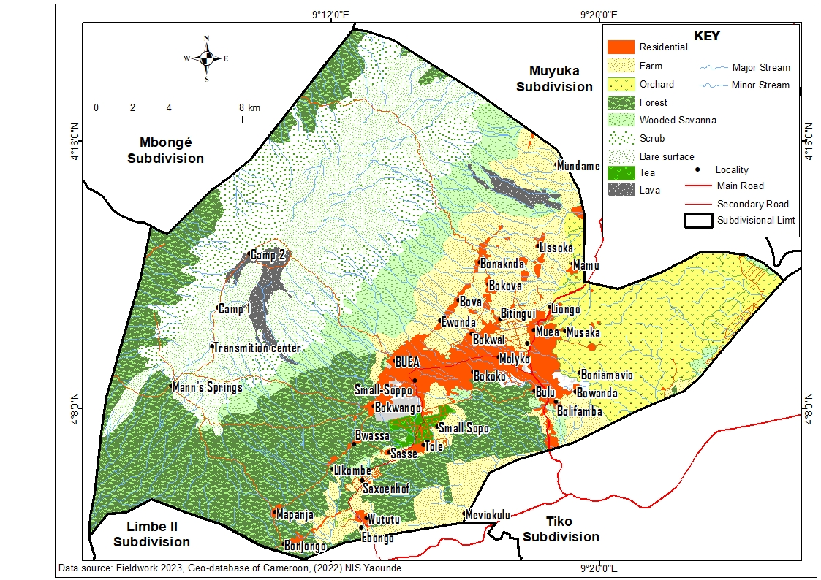**Figure 1: Location of the Eastern Flank of Mount Cameroon in the Fako Division of the South West Region of Cameroon**

Source: Adapted from the National Institute for Cartography Yaoundé Data Base, 2023

The climate of the study area is of the tropical monsoon type and characterized by two main seasons; the wet season with heavy rains (mid-March-October) and the dry season (November to mid-March). The rainy season is characterized by changeable weather with storms and high rainfall variability from mid-March to June and steady rains from mid-June to September. The changing weather with storms and squalls from October to November marks the transition period between the rainy and dry seasons. The Eastern Flank of Mount Cameroon records a high rainfall amount with an annual total of over 3500mm, distributed evenly almost throughout the year (Balgah, 2005). The area is composed mainly of volcanic rocks which range from massive basaltic lava flows to pyroclastic materials (ash and cindery materials) (Endeley *et al.,* 2001).

The soils are rich volcanic (Andosols) derived from the decomposed lava (Yerima *et al.,* 2013). Andosols usually have a bulk density of less than or equal to 0.9 g/cm3, resulting from a combination or amorphous volcanic material and organic matter (Ndeh *et al.,* 2022). They have a relatively high water holding capacity and resist erosion by water and are notorious for their highly variable exchange capacity. The natural vegetation at the foot of the mountain has been cleared down for settlements and farming. Plant recovery on the different lava flows has resulted in a rich and mosaic type of vegetation on the mountain slopes (Ndeh *et al.,* 2022). From about 915 m above Buea town, is a thick slope covered by thick and evergreen forest. The forest extends up to an altitude of 1700 m and gives way to typical savanna vegetation. At an altitude of 3000 to 3500 m, the slope is covered by grass, which is much shorter than the proceeding savanna. Between 3600 and 4000 m, the typical vegetation is comprised of lichens and mosses (Neba, 1999 cited in Ndeh *et al.,* 2022). Several institutional establishments are found within region and due to the rich volcanic soils, farming is the predominant economic activity practiced characterised by the use of agrochemicals. A lot of construction works are carried out to cater for the increasing population as a result of the creation of many new institutions.

* 1. **Methods**

This study adopted the mixed research design as it combined both qualitative and qualitative research approaches. Primary data were obtained from the field through observations, interviews and questionnaire administration. Satellite images downloaded from the United States Geological Survey for land use land cover analysis. The secondary data were obtained from the University of Buea Library, internet sources, the council and CAMWATER. To ensure validity and reliability of conclusions from the sample, the study area was stratified into two areas; urban and rural catchment areas. The essence was to evaluate the extent to which human invasion in terms of buildup and agricultural activities have intruded into the water catchments of these areas. Eight key water catchment areas such as Mile 18 (Wonya Mavio), Muea (Up and Down Njonji), Bokwai, Bwiteva, Small Soppo, Amen Sping and Bulu Blind (mile 16) and Koke were sampled. Also, the water consumers from some major urban areas of Molyko, Government Residential Area and Bokwango were sampled.

The sampled households constituted those using community water supplies, local stream users/community water supply schemes and CAMWATER supply sources. Households using boreholes were not included in the sample because the sources of their water abstractions were from the immediate environment and not from the water catchments. Their choice of water supply and management is crucial in ensuring urban sustainability and the catchments are located within the rural fringes while the majority of the water consumers were within the urban fabric of the study area warranting that both the rural and urban areas be sampled. The target population considered in the study was the total population of each zone since all residents are impacted by water supply issues either directly via potable water consumption or indirectly through other secondary activities like farming. Household views were ranked on a five (5) points Likert scale (5-strongly agreed, 4-agree, 3-neutral/uncertain, 2-disagree, 1-strongly disagree). The target population of the study was drawn from the total population according to the 2005 population census which stood at 131325 (Table 1).

**Table 1: Sample Population from Communities in the Easter Flank of Mount Cameroon**

|  |  |  |  |  |
| --- | --- | --- | --- | --- |
| **Questionnaire Distribution** | | | | Interviews |
| Communities | Quadrants | Target Population | Sampled households |  |
| 1. Federal Quarters | Urban | 2308 | 15 | 3 |
| 2. Small Soppo | 6367 | 31 |
| 3. Molyko, | 13831 | 40 |
| 4. Clerk’s Quarters | 2623 | 17 |
| 5. Government Residential Area (GRA) | 777 | 5 |
| 6. Koke | Rural | 1451 | 10 | 2 |
| 7. Mile 18- Muea | 27329 | 32 |
| 8. Mile 16 | 1459 | 10 |
| 9. Bokwai | 2258 | 15 |
| 10. Bwiteva | 1677 | 10 |
| **Total** | **2** | **70402** | **185** | **5** |

**Source: Extracted from Population Statistic (2015)**

From these strata, a total of 185 households were randomly selected for questionnaire administration and 5 interviews were done proportionately as the sampled population for the study, to avoid representation bias. Thus, a total of 190 respondents constituted this study based from the Fishers formula. Thematic data analysis was used to analyze the data obtained from the interviews. It analyses the topics, ideas, and patterns of meaning that come up repeatedly. Questionnaire data were analysed using the statistical package for SPSS and the Pearson correlation analysis was used to vouch the relationship between the different aspects of human invasion of water catchments and water supply from the catchments to the communities within the Mount Cameroon Area.

# To further assess the impact of land use changes on water catchment transformation, existing shapefiles on the administrative limits of Cameroon were obtained from the NIC Yaoundé which constitutes part of the Geo database of Cameroon for 2024. The shapefiles were displayed in ArcGIS 10.3, for further analysis. The administrative limits shapefiles were corrected based on field realities.

To process the data, the Global Positioning System (GPS) Receiver; Mark Garmin 62 was used to generate coordinates, recorded in XYZ giving the location of a feature in longitude, Latitude and Altitude. The coordinates were offloaded directly into QGIS 3.6 for processing. Coordinates for some of the wetlands were gotten from the field with the GPS. The coordinates were imported into **ArcGIS** 10.3 in which the attributed tables were created for subsequent analysis. Concerning Landsat Images and Google Earth Images Processing, three Satellite images of different years (1993, 2010 and 2023) were downloaded from the United State Geologic Survey (USGS) Earth Explorer and processed of portraying the dynamics of human invasion (built-up expansion and agriculture) and implication on water catchments in the study area. Interactive Supervised image Classification (Maximum Likelihood) was adopted for the processing of the image to generate a raster format depicting the designed land cover/land uses; especially the built-up and agricultural expansion land uses which constituted the themes under study. The raster format was converted from raster to vector format before the extraction and symbolization of the different land uses to produce the land use map and the spatial distribution of the land uses per periods. This study adopts 1993 as a base year because of the civil servants reforms that led to severe economic hardships leading to increasing invasion of catchments for settlements and agriculture.

To determine the rate of land use/cover changes around the water catchments, the magnitude of change, trends and the periodic rate of change were calculated. The magnitude of change for each LULC class was calculated by subtracting the area coverage of the second year from that of the initial year. Magnitude of change (M) =Land use situation of the New Year (Y2) – the land use situation of the previous year (Y1) as seen in Equation (1)

**Magnitude of Change =** Y2-Y1 ………………….…………………………………….…..(1)

Percentage change (trend) for each LULC type was then calculated by dividing magnitude change by the base year (the initial year) and multiplied by 100 as shown by the Equation (2).

**Trend** = $\frac{Magnitude of change}{Base year}$ x 100… ………………………..……………………………..(2)

**3. Results and Discussions**

This section covers information gotten from the field regarding human invasion of water catchments and implications on the sustainability of water supply in the Easter Flank of Mount Cameroon. It starts by looking at the spatial distribution of water catchments within the study area, catchments water yields, drivers of catchment degradation, water catchment management practices, and implications of water supply challenges, coping mechanisms and proposed sustainable water catchment policies.

**3.1 Spatial Distribution of Water Resources within the Easter Flank of Mount Cameroon**

The Easter Flank of Mount Cameroon is endowed with litany of water catchments some of which include the Bokwai, Bwiteva, Muea (Up Njonji), Down Njonji (Muea), Mile 18 (Wonya Mavio), Bulu Blind (Mile 16), Amen Spring (Mile 16), Small Soppo, German Spring, Mosel spring, Koke and Bultiking water catchments (Figure 2). Most of these watersheds, rivers, springs and stream take their rise from Mount Cameroon.

This area has the highest elevation with a height of 4900 m above sea level. While these sources serve as common pool resources, they are usually open to contamination caused by urbanization and increasing water abstraction by vendors. Within the study area, water supply is the concern of CAMWATER (Cameroon Water Utility Company), Councils and some NGOs. However, nowadays due to many communities have harnessed their water supplies from streams or springs due to ineffective water supply or distribution by the organizations. The local water uses in the study catchments identified were domestic (drinking, laundry, cooking among many others) and agriculture (livestock, home gardening of vegetables and market gardening farms).

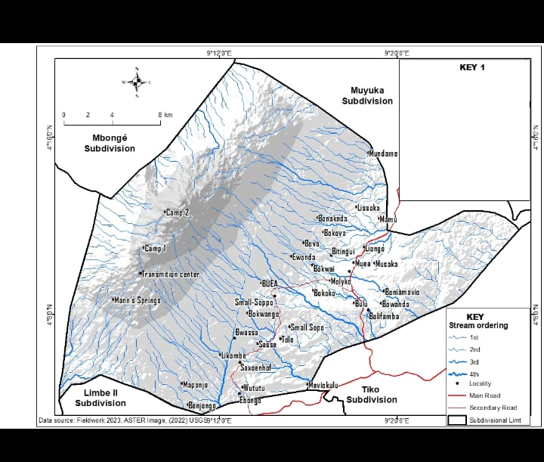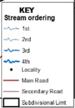

**Figure 2: Hydrological Map of the Eastern Flank of Mount Cameroon**

**Source: Fieldwork, 2023**

There is a range of water sources from where the households in the sub-catchment get their water including the following sources; pipe borne (in the form of taps), rain (through rainwater harvesting), streams and vendors. The use of the different water sources by the households is attributed to the unequal and seasonal distribution of most of the water sources in the sub-catchment. This unwillingly forces the households to resort to other social practices (that include the use of various storage methods, water rationing and recycling and alternative water sources).

Precisely, 49% of the respondents reported pipe-borne water to be the major and reliable source of water followed by the streams/springs (38%) and water vendors (13%), especially in areas like Bwiteva.Findings on unequal water supply and reliability corroborate the works of (IPCC, 2008) who opined that water supplies from rivers, lakes and rainfall are characterized by their unequal natural geographical distribution and accessibility, and unsustainable water use.Most water catchments within the Eastern flank of mount Cameroon have been invaded by anthropogenic activities which may contribute to reducing the quality and quantity of water yields. Figure 3 represents the trends of water supply in the study area.

**Figure 3: Trends of Catchment Water Yields in the study area**

Source: CAMWATER (2023)

From the figure above, it is evident that the water catchment yields over the years have been increasing from 1659840m3 in 2005 to 4643981.03m3 in the year 2023. However, the question that comes to mind is whether these quantities get to the final consumers or what quantities are lost on the way? In most cases, water yields at the catchments are not the same as water supply to the communities via CAMWATER schemes. Due to factors such as the destruction of water supply facilities like broken pipes and leakages, the final quantity of water supplied is often small compared to the quantities yield. This explains why Fulai *et al*. (2019) indicated that due to inconsistent water supply, coping strategies such as reliance on other water sources have become commonplace in Bamenda.

**3.2 Drivers of Water Catchment Degradation**

The water catchments within the eastern slope of mount Cameroon continue to degrade arising from several factors; built-up expansion (housing and roads), waste disposals and agricultural activities. These are demonstrated on the LULC maps with buffers showing net change from one land use type to another within the water catchments of the study. It has been found that the built-up areas expand to peripheral areas by the process of edge expansion, often at the cost of water catchments. Equally, due to the increasing demand for food and fiber arising from population growth in the study area, more water catchments have been invaded contributing to overall degradation and reduction in surface area cover of the catchments which by implication affects to quality and quantity of water supply to the population. Figures 4 and 5 show built-up expansion/farming activities in the Easter Flank of Mount Cameroon from 1983-2023.

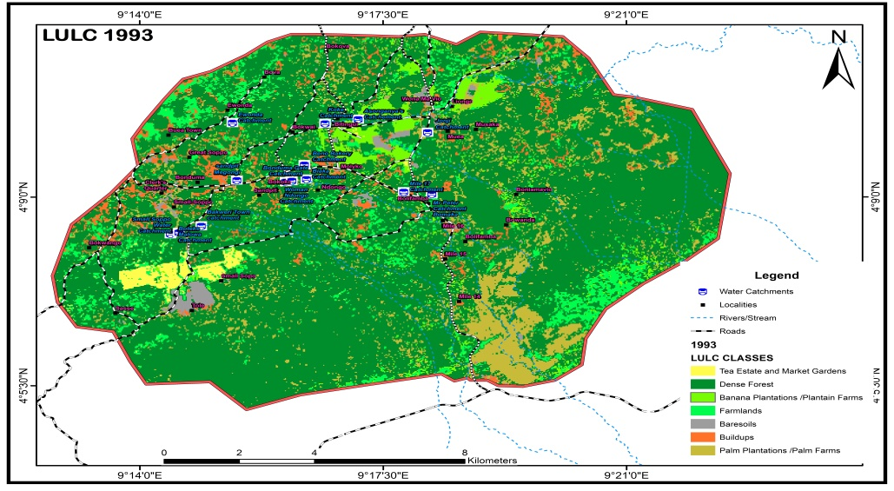

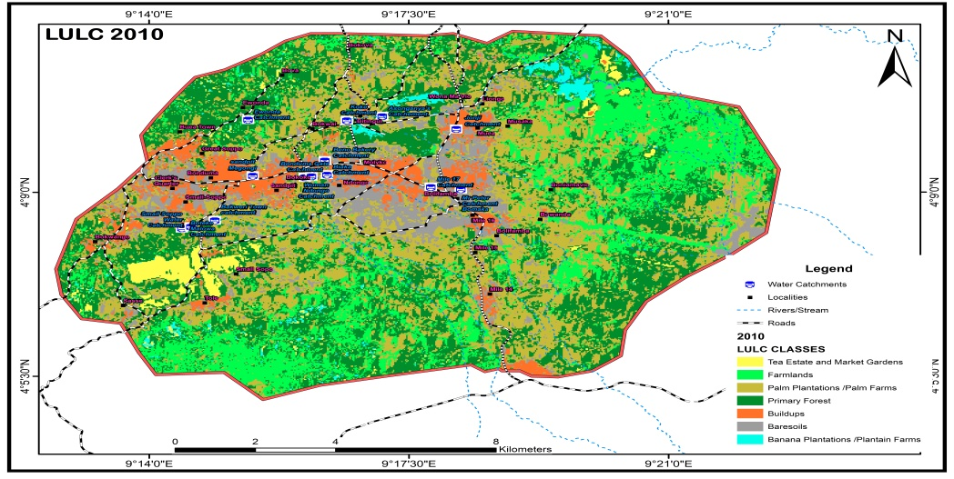

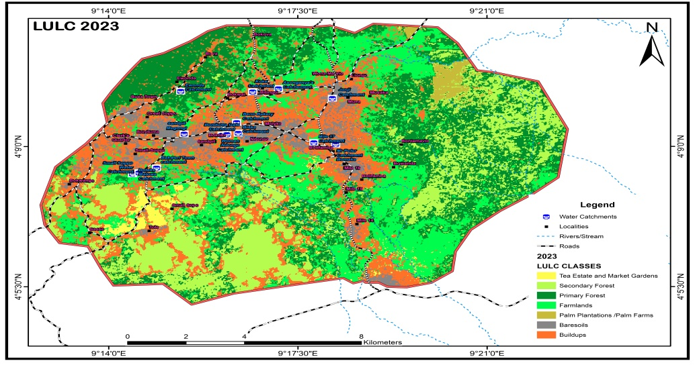

**Figures 4: Built-up and farming Expansions as Drivers of Catchments Degradation**

Source: NIC Yaoundé Data Base, 2023

**Figures 5: Drivers of water Catchments Degradation**

Source**: Extracted from LULC Maps of 1993, 2010 and 2023**

From Figure 4 and 5, the most dominant LULC class for 1990 was primary forest and it occupied 12600.73km (74.62%) in the study area. This implies that the remaining 4286.31km(25.38%) of land were occupied by palm plantations 1522.66km (9.02%), farmland 1145.51km (6.78%) and banana plantations, build-ups, bare soil and tea estate and market gardens occupying 9.58%. Similarly, in the year 2010, 30.52% (5154.54km) of land was occupied by dense forest in Buea while farmlands increased from 6.78% to 18.93% and palm plantations from 9.02% to 31.28%. By the year 2023, dense forest had decreased from 30.52% to 24.62% while build-ups and farmlands increased by 17.61% and 4.12%. By implication, the sky-rocking increase in built-up and farmlands constituted the major drivers of catchment areal change in the study area.

**Table 2: Change Detection of land cover change**

|  |  |  |  |  |  |  |
| --- | --- | --- | --- | --- | --- | --- |
| **Land Use/Cover (LULC)** | **1993-2010** | **%** | **2010-2023** | **%** | **193-2023** | **%** |
| Banana Plantations | -382.35 | -2.27 | 218.23 | 1.29 | 600.58 | -3.56 |
| Bare soils | -1.353.51 | 8.01 | 724.59 | -3.97 | -210.75 | 4.04 |
| Buildups | 458.16 | 2.72 | 2974.58 | 17.61 | 3432.75 | 20.33 |
| Farmlands | 2051.22 | 12.15 | 695.61 | 4.12 | 2746.83 | 16.23 |
| Palm Plantations /Palm Farms | 3759.08 | 22.26 | -5047.49 | -29.89 | -1288.38 | -7.63 |
| Tea Estate and Market Gardens | 207.1 | 1.23 | -132.2 | -0.78 | 75 | -202.88 |
| **Total** | **16887.04** | **100** | **16887.57** | **100** | **16888.62** | **100** |

Source**: Extracted from LULC Maps of 1993, 2010 and 2023**

From Table 2 and Maps, the total area covered by built-up in the Eastern flanks of Mount Cameroon grew from 458.16km (2.72%) between 1993 and 2010 and between 2010 to 2023 it witnessed an astronomical increase of 2974.58km (17.61%) indicating an additional increase of 15.74% within 13 years period as opposed to the initial 2.72% within 17 years. this was a significant increase in buildup owing to population increase and other economic activities in the study area. This indicated that within a shorter period of 13 years buildup in the study area increased beyond what operated during the longer 17 years period. Also within the 30-year period of this study, buildup increased by 20.33% from 1993 to 2023 occupying an area of 3432.75km. This is a clarion call for planning adjustments with regards to buildup expansion and water catchment degradation within our area of study.

Additionally, aside from the expansions of built-ups into water catchments in the study areas, agricultural activities have been expanding engulfing this precious liquid. Here we examine agricultural expansion in the study areas in terms of farmland expansion (farming), palm plantations and market gardens that have contributed enormously to reducing the area covered by water catchments. This area covered by farmlands increased by 2051.22 km2 between 1993to 2013 and between 2013 and 2023 it dropped to 695.61. According to research, the reason for this drop in farmlands from 12.15% to 4.12% within this period was attributed to the influence of the socio-political crisis from 2016 that scared cultivars from going to their farms. However, between 1993 and 2023, farmlands increased by 16.23% indicating an area covered of 2746.83km in the study area.

Also, urban agriculture (market gardens) has continue to rise in the study area encompassing the water catchments as most of these market gardens are located around the water catchments or swamps to take advantage of the perpetual flow of water. Market gardens increased by 1.23% (207.1km) between 1993 to 2010 and however have continued to decrease as between 2010 and 2023 decreased by -0.78% occupying just 132.2km of land in the study area. Even though urban agriculture served as a source of livelihood for the population of the study and other Internally Displaced Persons, it seems to witnessing a regression in production. From the fieldwork, some respondents indicated that the high cost of land, low-profit margins and financial constraints have seriously handicapped this sector in the study area. Plates 1, shows built-up expansion into water catchment area.

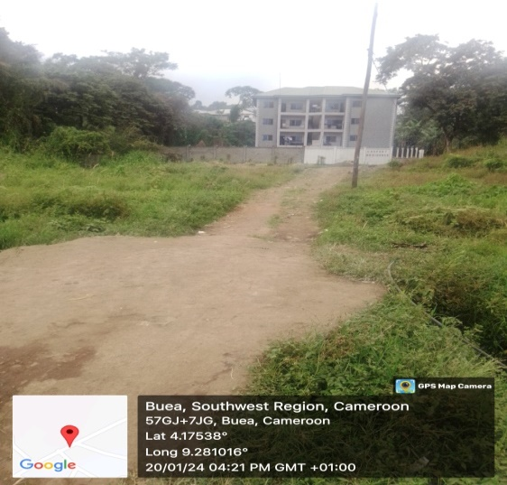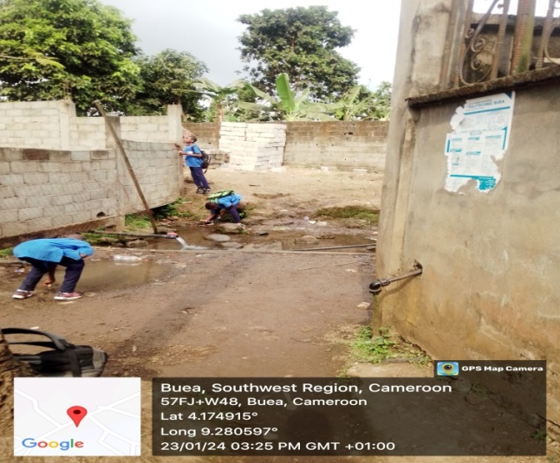

B

A

**Plate 1: Housing construction within the water catchments (A-Bwiteva and B-Mile 18)**

**Source: Fieldwork, 2024**

Aside from population growth and catchment water yield reduction with p-value 0.092614, built-up expansion and agricultural extension into the water catchments of the study area, climate variability has continuously played a negative role in the sustainability of urban water supply via seasonal variations in temperature and rainfall amounts. It was observed that between the year 1990 and 1999, rainfall was below the mean (2425.68mm) while from the year 2000 to 2016, rainfall was above the mean. From the linear regression equation in Figure 6, it shows that rainfall is increasing by 14.771mm per annum.

**Figure 6: Rainfall Variability as Drivers of water catchment degradation**

Source: Nkemasong *et al.* (2023)

Despite the fluctuation in rainfall over the years presented in Figure 6, the rainfall trend indicates and increasing trend. Variability of rainfall was compared between seasons and the wet season coefficient of variation (CV %) was 20.46% showing a high value of reliability of rainfall for that enabled high stream discharged with a wet season mean of 2164.98mm. For dry season rainfall variability, the CV of 28.79 % showed that rainfall cannot solely be relied upon during the dry season. This suggests that supplementary measures have to be put in place to augment sufficient water supply during the dry season. This explains why there is often water rationing during the dry season and most households in different communities resorted to alternative water sources and water conservation/recycling. However, observations show that there is a gradual shift of the conventional wet season period into the dry season making the dry season more wetter than before and the rainy season less wetter.

Equally, the analyses of temperature situations of the study area presented in Figure 7 illustrated that maximum temperature increases by 0.10C and 0.20C for minimum temperature per year with a sharp decrease in the minimum temperature from 1990 -1993 and thereafter, increases in 1994 and 1995 and falls again in 1996 and keeps fluctuating till 2016 when it became stable in an increasing rate till date. The trend equation and the trend line of the mean minimum temperature generally show an increasing trend which means that the average minimum temperature over the years has been rising (Nkemasong, 2014; Balgah *et al.,* 2017; Nkemasong *et al.,* 2023).The increase in temperature has the probability of drying off some water sources (ephemeral streams) leading to water shortages in some communities within the study area.

**Figure 7: Temperature Variability as Drivers of water catchment degradation**

Source: Nkemasong *et al.* (2023)

Furthermore, the astronomical degradation of water catchments has been attributed to poor management of water catchments and limited investment in water supply infrastructure. Due to the above failures in water supply management, some of the water sources were reported to be non-operational, especially the community taps in unplanned settlements and those that were functional were in a deplorable state. This was attributed to non-cooperation among the water users, supervisory constraints and lack of maintenance by the local government staff. Similarly, on 3rd March, 2024, local council executive members in Bomaka (Mile 18) and Upper Muea responsible for the management and maintenance of the Mile 18 water and Upper Muea water catchment supply committee reported that:

*“Most of the water sources in the area have become dysfunctional due to lack of supervision and maintenance by the government and inadequate community involvement in the maintenance process. Calls had been made to the Community Development workers to assess the situation and intervene, but all these need money which the users have refused to comply on time and even the few that comply do so sluggishly and timidly which has continuously over time slow down the maintenance process”.*

Despite the citizen protest for change in the water supply situation to the municipal leadership, nothing gives people a sense of place. Many high-income earners people have to pay for water even when they do not consume water for most part of the months as their meter readings estimated are billed by CAMWATER while the low-income earners continue to consume water from alternative but doubtful sources. The analysis of the main drivers of water resources scarcity revealed that the majority of households (46%) reported that deforestation and the increasing population were responsible for increased regional climate variability-related scenarios resulting in water supply deficiency from the various catchments. Other respondents (20, 21 and 13%) attributed water resources scarcity to being driven by poor land use practices, destruction of water pipes/leakages and pollution (point and non-point sources) respectively. Plate 1 shows some of the anthropogenic activities reported to post significant threats to water resources in the catchment in the form of scarcity, degradation and water pollution. Hence, findings the drivers of water supply deficiency corroborated the works of (Olokesusi, 2006; Syngellakis & Arudo, 2006, Baba & Ndi, 2017) who indicated that the major areas of concern pertaining to Water Resource Management are related to poor watershed management, inadequate water accessibility and quantity, poor water quality and inadequate institutional capacity, and institutional weaknesses and lack of infrastructure to effectively manage water resources. These have subsequently leaded to failures at all levels of city life especially in health, sanitation, education and employment.

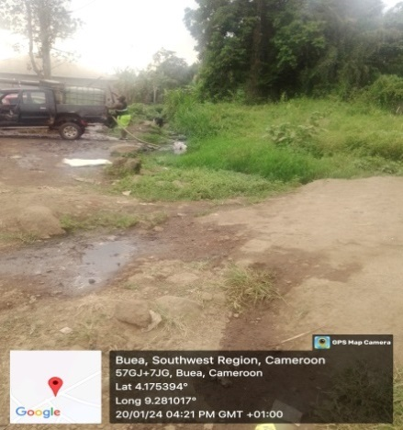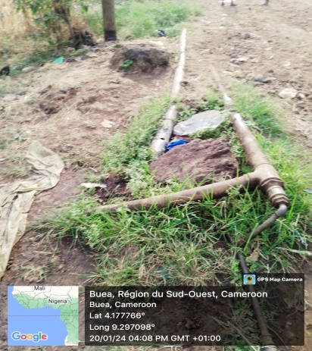 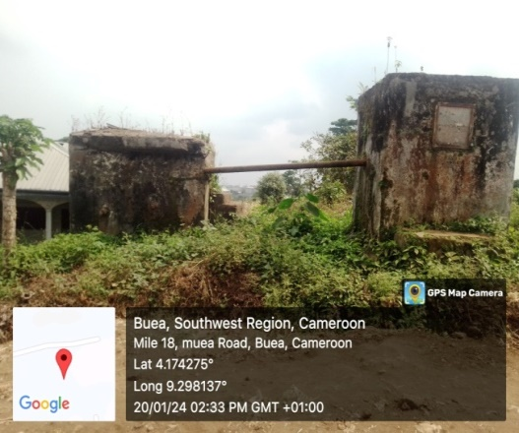

**Plate 2: Water abstraction Upstream, Broken Water Pipe and Dilapidated Water Catchment Facilities in Bwiteva Community**

**Source: Fieldwork, 2024**

**3.3 Interventions to Ensure Catchments Management and the Sustainable Water Supply**

Several interventions have been done at the community, stakeholders and NGO’s level to ensure the sustainability of the water supply and avoid water catchment degradation in the Eastern Flank of Mount Cameroon. Table 3, presents a record of the various interventions that were suggested by households/stakeholders in the sub-catchment to ensure sustainable water supply and catchment management.

**Table 3: Interventions to Ensure Catchments Management and the Sustainable Water Supply**

|  |  |
| --- | --- |
| **Interventions** | **Mean** |
| **Catchments Management** | |
| Protection forestry | 3.51 |
| Zero or minimum tillage | 4.62 |
| Gully control works | 3.50 |
| Reforestations | 3.41 |
| Enforce regulations (prohibits construction and agricultural activities) | 4.88 |
| Fencing of water catchments/points | 4.27 |
| **Sustainable Water Supply** | |
| Regular catchment and water supply facilities maintenance or cleaning | 3.64 |
| Construction of more water supply points (taps ) | 3.42 |
| Participatory planning | 4.07 |
| Training of water managers on water catchment management | 4.03 |

Source: Fieldwork, 2024

The major intervention to ensure catchment management was enforcement of regulations with a mean score of 4.88 representing a strongly agreed perspective from the households. This was closely followed with zero or minimum tillage (4.62) and fencing of water catchments (4.27). The major driver of water catchment degradation as per land use, land cover maps was regarded to be expansion of built-up (from 3.53% in 1993 to 23.86% in 2023). Thus enforcement of housing regulation or urban planning policies is a prerequisite to ensuring sustainable catchments and water supply in the study area. The populations adjacent to the water catchments (especially those that have not been fully deforested) have been prohibited by water authorities’ from carrying out any form of deforestation in or around these areas. Soil in vegetation-filled areas acts like a gigantic sponge, storing a vast quantity of water that is used by plants and trees or released gently into streams and rivers. Vegetation depletion reduces the storage capacity of this sponge, leading to water shortages during the dry season’s period. During the wet seasons, deforested water catchments are flooded leading to water contamination, especially for downstream users.

This strategy is therefore used to encourage more water infiltration and sore in the catchment for distribution to the population. Also, zero or minimum tillage is an important measure proposed to ensure the sustainability of water catchment management. Improperly managed agricultural activities within the water catchments may influence water infiltration capacity, contribute to excess surface water nutrients, pesticides, sediment, and bacteria, or alter stream flow. Since agricultural activities comprised a significant proportion of land use in catchment areas, and thus constitute an issue that must be addressed as part of an Integrated Catchment Management Approach (ICM), zero or minimum tillage has been used to reduce the sediment entering a river, by greatly reducing sensitive cultivation practices. The management techniques include ploughing, planting along the contour, which reduces soil loss from a slope, and prevent sediments from leaving buffer strips to watercourses.

With regards to measures to ensure sustainable water supply, participatory planning recorded a strongly agreed opinion from the households with a mean score of 4.07, followed by training of water managers (4.03) and respondents also affirmed that regular catchments/water points cleaning and maintenance (3.64) will go a long way to ensure a more sustainable water supply in the eastern flank of Mount Cameroon. This later points according to the stakeholders will eliminate leakages and ensure a more sustainable water supply to the population and equally reduce health risks associated with poorly maintained water facilities. The chi-square results depicted that there was a significant relationship among households‟ perceptions towards interventions to ensure sustainable water supply and catchment management (χ2=113.124, df=5 and p=0.0005). This further confirms that the households in the catchments know very well the concerns that affect them to ensure sustainable water supply and management.

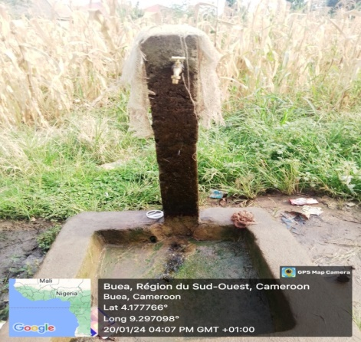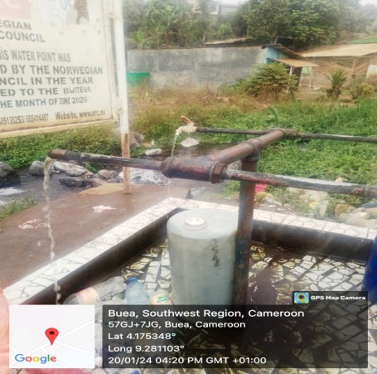

Plate 3: Community Tap (A) and Tap donated by an NGO (NRC) (B) (Bitingui)

Fieldwork (2024)

To ensure that communities have access to potable water, some NGOs have built taps in strategic areas in the Eastern Flank of Mount Cameroon (B). The capacity of beneficial communities in terms of water management and sanitation techniques has equally been improved upon via seminars and radio programs. They provide training and guidance on effective water conservation methods, efficient use of water resources, and sustainable sanitation solutions.

1. **Conclusion and Perspectives**

The Eastern Flank of Mount Cameroon is endowed with litany water catchments which if managed sustainably via proper land use planning options and management of water supply facilities, the yields will go a long way to improve the potable water challenges currently faced in the area. However, there is continuous human encroachment into the water catchment areas in the eastern flank of Mount Cameroon due to the increasing demand for food and fibre necessitating more intensive use of agricultural land. The increasing agricultural expansion, settlement expansion and deforestation create increasing erosion and sedimentation of water tanks contributing to increased overland flow and reducing the quantity of water storage in the water tanks. There is therefore a significant relationship between water catchments land uses and quantity of water yields. There is also a statistically significant relationship between water facilities and potable water supply to communities from harnessed water catchment. Despite several interventions and efforts from the community, stakeholders and NGO’s level to ensure the sustainability of water supply and avoid water catchment degradation in the Eastern Flank of Mount Cameroon through the enforcement of regulations, zero or minimum tillage and fencing of water catchments, land cover maps among others, there were limited. Thus, there is a need to improve on both catchment management (creation of buffer zones around catchments) and maintenance of water supply facilities to maintain a sound and healthy water system in the Eastern Flank of the Mount Cameroon.

**Disclaimer (Artificial intelligence)**

Option 1:

Author(s) hereby declare that NO generative AI technologies such as Large Language Models (ChatGPT, COPILOT, etc.) and text-to-image generators have been used during the writing or editing of this manuscript.

Option 2:

Author(s) hereby declare that generative AI technologies such as Large Language Models, etc. have been used during the writing or editing of manuscripts. This explanation will include the name, version, model, and source of the generative AI technology and as well as all input prompts provided to the generative AI technology

Details of the AI usage are given below:

1.

2.

3.

**REFERENCES**

Amawa, S.G. (2009). Stream Discharge, Seasonality and Variability along the Bamenda and Adamawa Highlands (Cameroon). *Journal of Applied social sciences*: Vol. 8. No. 1. Pp.89-120 University of Buea, Cameroon.

Endeley, R.E, Ayonghe, S.N & Tchuenteu, P. (2001). A preliminary hydro geochemical baseline study of water sources around mount Cameroon. *Journal of Cameroon Academy of Sciences* 1(3):127-185.

Kimengsi, J.N., Amawa, S.G. & Gwan, S.A. (2018). A Model for Sustainable Water Supply in Rural Communities: The case of Ekondo-Titi, Cameroon. *Sustainability in Environment* 3(1), 46-58

Kimengsi, J.N., Balgah, S.N. & Achia S. N (2017). Peri-Urban Land use Dynamics and Development Implications in the Bamenda III Municipality of Cameroon. Sustainability in Environment 2(3), 273-288

Lambi, C.M. (2010). The Environment and Development Frontier in Sub-Saharan Africa: Some Global Lessons: NAB Ventures Bamenda, Cameroon. ISBN: 9956-420-277

Nancy Fulai Chiaga, Jude Ndzifon Kimengsi and Balgah Sounders Nguh, (2019). «Catchment management and the sustainability of urban water supply. Evidence from Bamenda, Cameroon ». Canadian journal of tropical geography/Revue canadienne de géographie tropicale [Online], Vol. (6) 2. Online in December 25, 2019, pp. 1-8. URL: <http://laurentian.ca/cjtg>

Ndeh N Yvette., Godswill A. Asongwe, Kenneth Mbene, Christopher Ngosong, Norbert N. Fomenky, Irene B. Bame & Aaron S. Tening (2022), Pursuing development on the Eastern Flank of Mt Cameroon: Implications on its heavy metal status, environmental quality and human security *African Journal of Agricultural Research*, Vol. 18(9), pp. 730-741, September, 2022, DOI: 10.5897/AJAR2022.16063

Ndenecho, E.N. (2007) Upstream Water Resources Management Strategy and Stakeholder Participation: Lessons from the North Western Highlands of Cameroon, Unique printers Bamenda

Nformi, W. (2006) “Kumbo Water Crises: An Imminent Environmental Harzard”. In Focus on Kumbo, a publication of the Kumbo Urban Council, No 5, July to December 2006. Pp. 30-31

Nyambod, E (2010): Geographical Information Systems as a tool for participatory Land administrating matrix: Bamenda City, North West Region of Cameroon, Master thesis in Advanced studies in Human Ecology, VrijeUniversiteitBrusse

Pena, F. (2007): Water rights for Indigenous People in Northern Mexico”. In id 21 Natural Resources Highlights- Water (March 2007). Institute of Development Studies (IDS) England Petrella, R. (2009). Water in Africa, squandering a vital Resource. The courier No. 10 N.E- March April

Saipothong P., Preechapanya, P., Promduang, T; Kaewpota N. & Thomas, D.E (2006); “Community Based Watershed Monitoring and Management in Northern Thailand” In Mountain Research and Development, Vol.26, No. 3, August 2006, United Nations University Press New York. Pp.289-291

Usongo P A & Briyan A. (2021), An Assessment of the Spatio Temporal Dynamics of Potable Water Delivery for Water Resource Management on the South Eastern Flank of Mount Cameroon. Int J Environ Sci Nat Res. 2021; 28(3): 556236. DOI: [10.19080/IJESNR.2021.28.556236](http://dx.doi.org/10.19080/IJESNR.2021.28.556236)

Yerima BPK, Van Ranst E, Sertsu S, Verdoodt A (2013). Pedogenic Impacts on the Distribution of Total and Available Fe, Mn, Cu, Zn, Cd, Pb and Co Contents of Vertisols and Vertic Inceptisols of the Bale Mountain Area of Ethiopia. African Journal of Agricultural Research 8:5429-5439

Mukwada G, Mutana S. Surviving the limits imposed by a changing climate: the case of urban drought and water supply sustainability in Phuthaditjhaba. InSustainable Futures in Southern Africa’s Mountains: Multiple Perspectives on an Emerging City 2023 Jan 31 (pp. 75-89). Cham: Springer International Publishing.

Adams EA (2018) Thirsty slums in African cities: household water insecurity in urban informal settlements of Lilongwe, Malawi. Int J Water Resour Dev 34(6):869–887

Nerini FF, Sovacool B, Hughes N, Cozzi L, Cosgrave E, Howells M, Tavoni M, Tomei J, Zerriffi H, Milligan B (2019) Connecting climate action with other Sustainable Development Goals. Nature Sustainability 2(8):674–680. <https://doi.org/10.1038/s41893-019-0334-y>

Hurlimann A, Wilson E (2018) Sustainable urban water management under a changing climate: the role of spatial planning. Water 10(5):546. <https://doi.org/10.3390/w10050546>

Jaramillo P, Nazemi A (2018) Assessing urban water security under changing climate: challenges and ways forward. Sustain Cities Soc 41:907–918. https://doi.org/10.1016/j.scs.2017.04.005