Original Research Article

Evaluating the Impact of Green Visibility on Park Bench Utilization: A Case Study in Zhengzhou City, China

.

ABSTRACT

|  |
| --- |
| Green visibility, is an important index to measure the degree of green vegetation coverage in urban open space. This study takes different theme parks in Jinshui District of Zhengzhou City as the object, based on the green visibility index, and uses semantic segmentation technology and Citespass software to analyse the relationship between seat setting and green visibility. The results show that too high or too low green visibility is not suitable for setting seats, and a good green landscape can effectively attract tourists to stop and rest. Accordingly, optimisation suggestions are made: placing the seats in locations with open views and moderate shading, and adopting plant configurations that promote natural ventilation and changes in light and shadow, in order to enhance the aesthetics of the park and the practicality of the seats, to provide a more pleasant resting environment for the public, and at the same time, to provide references for the design of the seats in the scenic landscape parks. |

*Keywords:green visibility, seating, semantic segmentation, parks, green landscape*

1. INTRODUCTION

Green visibility[1], as a key indicator for evaluating the greening level of urban open space , is not only related to the improvement of urban ecological environment, but also profoundly affects the quality of daily life and physical and mental health of citizens [2-4].In modern urban planning and design, the importance of green visibility is becoming more and more prominent, and its optimisation strategies are widely used in the renovation and enhancement of public spaces[5] such as parks, streets[6] and squares.Seating, as an indispensable part of these public spaces, its design is not only about the comfort and experience of the users, but also the embodiment of urban culture and humanistic care.In recent years, with the improvement of people's living standards and the enhancement of health consciousness, the public demand for public space seats is no longer only satisfied with the basic rest function, but more attention to its harmonious symbiosis with the surrounding environment, as well as the psychological and physiological pleasure brought about by the appropriate evaluation added[7], but also to the surrounding environmental vitality.As one of the important factors affecting the experience of using the seats, the level of green visibility directly influences the degree of greenery, air quality and visual aesthetics of the surrounding environment of the seats, which in turn affects the length of stay and satisfaction of the public.To summarise the papers about green visibility on the Knowledge Network, six papers with a close relationship with green visibility were selected for display, and it was found that in the current study, the research on green visibility is mostly focused on street scene, urban green space, etc., and there is little relationship with seating at the park level.

Table 1. six papers with a close relationship with green visibility

|  |  |  |  |  |  |  |
| --- | --- | --- | --- | --- | --- | --- |
|  |  |  |  |  |  |  |
| **Author** | **Keyword 1** | **Keyword 2** | **Research target** | **Research technology** | **Certain year** | **Relationship to seat** |
| Liu Dandan | Urban greenery | AI | Nanjing | GIS | 2024.12 | None |
| Chen Hong | City centre | Street image | Xi'an main city | K-Means | 2024.12 | None |
| Sun Dong | Semantic segmentation | Regression model | Industrial zone | Regression model | 2024.11 | None |
| Gao Mengru | Green rating | Emotional benefits | Human emotions | VR | 2024.1 | None |
| Hou Rui | Green rating | Percentage of field of view | Courtyard house | Thermal comfort | 2024.6 | None |
| Wang Yuting | Street space | Street image | Historic district | Python | 2024.9 | None |

Therefore, this study aims to explore in depth the influence of green visibility on park seating design, and to analyse the situation of seating setup under different green visibility conditions, with a view to proposing a seating design strategy that is more in line with the needs of the public and enhances the quality of public space.By optimising the integration of the seats with the surrounding green landscape, it can not only enhance the rest quality of the public and provide an objective basis for landscape architects in designing the seats, but also promote the improvement of the urban ecological environment and realise the beautiful vision of harmonious coexistence between human beings and nature[8].

2. material and methods

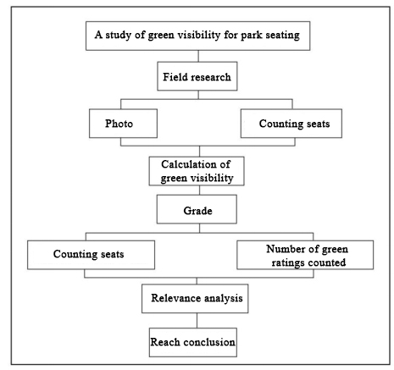

**Figure 1: Experimental design concept**

As shown in Figure 1, in the case of this study, we started by taking photographs to get the relevant information for analysis, used computers to process and analyse the data, and finally obtained the conclusions of the analysis.

**2.2 Selection of research subjects**

Taking Zhengzhou High Speed Rail Park as an example, the High Speed Rail Park is located in the central axis of Longhu and Longzihu sectors in Zhengdong New District, with an area of about 5,000 acres, and contains rich landscape elements and functional areas, such as cycling garden paths, landscape plazas, and children's playgrounds, etc., to provide a diverse spatial environment for research.It is an important part of the ecological corridor of Zhengdong New Area.The second and third theme parks (3 plots) of the four sections of the HSR Park were selected for the study (Figure 2).

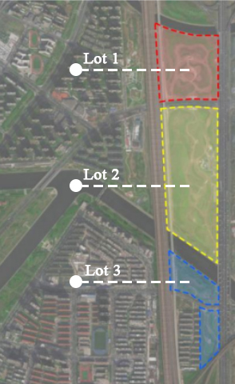

**Figure 2: Zhengzhou High-Speed Railway Park**

**2.3 Technical processes**

In this study, Python, Photoshop, Excel, Citespass[9] and other software were comprehensively used to realise the work procedure from field research photos - image semantic segmentation[10] - green visibility calculation - data statistics - correlation calculation.

**2.3.1 Data collection**

This study used field research to analyse data and statistics on the number of seats and the green visibility occupied by the seats in the selected objects.Firstly, the number of seats in the field is counted, and then based on the range of human vision (80-260 ° in the horizontal direction, 120 ° in the vertical direction) to the front, the left front, the right front of a total of three directions, to obtain the seat of the three-dimensional three-dimensional landscape under the space of the photographs, the collected photographs are screened and finally obtained a total of 341 effective photographs (the shooting mode is shown in Figure 3) .Green visibility reflects the level of visual perception of spatial greening from a human perspective, and its use as an evaluation index can be a good way to evaluate the amount of greening in a three-dimensional space.For example, in the study of the Baxianan district of Xi'an, it makes full use of the space, inserts greenery into the seams, enriches the green forms, etc., and improves the green quality of the street space by enhancing the green visibility rate, with a view to providing references for the future transformation of the historical block in the Baxianan district.

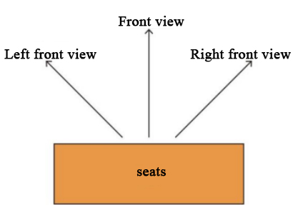

**Figure 3: Illustration of Photo Taking Method**

**2.3.2 Calculation of green visibility of seats**

In this study, for the calculation of the green visibility of the seats, the photos obtained from the field study were first semantically segmented, and subsequently the pixel ratio of the plants in each photo, i.e., the green visibility, was calculated.

**2.3.3 Semantic segmentation**

In this study, Deeplab v3 semantic segmentation[11] algorithm under Cityscape dataset is used to segment the acquired images in order to mainly segment six types of elements, namely, woods, grass, roads, buildings, sky, and people as shown in Figure 4 below.

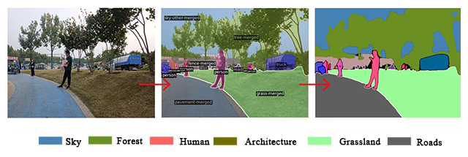

**Figure 4: Display of Six Elements of Semantic Segmentation**

**2.3.4 PS calculations**

$G=\frac{P_{p}}{P_{W}}$　　　　　 　（1）

Through Photoshop, the pixels of the woods and grass in the photos were firstly selected to be counted, and then the pixels of the whole photos were counted, and the data were imported into Excel to be calculated, and the green visibility of each photo was derived from the formula(1)Where G represents the green visibility, PP represents the pixels of the plants in the picture, and Pw represents the pixels of the whole picture. The specific results are shown in Table 2 and Table 3.

**Table 2 Green visibility in the second section of the theme park (Parcel 1 and Parcel 2)**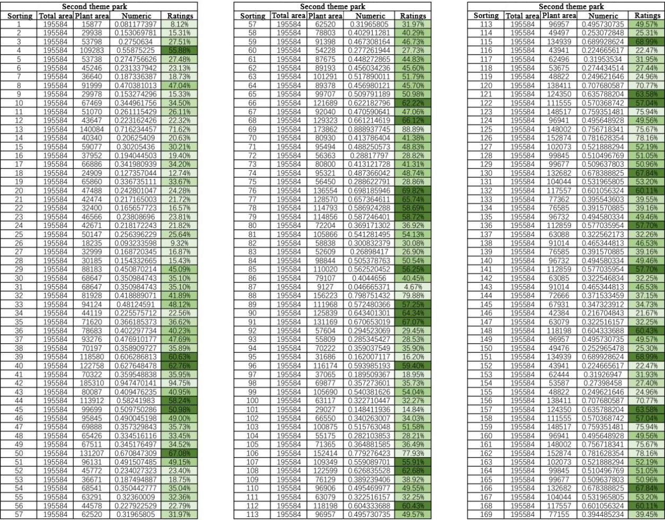

**Table 3 The third paragraph: Green View Rate of the Theme Park (Plot 3)**

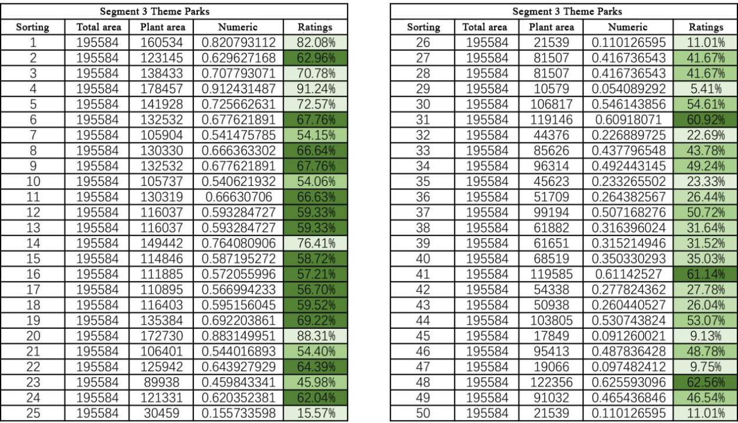

**2.4 Data Processing**

Classify the obtained data into green view rate levels according to the grading method where [0,25][70,100] is level one; [24,40] is level two; [40,55] is level three; and [55,70] is level four. Then, statistically analyze the number of green view rates and the number of seats within each green view rate level as shown in the figure (specific results are shown in Table 4, Figure 5, and Figure 6).

**Table 4** G**reen view rate level**

|  |  |  |  |  |
| --- | --- | --- | --- | --- |
|  | **Segment 2 Theme Park (Lots 1, 2)** | | **Segment III Theme Park (Lot 3)** | |
| Grade | Number of green ratings | Number of seats | Number of green ratings | Number of seats |
| 0-25 | 29 | 22 | 7 | 5 |
| 25-40 | 49 | 39 | 6 | 5 |
| 40-55 | 43 | 31 | 13 | 13 |
| 55-70 | 31 | 24 | 16 | 13 |
| 70-100 | 13 | 11 | 6 | 4 |

**Figure 5 and Figure 6: Line graphs of green view rate and number of seats in different theme parks**

**2.5 IBM SPSS data calculations**

IBM SPSS (Statistical Package for the Social Sciences) is used for dissertations mainly because of its powerful data analysis functions [8], intuitive data visualisation effects and wide range of application areas, which are features that make SPSS an indispensable and important tool in academic research.SPSS provides a wealth of statistical analysis methods, including descriptive statistics, correlation analysis, regression analysis, ANOVA, etc., which can meet the demand for in-depth analysis and mining of data in the thesis. Through SPSS, researchers can clean, screen and organise the collected data, as well as carry out various statistical analyses, so as to draw scientific and accurate conclusions. When performing correlation analysis, the arithmetic function of SPSS can be used to find the relationship between the two variables in this study.

3. results and discussion

**3.1 Corresponding Number of Seats for Different Levels of Green View Rate**



**Figure 7: Bar chart of different levels of green view rate and the number of seats**

The above figure shows the distribution of the number of green views and the number of chairs for two parcels (Parcel 1 and Parcel 2) in different green view intervals. Green visibility quantity 1 (Parcel 1): represented in orange, it shows the green visibility quantity of Parcel 1 in different green visibility intervals. It can be seen that the highest number of green views, close to 50, is reached in the 25-40 interval. Number of chairs 1 (parcel 1): indicated in green, shows the number of chairs in parcel 1 in different green visibility intervals. The number of chairs is also relatively high in the 25-40 interval, but slightly lower than the green visibility number. In terms of distributional trends, Parcel 1 has the highest concentration of green visibility and chair counts in the 25-40 interval, while Parcel 2 has the highest concentration of green visibility in the 55-70 interval and a higher concentration of chair counts in the 40-55 interval. Parcel 1 had significantly higher numbers of GVCs and chairs in the lower GVC intervals (0-25 and 25-40) than Parcel 2. Parcel 2 had relatively higher numbers of GVCs in the higher GVC intervals (55-70), but relatively lower numbers of chairs in all intervals.

**3.2 High or low Pearson correlation between green visibility and number of seats**

In practice, Pearson's correlation coefficient is widely used to measure the strength of the linear relationship between two continuous variables, for example, in the fields of social sciences, psychology, biology, economics and marketing to quantify the linear relationship between two continuous variables. Pearson's correlation coefficient has a value between -1 and 1, where: when the linear relationship between two variables is enhanced, the correlation coefficient tends to 1 or -1, and when the correlation coefficient is close to 0, it indicates that there is little or no linear relationship between the two variables. For the researched 0-25, 25-40, 40-55, 55-70, and 70-100 in IBM SPSS with 1, 2, 3, 4, and 5 substitutions, respectively, the Pearson's correlation of the researched two park plots was calculated and obtained as shown in the table below.

Table 5 Pearson correlation coefficient

|  |  |  |  |
| --- | --- | --- | --- |
|  |  |  |  |
| Strips | Pearson correlation coefficient | | Significance |
| Plot 1 | 0.992 | | ＜0.01 |
| Plot 2 | 0.969 | | 0.006 |

From the calculated data, it can be seen that the Pearson correlation coefficients for both plots are close to 1, indicating a strong linear relationship between the two variables, and therefore can be used as a reference standard for setting up seating in park environments where green visibility plays a role and can be the main influence on human perception.

**3.3 Fitting the data model**

|  |  |  |  |  |  |  |
| --- | --- | --- | --- | --- | --- | --- |
| **Table 6** | data modeling |  |  |  |  |  |
| **Level** | **Green view rate count 1** | **Green view rate count 2** | **Total number** | **Plot 1 seat count** | **Plot2 seat count** | **Total number** |
| 0-25 | 29 | 7 | 36 | 22 | 5 | 27 |
| 25-40 | 49 | 6 | 55 | 39 | 5 | 44 |
| 40-55 | 43 | 13 | 56 | 31 | 13 | 44 |
| 55-70 | 31 | 16 | 47 | 24 | 13 | 37 |
| 70-100 | 13 | 6 | 19 | 11 | 4 | 15 |

From 3.2, it can be seen that there is a very strong linear relationship between the number of green visibility and the number of seats investigated, so a mathematical model was fitted to both. The number of plots corresponding to different levels of green visibility and the number of seats in different plots were counted, with the number of different levels of green visibility as the independent variable and the total number of seats as the dependent variable, and a scatter plot was drawn, and it was found that as the number of sites corresponding to the corresponding level increased, the corresponding number of seats also increased. Linear fitting of the two yielded the following results as shown in Fig.



**Figure 8: Linear fitting results of green view rate count versus number of seats**

*ｙ＝ａ＋ｂｘ*　　　　　　　　　　　　　　　　　　　　　　　　　　　　　（2）

Where a is the intercept, b represents the slope of the number of set seating locations to the actual number of seats, x represents the number of green visibilities that satisfy each level, y represents the number of park seats that correspond to it, and R squared is 0.9968, which is close to 1 and represents a good fit.

4. Conclusion

Through the above analysis and statistics, the following conclusions were obtained:

(1) Among the researched park seats, the green visibility rate of geographic locations with more seats is concentrated in the range of 25%-55%, which indicates that it is not suitable to set up seats with too high or too low green visibility rate.

(2) The Pearson correlation coefficient test and mathematical simulation of the number of different levels of green visibility and the number of seats show a strong connection and linear relationship between the two, which provides a reference for future research on the design and arrangement of seats.

Based on these findings, this study proposes a series of recommendations for seating setup based on green visibility optimisation. These recommendations include placing the seats at locations with open views and moderately shaded by tree canopies, and adopting plant configurations that promote natural ventilation and light and shadow changes. These measures aim to enhance the aesthetics of the parks while improving the practicality and attractiveness of the seats, so as to create a more pleasant leisure environment for the public. This study provides landscape architects with an objective basis for seating design by thoroughly exploring the influence of green visibility on park seating design. At the same time, this study also provides a useful reference for the improvement of urban ecological environment and the realisation of the beautiful vision of harmonious coexistence between human and nature.Understanding how green visibility influences public seating preferences can help city planners and designers optimize urban open spaces for better psychological comfort and social engagement.In the future, we will continue to pay attention to the relationship between green visibility and the quality of public space, and explore more design strategies and methods based on green visibility optimisation.

COMPETING INTERESTS DISCLAIMER:

Authors have declared that they have no known competing financial interests OR non-financial interests OR personal relationships that could have appeared to influence the work reported in this paper.

**Disclaimer**

Author(s) hereby declare that NO generative AI technologies such as Large Language Models (ChatGPT, COPILOT, etc.) and text-to-image generators have been used during the writing or editing of this manuscript.

References

1. Zhang, J.; Shi, L. Spatial Intersection Analysis Based on the Choice of Streets, the Functionality Mixing Degree of Land Use and the Green Visibility Rate by Street Views—Taking the City Center in Shanghai as the Research Area. *Journal of Civil Engineering and Urban Planning* **2023**, *5*.

2. Yang, H.-M.; Wang, J.-Y.; Li, C.; Zhang, Y.-Q.; Wang, R.; Yang, Q.; Yao, Y.; Wang, Z.; Xu, S.-L.; Huang, H.-H.; et al. Is there an association between eye-level greenness and childhood hypertension using street view? Findings from the Seven Northeastern Cities study in China. *Environmental Research* **2025**, *268*, 120768, doi:<https://doi.org/10.1016/j.envres.2025.120768>.

3. Hu, H.; Zhou, H.; Cheng, J.; Shu, T. The effects of green apartment living, neighborhood greenspace exposures and greenspace exposures in activity space on residents’ walking behaviors and mental health in China. *Applied Geography* **2025**, *177*, 103545, doi:<https://doi.org/10.1016/j.apgeog.2025.103545>.

4. Niu, J.; Zhang, K.; Chen, J.; Qin, H.; Wei, X.; Huo, J.; Wu, H.; Han, G.; Yan, J. Interrelationships among physical activity, positive emotion, and thermal sensation in urban park green spaces: An empirical study in Chongqing, China. *Building and Environment* **2025**, *270*, 112567, doi:<https://doi.org/10.1016/j.buildenv.2025.112567>.

5. Ding, A.; Cenci, J.; Zhang, J. Links between the pandemic and urban green spaces, a perspective on spatial indices of landscape garden cities in China. *Sustainable Cities and Society* **2022**, *85*, 104046, doi:<https://doi.org/10.1016/j.scs.2022.104046>.

6. Navarrete-Hernandez, P.; Kiarostami, N.; Yang, D.; Ozcakir, A. Green Enough? A dose-response curve of the impact of street greenery levels and types on perceived happiness. *Landscape and Urban Planning* **2024**, *251*, 105130, doi:<https://doi.org/10.1016/j.landurbplan.2024.105130>.

7. Fu, H.; Guan, J.; Zhong, Q.; Fu, L.; Jian, Y.; Li, J. Landscape Elements, ecosystem services and users’ Happiness: An indicator framework for park management based on cognitive appraisal theory. *Ecological Indicators* **2024**, *165*, 112209, doi:<https://doi.org/10.1016/j.ecolind.2024.112209>.

8. Hung, S.-H.; Chang, C.-Y. Designing for harmony in urban green space: Linking the concepts of biophilic design, environmental Qi, restorative environment, and landscape preference. *Journal of Environmental Psychology* **2024**, *96*, 102294, doi:<https://doi.org/10.1016/j.jenvp.2024.102294>.

9. Li, H.; Xiang, Y.; Yang, W.; Lin, T.; Xiao, Q.; Zhang, G. Green roof development knowledge map: A review of visual analysis using CiteSpace and VOSviewer. *Heliyon* **2024**, *10*, e24958, doi:<https://doi.org/10.1016/j.heliyon.2024.e24958>.

10. Wang, Z.; Yi, J.; Chen, A.; Chen, L.; Lin, H.; Xu, K. Accurate semantic segmentation of very high-resolution remote sensing images considering feature state sequences: From benchmark datasets to urban applications. *ISPRS Journal of Photogrammetry and Remote Sensing* **2025**, *220*, 824-840, doi:<https://doi.org/10.1016/j.isprsjprs.2025.01.017>.

11. Aikoh, T.; Homma, R.; Abe, Y. Comparing conventional manual measurement of the green view index with modern automatic methods using google street view and semantic segmentation. *Urban Forestry & Urban Greening* **2023**, *80*, 127845, doi:<https://doi.org/10.1016/j.ufug.2023.127845>.