**Artificial Intelligence in Legal Practice: Opportunities, Challenges, and Future Directions**

**ABSTRACT**

Artificial intelligence (AI) refers to computer software and systems that do not just do tasks they have been programmed for in advance; they actually *learn* as they go, improving their performance through feedback. AI refers to inspiration of human intelligence processes by machines, particularly computer systems. AI has already begun to make its mark on various industries, and the legal profession is no exception. It is taking the legal world by storm and lawyers are embracing the change, despite their traditional resistance to technology. It is empowering legal professionals to exceed expectations, boost efficiency, enhance compliance, drive better decision-making, and improve client service. This paper discusses how and why corporate legal departments are embracing AI in their complex legal practice.

**Key Words:** artificial intelligence, AI, machine learning, ML, generative AI, law, legal practice

**INTRODUCTION**

“Artificial Intelligence (AI) refers to the development of computer systems that can perform tasks that typically require human intelligence, such as learning, reasoning, perception, and decision-making. AI means the ability to acquire and apply knowledge through man made device. The goal of AI is to create intelligent machines that can perform tasks more efficiently, accurately, and autonomously than humans. AI is increasingly becoming a part of real, everyday life. It is progressively entering into the legal profession, changing the way in which lawyers carry out their work and provide their legal services to clients. AI is transforming the legal industry for lawyers, the courtroom, consumers, education, and the future of law practice. Today, the team human + AI is the winning formula, and this statement is fully applicable to the legal profession, where artificial intelligence is not a substitute for lawyers but a very powerful and indispensable complement to increase their effectiveness. Figure 1 shows AI symbol” [1].

“Legal practice refers to works done primarily for the purpose of rendering legal advise or giving legal representation. The legal industry is experiencing a profound transformation driven by the rapid advancement of technology. Although the legal industry lags when it comes to embracing technology, AI is making its mark there too and there is no turning back. However, in the United States, courts seems more far ahead in technology adoption, as the US legal systems are heavily dependent on case law. From automating contract review and analysis to predicting litigation outcomes, AI is reshaping the legal landscape for the better. AI helps lawyers do their legal workload faster and saves them time” [2].

**WHAT IS ARTIFICIAL INTELLENCE?**

“The term “artificial intelligence” (AI) is an umbrella term John McCarthy, a computer scientist, coined in 1955 and de­fined as “the science and engineering of in­telligent machines.” It refers to the ability of a computer system to perform human tasks (such as thinking and learning) that usually can only be accomplished using human intelligence” [3]. Typically, AI systems demonstrate at least some of the following human behaviors: planning, learning, reasoning, problem solving, knowledge representation, perception, speech recognition, decision-making, language translation, motion, manipulation, intelligence, and creativity.

The [10 U.S. Code § 2358](https://www.law.cornell.edu/uscode/text/10) define artificial intelligence as [4]:

1. “Any artificial system that performs tasks under varying and unpredictable circumstances without significant human oversight, or that can learn from experience and improve performance when exposed to data sets.
2. An artificial system developed in computer software, physical hardware, or other context that solves tasks requiring human-like perception, cognition, planning, learning, communication, or physical action.
3. An artificial system designed to think or act like a human, including cognitive architectures and neural networks.
4. A set of techniques, including machine learning, that is designed to approximate a cognitive task.
5. An artificial system designed to act rationally, including an intelligent software agent or embodied robot that achieves goals using perception, planning, reasoning, learning, communicating, decision making, and acting.”

AI provides tools creating intelligent machines which can behave like humans, think like humans, and make decisions like humans. The main goals of artificial intelligence are [5]:

1. Replicate human intelligence
2. Solve knowledge-intensive tasks
3. Make an intelligent connection of perception and action
4. Build a machine which can perform tasks that requires human intelligence
5. Create some system which can exhibit intelligent behavior, learn new things by itself, demonstrate, explain, and can advise to its user.

“AI is not a single technology but a range of computational models and algorithms. The concept of AI is an umbrella term that encompasses many different technologies. AI is not a single technology but a collection of techniques that enables computer systems to perform tasks that would otherwise require human intelligence. The major disciplines in AI include” [6][25]:

* *Expert systems*
* *Fuzzy logic*
* *Neural networks*
* *Machine learning (ML)*
* *Deep learning*
* *Natural Language Processors (NLP)*
* *Robots*

These computer-based tools or technologies have been used to achieve AI’s goals. Each AI tool has its own advantages. Using a combination of these models, rather than a single model, is recommended. Figure 2 shows a typical expert system, while Figure 3 illustrates the AI tools. These tools are gaining momentum across every industry. Analytics can be considered a core AI capability.

**GENERATIVE AI**

“Artificial Intelligence (AI) is increasingly a part of our world and it is rapidly changing our lives. Generative AI (GenAI) is a subset of [artificial intelligence](https://en.wikipedia.org/wiki/Artificial_intelligence) that uses [generative models](https://en.wikipedia.org/wiki/Generative_model) to produce text, images, videos, or other forms of data. Generative AI (GenAI) is a term for any type of AI system capable of using generative models to create new forms of humanlike creative content, like text, images, music, audio, video and more.  GenAI models include various algorithms able to learn the various patterns and structures of input training data before generating novel outputs with similar characteristics. It is essentially a narrow type and application of the broader artificial intelligence umbrella of technologies. It describes algorithms (such as ChatGPT) that can be used to create new content, including audio, code, images, text, simulations, and videos. It is specifically designed and trained to generate new content. The versatility and potential of GenAI to transform various aspects of business operations make it an attractive investment for companies across industries. GenAI uses neural networks, machine learning, deep learning models, complex algorithms, and large and varied training datasets to produce original content based on user input and how to reason in ways akin to a human brain. The technology is built on AI tools shown in Figure 4” [7]. It uses neural networks to identify the patterns and structures within existing data to generate new and original content.

“Generative AI can be thought of as a machine-learning model that is trained to create new data, rather than making a prediction about a specific dataset. Since its inception, the field of [machine learning](https://en.wikipedia.org/wiki/Machine_learning) used both [discriminative models](https://en.wikipedia.org/wiki/Discriminative_model) and [generative models](https://en.wikipedia.org/wiki/Generative_model), to model and predict data. A generative AI system is constructed by applying [unsupervised machine learning](https://en.wikipedia.org/wiki/Unsupervised_learning) or [self-supervised](https://en.wikipedia.org/wiki/Self-supervised_learning) machine learning to a data set. The most common way to train a generative AI model is to use supervised learning. Generative AI can also be trained on the motions of a [robotic](https://en.wikipedia.org/wiki/Robotic) system to generate new trajectories for [motion planning](https://en.wikipedia.org/wiki/Motion_planning) or [navigation](https://en.wikipedia.org/wiki/Robot_navigation). Generative AI models are used to power [chatbot](https://en.wikipedia.org/wiki/Chatbot) products such as [ChatGPT](https://en.wikipedia.org/wiki/ChatGPT" \o "ChatGPT)” [8].

GenAI has the potential to change — in some cases radically — how legal professionals do their jobs in the years to come. Law firms using GenAI systems are already posting greater efficiencies in legal research and document management. AI (GenAI) assistants will become indispensable to practically every lawyer. Many professionals including those working in court systems may think of GenAI as public-facing tools like ChatGPT.

**AI IN LEGAL PRACTICE**

Over the past few years, legal professionals have become less wary of artificial intelligence. Figure 5 shows some legal professionals [9]. They are increasingly embracing AI as a transformative force, becoming more and more optimistic about [the positive impact](https://www.thomsonreuters.com/en/insights/articles/benefits-of-artificial-intelligence-ai.html) it can have on legal practices. Imagine a world where legal professionals can sift through mountains of case law in seconds, predict the outcomes of trials with remarkable accuracy, and automate tedious contract reviews—all thanks to artificial intelligence.

The legal industry is undergoing a profound transformation driven by advancements in technology, particularly with the rise of artificial lawyers—AI-powered systems that perform tasks traditionally handled by human lawyers. “In recent years, related technological advances have allowed legal teams to automate or expedite work that has traditionally been done by entry-level colleagues. Today, some lawyers use AI to automate routine tasks such as [contract review](https://pro.bloomberglaw.com/insights/transactions/guide-to-legal-contract-management/), research, and generative legal writing. Figure 6 represents legal practice” [10], while Figure 7 represents AI in legal practice [11].

Legal work, well known for its long hours and heavy workloads, is being revolutionized by [artificial intelligence](https://builtin.com/artificial-intelligence), specifically [generative AI](https://builtin.com/artificial-intelligence/generative-ai). Artificial intelligence improves the efficiency of legal work by way of automation. From streamlining legal research and enhancing contract management to employing predictive analytics and revolutionizing e-discovery, AI tools are reshaping how law firms operate, making processes faster, more accurate, and highly efficient. AI tools can now handle the endless reading, summarizing, creating, and filing of documents ordinarily relegated to junior attorneys or paralegals. The tools are already being leveraged in several legal practices, including [12]:

* Due Diligence
* Prediction Analytics
* Contract Analysis
* Contract Review
* Legal Document Generation
* e-discovery
* Legal Research
* Contract Negotiation
* Document management
* Deep analytics insights
* Customer service
* Language analytics
* Dispute resolution

**APPLICATIONS OF AI IN LEGAL PRACTICE**

“AI has been successfully applied in various sectors such as education, healthcare, finance, manufacturing, and transportation, where it has make significant improvements in efficiency, cost reduction, and the development of innovative products and services”[25]. The technology can be used to assist in legal research, perform contract analysis, and even generate contracts, agreement, and other legal documents. The primary areas where AI is being applied in the law include review of documents, legal research, legal education, contract and legal document analysis, proofreading, document generation, and more. Some of these areas are covered here [13-15]:

* *Intellectual Property:* “This encompasses a broad spectrum of intangible assets, including patents, copyrights, trademarks, and trade secrets. AI has become a game changer across various sectors, and intellectual property (IP) law is no exception. The convergence of IP and AI presents both [unparalleled opportunities and unique challenges for businesses across industries](https://www.beneschlaw.com/resources/ai-and-ip-leveraging-opportunities-for-your-business.html). The legal challenges the new technology presents are formidable, particularly at the intersection of AI and intellectual property. The use of proprietary material in training AI systems and the potential exposure of confidential information pose significant risks”.[25]
* *Copyright:* “Copyright law protects original works of authorship, such as literary, artistic, and musical works. Copyrights are a form of intellectual property protected by federal law. Owning a copyright gives the owner the exclusive right to reproduce, publish, or sell an original work of authorship, such as a book, a painting, or a song. Although copyright law does not specifically address artificial intelligence, protection under the Copyright Act must meet the following requirements: (1) an original work of authorship; (2) fixed in a tangible medium; (3) that has a minimal amount of creativity. Any work that does not meet the three requirements does not qualify for copyright protection. Since machine-created work may not need the criteria for copyright protection, ownership may not be clearly distinguished. A lawyer advising an AI company will need to develop new law and provide recommendations about how the law will be applied to issues of copyright infringement”.[25]
* *AI-generated Art:* “Artists using traditional mediums, such as paint, pen, or paper, are considered the authors of the work and generally hold copyright over their work by default. The fundamental question before addressing AI-created art is whether copyright can belong to anyone other than a human being. Figure 8 shows a typical AI-generated art. It is safe to state that artificial intelligence generated art is here to stay. So once an AI-generated masterpiece is created, what stops someone from claiming it as their own and using it commercially or preventing others from using it? On top of existentially threatening the very concept of artists and creatives, AI-generated content raises several new legal issues. Ultimately humans are the ones that make the final decision to use art generated by a machine and AI clearly cannot grant permission for use of the work or hold a copyright”. [16].
* *Patent:* A [patent](https://acuraip.com/what-is-a-patent/) grants its owner the exclusive right to exclude others from making, using, selling, and importing an invention for a limited period, usually 20 years from the filing date. The patent world is discussing whether an AI can be listed as an “inventor” on a patent application. It is not beyond imagination that Artificial General Intelligence may find its way as a “legal person” or may have laws specifically drafted for its regulation and ownership in the near future.
* *Trade Secrets:* These encompass confidential information that provides a competitive advantage to its owner. AI technologies, such as machine learning models, training data, and algorithms, may be considered trade secrets if they meet the necessary requirements of confidentiality, economic value, and reasonable efforts to maintain secrecy.

* *Contracts:* “Contracts serve as the backbone of our economic structure; they are indispensable for any business transaction. However, the whole procedure of mediating and yet the process of negotiating and settling a contract is a hassle. Administering the signing of the contract, overseeing and supervising it can prove to be a pain.  The lawyers from both parties are required to manually inspect, refine, and swap red-lined documents in a repetitive manner. This whole process provides huge potential for automation. AI-based solutions are helping legal teams offload the mundane aspects of reviewing and redlining contracts so that they can focus on more high-impact work. AI can be used to automate the drafting and review of contracts, as well as to identify potential issues and inconsistencies. ChatGPT can assist in writing legal documents such as contracts and it is also used for legal translation” [16].
* *Chatbots:* “AI-powered chatbots are already streamlining the intake and triage of legal requests. Bots can prove to be highly effective in offering legal help and in providing the masses with easy access to services.  A lawyer bot is basically software that has the capacity of carrying out automated tasks which generally get performed by lawyers. These bots are useful for boosting the speed of the work and in offering an enhanced experience by enabling the clients to self-serve themselves online” [15].
* *Due Diligence:* “Uncovering background information through the due diligence process is another time-consuming process that legal practitioners spend their time on. The AI-powered platforms can assist in accelerating the process and in cutting down time. Acceleration of the due diligence process would have a considerable impact since it would aid in verifying current figures as well as facts from the prior cases. The due diligence procedure is generally a hassle for humans and AI would play a massive role in boosting the accuracy. AI-powered tools can quickly analyze and categorize large volumes of documents, which can be especially helpful in the discovery phase of litigation and during due diligence processes. Legal professionals who wish to perform due diligence on the use of AI in their practices need to do so [thoughtfully and rigorously](https://www.thomsonreuters.com/en/insights/articles/7-questions-to-consider-before-using-genai-in-your-work.html)” [14].
* *Legal Document Review:* “Legal document review is a tedious and time-consuming task, but AI systems have revolutionized this process. Generative AI systems, utilizing natural language processing, are now capable of understanding and responding to plain English questions. Using AI for document review can significantly reduce the time and effort required to determine document relevance and legal privilege. It guarantees that all documents undergo thorough review and comply with pertinent regulations. Figure 9 represents AI in legal document review” [17].
* *Predictive Analytics:* “Predictive analytics is transforming strategic planning in the legal industry. By analyzing historical legal data, case precedents, and other relevant factors, machine learning models can forecast litigation outcomes and inform strategic decisions. Predictive analytics can also aid in filing motions by analyzing historical data from similar cases, court rulings, and judge-specific trends to forecast the likelihood of a motion being granted or denied. Figure 10 shows a typical court setting” [17].
* *Legal Research:* “Legal research is one of the most important aspects of the legal practice. Before the advent of artificial intelligence, lawyers have to spend days or hours researching cases and flipping through the volumes of books when making legal research. AI systems have the capacity to search and analyze vast amounts of legal information in a fraction of the time it takes a human. As these tools become more accurate and efficient, traditional legal research roles may be replaced by AI-driven solutions. As law schools try to meet the demands of a booming industry, the focus on applied research in AI and emerging technologies is also expanding” [13].
* *Legal Education:* “AI is making its mark on legal education. Many law schools and professors are proactively incorporating AI into the classroom. Law school curriculums will need to keep pace with changes in technology law, ethics, and data science.  Law schools are integrating AI into their curricula, offering courses on AI ethics, data science, and technology law. These curriculum changes ensure that future lawyers are equipped with the skills needed to navigate the evolving legal landscape. Law schools are also updating their academic integrity policies to address the influence of generative AI” [12].

**BENEFITS**

“Lawyers play a critical role in upholding the rule of law and maintaining a just society. Artificial intelligence plays a very significant role in the modern legal practice. AI empowers lawyers to do their job better, faster, and smarter. Advances in AI will change the nature of legal work for lawyers, helping to make them more effective and efficient.

Artificial intelligence for lawyers automates routine tasks, enhances efficiency, and minimizes errors. Along with overtaking paperwork and handling of data, it is also aiding the industry towards becoming more consumer-centric.  Other benefits of AI in law include” [11,12]:

* *AI Saves Time:* The biggest, most obvious benefit to AI applications is time savings. Computer systems can analyze more information, more thoroughly than humans can, in a tiny fraction of the time. This benefit applies to all types of AI applications. Computers can quickly search through and identify discoverable or potentially relevant data of all forms and file types. Obviously, those time savings can translate into monetary savings, since less attorney or staff time is involved in finding answers and identifying mistakes.
* *Automation:* “Automation refers to technologies that use rules to carry out tasks. AI is changing the way legal services are provided by automating repetitive tasks, streamlining document management and location, processing a tremendous amount of information and refining contract review. AI technology in the legal field automates many of the repetitive duties that keep attorneys at the office until late in the night, creating all-too-common burnout” [17].
* *Streamlining Legal Processes:* We all know that a lawyer’s time is valuable…and expensive. Finding ways to save time in the legal industry, yet remain accurate and compliant, is critical. Law practices can be streamlined through automation and introduce an AI solution to help. AI will assist with and accelerate critical parts of legal services, including comprehensive document review, exhausting proofreading and rigorous legal research.
* *Quality Assurance in Legal Documentation*: “Leveraging AI for quality assurance and legal reviews is becoming more and more necessary as it meticulously reads and summarizes relevant documents and then discloses any discrepancies or inaccurate data findings. It will locate specific clauses, potential risks or obligations associated with the company instantly, saving time, effort, and energy” [14].
* *Strategic Decision-Making*: “Human judgment and human expertise will always be necessary in the area of legal practices. No matter how smart machine learning, AI algorithms, and AI tools are, the legal profession still relies on humans to uphold ethical standards, share valuable insights and perform strategic work. Using similar case law and having concrete data that highlights those outcomes, legal professionals can form new strategies or change existing strategies that will likely yield positive conclusions” [13]
* *Reducing Workload and Stress*: AI not only alleviates redundant, time-consuming in-house staff workload, it ultimately plays a role in creating higher job satisfaction, reducing attorney stress, and minimizing work frustration. By allowing AI to perform administrative tasks and offer support in drafting, document analysis, and more, a legal professional can focus their time on higher-value, strategic duties that utilize their trained legal expertise.
* *Enhancing In-House Client Service*: “When legal professionals are forced to focus their time staring at endless documents and data, client phone calls go unanswered, emails get ignored, and clients are left feeling unimportant. AI enables in-house lawyers to focus more on strategic legal advising and less on mundane tasks, which improve service for internal and external clients. Less time spent on low-level, monotonous responsibilities means attorneys have time and opportunity to engage more in human-specific activities. AI also equips legal teams with better information and legal research, helping build better cases, yielding positive results, and ultimately makes their clients happy” [12].
* *Reducing Litigation Costs:* Proponents of legal AI have pointed out that the technology has the potential to provide greater access to justice for litigants with limited resources. Because machine learning can help lawyers speed up the due diligence process by analyzing cases more efficiently, this decreases the risk that litigation funders need to take.
* *Increased Efficiency:* “AI is quickly becoming a necessary tool to stay competitive in today’s legal industry, especially when it comes to legal research, one of the most time-consuming tasks that legal professionals are forced to do with nearly every case. AI assists lawyers by finding the authoritative sources and can even rank them by relevance. It can extract key information, provide a summary of each document, or compare the documents according to specified data. Artificial lawyers can handle repetitive tasks such as document review, legal research, and contract analysis more quickly and accurately than humans. They can also operate round the clock without breaks, providing continuous support, and reducing turnaround times” [11].
* *Cost Reduction:* Firms can save on labor costs by employing robot lawyers for tasks that would otherwise require human paralegals or junior associates. Reduced costs can make legal services more accessible to individuals and small businesses who might not afford traditional legal assistance.

**CHALLENGES**

“Unfortunately, AI can also negatively impact the legal field. For example, AI’s ability to create deep fake technology can spread harmful misinformation and disinformation. This is especially a concern for lawyers who work in intellectual property law. AI is not going to complete the whole process of filing a statement of claim without human input and checks. Lawyers must navigate issues such as algorithmic bias, hallucinations, and confidentiality concerns when using AI in their practice. The use of AI in legal practice raises unprecedented legal questions that require new rules and thoughtful navigation. Other challenges of AI in law practice include the following” [11,18]:

* *Data Privacy*: With AI tools processing sensitive legal documents, data security and compliance are paramount. Clients demand confidentiality, and breaches can lead to severe repercussions. It is important to have robust cybersecurity measures that ensure AI applications align with ethical and regulatory standards.
* *Ethical Concern*: “Many legal professionals have reported being concerned that GenAI usage could put them or their firms in violation of ethical and professional codes of conduct. Currently, there are no clear industry-wide and fully-agreed-upon guidelines as to how to proceed. What lawyers have to do at present is monitor developments from the state to international level to get a sense of how ethical codes of conduct are evolving in the AI era. It may come down to each law firm creating its own ethical playbook for using GenAI” [12].
* *Risks:* “The use of AI in handling sensitive legal information increases the risk of data breaches and cyberattacks. Ensuring the confidentiality of client information managed by artificial lawyers is critical and can be challenging. Using AI-based models carry a substantial degree of risk. The main risks identified are taking away jobs, vulnerable to cyber-attacks, economic constraints, untrained lawyers, IP rights, privacy and data protection and ethical issues. While it is important to move forward, it is no less important to do so in a safe, ethical, and sustainable way. Lawyers are required to protect all client information from both intentional and inadvertent disclosure. A key ethical duty that lawyers have is ensuring that the use of AI solutions does not pose a risk to their duty to preserve client confidentiality and to maintain the attorney-client privilege” [13].
* *Skills Gap:* Adopting AI requires tech-savvy lawyers, yet not all professionals possess the necessary skills. This “skills gap” challenges firms seeking seamless AI adoption. Training programs are essential to bridge this digital divide, ensuring lawyers are equipped to work alongside AI tools.
* *Job Replacement:* “As AI disrupts the legal profession, it raises questions about who, or what, can be a lawyer. Maybe AI will not replace all lawyers outright. But it can still provide sound legal advice. Anybody, any entity, can provide legal information, including AI systems. As artificial intelligence approaches the bar, human lawyers will not be sent back to the bench just yet. AI does not understand that nuance, and could draw conclusions that may not produce the best result for a client. There are still many aspects of the legal profession that no amount of AI development would likely be able to automate or replace. The future of lawyering is not about the wholesale replacement of lawyers by AI. Instead, it is about the emergence of a symbiotic relationship, where AI augments human capabilities, empowers more informed decision-making, and frees lawyers to focus on the higher-order aspects of legal practice. The automation of routine tasks may lead to fewer job opportunities for paralegals and junior lawyers” [14].
* *Regulations:* For centuries, regulations of the legal profession have made it clear there cannot be an engagement in legal practice by unqualified entities. In other words, the practice of law is limited to those admitted as licensed legal practitioners in the jurisdiction. AI does not have to comply with ethical responsibilities like a duty to act in the client’s best interest that sets lawyers apart.

**CONCLUSION**

[Artificial intelligence (AI)](https://www.analyticssteps.com/blogs/what-artificial-intelligence-types-uses-and-how-it-works) has been paving its way towards emerging as the backbone factor in the legal profession. The changes brought by the use of AI tools impact the foundational principles of the duties governing the legal profession, and the rights of clients and citizens. There is clearly great promise in what AI tools can and will do to support legal professionals in their work. Although AI technology still remains in the initial stage, it has the potential of unleashing significant opportunities to revolutionize and rejuvenate the law industry in the near future. Empowered by technology, lawyers are more productive, allowing more legal matters to be represented around the world.

It is evident that AI is impacting the legal profession, and this technology is here to stay. AI will create new opportunities for the legal profession. The future of legal practice has never looked brighter. Some law schools are increasingly [incorporating AI into their curriculums](https://www.reuters.com/legal/transactional/law-schools-boost-their-ai-offerings-industry-booms-2024-06-18/) in order to prepare lawyers for using AI in their practices and advising clients on AI-related matters. More information on artificial intelligence in law practice industry is available from the books in [19-24] and the following related journals:

* *The AI Journal*
* *AI Magazine*
* *Energy and AI*
* *Journal of Intelligence*
* *[Artificial Intelligence and Law](https://link.springer.com/journal/10506)*
* *Journal of Digital Technologies and Law*

Disclaimer (Artificial intelligence)

Author(s) hereby declare that generative AI technologies such as Large Language Models, etc. have been used during the writing or editing of manuscripts. This explanation will include the name, version, model, and source of the generative AI technology and as well as all input prompts provided to the generative AI technology

Details of the AI usage are given below:

1. **AI Tool Used:** ChatGPT (GPT-4)

**Version & Model:** OpenAI GPT-4 (March 2025 version)

**Source:** OpenAI (<https://openai.com/>)

**Nature of AI Assistance:**

1. **Content Refinement** – AI was used to improve sentence structure, grammar, and readability while maintaining the original meaning.
2. **Summarization & Expansion** – AI assisted in summarizing research findings and expanding on key discussion points.
3. **Reference Formatting** – AI provided assistance in structuring and formatting citations but did not generate original references.
4. **Proofreading & Clarity Checks** – AI was used to enhance clarity, coherence, and academic tone.

**REFERENCES**

[1] “The rise of artificial intelligence in construction industry,” June 2022,

https://gharpedia.com/blog/artificial-intelligence-in-construction/

[2] D. Thakore, “How artificial intelligence (AI) revolutionizes legal practice — it is the future of law,” July 2023,

https://medium.com/the-generator/how-artificial-intelligence-ai-revolutionizes-legal-practice-it-is-the-future-of-law-e628eac11775

[3] M. N. O. Sadiku, “Artificial intelligence,” *IEEE Potentials,* May 1989, pp. 35-39.

[4] “Artificial intelligence (AI),”

<https://www.law.cornell.edu/wex/artificial_intelligence_(ai)>

[5] “Artificial intelligence tutorial,”

https://www.javatpoint.com/artificial-intelligence-tutorial

[6] [D. Quinby](https://www.phocuswright.com/Analysts/Douglas-Quinby), “Artificial intelligence and the future of travel,” May 2017,

https://www.phocuswright.com/Travel-Research/Research-Updates/2017/Artificial-Intelligence-and-the-Future-of-Travel

[7] “Generative AI explainer,” Unknown Source.

[8] M. N. O. Sadiku, P. A. Adekunte, and J. O. Sadiku, “Generative artificial intelligence,” *International Journal of Trend in Scientific Research and Development,* vol. 8, no. 6, November-December 2024, pp. 561-570.

[9] “The role of AI in modern legal practice,” August 2024,

https://copymate.app/blog/the-role-of-ai-in-modern-legal-practice/

[10] D. Faggella, “AI in law and legal practice – A comprehensive view of 35 current applications,” September 2021,

https://emerj.com/ai-in-law-legal-practice-current-applications/

[11] “Artificial lawyers: The future of legal practice or just a myth?” July 2024,

https://www.runsensible.com/blog/artificial-lawyers-legal-practice/

[12] J. Levine, “ 7 Benefits of AI in the legal industry,” May 2024,

https://contractpodai.com/news/ai-benefits-legal/

[13] M. N. O. Sadiku, P. O. Adebo, and J. O. Sadiku, “Artificial intelligence law: An overview,” *International Journal of Trend in Research and Development,* vol. 13, no. 3, May-June 2024, pp. 38-42.

[14] A. Mathur, “Art-istic or art-ificial? Ownership and copyright concerns in AI-generated artwork,” November

https://itsartlaw.org/2022/11/21/artistic-or-artificial-ai/

[15] G. Mukundan, “Intersection of artificial intelligence and intellectual property laws,” April 2023,

https://acuraip.com/the-intersection-of-artificial-intelligence-and-intellectual-property-law/

[16] https://writesonic.com/photosonic-ai-art-generator

[17] A. Olsen, “Transforming legal practice: How artificial intelligence for lawyers is changing the field,” August 2024,

https://iplawusa.com/transforming-legal-practice-how-artificial-intelligence-for-lawyers-is-changing-the-field/#:~:text=Artificial%20intelligence%20is%20revolutionizing%20the,tasks%20more%20swiftly%20and%20accurately.

[18] “AI in legal practice: Balancing efficiency and employment,” December 10, 2024,

https://quantilus.com/article/ai-in-legal-practice-balancing-efficiency-and-employment/

[19] M. N. O. Sadiku, S. M. Musa, and S. R. Nelatury, *Applications of Artificial Intelligence*. Sherida, NY: Gotham Books, 2022.

[20] M. N. O. Sadiku, *Law in the Digital Age.* Las Vegas, NV: Book Films Media, 2024.

[21] [B. Custers](https://www.amazon.com/s/ref=dp_byline_sr_book_1?ie=UTF8&field-author=Bart+Custers&text=Bart+Custers&sort=relevancerank&search-alias=books) and [E. Fosch-Villaronga](https://www.amazon.com/s/ref=dp_byline_sr_book_2?ie=UTF8&field-author=Eduard+Fosch-Villaronga&text=Eduard+Fosch-Villaronga&sort=relevancerank&search-alias=books) (eds.), *Law and Artificial Intelligence: Regulating AI and Applying AI in Legal Practice (Information Technology and Law Series, 35).* T.M.C. Asser Press, 2022.

[22] K. D. Ashley, *Artificial Intelligence and Legal Analytics: New Tools for Law Practice in the Digital Age.* Cambridge University Press, 2017.

[23] [H. Arora](https://www.amazon.com/s/ref=dp_byline_sr_book_1?ie=UTF8&field-author=Himanshu+Arora&text=Himanshu+Arora&sort=relevancerank&search-alias=books), *Artificial Intelligence in Law Enforcement: Use-Cases, Impact on Fundamental Rights and Ethical Reflections.* Eliva Press, 2023.

[24]  [N. Waisberg](https://www.google.com/search?sca_esv=1635c2d40717c99f&hl=en&sxsrf=AHTn8zq4PYzL5i4zD8JyVSHRoNyGMfbfjw:1742067360307&q=inauthor:%22Noah+Waisberg%22&udm=36) and [A. Hudek](https://www.google.com/search?sca_esv=1635c2d40717c99f&hl=en&sxsrf=AHTn8zq4PYzL5i4zD8JyVSHRoNyGMfbfjw:1742067360307&q=inauthor:%22Alexander+Hudek%22&udm=36), *AI For Lawyers: How Artificial Intelligence is Adding Value, Amplifying Expertise, and Transforming Careers.* Wiley, 2021.

**[25]** Matthew N. O. Sadiku, Philip O. Adebo and Janet O. Sadiku(2025): Artificial Intelligence in the Construction Industry: International Journal of Trend in Research and Development: 12(1): 2394-9333



Figure 1 AI symbol [1].

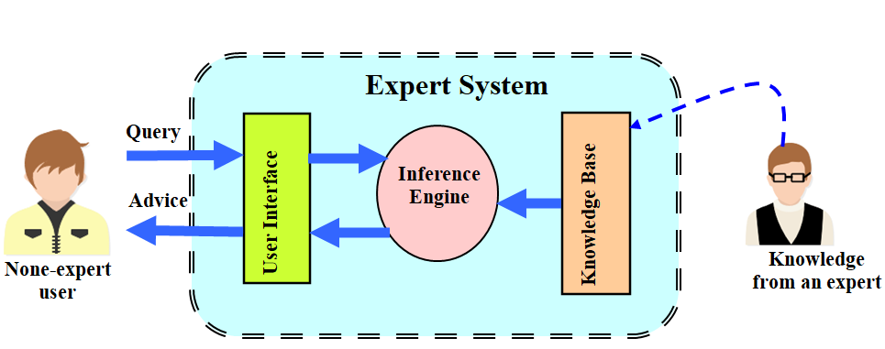

Figure 2 A typical expert system.

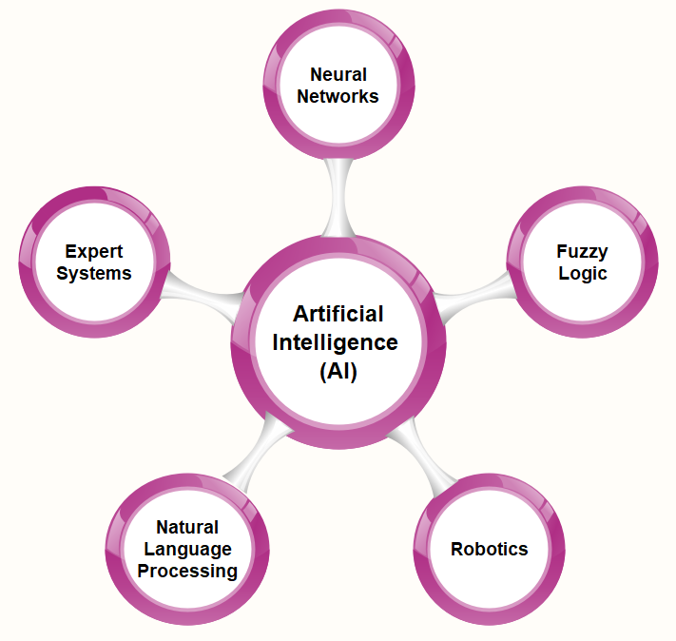

Figure 3 AI tools.

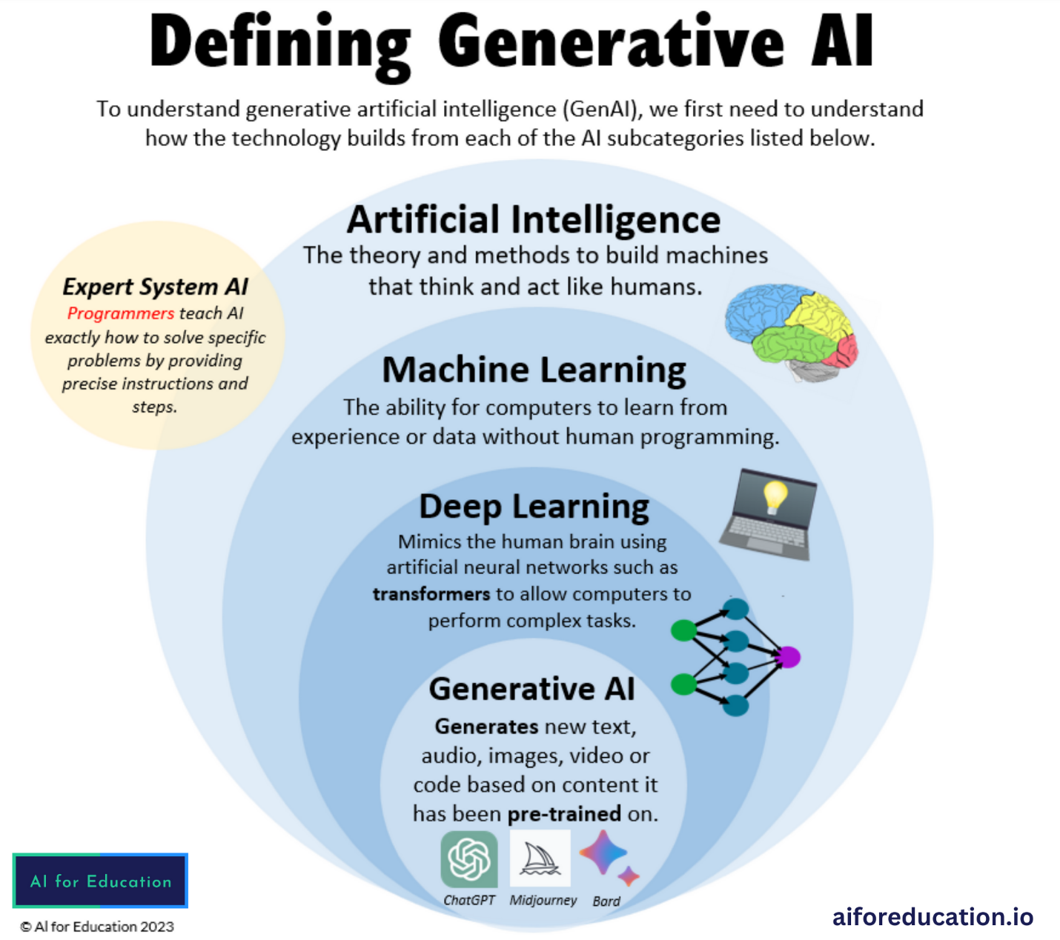

Figure 4 GenAI built on AI tools listed above [7].



Figure 5 Some legal professionals [9].



Figure 6 Representation of the legal practice [10].

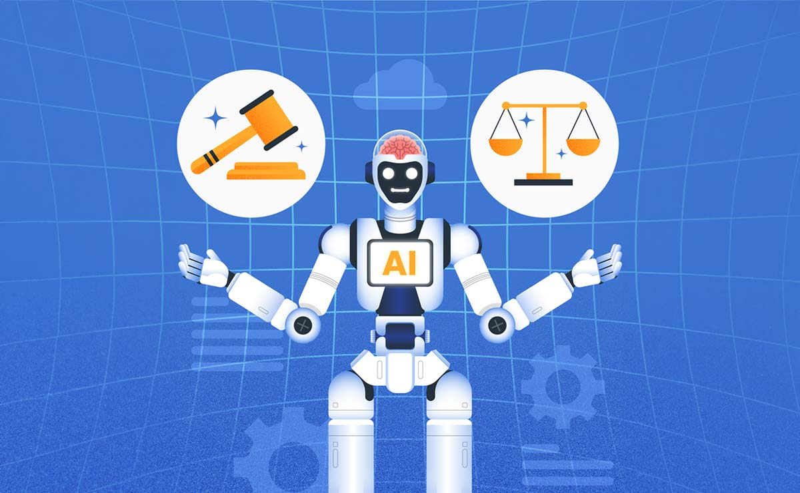

Figure 7 Representation of AI in legal practice [11].



Figure 8 AI-generated art [16].



Figure 9 Representation of AI in legal document review [17].

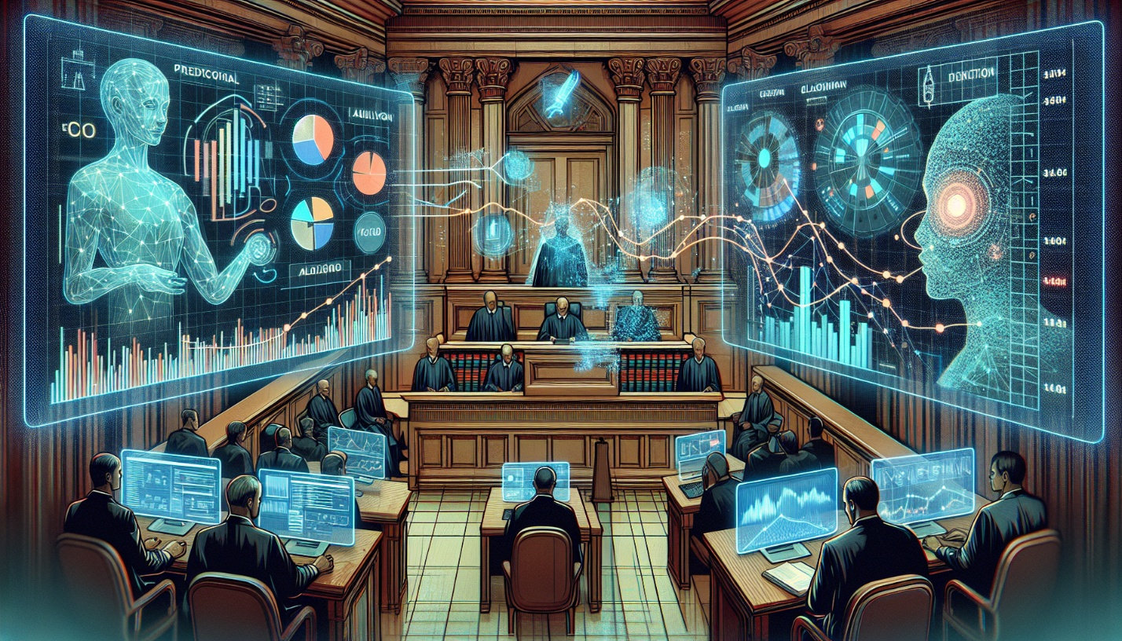

Figure 10 A typical court setting [17].