Short communication

Enhanced Malware Detection in windows Applications Using Ensemble

Learning Techniques

.
ABSTRACT
In order to protect computer systems from attacks that compromise their functionality and security, malware detection is crucial. To protect computer systems from attacks that compromise their functionality and security, malware detection is crucial. The goal of malware detection is to identify and remove malicious software that compromises the availability, confidentiality, or integrity of computer systems. Detecting malware in applications is a dynamic area of cybersecurity. Efficiency and accuracy are essential. The purpose of this study is to use machine learning techniques to enhance applications' capacity to detect malware. This work will examine malware detection and classification components using Adaboost, a modern machine learning (ml) technique. The proposed study makes use of the "Windows Malware Detection Dataset," which is a publicly available dataset. In order to select the best features,We employed an ensemble learning strategy. Our objective is to develop a dependable detection system that integrates state-of-the-art machine learning techniques. This project develops learning strategies using machine learning algorithms, including supervised and unsupervised learning techniques.

The suggested modelbuilds a classification and recognition model using machine learning algorithms, including supervised and unsupervised learning techniques. The suggested methodology includes data preparation, model training, and evaluation in order to produce a dependable detection system. With a 99.9% accuracy rate, the suggested methodology performs better than current models.
KEYWORDS— ADABOOST, MALWARE, AND DECISION TREES.
INTRODUCTION

The stability and security of computer systems are threatened by malware, which calls for more advanced detection techniques than just traditional signature-based methods. Machine learning (ML) offers a powerful solution by detecting malicious software by analyzing patterns and anomalies. This study uses an ensemble learning technique called adaboost to increase the accuracy of malware classification using the Windows malware detection dataset. Through feature selection, data preparation, and model training, we integrate static and behavioral analysis for improved detection. By employing supervised learning, we hope to develop a dependable system that efficiently classifies malware, enhancing cybersecurity and strengthening defenses against evolving cyberthreats.
Heuristic and signature-based methods are primarily used by traditional malware detection systems to classify files as either benign or dangerous. However, these approaches struggle with notable false positives and new kinds of malware. Our proposed solution enhances detection and enables multi-class classification of malware families by combining adaboost with decision trees. It extracts features from multiple sources and improves accuracy through ensemble learning. Although related work highlights other ML algorithms, our approach offers a scalable, high-accuracy solution. By categorizing various malware types, we provide cybersecurity experts with thorough insights for targeted mitigation strategies.

2. MATERIAL AND METHODS

As seen in figure 1, the suggested model is a scalable yet potent deep learning architecture model that uses adaboost to efficiently classify various malware families. The suggested model improves malware classification by using Adaboost in combination with decision trees for multi-class classification.
detection. Unlike traditional systems that only identify the presence of malware, the suggested methodology separates malware into various families.
3.1 Data preprocessing: this step entails obtaining important characteristics from malware samples, such as dlls_imported, api_functions, pe_header, and pe_section. By addressing missing values, encoding categorical variables, and normalizing or scaling features, this step guarantees data consistency. The dataset is methodically divided into training, validation, and test sets to improve model performance and generalization.
3.1 Model training: Adaboost improves instances during the training phase, whereas decision trees act as weak learners. Adaboost iteratively improves performance, while decision trees create classification rules based on features that are extracted. To get the best results, important hyperparameters like the number of estimators and tree depth are optimized.
3.2 Model evaluation: unseen data is used to test the trained model in order to determine the classifier's efficacy. Performance metrics are calculated, including f1-score, recall, accuracy, and precision. In order to assess the model's resilience and guarantee accurate detection across a range of malware families, new malware samples are also added.
3.3 Implementation: The model is related to cybersecurity systems, used for real-time malware detection, and regularly retrained to adapt to evolving threats.
The model is trained on a large dataset and then tested with new samples to ensure resilience. This approach provides a scalable, high-accuracy solution that aids cybersecurity professionals in identifying and getting rid of various malware threats.

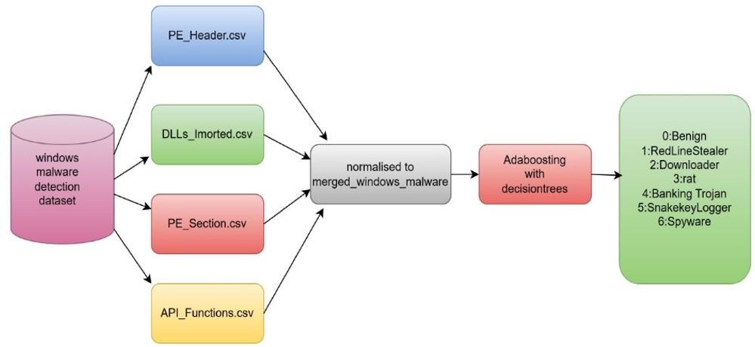

Figure 1: Proposed Architecture

3. RESULTS AND DISCUSSION
The Windows malware detection dataset, which included Windows portable executable (PE) samples divided into four different feature sets, was used to analyze the suggested model. Each feature set offers comprehensive insights into different facets of malware behavior and is kept in a distinct CSV file.
The dynamic link libraries (dlls) imported by every malware sample are listed in dlls_imported.csv. The malware family label is shown in the second column, the sha256 hash values are in the first, and the imported DLL names are described in the remaining columns.
The api functions that the malware called are listed in api_functions.csv, along with the labels and sha256 hashes that correspond to them.
52 labelled fields in the pe_header.csv file describe the executable files' pe_header properties.
values from nine fields in ten distinct pe_sections, all properly labeled, are included in pe_section.csv.
the dataset consists of six malware family labels: 0 – benign, 1 – redlinestealer, 2 – downloader, 3 – rat, 4 - banking trojan, 5 – snakekeylogger, 6 – spyware.

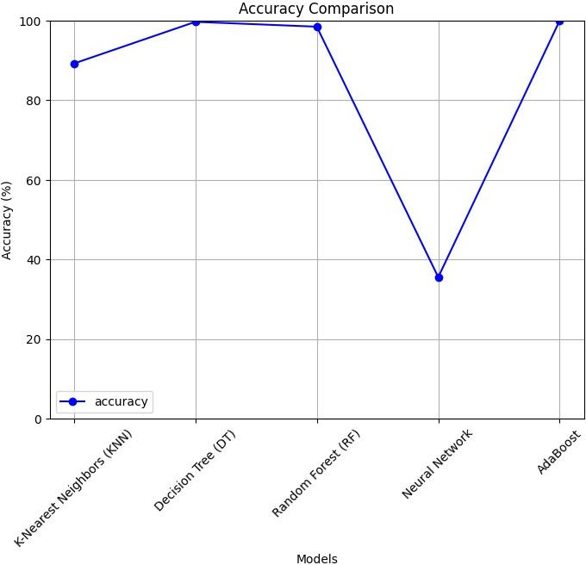

Figure-2 accuracy

The accuracy graph in Figure 2 shows that the accuracy of the suggested model is 89.22%, 99.70, 98.47%, 32.52, and 100% for k-nearest neighbors (knn), decision trees (dt), random forests (rf), neural networks, and adaboost, respectively. The outcomes demonstrate how well ensemble approaches work to increase the precision of malware detection. surpasses current models in performance. This implies that it has the ability to learn and generalize intricate feature patterns.

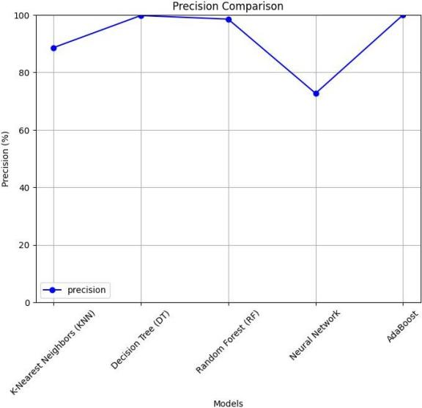
figure-3 precision

The accuracy of the model's positive malware classes is gauged by the precision shown in Figure 3. The precision scores for the various models are as follows: adaboost = 100%, decision tree (dt) = 99.78%, random forest (rf) = 98.53%, neural network = 72.7%, and k-nearest neighbors (knn) = 88.57%. The results show that detection precision is greatly improved by ensemble approaches.

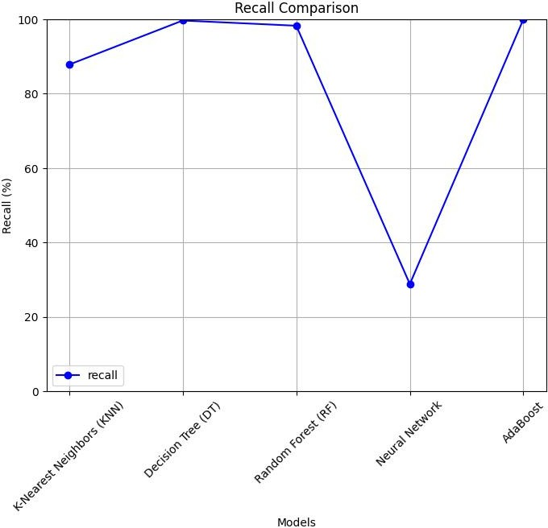
Figure -4:recall
The recall shown in Figure 4 indicates that the models accurately identify all related malware samples. K-nearest neighbors (knn) had a recall score of 87.81%, decision trees (dt) had a score of 99.67%, random forests (rf) had a score of 98.27%, neural networks had a score of 28.79%, and adaboost had a score of 100%. The outcomes demonstrate how well ensemble approaches work to increase malware detection recall performance.

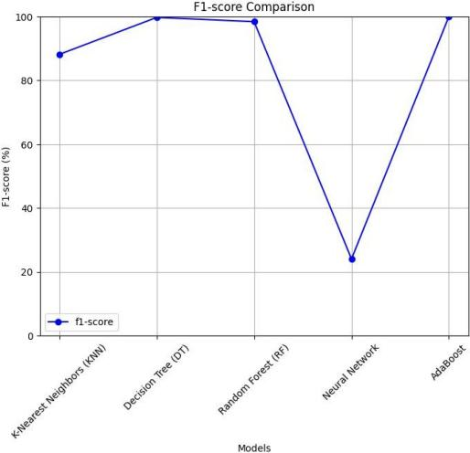
Figure 5: F1-Score

the f1-score depicted in the fig-5 takes both, precision and recall measures to determine the system classification effectiveness. the f1 score is 1.00 of adaboost proves that the model has equally good performance in all the metrics and can thus be considered the most accurate of the models for malware detection and classification.

- Conclusion

This study emphasizes how crucial malware detection is to protecting computer systems from security risks. The study improves the precision and effectiveness of malware classification by utilizing machine learning techniques, especially adaboost. An ensemble learning technique was used to enhance detection performance and optimize feature selection using the Windows malware detection dataset. The suggested model successfully detects and categorizes malware by combining supervised and unsupervised learning techniques. The findings show that the developed system outperforms current models with a remarkable 99.9% accuracy rate, making it a very successful malware detection solution.

Disclaimer (Artificial intelligence)
Option 1:
Author(s) hereby declare that NO generative AI technologies such as Large Language Models (ChatGPT, COPILOT, etc.) and text-to-image generators have been used during the writing or editing of this manuscript.
Option 2:
Author(s) hereby declare that generative AI technologies such as Large Language Models, etc. have been used during the writing or editing of manuscripts. This explanation will include the name, version, model, and source of the generative AI technology and as well as all input prompts provided to the generative AI technology
Details of the AI usage are given below:
1.
2.
3.

REFERENCES

garg, n. tahilramani, p. chauhan and r. patel, "microsoft malware detection using machine learning," 2022 6th international conference on intelligent computing and control systems (iciccs), madurai, india, 2022, pp. 1-6, doi: 10.1109/iciccs53718.2022.9788420.
akhtar, muhammad & feng, tao. (2022). malware analysis and detection using machine learning algorithms. symmetry. 14. 2304. 10.3390/sym14112304.
usha divakarla, k hemant kumar reddy, k chandrasekaran, a novel approach towards windows malware detection system using deep neural networks, procedia computer science, volume 215, 2022, pages 148-157, issn 1877-0509, https://doi.org/10.1016/j.procs.2022.12.017.
maray, mohammed, mashael s. maashi, haya mesfer alshahrani, sumayh s. aljameel, sitelbanat abdelbagi and ahmed s. salama. “intelligent pattern recognition using equilibrium optimizer with deep learning model for android malware detection.” ieee access 12 (2024): 24516-24524.
ayeni, olaniyi & owolafe, otasowie & akinsola, olabiyi. (2021). malware detection using machine learning. 84-87. 10.20533/icitst.2021.0008.
ogwara no, petrova k, yang ml, macdonell sg. mindpres: a hybrid prototype system for comprehensive data protection in the user layer of the mobile cloud. sensors. 2025; 25(3):670. https://doi.org/10.3390/s25030670.
guo w, du w, yang x, xue j, wang y, han w, hu j. malhapgnn: an enhanced call graph-based malware detection framework using hierarchical attention pooling graph neural network. sensors. 2025; 25(2):374. https://doi.org/10.3390/s25020374.
anderson, hyrum s., and phil roth. "ember: an open dataset for training static pe malware machine learning models." arxiv preprint arxiv:1804.04637 (2018).
alazab, mamoun & venkatraman, sitalakshmi & watters, paul. (2010). towards understanding malware behaviour by the

extraction of api calls. proceedings - 2nd cybercrime and trustworthy computing workshop, ctc 2010. 10.1109/ctc.2010.8.
alazab, m., venkatraman, s., watters, p., alazab, m., alazab, a. (2012). cybercrime: the case of obfuscated malware. in: georgiadis, c.k., jahankhani, h., pimenidis, e., bashroush, r., al- nemrat, a. (eds) global security, safety and sustainability & e- democracy. e-democracy icgs3 2011 2011. lecture notes of the institute for computer sciences, social informatics and telecommunications engineering, vol 99. springer, berlin, heidelberg. https://doi.org/10.1007/978-3-642-33448-1_28.
w. huang and j. w. stokes, "mtnet: a multi-task neural network for dynamic malware classification", proc. int. conf. detection intrusions malware vulnerability assessment, pp. 399-418, jul. 2016.
raff, e., barker, j., sylvester, j., brandon, r., catanzaro, b., & nicholas, c. (2017). malware detection by eating a whole exe. arxiv preprint arxiv:1710.09435.
krcál, marek, ondř švec, martin bálek and otakar jasek. “deep convolutional malware classifiers can learn from raw executables and labels only.” international conference on learning representations (2018).
pachhala, n., jothilakshmi, s., & battula, b. p. (2023). enhanced malware family classification via image-based analysis utilizing a balance-augmented vgg16 model. traitement du signal, 40(5), 2169-2178.
pachhala, n., jothilakshmi, s., battula, b.p. (2024). cross- platform malware classification: fusion of cnn and gru models. international journal of safety and security engineering, vol. 14, no. 2, pp. 477-486. https://doi.org/10.18280/ijsse.140215
1

