**APPLICATION OF INTELLIGENT OVERCURRENT RELAYS FOR REAL-TIME PROTECTION OF INDUCTION MOTOR UNDER FAULT CONDITIONS**

.

ABSTRACT

|  |
| --- |
| Protecting an induction motor from faults is essential to ensure its reliable operation, extend its lifespan, and safeguard the overall electrical system. This paper presents a comprehensive analysis and protection strategy for a 7.5 kW, 400 V, 50 Hz, 1440 RPM, three-phase squirrel-cage induction motor under various fault conditions using MATLAB/Simulink. The faults considered include normal case (without fault), single line-to-ground fault (L-G), double line-to-ground fault (L-L-G), three line-to-ground fault (L-L-L-G), and line-to-line fault (L-L). The simulation runs for a total duration of 2 seconds, with the motor operating under normal conditions from 0 to 0.6 seconds. Faults are applied between 0.6 and 2 seconds, during which an intelligent overcurrent relay is incorporated to detect the fault and trip the motor at 1.4 seconds.  The results reveal distinct behaviors of the induction motor during normal and fault conditions, characterized by variations in rotor speed, electromagnetic torque, and stator currents. Under normal operation, the motor operates at steady-state conditions with balanced stator currents, constant torque, and rotor speed close to the synchronous value. However, during fault conditions, significant disruptions are observed. Single line-to-ground faults cause moderate unbalances, while double line-to-ground faults and line-to-line faults induce higher levels of stator current surges and torque oscillations. Three line-to-ground faults present the most severe case, leading to rapid torque drops, rotor deceleration, and excessive current surges in all phases.  The intelligent overcurrent relay demonstrates its effectiveness by detecting abnormal current levels across all fault scenarios and successfully isolating the motor at 1.4 seconds, mitigating potential damage. This study highlights the critical role of intelligent protection devices in enhancing the reliability and operational safety of induction motors under fault conditions. The MATLAB/Simulink simulation software proves to be an effective tool for modeling, analyzing, and validating the performance of the motor and protection system.  This work provides valuable insights into fault dynamics in three-phase induction motors and underscores the importance of implementing intelligent relay-based protection schemes for improved fault mitigation and motor reliability. |

*Keywords: induction motors,* *fault, simulation, intelligent overcurrent relay, mitigation MATLAB/Simulink.*

1. INTRODUCTION

In modern industrial systems, three-phase induction motors are crucial for driving a wide range of mechanical applications due to their reliability, efficiency, and robust design. As essential components in sectors such as manufacturing, mining, and energy, induction motors are relied upon for continuous operation and high performance. However, these motors are vulnerable to electrical faults [1, 2], particularly overcurrent conditions that can occur due to short circuits, overloads, or system abnormalities. Such overcurrent conditions induce excessive heat in the motor windings, degrade insulation, and, if not addressed swiftly, may result in severe motor damage or complete failure. This has considerable operational and economic consequences, making the design and implementation of effective protection strategies a top priority for industries dependent on these motors, which can often get energies by renewable sources [3]

Many commonly used motor protection devices, such as thermal overload relays and circuit breakers, are primarily designed to protect against overheating due to prolonged overloads or short-circuit conditions, rather than detecting and responding to overcurrent faults with the precision needed in complex applications like when induction motor is energy using a renewable energy source [4,5,6,7]. Thermal overload relays primarily respond to sustained thermal stress rather than instantaneous overcurrent. They contain a bimetallic strip or a heater element that heats up in response to prolonged overload conditions, simulating the thermal characteristics of motor windings. When a motor draws excessive current over time, the relay eventually trips to protect it from overheating. However, thermal overload relays are slow to react to short-duration but severe overcurrent spikes, such as those caused by a fault. Consequently, they are not suitable for scenarios requiring rapid disconnection from an overcurrent fault, where immediate action is essential to avoid insulation damage or motor burnout [6]. Similarly, circuit breakers do provide some level of fault protection, they are primarily designed for safeguarding wiring and preventing catastrophic short circuits, not for detecting subtle overcurrent variations specific to motor protection. Circuit breakers typically operate by mechanically disconnecting the circuit upon detecting high current levels that exceed a predefined threshold [7, 8].

Motors experience different types of overcurrent conditions depending on the fault type, location, and load, unlike intelligent protection systems, traditional thermal relays and circuit breakers lack the ability to differentiate between transient disturbances (such as inrush currents) and actual fault conditions. Intelligent overcurrent relays, on the other hand, can continuously monitor the motor's current profile and adjust their trip characteristics in real-time, allowing them to distinguish between safe operating transients and dangerous fault-induced overcurrent. This differentiation is critical to avoid unnecessary shutdowns and ensure accurate fault response.

Many engineers have developed different techniques to detect overcurrent in 3-phase motors. This makes it possible to perform the right steps at the proper time, thus preventing the effects of such a severe failure. Several studies have been carried out on the topic of three-phase motor protection against overcurrent, [9, 10, 11, 12, 13, 14]

Recent trends in the motor protection field shows that adaptive overcurrent relays are one of the most widely used protection mechanisms for mitigating fault conditions in induction motors. This overcurrent relay functions by detecting abnormal current levels that exceed preset thresholds and triggering a trip signal to disconnect the motor from the power source. This rapid response is essential in preventing overheating and subsequent damage to the motor’s internal components. However, traditional overcurrent relays have limitations. They often lack the sensitivity and precision needed for complex fault scenarios, particularly in systems with varying load conditions or in networks integrated with renewable energy sources. These limitations can lead to issues like nuisance tripping or insufficient fault mitigation, thus underscoring the need for more advanced relay design and simulation approaches[15, 16,35, 36,37].

The development of a robust overcurrent relay design requires a deep understanding of the motor’s fault characteristics and the fault response requirements under different operational scenarios. Simulation tools, particularly MATLAB/Simulink, offer a powerful platform for designing and testing overcurrent relay-based protection systems. By modeling the induction motor, fault types, and relay parameters, simulation allows for the analysis of relay performance under controlled conditions and enables iterative optimization of relay settings for enhanced fault detection and response accuracy. The ability to test the relay’s effectiveness in both symmetrical and unsymmetrical fault scenarios, as well as under various load profiles, provides invaluable insights that contribute to designing more effective protection schemes [17, 18, 31, 32, 33, 34`] .

In [19], the authors proposed a new method for 100% protection against the stator earth fault in synchronous generator using over current relay. Conventional ground fault protection schemes were applied to any generator that covers at most 95% of generator stator length. Moreover, an investigation into the differences between first harmonic fault current and third harmonic fault current was performed. Proper simulation model, earth faults were simulated at various distant points from the generator neutral and using the simulations, first harmonic fault current and third harmonic fault current characteristics were properly distinguished. Additionally, the threshold current of the proposed differential third harmonic over current relay was selected based on the results of the simulations.

The article [20] presented the optimization-based control of overcurrent relays in distribution network considering real-time measurements: A case study. The authors carried out a coordination on a real power system serving in Erzurum/Turkey, the tripping delay times (TDT) of OCRs and the contact opening delay times (CODT) of circuit breakers (CB) were measured and the CTI constraints in the coordination were determined according to the obtained measurements. Time multiplier setting (TMS) values were obtained from the CTI value which was determined according to the proposed real-time measurement. Performance of the relay TMS values were obtained and compared according to the proposed and classical methods. The power model and solution show 18.67 % improvement in the operation times of the first relays, Relay 2, improve by 11.67 % in Relay 3, 19.94 % in Relay 4, 28.6 % in Relay 6 and 23.31 % in Relay 7. The TMS value of Relay 5 was the same for the proposed and the classical method. As a result, the fast operation, reliability and selectivity of the power system were improved by ensuring correct relay coordination with the proposed method.

In [21] the authors analyze the real results data collected for the selected commercial building of an over current relay implemented in a distribution board for high voltage and low voltage downward at a commercial building. All the parameters needed were first clarified before testing was carried out using the MICROTEST 860 set. The analysis proves that according to the IEC Standard of 0.10-time multiplier Setting (TMS) which was practically used to obtain the operation time in seconds for the current curve set. The results show that the normal inverse curve from manual calculation results was more accurate compared to the service setting (SS) made based on the incoming setting in a real commercial building. The research successfully determined the proper methods for the OC relay setting for the power distribution system. However, no mitigation algorithm was proposed.

The authors of [22, 23, 24] propose optimal protection relay coordination for overcurrent relays in radial system. The main objective of the research work was to perform overcurrent relay protection coordination to obtain an optimum relay setting to minimize the operating time of overall relays in the network. The optimum value of time multiplier setting (TMS) was determined based on predefined value of tap setting (TS) and plug setting multiplier (PSM). MATLAB/Simulink software was used to implement the optimization method using Particle Swarm Optimization (PSO). The result from the optimization method was compared with conventional relay coordination method for electromechanical relay as study case. The algorithm was applied for radial network. The results of the studies performed was useful in selecting the best relay setting in order to optimize the design and to achieve reliable electrical network. In [25] there was a small improvement made to this technique. The authors use improved mathematical formulation for optimum overcurrent relay coordination for radial distribution networks. They claimed that using an improved mathematical formulation of relay coordination reduced the system complexity they by avoiding miscoordination as an outcome of employing a new objective function with an additional constraint. Additionally, it was compared with the conventional approach considering all parameters of radial distribution as it is. The results obtained show that the proposed approach is superior, optimal, and effective as compared to the conventional approach. The performance and effectiveness of the proposed approach were evaluated on two radial distribution networks.

Another way to mitigate faults in a three-phase induction is by usingthermal overload relays. Thermal overload protection uses temperature sensors embedded in the motor windings or mounted externally. These relays trip the motor when overheating is detected, often due to prolonged overloading, locked rotor conditions, or single-phasing. Authors in [5, 26] explored the techniques of thermal overload protection to mitigate fault in a three-phase induction motor. The study demonstrates that full-order thermal models can be systematically reduced via pole-zero cancellation or Hankel singular-values-based model reduction techniques without additional physical assumptions. As a result, a system of a substantially lower dimension, which was nearly the same response characteristics in the frequency band of interest was obtained. Both the estimated rotor cage temperature, which was extracted from the voltage and current measurements by a sensor less rotor temperature estimator, and the measured stator winding temperature were used to evaluate the performance of low-order thermal models. A certain tolerance for the modeling error show that reduced low-order thermal model can be used to characterize the thermal dynamics of a small- to medium-sized line-connected induction machine and to provide proper protection against motor overheating.

The study in [27] incorporates a correlation model linking voltage unbalance and mechanical overload, with thermal gradients generated from the interplay of these factors. Voltage unbalance estimation adheres to IEEE Standard 141, IEEE Standard 1159, and NEMA guidelines. The correlation models were experimentally validated on a 746 W (1 hp) three-phase induction motor, demonstrating effectiveness at various stator points in analyzing the relationship between voltage unbalance and mechanical overload.

Despite the diverse methodologies proposed by researchers for fault detection in three-phase induction motors, most fail to classify all fault types comprehensively. Therefore, this research focuses on designing and simulating an overcurrent relay-based protection system specifically for three-phase induction motors. The proposed study will develop a customizable relay model capable of adapting to different fault conditions, with key objectives including the evaluation of the relay’s response time, fault detection accuracy, and adaptability to dynamic changes. Additionally, the research will examine the relay’s performance under varying fault severity levels, assessing its ability to safeguard the motor from both minor and severe overcurrent events. By conducting simulations in MATLAB/Simulink, this research aims at identifying the strengths and limitations of overcurrent relay protection systems in the revised literatures and propose a design model for performance enhancements of the motor and to ensure the induction motor reliability and extension of its operational lifespan.

**2. OVER CURRENT RELAYS (OCRs)**

An overcurrent relay (OCR) operates by opposing excessive current flow. Its primary function is to compare the actual measured current against a preset threshold. The logical representation of the OCR is shown in Figure 1. When the input current exceeds the preset threshold, the relay detects the rise and sends a trip signal to the circuit breaker (C.B.), causing it to open its contacts and disconnect the protected device. When the relay detects a fault, this condition is referred to as fault pickup. Upon fault detection, the relay can either send a trip signal immediately (instantaneous overcurrent relay) or delay the trip signal for a specified time before activation (time overcurrent relay) [28, 29].

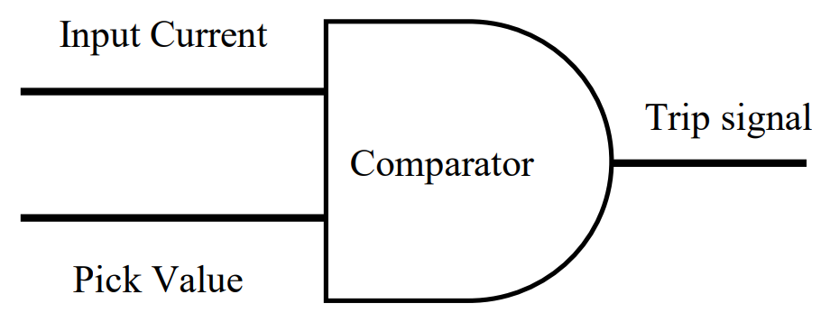

**Fig. 1: Logical exemplification of Over-Current Relay**

Overcurrent relays (OCRs) can be categorized based on their operational characteristics into three main types:

* Instantaneous OCRs: These relays operate without any intentional time delay. They instantly transmit a trip signal to the circuit breaker (C.B.) as soon as a fault is detected.
* Definite Time OCRs: These relays are primarily used for backup protection. If a primary protection device, such as a distance relay, fails to send a trip signal to the circuit breaker after a fault occurs, the OCR will activate after a predetermined time delay to ensure the circuit breaker trips.
* Inverse Definite Minimum Time (IDMT) OCRs: These relays operate with an inverse time characteristic. Their operating time is inversely proportional to the magnitude of the fault current—meaning the higher the fault current, the shorter the operating time. This feature allows them to handle a wide range of fault currents and operating times. The operating time of IDMT OCRs is determined based on their characteristics and specific parameters.

**2.1 Over Current Relay Algorithm**

Fig. 2 presents the algorithm for implementing overcurrent protection in a three-phase induction motor. The system utilizes a comparator to evaluate the fault current against a predefined reference current. When the fault current exceeds the reference value, a trip signal is generated and sent to the circuit breaker (C.B.), which disconnects the power supply to protect the three-phase induction motor.

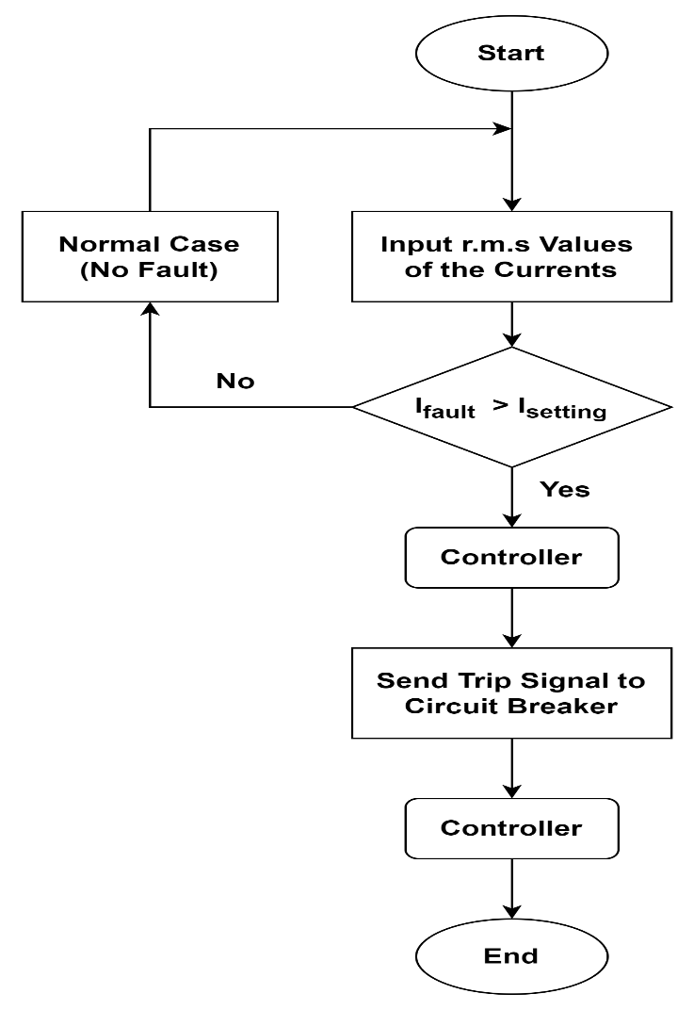

**Fig 2: Flow chart of overcurrent protection**

**2.2 Faults and Classifications**

Under normal operating conditions, the power system functions within balanced parameters, with components operating as intended, bus voltages remaining stable, and load currents staying within specified limits. However, a fault may occur in the circuit due to a failure disrupting the normal flow of current. When system insulation breaks down, resulting in a low-impedance path either between phases or between phase(s) and ground, a short circuit fault occurs. These short circuit faults are classified as follows [30] .

* Symmetrical faults.
* Unsymmetrical faults.

**2.2.1. Symmetrical Faults**

In such cases, all phases are short-circuited either to the ground or to each other. These faults are classified as balanced faults, as they maintain system symmetry. Balanced faults are the most severe type, as they involve the highest fault currents. Therefore, the calculations for balanced short-circuit cases are performed to determine these maximum fault currents.

**2.2.2. Unsymmetrical Faults**

Unsymmetrical faults involve only one or two phases, resulting in an imbalance in the system. These faults typically occur between lines or between a line and the ground. An unsymmetrical series fault occurs between a phase and the ground or between phases, whereas an unsymmetrical shunt fault is characterized by an imbalance in line impedances. Three-phase shunt faults can be classified as follows:

* Single line to ground fault (L-G).
* Double lines faults (L-L).
* Double line to ground fault (L-L-G).
* Triple line fault (L-L-L).
* Triple line to ground fault (L-L-L-G).

3. SIMULATION TEST CASE

The framework proposed in this research work is to design and simulate an overcurrent relay-based protection system tailored for three-phase induction motors. The study involves developing a relay model with customizable trip settings that can adapt to different fault conditions. Once the relay model detects any fault in the system, a trip signal will be sent to the circuit breaker to disconnect the power supply from the induction motor they by protecting the induction motor from damaging. To address the above-mentioned problem, a 3-phase squirrel-cage induction motor is simulated using MATLAB Simulink. The simulation model utilized a 7.5 kW, 3-phase squirrel-cage induction motor (IM). A fault block which replicates faulty operations is connected to the system, an overcurrent relay is also connected to the system to send trip signal to circuit breaker in case any type of fault occurs in the system. Fig 3 displays the finalized model, while Table 1 outlines the key parameters of the three-phase induction motor.

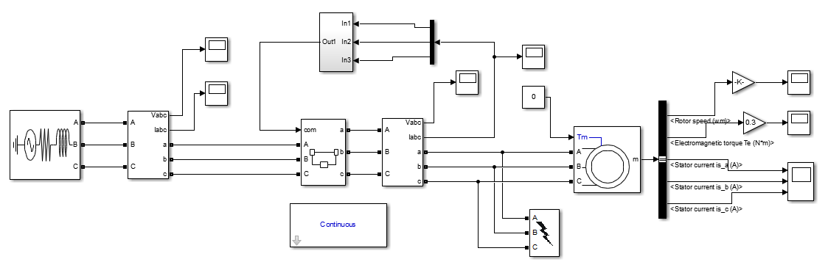

**Fig.3. Simulation setup as represented in MATLAB’s workspace**

**Table. 1. Motor simulation details and specs.**

|  |  |  |
| --- | --- | --- |
| **Number** | **Parameters** | **Value** |
| 1 | Input power of the motor | 7.5Kw |
| 2 | Motor input voltage | 400V |
| 3 | Frequency | 50Hz |
| 4 | Motor speed | 1440 RPM |
| 5 | Mechanical power | 7.5Kw |
| 6 | Stator resistance | 0.7384 $Ω$ |
| 7 | Stator inductance | 0.003045 $mH$ |
| 8 | Rotor resistance | 0.7402 $Ω$ |
| 9 | Rotor inductance | 0.003045 $mH$ |
| 10 | Mutual inductance | 0.1241H |
| 11 | Inertia(J) | 0.0343 (kg.m2) |
| 12 | Friction factor(F) | 0.000503 $(N.m.s)$ |
| 13 | Number of pole pair | 4 |
| 14 | Initial condition | 10000000 |

The selection of the 3-phase squirrel-cage motor is based on its extensive use in various electromechanical systems, including maritime applications. The model is developed to simulate the operation of the induction motor alongside a fault block specifically inject fault to the induction motor. The detailed specifications of the induction motor are outlined in Table 1, while Fig. 3, illustrates the simulation setup within the MATLAB workspace. The focus of the fault analysis is on the stator winding during a short-circuit event. The Simulink 3-phase fault block is capable of simulating two types of faults: phase-to-phase and phase-to-ground short circuits. Specifically, for fault detection and identification, five different scenarios are examined: Normal Case (Without Fault), single line to ground fault (L-G), double line to ground fault (L-L-G), Three line to ground fault (L-L-L-G), and line to line faults (L-L).

**4. SIMULATION RESULTS AND DISCUSSION**

The parameters in table 1 were acquired from experimental work with a three-phase induction motor. These settings were then utilized to simulate and examine the behavior of the induction motor without fault and with fault condition with overcurrent relay attach to the system to send trip signal to the circuit in other to protect the system. MATLAB/Simulink software was used. The induction motor performance behavior with normal case (without fault), single line to ground fault (L-G), double line to ground fault (L-L-G), three lines to ground fault (L-L-L-G), and line to line faults (L-L), was presented in term of graphical representation. To analyze the performance behavior of the induction motor without fault, the system was simulated without applying any fault to the system. The analysis of fault scenarios was done by applying a three-phase fault block to the system, in this case the fault block was varies depending on the type fault we want to simulate and analyzed.

**4.1. Normal Case (Without Fault):**

In simulation and analysis of a three-phase induction motor, if there is no fault, the output signal will be normal with balance value of rotor speed, electromagnetic torque and stator current as given in Fig. 3. These energies are considered the reference initial parameters. When a small change is occurred is these parameters, and then the phase that with this case is considered as fault clauses.

|  |  |
| --- | --- |
|  |  |

**(a) (b)**

|  |
| --- |
|  |

**(c)**

**Fig. 4. (a) Rotor speed** **simulation result at no fault. (b)Electromagnetic torque simulation result at no fault. (c) Stator currents simulation result at no fault**

As seen in Fig. 4. a, we have a normal transient state at the rotor speed; the speed start from zero (0) and move to the rated speed of about 1500 (rpm) and maintain a stable output till 2 seconds without any distortion in the speed.

As seen in Fig. 4. b, we have a normal transient state at the electromagnetic torque; however, at start, the electromagnetic torque experiences an increase of 2 to 2.5 the rated torque before it stable at 0.2 seconds and maintain a stable transient state till 2 second.

It can be seen in Fig. 4. c, that the stator current also maintain a normal transient state; however, there is a higher current at start, this is as a result of large inrush current at start.

**4.2. Single** **Line to Ground Fault (L-G):**

When a line-to-ground (A-G, B-G, C-G) fault was applied from 0.6 seconds to 2 seconds in the system and implement an overcurrent relay to trip the induction motor at 1.4 seconds, the rotor speed, electromagnetic torque, and stator currents exhibit specific behaviors during different time intervals. Fig. 5 present the simulation result.

|  |  |
| --- | --- |
|  |  |

**(a) (b)**

|  |
| --- |
|  |

**(c)**

**Fig. 5. (a) Rotor speed simulation result at line to ground fault. (b)Electromagnetic torque simulation result at line to ground fault. (c) Stator currents simulation result at line to ground fault**

As seen in Fig. 5. a, the rotor speed stabilized at a value close to the synchronous speed from (0-0.6 second), at 0.6 seconds when the fault occurs, the motor experiences an unbalanced stator voltage leading to fluctuations in the rotor speed, and at 1.4 seconds, when the overcurrent relay detects the fault and disconnects the motor from the power supply, the rotor speed decreases gradually and eventually approach zero over time.

As seen in Fig. 5. b, from (0-0.6 second) the electromagnetic torque remains steady corresponding to the load torque applied to the motor, at 0.6 second the motor torque struggles to maintain its normal operation under fault conditions and at 1.4 second after the motor is tripped, the electromagnetic torque rapidly diminishes to zero because there is no electrical energy to sustain it.

It can be seen in Fig. 5. c, from (0-0.6 second) the stator currents are balanced and sinusoidal, at 0.6 second when the fault occurs, the stator current experience a significant increase in current magnitude, at 1.4 second when the overcurrent relay trips the motor, the stator currents immediately drop to zero, as the motor is electrically disconnected from the supply.

**4.3. Double Line to Ground Fault (L-L-G)**

When a double-line-to-ground (L-L-G) fault was applied instead of a single-line-to-ground (SLG) fault, it was observed that the impact on the rotor speed, electromagnetic torque, and stator currents was more severe due to the increased level of asymmetry and imbalance in the system. Fig. 6 present the simulation result.

|  |  |
| --- | --- |
|  |  |

**(a) (b)**

|  |
| --- |
|  |

**(c)**

**Fig. 6. (a) Rotor speed simulation result at** **double line to ground fault. (b)Electromagnetic torque simulation result at double line to ground fault. (c) Stator currents simulation result at double line to ground fault**

As seen in Fig. 6. a, rotor speed remains stable from (0-0.6 seconds), at 0.6 seconds the rotor speed experience larger dropcompared to an SLG fault because the fault severely disrupts the motor's ability to generate torque, and at 1.4 seconds, the overcurrent relay trips the motor, the rotor speed decelerates towards zero.

As seen in Fig. 6. b, the torque fluctuates slightly due to normal motor dynamics but remains stable from 0-0.6 seconds, at 0.6 seconds the torque fluctuates more violently than in the case of an SLG fault, at 1.4 seconds the electromagnetic torque rapidly reduces to zero since no electrical energy is being supplied.

It can be seen in Fig. 6. c, the stator currents are balanced, sinusoidal, and phase-shifted by 120°, at 0.6 second, the total stator current increases significantly, which triggers the overcurrent relay and at 1.4 seconds the overcurrent relay trips the motor, and the stator currents drop to zero almost immediately.

**4.3. Three Line to Ground Fault (L-L-L-G)**

When a three-line-to-ground (L-L-L-G) fault was applied to the system, the impact was the most severe among all types of faults. This is because all three phases are shorted to ground, resulting in a complete loss of balance and significant disruption in the induction motor's performance. Fig. 7 present the simulation result.

|  |  |
| --- | --- |
|  |  |

**(a) (b)**

|  |
| --- |
|  |

**(c)**

**Fig. 7. (a) Rotor speed simulation result at three lines to ground fault. (b)Electromagnetic torque simulation result at three lines to ground fault. (c) Stator currents simulation result at three lines to ground fault**

As seen in Fig. 7. a, rotor speed remains stable and close to synchronous speed under normal operating conditions from 0-0.6 seconds, at 0.6 seconds when the fault occurs, the rotor speed drop rapidly to zero due to absence of torque to counteract the load torque and friction, when overcurrent relay trips at 1.4 seconds, the rotor speed continue to decelerate and eventually approach zero.

As seen in Fig. 7. b, the motor torque operates smoothly, producing consistent torque with minor oscillations due to normal operating dynamics, but at 0.6 seconds when the fault occurs, the torque experiences a total disruption in torque production, as the balanced three-phase power supply is entirely lost, and at 1.4 seconds after the relay trips the motor, the torque remains at zero since the motor is no longer connected to the power supply

It can be seen in Fig. 7. c, the stator currents are balanced, sinusoidal, and maintain a steady magnitude from 0-0.6 seconds, but at 0.6 seconds stator currents was highly distorted, and at 1.4 seconds After the overcurrent relay trips, the stator currents immediately drop to zero, as the motor is disconnected from the power source

4.3. Line to Line Faults (L-L)

When a line-to-line (L-L) fault was applied to the system, it creates an unbalanced condition where two phases are short-circuited, while the third phase remains unaffected. This type of fault is less severe than a three-line-to-ground fault but more severe than a single-line-to-ground fault. Fig. 8 present the simulation result.

|  |  |
| --- | --- |
|  |  |

(a) (b)

|  |
| --- |
|  |

(c)

**Fig. 8. (a) Rotor speed simulation result at** **line-to-line fault. (b)Electromagnetic torque simulation result at line-to-line fault. (c) Stator currents simulation result at line-to-line fault**

As seen in Fig. 8. a, from 0-0.6 seconds the rotor speed remains stable and close to the synchronous speed, but at 0.6 seconds when the fault occurs the rotor speed gradually drop but less severe than a three-line-to-ground fault but more severe than a single-line-to-ground fault, after 1.4 seconds when the overcurrent relay trips and disconnects the motor, the speed gradually approach zero.

As seen in Fig. 8. b, the torque is stable from 0-0.6 seconds, but at 0.6 seconds when the fault occurs the torque fluctuate around a reduced average value, and when the relay trips at 1.4 seconds, the torque drops to zero

It can be seen in Fig. 8. c, the stator currents are balanced, sinusoidal, and at a steady magnitude from 0-0.6 seconds, but at 0.6 seconds the stator current waveforms become highly unbalanced, and 1.4 second, the overcurrent relay trips the stator due to the unbalanced scenario and the currents drop to zero as the motor is disconnected from the power source.

**5. CONCLUSION**

This study focused on the design, simulation, and analysis of fault conditions in a 7.5 kW, 400 V, 50 Hz, 1440 RPM, three-phase squirrel-cage induction motor using MATLAB/Simulink, with the implementation of an intelligent overcurrent relay for fault mitigation. The research evaluated the motor's performance under normal conditions and various fault scenarios, including Single Line-to-Ground (L-G), Double Line-to-Ground (L-L-G), Three Line-to-Ground (L-L-L-G), and Line-to-Line (L-L) faults. The results demonstrate that faults significantly disrupt motor operation, leading to unbalanced and excessive stator currents, oscillations in electromagnetic torque, and rotor speed instability. Among the analyzed faults, the Three Line-to-Ground Fault (L-L-L-G) was identified as the most severe, causing rapid rotor deceleration and large current surges. Single Line-to-Ground and Line-to-Line faults exhibited moderate disruptions, while Double Line-to-Ground faults presented intermediate severity. The incorporation of an intelligent overcurrent relay proved highly effective in mitigating fault impacts. The relay accurately detected abnormal current levels across all fault conditions and tripped the motor at 1.4 seconds, thereby isolating the system from further damage. This highlights the critical role of advanced protection devices in ensuring motor reliability and operational safety.

Overall, this work emphasizes the importance of intelligent fault detection and mitigation strategies in protecting induction motors. The insights provided by this study contribute to the broader understanding of motor fault dynamics and the necessity for robust protection schemes in industrial applications. Future work can explore the integration of adaptive relay settings and advanced fault-detection algorithms to further enhance motor protection under varying operating conditions.

Disclaimer (Artificial intelligence)

Option 1:

Author(s) hereby declare that NO generative AI technologies such as Large Language Models (ChatGPT, COPILOT, etc.) and text-to-image generators have been used during the writing or editing of this manuscript.

# REFERENCES

1. N. A. Mohar, E. C. Mid, S. M. Suboh, N. H. Baharudin, N. B. Ahamad, N. A. Rahman, E. Ruslan and D. A. Hadi, "Fault Detection Analysis for Three Phase Induction Motor Drive System using Neural Network," *In Journal of Physics: Conference Series,* vol. 1878, no. 1, p. 012039, 2021.
2. R. Senthil Kumar, B. Rajesh Kumar and M. Lincy Luciana, " Fault detection for three-phase induction motor drives using fuzzy logic," *Int J Pure Appl Math,* vol. 118, p. 20, 2018.
3. OI Jackson, EE Okpo, AT Umoette “[Comparative Analysis of Direct and Soft Starting Method for Induction Motor on Difference Load Levels](https://scholar.google.com/citations?view_op=view_citation&hl=en&user=VGedR9sAAAAJ&pagesize=80&citation_for_view=VGedR9sAAAAJ:8k81kl-MbHgC)”Journal of Engineering Research and Reports 26 (10)
4. K. Widarsono, A. F. Ilman and A. Rejeki, "Design and Implementation of Protection Relay 3 Phase Induction Motor," *JAREE (Journal on Advanced Research in Electrical Engineering),* vol. 3, no. 2, 2019.
5. AT Umoette, EA Ubom, IE Akpan [Comparative analysis of three NOCT-based cell temperature models](https://scholar.google.com/citations?view_op=view_citation&hl=en&user=VGedR9sAAAAJ&pagesize=80&citation_for_view=VGedR9sAAAAJ:UeHWp8X0CEIC) Int. J. Syst. Sci. Appl. Math 1 (4), 69
6. Umoette A.T, Udofia J. P. and Ubom E.A, “Energy Audit and Standalone Solar Power Generation Design For Akwa Ibom State University Main Campus”. International Multilingual Journal of Science and Technology (IMJST) ISSN: 2528-9810 Vol. 8 Issue 6, June – 2023
7. Umoette, A. T. Okoro O. I. and Davidson, I. E. "Performance Analysis of a 10hp Three phase Induction Motor Using Classical and Finite-Elements for Varying Load Conditions," 2021 IEEE PES/IAS PowerAfrica, 2021, pp.1-5.
8. . A. Corzine, "A new-coupled-inductor circuit breaker for DC applications," *IEEE Transactions on Power Electronics,* vol. 32, no. 2, pp. 1411-1418, 2016.
9. X. Zhang, F. Wang, D. Xing and L. Zhu, "Three-Phase Motor Driver with Overcurrent Protection Function," in *2024 IEEE International Symposium on Circuits and Systems (ISCAS)*, 2024.
10. Umoette, A. T. Okoro O. I. and Davidson, I. E, "Speed Performance Enhancement and Analysis of a Three Phase Induction Motor Driving a Pump Load using Vector Control Technique," 2022 IEEE PES/IAS PowerAfrica, Kigali, Rwanda, 2022, pp. 1-5, doi: 10.1109/PowerAfrica53997.2022.9905269.
11. P. Bhingare, D. Bhoyar, S. Ninawe and K. Kathane, "Review on 3 Phase Induction Motor Monitoring and Protection System," *Int. J. of Aquatic Science,,* vol. 15, no. 1, pp. 159-164, 2024..
12. K. Dong-Kurl, "A Study on Device Development for Electrical Fire Protection on Open Phase of Three-Phase Motor," *Journal of Korean Institute of Fire Science and Engineering,* vol. 26, no. 1, pp. 61-67, 2012.
13. H. Susilawati, A. F. Ikhsan, I. Nawawi and A. W. Priatna, "Protecting and monitoring system for three phase induction motor," in *In 2019 IEEE 5th International Conference on Wireless and Telematics (ICWT)*, 2019.
14. Y. Mandekar, S. Bongale, V. Savant, H. Savsani, S. Salunkhe and M. P. S. Pawar, "Three phase induction motor protection scheme," *International Research Journal of Engineering and Technology (IRJET),* vol. 4, no. 03, 2017.
15. M. Rojnić, R. Prenc, H. Bulat and D. Franković, "A comprehensive assessment of fundamental overcurrent relay operation optimization function and its constraints," *Energies,* vol. 15, no. 4, p. 1271, 2022.
16. M. M. Guimarães, R. H. Takahashi, M. H. Costa, C. H. Moia and E. G. Carrano, "Robust coordination of overcurrent relays for several simultaneous faults in wind power generation systems," Applied Soft Computing, 2023.
17. FE Effiong, AT Umoette, KJ Oyadinrin [Development Of Fussy Logic Approach For Fault Current Diagnosis And Classification In Power Lines](https://scholar.google.com/citations?view_op=view_citation&hl=en&user=VGedR9sAAAAJ&cstart=20&pagesize=80&citation_for_view=VGedR9sAAAAJ:Y0pCki6q_DkC). Journal of Multidisciplinary Engineering Science Studies (JMESS) 8 (1), 4563- 4571
18. M. A. Chowdhury, K. T. Reza, M. D. Alam and E. Basher, "Third harmonic differential over current relay based protection system for stator ground fault in synchronous generator," in *In 2016 9th International Conference on Electrical and Computer Engineering (ICECE)*, 2016.
19. A. Unluturk and I. Ozer, "Optimization based control of overcurrent relays in distribution network considering real-time measurements: A case study," *Applied Energy,* vol. 377, p. 124439, 2025.
20. I. F. Mohammad, M. N. K. H. Rohani, A. S. Rosmi, B. Ismail, M. H. Hussain, A. A. Mas’ud and F. Muhammad-Sukki, "Protection Relay Setting based on Overcurrent Phenomena in Commercial Building," *Journal of Advanced Research in Applied Sciences and Engineering Technology,* vol. 34, no. 1, pp. 212-227, 2024.
21. N. S. R. A. Manap, "Optimal Coordination of Overcurrent Relay Protection Using Evolutionary Programming," 2018.
22. K. Mohd Azri, "Optimal protection relay coordination for overcurrent relays in radial system/Mohd Azri Kasdi," 2018.
23. N. S. R. A. Manap, "Optimal Coordination of Overcurrent Relay Protection Using Evolutionary Programming," 2018.
24. S. D. Godwal, K. S. Pandya, S. C. Vora, C. R. Mehta and V. N. Rajput, "Optimum Overcurrent Relay Coordination for Radial Distribution Networks Using Improved Mathematical Formulation," in *In International Conference on Sustainable Technology and Advanced Computing in Electrical Engineering*, 2023.
25. Z. Gao, R. S. Colby, T. G. Habetler and R. G. Harley, " A model reduction perspective on thermal models for induction machine overload relays," *IEEE Transactions on Industrial Electronics,* vol. 55, no. 10, pp. 3525-3534, 2008.
26. J. L. Gonzalez-Cordoba, R. A. Osornio-Rios, D. Granados-Lieberman, R. D. J. Romero-Troncoso and M. Valtierra-Rodriguez, " Correlation model between voltage unbalance and mechanical overload based on thermal effect at the induction motor stator," *IEEE Transactions on Energy Conversion,* vol. 32, no. 4, pp. 1602-1610, 2017.
27. D. Tzelepis, E. Tsotsopoulou, V. Nikolaidis, A. Dysko, V. Papaspiliotopoulos, Q. Hong and C. Booth, "Impact of Synchronous Condensers on Transmission Line Protection in Scenarios with High Penetration of Renewable Energy Sources," in *15th International Conference on Developments in Power System Protection (DPSP 2020)*, 2020.
28. B. K. Sugumar and S. Balaraman, "Implementation of differential algorithm for busbar protection.," *International Research Journal of Multidisciplinary Technovation,* vol. 1, no. 2, pp. 150-157, 2019.
29. R. Majumder, S. Dolui, D. Agasti and S. Biswas, "Micro-controller based over current relay using Hall Effect current sensor," in *In 2018 Emerging Trends in Electronic Devices and Computational Techniques (EDCT)*, 2018..
30. J. L. Gonzalez-Cordoba, R. A. Osornio-Rios, D. Granados-Lieberman, R. D. J. Romero-Troncoso and M. Valtierra-Rodriguez, "Thermal-impact-based protection of induction motors under voltage unbalance conditions," *IEEE Transactions on Energy Conversion,* vol. 33, no. 4, pp. 1748-1756, 2018.
31. T Umoette, O Ndifreke, N Okpura [Analysis Of Voltage Profile And Power Transfer Capability Enhancement On Nigeria 330kv Transmission Power Network Using Statcom Facts Device](https://scholar.google.com/citations?view_op=view_citation&hl=en&user=VGedR9sAAAAJ&citation_for_view=VGedR9sAAAAJ:zYLM7Y9cAGgC) Journal of Multidisciplinary Engineering Science Studies (JMESS) 8 (11 …
32. UI Ukut, N Okpura, A.T Umoette [Comparison Of Load Flow Analysis On IEEE 33 Bus System Based On Newton Raphson And Fast Decoupled Methods](https://scholar.google.com/citations?view_op=view_citation&hl=en&user=VGedR9sAAAAJ&citation_for_view=VGedR9sAAAAJ:eQOLeE2rZwMC) . Science and Technology publishing (SCI&TECH) ISSN: 2632-1017 VOL. 7, Isuue 2, February - 2023
33. Umoette A.T, Okoro I. O and Abunike E ‘Performance Enhancement of 2.5kW Induction Motor Drive Using Novel Hybridized Control Algorithm’ American Journal of Engineering Research (AJER) e-ISSN: 2320-0847 p-ISSN : 2320-0936 Volume-13, Issue-8, pp-47-61
34. H. Mohan M. K. Pathak, and Dwivedi S.K., “Reactive Power Based Speed Control of Induction Motor Drive using Fuzzy Logic for Industrial Applications”. IEEE International Conference on Power Electronics, Smart Grid and Renewable Energy (PESGRE2020). 2020.
35. Ahmad I. and Tripathi R.K., “Indirect field-oriented control (IFOC) of induction motor using SPVPWM fed with Z-souce inverter”. IEEE conference on Engineering and system, PP 1.5. 2012
36. Silas A. F., Umoette A.T., and Ekanem B.D. “Energy Analytical Model for The Selection of Peak Sun Hour and Days of Power Autonomy for PV Solar Power System Components Sizing”. Journal of Multidisciplinary Engineering Science and Technology (JMEST) ISSN: 2458-9403 Vol. 11 Issue 3, March – 2024
37. Umoette a.t., silas a. F. And kingsley b. C. “clearness index–based computation and evaluation of mean daily insolation and optimal fixed tilt angle for pv installation in uyo, akwa ibom state”. International multilingual journal of science and technology (imjst) issn: 2528-9810 vol. 9 issue 3, march – 2024