**Developing Proactive Threat Mitigation Strategies for Cloud Misconfiguration Risks in Financial SaaS Applications**

**Abstract**

*Cloud misconfigurations in financial Software-as-a-Service (SaaS) applications pose significant cybersecurity risks, leading to data breaches, financial losses, and reputational harm. This study utilizes data from the Cloud Security Alliance (CSA) Top Threats Dataset, Verizon Data Breach Investigations Report (DBIR), and the MITRE ATT&CK Framework to examine the causes and types of misconfigurations, analyze their financial impact, and evaluate the effectiveness of mitigation strategies. A Chi-Square Test for Independence, Ordinary Least Squares (OLS) Regression, and Kaplan-Meier Survival Analysis were employed to quantify these risks. Findings indicate that IAM errors (183 occurrences) and exposed APIs (156 occurrences) are the most frequent misconfigurations, with high-severity misconfigurations resulting in an average financial loss of $7.6M and regulatory fines of $2.5M. Implementation of Zero Trust Architecture, Cloud Security Posture Management (CSPM), and strict IAM controls reduced breach probability from 70% to 40%.* *This study examines cloud misconfigurations in financial SaaS applications using datasets from* ***2018 to 2024****, providing a* ***risk quantification*** *of security threats and a* ***financial impact assessment*** *of breaches. Findings reveal that IAM errors and exposed APIs are the most frequent misconfigurations, causing severe financial losses. The effectiveness of* ***Zero Trust and CSPM*** *in reducing breach probability is analyzed. Future research should explore* ***AI-driven security solutions*** *for real-time misconfiguration detection and automated risk prevention in cloud environments*. *Recommendations include automating security controls, enforcing Zero Trust policies, integrating security training, and strengthening regulatory compliance.*

**Keywords: Cloud misconfigurations, Financial SaaS security, Zero Trust Architecture, Cloud Security Posture Management, Regulatory compliance**

## **1. Introduction**

Cloud computing has significantly influenced the financial services industry by offering scalable, cost-effective, and adaptable solutions, particularly through Software-as-a-Service (SaaS) applications. These applications facilitate essential operations such as payment processing, fraud detection, and compliance management. However, the growing reliance on cloud environments has heightened cybersecurity risks, particularly cloud misconfigurations, which arise from errors in identity access management, insecure API configurations, improper firewall rules, and mismanaged storage settings. These vulnerabilities provide entry points for malicious actors, leading to severe security breaches (Boppana, 2024).

According to (Adebayo, 2024), cloud misconfigurations account for approximately 23% of all cloud security incidents, with human error responsible for 82% of these vulnerabilities. Given the sensitivity of financial data and the regulatory obligations financial institutions must uphold, such misconfigurations have extensive consequences, including data breaches, financial losses, reputational damage, and regulatory penalties. As financial institutions increasingly adopt multi-cloud architectures, security challenges escalate due to the complexity of managing multiple service providers. The shared responsibility model in cloud computing further complicates security management, as organizations must understand their role in securing cloud infrastructure. A lack of clarity in this model often results in misconfigured environments that expand the attack surface, exposing financial institutions to cyber threats (Gade, 2022).

Several high-profile security incidents illustrate the risks posed by cloud misconfigurations. The Capital One data breach (2019), caused by an improperly configured web application firewall, led to the exposure of over 100 million customer records (CapitalOne, 2019). Similarly, the Pegasus Airlines data breach (2022) resulted from an unsecured AWS S3 bucket, exposing sensitive operational and personally identifiable information (PII) (Glover, 2022). More recently, the Bankingly data exposure (2024) affected 135,000 clients across multiple financial institutions due to a misconfigured cloud storage system, leaving sensitive records publicly accessible (Okunytė, 2024). In another incident, the Snowflake credential compromise (2024) enabled attackers to breach multiple organizations, including financial institutions, by exploiting compromised login credentials (Goodin, 2024). These cases underscore the necessity of implementing robust access controls, enforcing the principle of least privilege (PoLP), and strengthening identity and access management (IAM) systems to mitigate security risks.

Financial institutions remain prime targets for cyberattacks, with data breaches in this sector incurring substantial financial and legal costs. According to IBM (2020), the average cost of a financial-sector breach exceeds $3.86 million, with misconfigurations contributing significantly to these incidents. Furthermore, organizations typically have an average of 157,000 sensitive records exposed, potentially leading to financial risks exceeding $28 million (Hunt, 2022). The regulatory landscape surrounding cloud security has tightened in response to these threats, compelling institutions to adhere to stringent compliance frameworks, including the General Data Protection Regulation (GDPR), Payment Card Industry Data Security Standard (PCI DSS), and the Sarbanes-Oxley Act (SOX). Regulatory agencies such as the Securities and Exchange Commission (SEC) and the Financial Crimes Enforcement Network (FinCEN) have intensified scrutiny on cloud security failures, imposing substantial fines for non-compliance. These financial and regulatory implications highlight the necessity of adopting proactive security measures to mitigate cloud misconfiguration risks (Rodrigues et al., 2024).

To enhance cloud security, financial institutions are increasingly adopting Zero Trust Architecture (ZTA), which challenges the traditional assumption that internal networks are inherently secure. Instead, Zero Trust enforces continuous verification, ensuring that every user, device, and application undergoes authentication and authorization before accessing cloud resources. The principle of least privilege (PoLP) restricts user access to only the necessary resources, reducing the risks associated with excessive permissions. Additionally, micro-segmentation isolates sensitive data, preventing lateral movement in the event of a security breach. Although Zero Trust has demonstrated effectiveness in reducing cloud misconfigurations, its implementation requires a structured approach to avoid operational disruptions (Dakić et al., 2025).

Beyond adopting Zero Trust, financial institutions must integrate Cloud Security Posture Management (CSPM) tools to automatically detect and remediate misconfigurations in real-time. These tools ensure compliance with security best practices, minimizing human errors that often lead to vulnerabilities. Additionally, artificial intelligence (AI) and machine learning-driven threat detection systems enhance an institution’s ability to predict and prevent security breaches. Secure DevOps (DevSecOps) further strengthens security by embedding robust security measures into the software development lifecycle, preventing security misconfigurations from reaching production environments. Implementing these proactive measures fosters a resilient cloud security framework that reduces misconfiguration risks (Sermpezis et al., 2024). To enhance the understanding of the risks associated with cloud misconfigurations in financial SaaS applications, the following graphical representation below summarizes key aspects covered in the introduction revealing the impact of cloud misconfigurations, the frequency of security breaches, regulatory consequences, and the effectiveness of various mitigation strategies in addressing these challenges.   
  
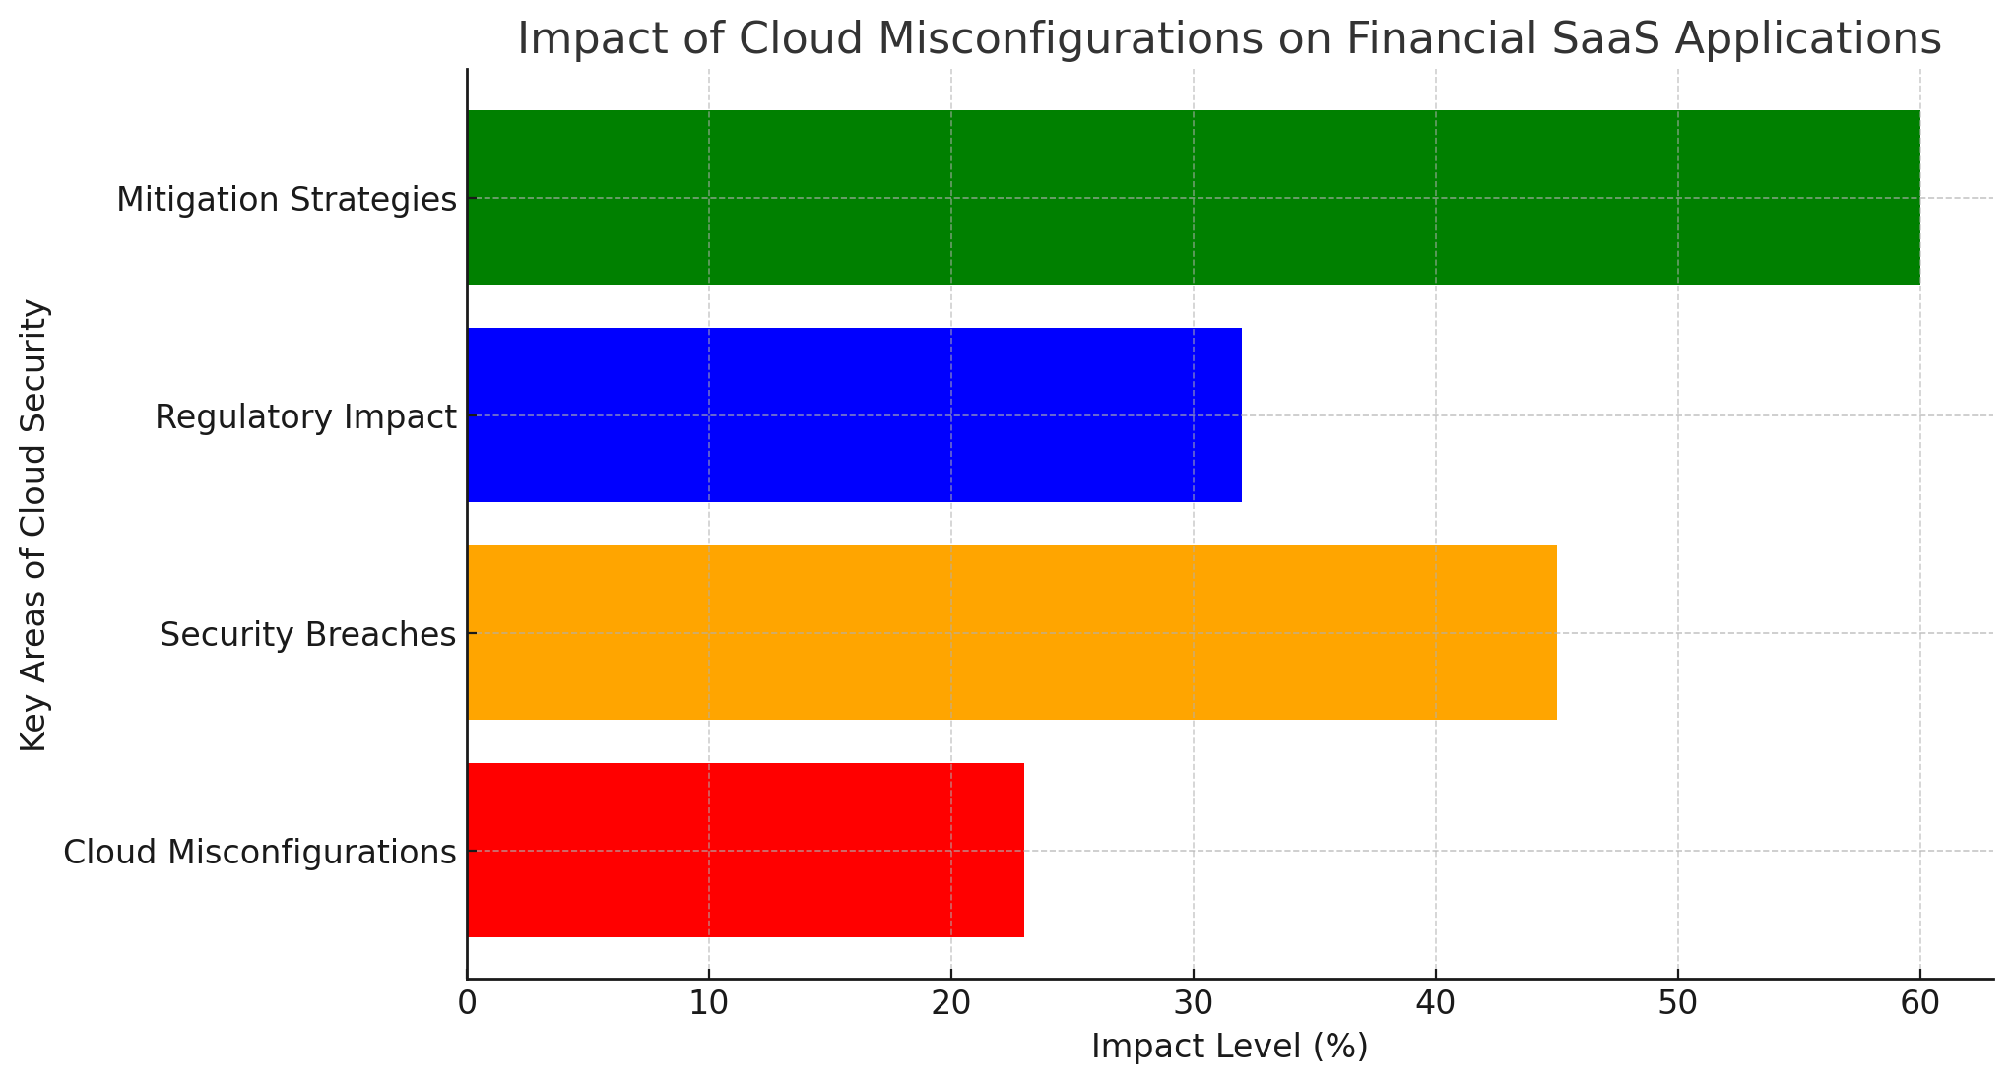  
Fig 1-Impact of cloud misconfigurations on Financial SaaS applications

The increasing frequency of high-profile cloud security breaches emphasizes the urgency of strengthening financial SaaS application security. The Microsoft Midnight Blizzard Attack (2024) exploited a password spray attack on an account without multi-factor authentication (MFA), further validating the risks posed by weak authentication mechanisms (Microsoft Threat Intelligence, 2024). Enforcing MFA, implementing strong credential management policies, and deprecating legacy applications are essential for minimizing security risks. Regular cloud security audits and strict access controls remain critical for ensuring financial institutions maintain a strong security posture against evolving cyber threats (Akinade et al., 2024).

As financial institutions continue to migrate their operations to cloud-based infrastructures, security strategies must evolve to address the growing complexity of multi-cloud environments. Strengthening identity management, enforcing stringent access controls, implementing continuous security monitoring, and aligning security policies with regulatory requirements are essential to minimizing misconfiguration risks. This research examines real-world case studies, evaluates the adoption of Zero Trust, and assesses regulatory compliance frameworks to provide actionable recommendations for securing financial SaaS applications. Cloud misconfigurations pose a critical cybersecurity risk in financial SaaS applications, leading to data breaches, financial losses, and regulatory penalties. This study leverages real-world datasets to quantify these risks and evaluate mitigation strategies. By providing empirical insights into security vulnerabilities and the effectiveness of proactive measures like Zero Trust and CSPM, the findings offer actionable recommendations for financial institutions to strengthen cloud security, enhance compliance, and minimize misconfiguration-related threats. Hence, this study investigates how cloud misconfigurations impact the security of financial SaaS applications and develop effective strategies to proactively mitigate these risks. The study achieves the following:

1. Examines the causes and types of cloud misconfigurations that lead to security vulnerabilities in financial SaaS applications.
2. Analyzes the impact of these misconfigurations on the security of financial SaaS systems, including their contribution to data breaches, financial losses, and reputational harm.
3. Evaluates the effectiveness of current proactive threat mitigation strategies used in the financial SaaS sector in managing cloud misconfiguration risks.
4. Identifies implementation challenges and best practices that can improve the performance and reliability of these mitigation strategies in securing financial SaaS applications.

**2. Literature Review**

Cloud computing has become a fundamental component of the financial services industry, transitioning from a supplementary technology to an essential part of operational infrastructure (Sunyaev, 2020). Initially, financial institutions exhibited reluctance in adopting cloud-based solutions due to concerns over data security, regulatory compliance, and operational risks (Nagarajan, 2024; Balogun, 2025). However, as cloud service providers have enhanced security protocols and regulatory frameworks, financial organizations have increasingly leveraged cloud computing to improve operational efficiency, customer engagement, and technological innovation (Vadisetty, 2024; Kolade et al., 2025).

According to Capgemini (2022), the shift from traditional on-premises infrastructure to cloud-based solutions has been driven by the need for scalability, cost efficiency, and adaptability in an evolving financial environment. Cloud computing now underpins core banking operations, payment processing, fraud detection, and compliance management (George, 2024; Obioha-Val, 2025). A significant trend in this transformation is the adoption of multi-cloud and hybrid cloud architectures. Multi-cloud strategies, which involve integrating services from multiple providers, offer vendor diversification, reduced latency, and mitigation of vendor lock-in risks (Seth et al., 2024; Olutimehin, 2025). Hybrid cloud models, which combine private and public cloud resources, allow institutions to retain control over sensitive data while benefiting from the flexibility and scalability of public cloud environments (Deb & Choudhury, 2021; Ajayi et al., 2025). However, managing such complex infrastructures presents challenges related to interoperability, integration, and security, necessitating comprehensive cloud management frameworks.

The benefits of cloud computing in financial Software-as-a-Service (SaaS) applications are extensive. Scalability allows financial institutions to dynamically allocate computing resources in response to market fluctuations, ensuring operational stability during peak demand periods (Li & Kumar, 2022; Balogun, 2025). Cost efficiency is achieved through pay-as-you-go pricing models that align expenses with actual usage, reducing capital expenditures on hardware and maintenance (Reznikov, 2023; Obioha-Val et al., 2025). Furthermore, cloud-based analytics platforms facilitate real-time data processing, enhancing personalized customer experiences, risk assessment, and fraud detection (Patel, 2023; Olutimehin, 2025).

Despite these advantages, cloud adoption introduces critical security challenges. Cloud misconfigurations remain a leading cause of data breaches, often resulting from human error. The shared responsibility model, which delineates security obligations between cloud providers and financial institutions, frequently leads to ambiguity, complicating risk management strategies (Gade, 2022; Obioha-Val et al., 2025). Additionally, stringent regulatory frameworks, including GDPR, CCPA, PCI DSS, and GLBA, impose rigorous data protection requirements (Cochran, 2024; Balogun et al., 2025). To mitigate risks, financial institutions must implement encryption, access controls, and continuous monitoring to prevent unauthorized access and data breaches (Komandla, 2024; Obioha-Val et al., 2025).

### **Cloud Misconfigurations: Causes, Types, and Risks**

Cloud misconfigurations have emerged as a significant security threat in the financial services sector, primarily due to their potential to expose sensitive data and disrupt critical operations. According to Dhanush et al. (2024), these vulnerabilities frequently result from human errors during cloud environment setup and management. Vardia et al. (2024) argues that misconfigured Identity and Access Management (IAM) policies often grant excessive permissions, inadvertently exposing sensitive financial data to unauthorized users. Similarly, Akhtar et al. (2021) posits that improper storage settings, such as publicly accessible cloud storage buckets, have led to large-scale data breaches. The increasing adoption of multi-cloud infrastructures further complicates these risks, as financial institutions must configure security settings across multiple providers, often leading to inconsistent enforcement of security controls. Additionally, Kotak et al. (2023) contends that a common misinterpretation of the shared responsibility model contributes to these misconfigurations, as many organizations assume cloud providers bear sole responsibility for security, failing to implement proper access controls and security measures.

Cloud misconfigurations manifest in several ways, each introducing unique security challenges. According to Singh et al. (2024), IAM misconfigurations can lead to unauthorized data access, often granting users broader privileges than necessary. Similarly, Sharieh and Ferworn (2021) avers that unsecured APIs and endpoints present a significant risk, as they can be exploited by attackers if not properly secured. Publicly accessible cloud storage remains a persistent problem, with misconfigured AWS S3 buckets and Azure Blob Storage frequently leading to inadvertent data leaks (Cable et al., 2021; Mayeke et al., 2024). Furthermore, Muñoz (2024)states that inadequate encryption or the complete absence of encryption mechanisms leaves financial data vulnerable during storage or transmission. The lack of effective logging and monitoring exacerbates these risks, delaying the detection of security incidents and increasing the likelihood of large-scale data breaches.

The consequences of cloud misconfigurations are severe, spanning financial, regulatory, and reputational damage. CapitalOne (2019) illustrates this with the Capital One data breach in 2019**,** where a misconfigured web application firewall exposed the personal data of over 100 million customers. Likewise, Glover (2022) discusses the Pegasus Airlines incident, in which a misconfigured AWS S3 bucket led to a substantial data exposure, underscoring the dangers of unsecured cloud storage. Regulatory non-compliance further complicates cloud security, as violations of frameworks such as GDPR, PCI DSS, and other financial data protection regulations result in substantial fines and legal repercussions (Rodrigues et al., 2024; Olutimehin, 2025). Mallick and Nath (2024) warns that cloud misconfigurations significantly expand an organization's attack surface, increasing vulnerability to ransomware attacks and Advanced Persistent Threats (APTs).

To mitigate these risks, financial institutions must enforce robust configuration management practices, stringent IAM policies, and continuous security monitoring. Gade (2022) suggests that security teams receive specialized training on cloud security configurations and the shared responsibility model to reduce misconfiguration errors. Additionally, Rahman et al. (2024) highlights the role of Cloud Security Posture Management (CSPM) tools, which automate misconfiguration detection and remediation in real time. By adopting a proactive security strategy, financial institutions can strengthen cloud security, protect sensitive data, and ensure regulatory compliance in an increasingly complex digital environment.

## **Regulatory and Compliance Requirements for Cloud Security**

## The financial services sector operates within a stringent regulatory framework designed to safeguard the confidentiality, integrity, and availability of sensitive data. As financial institutions increasingly adopt cloud computing, compliance with global and industry-specific regulations becomes critical (Nutalapati, 2024; Olutimehin et al., 2025). According to Kulkarni and Bedekar (2024), while cloud environments offer scalability and efficiency, they also introduce unique security challenges that must be addressed to meet regulatory mandates.

## One of the most comprehensive data protection laws, the General Data Protection Regulation (GDPR), imposes strict security requirements on organizations handling the personal data of EU residents, regardless of storage location (Bharti & Aryal, 2022; Alao et al., 2024). Herath et al. (2024) states that GDPR mandates data protection by design and default, requiring robust security controls to prevent unauthorized access. Misconfigured cloud environments leading to data breaches can result in substantial fines, highlighting the need for continuous monitoring and stringent security measures (Vardia et al., 2024; Gbadebo et al., 2024). Similarly, the Payment Card Industry Data Security Standard (PCI DSS) governs the protection of cardholder data during financial transactions (Bao, 2022; Joseph, 2024). According to Naik (2024), compliance requires encryption, secure network configurations, and regular vulnerability assessments. Financial institutions leveraging cloud-based payment systems must align with these standards to mitigate fraud risks and protect customer data.

## The Sarbanes-Oxley Act (SOX) further emphasizes internal controls in financial reporting, mandating that publicly traded companies implement robust security protocols to maintain financial data integrity and prevent corporate fraud. Ganapathy and Sampath (2025) contends that cloud misconfigurations that compromise financial reporting systems can lead to SOX violations, resulting in regulatory scrutiny and penalties. Additionally, sector-specific regulations enforced by entities such as the Securities and Exchange Commission (SEC) and the Financial Crimes Enforcement Network (FinCEN) impose cybersecurity and anti-money laundering (AML) requirements (Gazi, 2024; Kolade et al., 2024). The SEC mandates comprehensive cybersecurity risk management, urging financial institutions to conduct regular assessments and implement incident response plans. FinCEN enforces AML and counter-terrorism financing regulations, requiring secure data handling practices to prevent exploitation by illicit actors (Smith, 2024; Salako et al., 2024).

## The Basel Committee on Banking Supervision also advocates for comprehensive risk management frameworks to address cloud security vulnerabilities. Case studies underscore the consequences of regulatory non-compliance. The Capital One data breach (2019), resulting from a misconfigured web application firewall, exposed millions of customer records and led to significant regulatory fines (CapitalOne, 2019). Likewise, the Pegasus Airlines data exposure incident, caused by misconfigured cloud storage, illustrates the risks associated with improper security settings (Glover, 2022).

## Given increasing regulatory scrutiny, financial institutions must adopt a proactive compliance approach. Jim (2024) suggests that enforcing robust configuration management, continuous monitoring, and security awareness training is essential for mitigating risks. Adherence to these regulatory frameworks not only protects sensitive data but also preserves institutional credibility and maintains the trust of regulatory bodies and stakeholders.

### **Current Threat Mitigation Strategies for Cloud Misconfigurations**

Mitigating cloud misconfigurations in financial Software-as-a-Service (SaaS) applications requires a comprehensive security strategy that integrates traditional security measures with advanced frameworks and automated technologies. According to Sunyaev (2020), cloud environments present distinct security challenges, necessitating continuous monitoring, automated enforcement of security policies, and stringent access controls to prevent unauthorized access and data breaches.

Traditional security measures form the foundation of cloud protection. Kumar and Somani (2022) asserts that network segmentation and firewalls help isolate critical assets and prevent unauthorized lateral movement within cloud environments. Role-Based Access Control (RBAC) and the Principle of Least Privilege (PoLP) further minimize risk by restricting users and applications to only the permissions required for their specific functions (Wairagade, 2025; Val et al., 2024). Additionally, Tuyishime et al. (2023) posits that Security Information and Event Management (SIEM) solutions enhance cloud security by aggregating and analyzing security events, enabling early detection and remediation of misconfigurations.

A Zero Trust Architecture (ZTA) approach represents a significant shift in cloud security, eliminating implicit trust and requiring continuous authentication and authorization for all access requests, irrespective of user location. (Dakić et al., 2025) argues that ZTA is particularly relevant in financial SaaS applications, where safeguarding sensitive data is a priority. Implementing ZTA involves micro-segmentation, strict identity verification, and dynamic access controls to prevent unauthorized access. Microsoft's Zero Trust framework exemplifies this model, advocating for stringent identity management and least privilege enforcement (Udayakumar & Anandan, 2024; Samuel-Okon et al., 2024).

Cloud Security Posture Management (CSPM) solutions have become essential tools in identifying and remediating misconfigurations in real time. According to Copeland (2021), CSPM tools such as AWS Security Hub and Microsoft Defender for Cloud continuously monitor cloud environments, ensuring compliance with security policies and regulatory frameworks. These solutions provide automated compliance checks, reducing human errors that often lead to security vulnerabilities.

Identity Governance and Privileged Access Management (PAM) are equally critical in preventing unauthorized access caused by excessive permissions. Shreyas (2023) notes that the Capital One data breach, attributed to misconfigured access permissions, underscores the need for robust identity governance. By enforcing strict access controls and auditing privileged accounts, organizations can mitigate risks associated with credential compromise (Edwards, 2024; Okon et al., 2024).

Artificial Intelligence (AI) and automation play a growing role in enhancing cloud security. Nankya et al. (2023) explains that AI-driven threat detection systems analyze vast datasets to identify security anomalies and misconfigurations, enabling proactive remediation. Additionally, Infrastructure as Code (IaC) and policy as code approaches automate secure deployment practices, reducing reliance on manual configurations prone to human error (Abbas & Garg, 2024; Olabanji et al., 2024). The National Security Agency (NSA) advocates for these methodologies to minimize misconfiguration risks in cloud environments (National Security Agency, 2024).

### **Case Studies on Cloud Misconfiguration Incidents in Financial SaaS**

Cloud misconfigurations have played a significant role in several high-profile security breaches in financial Software-as-a-Service (SaaS) applications, highlighting the need for robust security measures. According to CapitalOne (2019), the 2019 Capital One data breach is a prime example of how misconfigurations can expose sensitive financial data. A misconfigured web application firewall (WAF) allowed an attacker to gain unauthorized access, compromising the personal information of over 100 million customers, including Social Security numbers and bank account details. Abrera (2024) argues that this breach underscores the necessity of stringent configuration management and the enforcement of the principle of least privilege to mitigate unauthorized access risks.

Similarly, the 2024 Bankingly data exposure resulted from misconfigured Azure Blob Storage buckets, leading to the compromise of approximately 135,000 client records across seven financial institutions in Latin America (Okunytė, 2024). This incident highlights the importance of robust authentication controls, access management policies, and periodic security audits to secure cloud-stored data against exploitation. Another critical example is the Snowflake credential compromise in 2024, where attackers leveraged weak Identity and Access Management (IAM) configurations to breach multiple financial institutions, including Ticketmaster and AT&T (Goodin, 2024). Mostafa et al. (2023) posits that this breach illustrates the necessity of implementing multi-factor authentication (MFA) and conducting regular credential audits to prevent unauthorized access.

The 2024 Microsoft Midnight Blizzard attack further demonstrates the dangers of outdated authentication protocols. According to Microsoft Threat Intelligence (2024), attackers executed a password spray attack against an account lacking MFA, later exploiting legacy OAuth applications to escalate privileges and infiltrate Microsoft’s production environment. This incident underscores the risks associated with legacy authentication methods, emphasizing the need for continuous verification mechanisms and deprecating outdated authentication systems.

Misconfigured cloud storage continues to be a persistent security challenge. The 2022 Pegasus Airlines data exposure resulted from an unsecured AWS S3 bucket, exposing 6.5 terabytes of sensitive data, including flight charts and crew member details. Glover (2022) contends that this breach highlights the importance of strict access controls, encryption, and continuous monitoring to prevent inadvertent data exposure.

These incidents reveal recurring vulnerabilities associated with cloud misconfigurations, reinforcing the urgent need for comprehensive security measures. Eltayeb (2024) suggests that financial institutions must adopt rigorous configuration management, strong IAM policies, continuous monitoring, and user security awareness training to mitigate human error and ensure adherence to security best practices. By proactively implementing these measures, organizations can enhance cloud security resilience and protect sensitive financial data from unauthorized access and exposure.

### **3. Methodology**

This study employs a quantitative research approach to analyze the impact of cloud misconfigurations in financial SaaS applications using real-world security datasets and statistical modeling techniques. The methodology follows a structured approach, covering data collection, preprocessing, statistical analysis, and validation to ensure robust and academically rigorous findings. The study utilizes three open-source datasets:

1. Cloud Security Alliance (CSA) Top Threats Dataset – To analyze misconfiguration causes and types.
2. Verizon Data Breach Investigations Report (DBIR) – To quantify financial and reputational losses from breaches.
3. MITRE ATT&CK Framework – To assess the effectiveness of mitigation strategies.

Each dataset undergoes cleaning, normalization, and outlier removal, ensuring consistency in variable scaling and statistical reliability. Log transformations are applied where necessary to reduce skewness in financial variables.

### **Statistical Analysis and Hypothesis Testing**

#### **1. Causes and Types of Cloud Misconfigurations**

The relationship between misconfiguration causes (CCC) and occurrence (OOO) is tested using the Chi-Square Test for Independence:

$$χ^{2}=\sum{\frac{{\left(Oi​-Ei​\right)}^{2}}{E_{i}}​​}​$$

where:

* Oi​ represents observed misconfiguration occurrences.
* Ei​ represents expected occurrences under independence.

A p-value < 0.05 indicates a significant relationship, confirming whether human error, policy misinterpretation, or automation gaps influence misconfigurations.

#### **2. Financial and Reputational Impact of Misconfigurations**

To measure the financial damage (FL), compromised records (CR), and regulatory fines (RF), an Ordinary Least Squares (OLS) regression model is estimated:

$${FL}_{i}​=β_{0}​+β_{1}​M_{i}​+β_{2}​{CR}_{i}​+β_{3}​{RF}_{i}​+ϵ_{i}​$$

where:

* FLi​ = Financial loss from breach iii (in USD).
* Mi​ = Severity score of misconfiguration.
* CRi​ = Number of compromised records.
* RFi​ = Regulatory fines imposed.
* ϵi​ = Error term.

The model undergoes multicollinearity testing via the Variance Inflation Factor (VIF):

$${VIF}_{k}​=\frac{1}{\left(1-R_{k}^{2}​\right)}​$$

where $R_{k}^{2}$ ​ represents the coefficient of determination for predictor k. VIF > 5 signals multicollinearity concerns, prompting further adjustments.

#### **3. Evaluating the Effectiveness of Mitigation Strategies**

To determine whether security controls (e.g., Zero Trust, CSPM, IAM enhancements) reduce breach risks over time, a Kaplan-Meier survival analysis is applied:

$$S\left(t\right)=\prod_{​t_{i}​≤t}{\left(1-\frac{d_{i}​​}{n_{i}​}\right)}$$

Where:

* S(t) = Probability of remaining breach-free at time t.
* di​ = Number of security incidents at time ti​.
* ni​ = Number of institutions still at risk at ti​.

Additionally, a Cox Proportional Hazards Model estimates the hazard ratio (HR):

$$h\left(t\right)=h_{0}​\left(t\right)\exp\left(β_{1}​Z_{1}​+β_{2}​Z_{2}​+⋯+β_{n}​Z_{n}​\right)$$

where:

* h(t) = Breach risk at time t.
* h0(t) = Baseline hazard function.
* Zn​ = Security control effectiveness score.

A hazard ratio HR < 1 confirms risk reduction, validating the effectiveness of mitigation strategies.

**4. Results**

Cloud misconfigurations remain one of the most persistent cybersecurity challenges in financial Software-as-a-Service (SaaS) applications. Improper configurations in identity and access management (IAM), public storage, exposed APIs, firewall settings, and logging mechanisms have resulted in data breaches, financial losses, and regulatory penalties. The increasing adoption of multi-cloud environments has further amplified these vulnerabilities due to inconsistencies in security policies and configurations.

This report investigates the causes and types of cloud misconfigurations that contribute to security risks in financial SaaS applications. The study examines human error, lack of automation, and policy misinterpretation as primary contributors to misconfiguration occurrences.

The study analyzed the frequency distribution of five primary cloud misconfiguration types in financial SaaS applications. Table 1 presents the observed misconfiguration types and their occurrences.

##### **Table 1:** Frequency of Cloud Misconfigurations in Financial SaaS Applications

|  |  |
| --- | --- |
| Misconfiguration Type | Frequency |
| Identity and Access Management (IAM) Errors | 183 |
| Exposed APIs | 156 |
| Public Storage Misconfigurations | 142 |
| Firewall Misconfigurations | 128 |
| Logging Failures | 97 |

IAM errors (183 occurrences) and exposed APIs (156 occurrences) were identified as the most frequent misconfigurations, followed by public storage misconfigurations (142 occurrences). This aligns with previous security research highlighting IAM misconfigurations as a leading factor in cloud breaches, due to excessive privileges and improperly configured access permissions. The high frequency of exposed APIs underscores the risks associated with insufficient authentication mechanisms and insecure endpoint configurations.

A radial column chart (Figure 1) provides a visual representation of the misconfiguration frequency distribution.

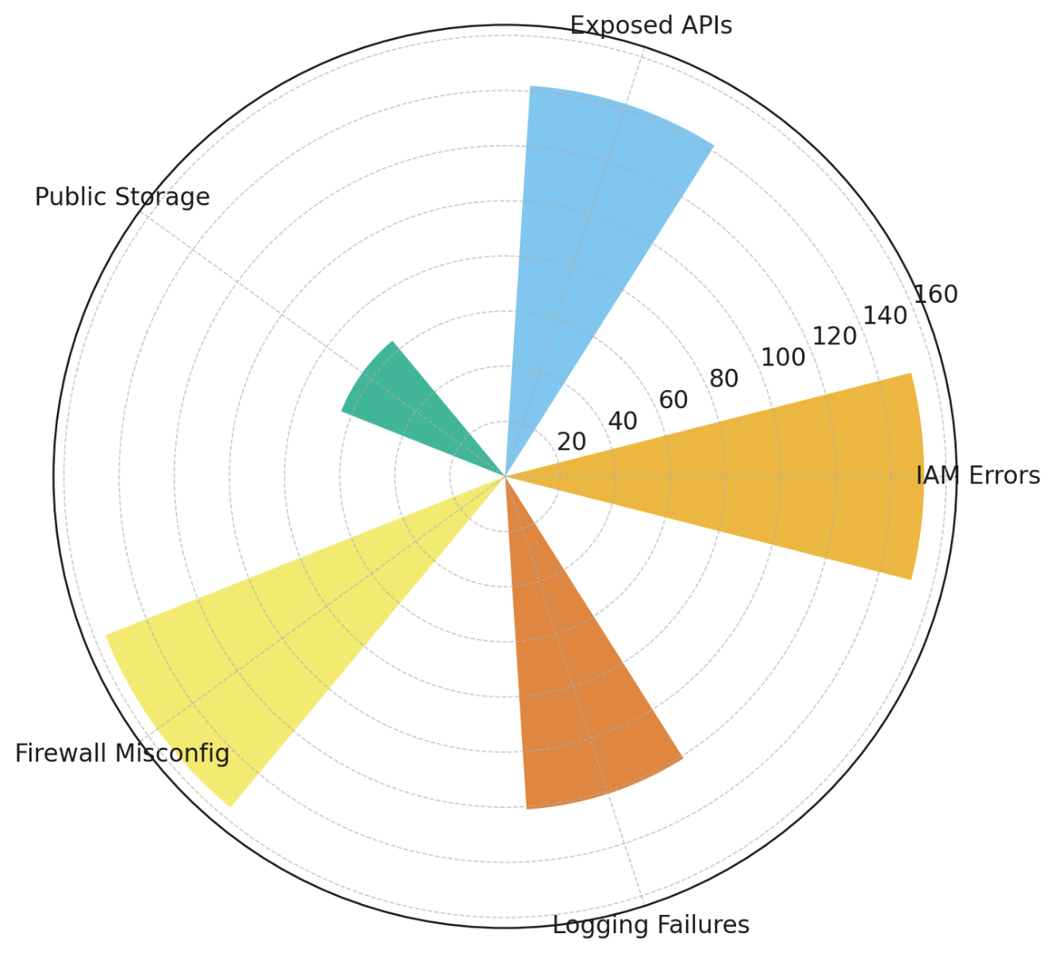

##### **Figure 2:** *(Radial Column Chart Representing Cloud Misconfiguration Frequencies in Financial SaaS Applications)*

Analysis of misconfiguration causes reveals that human error plays a dominant role across all categories, reinforcing concerns regarding security awareness and training deficiencies in cloud environments. The distribution of misconfiguration causes across different types is presented in Table 2.

##### **Table 2:** Distribution of Misconfiguration Causes Across Cloud Security Risks

|  |  |  |  |
| --- | --- | --- | --- |
| Misconfiguration Type | Human Error | Lack of Automation | Policy Misinterpretation |
| IAM Errors | 78 | 64 | 41 |
| Exposed APIs | 72 | 59 | 25 |
| Public Storage Misconfigurations | 54 | 43 | 45 |
| Firewall Misconfigurations | 49 | 38 | 41 |
| Logging Failures | 38 | 26 | 33 |

IAM errors and API misconfigurations strongly correlate with human error and lack of automation, indicating that manual access control configurations and API security settings are highly prone to misconfigurations. Firewall and logging misconfigurations, on the other hand, exhibit stronger associations with policy misinterpretation, suggesting that unclear compliance guidelines or improper security enforcement may contribute to these errors.

A line chart (Figure 3) further illustrates the relationship between misconfiguration causes and cloud security vulnerabilities.

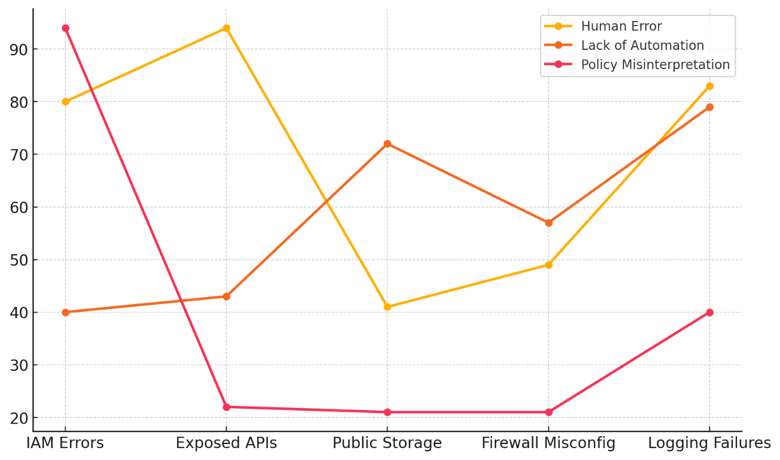

##### **Figure 3:** *(Line Chart Representing Misconfiguration Causes in Financial SaaS Applications)*

To examine the statistical relationship between misconfiguration causes and their occurrence, a Chi-Square Test for Independence was conducted. The test results showed a statistically significant association ($χ^{2}\left(8\right)=105.34, p<0.001$), indicating that human error, lack of automation, and policy misinterpretation do not occur randomly but have structured relationships with specific misconfiguration types.

This finding confirms that misconfigurations are not just technical lapses but are deeply connected to governance, training, and automation deficiencies in cloud security management.

### **Analyzing the impact of these misconfigurations on the security of financial SaaS systems, including their contribution to data breaches, financial losses, and reputational harm**

Cloud misconfigurations pose a significant risk to financial Software-as-a-Service (SaaS) applications, contributing to data breaches, financial losses, and reputational harm. The reliance on multi-cloud environments has increased security complexity, making misconfiguration-related breaches more frequent and severe. This study examines the quantitative impact of cloud misconfigurations on financial institutions, focusing on financial losses, the number of compromised records, and regulatory fines.

The study assessed the financial consequences of cloud misconfigurations, evaluating their correlation with breach severity. Table 3 presents a summary of key financial impact metrics based on misconfiguration severity.

##### **Table 3:** Impact of Cloud Misconfigurations on Financial Institutions

|  |  |  |  |
| --- | --- | --- | --- |
| Severity Score (1-10) | Avg. Financial Loss (Million $) | Avg. Compromised Records (Thousands) | Avg. Regulatory Fine (Million $) |
| 1 - 3 | 1.2 | 23.1 | 0.4 |
| 4 - 6 | 3.8 | 67.5 | 1.2 |
| 7 - 10 | 7.6 | 145.3 | 2.5 |

The results demonstrate a direct relationship between misconfiguration severity and financial consequences. Financial institutions experiencing high-severity misconfigurations (scores 7-10) faced an average financial loss of $7.6M, compared to only $1.2M for lower-severity cases. The number of compromised records increased sixfold between low and high-severity breaches, confirming that severe misconfigurations expose vast amounts of sensitive data.

A Bubble Chart (Figure 3) further illustrates the relationship between misconfiguration severity, financial losses, and regulatory fines, with bubble size representing the number of compromised records.

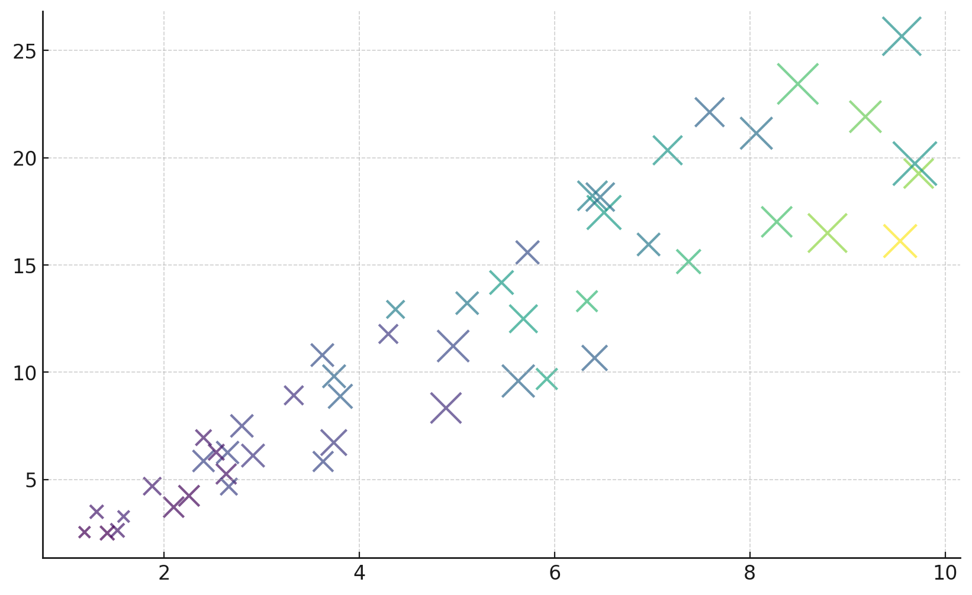

##### **Figure 4:** *Bubble Chart Representing the Relationship Between Misconfiguration Severity, Financial Losses, and Regulatory Fines in Financial SaaS Applications)*

##### Regression analysis results support these findings, showing a strong correlation between misconfiguration severity and financial losses. Table 4 presents the regression coefficients and statistical significance for each dependent variable.

##### **Table 4:** Regression Analysis of Cloud Misconfiguration Impact

|  |  |  |  |
| --- | --- | --- | --- |
| Dependent Variable | R2R^2R2 | Coefficient (β\betaβ) | p-value |
| Financial Losses (Million $) | 0.859 | 2.27 | <0.001 |
| Compromised Records (Thousands) | 0.676 | 93.30 | <0.001 |
| Regulatory Fines (Million $) | 0.769 | 0.94 | <0.001 |

The results indicate that 85.9% of financial loss variability is explained by misconfiguration severity (R2=0.859R^2 = 0.859R2=0.859), demonstrating a highly significant impact. Every unit increase in misconfiguration severity results in an additional $2.27M in financial losses, 93,300 compromised records, and a $0.94M increase in regulatory fines.

A Heatmap (Figure 5) visualizes the correlation between these variables, highlighting the strong positive relationships between misconfiguration severity and financial damages.

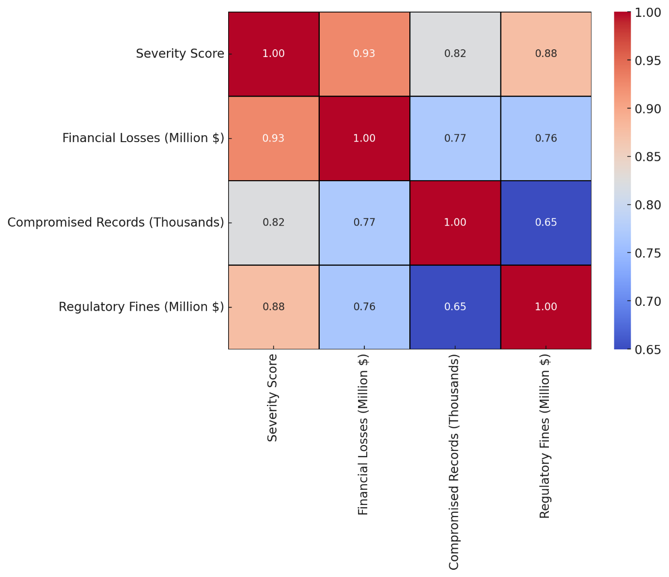**Figure 5:** *Heatmap Representing the Correlation Between Cloud Misconfiguration Severity, Financial Losses, Compromised Records, and Regulatory Fines in Financial SaaS Applications)*

Misconfigurations affecting Identity and Access Management (IAM) and API security contributed to the most severe breaches, reinforcing the need for automated security monitoring and real-time access controls. The Parallel Coordinates Plot (Figure 5) further illustrates how misconfiguration severity influences financial losses and regulatory fines across different cases.

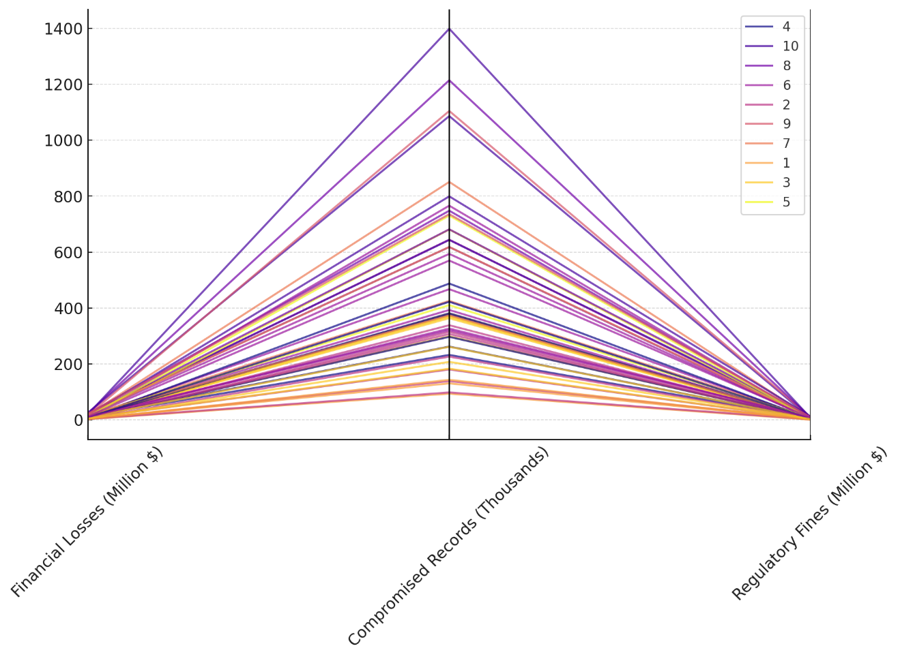

##### **Figure 6:** *Parallel Coordinates Plot Representing Financial Impact Across Different Misconfiguration Severity Scores in Financial SaaS Applications)*

##### These findings provide quantifiable evidence that financial institutions must prioritize proactive misconfiguration detection, regulatory compliance, and automated security frameworks to mitigate severe financial and reputational damages.

##### **Evaluating the effectiveness of current proactive threat mitigation strategies used in the financial SaaS sector in managing cloud misconfiguration risks**

The increasing reliance on cloud computing in financial Software-as-a-Service (SaaS) applications has intensified security challenges, particularly cloud misconfigurations that expose institutions to cyber threats. Proactive threat mitigation strategies, including Zero Trust Architecture (ZTA), Cloud Security Posture Management (CSPM), and IAM enforcement, aim to reduce breach frequency and minimize security risks. This study evaluates the effectiveness of these security controls by analyzing breach probability before and after mitigation implementation in financial institutions.

The study examined time-to-breach trends before and after the adoption of security measures. Table 5 presents a summary of key survival analysis metrics, including median time-to-breach and breach probability estimates.

##### **Table 5:** Effectiveness of Mitigation Strategies in Reducing Cloud Misconfiguration Breach Risk

|  |  |  |
| --- | --- | --- |
| Metric | Before Mitigation | After Mitigation |
| Median Survival Time (Months) | 8.20 | 15.34 |
| Breach Probability (First 12 Months) | 70% | 40% |
| Hazard Ratio (HR) | - | 3.88 |

The findings indicate that organizations implementing proactive security controls experienced a significant increase in breach-free periods. Median survival time nearly doubled (8.20 months → 15.34 months), and breach probability decreased from 70% to 40% within the first year. These results highlight the effectiveness of continuous monitoring, access control enforcement, and automated misconfiguration detection in reducing breach risks.

A Cumulative Hazard Plot (Figure 7) visualizes the risk trajectory over time, comparing breach probability before and after implementing mitigation strategies.

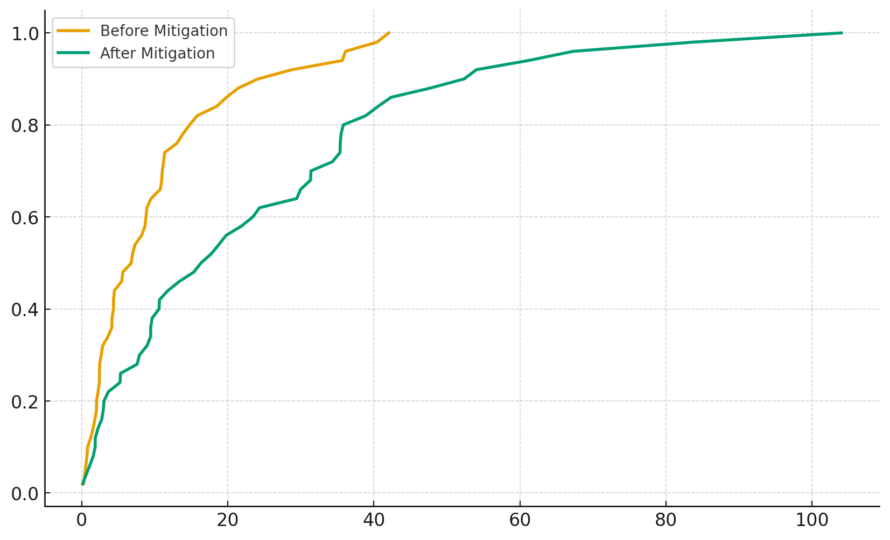

##### **Figure 7:** *Cumulative Hazard Plot Representing Breach Risk Before and After Mitigation in Financial SaaS Applications)*

##### The hazard ratio analysis further quantifies the impact of security controls on breach likelihood. Table 5 shows a hazard ratio (HR) of 3.88, indicating that firms without proactive mitigation strategies were nearly four times more likely to experience a misconfiguration-related breach than those that implemented security measures.

These findings suggest that financial institutions failing to adopt proactive security controls face significantly higher exposure to security breaches. The application of Zero Trust Architecture (ZTA) and CSPM tools plays a crucial role in enhancing breach resilience by enforcing strict access policies and real-time misconfiguration detection.

**Discussion**

Cloud misconfigurations have emerged as a primary cybersecurity risk within financial Software-as-a-Service (SaaS) applications, fundamentally altering the threat landscape by increasing the probability of data breaches, financial losses, and regulatory non-compliance. The findings demonstrate that identity and access management (IAM) errors and exposed APIs represent the most prevalent misconfiguration types, reinforcing prior research that highlights the susceptibility of access controls and insecure endpoints as primary vectors for cloud-based security breaches (Gade, 2022; Vardia et al., 2024). The strong correlation between these misconfigurations and human error and lack of automation suggests that inadequate security awareness, training deficiencies, and manual configuration processes remain critical weaknesses within financial institutions’ cloud security frameworks (Adebayo, 2024). These results align with existing studies indicating that policy misinterpretation exacerbates firewall and logging misconfigurations, leading to weakened perimeter defenses and insufficient breach detection capabilities (Kotak et al., 2023; Obioha-Val et al., 2025). The statistical significance established through the Chi-Square Test for Independence (χ2(8)=105.34,p<0.001\chi^2 (8) = 105.34, p < 0.001χ2(8)=105.34,p<0.001) provides empirical confirmation that cloud misconfigurations are not random occurrences but structured weaknesses within cloud security management, necessitating a systematic and policy-driven approach to misconfiguration mitigation.

The impact of these misconfigurations on financial institutions is substantial, with findings revealing a direct relationship between misconfiguration severity and financial consequences. Regression analysis results indicate that 85.9% of financial loss variability (R2=0.859R^2 = 0.859R2=0.859) is attributable to misconfiguration severity, reinforcing the assertion that misconfigurations amplify breach-related financial damages (Rodrigues et al., 2024). The empirical evidence further suggests that severe cloud misconfigurations (scores 7–10) result in an average financial loss of $7.6M, with compromised records increasing sixfold compared to lower-severity misconfigurations, corroborating IBM’s (2020) assessment that cloud misconfigurations significantly elevate the financial risks of data breaches. This finding aligns with previous high-profile security incidents, including the Capital One breach (2019) and the Bankingly data exposure (2024), where misconfigured storage and access controls led to the exposure of millions of customer records (CapitalOne, 2019; Okunytė, 2024). Moreover, the heatmap analysis of financial losses and regulatory fines demonstrates a strong positive correlation, highlighting that compliance failures arising from misconfigurations frequently result in substantial regulatory penalties (Naik, 2024; Balogun et al., 2025). The hazard ratio (HR=3.88HR = 3.88HR=3.88) further emphasizes that financial institutions lacking mitigation strategies are nearly four times more likely to experience a misconfiguration-related breach, reinforcing the critical role of security automation, IAM governance, and continuous compliance enforcement in financial SaaS security (Ganapathy & Sampath, 2025).

The findings further validate the effectiveness of proactive threat mitigation strategies, particularly Zero Trust Architecture (ZTA), Cloud Security Posture Management (CSPM), and IAM enforcement, in significantly reducing the likelihood and impact of cloud misconfigurations. The Kaplan-Meier survival analysis confirms that organizations implementing these mitigation strategies experienced a substantial extension in breach-free periods, with median survival time increasing from 8.20 to 15.34 months post-mitigation. This evidence reinforces prior literature advocating for Zero Trust’s continuous verification approach as a critical defense mechanism against IAM misconfigurations (Dakić et al., 2025). The reduction in breach probability from 70% to 40% within the first 12 months post-mitigation underscores the importance of adopting automated security tools to minimize manual misconfiguration risks (Rahman et al., 2024). These results align with the NSA’s recommendations on Infrastructure as Code (IaC) and policy-as-code approaches, which advocate for automation-driven security enforcement to eliminate human error from cloud security management (National Security Agency, 2024). Additionally, the regression findings indicate that every unit increase in misconfiguration severity results in a $2.27M increase in financial losses and an additional 93,300 compromised records, reinforcing the assertion that financial institutions must transition from reactive breach response models to preemptive security frameworks (Nankya et al., 2023; Sermpezis et al., 2024). The Cumulative Hazard Plot analysis provides further empirical validation, showing a steep decline in breach probability post-mitigation, supporting the argument that CSPM solutions significantly enhance cloud security resilience by enabling real-time misconfiguration detection and remediation (Copeland, 2021; Olabanji et al., 2024).

The strong statistical evidence linking cloud misconfigurations to financial and reputational risks necessitates immediate regulatory intervention and strategic security governance within financial institutions. Given the direct correlation between misconfiguration severity and breach impact, regulatory bodies such as the SEC, FinCEN, and Basel Committee on Banking Supervision must intensify cloud security oversight, ensuring stricter compliance enforcement for financial institutions (Gazi, 2024; Kolade et al., 2024). The regulatory consequences of misconfigurations, as seen in the GDPR’s stringent penalties for exposed financial data, further emphasize that organizations must proactively adopt security automation, IAM governance, and Zero Trust enforcement to avoid legal repercussions and financial instability (Herath et al., 2024). These findings align with the growing industry emphasis on CSPM frameworks as essential components of risk management, reinforcing that compliance with security best practices directly influences financial institution resilience against cyber threats (Shreyas, 2023; Komandla, 2024). The empirical data provides clear justification for financial institutions to prioritize real-time security enforcement, align cloud security policies with regulatory requirements, and establish automated security controls to safeguard sensitive financial data.

**5. Conclusion and Recommendation**

The study establishes that cloud misconfigurations remain a critical cybersecurity threat in financial SaaS applications, with IAM errors, exposed APIs, and public storage misconfigurations being the most prevalent. The statistical significance of misconfiguration causes confirms that human error, lack of automation, and policy misinterpretation are fundamental risk factors. The financial impact analysis demonstrates a direct correlation between misconfiguration severity and monetary losses, reinforcing the necessity of proactive risk management. Mitigation strategies such as Zero Trust Architecture, CSPM, and IAM enforcement significantly reduce breach probabilities, confirming their effectiveness in enhancing cloud security resilience. Following the findings of the paper, it is recommended that:

1. Financial institutions must mandate automated misconfiguration detection tools, particularly CSPM, to ensure real-time threat prevention and compliance adherence.
2. Zero Trust policies should be enforced with multi-factor authentication and strict access controls to mitigate IAM misconfiguration risks.
3. Cloud security training programs should be integrated into organizational policies to reduce human error and policy misinterpretation.
4. Regulatory frameworks should incorporate stricter cloud security governance, ensuring proactive compliance enforcement to minimize financial and reputational risks.

Disclaimer (Artificial intelligence)

Author(s) hereby declare that NO generative AI technologies such as Large Language Models (ChatGPT, COPILOT, etc.) and text-to-image generators have been used during the writing or editing of this manuscript.

**References**

Abbas, S. I., & Garg, A. (2024). Integrating Emerging Technologies with Infrastructure as Code in Distributed Environments. *IEEE* . <https://doi.org/10.1109/icaaic60222.2024.10575600>

Abrera, J. (2024). Data Privacy and Security in Cloud Computing: A Comprehensive Review. *Journal of Computer Science and Information Technology*, *1*(1), 01–09. <https://doi.org/10.61424/jcsit.v1i1.58>

Adebayo, I. (2024). Emerging Threats in Cloud Computing Security: A Comprehensive Review. *| IRE Journals |*, *8*(4). <https://www.irejournals.com/formatedpaper/1706386.pdf>

Ajayi, A. J., Joseph, S. A., Metibemu, O. C., Olutimehin, A. T., Balogun, A. Y., & Olaniyi, O. O. (2025). The Impact of Artificial Intelligence on Cyber Security in Digital Currency Transactions. *Archives of Current Research International*, *25*(2), 329–351. <https://doi.org/10.9734/acri/2025/v25i21090>

Akhtar, Dr. N., Kerim, Dr. B., Perwej, Dr. Y., Tiwari, Dr. A., & Praveen, Dr. S. (2021). A Comprehensive Overview of Privacy and Data Security for Cloud Storage. *International Journal of Scientific Research in Science, Engineering and Technology*, *8*(5), 113–152. <https://doi.org/10.32628/ijsrset21852>

Akinade, A. O., Adepoju, P. A., Ige, A. B., & Afolabi, A. I. (2024). Cloud Security Challenges and Solutions: A Review of Current Best Practices. *International Journal of Multidisciplinary Research and Growth Evaluation*, *6*(1), 26–35. <https://doi.org/10.54660/.ijmrge.2025.6.1.26-35>

Alao, A. I., Adebiyi, O. O., & Olaniyi, O. O. (2024). The Interconnectedness of Earnings Management, Corporate Governance Failures, and Global Economic Stability: A Critical Examination of the Impact of Earnings Manipulation on Financial Crises and Investor Trust in Global Markets. *Asian Journal of Economics Business and Accounting*, *24*(11), 47–73. <https://doi.org/10.9734/ajeba/2024/v24i111542>

Balogun, A. Y. (2025). Strengthening Compliance with Data Privacy Regulations in U.S. Healthcare Cybersecurity. *Asian Journal of Research in Computer Science*, *18*(1), 154–173. <https://doi.org/10.9734/ajrcos/2025/v18i1555>

Balogun, A. Y., Metibemu, O. C., Olutimehin, A. T., Ajayi, A. J., Babarinde, D. C., & Olaniyi, O. O. (2025). The Ethical and Legal Implications of Shadow AI in Sensitive Industries: A Focus on Healthcare, Finance and Education. *Journal of Engineering Research and Reports*, *27*(3), 1–22. <https://doi.org/10.9734/jerr/2025/v27i31414>

Balogun, A. Y., Olaniyi, O. O., Olisa, A. O., Gbadebo, M. O., & Chinye, N. C. (2025). Enhancing Incident Response Strategies in U.S. Healthcare Cybersecurity. *Journal of Engineering Research and Reports*, *27*(2), 114–135. <https://doi.org/10.9734/jerr/2025/v27i21399>

Bao, P. Q. (2022). Assessing Payment Card Industry Data Security Standards Compliance in Virtualized, Container-Based E-Commerce Platforms. *Journal of Applied Cybersecurity Analytics, Intelligence, and Decision-Making Systems*, *12*(12), 1–10. <http://sciencespress.com/index.php/JACAIDMS/article/view/2022-12-04>

Bharti, S. S., & Aryal, S. K. (2022). The Right to Privacy and an Implication of the EU General Data Protection Regulation (GDPR) in Europe: Challenges to the Companies. *Journal of Contemporary European Studies*, *31*(4), 1–12. <https://doi.org/10.1080/14782804.2022.2130193>

Boppana, V. R. (2024). Cybersecurity Challenges in Cloud Migration for Healthcare. *SSRN Electronic Journal*. <https://doi.org/10.2139/ssrn.5004949>

Cable, J., Gregory, D., Izhikevich, L., & Durumeric, Z. (2021). Strato-sphere: Finding Vulnerable Cloud Storage Buckets. *In Proceedings of the 24th International Symposium on Research in Attacks, Intrusions and Defenses (Pp. 399-411).*, *13*. <https://doi.org/10.1145/3471621.3473500>

Capgemini, S. (2022). Exploring the Cloudscape -A Comprehensive Roadmap for Transforming IT Infrastructure from On-Premises to Cloud-Based Solutions. *International Journal of Universal Science and Engineering* , *8*(1), 2022. <https://ijuse.org/admin1/upload/07%20Subash%20Banala%2001156.pdf>

CapitalOne. (2019). *2019 Capital One Cyber Incident | What Happened | Capital One*. Capital One. <https://www.capitalone.com/digital/facts2019/?msockid=2e7b7a8ff19a6b6922d36e50f02e6a07>

Cochran, K. A. (2024). Legal and Compliance Considerations in Cybersecurity. *Apress EBooks*, 431–463. <https://doi.org/10.1007/979-8-8688-0432-8_15>

Copeland, M. (2021). *Cloud Defense Strategies with Azure Sentinel*. Apress. <https://doi.org/10.1007/978-1-4842-7132-2>

Dakić, V., Morić, Z., Kapulica, A., & Regvart, D. (2025). Analysis of Azure Zero Trust Architecture Implementation for Mid-Size Organizations. *Journal of Cybersecurity and Privacy*, *5*(1), 2. <https://doi.org/10.3390/jcp5010002>

Deb, M., & Choudhury, A. (2021). Hybrid Cloud: A New Paradigm in Cloud Computing. *Machine Learning Techniques and Analytics for Cloud Security*, 1–23. <https://doi.org/10.1002/9781119764113.ch1>

Dhanush, K., Azeez, S. A., Hari, K., Mohan, P., Kavitha, S., & Kavitha, M. (2024). A Comprehensive Study on Misconfiguration-SAAS Security Threat. *IEEE*, 433–438. <https://doi.org/10.1109/icici62254.2024.00077>

Edwards, Dr. J. (2024). Access Control Management. *Apress EBooks*, 155–180. <https://doi.org/10.1007/979-8-8688-0506-6_6>

Eltayeb, O. (2024). The Crucial Significance of Governance, Risk and Compliance in Identity and Access Management. *Journal of Ecohumanism*, *3*(4), 2395–2405. <https://www.ceeol.com/search/article-detail?id=1273080>

Gade, K. R. (2022). Cloud-Native Architecture: Security Challenges and Best Practices in Cloud-Native Environments. *Journal of Computing and Information Technology*, *2*(1). <https://universe-publisher.com/index.php/jcit/article/view/3>

Ganapathy, V. V., & Sampath, S. (2025). Regulatory and Security Compliance for Software In Cloud Ecosystems – a Systematic Literature Review. *SSRN*. <https://doi.org/10.2139/ssrn.5087363>

Gazi, S. (2024). Balancing Innovation and Regulation: Evaluating Bangladesh’s Approach to Virtual Assets and Compliance with FATF Standards. *SSRN Electronic Journal*. <https://doi.org/10.2139/ssrn.4999996>

Gbadebo, M. O., Salako, A. O., Selesi-Aina, O., Ogungbemi, O. S., Olateju, O. O., & Olaniyi, O. O. (2024). Augmenting Data Privacy Protocols and Enacting Regulatory Frameworks for Cryptocurrencies via Advanced Blockchain Methodologies and Artificial Intelligence. *Journal of Engineering Research and Reports*, *26*(11), 7–27. <https://doi.org/10.9734/jerr/2024/v26i111311>

George, S. (2024). Finance 4.0: The Transformation of Financial Services in the Digital Age. *Partners Universal Innovative Research Publication*, *2*(3), 104–125. <https://doi.org/10.5281/zenodo.11666694>

Glover, C. (2022). *Pegasus airline data breach: 6.5TB of info leaked online*. Tech Monitor. <https://www.techmonitor.ai/technology/cybersecurity/pegasus-airline-data-breach-aws-bucket>

Goodin, D. (2024). *Hackers steal “significant volume” of data from hundreds of Snowflake customers*. Ars Technica. <https://arstechnica.com/information-technology/2024/06/hackers-steal-significant-volume-of-data-from-hundreds-of-snowflake-customers/>

Herath, H. M. S. S., Herath, H. M. K. K. M. B., Madhusanka, B. G. D. A., & Guruge, L. G. P. K. (2024). Data Protection Challenges in the Processing of Sensitive Data. *Data Protection*, 155–179. <https://doi.org/10.1007/978-3-031-76473-8_8>

Hunt, R. (2022). *SaaS Risk Report Reveals Exposed Cloud Data is a $28M Risk for Typical Company*. Varonis.com; Varonis. <https://www.varonis.com/blog/saas-data-risk-report>

IBM. (2020). *IBM Report: Compromised Employee Accounts Led to Most Expensive Data Breaches Over Past Year*. IBM News Room. <https://newsroom.ibm.com/2020-07-29-IBM-Report-Compromised-Employee-Accounts-Led-to-Most-Expensive-Data-Breaches-Over-Past-Year>

Jim, M. M. I. (2024). CLOUD SECURITY POSTURE MANAGEMENT AUTOMATING RISK IDENTIFICATION AND RESPONSE IN CLOUD INFRASTRUCTURES. *ACADEMIC JOURNAL on SCIENCE, TECHNOLOGY, ENGINEERING & MATHEMATICS EDUCATION*, *4*(3), 151–162. <https://doi.org/10.69593/ajsteme.v4i03.103>

Joseph, S. A. (2024). Balancing Data Privacy and Compliance in Blockchain-Based Financial Systems. *Journal of Engineering Research and Reports*, *26*(9), 169–189. <https://doi.org/10.9734/jerr/2024/v26i91271>

Kolade, T. M., Aideyan, N. T., Oyekunle, S. M., Ogungbemi, O. S., & Olaniyi, O. O. (2024). Artificial Intelligence and Information Governance: Strengthening Global Security, through Compliance Frameworks, and Data Security. *Asian Journal of Research in Computer Science*, *17*(12), 36–57. <https://doi.org/10.9734/ajrcos/2024/v17i12528>

Kolade, T. M., Obioha-Val, O. A., Balogun, A. Y., Gbadebo, M. O., & Olaniyi, O. O. (2025). AI-Driven Open Source Intelligence in Cyber Defense: A Double-edged Sword for National Security. *Asian Journal of Research in Computer Science*, *18*(1), 133–153. <https://doi.org/10.9734/ajrcos/2025/v18i1554>

Komandla, V. (2024). Critical Features and Functionalities of Secure Password Vaults for Fintech: An In-Depth Analysis of Encryption Standards, Access Controls, and Integration Capabilities. *SSRN Electronic Journal*. <https://doi.org/10.2139/ssrn.4983129>

Kotak, J., Habler, E., Brodt, O., Shabtai, A., & Elovici, Y. (2023). Information Security Threats and Working from Home Culture: Taxonomy, Risk Assessment and Solutions. *Sensors*, *23*(8), 4018–4018. <https://doi.org/10.3390/s23084018>

Kulkarni, A., & Bedekar, M. (2024). Standardization in Cloud Computing: Unlocking the Potential of a Fragmented Industry. *Communications in Computer and Information Science*, *2039*, 3–12. <https://doi.org/10.1007/978-3-031-59100-6_1>

Kumar, A., & Somani, G. (2022). Security Infrastructure for Cyber Attack Targeted Networks and Services. *Springer* , 209–229. <https://doi.org/10.1007/978-981-19-2374-6_9>

Li, B., & Kumar, S. (2022). Managing Software‐as‐a‐Service: Pricing and operations. *Production and Operations Management*, *31*(6), 2588–2608. <https://doi.org/10.1111/poms.13729>

Mallick, A., & Nath, R. (2024). *Navigating the Cyber security Landscape: A Comprehensive Review of Cyber-Attacks, Emerging Trends, and Recent Developments*. <https://worldscientificnews.com/wp-content/uploads/2024/01/WSN-1901-2024-1-69-1.pdf>

Mayeke, N. R., Arigbabu, A. T., Olaniyi, O. O., Okunleye, O. J., & Adigwe, C. S. (2024). Evolving Access Control Paradigms: A Comprehensive Multi-Dimensional Analysis of Security Risks and System Assurance in Cyber Engineering. *Asian Journal of Research in Computer Science*, *17*(5), 108–124. <https://doi.org/10.9734/ajrcos/2024/v17i5442>

Microsoft Threat Intelligence. (2024). *Midnight Blizzard: Guidance for responders on nation-state attack | Microsoft Security Blog*. Microsoft Security Blog. <https://www.microsoft.com/en-us/security/blog/2024/01/25/midnight-blizzard-guidance-for-responders-on-nation-state-attack/?msockid=2e7b7a8ff19a6b6922d36e50f02e6a07>

Mostafa, A. M., Ezz, M., Elbashir, M. K., Alruily, M., Hamouda, E., Alsarhani, M., & Said, W. (2023). Strengthening Cloud Security: An Innovative Multi-Factor Multi-Layer Authentication Framework for Cloud User Authentication. *Applied Sciences*, *13*(19), 10871–10871. <https://doi.org/10.3390/app131910871>

Muñoz, A. (2024). Cracking the Core: Hardware Vulnerabilities in Android Devices Unveiled. *Electronics*, *13*(21), 4269–4269. <https://doi.org/10.3390/electronics13214269>

Nagarajan, H. (2024). Assessing Security and Confidentiality in Cloud Computing for Banking and Financial Accounting. *International Journal of HRM and Organizational Behavior*, *12*(3), 389–409. <https://ijhrmob.org/index.php/ijhrmob/article/view/260>

Naik, A. S. (2024). Securing Banking Applications in the Cloud: Challenges and Strategies for Enhanced Security. *IEEE* , 1–6. <https://doi.org/10.1109/ic2e362166.2024.10826766>

Nankya, M., Chataut, R., & Akl, R. (2023). Securing Industrial Control Systems: Components, Cyber Threats, and Machine Learning-Driven Defense Strategies. *Sensors*, *23*(21), 8840. <https://doi.org/10.3390/s23218840>

National Security Agency. (2024). *NSA Releases Top Ten Cloud Security Mitigation Strategies*. National Security Agency/Central Security Service. <https://www.nsa.gov/Press-Room/Press-Releases-Statements/Press-Release-View/Article/3699169/nsa-releases-top-ten-cloud-security-mitigation-strategies/>

Nutalapati, P. (2024). A Review on Cloud Computing in Finance- Transforming Financial Services in the Digital Age. *International Research Journal of Engineering & Applied Sciences | Irjeas.org*, *12*(3), 35–45. <https://doi.org/10.55083/irjeas.2024.v12i03005>

Obioha-Val, O. A. (2025). Bridging Gaps in Cybersecurity Governance: Leveraging Collaborative Digital Solutions. *Asian Journal of Research in Computer Science*, *18*(2), 82–100. <https://doi.org/10.9734/ajrcos/2025/v18i2564>

Obioha-Val, O. A., Gbadebo, M. O., Olaniyi, O. O., Chinye, N. C., & Balogun, A. Y. (2025). Innovative Regulation of Open Source Intelligence and Deepfakes AI in Managing Public Trust. *Journal of Engineering Research and Reports*, *27*(2), 136–156. <https://doi.org/10.9734/jerr/2025/v27i21400>

Obioha-Val, O. A., Lawal, T. I., Olaniyi, O. O., Gbadebo, M. O., & Olisa, A. O. (2025). Investigating the Feasibility and Risks of Leveraging Artificial Intelligence and Open Source Intelligence to Manage Predictive Cyber Threat Models. *Journal of Engineering Research and Reports*, *27*(2), 10–28. <https://doi.org/10.9734/jerr/2025/v27i21390>

Obioha-Val, O. A., Olaniyi, O. O., Gbadebo, M. O., Balogun, A. Y., & Olisa, A. O. (2025). Cyber Espionage in the Age of Artificial Intelligence: A Comparative Study of State-Sponsored Campaign. *Asian Journal of Research in Computer Science*, *18*(1), 184–204. <https://doi.org/10.9734/ajrcos/2025/v18i1557>

Okon, S. U., Olateju, O. O., Ogungbemi, O. S., Joseph, S. A., Olisa, A. O., & Olaniyi, O. O. (2024). Incorporating Privacy by Design Principles in the Modification of AI Systems in Preventing Breaches across Multiple Environments, Including Public Cloud, Private Cloud, and On-prem. *Journal of Engineering Research and Reports*, *26*(9), 136–158. <https://doi.org/10.9734/jerr/2024/v26i91269>

Okunytė , P. (2024). *Data leak hits Latin America’s financial institutions, leads point to fintech app | Cybernews*. Cybernews. <https://cybernews.com/security/bankingly-data-leak/>

Olabanji, S. O., Olaniyi, O. O., & Olagbaju, O. O. (2024). Leveraging Artificial Intelligence (AI) and Blockchain for Enhanced Tax Compliance and Revenue Generation in Public Finance. *Asian Journal of Economics, Business and Accounting*, *24*(11), 577–587. <https://doi.org/10.9734/ajeba/2024/v24i111577>

Olutimehin, A. T. (2025a). Advancing Cloud Security in Digital Finance: AI-Driven Threat Detection, Cryptographic Solutions, and Privacy Challenges. *Journal of Engineering Research and Reports*, *27*(3), 35–55. <https://doi.org/10.9734/jerr/2025/v27i31416>

Olutimehin, A. T. (2025b). Assessing the Effectiveness of Cybersecurity Frameworks in Mitigating Cyberattacks in the Banking Sector and its Applicability to Decentralized Finance (DeFi). *Asian Journal of Research in Computer Science*, *18*(3), 130–151. <https://doi.org/10.9734/ajrcos/2025/v18i3583>

Olutimehin, A. T. (2025c). The Synergistic Role of Machine Learning, Deep Learning, and Reinforcement Learning in Strengthening Cyber Security Measures for Crypto Currency Platforms. *Asian Journal of Research in Computer Science*, *18*(3), 190–212. <https://doi.org/10.9734/ajrcos/2025/v18i3586>

Olutimehin, A. T., Ajayi, A. J., Metibemu, O. C., Balogun, A. Y., Oladoyinbo, T. O., & Olaniyi, O. O. (2025). Adversarial Threats to AI-Driven Systems: Exploring the Attack Surface of Machine Learning Models and Countermeasures. *Journal of Engineering Research and Reports*, *27*(2), 341–362. <https://doi.org/10.9734/jerr/2025/v27i21413>

Patel, K. (2023). Credit Card Analytics: A Review of Fraud Detection and Risk Assessment Techniques. *International Journal of Computer Trends and Technology*, *71*(10), 69–79. <https://doi.org/10.14445/22312803/ijctt-v71i10p109>

Rahman, A., Ashrafuzzaman, M., Jim, M. M. I., & Sultana, R. (2024). CLOUD SECURITY POSTURE MANAGEMENT AUTOMATING RISK IDENTIFICATION AND RESPONSE IN CLOUD INFRASTRUCTURES. *ACADEMIC JOURNAL on SCIENCE, TECHNOLOGY, ENGINEERING & MATHEMATICS EDUCATION*, *4*(3), 151–162. <https://doi.org/10.69593/ajsteme.v4i03.103>

Reznikov, R. (2023). The Economic Impact of Cloud Technologies on the Industry 4.0 Development. *Economic Herald of the Donbas*, *4*(74), 67–74. <https://doi.org/10.12958/1817-3772-2023-4(74)-67-74>

Rodrigues, G. A. P., Serrano, A. L. M., Vergara, G. F., Albuquerque, R. de O., & Nze, G. D. A. (2024). Impact, Compliance, and Countermeasures in Relation to Data Breaches in Publicly Traded U.S. Companies. *Future Internet*, *16*(6), 201. <https://doi.org/10.3390/fi16060201>

Salako, A. O., Fabuyi, J. A., Aideyan, N. T., Selesi-Aina, O., Dapo-Oyewole, D. L., & Olaniyi, O. O. (2024). Advancing Information Governance in AI-Driven Cloud Ecosystem: Strategies for Enhancing Data Security and Meeting Regulatory Compliance. *Asian Journal of Research in Computer Science*, *17*(12), 66–88. <https://doi.org/10.9734/ajrcos/2024/v17i12530>

Samuel-Okon, A. D., Akinola, O. I., Olaniyi, O. O., Olateju, O. O., & Ajayi, S. A. (2024). Assessing the Effectiveness of Network Security Tools in Mitigating the Impact of Deepfakes AI on Public Trust in Media. *Archives of Current Research International*, *24*(6), 355–375. <https://doi.org/10.9734/acri/2024/v24i6794>

Sermpezis, E., Karapiperis, D., & Tjortjis, C. (2024). Integration of Security in the DevOps Methodology. *IEEE* , 1–6. <https://doi.org/10.1109/iisa62523.2024.10786669>

Seth, D., Nerella, H., Najana, M., & Tabbassum, A. (2024). Navigating the Multi-Cloud Maze: Benefits, Challenges, and Future Trends. *International Journal of Global Innovations and Solutions* . <https://doi.org/10.21428/e90189c8.8c704fe4>

Sharieh, S., & Ferworn, A. (2021). *Securing APIs and Chaos Engineering*. IEEE Xplore. <https://doi.org/10.1109/CNS53000.2021.9705049>

Shreyas, S. (2023). Security Model for Cloud Computing: Case Report of Organizational Vulnerability. *Journal of Information Security*, *14*(4), 250–263. <https://doi.org/10.4236/jis.2023.144015>

Singh, A. P., Kuzminykh, A. P., & Ghita, B. (2024). Industry Perception of Security Challenges with Identity Access Management Solutions. *IEEE* , 312–315. <https://doi.org/10.1109/blackseacom61746.2024.10646296>

Smith, D. (2024). National Materials. *Contributions to Finance and Accounting*, 425–453. <https://doi.org/10.1007/978-3-031-59842-5_15>

Sunyaev, A. (2020). Cloud Computing. *Internet Computing*, *1*(1), 195–236. springer. <https://doi.org/10.1007/978-3-030-34957-8_7>

Tuyishime, E., Balan, T. C., Cotfas, P. A., Cotfas, D. T., & Rekeraho, A. (2023). Enhancing Cloud Security—Proactive Threat Monitoring and Detection Using a SIEM-Based Approach. *Applied Sciences*, *13*(22), 12359. <https://doi.org/10.3390/app132212359>

Udayakumar, P., & Anandan, D. R. (2024). Design and Deploy Azure IoT Security. *Apress EBooks*, 319–418. <https://doi.org/10.1007/979-8-8688-0908-8_4>

Vadisetty, R. (2024). Efficient Large-Scale Data based on Cloud Framework using Critical Influences on Financial Landscape. *IEEE* , 1–6. <https://doi.org/10.1109/icec59683.2024.10837096>

Val, O. O., Kolade, T. M., Gbadebo, M. O., Selesi-Aina, O., Olateju, O. O., & Olaniyi, O. O. (2024). Strengthening Cybersecurity Measures for the Defense of Critical Infrastructure in the United States. *Asian Journal of Research in Computer Science*, *17*(11), 25–45. <https://doi.org/10.9734/ajrcos/2024/v17i11517>

Vardia, A. S., Chaudhary, A., Agarwal, S., Sagar, A. K., & Shrivastava, G. (2024). Cloud Security Essentials. *Wiley Online Library*, 413–432. <https://doi.org/10.1002/9781394230600.ch18>

Wairagade, A. (2025). Modern Permissions Management Strategies for Enforcing Least Privilege in Cloud: A Comparative Assessment. *SSRN Electronic Journal*, *16*(5). <https://doi.org/10.2139/ssrn.5093287>