Modeling and simulation analysis of hybrid electric vehicle based on AMEsim software

Abstract
In recent years, with the continuous consumption of global oil resources, environmental pollution has become increasingly serious. Therefore, more and more attention has been paid to reducing pollutants emitted by vehicles, and it is particularly important to develop energy-saving, exhaust-free, pollution-free new energy vehicles.
Until the problem of battery technology is solved, plug-in hybrid electric vehicles can be used as one of the options for the transition from traditional vehicles to new energy vehicles. The power system of hybrid electric vehicles is complex and the optimum temperature range of power components is different. Thermal management of hybrid electric vehicles is from the perspective of the vehicle, to coordinate the relevant matching, optimization and control of the vehicle engine, air conditioning, battery, motor and other related components and subsystems, effectively solve the vehicle thermal related problems, so that each function module is in the best temperature working range, and improve the economy and power of the vehicle. Ensure vehicle safety. An accurate hybrid vehicle model is a prerequisite for establishing a thermal management system. Therefore, this paper takes plug-in parallel hybrid electric vehicle as the research object, and builds a simulation model composed of drive module, engine module, battery module, vehicle control unit, transmission module and motor module based on the AMEsim simulation platform.
This paper mainly analyzes the system structure of different hybrid electric vehicles, chooses this paper to study the system structure of hybrid electric vehicles, and matches the parameters of each power component according to the basic parameters and dynamic requirements of the vehicle, builds the vehicle model based on AMEsim software, and carries out the vehicle speed following simulation and dynamic simulation under NEDC conditions
The simulation results show that the vehicle speed follows well under NEDC conditions, and the dynamic performance meets the design requirements. It can be considered that the model selection, parameters setting and vehicle control model of engine, drive motor, generator, power battery and other components meet the requirements of this paper. The results show that the simulation model is accurate and reliable.
Keywords: Hybrid vehicle；AMEsim；Simulation analysis

1 Introduction
In recent years, with the continuous consumption of oil resources in our country, environmental pollution has become increasingly serious. Therefore, reducing the pollutants emitted by vehicles has received more attention, and it is extremely important to develop new energy vehicles that save energy, no exhaust gas and no pollution. In China, the transportation industry is a large carbon dioxide emission industry, in order to avoid global temperature rise and environmental pollution, the transportation industry is under great pressure to reduce emissions. Studies have shown that road transport is the main body of carbon dioxide emissions in China's transport sector: in 2018, of the total emissions of the transport sector, road transport, rail transport, water transport and civil aviation accounted for 73.5%, 6.1%, 8.9% and 11.6%, respectively, with road transport accounting for the highest proportion of 73.5%. In 2019, of the total emissions of the transport sector, road transport, rail transport, water transport and civil aviation accounted for 79.2%, 4.39%, 7.06% and 9.13% respectively, with road transport accounting for the largest proportion of 79.2%.
In recent years, with the rapid development of urbanization in China, more and more families have cars, and private cars have gradually become an important part of road transport. The increase in carbon emissions caused by private cars cannot be underestimated. In order to effectively control greenhouse gas emission and mitigate the deterioration of environmental quality, China has put forward a "double carbon" goal vision in 2020. The total carbon emission reduction of automobiles is crucial to achieve the goal of "dual carbon", and the development of new energy vehicles will be an important direction of the transformation and upgrading of the automobile industry. At present, the effective means to control the growth of vehicle carbon emissions is to use new energy vehicles to replace traditional fuel vehicles.
New electric vehicle (NEV) refers to a vehicle that uses a new power system and is driven entirely or mainly by new energy sources, including battery electric vehicle (EV). BEV), plug-in hybrid electric vehicle (PHEV), fuel cell electric vehicle (FCEV), etc. In 2020, China issued the "Energy Saving and New Energy Vehicle Technology Roadmap 2.0" and the "New Energy Vehicle Industry Development Plan (2021-2035)", which further clarified the future development vision and implementation goals of NEV. In this context, quantitative research on the role of NEV in the carbon emission reduction of private cars, and analysis of the development path of new energy vehicles and the path of carbon emission reduction and carbon peaking of private cars are of great significance for China to achieve the goal of "double carbon". However, conventional new energy vehicles also have the disadvantages of short driving range and high price.
In order to solve the above problems, the advantages of PHEV (Plug in Hybrid Electric Vehicle) are more obvious. Compared with conventional HEVs, PHEVs are equipped with large-capacity power batteries that can be externally charged through the power grid. PHEV combines the advantages of the conventional HEV drive system and the advantages of the EV drive system, and the pure electric range is greatly increased, and the power can be used for short distances, and it can still work like a conventional HEV when the power is exhausted. PHEV is considered to be one of the best choices for the transition from traditional fuel vehicles to new energy vehicles before the problems such as battery technology for pure electric vehicles have not been overcome.

2 Research status of hybrid electric vehicle
Li Feng of Jilin University has developed a thermal management system suitable for plug-in hybrid electric vehicles by analyzing the operating characteristics of plug-in hybrid electric vehicles and the structure of the power system. By taking the temperature parameter as the control basis of the logic threshold method, a control strategy method for the thermal management system is proposed, and the feasibility and accuracy of the designed thermal management system and control strategy are verified by simulation.
Wang Guohua from Jilin University built a simulation model of an automobile cooling system, and formulated a multi-temperature zone regulation strategy for fluid flow thermal control in view of the optimal operating temperature range and operating temperature range of the battery. The operating temperature range of the battery pack was divided into high temperature zone, normal temperature zone and low temperature zone for thermal control. The temperature of the battery pack is adjusted to the best working range, so as to ensure the working efficiency of the lithium battery.
Xia Yingqi from Hefei University of Technology designed integrated thermal management system control strategy and battery heating strategy based on model predictive control by building a thermal management performance simulation platform for pure electric vehicles, and verified the effect and performance impact of model predictive control strategy through comparison and analysis with PID strategy.
Aiming at the problem of parameter matching of hybrid electric vehicle power system, domestic and foreign experts have done a lot of research on this problem. Bin G et al. designed the main parameters of motor, power battery and other components through matching method to solve the problem of parameter matching encountered by engine power hybrid system manufacturers. The matched vehicle dynamics meet the design objectives, and the fuel economy is improved by 30%.
Wang W et al. considered the influence of weak magnetic ratio and salient pole ratio on the external characteristics of the motor, and proposed the candidate range of significant rate and weak magnetic rate by analyzing the influence of significance rate and field weakening rate on the external characteristics. Thus, the electromagnetic parameters of the permanent magnet synchronous motor can be obtained to meet the power requirements of the motor.
According to the power requirements, He H et al. carried out parameter matching design for the main components of the vehicle power components such as the engine and the motor, and determined the characteristic parameters of the planetary gear. The power model is established by using Matlab software. The simulation results show that the vehicle matching design meets the requirements of the vehicle control strategy.

3 Complete vehicle physical model construction
There are three main power system structures of hybrid electric vehicles: series, parallel and hybrid. Three different powertrain structures have different structural characteristics, advantages and disadvantages. Next, I will determine the structure of the hybrid electric vehicle in this study according to the characteristics of the three basic structures and the characteristics of the powertrain:
(1) Series hybrid electric vehicles
Series hybrid power system has the advantages of simple structure, the engine only drives and the generator generates electricity, to ensure that the engine can not be affected by external conditions can always operate in the best working conditions, high efficiency and can reduce the exhaust emissions of the engine.
Although this structure can make the engine always run under the condition of high efficiency, the engine energy needs to be transmitted to the wheel by the generator to drive the vehicle, and there is a certain energy loss in the process of energy conversion. At the same time, the high dependence of this structure on motors and batteries requires large-capacity batteries and high-power motors to increase the system cost. The power system structure diagram of the series hybrid vehicle is shown in Figure 1:
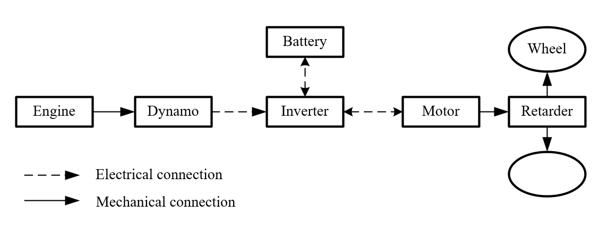
Fig. 1 Schematic diagram of a series hybrid vehicle structure

(2) Parallel hybrid electric vehicles
The characteristics of the parallel hybrid system are that the engine and the electric motor can drive the vehicle individually or simultaneously, and the power transmission is direct halfway without energy conversion to reduce energy loss. If the battery is used to drive the vehicle separately, the vehicle emissions can be reduced by pure electric driving, and the engine can also be used to drive the vehicle separately like a traditional car. The engine can also be combined with the drive motor to drive the vehicle, which is more powerful for the hybrid drive mode. The parallel system does not require a complex power distribution device and has the advantage of low cost. At the same time, the parallel hybrid power system has the advantages of high energy efficiency and flexible switching of power sources according to driving needs. At the same time, the engine and electric motor can work simultaneously with better acceleration performance compared to electric cars or conventional cars. However, the battery equipped with parallel devices usually has a smaller battery capacity, and the pure electric mode has a shorter range and is more suitable for short distances. The power system structure diagram of the parallel plug-in hybrid electric vehicle is shown in Figure 2:
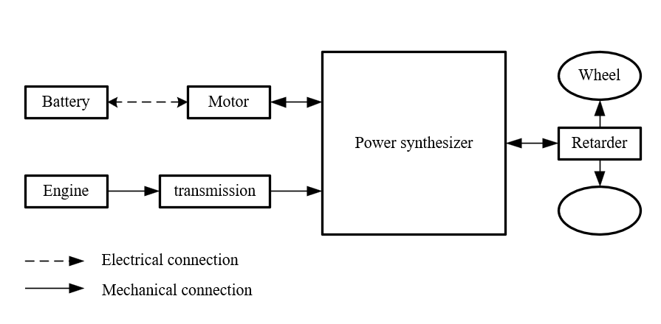
Fig.2 Structure diagram of parallel hybrid electric vehicle
(3) Hybrid electric vehicles
The hybrid hybrid system has the advantages of both series and parallel structure, which can realize the efficient operation of the engine and provide flexible power output according to demand. The motor can drive the vehicle alone or provide additional power when needed, so the hybrid structure has strong adaptability to keep the power components in efficient operation whether at low speed or high speed.
In general, the hybrid hybrid system has the best overall performance, but the hybrid hybrid system has high requirements for the vehicle control system because of its complex structure, which increases the difficulty of manufacturing. The cost of manufacturing hybrid hybrid electric vehicles is high, and the design of mechanical components such as planetary gear sets is complex, with high manufacturing and maintenance costs and complex maintenance. Although it combines the advantages of series and parallel, the cost is high and the promotion and application of the market are not utilized. The schematic diagram of the power system structure of the hybrid plug-in hybrid electric vehicle is shown in Figure 3.
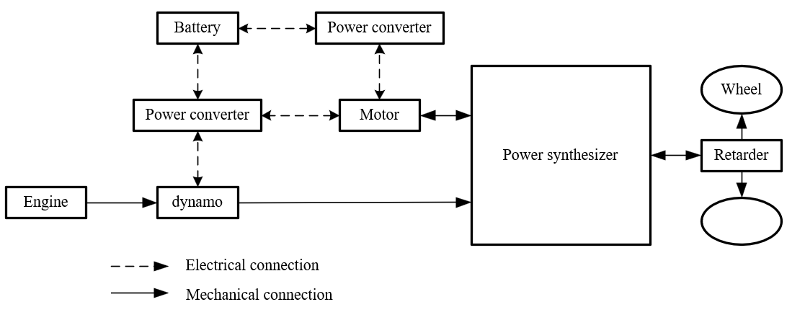
Fig. 3 Schematic diagram of a plug-in hybrid electric vehicle with a mixed connection type
Through the above analysis of the three different structures, it can be seen that although the hybrid hybrid system has the best comprehensive performance of both series and parallel characteristics, the hybrid hybrid electric vehicle has a complex structure of the power system and high manufacturing and maintenance costs. The parallel hybrid system can not only achieve pure electric driving, but also achieve separate engine drive, with high mechanical efficiency and relatively simple mechanical structure. The engine and electric motor can drive the wheels individually or simultaneously, which reduces the energy conversion loss compared with the tandem type; Compared with the hybrid type, the structure is simple, and the system complexity and cost are reduced. Therefore, this paper chooses parallel hybrid power system configuration as the vehicle structure studied in this paper.
The basic parameters of the vehicle are shown in Table 1. The dynamic performance of the designed vehicle is shown in Table 2.

Table 1 Vehicle basic parameters
Vehicle mass/kg Full load mass/kg Wheel diameter/m Windward area/m²
1200 1750 0.381 2.28

Table 2 Performance index of parallel plug-in hybrid
 | demand |  | Numerical value
Dynamic property | Hybrid maximum speed Vmax（km/h） | $$≥170$$
Dynamic property | Maximum gradient（20km/h） | $$≥30$$
Dynamic property | 100 km acceleration time Vmax（km/h） | $$≤13$$

As the main power source of hybrid electric vehicle, the engine directly affects the power output of the vehicle, and the accuracy of its model is very important. Considering that the engine model parameters are difficult to obtain accurately, the static model is usually applied to the simulation of hybrid electric vehicles.
When the high-voltage battery is in a state of loss of power, the engine needs to run independently to maintain the maximum speed of the vehicle, and the maximum power of the engine should not be less than the power required for the vehicle to maintain the maximum speed: the engine model diagram is shown in Figure 4.
$P_{max}i_{e}≥(f_{0}+f_{1}v_{max}+f_{2}{v^{2}}_{max})v_{max}$ （1）
Formula: $P_{max}$ The maximum power of the engine/Kw，$i_{e}$ is the transmission ratio of the gearbox; $f_{0}$ 、$f_{1}$、$f_{2}$ is the sliding resistance factor；$v_{max}$ for maximum speedKm/h.
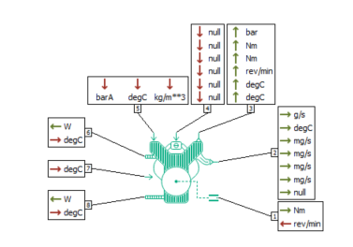
Fig.4 Engine model
The input and output variables of the eight ports in the engine model are relatively complicated. Port 1 is the main output port of the engine, which is connected to the gearbox and mainly outputs the engine torque. Port 2 is the emission port of the engine, with a total of seven output variables, mainly the emission rate of CO, HC, NOx and particles, as well as the engine exhaust temperature and emission gas flow rate; Ports 3 and 4 are the average braking pressure and torque loss rate of the engine respectively; Port 5 is the main control port of the engine, and its four inputs from left to right are: engine load, combustion mode, overheat combustion coefficient, idle speed; Ports 6, 7 and 8 are the combustion chamber temperature, coolant temperature and oil temperature, and the corresponding combustion heat loss and friction loss, respectively.
For parallel hybrid electric vehicles, the drive motor in pure electric mode is the only power source of the vehicle, and the maximum torque should meet the dynamic performance requirements of the vehicle in pure electric mode (acceleration performance, climbing ability, etc.):
$\int_{0}^{h}{\frac{T_{p2}ii_{e}}{Rm}}dt≥v_{t}$ （2）
$T_{p2}i_{e}i_{1st}≥(mgsin\left(\operatorname{atan}\left(d_{max}\right)\right)+f_{0}+f_{1}v+f_{2}v^{2})R$ （3）
Formula:$T_{p2}$Maximum torque for driving motor/Nm; $i$ is the transmission speed ratio; $i_{1}$ a gear ratio for the gearbox; $m$ is vehicle masskg;Ｒ wheel radiusm;$d_{max}$ is the maximum gradient.
When the motor of the hybrid electric vehicle reaches the maximum speed, it is necessary to ensure that the drive motor runs within the normal speed range, that is, its corresponding speed should be lower than the maximum speed:
$\frac{n_{pmax}}{i_{t}}≥\frac{30v}{πR}$ （4）
The model diagram of the drive motor is shown in Figure 5. In AMESim, the motor model is equipped with an inverter, which is an integrated electric generator model. The motor has five ports, with interface 1 to output power loss and input motor temperature. Interface 2 is a power transmission interface, output motor torque, input speed. Interface 3 is an output torque signal. Port 4 receives torque commands. Ports 5 and 6 are voltage and current signals used to connect to the battery module.

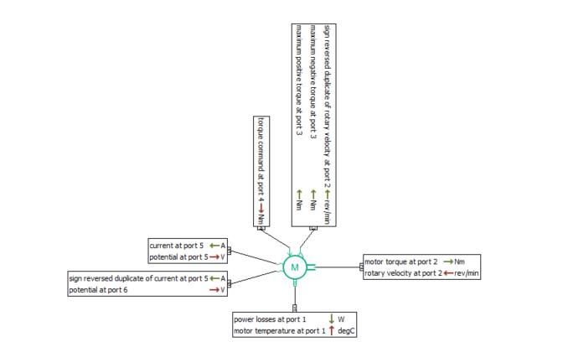
Fig.5 Motor model
The power battery power should meet the driving range requirements under pure electric conditions, and the required power can be calculated according to the constant velocity method. The power required for a car to travel at a constant speed
$p_{etc}=\frac{v_{etc}}{3600μ_{t}}(mgf+\frac{C_{D}Av_{max}^{2}}{21.15})$ （5）
$C=\frac{1000P_{etc}L}{U_{b}ε_{sos}v_{etc}μ_{m}}$ （6）
Formula: L is the driving range/km；$ε_{sos}$ is indicates the battery discharge depth，$ε_{sos}=0.85$；$μ_{m}$ is motor efficiency.
The battery model is shown in Figure 6. The model has four interfaces. Port 1 Output power loss, input the battery temperature signal. Ports 2 and 3 are voltage and current signal ports that are used to connect to the motor model. Port 4 is an output signal port that outputs state of charge (SOC) signals of the battery.

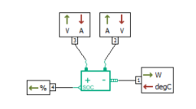
Fig.6 Battery model
According to equations (1) ~ (6), the matching parameters of the power system are shown in Table 3.
Table 3
engine maximum power/kW maximum torque/(N·m)
62 124
motor maximum power maximum torque maximum speed
32/kW 186N·m 4800 r·min
batter rated voltage/V maximum capacity/(A·h)
360 32

The physical model of the vehicle is built by AMESim, as shown in Figure 7. The model consists of driving module, engine module, battery module, vehicle control unit, transmission module, motor module and so on.
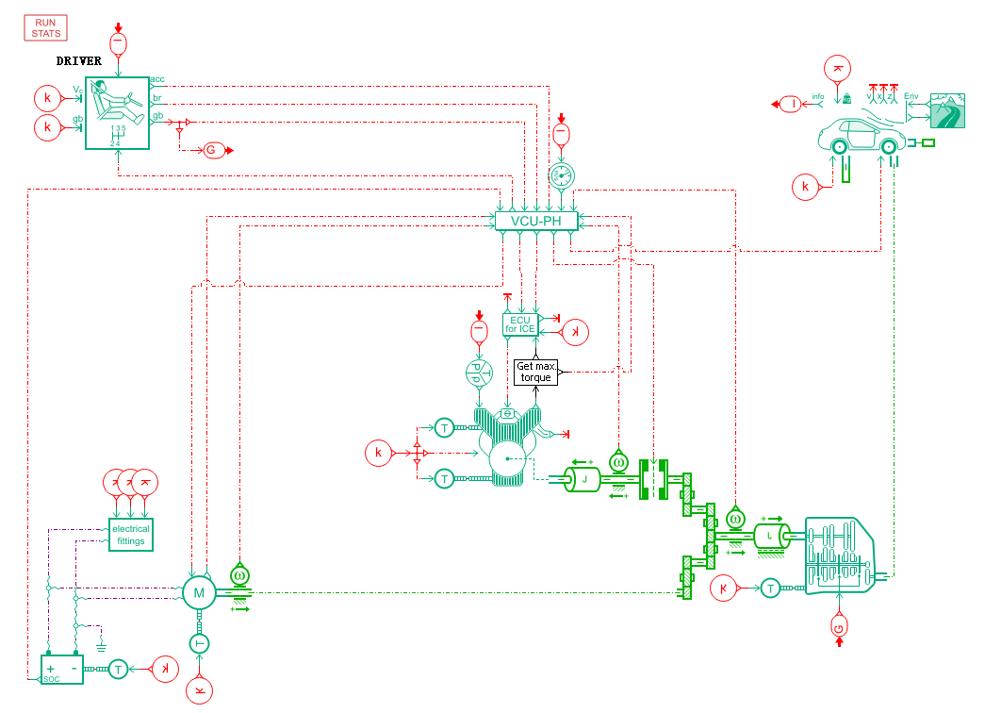
Fig.7 Hybrid electric vehicle model

4 Simulation results and analysis
In order to verify whether the vehicle dynamics model meets the basic requirements of the design of this paper, this paper chooses to test the NEDC working condition under the condition of 20℃ ambient temperature, observe the speed following, and verify the maximum speed of this model, the climbing speed of the vehicle when the slope is 30%, and the acceleration time of 100 km. The simulation results are shown in fig. 8, fig. 9 and fig. 10 respectively.
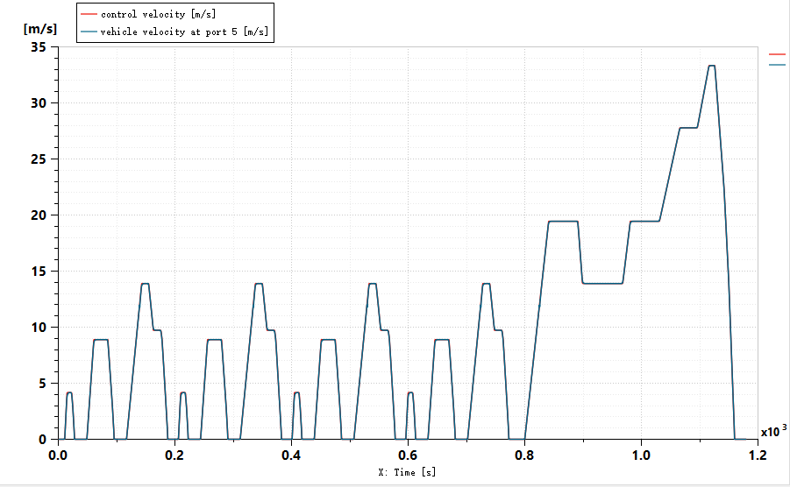
Fig. 8 Vehicle speed following curve under NEDC condition
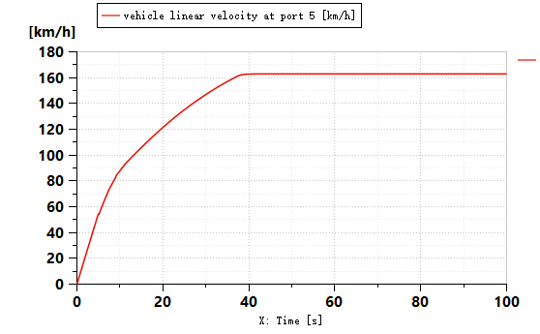
Fig. 9 Maximum speed diagram
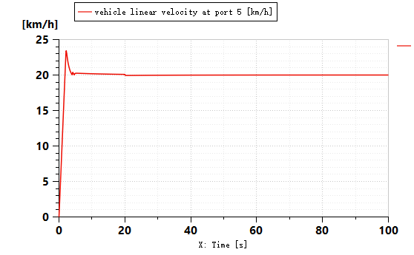
Fig. 10 Maximum climbing speed diagram

As can be seen from fig. 8, the matching degree between the simulated speed and the actual control speed under NEDC conditions is almost completely consistent, and the established simulation model is accurate and reliable, and the speed under NEDC conditions has good follow-through, meeting the dynamic requirements of all conditions.
Vehicle dynamic performance is one of the main performance of the vehicle, including 0 ~ 100 km/h acceleration performance, vehicle climbing performance, etc. FIG. 9 and FIG. 10 show the slope speed curve and the simulation curve of maximum speed when the slope is 35% respectively. As can be seen from Figure 9, the speed of the hybrid electric vehicle model constructed this time is 101.7km/h at 13s and 170km/h at 41s, meeting the design requirements of 100km acceleration time and 170km/h maximum speed. As can be seen from Figure 10, when the slope is 35%, the speed can reach 20km/h, meeting the design requirements of the maximum slope. It can be considered that the selection, parameter setting and vehicle control model of engine, drive motor, generator, power battery and other components meet the requirements of this paper.

4 Conclusion
In this paper, a certain hybrid electric vehicle is the research object. Firstly, the system structure of different hybrid electric vehicles is analyzed, the system structure of the hybrid electric vehicle studied in this paper is determined, and the parameters of each power component are matched according to the basic parameters of the vehicle and the designed dynamic requirements. Secondly, the vehicle dynamics simulation model is established based on AMESim software, and the vehicle speed following and dynamic performance simulation are carried out under NEDC conditions. The simulation results show that the vehicle model has a good performance in speed following and meets the design requirements through dynamic simulation. The simulation model is verified to be accurate and reliable, which lays a foundation for the subsequent thermal management of hybrid electric vehicles.

Disclaimer (Artificial intelligence)

Option 1:

Author(s) hereby declare that NO generative AI technologies such as Large Language Models (ChatGPT, COPILOT, etc.) and text-to-image generators have been used during the writing or editing of this manuscript.

Option 2:

Author(s) hereby declare that generative AI technologies such as Large Language Models, etc. have been used during the writing or editing of manuscripts. This explanation will include the name, version, model, and source of the generative AI technology and as well as all input prompts provided to the generative AI technology

Details of the AI usage are given below:
1.
2.
3.

Reference
- 李峰.插电式混合动力汽车热管理系统开发及其控制算法研究[D].吉林大学,2016. 插电式混合动力汽车热管理系统开发及其控制算法研究 - 中国知网
- Hannan MA, Azidin FA, Mohamed A. Hybrid electric vehicles and their challenges: A review. Renewable and Sustainable Energy Reviews. 2014 Jan 1;29:135-50. 混合动力电动汽车及其挑战 - ScienceDirect
- 李嘉晨.针对电池管理系统基础软件的功能安全设计和应用[D].华东师范大学,2022.DOI:10.27149/d.cnki.ghdsu.2022.003803. 针对电池管理系统基础软件的功能安全设计和应用 - 中国知网
- 石先立.某混合动力汽车整车热管理系统优化研究[D].重庆理工大学,2021.DOI:10.27753/d.cnki.gcqgx.2021.000141. 某混合动力汽车整车热管理系统优化研究 - 中国知网
- Vicente, A. T. D., Camperos, M. C., & Almonacid-Durán, M. (2025). The evolution of electric and hybrid vehicles and their influence on sustainable transport: A review and future research lines. Sustainable Technology and Entrepreneurship, 100100. The evolution of electric and hybrid vehicles and their influence on sustainable transport: A review and future research lines - ScienceDirect
- 李嘉轶.混合动力汽车整车热管理系统控制策略仿真与优化研究[D].天津科技大学,2021.DOI:10.27359/d.cnki.gtqgu.2021.000528. 混合动力汽车整车热管理系统控制策略仿真与优化研究 - 中国知网
- Urooj A, Nasir A. Review of intelligent energy management techniques for hybrid electric vehicles[J]. Journal of Energy Storage, 2024, 92: 112132. Review of intelligent energy management techniques for hybrid electric vehicles - ScienceDirect
- Zhang, Xiang, and Xiaoyang Cui. "Impact of cutting-edge hybrid electric vehicle technological innovation on carbon emissions in China." Sustainable Futures (2025): 100447. Impact of cutting-edge hybrid electric vehicle technological innovation on carbon emissions in China - ScienceDirect
- 庄宿强.新能源汽车发展现状与未来展望[J].汽车维护与修理,2025,(05):61-63.DOI:10.16613/j.cnki.1006-6489.2025.05.012. 新能源汽车发展现状与未来展望 - 中国知网
- Tian, Jiamei, Ping Wang, and Daina Zhu. "Overview of Chinese new energy vehicle industry and policy development." Green Energy and Resources (2024): 100075. Overview of Chinese new energy vehicle industry and policy development - ScienceDirect
- Hu, Ruifeng, Teng Cai, and Weiqiao Xu. "Exploring the technology changes of new energy vehicles in China: Evolution and trends." Computers & Industrial Engineering 191 (2024): 110178. Exploring the technology changes of new energy vehicles in China: Evolution and trends - ScienceDirect
- 孟浩伟.混合动力汽车动力参数匹配与仿真优化研究[D].广西科技大学,2024. 混合动力汽车动力参数匹配与仿真优化研究 - 中国知网
- Bin G, Hong C, Dafeng S. Research on fast matching method of power system parameters of parallel hybrid electric vehicles[J]. IFAC-PapersOnLine, 2018, 51(31): 11-14. Research on Fast Matching Method of Power System Parameters of Parallel Hybrid Electric Vehicles - ScienceDirect
- Wang W,Fu R, Fan Y. Electromagnetic parameters matching of permanent magnet synchronous motor for hybrid electric vehicles[J]. IFAC-PapersOnLine, 2018, 51(31): 407-414. Electromagnetic Parameters Matching of Permanent Magnet Synchronous Motor for Hybrid Electric Vehicles - ScienceDirect
- He H, Luo J, Peng J, et al. Parameter matching and simulation analysis of electromechanical coupling device for hybrid electric vehicle[J]. Energy Procedia, 2017, 105: 2329-2334. (PDF) Parameter Matching and Simulation Analysis of Electromechanical Coupling Device for Hybrid Electric Vehicle

