Original Research Article

McNamm Wheel AGV design

.

ABSTRACT

|  |
| --- |
| Nowadays, the development of intelligent manufacturing and industrial Internet technology is leading the trend of the times step by step, the development of intelligent equipment has gradually become the traditional manufacturing industry is facing the transformation and upgrading of an important strategic point. At present, AGV handling robots have been widely used in all walks of life, but the general wheeled robots on the market generally have some problems, that is, restricted by the environment, can not move flexibly in the narrow space, but the use of McNamm wheels can be a perfect solution to this problem, so based on the McNamm wheels of the wheeled trolleys have a broader application prospects. This design focuses on the study of a wheeled AGV based on McNamm wheels that can work flexibly in a small space. The main content of this design is to analyze the structural characteristics and working principle of the McNamm wheel AGV cart, master the common design steps of non-standard equipment, understand the positioning principle of wheeled robots, transmission scheme and trajectory control principle by consulting relevant information, design the transmission and control system of the McNamm wheel AGV cart according to the needs of intelligent inspection, logistics, transportation and distribution functions, and carry out the calculation of parameters of the main programs. Mainly through the McNamm wheel work force analysis, so as to determine the direction of its movement, and then through the combination of a number of wheat wheel to achieve the movement in all directions. Then through the load and body requirements on the spring design, and then in accordance with the spring requirements on the hydraulic cylinder for simple calculations, and finally through the solid works, proe, creo software on the mcnemonic wheel body modeling design, and then the use of mainstream simulation and analysis software ANSYS workbench, Adams on the simulation and analysis of the established model. |

*Keywords:* Intelligent Vehicle; McNamm Wheel; Omnidirectional Mobility; AGV Adams Simulation *.*

1. INTRODUCTION

Nowadays, compared with the traditional manufacturing industry, the development of intelligent manufacturing industry and the close integration of industrial technology based on the Internet is standing in the wind of the times, step by step, leading the wave of progress of the times[1]. Therefore, the traditional manufacturing industry is facing the transformation and upgrading of the important strategic point lies in the development of intelligent equipment. System intelligence, integration, Fan Guanghua has been one of the mainstream of future research, and multi-intelligent body system (Multi-Agent System) is now the main development direction of research. And in the future will be given more and more research and attention[2]. The intelligent car as its core has rightly become the main research object and occupies an important position in its system.

Intelligent trolley is essentially a kind of wheeled mobile robot, synthesizing various modern advanced technologies[3]. Through the integration of multi-intelligent systems, the intelligent trolley can complete the corresponding designated actions in different environments through the pre-setting of the integrated control commands. In addition, it can also realize the powerful functions of automatic tracing and light searching as well as automatic obstacle avoidance by assembling various corresponding light sensors and vibration-damping structures. It is not only stable but also timely and efficient[4]. According to its application characteristics, it has a very broad application market and development prospects in the fields of intelligent inspection, logistics transportation and distribution, geological exploration, tracking and identification, and earthquake relief[5]. However, it is not difficult to see that these robots in the work also inevitably exposed a lot of consistency problems, is not flexible enough. Easily in the work process because of the restricted environment and the resulting movement restrictions, and thus can not fulfill the task. Therefore, people focus on the research of wheeled robots that can move in all directions. The McNamm wheel is not only flexible in a small space environment, but also simple and efficient, so it has been attracting more and more attention.

The research of mobile wheeled AGV based on McNamm's wheel is developing very rapidly abroad, while the domestic research has just started.AGV is called (AutomatedGuided Vehicle). It is a powerful automation equipment, including mechanical integration, electronic integration, sensor integration and control system integration and so on. In industrial production AGV is mainly refers to the driverless type of a laser-guided transportation vehicle. In the modern production process can be faster and more convenient to realize the product transportation through its flexible and changeable characteristics[6].

The main content of this design is about the McNamm wheel of a cart of the overall AGV design[7]. The analysis of the structural characteristics and working principle of its main McNamm wheel, through the analysis of the McNamm wheel working force, so as to determine the direction of its movement, and then through the combination of a number of McNamm wheels to achieve the movement in all directions[8]. Finally, the main body of the McNamm wheel is modeled and designed by solid works, proe, creo software, and then the established model is simulated and analyzed by using the mainstream simulation and analysis software ANSYS workbench, Adams to understand the wheeled robot's positioning principle, transmission scheme and trajectory control principle[9].

2. Structural Design of McNamm Wheel Wheel Frame

**2.1 McNamm Wheel Movement Principle**

The McNamm Wheel is a wheeled structure invented by the Swedish company McNamm that can move in all directions[10]. The main structure of the McNamm wheel consists of five parts. Firstly, there are two rims and hubs on the outside, and secondly, there is a circle of equidistant rotary rollers in the center, which are evenly spaced around the hubs. The number of rotary rollers in the center can be selected according to your needs, and can be made into 8 or 16 wheels. However, it should be noted that the axis of the roller and the axis of the hub need to form an angle, specifically how many degrees according to the requirements of the designer to set their own, but the industry and daily production process is basically the use of 45 degrees angle, easy to calculate the force and in the movement of the movement is faster to realize the steering. Roller shape can be approximated as an elliptical cylinder, roller bus is a series of equal length spiral or a strip of the outer arc length of the ellipse, each roller is hollow, the middle of the need to add a roller mandrel and the hub connection, whenever the big wheel as a whole around the axis of the hub rotating, inside the various small rollers are rotating around their respective inside the mandrel and its contact point with the ground for the line exactly as a circle. The line of contact with the ground is exactly a circle, so that continuous uninterrupted forward rolling can be realized. By combining these wheels, a full range of movement of the mechanism can be realized [4]. In general, the difference between the McNamm wheel and the traditional ordinary wheel is that the wheel rolling structure has changed, the traditional roller wheel is the wheel is directly subjected to the friction of the ground so as to make the mechanism to move, while the McNamm wheel is by which the various small rollers to go to contact with the ground, friction on the small rollers to make it move, and the small rollers are confined in the large wheel, thus driving the large wheel to rotate. These small rollers evenly distributed around the hub, because the angle with the hub axis is 45 degrees, so in the process of movement, these small rollers will be subject to friction can be acted on two different aspects. One of these is acting on its own rotation, one is acting on the movement along the mandrel, and because the rollers are limited by the hub, and therefore also on the movement of the wheel. Breaking down the forces it can be seen that the rollers can break down the forward speed of the large wheel into component speeds in both directions, along the X-axis and along the Y-axis, and so the whole large wheel can be relied upon to slide laterally to move the overall mechanism forward and backward . The final sum-vector obtained by vector synthesis of the forces and forward directions and velocities of each individual McNamm wheel allows the mechanism to move and rotate freely in the direction of the final sum-vector without changing its original structure or orientation. When the McNamm wheel is given a certain rate to make it roll forward, the rollers contact with the ground by the ground friction and thus move sideways, which in turn squeezes the wheel hub to force or drive the main wheel to move sideways as well. In industrial production, in order to truly realize the omni-directional movement of the mechanism will usually be more than McNamm wheels set up together, so that the trolley on the ground in accordance with the instructions given by the control system to carry out the specified translational and rotational command action. Usually, the McNamm wheel-based intelligent trolley generally uses multiple motors to control the rotation of the McNamm wheel, where four servo motors are used to control the rotation of the four McNamm wheels, and different commands from each motor control the forward and reverse rotations of the corresponding McNamm wheels, so as to combine and realize the omnidirectional movement of the trolley.

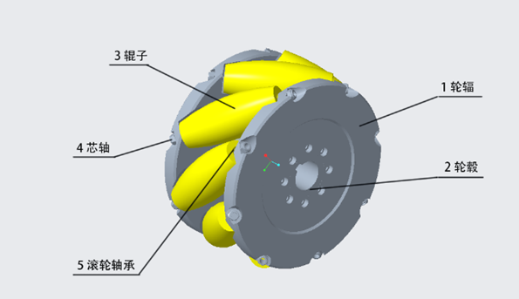

**Fig. 1 McNamm Wheel Body Structure**

In terms of the degrees of freedom of the mechanism, the McNamm wheel is able to realize the function of omnidirectional movement because it has two degrees of freedom, while the traditional wheel actually has only one degree of freedom, that is, only the wheel rotates around the axis of its hub, but the McNamm wheel also has a small roller inside the rotation around its roller axis, so the McNamm wheel in the movement, not only can have active rotation movement, but also passive movement on the axis of the roller. Therefore, when the McNamm wheel is in motion, it not only has an active rotary motion, but also has a passive motion on the axis of the rollers. When the McNamm wheel rotates around a fixed axle, the contact point between the rollers and the ground forms an elliptical cylindrical surface, which leads to continuous rolling, and then, by combining the movements of the different wheels, free movement on a flat surface is realized.

**2.2 Kinematic analysis of the McNamm wheel**

As shown in the figure below, due to the special structure of the wheat wheel, when it receives the motor drive forward movement, due to the wheat wheel peripheral roller is in contact with the ground, when the wheat wheel around the hub axis rotation, the roller will produce friction with the ground Ff the direction of its force for the hub coordinate system y-axis positive direction. When the hub forward (around the hub axis counterclockwise) rotation, the roller passive contact with the ground, and the roller contact with the ground can be idealized as a point of contact, the point of contact in the “touch” the ground at the moment will be subjected to the direction of its movement in the opposite direction of the force (and the analysis of ordinary tires are similar), the point of contact of the “direction” of the “movement” is positive. The “direction of motion” of the contact point is backward, so the direction of the friction force is forward (the y-axis of the wheel coordinate system is forward). Ground friction Ff along the perpendicular and parallel to the roller axis direction of force decomposition, because the roller is a passive wheel, so it will be perpendicular to the hub axis of the force F ⊥ and passive rotation, which also indicates that the force F ⊥ is rolling friction, the roller wear and tear is greater; parallel to the hub axis of the force F ∥ will also force the roller movement, but is the active movement (rollers by the hub on both sides of the axes of the hub mechanical limit), so F ∥ is static friction, and the friction direction is positive forward (hub coordinate system y axis positive). So the partial force F ∥ is static friction ground friction acting on the roller is decomposed into rolling friction and static friction, rolling friction to promote roller rotation, belong to the ineffective movement; static friction to promote the movement of the rollers relative to the ground (similar to the movement of ordinary rubber tires), and the rollers by the hub “stuck”, and thus drive the whole wheat wheel Along the roller axis movement (that is, the hub rotates counterclockwise, the direction of movement is 45 ° left up; hub clockwise rotation, the direction of movement is 45 ° right down)

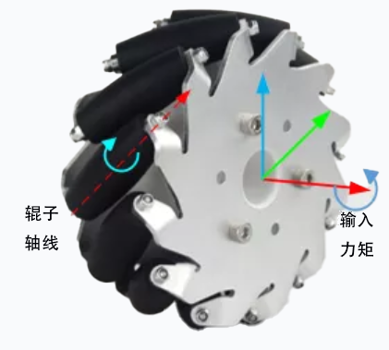

**Fig. 2 Moment applied to the McNamm wheel**

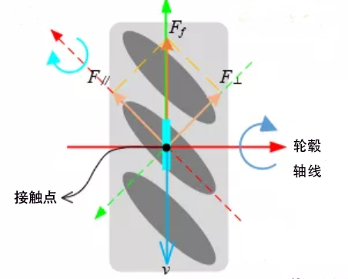

**Fig. 3 Direction and distribution of forces on the McNamm wheel**

Friction drives the overall movement of the wheat wheel; the actual (force) direction of movement of a single wheat wheel is the axial direction of the rollers, so by changing the angle between the rollers' axis and the hub's axis, the actual (force) direction of movement of the wheat wheel can be changed. This is shown in the figure below:

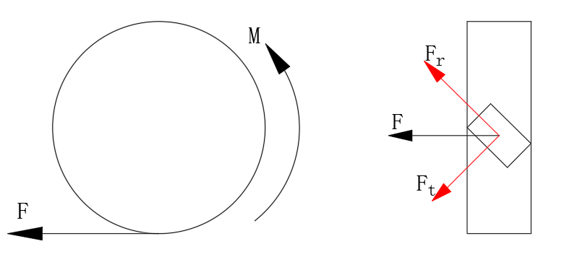

**Fig. 4 Simulated McNamm wheel contact point force sketch**

**2.3 FORCE ANALYSIS OF WHEAT WHEELS IN MOTION**

(1) Turning force analysis

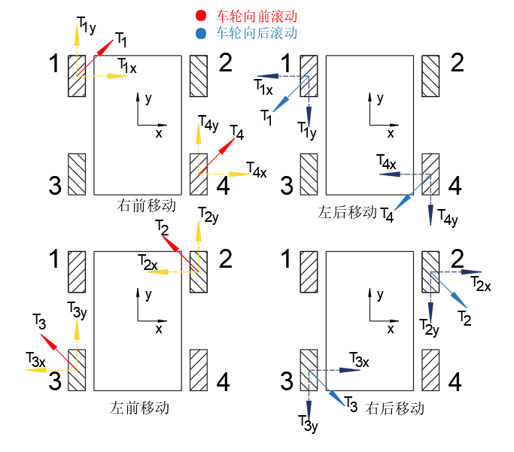

**Fig. 5 Turning force analysis**

When 1, 4 wheels forward rotation, 2, 3 wheels do not turn, the roller contact with the ground as an idealized point contact, at this time 1, 4 wheat wheel connected to the motor control corresponding to the wheat wheel forward, by the definition of friction and resistance can be seen at the point of contact by the forward friction F, which will be decomposed along the perpendicular roller and the direction of the parallel rollers to obtain the F ⊥ and F ∥, by the above part of the content can be seen, F ⊥ is to promote the rollers to rotate! The force belongs to the rolling friction for the ineffective, so the real force to make the cart forward turn for F∥ recorded as T, so the cart is subjected to the force for the 1, 4 wheat wheel along the roller direction forward force, so the cart as a whole to move to the right front direction. The following is obtained by the same reasoning:

When wheels 1 and 4 rotate backward and wheels 2 and 3 do not rotate, the force on the cart as a whole is the backward force along the direction of the rollers of wheat wheels 1 and 4, and therefore the cart as a whole moves in the left backward direction;

When the 2, 3 wheels rotate forward, 1, 4 wheels do not rotate, the cart as a whole is subjected to the force along the direction of the 2, 3 wheat wheel roller forward force, the cart as a whole to the left front direction;

When the 2,3 wheels rotate backward and the 1,4 wheels do not turn, the force on the cart as a whole is a backward force along the direction of the 2,3 wheat wheel rollers, and the cart as a whole moves in the right rearward direction;

3. Overall motion analysis of the cart based on Adams software

Adding constraints to the simulation model.

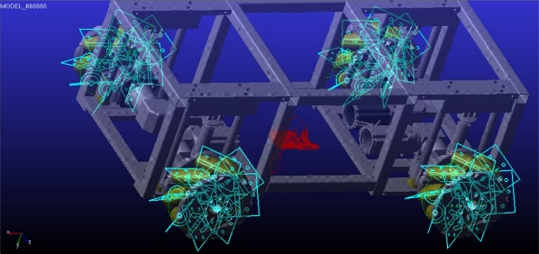

Fig. 6 Addition of constraints

Adding a rotating sub to a simulation model.

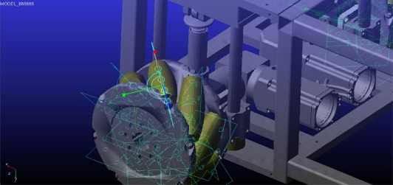

Fig. 7 Addition of rotating parts

Analysis of Displacement

Since the big wheel is assembled by 8 small sticks, the motion state of the small sticks is analyzed first. The small stick of the left front wheel which contacts the ground first is selected as the object of analysis, and its displacement diagram is shown in Fig. 8.

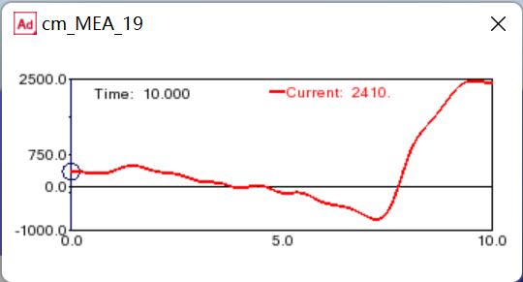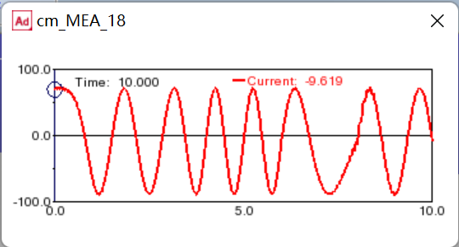

**Fig. 8 Displacement of the roll in X and Y directions**

As can be seen from the figure, the motion of the roller is equivalent to a compound motion that rolls up and down around the wheel axis with a forward motion, and its projection on the Y-axis is an image approximating a cosine function, and its image on the X-axis can be seen that there is basically no displacement of the stick in the X-axis direction between 0-6 seconds, and it only starts to show displacement after 6 seconds, which is due to the fact that the movement of the trolley is rotating in place when it is in the 0-6 seconds. This is because in 0-6 seconds the trolley is rotating in place, thus the roller is basically not moving in the X-axis direction, and the displacement occurs only after the trolley is moving forward after 6 seconds, and the reason for the slight fluctuation in the 0-6 seconds may be that the contact rigidity with the ground is too large, and the vibration of the trolley is more obvious.

Roll speed analysis

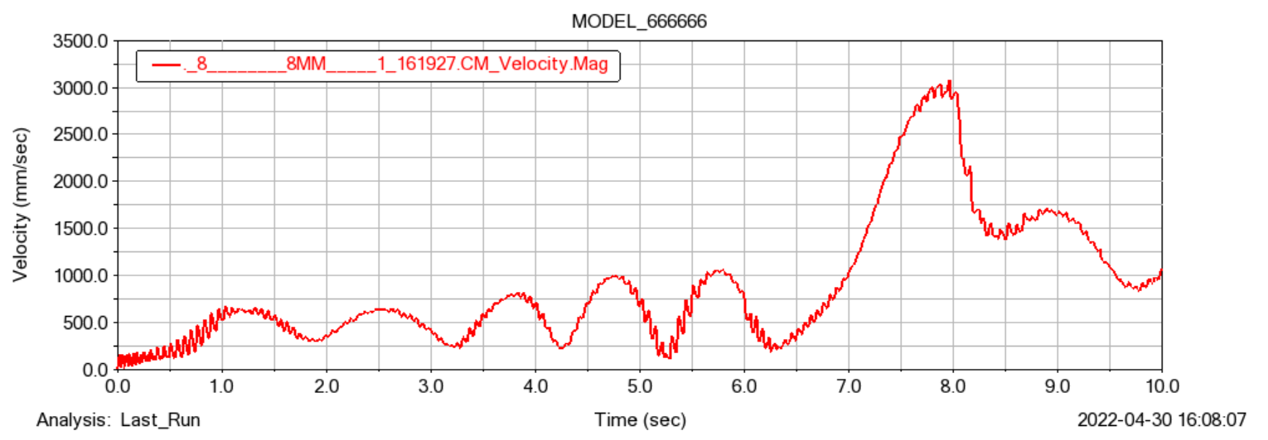

**Fig. 9 Velocity change of the roll**

As can be seen in Fig.9, the projection of the roller's velocity in the coordinate system during 0-6s is basically similar to a trigonometric function image, which is because the roller is mainly doing rotational movement of the body during 0-6s, so the direction of the velocity changes according to the angle of rotation , plus the wheel drive is given a speed function to control the forward and backward rotation of the wheel during this time period so that the velocity also increases and decreases, and the combined vector of the two causes the image to rise and fall. The large ups and downs in 6-8s are due to the fact that at this time the cart is moving in a straight line and the wheels are accelerating all the time, thus showing a faster increase.

Analysis of contact force

For reference, the rollers of the left front wheel which are in contact with the ground from the very beginning are chosen, as shown in Fig. 10.

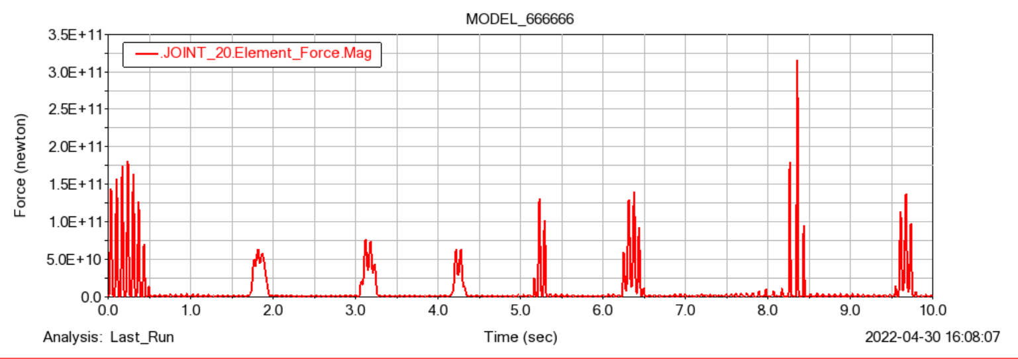

Fig.10 Roller contact force with the road surface

As can be seen from the figure, the friction force between the roller and the ground is larger and more concentrated when the roller is rotating in place at the beginning, and smaller when the cart is moving forward after that, mainly because the contact time between the roller and the ground is longer than that of rolling forward during the process of rotating in place at the beginning and at the time point of 5-6 seconds after that, so the friction force acts for a longer time, and the force is more concentrated, and the friction force is more concentrated in the middle of the process of moving forward during the process of 2-4s. movement when the roller and the ground contact time is short, so the friction force is also smaller.

Driving power analysis

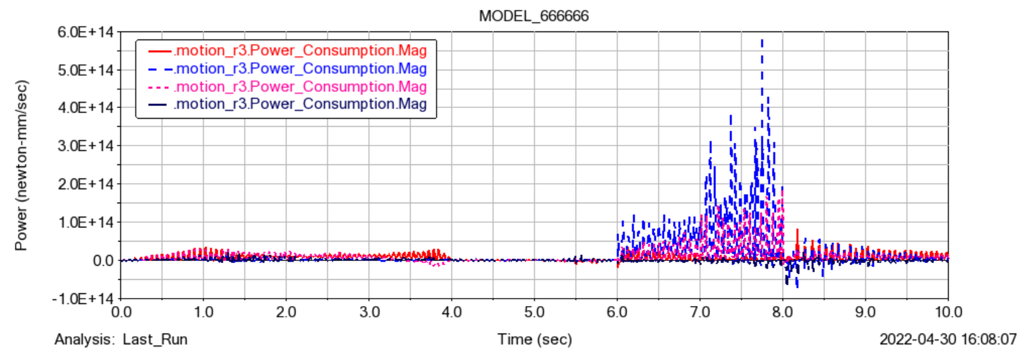

Fig.11 driving power changes

As shown in Fig.11, for the four drive power change size. The driving power of the left front wheel, left rear wheel, right front wheel and right rear wheel is the output power of the servo motor after passing through the reducer, so we can judge whether the motor power meets the requirements by setting the critical conditions.

Speed analysis of the drive

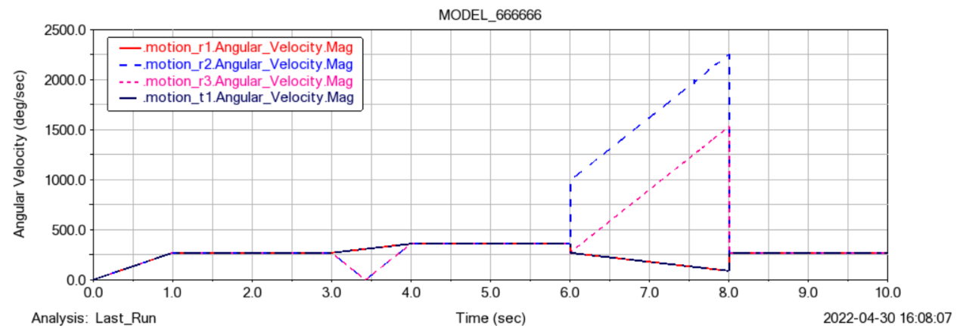

Fig.12 Four drive angular speed change

As in Fig.12, it represents the magnitude of the rotational speed change of the four drives. r1 represents the left front wheel, r2 represents the right front wheel, r3 represents the right rear wheel, and t1 represents the left rear wheel. Where the left front wheel and the left rear wheel have the same change in rotational speed, both are controlled by the function to gradually increase in 0-1 second until it rotates 270 degrees, then it stays the same again in 1-3 seconds, then it turns 90 degrees forward in 3-4 seconds, so the rotational speed is also increased upwards, and in 4-6 seconds the left front wheel and the left rear wheel are kept in the same state as in the 3rd second, so the rotational speed is also unchanged. In the last 6-8 seconds these two wheels are rotating 90 degrees backward, so they are equivalent to a deceleration motion. The right front wheel and the right rear wheel have the same state of motion as the left front wheel and the left rear wheel in 0-3 seconds and 4-6 seconds, because the control function is the same in 0-3 seconds and 4-6. However, in 3-4 seconds, the function of the right front wheel and the right rear wheel is controlled to rotate backward by 630 degrees, i.e., it is equivalent to rotating backward by one turn after canceling with the 270 degrees of rotation in the first three seconds, so it is equivalent to decelerating to 0 and then start accelerating again, and it happens to be the same as that of the left front wheel and the left rear wheel after accelerating at this stage.

Torque analysis of the drive wheel

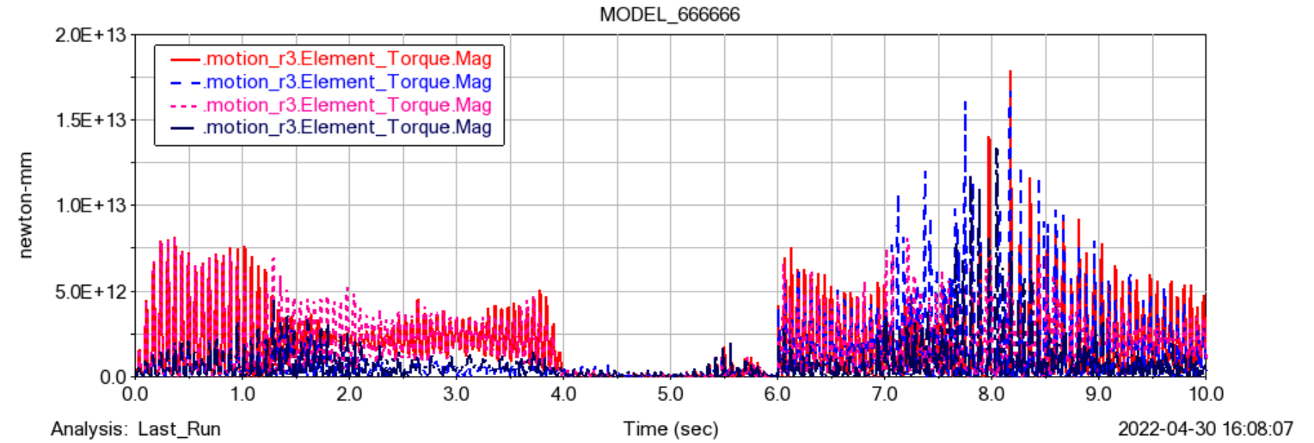

Fig.13 Driving wheel torque

As shown in Fig.13, which represents the magnitude of change in torque of the four drive wheels during the movement, it can be seen from the figure that the four drive wheels have almost no torque in 4-6 seconds, which is because the overall forward movement of the cart is kept smooth during that time period. In the two time periods of 0-3 seconds and 6-8 seconds, the whole cart is doing rotary motion, so the torque of each drive is larger, and the comparison shows that the torque of the left front wheel and the right rear wheel is larger than the torque of the right front wheel and the left rear wheel during steering. And it changes regularly during the time period.

4. CONCLUSION

The omni-directional movement of the McNamm wheel AGV trolley is carried out through the direction of its force movement by matching the McNamm wheels with different rotational direction, and then from analyzing the difference of the wheel force and steering of the single McNamm wheel when it is rotating forward and backward to analyzing the overall movement of the trolley when each McNamm wheel in the combination of the McNamm wheel wheel set is rotating forward and backward with each other so that the omni-directional movement of the trolley can be realized. Purpose Not only the principle of omnidirectional movement is determined, but also the overall framework of the trolley is basically determined, which is a good preparation for the later structural design.

In order to analyze the stability of the trolley, the overall kinematics simulation of the trolley is simulated by Adams software. First of all, draw a good 3D model in proe, and add a large enough rectangle tangent to the four McNamm wheels to make the ground. Then import the model into Adams, delete the unwanted parts, and then add the constraints, each part of the car has a constraint relationship between the constraints should be added, and then the model drawn in the ground in Adams fixed, and then the four McNamm wheels to add a good drive function, the car can realize the movement, and then start the simulation analysis. Inside the post-processing to observe the overall movement of the cart and the wheel contact force force situation, as well as the roller displacement, speed change rule, as well as drive the power and speed change.

The design of this comprehensive down to analyze there are still many shortcomings, first of all, the structure design is slightly rough, so that the front end of the drive shaft stress is too concentrated, the later can be replaced with a coupling or change the length of the shaft to reduce the stress concentration. There is also the simulation did not analyze the tensioning device of the trolley, which can be analyzed and solved by adding springs and corresponding constraints, so as to analyze the overall stability of the trolley. After the overall design analysis is completed, the overall structure of the trolley can be further optimized to reduce the body load and increase the internal space, so as to improve the working efficiency and smoothness of the body. The optimization can be achieved visually and effectively by improving the damping capacity of the spring and optimizing the structural performance of the axle.

Competing interests

Authors have declared that no competing interests exist.

## DISCLAIMER (ARTIFICIAL INTELLIGENCE)

Author(s) hereby declare that NO generative AI technologies such as Large Language Models (ChatGPT, COPILOT, etc.) and text-to-image generators have been used during the writing or editing of this manuscript.

.

References

[1] Le L T ,Khang G N ,Thien D V .A Study on the Kalman Filter Based PID Controller for Mecanum-wheeled Mobile Robot[J].Journal of Physics: Conference Series,2025,2949(1):012029-012029.

[2]Nakagawa Y ,Igo N ,Hoshino K .Controlling a Mecanum-Wheeled Robot with Multiple Swivel Axes Controlled by Three Commands[J].Sensors,2025,25(3):709-709.

[3]Dao N P ,Phung H M .Nonlinear robust integral based actor–critic reinforcement learning control for a perturbed three-wheeled mobile robot with mecanum wheels[J].Computers and Electrical Engineering,2025,121109870-109870.

[4]Yong A L ,Chang H S ,Soo E P .Development of a Manually Operated Mobile Robot That Prints Construction Site Layouts[J].Machines,2022,10(12):1192-1192.

[5]SeverGabriel R ,Mihai C ,RaduEugen B , et al.Mobile Robots—AHP-Based Actuation Solution Selection and Comparison between Mecanum Wheel Drive and Differential Drive with Regard to Dynamic Loads[J].Machines,2022,10(10):886-886.

[6]Yong A L ,Chang H S ,Soo E P .Development of a Manually Operated Mobile Robot That Prints Construction Site Layouts[J].Machines,2022,10(12):1192-1192.

[7]Congjun M ,Xiaoying L ,Guofei X , et al.A T-S Fuzzy Quaternion-Value Neural Network-Based Data-Driven Generalized Predictive Control Scheme for Mecanum Mobile Robot[J].Processes,2022,10(10):1964-1964.

[8]Jing Z ,Jiacheng W ,Jiazhong H , et al.Design, Fabrication, and Control Algorithm of Self-Reconfigurable Modular Intelligent Vehicles[J].Applied Sciences,2022,12(14):6886-6886.

[9]Ricardo P ,Rafael C ,Vicente C , et al.Nonuniform Dual-Rate Extended Kalman-Filter-Based Sensor Fusion for Path-Following Control of a Holonomic Mobile Robot with Four Mecanum Wheels[J].Applied Sciences,2022,12(7):3560-3560.

[10]Singh P Y ,Vandana A ,J.C. M , et al.A robust sliding mode control of mecanum wheel-chair for trajectory tracking[J].Materials Today: Proceedings,2022,56(P2):623-630.