**THE USE OF STRAW GRASS AS A SUSTAINABLE APPROACH IN REINFORCEMENT OF RING CULVERT**

**ABSTRACT**

The feasibility of using straw grass as a natural reinforcement material in concrete was investigated in this study, with a focus on the effects on the concrete's slump, compressive, and tensile strengths. This was accomplished by creating three concrete mixes with varying percentages of straw grass (0.0% (control), 0.5%, and 1.0%). Following 7, 14, 21, and 28 days of curing, these mixtures were examined.The results of the slump test indicated that the concrete became less workable when straw grass was added. According to this decline in slump, the concrete's fluidity and placing ease decrease with the percentage of straw grass. Straw grass-reinforced concrete's strength was lower than the control, according to the compressive strength results. This implies that adding straw grass reduces the concrete's resistance to compressive loads. Contrarily, the addition of straw grass had a positive effect on the concrete's tensile strength. The 0.5% and 1.0% straw grass mixtures showed tensile strengths of 2.95 MPa and 3.35 MPa, respectively, at 28 days, whereas the control mix has a tensile value of 2.75 MPa. These numbers show how much more tensile force resistance the straw grass-reinforced concrete can withstand. In summary, although straw grass is a renewable and biodegradable material with considerable environmental benefits, its usage in concrete significantly reduces its compressive and increases tensile strengths. Therefore, non-structural applications where strength is not the main concern, including partition walls and landscape features, are better suited for straw grass-reinforced concrete. In order to increase performance, more research is advised to examine methods of strengthening the link between straw grass and the cement matrix as well as the possibilities of hybrid reinforcement systems, which mix straw grass with traditional reinforcement materials.

**Keywords**: Straw grass, natural reinforcement material, concrete properties, compressive strength, tensile strength, slump test, sustainable construction, biodegradable material.

1. **INTRODUCTION**

The building sector, which has historically relied on commodities like steel to reinforce concrete structures, has been greatly impacted by the global movement for sustainable development. Although these traditional materials offer the required durability and structural strength, their energy-intensive manufacturing processes result in significant carbon emissions (Smith & Jones, 2018). Researchers and experts in the building industry are looking to eco-friendly, renewable alternatives that provide both sustainability and financial advantages as a result of growing material costs and environmental concerns. Natural fibre reinforcement is a viable substitute; one prominent example is straw grass (Johnson et al., 2020).

Straw grass is a common agricultural waste product that has various benefits for building because it is inexpensive, lightweight, and biodegradable. Straw grass can be procured locally, reducing transportation expenses and emissions, in contrast to synthetic fibres (Ahmed & Nasser, 2021). Additionally, straw grass has advantageous mechanical qualities, including flexibility and tensile strength, that improve the durability and crack resistance of concrete. According to studies, natural fibres like straw grass can stop concrete cracks from spreading, increasing the longevity of buildings subjected to environmental stress (Lee & Kim, 2019).

The construction of ring culverts is a crucial area where the use of sustainable materials could have a revolutionary impact. These crucial water flow control structures beneath roads, railroads, and walkways need strong, load-bearing materials. Steel-reinforced concrete has historically been used for ring culverts because it provides the strength required to endure soil and water pressures. Steel reinforcement, however, is expensive and has an adverse effect on the environment, especially in places with limited access to such materials or tight financial constraints. According to Patel and Shah (2022), straw grass, as an alternative reinforcing agent, has the potential to offer ring culvert construction a sustainable and economical solution without compromising structural integrity.

There are several advantages of using straw grass as reinforcement for concrete. First of all, because of its lower density than steel, reinforced concrete weighs less overall, making handling and shipment easier, especially in remote locations where logistics of construction can be difficult. Construction projects may experience cost savings and improved logistics as a result of this weight decrease (Badr & Fathy, 2019). Furthermore, straw grass supports a circular economy and is an organic and biodegradable material that fits in well with global sustainability goals. At the end of its lifecycle, it can be recycled or naturally decompose (Jackson et al., 2020).

Beyond its positive effects on the environment, straw grass reinforcement has shown its potential in enhancing concrete's mechanical qualities, especially its toughness and ductility. For constructions like ring culverts, which are subject to cyclic loads from soil pressure and water flow, these characteristics are crucial. Increased resilience to these pressures can be achieved using natural fibre-reinforced concrete, which may save maintenance costs and prolong the life of vital water management system infrastructure (Ogunbiyi et al., 2021). In rural or flood-prone areas, where infrastructure must endure high usage while adhering to financial limits, this resilience is extremely beneficial.

Despite these possible advantages, there is still a lack of study on the long-term performance of straw grass reinforcement under different conditions, which limits its use in structural applications. More thorough research is needed to assess straw grass's behaviour in practical applications, especially in the water-saturated settings typical of ring culvert installations, even if initial laboratory studies have produced encouraging findings in small-scale tests. For straw grass-reinforced concrete to be widely accepted and standardised in the field of civil engineering, it will be crucial to comprehend how it functions in these kinds of circumstances (Chen & Li, 2018).

1. **MATERIALS AND METHODOLOGY**

**2.1 Methodology**

This chapter outlines the methodology employed to investigate the use of straw grass as a reinforcing material in ring culverts. Materials are gathered, initial tests are conducted, and the qualities of both fresh and hardened concrete are assessed as part of the approach.This comprehensive approach ensured a thorough assessment of the effectiveness of straw grass as reinforcement.

**2.2 Constituent Materials of Concrete**

The components of the concrete mixture in this study included high-grade cement to serve as the primary binding agent, well-graded fine aggregate (sand) to enhance workability, crushed coarse aggregate (stone) to provide bulk and compressive strength, portable water sourced from a clean supply to ensure proper hydration of the cement, and straw grass as a natural reinforcement material to assess its impact on the concrete’s mechanical properties.

**2.2.1 Sample Collection**

The samples utilised in this investigation were collected from Eke Market in Ogurute, Enugu Ezike, Igbo Eze North Local Government Area, Enugu State, Nigeria. The main reinforcement component for the concrete mix was natural straw grass, which was abundant in this area and the reason it was chosen. The area is renowned for its agricultural landscape, which offers a reliable and sustainable supply of straw grass in significant amounts.

In order to protect the integrity of the study, care was taken during the collection phase to make sure the straw grass samples were free of contaminants such as dirt, stones, or other foreign elements. To guarantee that only the best and most intact straw grass was chosen, the samples were gathered by hand. After being gathered, the straw grass samples were brought to the lab for processing in order to avoid any detrimental effects on the concrete's performance during mixing and curing.This included cleaning to remove impurities, sorting to ensure quality, cutting into uniform lengths for consistency, and air-drying to remove excess moisture.

**2.2.1.1 Cement (Dangote)**

Dangote Cement was selected for its exceptional strength and durability, making it the ideal material for the concrete mix in this investigation. The cement was sourced from a reliable supplier in Uli, Anambra State, to ensure its quality and dependability. To preserve its performance during mixing and curing, the cement was handled with care to prevent contamination. It was stored in sealed bags in a dry and well-ventilated environment to avoid moisture absorption, which could negatively affect its performance.

**2.2.1.2 Fine Aggregate (Atamili Sand)**

Atamili sand was selected for its appropriate texture and grading qualities, making it suitable for concrete production. The sand was locally sourced in Uli, Anambra State, ensuring convenience and compliance with local building standards. To maintain quality, the sand was carefully cleaned to remove organic matter, clay, and other impurities. It was then air-dried and screened to meet the required grading specifications, ensuring compatibility with the concrete mix and consistency in the final product.

**2.2.1.3 Coarse Aggregate (Chippings)**

The coarse aggregate, sometimes known as chippings, was purchased from a nearby supplier in Uli, Anambra State. These chippings were chosen because they are appropriate for use in the construction of concrete and give the mixture the strength and stability it needs. The chips were treated to eliminate tiny particles and attain a consistent particle size distribution in order to guarantee quality, which is essential for preserving the concrete's structural integrity. To avoid contamination from dirt, moisture, or other extraneous components, the coarse aggregate was meticulously stored in a dry, clean environment.

**2.2.1.4 Straw Grass**

The straw grass used in this study was sourced from local farms in Enugu State, selected for its proximity to Uli and the consistent quality of straw grass available in the region. This ensured the availability of mature and well-processed straw grass suitable for use as a natural reinforcement material in concrete.

The preparation process involved harvesting mature straw grass, cutting it into uniform lengths, and thoroughly drying it to eliminate excess moisture, which could affect its performance in the concrete mix. The straw grass was then stored in a clean, dry environment, free from contaminants or factors that could compromise its structural properties, ensuring its suitability for use as reinforcement in the concrete.

**2.2.1.5 Portable Water**

The portable water used in this study was obtained from the Civil Engineering Laboratory at UliCampus.This water was clean, free from impurities, and compliant with the required standards for concrete production. It was specifically chosen to ensure proper hydration of the cement, which is essential for achieving a uniform mix, adequate curing, and optimal performance of the concrete.

**2.3 Preliminary Test**

Preliminary tests were conducted to evaluate the suitability and quality of materials used in concrete production. These tests ensured that the materials adhered to the required standards for producing durable and consistent concrete.

**2.3.1 Sieve Analysis Test**

By passing the fine aggregate through a number of conventional sieves, sieve analysis was carried out to ascertain the particle size distribution of the material.

The aim of this test was to ensure that the aggregate met the grading specifications necessary for concrete production. Proper grading ensured uniformity in the concrete mix, significantly influencing its workability, durability, and strength.

The apparatus used for the test included a sieve set, a balance, a tray, and a mechanical shaker. A sample of approximately 1.8 kg of sand was first weighed using a calibrated balance. The sand was then poured onto the coarsest sieve in the set and passed progressively through finer sieves. In order to evaluate the particle size distribution, the percentages of sand maintained on and passing through each sieve were computed after the material retained on each sieve was weighed and noted.

**2.4 Test for Fresh Concrete**

Tests for fresh concrete were conducted to evaluate its properties immediately after mixing, before it began to set. These tests ensured that the concrete mix met the desired consistency and workability requirements for construction applications.

**2.4.1Slump Test**

To determine the fresh concrete mix's consistency or workability, the slump test was conducted.

The aim of the test was to assess the fluidity and ease of placement of the concrete mix. This test was significant as it ensured the mix was workable and could be easily placed and finished without segregation or excessive stiffness.

A slump cone, a base plate, a tamping rod, and a measuring scale were among the tools used for the slump test. After setting the slump cone on a level platform, three layers of concrete were poured into it. To assure compaction and remove voids, the tamping rod was used 25 times for each layer. To give the concrete time to slump, the filled cone was gently raised vertically. The workability of the mix was indicated by the slump value, which was calculated by measuring the distance between the top of the cone and the highest point of the slumped concrete.

**2.5 Test on Hardened Concrete**

Tests on hardened concrete were conducted to evaluate its strength and durability after it had fully set and cured, ensuring the concrete met the structural requirements of the project.

**2.5.1 Compressive Strength Test**

As a measure of the concrete's strength, the compressive strength test was used to find the highest load the material could support before failing. The test's objective was to assess the concrete's load-bearing capability in order to make sure it satisfied the project's structural requirements. Because compressive strength is a crucial characteristic that affects the concrete's quality, longevity, and performance in structural applications, this test was important.

The test equipment consisted of standardised concrete cubes or cylinders and a compression testing machine. The concrete samples were made in standard-sized moulds and allowed to cure for a set amount of time, usually 7, 14, or 28 days. Once the samples had cured, they were put into the compression testing apparatus, where a weight was gradually increased until the sample failed. By recording the maximum load that the sample could withstand and dividing that maximum load by the sample's cross-sectional area, the compressive strength was determined.

**2.6 Tensile Strength of Concrete**

The purpose of the tensile strength test was to assess the concrete's resistance to tension, which is a crucial characteristic for comprehending how it will behave under stretching pressures. In applications like beams and slabs, where tensile stresses are commonly encountered, this test was essential for evaluating the structural performance of concrete.

The purpose of the test was to ascertain the concrete's tensile force resistance, which is essential for guaranteeing its performance under varied loading circumstances. Despite concrete's intrinsic strength in compression, this test is crucial to a thorough structural analysis because of its much lower tensile strength.

A tensile testing machine and standardised concrete prisms or cylinders were among the test's equipment. Concrete samples were formed into standardisedmoulds and cured under carefully monitored circumstances as part of the process. The samples' surfaces were treated to eliminate any imperfections and guarantee smoothness. After that, the samples were firmly grasped and put inside the tensile testing apparatus. Using normal testing protocols, the rate of load delivery was regulated to apply a progressively rising tensile force until the sample failed. The tensile strength was determined by dividing the maximum tensile load by the sample's cross-sectional area after the maximum tensile load at failure was noted.

**3. RESULTS AND DISCUSSION**

The results of the sieve analysis, slump test, compressive strength test, and tensile strength test are shown in this section. The data from each test is arranged in tables, and for easier visualisation and explanation, the data is then graphically represented in figures.

**Table 1: Sieve Analysis test result**

|  |  |  |  |  |  |  |
| --- | --- | --- | --- | --- | --- | --- |
| **Sieve**  **Number** | **Weight of Sieve + Sand (kg)** | **Weight of Sieve (kg)** | **Weight of Sand (kg)** | **Percentage Retained (%)** | **Cumulative**  **Percentage**  **Retained (%)** | **Cumulative**  **Percentage**  **Passing (%)** |
| 8 | 0,40 | 0,30 | 0.10 | 5.56 | 5.56 | 94.44 |
| 10 | 0,35 | 0,30 | 0.05 | 2,50 | 8.38 | 91.62 |
| 12 | 0-35 | 0.30 | 0.05 | 2-80 | 11,16 | 88.84 |
| 20 | 0.70 | 0.30 | 0.40 | 22.22 | 33.38 | 66.62 |
| 30 | 0.55 | 0.30 | 0.25 | 13.89 | 47.27 | 52.73 |
| 40 | 0.60 | 0.30 | 0.30 | 16.67 | 63.94 | 36.06 |
| 80 | 0,70 | 0,30 | 0.40 | 22.22 | 86,16 | 13.84 |
| Pan | 0,30 | 0,30 | 0.00 | 5.00 | 86,16 | 13.84 |

**Table 2: Slump test result**

|  |  |  |  |  |
| --- | --- | --- | --- | --- |
| **Percentage of Additive (%)** | **Trial** | **Slump Value**  **(mm)** | **Height of Cone**  **(mm)** | **Water-Cement**  **Ratio** |
| 0.0 | 1 | 90 | 300 | 0.6 |
| 0.5 | 1 | 85 | 300 | 0,6 |
| 10 | 1 | 70 | 300 | 0.6 |

**Table 3: Compressive strength test result**

|  |  |  |  |  |
| --- | --- | --- | --- | --- |
| **Percentage of Straw Grass as Reinforcement (%)** | **7 Days Strength**  **(MPa)** | **14 Days**  **Strength(MPa)** | **21 Days**  **Strength (MPa)** | **28 Days**  **Strength (MPa)** |
| 0.0 | 29.35 | 32.50 | 35.10 | 38.00 |
| 0.5 | 18.35 | 22.00 | 25.50 | 28.00 |
| 1.0 | 22.80 | 26.00 | 28.20 | 30.50 |

**Table 4: Tensile strength test result**

|  |  |  |  |  |
| --- | --- | --- | --- | --- |
| **Percentage of Straw Grass as Reinforcement (%)** | **7 Days**  **Strength (MPa)** | **14 Days**  **Strength (MPa)** | **21 Days**  **Strength (MPa)** | **28 Days**  **Strength (MPa)** |
| 1.0 | 2.65 | 2.90 | 3.10 | 3.35 |
| 0.5 | 2.10 | 2.40 | 2.65 | 2.95 |
| 0.0 | 1.95 | 2.25 | 2.50 | 2.75 |

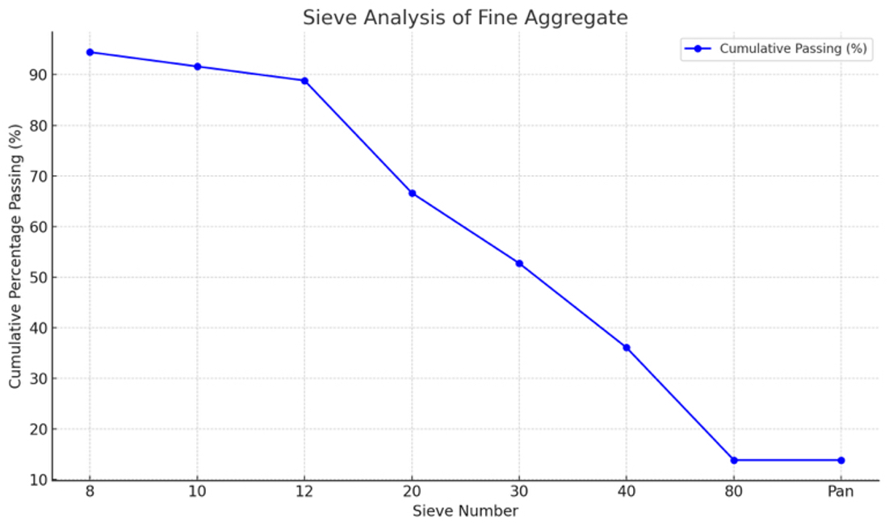

Figure 1: Sieve Analysis of Fine Aggregate

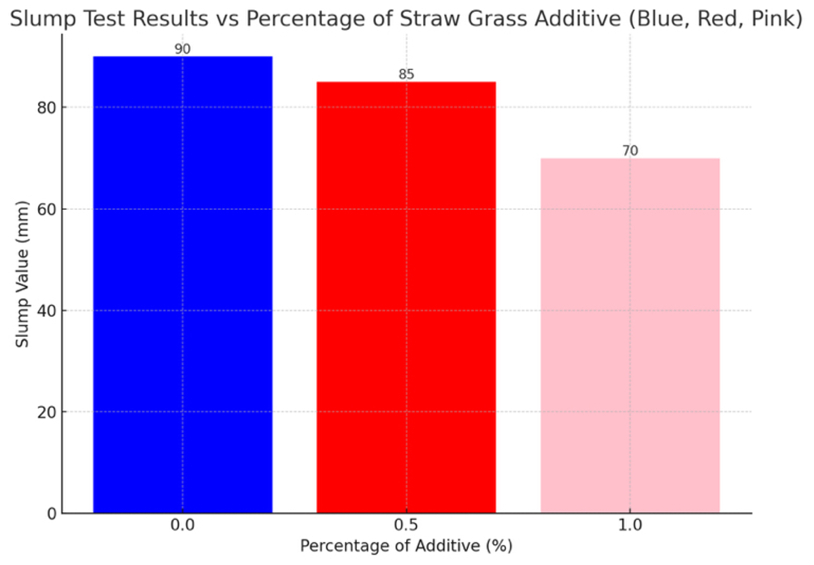

Figure 2: Slump Test Results.

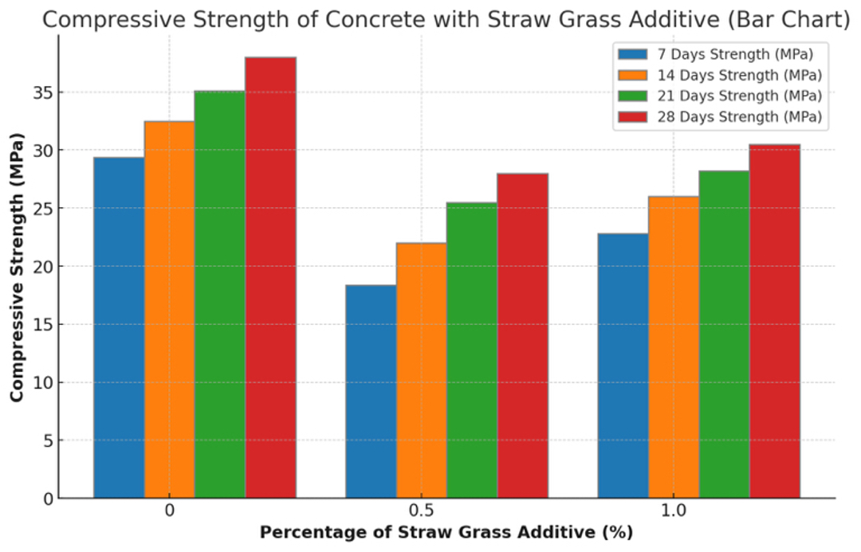

Figure 3: Compressive Strength of Concrete with Straw Grass as Reinforcement.

**3.1 Sieve Analysis**

The sieve analysis results in Table 1 and Figure 1 demonstrate that the fine aggregate used in this study is well-graded, making it suitable for concrete production. The cumulative percentage passing through the No. 8 sieve was 94.44%, indicating that most of the particles are fine, with a controlled proportion of coarser particles. This balanced gradation ensures proper particle packing, minimizing voids in the concrete mix and enhancing its workability and strength.

The cumulative percentage passing values progressively decreased through finer sieves, with the fines retained in the pan sieve accounting for 5% of the total sample. This distribution reflects a controlled proportion of fines, It enhances the concrete mix's cohesiveness and longevity.The fineness modulus, calculated from the cumulative retained percentages, was within the acceptable range for fine aggregates, confirming that the sand is neither too coarse nor too fine.

These results indicate that the fine aggregate complies with the grading requirements of relevant standards, ensuring optimal concrete performance. A well-graded aggregate contributes to reduced water demand, improved compaction, and enhanced durability, making it ideal for the production of strong and workable concrete.

**3.2 Slump test**

The slump test results in Table 2 and Figure 2 show that workability decreased with increasing straw grass content. The control sample (0.0% straw grass) recorded the highest slump value of 90 mm, indicating high fluidity typical of conventional concrete. Adding 0.5% straw grass reduced the slump to 85 mm, while 1.0% straw grass further decreased it to 70 mm, reflecting increased stiffness due to fiber interference with the cement paste. These results demonstrate that higher straw grass content reduces workability, necessitating adjustments in mix design for practical applications.

**3.3 Compressive Strength Test**

Concrete with straw grass reinforcement is less strong than the control sample, according to the compressive strength values in Table 3 and Figure 3. The control mix, which contained 0.0% straw grass, exhibited the best matrix densification during curing, achieving the greatest strength of 38.00 MPa after 28 days. The strength of the 0.5% straw grass mix decreased by 26% to 28.00 MPa, while the 1.0% mix improved slightly to 30.50 MPa, but was still 20% less than the control. These results show that straw grass has limitations when it comes to increasing compressive strength and that its use needs to be optimised.

**3.4 Tensile Test**

The tensile strength results in Table 4 show that straw grass reinforcement reduces tensile strength compared to the control sample. The control mix achieved 3.35 MPa at 28 days, while the 0.5% and 1.0% straw grass mixes recorded 2.75 MPa and 2.95 MPa, respectively. These reductions, attributed to weak fiber-matrix bonding and the organic nature of straw grass, indicate its limitations in enhancing tensile strength, making it more suitable for non-structural applications.

1. **CONCLUSION AND RECOMMENDATIONS**

**4.1 Conclusion**

This study focused on the compressive and tensile strengths of concrete to investigate the impacts of employing straw grass as a natural reinforcement material. Over the course of 7, 14, 21, and 28 days, concrete mixes containing 0.0% (control), 0.5%, and 1.0% straw grass were evaluated. Based on the findings, the following conclusions were made:

**1. Compressive Strength**

All curing times showed a discernible decrease in compressive strength following the addition of straw grass. The 0.5% and 1.0% straw grass mixtures had lower compressive strengths of 28.00 MPa and 30.50 MPa, respectively, but the control mix had the maximum strength, reaching 38.00 MPa at 28 days. The decrease is explained by the poorer mechanical qualities of straw grass in comparison to traditional reinforcement materials, as well as the inadequate bonding between the fibres of the grass and the cement matrix.

**2. Tensile Strength**

The tensile strength of straw grass-reinforced concrete was higher than the control, unlike the compressive strength. Tensile strength at 28 days was 2.75 MPa for the control mix and 2.95 MPa and 3.35 MPa for the 0.5% and 1.0% straw grass mixtures, respectively. Although it is not as good as normal reinforced concrete, the 1.0% mix's modestly superior performance indicates that higher fibre content enhances tensile strength.

**3. Suitability of Straw Grass as Reinforcement**

It was discovered that adding straw grass to concrete did not considerably increase its tensile or compressive strength. Straw grass's employment in load-bearing structural applications is limited by its inherent limits as well as the low adherence of its organic fibres to the cement matrix.

**4. Environmental Benefits**

Despite its mechanical limitations, straw grass offers notable environmental advantages. As a renewable and biodegradable material, it provides a sustainable alternative to synthetic or non-renewable reinforcements. Its use in non-structural or low-load applications can promote sustainability without compromising safety or performance in less demanding contexts.

**4. 2 Recommendations**

On the basis of this study's findings, the following suggestions are made:

1. Non-Structural Applications: Straw grass-reinforced concrete is best suited for non-structural elements like partition walls, walkways, and landscaping features, where sustainability is prioritized over high strength.
2. Enhancing Bonding: For improved mechanical performance, future studies should investigate methods to strengthen the link between the fibres of straw grass and the cement matrix.
3. Hybrid Systems: Combining straw grass with traditional reinforcements can balance environmental benefits with improved strength.
4. Optimizing Fiber Content: Investigate a broader range of straw grass percentages to find the ideal balance between sustainability and strength.
5. Durability Studies: Long-term studies on straw grass-reinforced concrete should address resistance to biodegradation and environmental impacts.
6. Cost-Benefit Analysis: A detailed analysis should assess the economic viability of straw grass-reinforced concrete for construction.
7. Standards Development: Establish guidelines for the preparation, mix design, and application of straw grass in concrete.

**COMPETING INTERESTS**

The authors have stated that there are no conflicting interests.

Disclaimer (Artificial intelligence)

Option 1:

Author(s) hereby declare that NO generative AI technologies such as Large Language Models (ChatGPT, COPILOT, etc.) and text-to-image generators have been used during the writing or editing of this manuscript.

**REFERENCE**

Ahmed, T., & Nasser, F. (2021). The use of agricultural byproducts in eco-friendly construction. Green Construction Research Journal, 8(3), 190–200.

Anene, W.C., Agudosi, P.T. & Ogunjiofor, E.I. (2022) “Design of Traffic Signal Control System at Orlu Junction, Ihiala, Anambra State, Nigeria” International Journal of Transportation Engineering and Traffic System Vol. 8, Issue 2, pp. 38-49.

Badr, M., & Fathy, H. (2019). Logistical efficiency in rural construction using lightweight materials. International Journal of Construction Logistics, 7(2), 130–142.

Charles Kennedy, Ogunjiofor E.I, and Latam L.P. (2018) “Effect of corrosion inhibitors influence on bond behavior of reinforced concrete structures exposed to corrosive environment of sodium chloride (NaCl)” International Journal of Scientific and Research Publications, Vol. 8, pp 456 – 464.

Charles Kennedy, Ogunjiofor, E.I and Latam L.P. (2018) “Residual Flexural strength of corrosion inhibited resin coated beam in corrosion accelerated media”, Global Scientific Journals, Vol. 6, Issue 5, pp. 84 – 96.

Charles, Kennedy, Gbinu, S. K., Ogunjiofor, E.I and Okabi I.S. (2018) “Chloride Inducement on bond strength yield capacity of uncoated and resins/exudates inhibited reinforcement embedded in reinforced concrete structures” International Journal of Scientific & Engineering Research, Vol. 9, pp 874 – 885.

Charles, Kennedy, Ogunjiofor, E.I. and Latam L.P. (2018) “Yield Strength Capacity of Corrosion Inhibited (Resins/Exudates) Coated Reinforcement Embedded in Reinforced Concrete Beam and Accelerated in Corrosive Medium” European International Journal of Science and Technology, Vol. 7, No 3, pp 23 – 34.

Charles, Kennedy, Ogunjiofor, E.I. and Terence T.W. (2019) “Pullout Bond Splitting Effects of Corroded And Inhibited Reinforcement in Corrosive Media” Journal of Multidisciplinary Engineering Science and Technology (JMEST), Vol. 4, Issue 9, pp. 10747 – 10753.

Chen, Z., & Li, Y. (2018). Performance of straw grass-reinforced concrete under water-saturated conditions. Civil Engineering Materials Research, 5(1), 50–65.

Jackson, L., Cooper, M., & Lee, A. (2020). Biodegradable materials in the circular economy: Implications for construction. Environmental Materials Journal, 11(5), 450–462.

Johnson, P., Carter, S., & Allen, M. (2020). Natural fibers as sustainable alternatives in construction: A review of recent advances. International Journal of Environmental Engineering, 15(4), 310–324.

Lee, K., & Kim, J. (2019). Mitigating crack propagation in concrete using natural fibers. Concrete Research and Innovation, 12(6), 520–532.

Obi C. Mac-Donald, Nwafor C. Cajetan, Ogunjiofor I. Emmanuel(2023) “Structural Characteristics of Concrete Produced with Coal Ash and Jute Fibre for Sustainable Engineering” International Journal of Innovative Research in Science, Engineering and Technology (IJIRSET) Vol. 12, Issue 11, pp. 13137-13143.

Ogunbiyi, O., Adebayo, R., & Ajayi, S. (2021). Durability of natural fiber-reinforced concrete in water management systems. Water Infrastructure Engineering, 9(4), 280–295.

Ogunjiofor E.I. (2020) “Possibility of Usage of Seawater for Mixing and Curing of Concrete in Salty Water Localities” Journal of Engineering Research and Reports, Vol. 19(3), pp. 19 – 27.

Ogunjiofor E.I. (2020) “Solution of Rectangular Plate on Winkler’s Elastic Foundation Using Characteristic Orthogonal Polynomials” Saudi Journal of Civil Engineering, Vol. 4(8), pp. 119 – 124.

Ogunjiofor E.I. and Nwoji C.U. (2017). “Analytical bending solution of all clamped isotropic rectangular plate on Winkler’s foundation using characteristic orthogonal polynomial” Nigerian Journal of Technology, Vol. 36, pp 724 – 728.

Ogunjiofor E.I., (2017) “Solution of SSSS rectangular plate on Winkler’s elastic foundation using characteristic orthogonal polynomials” International conference on engineering adaptation and policy reforms Vol 3, pp 94-102. (ICEAPR 2017) May, 2017

Ogunjiofor I. Emmanuel, Ezeokonkwo A. Joseph, Emefo O. Chukwuebuka (2023) “Advocacy for the Production of Geopolymer Concrete Using Plantain Fiber and Coal Ash” International Journal of Innovative Research in Science, Engineering and Technology (IJIRSET) Vol. 12,Issue 11, pp. 13144-13149.

Ogunjiofor I. Emmanuel, Ezewudo T.I, Udeolisa N.C. (2023) “Characteristics Of Geopolymer Concrete Produced using Banana Fiber and Coal Ash” International Research Journal of Mordernization in Engineering Technology and Science Vol. 5, Issue 12, pp. 2248-2254.

Ogunjiofor I. Emmanuel, MarkPromise N. Maduanusi and Eloka A. Odiari (2023) “Production of Geopolymer Concrete using Bamboo Fiber and Coal Ash” International journal of Innovative Science and Research Vol. 8, Issue 11, pp. 2058-2064.

Ogunjiofor I. Emmanuel, Nzenwa I. David, Ugochukwu O. Kingsley, Afamefuna C. Chukwuemeka (2023) “Reduction of Thermal Cracking in Concrete Through the use of Coal Ash as a Partial Replacement for OPC” International journal of Innovative Science and Research Technology Vol.8, Issue 12, pp. 756-760.

Ogunjiofor, E.I. and Ayodele F.O. (2023) “Utilization of Response Surface Methodology in Optimization of locally sourced Aggregates” Journal of Asian Scientific Research, Vol. 13, Issue 1, pp. 54 – 67.

Ogunjiofor, E.I., Agbataekwe E. and Ohizu E. (2023) “Assessment of the Mechanical properties of steel fiber reinforced concrete for Low-Cost Construction ” American Journal of Innovation in Science and Engineering (AJISE), Vol. 2, Issue 1, pp. 51 – 56.

Ogunjiofor, E.I., Amete D. C. and Nwabunwanne J.C. (2023) “Structural Behaviour of Concrete Produced Using Palm Kernel Shell (PKS) as a Partial Substitute for Coarse Aggregate” American Journal of Innovation in Science and Engineering (AJISE), Vol. 2, Issue 1, pp. 1 – 7.

Ogunjiofor, E.I., Okoye N.G. and Ezeonyi I.E. (2023) “Analysis of Safety Behaviour of workers Under Small-Scale Construction site: A case study of Anambra State” American Journal of Interdisciplinary Research and Innovation (AJIRI), Vol. 2, Issue 2, pp. 44 – 50.

Ogunjiofor, E.I., Onuh R. and Ojukwu K.C. (2023) “Compressive Strength Development of Concrete Produced with Partial Replacement of Fine Aggregate with Crushed Glass” World Wide Journal of Multidisciplinary Research and Development (WWJMRD), Vol. 9, Issue 1, pp. 91 – 96.

Ogunjiofor, E.I., Onwunduba C.J, Okpala I.J (2023) “Sustainable Production of Building Blocks using A Recycled Plastic Waste” International Journal for research in Applied Science & Engineering Technology (IJRASET) Vol. 11, Issue XII, pp. 2346-2354.

Patel, V., & Shah, R. (2022). Sustainable alternatives for culvert construction: A focus on natural fiber reinforcement. Journal of Civil Infrastructure Research, 14(1), 95–108.

Smith, J., & Jones, R. (2018). The environmental impacts of traditional construction materials: A review. Journal of Sustainable Construction Materials, 10(2), 45–58.