Review Article
Crystallographic Investigation of PVA@PLA Nanocomposite Film by X-ray Diffraction: Insight from High Resolution TEM

ABSTRACT

PLA-PVA films have desirable unique, unparalleled properties such as good oxygen and moisture barrier, excellent mechanical strength and low toxicity. The biodegradability of PLA and PVA offers a sustainable alternative to traditional plastic packaging. The PLA-PVA film stacking technology and its potential benefits for sustainable packaging. The XRD pattern of PVA exhibited sharp diffraction peaks at 20.0 ° and 41.0 °, reflecting its semi-crystalline nature, with the peak at 20.0 ° where a main diffraction of PLA was found around 16.5 °. PVA generally crystallizes in the monoclinic unit cell with dimensions of a= 7.81 Å, b= 2.52 Å, c= 5.51 Å, and α=γ= 90.0 °, and β= 91.70 °. PLA depicted semi-crystalline synthetic polymer with α form which most stable polymorph with shape an orthorhombic unit cell. Taking two typical spacing showed in 0.40 ± 0.02 nm and 0.26 ± 0.03 nm acquired from HR-TEM interface accord with (200) and (002) Miller indices of PVA. The HR-TEM images also computed the d-spacing of PLA 0.340 nm with respective fringe. SEM is used to obtain the morphology such a nanostructure PVA-PLA composite materials. The size, shape, purity, surface morphology and distribution of PLA-PVA composite were explored by SEM. The research explores the structure and properties of biodegradable PVA-PLA nanocomposite films using XRD, SEM and HR-TEM. The findings reveal how these materials can be made stronger and more sustainable, making them ideal for eco-friendly packaging.

Keywords: HR-TEM, Nanocomposite, PVA, PLA, XRD.

1.0 Introduction
Long chains of molecules buried in three-dimensional geometry make up polymers which may be created chemically or naturally. Polymers have remarkable flexibility and strength. By incorporating specialized reinforcements [1]. A green substitute for petrochemical commodity plastics, poly lactic acid (PLA) is utilized in packaging, agricultural goods, disposable materials, textiles and automotive composites [1]. “However, several of its features, namely in terms of thermo-mechanical and electrical performance, must be enhanced for various usage. The exceptional qualities of carbon-based nanoparticles (CBN) have sparked an increase in research into composites made of PLA and CBN. The information that is currently accessible is collated and examined with an emphasis on composites made of PLA and carbon nanotubes (CNTs)” [1]. The processes of manufacture and the impact of CBN loading on the mechanical characteristics of PLA are examined [2]. PVA is one of the synthetic polymers produced in the world largest quantities over the past century. It is made by free radical polymerizing vinyl acetate to create polymerization, then hydrolyzing in PVA chains [3] With relation to biomaterials, specifically, biodegradation is a crucial factor. PVA is a common vinyl polymer and is thought to be non-biodegradable since its main chain is made up primarily of carbon-carbon bonds [4-5]. Hence included in various formulations a large main chain scission following for functional administration. Polypropylene is frequently used as the matrix material in applications based on natural fibers, such as automotive applications [6]. Composites using matrices made from renewable basic resources have received little research attention [6]. There are many different types of polymers made from renewable resources, including plastics based on starch, lignin, cellulose esters, polyhydroxyl butyrates and PLA [6]. These polymer drawbacks include a lack of commercial availability, difficult processing, low toughness, high cost, and poor moisture stability [6]. The durability of renewable materials is particularly crucial, especially if the items don't have a single use [6]. Two or more different materials that create regions large enough and that are typically strongly bound together at the interface make up composite materials [7]. Such materials include reinforced rubber, filled polymers and chopped fiber composites, polycrystalline aggregates (metals), and many more natural and synthetic materials [7]. According to legend, Albert Einstein's renowned work from 1906, in which he calculated the effective viscosity of a fluid containing a small number of hard spherical particles, is where the study of mechanical properties had its start [7]. Depending on the kind of matrix, composite materials can be divided into three primary categories like metal matrix composites (MMC), ceramic matrix composites (CMC), and polymer matrix composites (PMC) [8]. Engineered mixtures of two or more materials, one of which is a metal, are known as metal-matrix composites (MMCs), where tailored qualities are obtained by methodically combining various ingredients [8]. The combinations of strength, stiffness, and density that can be achieved using conventional monolithic materials are constrained. High specific strength and specific modulus are combined by engineered MMCs made of continuous or discontinuous fibers, whiskers, or metal particles [8]. “Increased strength and stiffness are two of the most often seen characteristics of metal matrix composite materials. Compared to their pure metal equivalents, certain composites are designed to offer superior creep resistance. This lessens the possibility of the material warping or deforming, especially when it is subjected to welding or tensile stress at high temperatures” [8]. The sectors with the highest risk of creep fatigue or abrupt temperature fluctuations are the greatest candidates for metal matrix composites. These materials also have a decreased thermal expansion coefficient, which is advantageous for applications requiring material integrity at very high temperatures [8]. “MMCs must be produced at a somewhat higher temperature, which is one drawback. Technical ceramics and composite materials are combined to form ceramic matrix composites (CMCs). They are ceramic fiber-reinforced materials made up of ceramic fibers enmeshed in a ceramic matrix. Despite having fragile elements, CMCs are strong thanks to the fiber-to-matrix interface clever design which deflects and arrests matrix cracks to avoid failure of the fibrous reinforcement. Due to the harsh environments in which CMCs are utilized, tri biological reactions are a crucial subject” [9]. Traditional ceramics and the high-performance metal alloys previously employed are substantially different from ceramic matrix composites. Like ceramics, they are rigid and unaffected by temperature changes. However, they also have far superior toughness and resilience to thermal stress, as well as being very light (one-third the weight of the nickel super alloys they often replace) [10]. CMCs can maintain a respectable degree of mechanical strength even at extremely high temperatures. They are very rigid and have excellent mechanical, thermal, dimensional, and chemical stability. CMCs are less prone to shatter than conventional ceramic materials and may stretch up to 1.0 % before breaking. Common uses for CMCs include heat exchangers and burner components, gas turbine parts, engine exhaust systems, the aerospace industry, hypersonic vehicles, and the nuclear power industry. The main disadvantage of CMCs is its brittleness [10]. A polymer matrix composite (PMC) is a composite material made of several short or continuous fibers joined by an organic polymer matrix. PMC are intended to move loads among a matrix's fibers. Inorganic or organic polymers can be used as the matrix in polymer matrix composites, together with continuous or short fibers and particles ranging in size from millimeters to nanometers, as the reinforcing material [11]. There are vast areas of applications of polymer matrix composite in this century. Reinforced plastics are made up of polyester resins, and these resins use E-glass, or low-stiffness glass fibers for reinforcements. They have been around much longer, as it was only about 40 years ago when people first began using them for automotive panels, boat hulls, pipes, and the like [11]. On the other hand, advanced composites are composed of various matrix and fiber combinations. As a result, a composite material with exceptional stiffness and strength is produced. Advanced composites are very new, having just been developed roughly 15 years ago compared to reinforced plastics [11]. They are often employed in the aerospace sector, but haven't been widely utilized elsewhere due to their high cost. Composites made of polymer are popular because they may be both light and strong. Stones and metals were frequently used by people in the past for a variety of reasons, although things weren't always successful on this front. Another benefit of PMC is their strong resilience to corrosion and fatigue. Currently available PMC have a propensity to break down at temperatures below 316.0 °C (about 600.0 °F) [11]. Microorganisms may quickly break down biodegradable polymers, ensuring that the environmental effect of both the original biodegradable polymer and its byproducts is minimized. Enzymes produced by microorganisms are used in enzyme-catalyzed processes to split these polymers into smaller pieces [12]. These days, polymers are a big part of our life. Polymers come in a variety of forms and serve a variety of functions. There are some polymers that can withstand environmental deterioration and are blamed for the development of polymeric solid waste. These solid wastes persist for a very long period without degrading and pose serious environmental issues [12]. The disposal of trash from these items is also becoming a significant issue due to the growing use of polymers. In order to limit the harm done to the environment during their disposal, biodegradable polymers were developed. Microorganisms may very easily break down biodegradable polymers. Natural and manufactured biodegradable polymers are the two different forms of biodegradable polymers. The following are some lists of biodegradable polymers are included in Table 1 [12].

Table 1. Example of biodegradable polymers.

Natural biodegradable polymer | Synthetic biodegradable polymer
Wood, Pectins, Soya, Casein, Whey, Collagen, Chitosan, Gelatin, Hyaluronan, Starch, Albumin, Alginate, Guar gum, Carrageenan | Polyglycolic acid, Polyorthoesters, Polyphosphoester, Polyanhydride, Polyester-amides, Polyamides, Poly(lactic acid), Poly(caprolactone), Poly (33-hydroxybutyric acid), Poly (sebacic acid), Poly (adipic acid), Polyposphazenes, Poly (dioxanone).

Man-made polymers of natural, semi-synthetic or synthetic origins that can dissolve, scatter and swell in water are known as water-soluble synthetic polymers [13]. PVA is one of these polymers and is odorless, non-toxic, biodegradable and biocompatible. Although it has limited barrier and thermal qualities and is somewhat expensive, it also has strong chemical resistance and great mechanical properties [14]. PVA can be found in a variety of forms, including film, fiber and powder, without the insolation of monomers [14]. PVA, a semi-crystalline polymer, the majority of the phases are amorphous, and there is only a little percentage of crystallinity [15]. The molecular weight of PVA normally ranges between 20,000 and 400,000, and depending on the length of vinyl acetate used to create PVA, the degree of hydrolysis is typically in the range of 80.0 to 99.0 %. These factors together determine the substance's qualities [16], Due to the PVA surface abundance of hydroxyl groups, which makes it one of the most hydrophilic polymers with a high sensitivity to moisture, blends and composite materials derived from it have become common for packaging applications [16]. In general, full-hydrolysis PVA is not considered to be a thermoplastic polymer mainly due to its melting temperature being very close to the degradation temperature in the absence of plasticizers. In order to regulate the required melting temperature, fluidity and thermal stability, particularly for screw extrusion and injection molding techniques that are often used for packaging applications, it is imperative to employ eight plasticizers for PVA [17]. As mentioned by Jang and Lee [17], the addition of plasticizer to PVA can decrease its melting temperature, brittleness and improve the flexibility and process ability, as a result of increasing the segment mobility and reducing the crystallinity. However, the use of excessive plasticizer is known to result in phase separation due to the increase of hydrogen bonding between plasticizer and polymer molecules. Partial-hydrolysis PVA contains residual acetate groups, sometimes known as a copolymer of vinyl acetate and vinyl alcohol. These groups can restrict the creation of hydrogen bonding with adjacent –OH groups, resulting in increased blend solubility, water uptake and permeability. Due to the differences in the thermal characteristics of full-hydrolysis and partial-hydrolysis PVA/cellulose nano whisker (CNW) composite films, partial-hydrolysis PVA is not favored for packing applications [18]. Due to strong interactions between polymer matrices and nano-fillers that limit chain mobility, full-hydrolysis PVA/CNW nanocomposites were reported to have superior thermal stability than their partial-hydrolysis counterparts. In addition, when low-molecular-weight PVA and chitosan were combined, hydrogen bonds were less likely to form, which decreased strength and stiffness while raising elongation due to phase separation [18]. According to Grande et al. Due to their superior material performance, PVA, its blends, and composites have therefore seen a sharp surge in utilization in recent years for packaging applications.

Biodegradable polymers are frequently utilized outside of medicine to lessen the amount of waste in packaging materials. Significant effort is also being made to replace petrochemical-derived products with ones that can be produced from biodegradable resources. PLA is one of the polymers that is most frequently used for packaging. The most significant benefit of making PLA is the ability to modify the polymer physical characteristics through processing techniques. Numerous films, wrappings, and containers are made of PLA [19]. PLA, a biodegradable polymer made from renewable resources, is one of these materials. Due to its biocompatibility, PLA a biodegradable polymer, has been extensively employed in many industrial applications. PLA is commonly employed in the medical industry due to its high compatibility and degradability [19].

Table 2. Physical properties of PLA.
Parameters | Values | Reference
Melting point | 155.0 to 185.0 °C | [19]
Intrinsic viscosity IV | 0.20 to 8.0 dL/g
Glass transition temperature | 60 to 65.0 °C
Heat transfer coefficient | 0.025 λ(w/m*k)
Density | 1.20 to 1.30 kg/L

PLA combines a number of intriguing qualities that make it the perfect choice for biological applications. Films made of plastic, bottles, and biodegradable medical equipment are some of the most popular uses. A brand-new class of biodegradable polymer called PLA is created from the starch basic ingredients suggested by sustainable plant resources described in Fig. 1. Scarification of raw starch results in the production of glucose, which is subsequently fermented by certain strains of bacteria to create high-purity PLA [19] descripted in Table 2.

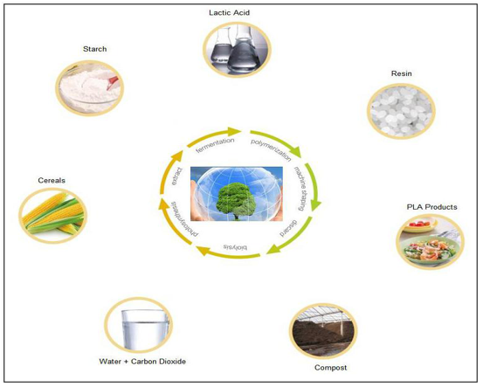
Fig. 1. Functional approaches of PLA [19].

After usage, it has high biodegradability and may be entirely broken down by natural microorganisms. As a result, carbon dioxide and water are produced without harming the environment depicted in Fig. 2. This substance is regarded as being ecologically benign and is highly helpful for environmental preservation. When PLA is burned, it has the same combustion calorific value as burning paper, which is half that of conventional plastics (such as polyethylene). Hazardous gases like nitrides and sulfides will never be released during the cremation of PLA [19]. Lactic acid is also found in the body as a monomer, demonstrating the safety of this decomposable substance. PLA plastics are buried in the ground to degrade where the carbon dioxide produced enters directly into the soil's organic matter or is absorbed by plants, preventing emissions into the atmosphere.
Fig. 2. Impact of using non-toxic polymer of PLA [19-23].

Even when burned, PLA produces less smoke than polymers made from oil. Plastic items, packaged food, non-woven textiles, industrial and civil cloth as well as cutlery, spoons and disposable tableware are all processed using PLA since it is compatible for several processing techniques such blow molding and thermoplastic. Then transformed into fabrics for use in agriculture, healthcare, wipes, sanitary items, outdoor anti-ultraviolet fabrics, tent fabrics, floor mats and other things [20]. Due to its accessibility and inexpensive cost, starch is being used in more and more applications, however it lacks the strength and rigidity to endure loads [20]. To combat some of the imitations linked to starch-based polymer blends, extensive study has been done. A possible biodegradable polymer has been researched using starch and PVA. Some researchers have reported on the mechanical characteristics and biodegradability of starch PVA blended films, however they haven't been thoroughly investigated to ascertain their chemical heterogeneity or surface functionalities [20].

The manufacture of biopolymer films frequently use the solvent-casting method. Drying, casting, and solubilization are steps in this process. In solvents including xylene, methylene chloride, benzene, chloroform, and dioxane, PLA is well known to be very soluble. PLA films made with toluene, xylene, acetone and ethyl acetate displayed a surface segregation and enhanced hydrophobicity [21]. By incorporating nanoclays and natural fibers into the process of manufacturing PLA films, the majority of research has focused on enhancing the mechanical and barrier characteristics of PLA. Methylene chloride and acetonitrile when combined with PLA thin films changed the crystalline structure, improving heat stability but making the material brittle [22]. By examining how processing factors affect the final characteristics of PLA, our work helps to solve these toughness [22]. Starch and synthetic polymers are frequently combined today and are thought to be an effective approach. In order to create a viable biodegradable polymer, starch has been combined with the synthetic biopolymer PVA [23]. The lack of water resistance and poor mechanical properties of the Starch/PVA blended films restricts their applicability. This may be due to poor compatibility between starch and PVA and subsequent phase separation during film synthesis [23]. The strength and stiffness of polymers can be dramatically and qualitatively improved by using modest quantities of nanoparticle reinforcement. Nanoparticle reinforced materials were expensive; however, costs have now begun to decline, and in the near future, widespread usage of these materials may be anticipated [23]. Composites enhanced with nanoparticles eventually replace current wind energy materials. A computational multiscale model that incorporates the interaction between fiber and matrix at the higher scale level (micro level) and the interaction between nano clay and epoxy and matrix at the nano level has been developed in order to analyze the impact of nanoparticle distribution in the matrix and in the interface [Fig. 3.] on the strength of composites [23]. Most recently carbon nanotubes (CNTs) also investigated as a reinforcing [23, 52].

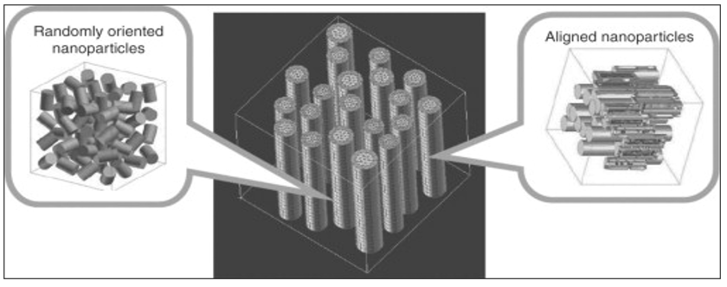

Fig. 3. Multi particle unit cell of nanoparticle-reinforced composite with interface model [23].

Polymer composite film consists of PLA and PVA is made here to improve the strength of polymer and keeping it biodegradable and environment friendly for food packing materials. Furthermore, carbon nanotube is used as a reinforcing agent to enhance the quality and tensile strength of the polymer matrix. These findings will be useful in forecasting the mechanical properties like impact and tensile strength of polymer matrix composite on the basis of crystallographic investigation. The final composite will be biodegradable, strong and environment friendly as like as food packing materials.

3.0 Characterization
3.1 X-ray Diffraction (XRD)
The X-Ray diffraction analysis of the composite samples was carried out X-ray diffractometer SmartLab SE, Rigaku, Japan [24]. X-Ray beam generated from an X-ray tube (Cu kα) with an energy of 40 kV, 50mA [25]. This high energy beam passes through a Ni K_{β} filter which allows only the Cu kα, removes all the unexpected wavelengths from the source beam [26]. Then it passes through cross beam optics (CBO) and then follows Bragg Bentano BB-geometry as the sample is powder [27]. For film or composite sample parallel beam geometry is followed. To maintain the fixed angle between the sample and the beam 2.5 mm solar slit is used [28]. Then the beam passes through 10.0 mm slit to maintain the path length. After that the beam bombards with the sample and diffraction takes place in the crystal planes for constructive interference [29]. The diffracted beam is called secondary beam which passes through Ni K_{β} filter and then 2.5º parallel slit analyzer (PSA) to make the diffracted rays in parallel [30]. The instrumentation of X-ray diffractometer skeleton explored in Fig. 4.
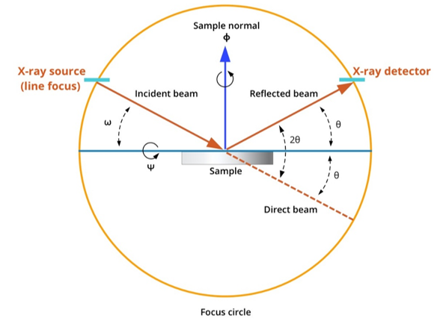
Fig. 4. Instrumentation of X-ray diffractometer skeleton [24-32].

Then passes through 2.5 mm solar slit and then the attenuator to amplify the intensity of the secondary beam [31]. Then goes to the Hypix 400 detector [hybrid pixel array detector (HPAD)] which includes 400 pixels [59-61]. At last the diffractogram is found which is ready to analysis [32].

3.2 Transmission Electron Microscopy (TEM)
TEM is an analytical technique explored to visualize the smallest unique structures in matter [33]. Unlike optical microscopes, which rely on light source in the ordinary visible spectrum, TEM can reveal detail at the atomic scale by magnifying nanometer structures up to 50.0 million times [34]. This is because electrons can have a significantly shorter wavelength (about 100,000 times smaller) than that of visible light [35] when accelerated through a strong electromagnetic field, thus increasing the microscope resolution by several orders of magnitude [36]. Acquire TEM image have a high energy electron beam is accelerated through an extremely thin electron transparent sample, typically thinner than 10.0 to 100.0 nm [37].
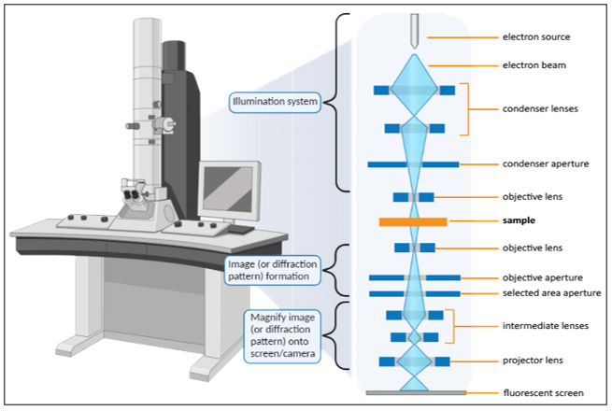
Fig. 5. TEM interfaced skeleton.

A series of low current electromagnetic lenses and controlled apertures are placed throughout the microscope column to focus the beam on the sample, minimize distortions, and magnify the resulting image onto a phosphor screen or a specialized camera or CMOS detector [37]. TEM comes in many different forms, but all share the same fundamental principles and components. The two major types of TEM instruments are the conventional TEM (also referred to simply as TEM) and the STEM (scanning transmission electron microscope) [37]. Other variations of TEMs include the AC-S/TEM (where AC stands for “aberration corrected”) and the E-S/TEM (where E stands for “environmental”) [38]. The HR-TEM explored the lattice [39] and SAED-TEM depicted the diffraction of crystal [40] in specific area at 20 to 40 cm control aperture. TEM interface explored skeleton in Fig 5.The most powerful modern day TEMs are equipped with modifications and additional detectors that not only push the performance and stability of the microscope but offer the added capability to collect chemical and electronic information at sub-nanometer length scales from a wide range of materials [41].

3.3 Scanning Electron Microscopy (SEM)
SEM is a powerful technique designed to examine a materials like composite surface. SEM, an electron beam with acceleration voltages of up to 30.0 kV is focused on the specimen [55]. The interactions between the electron beam and the specimen emit signals from the specimen and detectors collect them [55]. The recorded signals are combined to form an image. When a sample is radiated with an electron beam, “elastic scattering” results from the atomic nucleus or the outer shell electrons with similar energy [55]. The incident electrons that are elastically scattered at an angle larger than 90.0 degrees are called backscattered electrons (BSEs). BSE signals provide both compositional and topographic information of the sample [55]. When the incident electrons and the electrons and atoms of the specimen interact, “inelastic scattering” occurs [57]. During inelastic interactions, the accelerated electrons transfer considerable energy to the specimen atoms, causing the excitation of the sample electrons and leading to the generation of secondary electrons (SEs) defined with energies less than 50.0 eV [57]. SEs are the most extensively used signals in SEM, emitted electrons have low energy; only escape from a region within a few nanometers of the sample, providing accurate topographic information with good resolution. SEM contains an electron gun that accelerates the electrons through 0.10 to 30.0 keV [57]. Electromagnetic lenses and apertures are used to focus the electrons on the beam and de-magnify them to the size of the electron source [∼50.0 m for a tungsten (W) filament] before the electron beam hits the sample to the required size (1.0 to 100.0 nm) [57]. The analysis is performed in a high-vacuum environment to avoid electron scattering [57].

4.0 Result and Discussion
4.1 X-ray Crystallography Analysis
Fig. 6 (a) PVA illustrates the XRD pattern of pure PVA film. One can notice that pure PVA film exhibits two characteristic diffraction at 19.5 º and 38.6 º which are related to the semi-crystalline charactersticic of PVA membrane [42]. This semi-crystalline structure of PVA is supported by the intramolecular and intermolecular hydrogen bonds [42]. Molecules in the individual monomer unit or even in the different monomer units can create these types of bonding [42]. In contrast, the XRD pattern of PVA exhibited sharp peaks at 20.0 ° and 41.0 °, reflecting its semi-crystalline nature, with the peak at 20.0 ° being particularly intense [43]. PVA semi crystalline structure of PVA maintained by intermolecular and intramolecular hydrogen bonding [43] linkage to the adjacent molecules or atoms. It is reported that PVA generally crystallizes in the monoclinic unit cell with dimensions of a= 7.81 Å, b= 2.52 Å, c= 5.51 Å, and α=γ= 90.0 °, and β= 91.70 ° [43]. On the other hands, PLA is a semi-crystalline synthetic polymer with a crystalline structure that can be α, β, or γ. The α form is the most stable and common polymorph. The most common and stable form, with an orthorhombic unit cell of PLA [44].

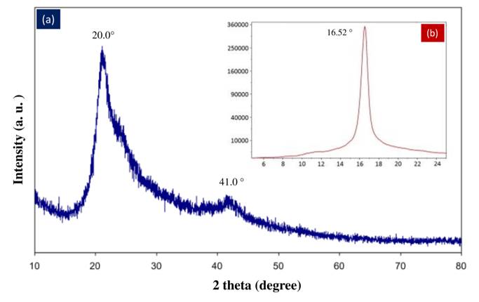
Fig. 6. X-ray diffractrogram of (a) PVA and (b) PLA [42-43].

The XRD pattern explored the results, Fig. 6 (b), the strongest reflection intensity diffraction of PLA fibre appears at 2θ= 16.52 °.This finding is consistent with previous studies [45], where a main diffraction of PLA was found around 16.5 °. The approximate degree of crystallinity of the samples can be expressed in a simple way from the ratio of the relative areas of diffraction to the entire area of the pattern after removing background scattering [45]. Thus the crystallinity of PLA fibre from XRD pattern is about 75.0 % [45]. The crystallization rate and crystallinity of PLA were controlled by the addition of physical nucleating agents as well as optimization of injection molding processing conditions [46].

4.2 Transmission Electron Microscopy Analysis
4.2.1 TEM Analysis of PVA
TEM ptychographic investigation, used HR-TEM to observe crystal information of PVA as well as confirm the effects of annealing temperature in Fig. 7. For the single-crystal region of PVA sample and clear fringes observed in the HR-TEM in Fig. 7 (a). Computed d-spacing from line profiles to ten different point at 0.40 ± 0.01 nm d-spacing was measured and its FFT image in Fig. 7 (d) also shows showed d-spacing at 0.45 (±0.02) nm, 0.26 (±0.01) nm, 0.22 (±0.01) nm [47]. Simulated the single-crystal electron diffraction pattern of Bunn's PVA model in Fig. 7 (g) was explored. The d-spacing could associated with the (200), (002), (101) and (202) planes respectively using the FFT pattern [47]. Taking two typical spacing showed in Fig. 7 (h), 0.40 ± 0.02 nm and 0.26 ± 0.03 nm acquired from TEM interface accord with the d-spacing of the (200) and (002) planes of PVA from Bunn's model [47]. The HR-TEM, the same crystal of the PVA sample was also imaged via TEM ptychography and its simultaneous HAADF-STEM [high-angle annular dark-field scanning transmission electron microscopy] image [48]. Collection angles for HAADF images are from 72 to 271m rad. The dose here is 6.5 × 104 (e−/Å2), and no severe beam damage was found during the acquisition [47]. The reconstructed WDD [Wigner distribution deconvolution] phase [49] image and the HAADF image are shown in Fig. 7 (c) and (b), respectively. The d-spacing from the two images are the same as the ones acquired from the HR-TEM image, and the d-spacing are marked in Figs. 7 (c) and (b) and FFT images of Fig. 7 (f) and (e). Comparing the HAADF and the TEM ptychography [48-49], Fig. 7 (c) shows more significance in detail than Fig. 7 (b), and thus, TEM ptychography brings more information on the phase structure, and the TEM image shows how the light atoms order in the material in the [010] viewing direction [47-49].

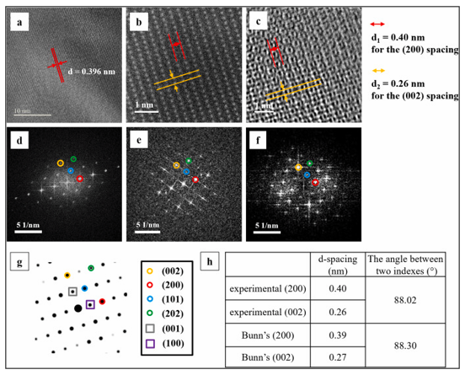
Fig. 7. TEM images of PVA orientated in the [010] direction (a) HR-TEM image, (b) HAADF-STEM image, (c) Simultaneous electron ptychography WDD phase image, (d) FFT of (a). (e) FFT of (b). (f) FFT of (c). (g) Simulated single-crystal electron diffraction pattern of Bunn's model, (h) comparison between electron ptychographic data and Bunn's model [47].

4.2.2 TEM Analysis of PLA
HR-TEM of PLA explored to a high-resolution transmission electron microscopy image of PLA, allowing for detailed visualization of the polymer crystal structure and morphology at the nanoscale level, revealing features like the arrangement of polymer chains and potential crystalline domains within the material [50]. Understanding crystallization behavior of PLA crystallizes under different processing conditions to optimize its mechanical properties. Evaluating the effects of additives like analyzing how fillers or other additives affect the PLA crystal structure and morphology [50]. Investigating degradation mechanisms such as observing the changes in PLA structure during degradation processes [50].
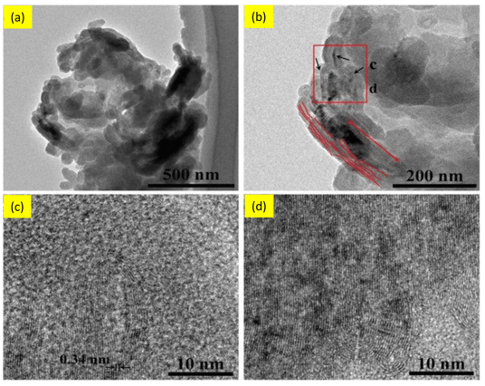
Fig. 8. TEM interface for sample CNTs/PLA (a), (b) Microstructures of the composite and CNTs dispersion in PLA matrix (c), (d) HR-TEM images showing the lattice of CNTs [50-51].

The Fig. 8 (a) show that the PLA in uniformed distribution of the inner core where the CNTs shoed the agglomerated [51] and Fig. 8 (b) and (c) explored to the PLA and CNTs were formed a composite matrix into the interface [51]. The HR-TEM images also computed the d-spacing of PLA in CNTs matrix in 0.340 nm with uniform dispersion CNTs as reinforcing matrix [51] revealed that the CNTs matrix lattice also fringe were in an orthorhombic unit cell of PLA in Fig. 8 (d) [51-52].

4.3 Surface Morphology Analysis by SEM
SEM is used to obtain the morphology of such nanostructure materials or composite. The size and polydispersity, shape, purity, surface morphology, and distribution of composite are characterized by SEM [56]. The surface morphology of the PVA observed in much unified shape in structure in sheet edge explored in Fig 9. The Fig. 9 (a) PVA, (b) PVA/PLA (90:10), (c) PVA/PLA (70:30), (d) PVA/PLA (50:50), (e) PVA/PLA (30:70) and (f) PVA/PLA (10:90) composite, maintain the proportional of stoichiometric percentage. Increasing the percentage of PLA, the surface particle growth in more homogeneous distribution but the PVA shows an opposite phenomenon where observed more porosity in Fig 9 (e).

Fig. 9. Morphology of (a) PVA, (b) PVA/PLA (90:10), (c) PVA/PLA (70:30), (d) PVA/PLA (50:50), (e) PVA/PLA (30:70) and (f) PVA/PLA (10:90) composite [56].

In Fig. 9 (f) also observed that the PVA/PLA composite were in amorphous nature in surface. A PVA-PLA composite is a blend of polyvinyl alcohol (PVA) and polylactic acid (PLA). This composite has many potential uses, including in food packaging, electronics and other functional approaches [58].

5.0 Functional Application
The PVA-PLA composite have a wraps, disposable, blend, scaffold, carrier, sensing and strength function [53] displayed in Fig. 10. PVA-PLA composite can be combined to make biodegradable, antimicrobial, and active food packaging materials [53]. PLA sheets on the outside of the laminate provide water resistance and a barrier to water vapor [53]. Composite PVA sheets on the inside provide an oxygen barrier. Active compounds in the PVA composite sheet can extend the shelf life of food. Antibacterial agents can be added to the polymer matrix like CNTs [52].
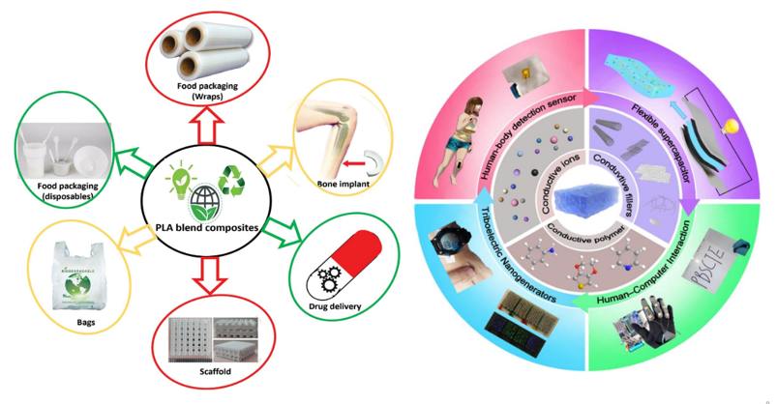
Fig. 10. Function application of PVA-PLA nanocomposite [53-54].

PVA-PLA composite are biodegradable polymers [54]. PVA-PLA composite is non-toxic. PVA-PLA composite have good mechanical properties. To make the laminate, thermos compression can be used to avoid the need for glue additives. Plasticizing PVA-PLA composite can help active compounds diffuse to the food, extending its shelf life [54]. The self-healing property of PVA-PLA composite can be enhanced by blending it with other biopolymers. The release rate of active substances can be slowed by adding layered CNTs to the PVA matrix [52-54]. From avoiding the heavy metal contamination, food preservative and antibiotics, natural or organic polymers were the best choice for food packing materials now a days [62-70]. Polyvinyl alcohol matrix stacked with poly lactic acid films could be a new strategy in the field of endurable composite to reach high-performance biodegradable packaging materials. The desirable properties of PLA-PVA multilayer nanocomposites lead to the replacement of traditional plastics. This manuscript has great potential to attract the attention of researchers in achieving desirable materials in the packaging industry. This could lead to better biodegradable plastics for medical, food, and industrial applications.

Conclusion
PVA and PLA solution for making two different biodegradable polymer film and stacked as sandwich semi crystalline structure that exhibited improved thermal and mechanical stability. The stacked film demonstrated excellent thermal, biodegrade and mechanical stability. PVA film exhibits two characteristic diffraction at 19.5 º and 38.6 º which are related to the semi-crystalline characteristic of PVA. This semi-crystalline structure of PVA is supported by the intramolecular and intermolecular hydrogen bonds. In contrast, the XRD pattern of PVA exhibited sharp peaks at 20.0 ° and 41.0 °, reflecting its semi-crystalline nature, with the peak at 20.0 ° where a main diffraction of PLA was found around 16.5 °. PVA generally crystallizes in the monoclinic unit cell with dimensions of a= 7.81 Å, b= 2.52 Å, c= 5.51 Å, and α=γ= 90.0 °, and β= 91.70 °. PLA is a semi-crystalline synthetic polymer with a crystalline structure that can be α, β, or γ. The α form is the most stable and common polymorph with an orthorhombic unit cell. The d-spacing could associated with the (200), (002), (101) and (202) planes respectively using the FFT pattern. Taking two typical spacing showed in 0.40 ± 0.02 nm and 0.26 ± 0.03 nm acquired from HR-TEM interface accord with (200) and (002) planes of PVA. The HR-TEM images also computed the d-spacing of PLA 0.340 nm with respective fringe. SEM depicted to obtain the surface morphology of the nanostructure composite. The size, shape, purity, surface morphology and distribution of PLA-PVA composite were explored by SEM. The investigation conducted to determine the PLA-PVA blend to develop this biodegradable film with outstanding thermal and mechanical characteristics and apply for food packing materials.

Data Availability
The data is available on request.

Acknowledgement
The author’s heartiest thanks to Dr. Shirin Akter Jahan, PSO, BCSIR, Bangladesh for kind cooperation to access the software, PC and other appliances. We also heartiest thanks to Dr. Sharif Md. Al-Reza, Chairman, Department of Applied Chemistry and Chemical Engineering, Islamic University, Kushtia-7003, Bangladesh for access the laboratories facilities and software.

Competing Interests Disclaimer
Authors have declared that they have no known competing financial interests or non-financial interests or personal relationships that could have appeared to influence the work reported in this paper.

Disclaimer (Artificial intelligence)
Author(s) hereby declare that NO generative AI technologies such as Large Language Models (ChatGPT, COPILOT, etc.) and text-to-image generators have been used during the writing or editing of this manuscript.

Reference
[1]. Chohan, U. W. (2020). Modern Monetary Theory (MMT): a general introduction.
[2]. Oksman, K., Skrifvars, M., & Selin, J. F. (2003). Natural fibres as reinforcement in polylactic acid (PLA) composites. Composites science and technology, 63(9), 1317-1324.
[3]. Baker, J. (2012). The technology–organization–environment framework. Information Systems Theory: Explaining and Predicting Our Digital Society, Vol. 1, 231-245.
[4]. Alves, R. C. P., Alves, D., Guz, B., Matos, C., Viana, M., Harriz, M., ... & Polletti, P. (2016). Advanced hepatocellular carcinoma. Review of targeted molecular drugs. Annals of hepatology, 10(1), 21-27.
[5]. Simon, H., Baker, K. R., & Phillips, S. (2012). Compilation and interpretation of photochemical model performance statistics published between 2006 and 2012. Atmospheric Environment, 61, 124-139.
[6]. Oksman, K., Skrifvars, M., & Selin, J. F. (2003). Natural fibres as reinforcement in polylactic acid (PLA) composites. Composites science and technology, 63(9), 1317-1324.
[7]. Hashin, Z. (1983). Analysis of composite materials—a survey.
[8]. Rohatgi, P. K. (1993). Metal matrix composites. Defence science journal, 43(4), 323.
[9]. Curtin, W. A. (1991). Theory of mechanical properties of ceramic‐matrix composites. Journal of the American Ceramic Society, 74(11), 2837-2845.
[10]. Zaninotto, G., Bennett, C., Boeckxstaens, G., Costantini, M., Ferguson, M. K., Pandolfino, J. E., ... & Low, D. E. (2018). The 2018 ISDE achalasia guidelines. Diseases of the Esophagus, 31(9), doy071.
[11]. Kessler, R. C., Petukhova, M., Sampson, N. A., Zaslavsky, A. M., & Wittchen, H. U. (2012). Twelve‐month and lifetime prevalence and lifetime morbid risk of anxiety and mood disorders in the United States. International journal of methods in psychiatric research, 21(3), 169-184.
[12]. Luckachan, G. E., & Pillai, C. K. S. (2011). Biodegradable polymers-a review on recent trends and emerging perspectives. Journal of Polymers and the Environment, 19, 637-676.
[13]. Singha, K., Day‐Lewis, F. D., Johnson, T., & Slater, L. D. (2015). Advances in interpretation of subsurface processes with time‐lapse electrical imaging. Hydrological Processes, 29(6), 1549-1576.
[14]. Tănase, E. E., Popa, M. E., Râpă, M., & Popa, O. (2015). PHB/cellulose fibers based materials: physical, mechanical and barrier properties. Agriculture and Agricultural Science Procedia, 6, 608-615.
[15]. Guimarães, R. M., Andrade, S. S. C. D. A., Machado, E. L., Bahia, C. A., Oliveira, M. M. D., & Jacques, F. V. L. (2015). Diferenças regionais na transição da mortalidade por doenças cardiovasculares no Brasil, 1980 a 2012. Revista Panamericana de Salud Pública, 37, 83-89.
[16]. Mousa, E., Wang, C., Riesbeck, J., & Larsson, M. (2016). Biomass applications in iron and steel industry: An overview of challenges and opportunities. Renewable and sustainable energy reviews, 65, 1247-1266.
[17]. Negim, E. S. M., Rakhmetullayeva, R. K., Yeligbayeva, G. Z., Urkimbaeva, P. I., Primzharova, S. T., Kaldybekov, D. B., ... & Craig, W. (2014). Improving biodegradability of polyvinyl alcohol/starch blend films for packaging applications. International Journal of Basic and Applied Sciences, 3(3), 263.
[18]. Giannakas, A., Vlacha, M., Salmas, C., Leontiou, A., Katapodis, P., Stamatis, H., ... & Ladavos, A. (2016). Preparation, characterization, mechanical, barrier and antimicrobial properties of chitosan/PVOH/clay nanocomposites. Carbohydrate polymers, 140, 408-415.
[19]. Chiellini, E., Corti, A., D'Antone, S., & Solaro, R. (2003). Biodegradation of poly (vinyl alcohol) based materials. Progress in Polymer science, 28(6), 963-1014.
[20]. Park, C., Choi, Y. Y., Vogeley, M. S., Gott III, J. R., Kim, J., Hikage, C., ... & SDSS collaboration. (2005). Topology analysis of the Sloan Digital Sky Survey. I. Scale and luminosity dependence. The Astrophysical Journal, 633(1), 11.
[21]. Byun, S. Y., Meece, J. L., & Irvin, M. J. (2012). Rural-nonrural disparities in postsecondary educational attainment revisited. American educational research journal, 49(3), 412-437.
[22]. Hughes, K. D., Jennings, J. E., Brush, C., Carter, S., & Welter, F. (2012). Extending women's entrepreneurship research in new directions. Entrepreneurship theory and practice, 36(3), 429-442.
[23]. Dai, G., & Mishnaevsky Jr, L. (2013). Damage evolution in nanoclay-reinforced polymers: a three-dimensional computational study. Composites science and technology, 74, 67-77.
[24]. Alam, M. A., Sadia, S. I., Shishir, M. K. H., Bishwas, R. K., Ahmed, S., Al-Reza, S. M., & Jahan, S. A. (2025). Crystallinity integration and crystal growth behavior study of preferred oriented (111) cubic silver nanocrystal. Inorganic Chemistry Communications, 173, 113834.
[25]. Alam, M. A., Ahmed, S., Bishwas, R. K., Mostofa, S., & Jahan, S. A. (2025). X-ray crystallographic diffraction study by whole powder pattern fitting (WPPF) method: Refinement of crystalline nanostructure polymorphs TiO2. South African Journal of Chemical Engineering, 51, 68-77.
[26]. Sadia, S. I., Shishir, M. K. H., Ahmed, S., Aidid, A. R., Islam, M. M., Rana, M. M., ... & Alam, M. A. (2024). Crystallographic biography on nanocrystalline phase of polymorphs titanium dioxide (TiO2): A perspective static review. South African Journal of Chemical Engineering.
[27]. Al-Mahmud, M. R., Shishir, M. K. H., Ahmed, S., Tabassum, S., Sadia, S. I., Sachchu, M. M. H., ... & Alam, M. A. (2024). Stoichiometry crystallographic phase analysis and crystallinity integration of silver nanoparticles: A Rietveld refinement study. Journal of Crystal Growth, 643, 127815.
[28]. Sadia, S. I., Shishir, M. K. H., Ahmed, S., Alam, M. A., Al-Reza, S. M., Afrin, S., ... & Jahan, S. A. (2024). Green synthesis of crystalline silver nanoparticle by bio-mediated plant extract: A critical perspective analysis. Nano-Structures & Nano-Objects, 39, 101272.
[29]. Ahmed, S., Shishir, M. K. H., Sadia, S. I., Al-Reza, S. M., Sachchu, M. M. H., Aidid, A. R., ... & Alam, M. A. (2024). Crystallographic phase biographs of copper nanocrystalline material: A statistical perspective review. Nano-Structures & Nano-Objects, 39, 101275.
[30]. Shishir, M. K. H., Afrin, S., Sachchu, M. M. H., Eva, T. N., Tabassum, S., Ahmed, S., ... & Alam, M. A. Crystalline Copper Nanomaterials for Advanced Ceramic: A Comprehensive Review for Functional Ceramic Coating Approaches.
[31]. Alam, M. A., Bishwas, R. K., Mostofa, S., & Jahan, S. A. (2024). Impact on preferred orientation and crystal strain behavior of nanocrystal anatase-TiO2 by X-ray diffraction technique. South African Journal of Chemical Engineering, 49, 348-352.
[32]. Alam, M. A., Bishwas, R. K., Mostofa, S., & Jahan, S. A. (2024). Crystallographic phase stability of nanocrystalline polymorphs tio2 by tailoring hydrolysis pH. South African Journal of Chemical Engineering, 49, 73-85.
[33]. Alam, M. A., Bishwas, R. K., Mostofa, S., Sarkar, D., & Jahan, S. A. (2024). X-ray crystallography derived diffraction properties of cuprite crystal as revealed by transmission electron microscopy. Physics Open, 20, 100228.
[34]. Shishir, M. K. H., Sadia, S. I., Ahmed, S., Aidid, A. R., Rana, M. M., Hasan, M. M., ... & Alam, M. A. (2024). Transmission Electron Microscopic and X-ray Diffraction Based Study of Crystallographic Bibliography Demonstrated on Silver, Copper and Titanium Nanocrystals: State of the Art Statical Review. Asian Journal of Applied Chemistry Research, 15(3), 1-19.
[35]. Ahamed, M. S., Ali, M. S., Ahmed, S., Sadia, S. I., Islam, M. R., Rahaman, M. A., & Alam, M. A. (2024). Synthesis of silver nanomaterials capping by fruit-mediated extracts and antimicrobial activity: A Critical Review. International Research Journal of Pure and Applied Chemistry, 25(1), 45-60.
[36]. Kobir, M. M., Tabassum, S., Ahmed, S., Sadia, S. I., & Alam, M. A. (2024). Crystallographic benchmarking on diffraction pattern profiling of Polymorphs-TiO2 by WPPF for Pigment and Acrylic Paint. Archives of Current Research International, 24(1), 62-70.
[37]. Zuo, J. M., & Spence, J. C. (2017). Advanced transmission electron microscopy. New York: Springer Science+ Business Media.
[38]. Tabassum, M., Alam, M. A., Mostofa, S., Bishwas, R. K., Sarkar, D., & Jahan, S. A. (2024). Synthesis and crystallinity integration of copper nanoparticles by reaction medium. Journal of Crystal Growth, 626, 127486.
[39]. Alam, M. A., Bishwas, R. K., Mostofa, S., & Jahan, S. A. (2024). Low-temperature synthesis and crystal growth behavior of nanocrystal anatase-TiO2. Materials Letters, 354, 135396.
[40]. Alam, M. A., Tabassum, M., Mostofa, S., Bishwas, R. K., Sarkar, D., & Jahan, S. A. (2023). The effect of precursor concentration on the crystallinity synchronization of synthesized copper nanoparticles. Journal of Crystal Growth, 621, 127386.
[41]. Alam, M. A., Mobashsara, M. T., Sabrina, S. M., Bishwas, R. K. B., Debasish, D. S., & Shirin, S. A. J. (2023). One-pot low-temperature synthesis of high crystalline cu nanoparticles. Malaysian Journal of Science and Advanced Technology, 122-127.
[42]. Aziz, S. B., Abdulwahid, R. T., Rasheed, M. A., Abdullah, O. G., & Ahmed, H. M. (2017). Polymer blending as a novel approach for tuning the SPR peaks of silver nanoparticles. Polymers, 9(10), 486.].
[43]. Sapalidis, A. A. (2020). Porous Polyvinyl alcohol membranes: Preparation methods and applications. Symmetry, 12(6), 960
[44]. Tábi, T., Hajba, S., & Kovács, J. G. (2016). Effect of crystalline forms (α′ and α) of poly (lactic acid) on its mechanical, thermo-mechanical, heat deflection temperature and creep properties. European Polymer Journal, 82, 232-243
[45]. Jia, W., Gong, R. H., & Hogg, P. J. (2014). Poly (lactic acid) fibre reinforced biodegradable composites. Composites Part B: Engineering, 62, 104-112
[46]. Harris, A. M., & Lee, E. C. (2008). Improving mechanical performance of injection molded PLA by controlling crystallinity. Journal of applied polymer science, 107(4), 2246-2255.
[47]. Hao, B., Ding, Z., Tao, X., Nellist, P. D., & Assender, H. E. (2023). Atomic-scale imaging of polyvinyl alcohol crystallinity using electron ptychography. Polymer, 284, 126305
[48]. Utsunomiya, S., & Ewing, R. C. (2003). Application of high-angle annular dark field scanning transmission electron microscopy, scanning transmission electron microscopy-energy dispersive X-ray spectrometry, and energy-filtered transmission electron microscopy to the characterization of nanoparticles in the environment. Environmental science & technology, 37(4), 786-791.
[49]. Rodenburg, J. M., & Bates, R. H. T. (1992). The theory of super-resolution electron microscopy via Wigner-distribution deconvolution. Philosophical Transactions of the Royal Society of London. Series A: Physical and Engineering Sciences, 339(1655), 521-553.
[50]. Kaiser, M. R., Anuar, H., & Razak, S. B. A. (2013). Ductile–brittle transition temperature of polylactic acid-based biocomposite. Journal of Thermoplastic Composite Materials, 26(2), 216-226.
[51]. Zhou, X., Deng, J., Fang, C., Lei, W., Song, Y., Zhang, Z., ... & Li, Y. (2021). Additive manufacturing of CNTs/PLA composites and the correlation between microstructure and functional properties. Journal of Materials Science & Technology, 60, 27-34
[52]. Hossain, J., Md. Mazedul S., Shanawaz A., Sumaiya S., Md. S, Nafis S., Upoma P., Ashifa I., Aliza R., Natasha H., Fahim A., and Md. A.. (2025). “Reinforcement of Biodegradable PLA-PVA Composite Films With Carbon Nanotubes: Mechanical and Thermal Property Analysis”. Journal of Materials Science Research and Reviews 8 (1):110-23. https://doi.org/10.9734/jmsrr/2025/v8i1383.
[53]. Xu, Q., Wu, Z., Zhao, W., He, M., Guo, N., Weng, L., ... & El-Bahy, Z. M. (2023). Strategies in the preparation of conductive polyvinyl alcohol hydrogels for applications in flexible strain sensors, flexible supercapacitors, and triboelectric nanogenerator sensors: an overview. Advanced Composites and Hybrid Materials, 6(6), 203.
[54]. Parveez, B., Abu Bakar, M. S., Aabid, A., & Baig, M. (2024). A comprehensive review of PLA-blended biocomposites and their application in biomedical and food packagings. Polymer-Plastics Technology and Materials, 63(18), 2453-2483.
[55]. Inkson, B. J. (2016). Scanning electron microscopy (SEM) and transmission electron microscopy (TEM) for materials characterization. In Materials characterization using nondestructive evaluation (NDE) methods (pp. 17-43). Woodhead publishing.
[56]. Wang, W., Gong, Y., Sun, Q., Li, L., Xu, A., & Liu, R. (2022). High performance polyvinyl alcohol/polylactic acid materials: Facile preparation and improved properties. Journal of Applied Polymer Science, 139(26), e52470.
[57]. Zhou, W., Apkarian, R., Wang, Z. L., & Joy, D. (2007). Fundamentals of scanning electron microscopy (SEM). Scanning microscopy for nanotechnology: techniques and applications, 1-40.
[58]. Bueno, J. N., Corradini, E., de Souza, P. R., Marques, V. D. S., Radovanovic, E., & Muniz, E. C. (2021). Films based on mixtures of zein, chitosan, and PVA: Development with perspectives for food packaging application. Polymer Testing, 101, 107279.
[59]. Ahmed, S., Shishir, M. K. H., Islam, M. T., Rahaman, M. A., Aman, S., Aidid, A. R., ... & Alam, M. A. (2025). Crystallinity Integration of Anatase (TiO2) Nanocrystal by Whole Powder Pattern Fitting (WPPF) Method: A Rietveld Refinement Study. Results in Materials, 100673.
[60]. Alam, M. A., Munni, S. A., Mostafa, S., Bishwas, R. K., & Jahan, S. A. (2023). An investigation on synthesis of silver nanoparticles. Asian Journal of Research in Biochemistry, 12(3), 1-10.
[61]. Alam, M. A., Mostafa, S., Bishwas, R. K., Sarkar, D., Tabassum, M., & Jahan, S. A. Low temperature synthesis and characterization of high crystalline 3c-Ag Nanoparticle. Available at SSRN 4446717.
[62]. Eva, T. N., Nahar, K., Hoda, M. D., Sachchu, M. M. H., Afrin, S., Lima, M. N. J., ... & Alam, M. A. Monitoring of Trace Elements in Groundwater of Municipal Area at Kushtia and Jhenaidah District of Bangladesh.
[63]. Haque, N. N., Alam, M. A., Baidya, A. S., Zenat, E. A., Roy, C. K., Hossain, M. K., & Munshi, J. L. (2024). Heavy metal scavenging potential of indigenous microalgae of Bangladesh: A study on its application in textile effluent treatment. South Asian Journal of Research in Microbiology, 18(7), 58-75.
[64]. Sachchu, M. M. H., Hossain, A., Kobir, M. M., Hoda, M. D., Ahamed, M. R., Lima, M. N. J., ... & Alam, M. A. (2024). Heavy metal intake by fishes of different river locations in Bangladesh: A comparative statistical review. Asian Journal of Fisheries and Aquatic Research, 26(6), 43-67.
[65]. Haque, N. N., Alam, M. A., Baidya, A. S., Zenat, E. A., Rahman, M. Z., Roy, C. K., & Munshi, J. L. (2024). Bioremedial capacity of indigenous hydrophytes and microalgae of Bangladesh: A comparative study on their potential in tannery effluent treatment. Asian Journal of Environment and Ecology, 23(6), 53-65.
[66]. Khatun, M., Kobir, M. M., Miah, M. A. R., Sarkar, A. K., & Alam, M. A. (2024). Technologies for remediation of heavy metals in environment and ecosystem: a critical overview of comparison study. Asian Journal of Environment and Ecology, 23(4), 61-80.
[67]. Zenat, M., Akther, E., Haque, N. N., Hasan, M. R., Begum, M., Munshi, J. L., & Alam, M. A. (2024). Antifungal activity of various plant extracts against aspergillus and penicillium species isolated from Leather-Borne Fungus. Microbiology Research Journal International, 34(1), 10-23.
[68]. Kobir, M. M., Ali, M. S., Ahmed, S., Sadia, S. I., & Alam, M. A. (2024). Assessment of the physicochemical characteristic of wastewater in Kushtia and Jhenaidah Municipal Areas Bangladesh: A Study of DO, BOD, COD, TDS and MPI. Asian Journal of Geological Research, 7(1), 21-30.
[69]. Islam, M. R., Ahmed, S., Sadia, S. I., Sarkar, A. K., & Alam, M. A. (2023). Comprehensive review of phytochemical content and applications from cestrum nocturnum: A Comparative Analysis of Physicochemical Aspects. Asian Journal of Research in Biochemistry, 13(4), 43-58.
[70]. Haque, N. N., Alam, M. A., Roy, C. K., Zenat, M., Akther, E., & Munshi, J. L. (2023). Cyanobacteria mediated CO2 segregation: A promising alternative method for sustainable bioremediation and biomass production. Asian Journal of Research in Biochemistry, 13(3), 28-43.

