**Thermodynamic Analysis of** **Hydromagnetic Micropolar Nanofluid Flow with Viscous Dissipation and Non-Uniform Heat Source in a Porous Channel**

**Abstract**The present study evaluates the flow and heat transfer dynamics of an electrically conducting micropolar nanofluid in the presence of microrotation, non-uniform heat source in a porous channel. The understanding of this phenomenon is indispensable in various engineering and manufacturing works, such as groundwater remediation in environmental engineering, enhanced oil recovery in petroleum engineering, design of heat exchangers in system cooling engineering, and so on. Thus, the current study explores hydromagnetic of heat-mass propagation in a non-Newtonian micropolar fluid that passing a porous channel, containing tiny microscopic nanoparticles. A mathematical model consisting of thermal radiative influence, temperature-dependent thermal conductivity, and subject to a non-uniform heat source is set up with engineered colloidal nanofluids dispersed in a base fluid using the Buongiorno model. The transformation of the model into ordinary differential equation form is achieved using suitable quantities, and the resultant model is solved numerically to derive the required solution for the transport phenomena. The results are communicated in figures and tables to show the influence of the embedded parameters on various dimensionless profiles of practical engineering applications. The results showed that the skin friction coefficient reduces as the micropolar parameter increases whereas the vortex viscosity term amplified the couple stress profile. There is a growth in the thermal field as the thermophoresis, Brownian motion, and Peclet numbers for mass and heat diffusion escalate in magnitude.

**Keywords** Hydro-magneto micropolar fluid; Nanofluid flow, non-uniform heat distribution; Porous channel; Thermal radiation.

**1. Introduction**

Many useful practical applications exist for non-Newtonian fluids in several fields of engineering, manufacturing, and technological advances that cut across human endeavour. These applications have encouraged scientists and researchers to delight in investigating the flow phenomena, heat dynamics, and mass distribution mechanisms of these fluids across various configurations. Typical applications include food manufacturing and processing, petroleum engineering, polymer processing and engineering, powder manufacturing and technology, chemical and biomedical engineering, paint rheology, plastic manufacturing, and so on (Hauswirth, et al. 2020; Peng et al., 2014; Fatunmbi & Okoya, 2020; Lu et al., 2016). The non-Newtonian fluids are complex and complicated in nature; they are of different categories and types. The diversity and complexity of their properties and constitutive equations have given birth to different models, as no single type can effectively exhibit the intrinsic attributes they portray (Fatunmbi & Salawu, 2021). Researchers have investigated the thermophysical properties exhibited by these different fluid models on a variety of geometry and conditions. Some of these models include the Eyring-Powell model discussed by Awais et al. (2024), the Casson fluid type explored by Fatunmbi & Okoya (2020), the Williamson fluid kind narrated by Lu et al. (2016), the Carreau fluid type discussed by Peng et al. (2014), the Jeffrey fluid type expounded by Fatunmbi & Salawu (2021), and the tangent hyperbolic type investigated by Awais et al. (2024), among others.

Among this category, the micropolar fluid is prominent. Its description, properties, and constitutive laws were first considered and investigated by Eringen (1972). This concept describes fluids with microstructures and rigid, randomly oriented particles that exhibit translation and spinning properties. Liquid crystals, suspension solutions, animal blood, and polymer flow all exhibit the common behaviour and attributes of the micropolar fluid. This fluid model is crucial in polymer engineering, powder and paint manufacturing, chemical and biomedical engineering, pharmaceuticals, etc. (Fatunmbi & Okoya, 2020; Ahmed et al. 2024). These useful applications have inspired various scholars to research their attributes on diverse shapes with different conditions. Thus, Fakour et al. (2022) looked into the flow of this fluid model in a channel experiencing homogeneous chemical reactions using both analytical and numerical methods. The study outcomes exhibited a decline in the momentum bounding layer due to an escalation in the magnitude of the Reynolds number. On another geometry, Fatunmbi and Okoya (2020) explored such a model over a linearly extending material device with varying thermophysical properties. Furthermore, Sheikholeslami et al. (2021) engaged an analytical tool of the homotopy perturbation to evaluate chemical reactions, suction, and injection on the transport of micropolar fluid configured in a channel. The authors reaffirmed the linear relationship between the Reynolds and Peclet numbers, the Nusselt and Sherwood numbers for both suction and injection. A study by Jalili et al. (2021) focusing on the nature of heat and mass distribution through a two-dimensional, steady movement of a micropolar fluid configured between two parallel porous plates showed that the profiles of velocity, temperature, and concentration increase as the coupling parameter rises but the microrotation profile exhibits a different behavior. Moreover, improved thermophysical properties of the micropolar fluid can be achieved in the presence of nanoparticles (Kumar et al. 2023).

In many engineering and technological operations where thermal heat conduction is crucial, the low heat transfer characteristics of conventional fluids have impeded advancement in such fields. Regular conventional fluids like engine oil, paraffin, vegetable oil, ethylene glycol, etc., manifest poor thermal conductivity, and as such, their heat transfer capabilities are very low to meet the required need in many thermal devices and machines. For instance, in transport and automobile engineering, drug production, electronic cooling, systems manufacturing, etc., the common heat transfer fluids exhibit low thermal conductivity and conductance capacity, which inhibits heat transfer optimization in the system. Choi (1995) introduced nanofluid, a solution to this issue, by dispersing tiny nanoparticles in a base fluid. The suspension of these nanoparticles (of 1-100 nm in size) in the common fluid raises the heat conductance of such fluids. Such a combination results in improved thermal conductivity and thermal efficiency. Inspired by this discovery, Mohyud-Din et al. (2019) adopted an analytic procedure via the homotopy analysis to evaluate the transport mechanism of a hydromagnetic micropolar fluid consisting of tiny nanoparticles in a porous channel subjected to radiative flux. The study shows that the channel experiences higher heat transfer at the lower region as the radiation term increases, but the upper region manifests an opposite trend. Abbas et al. (2020) evaluated such a phenomenon over the Riga channel with an exponential stretching property subject to slippery surfaces. The dynamics of a micropolar fluid containing tiny nanoparticles over an inclined channel experiencing thermal radiation and dissipation were analyzed by Shashikumar et al. (2021). The findings reveal a drop in the heat distribution as a result of escalation in the volume fraction of silver nanomaterials suspended in water. Das and Chatterjee (2022) discussed how thermal and Brownian migration nanoparticles affect the thermal efficiency of a transformer. According to the authors, the volume fraction and speed of oil in the transformer wall decreased as the temperature gradient rose. In a separate study, Lund et al. (2021) developed a mathematical model for the distribution of heat and mass dynamics of a micropolar nanofluid over a shrinking and stretching surface using the Buongiorno model. Raju (2021) incorporated the impact of ohmic and viscous heating in the thermal field, accounting for the thermal radiation effect on the transport mechanism of a hybridized micropolar nanofluid subject to an inclined channel experiencing convective conditions at the wall. Extending such an investigation, Masthanaiah et al. (2021) discussed the case involving entropy production in cold fluid flowing in a channel filled with voids using the numerical method of solution. Yasir et al. (2023) adopted the Buongiorno and the Cattaneo-Christov model to discuss the transport mechanism of the Oldroyd-B nanofluid over a stretching device using the homotopy analysis method. The analysis showed that the heat and concentration relaxation terms caused a decline in the thermal concentration profiles.

The interaction between moving conductive fluids and magnetic fields is termed magnetohydrodynamics. This phenomenon offers a major application in many areas of engineering, manufacturing, and technology settings (for example, MHD generators, nuclear reactors, hot rolling processes, biomedical engineering, etc.). Moreover, this phenomenon finds practical application across various configurations and surfaces in industries such as textile and paper manufacturing, polymer production, continuous casting, electromagnetic braking, hot rolling, wire annealing and thinning, electromagnetic stirring, and MHD pumps, among others (Fatunmbi & Salawu, 2021). Magnetohydrodynamics (MHD) describes the interaction between electrically conductive fluids and magnetic fields, with applications in MHD generators, nuclear reactors, electromagnetic braking, and polymer processing (Bhutto, 2023). In industrial settings, MHD effects influence heat transfer and fluid flow across diverse configurations, including textile and paper manufacturing, electromagnetic stirring, and wire annealing (Pop & Ingham, 2001). However, previous studies have not extensively examined the impact of nonuniform heat sources on heat transfer mechanisms. In channel flow, spatially varying heat sources introduce complex thermal gradients, affecting fluid properties, flow patterns, and convective heat transfer rates. Such effects are critical in applications like heat exchangers, solar collectors, and electronic cooling systems (Bejan, 2013).

Thus, the present study focuses on the transport mechanism and the analysis of heat and mass distribution for the non-Newtonian micropolar fluid hosting tiny microscopic nanoparticles in a porous channel and subject to nonuniform heat source. The developed mathematical model in the current work incorporates thermal radiative flux, variable thermal conductivity, and thermophoretic and Brownian motion effects. This model is set up in the presence of engineered colloidal nanofluids, which are created by the mixture of the tiny nanoparticles and the micropolar fluids via the Buongiorno model. This work finds useful application in various industrial and engineering processes such as biomedical engineering for drug delivery and treatment of hypothermia; petroleum engineering, lubrication, micro-emulsions, paints and foams, micro-machines, alloys, polymer processing, groundwater remediation for removal of the contaminant using thermophoresis, etc. The descriptive set of equations is numerically solved, graphically and tabularly presented with appropriate discussions for practical applications.

**2. The model design and formulation**

The current study's model description is based on the assumption that the fluid motion is a non-Newtonian micropolar fluid characterized by incompressibility and non-transient properties. The micropolar fluid hosts some tiny, microscopic nanoparticles suspended in it to form micropolar nanofluid. Furthermore, a magnetic field of uniform strength is applied and directed the perpendicular to the flow route. As depicted in Figure 1, the working fluid flow and heat mass transmission occur in a 2D porous channel. Besides, Figure 1 displays the configuration and coordinate system for the flow pattern, providing a visual explanation of the current problem. Temperature-varying thermal conductivity, thermal radiation, thermal migration, and irregular movement of the tiny particles, as well as a non-uniform heat source, all influence the heat transfer model's formulation in the study. The thermal condition of the lower plate of the channel is depicted by $T_{1}$, while $T_{2}$ denotes the thermal condition of the upper region of the channel. The model's development does not incorporate an applied polarization voltage on the electric field or an induced magnetic field.

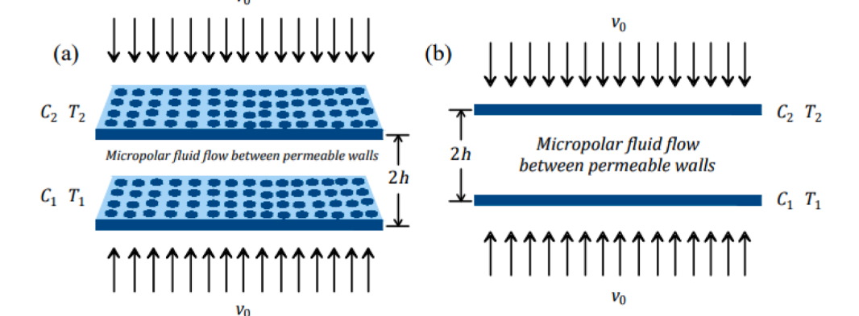

**Figure 1:** Configuration of the flow design

In light of these assumptions, the continuity, momentum, microrotation, energy, and concentration equations relevant for the problem at hand are specified in equations (1-6) (Fakour et al., 2015; Alizadeh, 2018; Mirgolbabaee, et al., 2017).

$$\begin{aligned}∂(u_{x})+∂(v_{y})=0,\#(1)\end{aligned}$$

$$\begin{aligned}ρ\left(u∂(u_{x})+v∂(u_{y})\right)=\left(μ+β\right)\left(∂^{2}(u_{xx})+∂^{2}(u_{yy})\right)+β∂(ω_{y})-\frac{(μ+β)}{κ^{⋆}}u-σB_{0}^{2}u-∂(P_{x}).\#(2)\end{aligned}$$

$$\begin{aligned}ρ\left(u∂(v_{x})+v∂(v_{y})\right)=\left(μ+β\right)\left(∂^{2}(v_{xx})+∂^{2}(v_{yy})\right)-β∂(ω_{x})-\frac{(μ+β)}{κ^{⋆}}v-∂(P_{y}).\#(3)\end{aligned}$$

$$\begin{aligned}ρj\left(u∂(ω_{x})+v∂(ω_{y})\right)=-β\left(2ω+∂(u_{y})-∂(v_{x})\right)+γ\left(∂^{2}(ω_{xx})+∂^{2}(ω_{yy})\right)\#(4)\end{aligned}$$

$$\begin{aligned}\begin{matrix} & ρcp\left(u∂(T_{x})+v∂(T_{y})\right)=∂_{y}\left(k∂(T_{y})\right)+τ\left[D_{b}∂(T_{y})∂(C_{y})+\frac{D_{T}}{T_{2}}{\left(∂(T_{y})\right)}^{2}\right]+ \\ & +\frac{16σ_{⋆}T_{2}^{3}}{3k^{⋆}}∂^{2}(T_{yy})+\frac{k_{2}}{b^{2}}\left[A\left(T_{1}-T_{2}\right)f^{'}+B\left(T-T_{2}\right)\right].\end{matrix}\#(5)\end{aligned}$$

$$\begin{aligned}u∂(C_{x})+v∂(C_{y})=D_{b}∂(C_{yy}+\frac{D_{T}}{T_{2}}∂(T_{yy}).\#(6)\end{aligned}$$

According to [44-46] the applied wall constraints are supplied as:

$$\begin{aligned}\begin{matrix} & u=0,v=0,ω=-m∂(u_{y}),T=T_{1},C=C_{1}\text{ at }y=-b, \\ & u=\frac{ϑ_{0}x}{b},v=0,ω=\frac{ϑ_{0}x}{b^{2}},T=T_{2},C=C_{2}\text{ at }y=+b.\end{matrix}\#(7)\end{aligned}$$

The symbols that featured in the governing equations are $u(v)$ which signifies the components of velocity in $x(y)$ directions, $P,ρ,σ,μ,β,γ,κ^{⋆},B_{0}$ and $ω$ are symbols that represent pressure, fluid density, electric conductivity, dynamic viscosity, vortex or microrotation viscosity, spin gradient viscosity, permeability term, magnetic field strength, and the microrotation component respectively. The subscripts $1$ and $2$ connote the conditions at the lower and upper plates respectively while $A(B)$ depicts coefficient of space (heat) dependent heat source. Likewise, in the energy and concentration equations, $T,cp,k^{⋆},k,D_{b},D_{T}$ and $σ_{⋆}$ are respectively described as the micropolar fluid temperature, specific heat capacity at uniform pressure, mean absorption coefficient, heat conductivity and molecular diffusion, thermophoretic and the Stefan-Boltzmann constant. At the boundary walls, $b$ signalled the channel width, while $m$ represents the micropolar surface parameter which is defined at the interval $[0,1]$. It determines the extent to which the microparticles rotate in the neighbourhood of the channel wall. In this interval, the microparticles near the channel walls experience non rotation when $m=0$ which also means $ω=0$. At the instance when $m=0.5$, there exists a weak concentration and such that the non-symmetric part the stress tensor disappears whereas the turbulence flow condition occurs at $m=1$ as studied by Ahmadi (1972) and Mishra et al. (2019). The variable thermal conductivity is expressed as

$$\begin{aligned}k=k_{2}\left[1+δ\left(\frac{T-T_{2}}{T_{1}-T_{2}}\right)\right].\#(8)\end{aligned}$$

**2.1. Transformation Variables**

Incorporating the stream function $u=∂(ψ_{y}),v=-∂(ψ_{x})$ as given in equation (9) where $ξ$ represents the dimensionless variable, $f(ξ),g(ξ),ϕ(ξ)$ and $θ(ξ)$ are the non-dimensional stream function, microrotation function concentration function and temperature function in that order (see Mirgolbabaee; 2017; Ahmad, 2021).

$$\begin{aligned}ξ=\frac{y}{b},ψ=-ϑ_{0}xf(ξ),ω=\frac{ϑ_{0}x}{b^{2}}g(ξ),θ(ξ)=\frac{T-T_{2}}{T_{1}-T_{2}},ϕ(ξ)=\frac{C-C_{2}}{C_{1}-C_{2}} \#(9)\end{aligned}$$

In light of equation (9) in the model equations (1-6), there is the validity of conservation of mass (1). Using equation (9) when $T_{1}-T_{2}=H_{1}x,C_{1}-C_{2}=H_{2}x$, the controlling equations (2-6) transform to these new forms of equations.

$$\begin{aligned}\begin{matrix} & L_{2}g_{ξξ}-L_{1}\left(2g-f_{ξξ}\right)-ReL_{3}\left(fg_{ξ}-f_{ξ}g\right)=0.\end{matrix}\#(10)\end{aligned}$$

$$\begin{aligned}\begin{matrix}\left(1+δθ+Nr\right)θ_{ξξ}+δθ_{ξ}^{2}-P_{h}\left(fθ_{ξ}-f_{ξ}θ\right)+P_{h}\left(Ntθ_{ξ}^{2}+Nbϕ_{ξ}θ_{ξ}\right)+\left(Af^{'}+Bθ\right)=0.\end{matrix}\#(11)\end{aligned}$$

$$\begin{aligned}\begin{matrix} & ϕ_{ξξ}+P_{m}\left(f_{ξ}ϕ-fϕ_{ξ}\right)+\frac{Nt}{Nb}θ_{ξξ}=0.\end{matrix}\#(12)\end{aligned}$$

On using (9) in (7), the wall constraints correspondingly become

$$\begin{aligned}\begin{matrix} & f(-1)=0,f_{ξ}(-1)=0,g(-1)=0,θ(-1)=1,ϕ(-1)=1\text{ at }ξ=-1 \\ & f_{ξ}(1)=-1,f(1)=0,g(1)=1,θ(1)=0,ϕ(1)=0\text{ at }ξ=1.\end{matrix}\#(13)\end{aligned}$$

The entrenched parameters are indicated as $L_{1}=\frac{β}{μ}$ named vortex viscosity term whereas the term symbolized by $L_{2}=\frac{γ}{μb^{2}}$ and $L_{3}=\frac{j}{b^{2}}$ define sping gradient viscosity and micro-inertia density in that order, $δ$ is thermal conductivity term, $M=\frac{σB_{0}^{2}b^{2}}{μ}$ indicates the magnetic field term, $ζ=\frac{b^{2}}{κ^{⋆}}$ the porosity term, $Re=\frac{ρϑ_{0}b}{μ}$ defines Reynolds number, $Nr=\frac{16T_{2}^{3}σ_{0}}{k_{⋆}k_{2}}$ denotes thermal radiation, $Pr=\frac{cpμ}{k_{2}}$ describes the Prandtl number, $Nt=\frac{τ(T_{1}-T_{2})D_{t}}{T_{2}bϑ_{0}}$ denotes the thermophoretic term, $Nb=\frac{τ(C_{1}-C_{2})D_{b}}{bϑ_{0}}$ stands for the Brownian motion, $Sc=\frac{μ}{ρD_{b}}$ is the Schmidt number, $P_{m}=ScRe$ ($P_{h}=PrRe$)represents the Peclet number for mass (heat) flow. In this case, $Re$ is the permeation Reynolds number, such that $Re>0$ indicates suction term whereas $Re<0$ connotes injection term.

The technological quantities of interest are the wall friction coefficient $C_{f}$, thermal $T_{g}$ and concentration $S_{g}$ gradients which specified as:

$$\begin{aligned}\begin{matrix} & C_{f}Re_{x}^{0.5}=2{\left(\frac{1-n}{2}\right)}^{1/2}\left((1+β)f_{ξξ}(-1)-\frac{βδ}{3}\left(\frac{n+1}{2}(f_{ξξ})^{3}\right)\right), \\ & T_{g}Re_{x}^{-0.5}=-{\left(\frac{n+1}{2}\right)}^{\frac{1}{2}}\left(\left(1+Nr\right)\right)θ_{ξ}(-1), \\ & S_{g}Re_{x}^{-0.5}=-{\left(\frac{n+1}{2}\right)}^{\frac{1}{2}}ϕ_{ξ}(-1).\end{matrix}\#(14)\end{aligned}$$

**3. Solution Procedures and Results Validation**

The solution methodology for the set of non-dimensional equations (10-13) and the wall conditions (14) modelling the problem is gotten using a numerical procedure via shooting techniques with Runge-Kutta Fehlberg method. This approach has been found to the effective for solving both linear and nonlinear differential equations with high accuracy, stability and reliability. The accuracy of the solution obtained is checked by comparison with earlier related published works of Sheikholeslam (2014) and collated in Table 1. The validation reveals a very good agreement between the existing data in published works and the present one in the limiting case as displayed in the table.

**Table 1:** Comparison of current results with published data for variation in $ξ(-1.0≤ξ≤1.0)$ when $Re=0.5(Re=1.0),L_{1}=L_{2}=L_{3}=0.1,Ph=0.5,Pm=0.5,ζ=Nt=Nb=A=B=Nr=δ=0$  
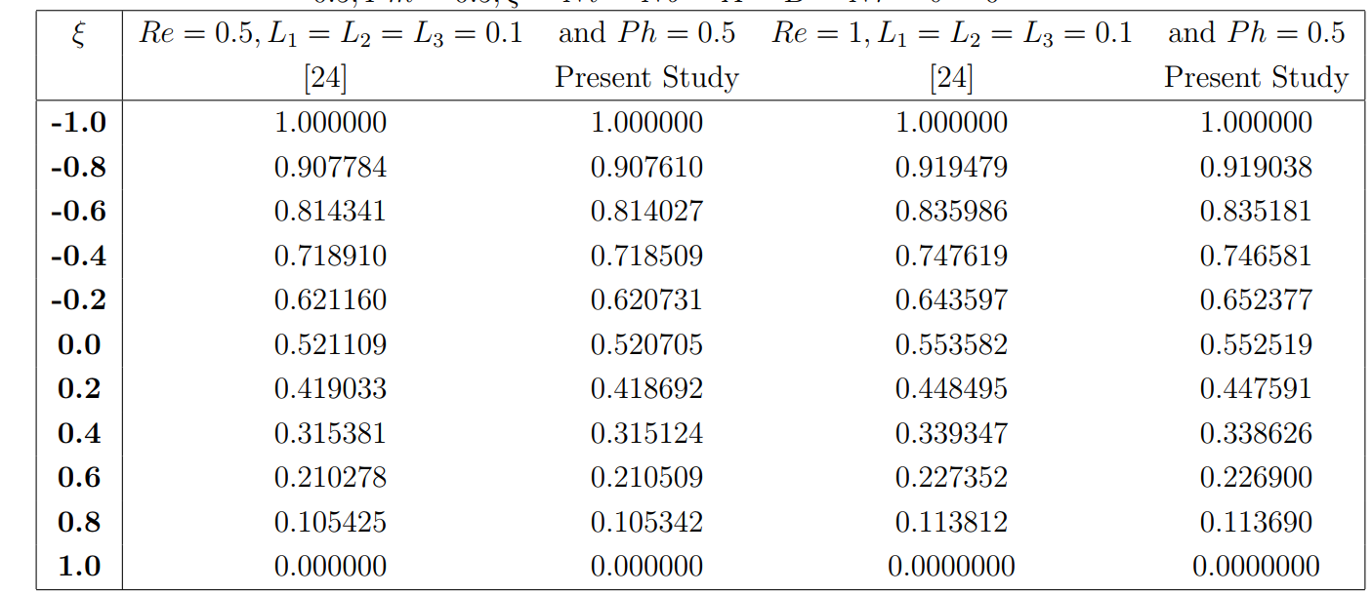

The results obtained in the current work are presented in two forms. Firstly, the results are presented in the form of tables showing the impact of key parameters on the quantities of engineering technology, like the skin friction coefficient, couple stress factor, heat transfer factor, and mass transfer coefficient across the surface of the channel. These are presented in subsection 4.1. The graphical reports of the results are presented in subsection 4.2 with relevant description and discussion of the embedded physical parameters on the flow fields. Tables 2-5 reveal the characteristics of the quantities of engineering technology as various parameters changes in value. The impact of $L_{1},M,ζ,Re,A,B,Nt,Nb,Ph$ and $Pm$ have been checked on various physical quantities.

**Table 2:** Computations of skin friction coefficient $f^{″}(±1)$, couple stress $g^{'}(±1)$ and heat transfer mechanism $θ^{'}(±1)$ for variation in $L_{1}$ when $L_{2}=L_{3}=0.2,M=0.5,ζ=0.3,Re=5.0$  
  
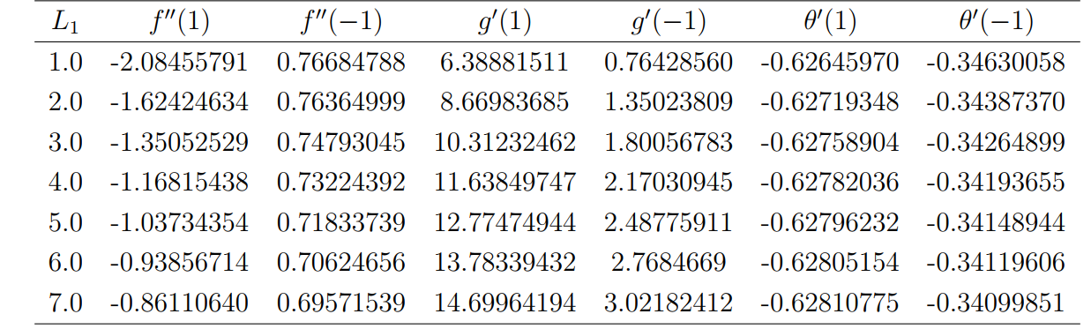

Table 2 points out the impact of the vortex viscosity parameter $L_{1}$ on $f^{″}(±1)$, $g^{'}(±1)$ and on $θ^{'}(±1)$ at the channel walls. An increase in $L_{1}$ values cause the shear stress at both ends of channel walls to decline significantly. The microstructural nature of the rigid particles in the micropolar fluid aids in reducing the wall shear stress. This trend is attributed to the improved micro-rotational nature plus heat dissipation occasioned by the influence of this parameter. Conversely, as the magnitude of $L_{1}$ increases, the couple stress factor increases at the walls, as shown in this table. The increase in couple stress is greater on the upper wall than on the lower wall of the channel. The primary reason for this reduction is the resistance to fluid motion caused by microrotation effects. Due to this resistance, a greater inner moment is required to boost the microrotational motion, and as a result, the couple stress tends to rise at the walls. Nevertheless, the heat transfer slightly increases at the channel's upper plate, while it is decreases at the lower part. These slight changes in quantity are due to the non-coupling effect of the vortex viscosity term in the energy equation.

**Table 3:** Computation of $f^{″}(±1)$, $g^{'}(±1)$ and $θ^{'}(±1)$ for variation in $M$ when $L_{1}=0.5,L_{2}=L_{3}=0.2,ζ=0.3,Re=5.0$  
  
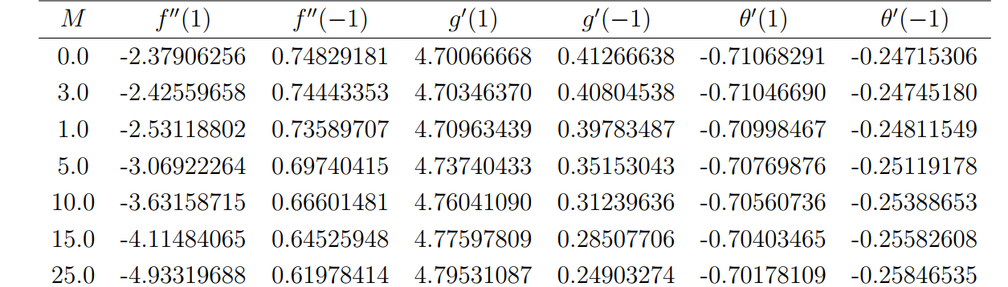

Table 3 analyzes the impact of $M$ on the quantities of primary engineering interest. An improvement in the magnitude of $M$ raises the shear stress in the upper part ($f^{″}(1)$) of the channel walls due to the Lorentz force exerted as a result of the interaction of the fluid and the magnetic field. This force also induces a higher spinning of the microfluid phenomenon, resulting in an increase in the couple stress at the upper wall ($g^{'}(1)$), as illustrated in Table 3. The manifestation of $M$ on $f^{″}(±1)$ reveals a complex characteristic at both walls due to the fact that the flow is electrically conducting. The Lorentz force, the asymmetry in flow dynamics, and the application of different boundary conditions at both the upper and lower parts of the channel contributed to this complexity. These quantities combined to create an uneven velocity profile in the channel, resulting in a variation in shear and couple stress on both walls as exhibited in the table. Conversely, as the magnetic field term increased, the lower wall of the channel experienced a decrease in shear and couple stress. Additionally, as $M$ increases, the rate of heat transfer slightly decreases at the upper wall and moderately increases in the lower part of the channel.

**Table 4:** The numerical computations different $ζ$ when $Re$  
  
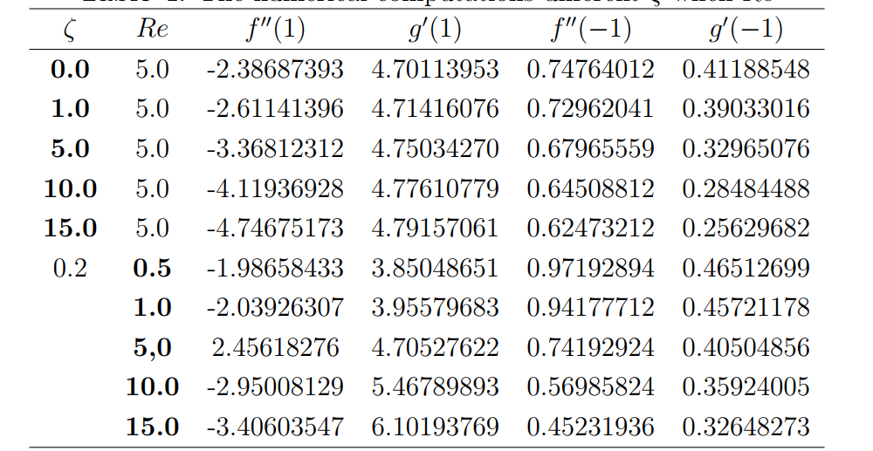

Table 4 reveals the nature of the skin friction coefficient $f^{″}(±1)$ and the couple stress $g^{'}(±1)$ with different values of the porosity $(ζ)$ and Reynolds number $(Re)$ terms. There is an increase in the upper wall shear stress $f^{″}(1)$ and couple stress $g^{'}(1)$ as the porosity term $ζ$ magnifies. As this parameter varies in strength, the lower wall manifests a converse pattern. An increase in $ζ$ prompted the flow dynamics in a channel to be resisted, and this behaviour forces the fluid to move in the upstream field, which might enhance the velocity gradients in the neighbourhood of the upper wall, leading to a higher shear stress. Additionally, as the intensity of $Re$ increases, the upper wall of the channel displays a higher shear stress and couple stress, while the lower part of the channel shows a decline in these quantities. Due to turbulence, as $Re$ gets bigger, the stresses in the flow field get bigger as well. However, the shear and couple stresses at both walls change because of the boundary condition that was used.

**Table 5:** The numerical computation of the values the heat transfer $θ^{'}(±1)$ and mass transfer $ϕ^{'}(±1)$ mechanism for variation in $A$ and $B$ when $Pm=0.2,Ph=0.5,Nt=Nb=0.2$  
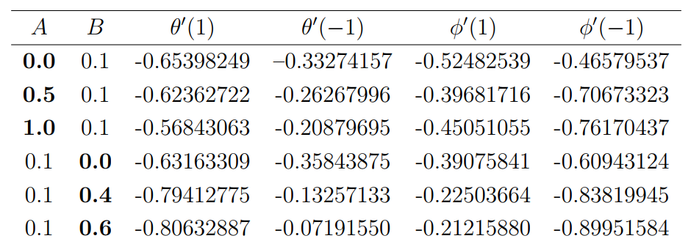

Table 5 displays the heat and mass transfer mechanism resulting from the growth in space and temperature-dependent parameters. This presentation reveals that as the magnitude of $A$ increases, the rate of heat transfer at both walls decreases. The increasing nature of the space-dependent heat source term results in a loss of heat to the ambient. As heat concentrates away from the walls, the heat source redistributes spatially within the channel, leading to a reduction in temperature gradients near the walls and a mitigation of heat transfer. Meanwhile, as the temperature-dependent heat source enhances, the heat transfer at the walls manifests dual characteristics. A rise in $B$ leads to improved heat transmission in the upper wall of the channel ($θ^{'}(1)$) whereas the lower region ( $θ^{'}(-1)$ exhibits a decline in the rate of heat transfer. This pattern indicates that an increase in $B$ leads to a significant rise in the temperature gradient at the upper wall, thereby enhancing heat transfer. However, the heat creation at the lower part of the channel flattens the temperature gradient, reducing the heat transmission rate. The mass transfer phenomenon $(ϕ^{'}(1)$ at the upper chamber of the channel witnessed a dampen effect as $A$ and $B$ magnify in the energy field.  
  
The rate of heat transfer mechanism depreciates as the thermophoresis term $Nt$ escalates in strength, as depicted in Table 6. This parameter causes the accumulation of tiny microscopic nanoparticles, which migrate from the heated area to the colder area near the walls. The accumulation of the microscopic particles causes a flattening of the thermal gradient at the walls, an increase in the thermal bounding surface, and a growth in the heat resistance at the channel walls, all of which results to a decline in the heat transfer. However, there is a rise in the mass distribution at the lower part of the channel as $Nt$ increases in magnitude, but an increase is found on the other side of the channel. An increase in $Nb$, on the other hand, results in a dual pattern of mass transfer. At the upper wall $ϕ^{'}(1)$, higher intensity of $Nb$ temperature triggers particle diffusion and a rise in heat distribution, and as a result, the temperature gradient is increasing, which leads to a higher heat transfer. Conversely, the trend reverses at the base of the wall, as shown in this table.

**3.1. Influence of various parameters on velocity and microrotation profiles**

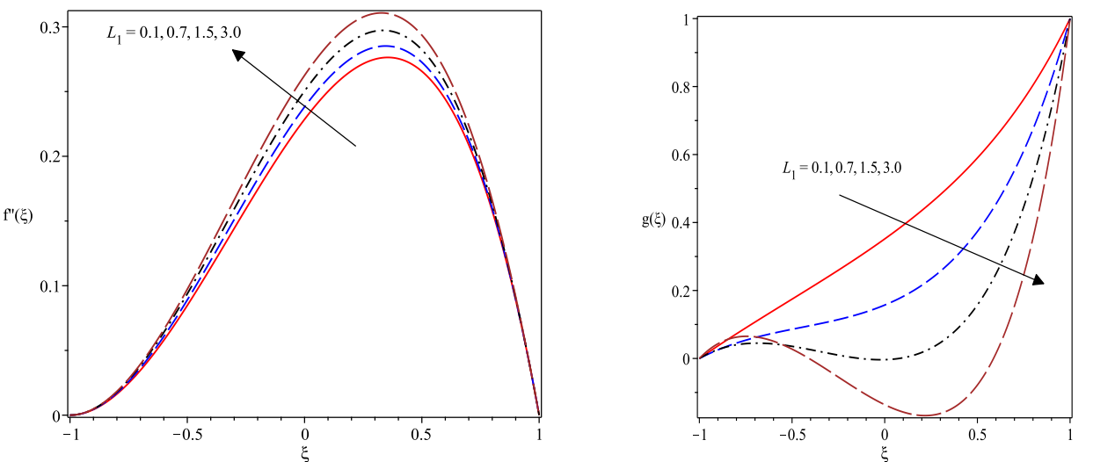

**Figure 2**: Plot of $f^{'}(ξ)$ for variation in $L_{1}$**Figure 3**: Trend of $g(ξ)$ for variation in $L_{1}$

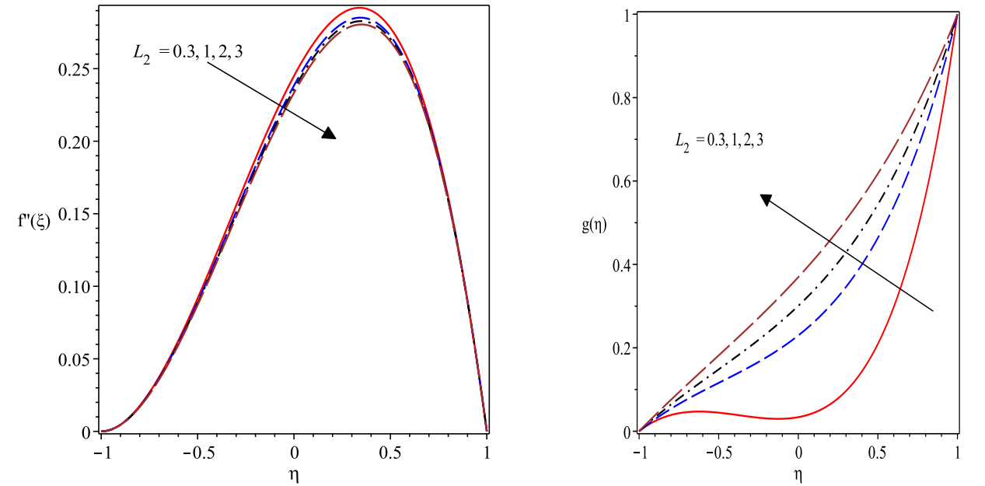  
  
**Figure 4**: Plot of $f^{'}(ξ)$ for variation in $L_{2}$**Figure 5**: Graph of $g(ξ)$ for variation in $L_{2}$

Figure 2 describes the effect of the vortex viscosity term $L_{1}$ on the velocity profile. A rise in the magnitude of $L_{1}$ (0.1-3.0) accelerates the fluid motion in the channel. This trend is attributed to the decline in the dynamic viscosity $μ$ as $L_{1}$ enhances and as such, there is less resistance to the fluid movement. Conversely, the microrotation profiles declines with growth in $L_{1}$ as depicted in figure 3. The magnification of the vortex viscosity parameter causes the field of micropolar fluid to decrease due to the reduction in the bonding force. The spin gradient viscosity parameter symbolized by $L_{2}$ causes the momentum bounding structure to shrink as noted in figure 4. In this case, the flow velocity is drastically impeded as $L_{2}$ rises. Meanwhile, the microrotation bounding profile gains more momentum and rises as $L_{2}$ increases as found in figure 5. In figure 6, a rise in the micro inertial density parameter $L_{3}$ (0.1-1.2) causes the microrotation profiles to fall in the system. These observations are in agreement with earlier published study of [22, 24]  
The magnetic field parameter denoted by $M$ causes the fluid motion to decelerate as noted in figure 8. This dimensionless term $M$ measures the impact of the Lorentz force exerted on the electro-conductive micropolar nanofluid. This force is a resistive type of force which is induced by the moving electrically conducting fluid as it interacts with the magnetic field. Thus as $M$ rises, the Lorentz force becomes more intense and thus, there is a resistance to the fluid flow. Conversely, the microrotation profile escalates with a rise in the magnetic field term. The Lorentz force induces the micro structures of the micropolar fluid leading to a boost in the gyration vector as depicted in figure 8. The impact of the porosity term denoted by $ζ$ on the flow stream is displayed in figure 9. There is a decline in the momentum bounding structure and the flow stream due to a hike in the porosity term.

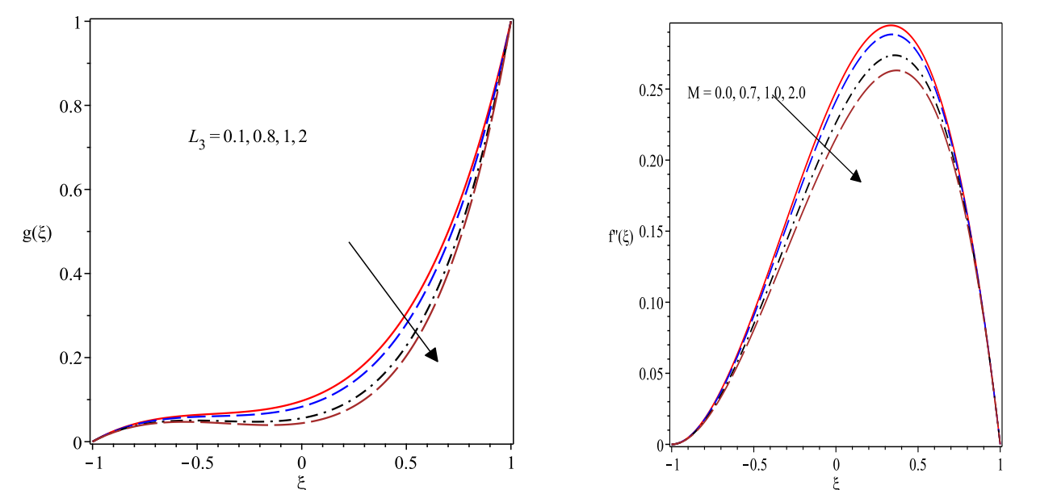

**Figure 6**: Trend of $f^{'}(ξ)$ for variation in $L_{3}$**Figure 7**: Trend of $f^{'}(ξ)$ for varying $M$

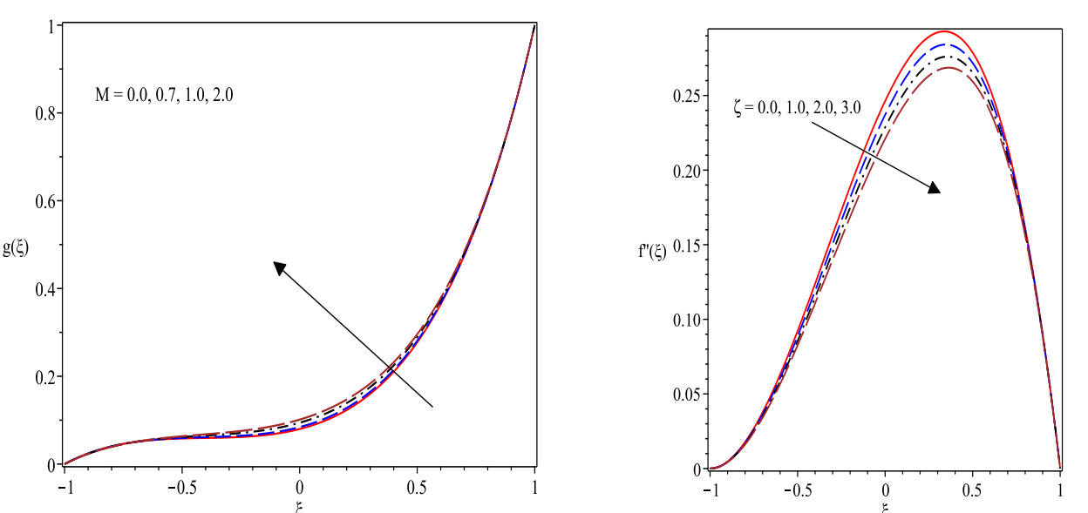

**Figure 8**: Plot of $g(ξ)$ for variation in $M$**Figure 9**: Graph of velocity for varying $ζ$

**3.2. Effects various parameters on thermal and concentration profiles**

This subsection reveals the effects of some key parameters on the thermal and concentration profiles. A rise in the thermophoresis term denoted by $Nt$ causes the thermal field to appreciate as noted in figure 10. This pattern is caused by the thermal movement of the tiny particles of the nanoparticles and the thickness of the thermal boundary layer as $Nt$ increases. The thermophoretic term denotes a non-dimensional quantity that measures the level of the thermophoretic force causes by the tiny particles in the micropolar fluid system. A rise in $Nt$ triggers the microscopic particles to migrate away from the channel heated surface which then lead to surface cooling and a rise in the thickness of the thermal profile. However, the concentration profiles behave contrary as $Nt$ rises in magnitude as demonstrated in figure 11.

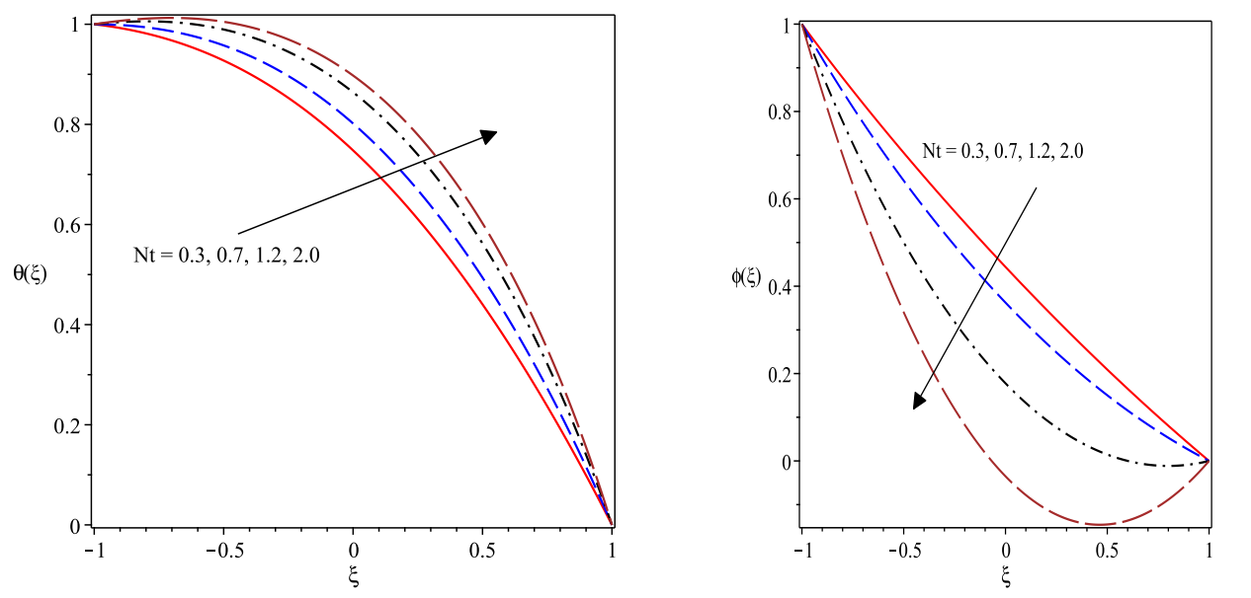

**Figure 10**: Trend of $θ(ξ)$ for changes in $Nt$**Figure 11**: Profiles of $ϕ(ξ)$ for $Nt$

The Brownian motion term symbolized by $Nb$ induces raises the thermal and concentration profiles as found in figures 12 and 13 respectively. Both the thermal and concentration boundary layer structures expanded by the increase in $Nb$. The haphazard movement experienced in the tiny particles suspended in the micropolar fluids is termed $(Nb)$. The parameter measures the significance of Brownian motion in the system. The dispersion of microscopic particles in the micropolar fluid is enhanced via $(Nb)$ and consequently raised the thermal transport rate in the micropolar nanofluids. The rise in the thermal structure is occasioned by the random motion of the tiny particles leading to higher temperature

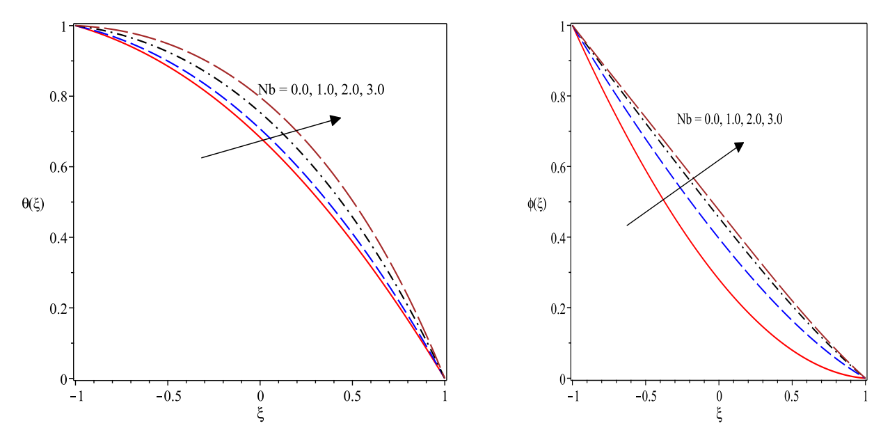

**Figure 12:** Plot of $θ(ξ)$ for variation in $Nb$**Figure 13**: Plot of $ϕ(ξ)$ for varying $Nb$

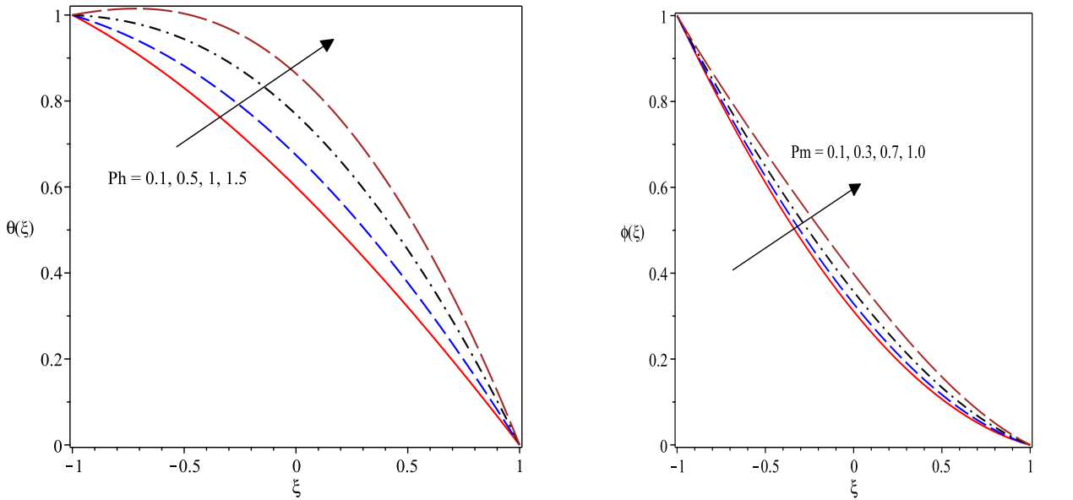

**Figure 14**: Plot of $θ(ξ)$ for variation in $Ph$**Figure 15:** Trend of $ϕ(ξ)$ for varying $Pm$

Figures 14 and 15 manifest the impact of the Peclet number for heat and mass diffusion on the temperature and concentration profiles respectively. An increase in the Peclet number for heat diffusion $Ph$ raises the thermal profiles and causes thickens the thermal boundary layer. Likewise, amplifying the Peclet number for mass diffusion $Pm$ boosts the concentration thermal structure as found in figure 15.

Figures 16 and 17 respectively reveal the influence of both space-based heat source $A$ and heat-based heat source $B$ on the temperature distribution of the micropolar nanofluid in the channel. It is evidently shown that the thermal field is an increasing function of of both $A$ and $B$ as noted in these figures. This trend is occasioned by the additional heat generated by the inclusion of heat source terms in the system.

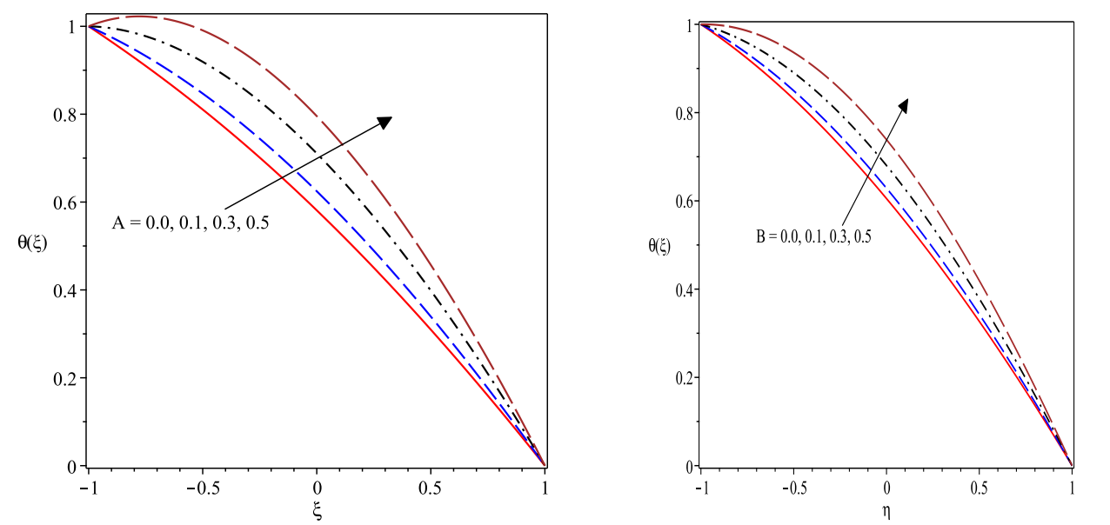

**Figure 16**: Plot of $θ(ξ)$ for variation in $A$**Figure 17**: Plot of $θ(ξ)$ for varying $B$

**Conclusion**  
The current work developed a comprehensive mathematical model to investigate the hydromagnetic heat and mass transfer characteristics of micropolar fluids embedded with microscopic nanoparticles within a porous channel. The model analysis incorporates a non-uniform heat source and variable thermal conductivity in the thermal field, which are critical in capturing the complexities of the system. The non-Newtonian micropolar fluids, enriched with engineered colloidal nanofluids, are modeled using the Buongiorno framework, which accounts for the effects of thermophoresis and Brownian motion for the governing nanoparticles dynamics in the fluid. The model equations are transformed from the initial partial derivatives to ordinary derivatives and solved using numerical approach of shooting with Runge-Kutta Felhberg scheme. The numerical outcomes are displayed using figures and tables with appropriate deliberations of results relevant to various applications. The solutions to the model equations compared favorably with existing studies in the limiting sense. The understanding of heat and mass transfer mechanism in the flow phenomenon of nanofluid passing a porous channel is useful in many engineering and manufacturing processes like groundwater remediation in environmental engineering, enhanced oil recovery in petroleum engineering, design of heat exchangers in system cooling engineering, and so on. These applications have motivated this investigation. Some key points obtained from this study are that:

1. The skin friction at upper and lower walls of the channel decreases as the vortex viscosity term of the material micropolar fluid terms increase in magnitude. However, the couple stress manifests an opposite behaviour as the vortex viscosity term improves in strength.
2. An increase in the value of $M$ causes a rise in the skin friction coefficient and the couple stress in the upper part of the channel walls but a contrary behaviour is found in the lower part of the channel.
3. The space-dependent heat source term reduces heat transfers phenomenon while the temperature-dependent heat source amplifies the heat transfer, there is an improvement in the heat transmission in the upper wall of the channel but a decrease in the lower region of the channel due to these terms.
4. The thermal distribution becomes huge as the thermophoresis, Brownian motion, Peclet number for mass and heat diffusion increases but there is a decline in the hydrodynamic boundary layer as the porosity and magnetic field terms appreciate in strength.

**Disclaimer (Artificial intelligence)**

Option 1:

Author(s) hereby declare that NO generative AI technologies such as Large Language Models (ChatGPT, COPILOT, etc.) and text-to-image generators have been used during the writing or editing of this manuscript.

Option 2:

Author(s) hereby declare that generative AI technologies such as Large Language Models, etc. have been used during the writing or editing of manuscripts. This explanation will include the name, version, model, and source of the generative AI technology and as well as all input prompts provided to the generative AI technology

Details of the AI usage are given below:

1.

2.

3.

**References**

Peng, Y., L, B. H., Yuan, J. L., Ji, H. B., Sun, L., & Dong, C. C. (2014, February). Application and prospect of the non-Newtonian fluid in industrial field. In Materials Science Forum (Vol. 770, pp. 396-401). Trans Tech Publications Ltd.

Fatunmbi, E. O. & Okoya, S. S. (2020). Quadratic Mixed Convection Stagnation-Point Flow in Hydromagnetic Casson Nanofluid over a Nonlinear Stretching Sheet with Variable Thermal Conductivity, Defect and Diffusion, 409, 95-109.

Lu, G., Wang, X. D., & Duan, Y. Y. (2016). A critical review of dynamic wetting by complex fluids: from Newtonian fluids to non-Newtonian fluids and nanofluids. Advances in colloid and interface science, 236, 43-62.

Fatunmbi, E. O. & Salawu, S. O. (2021). Analysis of hydromagnetic micropolar nanofluid flow past a nonlinear stretchable sheet and entropy generation with Navier slips, International Journal of Modelling and Simulation, DOI: 10.1080/02286203.2021.1905490 (2021), 1-12.

Awais, M., Salahuddin, T., Muhammad, S. (2024). Effects of viscous dissipation and activation energy for the MHD Eyring-Powell fluid flow with Darcy-Forchheimer and variable fluid properties. Ain Shams Engineering Journal, 15(2), 102422.  
Awais, M., Salahuddin, T., Muhammad, S. (2024). Effects of viscous dissipation and activation energy for the MHD Eyring-Powell fluid flow with Darcy-Forchheimer and variable fluid properties. Ain Shams Engineering Journal, 15(2), 102422.

Hamid, M., Usman, M., Khan, Z. H., Haq, R. U., Wang, W. (2019). Heat transfer and flow analysis of Casson fluid enclosed in a partially heated trapezoidal cavity. International Communications in Heat and Mass Transfer, 108, 104284.

Reddy, J. R., Sugunamma, V., Sandeep, N. (2017). Enhanced heat transfer in the flow of dissipative non-Newtonian Casson fluid flow over a convectively heated upper surface of a paraboloid of revolution. Journal of Molecular liquids, 229, 380-388.

Jalili, B., Ganji, A. D., Jalili, P., Nourazar, S. S., Ganji, D. D. (2022). Thermal analysis of Williamson fluid flow with Lorentz force on the stretching plate. Case Studies in Thermal Engineering, 39, 102374.

Asjad, M. I., Zahid, M., Inc, M., Baleanu, D., Almohsen, B. (2022). Impact of activation energy and MHD on Williamson fluid flow in the presence of bioconvection. Alexandria Engineering Journal, 61(11), 8715-8727.

Alsemiry, R. D., Sayed, H. M., Amin, N. (2022). Mathematical analysis of Carreau fluid flow and heat transfer within an eccentric catheterized artery. Alexandria Engineering Journal, 61(1), 523-539.

Fatunmbi, E. O., Animasaun, I. L., Oke, A. S., Salawu, S. O. (2022). Insight into the heat transfer across the dynamics of Carreau fluid subject to inclined Lorentz force conveying tiny particles and motile gyrotactic microorganisms: The case of stratification. Heat Transfer, 51(8), 7562-7583.

Mabood, F., Fatunmbi, E. O., Benos, L., Sarris, I. E. (2022). Entropy generation in the magnetohydrodynamic Jeffrey nanofluid flow over a stretching sheet with wide range of engineering application parameters. International Journal of Applied and Computational Mathematics, 8(3), 98.

Manjunatha, G., Rajashekhar, C., Vaidya, H., Prasad, K. V., Makinde, O. D., Viharika, J. U. (2020). Impact of variable transport properties and slip effects on MHD Jeffrey fluid flow through channel. Arabian Journal for Science and Engineering, 45, 417-428.

Khan, M., Rasheed, A., & Salahuddin, T. (2020). Radiation and chemical reactive impact on tangent hyperbolic fluid flow having double stratification. AIP Advances, 10(7).

Adigun, A. J., Fatunmbi, E. O., Boneze, C. U. (2022). Quadratic Mixed Convection Tangent Hyperbolic Stratified Fluid Flow Past a Vertical Elongated Sheet with Nonlinear Thermal Radiation: Spectral Local Linearization Method. International Journal of Mathematical Sciences and Optimization: Theory and Applications, 8(2), 131-148.

Eringen, A. C. (1966). Linear theory of micropolar elasticity. Journal of Mathematics and Mechanics, 909-923.

Eringen, A. C. (1972). Linear theory of nonlocal elasticity and dispersion of plane waves. International Journal of Engineering Science, 10(5), 425-435.

E. O. Fatunmbi and S. O. Salawu. Analysis of hydromagnetic micropolar nanofluid flow past a nonlinear stretchable sheet and entropy generation with Navier slips, International Journal of Modelling and Simulation, <https://doi.org/10.1080/02286203.2021.1905490>

Ahmed, Z., Nadeem, S. (2019). Flow of a micropolar CNT-based nanofluid across a squeezing channel. Physica Scripta, 94(10), 105203.

Koci, M., Stamenkovi, ή, Petrovi, J., Bogdanovi-Jovanovi J. (2023). MHD micropolar fluid flow in porous media. Advances in Mechanical Engineering, 15(6), 16878132231178436.

Fakour, M., Vahabzadeh, A., Ganji, D. D., Hatami, M. (2015). Analytical study of micropolar fluid flow and heat transfer in a channel with permeable walls. Journal of Molecular Liquids, 204, 198-204.

Fatunmbi, E. O., Okoya, S. S. (2020). Heat transfer in boundary layer magneto-micropolar fluids with temperature-dependent material properties over a stretching sheet. Advances in Materials Science and Engineering, 2020(1), 5734979.

Sheikholeslami, M., Hatami, M., Ganji, D. D. (2014). Micropolar fluid flow and heat transfer in a permeable channel using analytical method. Journal of Molecular Liquids, 194, 30-36.

Jalili, B., Azar, A. A., Jalili, P., Ganji, D. D. (2023). Analytical approach for micropolar fluid flow in a channel with porous walls. Alexandria Engineering Journal, 79, 196-226.

S.U.S. Choi, Enhancing thermal conductivity of fluids with nanoparticles, ASME Publ. Fed. 231 (1995) 99-106.

Mohyud-Din, S. T., Jan, S. U., Khan, U., Ahmed, N. (2018). MHD flow of radiative micropolar nanofluid in a porous channel: optimal and numerical solutions. Neural Computing and Applications, 29, 793-801.

Abbas, N., Nadeem, S., Malik, M. Y. (2020). Theoretical study of micropolar hybrid nanofluid over Riga channel with slip conditions. Physica A: Statistical Mechanics and its Applications, 551, 124083.

Shashikumar, N. S., Macha, M., Gireesha, B. J., & Kishan, N. (2020). Finite element analysis of micropolar nanofluid flow through an inclined microchannel with thermal radiation. Multidiscipline Modeling in Materials and Structures, 16(6), 1521-1538.

Das, A. K., Chatterjee, S. (2020). Analysis of thermophoresis and Brownian motion effect in heat transfer for nanofluid immersed distribution transformer, Electrical Engineering, <https://doi.org/10.1007/s00202-017-0676-2>.

Hauswirth, S. C., Bowers, C. A., Fowler, C. P., Schultz, P. B., Hauswirth, A. D., Weigand, T., & Miller, C. T. (2020). Modeling cross model non-Newtonian fluid flow in porous media. *Journal of Contaminant Hydrology*, *235*, 103708.

Lund, L. A. Omar, Z., Khan. I (2019). Mathematical analysis of magnetohydrodynamic (MHD) flow of micropolar nanofluid under buoyancy effects past a vertical shrinking surface: dual solutions, Heliyon 5 (2019) e02432.

Raju, S. S. K. (2023). Dynamical dissipative and radiative flow of comparative an irreversibility analysis of micropolar and hybrid nanofluid over a Joule heating inclined channel. Scientific Reports, 13(1), 5356.

Masthanaiah, Y., Tarakaramu, N., Khan, M. I., Rushikesava, A., Moussa, S. B., Fadhl, B. M., ... Eldin, S. M. (2023). Impact of viscous dissipation and entropy generation on cold liquid via channel with porous medium by analytical analysis. Case Studies in Thermal Engineering, 47, 103059.

Rafique, K., Anwar, M. I., Misiran, M., Khan, I., Baleanu, D., Nisar, K. S., ... Seikh, A. H. (2020). Hydromagnetic flow of micropolar nanofluid. Symmetry, 12(2), 251.

Mollamahdi, M., Abbaszadeh, M., Sheikhzadeh, G. A. (2016). Flow field and heat transfer in a channel with a permeable wall filled with Al2O3-Cu/water micropolar hybrid nanofluid, effects of chemical reaction and magnetic field. Journal of Heat and Mass Transfer Research, 3(2), 101-114.

Ahmed, Z., Nadeem, S. (2019). Flow of a micropolar CNT-based nanofluid across a squeezing channel. Physica Scripta, 94(10), 10520

Fatunmbi, E. O., Okoya, S. S. (2020). Heat Transfer in Boundary Layer Magneto-Micropolar Fluids with Temperature-Dependent Material Properties over a stretching sheet Advances in Materials Science and Engineering, 2020, Article ID 5734979, 11 pages <https://doi.org/10.1155/2020/5734979>  
Salawu, S.O., & Ogunseye, H. A. (2020). Entropy generation of a radiative hydromagnetic Powell-Eyring chemical reaction nanofluid with variable conductivity and electric field loading, Results in Engineering 5 (2020) 100072

Fatunmbi, E. O. Mabood, F. Elmonser, H. Tlili, I. (2020). Magnetohydrodynamic nonlinear mixed convection flow of reactive tangent hyperbolic nano fluid passing a nonlinear stretchable surface, Phys. Scr. 96 (2021) 015204.

Al-Khamaiseh, B., Razavi, M., Muzychka, Y. S., Kocabiyik, S. (2017). Thermal resistance of a 3-D flux channel with nonuniform heat convection in the sink plane. IEEE Transactions on Components, Packaging and Manufacturing Technology, 8(5), 830-839.

Muthtamilselvan, M., Periyadurai, K., Doh, D. H. (2017). Effect of uniform and nonuniform heat source on natural convection flow of micropolar fluid. International Journal of Heat and Mass Transfer, 115, 19-34.

Fatunmbi, E. O., Salawu, S. O. (2020). Thermodynamic second law analysis of magneto-micropolar fluid flow past nonlinear porous media with non-uniform heat source. Propulsion and Power Research, 9(3), 281-288.

Alizadeh, M., Dogonchi, A. S., Ganji, D. D. (2018). Micropolar nanofluid flow and heat transfer between penetrable walls in the presence of thermal radiation and magnetic field. Case studies in thermal engineering, 12, 319-332.

Mirgolbabaee, H., Ledari, S. T., Ganji, D. D. (2017). Semi-analytical investigation on micropolar fluid flow and heat transfer in a permeable channel using AGM. Journal of the Association of Arab Universities for Basic and Applied Sciences, 24, 213-222.

Ahmad, S., Ashraf, M., Ali, K. (2021). Simulation of thermal radiation in a micropolar fluid flow through a porous medium between channel walls. Journal of Thermal Analysis and Calorimetry, 144, 941-953.

Sibanda, P., Awad, F. (2010). Flow of a micropolar fluid in channel with heat and mass transfer. Fluid Mechanics and Heat & Mass Transfer.

Ahmadi, G. (1976). Stability of a micropolar fluid layer heated from below. International Journal of Engineering Science, 14(1), 81-89.

Mishra, S. R., Hoque, M. M., Mohanty, B., Anika, N. N. (2019). Heat transfer effect on MHD flow of a micropolar fluid through porous medium with uniform heat source and radiation. Nonlinear Engineering, 8(1), 65-73.

Zheng, Si, X., Zhang, L., Chao, Y. (2011). The flow of a micropolar fluid through a porous channel with expanding or contracting walls. Central European Journal of Physics, 9, 825-834.

Ahmed , A., Muhammad , S., & Ucheri , M. A. T. (2024). Hybrid Nano Fluid Slip Flow Over a Permeable Sheet with Radiative Heat Flux, Variable Thermal Conductivity and Heat Source. Physical Science International Journal, 28(4), 86–101. <https://doi.org/10.9734/psij/2024/v28i4840>

Kumar, P., Poonia, H., & Kumari, P. (2023). Heat Transfer Analysis of Silver-water Nanofluid Flow over Stretching Cylinder Subjected to Multiple Convective Conditions over Stretching Sheet and Stretching Cylinder. Journal of Scientific Research and Reports, 29(1), 14–25. <https://doi.org/10.9734/jsrr/2023/v29i11722>