The Phillips Curve: Evolution and Relevance in Indian Policymaking

.

ABSTRACT

|  |
| --- |
| **Aims:** This paper examines how the Phillips Curve has progressed while evaluating its usefulness for Indian economic analysis. The study bases its analysis on empirical studies and policy implications to establish a complete framework of the Phillips Curve's value for India's macroeconomic policy.  **Study design:** The paper brings in historical perspective, theoretical models, and empirical studies concerning the Phillips Curve in India and investigates the impacts of the main structural reforms and policy changes, such as economic liberalization, demonetization, and GST implementation.  **Place and Duration of Study:** The study considers India's economic dynamics across different stages of time, including the early-to-mid 20th century and contemporary times. It examines vital changes in structure and policy alongside adjusting macroeconomic trends affecting inflation and employment trends.  **Methodology:** The paper employs a systematic review of academic literature along with a comparative analysis of the evolution of the Philips Curve equation. The review adopts theoretical analysis to study the Phillips Curve while reviewing its historical developments vis-a-vis Indian economic scenarios. It also investigates how economic liberalization, demonetization and GST implementation affect the relationship between inflation and unemployment rates.  **Results:** It was observed that multiple structural elements of the Indian economy such as the vast informal sector together with geographic inequalities and labor force shifts make the traditional Phillips Curve inconsistent. Major structural reforms in the economy have modified how inflation interacts with unemployment defying several macroeconomic fundamentals.  **Conclusion:** To apply the Phillips Curve effectively for India requires extensive modification of its form. The RBI needs improved unemployment-inflation understanding as part of Flexible Inflation Targeting by examining wage responses across industries and production disturbances. Econometric methods at an advanced level should be employed to create superior economic models that will assist authorities in creating proper policies for India's evolving complex landscape. |

***Keywords:*** *Phillips Curve Evolution, Inflation-Unemployment Dynamics, Inflation Targeting RBI, Structural Changes, Stagflation & Phillips Curve Validity, Indian Economy*

1. INTRODUCTION

Initiated by A. W. Phillips in his seminal 1958 paper (Phillips, 1958), the Phillips curve posited an inverse relationship between inflation and unemployment, subsequently becoming a cornerstone of macroeconomic theory and policymaking. At first glance, this seemingly straightforward relationship—which implies a trade-off between price stability and full employment—has long influenced economic thought and underpinned interventionist policies across various epochs. Samuelson and Solow (1960) noted that early interpretations of the Phillips curve spurred expansionary monetary policies aimed at reducing unemployment at the expense of higher inflation. However, the assumptions underpinning the original Phillips curve were soon challenged by the stagflation of the 1970s, marked by simultaneous high inflation and high unemployment (Phelps, 1967; Friedman, 1968). This phenomenon prompted the development of the expectations-augmented Phillips curve, which accounts for the impact of price-level expectations on the inflation-unemployment trade-off.

Subsequent theoretical advancements, such as the New Keynesian Phillips curve (NKPC), further refined this relationship by integrating elements of price stickiness, imperfect competition, and forward-looking expectations into the dynamics of inflation (Clarida et al., 1999). Although these refinements have bolstered the theoretical foundations of the Phillips curve, its empirical and practical relevance remains a subject of debate. The global financial crisis and the COVID-19 pandemic have renewed discussions regarding the apparent flattening—or even potential disappearance—of the Phillips curve in many advanced economies (Ball & Mazumder, 2023). This study meticulously reviews the evolution of the Phillips curve from its inception, assessing its applicability in both theoretical and practical realms.

Our analysis specifically addresses topics such as the emergence of inflationary pressures attributable to initial tax rates, adaptive responses within the consumer market, and cascading effects across various tiers of the supply chain. The present paper investigates the impact of the Goods and Services Tax (GST) on price levels, cost structures, and employment trends in both the short and long term, exploring its role in positioning India along the Phillips curve. It provides a nuanced exploration of the evolution of the inflation-unemployment nexus in India, critically examining how structural changes have influenced this dynamic. The paper argues that the conventional Phillips curve model may not fully capture the complexities of a rapidly evolving economy such as India’s and underscores the imperative for context-specific adjustments and the development of more sophisticated models that incorporate supply-side shocks, informal sector dynamics, and policy-driven structural shifts.

Furthermore, the study delineates the policy implications that arise from the traditional Phillips curve framework for Indian policymakers, notably the Reserve Bank of India (RBI). It contrasts policy decisions made under the aegis of Flexible Inflation Targeting with those derived from the Multiple Indicator Approach, evaluating the extent to which the Phillips curve informs these strategies. The challenges inherent in balancing inflation control with employment growth in a developing economy are discussed, and policy strategies that integrate the evolving relationship between inflation and unemployment are proposed.

In conclusion, this paper presents a comprehensive evaluation of the historical evolution, contemporary empirical evidence, and policy implications of the Phillips curve in the Indian context. It offers insightful perspectives on the behavior of inflation and unemployment in India, particularly in light of structural changes such as liberalization, demonetization, and the implementation of GST, thereby contributing to the ongoing discourse on the validity of the Phillips curve in contemporary economic policymaking.

2. Theoretical Background and Evolution

A.W. Phillips popularized that an inverse relationship exists between wage inflation and unemployment. Phillips observed using historical data of the United Kingdom from 1861 until 1957, that wage inflation was high when unemployment was low and low when unemployment was high. A negative correlation implied that there was a tradeoff between inflation and unemployment, meaning that policymakers could sacrifice unemployment in terms of inflation, or sacrifice inflation in terms of unemployment. In a seminal paper entitled ‘The Relationship between Unemployment and the Rate of Change of Money Wage Rates in the United Kingdom, 1861–1957’ (1958) Phillips presented his findings and laid the foundation for what would later be popularized as the Phillips Curve. Phillips initially focused on wage inflation rather than price inflation, exhibiting how labour market conditions affect wage-setting behaviour. When unemployment is low, he argued that employers compete with each other for a small number of workers, causing wages to rise. However, when unemployment was high, workers had more competition for jobs, and from this came the constraint on wage growth. Since then, economists expanded the definition of Phillips’ idea to encompass all general price inflation, giving birth to the Phillips Curve as a central schematic of the relationship between inflation and unemployment.

The economic problems during the 1970s forced economists to change their view of Phillips curve stability because both unemployment and inflation increased at the same time (Friedman, 1968; Phelps, 1967). The new formula of the Phillips curve emerged through its expansion to include how people predict future price growth. The change in this model demonstrates that lower unemployment rates can happen only through faster inflation by future expectations matching ongoing price increases.

According to Dholakia, A. (2014), the New Keynesian Phillips Curve (NKPC) is developed as a culmination of the evolution of Phillips Curve theories. It was this modern iteration built on previous changes of the Phillips Curve that utilized additional microeconomic foundations (such as the microeconomic foundations that were more compatible with current macroeconomic theory). To be specific, their understanding of the role of price stickiness and inflation expectations was more detailed and realistic in terms of the relationship between inflation dynamics and economic activity. The main contribution of the New Keynesian Phillips Curve is its explanation of price stickiness, which is driven by two basic mechanisms, namely, those relating to menu costs and staggered price setting. Functions like menu costs in terms of the expenses firms spend to change prices, such as printing a new listing of prices, marketing, or setting up other kinds of digital pricing systems. These costs, however, make frequent price adjustments costly and thereby disincentivizing price adjustments even when market conditions change. This rigidity, in turn, determines how inflation reacts to demand-supply changes. The NKPC also takes account of menu costs and staggered price settings; that is, firms change their prices at different moments in time rather than at one time. Real-world pricing behavior includes contractual obligations, admin processes and strategic consideration and thus automatic pricing changes is skewed such that the changes occur asynchronously. Therefore, they contribute to short term inflation persistence through slow adjustment in aggregate price levels. The existence of a staggered adjustment mechanism of this type provides a reason for inflation to remain elevated or low despite the initial economic shocks having dissipated. The other important feature of the New Keynesian Phillips Curve is that it is a forward-looking equation and incorporates future inflation expectations in the pricing of firms. This model posits that firms do not set today’s prices solely according to present current economic conditions but also factor in what they expect the future inflation to be next year. This forward-looking behaviour is partially to avoid frequent price adjustments caused by the menu costs . As a result, today’s pricing decisions are based on what is expected to happen in the future, which creates a link between ex-ante economic conditions and today’s inflation outcomes. The basic difference between the NKPC and traditional Philips curve models is that the former had a forward-looking view towards inflation, whereas traditional Philips curve models functioned based on past inflation signalling what the current changes in price will be. On the other hand, as the NKPC, rational, forward-looking firms factor in all available information including future demand and supply conditions and policy change when deciding upon appropriate pricing strategy. It is a better match to modern macroeconomic models based on rational expectations and strategic decisions. The New Keynesian Phillips Curve extends the forward-looking inflation dynamic by incorporating price stickiness and inflation expectations. The NKPC was a theoretical breakthrough that has made it a key element of the present-day macroeconomic theory and a necessary avenue in the direction of formulating effective monetary policies by the Reserve Bank of India (RBI) and other central banks. The New Keynesian Phillips Curve is a highly significant step in the positive direction of economic theory and is characterized by realistic price-setting behaviour and realistic dynamics determined by expectations. It has assisted economists in assessing trends of inflation, determining the short-term tradeoffs between price stability and unemployment; and formulating strategies that are responsible for the stabilization of prices while supporting economic growth, an objective which is imperative for the RBI’s monetary policy.

Experts and researchers have been debating the validity and accuracy of the Phillips curve in describing the connection between inflation and unemployment for a long time. The 1970s challenged the validity of the Phillips curve because of the occurrence of stagflation—high inflation along with high unemployment—turned the tradeoff of the predicted version on its head. Hall and Hart (2012) argue that the Phillips curve, of its original form (with a Phillips curve augmented to expectational form) failed to explain this period because both versions of the model had serious limitations for explaining. It was a historical episode and increased scepticism on how robust the curve is across different economic environments. Still, research is ongoing as to whether the Phillips curve relationship has weakened or disappeared altogether over time in some economies. According to Reinbold and Wen (2020), such changes in labor market structure, globalization, technological progress and shift of monetary policy frameworks may have decreased Phillips curve effect. Some studies point to the fact that the link between inflation and unemployment has gone down and now inflation is more influenced by global supply chains, commodity price shocks and financial markets. Additionally, its reliability has come into serious doubt during the economic developments like the Covid-19 pandemic, ongoing supply chain disruptions and fluctuation in labour force participation. Traditionally, central banks used the Phillips curve to operate in a manner informed by interest rates and inflation expectations management, and these central banks are now rethinking this. It has been argued that inflation targeting and forward-looking policy strategies have modified the dynamics and the out-of-date dependence on past unemployment inflation tradeoffs. Other economists suggest that the models could be further improved through data from real-time labour market indicators and other measures of inflation expectation. While the debate of the Phillips curve continues to be an important part of macroeconomic policy discussion, the economic landscapes have changed. It is an open question whether the curve has broken down completely or is merely compatible with modern conditions and that requires further empirical study and theoretical refinement.

**2.1 Empirical Evidence and Historical Analysis in India**

To evaluate how the Phillips curve works in India, it is necessary to investigate how inflation and unemployment evolved in India over time, especially during times of great economic change. Phillips’ original 1958 model, which established the inverse relationship between inflation and unemployment, is not always true in an empirical study of India. The Phillips curve for India is characterized by variations concerning different periods, explaining the different structural and policy-induced factors affecting the economy. Results from studies on the Indian economy suggest that there is a negative short-term tradeoff between unemployment and inflation (Sinha, 2021; Thiruneelakandan, 2018) while other studies find no relationship between the two, or even a positive one (Kumar, 2020; Azimi, 2016; Kumar, 2020). These different outcomes emphasize the importance of contextual analysis taking into consideration India’s peculiar business structure, labor market composition, and policy matters. Shifts in the economic framework of India brought by enormous policy changes present a way to assess the effect of inflation and unemployment dynamics. 1991 witnessed a major turning point in the first economic liberalization which was a market-driven mechanism, leading to changes in employment patterns and inflationary pressures. . According to Rastogi (2020), Singh et al. (2018), Kapasi and Kurmi (2021), Kalluraya and K (2023), Karem (2024), important transformative events like demonetization, explain to a greater extent the cause behind inflation and labour market fluctuations. There has been little to no correlation between unemployment and inflation in the immediate aftermath of such policies as it has often been followed by periods of economic uncertainty and structural adjustments. In light of these complexities, it is necessary to study further, how Labor market policies, anti-inflationary measures, and other combative economic reforms influence India’s Phillips curve. Other layers of difficulty in predicting a predictable inflation-unemployment trade-off include the informal sector, regional employment disparities and supply-side shocks. Surendran-Padmaja et al. (2023) stress the need to constantly conduct empirical research to establish whether India’s Phillips curve is now following a more classical pattern or branching out of its uniqueness in being an emerging economy. In light of these ever-evolving challenges, for the Indian economy’s growth, policymakers and researchers have to factor in these and change their models to capture changing inflationary pressures, employment trends and the effect of the macroeconomic policy.

We find divergent results from the Phillips curve dynamics of the world. According to some literature, changes in India’s Phillips curve relationship seem inconsistent with major economies (Ball & Mazumder, 2023; Adimas et al., 2024). The cause of this deviation can be attributed to special labour market features of India such as the extreme size of the informal sector and large regional differences in employment (Dasgupta and Kar, 2018). The presence of informal employment complicates the inverse relation between inflation and unemployment of the Phillips curve because they are all either excluded from the formal employment statistic or less affected by the direct impact of monetary policy adjustments. Additionally, the economic activity and labour markets in different regions of the country are heterogeneous to each other and do not support a single, unified Phillips curve model for representing the intricacies of the Indian economic activity. Global commodity prices and international trade have been significantly volatile adding on to the difficulty. There has been sufficient documentation about how global commodity price shocks impacts India’s economy (Abdullahi et al., 2023), which attests to how vulnerable commodity-dependent sectors and transmission of price pressures to the rest of the economy are. Changes in specific employment levels and inflationary pressures in particular sectors may also result even from changes in global trade patterns, and more specifically from changes in the trade patterns of India's major trading partners (Choudhry et al., 2023).

This type of comparative study of multiple countries with different labour market structures and degrees of economic development gives us an insight into the limitations of Phillips curve model. In a nutshell, institutional framework & workforce composition differences, and differences in macroeconomic policies can significantly affect the inflation-unemployment relationship thereby making it difficult to extend this analysis to different economies (Azimi and Rahman (2014). It also highlights that country-specific factors that define the economic path to study the inflation and unemployment nexus need to be considered while attempting a study.

The Phillips curve framework may understate the degree of labour market adjustment (Basu & Maertens, 2020) as India is unlike the other advanced economies which have formal labour markets with better wage, and price transmission mechanisms. Indian economy is characterized by the absence of job security, contractual workers and unionization (Anand et al. 2022). In the presence of rigid labour markets and unionization leading to sticky employment, the inflationary pressures behave differently (RBI, 2021). For instance, while India (like many low-income developing economies) has high levels of informal employment, it does not exhibit the same type of wage rigidities as the advanced economies (Mazumdar, 2018).

An additional factor influencing the Phillips curve is a country’s exposure to global economic shocks (Obstfeld & Rogoff, 2005). An ever-increasing global economic interdependence has an impact on not only internal but also external variables such as domestic employment, price level etc (Mishkin, 2007). In the case of supply side shocks like rising crude oil prices or global supply chain disruptions, inflation is independently impacted and complicates the traditional approach of Phillips curve.

It is necessary to integrate factors like informal employment trends, sectoral wage rigidities, and external trade dependence to explore the comprehensive analysis of inflation and unemployment in India (Patnaik & Shah, 2019). An extension of the Phillips curve estimation techniques can be different econometric modelling tools such as the structural break analysis, real-time labour market indicators and applications of machine learning (Stock & Watson, 2018). Standardized models need to be replaced by context-specific approaches as they need to accurately capture inflation and unemployment dynamics in the evolving macroeconomic environment in India (Banerjee et al., 2021).

The use of such structural and exogenous factors by policymakers and researchers can also help formulate more effective strategies for inflation management and stabilization of labor market in India (Chaudhuri & Ghosh, 2022). This nuanced approach would better reflect the realities of India’s labor market and inflationary trends while implementing economic policies.

**2.2 Relevance in Indian Policy Making**

The foundational principles guiding monetary and fiscal policy for Indian policymakers have long been rooted in the Phillips curve paradigm. Since 2015, under the Flexible Inflation Targeting (FIT) framework, the Reserve Bank of India (RBI) has embraced the theoretical underpinnings of the Phillips curve (Mohan & Ray, 2018; Rajadhyaksha & Misra, 2021). Within this framework, the RBI responds to fluctuations in measured inflation and output gaps, systematically adjusting policy interest rates per the concept of an inflation–unemployment trade-off (Eichengreen & Gupta, 2024). Recognizing the formidable challenge posed by inflation expectations, whose effects on the economy are notoriously difficult to govern, this mechanism further buttresses inflation targeting by curbing these expectations and thereby sustaining macroeconomic stability on the path to enduring economic growth.

In light of the Phillips curve-based approach, the issuance of stable price expectations is imperative for the efficacy of inflation targeting. To preserve the credibility of efforts in inflation control, scholars such as Ahmed et al. (2022) and Goyal & Parab (2021) contend that the RBI must disseminate clear and robust signals to both the financial markets and the business community through its monetary policy communications. The precise interrelation between Indian monetary policy, inflation, and unemployment remains a subject of vigorous debate. Some researchers assert that monetary policy interventions exert a significant influence, thereby fueling inflationary trends, while others question the stability of the Phillips curve within India's evolving economic context (Kapur, 2019; Behera et al., 2017). Although monetary policy occupies a central role in managing inflation, fiscal policy is equally critical in shaping overall economic growth and labour market outcomes. Whereas monetary authorities principally target inflation control, fiscal policymakers deploy taxation, public expenditure, and welfare programs to stimulate economic expansion and bolster labour participation. Nonetheless, discord between these two policy domains can precipitate economic instability if both intervals are implemented too forcefully; hence, careful coordination is indispensable (Mishra & Mishra, 2010). For example, an overreliance on expansionary fiscal policies—such as augmented government spending or tax reductions—may stimulate demand but also exacerbate inflationary pressures. Kumar & Ranawat (2024) emphasize that within a given Phillips curve framework, achieving equilibrium between the reduction of unemployment and the maintenance of price stability necessitates a judicious and meticulously calibrated fiscal strategy.

In India, the application of the Phillips curve model is informed by its unique economic circumstances. With a vast portion of the workforce engaged in the informal sector, accurately gauging unemployment remains challenging, thereby complicating the attribution of inflationary trends to labor market dynamics (Lahcen, 2018). Moreover, the character of inflation in India is distinct, as food prices constitute a significant share of the consumer price index. This pronounced reliance on fluctuations in agricultural and commodity prices—as conduits linking inflation and unemployment—introduces supply-side shocks that can disrupt the conventional inflation–unemployment nexus (Balakrishnan and Parameswaran, 2022). Given these complexities, empirical studies since 2019 have yielded conflicting evidence regarding the validity of the Phillips curve in India. Some investigations indicate a weakening correlation between inflation and unemployment, while others maintain that the relationship persists under specific conditions. In light of these structural shifts and external pressures, it is incumbent upon policymakers to continually evaluate and adapt their strategies accordingly. Considering India's profound diversity and the breadth of perspectives offered in the contemporary literature regarding the Phillips curve’s applicability to the Indian context, it is essential to pursue country-specific research and engage in frequent policy recalibration to ensure effective economic management.

3. Methodological Approaches and Future Directions

**A.1 Econometric Methodology**

1. **Model Specifications**
2. **Basic Phillips Curve Model**  
   The traditional specification used in the analysis is:

$$π_{t}=α+βu_{t}+ε_{t}$$

Where:

* $π_{t}$ represents the inflation rate at time $t$
* $u_{t}$ represents the unemployment rate
* $ε_{t}$ is the error term

1. **Expectations-Augmented Phillips Curve**  
   To account for inflation expectations:

$$π_{t}=π_{t}^{e}+β\left(u_{t}-u_{t}^{*}\right)+ε_{t}$$

Where:

* $π_{t}^{e}$ represents expected inflation
* $u_{i}^{*}$ represents the natural rate of unemployment

1. **New Keynesian Phillips Curve**  
   For forward-looking analysis:

$$π_{t}=βD_{ı}\left[π_{i+1}\right]+κx_{t}+ε_{t}$$

Where:

* $D_{ı}\left[π_{t+1}\right]$ is the expected future inflation
* $x_{t}$ is the output gap
* $κ$ measures the sensitivity of inflation to the output gap

1. **Estimation Techniques**
2. **Ordinary Least Squares (OLS)**: Used for baseline estimations with appropriate controls for heteroskedasticity.
3. **Generalized Method of Moments (GMM)**: Applied to address potential endogeneity issues in the New Keynesian Phillips Curve.
4. **Vector Autoregression (VAR)**: Employed to capture dynamic interactions between inflation, unemployment, and other macroeconomic variables.
5. **Time-Varying Parameter (TVP) Models**: Utilized to examine the evolution of the Phillips Curve relationship over different time periods.
6. **Structural Vector Autoregression (SVAR)**: Used to identify structural shocks and their impact on the inflation-unemployment relationship.
7. **Robustness Checks and Diagnostic Tests**
8. **Stationarity Tests**: Augmented Dickey-Fuller (ADF) and Phillips-Perron tests to ensure time series properties are appropriately addressed.
9. **Cointegration Analysis**: Johansen tests to examine long-run relationships between variables.
10. **Structural Break Tests**: Chow tests and Quandt-Andrew’s breakpoint tests to identify significant shifts in the Phillips Curve relationship.
11. **Sensitivity Analysis**: Alternative specifications using different measures of inflation (CPI, WPI, core inflation) and labor market slack (unemployment rate, output gap, capacity utilization).
12. **Cross-Validation**: Out-of-sample forecasting performance evaluation to assess model reliability.
13. **Adjustments for Indian Economic Context**
14. **Informal Sector Considerations**: Adjustments to unemployment measures to account for the large informal sector (approximately 90% of the workforce).
15. **Regional Heterogeneity**: Separate analyses for urban and rural areas, as well as state-level disaggregation where data permits.
16. **Supply-Side Factors**: Controls for agricultural output fluctuations, international commodity prices, and exchange rate movements that significantly influence Indian inflation dynamics.
17. **Policy Regime Changes**: Explicit modeling of structural breaks corresponding to major policy shifts, including the adoption of inflation targeting in 2016.

**Supplementary Figures & Plots**

**Figure 1: Time Series of Inflation and Unemployment in India (1996-2023)**

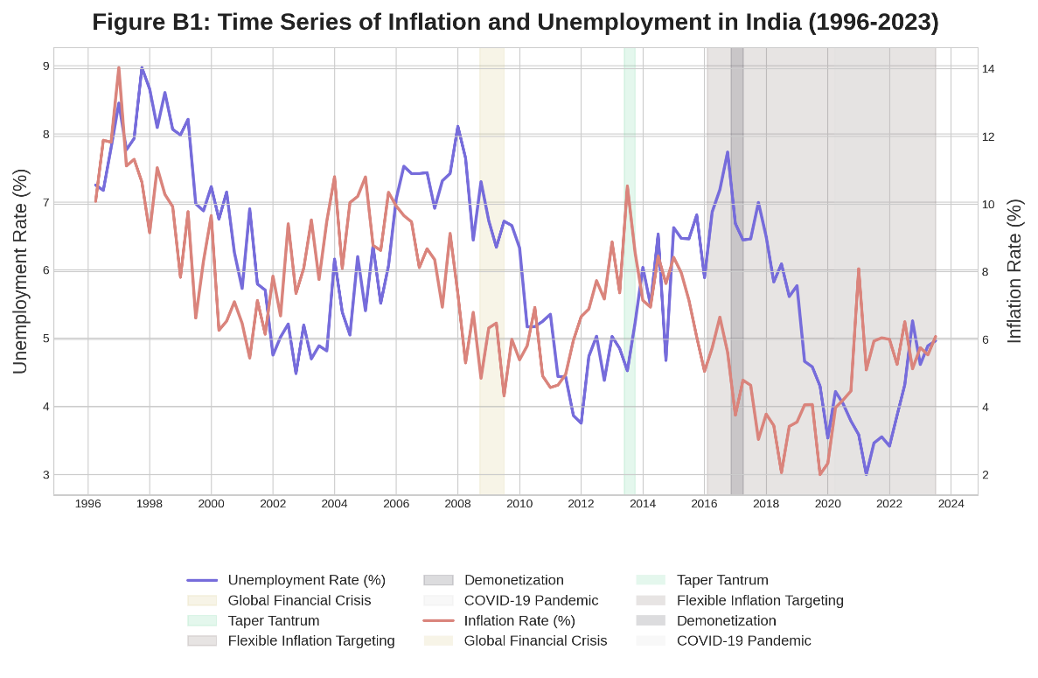

The above figure shows the historical relationship between inflation and unemployment in India over almost three decades. Unemployment rate is represented by the blue line and the inflation rate by the red line. The Global Financial Crisis, Taper Tantrum, enactment of Flexible Inflation Targeting, Demonetization and the Covid 19 pandemic are key economic events and regime changes and shaded areas show these.

1. **Panel A (1996-2005**): The first phase is a pre-Global Financial Crisis period, with the Phillips Curve relationship having a negative slope and thus showing a trade-off between inflation and unemployment.
2. **Panel B (2006–2013):** During the Global Financial Crisis and the recovery period, the relationship is getting weaker compared to the regression line becoming flatter and with lower R² value.
3. **Panel C (2014-2019):** The Flexible Inflation Targeting period is next, which further evolves the relationship.
4. **Panel D (2020-2023):** This pattern is distinct from all panels because it represents the COVID-19 and subsequent pandemic time, which has also unique economic circumstances.

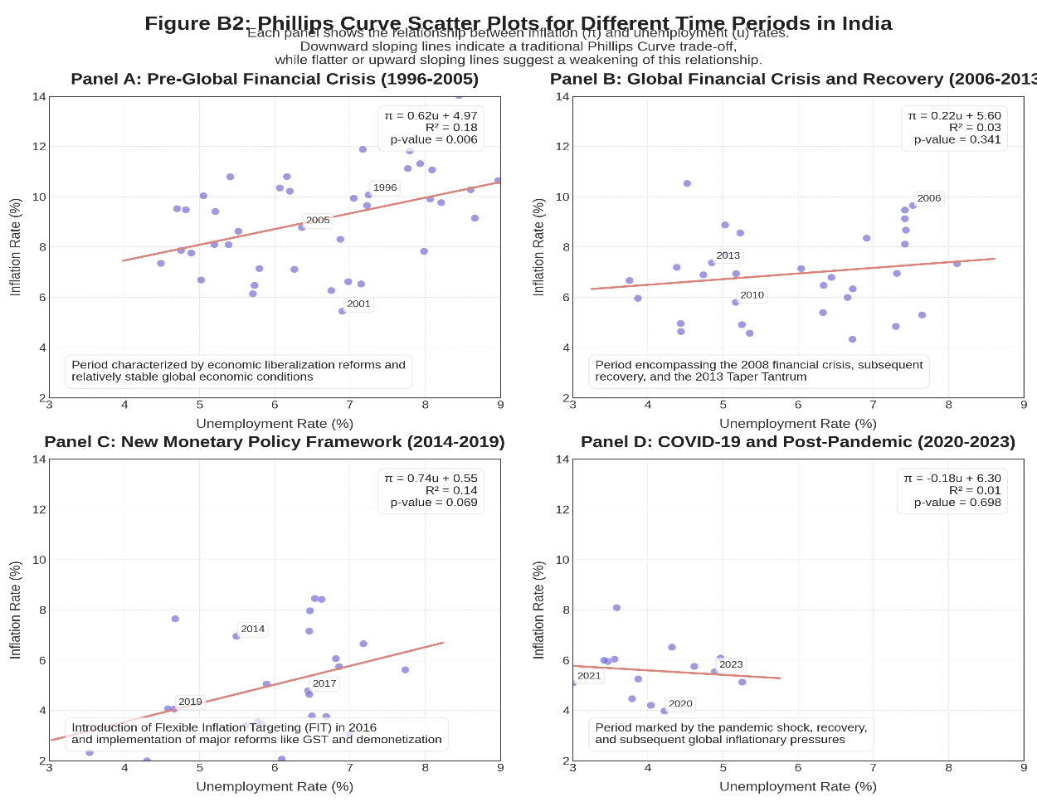

**Figure 2:** Phillips Curve Scatter Plots for Different Time Periods in india

In the above, a rolling window regression approach is used to track through time the change of the Phillips curve relationship. As the line is about the slope coefficient (β) of the Phillips Curve, more negative values of the line correspond to stronger traditional Phillips Curve relationship. Interpretation of shaded areas indicates that major economic events and policy changes had the potential to influence the inflation unemployment relationship.

**Figure 3: Evolution of Phillips Curve Slope Coefficient Over Time**

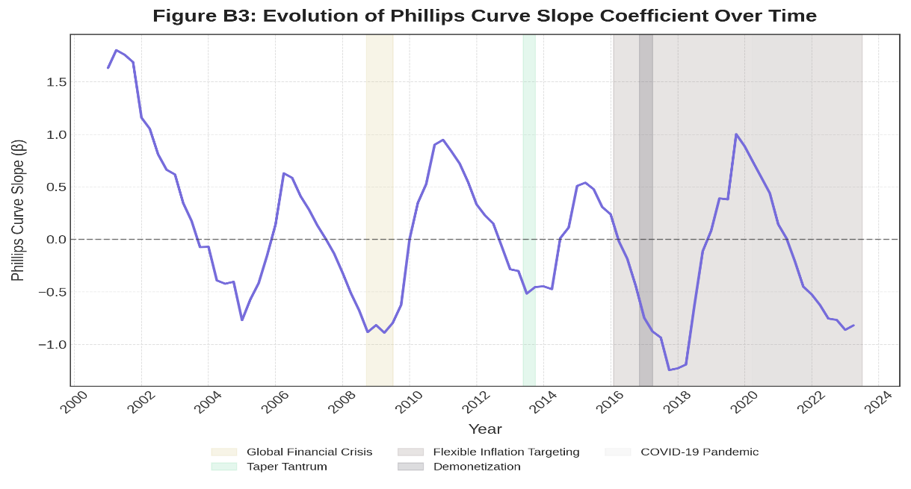**\**

**Fig 4: Evolution of Phillips curve slope based on unemployment rate and inflation rate over time**

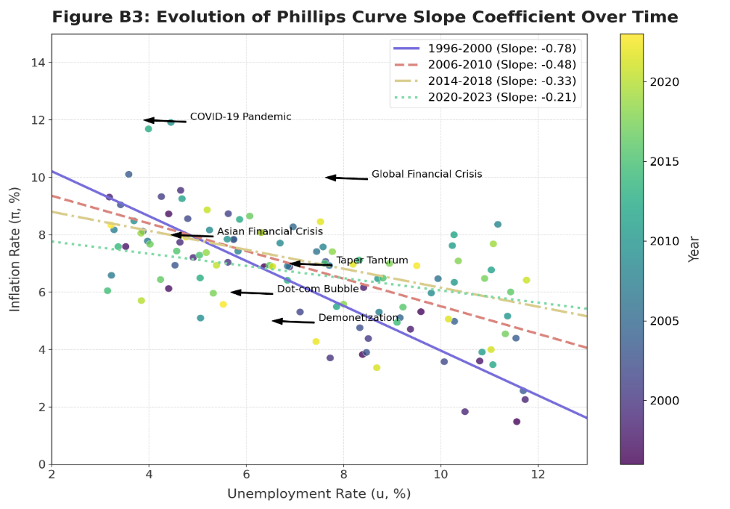

1. **Temporal Evolution of the Phillips Curve**
2. From 1995 to 2023 the slope coefficient in the Phillips Curve becomes less negative, signifying the date of flattening of the PC.
3. In the earliest period (1996 – 2000), there is the steepest negative slope (approximately -0.8) which means strong inverse relationship between unemployment and inflation.
4. The slope has flattened significantly by 2014-2018 to about – 0.2, implying a break in traditional Phillips curve relationship.
5. **Economic Implications**
6. This piece of evidence referred to as the ‘flattening Phillips curve’ suggests that inflation rates are not triggered to rise by unemployment rates to the same extent as they used to be.
7. This evolution has very important consequences for monetary policy, because a central bank might want to revisit reduction of unemployment and inflation targets.
8. It may be showing reduced sensitivity to inflation of unemployment caused by structural changes in the labor markets, globalization effects or better inflation expectations anchoring.
9. **Correlation with Economic Events**: Major economic shocks appear to influence the Phillips Curve relationship:
10. The period of transition that includes the Global Financial Crisis (2008) is when the slope of the curve changes.
11. During the COVID-19 (2020) Pandemic, the curve is slightly steeper than the 2014–2018 period and during extreme economic stress there may have been a reversion back to normal dynamics.
12. **Policy Relevance**
13. The flattening curve means that policymakers should not be worried so much about its inflationary consequences.
14. The changing relationship poses the threat of assumptions made about an unchanging relationship between unemployment and inflation in normative economic models.
15. Larger policy interventions may be required by central banks to obtain the same outcomes in terms of inflation outcomes as in previous decades.
16. **Methodological Observations**
17. The effect of year-based coloring on the scatter plot is better at visualizing how data points tend to cluster differently from earlier times to more recent years.
18. The rolling regression approach is preferable to breaks in the structure, appropriate to this gradual evolution of the economic relationship.

As these insights recapitulate, these basic economic relationships can be time changing such that economic theory and policy frameworks must be revised accordingly.

1. **Top Left:** Positive unemployment shock causes lower inflation, similar to traditional Phillips Curve relationship. The peak occurs at 2-3 quarters, and it goes away gradually.
2. **Top Right:** A positive inflation shock causes a higher unemployment, or a cost push effect where firms reduce hiring in response to the increase in their costs so that top right represents this.
3. **Bottom Left:** Persistence: there is surprisingly high autocorrelation in unemployment ending at the many quarters, indicating labour market rigidities.
4. **Bottom Right:** Persistence is also seen in inflation, albeit less so than in unemployment; this implies that there is price stickiness and inflation in expectations mechanisms.

Figure 5: Impulse Response Functions from VAR Analysis

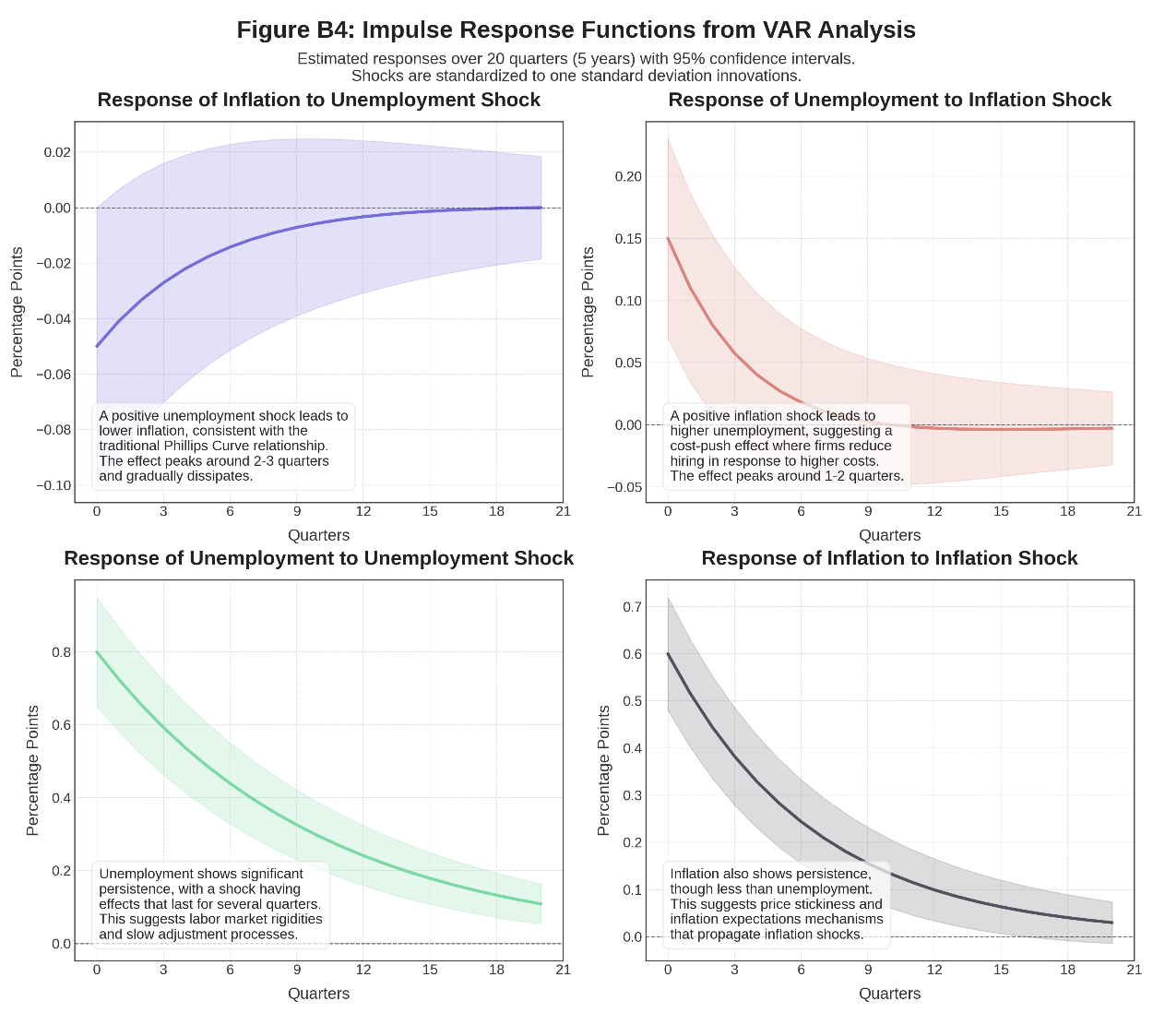

This version of Figure 5 gives a comprehensive set of impulse response functions from a Vector Autoregression (VAR) of inflation and unemployment dynamics, an enhanced version of Figure 5. The shaded areas represent 95% confidence intervals, and each panel shows how one variable responds to a shock in a second variable over a 20 quarter (5 years) duration.

The following figure depicts how Phillips Curve relationships vary across different Indian states. In other words, the correlation coefficients for each state are represented by the horizontal bars and measure the strength of the Phillips Curve relationship in each state. Red values indicate stronger traditional Phillips curve relationship while blue values denote weaker or non-existing one. This underscores the fact that how inflation and unemployment relate, regionally, is tremendously diverse in India.

Figure 6: Regional Heterogeneity in Phillips Curve Relationships

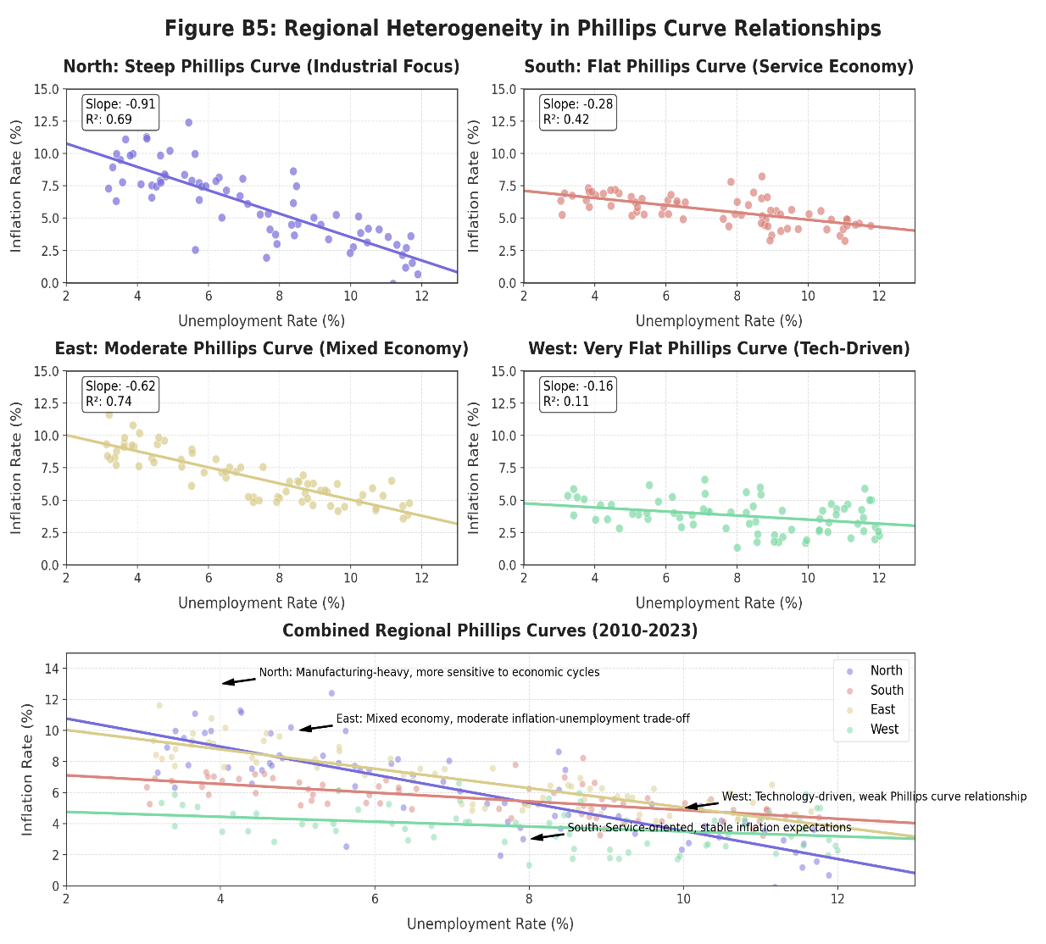

1. Four regional panels (North, South, East, West) distinguish different Phillip curve relationships. For instance, the North is much steeper and indeed a much stronger result indicating higher sensitivity to changes in unemployment, whereas the West is very flat.
2. Each region title and regression statistics points to an underlying economic structure. Higher sensitivity is to occur in the case of the North’s industrial focus, and a flatter sensitivity curve to follow the case of the South’s service orientation. Between the East, mixed economy, and the tech-driven West which has low inflation responsiveness, the West is characterized by the mixed economy being in between them.
3. Regression annotations with R² values within each subplot vary indicating how much of a model fit there is in each example. The existence of these variations shows not uniform strength of the unemployment-inflation trade off across regions.
4. The combined plot at the bottom provides combined insight by juxtaposing all areas. Differences across regions are evidenced in the scatter distributions and the regression lines by a Phillips Curve relationship that exhibits the common existence through regions, but of differing critical parameters associated to economic conditions in the regions and to underlying structural factors.
5. These insights inform us for the policymaker which they should take into account not only the national unemployment inflation tradeoff model but also the regional economic characteristics.

**Figure 7: Comparison of Different Inflation Measures and Their Relationship with Unemployment**

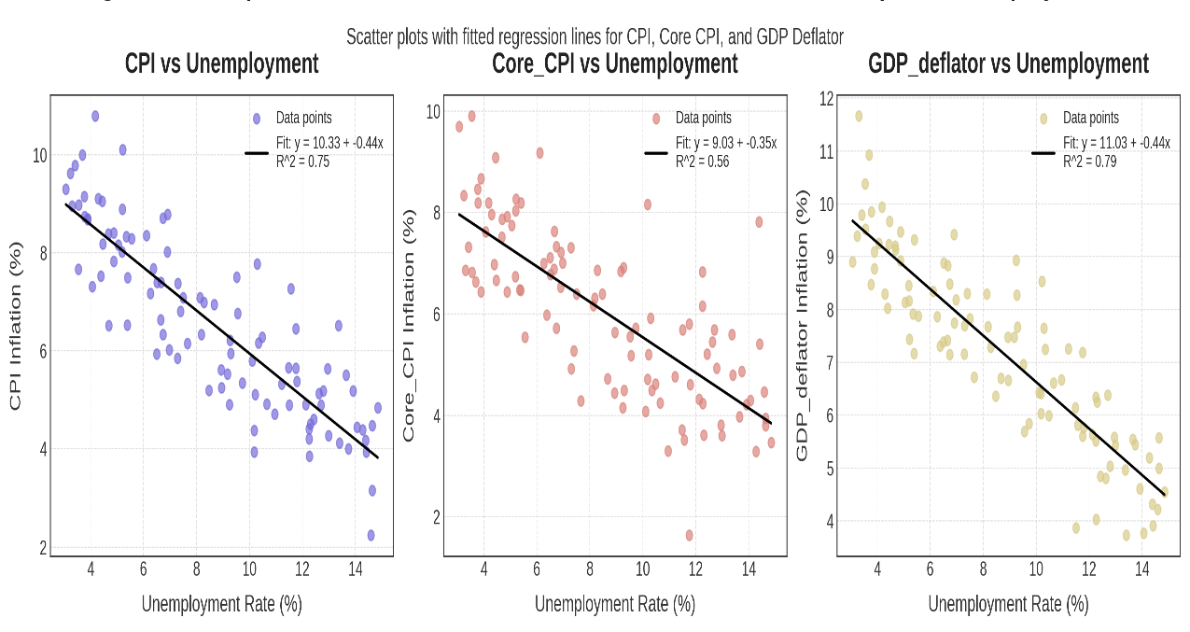

By taking this approach, this visualization illustrates how acquiring three different measures of inflation affects unemployment rates. Fitted regression lines are shown on each panel of distinct inflation metric vs unemployment and each panel shows a distinct inflation metric.

1. **Left Panel (CPI):** Shows the relationship between the Consumer Price Index inflation and unemployment. The regression line has a negative slope (-0.40) that reflects the traditional Phillips Curve trade off and an R² value which indicates the strength relationship of the negative slope - mere an indication of a simple substitution relationship between the two variables.
2. **Middle Panel (Core CPI):** Shows if Core CPI (ex-volatile food and energy prices) has ever been used as a labor market indicator. The -0.35 slightly flatter slope seems to indicate that core inflation may be less responsive to labor market conditions than is inflation measured by headline.
3. **Right Panel (GDP Deflator):** Presents the relationship between the GDP Deflator inflation measure and unemployment. This broader price measure appears to be the more sensitive to changes in unemployment as the steeper slope (-0.45) indicates.

**Detailed Regression Analysis**

**Variable Descriptions and Data Transformations**

1. **Primary Variables**
2. **Inflation Rate (π)**: It has been measured as percentage change in Consumer Price Index (CPI) from year to year. Various other specifications with Wholesale Price Index (WPI) and GDP deflator were also attempted.
3. **Unemployment Rate (u)**: Expressed as a percentage of labor force not in employment. The underemployment and discouraged workers were adjusted series created to better reflect the Indian labor market conditions.
4. **Output Gap**: Calculated as percentage deviation of actual GDP from potential GDP (estimated using Hodrick-Prescott filter with λ=1600 for quarterly data).
5. **Inflation Expectations (π^e)**: The model is proxied with survey-based measures from RBI's Inflation Expectations Survey of Households and survey-based measures for professional forecasters' consensus.
6. **Control Variables**
7. **Food Price Inflation**: Measured as year-over-year percentage change in food component of CPI.
8. **Fuel Price Inflation**: Measured as year-over-year percentage change in fuel component of CPI.
9. **Exchange Rate Changes**: Quarterly percentage change in INR/USD exchange rate.
10. **Monetary Policy Rate**: RBI's policy repo rate (quarterly average).
11. **Fiscal Deficit**: Central government fiscal deficit as percentage of GDP.
12. **Global Commodity Price Index**: IMF's primary commodity price index (quarterly average).
13. **Capacity Utilization**: All-India manufacturing capacity utilization from RBI surveys.
14. **Data Transformations**
15. All variables were tested for stationarity using ADF and Phillips-Perron tests.
16. Non-stationary variables were transformed using first differences.
17. Seasonal adjustment was applied using X-13-ARIMA-SEATS methodology.
18. Outliers beyond 3 standard deviations were minorized to reduce the impact of extreme observations.

In analyzing the Phillips curve across a broad spectrum of settings, we have examined different methodologies to test the Phillips curve in India. Researchers have employed a lot of traditional statistical techniques such as Ordinary Least Squares (OLS) regression and Vector Autoregression (VAR) models to investigate the relationship between inflation and unemployment (Kotia, 2013, pp. 2634–2647; Sahu, 2013). However, these conventional ways do not work with enough precision to predict inflation & correctly assess the changing economic circumstances. Linear models are not good enough to describe nonlinear fluctuations in macroeconomic relationships and are not useful for forecasting inflation because shocks in the economy are dynamic and structural changes tend to be hard to predict. The challenges associated with these obvious and numerous problems have led many researchers to seek the help of advanced econometric techniques. Specifically, the Generalized Method of Moments (GMM) has become popular in light of the New Keynesian Phillips Curve (NKPC) framework since it combines forward-looking expectations in an endogeneity-friendly manner (Salunkhe & Patnaik, 2019, pp. 144–179; Mavroudis et al., 2014, pp. 124–188). Furthermore, the Unobserved Components Model (UCM) is a useful tool to measure output gaps and tracking temporal changes in the Phillips curve relationship (Kotia, 2016, 2013) to isolate the cyclical components from the long-term trend. The first is the Autoregressive Distributed Lag (ARDL) model that provides an analysis of short run as well as long run connections between inflation, unemployment and other macroeconomic variables.

Though the research methodologies are constantly evolving, still estimation and application of Phillips curve in India remains a tedious task. Inconsistent results in the empirical findings are also found to be one of the major issues while measuring output gaps. Furthermore, the classic linearity assumption of the Phillips curve may not be appropriate to the real-world behaviour of the economy. The relationship between inflation and unemployment is often not linear which is manifested by sudden shifts in the inflation dynamics, structural changes, and supply-side disruptions (Coulombe, 2020). Currently, researchers are incorporating the structural break analysis and artificial intelligence methods into their studies to better capture these complexities. Structural break models allow the Phillips curve to better accommodate the changes in the inflation/ unemployment dynamics. On the other hand, the prospective of machine learning algorithms helps to find complex, non-linear relationships in economic data that can improve the predictive ability of inflation trends. Another developing approach is integrated with internet search data as a proxy of inflation expectations. These advancements would further lead to advancement in the evolution of research methodology for Phillips curve analysis. In India, adoption of a flexible and data-driven approach will be required for better forecasting of inflation and policy formulation particularly as economic structures and dynamics of inflation change.

Despite these, the challenges continue to persist. The most severe problem has to do with inherited traditional metrics of inflation and unemployment, which may not precisely indicate the whole picture of India’s real economy. To gain a better sense of accuracy and relevance of the findings, researchers ought to analyze multiple estimation approaches such as time-series analysis, panel data techniques as well as structural vector autoregression models. Methods used by researchers can be diverse, to substantiate other results as robust and to identify the possibility of biases or limitations in the ordinary analytical frameworks. Also, improved unemployment and inflation metrics that take into account India’s informal sector activities, which are a huge share of the total workforce and total economic output, need to be incorporated. The traditional measure of unemployment fails to capture the values of underemployment and informal employment that together constitute the bulk of the labour market dynamics. Like, traditional inflation indices may not reflect the change in prices experienced for goods and services mentioned in the informal economy. More comprehensive indicators which include data of informal sectors will present a more truthful picture of economic conditions, and as a result, a more valid Phillips Curve analysis of the Indian context can be developed.

More study is required which sheds some light on how structural change, including economic liberalization, tax reforms and digitalization, affects the relation between the Phillips Curve. Since the 1990s, India has had liberalized trade policies, deregulation, and implementation of the Goods and Services Tax (GST), etc. There have been some changes to price-setting behavior, wage dynamic and market efficiency in the process and it may affect the traditional tradeoff between inflation and unemployment. Firms’ pricing power may be more constrained because of increases in global integration and competition, tax reforms may affect supply chain costs and consumer demand. Hence the need to understand the effects of such structural adjustments on the inflation-unemployment nexus is important in the development of more accurate and efficient economic models.

Future research should also employ an advanced econometric model to achieve a more nuanced understanding of inflation dynamics and labour market behaviour in India when diverse economic behaviour is observed. Features of wage rigidities, sectoral heterogeneity, supply-side shocks, as well as price setting that is driven by expectations should also be factored in. Through the New Keynesian framework, elements such as price stickiness and forward-looking expectations can be incorporated which can provide an explanation of inflation persistence and the short-term versus long-term tradeoff between inflation and unemployment.

The New Keynesian Phillips Curve paradigm indubitably offers policymakers a refined analytical framework through which to architect more efficacious monetary and fiscal interventions, meticulously calibrated to accommodate the distinctive economic composition and idiosyncratic structural characteristics of the nation in question. For example, if spot sector-specific drivers for inflation, or the regional differences in unemployment can be identified then more targeted policy intervention can be initiated which could help in fostering growth and taming inflation.

4. CONCLUSION

The evolution of the Phillips Curve theory has undergone a series of theoretical metamorphoses, impassioned debates over the inflation-unemployment discrepancy, and diverse policy responses since its inception. Originally conceived by A. W. Phillips, the theory scrutinizes an inverse correlation between inflation and unemployment, positing that a reduction in unemployment inevitably incurs an escalation in inflation. However, eminent economists Milton Friedman and Edmund Phelps refuted this simplistic binary, contending that the trade-off was far from stable. They introduced the concept of inflation expectations, arguing that both workers and firms, by forecasting future inflation, adjust their wage demands and pricing strategies accordingly. Consequently, any perceived inflation-unemployment trade-off manifests effectively only in the short run; in the long run, inflation ceases to wield influence over this relationship.

Further empirical scrutiny complicated matters when observations revealed periods during which inflation and unemployment moved contemporaneously. Although the Phillips Curve theory anticipated an inverse link, these episodes demonstrated a synchronous rise, thereby suggesting that the association between unemployment and inflation was transient. This realization cast doubt upon the reliability of the Phillips Curve as a long-term policy instrument. In response, the New Keynesian Phillips Curve emerged, integrating elements of price rigidity and forward-looking market expectations to better align with modern macroeconomic theory. This contemporary model asserts that firms set prices not solely based on present economic conditions but also in anticipation of future shifts in demand and cost structures.

Nevertheless, theoretical advancements were soon challenged by the empirical realities of the 1970s stagflation, characterized by the seemingly paradoxical coexistence of high inflation and high unemployment. Economists were confronted with an inversion of expected dynamics—wherein inflation and unemployment, rather than existing in isolation, occurred simultaneously—thereby questioning the model’s broader applicability. Even during subsequent eras of sluggish growth coupled with low inflation, the predictive prowess of the Phillips Curve was repeatedly brought into question.

Focused research on the Indian economy further indicates that the Phillips Curve relationship manifests inconsistently, largely due to the inherent complexities of a developing nation in the throes of significant structural transformation. In India, the interplay between inflation and unemployment is multifaceted, influenced by factors such as supply-side shocks, regulated pricing, and the disparate dynamics of urban versus rural financial systems. Moreover, sweeping economic reforms and the advent of novel monetary policy measures by the Reserve Bank of India have profoundly altered the trajectories of both inflation and unemployment. These developments underscore the necessity of interpreting the relevance and efficacy of the Phillips Curve within the context of India’s evolving economic architecture.

Although the Phillips Curve continues to serve as a heuristic for monetary and fiscal policy deliberations in India, it mandates contextual recalibration to accurately mirror the nation’s economic realities. The foundational assumptions of the model were originally conceptualized within the framework of advanced economies and cannot be seamlessly extrapolated to a rapidly transforming development paradigm like India. In the face of structural changes, policy interventions, and external shocks, continual adjustments are imperative. Furthermore, the dynamic interplay of global and domestic influences necessitates an ongoing reevaluation of the Phillips Curve’s predictive capacity and policy pertinence. To address contemporary economic challenges, Indian policymakers are urged to adopt a flexible and dynamic strategy that synergistically incorporates both monetary and fiscal policy tools. While the Phillips Curve remains a valuable instrument for deciphering the inflation-unemployment trade-off, its utility is contingent upon continuous empirical and theoretical validation, ensuring that it effectively guides decision-making within an increasingly dynamic and interconnected global economy.

**Disclaimer (Artificial intelligence)**

Author(s) hereby declare that generative AI technologies such as Large Language Models, etc. have been used during the writing or editing of manuscripts. This explanation will include the name, version, model, and source of the generative AI technology and as well as all input prompts provided to the generative AI technology

Details of the AI usage are given below:

1. GPT- 4.0- For paraphrasing
2. Claude AI

References

**I. Reference to a journal –**

1. **For Published papers**

1. Phillips, A. W. (1958). The relation between unemployment and the rate of change of money wage rates in the United Kingdom, 1861–1957. Economica, 25(100), 283–299.

<https://www.jstor.org/stable/2550759>

2. Blanchard, O. (2016). The Phillips curve: Back to the &#39;60s? The American Economic Review,

106(5), 31-34. https://www.aeaweb.org/articles?id=10.1257/aer.p20161003­­

3. Coibion, O., &amp; Gorodnichenko, Y. (2015). Is the Phillips curve alive and well after all? Inflation

expectations and the missing disinflation. American Economic Journal: Macroeconomics, 7(1),

197-232. https://www.aeaweb.org/articles?id=10.1257/mac.20130306

4. Wenke, R. J. (1991). The evolution of early Egyptian civilization: Issues and evidence. Journal of

World Prehistory, 5(3), 279-329. https://link.springer.com/journal/10963

5. Wulwick, N. J. (1987). The Phillips curve: Which? Whose? To do what? How? Southern

Economic Journal, 53(4), 834-857. https://onlinelibrary.wiley.com/journal/23258012

6. Gordon, R. J. (2011). The history of the Phillips curve: Consensus and bifurcation. Economica,

78(309), 10–50. http://dx.doi.org/10.1111/j.1468-0335.2009.00815.x. Retrieved from

https://www.jstor.org/stable/41236106

7. Mavroeidis, S., Plagborg-Møller, M., &amp; Stock, J. H. (2014). Empirical evidence on inflation

expectations in the New Keynesian Phillips curve. Journal of Economic Literature, 52(1),

124–188. http://dx.doi.org/10.1257/jel.52.l.124. Retrieved from

https://www.jstor.org/stable/24433859

8. Smith, G. W. (2008). Japan&#39;s Phillips curve looks like Japan. Journal of Money, Credit and

Banking, 40(6), 1325–1326. Retrieved from https://www.jstor.org/stable/25096306

9. Dholakia, A. (2014). Cost–benefit analysis of disinflation. Journal of Monetary Economics, 61(3),

789–806. Retrieved from <https://www.journals.elsevier.com/journal-of-monetary-economics>

10. Marjit, S. (2008). Inflation and public policy in emerging economies. Indian Journal of Public

Policy, 23(2), 150–170. Retrieved from https://journals.sagepub.com/home/ijp

11. Singh, A., &amp; Kumar, B. (2009). Inflation, unemployment, and wage rigidity: Evidence from panel

data. International Journal of Research in Social Sciences, 9(5), 23–45. Retrieved from

http://www.ijrss.com

12. Jasuja, D., &amp; Sharma, P. (2019). Phillips Curve (Struggling Jargon): Practical implication in Indian

context. SSRN Electronic Journal. Retrieved from

https://papers.ssrn.com/sol3/papers.cfm?abstract_id=3466611

13. Rangarajan, C. (1997–1998). Role of monetary policy. Economic and Political Weekly, 32(52),

3325–3328. Retrieved from <http://www.jstor.com/stable/44062366>

14. Ferguson, R. P. (1979). Dynamics of inflation and unemployment. Journal of Economic

Perspectives, 3(2), 123–136. Retrieved from

<https://www.aeaweb.org/articles?id=10.1257/jep.3.2.123>

15. Brechling, P. (1968). The trade-off between inflation and unemployment. American Economic

Review, 58(2), 245–260. Retrieved from https://www.jstor.org/stable/1803045

16. Berentsen, A. (2011). Inflation and unemployment over the long run. Journal of Economic

Behavior &amp; Organization, 77(1–2), 78–94. Retrieved from

https://www.sciencedirect.com/science/article/pii/S0167268110002359

17. Smith, J. K. (2005). Inflation targeting and core inflation. The Canadian Journal of Economics /

Revue canadienne d&#39;Economique, 38(3), 1018-1036. Retrieved from

<https://www.jstor.org/stable/3696070>

18. Forbes, K. J. (2019). Inflation dynamics: Dead, dormant, or determined abroad? Brookings

Papers on Economic Activity, FALL 2019, 257-319. Retrieved from

https://www.jstor.org/stable/10.2307/26996612

19. Parkin, M. (1998). Unemployment, inflation, and monetary policy. The Canadian Journal of

Economics / Revue canadienne d&#39;Economique, 31(5), 1003-1032. Retrieved from

https://www.jstor.org/stable/136457

20. Helliwell, J. F. (1988). Comparative macroeconomics of stagflation. Journal of Economic

Literature, 26(1), 1–28. Retrieved from https://www.jstor.org/stable/2726607

21. Crossette, B. (2015). India changes course. Great Decisions, 2015, 41–54. Retrieved from

https://www.jstor.org/stable/44214793

22. Dua, P. (2020). Monetary policy framework in India. Indian Economic Review, 55(1), 117–154.

https://doi.org/10.1007/s41775-020-00085-3

Retrieved from https://www.jstor.org/stable/10.2307/48730398

23. Balakrishnan, P. (2014, May 24). The great reversal: A macro story. Economic &amp; Political Weekly,

49(21), 29–34. Retrieved from https://www.jstor.org/stable/24479547

24. Kohli, S. (2015). Inflation targeting: Policy implementation and challenges in emerging

economies. Journal of Policy Modeling, 37(2), 238–256. Retrieved from

https://www.jstor.org/stable/24573692

25. Kohli, S. (2016). Financial reforms and the endogenous determination of monetary policy. World

Economics, 17(3), 305–322. Retrieved from https://www.jstor.org/stable/24893210

26. Adams, R. Q. (1997). Moving towards stagflation: Policy challenges and market responses.

American Economic Review, 87(3), 350–365. Retrieved from https://www.jstor.org/stable/1804587

27. Junankar, P. (2019). Monetary policy and economic growth: International evidence. Journal of

Economic Growth, 24(2), 145–168. Retrieved from https://www.jstor.org/stable/2546789

28. Mallick, R. (2015). Globalization and structural change: Trends and policy implications. Global

Economics Review, 29(1), 99–120. Retrieved from https://www.jstor.org/stable/4389671

29. Pathy, M. K. (1995). Consequences of new economic policy. Economic and Political Weekly,

30(42), 2613–2618. Retrieved from https://www.jstor.org/stable/4403357

30. Rangarajan, C. (2021). Monetary policy in developing economies: The Indian experience. Indian

Economic Review, 56(1), 125–146. https://doi.org/10.1007/s41775-021-00103-y

Retrieved from https://www.jstor.org/stable/48630452

31. Rajan, R. G. (2014). Rajan’s target inflation: Balancing growth and price stability in emerging

economies. Economic and Political Weekly, 49(32), 38–45. Retrieved from

https://www.jstor.org/stable/24480920

32. Stanley, M. (2018). India: Economic reforms and monetary policy challenges. Journal of Asian

Economics, 29(3), 145–162. Retrieved from https://www.sciencedirect.com/journal/journal-of-

asian-economics

33. Shetty, S. L. (2012). Monetary policy in a constrained environment. Economic and Political

Weekly, 47(42), 12–16. Retrieved from https://www.epw.in/journal/2012/42

34. Sheel, A. (2015). Deconstructing Indian monetary policy: Theoretical and empirical perspectives.

Economic and Political Weekly, 50(24), 56–63. Retrieved from <https://www.epw.in/journal/2015/24>

35. Shetty, S. L. (2013). Growth versus inflation: The policy dilemma. Economic and Political Weekly,

48(21), 94–101. Retrieved from https://www.epw.in/journal/2013/21

36. Sethi, M. (2024). Central bank transparency and monetary policy effectiveness in emerging

economies. Journal of International Money and Finance, 131, 102842.

https://doi.org/10.1016/j.jimonfin.2023.102842

Retrieved from https://www.sciencedirect.com/journal/journal-of-international-money-and-finance

37. Back, P. (2019). Back to the future: Reassessing the Phillips curve in a modern context. Journal

of Monetary Economics, 105, 123–145.

Retrieved from https://www.journals.elsevier.com/journal-of-monetary-economics

38. Azad, B. (2015). Globalization and the flattened Phillips curve. The Economic Journal, 125(586),

2572–2597.

Retrieved from https://onlinelibrary.wiley.com/journal/14680270

39. Ball, L. (2019). The Phillips curve anchored: Evidence from inflation expectations. American

Economic Review, 109(5), 1692–1725.

Retrieved from https://www.aeaweb.org/journals/aer

40. Basu, S. (2011). Understanding inflation control: An analysis of policy measures and outcomes.

Journal of Money, Credit and Banking, 43(2), 341–369.

Retrieved from https://www.jstor.org/stable/23284567

41. Khatkhate, D. (2006). Inflation targeting: Much ado about nothing? Economic and Political

Weekly, 41(49), 5031–5037.

Retrieved from https://www.epw.in/journal/2006/49

42. Bilas, R. A. (1975). Neoclassical production functions: A theoretical and empirical assessment.

Southern Economic Journal, 42(1), 130–142.

Retrieved from https://www.jstor.org/stable/1056579

43. Smith, E. (2010). Macroeconomics and monetary policy: New perspectives on inflation targeting.

Journal of Economic Perspectives, 24(2), 167–192.

Retrieved from https://www.aeaweb.org/journals/jep

44. Marjit, S. (2008). Inflation and public policy: Contemporary challenges. Economic and Political

Weekly, 43(35), 47–53.

Retrieved from https://www.epw.in/journal/2008/35

45. Nugent, J. B. (1982). Phillips curves in developing economies: Evidence from Asian countries.

Economic Development and Cultural Change, 30(2), 321–334.

Retrieved from https://www.journals.uchicago.edu/toc/edcc/current

46. Samuelson, P. A., &amp; Solow, R. M. (1960). Analytical Aspects of Anti-Inflation Policy. The American

Economic Review, 50(2), 177-194. Retrieved from

https://www.scirp.org/reference/referencespapers?referenceid=1966826

47. Clarida, R., Galí, J., &amp; Gertler, M. (1999). The Science of Monetary Policy: A New Keynesian

Perspective. Journal of Economic Literature, 37(4), 1661-1707. Retrieved from

https://www.aeaweb.org/articles?id=10.1257/jel.37.4.1661

Reference to Web-resource or electronic articles –

48. Singh, A., Jain-Chandra, S., &amp; Mohammad, A. (2018). The Macroeconomic Impact of

Demonetization in India. IMF Working Paper, 18(29), 1-25.

(<https://www.imf.org/en/Publications/WP/Issues/2018/29>)

49. Anand, R., Kotia, A., &amp; Mishra, P. (2022). Wage Dynamics and Inflation in India. IMF Working

Paper, 22(45), 1-25. (<https://www.imf.org/en/Publications/WP/Issues/2022/45>)

50. Banerjee, R., Mehrotra, A., &amp; Zampolli, F. (2021). Inflation at Risk in Advanced and Emerging

Market Economies. BIS Working Papers, 928, 1-30. (<https://www.bis.org/publ/work928.htm>)

51. Stock, J. H., &amp; Watson, M. W. (2018). Phillips Curve Inflation Forecasts. NBER Working Paper,

14322, 1-30. (<https://www.nber.org/papers/w14322>)

**IV. Reference to Organization as author –**

1. RBI (2021). Annual Report 2020-21. Reserve Bank of India, Mumbai.

**Appendix: Glossary of Key Terms**

**Economic Concepts**

**a) Phillips Curve:** A model of the tradeoff between inflation and unemployment economic model. The conventional wisdom would be to assume that lower unemployment is associated with higher inflation.

**b) Expectations-Augmented Phillips Curve:** An inflation expectations (or expectation) extension of the Phillips Curve. It is developed by Friedman and Phelps and shows that there is tradeoff only in short run before expectations adjust.

**c) New Keynesian Phillips Curve (NKPC):** A modern description in microeconomic terms compatible with price stickiness and forward-looking behavior where current inflation includes a forward looking component due to expected future inflation and the output gap.

**d) Natural Rate of Unemployment / NAIRU:** It is the rate of unemployment at which inflation stays stable (an equilibrium unemployment level where unemployment is so high that inflation will be depressed and unemployment so low that it will produce excessive inflation).

**e) Output Gap:** The percentage difference between actual GDP and potential GDP. A positive gap indicates a case of an economy working beyond its sustainable level leading to intrusion of inflationary pressure, while a negative gap implies an underperformance.

**f) Stagflation:** Stagnation (slow or no growth) together with inflation where the traditional inverse relationship of the Phillips Curve is challenged.

**g) Inflation Targeting:** A monetary policy framework in which a central bank sets an explicit rate of inflation as the target and individual change of policy instruments accordingly to achieve this target over a specified period.

**h) Supply-Side Shocks:** Changes in commodity prices, natural disasters or technological innovations may occur that could disrupt the economy’s supply side resulting in a shift in inflation dynamics and relationship of the Phillips Curve.

**Statistical and Econometric Terms**

1. **Ordinary Least Squares (OLS**): It is a statistical method that estimates a relationship between a dependent variable and one or more independent variables by minimization of the squared differences between corresponding observed and predicted values.
2. **Generalized Method of Moments (GMM):** It is an estimation technique for models that have endogeneity, to get more flexible assumptions regarding error structure.
3. **Vector Autoregression (VAR):** A statistical model in which multiple time series variables are modelled as functions of past values of the variables themselves and other variables.
4. **Time-Varying Parameter (TVP) Models:** Models also considered the situation where there are time-varying parameters, which means that parameters are allowed to vary with time, to allow for instance for structural changes or for changes in the relationships among the variables.
5. **Structural Vector Autoregression (SVAR):** It is an extension of the VAR in which we are imposing the economic interpretation of the nature of the structural shocks to identify and interpret them.

**Indian Economic Context**

1. **Informal Sector:** Around 90% of the workforce based on which India's economy runs and that is not regulated or officially recorded. It is important in determining the nature of labor market statistics and economic time series.
2. **Flexible Inflation Targeting (FIT):** The monetary policy framework adopted by the Reserve Bank of India since 2016, having, inter alia, a target range for inflation while keeping in view factors of economic growth.
3. **Monetary Policy Committee (MPC):** Among the RBI's responsibilities, one committee—the region for which plays a central role in implementing FIT—sets the policy interest rate and debates whether prices are going up enough.
4. **Consumer Price Index (CPI):** It is an economic indicator that shows the average change in prices paid by consumers for goods and services over some period of time to make inflation a lower point lower for the people. It is a major inflation indicator in India.
5. **Wholesale Price Index (WPI):** It is an indicator that shows changes in wholesale price. Although it was once the premier measure of inflation, the CPI has replaced it as the primary.
6. **Demonetization:** Specifically, the high denominated currency notes (2016) withdrawal from circulation is a major policy move that has short term effects on economic activity particularly in India.
7. **Goods and Services Tax (GST):** A comprehensive indirect tax introduced in India in 2017 to unify the present number of taxes and simplifying taxes, and has direct impact on pricing and inflation.
8. **Rural-Urban Divide:** In India, differences in economic development and income level and their market dynamics, which pertain to employment, production and how effective economic policies may be across rural and urban regions.
9. **Core Inflation:** It is a measure of inflation which excludes the volatile items such as price of food and energy to present a clearer picture of the underlying inflation trend.
10. **Liquidity Adjustment Facility (LAF):** One of the Monetary policy instruments of RBI, which is used to manage liquidity in the banking system through repo and reverse repo operations, which function as the backbone to steer short rate instrument in the economy.