**Integration of AI and IoT for Yield Optimization in Precision Farming**

**Abstract**

Precision farming has emerged as a transformative approach to modern agriculture, addressing the challenges of increasing food demand, resource scarcity, and environmental sustainability. The integration of Artificial Intelligence (AI) and the Internet of Things (IoT) has revolutionized precision farming by enabling real-time data collection, analysis, and decision-making. This paper explores the role of AI and IoT in optimizing crop yields, reducing resource wastage, and enhancing agricultural sustainability. In this study, the underlying technologies, including IoT sensors, drones, autonomous vehicles, and AI algorithms such as machine learning and deep learning, have been examined. Recent advancements, such as edge computing, digital twins, and blockchain, are discussed, along with their applications in precision irrigation, disease detection, yield prediction, and resource optimization. The study revealed that precise application of water, fertilizers, and pesticides reduces waste and lowers production costs. For instance, AI-powered irrigation systems can reduce water usage by up to 50%, significantly lowering water bills. Automation and data-driven decision-making reduce labor costs and improve operational efficiency. By combining the real-time data collection capabilities of IoT with the advanced analytical power of AI, precision farming enables farmers to make data-driven decisions, optimize resource usage, and maximize crop yields. Moreover, Case Study 1 (Smart Irrigation in California) revealed that the system reduced water usage by 20% while increasing crop yields by 15%. Similarly, Case Study 2 (Disease Detection in India) revealed that the system achieved an accuracy of 90% in disease detection, enabling timely intervention and reducing crop losses. Despite the promising potential, challenges related to data privacy, interoperability, and accessibility remain. Policymakers must create supportive regulatory frameworks that encourage innovation while safeguarding sensitive agricultural data. Looking ahead, emerging technologies such as edge computing, 5G connectivity, blockchain, and advanced AI models promise to further enhance the capabilities of precision farming, making it more accessible, scalable, and efficient. This paper concluded with future prospects, emphasizing the need for continued innovation and collaboration to fully realize the benefits of AI and IoT in precision farming. By addressing these challenges, the integration of AI and IoT can pave the way for a more sustainable and productive agricultural future.

***Keywords:*** Precision Farming, Artificial Intelligence (AI), Internet of Things (IoT), Yield Optimization, Smart Agriculture.

**1. Introduction**

Agriculture has been the backbone of human civilization for millennia, providing food, fiber, and fuel to sustain societies. However, the agricultural sector today faces unprecedented challenges. The global population is projected to reach 9.7 billion by 2050, according to the United Nations (2019), necessitating a 70% increase in food production to meet the growing demand. This surge in demand comes at a time when arable land is shrinking due to urbanization, soil degradation, and climate change. “According to the UN Food and Agriculture Organization, with increasing population mouths, global food production must be increased substantially by 2050. To meet the demand, farmers and agricultural companies will have to push the innovations by suppressing their current practices” (Kumar et al., 2020).

Additionally, traditional farming practices, characterized by the uniform application of water, fertilizers, and pesticides, are increasingly unsustainable. These practices often lead to resource wastage, environmental pollution, and reduced crop yields, exacerbating the challenges faced by the agricultural sector (Liakos et al., 2018).

“In this context, precision farming, also known as precision agriculture, has emerged as a transformative approach to modern agriculture. Precision farming leverages advanced technologies to optimize crop yields, reduce resource wastage, and enhance sustainability. Unlike traditional farming, which treats entire fields uniformly, precision farming enables site-specific management of agricultural inputs” (Mohanty et al., 2016; Maurya et al., 2024). “This means that water, fertilizers, and pesticides are applied only where and when they are needed, based on real-time data and analysis. The result is a more efficient use of resources, higher crop yields, and a reduced environmental footprint” (Khaspuria et al., 2024).

“The advent of the Internet of Things (IoT) and Artificial Intelligence (AI) has revolutionized precision farming. IoT refers to the network of interconnected devices that collect and exchange data” (Akhter and Sofi, 2022). “In agriculture, IoT devices such as soil sensors, weather stations, drones, and autonomous vehicles generate vast amounts of data on soil conditions, weather, crop health, and more” (Shafi et al., 2019; Van Klompenburg et al., 2020). “This data is transmitted to cloud-based platforms for storage and analysis, forming the foundation for informed decision-making” (Bochtis et al., 2014).

AI, particularly machine learning (ML) and deep learning (DL) play a crucial role in processing and analyzing the data generated by IoT devices. AI algorithms can identify patterns, make predictions, and provide actionable insights that enable farmers to optimize their practices (Padhiary et al., 2024; Shaikh et al., 2022). For example, AI can analyze images captured by drones to detect early signs of crop stress, diseases, and pest infestations. It can also predict crop yields based on historical data, weather conditions, and soil properties, allowing farmers to make more proactive decisions (Shafi et al., 2019).

“The integration of AI and IoT in precision farming creates a synergistic effect, enabling real-time data collection, analysis, and decision-making” (Sharma et al., 2020). “This integration is particularly effective in yield optimization, as it allows for the precise management of agricultural inputs. By combining the strengths of IoT and AI, precision farming systems can optimize irrigation schedules, recommend optimal fertilizer application rates, and even automate tasks such as planting and harvesting” (Farooq et al., 2019). The result is a more efficient, sustainable, and productive agricultural system.

“However, the integration of AI and IoT in precision farming is not without challenges. Issues related to data privacy, security, interoperability, and cost must be addressed to fully realize the potential of these technologies. Despite these challenges, the future of precision farming looks promising. Emerging technologies such as edge computing, digital twins, and blockchain are expected to further enhance the capabilities of precision farming systems” (Shafi et al., 2019; Van Klompenburg et al., 2020). Additionally, the integration of AI and IoT with other emerging technologies, such as biotechnology and nanotechnology, could unlock new possibilities for yield optimization and sustainable agriculture.

This paper provides a comprehensive review of the integration of AI and IoT in precision farming, with a focus on yield optimization. We explore the underlying technologies, recent advancements, challenges, and future prospects, supported by recent references. By examining the current state of the art and identifying areas for future research, this paper aims to contribute to the ongoing efforts to harness the power of AI and IoT for sustainable and efficient agriculture (fig. 1).

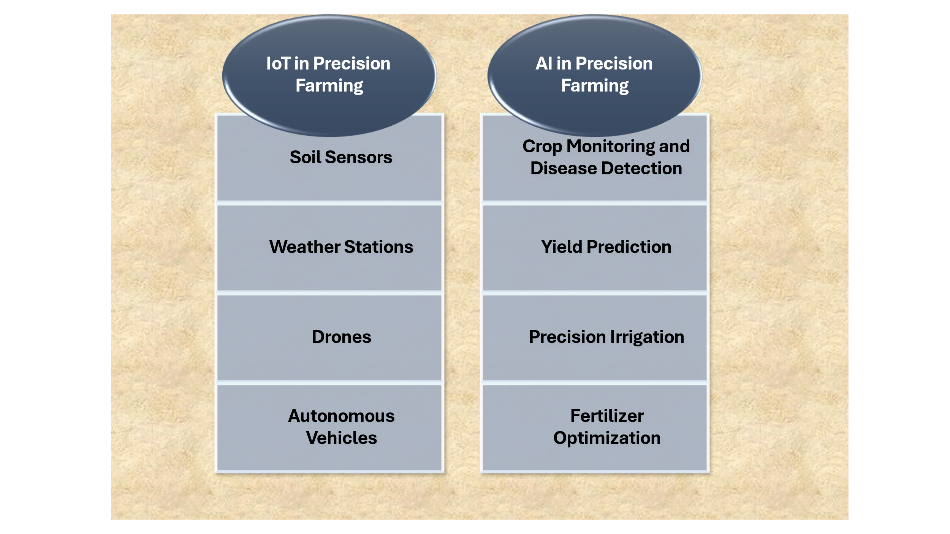

**Fig. 1: IoT and AI in Precision Farming**

**2. IoT in Precision Farming**

IoT plays a pivotal role in precision farming by enabling the collection of real-time data from various sources. Key IoT devices used in agriculture include:

* **Soil Sensors:** These sensors measure soil moisture, temperature, pH, and nutrient levels, providing critical information for irrigation and fertilization decisions (Zhang et al., 2020).
* **Weather Stations:** IoT-enabled weather stations monitor environmental conditions such as temperature, humidity, wind speed, and rainfall, helping farmers anticipate and mitigate the impact of adverse weather.
* **Drones:** Equipped with cameras and sensors, drones capture high-resolution images of crops, enabling the detection of pests, diseases, and nutrient deficiencies (Shafi et al., 2019).
* **Autonomous Vehicles:** Self-driving tractors and harvesters equipped with IoT sensors can perform tasks such as planting, spraying, and harvesting with high precision (Bochtis et al., 2014).

The data collected by IoT devices is transmitted to cloud-based platforms for storage and analysis, forming the foundation for AI-driven decision-making.

**3. AI in Precision Farming**

AI technologies, particularly ML and DL, are increasingly being applied to analyze the vast amounts of data generated by IoT devices. Key applications of AI in precision farming include:

* **Crop Monitoring and Disease Detection:** AI algorithms analyze images captured by drones and satellites to detect early signs of crop stress, diseases, and pest infestations. For instance, convolutional neural networks (CNNs) have been used to identify diseases in crops such as wheat and rice (Mohanty et al., 2016).
* **Yield Prediction:** ML models, such as random forests and support vector machines (SVMs), are used to predict crop yields based on historical data, weather conditions, and soil properties (Van Klompenburg et al., 2020).
* **Precision Irrigation:** AI algorithms optimize irrigation schedules by analyzing soil moisture data, weather forecasts, and crop water requirements. This not only conserves water but also enhances crop yields.
* **Fertilizer Optimization:** AI-driven systems recommend optimal fertilizer application rates based on soil nutrient levels and crop requirements, reducing the risk of over-fertilization and environmental pollution (Liakos et al., 2018).

**4. Integration of AI and IoT for Yield Optimization**

The integration of AI and IoT in precision farming creates a synergistic effect, enabling real-time data collection, analysis, and decision-making. This integration is particularly effective in yield optimization, as it allows for the precise management of agricultural inputs. Key aspects of this integration include (fig. 2):

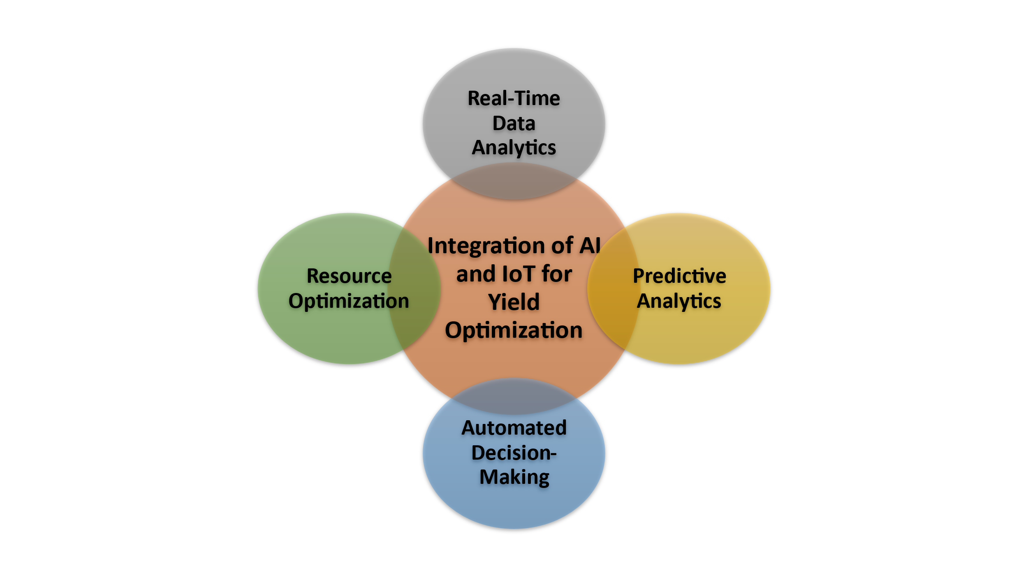

**Fig. 2: Integration of AI and IoT for Yield Optimization**

* **Real-Time Data Analytics:** “IoT devices continuously collect data on soil, weather, and crop conditions, which is processed by AI algorithms in real-time. This enables farmers to make timely decisions, such as adjusting irrigation schedules or applying pesticides, to optimize yields” (Farooq et al., 2019).
* **Predictive Analytics:** “AI models use historical and real-time data to predict future crop performance, enabling proactive management. For example, predictive models can forecast the likelihood of pest outbreaks or disease spread, allowing farmers to take preventive measures. These days, software tools that use AI algorithms are everywhere. While each agricultural business has unique requirements, locating a software-as-a-service platform can enable harnessing the power of AI via a secure, multi-tenant architecture” (Javaid et al., 2023).
* **Automated Decision-Making:** AI-driven systems can automate decision-making processes, such as controlling irrigation systems or adjusting fertilizer application rates. This reduces the need for manual intervention and ensures that crops receive the optimal number of inputs (Bochtis et al., 2014).
* **Resource Optimization:** By integrating AI and IoT, farmers can optimize the use of resources such as water, fertilizers, and pesticides, reducing costs and environmental impact while maximizing yields (Zhang et al., 2020).

**5. Recent Advancements and Case Studies**

Recent advancements in AI and IoT have further enhanced their application in precision farming. Some notable developments include (fig. 3):

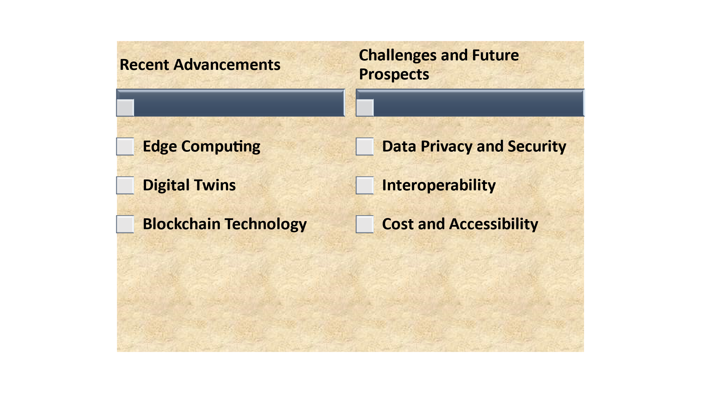

**Fig. 3: Recent Advancements and Challenges and Future Prospects of AI and IoT in Precision Farming**

* **Edge Computing:** Edge computing involves processing data closer to the source (e.g., on IoT devices) rather than in centralized cloud servers. This reduces latency and enables real-time decision-making, which is critical for time-sensitive applications such as precision irrigation (Shi et al., 2016).
* **Digital Twins:** Digital twins are virtual replicas of physical farming systems that simulate real-world conditions. By integrating IoT data with AI models, digital twins enable farmers to test different scenarios and optimize their strategies before implementing them in the field (Grieves, 2014).
* **Blockchain Technology:** Blockchain technology is being explored as a means to enhance data security and transparency in precision farming. By securely recording data from IoT devices and AI models, blockchain can ensure the integrity of agricultural data and facilitate traceability (Tian, 2016). Moreover, a combination of blockchain and IoT can be used to create a smart and secure agricultural system. Applying blockchain in agriculture with IoT, smart technology, and sensors can help ensure food safety and quality, trace food origins, and optimize agricultural production (LB, 2022).

Several case studies highlight the successful integration of AI and IoT in precision farming:

* **Case Study 1: Smart Irrigation in California:** A large-scale smart irrigation system in California uses IoT sensors to monitor soil moisture and weather conditions, combined with AI algorithms to optimize irrigation schedules. The system reduced water usage by 20% while increasing crop yields by 15% (Zhang et al., 2020).
* **Case Study 2: Disease Detection in India:** In India, a pilot project used drones equipped with multispectral cameras and AI algorithms to detect early signs of disease in rice crops. The system achieved an accuracy of 90% in disease detection, enabling timely intervention and reducing crop losses (Shafi et al., 2019).
* **Case Study 3: Smart Greenhouses in the Netherlands:** In the Netherlands, a smart greenhouse project integrated IoT sensors with AI-driven climate control systems. The sensors monitored temperature, humidity, and CO2 levels, while AI algorithms optimized the greenhouse environment for tomato cultivation. The project achieved a 25% reduction in energy consumption and a 20% increase in tomato yield (Hemming et al., 2019).
* **Case Study 4: Precision Livestock Farming in Australia:** In Australia, IoT-enabled wearable devices were used to monitor the health and behavior of dairy cows. AI algorithms analyzed the data to detect early signs of illness and optimize feeding schedules. This led to a 15% increase in milk production and a reduction in veterinary costs (Neethirajan, 2017).

**6. Benefits of AI and IoT Integration in Precision Farming**

The integration of AI and IoT offers numerous benefits, including:

* **Increased Crop Yields:** By optimizing farming practices, AI and IoT help farmers achieve higher productivity and better-quality crops. For example, precise application of fertilizers and water ensures that crops receive the nutrients they need to thrive.
* **Resource Efficiency:** Precise application of water, fertilizers, and pesticides reduces waste and lowers production costs. For instance, AI-powered irrigation systems can reduce water usage by up to 50%, significantly lowering water bills.
* **Sustainability:** Reduced resource consumption and minimized environmental impact contribute to more sustainable agricultural practices. For example, by reducing the over-application of fertilizers, AI and IoT help prevent soil and water pollution.
* **Cost Savings: “**Automation and data-driven decision-making reduce labor costs and improve operational efficiency. For instance, autonomous machinery can perform tasks such as planting and harvesting with minimal human intervention, reducing labor costs. The Agribot Platform, a United Kingdom smart agriculture solution platform enables farmers to make disease treatment decisions that are both environmentally and economically advantageous by giving them an understanding of crop health which can be received on their smartphone. Agribot can perform several tasks including AI-based disease diagnosis, crop health status, the detection of soil stress and the measurement of localized weather” (Muhammed et al., 2024).
* **Risk Mitigation:** Predictive analytics and real-time monitoring help farmers anticipate and mitigate risks such as disease outbreaks and adverse weather conditions. For example, by predicting the likelihood of a pest infestation, farmers can take preventive measures to protect their crops.

**6. Challenges and Future Prospects**

Despite the significant potential of AI and IoT in precision farming, several challenges remain (fig. 3):

* **Data Privacy and Security:** The collection and transmission of sensitive agricultural data raise concerns about data privacy and security. Ensuring the confidentiality and integrity of data is critical to the widespread adoption of AI and IoT in agriculture (Farooq et al., 2019).
* **Interoperability:** The lack of standardization and interoperability among IoT devices and AI platforms can hinder the seamless integration of these technologies. Developing common standards and protocols is essential to enable data sharing and collaboration.
* **Cost and Accessibility:** “The high cost of IoT devices and AI technologies can be a barrier to adoption, particularly for smallholder farmers in developing countries. Efforts to reduce costs and increase accessibility are needed to ensure that the benefits of precision farming are widely shared” (Van Klompenburg et al., 2020).

Looking ahead, the future of AI and IoT in precision farming is promising. Emerging technologies such as 5G, quantum computing, and advanced robotics are expected to further enhance the capabilities of precision farming systems. Additionally, the integration of AI and IoT with other emerging technologies, such as biotechnology and nanotechnology, could unlock new possibilities for yield optimization and sustainable agriculture.

The future of AI and IoT in precision farming looks promising, with several emerging trends and technologies poised to further enhance its capabilities:

* **Edge Computing:** Edge computing involves processing data locally on IoT devices rather than transmitting it to centralized servers. This approach reduces latency and improves real-time decision-making, making it ideal for precision farming applications.
* **Connectivity:** The rollout of 5G networks will enable faster and more reliable communication between IoT devices, enhancing the scalability and performance of precision farming systems.
* **Blockchain Technology:** Blockchain can be used to ensure the security and transparency of agricultural data. For example, blockchain-based systems can track the origin and quality of agricultural products, improving traceability and consumer trust.
* **Advanced AI Models:** Advances in AI, such as reinforcement learning and generative adversarial networks (GANs), will enable more accurate and sophisticated analysis of agricultural data. For instance, GANs can be used to generate synthetic data for training AI models, improving their performance.
* **Collaborative Platforms:** The development of collaborative platforms that connect farmers, researchers, and technology providers will facilitate knowledge sharing and innovation in precision farming.

**7. Conclusion**

The integration of Artificial Intelligence (AI) and the Internet of Things (IoT) in precision farming represents a groundbreaking advancement in agriculture, offering transformative solutions to address the challenges of food security, resource efficiency, and environmental sustainability. By combining the real-time data collection capabilities of IoT with the advanced analytical power of AI, precision farming enables farmers to make data-driven decisions, optimize resource usage, and maximize crop yields. IoT devices, such as soil sensors, drones, and weather stations, generate vast amounts of data from agricultural fields, while AI algorithms process this data to provide actionable insights, such as optimal planting times, precise irrigation schedules, and early warnings for pest infestations or disease outbreaks. This synergy not only enhances productivity but also reduces waste, lowers production costs, and minimizes the environmental impact of farming practices. For instance, AI-powered predictive analytics can forecast weather patterns and crop performance, enabling farmers to adapt proactively, while IoT-enabled automated machinery, such as autonomous tractors and harvesters, reduces labor costs and improves operational efficiency.

Despite its immense potential, the widespread adoption of AI and IoT in precision farming faces several challenges, including high initial costs, limited technical expertise among farmers, connectivity issues in rural areas, and concerns about data privacy and security. Addressing these challenges will require collaborative efforts from governments, research institutions, and private sector companies to invest in infrastructure, training, and research. Policymakers must also create supportive regulatory frameworks that encourage innovation while safeguarding sensitive agricultural data. Looking ahead, emerging technologies such as edge computing, 5G connectivity, blockchain, and advanced AI models promise to further enhance the capabilities of precision farming, making it more accessible, scalable, and efficient.

In conclusion, the integration of AI and IoT in precision farming holds the key to a more sustainable and productive agricultural future. By empowering farmers with real-time data, predictive insights, and automated solutions, these technologies can help address the dual challenges of feeding a growing global population and mitigating the environmental impact of agriculture. However, realizing this potential will require overcoming existing barriers and fostering collaboration among stakeholders. With continued innovation and investment, AI and IoT can revolutionize farming practices, ensuring food security, promoting sustainability, and building resilience against the unpredictable effects of climate change. The future of agriculture lies in the seamless integration of technology and tradition, paving the way for a smarter, greener, and more prosperous farming ecosystem.

**Disclaimer (Artificial intelligence)**

Option 1:

Author(s) hereby declare that NO generative AI technologies such as Large Language Models (ChatGPT, COPILOT, etc.) and text-to-image generators have been used during the writing or editing of this manuscript.

Option 2:

Author(s) hereby declare that generative AI technologies such as Large Language Models, etc. have been used during the writing or editing of manuscripts. This explanation will include the name, version, model, and source of the generative AI technology and as well as all input prompts provided to the generative AI technology

Details of the AI usage are given below:

1.

2.

3.

**References**

1. Bochtis, D. D., Sørensen, C. G., & Busato, P. (2014). Advances in agricultural machinery management: A review. *Biosystems engineering*, *126*, 69-81.
2. Farooq, M. S., Riaz, S., Abid, A., Abid, K., & Naeem, M. A. (2019). A Survey on the Role of IoT in Agriculture for the Implementation of Smart Farming. *Ieee Access*, *7*, 156237-156271.
3. Grieves, M. (2014). Digital twin: manufacturing excellence through virtual factory replication. *White paper*, *1*(2014), 1-7.
4. Hemming, S., de Zwart, F., Elings, A., Righini, I., & Petropoulou, A. (2019). Remote control of greenhouse vegetable production with artificial intelligence—greenhouse climate, irrigation, and crop production. *Sensors*, *19*(8), 1807.
5. Liakos, K. G., Busato, P., Moshou, D., Pearson, S., & Bochtis, D. (2018). Machine learning in agriculture: A review. *Sensors*, *18*(8), 2674.
6. Mohanty, S. P., Hughes, D. P., & Salathé, M. (2016). Using deep learning for image-based plant disease detection. *Frontiers in plant science*, *7*, 1419.
7. Neethirajan, S. (2017). Recent advances in wearable sensors for animal health management. *Sensing and Bio-Sensing Research*, *12*, 15-29.
8. Shafi, U., Mumtaz, R., García-Nieto, J., Hassan, S. A., Zaidi, S. A. R., & Iqbal, N. (2019). Precision agriculture techniques and practices: From considerations to applications. *Sensors*, *19*(17), 3796.
9. Shi, W., Cao, J., Zhang, Q., Li, Y., & Xu, L. (2016). Edge computing: Vision and challenges. *IEEE internet of things journal*, *3*(5), 637-646.
10. Tian, F. (2016, June). An agri-food supply chain traceability system for China based on RFID & blockchain technology. In *2016 13th international conference on service systems and service management (ICSSSM)* (pp. 1-6). IEEE.
11. United Nations. (2019). World Population Prospects 2019: Highlights. *Department of Economic and Social Affairs, Population Division*.
12. Van Klompenburg, T., Kassahun, A., & Catal, C. (2020). Crop yield prediction using machine learning: A systematic literature review. *Computers and electronics in agriculture*, *177*, 105709.
13. Zhang XueYan, Z. X., Zhang JianWu, Z. J., Li Lin, L. L., Zhang YuZhu, Z. Y., & Yang GuoCai, Y. G. (2017). Monitoring citrus soil moisture and nutrients using an IoT based system.
14. Zhang, X., Zhang, J., Li, L., Zhang, Y., & Yang, G. (2020). Monitoring citrus soil moisture and nutrients using an IoT-based smart irrigation system. *Sensors, 20*(7), 1979.
15. Akhter, R., & Sofi, S. A. (2022). Precision agriculture using IoT data analytics and machine learning. *Journal of King Saud University-Computer and Information Sciences*, *34*(8), 5602-5618.
16. Khaspuria, G., Khandelwal, A., Agarwal, M., Bafna, M., Yadav, R., & Yadav, A. (2024). Adoption of Precision Agriculture Technologies among Farmers: A Comprehensive Review. *Journal of Scientific Research and Reports*, *30*(7), 671–686.
17. Shaikh, T. A., Rasool, T., & Lone, F. R. (2022). Towards leveraging the role of machine learning and artificial intelligence in precision agriculture and smart farming. *Computers and Electronics in Agriculture*, *198*, 107119.
18. Maurya , D. K., Maurya , S. K., Kumar, M., Chaubey , C., Gupta, D., Patel , K. K., Mehta, A. K., & Yadav , R. (2024). A Review on Precision Agriculture: An Evolution and Prospect for the Future. *International Journal of Plant & Soil Science*, *36*(5), 363–374.
19. Padhiary, M., Saha, D., Kumar, R., Sethi, L. N., & Kumar, A. (2024). Enhancing precision agriculture: A comprehensive review of machine learning and AI vision applications in all-terrain vehicle for farm automation. *Smart Agricultural Technology*, 100483.
20. Sharma, A., Jain, A., Gupta, P., & Chowdary, V. (2020). Machine learning applications for precision agriculture: A comprehensive review. *IEEe Access*, *9*, 4843-4873.
21. Kumar, S. V., Singh, C. D., & Upendar, K. (2020). Review on IoT based precision irrigation system in agriculture. *Current Journal of Applied Science and Technology*, *39*(45), 15-26.
22. Javaid, M., Haleem, A., Khan, I. H., & Suman, R. (2023). Understanding the potential applications of Artificial Intelligence in Agriculture Sector. *Advanced Agrochem*, *2*(1), 15-30.
23. LB, K. (2022). Survey on the Applications of Blockchain in Agriculture. *Agriculture*, *12*(9), 1333.
24. Muhammed, D., Ahvar, E., Ahvar, S., Trocan, M., Montpetit, M. J., & Ehsani, R. (2024). Artificial Intelligence of Things (AIoT) for smart agriculture: A review of architectures, technologies and solutions. *Journal of Network and Computer Applications*, 103905.