**Dissecting Genetic Variation and Associations in Chickpea (*Cicer arietinum* L.) through Biparental Population Analysis**

.

ABSTRACT

|  |
| --- |
| **Aims:** The genetic variability in the germplasm collection has been used to create resistant cultivars to combat stresses that limit productivity due to linkage drag. North Carolina Design-III system is very effective in breaking undesirable linkage and creating genetic variability in a population.  **Study design:** North Carolina Design-III was used for the experiment.  **Place and Duration of Study:** The experiment was conducted at NEBCRC, Pantnagar, Uttarakhand, between rabi 2020-21 to 2023-24.  **Methodology:** The experiment developed a biparental population by crossing a high-yielding genotype GNG 2127 with a line P 13273 and evaluated them in RCBD with two replications.  **Results:** The analysis of variance revealed that a significant difference was observed for the examined traits. The highest variance was found for a number of pods plant-1 followed by biological yield plant-1 and harvest index due to male, female and male-female interaction. The highest value of GCV and PCV was observed for biological yield plant-1 followed by a number of secondary branches plant-1, number of pods plant-1, harvest index and seed yield plant-1. The maximum value of heritability and genetic advance as a percent of the mean was recorded for the biological yield plant-1. Seed yield plant-1 showed a highly positive and significant correlation with traits viz., number of secondary branches plant-1, number of pods plant-1, biological yield plant-1 and harvest index. Path coefficient analysis exhibited a positive and direct effect for the number of pods plant-1 and harvest index and a low residual effect.  **Conclusion:** The results showed a sufficient amount of variance for the studied traits that may be used to improve plant architecture and other traits in BIPs. |

***Keywords:*** *Chickpea, NCD-III, Genetic variability, Correlation coefficient, Path analysis*

1. INTRODUCTION

“The chickpea (*Cicer arietinum* L.), a self-pollinated diploid (2n=2x=16) with a genome size of 740 Mb, is the most significant food legume crop in South Asia and the third most significant food legume crop globally in terms of annual production, behind beans and peas” (**FAOSTAT, 2023**). “In many parts of the world, chickpeas are a valuable source of dietary protein for both humans and, in certain situations, animals. Chickpea is a rich source of protein and dietary fibre along with other macro and micro-nutrients and has several health benefits” **(Vélez *et al*., 2023)**. “With a yield of 1816.9 kg/ha, the world produced 16.53 million tonnes of chickpeas from 14.09 million hectares of land. India is contributing the highest share in area (74.30%) and production (74.16%) of chickpeas. It is the premier legume crop in India being cultivated during the *Rabi* season, covering an area of 10.47 million hectares with production of 12.26 million tonnes and productivity of 1171.6 kg/ha” **(FAOSTAT, 2023)**. “In India, Maharashtra is leading in production (31.75 lakh tonnes) followed by Madhya Pradesh (30.95 lakh tonnes), Rajasthan (18.09 lakh tonnes), and Gujarat (12.98 lakh tonnes). In Uttarakhand, the productivity of chickpeas is low (800 kg/ha), despite growing in an area of 0.01 lakh ha with a production of 0.01 lakh tonnes” **(DPD GoI, 2022-23)**. The low yield has been attributed to several biotic and abiotic factors that have an adverse relationship with yield and yield component traits. Biotic stresses, especially diseases like botrytis grey mold (BGM) destroy crops and limit production.

“A prerequisite for genetic improvement in any crop is the presence of genetic variability. The significant genetic variation found in the native chickpea germplasm has been widely utilized in many breeding initiatives, including Line × Tester and Diallel studies” (**Begna, 2021**). Natural genetic variability is necessary for any crop to undergo genetic improvement. However, the gene pool in chickpeas has been reduced due to the widespread exploitation of natural variability (**Singh *et al*., 2022**). Therefore, the development of genetic variability is necessary. In addition, genetic improvement in any crop requires knowledge of the gene actions contributing to the inheritance of different traits (**Babbar, 2017**). The type of gene activity governing the genetic variation mostly determines which method is most effective (**Hill *et al*., 2008**). Thus, precise tests of the genetic components assist the breeder in making the appropriate choice regarding the best breeding technique to employ. An appropriate breeding program can be developed to increase economic traits by knowing their genetics and accurately estimating the components of genetic variation (**Cobb *et al*., 2019**). Furthermore, unbalanced linkages and continued selfing would introduce bias into the estimates of genetic components of variance. In this context, the current research on the inheritance of economic traits was designed to include biparental progeny. Biparental mating designs, particularly North Carolina Design-III (NCD-III), have two functions: they tend to increase genetic variation within a population and give the most accurate estimate of the dominant and additive components of genetic variation through dissecting the unbalanced linkages between stress factors and yield (**Reddy *et al*., 2018**). The degree of linear association between independent traits and the relationships among them are generally shown by correlation coefficients. It is not adequate to merely describe the relationship between traits when the causative relationship is required (**Shipley, 2016**). Path analysis is employed to identify the reasons for this. Path analysis is also used to determine the exact amount to which the cause-and-effect components influence each other (**Lleras, 2005;** **Shipley, 2016**). The objectives of this investigation were to estimate genetic variation components such as dominance variance and additive genetic variance, which aid in assessing the degree of dominance, heritability and genetic advancement of various traits, which are necessary before recommending the appropriate breeding program for this crop.

2. material and methods

1. **Experimental site**

The field experiment was conducted at Norman E. Borlaug Crop Research Centre (NEBCRC), G.B. Pant University of Agriculture and Technology, Pantnagar. Geographically, the research center is located in the Tarai region, in the foothills of the Shivalik range of the Himalayas. It is positioned between 29.3º N latitude and 79.29º E longitude, at an elevation of 243.83m above mean sea level. The soil type is sandy clay loam, with a pH of 7.2, a high-water table, and a shallow depth. In the present experiment, two genotypes *viz*., GNG 2127 (high-yielding variety) and P 13273 (moderately resistant to BGM), collected from the pulse breeding store of NEBCRC, were crossed to develop F1 during rabi 2020-21. F1 was selfed to produce F2 populations during rabi 2021-22. Biparental progenies (BIPs) were generated from the F2 generation of the inter-varietal cross using North Carolina Design-III (**Comstock and Robinson, 1948, 1952**) by designating four random F2 plants as males and backcrossing them to both the original parents during rabi 2022-23. Eight progenies were generated in this way making up one set and likewise, three sets were generated using random samples of plants in the F2 population. The selected plants from the F2 population were also selfed to produce F2:3 progenies (F2-derived F3 progenies). In this way, a total of 24 biparental progenies and 12 F2:3 progenies were generated and evaluated in randomized complete block design during rabi 2023-24.

1. **Observation recorded**

BIPs and F2:3 progenies from the inter-varietal cross and their parents were evaluated in Randomized Complete Block Design (RCBD) with two replications. The test plot consisted of a single row of 2m in length with row-to-row and plant-to-plant spacing of 30cm and 10cm, respectively. The recommended package of practices was followed for raising a normal and healthy crop. The observations were recorded on five randomly selected competitive plants from each test plot for characters *viz.,* days to 50% flowering, days to maturity, plant height (cm), first pod height (cm), number of primary branches plant-1, number of secondary branches plant-1, number of pods plant-1, number of seeds pod-1, 100-seed weight (g), seed yield plant-1 (g), biological yield plant-1 (g) and harvest index (%).

1. **Statistical analysis**

The average of five randomly selected plants of all the morphological characters was used in the analysis of variance as per the method given by **Comstock and Robinson (1948, 1952)** using the “agricolae” package in R statistical software **(Mendiburu and Yaseen, 2020)**. Further, the association analysis will be undertaken between yield and the remaining morphological traits to ascertain the degree and direction of the relationship between yield and other morphological characteristics using the “variability” package in R software (**Popat *et al*., 2020**). Genotypic and phenotypic coefficients of variation were estimated according to the method given by **Burton and Devane (1953**). The classification of the estimates of PCV and GCV was followed as low (0-10%), moderate (10 - 20%) and high (>20%) given by **Deshmukh *et al*., (1986)**. The broad sense heritability **(Allard, 1960**) and genetic advance as percentage of the mean were also calculated (**Johnson *et al*., 1955**).

3. results and discussion

1. **Analysis of variance**

The analysis of variance (ANOVA) showed sufficient genetic variability in the BIPs as the families revealed significant differences among each other. ANOVA for North Carolina Design-III is presented in **Table 1** for cross GNG 2127 x P 13273. The results cleared the highly significant mean squares of sets for all the studied traits except for the number of primary branches plant-1 and the number of seeds pod-1 and indicated differences between them. Also, for females in sets the results illustrated those significant mean squares for all the studied traits except the number of seeds pod-1 and number of primary branches plant-1. This result indicated that female parents differed markedly in their mean performance in the biparental cross. On the other hand, the results showed highly significant values of the mean squares due to males in sets for all the studied traits except number of seeds pod-1, harvest index, and number of primary branches plant-1. The results revealed overall differences between F2 male plants in this cross, as well as, the results also cleared that the variance due to females was larger than the variance due to males for all the studied traits with a few exceptions i.e. number of secondary branches plant-1 and 100-seed weight. The results cleared that the female and male interaction mean squares were highly significant for all the studied traits except number of seeds pod-1 and number of primary branches plant-1. “These results indicated that females behaved somewhat differently from males to another and these males differed markedly in their genetic background. On the other hand, insignificant mean squares due to interaction reflect that the male or female changes nearly of similar magnitudes for these traits. The range of averages for all variables showed a broad range of variability among BIPs. Intermating in a population with a high degree of self-pollination could be the reason behind this. A wide range of variability as a result of biparental mating has also been discovered in several other crops like rapeseed, cotton and muskmelon” (**Sharma, 2004; Ali, 2013; Singh and Vashisht, 2023**).

**Table 1.** Analysis of variance based on NCD-III design for 13 characters in chickpea

|  |  |  |  |  |  |  |  |  |  |  |  |  |  |
| --- | --- | --- | --- | --- | --- | --- | --- | --- | --- | --- | --- | --- | --- |
| **Source of Variation** | **df** | **Mean sum of square** | | | | | | | | | | | |
| **DF** | **DM** | **PH** | **FPH** | **PB** | **SB** | **PPP** | **SPP** | **BY** | **SY** | **HI** | **SW** |
| **Sets** | 2 | 91.27*** | 18.52* | 116.14*** | 40.39** | 0.15 | 10.02* | 237.58*** | 0.58 | 176.31* | 20.60* | 29.30* | 6.97* |
| **Replications/sets** | 3 | 7.38 | 7.27 | 8.44 | 3.1 | 0.54 | 0.62 | 71.56* | 0.06 | 26.79 | 3.16 | 8.53 | 0.99 |
| **Females/sets** | 3 | 35.04*** | 38.02** | 87.93*** | 19.68* | 0.54 | 13.79* | 1104.23*** | 0.73 | 432.62*** | 66.38*** | 237.24*** | 1.21* |
| **Males/sets** | 9 | 25.06*** | 12.46* | 47.66*** | 14.27* | 0.26 | 19.84*** | 868.95*** | 0.17 | 417.79*** | 33.27*** | 29.19 | 7.07* |
| **Interactions/sets** | 9 | 39.93*** | 3.96* | 47.71*** | 8.02* | 0.49 | 14.95** | 971.73*** | 0.12 | 323.07*** | 43.69*** | 68.19** | 5.44* |
| **Error** | 21 | 3.19 | 4.84 | 8.15 | 5.2 | 0.45 | 3.57 | 20.42 | 0.25 | 37.84 | 4.6 | 15.37 | 4.13 |
| **Mean** |  | 82.91 | 129.89 | 36.35 | 13.97 | 2.58 | 8.08 | 19.72 | 1.39 | 24.37 | 3.97 | 15.12 | 15 |
| **CV** |  | 2.15 | 1.69 | 7.85 | 16.31 | 25.86 | 23.39 | 22.9 | 36.03 | 25.23 | 23.56 | 25.92 | 13.54 |

*\*Significance at 5% level; **Significance at 1% level; ***Significance at 0.1% level; CV, coefficient of variation; DF, days to flowering; DM, days to maturity; PH, plant height; FPH, first pod height; PB, number of primary branches plant-1; SB, number of secondary branches plant-1; PPP, number of pods plant-1; SPP, number of seeds pod-1; BY, biological yield plant-1; SY, seed yield plant-1; HI, harvest index; SW, seed weight*

1. **Components of genetic variance**

Assessment of the genetic variance components using NCD-III are summarized in **Table 2**. Regarding the relative magnitude of additive and dominance components variance was estimated. The values of additive variance were higher than those of dominance (non-additive) variance for days to maturity, first pod height, number of primary branches plant-1, number of seeds pod-1, and 100-seed weight. The results for heritability revealed that the values of heritability in a broad sense ranged from 5.56 % for the number of primary branches plant-1 to 99.75 % for the number of pods plant-1. On the other hand, the estimated values of heritability in a narrow sense were less than in a broad sense and ranged from 4.76 % for a number of primary branches plant-1 to 48.49 % for a number of pods plant-1. “The high magnitude of heritability indicated that these traits were under genotypic control. Biparental mating releases genetic variation, especially additive genetic variability, due to forced recombination that modifies linkage disequilibrium” (**Chandrakant *et al*., 2015**). The highest value of genetic advance as percent over mean was noticed for plant height, first pod height, number of secondary branches plant-1, number of pods plant-1, number of seeds per pod, biological yield plant-1, harvest index, and seed yield plant-1, moderate for 100-seed weight, and low for rest of the traits. Plant height, first pod height, number of pods plant-1, and biological yield exhibited high heritability coupled with high genetic advance. 100-seed weight showed high heritability and moderate genetic advance suggesting that this trait was governed by additive gene action while days to flowering and days to maturity showed high heritability but low genetic advance suggesting the influence of environmental effects in their inheritance. The highest value heritability in a broad sense was executed by all the studied traits except number of primary branches plant-1 and the number of seeds pod-1 that showed low value. No trait fell in the moderate range of heritability in a broad sense. High genetic advance and moderate-to-high heritability were found for plant height, first pod height, number of pods plant-1 and biological yield plant-1. These traits were found to be governed by additive gene actions and to be least affected by environmental factors. The yield potential may be significantly increased by selecting any one of these traits or by selecting many traits at the same time. The estimates of PCV were higher than their corresponding GCV estimates. The highest value of GCV and PCV was seen for the biological yield plant-1 followed by the number of secondary branches plant-1, number of pods plant-1 and harvest index while the lowest was for days to flowering and maturity, first pod height and 100-seed weight. The number of seeds pod-1 showed high PCV and low GCV and moderate value for plant height and seed yield plant-1. The ratio of σ²D/ σ²A was less than unity for days to maturity, first pod height, number of primary branches plant-1, number of seeds pod-1 and 100-seed weight, indicating the preponderance of additive variance in the inheritance of these characters. The highly inflated ratio for days to flowering, plant height, number of secondary branches plant-1, number of pods plant-1, biological yield plant-1, harvest index, and seed yield plant-1 indicated that the dominance variance was more important for these traits. The estimates of the average degree of dominance were significantly higher than unity for days to maturity, number of secondary branches plant-1, number of pods plant-1, biological yield plant-1, harvest index, and seed yield plant-1, indicating overdominance gene effects in the expression of these characters.

**Table 2.** Estimates of genetic components of variance in BIPs for 13 characters in chickpea

|  |  |  |  |  |  |  |  |  |  |  |  |  |
| --- | --- | --- | --- | --- | --- | --- | --- | --- | --- | --- | --- | --- |
| **Parameters** | **DF** | **DM** | **PH** | **FPH** | **PB** | **SB** | **PPP** | **SPP** | **BY** | **HI** | **SW** | **SY** |
| **σ²ml** | 18.37 | 0.43 | 19.78 | 1.41 | 0.01 | 8.48 | 45.65 | 0.06 | 142.61 | 26.41 | 0.65 | 19.54 |
| **σ²m** | 5.47 | 1.90 | 9.87 | 2.26 | 0.04 | 6.79 | 21.13 | 0.01 | 94.98 | 3.45 | 0.73 | 7.16 |
| **σ²A (GCA)** | 21.88 | 7.62 | 39.50 | 9.07 | 0.18 | 12.19 | 48.53 | 0.70 | 79.95 | 13.82 | 2.93 | 3.67 |
| **σ²D (SCA)** | 36.74 | 0.87 | 39.56 | 2.82 | 0.03 | 26.96 | 51.30 | 0.13 | 85.23 | 52.83 | 1.30 | 9.09 |
| ***ā*** | 0.02 | 1.00 | 0.31 | -0.22 | 0.70 | 1.12 | 1.70 | 0.75 | 1.36 | 3.82 | 0.45 | 1.68 |
| **h²(ns)** | 37.21 | 45.79 | 46.88 | 73.52 | 4.76 | 25.63 | 48.49 | 8.07 | 47.09 | 16.85 | 35.05 | 24.56 |
| **h²(bs)** | 99.69 | 51.02 | 93.83 | 96.38 | 5.56 | 82.30 | 99.75 | 9.57 | 97.29 | 81.26 | 50.60 | 85.38 |
| **GA (%) mean** | 7.09 | 2.96 | 24.39 | 38.08 | 7.39 | 45.06 | 50.67 | 35.23 | 51.87 | 20.79 | 13.92 | 49.26 |
| **GCV** | 8.41 | 2.56 | 14.75 | 9.23 | 2.85 | 22.01 | 22.50 | 7.73 | 26.03 | 21.00 | 5.31 | 17.93 |
| **PCV** | 8.42 | 3.58 | 15.22 | 9.40 | 12.10 | 24.26 | 22.53 | 24.97 | 26.39 | 23.29 | 7.47 | 19.40 |
| **Mean** | 82.91 | 129.89 | 36.35 | 13.97 | 2.58 | 8.08 | 19.72 | 1.39 | 24.37 | 15.12 | 15.00 | 3.97 |

*σ²A, Additive variance; σ²D, dominance variance; ā, average degree of dominance; h²(ns), heritability in narrow sense; h²(bs), heritability in broad sense; GA (%) mean, genotypic advance as percent of mean; GCV, genotypic coefficient of variance; PCV, phenotypic coefficient of variance*.

1. **Association studies between yield and yield components**

The estimates of the correlation between each pair of traits in biparental families are presented in **Fig. 1**. The results indicated that seed yield plant-1 showed a positive and highly significant correlation with number of secondary branches plant-1, number of pods plant-1, biological yield plant-1 and harvest index revealing the importance of these characters in determining yield. (**Fig. 2**). The remaining traits showed a negative correlation except for number of primary branches plant-1, number of seeds pod-1 and plant height, which positively correlated with seed yield plant-1. The results of this study showed that for most of the traits examined, the genotypic correlation was higher than the phenotypic correlation. This suggests that the apparent association between the two characters is due to the favourable influence of the environment and genes. Negative and significant relationships were determined between seed yield plant-1 and first pod height, days to maturity, number of seeds pod-1, days to maturity and harvest index. The number of pods plant-1 had a strong association with biological yield while biological yield plant-1 had a positive correlation with the harvest index that revealed the efficiency of biomass in converting economic yield. The findings demonstrated the significance of the number of secondary branches plant-1, number of pods plant-1, biological yield plant-1 and harvest index in influencing yield, as well as the positive and highly significant association between seed production and these variables. As in our research, **Kumar *et al*., (2018)** stated that positive and significant relationships between seed yield and the number of pods plant-1 and harvest index can be proposed as prime selection criteria for chickpea breeding.

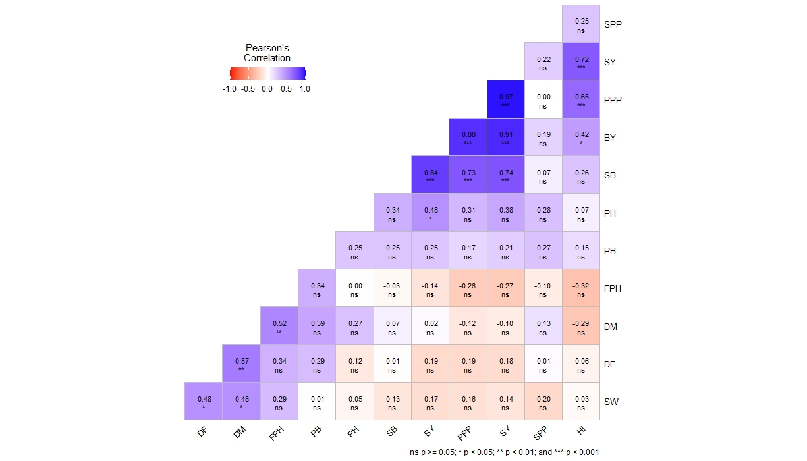

**Fig. 1. Correlation coefficient diagram showing the relationship between twelve characteristics of BIPs families.**

|  |  |
| --- | --- |
|  |  |
|  |  |

**Fig. 2. Highly significant correlation coefficient between seed yield plant-1 and a) biological yield plant-1, b) harvest index, c) number of pods plant-1 and d) number of secondary branches plant-1.**

1. **Path coefficient analysis**

The relationships determined by path analysis among the examined characteristics in the research are shown in **Fig. 3**. The direct effect of attributes on seed yield plant-1 was found to be highest for the number of pods plant-1 followed by biological yield plant-1, number of seeds pod-1 and harvest index. The direct effect of the number of pods plant-1 on seed yield plant-1 has the highest value (0.677) of the statistically significant direct effects. The ratio of the direct effect of seed yield plant-1 on the number of pods plant-1 is 69.93%. In other words, 69.93% of the variation in the number of pods plant-1 comes from the direct effects of seed yield plant-1 on number of pods plant-1. Thus, increases in the number of pods plant-1 raise seed yield plant-1 significantly. The direct effect of the biological yield plant-1 on seed yield plant-1 is positive and statistically significant and the ratio of the direct effect of the biological yield plant-1 on seed yield plant-1 is 17.38%. The direct effect of the number of seeds pod-1 on seed yield plant-1 is positive and statistically significant and the ratio of the direct effect of the number of seeds pod-1 on seed yield plant-1 is 72.09%. The direct effect of the harvest index on seed yield plant-1 is positive and statistically significant and the ratio of the direct effect of the harvest index on seed yield plant-1 is 19.80%. The highest indirect effect of biological yield plant-1, number of secondary branches plant-1, and harvest index through the number of pods plant-1 was found on seed yield plant-1, and their ratios are 65.67%, 66.39%, and 61.64%, respectively. The number of pods plant-1 had the greatest direct impact on seed yield plant-1, followed by biological yield plant-1, number of seeds pod-1, and harvest index. Because the aforementioned traits have the greatest direct influence on seed yield, selecting them may result in a higher yield and similar results were also reported by **Agrawal *et al*., (2018)** and **Manikanteswara *et al*., (2019**). It may be possible to get increases of 66.39% in the number of secondary branches plant-1, 65.67% in biological yield plant-1 and 61.64% in the harvest index by selection studies on the mentioned characteristics in chickpea plants. The highest indirect effect of biological yield plant-1, number of secondary branches plant-1, and harvest index through the number of pods plant-1 was found on seed yield plant-1 and hence these traits may be given more emphasis while selecting high-yielding chickpea genotypes. According to this study, plant breeding efforts cannot rely solely on linear connections between the variables being studied. Their combined efficacy is shown to be statistically significant and these general criteria must serve as the basis for selection.

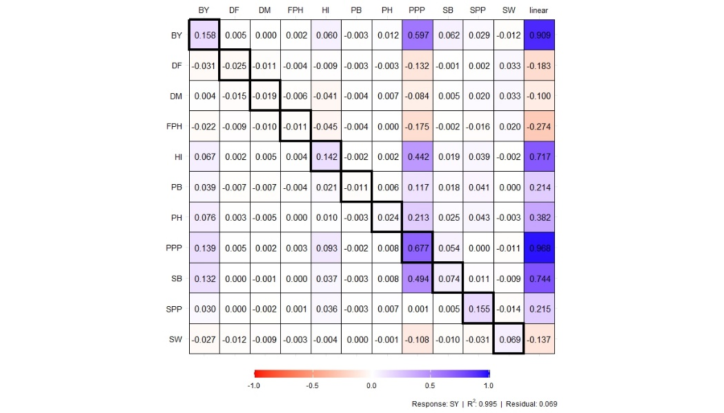

**Fig. 3.** **Path coefficient diagram showing the interrelations of twelve characteristics of BIPs families. Direct (diagonal) and indirect (off-diagonal) effects.**

4. Conclusion

In summary, the current study demonstrated that the breakdown of linkage disequilibrium resulting from biparental mating releases a large range of variability for the number of pods plant-1, biological yield plant-1, harvest index and seed yield plant-1 in progeny. The produced progenies may be used further in various breeding programs based on the information on variance components. Most of the variables such as biological yield plant-1, first pod height, number of pods plant-1 and seed yield plant-1 that contributed to growth and yield, showed significant genetic variability, high heritability, high genetic advance and positive associations, indicating the possibility of more improvement through hybridization or selection followed by selection. According to the aforementioned findings, most of the traits, including seed yield, showed a prevalence of overdominance gene action, linked to heterozygosity that is not fixable. Selection for these traits should therefore be postponed until later generations, when most of the loci become homozygous, as it will not be successful in early segregating generations.

**Disclaimer (Artificial intelligence)**

Author(s) hereby declare that NO generative AI technologies such as Large Language Models (ChatGPT, COPILOT, etc.) and text-to-image generators have been used during the writing or editing of this manuscript.

**ACKNOWLEDGEMENT**

The author is thankful to Govind Ballabh Pant University of Agriculture and Technology, Pantnagar, for providing facilities in conducting the research work.

References

1. Agrawal, T., Kumar, A., Kumar, S., Kumar, A., Kumar, R. R., Kumar, S. & Singh, P. K. (2018). Correlation and Path Coefficient Analysis for Grain Yield and Yield Components in Chickpea (*Cicer arietinum* L.) under Normal and Late Sown Conditions of Bihar, India. *International Journal of Current Microbiology and Applied Sciences*, *7*(2), 2319-7706. <https://doi.org/10.20546/ijcmas.2018.702.197>
2. Ali, S. E. S. (2013). Estimate of some genetic parameters in a cotton cross through North Carolina Design III. *Journal of Plant Production*, *4*(2), 313-317. <https://dx.doi.org/10.21608/jpp.2013.68993>
3. Babbar, A. (2017). Gene action for quantitative traits in chickpea (*Cicer arietinum* L.). *Plant Gene and Trait*, *8*(2). <http://dx.doi.org/10.5376/pgt.2017.08.0002>
4. Begna, T. (2021). Combining ability and heterosis in plant improvement. *Open Journal of Plant Science*, *6*(1), 108-117. <https://doi.org/10.17352/ojps.000043>
5. Chandrakant, C., Ramesh, R., Vaijayanthi, S., Byregowda, P. V., Rao, M. M., Keerthi, A. & Shivakumar, M. S. (2015). Impact of F2 bi-parental on quantitative traits inter-relationships and frequency of transgressive segregants in Dolichos bean (*Lablab purpureus* L.). *Electronic Journal of Plant Breeding*, *6*, 723–728. [*https://ejplantbreeding.org/index.php/EJPB/article/view/203*](https://ejplantbreeding.org/index.php/EJPB/article/view/203)
6. Cobb, J. N., Juma, R. U., Biswas, P. S., Arbelaez, J. D., Rutkoski, J., Atlin, G., Hagen, T., Quinn, M. & Ng, E. H. (2019). Enhancing the rate of genetic gain in public-sector plant breeding programs: lessons from the breeder’s equation. *Theoretical and Applied Genetics*, *132*, 627-645. <https://doi.org/10.1007/s00122-019-03317-0>
7. Comstock, R. E. & Robinson, H. F. (1948 & 1952). Estimation of average dominance of genes: Heterosis (ed. J.W. Gowden). Iowa State College Press, Ames, Iowa.
8. Deshmukh, S. N., Basu, M. S. & Reddy, P. S. (1986). Genetic variability, character association and path coefficients of quantitative traits in Virginia bunch varieties of groundnut. India *Journal of Agricultural Sciences,* *56*, 816-821.
9. FAOSTAT, 2023. <https://www.fao.org/faostat/en/#data> (last access: 27 February 2025).
10. Hill, W. G., Goddard, M. E. & Visscher, P. M. (2008). Data and theory point to mainly additive genetic variance for complex traits. *PLoS Genetics*, *4*(2), e1000008. <https://doi.org/10.1371/journal.pgen.1000008>
11. Kumar, A., Kumar, A., Yadav, A. K., Nath, S., Yadav, J. K. and Kumar, D. (2018). Correlation and path coefficient analysis for various quantitative traits in chickpea (*Cicer arietinum* L.). *Journal of Pharmacognosy and Phytochemistry*, *7*(1S), 2695-2699.
12. Lleras, C. (2005). Path analysis. *Encyclopedia of Social Measurement*, *3*(1), 25-30.
13. Manikanteswara, O., Lavanya, G. R., Ranganatha, Y. H. and Chandu, M. M. S. (2019). Estimation of Genetic Variability, Correlation and Path Analysis for Seed Yield Characters in Chickpea (*Cicer arietinum* L.). *International Journal of Current Microbiology and Applied Sciences*, *8*(3), 2355-2361. <https://doi.org/10.20546/ijcmas.2018.709.101>
14. Mendiburu, F. D. & Yaseen, M. (2020). Agricolae: Statistical procedures for agricultural research. R package version 1.4. 0.
15. Popat, R., Patel, R. & Parmar, D. (2020). Variability: genetic variability analysis for plant breeding research. R package version 0.1. 0.
16. Reddy, T. N. S., Avinashe, H. & Dubey, N. (2018). A Review on Biparental Mating Design. *International Journal of Research and Analytical Reviews*, *5*(4), 726-731.
17. Sharma, D. (2004). North Carolina Design II analysis in Indian rapeseed (*Brassica campestris* L.). *SAARC Journal of Agriculture,* *2*, 175-190.
18. Shipley, B. (2016). *Cause and correlation in biology: A user's guide to path analysis, structural equations and causal inference with R*. Cambridge University Press.
19. Singh, N. & Vashisht, V. K. (2023). Genetic analysis in muskmelon (Cucumis melo L.) subjected to north carolina mating design-III. *Annals of Horticulture*, *16*(1), 80-86. <http://dx.doi.org/10.5958/0976-4623.2023.00013.0>
20. Singh, R. K., Singh, C., Ambika, Chandana, B. S., Mahto, R. K., Patial, R. et al. (2022). Exploring chickpea germplasm diversity for broadening the genetic base utilizing genomic resourses. *Frontiers in Genetics*, *13*, 905771. <https://doi.org/10.3389/fgene.2022.905771>