**The Status of gully erosion, driving factors and management options in Ethiopia: A review**

***Abstract***

*Gully erosion is a severe erosion process that has significant environmental and economic consequences. The aim of this review was to assess the magnitude, determinant factors, and possible management options for gully erosion in Ethiopia. Relevant materials were discovered using search engines such as Google, Google Scholar, Research Gate, Academia, and the most popular journal websites. The search criteria included recent publications in respectable journals (2005-2024). The inclusion and exclusion criteria were developed to fit the study's objectives. The reviewed findings and reports demonstrated that the amount of gully erosion across agro-ecology was expanding at a rapid rate and contributed to large soil losses, affecting agricultural production and productivity and posing socioeconomic and environmental challenges. Land cover, agricultural expansion, population increase, human paths, farming practices, poor land use, overgrazing, steep slope agriculture, area topography, soil type, and climatic conditions have all been cited as contributing reasons to gully erosion. Gully erosion control strategies identified included diverting runoff from gully heads, changing gully morphology, constructing check dams, re-vegetating with locally available planting materials, planting grass, and integrating check dams with grass and re-vegetative planting materials. Following the findings of this review, it was recommended that innovative technological development and promotion of specific agro-ecological gully erosion control strategies be prioritized, as well as community awareness and training on gully erosion prevention measures.*

*Keywords: Check dams; Community; gully erosion; Steep slope; Soil erosion; Watersheds.*

1. **Introduction**

Severe degradation of land, water, forest, rangeland, and wildlife resources that appear to be inextricably linked. This results in significant soil loss, low vegetative cover, unsustainable agricultural methods, ongoing use of dung and crop leftovers for fuel, overgrazing, and wildlife destruction and/or migration, all of which contribute to the degradation of existing resources in a vicious loop [1]. One of the numerous elements that lowers farmland production and ultimately makes the land unsuitable for farming is erosion. Depending on its sources and stages, water-induced erosion can take many different forms. Gully erosion is a serious erosion process with significant environmental and socioeconomic adverse consequences. It can also be disastrous for human lives and livelihoods, similar to land surface hazards such as landslides [2]. Farmers noticed and believed that gully erosion provides to soil erosion and fertility loss, deforestation and vegetation removal, overgrazing, steep slope cultivation, and continuous cropping were all identified as direct human activities that contributed to land degradation [3]. The primary causes of land degradation in Ethiopia's highlands include rapid population increase, severe soil erosion, deforestation, overgrazing, insufficient vegetative cover, inconsistent crop production on steep slopes, erosive rainfall patterns, a lack of fallowing, and insufficient conservation measures [4,5]. Similarly, [1] stated that population pressure, agricultural growth, migration, fast urbanization, resettlement, climate change, and environmental pollution all have an impact on Ethiopia's natural resources. Ethiopia is Africa's second most populated country, with 102 million people with a 2.6% growth rate in 2020 (6).

Land degradation causes the loss of productive soil, reducing the amount of land available for agriculture [5]. The findings indicate that road construction and design issues with soil and water conservation measures were significant drivers of gully formation and development. Over three decades, 22 gullies lost approximately 340,957 tons of soil, resulting in the conversion of approximately 10 ha of productive agricultural area into unproductive land. The yearly rate of gully erosion was 62 ton ha−1 with an average gully density of 16.4 m/ha. Gully erosion leads to a loss of 24 ton year−1 Teff grain yield (Eragrostis teﬀ, E.abyssinica) and 14 t year−1 animal fodders [7]. This has a direct impact on the livelihoods of our farmers in particular, as well as the community as a whole. Gully generates a significant quantity of sediment load. It has been established that large-scale rehabilitation of alluvial gullies can yield >95% sediment reductions in one to two years [8]. Gully treatments utilizing locally available materials, such as grass and check dams, can effectively reduce gull expansion, and demonstrating the technology can significantly increase farmer knowledge and awareness of similar gully management in their area [9]. Thus, the aim of this review was to assess the magnitude, determinant factors and possible management option of gully erosion in Ethiopia.

1. **Materials and Methodology**

The procedure for this review was to identify and synthesize relevant material from peer-reviewed research and review articles, reports, conferences, and book chapters. The relevant materials were discovered using search engines such as Google, Google Scholar, Research Gate, Academia, and the most popular journal websites. More than 105 Portable Document Format (PDF) were downloaded, and pertinent items were reviewed and incorporated into the review. The search criteria include recent publications in respectable journals (2005-2024), as well as studies on land degradation and gully erosion in general, with a concentration on Ethiopia.

The search focused on keywords related to soil erosion and land degradation, as well as erosion stages, extent, and gully erosion treatment remedies. The following keywords were used in the literature search: 'impact of soil erosion, magnitude of soil erosion, land degradation in Ethiopia', 'causes of soil erosion in Ethiopia', 'driving factors of gully erosion', and 'management options of gully erosion in Ethiopia'. Following the literature search, the results from multiple databases were evaluated using the criteria. The literature published previous to 2005 was removed. Duplicate papers were also removed from the review. The inclusion and exclusion criteria were developed to fit the study's objectives, which were primarily concerned with determining the magnitude, causes, and management options for gully erosion in Ethiopia. This review employed both research and report characteristics to determine inclusion and exclusion. In this study, study parameters such as inclusion and exclusion criteria for the study location, the outcome of the finding, and the context were used. Report characteristics include the year of publication and the type of report, which might be full-length research articles, meta-analyses, book chapters, or reports.

1. **Results and Discussion**
   1. **Extent and effect of gully erosion in Ethiopia**

According to the study's findings, gully erosion occurred on the steep slope following land cover change in the 1970s and 1980s, were identified through house hold survey, Arc GIS mapping and direct field measurements, among other anthropogenic influences. Furthermore, the soil physical and chemical characteristics and high slope (gravity) of the area have exacerbated the issues [10]. The area covered by gullies in the watershed grew from 1.84 to 3.43 ha between 2005 and 2013, showing that the proportion of the watershed covered by gullies nearly doubled over the study period. Soil loss from the main watershed and gully catchment was estimated at 6 and 2 t ha−1 year−1 in 2015, and 7 and 9 t ha−1 year−1 in 2016, respectively [11]. The results demonstrate that the long-term gully erosion rate for the watershed was 2.12 t ha-1yr-1, and the total surface area occupied by gullies in the Bora and Banda sub watersheds were approximately 19,328.2 m2 and 6,433.2 m2, respectively. Soil loss was estimated to be more than 36,000 m3 in Bora and 8,700 m3 in Banda sub basins [12]. Furthermore, a study conducted in the Chentale watershed indicated that gully expansion is at a higher rate and contributes significantly to soil loss through soil erosion. Gully erosion has been identified as an important sediment source, accounting for up to 90% of a watershed's total annual sediment yield [11].

Between 1957 and 2016, gully density grew by 5.9 mha−1 in Guder, 5.4 mha−1 in Aba Gerima, and 3.7mha−1 in Dibatie. Over the past 60 years, total gully length in Guder, Aba Gerima, and Dibatie has expanded at a rate of 36.9myr−1, 33.6myr−1, and 17.8myr−1, respectively. The findings revealed that overall gully length and density varied over time within watersheds as well as across the three agro-ecologies [13]. Field measurements and observations revealed that the most significant physical impacts of gully erosion are soil loss (1,080,782.6m3) and biodiversity loss [10]. Furthermore, gully erosion caused physical, social and economic impacts in the area. Field measurement and observation revealed that loss of soil and biodiversity are the major physical impacts of gully erosion. Gully erosion is typically caused or exacerbated by a combination of poor land use and heavy rainfall. Once developed, gullies can continue to produce sediment long after the triggering reasons have subsided [14]. Active gullies reduce agricultural and cultivable soils. Moreover, assessments of gully morphology change from 2009 to 2020 in similar seasons are indicated that significant change was observed at Haru district, Western Ethiopia (Table 1).

Table 1. Change in gully morphology from 2009 to 2020 at Haru district, Western Ethiopia.

|  |  |  |  |  |  |  |  |  |  |  |  |
| --- | --- | --- | --- | --- | --- | --- | --- | --- | --- | --- | --- |
| Location | | | | Gully morphology in October, 2009 | | | | Gully morphology in October, 2020 | | | |
| Name | Lat. | Long. | Elev. | Length (m) | Head cut | 50% gully Length (m) | Lower gully | Length (m) | Head cut | 50% gully Length (m) | Lower gully |
|  | Width (m) | Width (m) | Width (m) |  | Width (m) | Width (m) | Width (m) |
| Loc. 1 | 985650 | 812102 | 1891 | 52.32 | 9.07 | 27.41 | 18 | 103.5 | 7.04 | 45 | 36.4 |
| Loc. 2 | 985896 | 811205 | 1921 | 32.6 | 8.69 | 27.8 | 21.09 | 32.72 | 8.03 | 20.67 | 24.87 |
| Loc. 3 | 988650 | 812567 | 1885 | 88.75 | 15.4 | 41.2 | 13.75 | 111 | 16.7 | 60.74 | 21.34 |
| Loc. 4 | 989755 | 812082 | 1939 | 21.4 | 2.04 | 3.13 | 2.1 | 52.7 | 5.2 | 5.8 | 3.51 |
| Loc. 5 | 992427 | 812796 | 1863 | 90 | 4.92 | 5.38 | 1.48 | 122.38 | 6.94 | 11.89 | 7.06 |
| Loc. 6 |  |  |  | 57.8 | 3.59 | 6.02 | 9.77 | 93.7 | 6.17 | 29.09 | 7.55 |
| Mean |  |  |  | 57.15 | 7.29 | 18.49 | 11.03 | 84.46 | 8.78 | 28.82 | 18.64 |
| Percentage change (2009 to 2020) | | | | | | | | 47.79 | 20.44 | 55.87 | 68.99 |

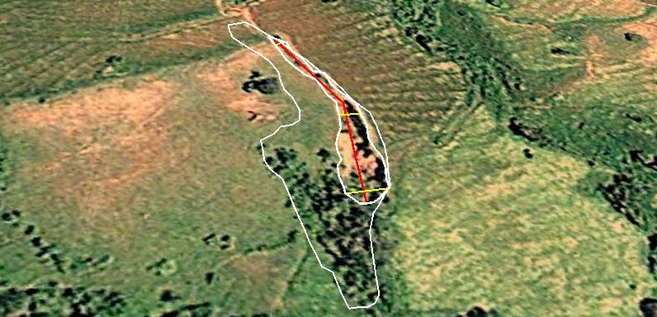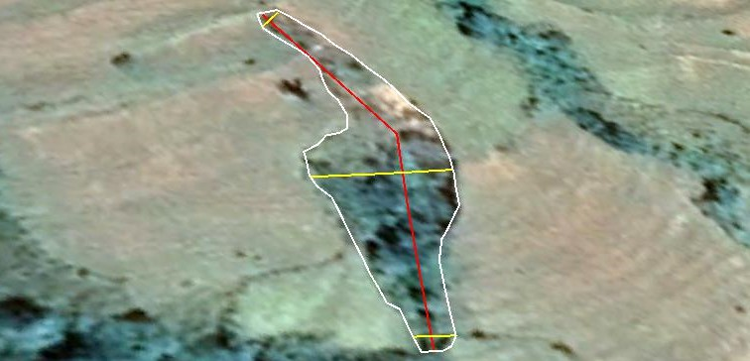Kaki gully shape in 2009 Kaki gully shape 2020

Figure 1. Change in gully morphology from 2009 to 2020 at Kaki kebele, Haru district, Western Ethiopia

Sources (own data)

* 1. **Driving factors of gully erosion in Ethiopia**

Gully erosion is not a process limited to badlands, mountains, and hills, but rather a global and serious cause of land degradation that affects a wide range of soils prone to crusting [14]. Gully formations are caused by a variety of factors. Different elements were shown to be necessary for gully development in the watershed. The maximum forecast accuracy was obtained by taking into account drainage density, elevation, land use, and groundwater. Separate variable importance investigations found that land cover for Nitisols and drainage density for Vertisols were the main predictors of gullies [15]. Based on field observations, the identified causes of gully erosion formation are fault agricultural practices, lack of proper waterway construction, runoff disposed from road side to farmland, releasing runoff from cultivation land to head and side of gully, topography of the area (steep slope & undulating), and lack of appropriate soil and water conservation practices. The findings highlight the urgent need for sustainable land management practices and erosion control measures to mitigate the adverse effects of gully erosion and restore ecosystem resilience [16].

According to [10], the drivers of gully erosion in South-Central Ethiopia were both anthropogenic and natural causes. The major identified driving factors of the area are change of land cover, agricultural land expansion, population growth, nature of the soil, topography of the area, climatic factors such as high intensity of rainfall and frequent drought. The direct human activities which were perceived to be causing land degradation in the study area include: deforestation and clearing of vegetation, overgrazing, steep slope cultivation and continuous cropping [3]. Rainfall, land use distribution and change, slope gradient, and other factors all have a significant impact on the rate of gully development; thus, site-specific assessments are required to properly establish spatiotemporal changes in gully development [13]. Cultivated fields on steep slopes cause significant soil loss, whereas regions with excellent plant cover have low sediment yield. High sediment yield in the watershed is caused by growing population pressure, steep slope farming, and unregulated grazing [4]. Human pathway development and gully occurrence are more likely to be associated in the Ethiopian Highlands [17].

* 1. **Management options of gully erosion**

Gully rehabilitation practices are still limited [18]. Although several solutions for preventing and combating gully erosion have proven to be effective, farmers rarely use them on a long-term and large-scale basis [14]. When a deep or permanent gully forms, inaction has a significant cost, both in terms of local environmental harm and downstream implications. To control existing gullies, both 'hard' and 'soft' engineering techniques are required, such as runoff diversion, gully re-shaping and/or reinforcement, check dam installation, and/or vegetation growth. Their use and failure rates are influenced by two key factors: runoff and sediment characteristics, and gully cross-sectional stability and microclimate. Both are influenced by a variety of external driving elements that can be classified into three categories: geomorphology and topography, climate, and the biophysical environment [19]. Several control strategies, such as re-vegetation, improved farming techniques, drainage management, efficient land use management, and early reaction, are advised to mitigate the erosion problem. The findings emphasize the necessity for coordinated land use planning and sustainable development solutions to successfully manage the erosion problem [20]

Low-cost measures such as grass planting and grass with check dam prevented significant gully head extension, but untreated gullies had an average upward expansion of 671 cm, resulting in a calculated soil loss of 11.0 ton. Farmers viewed all gully repair measures positively. Ongoing restoration programs and on-farm trials influenced survey respondents' awareness and understanding of comparable gully solutions [9]. Most of the farmers perceived the presence of soil erosion problem and its consequences and believed that it can be controlled [21]. Thus, there are encouraging conditions for rehabilitating the gullied area to ensure long-term ecosystem services in the watersheds. These hopeful conditions include the availability of a large labor force, access to transportation, civic societies focused on natural resource conservation, and the country's green economy development policy [10].

Promising results of gully rehabilitation with local available materials were observed at Gibe kabala watershed, Southwestern Ethiopia, Which needs scaling up of the best practices to the surrounding districts and similar agro ecologies of the country (22).

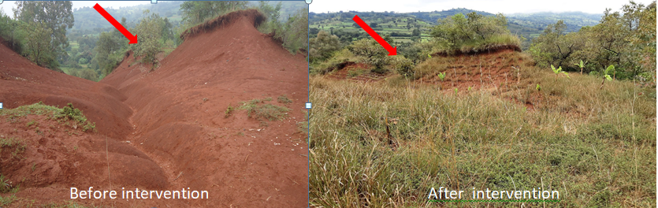

Figure 2. Gully rehabilitation with local available materials at Gibe kabala watershed, Southwestern Ethiopia.

* 1. **Future directions of gully erosion management in Ethiopia**

The worst stage of soil erosion, known as gully erosion, has a substantial impact on social, biological, and physical aspects. Early on, farmers were unaware of the impact of soil erosion, and when it progressed to gully erosion, the cost of remediation was too high for them. In order to raise knowledge of the effects, contributing factors and management alternatives of gully erosion in the country, it needs multidisciplinary team and holistic approach to act on it.

Adoption and promotion of climate-smart farming techniques, such as conservation tillage, no/zero tillage, agroforestry, and suitable water and soil conservation to reduce soil erosion processes. Additionally, to slow down the onset and progression of gully erosion, suitable land use, waterways (drainage lines), and designed or managed seasonal and all-weather roads should be promoted and used particular in rural areas.

Working on prevention by raising community knowledge is the safest and simplest way to control gully erosion. By concentrating on locally accessible materials for gully restoration, research institutes and higher education should endeavor to create and promote cutting-edge technologies that are socially, economically, and environmentally friendly.

1. **Conclusion and recommendations**

Soil erosion is a major issue that degrades our land resources biologically, physically, and chemically, affecting production, productivity, and biodiversity. Soil erosion caused by water has taken several forms, with the worst stage, gully erosion, causing socioeconomic and environmental challenges, particularly in highland areas and throughout the country. According to the reviewed findings, the rate of gully erosion is increasing periodically throughout the agro-ecology. Some of the factors that have been identified as contributing to this issue include changes in land cover, agricultural expansion, population growth, human pathways, farming systems, improper land use, overgrazing, steep slope cultivation, and topography of the area, soil type, and climatic factors. Options for management include diverting runoff from gully heads, modifying gully morphology, building check dams, re-vegetating with locally accessible planting materials, planting grass, and integrating check dams with grass and re-vegetative planting materials. Based on the above results, innovative technology development and promotion of specific agro-ecological gully erosion control techniques should be prioritized, along with raising awareness and training the community about gully erosion preventive measures.

**Disclaimer (Artificial intelligence)**

Author(s) hereby declare that NO generative AI technologies such as Large Language Models (ChatGPT, COPILOT, etc.) and text-to-image generators have been used during the writing or editing of this manuscript**.**

1. **References**
2. Wassie, S. B. (2020). Natural resource degradation tendencies in Ethiopia: a review. *Environmental systems research*, *9*(1), 1-29.
3. Majhi, A. (2022). Gully Erosion: An Underestimated Hazard?.
4. Saguye, T. S. (2017). Analysis of farmers perception on the impact of land degradation hazard on agricultural land productivity in Jeldu district in West Shewa Zone, Oromia, Ethiopia. *Journal of Agricultural Extension and Rural Development*, *9*(6), 111-123.
5. Dibaba, W. T., & Ebsa, D. G. (2022). Identifying erosion hot spot areas and evaluation of best management practices in the toba watershed, Ethiopia. *Water Conservation and Management*, *6*(1), 30-38.
6. Tadesse, A., & Hailu, W. (2024). Causes and consequences of land degradation in Ethiopia: A Review. *International Journal*, *10*(1), 10-21.
7. WHO of Ethiopia, Annual Report of 2022, [www.afro.who.int](http://www.afro.who.int).
8. Yazie, T., Mekonnen, M., & Derebe, A. (2021). Gully erosion and its impacts on soil loss and crop yield in three decades, northwest Ethiopia. *Modeling Earth Systems and Environment*, *7*(4), 2491-2500
9. Brooks, A. P., Daley, J., Spencer, J., Stout, J., Curwen, G., Pietsch, T., & Doriean, N. Target the right gullies using the right approach to achieve the GBR Water Quality Targets. In *WELCOME TO THE 10TH AUSTRALIAN STREAM MANAGEMENT CONFERENCE* (p. 506).
10. Mekuria, W., Phimister, E., Yakob, G., Tegegne, D., Moges, A., Tesfaye, Y., ... & Smith, J. U. (2024). Gully rehabilitation in southern Ethiopia–value and impacts for farmers. *Soil*, *10*(2), 637-654.
11. Hassen, G., & Bantider, A. (2020). Assessment of drivers and dynamics of gully erosion in case of Tabota Koromo and Koromo Danshe watersheds, South Central Ethiopia. *Geoenvironmental Disasters*, *7*(1), 5.
12. Bogale, A., Aynalem, D., Adem, A., Mekuria, W., & Tilahun, S. (2020). Spatial and temporal variability of soil loss in gully erosion in upper Blue Nile basin, Ethiopia. *Applied Water Science*, *10*(5), 1-8.
13. Osore, A., & Moges, A. (2014). Extent of gully erosion and farmer’s perception of soil erosion in Alalicha Watershed, Southern Ethiopia. *J. Environ. Earth Sci*, *4*, 74-81.
14. Yibeltal, M., Tsunekawa, A., Haregeweyn, N., Adgo, E., Meshesha, D. T., Aklog, D., ... & Liyew, M. (2019). Analysis of long-term gully dynamics in different agro-ecology settings. *Catena*, *179*, 160-174.
15. Valentin, C., Poesen, J., & Li, Y. (2005). Gully erosion: Impacts, factors and control. *Catena*, *63*(2-3), 132-153.
16. Amare, S.; Langendoen, E.; Keesstra, S.; Ploeg, M.v.d.; Gelagay, H.; Lemma, H.; Zee, S.E.A.T.M.v.d. (2021) Susceptibility to Gully Erosion: Applying Random Forest (RF) and Frequency Ratio (FR) Approaches to a Small Catchment in Ethiopia. Water **2021**, 13, 216. https://doi.org/ 10.3390/w13020216
17. Bitikoro P. J. (2024). Effect of Gully Erosion on the Environment. RESEARCH
18. Nir N, Knitter D, Hardt J, Schu¨tt B (2021) Human movement and gully erosion: Investigating feedback mechanisms using Frequency Ratio and Least Cost Path analysis in Tigray, Ethiopia. PLoS ONE 16(2): e0245248. <https://doi.org/10.1371/> journal.pone.0245248.
19. Belayneh, M., Yirgu, T., & Tsegaye, D. (2020). Current extent, temporal trends, and rates of gully erosion in the Gumara watershed, Northwestern Ethiopia. *Global Ecology and Conservation*, *24*, e01255.
20. Frankl, A., Nyssen, J., Vanmaercke, M., & Poesen, J. (2021). Gully prevention and control: Techniques, failures and effectiveness. *Earth Surface Processes and Landforms*, *46*(1), 220-238.
21. *Egbuna, O. K., Unachukwu, S. S., Alom, A. (2024) Gully Erosion Assessment and Management in Anambra State Nigeria*. Volume 7 Issue 12 | ISSN: 2456-8880IRE 1705987 Iconic Research And Engineering Journals.
22. Alemu, M.D., Kebede, A. and Moges, A. (2019) Farmers’ Perception of Soil Erosion and Adoption of Soil Conservation Technologies at Geshy Sub-Catchment, Gojeb River Catchment, Ethiopia. Agricultural Sciences, 10, 46-65. <https://doi.org/10.4236/as.2019.101005>.
23. Technical report of EIAR-Climate Action through Landscape management (CLAM) program. Annual Progress Report of 2022. ISBN:978-99944-3-846-4, <http://www.eiar.gov.et>, December 2022.