**Assessment of Indigenous Knowledge associated with Identification of germplasm, Production, Utilization and Conservation of Anchote [*Coccinia abyssinica*(Lam.) Cogn.] in Western and South Western Ethiopia**

**ABSTRACT**

**Aim**: Anchote is an underutilized indigenous root crop in Ethiopia but potentially produced as a food, socio-economic, cultural and medicinal crop in western and south western parts of Ethiopia. The study was conducted by using an ethno-botanical survey to assess and document the indigenous knowledge on germplasm identification, utilization and conservation of anchote on 200 household respondents using both quantitative and qualitative methods. **Study area and duration**: The survey was conducted in seven western and southwestern districts of Ethiopia in 2020 for three consecutive months. **Results**: From the assessments, most of the respondents had sufficient experiences and knowledge on producing and utilizing anchote. Socio-economic status of the households was found to be an important factor affecting the use, management and conservation while the difference in level of education had no impact. Anchote producers, mainly women households, identify the white and red fleshed genotypes by the color and size of their leaves; light green and lager leaf as white fleshed and deep green and/or medium sized leaf as red root fleshed anchote. It is produced as a sole crop in western areas (87.1%), but intercrop with maize (94.1%) at south western parts. The solely responsible for anchote conservation were women (99 %) especially elders and about 1 % were youth who use anchote as cash crop for their personal expenses of education and consumables. Majority of the producers (86%) use the root as main consumable part and plant it every year (81%); for food (98%), income source (87.5%), medicinal (97%) and cultural (97.5%) crop, respectively, and for animal fattening and feed dairy cows mainly as a calcium source (14%). Even though it is a highly valued cultural and medicinal crop, 74.1% of the respondents consume it as food more than once a week mainly during harvest seasons. Women conserve anchote seeds for the next planting period by treating with ash and store it in a closed container. The best roots are selected while harvesting depending on flesh colors and planted in a hole to serve as a seed source for seven to fifteen years at backyard, locally called ‘*Baachoo/ Guboo*’. **Conclusion**: The indigenous knowledge exhibited in this study on germplasm identification, production, conservation and utilization could be a significant step in bringing this underutilized root crop to the broader science arena.

**Key words**: Anchote, Baachoo/Guboo, Conservation, Germplasm Identification, Indigenous Knowledge, Utilization,

1. **INTRODUCTION**

Anchote ((*Coccinia abyssinica***(Lam.) Cogn.))**  is an Ethiopian species of *Coccinia,*a tuberous root crop belongs to the order *Cucurbitales,* family *Cucurbitaceae* (Abera, 1995)and was first described by Jean-Baptiste Lamarck, a French biologist and academician. The genus *Coccinia* includes about 30 species, of which 8 occur in Ethiopia (PGRC, 1995). *Coccinia abyssinica* is the only species cultivated for its edible tuberous roots and leaves (Desta *et al*., 2011). It is specifically widely cultivated and used in Jimma, Illu- Abba Bora and Wollega areas of the Oromia Regional State even though cultivated in different vernacular names in other parts of Ethiopia as *Shushe, Ushushe* (Dawuro), Anchote (Oromo), *Ajjo*(Kaffa), *Wouchich* (Tigray), and *Ususe*(Wolaita) (Schweinfurth,1867, 1048; Abera, 1995; Amare, 1973; Fufa and Urga,1997 and W. Kuls, 681). Among the native root and tuber crops to Ethiopia, anchote is believed to have enormous genetic diversity as it is indigenous and long-stayed in western and south western parts of Ethiopia produced and conserved mainly by women farmers (Girma and Hailu, 2007; Desta *et al*., 2017).

As the major food security challenges in Ethiopia are population growth, nutrient deficiencies, diseases, environmental degradation, drought and climatic change (Abdela *et al*., 2017), anchote is used as a subsistence crop commonly produced to fill food and nutritional gaps during the hunger months, June to September (Girma and Dereje, 2015). In addition to its nutritional and medicinal values, anchote has economic and socio-cultural importance. The production of anchote has strong cultural ties with Oromo as cultural food during the findings of true cross; *Meskel Festival*, for lactating mothers, elderly and during birth giving of women as the main calcium source for bone and joint strength. Anchote dish, owing to its contribution to good health is getting popular and demand is increasing. Due to its attachment to customs and tradition of the people in the region, the revival in the society is affecting and will continue to influence anchote culture (Habtamu, 2011). It is mainly grown for its storage root yield and leaf also used as a vegetable among the growers. As a food, it is a rich source of carbohydrate, vitamins, minerals, protein and calcium as compared to other root crops (Amsalu *et al*., 2008; Habtamu, 2011).

Anchote adapted well to south and south western parts of the country between 1300 to 2800 m above sea level, prefers soil pH of 4.5 to 7.5, mean minimum and maximum temperature (oC ) of 12 and 28 and rain fall ranging from 800 to 1200 mm/year (Amare, 1973; BARC, 2004; Desta *et al*., 2011). In average every farmer in Western Wollega usually allocate 400 to 600 square meters of land for anchote production primarily for home consumption income generation, rural employment, securing food and nutritional access (Abera,1995; Mengesha *et al.* 2012; Desta *et al*., 2021). Its productivity may varies based on genotypes, soil fertility level, location and cultural practices and ranges 20 - 30 tha-1 (Abera, 1995; BARC, 2004). However, under research condition it has a potential to yield up to 73 tha-1 (Desta *et al*., 2011) and 76.45 tha-1 (Mengesha *et al*., 2012). The national average total yield of anchote is 15-18 tha-1, which is in the range of total yield of sweet potato and potato (IAR, 1986). Habitually, its storage root is served as a side dish with cereals as; ‘*kitifo’,’lanqaxaa’*(finely grounded tuberous root), ‘wot’, soup, and ’*murmura*’(boiled tuber cut in pieces). Similarly, the leaf also primed and served as a side dish with bread or ‘*injera*’ (Abera, 1995). Moreover, traditional practitioners use anchote to treat different type of diseases such as diabetes, gonorrhea, tuberculosis, asthma and cholesterol lowering (Amare, 1973).

Indigenous knowledge (IK) refers to ideas, beliefs, values, norms, and rituals, which are native and embedded in the minds of people and unique to a given culture or society acquired by local people through the accumulation of experiences, informal experiments and intimate understanding of the environment in a given culture (Warren, 1995; Warren and Rajasekaran, 1993). Local people, including farmers are the guardians of IK systems as they are knowledgeable about their own situations, resources, what works and what doesn’t work, and how one change impacts other parts of their system (Reinhard *et al*., 2004). For centuries, farmers have planned agricultural production and conserved natural resources by adopting indigenous knowledge as management of natural environment, has been a matter of survival to the people who generated indigenous knowledge (Akullo *et al*., 2007). Increased anchote production, small-scale producers’ market participation and its multi-dimensional uses got a policy attention as a means of poverty reduction and food and nutritional security enhancements in Ethiopia, it will get research and development attention in production and wider utilization. The study was conducted to assess and document the indigenous knowledge available on germplasm identification, production, conservation and utilization of anchote at selected major producing areas of Ethiopia.

1. **MATERIALS AND METHODS**
   1. **Description of the study area**

This study was conducted in western and southwestern districts of Ethiopia with population sizes; West Wollega (1,987,182), East Wollega (1,806,001), Kellem Wollega (1,166,694), Horro Guduru Wollega (9840,709), Iluababor (1,861,919), Buno Bedelle (815,437), and Jimma zone (3,568,782) of Oromia Regional State (CSA, 2013 projection for 2017) (Figure 1 and 2). According to Desta *et al.*, (2022) the study areas encompass 396 m a.s.l to 3300 m a.s.l with the average altitude of 1590 m a.s.l though most producing areas lie to 2200 m a.s.l, receive precipitation from zero to 415 mm where rain starts in March and April where higher rains received in June (75-344), July (64-415), August (75-404), and September (88-315); the minimum, average and maximum temperatures(oC) are 5, 15 and 35, respectively; and acidic soil prone areas with moderately(5.6-6.5) to strongly(4.1- 5.5) acidic with the CEC values of low(11) to high(68).

* 1. **Methodology**

The study areas were selected in consultation with Agricultural Development offices of each Zones considering potential of the districts in anchote production, utilization and conservation. The respondents were selected based on the information obtained from Development Agents (DA’s) and other knowledgeable local farmers through the study tour. In each district, woreda agricultural experts, kebele managers and agricultural experts working in each kebele assisted the researcher in creating the list of farmers growing anchote and in facilitating the structured open-ended questionnaire interviews. The informants were selected randomly and interviewed out of 400 farmers, key informants and knowledgeable persons of the society based on their willingness and practical knowledge on production and use through repeated questioning to make the information reliable that describes an existing phenomenon on anchote. The sample size was determined using a formula, S=X2 NP(1-P)/d2(N-1)+X2P(1-P), where S- Sample size, x=1.96, P- Population portion(assume 50%), N- estimated population, d- degree of accuracy(usually 0.05).

Data were collected in 2020 for continuous three months; February, March and April on 200 respondents in western and southwestern parts of Ethiopia, 40 woredas and 127 kebeles, using questionnaire prepared in English and translated to ‘*Afan Oromo*’, Oromo people’s language, using both quantitative and qualitative methods. Each interviewee has been introduced to the purpose and subject of the study and covered different topics such as information about the study area, landholding capacity per household, anchote growing practices and its land share and specific information on the utilization, production, conservation and germplasm preference and identification of anchote. Climatic conditions of the study area include all topographies; lowland, mid-land and highland, agro-ecological zones; from arid to humid (396-3300 m a.s.l), and the minimum and maximum annual temperatures (oC) of the study areas were 12and 35 respectively, with mean annual rainfall ranges from 800 to 2000 mm.

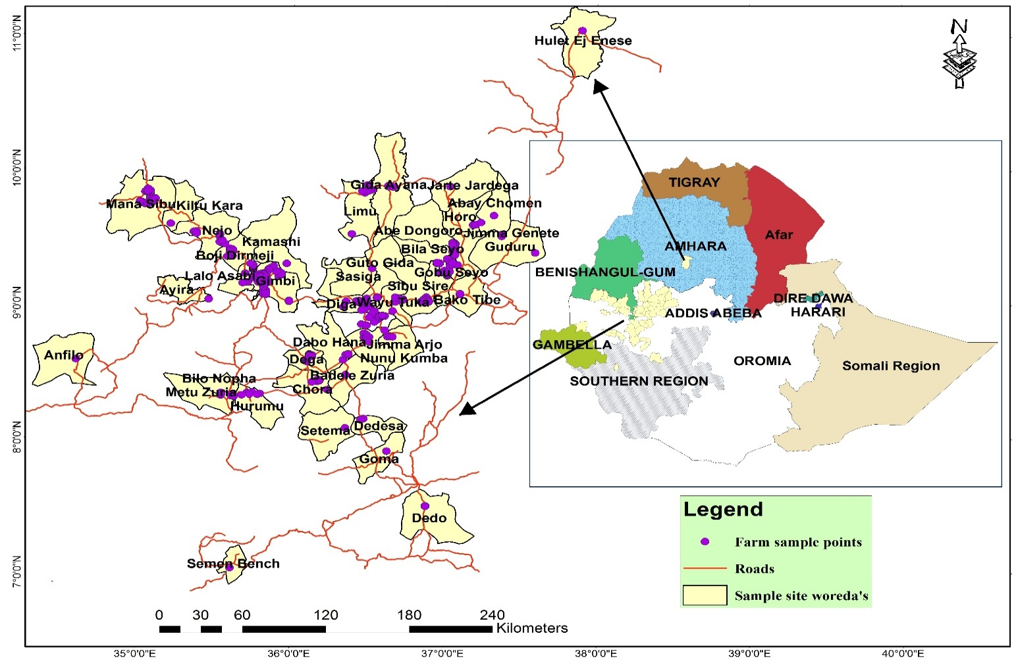

Figure 1. The seven zones growing anchote in which the indigenous knowledge study conducted

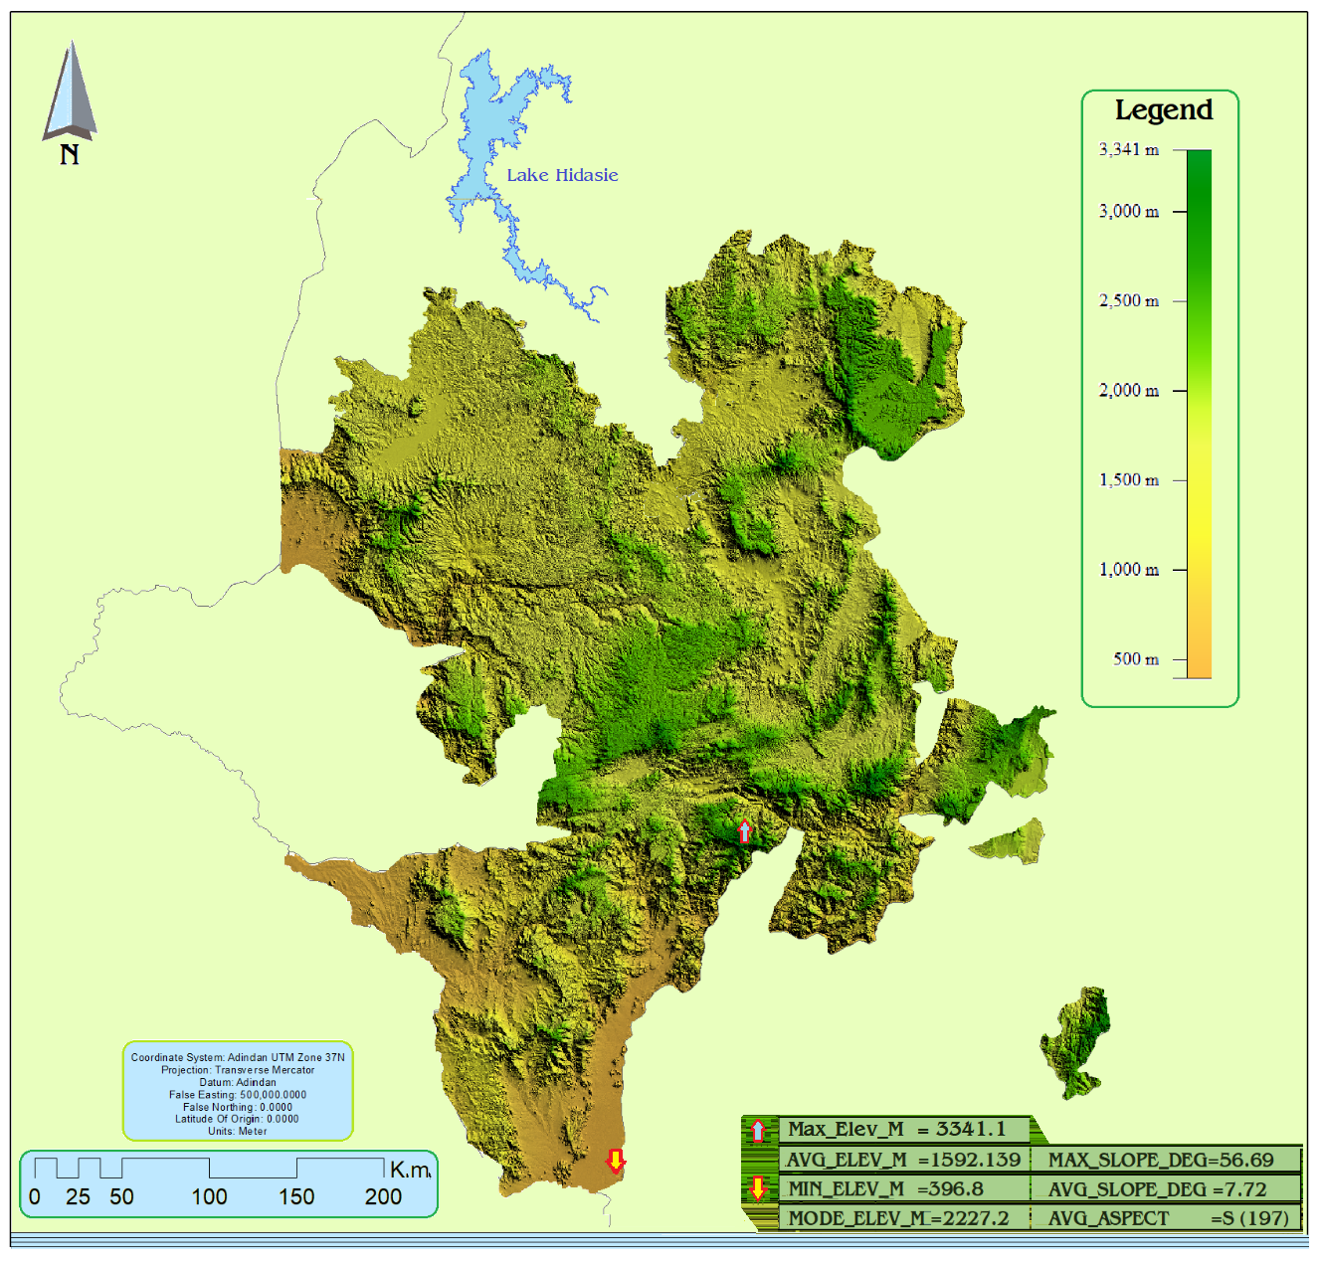

Figure 2. Agroecological zones(*left)* and topography (*right*) of major anchote producing and the study areas

The detailed information was focused on cultural practices, cultivation types and growing frequencies, seed production and sources, agricultural inputs, the parts and types of food prepared, and traditional use values of anchote. The respondents were also asked about the storage and associated problems, conservation practices, the local cultivars with their typical characteristics such as date and method of planting, maturity days, shelf life, taste, market price, crop rotation, production per hectare, response to disease and insect pest, land holding size per household, seasons of production, and production status (from Zonal Agri. Offices). Conservation practices, cultivar selection, food preparation and seed preparation were a gender-specific questions, mainly women farmers. The respondents were also asked whether there is extension system applied to production, conservation and utilization of anchote to magnify its role in attaining food and nutritional security of the households.

* 1. **Data analysis**

The quality of the data was ensured through careful coding and verification and analyzed using IBM SPSS software 26.0, presented using descriptive statistics and percentage.

1. **RESULTS AND DISCUSSION**
   1. **Production coverage and productivity**

The survey was aimed to study the indigenous knowledge of the society on germplasm identification, production, utilization and conservation of anchote in the study area. West Wollega was the main producing zone under rainfed condition though East Wollega has better productivity than the other major producing zones. Anchote is under cultivation in both rainfed and irrigation conditions where under rainfed condition western Wollega is the higher cultivator (1170.5 ha) followed by eastern Wollega (1096 ha) and Iluababor(725 ha)zones, whereas lower cultivars are Buno Bedelle(542), Kellem Wollega(378.5 ha), and Horro Guduru Wollega(173 ha). Under irrigation conditions, east Wollega is leading with 2915 ha followed by Kellem Wollega (278 ha) and Horro Guduru Wollega (165 ha). The productivity(qha-1) of east Wollega, west Wollega, Kellem Wollega, Horro Guduru Wollega, Iluababor, and Buno Bedelle was 88,60,71,55,60, and 50. The anchote production under irrigation conditions at the major producing areas portrays the higher value and year-round demand of the crop among the producers and the market. Even though, there is anchote cultivation in Jimma zone, due to the absence of attention from the agricultural development offices of the zone and woredas, data of the production and productivity status was not recorded and available at the study period. In addition, due to the lack of extension service from zonal and woreda agricultural offices of the respective study areas, data on area coverage under irrigation was scanty, though almost comparable with the production under rainfed condition (Table 1).

Table 1. Anchote area coverage and productivity in the study zones

|  |  |  |  |
| --- | --- | --- | --- |
| **Administrative Zones** | **Area coverage(ha)** | | **Productivity(q/ha)** |
|  | **Rainfed** | **Irrigation** |  |
| East Wollega | 1096 | 2915 | 88 |
| West Wollega | 1170.5 | NA | 60 |
| Kellem Wollega | 378.5 | 278 | 71 |
| Horro Guduru Wollega | 173 | 165 | 55 |
| Iluababor | 725 | NA | 60 |
| Buno Bedelle | 542 | NA | 50 |
| Jimma | NA | NA | NA |
| **Total** | **4085** | **3358** |  |

*NA- data not available primarily due to the absence and/or little attention paid from the agricultural development on anchote*

* 1. **History and sampled population size**

The sampled and interviewed households and key informants vary considerably in resourcefulness, knowledge and geographical factors. A total of 200 respondents were interviewed, out of which 90 (45%) and 110 (55%) were men and women farmers, respectively and all were farmers including the key informants (more knowledgeable and elderly) (Table 2).

Table 2. Study zones and number of respondents

|  |  |  |
| --- | --- | --- |
| Study Zone | Number | Percent |
| East Wollega | 30 | 15 |
| West Wollega | 50 | 25 |
| Buno Bedele | 20 | 10 |
| Illubabor | 20 | 10 |
| Horro Guduru Wollega | 30 | 15 |
| Kellem Wollega | 50 | 25 |
| Total | 200 | 100 |
| Male | 110 | 0.55 |
| Female | 90 | 0.44 |

Most of the respondents (60%) have involved in cultivation of anchote for more than 30 years and above and 40% were cultivating for more than 15 years. Most of the growers (81%) plant anchote every year regularly and 19% of them produce occasionally. According to the respondents, the principal purpose of growing anchote is for its roots (86%), roots and leaves (7.5%), and all parts; roots, leaves and fruits (6.5%). Those who are interested in producing all parts are the elderly and women; mainly for conserving the seeds for next planting, for income generation, and conservation of the crop (Figure 3).

Figure 3. Interest of farmers producing anchote for its different parts (leaves, roots and root and leaves)

The average land holding capacity per household was 1.22 hectares; with minimum (0.25 ha) and maximum (5 ha) of which 0.5 ha is left for grazing and barn area. Even though land shortage limits the types of crops to grow and land allocation to each crop, all the farmers growing anchote did not see it as a major challenge as anchote is mainly grown at backyards on small area of plot and under the fence along the line for stalking purposes. Anchote growers prefer to plant at the vicinity of their homes as wild animals such as porcupine severely attack the plant starting from root formation to the maturity and could cause significant yield damage.

Among the major crops growing in the study areas, anchote was the fifth (11.5%) major crop grown under rainfed conditions of the main production season, after maize (20%), tef (15%), wheat (14%), and sorghum (11.5%). Barely (9%) and other root and tuber crops (9%) production comes after anchote. Under irrigation condition, anchote was the major crop grown (28%) as compared to potato (21.5%) and other vegetable crops due to its higher demand by the consumers and with better market value for the growers (Figure 4).

Figure 4. Major crops growing in the study areas and the anchote with other vegetable crops under irrigation production during dry seasons

Even though anchote is preferably produced by most of the growing respondents, all of them were considered and categorized as a minor and underutilized crop by many respondents but very important crop mainly due to the lack of attention from the agricultural development and extension services of the government and other development organizations. Among most anchote producers, the primary purposes for which they produce were for food (98%), income generation (87.5%), medicinal (97%), cultural aspects (97.5%), and for animal fattening and treating lactating cows with hypocalcemia (14%). In general, anchote is produced mainly (95%) for food, income generation by women and younger generations, medicinal (for treating fractured bones and displaced joints, as protein and calcium source for lactating mothers, elderly, children, for treating diarrhea, diabetes, tuberculosis, tumor cancer), and cultural aspects especially during holidays (‘*Meskel*’), wedding and other religious and cultural events. The discrepancies from the primary purposes of production were the share of younger generations and few elderly respondents of which most of them produce solely for income generation from its roots and the seed (Figure 5). The results of this study agree with results of Masarat (2018) on three zones (Kellem, West and East Wollega) of 6 districts on 72 respondents and with Abera (1995). The indigenous knowledge of the respondents on using anchote as calcium source; for treating fractures bones and displaced joints, lactating mothers, elderly, children, lactating cows with hypocalcemia and for treating diarrhea agrees with the findings of Desta *et al*., (2021) as anchote contains 416.15mg/100g and Protein (11.81%), whereas its Zinc(5.74mg/100g) and Manganese(0.95mg/100g) which are responsible for treating diarrhea.

Figure 5. Purposes of anchote production among the growers in the study areas for food, income generation, forage (animal fattening and treating hypocalcemia), medicinal and cultural heritage values

The price of anchote seed is one of the most expensive than all cereals and other vegetable crops at the study areas, where one cup (*birchiko*) of anchote seed differs from place to place across the study areas and ranged from 48 to 105 birr with average of 71.50 birr. The higher demand for anchote seed by the growers, the smaller number of seed producers; elderly and women, and the rush to sale the roots as soon as it matures are the reasons behind for the higher seed price. The seed rate to plant on 200 m2 of land at backyard; which is the average land area allocated for anchote per household at the study areas, was 4 to 90 grams with the average of 41.7 grams of seed. The respondents reported that they harvest 0-40 cups(*sini*) of seed and the average was 7.75 cups from their produce per season.

Anchote growers barely use artificial fertilizers at most of the areas but about 5% of the respondents, mainly those produce as an income source, the younger generation, use up to 200kgha-1 Urea and DAP fertilizer with an average of 51.9 kg/ha. The average root yield per hectare of the study areas was 160.3 quintal which agrees with the results of Girma and Dereje (2015), Masarat (2018), and Yeshitila and Temesgen (2015). The average root conveyed for sale each harvest season was 472.5 kg.

The respondents’ preference for the white and red fleshed anchote root was quit boldly differentiated where 92.5% prefer white fleshed anchote for food and to produce, 10% red fleshed, and 2.5% prefer both types (Figure 6). The results of this study agree with Negasa *et al*., (2020). In contrary, when asked for medicinal and animal feed (fattening and hypocalcemia treatment) purpose, 90% of the respondents prefer red fleshed over the white fleshed one. The segregation in root flesh color could ignite the industrial use of anchote and the present result agrees with Adugna *et al*., (2021).

Figure 6. Respondents’ preference of anchote root flesh for food purpose

Across all the study areas, the indigenous knowledge in identifying the germplasms of the two major root flesh colors; white and red was quite similar. All respondents identify the white and red fleshed colored cultivars by the size of their leaf, root shape, root size, and maturity (Table 3).

Table 3. Germplasm identification among the anchote producers in the major producing areas

|  |  |  |
| --- | --- | --- |
| **Traits** | **Root flesh color** | |
|  | **White** | **Red** |
| Leaf size | large | Small, medium |
| Root shape | round | Longitudinal |
| Root size | Larger | Small, Medium |
| Cookability | Easier | Takes longer time/difficult |
| Drought resistance/tolerance | Medium | Resistant/tolerant |
| Maturity | Early | Late |
| Insect resistance/tolerance | Medium | Resistant/tolerant |
| Market demand | High | Medium to high* |

\**red fleshed anchote’s root demand depends on the purpose it intends; for medicinal and animal feed, its demand is higher*

Women farmers conserve anchote in seed and mother plant, called ‘*Baachoo/Guboo*’ and this is a reason why anchote is called crop of women, mainly due to their unreplaceable role in conserving and protecting the production and utilization of anchote for centuries as sole responsible practitioners. The seeds are extracted from matured fruits (yellow to red) washed thoroughly, treated with ash and let to dry. After drying under shade, it will be kept in closed container for the next growing season though it could stay up to two years. The mother plants are planted from selected roots while harvesting depending on root flesh color; preferably white, and planted in a hole for seed production purpose only and could serve as a seed source for seven to fifteen years.

1. **CONCLUSION AND RECOMMENDATION**

Among the major root and tuber crops, anchote is a potential crop produced in western and south western parts of Ethiopia with scanty information and attention from research and development. The indigenous knowledge of the producers at the major producing areas have retained its production, utilization, and conservation for many years back from its domestication as a valuable crop. In addition to its potential as a food and nutritional security crop, its socioeconomic, cultural and medicinal values for the farming communities is far reaching. Germplasm identification methods of the farmers accurately concedes with scientific findings reported so far. The indigenous knowledge and traditional farming system of the farmers that contributed for the present results need to be developed for future research inputs and developments in anchote diversity studies, production, utilization and conservation. Moreover, farmers of anchote should be supported to retain their indigenous knowledge on anchote utilization and conservation through on farm trainings and extension services.

Policy makers, development organizations and researchers should give attention to;

* Strengthening extension services to enhance the production and productivity of anchote farmers in the study area in order to improve their livelihood through improving their food and nutritional security, income generation and preserving the conservation practices they follow on anchote without any scientific information on the crop at the study areas.
* Government intervention needed to improve the marketing infrastructures for improved linkages and fair participations.
* Policy issues targeted on extension systems on preserving the indigenous knowledge of the farmers and the women role at study areas and linking to science and technology for improved production, utilization and conservation of anchote through research and development.

**DISCLAIMER (Artificial intelligence)**

Authors hereby declare that NO generative AI technologies such as Large Language Models (ChatGPT, COPILOT, etc.) and text-to-image generators have been used during the writing or editing of this manuscript.

1. **REFERENCES**

1 Warren, D. Michael, L. Jan Slikkerveer, & David B., (eds.) (1995). The Cultural Dimension of Development: Indigenous Knowledge Systems. London: Intermediate Technology.

2. Warren, D.M. and Rajasekaran, B. (1993). Putting local knowledge to good use. International Agricultural Development, 13 (4), 8-10.

3. Akullo D., Rogers K., Pauline B., Winnie A., Lucy A., and Margaret B. (2007). Indigenous Knowledge in Agriculture: A case study of the challenges in sharing knowledge of past generations in a globalized context in Uganda. World Library and Information Congress: 73rd Ifla General Conference and Council 19-23 August 2007, Durban, South Africa.

4. Desta F., Sentayehu A., Kebebew A., and Mandefro N. (2022). Characterization of Major Anchote [*Coccinia abyssinica* (Lam.) Cogn.] Producing Areas of Ethiopia.. 2nd International Conference and Buyers Sellers Meet for Medicinal Plants Used in Lifestyle Products, June 28-30,2022, Kolkata, India.

5. Abera, H. (1995). Anchote: An Endemic Tuber Crop. Jimma College of Agriculture. Jimma, Oromia, Ethiopia.

6. Plant Genetic Resource Center (PGRC / E). (1995). Plant genetic resources conservation.

7. Schweinfurth G. A., (1867). Beitrag zur Flora Aethiopiens. Georg Reimer, Berlin, Germany, 311.

8. Amare G. (1973). Developmental Anatomy of “tuber”s of Anchote: A potential Dry land Crop. In: Acta Horticulturae, Technical Communication of ISHS, 51–63.

9. Fufa H, Urga K . (1997). Nutritional and anti-nutritional characteristics of anchote (*Coccinia abyssinica*). Ethiop. J. Health Dev, 11(2), 163 -168.

10. Girma A and Hailu G. (2007). Response of Anchote (*Coccinia abyssinica*) to Organic and Inorganic Fertilizers Rates and Plant Population Density in Western Oromia, Ethiopia. East African Journal of Sciences, 1(2),120–126.

11. Desta F., Derbew B., and Amsalu A. (2017). Genetic Diversity and Traits Inheritance in Anchote [*Coccinia abyssinica* (Lain.) Cogii] Accessions of Ethiopia, SEBIL Vol.16. Addis Ababa, Ethiopia.

12. Abdela N., Midekso B., Jabir J., and Abdela W. (2017). Knowledge, attitudes and practices towards rabies in Dedo district of Jimma zone, southwestern Ethiopia: A community based cross-sectional study. International Journal of Medicine and Medical Sciences, 9(5),61-71.

13. Girma A and Dereje H. (2015). Yield and nutrient concentration of Anchote [*Coccinia abyssinica*(Lam.) Cogn.] affected by harvesting dates and in-situ storage. African Journal of Crop Science ISSN 2375-1231 Vol. 3 (5),156-161.

14. Habtamu Sh. (2011). Effect of Processing on Physicochemical and Antinutritional Factors of “Anchote”(*Coccinia Abyssinica*) and Development of Value Added Biscuit, a PhD thesis, Addis Ababa University.

15. Amsalu N., Weyessa G., Assefa T., Wubishet A., Asfaw K and Edosssa E. (2008). Variety development of taro, cassava, yam, and indigenous root and tuber crops of ethiopia. pp.303- 315. In: Gebremedhin Woldegiorgis, Endale Gebre and Berga Lemaga (Eds). Root and tuber crops: the untapped resources. EIAR, Addis Ababa, Ethiopia.

16. BARC. ( 2004). Progress report for 2003, OARI, Ethiopia.

17. Desta F. (2011). Phenotypic and nutritional characterization of Anchote (*Coccinia abyssinica* (Lam.) Cogn.) accessions of Ethiopia. MSc thesis, Jimma Uiversity, Jimma.

18. Mengash,D, Belew, D, Gebresilasie, W, and Sori, W. (2012). Growth and yield performance of Anchote [*Coccinia abyssinica* (Lam.) Cogn.] in response to Contrasting Environment. Asian J. Plant Sci. 11(4): 172–181.

19. Desta F., Sentayehu A., Kebebew A., and Mandefro N. (2021). Biochemical and Mineral Composition of Anchote (*Coccinia abyssinica* (Lam.) Cogn.) Accessions from Ethiopia. Ethiop. J. Crop Sci. Vol 9(1).

20. IAR. (1986). Department of Horticulture. Roots and Tubers team progress report for the period 1978/79. Addis Ababa. 1986,1-9.

21. Masarat E. (2018). Study on ethnobotany and phenotypic diversity in anchote (*Coccinia abyssinica* (Lam.) Cogn.) Landraces in Western Ethiopia. International Journal of Agricultural Sciences ISSN 2167-0447 Vol. 8 (2), pp. 1404-1427.

22. Yeshitila M and Temesgen D. (2015). Exploration and collection of root and tuber crops in East Wollega and Iluababora zones: Rescuing declining genetic resources. Indian Journal of Traditional Knowledge,vol 15(1), pp.86-92.

23. Negasa T., Mitiku A., Bekele Y. (2020). Determinants and Level of Smallholders’ Anchote Market Participation in Gimbi District of Southwestern Ethiopia: Heckman Two Stage Analysis. Agricultural Socio-Economics Journal, 20(2), 159-166 DOI: <http://dx.doi.org/10.21776/ub.agrise.2020.020.2.8>.

24. Adugna M., Yetenayet B., Tarekegn B., Sirawdink F, and Desta F. (2021). Starch composition and functional properties of raw and pretreated anchote (*Coccinia abyssinica* (Lam.) Cogn.) tuber flours dried at different temperatures. Foof Science and Nutrition (WILEY). DOI: 10.1002/fsn3.2687.

25. Reinhard Woytek, Preeti Shroff-Mehta, Prasad C. Mohan.2004. Indigenous Knowledge: Local Pathways to Global Development, Marking Five Years of the World Bank Indigenous Knowledge for Development Program, Knowledge and Learning Group Africa Region, The World Bank.