***Advancing Horticulture Through IoT and Sensor Technologies: Trends, Challenges and Future Directions***

**Abstract**

Smart horticulture involves integrating the Internet of Things (IoT) and sensor-based technologies to change modern agricultural practices. These technologies facilitate crop monitoring, optimize resource usage, and increase productivity by making real-time data collection and automation possible. These IoT-based systems use WSN, cloud computing, and artificial intelligence (AI) for the precision application of horticulture, mitigating climate variability, pest infestation, and water scarcity issues. This review explores the key applications of diverse applications of IoT in horticulture, including soil moisture sensing for efficient irrigation management, automated irrigation systems to reduce water wastage, greenhouse monitoring to regulate temperature and humidity, and smart pest control mechanisms that employ AI-driven analytics for early detection and mitigation. Additionally, IoT facilitates real-time tracking of crop growth, nutrient levels, and environmental conditions, allowing farmers to adopt data-driven strategies for higher yields and reduced environmental impact. The paper highlights the benefits, challenges, and future prospects of IoT-driven horticulture for sustainable and efficient crop production.

**Keywords:** Smart horticulture, IoT, sensor-based technologies, precision agriculture, automated irrigation, greenhouse monitoring, WSN, AI in agriculture.

**1. Introduction**

Horticulture is such an integral part of agriculture that has taken up a very important role in maintaining global food safety and security, boosting economies and ensuring environmentally friendly means of sustainability (Khan et al., 2020). Unfortunately, the traditional horticulture operations are continuously faced by unpredictable climatic patterns, inefficient use of resources, labor scarcity, and increasing cost of production (Dixon et al., 2014). There is, however, a solution through smart horticulture, driven by Internet of Things and sensor-based technology. These technologies enable live monitoring, timely and accurate decisions, and automatization of managing horticulture systems (Singh et al., 2025).

Horticulture is an important agriculture sector that contributes significantly to food security, economic development, and environmental sustainability (Jaenicke, and Virchow 2016). It includes fruit, vegetable, floriculture, and medicinal herb crops. According to experts, these crops contribute a lot to human nutrition and well-being (Block et al., 2011). Modern horticulture also faces some challenges such as climate change, depletion of natural resources, labor shortages, and need for enhancing productivity without increasing environmental impact (Wainwright et al., 2014).

To combat the perils, smart gardening has come into use as a high-tech method to improve garden operations through greater efficiency, sustainability, and precision in horticultural activities (Reddy et al., 2022). By integrating automation, artificial intelligence (AI), the Internet of Things (IoT), and other cutting-edge advancements, smart gardening boosts plant growth, saves resources, and decreases labor exploitation (Thilakarathne et al., 2025). These technologies are making traditional horticultural ways more resilient to external pressures while ensuring higher yields and superior-quality produce (Ahmed et al., 2024).

The integration of technology-driven solutions is redefining horticulture by increasing efficiency, sustainability, and productivity. Steadily rising demand for food and ornamental plants worldwide will mandate the incorporation of smart gardening techniques into an efficient, resource-friendly, and climate-hardy horticultural system (Altieri et al., 2008). On both commercial farms and home gardens, automation, data-driven decision-making, and innovative methods of cultivation make it possible to increase productivity, improve quality, and reduce environmental impact (Singh et al., 2025). Thus, smart horticulture-iot-enabled equipment, cloud computing, and AI can help better the yield by making the appropriate resource usage even in the tough conditions of competition that are a global challenge in the future (Vimal, 2023).

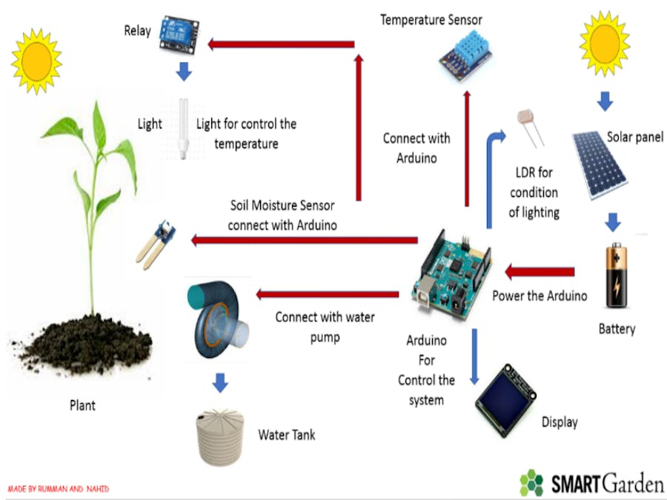

**Figure 1: Image of smart horticulture**

(Source, <https://www.hackster.io/smart-boys/smart-garden-2dd7b0>)

**Technological Elements of Smart Horticulture**

**Internet of Things (IoT)**

IoT-based devices, including soil moisture sensors, weather stations, and smart irrigation controllers, allow for real-time data on soil conditions, temperature, humidity, and other environmental factors (García et al., 2020). Such data allows farmers and gardeners to adjust the irrigation schedule, optimize nutrient application, and create ideal growing conditions (Lin, 2024). As a result, wastage of resources is minimized, and plant health is significantly improved.

The incorporation of new technologies in agriculture, including remote sensing, IoT, AI, and automation, is transforming the practice of farming (Fuentes-Peñailillo et al., 2024). These technologies not only enhance efficiency and sustainability but also play a role in enhancing food security and environmental protection (Pandey et al., 2023). Through the use of smart farming practices, farmers can maximize the use of resources, increase productivity, and create a sustainable future for agriculture.

**Automated Irrigation Systems**

Modern precision irrigation techniques, which include drip and sprinkler systems, are now fitted with AI-driven sensors and automated controllers (Aarif et al., 2025). Such a system ensures plants receive just what they need, just when they need it, minimizes water wastage, prevents overwatering, and thus decreases drought stress (Alharbi et al., 2024).

**Artificial Intelligence (AI) and Machine Learning (ML)**

AI-powered analytics process historical and real-time data to predict plant diseases, pest infestations, and crop yields (Titirmare et al., 2024). AI-driven management tools facilitate early detection of potential threats, allowing for proactive interventions that reduce crop losses and enhance productivity (Pandey, and Mishra, 2024). Machine learning algorithms further optimize planting schedules and resource allocation by analyzing past performance and environmental conditions (Morariu et al., 2020).

**Artificial Intelligence (AI) in Smart Horticulture**

AI is also essential in augmenting IoT by examining huge amounts of data and delivering actionable insights and predictive analysis. Machine Learning (ML) algorithms sift through data collected to make predictions regarding weather patterns, infestations by pests, and disease outbreaks, allowing farmers to take up-to-date preventive action. AI-based drones and remote sensing systems track crop health and farm conditions and identify problems like nutrient deficiencies, pest infestation, and disease outbreaks early on (Prasad et al., 2024).

Also, AI helps with precision farming by suggesting the best planting times, irrigation, and fertilization strategies through data-driven insights. AI and IoT integration in floriculture increases resource use efficiency, crop yield, and reduces environmental footprint (Kumar et al., 2020).

This synergy of technology equips farmers with real-time data and predictive analysis, enabling informed decision-making. The integration of these technologies is critical to tackling major agricultural issues such as climate change, population, and food security (Saeed El Etaiby, Y. (2023). With the integration of interconnected devices and sensors for data collection and analysis, smart farming provides a more sustainable and productive future for open-field and controlled-environment horticulture (Singh et al., 2025).

GPS technology accurately captures geographical coordinates, such as latitude, longitude, and altitude. Satellites send signals that allow GPS receivers to calculate real-time positions and monitor movement on a continuous basis (Kumar et al., 2021). Accurate location information enables farmers to identify specific field characteristics, such as pest infestations, soil conditions, weed distribution, and other possible challenges. With the identification of exact field locations, farmers can strategically deploy vital inputs such as seeds, fertilizers, herbicides, pesticides, and water, maximizing resource use (Dhanaraju, et al., 2022).

Remote sensing data plays an important role in differentiating amongst various crops, detecting pests and weeds, monitoring soil and plant stress, as well as detection of droughts (Adhikary et al., 2022). Several sensor-based methods ranging from photoelectric, electromagnetic to conductivity and ultrasonic methods are used to quantify soil texture, nutrient content, vegetation, moisture, vapor, air quality, and temperature (Padhiary, M., & Kumar, R. (2025).

A number of environmental conditions, including soil moisture, nutrient content, light intensity, humidity, rain, and leaf color, affect plant health. Smart sensor systems regulate and maintain ideal temperature and light intensity and save water and energy using micro-irrigation. Sensors measure changes in environmental factors and send real-time information to a microcontroller, which in turn initiates corrective measures to bring conditions back to optimal levels (García-Orellana et al., 2019).

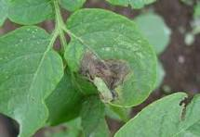

**Fig 2: Late bling of potato detection using AI**

Late blight of potato can be detected by image based diagnostic tools using AI

The most popular sensing technologies for use in agriculture are temperature, humidity, monitoring of soil patterns, airflow, location tracking, CO₂ content, pressure, light, and moisture sensors. The major properties of these sensors—like dependability, mobility, toughness, memory size, coverage, and computational performance—are very suitable for agricultural purposes.

Contemporary wireless sensors are vitally important to obtain real-time information on plant conditions and environment. These point sensors can integrate smoothly with future-oriented agricultural technology and equipment for boosting precision cultivation techniques (Balamurugan et al., 2016). Various sensor types and their operating modalities along with their applications have been elaborated in detail through Table 1.

**Drones and Remote Sensing**

Aerial crop monitoring with the use of multispectral and thermal imaging cameras equipped on drones is very effective for the early detection of nutrient deficiency signs, diseases, and pests (Barbedo 2019). Precise application of pesticides can be possible using remote sensing technologies while using minimum chemical levels with adequate control over pests and diseases (Abd El-Ghany et al., 2020).

**Vertical Farming and Hydroponics**

Hydroponics, aeroponics, and aquaponics are modern soilless cultivation techniques (Kumar et al., 2023). The benefits of such cultivation include optimization of space usage, lesser use of water, and crop production throughout the year in controlled environments (Benke, and Tomkins, 2017). The absence of soil-borne diseases and increased efficiency of nutrient delivery ensure healthy growth of plants and better sustainability (Stirling et al., 2016).

**Rooftop Gardening**

Urbanization has reduced arable land and, therefore, rooftop vegetable farming has become the sustainable way forward for city folks (Mougeot, 2006). This is a means to ensure fresh, chemical-free products while utilizing all unused urban space. It contributes to food security, enhances environmental sustainability, decreases the urban heat island effect, improves air quality, and enhances aesthetic value for buildings (Irfeey et al., 2023).

**Smart Greenhouses**

Modern greenhouses introduce automation in climate control. This means they maintain temperature, humidity, CO₂ levels, and lighting conditions in the most effective way to optimize plant growth (Bersani et al., 2022). IoT sensors and artificial intelligence algorithms made it possible to dynamically adjust environmental parameters for reduced energy costs as well as good yields (Rayhana et al., 2020).

**Precision Agriculture**

Precision agriculture is a novel approach to farming that utilizes modern technology and data analytics to increase crop yields (Karunathilake et al., 2023 and Padhiary et al., 2024). It aims at applying the appropriate amount of inputs (water, fertilizers, pesticides) at the right time and place for maximum yield without waste and less environmental impact(Mózner et al., 2012) .

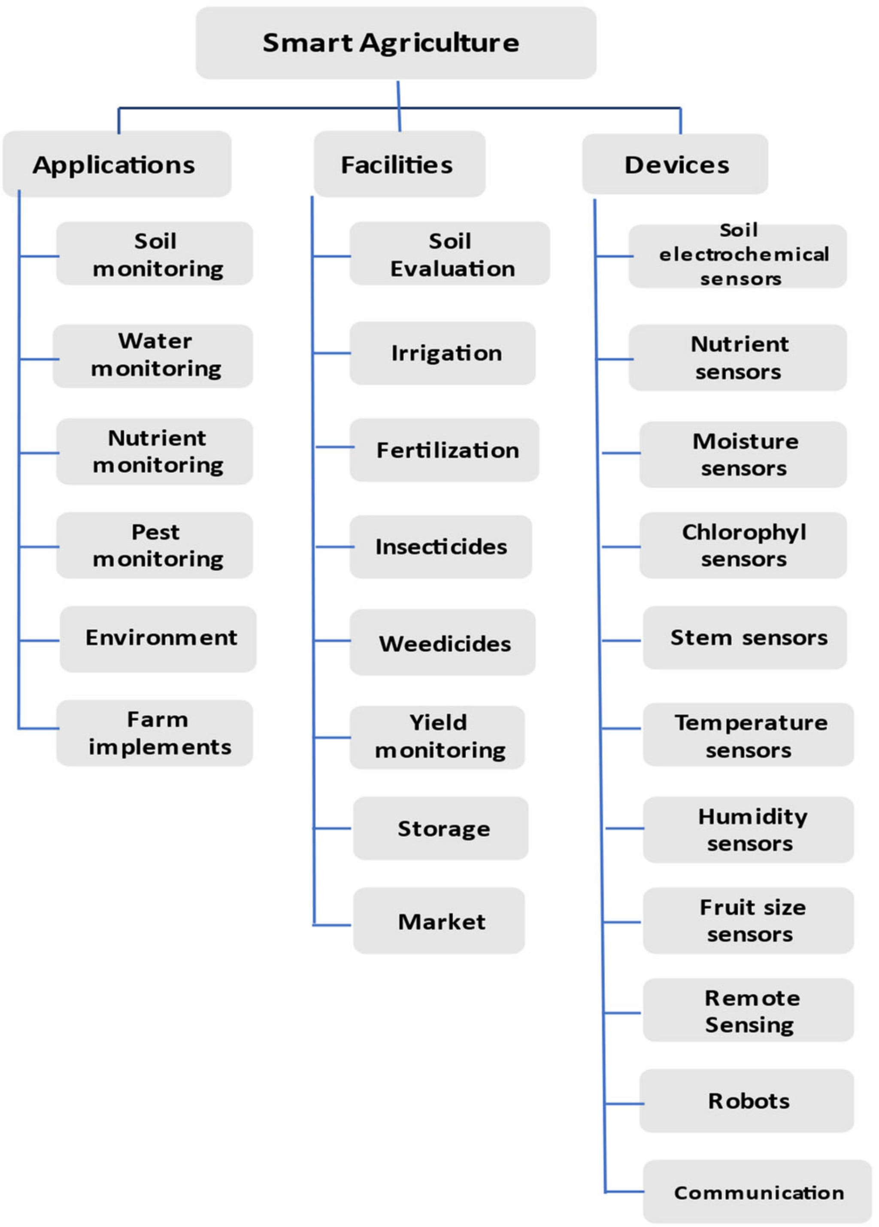Chart 1 : Precision Agriculture modalities

**(Source, Dhanaraju et al., 2022)**

**Advancements in Smart Farming Technologies**

**1. Remote Sensing & GIS**

Remote sensing and Geographic Information Systems (GIS) employ high-end technologies like drones and satellites to take high-resolution images of farms (Abdullahi et al., 2015). The images assist in tracking soil conditions, crop health, pest outbreaks, and nutrient deficiencies by studying spectral data, vegetation indices, and topographical differences (Omia et al., 2023). The combination of machine learning and artificial intelligence improves this data interpretation and offers farmers prescriptive insights into precision farming. The technologies can detect diseases in advance, allow real-time yields, and learn to adapt nutrients, making farm practices more efficient and sustainable (Kowalska and Ashraf 2023).

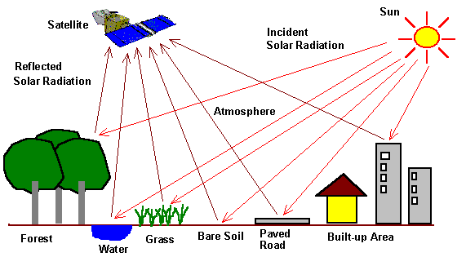

(Source, Aggarwal, 2004).

Figure 3: Remote sensing

**Key Technologies**

**Drones:** With multispectral and hyperspectral cameras, drones offer real-time imagery to diagnose plant health, identify stress, and maximize the allocation of resources (Neupane, and Baysal-Gurel, 2021). They are capable of taking high-definition images across multiple wavelengths, making it possible to identify early disease indications, deficiencies in nutrients, and water stress (Hoque et al., 2025). Moreover, drones mounted with AI-based analytics can analyze data in real-time, providing farmers with quick decision-making capabilities (Rao et al., 2021). Autonomous drones also improve efficiency by scanning vast farming grounds within a short duration without much human involvement (Mishra, and Mishra, 2024).

**Satellites:** Satellite-wide imaging aids precision agriculture by providing data on soil moisture content, vegetation, and climate fluctuations (Suzer et al., 2024). The images aid in monitoring crop development stages, determining drought levels, and detecting outbreaks of pests or diseases (Mahlein et al., 2016). With the advancement in AI and remote sensing technologies, satellite imagery is now analyzed more effectively, and real-time updates and predictive models aid farmers in making decisions based on data to ensure better yield and sustainability.

**GIS Mapping:** Geospatial analysis supports soil classification, land suitability evaluation, and precision nutrient management (AbdelRahman et al., 2022). With the incorporation of remote sensing information, GIS facilitates the development of comprehensive soil maps, terrain condition evaluation, and crop performance evaluation (de Paul Obade et al., 2013). Such information helps farmers make decisions on optimal land use, irrigation scheduling, and sustainable agriculture. Sophisticated GIS methods also support monitoring soil erosion, yield potential prediction, and effective natural resource management (Kingra et al., 2016).

**Benefits**

Smart farming uses real-time field information and precision technology to optimize water, fertilizer, and pesticide use (Mohamed et al., 2021). This means that waste is reduced, costs are minimized, and farm profitability is increased while soil health and sustainability are assured (Verhulst et al., 2010). They used on-time interventions based on remote sensing information result in higher productivity due to the identification of nutrient shortages, prevention of pest infestations, and the optimization of irrigation schedules. The technologies allow farmers to apply targeted treatments, leading to healthier crops and greater yields with the preservation of soil fertility and sustainability (Kumar, et al., 2022). Minimizes wastage of resources through optimization of input use, reducing carbon footprints, and encouraging environmentally friendly farming methods. It increases soil health, saves water, and reduces environmental effects through precision agriculture and sustainable resource management (Bhatia et al., 2023).

**2. Variable Rate Technology (VRT)**

Variable Rate Technology (VRT) allows automated equipment to deliver inputs like fertilizers, seeds, and pesticides at different rates depending on real-time soil and crop health analysis (Saleem et al., 2023). With the help of sophisticated sensors, GPS mapping, and AI-based data analytics, VRT provides accurate application, minimizing wastage of inputs and maximizing yield potential. This technology not only increases farm productivity but also promotes sustainable agriculture by reducing environmental footprint (He, 2023).

**Types of VRT**

**Map-Based VRT:** Employs pre-collected field data such as soil type, crop condition, and past yield trends to create prescription maps that direct accurate input application. The maps assist in maximizing the application of fertilizers, seeds, and pesticides by determining field variability, allocating resources efficiently, and enhancing overall farm productivity (Getahun et al.,2024).

**Sensor-Based VRT:** Sophisticated real-time sensors built into agricultural equipment continuously observe soil conditions, moisture content, and crop health indicators. Sensors evaluate changes in the field and make dynamic changes to rates of fertilizers, pesticides, and irrigation, delivering exact application (Paul et al., 2022). This reduces wastage of resources, improves nutrient use efficiency, and maximizes yield potential by targeting plant requirements at a micro-level (Weekley et al., 2012).

**Advantages**

Increases effectiveness by applying fertilizers, pesticides, and other inputs accurately through real-time data on soil and crops (Raza et al., 2023). Targeted application ensures minimal wastage, reduced expenditures, and optimized sustainable farming methods. They Customized input application, facilitated by precision technology, provides optimal nutrient distribution, minimizes resource wastage, and ensures even growth of the crop (Sharma, 2023). With data-driven knowledge, farmers are able to increase growth rates, enhance stress tolerance for the environment, and obtain more yields at better quality (Khan et al., 2018). Its Minimizes the risk of nutrient leaching, soil erosion, and water body contamination by providing accurate application of fertilizers and pesticides (Rashmi et al., 2020). Encourages soil conservation and improves ecosystem balance through sustainable farming practices.

**3. IoT & Data Analytics**

The Internet of Things (IoT) and data analytics use networked sensors to monitor in real time environmental and crop conditions (Elijah et al., 2018). Through collecting and analyzing enormous amounts of information on soil moisture, temperature, humidity, and nutrient content, these technologies provide accurate decision-making (Zhang et al., 2017). This leads to optimized farm management, efficient use of resources, and higher productivity with decreased environmental footprint.

**Technologies Used**

**IoT Sensors:** Continuously monitor and measure key environmental factors such as temperature, soil moisture, humidity, and nutrient levels. These sensors provide real-time data that help farmers make informed decisions about irrigation, fertilization, and overall crop management, ensuring optimal growing conditions and resource efficiency (Adinarayana et al., 2024).

**Big Data Analytics:** Employs sophisticated algorithms to analyze large volumes of agricultural data, deriving relevant patterns and insights to enable wise decision-making (Tantalaki, et al., 2019). Big Data Analytics strengthens yield prediction, optimizes resource allocation, and enhances disease and pest control using predictive analytics (Singh et al., 2025).

**Cloud Computing:** Offers scalable storage and computing muscle to handle extensive farm data. Supports remote work, real-time collaboration, and predictive analytics to enable better decisions. Farmers have the option of using cloud platforms to bring in data from IoT devices, satellite imagery, and AI models with ease, such that smooth management of the farms and productivity take place (Dhanaraju et al., 2022).

**Real-Time Monitoring**: Farmers are given real-time feedback on crop health, soil moisture levels, temperature fluctuations, and possible disease outbreaks. Real-time information allows for timely interventions to be made, ensuring better yield, minimizing resource wastage, and maximizing farm management efficiency (Getahun et al., 2024).

**Informed Decision-Making:** Data-driven insights with advanced analysis allow farmers to maximize farm operations by forecasting yield patterns, detecting possible risks, and undertaking accurate resource allocation mechanisms (Titirmare et al., 2024). This ensures greater efficiency, lower costs, and increased overall productivity.

**Predictive Abilities:** AI algorithms scan past and current data to forecast likely threats, including pest attacks, disease epidemics, and climatic risks. These algorithms propose timely interventions, enabling farmers to take preventive actions to protect crops and maximize yields (Kowalska and Ashraf, 2023).

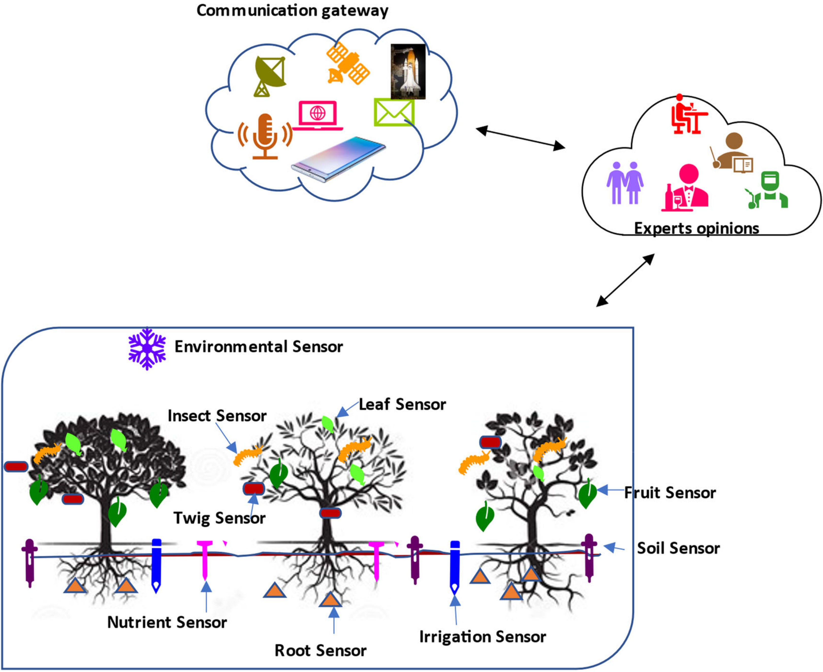

(Source, Dhanaraju et al., 2022)

Figure 4: An Internet-of-Things-based network for smart farming.

**4. Automated Irrigation Systems**

Automated irrigation systems combine IoT sensors, AI algorithms, and smart controllers to accurately control water distribution according to real-time soil moisture, weather predictions, and crop needs. Such sophisticated systems ensure that crops receive their ideal amount of water without overuse, saving water resources, and increasing overall farm sustainability (Ghareeb et al., 2023).

**Drip Irrigation with AI Sensors:** Employs AI-based sensors to track soil water content in real-time, facilitating accurate water delivery directly to the roots (Seyedzadeh et al., 2020). This process reduces evaporation and runoff significantly while maximizing water usage, resulting in better crop watering and sustainability.

**Smart Sprinkler Systems:** Leverages AI-powered controllers and IoT sensors to automatically modify irrigation schedules in real-time based on soil moisture levels, weather conditions, and crop water needs. The systems maximize water efficiency, avoid over-irrigation, and promote better overall crop health (Meyer et al., 2015).

**AI-Based Irrigation Scheduling:** Employs sophisticated machine learning algorithms to examine past climate data, current soil moisture content, and crop growth trends, allowing accurate water requirement forecasting. This technology maximizes irrigation scheduling, minimizes water loss, and improves overall crop yields by providing plants with the appropriate amount of water at the appropriate time (Sinwar et al., 2020).

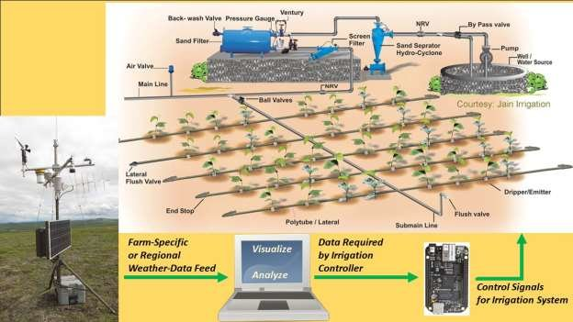

Source, Raeth, P. G. (2020).

**Figure 5: Image of Automated Irrigation Systems**

**Benefits**

Applies accurate irrigation methods to reduce water loss, maximize moisture retention, and avoid overwatering. Such practices improve soil quality, enhance water-use efficiency, and promote sustainable agriculture. Provides plants with the best possible hydration by constantly monitoring soil moisture and adjusting irrigation schedules in response (Obaideen, et al., 2022). This practice avoids water stress, encourages healthier root growth, and enhances overall plant resistance to disease and environmental changes. Automates irrigation processes using AI-driven controllers and IoT sensors, significantly reducing the need for manual labor. This automation allows for precise water distribution, minimizes human error, and enhances operational efficiency, enabling farmers to focus on other critical aspects of farm management (Gamal et al., 2023).

**5. Greenhouse Monitoring & Automation**

Smart greenhouses use IoT, AI, and sophisticated climate control systems to constantly monitor and adjust environmental conditions like temperature, humidity, light, and CO₂ levels. All these technologies cooperate to provide maximum plant growth with consistent high-quality output, less resource usage, and minimized manual effort (Evans et al., 2008).

**Technologies Utilized in Smart Greenhouses**

**IoT Sensors:** Ongoing monitoring of temperature, humidity, CO₂, and light levels with real-time transmission of data, allowing accurate environmental control for maximum plant growth and resource savings (Sehrawat, et al., 2019).

**Automated Climate Control**: Dynamically adjusts ventilation, heating, cooling, and irrigation using real-time sensor information, optimizing environmental conditions for plant growth with minimal energy usage and resource waste (Zhang et al., 2022).

**AI-Powered Predictive Analytics:** Employs sophisticated machine learning algorithms to process historical and real-time data, forecasting plant health problems, optimizing resource utilization, and anticipating corrective actions to improve crop productivity and sustainability (Kowalska, and Ashraf, 2023).

**Advantages**

Enables continuous cultivation by sustaining ideal growing conditions within controlled environments, reducing the effect of seasonal and climatic fluctuations on crop yield and quality. Improves economic viability by minimizing energy use, maximizing input utilization, and decreasing operation expenses through automated real-time adjustments. This results in considerable cost savings while keeping optimal growing conditions intact. Advanced AI-driven monitoring and predictive analytics enable early detection of plant health issues, facilitating proactive interventions. This not only improves overall yield quality but also minimizes crop losses, reduces dependency on chemical treatments, and enhances long-term sustainability in farming operations.

**6. Wireless Sensor Networks (WSNs) in Agriculture**

Wireless Sensor Networks (WSNs) are a network of interconnected intelligent sensors strategically deployed within agricultural fields, greenhouses, or storehouses (Ayaz et al., 2019). These sensors continuously monitor real-time data concerning environmental and soil factors and send this information to a central system for decision and analysis. The use of WSNs in agriculture greatly enhances farm management by allowing timely interventions and the optimal utilization of resources (Mowla et al., 2023).

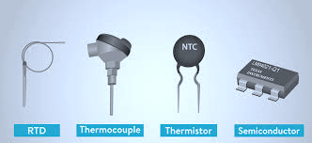

**Figure 6: Different temperature sensor**

**Soil Moisture Sensors:** They record the volumetric water content in the soil to provide accurate irrigation scheduling based on real-time conditions. They assist in avoiding overwatering, which results in root diseases, and underwatering, which may result in plant stress. Optimizing water consumption, they promote better crop development, increased yield, and effective water conservation methods (Yu et al., 2021).

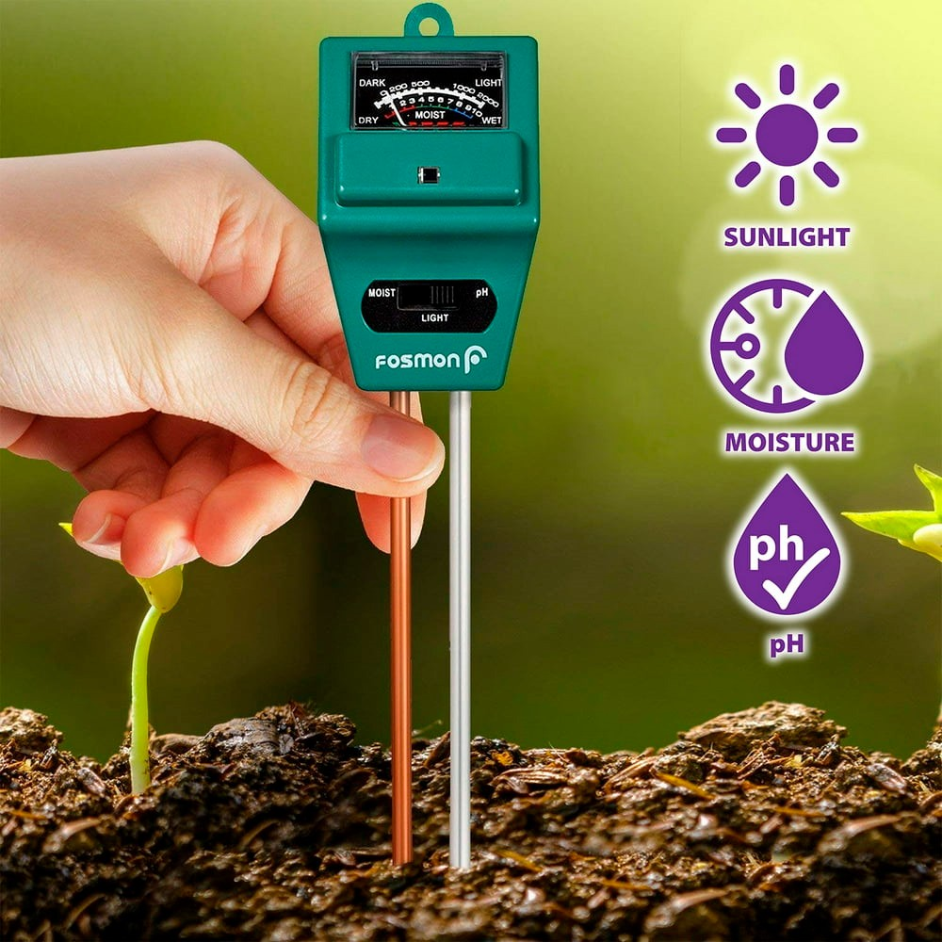

**Figure 7: soil moisture light and pH sensor**

**Weather Sensors:** Monitoring vital climatic parameters like temperature, humidity, wind speed, precipitation, atmospheric pressure, and solar radiation in real time. They supply valuable data that supports forecasting weather trends, allowing farmers to implement effective preventive measures in a timely manner against unfavourable conditions such as frost, drought, storms, and heat stress. Moreover, they assist in optimizing irrigation planning, pest and disease control, and general farm planning through providing information regarding microclimatic differences (Chu et al., 2017).

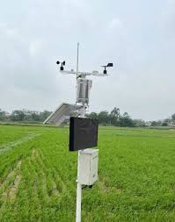

Figure 8: Weather sensors used in Smart horticulture

**Nutrient Sensors:** Ongoing monitoring of the nutrient content of the soil, measuring levels of key elements like nitrogen (N), phosphorus (P), and potassium (K), as well as micronutrients such as zinc, iron, and magnesium. They give accurate information on soil fertility, allowing specific fertilizer application that avoids deficiencies or toxicities. Through optimal fertilization, they maximize crop production, lower input costs, and reduce environmental damages due to excess nutrient runoff (Miyamoto et al., 2013).

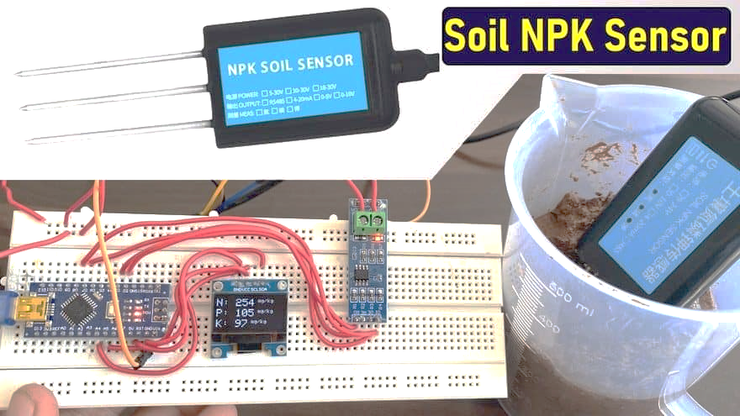

**Figure 9: Nutrient sensor**

**Light Sensors:** Ongoing measurement of sunlight intensity and duration, optimizing photosynthesis, plant growth, and greenhouse operations. They aid in automated shading and lighting systems, providing crops with sufficient light exposure, which is essential for flowering and fruiting processes. They also aid in energy efficiency in controlled environments by regulating artificial lighting according to natural sunlight availability (Conrad et al., 2014).

**pH Sensors:** Monitor soil and water pH levels continuously to maintain the proper chemical composition for optimal plant growth. pH sensors assist in soil amendment use by directing the use of lime, sulfur, or other corrective materials to ensure optimal pH levels for various crops. Having the right pH maintains the availability of nutrients, avoids toxicity, and promotes healthy plant growth, resulting in healthier yields and soil preservation (Wencel et al., 2014).

**Gas Sensors:** Ongoing monitoring and measurement of levels of key gases like carbon dioxide (CO2), ammonia (NH3), methane (CH4), and oxygen (O2), which are crucial for plant growth, soil health, and environmental sustainability. These sensors assist in identifying imbalances that can influence photosynthesis, respiration, and microbial processes in the soil. They also facilitate measuring greenhouse gas emissions, which further helps in sustainable agriculture practices and regulatory compliance by reducing the environmental footprint of agricultural activities (Love et al., 2021).

**Table 1: Different smart agriculture sensor**

|  |  |  |  |
| --- | --- | --- | --- |
| **Type of Sensor** | **Utility** | **Working Procedure** | **References** |
| **Acoustic-based sensors** | Detection and monitoring of pest population; harvesting of fruits. | Measures alterations in noise level in agricultural fields. | (N, Srivastava et al., 2013) |
| **Electromagnetic sensors** | Record electromagnetic responses; measure residual nitrate level and organic matter concentrations in soil; real-time measurement of transpiration rate. | Employ electrical circuits that record conduction or accumulation of electrical impulses in soil. | (Yunus et al., 2010, and Millan-Almaraz et al., 2013) |
| **Light Detection and Ranging (LIDAR)** | Agricultural land-based utilities such as 3D modeling, soil erosion monitoring, agricultural land mapping, and soil type detection. | LIDAR sends light wave pulses to the target object. After colliding with the target, light waves return to the sensor. The time taken to return is assessed. | (Schuster et al., 2017) |
| **Optical sensors** | Sense soil parameters like soil texture, mineral content, clay content, moisture, and soil color. Fluorescence-mediated optical sensors detect fruit maturation. Integral optical sensors combined with microwave scattering monitor orchard canopies. | Changes in light reflectance are assessed. | (Millan-Almaraz et al., 2013, Murray et al., 2018 and Molina et al., 2011) |
| **Mechanical sensors** | Measure soil mechanical resistance and soil particle compactness. | Sensors measure the force assessed by load cells or strain gauges. | (Hemmat et al., 2013) |
| **Mass flow sensors** | Assess yield production by measuring grain flow through a combined harvester. | Sensors record the mass flow of grains through various modules, including moisture content sensing sensors, data storage, and internal systems. | (Hemmat et al., 2013) |
| **FPGA (Field Programmable Gate Array) based sensors** | Measure moisture content, humidity, transpiration rate, and irrigation needs of plants. | Employ digital circuits surrounding silicon-based chips and logic blocks. | (Weiss, & Biber, 2011, Montagnoli et al., 2015) |
| **Electrochemical sensors** | Help measure nutrient status and pH of the soil. | Individual sensors record electrochemical gradients in agricultural soil. | (Yew et al., 2014, Cocovi-Solberg et al., 2014) |
| **Eddy covariance-based sensors** | Record changes in levels of various gases, including greenhouse gases like CO2, methane, and water vapor in agricultural lands. | Measures continuously over large agricultural areas. | (Kumar et al., 2017) |
| **Airflow sensors** | Assess soil-air content, permeability, and moisture content in mobile or static conditions. | It senses various soil properties using unique identifying characteristics. | (García-Ramos et al., 2012 |
| **Ultrasonic ranging sensors** | Help in pest detection, crop canopy monitoring, and weed recognition. | Employ ultrasonic sensors that send and receive ultrasonic pulses to detect object proximity. | (Dvorak et al., 2016) |
| **Flexible and wearable sensors** | Help sense shape, size, and growth of different plant parts. | Sensors made of stretchable materials enable mounting on plant parts. | (Dong et al., 2023, Tang et al., 2017) |
| **Battery-free and self-powered sensors** | Help sense environmental factors such as temperature and humidity; monitor food product quality. | Sensors are powered by solar cells and do not rely on batteries. | (La Rosa et al., 2022, Alippi et al., 2012) |

(Source, Rajak et al., 2023)

Table 2: Agricultural sensors: Sensor application, type of data collecting and description.

|  |  |  |  |
| --- | --- | --- | --- |
| **Sensor Name** | **Sensor Application** | **Type of Data Collected and Description** | |
| Soil NPK Sensor | Fertilizer Administration | Determines the concentration of potassium, phosphorus, and nitrogen in the soil to aid in fertilization. Using soil NPK sensors to track changes in soil nutrient levels over time, growers may adjust fertilizer application rates and timing. The application of soil NPK sensors can reduce fertilizer waste, enhance crop productivity and quality, and prevent nutrient runoff into nearby rivers. | (Ahmad et al., 2022) |
| Soil Moisture Sensor | Irrigation Monitoring Systems, Forecasting, and Harvesting | Measures the amount of water in the soil to determine when and how much to irrigate. These sensors may be positioned at various soil depths to monitor water availability at varying depths. Soil moisture sensors can aid in crop growth optimization, water conservation, and avoiding overwatering, which can result in nutrient loss and soil erosion. | (Mahbub, 2020, Pramanik et al., 2022) |
| Nitrate Sensor | Fertilizer Administration, Crop Disease Detection | Determines the nitrate content of the soil to aid in fertilizer application. Growers may alter fertilizer application rates and timing by using nitrate sensors to monitor changes in soil nitrogen levels over time. In addition to improving crop output and quality, nitrate sensors can assist in minimizing nitrogen runoff into surrounding waterways and decrease fertilizer waste. | (Sun et al., 2020, Patil et al., 2021) |
| Soil pH Sensor | Fertilizer Administration, Crop Disease Detection | Determines the soil’s pH level, which can aid in enhancing plant nutrient absorption. Growers may modify soil amendments and fertilizer application rates by using soil pH sensors to monitor variations in soil acidity over time. The use of soil pH sensors can improve crop production and quality, reduce nutrient deficits and toxicities, and stop soil acidification over time. | (Patil et al., 2021) |
| Electrical Conductivity Sensor | Fertilizer Administration, Quality Monitoring | Determines the electrical conductivity of water or soil, which may be used to check salt and nutrient levels. Adjusting irrigation procedures and preventing salt accumulation in soils may both be accomplished with electrical conductivity sensors. | (Yue et al., 2020) |
| CO2 Sensor | Quality Monitoring, Processing Monitoring, Climate Conditions Monitoring | Measures the quantity of carbon dioxide in the air, which may be used to keep track of plant development and respiration. Growing conditions may be improved by adjusting ventilation and lighting systems, which can be done with the use of CO2 sensors, which track changes in CO2 levels over time. By adjusting ventilation and illumination as necessary, CO2 sensors can assist in minimizing CO2 buildup, which can result in decreased plant growth and productivity. They can also aid in lowering energy use. | (Mahbub et al.,2021) |
| Temperature and Humidity Sensor | Irrigation Monitoring Systems, Quality Monitoring, Processing Monitoring, Forecasting and Harvesting, Climate Conditions Monitoring | Monitors environmental conditions by taking air temperature and humidity measurements. Extreme temperature ranges, high humidity levels, and other environmental variables that may affect plant growth and development may all be found with these sensors. Sensors for temperature and humidity can be placed in a variety of locations, such as outside weather stations or within greenhouses. These sensors can aid in improving growth conditions, guarding against pests and disease, and lowering energy expenditures. | (Mahbub et al.,2021) |
| Light Sensor | Quality Monitoring, Climate Conditions Monitoring | Measures the amount of light that plants receive, which can aid in maximizing growth and output. These sensors can measure the amount of light in different parts of a greenhouse or field and may be used to modify lighting or shade arrangements to improve growing conditions. By decreasing illumination or shading as necessary, light sensors may assist producers in producing high-quality crops with optimal yield and quality while also reducing energy use. | (Al-Tarawneh et al., 2022) |
| Weather Station | Logistics Monitoring, Forecasting, and Harvesting | Gathers information on wind direction and speed, rainfall, barometric pressure, and other weather-related data that may be used by farmers to make choices about planting, harvesting, and other agricultural tasks. With the use of these sensors, producers can foresee weather-related hazards and improve crop management techniques by tracking weather trends over time. Weather stations can be set up on a farm or in a particular area and used to track regional weather patterns and microclimates. | (Ioannou et al., 2021) |
| Water Level Sensor | Irrigation Monitoring Systems, Logistics Monitoring | Determines the level of water in a tank, pond, or other body of water. These sensors are frequently employed in agriculture to monitor water levels in irrigation systems and other bodies of water. | (Mahbub, M. 2020). |
| Livestock Sensor | Logistics Monitoring | Observes the health and conduct of cattle, which can aid in disease prevention and maximize output. Animal activity, body temperature, and eating habits may all be monitored with livestock sensors. These sensors can aid in improving feeding and breeding procedures, reducing animal stress, and promoting animal welfare. | (Mishra, & Sharma, 2023). |
| Plant Disease Sensor | Crop Disease Detection | Analyzes plant tissue or soil samples to detect plant diseases. These sensors can be used to monitor disease in crops and assist producers in taking steps to stop its spread or potential harm. | (Patle et al.,2022) |
| Smoke Sensor | Fire Detection | Calculates the number of smoke particles present in the air at any given time, which may signal the existence of a fire. The sensor alerts the smart agricultural system when smoke particles are found so that it may take the necessary precautions to stop the fire from spreading. | (Rehman et al., 2021, Morchid et al., 2022) |
| Flame Sensor | Fire Detection | Uses infrared light emission to locate fires. The sensor can recognize the infrared radiation that a flame releases when it is present. The sensor alerts the smart agricultural system when a flame is found so that it may take the necessary steps to stop the fire from spreading. | (Rehman et al., 2021, Morchid et al., 2022) |
| Flexible Sensor | Yield Monitoring | A flexible, wearable sensor designed specifically to track the quality of plants, fruits, and food. Real-time data collection is made possible by its soft and versatile shape, making it easy to install on the surface of various food items and plants without causing any damage. | (Huang et al., 2023) |

(Source, Morchid et al., 2024)

**Advantages of WSNs in Agriculture**

Continuously monitors field conditions, providing immediate updates on parameters like soil moisture, temperature, humidity, and nutrient levels. Real-time data enables farmers to make effective decisions, apply instant corrective measures, and optimize resource use, improving the general crop health and yield efficiency (Jawad et al., 2021). Applies sophisticated data analytics and sensor-driven technologies to maximize the use of water, fertilizers, and pesticides. Precision agriculture delivers inputs exactly where and when they are required, reducing waste, improving crop yields, saving natural resources, and lessening environmental effects (Banđur et al., 2019). Precision agriculture also assists in site-specific crop management, balancing nutrient delivery and efficient pest management while reducing costs of operations. Lowers substantially the need for labor field inspections and interventions through automation of data collection and decision-making activities (Saleh et al., 2020). This translates to lower labor costs, increased operational efficiency, and improved productivity. Moreover, it maximizes resource allocation, reduces wastage, and overall farm profitability through automation of mundane agricultural chores. Regularly check environmental and soil conditions to identify possible problems like drought stress, nutrient shortages, pest outbreaks, or disease infestations before they get out of control. Through real-time notifications, the systems allow farmers to intervene early, preventing losses in crops and enhancing the general resilience of farms (Chen et al., 2011). Early action increases productivity, avoids losses, and leads to sustainable agriculture. Applies innovative agricultural technologies and best management practices to maximize the utilization of natural resources, reduce environmental degradation, and increase long-term productivity. With the integration of precision agriculture, effective irrigation systems, and environmentally friendly pest management practices, sustainable farming increases biodiversity, lowers carbon footprints, and provides food security while sustaining soil health and water conservation (Varghese et al., 2015).

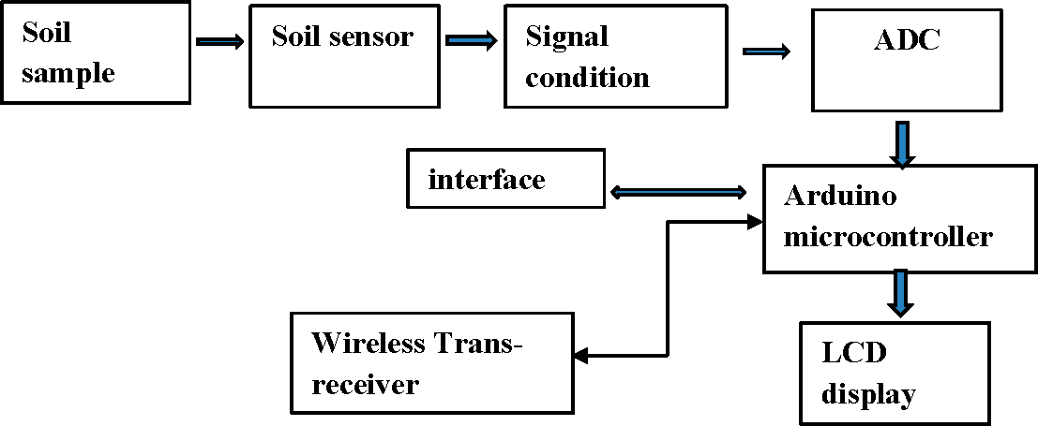

**(Source,** **Meshram et al., 2024)**

**Figure 10: Wireless Transmission for smart horticulture**

**AI Applications in precision Agriculture**

Integration of cutting-edge technologies like Wireless Sensor Networks (WSNs) and Artificial Intelligence (AI) is revolutionizing agriculture today through making it efficient, resource-sensitive, and sustainable (Linaza et al., 2021). These technologies play a central role in counteracting challenges including climate change, loss of natural resources, and food security. WSNs and AI create an avenue for precision farming, enhanced productivity, and climate resilience through real-time monitoring, forecasting, and automating processes (Sharma et al., 2020). With advancements in technology, these tools will become increasingly instrumental in defining the future of sustainable agriculture globally (Kirchmann, and Thorvaldsson, 2000).

Sophisticated machine learning algorithms analyze plant images to detect diseases, pest infestations, and nutrient deficiencies in their early stages. These systems provide farmers with suggested treatments, minimizing crop loss (Sudhakar. AI algorithms process historical and real-time data, such as weather conditions, soil health, and crop status, to predict yields with high accuracy. This helps in better planning, storage, and supply chain management. Artificial intelligence-powered robots and drones automate tasks like seeding, weeding, pesticide spraying, and harvesting. These autonomous systems enhance precision, reduce dependency on human labor, and optimize agricultural operations. AI integrates with IoT-based irrigation systems to monitor soil moisture levels and climatic conditions, ensuring efficient water distribution while preventing wastage. Additionally, AI streamlines logistics by predicting demand and optimizing the transportation and storage of perishable produce, reducing post-harvest losses. AI-driven wearable sensors track animal health, feeding patterns, and movement, enabling early disease detection and improved livestock management. AI-based vision systems also assist in sorting harvested produce based on quality parameters such as size, color, and texture, ensuring that only high-quality products reach the market.

**Advantages of Smart Horticulture**

This is the future of horticulture with smart gardening because of its numerous benefits, which increase productivity levels, enhance water productivity, reduce labor requirements, and make environmental sustainability more effective. It gives a pragmatic solution to meeting the growing demands in the global market for food, ornamental plants, and medicinal herbs while minimizing ecological impact. As these technologies become more accessible and affordable, smart gardening will play a pivotal role in building a sustainable and resilient agricultural system (Zhang et al., 2023).

**IoT and Sensor-Based Technologies in Horticulture:** IoT in Horticulture: Horticulture is referred to as the interconnection of physical devices, sensors, and data analytics platforms for optimizing agricultural operations (Meshram et al., 2024). The technologies enable precision agriculture by offering real-time insights into various environmental and crop parameters. IoT enables automation, reduces human error, and enhances decision-making, which improves productivity and sustainability (Javaid et al., 2022). Major components of IoT in horticulture:

**Wireless Sensor Networks (WSN):** Sensors track key environmental parameters, among them soil moisture, temperature, humidity, and light intensity, whose immediate signals are used to monitor the real-time nature of precision irrigation and fertilization as well as climate control (Nayyar, and Singh, 2015). This network of distributed sensor nodes is wirelessly connected; that automatically makes the decision for adaptive responses to altering field conditions. Cloud computing with artificial intelligence combined with WSN offers enhanced data analysis and predictive capabilities toward making horticulture management efficient and sustainable (Yick et al., 2008).

It aims to optimize irrigation schedules using real-time data from soil moisture sensors, weather forecasts, and crop water requirements. Thus, it helps ensure controlled over-irrigation and under-irrigation, saving these precious water resources (Rathinam et al., 2019). Advanced systems of automated irrigation use AI and machine learning algorithms to analyze historical data and predict optimal watering times, ensuring efficient use of water and improved crop health. Additionally, mobile applications provide farmers with the ability to monitor and manage irrigation operations remotely, which leads to the saving of labor costs and an increase in general productivity (Jawad et al., 2017).

**Green House Management:** IoT-enabled platforms manage vital environmental parameters such as temperature, humidity, levels of CO2, and light intensity to provide optimal conditions for crop growth (Thilakarathne et al., 2023). Wireless sensor networks and cloud-based data analytics are used in these systems to continuously monitor greenhouse parameters and adjust the climate conditions in real time. Automated ventilation, heating, and irrigation mechanisms respond dynamically to environmental fluctuations, ensuring consistent plant health and growth. AI-driven predictive models further enhance efficiency by analyzing historical data to optimize climate control strategies, reduce energy consumption, and maximize yield potential (Srinivasan, et al., 2024).

**Pest and Disease Detection:** Advanced image recognition technologies, combined with IoT-enabled sensor-based pest monitoring systems, enable early identification of pests and plant diseases (Sharma, and Shivandu, 2024). Such systems make use of high-resolution cameras, multispectral imaging, and AI-driven algorithms for crop health analysis and symptom detection at the initial stages of infestation or infection (Kumar et al., 2024). The systems can issue real-time alerts and implement automatic interventions such as targeted pesticide application or biological control methods, which improves the efficiency of disease management with reduced chemical overuse. Data sharing on cloud-based platforms allows farmers to monitor pest patterns and develop proactive crop protection strategies (Kiobia et al., 2023).

**Applications of IoT in Smart Horticulture**: IoT-driven horticulture has revolutionized agricultural practices by enabling data-driven decision-making, automation, and enhanced resource management (Postolache et al., 2023). Several applications demonstrate its effectiveness in optimizing production and sustainability, improving farm operations, and ensuring better quality produce. These applications include:

**Soil Moisture and Nutrient Sensing:** Real-time monitoring through IoT-enabled sensors provides accurate data on soil moisture levels and nutrient content, facilitating precision fertilization and water management (Kashyap, and Kumar, 2021). These sensors have prevented overfertilization and underirrigation, maximizing soil health with optimal plant growth. Advanced algorithms in machine learning analyze the gathered data to determine nutrient deficiencies for targeted interventions while enhancing crop production with reduced impacts on the environment. Remote monitoring capabilities also assist farmers in viewing soil conditions by mobile applications (Zhang et al., 2017).

**Automated Climate Control in Greenhouses:** AI will optimize climate conditions that support plant growth through dynamically adjusted temperature, humidity, levels of CO2, and light intensity (Shamshiri et al., 2013). These systems utilize IoT sensor devices' real-time information for automated heating, cooling, shading, and ventilation for the microclimate adaptation of different crop types. Machine learning algorithms analyze historical climate data, making predictions on environmental conditions that are used to make predictive adjustments both for improvement in energy efficiency and crop productivity. This makes way for mobile app-based remote monitoring and control options, reducing man-days required on site and slashing operational costs considerably (Weldeslasie et al., 2021).

**Smart Pest Control:** By integrating AI-traps with an IoT-based real-time monitoring and image recognition device, pests may be identified with early detection while collecting data online. It helps in high-definition camera surveillance for pest identification coupled with machine-learning-based algorithms about the prediction trends of pest invasion (Vijayalakshmi et al., 2019). These include precise-targeted pesticide application and biological control methods that reduce chemical application and environmental exposures. Further, using cloud-based analytics tools, farmers can monitor pest developments, receive real-time alerts, and take appropriate preventive measures to protect crops (Wu et al., 2022).

**Supply Chain Management:** Blockchain and IoT technologies critically perform tracking and post-harvest produce management that ensures quality, traceability, and transparency throughout the agricultural value chain (Bhagat, and Dhar, 2011). The sensors are IoT-enabled, monitoring storage conditions such as temperature and humidity to prevent spoilage and maintain food safety standards. Blockchain technology records immutable data on harvesting, transportation, and distribution, which reduces fraud and improves consumer trust. Real-time tracking of shipments also enhances the efficiency of logistics, minimizes post-harvest losses, and optimizes market access for farmers (Mwewa et al., 2025).

**Challenges and Limitations**

Despite the tremendous potential, IoT-based horticulture has various challenges that could hinder its spread and impact. These are mainly technological, financial, infrastructural, and regulatory barriers. Such barriers should be addressed for easy implementation and sustainability in the long run.

**High Initial Costs:** The adoption of IoT-based horticulture requires substantial investment in advanced sensors, automated systems, cloud-based analytics platforms, and network infrastructure. Small and medium-sized farmers may find these initial expenses prohibitive, limiting their ability to integrate smart horticulture solutions. Additionally, the cost of maintenance, software updates, and energy consumption further adds to the financial burden, necessitating government subsidies and financial assistance programs to promote wider adoption.

**Connectivity:** Many areas of farms and farmlands are very remote and far from the core of the nation. The Internet and network stability cannot be expected there. For smooth operation, real-time data transmission, and remote monitoring in precision horticulture, challenges lie in low broadband coverage, expensive satellite internet solutions, and non-uniform cellular networks. Improving these connectivity gaps needs investments in digital infrastructure in the rural areas, the deployment of LPWANs, and satellite-based communication technologies to guarantee the reliability of connectivity for precision horticulture.

**Data Security and Privacy:** As IoT-based horticultural systems are dependent on cloud storage and real-time data exchange, data security and privacy remain a huge concern. Risks of unauthorized access, hacking, and data breaches are also there for the sensitive agricultural information, including crop patterns, soil health data, and farm operations. Strong cybersecurity measures such as end-to-end encryption, multi-factor authentication, and blockchain technology can enhance data security. Another is ensuring compliance with data protection regulations and educating farmers on best cybersecurity practices to protect digital agricultural ecosystems.

**Technical Expertise:** Extensive training is a must for the farmers in efficiently using IoT-based tools since this technology includes heavy hardware, sophisticated software, and data interpretation, which require some technical knowledge for maximum benefit reaping from smart horticulture. Moreover, training programs, digital literacy plans, and information gap-bridging measures have to be enforced to allow them to confidently apply IoT solutions without any difficulty and inefficiency.

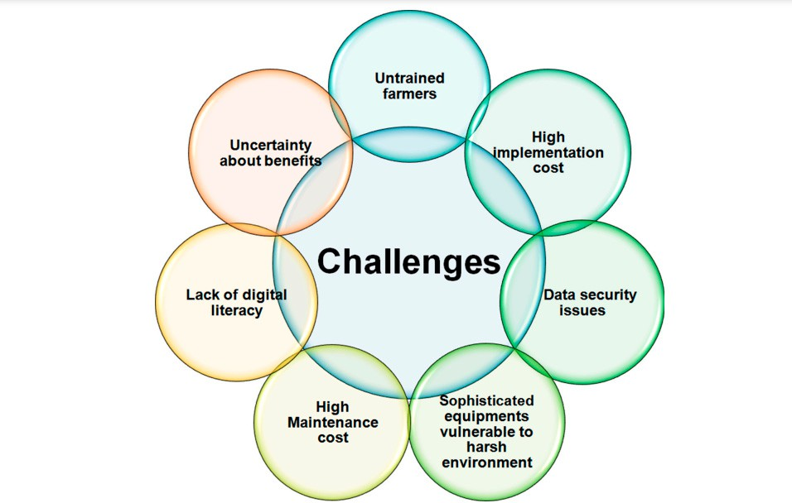

**Figure 11: Different challenges in Smart horticulture and Iot based**

**Future Opportunities**

The future of smart horticulture lies in the smooth integration of advanced AI algorithms, machine learning, and blockchain technology into decision-making, automation, and transparency. Nanotechnology-based sensors, edge computing, and 5G connectivity will also really improve the accuracy of real-time data processing and precision horticulture applications. The agricultural robots that are designed to be self-learning along with predictive analytics derived from AI will further enhance the managerial optimization of farms to provide higher productivity at minimal resource usage. The implementation of IoT on a large scale will be driven by government policies, research collaborations, and private sector investments. Sustainability-oriented innovation, for example, solar power for IoT devices and biodegradable sensors, will help harvest greener agriculture practices, and make smart horticulture more resilient and efficient and more accessible worldwide.

**Conclusion**

IoT and sensor-based technologies offer potential to revolutionize horticulture by increasing productivity, optimizing resource utilization, and minimizing environmental impact. These innovations would allow real-time data-driven decision-making, precision farming, and automation leading to a healthy crop with higher efficiency. Many such challenges of high cost in the initial installation, connectivity issues, as well as data security remain. However, advancements in AI, ML, and cloud computing are already continuing to influence the widespread take-up of these technologies. More initiatives will come from the government and private sector, including investments and research collaborations. All these would integrate IoT further into horticulture, bringing smart horticultural practices forward as part of an evolutionary, more resilient, sustainable, and technologically advanced agricultural ecosystem.

**Disclaimer (Artificial intelligence)**

Option 1:

Author(s) hereby declare that NO generative AI technologies such as Large Language Models (ChatGPT, COPILOT, etc.) and text-to-image generators have been used during the writing or editing of this manuscript.

Option 2:

Author(s) hereby declare that generative AI technologies such as Large Language Models, etc. have been used during the writing or editing of manuscripts. This explanation will include the name, version, model, and source of the generative AI technology and as well as all input prompts provided to the generative AI technology

Details of the AI usage are given below:

1. yes used ChatGpt for some correction

2.

3.

**Reference**

Aarif KO, M., Alam, A., & Hotak, Y. (2025). Smart Sensor Technologies Shaping the Future of Precision Agriculture: Recent Advances and Future Outlooks. *Journal of Sensors*, *2025*(1), 2460098.

Abd El-Ghany, N. M., Abd El-Aziz, S. E., & Marei, S. S. (2020). A review: application of remote sensing as a promising strategy for insect pests and diseases management. *Environmental Science and Pollution Research*, *27*(27), 33503-33515.

AbdelRahman, M. A., Saleh, A. M., & Arafat, S. M. (2022). Assessment of land suitability using a soil-indicator-based approach in a geomatics environment. *Scientific reports*, *12*(1), 18113.

Abdullahi, H. S., Mahieddine, F., & Sheriff, R. E. (2015). Technology impact on agricultural productivity: A review of precision agriculture using unmanned aerial vehicles. In *Wireless and Satellite Systems: 7th International Conference, WiSATS 2015, Bradford, UK, July 6-7, 2015. Revised Selected Papers 7* (pp. 388-400). Springer International Publishing.

Adhikary, S., Biswas, B., Naskar, M. K., Mukherjee, B., Singh, A. P., & Atta, K. (2022). Remote sensing for agricultural applications. In *Arid Environment-Perspectives, Challenges and Management*. IntechOpen.

Adinarayana, S., Raju, M. G., Srirangam, D. P., Prasad, D. S., Kumar, M. R., & veesam, S. B. (2024). Enhancing Resource Management in Precision Farming through AI‐Based Irrigation Optimization. *How Machine Learning is Innovating Today's World: A Concise Technical Guide*, 221-251.

Aggarwal, S. (2004). Principles of remote sensing. *Satellite remote sensing and GIS applications in agricultural meteorology*, *23*(2), 23-28.

Ahmad, U., Alvino, A., & Marino, S. (2022). Solar fertigation: A sustainable and smart IoT-based irrigation and fertilization system for efficient water and nutrient management. *Agronomy*, *12*(5), 1012.

Ahmed, N., Zhang, B., Deng, L., Bozdar, B., Li, J., Chachar, S., ... & Tu, P. (2024). Advancing horizons in vegetable cultivation: a journey from ageold practices to high-tech greenhouse cultivation—a review. *Frontiers in Plant Science*, *15*, 1357153.

Alharbi, S., Felemban, A., Abdelrahim, A., & Al-Dakhil, M. (2024). Agricultural and Technology-based strategies to improve water-use efficiency in Arid and Semiarid areas. *Water*, *16*(13), 1842.

Alippi, C., Boracchi, G., Camplani, R., & Roveri, M. (2012). Wireless sensor networks for monitoring vineyards. *Methodologies and Technologies for Networked Enterprises: ArtDeco: Adaptive Infrastructures for Decentralised Organisations*, 295-310.

Al-Tarawneh, L., Mehyar, A., Alasasaf, S. E., & Al-Mariat, M. (2022, December). Environmental tracking system using IoT based WSN: Smart agriculture. In *2022 4th IEEE Middle East and North Africa COMMunications Conference (MENACOMM)* (pp. 147-152). IEEE.

Altieri, M. A., & Koohafkan, P. (2008). *Enduring farms: climate change, smallholders and traditional farming communities* (Vol. 6, p. 63). Penang: Third World Network (TWN).

Ayaz, M., Ammad-Uddin, M., Sharif, Z., Mansour, A., & Aggoune, E. H. M. (2019). Internet-of-Things (IoT)-based smart agriculture: Toward making the fields talk. *IEEE access*, *7*, 129551-129583.

Balamurugan, S., Divyabharathi, N., Jayashruthi, K., Bowiya, M., Shermy, R. P., & Shanker, R. (2016). Internet of agriculture: Applying IoT to improve food and farming technology. *International Research Journal of Engineering and Technology (IRJET)*, *3*(10), 713-719.

Banđur, Đ., Jakšić, B., Banđur, M., & Jović, S. (2019). An analysis of energy efficiency in Wireless Sensor Networks (WSNs) applied in smart agriculture. *Computers and electronics in agriculture*, *156*, 500-507.

Barbedo, J. G. A. (2019). A review on the use of unmanned aerial vehicles and imaging sensors for monitoring and assessing plant stresses. *Drones*, *3*(2), 40.

Benke, K., & Tomkins, B. (2017). Future food-production systems: vertical farming and controlled-environment agriculture. *Sustainability: science, practice and policy*, *13*(1), 13-26.

Bersani, C., Ruggiero, C., Sacile, R., Soussi, A., & Zero, E. (2022). Internet of things approaches for monitoring and control of smart greenhouses in industry 4.0. *Energies*, *15*(10), 3834.

Bhagat, D., & Dhar, U. R. (2011). Agriculture supply chain management: A review. *IUP Journal of Supply Chain Management*, *8*(3).

Bhatia, L., Jha, H., Sarkar, T., & Sarangi, P. K. (2023). Food waste utilization for reducing carbon footprints towards sustainable and cleaner environment: a review. *International journal of environmental research and public health*, *20*(3), 2318.

Block, L. G., Grier, S. A., Childers, T. L., Davis, B., Ebert, J. E., Kumanyika, S., ... & Bieshaar, M. N. G. (2011). From nutrients to nurturance: A conceptual introduction to food well-being. *Journal of Public Policy & Marketing*, *30*(1), 5-13.

Chen, Y., Peng, X., & Zhang, T. (2011). Application of wireless sensor networks in the field of agriculture. In *2011 Louisville, Kentucky, August 7-10, 2011* (p. 1). American Society of Agricultural and Biological Engineers.

Chu, W. T., Zheng, X. Y., & Ding, D. S. (2017). Camera as weather sensor: Estimating weather information from single images. *Journal of Visual Communication and Image Representation*, *46*, 233-249.

Cocovi-Solberg, D. J., Rosende, M., & Miró, M. (2014). Automatic kinetic bioaccessibility assay of lead in soil environments using flow-through microdialysis as a front end to electrothermal atomic absorption spectrometry. *Environmental science & technology*, *48*(11), 6282-6290.

Conrad, K. S., Manahan, C. C., & Crane, B. R. (2014). Photochemistry of flavoprotein light sensors. *Nature chemical biology*, *10*(10), 801-809.

de Paul Obade, V., & Lal, R. (2013). Assessing land cover and soil quality by remote sensing and geographical information systems (GIS). *Catena*, *104*, 77-92.

Dhanaraju, M., Chenniappan, P., Ramalingam, K., Pazhanivelan, S., & Kaliaperumal, R. (2022). Smart farming: Internet of Things (IoT)-based sustainable agriculture. *Agriculture*, *12*(10), 1745.

Dhanaraju, M., Chenniappan, P., Ramalingam, K., Pazhanivelan, S., & Kaliaperumal, R. (2022). Smart farming: Internet of Things (IoT)-based sustainable agriculture. *Agriculture*, *12*(10), 1745.

Dixon, G. R., Collier, R. H., & Bhattacharya, I. (2014). An assessment of the effects of climate change on horticulture. *Horticulture: Plants for People and Places, Volume 2: Environmental Horticulture*, 817-857.

Dong, K., Wang, Y., Zhang, R., Wang, Z., Zhao, X., Chang, Z., ... & Zhao, Q. (2023). Flexible and shape‐morphing plant sensors designed for microenvironment temperature monitoring of irregular surfaces. *Advanced Materials Technologies*, *8*(4), 2201204.

DT, S., & Harshavardhan, K. Climate-Smart Horticulture: Adapting to Changing Environmental Conditions.

Dvorak, J. S., Stone, M. L., & Self, K. P. (2016). Object detection for agricultural and construction environments using an ultrasonic sensor. *Journal of agricultural safety and health*, *22*(2), 107-119.

Elijah, O., Rahman, T. A., Orikumhi, I., Leow, C. Y., & Hindia, M. N. (2018). An overview of Internet of Things (IoT) and data analytics in agriculture: Benefits and challenges. *IEEE Internet of things Journal*, *5*(5), 3758-3773.

Evans, R. G., & Sadler, E. J. (2008). Methods and technologies to improve efficiency of water use. *Water resources research*, *44*(7).

Fuentes-Peñailillo, F., Gutter, K., Vega, R., & Silva, G. C. (2024). Transformative technologies in digital agriculture: Leveraging Internet of Things, remote sensing, and artificial intelligence for smart crop management. *Journal of Sensor and Actuator Networks*, *13*(4), 39.

Gamal, Y., Soltan, A., Said, L. A., Madian, A. H., & Radwan, A. G. (2023). Smart irrigation systems: Overview. *Ieee Access*.

García, L., Parra, L., Jimenez, J. M., Lloret, J., & Lorenz, P. (2020). IoT-based smart irrigation systems: An overview on the recent trends on sensors and IoT systems for irrigation in precision agriculture. *Sensors*, *20*(4), 1042.

García-Orellana, C. J., Macías-Macías, M., González-Velasco, H. M., García-Manso, A., & Gallardo-Caballero, R. (2019). Low-power and low-cost environmental IoT electronic nose using initial action period measurements. *Sensors*, *19*(14), 3183.

García-Ramos, F. J., Vidal, M., Boné, A., Malón, H., & Aguirre, J. (2012). Analysis of the air flow generated by an air-assisted sprayer equipped with two axial fans using a 3D sonic anemometer. *Sensors*, *12*(6), 7598-7613.

Getahun, S., Kefale, H., & Gelaye, Y. (2024). Application of precision agriculture technologies for sustainable crop production and environmental sustainability: A systematic review. *The Scientific World Journal*, *2024*(1), 2126734.

Ghareeb, A. Y., Gharghan, S. K., Mutlag, A. H., & Nordin, R. (2023). Wireless sensor network-based artificial intelligent irrigation system: challenges and limitations. *Journal of Techniques*, *5*(3), 26-41.

He, L. (2023). Variable rate technologies for precision agriculture. In *Encyclopedia of Digital Agricultural Technologies* (pp. 1533-1542). Cham: Springer International Publishing.

Hemmat, A., Binandeh, A. R., Ghaisari, J., & Khorsandi, A. (2013). Development and field testing of an integrated sensor for on-the-go measurement of soil mechanical resistance. *Sensors and Actuators A: Physical*, *198*, 61-68.

Hoque, A., Padhiary, M., Prasad, G., & Kumar, K. (2025). Real-Time Data Processing in Agricultural Robotics. In *Computer Vision Techniques for Agricultural Advancements* (pp. 431-468). IGI Global Scientific Publishing.

Huang, W., Wang, X., Xia, J., Li, Y., Zhang, L., Feng, H., & Zhang, X. (2023). Flexible sensing enabled agri-food cold chain quality control: A review of mechanism analysis, emerging applications, and system integration. *Trends in Food Science & Technology*, *133*, 189-204.

Ioannou, K., Karampatzakis, D., Amanatidis, P., Aggelopoulos, V., & Karmiris, I. (2021). Low-cost automatic weather stations in the internet of things. *Information*, *12*(4), 146.

Irfeey, A. M. M., Chau, H. W., Sumaiya, M. M. F., Wai, C. Y., Muttil, N., & Jamei, E. (2023). Sustainable mitigation strategies for urban heat island effects in urban areas. *Sustainability*, *15*(14), 10767.

Jaenicke, H., & Virchow, D. (2016, November). The contribution of horticulture to sustainable development. In *International Symposia on Tropical and Temperate Horticulture-ISTTH2016 1205* (pp. 13-20).

Javaid, M., Haleem, A., Singh, R. P., Suman, R., & Gonzalez, E. S. (2022). Understanding the adoption of Industry 4.0 technologies in improving environmental sustainability. *Sustainable operations and computers*, *3*, 203-217.

Jawad, H. M., Nordin, R., Gharghan, S. K., Jawad, A. M., & Ismail, M. (2017). Energy-efficient wireless sensor networks for precision agriculture: A review. *Sensors*, *17*(8), 1781.

Karunathilake, E. M. B. M., Le, A. T., Heo, S., Chung, Y. S., & Mansoor, S. (2023). The path to smart farming: Innovations and opportunities in precision agriculture. *Agriculture*, *13*(8), 1593.

Kashyap, B., & Kumar, R. (2021). Sensing methodologies in agriculture for soil moisture and nutrient monitoring. *IEEE Access*, *9*, 14095-14121.

Khan, M. M., Akram, M. T., Janke, R., Qadri, R. W. K., Al-Sadi, A. M., & Farooque, A. A. (2020). Urban horticulture for food secure cities through and beyond COVID-19. *Sustainability*, *12*(22), 9592.

Khan, M. N., Mobin, M., Abbas, Z. K., & Alamri, S. A. (2018). Fertilizers and their contaminants in soils, surface and groundwater. *Encyclopedia of the Anthropocene*, *5*, 225-240.

Kingra, P. K., Majumder, D., & Singh, S. P. (2016). Application of Remote Sensing and Gis in Agriculture and Natural Resource Management Under Changing Climatic Conditions. *Agricultural Research Journal*, *53*(3).

Kiobia, D. O., Mwitta, C. J., Fue, K. G., Schmidt, J. M., Riley, D. G., & Rains, G. C. (2023). A review of successes and impeding challenges of IoT-based insect pest detection systems for estimating agroecosystem health and productivity of cotton. *Sensors*, *23*(8), 4127.

Kirchmann, H., & Thorvaldsson, G. (2000). Challenging targets for future agriculture. *European journal of agronomy*, *12*(3-4), 145-161.

Kowalska, A., & Ashraf, H. (2023). Advances in deep learning algorithms for agricultural monitoring and management. *Applied Research in Artificial Intelligence and Cloud Computing*, *6*(1), 68-88.

Kumar, A., Bhatia, A., Fagodiya, R. K., Malyan, S. K., & Meena, B. L. (2017). Eddy covariance flux tower: A promising technique for greenhouse gases measurement. *Adv. Plants Agric. Res*, *7*, 337-340.

Kumar, A., Kumar, S., Lal, P., Saikia, P., Srivastava, P. K., & Petropoulos, G. P. (2021). Introduction to GPS/GNSS technology. In *GPS and GNSS Technology in Geosciences* (pp. 3-20). Elsevier.

Kumar, P., Sampath, B., Kumar, S., Babu, B. H., & Ahalya, N. (2023). Hydroponics, aeroponics, and aquaponics technologies in modern agricultural cultivation. In *Trends, paradigms, and advances in mechatronics engineering* (pp. 223-241). IGI Global.

Kumar, S. V., Singh, C. D., & Upendar, K. (2020). Review on IoT based precision irrigation system in agriculture. *Current Journal of Applied Science and Technology*, *39*(45), 15-26.

Kumar, S., Meena, R. S., Sheoran, S., Jangir, C. K., Jhariya, M. K., Banerjee, A., & Raj, A. (2022). Remote sensing for agriculture and resource management. In *Natural Resources Conservation and Advances for Sustainability* (pp. 91-135). Elsevier.

Kumar, V., Gupta, S., & Verma, S. Sustainable Horticultural Techniques. Modern Horticultural Practices and Applications ISBN: 978-93-48217-00-4 Textify Publishers

Kumar, V., Sharma, K. V., Kedam, N., Patel, A., Kate, T. R., & Rathnayake, U. (2024). A comprehensive review on smart and sustainable agriculture using IoT technologies. *Smart Agricultural Technology*, 100487.

La Rosa, R., Dehollain, C., Costanza, M., Speciale, A., Viola, F., & Livreri, P. (2022, June). A battery-free wireless smart sensor platform with bluetooth low energy connectivity for smart agriculture. In *2022 IEEE 21st Mediterranean Electrotechnical Conference (MELECON)* (pp. 554-558). IEEE.

Lin, W. (2024). Optimization model of water-fertilizer coupling in garden plant cultivation based on big data analysis. *Desalination and Water Treatment*, *319*, 100516.

Linaza, M. T., Posada, J., Bund, J., Eisert, P., Quartulli, M., Döllner, J., ... & Lucat, L. (2021). Data-driven artificial intelligence applications for sustainable precision agriculture. *Agronomy*, *11*(6), 1227.

Love, C., Nazemi, H., El-Masri, E., Ambrose, K., Freund, M. S., & Emadi, A. (2021). A review on advanced sensing materials for agricultural gas sensors. *Sensors*, *21*(10), 3423.

Mahbub, M. (2020). A smart farming concept based on smart embedded electronics, internet of things and wireless sensor network. *Internet of Things*, *9*, 100161.

Mahbub, M., Hossain, M. M., & Gazi, M. S. A. (2021). Cloud-Enabled IoT-based embedded system and software for intelligent indoor lighting, ventilation, early stage fire detection and prevention. *Computer Networks*, *184*, 107673.

Mahlein, A. K. (2016). Plant disease detection by imaging sensors–parallels and specific demands for precision agriculture and plant phenotyping. *Plant disease*, *100*(2), 241-251.

Meshram, A., Kadam, R., Shinde, G., & Khalge, M. (2024). Sensor Based Agriculture and Horticulture Crop Production (Application of Sensors).

Meyer, T. C., & Hancke, G. P. (2015, November). Design of a smart sprinkler system. In *TENCON 2015-2015 IEEE Region 10 Conference* (pp. 1-6). IEEE.

Millan-Almaraz, J. R., Torres-Pacheco, I., Duarte-Galvan, C., Guevara-Gonzalez, R. G., Contreras-Medina, L. M., de Jesus Romero-Troncoso, R., & Rivera-Guillen, J. R. (2013). FPGA-based wireless smart sensor for real-time photosynthesis monitoring. *Computers and Electronics in Agriculture*, *95*, 58-69.

Mishra, H., & Mishra, D. (2024). AI for Data-Driven Decision-Making in Smart Agriculture: From Field to Farm Management. In *Artificial Intelligence Techniques in Smart Agriculture* (pp. 173-193). Singapore: Springer Nature Singapore.

Mishra, S., & Sharma, S. K. (2023). Advanced contribution of IoT in agricultural production for the development of smart livestock environments. *Internet of Things*, *22*, 100724.

Miyamoto, T., Wright, G., & Amrein, H. (2013). Nutrient sensors. *Current Biology*, *23*(9), R369-R373.

Mohamed, E. S., Belal, A. A., Abd-Elmabod, S. K., El-Shirbeny, M. A., Gad, A., & Zahran, M. B. (2021). Smart farming for improving agricultural management. *The Egyptian Journal of Remote Sensing and Space Science*, *24*(3), 971-981.

Molina, I., Morillo, C., García-Meléndez, E., Guadalupe, R., & Roman, M. I. (2011). Characterizing olive grove canopies by means of ground-based hemispherical photography and spaceborne RADAR data. *Sensors*, *11*(8), 7476-7501.

Montagnoli, A., Fusco, S., Terzaghi, M., Kirschbaum, A., Pflugmacher, D., Cohen, W. B., ... & Chiatante, D. (2015). Estimating forest aboveground biomass by low density lidar data in mixed broad-leaved forests in the Italian Pre-Alps. *Forest ecosystems*, *2*, 1-9.

Morariu, C., Morariu, O., Răileanu, S., & Borangiu, T. (2020). Machine learning for predictive scheduling and resource allocation in large scale manufacturing systems. *Computers in Industry*, *120*, 103244.

Morchid, A., El Alami, R., Qjidaa, H., El Alaoui, M., Touati, H., El Khadiri, K., & Ouazzani-Jamil, M. (2022, January). Fire safety system implementation for controlling and monitoring a siren in smart farm using gas sensor and flame sensor. In *International Conference on Digital Technologies and Applications* (pp. 733-742). Cham: Springer International Publishing.

Morchid, A., El Alami, R., Raezah, A. A., & Sabbar, Y. (2024). Applications of internet of things (IoT) and sensors technology to increase food security and agricultural Sustainability: Benefits and challenges. *Ain Shams Engineering Journal*, *15*(3), 102509.

Mougeot, L. J. (2006). *Growing better cities: Urban agriculture for sustainable development*. IDRC.

Mowla, M. N., Mowla, N., Shah, A. S., Rabie, K. M., & Shongwe, T. (2023). Internet of Things and wireless sensor networks for smart agriculture applications: A survey. *IEEe Access*, *11*, 145813-145852.

Mózner, Z., Tabi, A., & Csutora, M. (2012). Modifying the yield factor based on more efficient use of fertilizer—The environmental impacts of intensive and extensive agricultural practices. *Ecological Indicators*, *16*, 58-66.

Murray, S. C. (2018). Optical sensors advancing precision in agricultural production. *Photon. Spectra*, *51*(6), 48.

Mwewa, T., Lungu, G., Turyasingura, B., Umer, Y., Uwimbabazi, A., Kayusi, F., & Chavula, P (2025). Blockchain Technology: Improving Agricultural Supply Chain Efficiency and Transparency–A Review. *Asian Basic and Applied Research Journal* 7(1), Page 81-93

N. Srivastava, G. Chopra, P. Jain, B. Khatter (2013). Pest monitor and control system using wireless sensor network with special reference to acoustic device wireless sensor, International conference on electrical and electronics engineering

Nayyar, A., & Singh, R. (2015). A comprehensive review of simulation tools for wireless sensor networks (WSNs). *Journal of Wireless Networking and Communications*, *5*(1), 19-47.

Neupane, K., & Baysal-Gurel, F. (2021). Automatic identification and monitoring of plant diseases using unmanned aerial vehicles: A review. *Remote Sensing*, *13*(19), 3841.

Obaideen, K., Yousef, B. A., AlMallahi, M. N., Tan, Y. C., Mahmoud, M., Jaber, H., & Ramadan, M. (2022). An overview of smart irrigation systems using IoT. *Energy Nexus*, *7*, 100124.

Omia, E., Bae, H., Park, E., Kim, M. S., Baek, I., Kabenge, I., & Cho, B. K. (2023). Remote sensing in field crop monitoring: A comprehensive review of sensor systems, data analyses and recent advances. *Remote Sensing*, *15*(2), 354.

Padhiary, M., & Kumar, R. (2025). Enhancing Agriculture Through AI Vision and Machine Learning: The Evolution of Smart Farming. In *Advancements in Intelligent Process Automation* (pp. 295-324). IGI Global.

Padhiary, M., Kumar, R., & Sethi, L. N. (2024). Navigating the future of agriculture: A comprehensive review of automatic all-terrain vehicles in precision farming. *Journal of The Institution of Engineers (India): Series A*, *105*(3), 767-782.

Pandey, D. K., & Mishra, R. (2024). Towards sustainable agriculture: Harnessing AI for global food security. *Artificial Intelligence in Agriculture*.

Pandey, P. C., & Pandey, M. (2023). Highlighting the role of agriculture and geospatial technology in food security and sustainable development goals. *Sustainable Development*, *31*(5), 3175-3195.

Patil, V. K., Jadhav, A., Gavhane, S., & Kapare, V. (2021, March). IoT based real time soil nutrients detection. In *2021 International Conference on Emerging Smart Computing and Informatics (ESCI)* (pp. 737-742). IEEE.

Patle, K. S., Dehingia, B., Kalita, H., & Palaparthy, V. S. (2022). Highly sensitive graphene oxide leaf wetness sensor for disease supervision on medicinal plants. *Computers and Electronics in Agriculture*, *200*, 107225.

Paul, K., Chatterjee, S. S., Pai, P., Varshney, A., Juikar, S., Prasad, V., ... & Dasgupta, S. (2022). Viable smart sensors and their application in data driven agriculture. *Computers and Electronics in Agriculture*, *198*, 107096.

Postolache, S., Sebastião, P., Viegas, V., Postolache, O., & Cercas, F. (2023). IoT-based systems for soil nutrients assessment in horticulture. *Sensors*, *23*(1), 403.

Pramanik, M., Khanna, M., Singh, M., Singh, D. K., Sudhishri, S., Bhatia, A., & Ranjan, R. (2022). Automation of soil moisture sensor-based basin irrigation system. *Smart Agricultural Technology*, *2*, 100032.

Prasad, K. V., Kumar, S. J., & Prabha, K. (2024). Smart technologies in ornamental horticulture. *Indian Horticulture*, *69*(5), 12-15.

Raeth, P. G. (2020). Moving beyond manual software-supported precision irrigation to human-supervised adaptive automation. *African Journal of Agricultural Research*, *16*(11), 1548-1553.

Rajak, P., Ganguly, A., Adhikary, S., & Bhattacharya, S. (2023). Internet of Things and smart sensors in agriculture: Scopes and challenges. *Journal of Agriculture and Food Research*, *14*, 100776.

Rao, E. P., Rakesh, V., & Ramesh, K. (2021). Big Data analytics and Artificial Intelligence methods for decision making in agriculture. *Indian J Agron*, *66*(5), 279-287.

Rashmi, I., Roy, T., Kartika, K. S., Pal, R., Coumar, V., Kala, S., & Shinoji, K. C. (2020). Organic and inorganic fertilizer contaminants in agriculture: Impact on soil and water resources. *Contaminants in Agriculture: Sources, Impacts and Management*, 3-41.

Rathinam, D. D. K., Surendran, D., Shilpa, A., Grace, A. S., & Sherin, J. (2019, March). Modern agriculture using wireless sensor network (WSN). In *2019 5th international conference on advanced computing & communication Systems (ICACCS)* (pp. 515-519). IEEE.

Rayhana, R., Xiao, G., & Liu, Z. (2020). Internet of things empowered smart greenhouse farming. *IEEE journal of radio frequency identification*, *4*(3), 195-211.

Raza, I., Zubair, M., Zaib, M., Khalil, M. H., Haidar, A., Sikandar, A., ... & Ashfaq, M. (2023). Precision nutrient application techniques to improve soil fertility and crop yield: A review with future prospect. *International Research Journal of Educational and Tecnology*.

Reddy, R. V. S. K., Omprasad, J., & Janakiram, T. (2022). Technological innovations in commercial high tech horticulture, vertical farming and landscaping. *International Journal of Innovative Horticulture*, *11*(1), 78-91.

Rehman, A., Qureshi, M. A., Ali, T., Irfan, M., Abdullah, S., Yasin, S., ... & Węgrzyn, M. (2021). Smart fire detection and deterrent system for human savior by using internet of things (IoT). *Energies*, *14*(17), 5500.

Saeed El Etaiby, Y. (2023). Smart agriculture and future technologies for achieving food security. *International Journal of Family Studies, Food Science and Nutrition Health*, *4*(1), 56-71.

Saleem, S. R., Zaman, Q. U., Schumann, A. W., & Naqvi, S. M. Z. A. (2023). Variable rate technologies: development, adaptation, and opportunities in agriculture. In *Precision agriculture* (pp. 103-122). Academic Press.

Saleh, M. M. (2020). WSNs and IoT Their Challenges and applications for Healthcare and Agriculture: A Survey. *Iraqi Journal for Electrical & Electronic Engineering*.

Schuster, J. N., Darr, M. J., & McNaull, R. P. (2017). Performance benchmark of yield monitors for mechanical and environmental influences. In *2017 ASABE annual international meeting* (p. 1). American Society of Agricultural and Biological Engineers.

Sehrawat, D., & Gill, N. S. (2019, April). Smart sensors: Analysis of different types of IoT sensors. In *2019 3rd International Conference on Trends in Electronics and Informatics (ICOEI)* (pp. 523-528). IEEE.

Seyedzadeh, A., Maroufpoor, S., Maroufpoor, E., Shiri, J., Bozorg-Haddad, O., & Gavazi, F. (2020). Artificial intelligence approach to estimate discharge of drip tape irrigation based on temperature and pressure. *Agricultural Water Management*, *228*, 105905.

Shamshiri, R., & Ismail, W. I. W. (2013). A review of greenhouse climate control and automation systems in tropical regions. *J. Agric. Sci. Appl*, *2*(3), 176-183.

Sharma, A., Jain, A., Gupta, P., & Chowdary, V. (2020). Machine learning applications for precision agriculture: A comprehensive review. *IEEe Access*, *9*, 4843-4873.

Sharma, K., & Shivandu, S. K. (2024). Integrating artificial intelligence and internet of things (IoT) for enhanced crop monitoring and management in precision agriculture. *Sensors International*, 100292.

Sharma, S. (2023). Precision Agriculture: Reviewing the Advancements Technologies and Applications in Precision Agriculture for Improved Crop Productivity and Resource Management. *Reviews In Food and Agriculture*, *4*(2), 45-49.

Singh, G., Bhagat, N., & Thakur, S. (2025). Automated Production Management in Horticulture: An Industry 4.0 Perspective. In *Blockchain-Enabled Internet of Things Applications in Healthcare: Current Practices and Future Directions* (pp. 258-282). Bentham Science Publishers.

Singh, G., Bhagat, N., & Thakur, S. (2025). Automated Production Management in Horticulture: An Industry 4.0 Perspective. In *Blockchain-Enabled Internet of Things Applications in Healthcare: Current Practices and Future Directions* (pp. 258-282). Bentham Science Publishers.

Singh, G., Bhagat, N., & Thakur, S. (2025). Automated Production Management in Horticulture: An Industry 4.0 Perspective. In *Blockchain-Enabled Internet of Things Applications in Healthcare: Current Practices and Future Directions* (pp. 258-282). Bentham Science Publishers.

Singh, S., Reddy, K. S., Bhowmick, M. K., Srivastava, A. K., Kumar, S., & Peramaiyan, P. (2025). Accelerating Climate Adaptation with Big Data Analytics and ICTs. In *Advances in Agri-Food Systems: Volume I* (pp. 179-196). Singapore: Springer Nature Singapore.

Sinwar, D., Dhaka, V. S., Sharma, M. K., & Rani, G. (2020). AI-based yield prediction and smart irrigation. *Internet of Things and Analytics for Agriculture, Volume 2*, 155-180.

Srinivasan, S., Shoba, L. K., Alavanthar, T., Srinivasan, C., Murugan, S., & Sujatha, S. (2024, April). IoT-Enabled Horticultural Lighting for Optimizing Plant Growth and Agriculture Operations. In *2024 2nd International Conference on Networking and Communications (ICNWC)* (pp. 1-7). IEEE.

Stirling, G., Hayden, H., Pattison, T., & Stirling, M. (2016). *Soil health, soil biology, soilborne diseases and sustainable agriculture: A Guide*. Csiro Publishing.

Sudhakar, M., & Priya, R. M. (2023). Computer Vision Based Machine Learning and Deep Learning Approaches for Identification of Nutrient Deficiency in Crops: A Survey. *Nature Environment & Pollution Technology*, *22*(3).

Sun, J., Abdulghani, A. M., Imran, M. A., & Abbasi, Q. H. (2020, April). IoT enabled smart fertilization and irrigation aid for agricultural purposes. In *Proceedings of the 2020 International Conference on Computing, Networks and Internet of Things* (pp. 71-75).

Suzer, M. H., Şenbayram, M., & Çullu, M. A. (2024). Sustainable Farming through Precision Agriculture: Enhancing Nitrogen Use and Weed Management.

Tang, W., Yan, T., Ping, J., Wu, J., & Ying, Y. (2017). Rapid fabrication of flexible and stretchable strain sensor by chitosan‐based water ink for plants growth monitoring. *Advanced Materials Technologies*, *2*(7), 1700021.

Tantalaki, N., Souravlas, S., & Roumeliotis, M. (2019). Data-driven decision making in precision agriculture: The rise of big data in agricultural systems. *Journal of agricultural & food information*, *20*(4), 344-380.

Thilakarathne, N. N., Bakar, M. S. A., Abas, P. E., & Yassin, H. (2025). Internet of things enabled smart agriculture: Current status, latest advancements, challenges and countermeasures. *Heliyon*, *11*(3).

Thilakarathne, N. N., Bakar, M. S. A., Abas, P. E., & Yassin, H. (2023). Towards making the fields talks: A real-time cloud enabled IoT crop management platform for smart agriculture. *Frontiers in Plant Science*, *13*, 1030168.

Titirmare, S., Margal, P. B., Gupta, S., & Kumar, D. (2024). AI-powered predictive analytics for crop yield optimization. In *Agriculture 4.0* (pp. 89-110). CRC Press.

Titirmare, S., Margal, P. B., Gupta, S., & Kumar, D. (2024). AI-powered predictive analytics for crop yield optimization. In *Agriculture 4.0* (pp. 89-110). CRC Press.

Varghese, V. T., Sasidhar, K., & Rekha, P. (2015, August). A status quo of WSN systems for agriculture. In *2015 International Conference on Advances in Computing, Communications and Informatics (ICACCI)* (pp. 1775-1781). IEEE.

Verhulst, N., Govaerts, B., Verachtert, E., Castellanos-Navarrete, A., Mezzalama, M., Wall, P., ... & Sayre, K. D. (2010). Conservation agriculture, improving soil quality for sustainable production systems. *Advances in soil science: food security and soil quality*, *1799267585*, 137-208.

Vijayalakshmi, B., Ramkumar, C., Niveda, S., & Pandian, S. C. (2019, April). Smart pest control system in agriculture. In *2019 IEEE International Conference on Intelligent Techniques in Control, Optimization and Signal Processing (INCOS)* (pp. 1-4). IEEE.

Vimal, V. (2023, November). Integrating IoT-Based Environmental Monitoring and Data Analytics for Crop-Specific Smart Agriculture Management: A Multivariate Analysis. In *2023 3rd International Conference on Technological Advancements in Computational Sciences (ICTACS)* (pp. 368-373). IEEE.

Wainwright, H., Jordan, C., & Day, H. (2014). Environmental impact of production horticulture. *Horticulture: Plants for People and Places, Volume 1: Production Horticulture*, 503-522.

Weekley, J., Gabbard, J., & Nowak, J. (2012). Micro-level management of agricultural inputs: emerging approaches. *Agronomy*, *2*(4), 321-357.

Weiss, U., & Biber, P. (2011). Plant detection and mapping for agricultural robots using a 3D LIDAR sensor. *Robotics and autonomous systems*, *59*(5), 265-273.

Weldeslasie, D. T., Assres, G., Grønli, T. M., & Ghinea, G. (2021). Automated climate monitoring system: The case of greenhouse industries in Ethiopia. *Internet of Things*, *15*, 100426.

Wencel, D., Abel, T., & McDonagh, C. (2014). Optical chemical pH sensors. *Analytical chemistry*, *86*(1), 15-29.

Wu, T., Zhao, K., Zhang, C., Zhong, T., Li, Z., Bao, Z., ... & Du, F. (2022). Promising delivery platform for smart pest control with high water-retaining capacity. *ACS Applied Materials & Interfaces*, *14*(49), 55062-55074.

Yew, T. K., Yusoff, Y., Sieng, L. K., Lah, H. C., Majid, H., & Shelida, N. (2014, May). An electrochemical sensor ASIC for agriculture applications. In *2014 37th International Convention on Information and Communication Technology, Electronics and Microelectronics (MIPRO)* (pp. 85-90). IEEE.

Yick, J., Mukherjee, B., & Ghosal, D. (2008). Wireless sensor network survey. *Computer networks*, *52*(12), 2292-2330.

Yu, L., Gao, W., Shamshiri, R. R., Tao, S., Ren, Y., Zhang, Y., & Su, G. (2021). Review of research progress on soil moisture sensor technology. *International Journal of Agricultural and Biological Engineering*, *14*(4), 32-42.

Yue, S. J., Hairu, C., Hanafi, M., Shafie, S. M., & Abd Salim, N. (2020, December). IoT based automatic water level and electrical conductivity monitoring system. In *2020 IEEE 8th Conference on Systems, Process and Control (ICSPC)* (pp. 95-100). IEEE.

Yunus, M. A. M., & Mukhopadhyay, S. C. (2010). Novel planar electromagnetic sensors for detection of nitrates and contamination in natural water sources. *IEEE Sensors Journal*, *11*(6), 1440-1447.

Zhang, M., Han, Y., Li, D., Xu, S., & Huang, Y. (2023). Smart horticulture as an emerging interdisciplinary field combining novel solutions: Past development, current challenges, and future perspectives. *Horticultural Plant Journal*.

Zhang, M., Yan, T., Wang, W., Jia, X., Wang, J., & Klemeš, J. J. (2022). Energy-saving design and control strategy towards modern sustainable greenhouse: A review. *Renewable and Sustainable Energy Reviews*, *164*, 112602.

Zhang, X., Zhang, J., Li, L., Zhang, Y., & Yang, G. (2017). Monitoring citrus soil moisture and nutrients using an IoT based system. *Sensors*, *17*(3), 447.