**Identification, molecular docking and Pharmacokinetic evaluation of bioactive flavonoids from *Dennettia tripetala* Baker. f. (Annonaceae) Root**

**Abstract**

*Dennettia tripetala* Baker f. (Annonaceae) is a medicinal plant traditionally used for treating ailments such as pain, inflammation, diabetes, and respiratory conditions. This study focused on isolating and characterizing bioactive compounds from the ethyl acetate fraction of *D. tripetala* root extract and evaluating their potential therapeutic properties through molecular docking analysis. The plant material was sourced from Itak Ikot Akap village in Ikono local government area of Akwa Ibom State, Nigeria. The roots were thoroughly cleaned, air-dried, and ground into a fine powder. An extraction was performed using 70% aqueous methanol, followed by partitioning into various solvent fractions to separate the compounds based on their polarity. Open-column chromatography and preparative thin-layer chromatography (TLC) were employed to isolate rutin, which was identified and characterized using 1H NMR, 13C NMR, and FTIR spectroscopy. Molecular docking studies were performed to evaluate the binding affinities of rutin, quercetin, vitexin, and aspirin (standard) against analgesic and anti-inflammatory protein targets, including TRPV1, µ-opioid receptor, and phospholipase A2. Pharmacokinetic properties were assessed using Lipinski’s rule of five and *in silico* tools. The spectroscopic data obtained showed that the compound isolated was rutin, a flavonoid with strong antioxidant and anti-inflammatory properties. Molecular docking revealed that rutin exhibited higher binding affinities compared to aspirin for several protein targets, suggesting its potential as a natural analgesic and anti-inflammatory agent. However, pharmacokinetic analysis indicated poor oral bioavailability due to Lipinski rule violations, emphasizing the need for alternative delivery strategies. This study highlights *D. tripetala* root as a valuable source of bioactive compounds, particularly rutin, with promising therapeutic applications.

**Keywords**: *Dennettia tripetala,* anti-inflammatory, analgesic, phytochemical properties, isolation, molecular docking.

**Introduction**

*Dennettia tripetala*, commonly known as pepper fruit, is a plant native to the rainforests of West Africa, particularly Nigeria. It belongs to the family Annonaceae and was first described by the botanist Baker F. The plant is a small woody shrub or tree that typically reaches a height of 12 to 18 meters. It features a fibrous bark with a strong characteristic scent. Its leaves are elliptic in shape, measuring approximately 3 to 6 inches in length and 1.5 to 2.5 inches in width, with a shortly acuminate tip and a broadly rounded base. The plant produces fruits between March and May. *D. tripetala* is traditionally utilized in African medicine for various ailments. Its applications include the treatment of diabetes, fever, cough, catarrh, asthma, diarrhea, and pain. The fruits are specifically used to clear the throat, reduce excessive saliva, and enhance appetite. In postpartum care, similar to the use of Tetrapleura tetraptera, the fruits are incorporated into women's diets to promote uterine contraction [1].

Beyond its traditional uses, Dennettia tripetala has been studied for its pharmacological properties. Various parts of the plant have demonstrated potential as antioxidants, antidiabetic, antimicrobial, analgesic, anti-inflammatory, and anticancer agents. Phytochemical analyses of the fruits and leaves have identified numerous bioactive compounds, including alkaloids, tannins, saponins, flavonoids, terpenoids, steroids, and cardiac glycosides. Additionally, compounds such as quercetin, uvariopsine, stephenanthrine, and 2-methylphenol have been isolated from different parts of the plant. Gas Chromatography-Mass Spectrometry (GC-MS) analysis of the essential oils from the fruit and leaves has further revealed a variety of compounds contributing to its biological activities [2,3].

The root of *D. tripetala* is furnished with dennetine (2, 6-dimethoxychromone), 3-phenanthrene alkaloids-uvariopsine, stephenanthrine, argentinine and vanillin; the fruit essential oil gave 2-phenylnitroethane (72.41%), linalool (18.0%) and (6E) – nerolidod (4.51%), o-cymene, β-ocimene, copaene, -farnescene, caryophyllene and its oxide, eudesmol. *D. tripetala* fruit essential oils contain 1-nitro-pentane, α- and β-cinene, camphene, β-myrcene, α-phellandrene, p-cymene, (+)-4-carene, β-ocimene, linalool, α-terpinene, phenylethyl-alcohol, borneol, terpin-4-ol, α-terpineol, safrole, 2-methylphenyl formate, elemene, caryophyllene, humulene, α-farnescene, caryophyllene oxide, copaene, 4-epi-cubenol, guaiol, α-eudesmol, trans-cadinol, azulen-5-ol, ascorbic acid 2,6-dihexadecanoate and 9-octadecenoic acid. Leaf fatty acid composition, caprylic, capric, lauric, myristic (tetradecanoic), myristoleic (Tetradec-9-enoic), palmitic, palmitoleic (hexadec-9-enoic), stearic, oleic (cis-9-Octadecenoic), linoleic (cis, cis-9, 12-octadecadienoic), linolenic (cis, cis-9,12,15-octadecatrienoic) acid [4,5].

The increasing prevalence of chronic diseases like cancer, inflammations and pains as well as the resistance to synthetic treatments like the use of nonsteroidal anti-inflammatory drugs (NSAIDs) and opioids as well as their associated side effects creates an urgency for novel therapeutic alternatives of natural origin [6]. This study aims to isolate and characterize bioactive constituents from the ethyl acetate fraction of the root of *D. tripetala* and evaluate their therapeutic properties through molecular docking.

**Materials and Methods**

**Plant Collection and Identification**

The root of *D. tripetala* was collected from Itak Ikot Akap village in Ikono Local Government Area, Akwa Ibom State, Nigeria. The plant was identified by Dr Imeh Imoh Johnny of the Department of Pharmacognosy and Natural Medicine, Faculty of Pharmacy, University of Uyo, Uyo and authenticated by Prof Mrs. M.E Bassey of the Department of Botany and Ecological Studies, Faculty of Biological Sciences, University of Uyo, Uyo and a voucher specimen deposited in the herbarium. The voucher number UUPH A2(i) was assigned.

**Extraction and Partitioning**

The root of *D. tripetala* were air-dried and coarsely powdered with a hammer mill. About 3 kg of each of the powdered plant material was extracted in 70% aqueous methanol. The extract was dried and weighed, and stored in a refrigerator. The dried extract was then partitioned using various solvents including n-hexane (9.7g), dichloromethane (22.5g), ethyl acetate (14.0g), and n-butanol (17.3g), aqueous (19.8g), respectively to obtain the respective fractions after drying.

**Isolation of rutin**

About 18g of the ethylacetate fraction was subjected to open column chromatography for isolation and purification of sample. Gradient elution using solvents including n-hexane, dichloromethane, ethyl acetate, and methanol, were utilized. A total of 76 eluates were collected and grouped based on their Rf from Thin Layer Chromatography (TLC). TLC was carried out using different solvent systems, such as n-hexane: dichloromethane (1:9, 3:7, 50:50), 100% dichloromethane, dichloromethane: ethyl acetate (9:1, 7:3), 100% ethyl acetate, and ethyl acetate: methanol (9:1, 9:2)., respectively. Based on the TLC report, the fractions were bulked into three groups: ETQ (1-29) (2654 mg), EQZ (65-69) (1488 mg), and EQ1 (1533 mg) (70-76), respectively. The focus then shifted to EQZ1 (1533 mg), which was subjected to a second round of open column chromatography. This process involved a fresh gradient elution of solvents again using n-hexane, dichloromethane, ethyl acetate, and methanol in various ratios of increasing order of polarity. The fractions from this column were grouped into four new bulked categories: EQ1 (5-19), EQ2 (20-38), EQ3 (41-64), and EQ4 (65-95).

EQ3 (248 mg) was further purified by preparative thin-layer chromatography (TLC) using a solvent system of ethyl acetate: methanol (9:1). This procedure revealed four distinct spots on the TLC plate. These spots were scraped off, dissolved in methanol, and labeled for subsequent analysis. One of these spots, designated as EQ3A (49 mg), was selected for additional purification via preparative TLC, utilizing the same solvent system. This purification step yielded three spots, which were again scraped and dissolved in methanol. One of these spots, identified as QY, underwent further TLC analysis using various solvent systems, including 100% ethyl acetate and ethyl acetate: methanol (9:1, 9:2). The consistent appearance of a single spot across all solvent systems confirmed the purity of QY, with its final weight recorded as 8.6 mg.

***In silico molecular docking analysis***

*In silico* studies were conducted using the AutoDock 4.2.6 software program, AutoDockTools v.1.5.6, BIOVIA Discovery Studio 2021 (BIOVIA, 2021), MarvinSketch (ChemAxon, 2021), Notepad++ v7.5.9, Pymol 2.4.1, Ligplot + (The Scripps Research Institute, US), Visual Molecular Dynamics, and Avogadro). The RCSB Protein Data Bank was used to derive 3D structural protein receptors in .pdb format. The 2D structures of the ligand (SDF) molecules were retrieved from the PubChem database and the NIST Chemistry WebBook, while compounds not in the database were drawn with the MarvinSketch tool. The ligands Quercetin, Vitexin, and Rutin were docked with; Transient receptor potential vanilloid 1 (PDB Code 3J5R), µ- Opioid Receptor (PDB Code 4DKL) and Cannabinoid Receptor (PDB Code 5XR8) for the analgesic properties, while Phospholipase A2 (PDB Code 1BP2), Iterleukin -1, (PDB Code 1HIB) and Nuclear factor -kappa(PDB Code 1NF1) was used for the anti-inflammatory properties The molecular properties were obtained using Moleinspiration (https://www.molinspiration.com/cgi-bin/properties), and the pharmacokinetic properties were obtained at the PKCSM website using (<http://biosig.unimelb.edu.au/pkcsm/prediction>).Lipinski’s rule of 5 was used to determine the drugability of the synthesized products.

**Results and discussion**

The ¹H NMR spectrum (Figure 1) and corresponding data (Table 1) exhibit several distinct signals. Hydroxyl protons are observed at δ 12.3, 10.5, 9.5, and 9.1, consistent with phenolic or hydroxyl functionalities, characteristic of flavonoids such as rutin. In rutin, hydroxyl groups are located on the flavonoid core and the sugar moiety. The aromatic region (δ 6.9–7.7) indicates a substituted benzene ring, in agreement with the expected structure of the flavone core in rutin. Coupling patterns further support the substitution positions.

Signals in the aliphatic and sugar region (δ 3.3–5.1) suggest a glycosidic structure, which is a defining feature of rutin (quercetin conjugated with a disaccharide unit). The anomeric proton, appearing at δ 5.12, confirms the presence of a glycosidic linkage, while the signal at δ 1.14 corresponds to a methyl group.

The ¹³C NMR data further corroborate this structure. Carbonyl carbons resonate at δ 178.0, while aromatic carbons appear between δ 164.6 and 93.5, indicative of multiple substituted aromatic rings. The chemical shifts in the δ 70–76 region suggest the presence of carbons within a sugar or polyol framework, whereas the resonance at δ 16.5 is consistent with a methyl carbon.

Overall, these spectral characteristics strongly support a complex structure incorporating aromatic, hydroxyl, and sugar moieties, consistent with rutin. Comparison with literature data [7] confirms the identification of the compound as rutin, with the chemical shifts of both ¹H and ¹³C nuclei assigned to their respective atoms in the molecular structure (Figure 4).

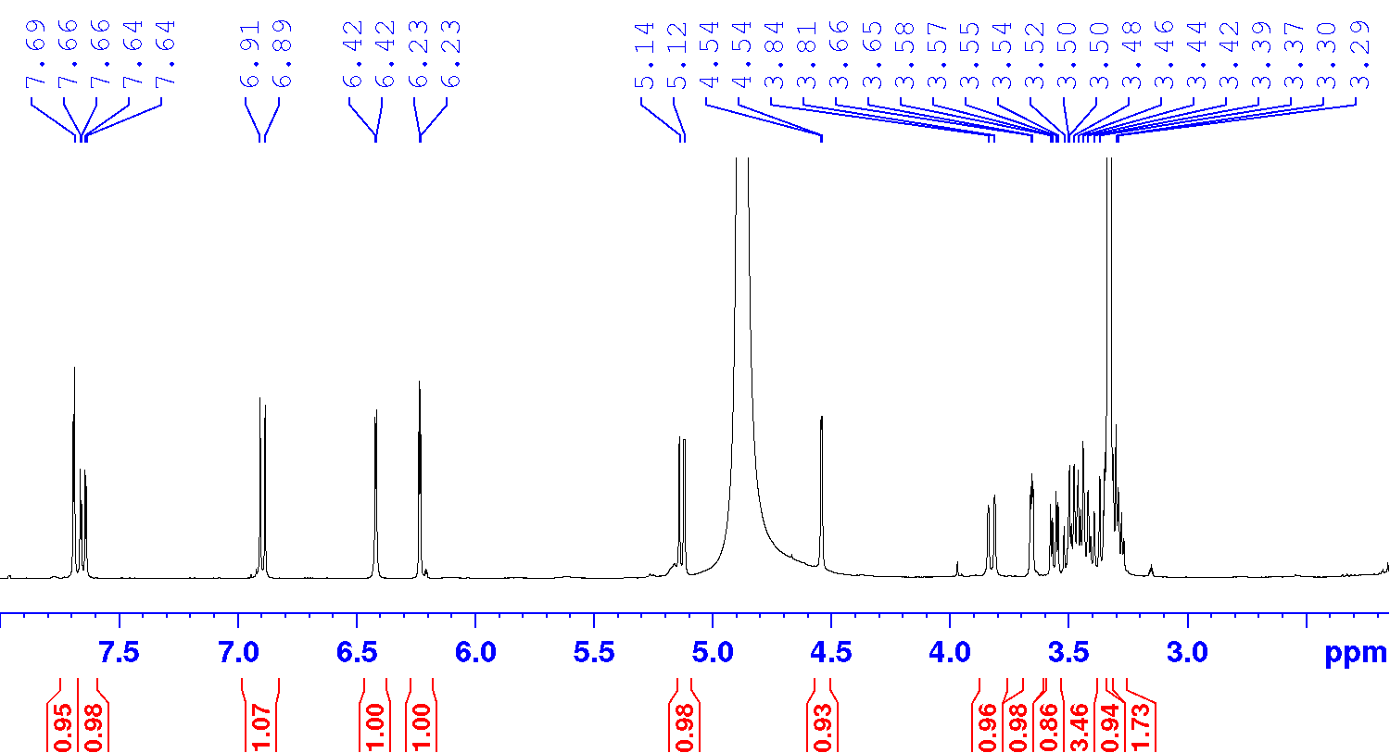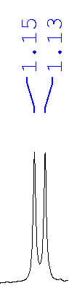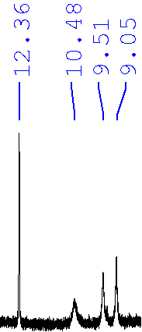

**Figure 1: 1H NMR of sample QY**

**Table 1: 1H NMR Data for Sample QY**

|  |  |  |  |  |
| --- | --- | --- | --- | --- |
| **Peak (δ ppm)** | **Multiplicity** | **Coupling Constant (J, Hz)** | **Functional Group/Assignment** | **Significant Peaks for Identification** |
| 12.3 | s | - | Hydroxyl group (-OH) | Yes, confirms hydroxyl group |
| 10.5 | b | - | Hydroxyl group (-OH) | Yes, confirms hydroxyl group |
| 9.5 | b | - | Hydroxyl group (-OH) | Yes, confirms hydroxyl group |
| 9.1 | b | - | Hydroxyl group (-OH) | Yes, confirms hydroxyl group |
| 7.69 | d | 2.2 | Aromatic proton | Yes, confirms aromatic group |
| 7.65 | dd | 8.4, 2.2 | Aromatic proton | Yes, confirms aromatic group |
| 6.90 | d | 8.4 | Aromatic proton | Yes, confirms aromatic group |
| 6.42 | d | 2.1 | Aromatic proton | Yes, confirms aromatic group |
| 6.23 | d | 2.1 | Aromatic proton | Yes, confirms aromatic group |
| 5.12 | d | 7.6 | Sugar proton | Yes, confirms glycoside unit |
| 4.54 | d | 1.6 | Sugar proton | Yes, confirms glycoside unit |
| 3.82 | dd | 10.8, 1.0 | Sugar proton | Yes, confirms glycoside unit |
| 3.66 | dd | 3.4, 1.6 | Sugar proton | Yes, confirms glycoside unit |
| 3.56 | dd | 9.5, 3.4 | Sugar proton | Yes, confirms glycoside unit |
| 3.48 | m | - | Sugar proton | Yes, confirms glycoside unit |
| 3.47 | m | - | Sugar proton | Yes, confirms glycoside unit |
| 3.45 | m | - | Sugar proton | Yes, confirms glycoside unit |
| 3.40 | m | - | Sugar proton | Yes, confirms glycoside unit |
| 3.34 | m | - | Sugar proton | Yes, confirms glycoside unit |
| 3.30 | m | - | Sugar proton | Yes, confirms glycoside unit |
| 3.29 | m | - | Sugar proton | Yes, confirms glycoside unit |
| 1.14 | d | 6.3 | Methyl group | Yes, confirms methyl group |

Source: Experimental data (2024)

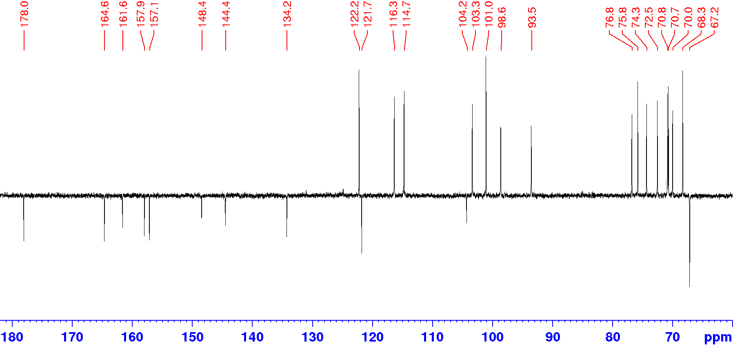

**Figure 2: 13C NMR spectra of sample QY**

**Table 2: 13C NMR Data for Sample QY**

|  |  |  |  |
| --- | --- | --- | --- |
| **Peak (δ ppm)** | **Literature Range (if available)** | **Functional Group/Assignment** | **Significant Peaks for Identification** |
| 178.0 | 176–180 | Carbonyl group (C=O) | Yes, confirms carbonyl group |
| 164.6 | 162–165 | Aromatic carbon attached to -OH | Yes, confirms hydroxyl group |
| 161.5 | 160–162 | Aromatic carbon attached to -OH | Yes, confirms hydroxyl group |
| 157.9 | 156–159 | Aromatic carbon | No, general aromatic signal |
| 157.1 | 156–158 | Aromatic carbon | No, general aromatic signal |
| 148.4 | 146–150 | Aromatic carbon | No, general aromatic signal |
| 144.4 | 143–145 | Aromatic carbon | No, general aromatic signal |
| 134.2 | 132–135 | Aromatic carbon | No, general aromatic signal |
| 122.1 | 120–123 | Aromatic carbon | No, general aromatic signal |
| 121.7 | 120–122 | Aromatic carbon | No, general aromatic signal |
| 116.3 | 115–117 | Aromatic carbon | No, general aromatic signal |
| 114.7 | 113–116 | Aromatic carbon | No, general aromatic signal |
| 104.2 | 103–105 | Aromatic carbon | No, general aromatic signal |
| 103.3 | 102–104 | Aromatic carbon | No, general aromatic signal |
| 101.0 | 100–102 | Aromatic carbon | No, general aromatic signal |
| 98.6 | 97–99 | Aromatic carbon | No, general aromatic signal |
| 93.5 | 92–94 | Aromatic carbon | No, general aromatic signal |
| 76.8–67.1 | 67–77 | Sugar carbons (glycoside unit) | Yes, confirms glycoside unit |
| 16.5 | 15–17 | Methyl carbon | Yes, confirms methyl group |



**Figure 3: FTIR spectra of sample QY**

**Table 3: FTIR Data for Sample QY**

|  |  |  |
| --- | --- | --- |
| **Peak (cm⁻¹)** | **Functional Group/Assignment** | **Significant Peaks for Identification** |
| 3400–3200 | Hydroxyl group (-OH) | Yes, confirms hydroxyl group |
| 1720–1700 | Carbonyl group (C=O) | Yes, confirms carbonyl group |
| 1600–1500 | Aromatic C=C | Yes, confirms aromatic group |
| 1200–1000 | C-O (alcohol or glycoside linkage) | Yes, confirms glycoside unit |



**Figure 4: Chemical structure of rutin (sample QY)**

**Table 4. Binding Interaction of ligands with proteins**

|  |  |  |  |  |  |  |  |  |
| --- | --- | --- | --- | --- | --- | --- | --- | --- |
| S/N | Ligands | Analgesic | | | Anti-inflammatory | | | Residue involved in H- bond interaction |
| **Binding Affinities of Targets (kcal/mol)** | | | | | |
| **TRPV1 (PDB Code 3J5R)** | **µ- Opioid Receptor**  **(PDB Code 4DKL)** | **Cannabinoid Receptor**  **(PDB Code 5XR8)** | **Phospholipase A2(PDB Code 1BP2)** | **Iterleukin -1**  **(PDB Code 1HIB)** | **NF-Kβ**  **(PDB Code 1NF1)** |
| 1 | Quercetin (E-380.43) | -8.9 | -7.1 | -9.5 | -8.1 | -5.0 | -6.1 | Ala, His, Phe, |
| 2 | Vitexin (E-409.01) | -9.7 | -7.0 | -8.2 | -7.9 | -4.0 | -7.4 | Glu, Arg, Thr, Asp. |
| 4 | Rutin (E- 751.59) | -10.6 | -7.6 | -8.2 | -7.7 | -3.4 | -7.1 | Gln, Thr,Tyr,Arg |
| 7 | Aspirin | -5.4 | -5.7 | -5.2 | -5.8 | -5.5 | -5.4 | Leu, Lys, Arg |

**Table 5: Pharmacokinetic properties of Quercetin, Vitexin, Rutin, Vanillin, 4- hydroxybutyric acid, Methyl 3-octenoate and Aspirin**

|  |  |  |  |  |  |  |  |  |  |  |
| --- | --- | --- | --- | --- | --- | --- | --- | --- | --- | --- |
| Ligands | Intestinal  absorption  (human) in % | Fraction unbound (human)  (Fu) | CYP3A4 inhibitor | Total Clearance  (log ml/min/kg) | AMES toxicity | Max. tolerated dose (human)  (log mg/kg/day) | LD50  (mol/kg) | Oral Rat Chronic Toxicity | Hepatotoxicity | Water solubility  (log mol/L |
| Quercetin | 77.207 | 0.206 | No | 0.407 | No | 0.499 | 2.471 | 2.612 | No | -2.925 |
| Vitexin | 46.695 | 0.242 | No | 0.444 | No | 0.577 | 2.595 | 4.635 | No | -2.845 |
| Rutin | 23.446 | 0.187 | No | -0.369 | No | 0.452 | 2.491 | 3.673 | No | -2.892 |
| Aspirin | 76.938 | 0.481 | No | 0.72 | No | 1.016 | 2.286 | 1.956 | No | -1.868 |

**Table 6. Characterization of drug-likeness molecular docking results**

|  |  |  |  |  |  |  |
| --- | --- | --- | --- | --- | --- | --- |
| Ligand | Lipinski rule parameter | | | | | |
|  | logP | MW | Surface area | nHBD(acceptors) | nOHDB(donors) | n Violators |
| Quercetin | 1.98 | 302.24 | 122.21 | 7 | 5 | 0 |
| Vitexin | 0.09 | 423.38 | 133.99 | 10 | 5 | 0 |
| Rutin | -1.69 | 610.52 | 240.90 | 16 | 10 | 4 |
| Aspirin | 1.31 | 180.51 | 74.76 | 3 | 1 | 0 |

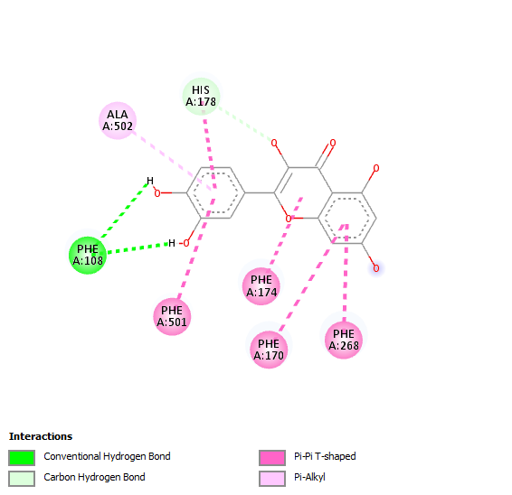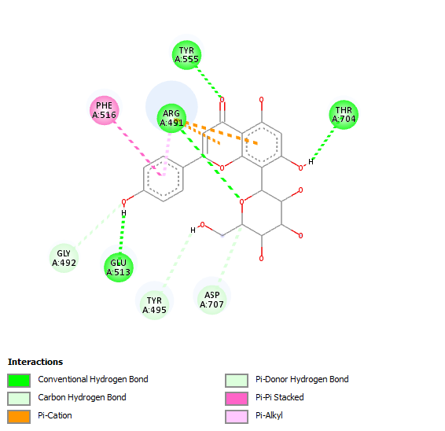

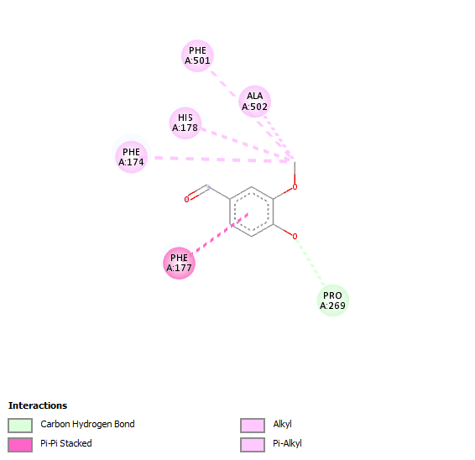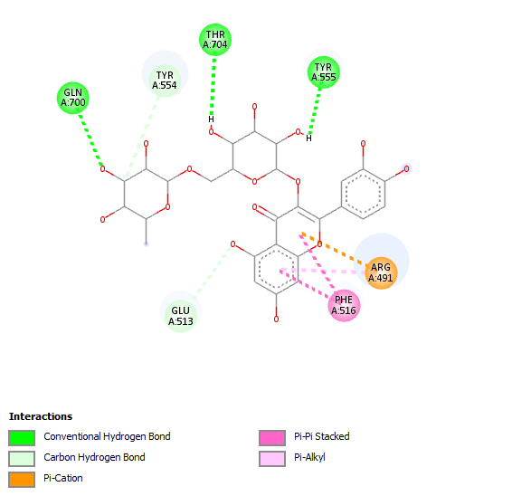

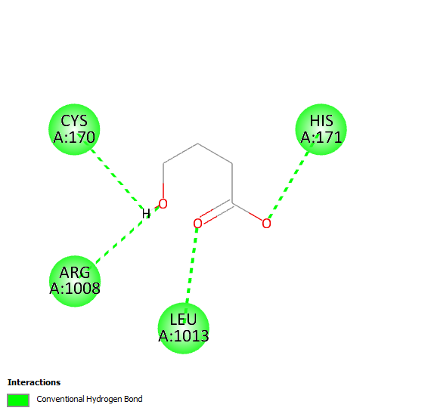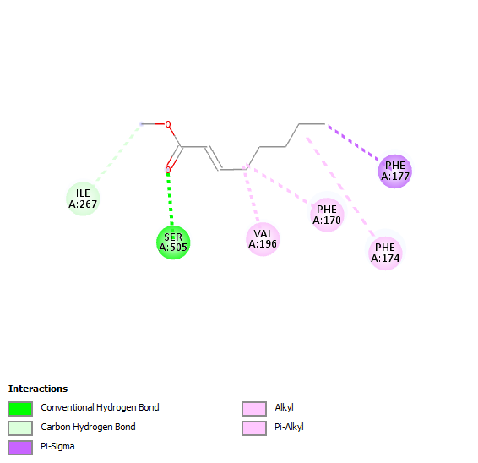

Figure 5. The 2D visualization results of ligands: Quercetin (E-380.43), Vitexin (E-409.01), Vanillin (E- 79.79), Rutin (E- 751.59), 4- hydroxybutyric acid (E-36.35), and Methyl 3-octenoate (E- 37.98) with analgesic target proteins.

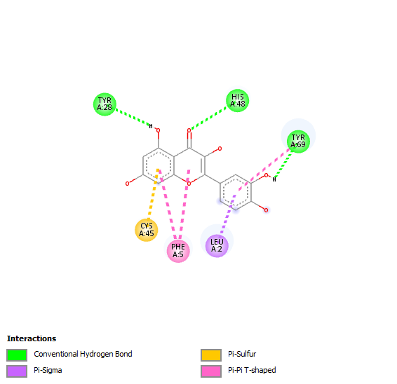 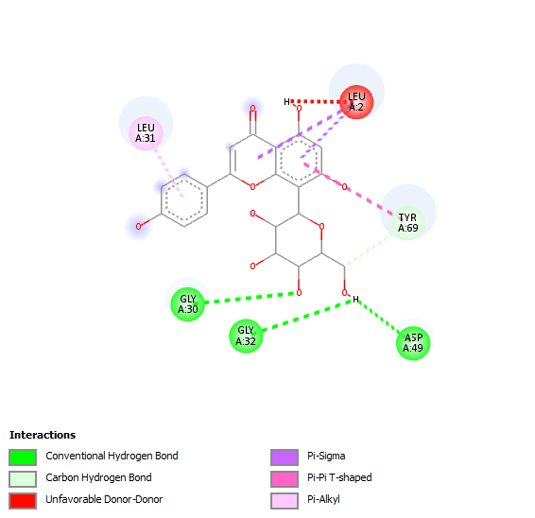

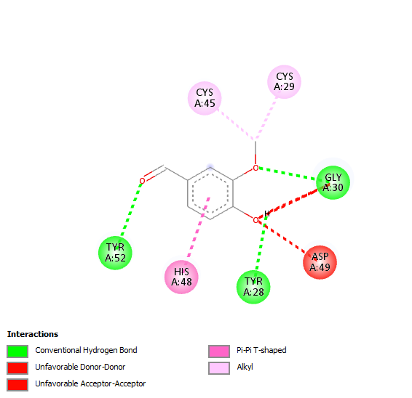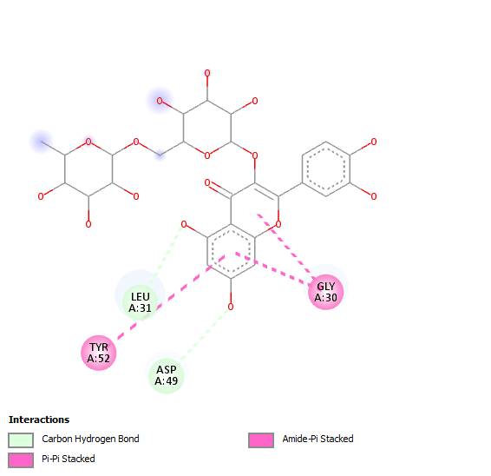

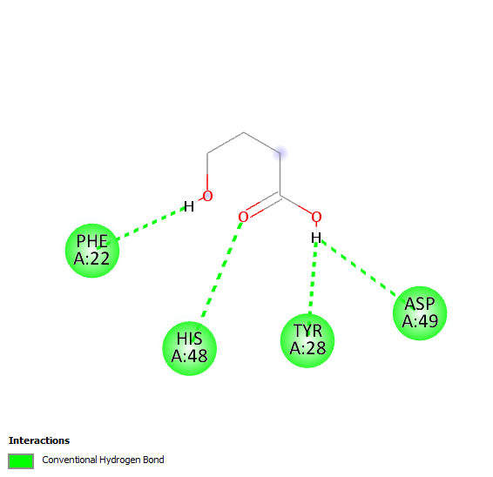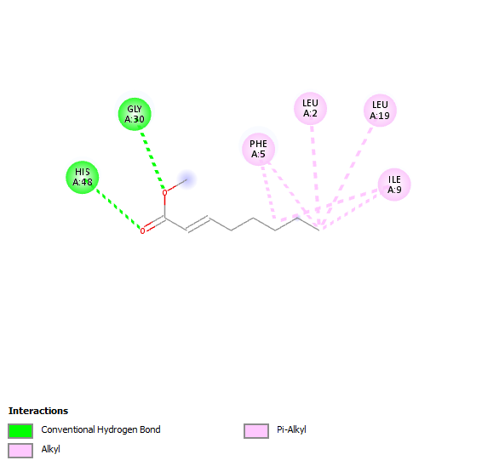

Figure 6. The 2D visualization results of ligands: Quercetin (E-380.43), Vitexin (E-409.01), Vanillin (E- 79.79), Rutin (E- 751.59), 4- hydroxybutyric acid (E-36.35), and Methyl 3-octenoate (E- 37.98) with anti-inflammatory target proteins.

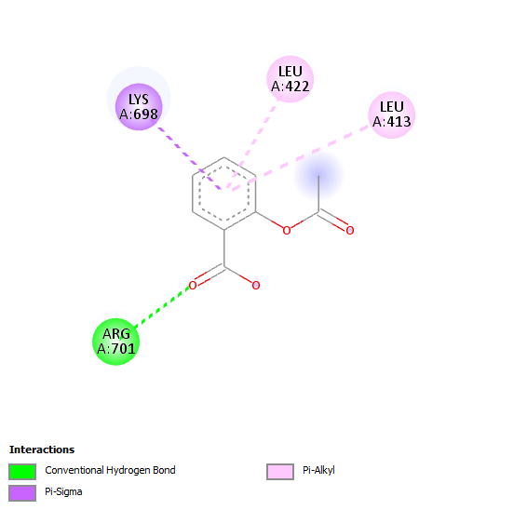

Figure 7. The 2D visualization results of Aspirin with the Transient receptor potential vanilloid 1 (PDB Code 3J5R).

**Discussion**

**Rutin**

Rutin is known for its antioxidant and anti-inflammatory properties. It can scavenge free radicals and inhibit inflammatory pathways, making it beneficial in managing oxidative stress and inflammation [8]. Rutin, also known as quercetin-3-O-rutinoside, is a well-known bioactive compound with antioxidant, anti-inflammatory, and other pharmacological properties. Studies have shown that it can inhibit key inflammatory mediators and protect against oxidative stress [9]. This compound’s isolation from *D. tripetala* underscores the plant’s therapeutic potential. It can inhibit microglial activation and reduce the production of pro-inflammatory cytokines [10]. The isolation of rutin from *D. tripetala* highlights the plant’s potential in developing natural anti-inflammatory agents.

**Molecular docking analysis**

The compounds were successfully docked onto the active site of target proteins (Transient receptor potential vanilloid-1, µ- Opioid Receptor, Cannabinoid Receptor, Phospholipase A2, Iterleukin -1 and Nuclear factor –kappa). Table 4 shows the binding energy, amino acid residues in H-Bond, and Hydrophobic Interactions in docking experiments. The lower binding energies seen between the ligands and the target proteins compared to the positive control (Aspirin) confirms the anti-inflammatory and analgesic potential *in silico*. The amino acid residues were essential components of protein active sites and played a role in hydrophobic interactions and hydrogen bond formation.

Table 6 reveals the results of the drug-likeness study performed using Lipinski's rules on the docked compounds. Rutin had four violations of the Lipinski rule out of the 7 drug-likeness compounds, with molecular weight, hydrogen bond donors, surface area and Number of hydrogen bond acceptors greater than 500, 5, 140 and 10 respectively. These violations indicate that Rutin may have poor oral bioavailability due to its size, polarity, and ability to form hydrogen bonds. Such properties can affect its ability to cross cell membranes and be absorbed in the gastrointestinal tract. Despite this, compounds that violate Lipinski's rules can still have biological activity and therapeutic potential, particularly if they are administered via non-oral routes (e.g., injection) or are designed to target specific sites. Lipinski's rule states that in general, oral active drugs must not have more than one violation of the following criteria Molecular weight ˂500, Number of hydrogen bond donors (nHBD) ≤5, Number of hydrogen bond acceptors (nHBA) ≤10, Calculated Log p ≤5 and Polar surface area (PSA) ˂ 140 Å 2). Quercetin, Vitexin and Aspirinviolated none of the Lipinski’s rules. Thus are good oral anti-inflammatory and analgesic candidates.

The pharmacokinetics study (Table 5) confirmed that the intestinal absorption, Fraction unbound (human)(Fu), Total Clearance (log ml/min/kg), AMES toxicity, L50 (mol/kg), Hepatotoxicity and most especially water solubility (log mol/L) are satisfactory.

**Conclusion**

This study revealed the therapeutic potential of *D. tripetala* due to its rich phytochemical constituents. The molecular docking analysis showed that rutin exhibits strong binding affinities with key analgesic and anti-inflammatory protein targets, such as TRPV1, µ-opioid receptor, and cannabinoid receptor. These findings validate the compound’s potential as a natural alternative for managing pain and inflammation. Despite rutin's notable bioactivity, its Lipinski rule violations suggest limited oral bioavailability, highlighting the need for innovative delivery methods or structural optimization to enhance its pharmacokinetic profile. Beyond rutin, this research also reinforces the broader pharmacological significance of *D. tripetala* as a reservoir of bioactive compounds with diverse medicinal properties.

**Disclaimer (Artificial intelligence)**

Author(s) hereby declare that NO generative AI technologies such as Large Language Models (ChatGPT, COPILOT, etc.) and text-to-image generators have been used during the writing or editing of this manuscript.

**References**

1. Iseghohi, S. O. (2015). A review of the uses and medicinal properties of *Dennettia tripetala* (Pepperfruit). *National Library of Medicine*, 3(4): 104-111.
2. Oyemitan, I. A., Iwalewa, E. O., Akanmu, M. A., Asa, S. O. and Olugbade, T. A. (2006). The abusive potential of habitual consumption of the fruits of *Dennettia tripetala* G.baker (Annonaceae) among the people in Ondo township (Nigeria). *Nigerian Journal of Natural Products Medicine*, 10(1): 55-62.
3. Elekwa, I., Okereke, S.C. and Chukwudoruo, C. S. (2011). Phytochemical screening and GC-MS analysis of the essential oil of *Dennettia tripetala* (pepper fruit) Seeds. *ABSU Journal of Environment, Science and Technology*, 1: 93-98.
4. Egharevba, H. O. and Idah, E. A. (2015). Major compounds from the essential oil of the fruit and comparative phytochemical studies of the fruits and leaves of *Dennettia tripetala* barker f. found in North Central Nigeria. *International Journal of Pharmacognosy and Phytochemical Research.* 7(6): 1262-1266.
5. Oyemitan, I. A., Iwalewa, E. O., Akanmu. M. A. and Olugbade, T. A. (2008). Antinociceptive and anti-inflammatory effects of essential oil of *Dennetia tripetala* G Baker (Annonaceae) in rodents, *African Journal Traditional Complementary and Alternative Medicine*, 5(4): 355-362.
6. Pahwa, R., Amandeep, G., Pankaj, B. and Jialal, I. (2021). Chronic inflammation. *StatPearls Publishing*. https://www.ncbi.nlm.nih.gov/books/NBK493173/ (Retrieved on August 2021).
7. Guvenalp Z., Kilic N., Kazaz C., Kaya Y., Demirezer L.O. (2006) Chemical constituents of Galium tortumense. *Turkish Journal of Chemistry*, 30: 515-523
8. Bezerra, D. P., Militao, G. C. G., de Morais, M. C. and de Sousa, D. P. (2016). The dual antioxidant/prooxidant effect of eugenol and its action in cancer development and treatment. *Nutrients*, 8(11), 682.
9. Kim, H. J., Kim, J. H. and Kim, J. H. (2015). Anti-inflammatory effects of methyl 2-octenoate in lipopolysaccharide-stimulated RAW264.7 cells. *Journal of Ethnopharmacology*, 174, 1-8.
10. Kimura, I., Ozawa, K., Inoue, D., Imamura, T., Kimura, M. and Maeda, T. (2018). The gut microbiota suppresses insulin-mediated fat accumulation via the short-chain fatty acid receptor GPR43. *Natue Communications*, 4.