**Ethical and Regulatory Challenges for Contract Research Organizations conducting (outsourced) clinical research in Sub-Saharan Africa with a case study of Cameroon**

**ABSTRACT**

**Introduction**

Contract Research Organizations (CROs), Clinical Research Centers/Networks and private research institutions play an important role in the clinical research process, especially in the drug discovery and development process. They act as essential partners for pharmaceutical drug delivery/development and biotech companies. Over the last few decades, the demand for outsourcing of clinical research by pharmaceutical companies has increased, with the market for CRO and private research institutional services growing significantly. This trend has been driven by a need for increased productivity and efficiency to meet the increasing research and development costs, as well as the complexities associated with modern drug development.

**Statement of objective.**

This study has an objective to establish CROs with known recognition in sub Saharan Africa. Special emphasis on Cameroon institutions regulating and conduct clinical research.

**Methodology**;

Historically, drug discovery services were predominantly conducted in-house, safeguarding intellectual property and close collaboration with internal teams. However, the competitive nature of the sector has motivated pharmaceutical companies to adopt an outsourcing model, allowing them to decentralize, outsourced and exploit specialized expertise and technologies offered by the CROs. These partnerships enable drug developers to accelerate the identification and validation of promising drug candidates through streamlined pre-clinical and clinical trial processes.

This is systematic research findings that we conducted a systematic search of the source documents from organizations, access to websites and google search to assemble our information, e-data information system. The systematic search gave us information on the contract organizations with online visibility. Vital information from annual reports, web information system management of the different organizations were accessible for easy navigations. Information on laws governing clinical research and major regulators in Cameroon

**Results:**

Through a systematic online search contract research organization operating in Cameroon and Sub Saharan Africa that were available and accessible on line were identified. The list was not exhaustive as some CROs may be in existence but we could not have access to their activities and home page for enough visibility online. The organizations and CROs operating in Cameroon have been well illustrated. The laws and regulations governing clinical research in Cameroon has been well illustrated. It was observed that CROs face multiple challenges. The Contract Research Organization (CRO) are faced with multiple challenges that can be a limiting factor to their growth and quality service delivery: These challenges are listed though not exhaustive as Technological Disruption, Regulatory landscape, intellectual Property Issues, Economic Volatility, Limited Human resource expertise, Return on investment/High Costs:

**Conclusion/Recommendation**:

The CROs in Cameroon are required to be in compliance with the law regulating research in human subjects of 2022 and the regulations on Clinical research in Cameroon. In sub Saharan Africa CROs are aligned with the regulation enforced in their different countries. The success of CROs is based on their compliance to innovative trends in clinical research and the capacity to strengthen collaboration among policy makers and actors. The ability to face challenging opportunities in clinical research and embrace transformative breakthroughs that can bring faster new chemical entities to the market at the same time improving the standard of care (SOC) of the population.

In the future, the synergy between innovation, strategic partnerships, and a commitment to excellence for CROs shall be the cornerstones of future success in conducting clinical research for Pharmaceutical drug discovery and development Based on the regulatory demanding nature of clinical regulation in Cameroon CROs must have a legal jurisdiction and recognition of their operation, and conform to the norms and standard laid down by regulatory authorities and the states of their jurisdiction CROs offer a wide range of services to support the development and execution of clinical trials, ensuring compliance with regulatory requirements and ethical standards.

Clinical Research Organizations (CROs) play a pivotal role in the pharmaceutical, biotechnology, and medical device industries as a research service delivery provider on a contract basis.

**Key words**- ethical, regulatory, contract research organization, private institution, service outsourcing, clinical research

**INTRODUCTION**

Clinical research plays a crucial part in the health care delivery and standard of care of the population through contribution in bringing new drugs to the market. Clinical research helps scientist to develop novel therapies, to treat, develop preventive strategies for the control and management of diseases [1]. clinical research is important and assures that particular disease therapies that are approved to the market have guaranteed safe, efficacious and of good quality. It is important to understand the potential side effects that is well documented and accessible to patients to allow them to make a choice of consumer acceptability [2]. CROs and other services delivery structures provides diverse array of services, englobing initial research and development to clinical trial management. CROs implement advanced technologies, including artificial intelligence (AI) and machine learning (ML), to enhance data analysis and improve operational efficiency [2]. These innovations are very important in appreciating the complexities of personalized medicine and the demands of patient-centered drug development. This study has an objective to establish CROs with known recognition in sub Saharan Africa. Special emphasis on Cameroon institutions regulating and conduct clinical research This paper also gives an overview of the ethical and regulatory challenges of CROs, private research institutions conducting clinical research outsourced by pharma companies

The clinical research process is defined by scientific rigor and an obligatory adherence and respect of ethical norms and standards. The upsurge of the COVID-19 pandemics illustrated the need for establishing some norms and standard in clinical research. Scientist, faced with the COVID 19 saw the urgency for developing vaccines for global intervention. There was the need to respect ethical regulation in their protocols, safeguarding data security and transparency. There is also a regulatory obligation that any treatment intervention is properly tested and validated before the regulatory approval for marketing authorization (MA) [3, 4].

**The Goals of Clinical Research**

The ultimate goal of clinical research is to advance medical knowledge and enhance the standard of care of patient population. It is important to note that for clinical research to be valid and applicable, the research must be conducted deliberately through a systematic investigation and data collection [5].

**Some important terminology in the study**

**Clinical Research:** The National Institutes of Health (NIH) defines clinical research as medical research that tests new treatments and therapies on people within a well-planned and structured approved protocol [1].

**Clinical trials:**

Clinical trials are a well-planned and structured research studies that test a new investigational product, surgical, medical device, or behavioral patterns in study subjects. These studies/trials are the main ways that scientist/researchers assess to determine if a therapy or prevention, or medical device, is safe and efficacious in human subjects [4]. NIH as defines clinical trials as research studies that assign one or more interventions to human subjects to evaluate the effect of the interventions on health-related outcomes, in both biomedical and behavioral research [1].

**Contract Research Organization (CRO**): is an institution or company serving as service delivery to provide support to the pharmaceutical, biotechnology, and medical device industries. They provide sponsors of pharmaceutical, biotech and medical device companies with research management services and technical research support. Traditional CROs provide clinical trial management services, while laboratory CROs provide drug discovery, manufacturing, laboratory and bioanalytical services with experimental analytical services [6]. An illustration of CROs functionality is illustrated in Figure 1.

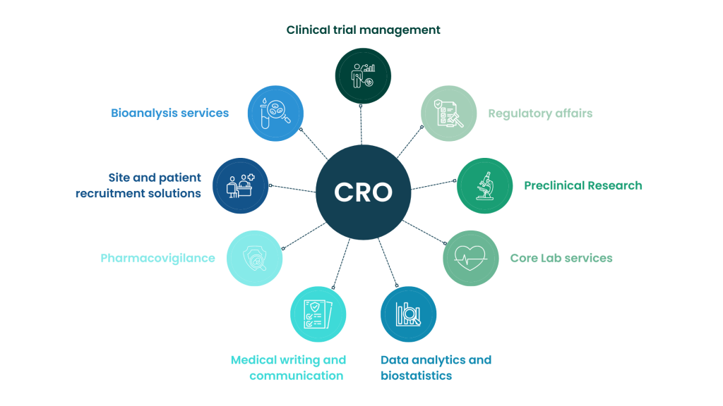

**Figure 1: CRO process and mission [3].**

**Methodology**;

Historically, drug discovery services were predominantly conducted in-house, safeguarding intellectual property and close collaboration with internal teams. However, the competitive nature of the sector has motivated pharmaceutical companies to adopt an outsourcing model, allowing them to decentralize, outsourced and exploit specialized expertise and technologies offered by the CROs. These partnerships enable drug developers to accelerate the identification and validation of promising drug candidates through streamlined pre-clinical and clinical trial processes.

We conducted a systematic search of the source documents from organizations, access to websites and google search to assemble our information, e-data information system. The systematic search gave us information on the contract organizations with online visibility. Vital information from annual reports, web information system management of the different organizations were accessible for easy navigations. Information on laws governing clinical research and major regulators in Cameroon

**Results**

**Regulation of Clinical Research in Cameroon.**

Clinical research in Cameroon from our search is regulated by structures put in place by the government, with a recent law no Law No. 2022/008 of April 27, 2022, relating to Medical Research Involving Human Subjects in Cameroon. Presidential decree N°98-405/PM DU 22 OCT 1998 regulating the homologation and marketing authorization of pharmaceutical products. The law is supported by many government circulars as follows;

Circular No 0977 /A/MINSANTE/SESP/SG/DROS/ of 18 April 2012 relating to the creation, organization and functioning of the national ethics committee for studies in human subjects. Nagoya Protocol on Access to Genetic Resources and the Fair and Equitable Sharing of Benefits Arising from their Utilization to the Convention on Biological Diversity: Protocols to the Parties to the Convention on Biological Diversity Nagoya, Japan [ref]. The Revised Standard Operating Procedures for Research Ethics Committees (RECs) in Cameroon, 2023. And the circular regulating clinical trials research in Cameroon [ 5}.

Cameroon Indicators of Clinical Research Regulatory Authority, Clinical research in Cameroon has been illustrated in figure 2

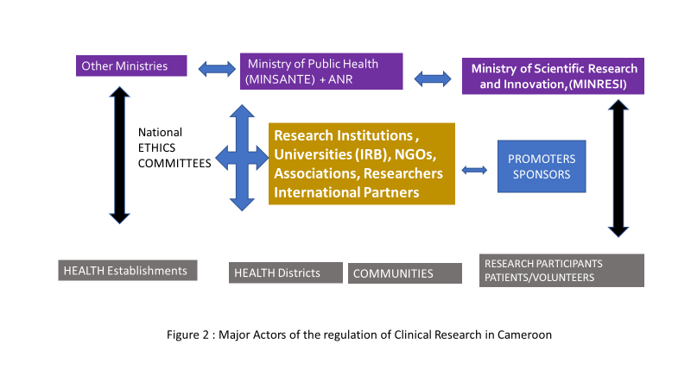

**The National Pharmaceutical Regulatory Authority**

This is the principal Medicine Regulatory Authority (NPRA) in Cameroon. However, it has 5 main actors that work collaboratively to complete the significant objectives of the NPRA. These actors (with French acronyms) include:

**The Department of Pharmacy, Drugs and Laboratories (DPML**).

The DPML is considered as the heart of pharmaceutical regulations in Cameroon and is one of the central technical divisions of the Ministry of Public Health [7]. DPML under the 2013 Act on the organization of the Ministry of Public Health, charges the DPML to develop and monitor the implementation of the national policy for the supply of pharmaceutical products including medical devices, collect and disseminate pharmaceutical information, among others.

**The General Inspectorate of Pharmaceutical Services and Laboratories (IGSPL).**

This service under the Minster of Public health coordinate the control of pharmaceutical services and laboratories in the country to assure good manufacturing practice and quality of drugs, vaccines and medical devices [6]

**The National Laboratory for the Quality Control of Drugs and Expertise (LANACOME).**

National Laboratory for Quality Control of Medicines and Expertise (LANACOME), by decree No. 96/055 of March 12, 1996. This decree confers on the laboratory the status of Public Administrative Establishment (EPA), endowed with legal personality and financial autonomy.

LANACOME function as a project supported by the World Health Organization, which characterizes it as a Laboratory which cover the Central African Region. For this, the WHO provides technical assistance, ongoing training of staff in the implementation of analysis procedures and methods, and the supply of reagents and reference substances.

Quality control activities for medicines and related products: vaccines, food products, food supplements, cosmetic products, condoms and medical devices. Research on the quality of medicines in circulation in collaboration with technical and financial partners (WHO), collaborative studies, etc.

Some expertise in narcotics, some medical plants and medical devices such as breathalyzers

· Some evaluations of Marketing Authorization application files. Continuing training and internships for students from university institutions.

**National Supply Centre of Medicines and Essential Consumables with French acronym (CENAME**)

This Centre was created by the Presidential Decree No 2005/252 of 30 June 2005 relating to the creation, organization and functioning of the National Supply Centre of Medicines and Essential consumable (French acronym CENAME). This structure was created to;

Ensure the availability, permanence and accessibility of essential medicines and medical devices throughout the national territory. Guarantee the quality of the essential medicines and medical devices that it distributes in accordance with the quality standards prescribed by the regulations in force; Provide regional funds for health promotion and other approved structures with essential medicines and medical devices at the best quality/price ratio; Carry out any other complementary or related operations that may be linked to its corporate purpose; Carry out any other mission entrusted to it by the public authorities and relating to its corporate purpose.

CANAME to ensure the availability, permanence and accessibility of essential medicines and medical devices, are required to provide the following services to clients; The acquisition of products from local and foreign suppliers; The storage of products according to good practices in force; The distribution of products in all regions of Cameroon; Quality management throughout the chain.

**The Division for Operational Health Research (DOHR) (French acronym DROS).**

DROS is under the tutelage of the Ministry of Public Health in Cameroon and is in charge of the maintenance and implementation of all public health services. They are charged with the responsibility of coordinating all health research, regulation and policies in Cameroon. They support government actions in making national health policy decisions and the conduct of clinical research in Cameroon [3]**.** DROS since its creation has contributed in shaping health research ethics by developing standard operating procedures for the national ethic committees, drafting laws and decisions relating to clinical research in Cameroon. All clinical trials with ethical approval require administrative approval by the Ministry of Health, within the jurisdiction of DROS.

**Health Product Registration.**

The National Drug Commission which is a statutory body in charge of evaluating all new drug product files submitted for marketing authorization approval and applications for the approval of pharmaceutical products for commercialization in the Cameroon market [7]. The approval process is rigorous and with well defined procedures and norms to be respected during the submission process. Health drug product registration is important for the state of Cameroon to keep inventory of all products circulating in the country to guarantee safety, efficacy and of good quality to support rational use of medicine by patients, and improvement of the standard of care.

**Inspections Services for quality assurance in Good Distribution Practice (GDP) and Good Manufacturing Practice (GMP).**

The GDP and GMP security deals with the quality assurance of medicinal products. This is done by a separate supply chain system. GDP guarantees that drug products is developed under regulatory compliance to assure a safe, efficacy and quality delivery of medicines to the patient population. GMP focuses on effective manufacturing process put in place and quality production of drugs [5, 6]. Good distribution practice (GDP) lays down the procedures required of the respect of minimum standards required by wholesale distributor to meet in order to ensure good quality and standard of drugs is maintained throughout the supply chain. Mandatory regulatory inspections on GDP and GMP are done in Cameroon by structured institutions. The General Inspectorate of Pharmaceutical Services and Laboratories (IGSPL),

service under the Minster of Public health coordinate the control of pharmaceutical services and laboratories in the country to assure good manufacturing practice and quality of drugs, vaccines and medical devices [6 ]The IGSPL Inspections are mandated by the law to perform regular inspections of the structures where pharmaceutical activities of drug manufacturing occurs. Inspections are legal obligations by the government that are done at least once in a year [8]. There is no information on the technologies used for regulatory inspections [7].

**National Laboratory Policy Management**

The Government of Cameroon through the National Development Strategy 2020-2030, is focused on strengthening the Cameroonian health system in all aspects by 2030. Improving the quality of health care for a better standard of care (SOC) to patients to services delivered to the population necessitates the putting of structures in place for a better and high performance of laboratory system with capacity to providing high quality services complying with relevant standards. It is on the basis of this organization that the strategy for a universal health coverage can be effective in Cameroon within the vision of the World Health Organization and Africa CDC. Through the drive for policy action initiatives establishment Cameroon has worked in collaboration with WHO to develop the National Laboratory Policy (NLP). in accordance with the Health System Transformation Agenda, Cameroon has a Biological and medical analysis laboratories database which is building capacity for effective functioning. However, information on the database is currently not available. There is also a logistics information management system that is being developed to have the logistical data they need to effectively manage the health product supply chain [7].

**Pharmacovigilance**

A national pharmacovigilance 9PHV) system has been developed in Cameroon working in collaboration with WHO. The principal objective of the PHV system is to protect the safety of all citizens exposed to new intervention products available to the population. The PHV system is set up enhance detection of potential adverse drug reactions (ADRs). These reactions could occur under the use of health products in normal conditions, abuse, misuse, poor quality of the product, irrational use of medications and others unknown factors. The national pharmacovigilance system consists of the created national pharmacovigilance commission, the pharmacovigilance Centre and the pharmacovigilance technical committee [7]. A member of the community, patient or health care provider is capable of reporting an adverse drug reaction. There are procedures in place for reporting ADRs, available online and coordinated by the Division of Pharmacy, medicine and laboratory (DPML) services under the Ministry of Health. The Commission for Pharmacovigilance set up since 2019 in Cameroon is a structure to regulate similar research within the Country and to collaborate with international actors for a global safety of the use of essential medicines [7, 8].

**Clinical Trials**

Clinical trials are conducted in Cameroon and regulated by the division for health operations of the Ministry of Health.; However, a clinical trial study needs an ethical approval by the National ethics committee and an administrative authorization by the Ministry of Health before the study can be initiated. All the clinical trials phases 1-4 can be conducted in Cameroon. The investigator must apply for an ethical clearance which is overseen by the national ethics committee or the regional ethics committee and the institutional review board (IRB). For clinical trials study an insurance cover is mandatory for the protection of subjects in the event of clinical trials gone wrong [8]

**Post Marketing Surveillance**

In phase IV studies in Cameroon, post-market surveillance studies are necessary to monitor and evaluate pharmaceutical products that are commercialized on the market. The national pharmacovigilance commission in Cameroon was created by the Ministry of Health (MoH) to monitor adverse events in drugs, regulatory compliance of medical devices and the homologated medicinal products in use [9]. It is mandatory for drugs, medical devices and vaccines approved for use in Cameroon to conduct phase IV studies on the population to assure sustainable use and effective monitoring.

**Import and Export**

There is a gap of information on drug flow on the exportation of drugs that has been homologated in Cameroon. Drug importation, regulations available is based on the authorization of imported drugs based on quality, and meeting the pharmacopoeia of the exported countries of manufacturing. Only drugs that has been approved by the regulatory authority in Cameroon can qualify for an Official Import Authorization (AOI) submission. An Official Import Authorization form can be acquired from the Ministry of trade, the agency for norms and standard (*ANOR)*. The Office of Standards and Pharmaceutical Legislation at the DPML office. The Official Import Authorization forms are processed and signed by the Minister of Public Health before it is approved at the Office of Standards and Pharmaceutical Legislation. A well-structured Information on systems used for this process is still in the process of development [9]. In Cameroon non, approved drugs can only be imported for research purposes only.

**Licensure-Professionals and Structures in operation.**

The Division of pharmacy, medicines and laboratories (DPML) authorizes pharmaceutical industries and professionals to operation and function in Cameroon. There is little information on the established system or portal with respect to licensing of professionals in Cameroon. To obtain a license to operate as a pharmaceutical company or to operate as a pharmaceutical professional in Cameroon, the applicant is required to meet the regulatory requirements put in place, with a developed SOP. The applicant is required to complete the necessary forms, which are available on the website of Ministry of Health. These documents must be submitted to the DPML for study and evaluation. After the evaluation process, the application would then be approved, and a certificate of authorization of license and to operate in Cameroon would be given to the applicant [7].

**Monitoring and Evaluation**

The Ministry of Health has put in place a system for the monitoring and evaluation of good distribution and good manufacturing practice in the drug and medical devices chain in Cameroon. However, there is no information regarding the processes and activities involved in monitoring and evaluation. Monitoring and evaluation are obligatory in all aspects of clinical research developments. There is the need for the monitoring and evaluation of clinical research studies, especially clinical trials with ethical clearance approval by ethical committee. This is to guarantee effective implementation of studies in the field [9]

**Track and Trace Module in Cameroon.**

Following the standard operation procedure manual for the standard management of drug operations in Cameroon, stock cards are regularly in use to track and monitor the movement of pharmaceutical products in the supply chain. This movements include mostly the entry and exit from one sector such as the manufacturer, wholesale or distribution. Drug stock managers are in charge of updating on a regular basis availability of stocks. Despite the effort in tracking pharmaceutical products movements in the country systemin operation is not popular and less is did to give awareness. [7].

**Mapping of Private Contract Research Organization/institution in Cameroon.**

There has been a great interest in clinical research in Cameroon through partnership with foreign actors and pharmaceutical companies promoting interventional studies in Cameroon. This research interest has created the need for clinical research organization incubation hubs. There is the need to identify some of those CROs established in Cameroon, for a better understand of their ethical regulation compliance. The CROs identified in Cameroon but not exhaustive can be shown in Table 1.

|  |  |  |  |
| --- | --- | --- | --- |
| **Table 1: The identified Private Contract Research Organization/institution in Cameroon with online visibility and Administrative Authorizations.** | | | |
| **No** | **Centres/Organizations** | **Research Portfolio** | **LOCATION/**  **CREATION** |
| 1 | Center for Research on Emerging and Re-Emerging Diseases (French Acronym *CREMER)* | Virology laboratory. Research on all emerging and re-emerging viral diseases | Yaoundé, |
| 2 | Centre for Research and Military Health (CRESAR), Cameroon | Medical and Biomedical research in Military community | Yaoundé |
| 3 | Pasteur Center of Cameroon (CPC): | Member of the International Network of Pasteur Institutes (RIIP), Main mission of fighting infectious diseases | Yaoundé |
| 4 | Research Institute for development (*Centre de recherche pour le development -IRD)* | Institute based in Cameroon and Central Africa. Research programmes in the domain of Environment and human Health | Yaoundé, 1960 |
| 5 | Higher Institute for Scientific and Medical Research (ISM) | Non-profit institution Better known as CRFilMT (Center for Research on Filariasis and Other Tropical Diseases. | Yaoundé created in 2005 |
| 6 | CRENC: Clinical Research Education, Networking Cameroon | Clinical Research Education, Networking and Consultancy | Yaoundé |
| 7 | Health Research Foundation (HRF) | Multidisciplinary platform that uses applied research to lead change in health care | Yaoundé |
| 8 | The International Medical Corps (IMC) | Work on displaced populations in refugee camps with vulnerable populations to implement health programs that focuses on disease surveillance, nutrition activities, gender-based violence (GBV), prevention and response to mental health, psychosocial support (MHPSS) and child protection | Adamawa, East, Far North, North and Northwest |
| 9 | Health education research foundation (HERO) | Health care research | Yaoundé, Cameroon |
| 10 | SGS Health Science Cameroun S. A | Conducts early and late phase clinical trials throughout the world. | Douala |
| 11 | Centre for medicinal plants and traditional medicine research (IMPM) | Research on Traditional medicine pharmacopoeia provide appropriate medicines and therapies using local natural substances | Yaoundé |
| 12 | ICAP AT Columbia university | Research on infectious diseases in collaboration with the Ministry of Public Health in assessing the impact of HIV response to treatment in Cameroon. Activity base programme on strengthening capacity to HIV treatment and care services, reduce perinatal transmission of HIV and increasing access to antiretroviral therapy (ART) for HIV-infected women and their families | Yaoundé, 2003 |
| 13 | WCG CenterWatch Clinical Services | Global Clinical Trial Relationships Survey with sponsors and CROs during the pandemic | Not identified |
| 14 | National Agency for Research on AIDS and Viral Hepatitis (ANRS) | Conduct Clinical research in infectious diseases (HIV, Hepatitis) | Yaoundé |
| 15 | The Cameroon Health Initiative at UAB (CHI UAB) | Focuses on improving the health of women and children in close collaboration with Cameroon partners | 2013 |
| 16 | Chantal Biya International Reference Centre (CIRCB) | Work in collaboration with the African Synergy Against AIDS and Suffering. It also works in close collaboration with UNESCO and the World Foundation for AIDS Research and Prevention for the transfer of technology. | Yaoundé |
| 17 | FHI 360 | Focuses on improving education, health and civil society. Initiatives providing HIV services | Yaoundé |
| 18 | Infiuss Health | Main aim is in transforming clinical research by removing the biggest barriers that slow studies down. Has I a complete AI-powered ecosystem for the management of project. | Not indicated |
| 18 | Central Africa Clinical Research Network (French Acronym CANTAM) | A network that conducts clinical trials for HIV/AIDS, malaria, tuberculosis, and other diseases in Central Africa. It was established in 2009 to strengthen clinical research capacity in countries like Cameroon and the Republic of Congo. Conducts clinical trials in accordance with ICH/GCP standards | Yaoundé, 2008 |
| 20 | Health Education and Research Organization (HERO), and Bamenda Center for Health Promotion and Research (BCHPR), | Research in health promotion, rural community development. | Bamenda, Cameroon |
| 21 | Elizabeth Glaser Pediatric AIDS Foundation in Cameroon (EGPAF-Cameroon) | EGPAF supports 190 health facilities in the country to provide high-quality, comprehensive HIV and AIDS services to women, children, and families. Supported the first five Prevention of mother-to-child transmission (PMTCT), health facilities in Cameroon working in partnership with the Cameroon Baptist Convention Health Services (CBCHS). | Bamenda in 2000 |
| 22 | Doctors without Borders (French Acronym (MSF) | Doctors Without Borders has been providing medical and nutritional care in Cameroon since 1984. Supports local authorities with medical and nutritional care, and responses to health emergencies and malaria outbreaks | Yaoundé, 1984 |
| 23 | Centre for Research in Infectious Diseases (CRID). | A Centre with an excellent environment for high quality and internationally approved health research on vector -borne diseases in Cameroon and Africa. Strengthens capacity training of the next generations of African scientists in vector biology. | Yaoundé |
| 24 | Research Foundation in Tropical. Diseases and the Environment. | Conduct research in Tropical Diseases | BUEA, CAMEROON |
| 25 | The Clinton Health Access Initiative (CHAI) | CHAI is a nonprofit global health organization committed to building a world in which everyone is able to live a healthy and fulfilling life. A global health organization collaborating with The Ministry of Public Health to drive change across entire health care system | Bamenda, 2002 |
| 26 | Centre for Health Implementation and Translational Research (CHITRES) | A Global Health Research unit of the Fobang Institute for Innovation in Science and Technology (FINISTECH). Provide solution to government through the evaluation of programs and clinical trials on interventions, including research on host and pathogen genomics. | Yaoundé |
| 27 | Brain Research Africa Initiative (BRAIN) | A non-governmental organization in Cameroon for promoting health for development in Africa through brain health research, education and service provision. | Yaoundé. |
| 27 | Organization for Coordination and Cooperation for the fight against the major endemics in Central Africa. *(Organisation de Coordination des Endémies de l'Afrique Centrale* (OCEAC). | Created in 1963 in Cameroon by the Ministers of Health Cameroon, Congo, Gabon, Central African Republic and Chad. This creation corresponded to the vast movement and migration, of displaced communities due to war and social unrest that settled in Africa. | Yaoundé |

**Selection of Contract Research Organization for outsourcing and Funding of Projects**

Selecting a Contract Research Organization (CRO) for developing drugs, devices, or vaccines requires a comprehensive evaluation of the organization’s capabilities, reliability, and track record. Conducting site visits and engaging with the CRO’s team offers valuable insights into their operational practices and culture. Such in-depth assessments are vital to determine a CRO’s fitness for clinical development projects, especially regarding regulatory filings through Phase I-III clinical trials for drugs, devices, and vaccines [9, 10].

**REGULATION FOR CONDUCTING CLINICAL RESEARCH BY CONTRACT RESEARCH ORGANIZATIONS**.

The regulation for conducting clinical trial research by a CRO takes into account the legal status and accreditation of the institution. The institution must be legalized to operate with a national accreditation. They need to a research proposal and obtain ethical approval from an institutional review board (IRB) or ethics committee. In Cameroon ethically, approved study with an ethical clearance require by the law governing health research an administrative authorization before a study is launched for commencement. For studies on investigational products the Drug regulatory authority (Division for Pharmacy, Medicine and Laboratory (DPML) must issue approval for use in clinical research, approval from the appropriate regulatory agency, and accreditation of Good Clinical Practice (GCP) guidelines. For field studies authorization is required in Cameroon from the regional delegates of health, and community participation from village community leaders. The U.S. Food and Drug Administration (FDA) has categorized the various types of clinical research under the following groups [11, 12]:

**Treatment research.** This involves studies for new drugs**,** psychotherapy research, medical devices, surgical and therapeutic procedures with other related innovative clinical interventions.

**Prevention research.** This involves techniques and methods of preventing or reducing the progress or re-emergence of diseases and pathologies through drugs, vitamins, vaccines and in some cases lifestyle diseases.

**Diagnostic research.** This is based on applyingeffective techniques to identify diseases or syndromes that can support clinicians and health practitioners to enhance their prediction of disease diagnosis in patients.

**Genetic studies.** This is designed to evaluated the associationbetween genes and disease with the objective of improving disease prediction and estimating the chances of an individual infection of a specific disease. The aspect of genetic polymorphism, mutations, genotype by environment interactions can be widely studied. This also involves support for personalized medicine (Pharmacogenomics application).

**Epidemiological studies.** This focuses on identifying trends in diseases patterns**,** incidence, prevalence and integrated disease management in certain populations by identifying risk factors and protective factors for those diseases at particular place and time.

**Clinical studies** Thus is a type of research that evaluates the efficacy and safety and quality of new intervention products in the population. The studies apply high through put new screening methods using test battery assays, the prevention, diagnosis, or treatment of new diseases or existing disease with potential treatment drug products [12]

There are two major types of clinical trials. The interventional and observational study. The interventional trials is applied to investigate a particular intervention, or treatment, while the observational studies aim at determining the outcome of treatment of people in under different situations.

**The need for Ethical Review Process in Clinical Research**

Health research ethics in clinical research are important in public health research and one health implementations. Ethical strategies ensure the integrity of the research results and also protect the safety of patients who participate in such studies. Ethical evaluation of studies prevents participants from being exploited or treated unfairly by the research team. Government regulations require that all clinical trials proposals be approved by an Ethical Committee, institutional review board (IRB), to ensure that the trials are ethical and that the rights of participants are protected. Some of the main ethical concern related to clinical trials is whether participants are fully informed about the risks related in the trials and the possibility that they will not personally benefit from the research. There is also fairness in selection of participants and the freedom to withdraw at anytime from the study without any consequences [13, 14].

**Ethical and regulatory issues with Clinical Research**

There has been abuses in the past that has motivated regulatory compliance in clinical research. These ethical issues are still a big challenge to medical researchers today. To manage clinical research misconducts, established state regulations requires that any research conducted with a human participant be reviewed and approved by an institutional review board (IRB) and the study once launched should be monitored till the close out of study. The ethics committee members must be multi-disciplinary, preferably physician-researchers, biomedical scientist, legal experts, biostatisticians and civil society advocates. Apart from a few exceptions, all research subjects have to give their informed consent before participation in a clinical study including disclosure of information about the study’s processes and goals. The issue of informed consent is the source of much conflict and debate among clinical researchers and contract research organizations. Adequate information on the risk and benefit of a study, insurance cover for clinical trials are major challenges in Clinical trials research in Cameroon. The spirit of voluntarism, and freedom to withdraw at any time in the course of a study by participants can be very challenging for studies in phases 1 and phases II. [6, 15].

**Vulnerable and special Populations**

The FDA’s criteria for research approval states that research involving vulnerable populations must consider the unique characteristics of those groups and the impact their research may have as a result of these peculiarity of that population. Vulnerable populations include children, prisoners, pregnant women, physically and mentally challenged people and economically or educationally disadvantaged people [8, 10]. The challenges clinical research face when conducting clinical trials especially on vulnerable population are multiple: For fair subject selection, it is important to include the vulnerable population- women and all other segments of the population during clinical research, while taking special care and consideration for test involving pregnant women and breastfeeding mothers, so as to prevent mother to child harmful effect [16].

During the conduct of pediatric studies, researchers needs to guarantee that the child needs to consent by assent or by proxy consent by a legal representative. Clinical research that involves patients who have an incurable disease or chronic disease should take into consideration and guarantee that the patient is not consenting because of any false assumptions of benefiting personally from the research [2, 17]. It has been reported that in some resource limited countries, the financial incentive to participate in several trials serially or simultaneously can be harmful to healthy volunteers. Research indicates that a high percentage of these volunteers do not have critical information of what can qualify them to participate in a paid research study. The motivating factors that hinders the fair treatment of vulnerable populations who take part in clinical research include the following [18]:

**Monetary Compensation**

Other major ethical issues for clinical researchers identified was linked to how much participants in studies should be compensated for their time dedicated to participate. We observed that Many CROs make provisions for compensation to participating subjects strictly for their out-of-pocket expenses only, this payment is in conflict with some patient advocates who strongly believe that compensation of participants should consider time lost at work to take part in the study, or simply put advocates are on the opinion that there should be incentive for participating in a clinical study. Ethical issues related to paying clinical research participants is based on the undue influence and coercive tendency of offering money in exchange for the voluntary acceptance of the risk of contracting a disease or otherwise exposed to harm during the research process. The lack of regulatory guidelines establishing fair subject participation and compensation highlights question of ethics of the pharmaceutical companies funding/sponsoring clinical research with the hope of making great profit from the products outcome being tested and approved for sale. The FDA and other ethical international bodies such as the declaration of Helsinki modified version of 2024 lay emphasis on protection of participants in clinical studies. For the issue of monetary compensation of study participation, this has been well elaborated and documented in the resources found at: the Food and Drug Administration on the payment and Reimbursement to Research Subjects [19-21].

**Regulating international clinical research:**

The global distribution of clinical trials is shifting to low-income and middle-income countries (LMICs), and adequate regulations are necessary for protecting the rights and interests of research participants in these countries [12]. However, policy-makers in LMICs are faced with ethico-legal challenges due to strong regulatory compliance for the protections for participants that can lead to many researchers or sponsors to conduct their research elsewhere, by so doing potentially depriving the local population of the opportunity to benefit from an international clinical research. The local governing bodies for regulation of clinical research are therefore charged with ethical and regulatory policies to support policy-makers to promote clinical research in their countries. In Cameroon a set of regulatory laws and administrative decisions have been put in place to support clinical research funded by international sponsors.

**Patient Recruitment and recruitment strategies**

Patient recruitment in clinical trials is usually a very time-consuming part of clinical trials. Scientists attempt more regularly to find more effective ways of recruiting volunteers, without any compromise of clinical quality [12]. However, recent innovation in recruitment has been the creation of contract research organizations (CROs), that has become an entire recruiting industry and performing outsourcing clinical services for pharmaceutical companies, to help researchers recruit patients to participate in their studies. In Cameroon for example, over a dozen established research institution have been identified as contract research organizations. The legal jurisdiction of these CROs needs to be defined to assure their credibility in conducting and recruiting participants for clinical studies. For example, the company Antidote is one of 15 clinical trial recruitment firms that are in the business of connecting medical researchers with patients who are candidates for specific clinical trials. Researchers may compete for patients who meet the cirteria for their proposed trials, as explained in *Contemporary Clinical Trials Communication*. The interests and wellbeing of patients must come before any other research considerations, including the need to inform patients of all their options as well as all risks and benefits. on the ethics of human gene editing [6, 22].

CROs develops effective recruitment strategies for patient’s participation in studies that requires meeting sample size criteria for a better power of statistics. The strategies include the use of patient’s data bases, building or develop specific target patient models, avenues to connect with patients using digital platform. They can perform community outreach through community engagement groups, use of word of mouth in local community groups, churches. They have to take into consideration socio-cultural diversity of the participant population, while collaborating with recruitment agencies, communication channels, while maintaining a clear focus on communication and continuous better improvement of optimizing patient enrollment and maximum participation in the clinical trials.

**IMPORTANCE OF ETHICAL AND REGULATORY CONSIDERATIONS IN CLINICAL RESEARCH**

Ethical and regulatory issues continue to be of great concern in shaping the process for clinical research to integrate the protection of patients during the study period. Attention to these ethical concerns for compliance in study trials is vital to guarantee the scientific and ethical norms of clinical trials [23]. With the advent of the advantages brought about by the outcome of CRO outsourcing services, there are identified challenges facing the CRO industry such as upholding reliable partnerships, and adapting to the changing shift in paradigm of the fast-growing industry. The CROs have assumed an import role as the pharmaceutical industry are constantly exploring new ways advance their research portfolios while optimizing the clinical study designs. The role of CROs has becomes very important and requires a more sustainable and effective collaboration and working synergy between CROs and the pharmaceutical industry partners. Such collaboration can lead to successful drug candidates reaching the market and addressing the unmet medical needs that drives advancement in healthcare, and significant reduction of drug attrition [24].

**Organization of Contract Research Organizations (CROs)**

Contract Research Organizations (CROs) play an important role in clinical trial management. They are specialized institutions providing support services to sponsors in conducting clinical trials. Their role is to guarantee that clinical trials are conducted within the framework of ethical and regulatory compliance, in an efficient and effective manner [22]. CROs conducts or are very involved in clinical trials and render other research support services to sponsors of clinical trials. They perform outsourcing services to support drug-related institutions, government services, on-governmental organizations, foundations, and university institutions. CROs acts as clinical research outsourcing service providers to these sponsors to conduct clinical trials for a limited period stipulated for the study. Each study undertaken by the CROs have a study life cycle and must be done within the confines of the ethical clearance duration.

CROs usually offer many outsourcings like: product development, clinical trials, laboratory services for processing and analysis of trial samples, archiving of samples in biobank/biorepository, medical writing, regulatory affairs, post-marketing surveillance and other complementary services. With the CROs, sponsors get their drug products approved by the regulatory authorities like the FDA, for marketing authorization and launching. Other benefits of the CROs include reduced time for the drug development process and approval of a new drug to the market, reduce cost of maintaining permanent personnel and cost of facilities. They also deal with a large amount of data (Big data), conduct very complex clinical trials designs and render their services according to the regulatory affairs of a particular region. All these activities bring many challenges for these companies.

**The Contract Research Organization Platform**

CROs are well established clinical research institutions/ companies providing support to sponsors in the conduct of a clinical research such as interventional/clinical trial study. They may be contracted by the sponsor to manage different aspects of clinical trial like site selection, participant recruitment, data management, study monitoring, and safety reporting of adverse drug reactions (Pharmacovigilance). CROs play a vital role to assure that clinical trials are conducted to guarantee, efficacy, safety and quality of drug products, medical devices, vaccines, and in compliance with ethical regulatory requirements. [25]. A classical CRO organigram is illustrated in Figure 2.

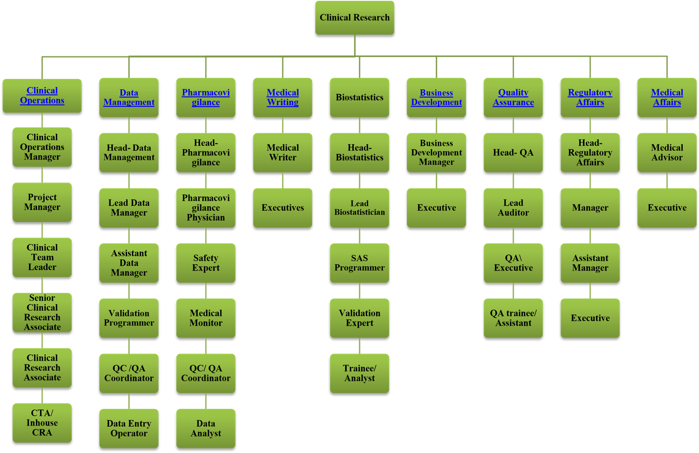

**Figure 2: A typical organizational chart of CRO [4]**

**Roles and Responsibilities of CROs in the Management of Clinical Trials.**

**Study Site Selection and Management**

CROs are responsible for identifying and selecting suitable study clinical sites for each trial. They must ensure that the selected study sites have the necessary infrastructure, logistics and expertise to conduct the trial. CROs are also responsible for managing the activities of the clinical study sites, including training, trial monitoring, and study technical and logistic support [25].

**Study Design and Protocol Development**

CROs provide input into the study design of the trial and assist with the development of the protocol. They must ensure that the trial is designed in a way that is feasible, ethical, and scientifically valid. The CRO must also ensure that the protocol is effectively applied in the field, through study monitoring during the conduct of the trial [19]]

**Regulatory Compliance**

CROs are responsible for ensuring that the study trials are in compliance to all applicable regulatory requirements and the fundamental ethical principles of respect of human, beneficence, non-maleficence. The CRO must ensure that the trial is conducted in compliance with the International Council on Harmonization (ICH) guidelines, the Helsinki Declaration, Good Clinical Practice (GCP) guidelines, and local regulatory guidelines [26].

**Data Management**

CROs are responsible for managing the collection, storage, and analysis of trial data. Ensure that data safety management board is in operation for clinical trials study, ensuring that data are collected and recorded accurately, and securely stored. The CRO is also responsible for ensuring that data is analyzed according to the statistical analysis plan outlined in the protocol, confidentiality of data and archiving for a defined period of time [15]. Clinical data management is a highly regulated process as illustrated in figure 3 and 4.

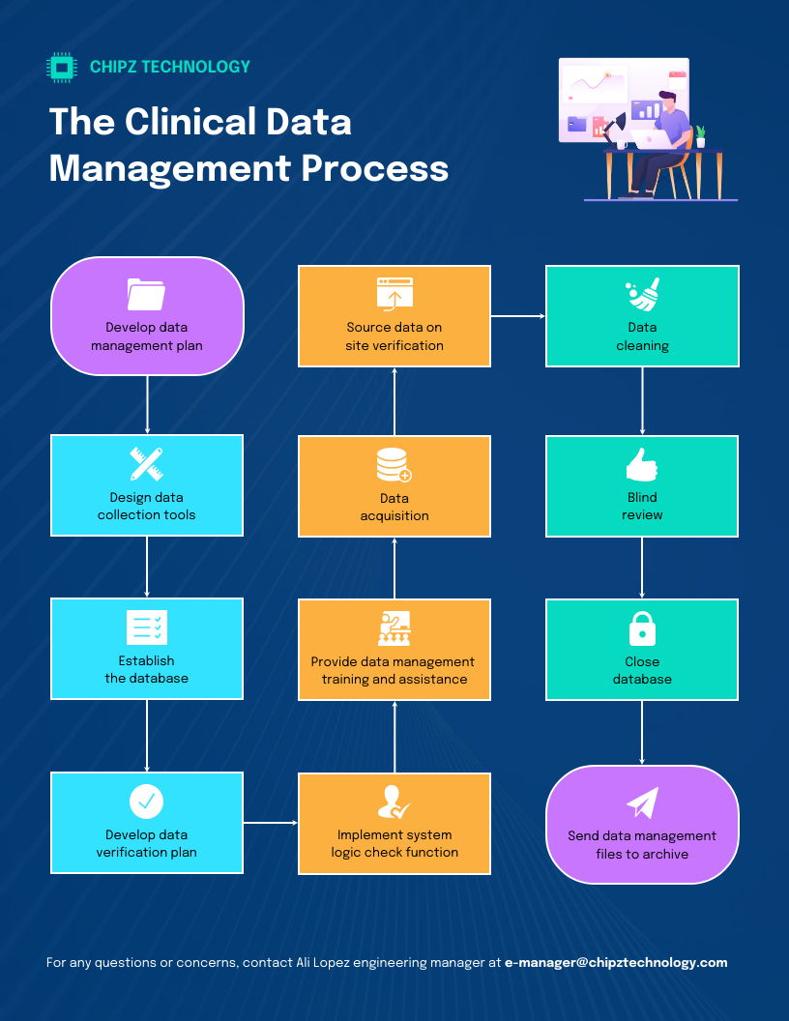

Figure 3. Clinical Data Management Process

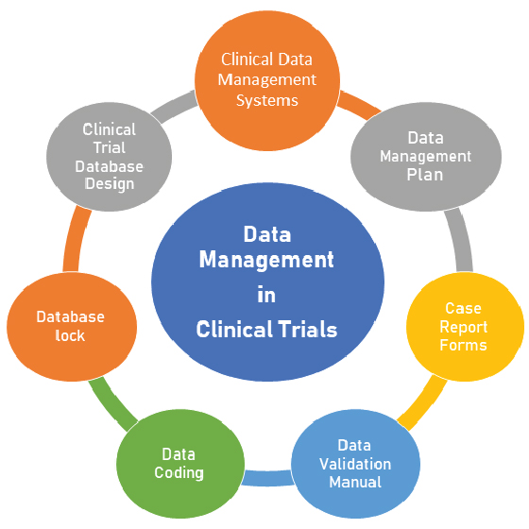

**Figure 4. Data management process in clinical trials**.

**Monitoring and Oversight**

CROs are responsible for monitoring the evolution of clinical trials and ensuring that they are conducted according to the protocol. CROs must ensure that the clinical study sites are monitoring the study to respect the protocol and that the trial is being conducted in compliance with regulatory requirements and ethical principles [27, 28].

**Safety Reporting**

CROs are responsible for reporting adverse events and other safety issues to the appropriate regulatory authorities during a study, and to ensure that appropriate measures are taken to mitigate any risks to trial participants. CROs need to have an effective system in place for the collection, reviewing, and reporting of adverse events and other safety information [29]. CROs play an important role in clinical trial management. They provide support to sponsors in conducting clinical trials efficiently and effectively, while ensuring that the trial is conducted in compliance with regulatory requirements and ethical principles. The CRO’s roles and responsibilities include site selection and management, study design and protocol development, regulatory compliance, data management, monitoring and oversight, and safety reporting. By fulfilling these roles and responsibilities, the CRO can help to ensure the success of the trial and the development of new, effective treatments for patients [29].

**Establishment of Clinical Sites**

A clinical site is a facility like a hospital or clinic with facilities for the conduct of clinical trials. These sites are equipped to conduct studies as specified by the ethically approved protocol and also ensuring that the data collected is accurate and reliable. Clinical sites are charged with the responsibility of recruiting and enrolling study participants who meet the inclusion criteria and administering the study intervention, and collection of valid data [5, 30].

Clinical site personnel are in direct contact with study participants and are responsible for ensuring that they receive appropriate care and guaranteeing the protection of their rights and welfare. [31]].

**Roles and Responsibilities of Clinical Sites Management team (CSMT) in the clinical trials management and recruitment.**

**Participant Recruitment**

The clinical site management team (CSMT) are responsible for identifying and recruiting suitable participants for the trial. The site must ensure that participants meet the eligibility criteria for the trial and that they understand the study procedures and risks. The participants should be well informed about the study, and the spirit of voluntarism before enrolling into the study [32f].

**Informed Consent**

The CSMT are responsible for obtaining informed consent from trial participants before they are enrolled in the trial. This has to be done through fair subject selection. The site must ensure that the participant understands the study procedures, the risks and benefits of participation, and that they have the right to withdraw from the trial at any time without any pressure and coercion [9]

**Conduct Study**

The CSMT are responsible for conducting the trial according to the protocol. The site must ensure that the study procedures are followed, the study intervention is administered correctly, and the data is collected accurately. In case of any changes the study team should apply for amendment of the study.

**Safety Reporting**

The CSMT are responsible for reporting adverse events and other safety issues to the sponsor and regulatory authorities. The site must have a system in place for collecting, reviewing, and reporting adverse events and other safety information possibly through the creation of a data safety management board (DSMB).

**Compliance with Regulations and Guidelines**

The CSMT is responsible for the aspect of compliance with all applicable national and international regulations and guidelines. The site must ensure that the trial is conducted in compliance with the International Council on Harmonization (ICH) guidelines, the Helsinki declarations, The Council for International Organization of Medical Sciences (CIOMS) guidelines recommnedations for health research and policy, dealing with ethics, medical product safety and development. They should also comply with Good Clinical Practice (GCP) guidelines, and local regulatory requirements and looking into the capacity strengthening of researchers conducting the study [32].

The CSMTs play crucial roles in clinical trial management for the recruitment and enrolling study participants, administering the study intervention, and collecting data. The clinical site’s roles and responsibilities include participant recruitment, obtaining informed consent, study conduct, safety reporting, and compliance with regulations and guidelines. By fulfilling these roles and responsibilities, clinical sites can help to ensure the success of the trial and the development of new, effective treatments for patients [33]. Clinical trial management is a complex process that requires collaboration and synergy between various stakeholders. Sponsors, CROs, and clinical sites all have important roles and responsibilities to ensure that clinical trials are conducted safely, ethically, and in compliance with all applicable regulations and guidelines. By working together and fulfilling their respective roles, these stakeholders can help to ensure the successful completion of a clinical trial and the development of new, effective treatments for patients [2, 34].

**Conditions and eligibility of Operation and Selection of CRO involved in Clinical research projects**

The fundamental conditions of identified criteria for the selection of CROs as outsourcing service provider for clinical research activities can be made up of the following their service catalog, years of experience, good knowledge and expertise of the pathology, good access to patients, wider geographical and landscape coverage, the quality of management, level of responsiveness, staff continuity and proficiency, career development plan, innovative technology, financial stability, and pricing [12]. CROs operation from an ethico-legal standpoint needs to have an administrative authorization to operate, and gain recognition from the region of operation by the competent authorities. They are required to uphold and respect the ethical norms and standards associated with clinical research activities [35]. For competencies of CROs we is expected to see the fulfilment of the following in their operations;

**Staff technical expertise and competence**

The CRO’s workforce should show continuity as well as its technical competence so that clinical trials can be handled by qualified specialists. In order to guarantee technical ability, sponsors should be able to audit the CRO’s internal training policies and career development records. More so, the detailed CVs of the CRO’s personnel assigned to the study should be reviewed to check employee education profile and expertise to demonstrate track record of performance within the clinical domain of interest [37].

**Technology Advancement**

There are too many multiple complex processes in clinical trials to be able to generate big data. Digital technology plays a crucial role to ensure efficient study management and target organized efficient data collection, cleaning, analysis, and reporting of results. It is important to know if CROs use advanced tools and high throughput assays to increase trial management efficiency. It is important that possess good Electronic Data Capture (EDC) system and electronic Trial Master File (eTMF) systems in sustainable use. Sponsors and regulatory authorities are interested to know if innovative tools are efficiently used and produce good results in other studies [15] Sponsors should look for CROs with strong technological capabilities that optimize study management and guarantee data quality [38]..

**Financial Stability**

Clinical trials are big financially oriented projects with a huge substantial investments inputs. It is therefore a big risk to change a CRO in the middle of a project cycle, as this can cause an important technical and financial problems. CROs must therefore build trust and credibility for long term partnership and reduce vulnerability to exposure to serious financial challenges. Sponsors are interested to work and collaborate with well-established CROs that can guarantee continuity of sustainable service. The client base of a CROs matters for its reputation as the longevity of operation adds to their credibility. Transparency in revenue increase annually over the years in company annual reports is a good indication of business growth. Sponsors are interested to investigate on CROs as potential collaborators, the financial health so as to verify the stability of such an important partner. [11, 38]

**Service Catalog**

Sponsors are interested to know if their potential CROs can provide a range of services required for the clinical trial. Clinical trials involve many tasks, so it is important for sponsors to engage a complete service CRO capable of managing multiple domains of expertise. Some of the basic services rendered by CROs includes services like regulatory affairs, site selection and activation, site management, monitoring, data management, logistics, pharmacovigilance, biostatistics, medical writing, and project management [12].

**Experience-Longevity/Competence of service expertise**

One major consideration by sponsors in choosing a CRO partner is to verify to the human resource team and experiences. The years of operation in business, number of study/clinical trials phases executed and managed successfully. The ability for conducting multicentered studies, and competence in specific therapeutic areas. It is important to note that CROs are not only expected to be capable of having experience as service providers, but should have experience in organization, a strong winning team with great mastery of clinical trials management [39].

**Knowledge of the disease**

It is important for CROs to have a staff strength with a great mastery of the disease under investigation to make a difference with competitors when engaging a clinical trial. For example, a study by a CRO with project managers, clinical research associates (CRAs), and data managers with expert knowledge in diabetes studies will significantly enhanced and guide the sponsor in the trial design, monitoring, and data management. It is always advisable to find more information about the team of a CRO before outsourcing is done. For a diabetes study the CRO can determine which clinical aspects of the study should be considered when writing the diabetes protocol. In addition, type of variables for assessment data are critical to ensure robust results. The end point or therapeutic test battery must be well selected. Identify a better recruitment strategy to be used, and the inclusion exclusion criteria. The CRO should put in place the best monitoring strategy, what should be closely monitored and the type of monitoring to avoid undesired protocol deviations. The understanding of competent CRO personnel can make very valuable contributions in all aspect of the clinical research [17, 40].

**Accessibility to patients**

A quick access to patients’ participation in a study is one of the most valuable services that CROs can offer to clinical trial sponsors. CRO with long standing fruitful relations with the population and creation of a data base of participants, established sites with high enrollment potential are most likely to be highly solicited for their services by Pharma companies. CROs are in constant interaction with many hospitals and investigators, and therefore can recommend sites capable of recruiting the type of patients suitable for in a specific study trial. CROs need to have contact with investigators specialized in the disease to be studied, provide access to hospital networks with strong recruitment capabilities. Sponsors are advised to select a CRO that will facilitate access to trial participants, this saving them time in site selection. CRO with good health information system management (HISM)/communication network are likely to be highly sort after by sponsors [41].

**Geographical coverage**

A wider coverage and distribution of a CRO is very important and relevant in clinical trials, especially phase III (Multicentered trials) of larger population. Such trials require the involvement of various countries and different actor and regulation specific guidelines of different countries. The phase III multicenter international trials (particularly those studying rare diseases) will need local services in each of the many countries where the research is conducted (e.g. regulatory services, onsite monitoring). The challenges of candidate CRO having trial management capabilities in several countries becomes evident. For example, can a CRO be capable to conduct a study in Africa and Europe or there will be a need to hire other CROs to cover additional nations increasing thus the list of service providers? Are CROs capable of developing a collaborative network based-system for the coordination of material transfer agreement, data sharing agreement and to sustain a robust data system management board (DSMB)? [42]

**Pricing**

It is important for every jurisdiction of operation of CROs to evaluate the charges for clinical services. The price of service rendered may not be the most important factor when selecting a CRO, but sponsors should be able to make choices of CROs as their service provider to conduct their trials within budget. Sponsors are expected to make executable well-structured and detailed budgets from CROs. A number of different financial proposals should be requested, assessed, and compared before making informed decision of the choice of service provider CRO. The price competitiveness should contribute in selecting the best bidder with a well-organized, with clear cost breakdowns and justifications [43]

**Quality management**

The importance of quality assurance in clinical trials must be put into consideration and more emphasis on compliance and high-quality data are strong contributing factors for trial sponsors considering the strong support for the drug development programs. Renown CROs have quality management systems in place that meets the principles of Good Clinical Practice (GCP), and international quality standards (e.g. ISO 9001). Study sponsors should conduct normal audits of the CRO’s facilities, for an onsite authentication of its quality control activities. It is necessary for sponsors to understand how CRO deals with protocol deviations, the effective implementation and management of correction and preventive action (CAPA) plans. For CROs to manage the CAPA plan, they need to follow a structured process that includes identifying the issue, evaluating its severity, investigating the root cause, determining resolution options, implementing corrective and preventive actions, monitoring their efficacy, and modifying procedures as required based on feedback. The CROs personnel need to be well trained on regulatory and laboratory quality norms and standards. [25, 33].

**Responsiveness/Timely delivery of job**

It is important that CROs committed to outsourcing services should develop the culture of respecting deadlines to deliver jobs completed. Failure to build confidence of time line for execution of jobs can be very costly for the company. Some CROs are insensitive to clients demands. Clinical trial sponsors should choose a CRO fully committed to their needs, a devoted consolidated team that pays full attention to their clients’ requests. It’s is sometimes risky when bigger CROs prioritize cooperate or *VIP clients*, while rendering less consideration to smaller sponsors or smaller projects. This priority behavior can lead to sponsors turning to small-size, more flexible CROs as a better option for the services. Sponsors should be able to understand if they are getting appropriate attention and quick responses their CRO, and they offer a highly valued service commitment when making the final choice. CROs must plan their jobs and establish a project cycle that meets the dead line and timely delivery of work outsourced to them to maintain a good reputation and build client confidence [44].

**Staff continuity**

A common problem with most CROs is to do with staff retention, with a turnover level above 20% as shown in the last two decades [12]. Personnel have developed a high occupational mobility and this continuous personnel oscillation in a CRO can negatively impact the quality of service and the relationships between the CRO, the sponsor’s team, and the clinical site staff. However, long-term CRO staff continuity improves and enhances clinical trial management processes. It is important for sponsors to review their turnover rates in other to verify whether a consolidated skilled study team can provide an optimized sustainable support during the course of the study [45].

**Clinical Research Centres in Africa**

CRO has increased in Africa to meet the clinical research needs to address poverty related diseases and emergent diseases. Some centres that are very active in Clinical research in Africa include Nigeria, Senegal, Burkina Faso, Ghana, Mali, Gambia, Kenya, Zambia, Uganda, Rwanda and South Africa as mapped in Figure 5. And table 2.

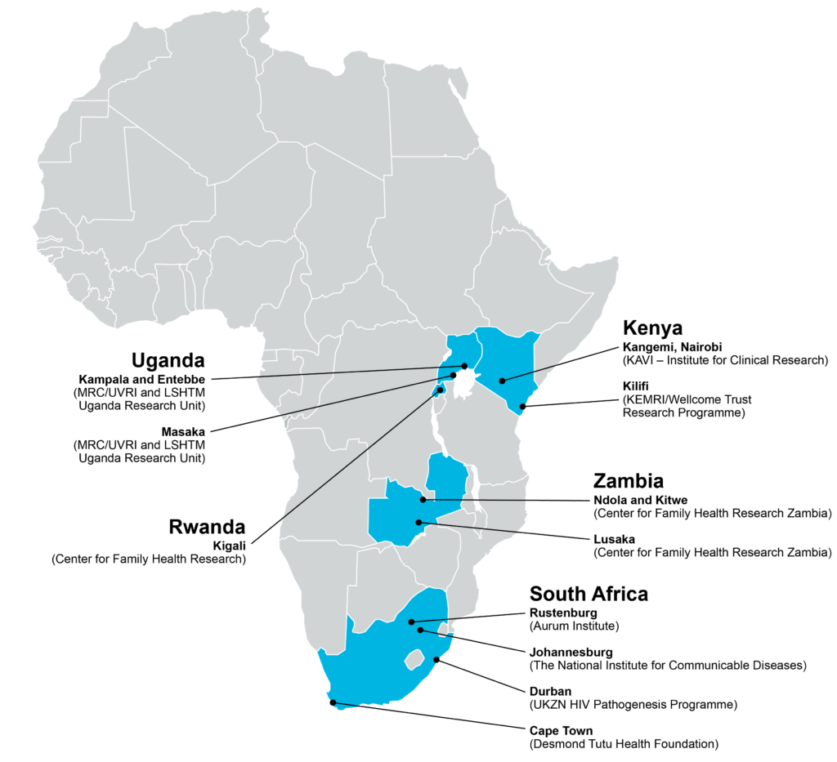

**Figure 5. Clinical Research Centres in sub Saharan Africa [22].**

Table 2. Some identified institutions of CRO in Africa [18, 22].

|  |  |  |
| --- | --- | --- |
| **No** | **CRO Institutions** | **Site of Location** |
| 1 | The Aurum Institute | Rustenburg and Tembisa-South Africa |
| 2 | The Center for Family Health Research (CFHR) | Kigali, Rwanda |
| 3 | Center for Family Health Research in Zambia (CFHRZ) | Lusaka and Ndola, Zambia |
| 4 | Desmond Tutu Foundation (DTHF). | Cape Town, South Africa |
| 5 | KAVI-Institute for Clinical Research (KAVI-ICR) | Nairobi, Kenya |
| 6 | Kenya Medical Research Institute-Wellcome Trust Research Programme (KWTRI). | Kilifi, Kenya |
| 7 | Medical Research Council Uganda.  Virus Research Institute Uganda/London School of Tropical Medicine and Hygiene. Uganda Research Unit on AIDS(MRC/UVRI/LSTMH) | Entebbe (HQ), Masaka, Kampala, Uganda. |
| 8 | National Institute for Communicable Diseases (NICD) | Johannesburg, South Africa |
| 9 | Uganda Virus Research Institute (IAVI-HIV Vaccine Programme (UVRI-IAVI). | Entebbe, Uganda |
| 10 | University of KwaZulu-Natal pathogenesis Programme (HPP). | Durban, South Africa. |

**CHALLENGES OF CROs IN CONDUCTING CLINICAL RESEARCH.**

The Contract Research Organization (CRO) and the Pharma industries are faced with multiple challenges with the drug discovery and development research. With the increasing challenges putting new drugs in the market is faced with more regulatory and ethical compliance constraints. The challenges can be a limiting factor for CROs growth and quality service delivery: These challenges are listed though not exhaustive as follows;

**Technological Disruption**: Rapid advancements in technology can overshadow the capabilities of existing processes and systems, necessitating continual adaptation and innovation to stay competitive. Sometimes new technologies may require regulatory approval before application into the clinical research processes [23].

**Regulatory landscape**: Working under strict ethical and regulatory compliance environment is a stumbling block for CROs who are usually faced with diverse regional/country regulatory landscapes can be very challenging for CROs working in collaboration with the drug discovery and development companies. There is impactful consequences as regulation become increasingly stringent, with increasing compliance burden, leading to longer timelines and higher pharmacoeconomic costs of operation [5]

**Sustainable Patient Recruitment and Retention**: Recruiting and maintaining patient participation in clinical trials is an ongoing battle. The complexity and length of clinical trials can affect negatively patient’s participation in studies and subjecting CROs under pressure to adopt innovative recruitment strategies, taking advantage of digital platforms [22].

**Intellectual Property Issues**: Outsourcing of clinical research activities to CROs present concerns on data security and intellectual property. Many pharmaceutical and biotechnology companies are reluctant to share sensitive information with CROs, which can slow down collaboration and research progress.There is therefore the need for pharmaceutical companies to sign a legally binding memorandum of understanding, data sharing agreements (DSA), material transfer agreement (MTA) with CROs before effective engagement in outsourcing activities [20].

**Economic Volatility**: Fluctuations in the economy and geopolitical uncertainties can impact market stability, effect on investment and operational decisions making within the CRO and Pharma sectors. CROs ideally operate better in a political and environmentally stable environment, to assure a sustainable quality in delivery as a service provider. These challenges highlight the need for CROs and drug discovery companies to enhance their operational efficiencies, leverage technology, and foster collaborations to navigate the evolving landscape effectively [17]. In resource limited countries with unstable macroeconomic environment CROs are very limited in operation, and will hardly attract bigger sponsors.

**Limited Human resource expertise**: The lack of qualified professionals in the CRO industry especially within the sub Saharan Africa regions is challenging to engage different types and complex clinical research projects. As CROs compete with biotech companies and pharmaceutical companies for skilled scientists and experts, attracting and retaining talent to be a better service provider has become increasingly competitive and very challenging [12].

**Return on investment/High Costs**: The costs associated with clinical trials and drug development is on a steady increase and will continue to rise, orientated by the need for advanced technology, robust quality assurance, and adherence to international standards. This financial pressure can limit the scope and scale of research initiatives both for CROs and sponsor Pharma companies [14].

**STRATEGIES FOR ADDREESING CROs CHALLENGES**

To have an overview of the complex landscape of clinical trials in the drug development process requires innovative strategies to address various challenges faced by this sector to put new drugs in the market. Strategic approaches to overcoming CROs challenges can be approach as follows and illustrated in Table 3;

1. **Enhancement of Target Validation**: Application and use of advanced technologies such as genomics, proteomics, metabolomics and bioinformatics can refine target identification and validation processes. These tools are adopted to facilitate a deeper understanding of biological mechanisms, enhancing the development of more effective pharmacotherapeutic agents and reducing the risk of drug attrition early in the research and development (R&D) process.
2. **Investing in Soft Skills in Scientific capacity building:**  Integrating entrepreneurial aspects, soft skills into scientific education is relevant in today’s clinical business ventures. Capacity strengthening programs on effective communication, teamwork, and critical thinking consolidate scientists to overcome the complexities of drug development more effectively, at the same time maximizing project management and improving overall efficiency.
3. **Decentralization of Clinical Trials:** Operating a decentralized clinical trials models is a way forward to address patient recruitment challenges by the application of digital technology platforms for outreach and engagement. The use of social media and online marketing approaches can increase access to participants engagements in studies the use of telemedicine for example can be a solution to facilitate ongoing patient retention and reduce logistical barriers.
4. **Strengthening Intellectual Property Management**: To reduce risks associated with data insecurity in outsourced clinical trials, there is the need to establish a robust intellectual property (IP) agreements and maintaining a strict good data governance protocol. This will help reassure stakeholders about the confidentiality and integrity of their proprietary information.
5. **Addressing Workforce Shortages**: The development of good collaborative partnerships platforms between academia and industry can create a pipeline for skilled professionals, giving opportunities and ensuring a continuous supply of qualified experts. Collaborative training initiatives equally enhance the reduced gap between theoretical knowledge and practical application in clinical settings.
6. **Navigating Regulatory Complexity**: Recruiting experts in regulatory affairs can influence the dynamics and foster relationships with regulatory agencies and streamlining the approval process. The use of regulatory consultants with expertise and dedication to regulatory compliance can contribute in the organization and the navigation of the complex landscape of drug approval.

**Table 3. Challenges of Contract Research Organizations [60].**

|  |  |  |
| --- | --- | --- |
| **No** | **Challenges** | **Characteristics** |
| **1** | High Quality Standards | CROs must meet a large number of requirements to be eligible to conduct their studies.  They should follow global standard operating procedures (SOPs) and carry out systems audits to make sure all the employees follow them. All the staff involved in the trials should be trained to follow Good clinical practice (GCP), local regulations and other guidelines. Fulfill quality assurance and quality control requirements for good reputation and customer satisfaction and to support product approved by regulatory organizations. |
|  | Loads of Paperwork | sponsors and CROs agree to the terms of conducting the study. They define which materials and methods to be used in the study, what kind of data to be obtained, and any tests to be performed. The agreement and study results are usually recorded both electronically and on paper. Upon completion, the study data is compiled, analyzed, and summarized. Medical writers create final reports in plain language that are usually stored and distributed online or on paper. All this documentation requires proper management in archives and online databases, so their maintenance requires a lot of human and physical resources as well as a high level of security and order. |
|  | Intricate Administration | Clinical research is an intricate procedure that requires numerous teams with various ranges of expertise to perform various jobs. These include: Medically trained staff who create clinical reports and conventions including clinical research doctors, restorative consultants and others. |
|  | Data Security | Global data leaks are accounted for by healthcare organizations. But CROs take their data security very seriously because their sponsors are highly concerned about keeping their data private. While security breaches cause data leaks, impair R&D activities, and reduce trust toward the company. To ensure data security, CROs develop their own sets of reliable tools. These usually include web-based document management systems with access control and electronic signatures, clinical trial management system (CTMS), electronic data capture (EDC), and more. |
|  | Accounting Challenges | CROs used to make rough estimates of the service costs because sponsors often placed changes orders which resulted in changes to third-party costs.  Under, the new accounting rules CROs have to make more accurate cost estimates, including third-party costs, because it forms a basis for their revenue recognition. Accurate cost estimation is a pressing matter for CROs nowadays. The new regulations make their finances volatile, making CROs worried about a drop-in share value on the stock market. |

T**HE FUTURE OF CROs FOR DRUG DISCOVERY AND DEVELOPMENT**

The future of Contract Research Organizations (CROs) and the drug discovery and development process has gained more popularity due to the breakthrough transformation, driven by technological advancements, increasing research and development coupled with the rising burden of chronic diseases. With the rise in the turnover in the number of outsourcing of clinical trials, particularly in emerging the markets, CROs are capable of sustaining its crucial role in facilitating efficient drug development processes as service providers [44].

The integration of digital technology has enhanced patient recruitment and management strategies, with a shift from the traditional methods towards techno-enabling solutions. Electronic data capture (EDC) systems are streamlining data collection, improving both accuracy and efficiency. The trend toward digitalization has not only reduce costs significantly but has accelerated timelines, allowing for quicker drug development cycles with the potential to bring more drug into the market [45].

A key growth driver for CROs is observed by the rising prevalence of chronic diseases, necessitating more robust drug development efforts across various therapeutic areas. Since pharmaceutical companies are faced with high drug development costs and pressures to deliver returns on investments, outsourcing to CROs has become more attractive. CROs with specialized skills and the ability exploit advanced technologies are well positioned to render quality services to sponsors [46]. In addition, the competitive for better expertise has become critical, as access to skilled professionals capable of delivering innovative solutions is now well define and bringing a competitive advantage. CROs that can effectively attract and retain expert professionals can provide faster, more efficient services, achieving a result of significant market growth. The operating landscape of Contract Research Organizations (CROs) within the framework of drug discovery and development presents a dynamic event of opportunities and challenges that can determine the future of the pharmaceutical industry. As CROs continue to render essential support services in navigating the complexities of drug development, their role in facilitating efficient clinical trials and ensuring regulatory compliance has becomes increasingly important [47, 48]. The advancements in technology, particularly digital tools and innovative methodologies, has offered immense potential to enhance technical processes, improve patient engagement, and ensure better outcomes. However, the pharma companies must meet up with the challenges of managing costs, addressing recruitment needs, and maintaining rigorous norms and standards of safety and efficacy within study protocols [49].

CROs can deliver more value to their sponsors when they consider good their reputation seriously as that is important in bringing to them potential sponsor and revenues. A reputable CRO adhere to the three main principles of keeping the right budget, meets deadlines and delivers quality services. CROs need smart resource management and budgeting, developing a full featured tracking software (ACTi TIME), that offers project management, cost calculations, billing, invoicing. The success of CROs and the drug discovery process depend on their adaptability to emerging trends and the ability to foster collaboration among stakeholders. The CROs sector can evolve by embracing innovative opportunities while proactively tackling the challenges that pave the way for transformative breakthroughs and bring new therapies to the market faster and also improve the overall standard of care (SOC) of the populations worldwide. Looking forward, there is the need for synergy between collaborators for an innovative, strategic partnerships, and a commitment to service excellence as a measuring rod for future success in drug discovery and development [13, 50].

**CONCLUSION**

Contract Research Organizations (CROs) play an important outsourcing role for pharmaceutical, biotechnology, and medical device industries as a service provider in clinical research services on a contract basis. Based on the ethical and regulatory challenging nature of clinical research, the CROs are required to have a legal jurisdiction and recognition of the administrative authorities in regions of operation. They are required to conform the norms and standard laid down by regulatory authorities and the states of their jurisdiction. They offer a wide range of services to support the development and execution of clinical trials, ensuring compliance with regulatory requirements and ethical standards. CRO selection requires careful examination. In order to make a well-grounded decision, sponsors should focus on evaluating the CRO’s service portfolio, expertise, clinical knowledge, access to patients, territorial integrity, quality of service, workforce continuity and skills, tools, financial strength, and costs. Careers in contract research organizations should offer exciting opportunities for individuals interested in the scientific, regulatory, and operational aspects of drug development. Collaborative partnership between sponsor and CROs needs to be a win-win relationship for a better achievement of the important goal of driving and maximizing clinical research. Engaging in a career with CROs can be a better opportunity to contribute to the advancement of medical science and the development of innovative and new promising new chemical entities to alleviate new and emerging pathologies.

**DISCLAIMER (ARTIFICIAL INTELLIGENCE)**

**Author(s) hereby declare that NO generative** AI technologies such as Large Language Models (ChatGPT, COPILOT, etc) and text-to-image generators have been used during writing or editing of manuscripts.

.

**REFERENCES**

1. *Arreté numero 0977 /A/MINSANTE/SESP/SG/DROS/du 18 avril 2012 portant creation, organisation et fonctionnement des comités d’éthique de la recherche pour la santé humaine au sein des structures relevant du ministere en charge de la santé publique [Comité](http://cdnss.minsante.cm/?q=en/institution/comit%C3%A9-national-d%E2%80%99ethique-pour-la-recherche-en-sant%C3%A9-humaine-cnersh)* [*National d’Ethique pour la Recherche en Santé Humaine -CNERSH | Centre de Documentation Numérique du Secteur Santé (minsante.cm)*](http://cdnss.minsante.cm/?q=en/institution/comit%C3%A9-national-d%E2%80%99ethique-pour-la-recherche-en-sant%C3%A9-humaine-cnersh)*.*
2. DECRET N°98-405/PM DU 22 OCT 1998 fixant les modalités d'homologation et de mise sur le marché des produits pharmaceutiques.-
3. ***Law No. 2022/008 of April 27, 2022, relating to Medical Research Involving Human Subjects in Cameroon,***
4. Nagoya Protocol on Access to Genetic Resources and the Fair and Equitable Sharing of Benefits Arising from their Utilization to the Convention on Biological Diversity : Protocols, etc., 2010 Oct. 29. II. Conference of the Parties to the Convention on Biological Diversity (2010 : Nagoya, Japan). III. United Nations. . ISBN 92-9225-306-9 1
5. *GUIDE DE BONNES PRATIQUES POUR LA CREATION, L’ORGANISATION ET LE FONCTIONNEMENT DES COMITES D’ETHIQUE DE LA RECHERCHE POUR LA SANTE HUMAINE*[*Guide De bonnes pratique.pdf (minsante.cm)*](http://cdnss.minsante.cm/sites/default/files/Guide%20De%20bonnes%20pratique.pdf) *2013*
6. Standard Operating Procedures for Research Ethics Committees (RECs) in Cameroon, July 2012
7. Muthuswamy V. Ethical issues in clinical research. Perspectives in Clinical Research January-March 2013, 4 (1):1-5; Website: www.picronline.org, DOI: 10.4103/2229-3485.106369
8. Frost J, Britten N. Learning from a Feasibility Trial of a Simple Intervention: Is Research a Barrier to Service Delivery, or is Service Delivery a Barrier to Research? Healthcare 2020, 8, 53; doi:10.3390/healthcare8010053. [www.mdpi.com/journal/healthcare](http://www.mdpi.com/journal/healthcare).
9. NIH/SEED.America’s Seed Funds; The NIH: An Innovator’s Guide for Evaluating a CRO in Clinical Research; NIHSEED, seed.nih.gov
10. Aguilera B, DeGrazia D, Rid A. Regulating international clinical research: an ethical framework for policy-makers BMJ Global Health 2020;5: e002287. doi:10.1136/bmjgh-2020-002287
11. Indian Council of Medical Research. Ethical Guidelines for Biomedical research on Human Participants. New Delhi: 2006.
12. Aguilera B, DeGrazia D, Rid A. Regulating international clinical research: an ethical framework for policy-makers.BMJ Global Health 2020;5:e002287. doi:10.1136/ bmjgh-2020-002287.
13. Wendler D. The Ethics of Clinical Research, First published Fri Jan 30, 2009; substantive revision Thu Sep 20, 2012, Stanford encyclopedia of Philosophy.
14. DPML: Drug and Medicine regulation in Cameroon. DPML.cm/indexphb/fr.info@dpml.cm last consulted 13 August, 2024.
15. Angwafor F. Monitoring and Evaluation. AUDA-NEPAD. African Medicine Regulation and Homologation programme (AMRH), 2011.
16. Fokunang CN, Tembe-Fokunang EA, Awah PK, Djuidje NM, Chi P, Ateudjieu J, Langsi R, Kaptue L, Abena OMT.The Role of Ethics in Public Health Clinical Research. In Current Topic in Public Health, 2013, INTECH. http://dx.doi.org/10.5772/52478 https://www.researchgate.net/publication/283491336
17. Emanuel EJ, Wendler D, Grady C. What makes clinical research ethical? JAMA 2000.
18. The Belmont Report - Ethical Principles and Guidelines for the protection of human subjects of research, 1979.
19. World Medical Association (WMA) Declaration of Helsinki – Ethical Principles for Medical Research Involving Human Subjects, 2000,
20. Meslin EM. Protecting human subjects from harm through improved risk judgments. IRB 1990; 12:7-10.
21. Garrard E, Dawson A. What is the role of the research ethics committee? Paternalism, inducements, and harm in research ethics. J Med Ethics 2005;31: 419-23.
22. Macklin R. On paying money to research subjects: 'Due' and 'Undue' inducements. IRB 1981; 3:1-6.
23. Nuffield Council on Bioethics. What happens after research is over? Research related to health care in developing countries, 2002.
24. Dilts, DMA, Sandler S,. Cheng, J, Crites L, Ferranti A, et al. Development of clinical trials in a cooperative group setting: The Eastern Cooperative Oncology Group. Clinical Cancer Research, 2008 14(11):3427–3433.
25. Glickman, SWJ, McHutchison ED, Peterson CB, Cairns RA, Harrington RM, Califf AM and Schulman KA. Ethical and scientific implications of the globalization of clinical research. New England Journal of Medicine 2008; 360:816–823.
26. Adjei AA, Harris AE, Awuah B. Roberts LR, Rivers BM, Yates CC, Newman LA, Sarkodie BD, Davis MB, Asare-Aboagye Y Unmet Needs in Oncology Clinical Research and Treatment in Africa: Focus on Ghana. Oncologist. 2022 Sep 2;27(9):760-767. doi: 10.1093/oncolo/oyac109.
27. Nebie EI, Sawadogo HN, van Eeuwijk P, Signorell A, Reus E, Utzinger J, Burri C.Opportunities and challenges for decentralized clinical trials in sub-Saharan Africa: a qualitative study.BMJ Open. 2023 Sep 22;13(9): e075903. doi: 10.1136/bmjopen-2023-075903.
28. Toto N, Douglas E, Gmeiner M, Barrett LK, Lindblad R, Makhaza L, Nedi W, Phulusa J, Quinnan GV, Sawyer LA, Thole H, Van Voorhis WC, Iroh Tam PY.
29. Conducting clinical trials in sub-Saharan Africa: challenges and lessons learned from the Malawi Cryptosporidium study.Trials. 2020 Jul 25;21(1):680. doi: 10.1186/s13063-020-04620-8.
30. Strother RM, Gopal S, Wirth M, Chadburn A, Noy A, Cesarman E, Lee JY, Remick SC, Busakhala N, Kaimila B, Mberi E, Ndlovu N, Omoding A, Krown SE.
31. Challenges of HIV Lymphoma Clinical Trials in Africa: Lessons from the AIDS Malignancy Consortium 068 Study. JCO Glob Oncol. 2020 Jul; 6:1034-1040. doi: 10.1200/GO.20.00152.
32. Weemeling DP. Clinical research regulatory issues. Am J Health Syst Pharm. 1999 Feb 1;56(3):252-6. doi: 10.1093/ajhp/56.3. 252..
33. Cornetta K, Smith FO. Regulatory issues for clinical gene therapy trials. Gene Ther. 2002 Jul 1;13(10):1143-9. doi: 10.1089/104303402320138925.
34. Knoepfler PS Key anticipated regulatory issues for clinical use of human induced pluripotent stem cells. .Regen Med. 2012 Sep;7(5):713-20. doi: 10.2217/rme.12.51.
35. Alten R, Cronstein BN. Clinicla trial development for biosimilars. Semin Arthritis. Rheum.
36. .Semin Arthritis Rheum. 2015 Jun;44(6 Suppl): S2-8. doi: 10.1016/j.semarthrit.2015.04.002.
37. Mermet-Bouvier P, Whalen MD vulnerability and clinical research: Mapping the challenges for Stakeholders. Ther inno.Regul. Sci. 2020 Sep;54(5):1037-1046. doi: 10.1007/s43441-020-00121-7.
38. Syed S, Boland BS, Bourke LT, Chen LA, Churchill L, Dobes A, Greene A, Heller C, Jayson C, Kostiuk B, Moss A, Najdawi F, Plung L, Rioux JD, Rosen MJ, Torres J, Zulqarnain F, Challenges in IBD research 2024: Precision Medicine. J. Inflamm Bowel Dis. 2024 May 23;30 (Supplement_2): S39-S54. doi: 10.1093/ibd/izae084.
39. Koonrung SN, Hirayama K. Ethical and regulatory challenges in genetic and genomic research involving stored biological specimen. Front Genet. 2022 Oct 21;13: 1062188. doi: 10.3389/fgene.2022.1062188.
40. Califf RM, Sugarman J. Exploring the ethical and regulatory issues in pragmatic clinical trials. Clin Trials. 2015 Oct;12(5):436-41. doi: 10.1177/1740774515598334
41. Ali J, Califf R, Sugarman J.Anticipated Ethics and Regulatory Challenges in PCORnet: The National Patient-Centered Clinical Research Network. Account Res. 2016;23(2):79-96. doi: 10.1080/08989621.2015.1023951.
42. Jeyaraman N, Ramasubramanian S, Yadav S, Balaji S, Muthu S, Jeyaraman M Regulatory Challenges and Frameworks for Fog Computing in Healthcare.
43. .Cureus. 2024 Aug 13;16(8): e66779. doi: 10.7759/cureus.66779.
44. Burt T, Sharma P, Dhillon S, Manchanda M, Mittal S, Trehan N. Clinical Research Environment in India: Challenges and Proposed Solutions. J Clin Res Bioeth. 2014 Nov 1;5(6):1-8. doi: 10.4172/2155-9627.1000201.
45. Villarreal CL, Price MA, Moreno AN, Zenteno A, Saenz C, Toppo A, Herrera-Escobar JP, Sims CA, Bulger EM Regulatory challenges in conducting human subjects research in emergency settings: The National Trauma Research Action Plan (NTRAP) scoping review; (NTRAP) Investigators Group National Trauma Research Action Plan.Trauma Surg Acute Care Open. 2023 Mar 2;8(1): e001044. doi: 10.1136/tsaco-2022-001044.
46. Lahey T The ethics of clinical research in low- and middle-income countries. Handb Clin Neurol. 2013; 118:301-13. doi: 10.1016/B978-0-444-53501-6.00025-1.Califf RM, Sugarman J. Exploring the ethical and regulatory issues in pragmatic clinical trials. Clin Trials. 2015 Oct;12(5):436-41. doi: 10.1177/1740774515598334. Epub 2015 Sep 15.
47. Baracaldo-Santamaría D, Feliciano-Alfonso JE, Ramirez-Grueso R, Rojas-Rodríguez LC, Dominguez-Dominguez CA, Calderon-Ospina CA. Making Sense of Composite Endpoints in Clinical Research.J Clin Med. 2023 Jun 29;12(13):4371. doi: 10.3390/jcm12134371.
48. Canedo JA, Rondão F, Ferreira CG, Ferrari BL, Mathias C. Lessons from implementing a clinical research network in Brazil. Am Soc Clin Oncol Educ Book. 2022 Apr; 42:1-10. doi: 10.1200/EDBK_349949.
49. Nebie EI, Sawadogo HN, van Eeuwijk P, Signorell A, Reus E, Utzinger J, Burri C. Opportunities and challenges for decentralized clinical trials in sub Saharan Africa: a qualitative study. BMJ Open. 2023 Sep 22;13(9): e075903. doi: 10.1136/bmjopen-2023-075903.
50. Bhardwaj P, Kumar J, Yadav RK. Patients driving the clinical trials designs. Democracy in clinical research. Rev Recent Clin Trials. 2019;14(4):237-246. doi: 10.2174/1574887114666190808142339. Phapale P [Pharmaco-metabolomics opportunities in drug development and clinical research.](https://pubmed.ncbi.nlm.nih.gov/38715865/) .Anal Sci Adv. 2021 Sep 30;2(11-12):611-616. doi: 10.1002/ansa.202000178.
51. Biswas P. Pharmacovigilance in Asia. Clinical research on transcatheter aortic valve replacement for bicuspid aortic valve disease: Principles, Challenges, and an Agenda for the Future. .J .Pharmacol Pharmacother. 2013 Dec;4(Suppl 1): S7-S19. doi: 10.4103/0976-500X.120941.
52. Ahmad Y, Madhavan MV, Baron SJ, Forrest JK, Borger MA, Leipsic JA, Cavalcante JL, Wang DD, McCarthy P, Szerlip M, Kapadia S, Makkar R, Mack MJ, Leon MB, Cohen DJ.Struct Heart. 2022 Nov 1;7(1):100102. doi: 10.1016/j.shj.2022.100102.
53. Brunoni AR, Nitsche MA, Bolognini N, Bikson M, Wagner T, Merabet L, Edwards DJ, Valero-Cabre A, Rotenberg A, Pascual-Leone A, Ferrucci R, Priori A, Boggio PS, Fregni F [Clinical research with transcranial direct current stimulation (tDCS): challenges and future directions.](https://pubmed.ncbi.nlm.nih.gov/22037126/) .Brain Stimul. 2012 Jul;5(3):175-195. doi: 10.1016/j.brs.2011.03.002.
54. Do A, Ilagan-Ying YC, Mehal WZ, Lim JK. Drug development of nonalcoholic fatty liver disease: challenges in research regulatory pathwaysand study end points. .Expert Opin Drug Discov. 2021 Feb;16(2):125-134. doi: 10.1080/17460441.2020.1811674.
55. Rossitto M, Fiscarelli EV, Rosati p. Chaleenges and promises for planning future clinical research into bacteriophage therapy against Pseudomonas aeruginosa in cyctic fibrosis: An argumentative review. .Front Microbiol. 2018 May 4; 9:775. doi: 10.3389/fmicb.2018.00775.
56. Ribeiro EFO, Belmiro AAMLM, Boas LCV, Niemann CU. How to set up a clinical research centre in Brazil, as an example of a middle-income country. Semin Hematol. 2023 Sep;60(4):233-242. doi: 10.1053/j.seminhematol.2023.08.004.
57. Yang M, Abudureyimu M, Wang X, Zhou Y, Zhang Y PHB2 ameliorates Doxorubicin-induced cardiomyopathy through interaction with NDUFV2 , Ren J.Redox Biol. 2023 Sep;65:102812. doi: 10.1016/j.redox.2023.102812.
58. Scavone C, di Mauro G, Mascolo A, Berrino L, Rossi F, Capuano A. The New Paradigms in clinical research. From early access programs to the novel therapeutic approaches for unmet medical needs. Front Pharmacol. 2019 Feb 13; 10:111. doi: 10.3389/fphar.2019.00111.
59. Mohamadi, Amin; Asghari, Fariba; Rashidian, Arash (2014). "Continuing review of ethics in clinical trials: a surveillance study in Iran". Journal of Medical Ethics and History of Medicine. 7: 22. PMC 4648212. Challenges of Contract Research Organizations.
60. https://www.actitime.com/productivity/contract-research-organizations-challenges last consulted 20 January 2025