**Case report**

**Inadvertent knot formation on a lumbar epidural catheter : A rare complication**

**Abstract**

The knotting of an epidural catheter is an unusual complication that can result in disfunction of the catheter, difficult removal and may require surgical management.  
 We report a case of knot formation on a lumbar epidural catheter, introduced at the L2-L3 level, which presented difficulty during withdrawal. Lumbar CT images were taken to evaluate the knot position and discuss posible solutions. The catheter was successfully removed without breakage, showing a simple knot 7 mm from its end. No neurological complications were observed.  
This case report demonstrates that knot formation in a lumbar epidural catheter is possible. Anesthesiology professionals should consider this complication when experiencing resistance during catheter withdrawal or injection.

**Keywords**  
   
Regional Anesthesia, Neuraxial Anesthesia, Epidural Analgesia, Device Removal, Catheter, Postoperative Analgesia

**INTRODUCTION**

Neuraxial anesthesia has a long-standing record of efficacy and safety in various surgeries, offering effective analgesia and anesthesia. Currently, lumbar epidural analgesia via catheter is the gold standard for postoperative pain management.[1] Accurate epidural catheter placement is a critical skill for anesthesiology residents, typically requiring 60–90 attempts to reach proficiency, though imaging confirmation is not routinely recommended, with functionality verified through clinical testing.[2]

Epidural analgesia success can be influenced by factors such as anatomical catheter location, needle insertion technique, fixation, and the addition of opioids or adjuvants. While catheter removal is generally straightforward, complications like breakage, entrapment, and knotting can occasionally arise, despite advancements in catheter technology. Knotting, a rare but serious complication, can lead to adverse neurological outcomes and may necessitate surgical removal.

In this case, we describe an instance of epidural catheter knotting that complicated removal. However, with patient repositioning and gentle traction, the catheter was successfully removed without complications.

**Case presentation:**

A 71-year.old woman was admitted to the hospital for knee osteoarthritis and was scheduled for a total knee arthroplasty. She was interviewed and examined by an anesthesiology resident; she was classified as an ASA II patient programmed for elective surgery, with no contraindication for neuraxial anesthesia.

Therefore, the anesthetic proposed plan was: sedation + combined neuraxial anesthesia, consisting of a spinal anesthesia and epidural catheter placement for postoperative analgesia.

Standard Type I monitors were applied (non-invasive blood pressure, pulse oximetry and plethysmography, EKG DII and V5 lead, BIS and EEG trace), supplemental oxygen was provided with nasal cannula at 3 litres per minute throughout the whole procedure.

The patient was placed in the left lateral position and an epidural puncture with a 17-gauge Tuohy needle was performed after subcutaneous local anesthesia with 2% lidocaine in the L2-L3 intervertebral space. The loss of resistance technique with air syringe was used for the identification of the epidural space. After acceding to the epidural space, a 27-gauge Whitacre needle was introduced, obtaining clear CSF, then 12 mg of hyperbaric bupivacaine were slowly administered. A 19-gauge epidural catheter (B. Braun Melsungen A.G.) was introduced 15 cm from the skin. There was no resistance when inserting the epidural catheter. The Tuohy needle was then removed, and the epidural catheter was withdrawn until the 12 cm mark was at the patients skin.

The patient achieved a T4 level anesthesia during the procedure, maintained adequate hemodynamic stability and referred to no discomfort in the postoperative period.

48 hours after the procedure, when the patient was discharged from orthopedic surgeons, the anesthesia resident on call tried to remove the catheter. However, it could not be removed due to resistance, and the attending anesthesiologist was called.

The patient was positioned in left lateral decubitus position and once again the catheter was pulled unsuccessfully due to high resistance.

The patient was informed about the situation and the whole surgical team decided a CT scan of lumbar spaces was the best option in order to evaluate the possibility of looping or kinking of the catheter.

CT scan images (Fig. 1.) showed the presence and knotting of the catheter in the epidural space.

To that moment, the patient was asymptomatic, no neurological compromise was reported. After evaluating the situation, the surgical team decided a Neurosurgery specialist should be consulted.

The consulted Neurosurgeon proposed surgical removal of the catheter under general anesthesia.

The surgical team spoke to the family and together, the patient and the family decided to accept the surgical procedure to remove the catheter.

In the operating room, an adittional attempt to remove the catheter was performed, this time with a lot more strenght when pulling the catheter, the removal was tried positioning the patient the same way the catheter was inserted. Fortunately, the catheter gradually came out although great resistance was still noted Consequently, the catheter was finally removed without any problems except for some discomfort at the insertion site during removal, and no neurological complication occurred.

Observation of the removed catheter showed that a hard single knot was formed at about 7 mm from the tip (Fig. 2).

The surgical procedure was cancelled and the patient was discharged by the afternoon.

**Discussion**

Among the complications associated with epidural neuraxial anesthesia, the most common are dural puncture, intravascular or intrathecal injection of local anesthetic, and difficulty in catheter removal due to knotting or rupture [3]. The incidence of epidural catheter knotting is challenging to determine, as many cases go unpublished, though estimates range from 0.0015% to 0.003% [4,5]. Knotting is rare and may occur proximal or distal to the skin entry point. To date (2024), 59 cases of catheter knotting have been reported, with only 18 describing a true knot [4].

The tendency of epidural catheters to curl or double back, is influenced by anatomical structures such as blood vessels and nerves. The main risk factor for knotting appears to be the length of catheter inserted, with higher rates of knotting reported when more than 5 cm are introduced into the epidural space [6]. Inserting more than 5 cm increases the risk of the catheter deviating, forming bends or loops that can lead to knotting. Recent studies suggest that inserting no more than 3–5 cm may minimize this risk. [7]

Resistance when threading the catheter may signal kinking or knotting; repositioning the Tuohy needle can reduce this risk. To ensure functionality, aspiration and flushing should be attempted before securing the catheter to the skin. If obstruction persists, complete catheter replacement may be necessary. While many catheters can be removed intact with traction, breakage is a risk, potentially requiring surgical exploration.[8] In our case, all clinical test to assess functionality were appropiate, and even the postoperative analgesia pump was functional, the clinical efficacy of the postoperative analgesia made us rule out the possibility of kinking or knotting at the moment of colocation of the catheter, no neurological symptoms were observed during the postoperative period.

If neurological symptoms like radicular pain or paresthesia arise during catheter manipulation, traction should be stopped, and radiological imaging (CT or MRI) may be needed to locate any knot or kink. In cases of complete obstruction, using radiopaque dye can help delineate the catheter’s path, while saline injection may lubricate the catheter for easier removal. Surgical removal is a last resort, generally reserved for cases involving neural irritation or infection risk.[8,9]

Many reports conclude that limiting catheter insertion length may reduce knotting risk.[10–12] Based on our experience, we propose the following systematic approach for managing trapped catheters:

* Apply gentle traction in varied positions and degrees of lumbar flexion.
* Test catheter patency with saline injection to potentially open the epidural space.
* Utilize radiographic imaging to confirm catheter position and orientation.
* Consider surgical consultation based on radiographic findings and patient symptoms.
* Ensure informed patient consent and shared decision-making if surgery is needed.

Kinking of an epidural catheter is a rare complication that typically occurs during placement, allowing for immediate assessment and, if necessary, prompt removal and re-insertion. However, in some cases, the catheter may function normally during placement but present difficulties upon removal. In such scenarios, radiologic evaluation is essential to identify potential knot formation or involvement of adjacent structures.[13,14]

Anesthesiology professionals should remain vigilant about this potential complication to ensure thorough patient counseling, informed decision-making, and careful clinical management, all of which help minimize complications associated with catheter removal. This case underscores the importance of meticulous catheter insertion and management techniques, contributing valuable insights to clinical practice. In our case, firm traction was successful in removing the catheter, likely because forced pulling tightened the knot, reducing its diameter and allowing it to pass through the ligaments, thus avoiding surgery. This approach underscores the importance of a systematic, patient-centered strategy, reserving surgical intervention as a last resort to minimize risks and prioritize patient safety.

**Conclusion**

Epidural catheter knotting is a rare but significant complication that can lead to difficult catheter removal and, in some cases, may require surgical intervention. This case highlights the importance of recognizing resistance during catheter withdrawal as a potential sign of knotting. Anesthesiology professionals should be aware of this possibility and employ a systematic approach that includes patient repositioning, gentle traction, and imaging when necessary. Our case demonstrates that, in select situations, firm traction in the correct positioning can facilitate catheter removal without surgical intervention. This underscores the need for careful catheter insertion techniques, avoiding excessive threading, and remaining vigilant for signs of entrapment. Increasing awareness of this complication will aid in timely identification and management, ultimately improving patient safety and perioperative outcomes.

**Figure 1**: Computed tomography (CT) scan in coronal view of the lumbar spine. The arrows indicate an area with an anomalous structure, possibly related to an epidural catheter. The image illustrates the precise location and spatial relationship of the structure in the lumbar region, aiding in the assessment of potential complications, such as catheter knot formation.

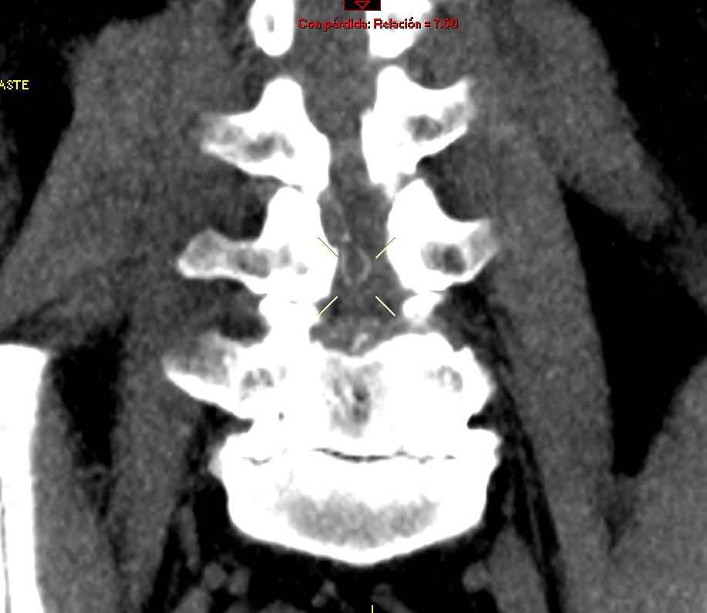

**Figure 2**: Photograph of the epidural catheter showing a simple knot near its tip. This image illustrates the formation of a knot in the catheter, which can lead to complications during removal.

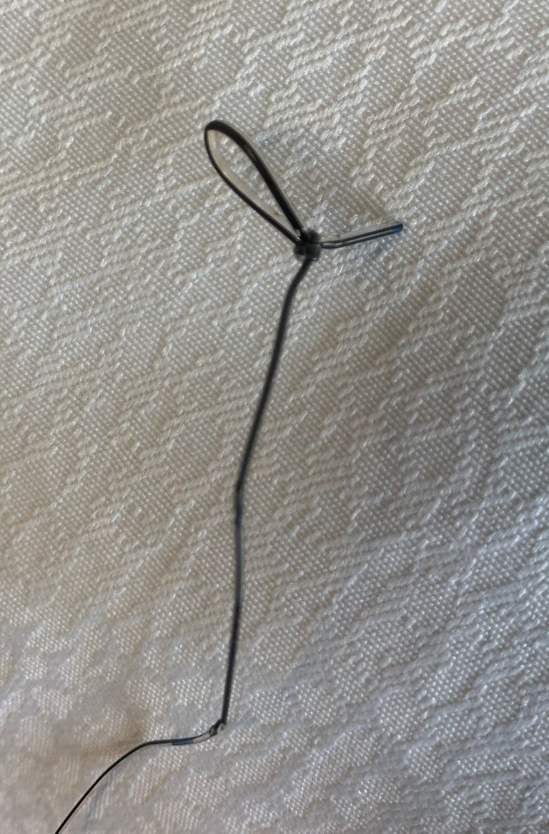

**Ethical Approval: As per international standards or university standards written ethical approval has been collected and preserved by the author(s).**

**Protection of humans and animals**

The authors declare that no experiments were performed on humans or animals for this research. The authors declare that the procedures followed were in accordance with the ethical standards of the responsible committee on human experimentation and in accordance with the World Medical Association and the Declaration of Helsinki.

**Confidentiality of data**

The authors declare that they have followed the protocols of their work center regarding the publication of patient data.

**Consent**

The authors declare that no patient data appear in this article. The authors have obtained informed consent from the patients and/or subjects referred to in the article. This document is in the possession of the corresponding author.

Disclaimer (Artificial intelligence)

Author(s) hereby declare that NO generative AI technologies such as Large Language Models (ChatGPT, COPILOT, etc.) and text-to-image generators have been used during the writing or editing of this manuscript.

**References**

1. Rawal N. Epidural technique for postoperative pain: Gold standard no more? Reg Anesth Pain Med. 2012 May;37(3):310–7.

2. Teng, W. N., Tsou, M. Y., Chang, W. K., & Ting, C. K. (2017). Eyes on the needle: Identification and confirmation of the epidural space. In *Asian Journal of Anesthesiology* (Vol. 55, Issue 2, pp. 30–34). Taiwan Society of Anesthesiologists. <https://doi.org/10.1016/j.aja.2017.05.009>

3. Liu H, Brown M, Sun L, Patel SP, Li J, Cornett EM, et al. Complications and liability related to regional and neuraxial anesthesia. Vol. 33, Best Practice and Research: Clinical Anaesthesiology. Bailliere Tindall Ltd; 2019. p. 487–97.

4. Khadka, B., Sharma, A., Regmi, A., Ghimire, A., & Bhattarai, P. R. (2023). Removing knotted or stuck epidural catheters: a systematic review of case reports. *Anesthesia and Pain Medicine*, *18*(3), 315–324. <https://doi.org/10.17085/apm.23013>

5. Mizota T, Kimura K, Takeda C. Knot formation in a thoracic epidural catheter: a case report. JA Clin Rep. 2021 Dec 1;7(1).

6. Holm, J. H., Licht, P. B., Toft, P., & Andersen, C. (2022). Procedural Aspects of Epidural Catheter Placement: A Prospective Observational Study of 173 Epidural Catheter Insertions. *Journal of Cardiothoracic and Vascular Anesthesia*, *36*(12), 4378–4385. <https://doi.org/10.1053/j.jvca.2022.08.003>

7. Palahniuk RJ, Beilin Y, Bernstein HH, Zucker-Pinchoff B. OBSTETRIC ANESTHESIA SECTION EDITOR The Optimal Distance That a Multiorifice Epidural Catheter Should Be Threaded into the Epidural Space [Internet]. Available from: <http://journals.lww.com/anesthesia-analgesia>

8. Mitra, R., & Fleischmann, K. (2007). Management of the sheared epidural catheter: is surgical extraction really necessary? In *Journal of Clinical Anesthesia* (Vol. 19, Issue 4, pp. 310–314). <https://doi.org/10.1016/j.jclinane.2006.11.005>

9. Kumar S, Mahajan S, Verma S. Epidural catheter kinking - An appalling experience. Vol. 39, Journal of Anaesthesiology Clinical Pharmacology. Wolters Kluwer Medknow Publications; 2023. p. 142–3.

10. Kumar, S., Mahajan, S., & Verma, S. (2023). Epidural catheter kinking - An appalling experience. In *Journal of Anaesthesiology Clinical Pharmacology* (Vol. 39, Issue 1, pp. 142–143). Wolters Kluwer Medknow Publications. <https://doi.org/10.4103/joacp.JOACP_538_20>

11. Brichant JF, Bonhomme V, Hans P. On knots in epidural catheters: A case report and a review of the literature. Int J Obstet Anesth. 2006 Apr;15(2):159–62.

12. Macfarlane, J., & Paech, M. J. (2002). Another Knotted Epidural Catheter. In *Anaesthesia and Intensive Care* (Vol. 30, Issue 2).

13. Renehan EM, Peterson RA, Penning JP, Rosaeg OP, Frcpc MB, Chow D, et al. Visualization of a looped and knotted epidural catheter with a guidewire.

14 Taksande K, S. K, Bhalerao N, Jadhav J, Wanjari D, Shatalwar A. Case Report – Accidental Epidural Catheter Breakage and Its Management. J. Pharm. Res. Int