**Anti-Arthritic Potential of Alocasia macrorrhizos Aqueous Extract in an Adjuvant Induced Arthritis Model**

**Abstract**

Rheumatoid arthritis is a chronic, inflammatory and autoimmune disease chatacterized by joint inflammation and systemic manifestations. This study aimed to evaluate the therapeutic potential of *Alocasia macrorrhizos* (EAAm) aqueous extract in an Adjuvant-Induced Arthritis (AIA) mode. Holtzman strain rats were used and AIA was performed by intradermal injection of 100 µL of Freund's Complete Adjuvant (FCA) at the base of the tail, followed by injection into the left knee joint. Induced animals were treated with Phosphate-buffered saline or EAAm (100 mg/kg) during nine days. Arthritic animals of both sexes showed intense inflammatory reactions and systemic manifestations. Treatment with EAAm reduced the knee edema, tissue inflammatory infiltrate, as well as the cytokines expression (IFN-y, IL-6 and IL-12p70), in serum and regional lymph nodes of the animals. These findings suggest that *Alocasia* *macrorrhizos* exhibits anti-arthritic effects, supporting its potential as a natural therapeutic alternative for inflammatory diseases.

**Keywords:** Inflammation, Medicinal plants, Autoimmune diseases, Cytokines, Knee

**Introduction**

Characterized by pain, swelling, joint stiffness and, in the most severe cases, bone deformation (Ostrowska et al. 2018), rheumatoid arthritis (RA) is a chronic, inflammatory, autoimmune disease that affects about 1% of the world population. It is estimated that in Brazil it affects 0.22 to 0.50% of the population (Alamanos et al. 2006; Mota et al. 2013). It affects a large number of individuals at full productive capacity, impacting both on the reduction of life quality and on the ability to work in its various degrees. It presents complications such as depression, predisposition to infections and increased medical and social security expenses, which generate great social and economic impact (Thomé 2011; Goeldner et al. 2011).

Thus, early diagnosis and immediate initiation of treatment are essential for disease control, preventing functional disability and irreversible joint damage. Conventional drug treatment uses anti-inflammatories and analgesics drugs such as methotrexate, chloroquine, hydroxychloroquine, sulfasalazine, and leflunomide (Albers et al. 2001; da Mota et al. 2018; Hazlewood et al. 2020). However, the continued use of antirheumatic drugs in conventional treatments presents risks and potential side effects, in addition to the high cost of drug treatment, medical and hospital expenses (Brazil 2010; De Azevedo et al. 2008).

In this context, there is growing interest in products of natural origin that present therapeutic effects with lower toxicity, reduced cost and promising responses in the treatment of patients with RA (Yang et al. 2013).

Therapy with medicinal plants promotes greater adherence to treatment without loss of efficacy (Bruning et al., 2012). *Alocasia macrorrhizos*  (L.) G. Don, Araceae is an evergreen robust herb growing up to 1.8 m under favorable conditions and distributed widely in Asia, and cultivated in many Pacific islands (Rahmman *et al*., 2012). Scientific studies have revealed that the genus is mainly scattered throughout Asia. It has broad traditional benefits, which have been associated with various biological properties such as cytotoxic, antihyperglycaemic, antimicrobial activities (Airbain *et al.,* 2022) The leaf juice of the plant is used as anthelmintic, digestive, astringent, and laxative (Mulla *et al.*, 2010). The medicinal plant *Alocasia macrorrhizos* has been used in the treatment of inflammatory diseases in folk medicine and has shown notable antioxidant, cytotoxic, and other therapeutic properties. (Cordeiro *et al.* 2021; Fang *et al.* 2012; Mulla et al., 2010; Md *et al.,* 2013; Rahman *et al.*, 2011). However, its effects on the inflammatory response are still poorly reported. Thus, the present study aimed to evaluate the anti-inflammatory and therapeutic potential effects of the aqueous extract of *A. macrorrhizos* in an *in vivo* study, using the experimental model of adjuvant-induced arthritis (AIA).

**Materials and methods**

**Animals**

Holtzman strain rats, 7 to 8 weeks, from the animal facility of CIPq (UFVJM), Diamantina, MG - Brazil, were used. The animals received filtered water and chow *ad libitum*. They were kept in polypropylene boxes, in an environment with controlled temperature and a 12-hour light-dark cycle, in the Medical School animal facility, from the Mucuri Campus (UFVJM), Teófilo Otoni, MG - Brazil. The protocol for use was approved by the Ethics Committee for the Use of Animals (CEUA – UFVJM) - Mucuri Campus, protocol nº 09/2021-R.

**Plant material - identification and preparation of *A. macrorrhizos* extract**

The plant was collected in the courtyard of the Institute of Science, Engineering and Technology (ICET) at UFVJM, Mucuri Campus. It was submitted to the National System for the Management of Genetic Heritage and Associated Traditional Knowledge (SISGEN), registration A7DD07D. The part of the plant used was the root (tuber), according to previous evidence of its anti-inflammatory action (Fang et al. 2012; Cordeiro et al. 2021). After collection, the tubers were washed in running water, cut into smaller parts and dried in an oven at 60°C for 24 hours, then crushed and diluted in distilled water at a concentration of 0.5 mg/ml, homogenized and left at rest for 24 hours, refrigerated and protected from light. After 24 hours, the extract was filtered (Cordeiro et al. 2021), lyophilized, aliquoted and frozen at -80ºC until use.

**Experimental model of adjuvant induced arthritis (AIA)**

The animals (n=20) were randomly divided into the experimental groups: Control - not induced; PBS - Induced and treated with phosphate-buffered saline (PBS); and EAAm - induced and treated with *A*. *macrorrhizos* aqueous extract (100 mg/kg). Arthritis was induced, under anesthesia (ketamine and xylazine), by intradermal injection of 100 µl of Freund’s complete adjuvant (FCA) containing heat killed *Mycobacterium* *tuberculosis* (1 mg/mL), followed by an intra-articular injection, in the left knee, of 30 µl of FCA containing heat killed *Mycobacterium* *tuberculosis* (1 mg/mL), after 7 days. The development of arthritis was confirmed by daily measuring the thickness of the hind paws and the diameters of the knee joints.

**Treatment with the aqueous extract of *A.* *macrorrhizos* (EAAm)**

Daily, before treatment, the aqueous extract was diluted in PBS and administered to the animals of the groups (EAAm – 100 mg/kg), by orogastric route (gavage), 100 µl of this extract. The animals in the induced group received gavage with the vehicle of the extract (PBS). The Control group did not receive gavage. Treatment started on the 12th day after intradermal injection and lasted nine days.

**Collection and analysis of joint fluid lavage cells**

On the 22nd day after arthritis induction, the animals were euthanized. Then, hair removal was performed on both knees and the joint cavity was washed with 100 µl of cold 0.9% saline solution and joint exudate was collected. Joint lavage fluid samples were diluted in Turk's solution at a ratio of 1:20 and used for global cell count in the Neubauer chamber (104 cells/mL).

**Quantification of cytokines (IFN-γ, IL-6, IL-12p70, IL-10)**

The cytokines IFN-γ, IL-6, IL-12p70 and IL-10 were evaluated, in the serum and in the supernatant of macerated inguinal lymph nodes samples from all animals, according to the manufacturer's instructions (BD Biosciences Pharmingen, San Diego, USA). The samples were analyzed in an ELISA reader (EZ Read 2000, Biochrom, Cambridge, UK) with a wavelength of 450 nm. Inguinal lymph nodes samples were obtained from all animals at day 22 post-induction and weighted. One hundred milligrams of tissues was homogenized in 1ml of 0.4M NaCl, 0.05% Tween 20, containing 0.5% bovine serum albumin, 0.1M phenylmethylsulfonyl fluoride, 0.1M benzethonium chloride, 10mM ethylenediaminetetraacetic acid (EDTA) and 20 kIU/ml aprotinin (Merck KGaA, Darmstadt, Germany). The supernatants were collected to determine the cytokines concentration.

**Histopathological analyzes**

After euthanasia of the animals, the tibiofemoral joint was removed and immersed in 10% formalin, kept at room temperature for approximately 48 hours, for fixation. Then, the pieces were washed in running water and immersed in a demineralization solution containing: EDTA, hydrochloric acid and PBS for 11 days. After demineralization, the pieces were dehydrated, diaphanized, embedded in paraffin, sliced at 5 µm and stained with hematoxylin & eosin (HE).

**Statistical analysis**

Statistical analyzes were performed using Prism version 8.1 (GraphPad Software, San Diego, USA). Results are presented as mean ± standard deviation, representative of at least three independent experiments. Significance between groups was analyzed using nonparametric Mann-Whitney test. Differences were considered significant when p < 0.05.

**Results and Discussion**

**Arthritis induction**

Animals injected with Freund's Complete Adjuvant (FCA) developed joint alterations and stiffness (Fig. 1-A), which is also an important feature in patients with arthritis in whom the joint stiffness, followed by muscle weakness, local swelling, and pain, causes structural deformities and biomechanical problems (Gomes 2008).

In the present study, signs of inflammation were observed in other sites, such as the ankle of the contralateral paw. According to Kelly et al. (2007), FCA-induced arthritis can generate swelling in the contralateral limbs, due to the symmetrical spread of the disease. Other findings are also in agreement with previous studies, such as joint nodules in the forelimbs, extending to the phalanges (Fig. 1-B), similar to patients with rheumatoid arthritis (Khurana et al. 2005). According to Bevaart (2010), arthritis in humans has a systemic effect, and may also manifest in the skin, which may explain the presence of erythema in the ears of animals with FCA-induced arthritis (Fig.1-C).

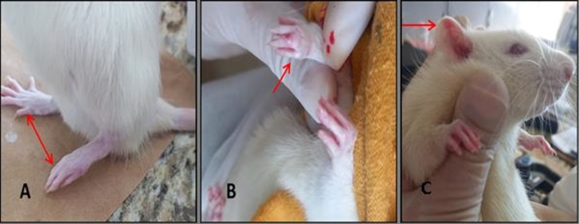

**Fig. 1** Inflammatory markers. Inflammation responses (red arrows) in rats with Freund's complete adjuvant-induced arthritis. (A) Stiffening of the legs and deformation of the phalanges; (B) joint nodules in the forelimbs; (C) erythematous reaction in the ear

Animals that received FCA injection showed an increase in the thickness of the left knee (edema) from the 3rd day after the first injection, with maximum values ​​reached on the 8th day, that is, 24 hours after the second injection, in both injected groups, which is in agreement with Oliveira et al. (2007) who defined that FCA arthritis starts between the 3rd and 7th day after injection. In the present study, there was a reduction in knee edema on the 12th day, mainly in the animals in the group treated with EAAm, when compared to the untreated animals (induced group) (Fig. 2), evidencing the effectiveness of the treatment with the aqueous extract in reducing the joint edema in animals with AIA. A similar result was obtained in the study by Zhang et al. (2008) with the plant *Turpinia arguta* that suggests a possible action of flavonoids, which requires a better investigation in *A. macrorrhizos*.

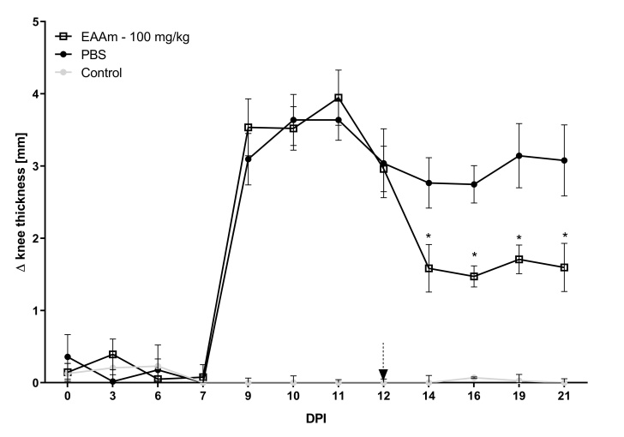

**Fig. 2** Knee thickness evaluation.Knee thickness variation in rats with Freund's complete adjuvant (FCA)-induced arthritis. Control = healthy animals; PBS = FCA-induced arthritis and treated with PBS; EAAm-100 mg/kg = FCA-induced arthritis and treated with aqueous extract of *Alocasia macrorrhizos* (100 mg/kg). Values are representative of three independent experiments and are ​​expressed as mean ± SEM. * p < 0.05 when compared to PBS. Dotted arrow = start of treatment. DPI = days post induction

**Cells present in synovial lavage fluid**

The total number of cells present in the joint lavage was higher in animals with adjuvant-induced and untreated arthritis (Fig. 3). Treatment with the aqueous extract of *A.* *macrorrhizos* (100 mg/kg) significantly reduced the number of cells in the joint lavage, as evidenced in the EAAm-100 mg/kg group (Fig. 3). According to Gomes et al. (2013) and Tarrant et al. (2006), the influx of leukocytes is one of the key events for the development of the inflammatory process in rheumatoid arthritis, being responsible for tissue destruction.

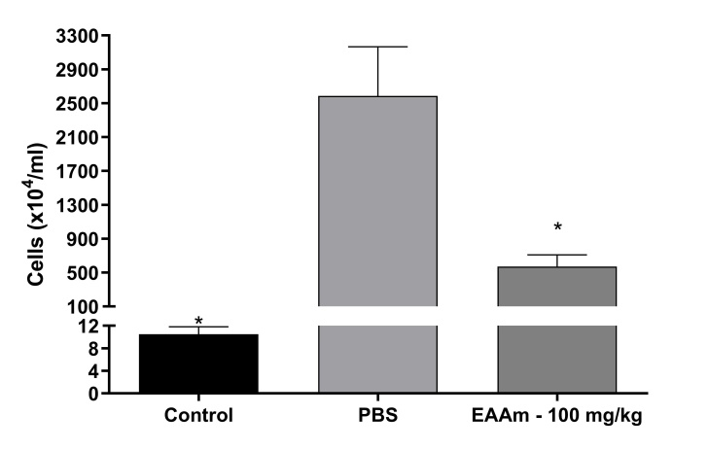

**Fig. 3** Cells in knee joint. Number of cells (x104/mL) in synovial lavage fluid of rats with Freund's complete adjuvant (FCA)-induced arthritis. Control = healthy animals; PBS = FCA-induced arthritis and treated with PBS; EAAm-100 mg/kg = FCA-induced arthritis and treated with aqueous extract of *Alocasia macrorrhizos* (100 mg/kg). Values are representative of three independent experiments and are ​​expressed as mean ± SEM. * p < 0.05 when compared to PBS

**Expression of inflammatory mediators (IFN-γ, IL-6, IL-12, IL-10)**

Treatment with *A. macrorrhizos* (100 mg/kg) promoted a significant reduction in the pro-inflammatory cytokines IFN-γ, IL-6 and IL-12 both in serum (Fig. 4) and in inguinal lymph nodes (Fig. 5), of the animals in the EAAm-100 mg/kg group, when compared to the animals in the Induced group. The IFN-γ is known to have a classic pro-inflammatory function, and its action is potentiated by the interleukin IL-12 (Pope et al. 2013). These cytokines are usually associated with structural damage to cartilage and bone (Thomé 2011); (Van Den Berg 2001).

According to da Silva et al. (2011), in arthritis, the expression of interleukin IL-6 induces the recruitment of mononuclear inflammatory cells, which contributes to the proliferation of B cells and synovial fibroblasts. These inflammatory response cells are responsible for initiating and continuing chronic immune-mediated inflammation, causing joint destruction and systemic manifestations.

No differences were observed between the groups regarding the expression of interleukin IL-10, both in serum and in inguinal lymph nodes (Fig. 4 and 5). According to Campo et al. (2011), IL-10 is classified as an antiinflammatory response cytokine, being produced by monocytes/macrophages, B cells and T cells (Campo et al. 2011; Choy 2001).

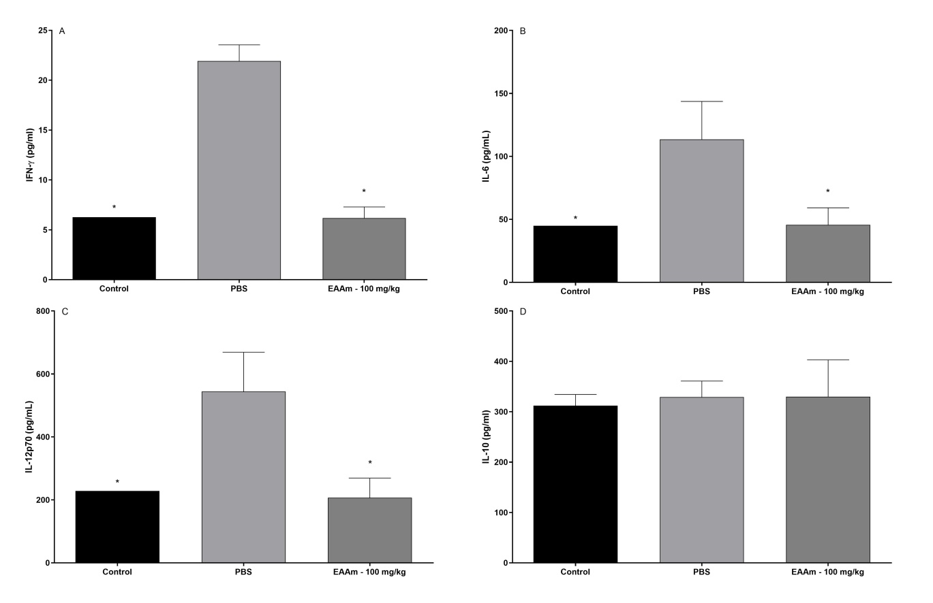

**Fig. 4** Serum cytokines. Cytokines detection in the serum samples of rats with Freund's complete adjuvant (FCA)-induced arthritis. (A) IFN-γ; (B) IL-6; (C) IL-12p70 and (D) IL-10. Control = healthy animals; PBS = FCA-induced arthritis and treated with PBS; EAAm-100 mg/kg = FCA-induced arthritis and treated with aqueous extract of *Alocasia macrorrhizos* (100 mg/kg). Values are representative of three independent experiments and are ​​expressed as mean ± SEM. * p < 0.05 when compared to PBS

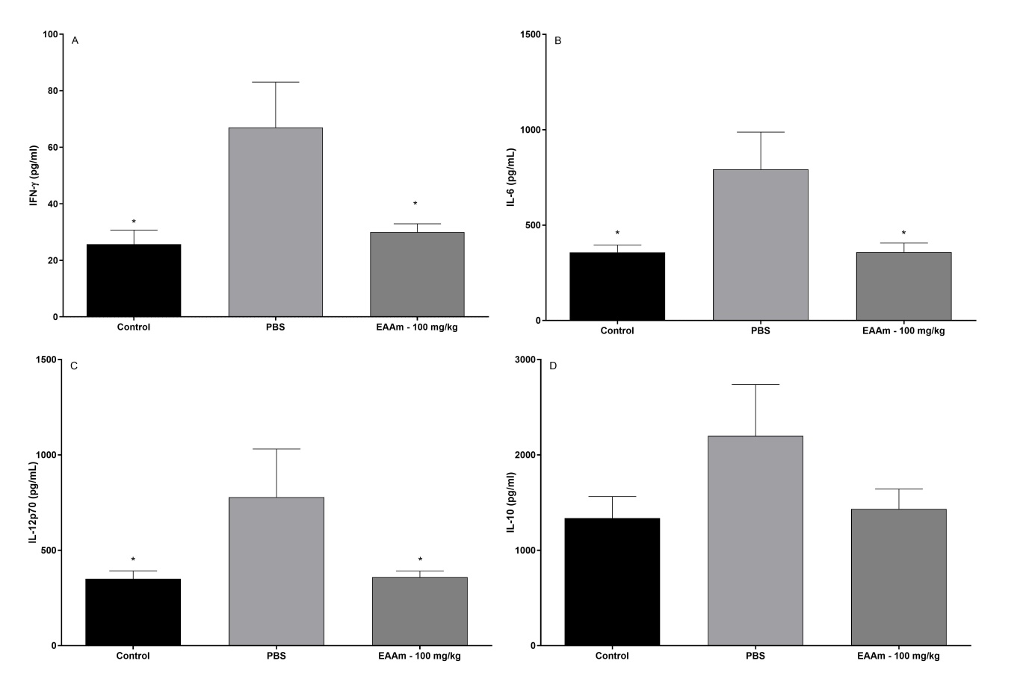

**Fig. 5** Lymph nodes cytokines. Cytokines detection in the inguinal lymph nodes of rats with Freund's complete adjuvant (FCA)-induced arthritis. (A) IFN-γ; (B) IL-6; (C) IL-12p70 and (D) IL-10. Control = healthy animals; PBS = FCA-induced arthritis and treated with PBS; EAAm-100 mg/kg = FCA-induced arthritis and treated with aqueous extract of *Alocasia macrorrhizos* (100 mg/kg). Values are representative of three independent experiments and are ​​expressed as mean ± SEM. * p < 0.05 when compared to PBS

**Histopathological alterations**

In the macroscopic analysis of the anterior region of the tibiofemoral joint, the animals with arthritis and without treatment (Induced) showed morphological alterations in the knee, such as increased thickness of the joint tissues, chondral lesion, mainly in the region of the left knee, which received the application of the FCA (Fig. 6). These alterations were less evident in the knees of the animals in the treated group (EAAm-100 mg/kg), as can also be seen in Fig. 6.

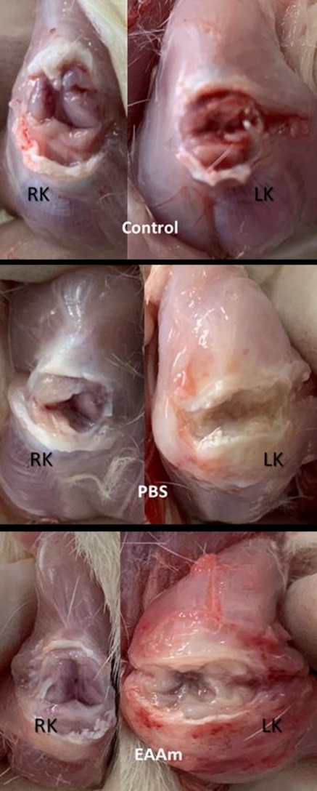

**Fig. 6** Knee joint evaluation.Macroscopic evaluation of the tibiofemoral joint of rats with Freund's complete adjuvant (FCA)-induced arthritis. Control = healthy animals; PBS = FCA-induced arthritis and treated with PBS; EAAm = FCA-induced arthritis and treated with aqueous extract of *Alocasia macrorrhizos* (100 mg/kg). RK = right knee (no-injection); LK = left knee (FCA injection). Images are representative of three independent experiments

In the microscopic analysis, the animals with arthritis and without treatment (Induced) presented joint edema, inflammation in the synovial membrane, cartilage degradation, intense inflammatory reaction in the joint cavity (Fig. 7 - C) and vascular neoformation (Fig.7 - D). These manifestations are in agreement with the joint alterations observed by Oliveira et al. (2007) and Menezes (2013). According to Van De Sande et al. (2016), inflammation of the synovial membrane occurs due to the hyperplasia of the inner layer, with intense cell proliferation, vascular neoformation and the presence of inflammatory infiltrate.

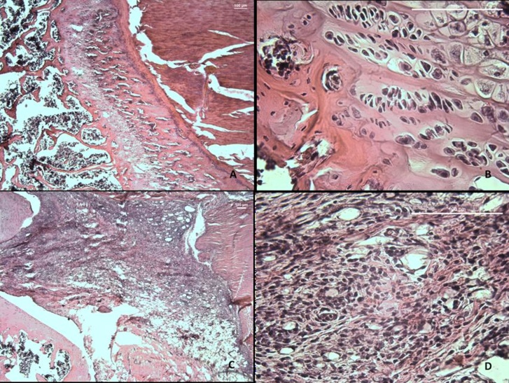

**Fig. 7** Knee joint histology.Microscopic (hematoxylin & eosin staining) evaluation of the left tibiofemoral joint of rats. (A-B) healthy animals; (C-D) Freund's complete adjuvant-induced arthritis and treated with PBS. Magnifications = 40x (A and C) and 400x (B and D). Histological sections containing muscle, loose connective tissue and cartilaginous tissue (A-B). Lymphomononuclear inflammatory infiltrate and vascular neoformation (C-D). Micrographs are representative of three independent experiments

In the present study, the animals with arthritis and without treatment (Induced) presented severe formation of joint pannus, cartilage destruction and bone erosion (Figure 8-A), alterations also reported in the study by Cai et al. (2006). Note that in the group treated with the extract (EAAm) there was less expansion of the synovial membrane in the joint cavity, with better delimitation of the cartilaginous matrix (Fig.8-B) regarding to the group without treatment (Induced), whom the synovium invasion and cartilage erosion were more pronounced. Therefore, treatment with aqueous extract of *A. macrorrhizos* (100 mg/kg) reduced the inflammatory process and preserved the cartilaginous and trabecular matrix from the tibiofemoral joint of rats with arthritis induced by FCA.

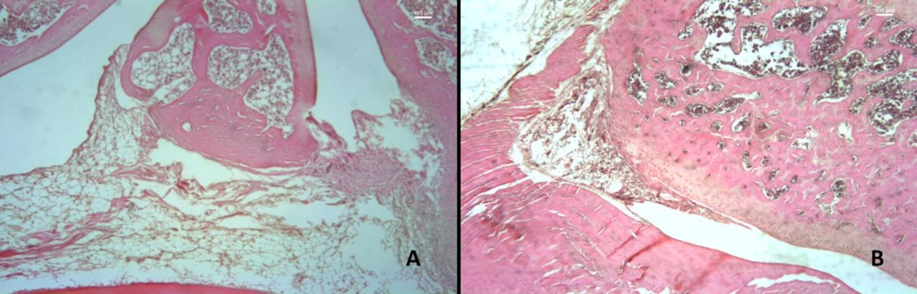

**Fig. 8** Left knee joint histology.Microscopic (hematoxylin & eosin staining) evaluation of the left tibiofemoral joint of rats with Freund's complete adjuvant (FCA)-induced arthritis. (A) FCA-induced arthritis and treated with PBS; (B) FCA-induced arthritis and treated with aqueous extract of *Alocasia macrorrhizos* (100 mg/kg). Magnifications = 40x. Micrographs are representative of three independent experiments

**Conclusion**

*Alocasia macrorrhizos* tuber aqueous extract reduced the inflammatory infiltrate and joint tissue degeneration, as well as the expression of pro-inflammatory cytokines in the serum and inguinal lymph nodes of rats with complete Freund's adjuvant induced arthritis. Thus, this paper demonstrated a promising effect in the treatment of arthritis, which needs further investigation.

Statements and Declarations

Data Availability

All data generated or analyzed during this study are included in this published article.

Ethics approval

This study was previously approved by the Animal Ethics Committee of the Federal University of Jequitinhonha and Mucury Valleys (UFVJM), Mucuri Campus, regarding the Guiding Principles in the Care and Use of Animals and in line with the principles of the Declaration of Helsinki, with an approved protocol number 09/2021-R.

Disclaimer (Artificial intelligence)

Author(s) hereby declare that NO generative AI technologies such as Large Language Models (ChatGPT, COPILOT, etc.) and text-to-image generators have been used during the writing or editing of this manuscript.

**References**

Alamanos Y, Voulgari PV, Drosos AA (2006) Incidence and prevalence of rheumatoid arthritis, based on the 1987 American College of Rheumatology criteria: a systematic review. Semin Arthritis Rheum 36:182-188. https://doi.org/10.1016/j.semarthrit.2006.08.006

Albers JMC, Paimela L, Kurki P et al (2001) Treatment strategy, disease activity, and outcome in four cohorts of patients with early rheumatoid arthritis. Ann Rheum Dis 60: 453-458. http://dx.doi.org/10.1136/ard.60.5.453

Arbain D, Sinaga LMR, Taher M, Susanti D, Zakaria ZA, Khotib J. Traditional Uses, Phytochemistry and Biological Activities of Alocasia Species: A Systematic Review. Front Pharmacol. 2022 May 24;13:849704. doi: 10.3389/fphar.2022.849704. PMID: 35685633; PMCID: PMC9170998.

Bevaart L, Vervoordeldonk MJ, Tak PP (2010) Evaluation of therapeutic targets in animal models of arthritis: how does it relate to rheumatoid arthritis. Arthritis Rheum 62:2192-205. https://doi.org/10.1002/art.27503

Brazil. Ministério da Saúde. Agência Nacional de Vigilância Sanitária (ANVISA) (2010) Resolução - RDC n° 14, de 31 de março de 2010: Dispõe sobre o registro de medicamentos fitoterápicos. Diário Oficial da União. https://bvsms.saude.gov.br/bvs/saudelegis/anvisa/2010/rdc0014_31_03_2010.html. Accessed 30 November 2022.

Bruning MCR, Mosegui GBG, Vianna CMM (2012) A utilização da fitoterapia e de plantas medicinais em unidades básicas de saúde nos municípios de Cascavel e Foz do Iguaçu – Paraná: a visão dos profissionais de saúde. Ciênc saúde coletiva 17: 2675-2685. https://doi.org/10.1590/S1413-81232012001000017

Cai X, Wong YF, Zhou H et al (2006) Manipulation of the induction of adjuvant arthritis in Sprague-Dawley rats. Inflamm Res 55:368-377. https://doi.org/10.1007/s00011-006-6026-x

Campo GM, Avenoso A, Nastasi G et al (2011) Hyaluronan reduces inflammation in experimental arthritis by modulating TLR-2 and TLR-4 cartilage expression. Biochim Biophys Acta 1812:1170-1181. https://doi.org/10.1016/j.bbadis.2011.06.006

Choy EHS, Panayi GS (2001) Cytokine pathways and joint inflammation in rheumatoid arthritis. N Engl J Med 344: 907-916. https://doi.org/10.1056/NEJM200103223441207

Cordeiro IH, Lima NM, Scherrer EC et al (2021) Metabolic profiling by LC-DAD-MS, FTIR, NMR and CE-UV of polyphenols with potential against skin pigmentation disorder. Nat Prod Res 25:1-6. https://doi.org/10.1080/14786419.2021.2005051

da Mota LMH, Kakehasi AM, Gomides APM et al (2018) 2017 recommendations of the Brazilian Society of Rheumatology for the pharmacological treatment of rheumatoid arthritis. Adv Rheumatol 58:2 https://doi.org/10.1186/s42358-018-0005-0

da Silva MA, Bersani-Amado CA, Ishii-Iwamoto EL, Bracht L, Caparroz-Assef SM. (2011) Protective Effects of Indomethacin and Cyclophosphamide but Not of Infliximab on Liver Metabolic Changes Caused by Adjuvant-Induced Arthritis. Inflamm 34:519-530. https://doi.org/10.1007/s10753-010-9259-3

de Azevedo ABC, Ferraz MB, Ciconelli RM (2008) Indirect cost of rheumatoid arthritis in Brazil. Value Health 11:869-877. https://doi.org/10.1111/j.1524-4733.2008.00332.x

Fang S, Caiyu L, Zhang Q et al (2012) Anticancer potential of aqueous extract of alocasia macrorrhiza against hepatic cancer in vitro and in vivo. J Ethnopharmacol 141: 947-56. https://doi.org/10.1016/j.jep.2012.03.037

Goeldner I, Skare TL, Reason ITM, Utiyama SRR (2011) Artrite reumatoide: uma visão atual. J Bras Patol Med Lab 47:495-503. https://doi.org/10.1590/S1676-24442011000500002

Gomes RP (2008) Atividade física no tratamento de artrite induzida por adjuvante de freund: efeitos na nocicepção, edema e migração celular. Dissertation, Universidade do Estado de Santa Catarina (UDESC)

Gomes RP, Bressan E, Silva TM, Gevaerd Mda S, Tonussi CR, Domenech SC (2013) Standardization of an experimental model suitable for studies on the effect of exercise on arthritis. Einstein (Sao Paulo) 11:76-82. https://doi.org/10.1590/S1679-45082013000100014

Hazlewood GS, Whittle SL, Kamso MM et al (2020) Disease‐modifying anti‐rheumatic drugs for rheumatoid arthritis: a systematic review and network meta‐analysis. Cochrane Database Syst Rev. 2020(3):CD013562. https://doi.org/10.1002/14651858.CD013562.

Kelly S, Dunham JP, Donaldson LF (2007) Sensory nerves have altered function contralateral to a monoarthritis and may contribute to the symmetrical spread of inflammation. Eur J Neurosci 26:935-942. https://doi.org/10.1111/j.1460-9568.2007.05737.x

Khurana R, Berney SM (2005) Clinical aspects of rheumatoid arthritis. Pathophysiol 12: 153-165. https://doi.org/10.1016/j.pathophys.2005.07.009

Md. Khirul Islam, Imran Mahmud, Sanjib Saha, Asit Baron Sarker, Himangsu Mondal, A.S.M. Monjur-Al-Hossain, Md. Anisuzzman, Preliminary pharmacological evaluation of Alocasia indica Schott tuber, Journal of Integrative Medicine, Volume 11, Issue 5, 2013, Pages 343-351, ISSN 2095-4964, https://doi.org/10.3736/jintegrmed2013045.

Menezes RR (2013) Monoartrite induzida por adjuvante completo de Freund em ratos Holtzman e avaliação dos efeitos induzidos pelo tratamento crônico com tiamina ou riboflavina. Dissertation, Universidade Federal de Minas Gerais (UFMG)

Mota LMH, Cruz BA, Brenol CV et al (2013) Diretrizes para o diagnóstico da artrite reumatoide. Rev Bras Reumatol 53:141-157. https://doi.org/10.1590/S0482-50042013000200003

Mulla WA, Kuchekar SB, Thorat VS, Chopade AR, Kuchekar BS (2010) Antioxidant, Antinociceptive and Anti-inflammatory Activities of Ethanolic Extract of Leaves of Alocasia indica (Schott.). J Young Pharm 2:137-143. <https://doi.org/10.4103/0975-1483.63152>

Mulla WA, Thorat VS, Patil RV, Burade KB. Anthelmintic activity of leaves of Alocasia indica Linn. Int J PharmTech Res. 2010; 2(1): 26-30.

Oliveira PG, Brenol CV, Edelweiss MI, Meurer L, Brenol JCT, Xavier RM (2007) Subcutaneous inflammation (panniculitis) in tibio-tarsal joint of rats inoculated with complete Freund’s adjuvant. Clin Exp Med 7:184–187. https://doi.org/10.1007/s10238-007-0148-6

Ostrowska M, Maslinski W, Prochorec-Sobieszek M, Nieciecki M, Sudol-Szopinska I (2018) Cartilage and bone damage in rheumatoid arthritis. Reumatologia 56:111–120. https://doi.org/10.5114/reum.2018.75523

Pope RM, Shahrara S (2013) Possible roles of IL-12-family cytokines in rheumatoid arthritis. Nat Rev Rheumatol 9:252-256. https://doi.org/10.1038/nrrheum.2012.170

Rahman MA, Solaiman M, Haque ME, Das AK. (2011) Analgesic and anti-inflammatory activities of Alocasia indica (Roxb.) Schott. Orient Pharm Exp Med 11:143-146. https://doi.org/10.1007/s13596-011-0027-1

Rahman MM, Hossain MA, Siddique SA, Biplab KP, Uddin MH. Antihyperglycemic, antioxidant, and cytotoxic activities of Alocasia macrorrhizos (L.) rhizome extract. Turk J Biol. 2012; 36:574-579.

Tarrant TK, Patel DD (2006) Chemokines and leukocyte trafficking in rheumatoid arthritis. Pathophysiol 13:1-14. https://doi.org/10.1016/j.pathophys.2005.11.001

Thomé R (2011) Modulação da artrite experimental induzida pela associação de colágeno tipo II e ovalbumina. Dissertation, Universidade Estadual de Campinas (UNICAMP)

Van de Sande MG, Baeten DL (2016) Immunopathology of synovitis: from histology to molecular pathways. Rheumatol (Oxf) 55:599-606. https://doi.org/10.1093/rheumatology/kev330

Van Den Berg WB (2001) Anti-cytokine therapy in chronic destructive arthritis. Arthritis Res Ther 3:18-26. https://doi.org/10.1186/ar136

Yang CLH, Or TCT, Ho MHK, Lau ASY (2013) Scientific basis of botanical medicine as alternative remedies for rheumatoid arthritis. Clin Rev Allergy Immunol 44:284–300. https://doi.org/10.1007/s12016-012-8329-8

Zhang L, Li J, Yu SC et al (2008) Therapeutic effects and mechanisms of total flavonoids of Turpinia Arguta Seen on adjuvant arthritis in rats. J Ethnopharmacol 116:167-72. https://doi.org/10.1016/j.jep.2007.11.027