**ASSESSMENT OF FOUR DIFFERENT METHODS OF MEASURING BIPARIETAL DIAMETER THROUGH COMPARATIVE ANALYSIS: A PROSPECTIVE STUDY**

**Abstract**

The study evaluates the accuracy of the different methods of measuring biparietal diameter (BPD) as an index of estimating gestational age (GA). This study was a prospective comparative analysis with 107 pregnant patient’s participants. They were examined abdominally in university of Calabar teaching hospital, cross River, Nigeria. The paired t-test was employed to compare the different methods of biparietal diameter to assess their accuracy. The results showed that there was no significant difference (P˂0.05) in the four methods of estimating gestational age using biparietal method except for outer to inner and table and table method which was 0.0719. When the paired t-test sample was used to compare the different methods with the last menstrual period (LMP) and gestational age, there was no significant difference in all the four different methods. However, the outer to inner and table to table method appears to be more significant indicating its suitability as a method of obtaining gestational age using biparietal diameter.

*Keyword:* Biparietal diameter, gestational age, ultrasound, menstrual period.

**Introduction**

The measurement of a gestational age can be determined by count the first day of the last occurrence of menstrual period to the current day and they are measured in weeks. It is referred as the last menstrual period (LMP) (Khare *et al*., 2019). Though this method has existed over the years, when it is unreliable, it weakens its accuracy. Therefore, ultrasonographic examination methods have become more reliable in determining the gestational age of a fetus. Biparietal diameter (BPD) is one of the ultrasonographic examination methods utilized in defining the fetal age. The essence of biparietal diameter is to measure the skull diameter of a fetus which is beneficial in determining the gestational age, growth rate and development of the fetus (Verburg, *et al*., 2008). However, biparietal diameter must be measured with other biometric parameters such as head circumference, abdominal circumference and femur length to establish the fetal weight. (Wong, *et al*. 2018) The process will help in proper diagnosis of fetal growth disorder which will prompt timely intervention. Failure to diagnose correctly will affect the antenatal monitoring and surveillance. According to Trish *et al*., (2004) biparietal diameter is precise in predicting gestational age and delivery date from second trimester, hence, its use in all pregnancy. There are basically four essential methods of biparietal diameter. They are inner to inner, outer to inner, table to table, outer to outer. The outer-to-outer method involves the measurement or placement of calipers from the outer edge of distal parietal bone to the outer edge of proximal parietal bone while, inner to inner biparietal diameter measurement place the calipers from inner edge of the distal parietal bone to the inner edge of the proximal parietal bone. The outer to inner biparietal diameter involves placing the calipers from outer rim of the distal parietal bone to the inner rim of the proximal parietal bone and table to table biparietal diameter method is done by placing the calipers from the midpoint of distal parietal bone to the midpoint of proximal parietal bone. (George *et al*.,2021). Though, biparietal diameter is the most widely used fetal biometry for determination of gestational age, factors such as the position of the fetus in the pelvis region and the brain side that was scanned can influence the value. Conversely, biparietal diameter scan can be carried out at different sections which are thalamic, ventricular and cerebellar. There is no gold standard section but the widely used section in most countries is the thalamic section (Papageorghiou *et al*., 2013). There are disparities in the review of BPD method to use indicating no consensus method. (ISUOG, 2014). However, the outer-to-outer method was recommen nd ded by the international growth chart because it's beneficial in comparing the antenatal and post-natal measurement of size of the head and growth. (Villar *et al.,* 2014). Different studies have been conducted to ascertain the variation between outer-to-outer method and inner to outer method. Napilitano *et al.,* (2016) reported that the inner to outer and outer to outer methods are both reproducible. However, the studies on the four methods have not been conducted to the best of my knowledge. Therefore, this study focuses on assessing the variation in the four methods of conducting biparietal diameter in 3rd trimester of fetal biometry by comparing the methods to establish the most appropriate method.

**Methods**

The study was performed at university of Calabar teaching hospital in Cross River state, Nigeria. The population of women involved in the study were all pregnant and within their 2nd and 3rd trimester. The participants were grouped into four sorts depending on their gestational age. Group 1 was between 23-27 weeks, group 2 were between 28-32 weeks, group 3 were between 33-37 weeks, group 4 were between 38-42 weeks. (Gebreel *et al*., 2024). The selection criteria include a. Singleton pregnant fetus. b. Pregnant women in 2nd and 3rd trimester, pregnant women who were sure of their dates at different weeks of gestation obtained by last menstrual period (LMP). Exclusion criteria are a. Pregnant women with any form of fetal skull abnormality. b. multiple gestation. c. alcohol mother. d. diabetic mother. e. hypertensive mother. Sample size of women who met inclusion criteria are 107. The ultrasound was carried out using digital ultrasound system imaging by EDAN model: DUS 3, SN: 317201-M12CO46001 with a convex transducer of 3-5MHz.

**Scanning Technique for Pregnant Abdomen**

The patient laid supine on the couch and ultrasound gel was evenly applied on the abdomen. The probe was placed on the abdomen, rotated at different angles and planes to sort for good oval shape of the fetal skull. Once found, the biparietal diameter measurements were carried using trans thalamic section with the following landmarks; a rugby football-shaped skull rounded at the back (occiput) and more pointed at the front (synciput), a long midline equidistant structure from the proximal and distal skull echoes, the cavum septum pellucidum bisecting the midline one-third of the distance from the synciput to the occiput, the two prominent anterior and posterior horns of the lateral ventricles symmetrically placed about the midline and the full length of the lateral ventricles. The first method (outer to outer), the first cross caliber was placed on the leading ridge of the distal parietal bone while the second cross caliber was placed on the leading edge of the proximal parietal bone. The second method (Outer to Inner), the first caliber was placed on the leading ridge of distal parietal bone while, the second cross caliber was positioned on the inner ridge of the proximal parietal bone. The third method (Inner to Inner) was done by placing the cross caliber on the inner ridge of the parietal bone and placing the second cross caliber on the inner ridge of the proximal parietal bone. The fourth method (Table to Table) was carried out by positioning the first cross calibre in the table of the distal parietal bone while, the second calibre was placed in the table of the proximal parietal bone as shown figure 1. The study was carried out in triplicate and the mean was determined.

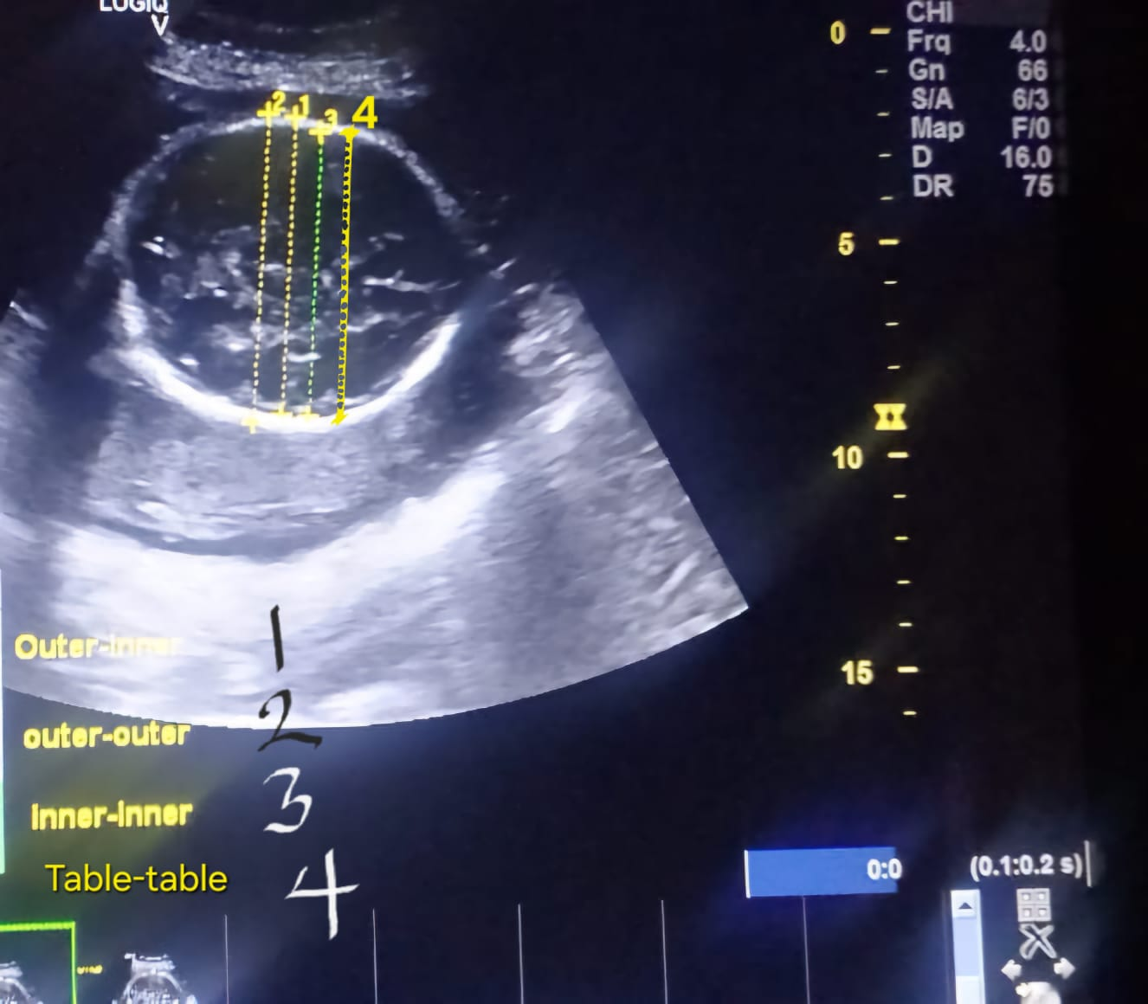

Figure 1: Different method of Biparietal method.

**Statistical Analysis**

The statistical analysis was carried out using SPSS statistical package version 30 The data were analyzed using frequencies and percentages while, a paired t-test at P˂0.05 significance was used to compare different methods of biparietal diameter (BPD).

**Results and Discussion**

**Outer to Outer Method of Biparietal.**

The result of the outer-to-outer method of measuring biparietal diameter was shown in table 1. The table shows the gestational age (GA) distribution of pregnant women involved in biparietal diameter determined using this method. It indicates that the GA of 33-37 were more frequent at 40.2% than others. However, 28-32 age has about 15.9% occurrence while, the least GA was about 13.9%.

Table 1. Outer to outer Biparietal Diameter Measurement.

|  |  |  |
| --- | --- | --- |
| Gestational Age (Weeks) | Frequency (MHz) | Percentage (%) |
| 23-27 | 2 | 15.9 |
| 28-32 | 43 | 40.2 |
| 33-37 | 47 | 13.9 |
| 38-42 | 15 | 14.0 |
| Total | 107 | 100.0 |

**Outer to Inner method of Biparietal Diameter**

The outer to inner method used for measurement of fetal skull is presented in table 2. The method measures from the outer distal edge to the inner proximal edge of the fetus. The GA distribution of 33-37 had the highest percentage of outer to inner BPD measurement. The least was recorded between the gestational age of 23-27.

Table 2. Outer to Inner Biparietal Diameter Method

|  |  |  |
| --- | --- | --- |
| Gestational Age (Weeks) | Frequency (MHz) | Percentage (%) |
| 23-27 | 2 | 1.9 |
| 28-32 | 31 | 29.0 |
| 33-37 | 60 | 56.0 |
| 38-42 | 14 | 13.1 |
| Total | 107 | 100.0 |

**The Inner-to-Inner method of Biparietal Diameter**

Table 3 shows the inner-to-inner method of biparietal measurement in different GA distribution of pregnant women. The highest percentage occurrence is within the gestational age of 28-32 while the least was found in the 38-42 weeks.

Table 3. Inner to Inner Biparietal Diameter Method

|  |  |  |
| --- | --- | --- |
| Gestational Age (Weeks) | Frequency (MHz) | Percentage (%) |
| 23-27 | 14 | 13.1 |
| 28-32 | 49 | 54.8 |
| 33-37 | 42 | 39.3 |
| 38-42 | 2 | 1.9 |
| Total | 107 | 100.0 |

**The Table-to-Table Method of Biparietal Diameter**

This method as presented in table 4 is the method of BPD that places the caliber from the midpoint of the table of the distal parietal bone to the proximal parietal bone. It shows that the highest percentage of GA was 33 to 37-week fetus while, the least was 23-27 weeks.

Table 4. Table to Table Biparietal Diameter Method

|  |  |  |
| --- | --- | --- |
| Gestational Age (Weeks) | Frequency (MHz) | Percentage (%) |
| 23-27 | 2 | 1.9 |
| 28-32 | 35 | 32.7 |
| 33-37 | 58 | 54.2 |
| 38-42 | 12 | 11.2 |
| Total | 107 | 100.0 |

The accuracy of the four methods of biparietal measurement was done to determine the significant difference at (P˂0.05) confidence level when compared with the last menstrual period. The result as shown in table 5 reveals that there is no significant difference between the BPD methods and last menstrual period. However, table to table biparietal diameter method appears to be less significant indicating its efficiency in determining the fetus age within the 3rd trimester.

Table 5. Accuracy of estimating four methods of gestational Age

|  |  |  |  |
| --- | --- | --- | --- |
| Paired Groups | T | Df | p-value |
| Pair 1-outer to outer/LMP | -13.171 | 106 | 0.000 |
| Pair 2-outer to Inner/LMP | 2.674 | 106 | 0.009 |
| Pair 3-inner to Inner/LMP | 23.081 | 106 | 0.000 |
| Pair 4-Table table/LMP | 2.289 | 106 | 0.024 |

Significant difference at (P˂0.05) confidence level.

Moreover, the pair t-test conducted to understand the difference among the mean of the individual methods as presented in table 6 suggests that there is no significant difference except for outer to inner/table to table method.

Table 6. Accuracy of the four methods estimating gestational age using paired T-test

|  |  |  |  |
| --- | --- | --- | --- |
| Paired Groups | T | Df | p-value |
| Pair 1-outer to inner/outer to outer | 17.437 | 106 | 0.000 |
| Pair 2-outer to outer/inner to inner | 29.432 | 106 | 0.000 |
| Pair 3-table to table/outer to inner | -361 | 106 | 0.719 |
| Pair 4-inner to inner/table to table | -18.707 | 106 | 0.000 |

Significant difference at (P˂0.05) confidence level.

**Discussion**

Given the necessity of managing pregnancy appropriately, particularly in cases of aberrant fetal growth, the significance of determining a fetus's gestational age cannot be overstated. The observation of last menstrual period before the actual menstrual cycle are used to determine the gestational age but it’s not reliable when the date can’t be remembered accurately. Moreover, different biometric parameters have been in use for obtaining the gestational age such as biparietal diameter (BPD), head circumference (HC), femur length (FL) and abdomen circumference (AC). However, they all have their merits and demerits. Due to the accuracy of biparietal method in determining the delivery date, it is important in all pregnancies (Trish *et al*., 2024). In the utilization of biparietal diameter, the outer to inner and table to table methods have demonstrated to have a reliable result but their application depends on regional adoption. (Wong *et al.,*2018). This study demonstrated the variation of the four methods of obtaining the fetus skull measurement in the third trimester. The ultrasound carried out shows that the different biparietal diameter methods had the highest percentage occurrence at gestational age of 33-37 weeks except for outer-to-outer method which had the highest percentage occurrence between 28-32-week gestational age. Further, the gestational age of 38-42 had a low percentage occurrence. This suggests that different biparietal methods become less effective in determining the gestational age as it advances. Dare *et al*., (2004) reported that the accuracy and precision of biparietal method decreases as gestational age collapses into late third trimester. However, there is no significant difference (P˂0.05) between the methods except for inner to inner and outer to outer method. This indicates that the different methods of obtaining biparietal diameter are efficient though, table to table method appears to be most proficient.

**Conclusion**

The findings suggest that the outer to inner and table to table methods demonstrated high accuracy in estimating gestational age in the third trimester with the table-to-table method being the most accurate.

**Acknowledgments**

The contributions of the authors are acknowledged in this review work.

**Funding**

The authors declare no financial support for the research, authorship, or publication of this article.

Ethical Approval:

As per international standards or university standards written ethical approval has been collected and preserved by the author(s).

Consent

As per international standards or university standards, Participants’ written consent has been collected and preserved by the author(s).

**Author contributions**

Conceptualization and Methodology, J.A.N., Data Curation, T.E., Draft Preparation, C.O.U., Writing—Review and Editing, T.N.U. and supervision, T.E. All authors have read and agreed to the published version of this manuscript.

**Conflict of Interest**

The authors declare no conflicts of interest.

**Data Availability Statement**

Data supporting this finding is available within the article.

**Disclaimer (Artificial intelligence)**

Author(s) hereby declares that NO generative AI technologies such as Large Language Models (ChatGPT, COPILOT, etc.) and text-to-image generators have been used during the writing or editing of this manuscript.

**Reference**

Dare, F. Smith O., Smith, N.C., and Smith, P. (2004). Ultrasonic measurement of biparietal diameter and femur in fetal age determination. *West African journal of Medicine*, 23(1):2004.

Gebreel, M.M., Mohamed, F., Abdel Fattah, A.H., (2024). Comparative Study of Fetal Transverse Cerebellar Diameter with Biparietal Diameter and Femur Length in the Estimation of Gestational Age in the Second and Third Trimesters. *Al-Azhar International Medical Journal* 5 (2024) 103-112.

George, R., Umamageswari, p., Mohamed, R.H., Vignesh, A.M, Elamparidha, P., and Kulasekeran, N. (2021). Can trans-cerebellar diameter supersede other fetal biometry in measuring gestational age? A prospective study. *Egypt Journal of Radiology and Nuclear Medicine*, 52:197 <https://doi.org/10.1186/s43055-021-00576-0>

International Society of Ultrasound in Obstetrics & Gynecology Education Committee. Sonographic examination of the fetal central nervous system: Guidelines for performing the ‘basic examination’ and the ‘fetal neurosonogram’. *Ultrasound Obstetric Gynecology* 2007; 29: 109–16.

Khare, S., Mandle, H., Chatterjee, M., Bichitrananda, R., and Deepti, G., (2019). Estimation of gestational age by real time ultrasonography (biparietal diameter and femur length) to estimate the foetal morphometry in II and III trimesters. *Journal of Evidence Based Medical Healthcare*, 6(2), 117-122. DOI: 10.18410/jebmh/2019/23.

Napolitano R, Donadono V, Ohuma EO, Knight CL, Wanyonyi SZ, Kemp B, et al. Scientific basis for standardization of fetal head measurements by ultrasound: a reproducibility study. *Ultrasound Obstetric Gynecology* 2016; 48: 80–5.

Papageorghiou AT, Sarris I, Ioannou C, Todros T, Carvalho M, Pilu G, et al. Ultrasound methodology used to construct the fetal growth standards in the intergrowth-21st project. BJOG 2013;120 (Suppl 2):27–32.

Trish *et al*., (2004). Routine 2nd trimester screening-assessing fetal anatomy. In: Serena (3rd Ed.) Obstetric Ultrasound: How, why and when. *Elsevie*r, London.

Verburg, B.O., Steegers, E. A. P., De Ridder, M., Snijders, R. J. M., Hofman, A., Moll§, H. A., Jaddoe, V. W. V., and Witteman, J. C. M. (2008). New charts for ultrasound dating of pregnancy and assessment of fetal growth: longitudinal data from a population-based cohort study. *Ultrasound Obstetric Gynecology*, 31: 388–396.

Villar J, Cheikh Ismail L, Victora CG, Ohuma EO, Bertino E, Altman DG, et al. international standards for newborn weight, length, and head circumference by gestational age and sex: the newborn cross-sectional study of the intergrowth-21st project*. Lancet* 2014; 384: 857–68.

Wong, L., Eldho, P., Hamsaveni, K.M., Jing, Fang., Ilona, L., Coombs, P.R., and Teoh, M. (2018). Biparietal diameter measurements using the outer-to-outer versus outer-to-inner measurement: A question of pedantry. *Australasian Society for Ultrasound in Medicine*, 21 (3) 161.