**PERCEPTION OF DOCTORS IN SURGICAL SPECIALTIES ABOUT FASTING GUIDELINES FOR DAY CASE SURGERIES IN A TERTIARY HOSPITAL IN SOUTH-SOUTH, NIGERIA**

**ABSTRACT**

***BACKGROUND*** *Preoperative fasting is a prescribed period before a procedure, when patients are not allowed oral liquids and solids. It is an essential aspect of anaesthesia, as lack of practice is detrimental to the patient. This study was carried out to assess the perception of doctors in surgical specialties about fasting guidelines for day case surgeries.* ***METHODS:*** *Measurements were done using an electronic, self-administered questionnaire divided into three main sections; Demography (age, sex, gender, marital status); knowledge; and practice.* Data was entered into SPSS 27 and analysed.***RESULTS:*** *The response rate to this study was 73%. Up to**90% were aware of the ASA published practice guidelines for preoperative fasting in healthy patients undergoing elective procedures, 50% described the correct practice guideline for adults and 60% for paediatric cases, but only 40% follow the guidelines for adults and 51% for paediatrics. The absence of standard hospital protocol and differing fasting instructions by surgical specialty residents and anaesthesia residents were the most common barriers for not complying with the guidelines.* ***CONCLUSION****: Majority of the respondents were aware of the ASA fasting guidelines and up to half could describe it correctly, but the implementation and actual practice of these guidelines was poor among respondents.*

***Key words: fasting guidelines, day case surgeries, surgeons, south-south, Nigeria***

**INTRODUCTION**

Preoperative fasting is a prescribed period before a procedure, when individuals scheduled for operative procedures are not allowed oral liquids and solids. It is an essential and critical aspect of anaesthesia, and lack of practice may be detrimental to the patient.

The concept of “pre-operative fasting” is said to have started in 1883, when Lister said, “While it is desirable that there should be no solid matter in the stomach when chloroform is administered, it will be found very salutary to give a cup of tea or beef-tea about two hours previously”.1

In 1946, Mendelson claimed a very high incidence of pulmonary aspiration during general anaesthesia (GA) in obstetrics,2 leading to the practice of NPO (Latin: Nulla per os; or nothing by mouth) after midnight before elective surgery; this became a routine clinical practice for many years.

Pulmonary aspiration when it occurs may lead to respiratory failure in patients undergoing elective and emergency procedures. The risk of aspiration increases when patients for surgery are not well fasted because of increase in residual gastric volume and decreasing pH. General anaesthesia also reduces reflexes and with decreasing oesophageal sphincter tone, regurgitation and aspiration of gastric contents can easily occur.

After the discovery by Mendelson,2 prolonged fasting was widely practiced until the latter half of the twentieth century when it was demonstrated that in patients given clear fluids orally up to 3h before surgery, there was no increase in gastric volume or acidity of gastric content.3

The American Society of Anesthesiologists (ASA) first published fasting guidelines in 1999 and later updated it in 2017, shortening the period of pre-operative fasting. They recommended that all healthy patients posted for elective surgery be allowed to have a regular solid meal 8 h prior, a light meal (toast and clear tea) 6 h prior, and unlimited clear fluids (water, fruit juices without pulp, clear tea, black coffee, and any liquid through which a newspaper can be read easily) up to 2 h prior to surgery.4

Several studies on preoperative fasting have been carried out,3,4 and despite the knowledge awareness of fasting guidelines and its advantages as well as importance, the practice implementation remains challenging as noted by researchers. Silva et al5 in their study in 2023 stated that healthcare professionals should ensure the comprehension of fasting guidelines, however, it does not appear that the challenge is with comprehension as reported by Gupta et al,6 but rather with the implementation. Whichever way it is, challenges with fasting guidelines remain, and Silva et al5 therefore recommend that further studies should aim to identify effective solutions to mitigate prolonged fasting.

In the University of Port Harcourt Teaching Hospital, surgeons usually manage patients for day case procedures; the Anaesthetist is rarely involved as the procedures are often carried out under local anaesthesia and fasting guidelines are prescribed by the surgeons.

This study was thus conducted to assess the current practice and implementation of fasting guidelines for day case procedures among surgeons in our Institutions.

**MATERIALS AND METHODS**

Ethical approval was obtained from the Institution’s Ethical Committee

**Study Area**: Port Harcourt, Rivers State South-South of Nigeria.

**Study Setting**: The study took place at the University of Port Harcourt Teaching Hospital, a tertiary health institution in Port Harcourt, Rivers State, Nigeria.

**Research design:** The study was a descriptive cross-sectional one.

**Study population:** The total population was doctors in all the surgical specialities

**Study Instrument**: A proforma was designed and circulated to all the doctors in the surgical specialties on Google form; the instrument was reviewed by all the authors.

**Data analysis:** Data was entered into a spreadsheet and analysed

Eleven (11) surgical specialties were included in the study, with a total of 263 doctors in surgery during the 4weeks of the study, 192 participated in the study, 108 Registrars, 41 Senior registrars, and 43 Consultants. University of Port Harcourt Teaching Hospital is a tertiary hospital in the South-South region of Nigeria. It is an 800 bedded hospital.

During the surgical residency, all surgeons undergo a two-month rotation in the Department of Anaesthesia and as such, are expected to know the basics of Anaesthesia. There are 12 theatre suites, and about 9 day-cases take place daily**.** All surgical specialties that have day cases were included in the study.

Measurements were done using an electronic questionnaire divided into three main sections: Demography (age, sex, gender, marital status); knowledge and practice.

Statistical package for social sciences (SPSS) version 27 was used to analyse data obtained. Quantitative data was assessed using mean, standard deviation, and qualitative data using frequencies and percentages**.**

**RESULTS**

The eleven (11) surgical specialties were included in the study, and out of a total of 263 doctors in surgery during the 4weeks of the study, only 192 participated (73%).

There were more respondents (48.4%) in the 36 – 50year age bracket as shown in Table I; only 30 (15.6%) were between 51 and 65 years, and there were more male respondents (73.4%) than female

**TABLE I: Mean socio-demographic and clinical characteristics of Respondents**

**BIODATA n (192) %**

**AGE**

20-35 69 35.9

36-50 93 48.4

51-65 30 15.6

**SEX**

Male 141 73.4

Female 51 26.6

**Table II** shows the numbers in the various specialties; there were more respondents in obstetrics and gynaecology and anaesthesia, and very few in neurosurgery (2.1%); majority were Registrars (56.3%) as shown in Fig I. Less than 10% had spent more than 20 years in practice; the majority were between 10 – 20 years in practice (Fig 2).

As shown in Table III, 89.6% knew about the ASA fasting guidelines, majority were aware of the positive effect on regurgitation but <30% knew that it enhances postoperative recovery (Table IV)

Most of the information on fasting guidelines were obtained from textbooks and published journal articles (Fig 3).

In actual practice as shown in Figs 4 & 5, majority of the respondents would fast adults and children for up to 6 hours to liquids (58.3%, 72.6% respectively)**,** and cited absence of clear hospital protocol and differing instructions as the main reasons limiting proper practice (Table V).

**TABLE II: SPECIALTIES AND NUMBER OF RESPONDERS**

**Specialty n %**

General surgery 19 9.8

Urology 12 6.3

Cardiothoracic 13 6.8

Maxillofacial 9 4.7

Ophthalmology 24 12.5

Obstetrics and Gynaecology 38 19.8

Orthopaedics 18 9.4

Burns and plastic 8 4.2

Anaesthesia 38 19.8

Neurosurgery 4 2.1

ENT 9 4.7

**Total 192 100**

**FIG I: CADRE OF SURGEONS:**

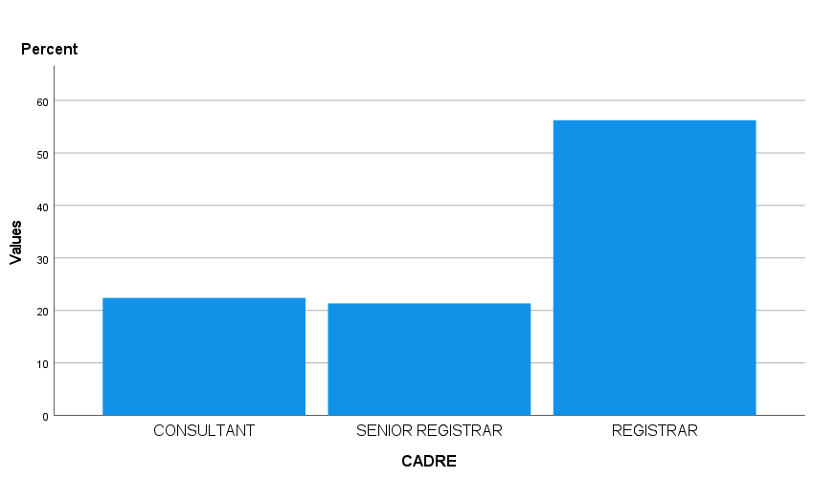

**FIG II: NUMBER OF YEARS OF PRACTICE**

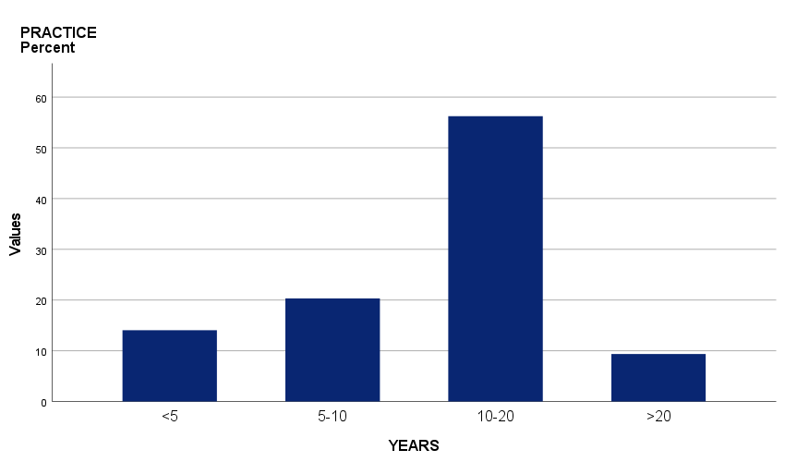

**TABLE III: KNOWLEDGE OF ASA FASTING GUIDELINES**

**ASA n (192) %**

Yes 172 89.6

No 20 10.4

**TABLE IV:** **KNOWLEDGE OF ASA FASTING GUIDELINES ON OUTCOME/MORBIDITY**

**Knowledge n %**

Improves comfort 20 10.4

Decreases stress 51 26.6

Less intraoperative hypotension 16 8.3 Enhances postoperative recovery 52 27.1

Prevents regurgitation 191 99.5

**FIG III: SOURCE OF INFORMATION ON FASTING GUIDELINES**

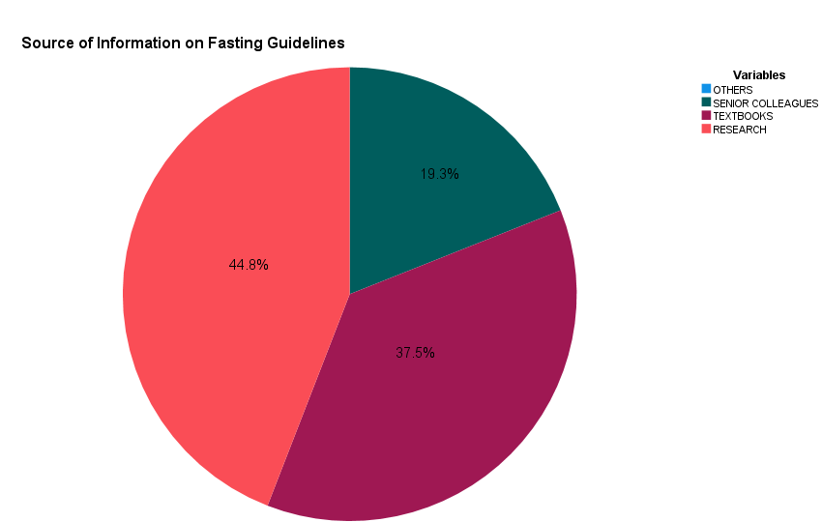

**FIG IV: ACTUAL PRACTICE OF SURGEONS TOWARDS FASTING GUIDELINES IN ADULTS**

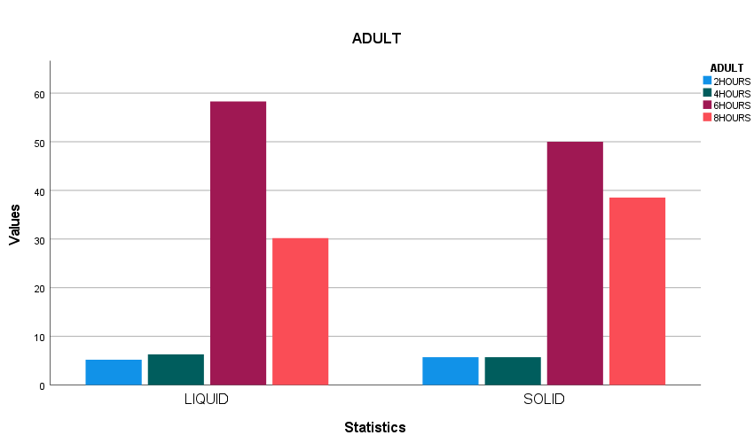

**FIG V: ACTUAL PRACTICE OF SURGEONS TOWARDS FASTING GUIDELINES IN PAEDIATRICS.**

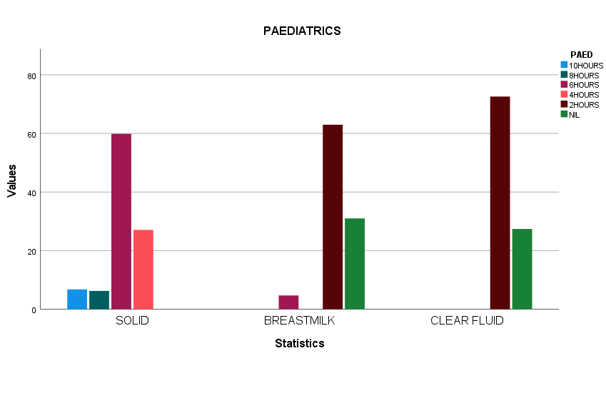

**TABLE V: LIMITING FACTORS TO IMPLEMENTING ASA GUIDELINES**

**Factors n %**

Inadequate guidelines 0 0

Lose flexibility 32 16.7

Lack of understanding 44 22.9

Differing instructions 71 37.0

No standard hospital policy 74 38.5.

No lectures 0 0

High workload 0 0

Others 0 0

**DISCUSSION**

Pre-operative fasting is a period before an elective procedure, when patients are instructed to abstain from taking anything liquid or solid by mouth, to reduce the risk of regurgitation and aspiration of gastric contents. The practice is aimed at improving patient safety.

The international preoperative fasting guidelines was officially published by ASA in 19991 and revised in 2017.1

In this study, majority of the respondents were between 36 – 50 years, there were more males than females, many had been in medical practice for 10 – 20 years, and there were more Registrars than Senior Registrars and Consultants. Majority of the respondents were from the Departments of Obstetrics & Gynaecology, Anaesthesia and Ophthalmology. Most of the surgeons (89.6%) were aware of the ASA published practice guidelines for preoperative fasting in healthy patients undergoing elective procedures. This is not unusual as a similar survey conducted in Sri Lanka by Gunawardhana et al7 showed that 70% of healthcare workers were aware of at least one of the recommended guidelines (ASA, Association of Anaesthetists of Great Britain and Ireland, Royal College of Nursing).7

Proper preoperative fasting improves patient safety, and majority of the respondents in this study knew that fasting would prevent regurgitation, however, the knowledge of other benefits of preoperative fasting was rather poor. This is similar to the study by Panjiar et al,8 in which the knowledge related to the advantages of liberalised fasting was poor among respondents.

Of importance in this study was the finding that respondents obtained most of their information on fasting guidelines from textbooks and published articles; these are accurate sources of information, especially indexed high impact journals.Gupta et al9 in their study however found that 54% of the participants in their study obtained knowledge about the fasting guidelines from their seniors, which may be attributed to the fact that they based their study only on postgraduate trainees compared to the index study that involved all cadre of surgeons; respondents who obtained the information on preoperative fasting from senior colleagues was just 19.3%.

One main purpose of the ASA guidelines is to provide direction for clinical practice related to preoperative fasting to reduce the risk of pulmonary aspiration and the severity of complications related to perioperative pulmonary aspiration. Pre-operative fasting standards have been developed by anaesthesia societies with almost all following a variant of the “2-4-6-8 rule”. The American Society of Anaesthesiologists (ASA) recommends patients to fast from fatty food or meats eight (8) hours prior to surgery, non-human milk or light meal for six (6) hours prior, breast milk for four (4) hours prior, and clear liquids including water, pulp-free juice, and tea or coffee without milk for two (2) hours prior to the anaesthetic.11 Despite the various guidelines, the practice of overnight fasting “NPO after midnight,” is still being practiced in most hospitals.9,10

Studies regarding the knowledge, attitude, and practice of preoperative fasting guidelines were carried out amongst anaesthesiologists,6,7 another was amongst the Postgraduate trainees of various surgical specialties, including anaesthesiology.9 However, this is the first study to assess amongst surgeons of all cadre in various surgical specialties, including anaesthesiologists in University of Port Harcourt Teaching Hospital.

This study revealed that although 89.6% of surgeons knew about fasting guidelines, having obtained the knowledge from textbooks and journals and were aware of the advantages of preoperative fasting, there was a wide discrepancy in the implementation of correct fasting guidelines in clinical practice with respect to solids and clear fluids for adults and children. This is similar to results by Gupta et al9, Dagher et al7, and Gunawardhana et al10 which showed that even though the surgeons were aware of the current guidelines, only a few implemented them in clinical practice.

In this study, respondents indicated that children were fasted for up to 6 hours to liquids. Challenges in implementation of fasting guidelines remain in clinical practice and as reported by Silva Junior, et al5 an average fasting time exceeding 11 hours was noted across all age groups, thus, despite a theoretical knowledge of fasting guidelines, there was low adherence. In their study on preoperative fasting blood sugar among elective surgical patients, Mato et al11 also reported that some patients were fasted beyond 16 hours. The emphasis should be on appropriate prescription and implementation of fasting guidelines, as studies12 have shown that prolonged pre-operative fasting can result in dehydration, hypotension, hypovolaemia and electrolyte imbalance.13,14 with associated increase in metabolic stress, hypoglycaemia and insulin resistance.15,16

Limiting factors to proper implementation of the appropriate fasting guidelines in this study were primarily the absence of clear protocols and differing instructions, very similar to the study by Yimer et al17 on paediatric surgical patients where the staff’s instructions and schedules did not follow international guidelines.

Silva Junior et al5 noted that “despite the international consensus on preoperative fasting time, our study demonstrated low adherence to current recommendations. They suggested that “healthcare professionals should ensure the comprehension of fasting guidelines and further suggested that studies should aim to identify effective solutions to mitigate prolonged fasting, showing that the challenge of proper implementation of fasting guidelines remain in healthcare practice.

We therefore recommend the formulation of a hospital-based policy on fasting guidelines, formal training of staff involved in preoperative management of patients, and interactive discussions and symposia. Regular inter-departmental interactive sessions should be conducted to lay emphasis on perioperative benefits of the guidelines.

**CONCLUSION**

This study showed that most of the respondents were aware of the ASA fasting guidelines, but the implementation of these guidelines and knowledge regarding benefits of liberalised fasting was poor among respondents. The absence of standard hospital policy and differing fasting instructions by surgical specialty residents and anaesthesia residents were the common barriers to complying with the guidelines. Therefore, comprehensive multi-professional educational programmes to increase the awareness regarding fasting guidelines and its importance among the surgeons is required to reduce the mean duration of fasting and develop standard hospital policy.

**ETHICAL APPROVAL AND CONSENT**

Ethical approval was obtained from the ethical committee of the University of Port Harcourt Teaching Hospital. All patients recruited for this study gave written consent before their data was collected.

**DISCLAIMER (ARTIFICIAL INTELLIGENCE)**

Author(s) hereby declares that NO generative AI technologies such as Large Language Models (ChatGPT, COPILOT, etc.) and text-to-image generators have been used during the writing or editing of this manuscript.

**COMPETING INTERESTS**

Authors have declared that no competing interests exist.

**REFERENCES**

1. Lister J (1979) On anaesthetics: Part III. In: The Collected Papers of Joseph Lister. Gryphon, Lewisville, North Carolina.
2. Mendelson CL (1946) The aspiration of stomach contents into the lungs during obstetric anaesthesia. Am J Obstet Gynecol. 52(2):191–205. https://doi.org/10.1 016/S0002-9378(16)39829-5
3. Maltby JR, Sutherland AD, Sale JP, Shaffer EA (1986) Preoperative oral fluids: is a five-hour fast justified prior to elective surgery? Anaesth Analg. 65(11):1112– 1116.
4. Practice Guidelines for preoperative fasting and the use of pharmacologic agents to reduce the risk of pulmonary aspiration: Application to healthy patients undergoing elective procedures: An updated report by the American Society of Anaesthesiologists Task force on preoperative fasting and the use of pharmacologic agents to reduce the risk of pulmonary aspiration. Anaesthesiology 2017; 126:376-93.
5. Silva Jùnior, RER, Soriano CA, Lima PAS, de Oliveira Santos BF, Pereira WGN et al. Beyond guidelines: The persistent challenge of preoperative fasting times. Surgeries 2023; 4: 611 – 622.
6. ASA. Practice Guidelines for Preoperative Fasting and the Use of Pharmacologic Agents to Reduce the Risk of Pulmonary Aspiration: Application to Healthy Patients Undergoing Elective Procedures: An Updated Report by the American Society of Anaesthesiologists Task Force on Preoperative Fasting and the Use of Pharmacologic Agents to Reduce the Risk of Pulmonary Aspiration. Anaesthesiology 126, 376-393.
7. Gunawardhana SA. Knowledge, attitude and practice of preoperative fasting guidelines in the National hospital of Sri Lanka. Sri Lankan J Anaesthesiol 2012; 20:92-5.
8. Panjiar P, Kochhar A, Vajifdar H, Bhat K (2019) A prospective survey on knowledge, attitude and current practices of pre-operative fasting amongst anaesthesiologists: a nationwide survey. Indian J Anaesth 63(5):350–355.
9. Gupta N. Patnaik S. Lakkegowda L.B et al. Perioperative fasting; knowledge attitude and practice of postgraduate trainees at a tertiary care hospital, an observational study.Ain-shams J Anaesthesiol 15,23(2022).
10. Dagher C, Tohme J, Bou Chebl R, Chalhoub V, Richa F, Abou Zeid H, Madi-Jebara S Preoperative fasting: assessment of the practices of Lebanese Anaesthesiologists. Saudi J Anaesth 2019;13(3):184–190.
11. Mato CN, Onwuchekwa AC, Ebirim LN. A survey of fasting blood glucose of adult elective surgical patients at the University of Port Harcourt teaching Hospital. Afr J Anaesth Intens Care 2010; 10 (2): 6 - 9.
12. Power S, Kavanagh DO, McConnell G, Cronin K, Corish C, Leonard M, Crean A, Feehan S, Eguare E, Neary P, Connolly J. Reducing preoperative fasting in elective adult surgical patients: a case-control study. Ir J Med Sci. 2012 Mar;181(1):99-104.
13. Dalal KS, Rajwade D, Suchak R. “Nil per oral after midnight”: Is it necessary for clear fluids? Indian J Anaesth 2010; 54:445-7.
14. Gebremedhn EG, Nagaratnam VB. Audit on preoperative fasting of elective surgical patients in an African academic medical center. World J Surg 2014; 38:2200-4.
15. Soop M, Nygren J, Thorell A, Ljungqvist O. Stress-induced insulin resistance recent developments. Curr Opin Clin Nutr Metab Care 2007; 10:181-6.
16. Mesbah A, Thomas M. Preoperative fasting in children. BJA Educ 2017; 17:346-50.
17. Yimer AH, Haddis L, Abrar M, Seid AM. Adherence to pre-operative fasting guidelines and associated factors among paediatric surgical patients in selected public referral hospitals, Addis Ababa, Ethiopia: Cross sectional study. Ann Med Surg (Lond). 2022 May 21; 78:103813. doi: 10.1016/j.amsu.2022.103813. PMID: 35734657; PMCID: PMC9207049.