**Hepatoprotective Effects of *Solanum Macrocarpon* Leaf Extract Against Paraquat-Induced Liver Toxicity in Wistar Rats**

**ABSTRACT**

*Solanum macrocarpon* is a nutrient-rich plant, while Paraquat is a widely used contact herbicide and has been linked to liver damage. This study evaluated the hepatoprotective effects of ethanolic leaf extract of Solanum macrocarpon (ELESM) against paraquat-induced liver toxicity in male Wistar rats. Forty-eight rats were divided into six groups (n=8). Group A received feed and distilled water, while Group B received 20 mg/kg/bw paraquat. Groups C and D received 250 mg/kg/bw and 500 mg/kg/bw ELESM, respectively. Groups E and F were co-administered 20 mg/kg/bw paraquat with 250 mg/kg/bw and 500 mg/kg/bw ELESM, respectively. Administration lasted 28 days, after which liver function tests and histopathological assessments were conducted. Data were analyzed using ANOVA (SPSS v25), with significance set at p≤.05. Results showed that paraquat (Group B) significantly elevated serum levels of AST, ALT, and ALP and caused severe liver damage, including tissue degeneration, inflammation, and hemorrhage. However, groups receiving ELESM alone or with paraquat exhibited near-normal liver enzyme levels and improved histological features. Co-administration of ELESM mitigated paraquat-induced liver toxicity, demonstrating significant hepatoprotective effects. These findings suggest that Solanum macrocarpon extract can counteract paraquat-induced liver damage, restoring affected parameters toward normal levels.

Keynotes: Hepatoprotection, *Solanum macrocarpon*, paraquat toxicity, liver function.

**INTRODUCTION**

The liver is the largest glandular organ and the second largest organ in the human body (Sibuleskey, 2013). It plays a vital role in metabolism, detoxification, glycogen storage, and bile secretion. Weighing approximately 1500g in adults, the liver receives about 1500milliliters of blood per minute via the portal vein and hepatic artery (Abdel-Misih and Bloomston 2010; Lorente*et al*., 2020). However, liver function can be adversely affected by exposure to toxic substances, including heavy metals such as lead (Nakhaee*et al*., 2019) and mercury (Lee*et al*., 2017), as well as herbicides like paraquat (Chen *et al*., 2021; Ofoego*et al*., 2020). These toxins cause oxidative stress, lipid peroxidation, cellular apoptosis, and metabolic disturbances, leading to liver damage and dysfunction (Tchounwou*et al*., 2012; Mergler*et al*., 2007; Kumar *et al*., 2019).

Paraquat is a widely used non-selective herbicide valued for its rapid action in weed control (Rajendran and Lakshman, 2023). It generates reactive oxygen species (ROS) in plant cells, leading to oxidative stress and cell death. In humans and animals, paraquat disrupts mitochondrial electron transport, increasing oxidative stress and causing severe damage to organs such as the liver, lungs, and kidneys (Ahmed *et al*., 2024; Ofoego*et al*., 2021).

Medicinal plants have gained attention for their potential protective effects against oxidative damage. Solanum macrocarpon (African eggplant) is a nutrient-rich indigenous vegetable cultivated in West, Central, and East Africa, as well as in the Caribbean, South America, and parts of Southeast Asia (Sounou*et al*., 2021). Its leaves contain essential nutrients, including proteins, carbohydrates, fiber, vitamins, and minerals, making it a valuable dietary component (Oboh*et al*., 2005). Additionally, Solanum macrocarpon has been reported to possess antioxidant properties due to its high content of phenolic compounds, flavonoids, and vitamins (Modoukpè*et al*., 2023; Ogunsuyi*et al*., 2020;Famuwagun*et al*., 2017;Usunobun&Igwe, (2016).

Given the organototoxic effects of paraquat and the antioxidant potential of Solanum macrocarpon, this study seeks to evaluate the protective effects of Solanum macrocarpon ethanolic leaf extract (ELESM) against paraquat-induced liver toxicity. Understanding the hepatoprotective properties of Solanum macrocarpon could provide valuable insights into its potential as a natural remedy for chemical-induced liver damage.

## ****MATERIALS AND METHODS****

### ****STUDY AREA****

This research was conducted in the Department of Anatomy, Faculty of Basic Medical Sciences, College of Health Sciences, Nnamdi Azikiwe University, Nnewi Campus, Nnewi, Anambra State.

### ****PROCUREMENT AND HOUSING OF EXPERIMENTAL ANIMALS****

Fifty-six (56) adult male Wistar rats (120–150g) were obtained from Research Enterprise, University of Ibadan, Oyo State. The animals were housed in well-ventilated rat cages at the Animal House of the College of Health Sciences, Nnamdi Azikiwe University, Nnewi Campus. Fresh, clean wood shavings were used for bedding and changed at least three times a week. The animals were maintained under standard conditions: temperature (25–28°C), relative humidity (60–80%), and a 12-hour light/dark cycle. They were weighed twice a week throughout the study. All procedures adhered to the ethical guidelines of the Faculty of Basic Medical Sciences, Nnamdi Azikiwe University, in compliance with the National Institute of Health (2011) **Guide for the Care and Use of Laboratory Animals.**

### ****PROCUREMENT OF PARAQUAT, PLANT MATERIAL, AND PREPARATION OF EXTRACT****

Paraquat dichloride (276g/L) (Springfield Agro Ltd., Apapa, Lagos) was purchased from Nkwo Market, Nnewi and reconstituted. Fresh leaves of Solanum macrocarpon were obtained from Eke Amaobi Market, Otolo Nnewi, Anambra State. The leaves were shade-dried and ground into coarse powder. Fifty grams (50g) of the powder was soaked in 250mL of absolute ethanol and allowed to macerate for 48 hours with intermittent shaking. The mixture was then filtered using porcelain cloth and subsequently with Whatman No. 1 filter paper. The filtrate was evaporated to dryness using a rotary evaporator and stored in a refrigerator for later use.

### ****PROCUREMENT OF ASSAY KITS****

### Aspartate aminotransferase (AST), alanine aminotransferase (ALT), and alkaline phosphatase (ALP) kits were procured from Lifeway Medical Diagnostics Center, Owerri, Imo State, supplied by TECO Diagnostic, Anahein, USA.

### ****ACUTE TOXICITY (LD₅₀) TESTING FOR PARAQUAT AND ETHANOLIC LEAF EXTRACT OF**** SOLANUM MACROCARPON

The median lethal dose (LD₅₀) for Paraquat and**ethanolic leaf extract of**Solanum macrocarponwere determined using Lorke's (1983) method with slight modifications. The procedure was conducted in the Department of Human Physiology, Faculty of Basic Medical Sciences, Nnamdi Azikiwe University, Nnewi Campus.

#### **Phase 1**

Nine (9) rats were divided into three groups (n=3). Each group received paraquat orally at doses of:

Group 1: 10 mg/kg

Group 2: 100 mg/kg

Group 3: 1000 mg/kg

The animals were observed for 24 hours for signs of toxicity and mortality.

#### **Phase 2**

Four (4) additional rats were individually assigned to:

Group 1: 1200 mg/kg

Group 2: 1600 mg/kg

Group 3: 2900 mg/kg

Group 4: 5000 mg/kg

Mortality was assessed after 24 hours. The same procedure was used to determine the LD₅₀ of Solanum macrocarpon extract. The LD₅₀ of paraquat was found to be **31.62 mg/kg body weight (bw)**, while the LD₅₀ of Solanum macrocarpon extract was **>5000 mg/kg bw** via oral administration in adult male Wistar rats.

### ****EXPERIMENTAL DESIGN AND PROTOCOLS****

Following a two-week acclimatization period with *ad libitum* access to feed and water, the rats were randomized into six groups (A–F) based on mean body weight (n=5 per group):**Group A (Control):** Received only feed and water.**Group B:** 20 mg/kg/bw paraquat.**Group C:** 250 mg/kg/bwSolanum macrocarpon extract.**Group D:** 500 mg/kg/bwSolanum macrocarpon extract.**Group E:** Co-administration of 20 mg/kg/bw paraquat + 250 mg/kg/bwSolanum macrocarpon.**Group F:** Co-administration of 20 mg/kg/bw paraquat + 500 mg/kg/bwSolanum macrocarpon.All treatments were administered orally once daily for 28 days using a syringe and cannula.

### ****TERMINATION OF EXPERIMENT, BLOOD SAMPLE COLLECTION, AND ORGAN HARVESTING****

#### ****TERMINATION OF EXPERIMENT****

At the end of the 28-day administration period, all treatments were discontinued.

#### ****BLOOD SAMPLE COLLECTION AND ORGAN EXTRACTION****

Twenty-four hours post-treatment, the final body weights were recorded. The animals were anesthetized with chloroform vapor, and blood samples (2 mL per rat) were collected via ocular puncture. The blood was centrifuged at 2500 rpm for 10 minutes (Wisperge Model 1384) to obtain serum, which was stored at -20°C for liver function analysis.After blood collection, the rats were sacrificed by cervical dislocation. The liver was harvested, rinsed in normal saline, and fixed in 10% formal saline for histological analysis.

### ****LIVER FUNCTION TESTS****

The concentrations of key clinical biochemistry markers—including aspartate aminotransferase (AST), alanine aminotransferase (ALT), and alkaline phosphatase (ALP)—were assessed to evaluate enzymatic activity in the liver of both the control and experimental groups. The enzyme activity in serum was measured using commercially available kits, following the manufacturer’s guidelines.

### ****HISTOLOGICAL PROCESSING OF LIVER TISSUES****

Liver tissues were processed using standard histological procedures, including fixation, dehydration, clearing, infiltration, embedding, sectioning, and staining with hematoxylin and eosin (H&E). Stained sections were examined under a light microscope (Olympus, China), and digital photomicrographs were captured.

### ****DATA ANALYSIS****

Data were analyzed using SPSS v27.0.1. Results were expressed as **Mean ± Standard Deviation (SD)**. Statistical significance was determined using **one-way ANOVA**, with p ≤ .05 considered significant.

**RESULTS**

**EFFECT OF CO-ADMINISTRATION OF ETHANOLIC LEAF EXTRACT OF *SOLANUM MACROCARPON* AND PARAQUATON SERUM AST, ALT, AND ALP LEVELS.**

Table 1 shows the effect of co-administration of ethanolic leaf extract of *Solanum macrocarpon* and Paraquaton serum AST, ALT, and ALP levels. There were significantlyhigher levels in the mean serum AST levels in groups B, C, D, E, and F when compared to Control group A. Although significantly higher than Control groups, the AST levels in other groups that received extract (Groups C and D) as well as groups that received a co-administration of paraquat and extract (Groups E and F) were significantly lower than that of the paraquat alone group (Group B).

The mean serum ALT result demonstrated a significantly higher values in groups B (Paraquat alone) and F (20mg/kg + high dose extract) (*p=*.00, p=.01 respectively). Groups C and D had no significant difference when compared to A. When compared to Group B, all experimental groups(C, D, E, and F)had a significantly lower ALT (p=.00, p=.00, p=.00, p=.03 respectively).

The result of ALP showed significantly higher levels in groups B, C, D, E, and F (p=.00, p=.00, p=.00, p=.00 respectively) compared to A. However, groups C, E, and F (p= .05, p= .06, p=.63 respectively) had a significantly lower ALP levels when compared to group B.

**Table 1: Effect of Co-administration of ethanolic leaf extract of *Solanum macrocarpon* and Paraquaton serum AST, ALT, and ALP levels.**

|  |  |  |  |
| --- | --- | --- | --- |
|  | **AST level (IU/l)** | **ALT level (IU/l)** | **ALP level (IU/l)** |
|  | **Mean±SEM** | **Mean±SEM** | **Mean±SEM** |
| Group A (control) | 29.33±0.66 | 24.17±1.74 | 81.60±2.13 |
| Group B (20 mg/kg of PQ) | 38.00±0.58* | 36.10±0.67* | 97.07±1.26* |
| Group C (low dose extract) | 35.00±1.00*a | 21.00±0.00#a | 91.41±0.83*a |
| Group D (High dose extract) | 33.33±0.67*a | 24.20±1.60#a | 92.07±0.98*b |
| Group E(20 mg/kg PQ + low dose extract) | 34.00±0.58*a | 24.43±2.72#a | 91.01±0.39*a |
| Group F(20mg/kg + high dose extract) | 34.00±1.15*a | 30.77±0.89*a | 95.90±2.97*a |
| P-value | 0.001 | 0.001 | 0.001 |
| F-ratio | 12.097 | 13.093 | 10.680 |

Data was analysed using ANOVA. *: significant when compared to A, #: not significant compared to group A. a: significant when compared to B, b: not significant when compared to group B.

**4.5 HISTOLOGICAL REPORT**

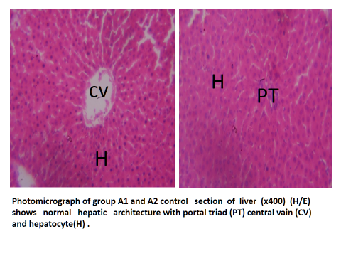

Plate 1: Photomicrograph of sections of liver of Group A (Control) (x400) (H/E) shows normal hepatic architecture with portal triad (PT) central vein (CV) and hepatocytes (H).

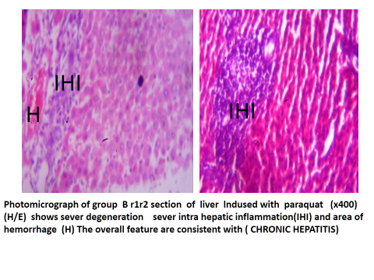

Plate 2: Photomicrograph of liver sectionsof group B (received 20mg/kg of paraquat) (x400) (H/E), shows severe degeneration and intra hepatic inflammation(IHI) and area of hemorrhage (H). The overall features are consistent with (Chronic hepatitis).

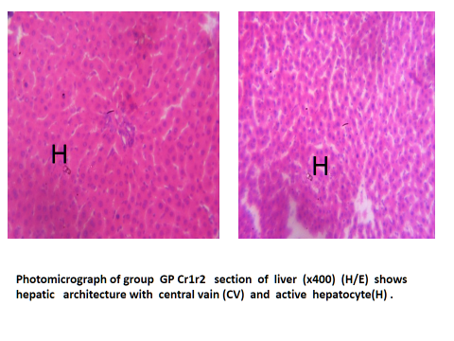

Plate 3: Photomicrograph sections of liver of Group C (that received 250mg/kg of Ethanolic extract of *Solanum macrocarpon*) (x400) (H/E) shows normal hepatic architecture with central vein (CV) and active hepatocytes (H).

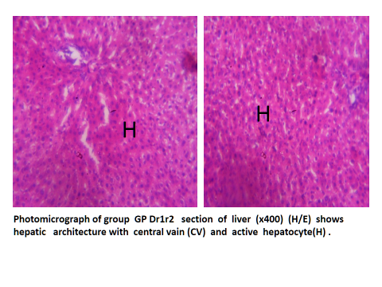

Plate 4: Photomicrograph of sections of liver of group D (that received 500mg/kg Ethanolic extract of *Solanum macrocarpon)* (x400) (H/E) shows hepatic architecture with central vein (CV) and active hepatocyte (H).

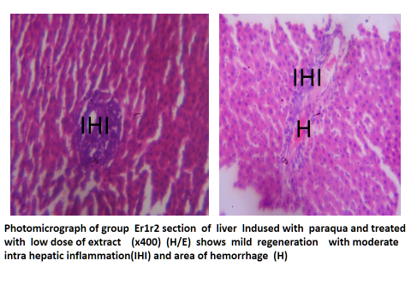

Plate 5: Photomicrograph of sections of liver Group E (received co-administration of 20mg/kg of paraquat and 250mg/kg of *Solanum macrocarpon*) (x400) (H/E) shows mild protective effects with moderate intra hepatic inflammation (IHI) and area of hemorrhage (H).

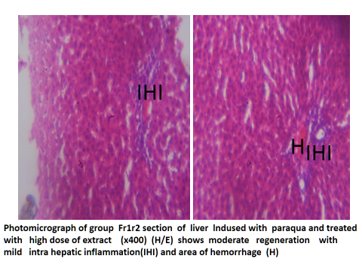

Plate 6: Photomicrograph of sections of liver of Group F (received 20mg/kg of paraquat and 500mg/kg of Ethanolic extract of*Solanum macrocarpon*) (x400) (H/E) shows moderate protective effect with mild intra hepatic inflammation (IHI) and area of hemorrhage (H).

**DISCUSSION**

This study evaluated the protective effect of Solanum macrocarpon against paraquat-induced hepatotoxicity by assessing liver function markers—Alkaline Phosphatase (ALP), Alanine Aminotransferase (ALT), and Aspartate Aminotransferase (AST)—alongside liver histoarchitecture. AST and ALT serve as indicators of hepatocellular injury, while ALP is associated with bile duct obstruction and overall liver function (LaLa*et al*., 2023). Previous research has shown that paraquat exposure in rats leads to significant tissue damage and impaired organ function (Kumar *et al.,* 2021; Ofoego*et al*., 2020; Sahu& Verma, 2020). Conversely, Solanum macrocarpon has been reported to contain bioactive phytochemicals, including alkaloids, flavonoids, saponins, tannins, resins, and essential oils, which confer medicinal properties (Ogunsuyi et al., 2022; Usunobun&Igwe, 2016).

Our findings revealed that rats exposed to paraquat alone exhibited a significant elevation in serum liver enzyme levels (AST, ALT, and ALP) and severe histopathological alterations. These included hepatic tissue degeneration, intrahepatic inflammation, hemorrhage, and features consistent with hepatitis.

However, co-administration of paraquat with Solanum macrocarpon extract significantly reduced AST, ALT, and ALP levels, indicating hepatoprotective effects. Notably, the high-dose extract groups (D and F) exhibited the most substantial reductions in enzyme levels, suggesting a dose-dependent protective effect. These biochemical improvements align with histological findings, where groups receiving Solanum macrocarpon extract (C, D, E, and F) displayed varying degrees of liver protection. Specifically, groups C and D (administered 250 mg/kg and 500 mg/kg of Solanum macrocarpon, respectively) had liver histoarchitecture similar to the control group (A). Meanwhile, groups E and F, which received paraquat alongside the extract, exhibited reduced hemorrhage and inflammation compared to the paraquat-only group (B). These observations support the hypothesis that Solanum macrocarpon mitigates oxidative damage and enhances tissue repair, likely through its antioxidant and anti-inflammatory properties.

The hepatoprotective potential of Solanum macrocarpon may be attributed to its phytochemical constituents. Flavonoids are known for their potent antioxidant activity and free radical scavenging properties, which protect cells from oxidative damage (Usunobun&Igwe, 2016). Similarly, saponins, tannins, and alkaloids have demonstrated antioxidant properties, contributing to cellular defense against oxidative stress and tissue injury. They do so by shielding cells from damage caused by free radicals and also help slow down or prevent the oxidation of other molecules by interrupting chain reactions and neutralizing radical intermediates(Awuchi and Okpala, 2022; Goodarzi*et al*., 2018; Yasueda*et al*., 2016).

Beyond phytochemicals, minerals play a crucial role in maintaining tissue health and biochemical processes. Essential minerals such as sodium, potassium, calcium, phosphorus, iron, magnesium, copper, and zinc—documented in Solanum macrocarpon leaves (Davidson & Monulu, 2018; Usunobun&Igwe, 2016) —support immune function, antioxidant activity, blood production, energy metabolism, wound healing, and DNA synthesis (Okesola et al., 2020; Mensah *et al*., 2008; Benowieez, 1981).

**CONCLUSION**

This study demonstrates the hepatoprotective effects of *Solanum macrocarpon* against paraquat-induced liver damage in a dose dependent manner. The synergistic action of these bioactive compounds and minerals may have contributed to the protective and restorative effects observed in this study, highlighting the therapeutic potential of Solanum macrocarpon against paraquat-induced hepatotoxicity.

**Ethical Approval**

Ethical approval was sort and obtained from the Ethical committee of the Department of Anatomy, Nnamdi Azikiwe University (ANA/EA/UG/AS/10/2024).

**Disclaimer (Artificial intelligence)**

Author(s) hereby declare that NO generative AI technologies such as Large Language Models (ChatGPT, COPILOT, etc.) and text-to-image generators have been used during the writing or editing of this manuscript.

**REFERENCES**

2013;2(1):2012–4

2013;2(1):2012–4

2013;2(1):2012–4

2013;2(1):2012–4

Abdel-Misih, S. Z., &Bloomston, M. (2010). Liver anatomy. Surgical Clinics of North America, 90(4), 643-653.

Ahmed, A., Prasad, A., & Bhattacharjee, A. (2024). Management of paraquat poisoning—The way forward. Indian Journal of Critical Care Medicine, 28(8), 722–723.

Awuchi, C. G., &Okpala, C. O. R. (2022). Natural nutraceuticals, especially functional foods, their major bioactive components, formulation, and health benefits for disease prevention—An overview. Journal of Food Bioactives, 19. https://doi.org/10.31665/JFB.2022.18317

Benowieez, R. (1981). Vitamins and you. New York: Berklett Books.

Chen, J., Su, Y., Lin, F., Iqbal, M., Mehmood, K., Zhang, H., & Shi, D. (2021). Effect of paraquat on cytotoxicity involved in oxidative stress and inflammatory reaction: A review of mechanisms and ecological implications. Ecotoxicology and Environmental Safety, 224, 112711.

Davidson, G. I., & Monulu, A. G. (2018). Vitamins and Minerals Composition of Eggplant (Solanum macrocarpon) and ‘Ukazi’ (Gnetum africanum) Leaves as Affected by Boiling and Steaming. *Journal of Scientific Research and Reports*, *21*(4), 1–8. <https://doi.org/10.9734/JSRR/2018/45255>

GildasYénoukounmè, S. E., Goudjo, M. A. C., Montcho, K. D. H., Gouveitcha, M. B. G., Komlan, F. A., &Gandonou, C. B. (2021). Response of seven African eggplant (Solanum macrocarpon L.) cultivars produced in Benin to salinity stress at seedling stage. African Journal of Agricultural Research, 17(2), 292-301. https://doi.org/10.5897/AJAR2020.15345

Famuwagun, A. A., Taiwo, K. A., Gbadamosi, S. O., Oyedele, D. J., Aluko, R. E., &Adebooye, O. C. (2017). Extraction optimization and antioxidant properties of African eggplant (Solanum macrocarpon) leaf polyphenols. Journal of Food Quality, 2017, 2159183.

Goodarzi, S., Rafiei, S., Javadi, M., &Khadem, H. H. (2018). A review on antioxidants and their health effects. Journal of Nutrition and Food Security, 3(2), 106–112.

Kumar, S., Gupta, S., Bansal, Y. S., Bal, A., Rastogi, P., Muthu, V., & Arora, V. (2021). Pulmonary histopathology in fatal paraquat poisoning. *Autopsy & case reports*, *11*, e2021342. https://doi.org/10.4322/acr.2021.342

Kumar, S., Prasad, S., Yadav, K. K., Shrivastava, M., Gupta, N., Nagar, S., Bach, Q. V., Kamyab, H., Khan, S. A., Yadav, S., &Malav, L. C. (2019). Hazardous heavy metals contamination of vegetables and food chain: Role of sustainable remediation approaches—A review. Environmental Research, 179, 108792. https://doi.org/10.1016/j.envres.2019.108792

Lala, V., Zubair, M., & Minter, D. A. (2023). Liver function tests. In StatPearls [Internet]. Treasure Island, FL: StatPearls Publishing. Available from: <https://www.ncbi.nlm.nih.gov/books/NBK482489/>

Lee, M. R., Lim, Y. H., Lee, B. E., & Hong, Y. C. (2017). Blood mercury concentrations are associated with decline in liver function in an elderly population: A panel study. Environmental Health, 16(1), 17. https://doi.org/10.1186/s12940-017-0228-2

Lorente, S., Hautefeuille, M., & Sanchez-Cedillo, A. (2020). The liver, a functionalized vascular structure. Scientific Reports, 10(1), 16194. https://doi.org/10.1038/s41598-020-73208-8

Lorke, D. (1983). A new approach to practical acute toxicity testing. Archives of Toxicology, 54, 275-287. http://dx.doi.org/10.1007/BF01234480

Mensah, J. K., Okoli, R. I., Ohaju-Obodo, J. O., &Eifediyi, K. (2008). Phytochemical, nutritional, and medical properties of some leafy vegetables consumed by Edo people of Nigeria. African Journal of Biotechnology, 7(20), 2304-2309.

Mergler, D., Anderson, H. A., Chan, L. H. M., Mahaffey, K. R., Murray, M., Sakamoto, M., & Stern, A. H. (2007). Methylmercury exposure and health effects in humans: A worldwide concern. Ambio, 36, 3-11. https://doi.org/10.1579/0044-7447(2007)36[3:MEAHEI]2.0.CO;2

Moussa, M. I. D., Alashi, A. M., Sossa-Vihotogbé, C. N. A., Akponikpè, P. B. I., Baco, M. N., Djènontin, A. J., Aluko, R. E., &Akissoé, N. H. (2023). Developments in research on the nutritional health-promoting properties of three traditional leafy vegetables commonly consumed in sub-Saharan Africa. Journal of Herbal Medicine, 40, 100668. <https://doi.org/10.1016/j.hermed.2023.100668>

Nakhaee, S., Amirabadizadeh, A., Brent, J., &Mehrpour, O. (2019). Impact of chronic lead exposure on liver and kidney function and hematologic parameters. Basic & Clinical Pharmacology & Toxicology, 124(5), 621-628. https://doi.org/10.1111/bcpt.13179

National Institute of Health. (2011). Guide for the care and use of laboratory animals (8th ed.). The National Academies Press.

Oboh, G., Ekperigin, M. M., & Kazeem, M. I. (2005). Nutritional and haemolytic properties of eggplants (Solanum macrocarpon) leaves. Journal of Food Composition and Analysis, 18(2–3), 153–160. https://doi.org/10.1016/j.jfca.2003.12.013

Ofoego, U. C., Ekwujuru, E. U., Ireka, M. I., &Ofoego, A. N. (2020). Ameliorative effect of Aframomummelegueta (Alligator Pepper) against paraquat-induced testicular damage. World Journal of Pharmaceutical Research, 9, 2105-2124. https://doi.org/10.20959/wjpr20205-17442

Ofoego, U., Eze, E., Nweke, E., Justicia, I., Mbagwu, S., Christian, O., &Karimah, R. (2021). Allium cepa (Onion) extract enhances and protects testicular function and architecture against paraquat-induced oxidative damage. International Journal of Life Science and Pharma Research.

Ogunsuyi, O. B., Ademiluyi, A. O., &Oboh, G. (2020). Solanum leaves extracts exhibit antioxidant properties and inhibit monoamine oxidase and acetylcholinesterase activities (in vitro) in Drosophila melanogaster. Journal of Basic and Clinical Physiology and Pharmacology, 31(3). <https://doi.org/10.1515/jbcpp-2019-0256>

Ogunsuyi, O. B., Omage, F. B., Olagoke, O. C., Oboh, G., & Rocha, J. B. T. (2022). Phytochemicals from African eggplants (*Solanum macrocarpon* L) and Black nightshade (*Solanum nigrum* L) leaves as acetylcholinesterase inhibitors: an *in-silico* study. *Journal of Biomolecular Structure and Dynamics*, *41*(16), 7725–7734. https://doi.org/10.1080/07391102.2022.2124194

Okesola, M. A., Ajiboye, B. O., Oyinloye, B. E., Osukoya, O. A., Owero-Ozeze, O. S., I Ekakitie, L., & Kappo, A. P. (2020). Effect of *Solanum macrocarpon* Linn leaf aqueous extract on the brain of an alloxan-induced rat model of diabetes. *The Journal of international medical research*, *48*(6), 300060520922649. https://doi.org/10.1177/0300060520922649

Rajaram, R., &Neelakantan, L. (2023). Recent advances in estimation of paraquat using various analytical techniques: A review. Results in Chemistry, 5, 100703. <https://doi.org/10.1016/j.rechem.2022.100703>

Sahu, M., Sharma, M., Rath, B., Joseph, T., &Padhi, K. (2020). Clinical and pathological profile of paraquat poisoning cases—A cross-sectional study in Odisha, India. Indian Journal of Forensic and Community Medicine, 7. https://doi.org/10.18231/j.ijfcm.2020.043

Sibulesky, L. (2013). Normal liver anatomy. Clinical Liver Disease (Hoboken), 2(1), 2012-2014.

Sumadewi, K. T. (n.d.). Embryology, anatomy, and physiology.

Tchounwou, P. B., Yedjou, C. G., Patlolla, A. K., & Sutton, D. J. (2012). Lead toxicity: A review. Environmental Toxicology and Pharmacology, 34(2), 22-31. https://doi.org/10.1016/j.etap.2012.04.001

Usunobun, U., &Igwe, C. (2016). Phytochemical analysis, mineral composition, and in vitro antioxidant activities of Solanum macrocarpon leaves. International Journal of Health, 4, 62-65. https://doi.org/10.14419/ijh.v4i1.6153

Yasueda, A., Urushima, H., & Ito, T. (2016). Efficacy and interaction of antioxidant supplements as adjuvant therapy in cancer treatment: A systematic review. Integrative Cancer Therapies, 15(1), 17–39. https://doi.org/10.1177/1534735415610427