**Gut Microbiota and Its Impact on Children with Autism Spectrum Disorder**

**Abstract:**

There is a substantial relationship between gut microbiota and Autism Spectrum Disorder (ASD). Studies have found that there are significant changes in microbial composition between people with ASD, their unaffected siblings, and healthy controls. Though results are still unstable, bacterial species like *Clostridium,* *Sutterella*, *Desulfovibrio*, *Lactobacillus*, *Bacterodies*, and *Faecalibacterium* are more common in ASD patients. Because up to 90% of people with Autism Spectrum Disorder (ASD) experience gastrointestinal (GI) problems, it is thought that the gut-brain axis is important in the development of ASD. The gut microbiota is made up of *Bacteroidetes*, *Firmicutes*, *Proteobacteria*, and *Actinobacteria*. It is affected by a number of variables, including nutrition, which can change the composition of the microbiota and the function of the brain through neuroendocrine and immunological pathways. Therapeutic methods that focus on the microbiome, including probiotics, microbiota transfer therapy, and specific diets, have demonstrated promise in reducing gastrointestinal and behavioral symptoms in individuals with Autism Spectrum Disorder (ASD). Despite encouraging outcomes from preclinical and observational studies, convincing clinical trials are needed to demonstrate whether or not a treatment has an effect or is effective. Additionally, the mother’s nutrition and lifestyle may heighten the risk of the child suffering from Autism Spectrum Disorder (ASD), which emphasizes understanding the interplay between the gut, brain, and microbiome. While there is potential for microbiome-based therapies in the treatment of Autism Spectrum Disorder (ASD), more research is required to grasp their full capabilities.

**Keywords:** Autism Spectrum Disorder (ASD), gut microbiota, gastrointestinal (GI) problems, probiotics, microbiota transfer therapy

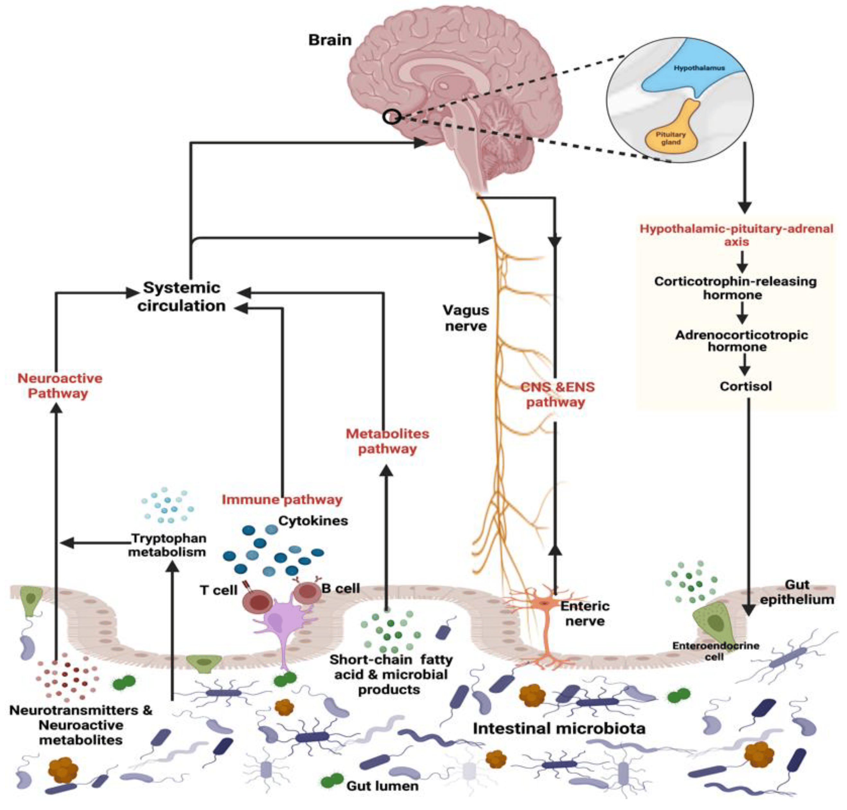

**Fig1: The figure shows the gut-brain-axis and its bidirectional relationship with gut microbiota, cns and hypothalamic axis (Fattorusso et al., 2019)**.

**Introduction:**

In addition to having a strong genetic component, Autism Spectrum Disorder refers to a condition that describes the constellation of early-appearing social communication deficits, including difficulty with conversational skills, nonverbal communication issues, and difficulties understanding other people's thoughts and feelings, as well as repetitive sensory-motor behaviors, such as hand flapping and figure flicking, rocking back and forth, and spinning objects (Dargenio et al., 2023; Lord et al., 2018). ASD has a complicated genetic foundation that includes genes related to central nervous system (CNS) development (Risch et al., 2014). The symptoms of autism often appear during infancy or, at most, the first three years of life. Almost all people with autism have a history of linguistic delay; many, but not all, have mental handicap. Because there is a lot of opportunity for error in normal development, other disorders are often correlated with language impairment, and it is necessary to measure the presence of specific social deficits across different language levels (e.g., assessing social skills in a nonverbal child differs from assessing social skills in a verbal child), researchers studying the link between autism and language impairment must be careful when choosing their measures and comparison groups (Lord et al., 2000). Although post-mortem, neuroimaging, and electrophysiological investigations have shown mild morphological and functional alterations, autism does not show significant brain damage (Lord et al., 2020).

Numerous potential risk factors for Autism Spectrum Disorder have been proposed. Several systematic reviews and meta-analyses have investigated prenatal and postpartum factors, as well as those related to the mother's food and lifestyle. A higher likelihood of Autism Spectrum Disorder (ASD) has been independently associated with both advanced maternal age (40 years or older) and advanced paternal age (50 years or older), according to many research. A higher incidence of ASD has also been linked to short inter pregnancy intervals (less than 24 months). A slightly increased incidence of both developmental delay and Autism Spectrum Disorder (ASD) has been associated with a number of variables. Some of these factors are more narrowly focused, such a mother's history of autoimmune disease or a recent hospitalization for a bacterial or viral infection; others are more broadly defined, and they include non-optimal pregnancy characteristics like a mother's metabolic problem, weight gain, or hypertension (Lord et al., 2018).

The estimated autism prevalence was around 4 per 10,000 persons when the first methodical investigations were carried out in the 1960s. On the other hand, the current estimates for the whole spectrum of autism range from 60 per 10,000 persons. This 15-fold increase has caused concerns of an epidemic. In 2012, an estimate gauged worldwide prevalence of Autism Spectrum Disorder (ASD) to be around 1%according to an analysis done by World Health Organization (WHO). Recent reports indicate that 1.5% of developed countries are diagnosed with ASD (Lord et al., 2018).

The specific etio pathogenesis of Autism Spectrum Disorder (ASD) has not yet been fully characterized, but it is emphasized in the literature of the past couple of decades that the connection between gut microbiota and the brain could be relevant to autism or other neuropsychiatric disorders (Martínez-González & Andreo-Martínez, 2019). The stereotypes of behaviors and difficulties in social communication are the major indicative features of the human Autism Spectrum Disorder (ASD). Other behaviors are also included, for example, anxiety, seizures, and hyperactivity found in clinical cases of patients with ASD (Vuong & Hsiao, 2017). While persons with Autism Spectrum Disorder (ASD) may have a number of different comorbidities, some of the symptoms include gastrointestinal (GI) inflammation and increased permeability of the epithelial barrier of the intestine. People with these gastrointestinal problems tend to report more bodily distress as well as greater anxiety when compared to autistic people without GI symptoms. They also have fewer social interactions (Martínez-González & Andreo-Martínez, 2019)

Microbiota refers to a comprehensive population of microorganisms that inhabit a designated environment, together with protozoan, fungus, archaea, and viruses (Jandhyala et al., 2015). Most significant part of the typical microbiota, however, is bacteria (Biedermann & Rogler, 2015). Bacterial colonization can be classified into three categories: mutualistic, commensalistic, and opportunistic. Mutualism is a term that describes a situation in which both creatures benefit from living together. As a result, the majority of the bacteria in the intestines are not commensalistic (even though they are referred to as commensals); instead, they are mutualistic, as both the bacteria and the human body gain advantages from their presence. In a commensalistic relationship, one organism benefits while the other is not affected in any way. If a microorganism is opportunistic, it means that it does not cause disease under normal settings, but it can produce disease if conditions become favorable (Biedermann & Rogler, 2015). The human gastrointestinal (GI) tract is one of the biggest interfaces in the human body, ranging between 250 and 400 square meters. It links the antigens, environmental factors, and host to one other. Microorganisms thought to inhabit the gastrointestinal system count more than 10^14 CFU/ml. Compared to human cells, this is almost ten times the count of bacterial cells and more than one hundred times the quantity of genetic material (microbiome) found in the human genome (Thursby & Juge, 2017). Human health and illness depend much on the bacteria; in fact, they are sometimes referred to as our "forgotten organ" (O'Hara & Shanahan, 2006). The gut flora communicates with immune system to enable the maturation or development of immune cells properly  (Chow et al., 2010). It is supposed that gut flora is important in influencing neuronal behavior through the gut-brain axis. Research has shown that gut microbiota has an impact on cognitive ability, repetitive behaviors, and social interactions in many animal models. Stress-induced intestinal permeability allows endotoxins to enter the bloodstream, which causes an immunological response. This process describes how gut microbiota might affect neurological diseases. By encouraging the passage of neurotoxins into the brain and by interfering with neurotransmitter systems, this peripheral inflammation can also have an effect on mental health (Hou et al., 2022).

Through the “Microbiome-gut-brain axis,” the gut microbiota may control the Central Nervous System in both directions. The microbiota may also modulate brain function and behavior through immunology, metabolism, endocrinology, and neurology. Microbiota can produce several compounds, such as short chain fatty acids (SCFAs), Propionate, and Butyrate, which can alter how the brain functions. An imbalance in microbiota and their endpoints could cause immunological and mitochondrial metabolic dysfunction which might aid in the pathology of ASD (Zou et al., 2020).

**The Gut Microbiota:**

The system of microorganisms which resides in the human digestive system is termed as gut microbiota (Scott et al., 2013). The human large intestine microbiota is very complex and comprises of hundreds of different bacterial species, also referred to as phylotypes. In adults, the volume of colonic contents is around 250 ml, and the quantity of bacteria found is estimated to be about 1011 CFU/ml of colonic contents (Scott et al., 2013). The gut microbial species residing in a single person have been found to have 3.3 million genes. This is a staggering number when compared to the close to 23,000 genes present in human genome, and reveals the significance of these species on human health (Al Bander et al., 2020).

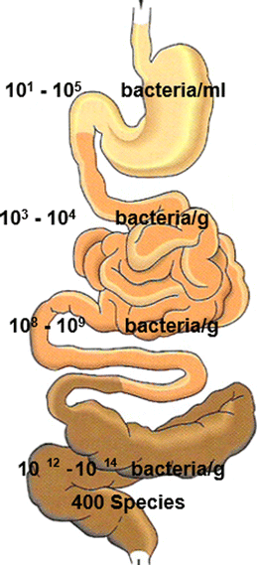

**Fig 2: The figure shows bacterial distribution along with human gastrointestinal track.**

In a healthy adult, gut microbiota is composed of four primary phyla which constitute over 90% along with other bacterial population. The phyla are *Bacteriodetes* including the genera *Bacteroides* and *Prevotella*, *Firmicutes* including the genera *Lactobacillus*, *Clostridium*, and *Ruminococcus*, *Proteobacteria* which includes some species of *Enterobacter* and *Actinobacteria* which includes *Bifidobacterium*. The less common phyla are *Fusobacteria* and *Verrucomicrobia* (Fattorusso et al., 2019).The makeup of the gut microbiota can vary significantly both within a single person and between different people.

When there are no bacteria in the gastrointestinal system, it causes serious complications with the progression of Gut-associated lymph tissues, low levels of secretory IgA antibodies in the intestines, and fewer or smaller Mesenteric lymph nodes (Janssen & Kersten, 2015). From the moment of birth, the Gut microbiota evolves with the host and the host's metabolic and neurological programming. Consequently, the progression of this microbial population is rather vital for later in life health. Along with preventing the colonization of infections, the gut microbiota plays a part in immune system development, food absorption, and metabolism. The Gut bacteria effects the brain development and behavior by modulating the neuroendocrine, neuroimmune, and autonomic nerve systems (Li et al., 2017). The infant-gut microbiota interaction begins at the time of birth and continues to evolve over the first few years of life (Derrien et al., 2019) . Dysbiosis can occur as a result of a variety of perinatal factors, including cesarean section delivery, type of feeding, antimicrobial therapy, gestational age, and environment, all of which can change the way bacteria colonize (Butel et al., 2018). Compared to healthy offspring, offspring with Autism Spectrum Disorder (ASD) have a significantly higher number of altered patterns of bacterial metabolites. The metabolites contained elevated amounts of 3-(3-hydroxyphenyl)-3-hydroxypropionic acid (HPHPA), which is a catabolic byproduct of Clostridia (Fattorusso et al., 2019).

## The Microbiome as a Potential Mediator of Risk Factors in ASD:

There are around 9.9 million bacterial genes in the human gut, which includes about 1 kilogram of bacteria [19]. The process of initial colonization begins after birth, when maternal microbes are obtained during vaginal delivery. On the other hand, recent studies suggest that maternal microbiota can potentially be obtained during pregnancy. Breast milk is high in human oligosaccharides, which help support the microbiota of the newborn. Though, the composition of microbiota throughout premature life can be reformed by many factors such as birth techniques, hygiene, and feeding patterns, including formula feeding (Hughes et al., 2018). As Alharthi *et al*. (2022) noted in their report, children who receive formula milk as compared to those who are breastfed have comparatively less diversity in their gut microbiota. In a healthy infant's intestine, the two most common bacteria identified are *Lactobacillus* and Bifidobacterium. The intestines are highly disordered during the early years of life, during the period of transitioning from milk to solid food. By approximately three years of age, the intestines become more orderly and begin to take on an adult-like configuration. The most common two groups, known as phyla, of bacteria in the gut of a healthy adult are *Bacteroidetes* and *Firmicutes*. Hughes *et al*. (2018) views these bacteria, along with *Actinobacteria,* *Proteobacteria*, and *Verrucomicrobia*, as mere fragments of the microbiota.

Gastrointestinal symptoms and the dysbiosis of gut microbiomes are two comorbidities that are common in people suffering from Autism Spectrum Disorder s (ASD). These medical conditions are also found to correlate with the level of functionality in individuals with ASD. It was demonstrated that people suffering from Autism Spectrum Disorder (ASD) had significantly altered gut microbiomes compared to other patients (Alharthi et al., 2022). The gut microbiota dysbiosis has been demonstrated to contribute to the progression of inflammatory diseases such as inflammatory bowel disease (IBD). Both autistic children and animal models of Autism Spectrum Disorder (ASD) show alterations not only in gut microbiota composition, but also in the microbiota metabolites. There is increasing evidence to support the concept that the microbiota may influence certain behavioral outcomes in models of neurodevelopmental and neurological disorders. Animals that have been reared in the absence of microbiota show abnormalities in a range of complex behaviors. Two different studies have shown that germ-free mice are less social. They do not interact socially with a novel mouse as much as non-social objects, and they have a lower likelihood of engaging with a strange mouse versus a known mouse (Vuong & Hsiao, 2017). Sufficient scientific evidence indicates that the gut microbiota of individuals diagnosed with Autism Spectrum Disorder (ASD) is indeed different from that of the neurotypical control subjects (Zou et al., 2021).

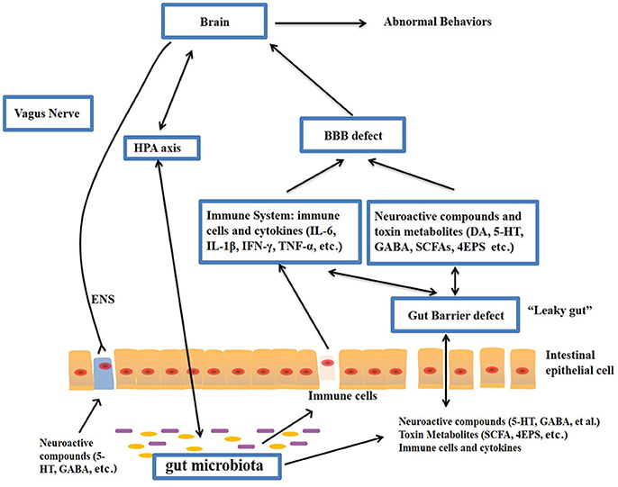

**Fig 3: The figure shows the potential relationship between gut microbiota and Autism Spectrum Disorder (Li et al., 2017).**

[**Gut-Brain Axis**](https://www.mdpi.com/2072-6643/11/3/521#sec5-nutrients-11-00521)**:**

The “Microbiota-gut-brain axis,” which is a two-way communication network between Gut and brain,may enables the microbiota in our digestive system to impact how our brain functions and how we act (Zou et al., 2021). Enteric nervous system (ENS) is situated in the intestinal mucosa and plays a crucial role in controlling the activity of digestive tract. ENS consists of millions of neurons. Hence, the stomach is called a ''second brain'' (Li et al., 2017). The two-way pathway consists of both motor and sensory (afferent) impulses. The afferent signals from the gastrointestinal tract to brain involve the intestine’s endocrine and goblet cells, cytokines, metabolites, and neuroactive substances. Efferent signals arise from the brain and include neuroendocrine and autonomic modulation to the gut wall. In this pathway, 90% of the fibers of the vagus nerve that link the brain and the gut are afferent, which means that the intestine is predominantly a transmitter, not a receiver (Alharthi et al., 2022). Various gut bacteria play a role in the physiology of the gut such are the intestinal barrier, regeneration of epithelial cells, secretion of mucus, and movement of the gastrointestinal tract (Vuong & Hsiao, 2017).

#### Gut Permeability:

A notable aspect of Autism Spectrum Disorder (ASD) is its functional relation to GUT. Intestinal barrier dysfunctions “leaky gut’’ is one of the most defining which is said to be a leakage of the gut (Li et al., 2017). In medicine, “leaky gut” refers to an illness in which the barrier epithelial cells of the small or large intestines become impaired. Consequently, there is an increase in the number and variety of substances and cells possible to traverse the border between the digestive tract and circulatory system (Dargenio et al., 2023). Intestinal permeability serves to impede the movement of endorsed intestinal content into the circulation which limits the potential for subsequent immunological inflammatory response and gastroenteritis intestinal diseases. A lactulose, mannitol, and zonulin test, determine permeability called Intestinal permeability, also known as gut permeability, is referred to as (Dargenio et al., 2023; Li et al., 2017). The obstetrical relationship among stomach and brain in course of evolution of Autism is postulated to be in which increased Gut permeability has been associated to Autism Spectrum Disorder (ASD). For example, injecting Propionic acid, which is formed by some bacteria in the intestine, into the cerebrum of the rats has been known to cause neuroinflammation and other Autism Spectrum Disorder (ASD) symptoms. This could explain why children who fall under the Autism Spectrum Disorder (ASD) category exhibit more severe symptoms when they consume food containing preservatives such as propionic acid (Dargenio et al., 2023).

Numerous gut-produced toxicants, such as propionic acid (PPA) and p-cresol, have been causatively implicated to ASD over the years (Gabriele et al., 2016; Persico & Napolioni, 2013). Increased urinary excretion of p-cresol may represent a marker of risk for autism in young children, particularly in girls and in more affected boys (Altieri et al., 2011). P-cresol (4-methylphenol) is an aromatic compound that can be synthesized in the gut by bacteria capable of producing cresol, such as *C. difficile* (Elsden et al., 1976), or it may come from the environment via intestinal, respiratory, or dermal exposure (Persico & Napolioni, 2013); unlike PPA, it is not a product of human metabolism due to the fact that humans lack the enzyme p-hydroxy-phenylacetate decarboxylase which is required to convert tyrosine metabolism to p-cresol (Selmer & Andrei, 2001). P-cresol and, in particular, its conjugated form, p-cresylsulfate, are among the most studied uremic toxins that have been shown to have a detrimental effect on multiple systems in chronic renal disease patients (Liabeuf et al., 2010; Persico & Napolioni, 2013). An increased prevalence of certain gut bacteria that can ferment tyrosine to p-cresol was found in autistic subjects in some studies (Altieri et al., 2011).

#### Immune System Pathway:

The microbiota, gut, and brain is interconnected in one way or another, and an immune system put into action serves notice to the fact that the gut and brain have the ability to influence each other. The composition of the gut’s microbial population fulfills an important task in enabling immune homeostasis to be achieved because the mucosal surfaces of the gut are always open to pathogenic and beneficial microbes that can provoke the immune response. Change in the gut microbial makeup has been linked to the deficiency in the immune system. For instance, Germ-free mice have a higher microglia density in different regions of the brain compared to mice that are raised in a specialized pathogen-free (SPF) environment. In addition, these GF mice exhibited unusual social avoidance behavior and a weak immunological response to viral infections. After supplementing germ-free mice with microbial Short-chain fatty acids (SCFAs), both microglia abnormalities and symptoms linked with Autism Spectrum Disorder (ASD) were improved. The gut flora can indirectly influence the innate immune system, which can alter the level of pro-inflammatory and anti-inflammatory cytokines in the blood. These cytokines have a direct effect on microglia homeostasis (Dargenio et al., 2023).Neurotransmitters are the means by which the microbiota communicate with the brain.

Substances like Dopamine (DA), 5-HT, γ-aminobutyric acid (GABA) and Histamine are neuroactive and may be produced by the gut microbiota and stimulate or inhibit central neurons through the vagus nerve. Another means by which the stomach and the brain interact is through immunological pathways. Multiple studies have previously reported that individuals with ASD have unusually high levels of gut Pro-inflammatory cytokines such as IL-1β, IL-6, IL-8 and IL-12p40 in their plasma. An increase in gut permeability occurs because of the subjection to immune system response to toxins of pathogenic bacteria and to certain localized inflammatory processes.

**Dietary Intervention: What is the Evidence?**

The interaction of the gut and CNS has several possible outcomes. One of these outcomes is the modulation of the immune system and the sympathetic nervous system due to circulating pro-inflammatory and anti-inflammatory cytokines or the production of metabolites like short chain fatty acids (SCFAs) (Santocchi et al., 2016). SCFAs are the products of microbiota fermentation of fiber and they are particularly abundant in the colon. Though some SCFAs, such as Propionic acid (PPA), become neurotoxic in large concentrations and have been shown to induce abnormal behaviors in mouse models, the metabolites of SCFAs from commensal microbiota are usually beneficial for the host (Hughes et al., 2018). It is thought that the deterioration in the integrity of the intestinal barrier is associated with changes in the gut microbiota. This may cause fatty acid and lipopolysaccharide (LPS) leakage and an increase in toxin absorption from the gastrointestinal lumen. These substances interact on Toll-like receptor 4 to cause systemic inflammation, which profoundly affects the central nervous system (Santocchi et al*.*, 2016).

Several investigations have shown that the diet containing high fat for pregnant women lowers the number of non-pathogenic *Campylobacter* and the *Bacteroides* in human babies. Buffington *et al*. state that when mothers take diet containing high fat, it induces dysbiosis and autism-like traits, but these changes can be reversed using *Lactobacillus reuteri*. While offspring born by cesarean section have Gut microbiota identical to that of their mother's skin Microbiota, which is dominated by *Staphylococcus*, *Corynebacterium*, and *Propionibacterium spp*., while infants born vaginally have gut microbiota identical to their mother's vaginal microbiota, which is dominated by *Lactobacillus*, *Prevotella,* or *Sneathia spp*. High *Staphylococcus aureus* concentrations can generate toxins that induce diarrhea, bloating, and nausea (Li et al., 2017).

While there have been several research that have shown changes to the bacterial Gut microbiota in people with Autism Spectrum Disorder (ASD), there have been fewer studies that have looked at the association among gut fungus and ASD. The yeast in the stomach, predominantly Candida albicans, causes the body to absorb less carbs and minerals and to release more toxins. Kantarcioglu *et al*. identified 338 yeast strains from 415 feces samples taken from persons with Autism Spectrum Disorder (ASD). Candida, especially Candida albicans, made up 81.4% of the yeast strain. Non-autistic healthy subjects had a lower yeast isolated rate (19.6%) (Li et al., 2017).

**Role of Propionic Acid:**

*Clostridium*, *Bacteroidetes*, *Desulfovibrio*, *Veillonella*, *Megasphaera*, and *Propionibacterium* are the main producers of PPA, a short-chain fatty acid that can pass through blood-brain barrier and cause behaviors similar to those of ASD. According to Thomas et al., high amounts of PPA administered intra cerebro-ventricularly cause some Autistic-like symptoms in mice (Thomas et al., 2012), and PPA administered intraventricularly to rats causes hyperactivity, repetitive behaviors, and abnormal motor movements that are comparable to the behavioral and electrographic abnormalities seen in people with ASD. PPA causes rats to behave less socially, most likely via changing certain neurotransmitters like serotonin and dopamine (Li et al., 2017).

**Potential Therapeutic Aspects:**

**Antibiotics:**

At this time, there are no proven or effective treatments for ASD. The therapies for ASD that have been authorised and recommended include rehabilitation, educational therapy, and psycho-pharmacological techniques (Santocchi et al., 2016). As a result, parents have begun to seek out alternative therapies that lack strong scientific support. These treatments, which include the use of vitamins and other supplements or the adoption of elimination diets, can be costly and possibly harmful (for example, a gluten-free and casein-free diet) (Rao et al., 2009).

Due to the growing recognition of gut dysbiosis and its role in Autism Spectrum Disorder (ASD), research is concentrating on rebalancing the gut microbiota as a potential treatment for these conditions. This method involves administering oral pre-probiotics and faecal microbiota transplants (FMT).

Antibiotics can be used to treat gastrointestinal illnesses because they have the ability to change the makeup of Gut microbiota. Investigation shows that exposure of antibiotics early in life may leads to autism, yet there are also cases in which antibiotics have been used to treat autism. For example, aminoglycosides can help relieve some symptoms of autism (Mehra et al., 2023). There are a few more FDA-approved drugs for handling autism, such as glutamate antagonists, in addition to aminoglycosides (Ghanizadeh & Michael, 2015).

**Usage of Probiotics in the Treatment of Autism Spectrum Disorder:**

The presence of aberrant Gut microbiota and the stimulation of mucosal immune response are two of the defining characteristics of autism. Therefore, the usage of probiotic bacteria in autism is regarded as therapeutic approach for the goal of lowering inflammation, restoring epithelial barrier function, alleviating specific behavioral difficulties, or restoring normal gut microbiota (Kałużna-Czaplińska et al., 2011). The majority of the probiotic research on Autism Spectrum Disorder (ASD) has focused on strains of *Lactobacillus* and *Bifidobacterium* (Tomova et al., 2015). In a cohort study of 22 kids with Autism Spectrum Disorder (ASD) ranging from 4 to 10 years old, oral supplementation with *Lactobacillus* *acidophilus* twice daily for a period of two months improved the children's capacity to concentrate and fulfill commands, such as following directions more effectively. Sadly, there was no evidence of any effects on either behavioral or emotional deterioration (Kałużna-Czaplińska & Błaszczyk, 2012). It has been observed that the consumption of probiotics and prebiotics contributes to the reduction of gastrointestinal issues and inflammation through the regulation of the microbiota (Tomova et al., 2015).

The therapeutic impact of a three-week oral therapy with a combination of *Bifidobacteria* and *Lactobacilli* strains (ProtexinR) was investigated in a recent study that was carried out on hamsters in which autistic-like behaviors were caused by the administration of PPA and clindamycin. Clindamycin and PPA both enhanced the excitotoxicity of glutamate in the brains of hamsters, which resulted in a decrease in magnesium and GABA levels (El-Ansary et al., 2018).

## Developing Function of Flavonoids in the Autism Spectrum:

Flavonoids are the large group of polyphenolic compounds that are often found in human diet because of their presence in fruits, vegetables, and drinks manufactured from plants. There are six prominent classes, including flavones, flavonols, flavanones, flavanols, anthocyanins and isoflavones. Their extensive biochemical effects have been associated with several disorders such as salad disorders and neurodevelopmental disorders (Du & Hill, 2015; Parker-Athill et al., 2009; Savino et al., 2023). Flavonoid, as well as their subclasses, were showed in a number of experimental studies to have the capacity to alter the biochemical signaling cascades which are connected with endogenous antioxidant systems, elevated mitocondrial activity, and lowered neuro-inflammation. Flavonoids have been found to be associated with primary neuroinflammation, neurological and psychiatric disorders including ASD. This is made possible by modifying crucial signaling pathways including the cAMP response element binding protein (CREB) pathway, Janus kinase and signal transducer and activator of transcription proteins (JAK/STAT) pathway, nuclear factor kappa light chain enhancer of activated B cells (NF-κB) pathway, and toll like receptor (TLR) pathway (Davinelli et al., 2020; Hamsalakshmi et al., 2022). Such actions are likely to alleviate the pro-inflammatory status of children with Autism Spectrum Disorder (ASD) who display increased stress reactivity and hyperarousal. Furthermore, flavonoids may enhance neuro-cognitive performance and stimulate neurogenesis for both normal and abnormal conditions as a result of their interplay with a variety of neuronal signaling cascades (Davinelli et al., 2023). Some natural flavonoids may have anti-anxiety effects due to benzodiazepine receptor activation (Paladini et al., 1999).

## Conclusion:

The significance of Gut microbiota in the onset and progression of Autism Spectrum Disorder (ASD) is being highlighted by more and more research. Dietary changes may have an impact on ASD symptoms because of the connection among stomach and central nervous system (CNS) through immunological regulation, Short-chain fatty acids (SCFAs), and systemic inflammation. The importance of Gut microbial balance has been emphasized by the association of propionic acid (PPA) in particular with behaviors like those of ASD. Antibiotics have been investigated as a possible treatment, but their effects are still complicated and can have both beneficial and bad consequences.

Probiotics have become a viable treatment option for people with ASD, as they have the ability to improve gastrointestinal health, lower inflammation, and modify gut microbiota. Furthermore, by focusing on oxidative stress and neuroinflammatory pathways, flavonoids provide an extra line of intervention due to their neuroprotective and anti-inflammatory qualities. Despite these developments, further mechanistic research and clinical trials are still required to create firm treatment recommendations.

Overall, probiotic supplements and meals high in flavonoids are examples of dietary therapies that may be used in conjunction with other approaches to manage the symptoms of ASD. Large-scale research is necessary for thorough validation before they can be incorporated into clinical practice. In order to maximize therapeutic effects in the management of ASD, future research should concentrate on individualized nutrition approaches that take into account individual gut microbiota compositions and metabolic reactions.

## 

**Disclaimer (Artificial intelligence)**

Option 1:

Author(s) hereby declare that NO generative AI technologies such as Large Language Models (ChatGPT, COPILOT, etc.) and text-to-image generators have been used during the writing or editing of this manuscript.

**References:**

1. Al Bander, Z., Nitert, M. D., Mousa, A., Naderpoor, N. J. I. j. o. e. r., & health, p. (2020). The gut microbiota and inflammation: an overview. *17*(20), 7618.
2. Alharthi, A., Alhazmi, S., Alburae, N., & Bahieldin, A. J. I. j. o. m. s. (2022). The human gut microbiome as a potential factor in autism spectrum disorder. *23*(3), 1363.
3. Biedermann, L., & Rogler, G. J. E. j. o. p. (2015). The intestinal microbiota: its role in health and disease. *174*, 151-167.
4. Butel, M.-J., Waligora-Dupriet, A.-J., Wydau-Dematteis, S. J. J. o. D. O. o. H., & Disease. (2018). The developing gut microbiota and its consequences for health. *9*(6), 590-597.
5. Chow, J., Lee, S. M., Shen, Y., Khosravi, A., & Mazmanian, S. K. J. A. i. i. (2010). Host–bacterial symbiosis in health and disease. *107*, 243-274.
6. Dargenio, V. N., Dargenio, C., Castellaneta, S., De Giacomo, A., Laguardia, M., Schettini, F.,…Cristofori, F. J. N. (2023). Intestinal barrier dysfunction and microbiota–gut–brain axis: Possible implications in the pathogenesis and treatment of autism spectrum disorder. *15*(7), 1620.
7. Davinelli, S., De Stefani, D., De Vivo, I., Scapagnini, G. J. T. i. E., & Metabolism. (2020). Polyphenols as caloric restriction mimetics regulating mitochondrial biogenesis and mitophagy. *31*(7), 536-550.
8. Davinelli, S., Medoro, A., Ali, S., Passarella, D., Intrieri, M., & Scapagnini, G. J. C. N. (2023). Dietary flavonoids and adult neurogenesis: Potential implications for brain aging. *21*(3), 651.
9. Derrien, M., Alvarez, A.-S., & de Vos, W. M. J. T. i. m. (2019). The gut microbiota in the first decade of life. *27*(12), 997-1010.
10. Du, X., & Hill, R. J. N. i. (2015). 7, 8-Dihydroxyflavone as a pro-neurotrophic treatment for neurodevelopmental disorders. *89*, 170-180.
11. El-Ansary, A., Bacha, A. B., Bjørklund, G., Al-Orf, N., Bhat, R. S., Moubayed, N., & Abed, K. J. M. B. D. (2018). Probiotic treatment reduces the autistic-like excitation/inhibition imbalance in juvenile hamsters induced by orally administered propionic acid and clindamycin. *33*, 1155-1164.
12. Fattorusso, A., Di Genova, L., Dell’Isola, G. B., Mencaroni, E., & Esposito, S. J. N. (2019). Autism spectrum disorders and the gut microbiota. *11*(3), 521.
13. Ghanizadeh, A., & Michael, B. J. I. j. o. c. n. (2015). Beta-lactam antibiotics as a possible novel therapy for managing epilepsy and autism, a case report and review of literature. *9*(1), 99.
14. Hamsalakshmi, Alex, A. M., Arehally Marappa, M., Joghee, S., & Chidambaram, S. B. J. I. (2022). Therapeutic benefits of flavonoids against neuroinflammation: a systematic review. 1-26.
15. Hou, K., Wu, Z.-X., Chen, X.-Y., Wang, J.-Q., Zhang, D., Xiao, C.,…therapy, t. (2022). Microbiota in health and diseases. *7*(1), 1-28.
16. Hughes, H. K., Rose, D., Ashwood, P. J. C. n., & reports, n. (2018). The gut microbiota and dysbiosis in autism spectrum disorders. *18*, 1-15.
17. Jandhyala, S. M., Talukdar, R., Subramanyam, C., Vuyyuru, H., Sasikala, M., & Reddy, D. N. J. W. j. o. g. W. (2015). Role of the normal gut microbiota. *21*(29), 8787.
18. Janssen, A. W., & Kersten, S. J. T. F. J. (2015). The role of the gut microbiota in metabolic health. *29*(8), 3111-3123.
19. Kałużna-Czaplińska, J., & Błaszczyk, S. J. N. (2012). The level of arabinitol in autistic children after probiotic therapy. *28*(2), 124-126.
20. Kałużna-Czaplińska, J., Socha, E., & Rynkowski, J. J. N. r. (2011). B vitamin supplementation reduces excretion of urinary dicarboxylic acids in autistic children. *31*(7), 497-502.
21. Li, Q., Han, Y., Dy, A. B. C., & Hagerman, R. J. J. F. i. c. n. (2017). The gut microbiota and autism spectrum disorders. *11*, 120.
22. Lord, C., Brugha, T. S., Charman, T., Cusack, J., Dumas, G., Frazier, T.,…State, M. W. J. N. r. D. p. (2020). Autism spectrum disorder. *6*(1), 1-23.
23. Lord, C., Cook, E. H., Leventhal, B. L., & Amaral, D. G. J. N. (2000). Autism spectrum disorders. *28*(2), 355-363.
24. Lord, C., Elsabbagh, M., Baird, G., & Veenstra-Vanderweele, J. J. T. l. (2018). Autism spectrum disorder. *392*(10146), 508-520.
25. Martínez-González, A. E., & Andreo-Martínez, P. J. M. (2019). The role of gut microbiota in gastrointestinal symptoms of children with ASD. *55*(8), 408.
26. Mehra, A., Arora, G., Sahni, G., Kaur, M., Singh, H., Singh, B.,…Medicine, C. (2023). Gut microbiota and Autism Spectrum Disorder: From pathogenesis to potential therapeutic perspectives. *13*(2), 135-149.
27. O'Hara, A. M., & Shanahan, F. J. E. r. (2006). The gut flora as a forgotten organ. *7*(7), 688-693.
28. Paladini, A., Marder, M., Viola, H., Wolfman, C., Wasowski, C., Medina, J. J. J. o. P., & Pharmacology. (1999). Flavonoids and the central nervous system: from forgotten factors to potent anxiolytic compounds. *51*(5), 519-526.
29. Parker-Athill, E., Luo, D., Bailey, A., Giunta, B., Tian, J., Shytle, R. D.,…Tan, J. J. J. o. n. (2009). Flavonoids, a prenatal prophylaxis via targeting JAK2/STAT3 signaling to oppose IL-6/MIA associated autism. *217*(1-2), 20-27.
30. Rao, A. V., Bested, A. C., Beaulne, T. M., Katzman, M. A., Iorio, C., Berardi, J. M., & Logan, A. C. J. G. p. (2009). A randomized, double-blind, placebo-controlled pilot study of a probiotic in emotional symptoms of chronic fatigue syndrome. *1*, 1-6.
31. Risch, N., Hoffmann, T. J., Anderson, M., Croen, L. A., Grether, J. K., & Windham, G. C. J. A. J. o. P. (2014). Familial recurrence of autism spectrum disorder: evaluating genetic and environmental contributions. *171*(11), 1206-1213.
32. Santocchi, E., Guiducci, L., Fulceri, F., Billeci, L., Buzzigoli, E., Apicella, F.,…Muratori, F. J. B. p. (2016). Gut to brain interaction in Autism Spectrum Disorders: a randomized controlled trial on the role of probiotics on clinical, biochemical and neurophysiological parameters. *16*, 1-16.
33. Savino, R., Medoro, A., Ali, S., Scapagnini, G., Maes, M., & Davinelli, S. J. J. o. C. M. (2023). The emerging role of flavonoids in autism spectrum disorder: a systematic review. *12*(10), 3520.
34. Scott, K. P., Gratz, S. W., Sheridan, P. O., Flint, H. J., & Duncan, S. H. J. P. r. (2013). The influence of diet on the gut microbiota. *69*(1), 52-60.
35. Thursby, E., & Juge, N. J. B. j. (2017). Introduction to the human gut microbiota. *474*(11), 1823-1836.
36. Tomova, A., Husarova, V., Lakatosova, S., Bakos, J., Vlkova, B., Babinska, K.,…behavior. (2015). Gastrointestinal microbiota in children with autism in Slovakia. *138*, 179-187.
37. Vuong, H. E., & Hsiao, E. Y. J. B. p. (2017). Emerging roles for the gut microbiome in autism spectrum disorder. *81*(5), 411-423.
38. Zou, R., Wang, Y., Duan, M., Guo, M., Zhang, Q., Zheng, H. J. J. o. a., & disorders, d. (2021). Dysbiosis of gut fungal microbiota in children with autism spectrum disorders. *51*, 267-275.
39. Zou, R., Xu, F., Wang, Y., Duan, M., Guo, M., Zhang, Q.,…Zheng, H. J. A. R. (2020). Changes in the gut microbiota of children with autism spectrum disorder. *13*(9), 1614-1625.
40. Altieri, L., Neri, C., Sacco, R., Curatolo, P., Benvenuto, A., Muratori, F.,…Saccani, M. J. B. (2011). Urinary p-cresol is elevated in small children with severe autism spectrum disorder. *16*(3), 252-260.
41. Elsden, S. R., Hilton, M. G., & Waller, J. M. J. A. o. m. (1976). The end products of the metabolism of aromatic amino acids by Clostridia. *107*, 283-288.
42. Gabriele, S., Sacco, R., Altieri, L., Neri, C., Urbani, A., Bravaccio, C.,…De Magistris, L. J. A. R. (2016). Slow intestinal transit contributes to elevate urinary p‐cresol level in I talian autistic children. *9*(7), 752-759.
43. Liabeuf, S., Barreto, D. V., Barreto, F. C., Meert, N., Glorieux, G., Schepers, E.,…Massy, Z. A. J. N. D. T. (2010). Free p-cresylsulphate is a predictor of mortality in patients at different stages of chronic kidney disease. *25*(4), 1183-1191.
44. Persico, A. M., & Napolioni, V. J. B. b. r. (2013). Autism genetics. *251*, 95-112.
45. Selmer, T., & Andrei, P. I. J. E. j. o. b. (2001). p‐Hydroxyphenylacetate decarboxylase from Clostridium difficile: a novel glycyl radical enzyme catalysing the formation of p‐cresol. *268*(5), 1363-1372.