**Isolation and Identification of Bacteria from Microplastic-Polluted Soil from Three Geopolitical Zones in Osun State, Nigeria**

**Abstract**

Plastic pollution has become a pressing environmental concern due to its widespread presence and persistence in terrestrial ecosystems. This study isolated and identified the microplastic-degrading bacteria from plastic-polluted soils in Osun State, Nigeria. Soil samples were collected from six locations in three zones, and their physicochemical properties were analyzed. Microbial isolation and identification were carried out using morphological and biochemical tests standards. The pH ranged from 8.2 to 8.8. and the temperature ranged from 25°C to 29.1°C. Microbiological assessments revealed high bacteria counts, with total viable bacterial counts ranging from 2.5 x 106 to 4.0 x 106 CFU/g. Four bacterial strains were isolated: Bacillus subtilis, Bacillus licheniformis, Bacillus amyloliticus, and Streptococcus spp. The isolated bacteria can be further studied for their enzymatic activities, offering eco-friendly solutions for plastic degradation. Further research and policy development are recommended to support bioremediation efforts in Nigeria and other regions affected by plastic pollution.

**Keywords:** Bacteria,Microplastic, Pollution, Soil.

**Introduction**

Microplastic pollution is increasingly recognized as an escalating environmental threat because of its extensive distribution, durability, and negative ecological consequences. Microplastics are defined as tiny plastic particles measuring less than 5 mm in size, and their buildup in both land and water environments represents a significant obstacle for waste management and ecological sustainability (Da Silva et al., 2024). This problem is especially severe in developing nations like Nigeria, where insufficient waste management systems and growing plastic consumption have led to rising levels of plastic pollution (Ololade *et al.,* 2023).

In recent times, research has begun to concentrate on discovering biological techniques to address microplastic pollution, especially through the involvement of microorganisms in plastic degradation (Yalwaji, 2022). This method, referred to as microbial bioremediation, provides a sustainable and environmentally friendly option compared to traditional plastic waste management approaches. Microorganisms that can break down plastics have specific enzymes, including hydrolases and oxidases, which can decompose complex polymer structures into simpler molecules, thus aiding the degradation process (Onyekachi and Chukwuemeka, 2018).

Numerous studies have uncovered plastic-degrading microorganisms from a variety of settings, including soil, water, and marine environments (Yalwaji, 2022). For example, research conducted by Yoshida et al. (2016) identified bacterial strains from soil contaminated with plastic that exhibited significant potential for polyethylene degradation. Likewise, Da Silva et al. (2024) discovered fungal species capable of breaking down polypropylene sourced from municipal waste. These results affirm the wide variety of microorganisms available for plastic degradation and highlight the necessity of investigating local microbial communities for possible bioremediation uses.

As one of the rapidly growing economies in Africa, Nigeria has seen fast-paced urbanization and industrial growth, resulting in considerable plastic waste production. Osun State, situated in southwestern Nigeria, is no exception. Many of its key cities, such as Iwo, Ara, Osogbo, Ikirun, Ife, and Ilesa, encounter issues related to plastic pollution, exacerbated by population increase and insufficient waste management infrastructure (Onyekachi and Chukwuemeka, 2022). These cities exemplify broader environmental challenges facing the area and serve as optimal sites for examining plastic-degrading microorganisms. By concentrating on Osun State, this research tackles a vital environmental concern that impacts both human health and ecosystem integrity. The buildup of microplastics in soil can lead to extensive repercussions, including the contamination of food chains and the disturbance of soil microbial populations (Ololade et al., 2023). Consequently, identifying and utilizing microorganisms with the ability to degrade plastics presents a promising approach to alleviating the effects of plastic pollution. This study isolated and identified bacteria from microplastics-polluted soil in six (6) locations within three (3) geopolitical zones of Osun State, Nigeria.

**MATERIALS AND METHODS**

**Study Area and Soil Sample Collection**

Soil samples were collected from six locations within three (3) geopolitical zones in Osun State, namely Iwo, Ara, Osogbo, Ikirun, Ife, and Ilesa, with coordinates shown in Table 1. These locations were selected due to their exposure to microplastic pollution from urbanization and waste disposal activities. For each location, five different sampling sites were chosen to obtain a representative sample. A sterile soil auger was used to collect approximately 500 grams of topsoil from a depth of 10 cm. The samples were placed in sterile polyethylene bags, labeled, and transported to the laboratory under controlled temperature conditions for further analysis.

**Table 1: Coordinates of sample location in Osun State**

_____________________________________________________________________

**S/N** **Location** **Gps Location** L**GA Senatorial District**

**___________________________________________________________________________**

1 Iwo 7040’14.5”N & 4013’38.1”E Iwo Osun West

2 Ara 7046’22.1”N & 4026’31.6”E Egbedoore Osun West

3 Osogbo 70’46.25.6”N & 4033’52.9”E Olorunda Osun Central

4 Ikirun 7055’11.3”N & 4040’12.2”E Ifelodun Osun Central

5 Ife 7028’59.9”N & 4033’17.6”E Ife Osun East

6 Ilesa 7040’52.2”N & 4047’15.7”E Ilesa Osun East

**Pre-treatment of Soil Samples**

The collected soil samples were homogenised by passing them through a 2 mm sieve to ensure uniformity. This step was essential for removing larger debris and stones, ensuring that only fine soil particles remained for subsequent microbiological analyses.

**Isolation of Microplastic-degrading bacteria**

Five-fold serial dilutions were prepared by adding 1 ml of prepared sample into 9 ml of sterile distilled water in a test tube. This process was repeated up to a dilution factor of 105. From each dilution, 0.1 ml was placed on prepared sterile nutrient agar (NA) plates using the spread plate method. The plates were incubated at 28°C for 48 hours. Colonies appearing on the plates were counted to determine the total viable count (TVC) and recorded as colony-forming units per gram of soil (cfu/g).

The distinct bacterial colonies observed on the nutrient agar were subcultured on fresh agar plates to obtain pure cultures. Each isolate was streaked onto nutrient agar using an inoculating loop and incubated at 28°C for another 24 hours. Purity was confirmed by observing the morphological characteristics of the colonies, ensuring that only uniform colonies were selected for further analysis.

**Morphological and Biochemical Characterization**

The isolated bacteria were subjected to morphological and biochemical tests to aid in their identification using Fawole and Oso, (2004) method. Gross colonial morphology includes colour, edges, and elevation through visual observation, while shape and Gram reaction were observed through the aid of a microscope using x100 objective lens.  Other biochemical tests included the catalase test through the use of hydrogen peroxide (H₂O₂) reagent for bubbles observation, the citrate test through the use of Simmons citrate agar slant producing colour changes, and the sugar fermentation test (lactose and sucrose) through the use of respective sugars for the production of gas and colour change.

**RESULTS AND DISCUSSION**

The physicochemical parameters and microbiological assessment of plastic polluted soil sample from six locations within three (3) geopolitical zones of Osun State were presented in Tables below:

**Table 2: Physicochemical parameters of plastic-polluted soil from six (6) locations within three (3) geopolitical zones of Osun State.**

**_____________________________________________________________________**

**Samples Coordinates**  **pH** **Temperature (0C)**

**S1** 70’40’14.5”N & 4013’38.1”E 8.8+0.1 250C+0.1

**S2** 7046’22.1”N & 4026’31.6”E 8.6+0.1 29.10C+0.1

**S3** 70’46.25.6”N & 4033’52.9”E 8.2+0.1 280C+0.1

**S4** 7055’11.3”N & 4040’12.2”E8.5+0.1 270C+0.1

**S5** 7028’59.9”N & 4033’17.6”E8.7+0.1 270C+0.1

**S6** 7040’52.2”N & 4047’15.7”E8.3+0.1 270C+0.1

_____________________________________________________________________

**KEYS**

**S1:** Iwo **S2:** Ara **S3:** Osogbo **S4:** Ikirun **S5:** Ife **S6:** Ilesa

**Table 3: Total Viable Bacterial Count of Plastic-Polluted Soil from six (6) locations within three (3) geopolitical zones of Osun State**

**Samples Dilution factors (CFU/g)**

**101 105**

S1 3.5 x 101 1.2 x 105

S2 2.8 x 101 0.9 x 105

S3 3.0 x 101 1.0 x 105

S4 4.0 x 101 1.5 x 105

S5 2.5 x 101 0.8 x 105

S6 3.2 x 101 1.1 x 105

**Table 4: Colonial, morphological and biochemical characterization of isolates**

**____________________________________________________________________**

**Characteristics Isolate 1 Isolate 2 Isolate 3 Isolate 4**

Colour Cream Cream Cream Cream

Shape Rod Rod Rod Rod

Elevation Flat Slighly raised Raised Flat

Edges Irregular Irregular Smooth Irregular

Gram staining +ve +ve +ve +ve

Catalase ND ND ND ND

Citrate utilizatization +ve +ve -ve +ve

Lactose +ve +ve -ve +ve

Sucrose +ve +ve -ve +ve

Organisms ***Bacillus*  *Bacillus*  *Bacillus Streptococcus***

***subtilis licheniformis amyloliticus spp***

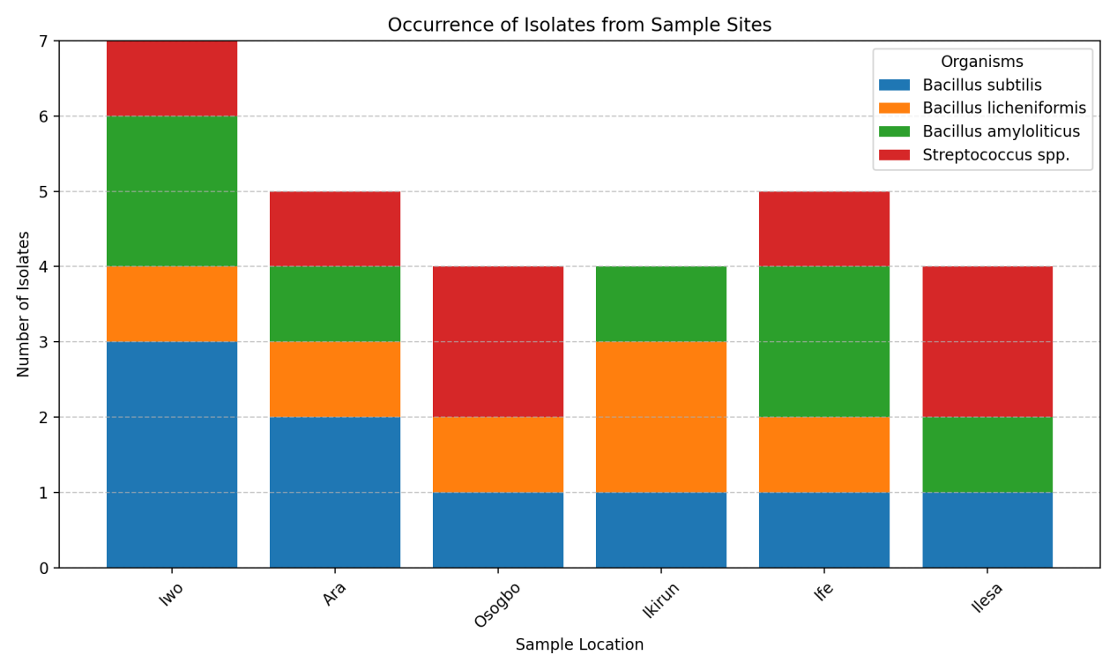

**Figure 1:** Occurrence of Isolates from Sample Sites

The soil's pH across the zones was alkaline, ranging from 8.2 to 8.8. Alkaline conditions, such as these, can influence microbial activities and plastic degradation rates. Previous studies have indicated that soil pH can directly impact microbial population density and enzyme activities related to plastic degradation (FES, 2021). For example, alkaline pH can promote the growth of certain bacterial species like Bacillus subtilis, which are known to degrade plastics (Yao *et al.*, 2022). Additionally, the soil temperature varied between 25°C and 29.1°C, with warmer temperatures facilitating microbial activity, including the breakdown of plastics (Lv *et al.*, 2024). This observation aligns with the findings of Emmanuel-Akerele *et al.* (2022), who reported that soil temperatures within this range support the enzymatic activities of plastic-degrading microorganisms.

The total viable bacterial count (TVBC) of the soil samples revealed a significant presence of bacteria, with CFUs (colony-forming units) ranging from 2.5 x105 to 4.0 x105 at 10¹ dilution factor and from 0.8 x105 to 1.5 x105 at a 10⁵ dilution factor. The high bacterial load observed, particularly in Ikirun (S4) and Iwo (S1), suggests that these areas may host abundant microbial communities capable of utilizing plastics as a carbon source. This observation is supported by studies documenting that high bacterial counts in microplastic-polluted soils indicate increased microbial activity aimed at plastic degradation (Nadeem *et al.*, 2022).

The identification of the bacterial isolates, including Bacillus subtilis, Bacillus licheniformis, and Streptococcus spp., suggests the presence of microorganisms known for their plastic-degrading capabilities. Bacillus subtilis, for example, has been extensively studied for its ability to produce enzymes like lipases and proteases that can degrade various forms of plastics, including polyethylene and polystyrene (Yao *et al.*, 2022). Similarly, Bacillus licheniformis has been shown to secrete extracellular enzymes that break down plastic polymers. The presence of these bacteria in polluted soils is indicative of potential biodegradation activities, as reported by recent studies focusing on microbial adaptation in plastic-contaminated environments (Lv *et al.*, 2024). The results are consistent with previous reports that microplastic pollution alters the microbial community structure, promoting the growth of plastic-degrading bacteria (Lamela *et al.*, 2023; Jumaah, 2015). The isolated bacterial species, especially from the Bacillus genus, are widely recognized for their role in biodegradation. These findings highlight the potential of these microbial species as key agents in bioremediation efforts, as demonstrated by similar works in plastic-polluted ecosystems (Yao *et al.*, 2022). The ability of these bacteria to utilize citrate and sucrose, as seen in the physiological tests, indicates their metabolic versatility, which is essential for surviving and thriving in harsh, plastic-laden environments. This adaptability is critical for the biodegradation process, as microbial metabolism is often driven by the need to utilize available carbon sources, including plastics, for survival (Lv *et al.*, 2024).

Overall, the findings authenticate Bacillus species' superior degradation efficiency and suggest exploring engineered Bacillus consortia to enhance degradation, as proposed by Emmanuel-Akerele *et al.* (2022). These results reaffirm the critical role of Bacillus species in addressing plastic pollution through bioremediation.

**Conclusion**

This study isolated and identified microplastic-degrading bacteria from plastic-polluted soils in Osun State, Nigeria. The findings highlight the potential of Bacillus strains for the bioremediation of plastic waste, offering a sustainable approach to mitigating environmental pollution. The alkaline pH and favourable temperatures of the soils significantly supported bacterial activity and degradation processes. These results underscore the importance of leveraging microbial resources for addressing the global challenge of plastic pollution.

**Recommendation**

To address plastic pollution effectively, large-scale bioremediation efforts should prioritise the application of *Bacillus subtilis* and *Bacillus amyloliticus,* given their demonstrated efficiency in degrading plastics. Continuous monitoring of soil conditions, such as pH and temperature, is essential to optimise bacterial activity and degradation rates. Furthermore, future research should focus on engineering microbial consortia and exploring the enzymatic pathways involved to enhance the bioremediation process.

**Acknowledgements**

I express my sincere gratitude to the Department of Science Laboratory Technology at Osun State Polytechnic, Iree, for access to laboratory facilities and technical support during the research. Additionally, I appreciate the efforts of my supervisors and co-supervisor at Lead City University, Ibadan, and Bamidele Olumilua University of Education, Science and Technology, Ikere-Ekiti, for their supervision, invaluable insights and contributions to manuscript preparation. There is no sponsorship from any agency at all, so no involvement in the interpretation of data or writing of the manuscript.

**Authors Contribution**

All authors have contributed significantly to this study. Author **OOA** was responsible for the conceptualisation and methodology of the research, software-related tasks and contributed to the original draft of the manuscript. Author **SO** provided supervision, handled data curation, and contributed to the writing, reviewing, editing, and visualisation of the research findings.Author **OBM** was instrumental in data curation, methodology and supervised the project. All authors have reviewed and approved the final version of the manuscript for submission.

**Disclaimer**

Author(s) hereby declare that NO generative AI technologies such as Large Language Models (ChatGPT, COPILOT, etc.) and text-to-image generators have been used during the writing or editing of this manuscript.

**References**

Da Silva, M. R. F., Souza, K. S., Motteran, F., de Araújo, L. C. A., Singh, R., Bhadouria, R., & de Oliveira, M. B. M. (2024). Exploring biodegradative efficiency: A systematic review on the main microplastic-degrading bacteria. Frontiers in Microbiology, 15, 1360844.

Emmanuel-Akerele, H. A., Akinyemi, P. O., & Igbogbo-Ekpunobi, O. E. (2022). Isolation and identification of plastic-degrading bacteria from dumpsites Lagos. Advances in Environmental Technology, 1, 59-71.

Fawole, M.O. and Oso, B.A, (2004). Characterization of bacteria: Laboratory manual of microbiology, Spectrum Publishers, Ibadan.

Frontiers in Environmental Science. (2021). Microplastics increase soil pH and decrease microbial activity. Frontiers in Environmental Science.

Gupta, V., Trivedi, A,, Nandeha, N., Monya, D., Dujeshwer, K., Pandey, A.K., and Singh, A. (2024). Micro Plastic Pollution in Soil Environment: A Comprehensive Review. J. Sci. Res. 30(6):412-9.

Jumaah, O. S. (2015). Screening of plastic-degrading bacteria from dumped soil area. IOSR Journal of Environmental Science, Toxicology and Food Technology, 11(5), 93-98.

Lamela, P. A. M., Diputado, Y. G., Lumantas, J. M., Gatpatan, I. G., & Cabulong, R. B. (2023). Isolation, characterization, and identification of plastic-degrading bacteria from Bago City landfill, Negros Occidental, Philippines. Philippine Journal of Natural Sciences, 28, 24-25.

Lv, S., Li, Y., Zhao, S., & Shao, Z. (2024). Biodegradation of typical plastics: From microbial diversity to mechanisms. International Journal of Molecular Sciences, 25(1), 593.

Nadeem, H., Alia, K. B., Muneer, F., Rasul, I., Siddique, M. H., Azeem, F., & Zubair, M. (2022). Isolation and identification of low-density polyethylene degrading novel bacterial strains. Archives of Microbiology, 203, 5417–5423.

Ololade, I. A., Apata, A., Oladoja, N. A., Alabi, B. A., & Ololade, O. O. (2023). Microplastic particles in river sediments and water of southwestern Nigeria. Environmental Science and Pollution Research, 30, 12345–12356.

Onyekachi, N. S., & Chukwuemeka, I. S. (2022). A review: State of plastic pollution in Nigeria and measures to tackle them. Journal of Analytical Toxicology and Environmental Studies, 2(1), 101.

Yalwaji, B. (2022). Plastic pollution in the environment in Nigeria: A rapid systematic review of the sources, distribution, research gaps, and policy needs. Scientific African, 7, e00242.

Yoshida, S., Hiraga, K., Takehana, T., Taniguchi, I., Yamaji, H., Maeda, Y., ... & Oda, K. (2016). A bacterium that degrades and assimilates poly(ethylene terephthalate). Science, 351(6278), 1196–1199. <https://en.wikipedia.org/wiki/Ideonella_sakaiensis>

Yao, Z., Seong, H. J., & Jang, Y. S. (2022). Degradation of low-density polyethylene by Bacillus species. Applied Biological Chemistry, 65(2), 97-104.