**Insights into Molecular Mechanisms of Plant-Pathogen Interactions: Advances and Perspectives**

**Abstract:** The molecular biology of plant-pathogen interactions explores the intricate mechanisms by which pathogens, including bacteria, fungi, viruses, and nematodes, interact with plants at the cellular and molecular levels. These interactions are critical in determining the outcome of disease development and host resistance. Pathogens employ specialized virulence factors, such as effector proteins, to manipulate host cell processes, suppress immune responses, and facilitate colonization. In turn, plants deploy a range of defense mechanisms, including pattern recognition receptors, signaling pathways, and the activation of immune responses to detect and resist pathogen invasion. Most plants are resistant to pathogens, as they can recognize and defend against potential invaders. Successful pathogens cause disease by evading or suppressing these defenses. In the early 20th century, classical breeding was the primary method for controlling plant diseases. However, it was not until we gained significant insight into the genetic interactions controlling disease resistance. Recent advancements in genomics, transcriptomics, and proteomics have significantly enhanced our understanding of the molecular underpinnings of these interactions, revealing complex signaling networks and genetic factors involved in both susceptibility and resistance. Understanding these molecular dynamics holds promise for developing novel strategies for disease control, including the engineering of plants with enhanced resistance traits and the design of targeted antimicrobial agents.

**Keywords:** Pathogen, genome, defense mechanism, signaling, transcriptomics and proteomics

**Introduction:** Plant pathogens pose a significant threat to global food security, causing devastating losses in crop yields and quality (Youssef et al., 2020). In response to these challenges, researchers have focused on understanding the molecular basis of plant-pathogen interactions. Recent advances in molecular biology and genomics have facilitated the identification of key genes and pathways involved in plant immunity and pathogen virulence. The interaction between plants and pathogens is complex and dynamic (Berkeley, 2024). Plants have developed a range of defense mechanisms to detect and respond to invading pathogens, including physical barriers, chemical defenses, and the immune system. At the same time, pathogens have evolved sophisticated strategies to evade or suppress plant immunity, allowing them to establish infections and cause disease (Yuan et al., 2020). The molecular mechanisms underlying plant-pathogen interactions involve a range of signaling pathways and regulatory networks. Pathogen-associated molecular patterns (PAMPs) and effector molecules are recognized by host receptors, leading to the activation of defense responses or the suppression of immune signaling (Berger et al., 2020). The co evolutionary arms race between plants and pathogens has resulted in the diversification and specialization of these molecular mechanisms, making it challenging to develop effective disease management strategies. Omics approaches, including transcriptomics, proteomics, and metabolomics, have enabled researchers to gain a systems-level understanding of plant-pathogen interactions. High-throughput sequencing and bioinformatics tools have been instrumental in identifying key genes and pathways involved in plant immunity and pathogen virulence (Bastas, 2022). These insights have facilitated the development of new strategies for disease management, including breeding resistant crops, developing novel pesticides, and engineering plant immune responses. The molecular biology of plant-pathogen interactions involves the various mechanisms plants use to defend against pathogens., the strategies pathogens use to evade or suppress plant immunity, and the key molecular interactions that occur between plants and pathogens during infection. In recent advances the high-throughput sequencing and bioinformatics and their applications to the study of plant-pathogen interactions (Ali et al., 2022). How the molecular biology of plant-pathogen interactions can be used to develop new strategies for disease management. the molecular biology of plant-pathogen interactions is a rapidly evolving field with significant implications for global food security. The complex interplay between plants and pathogens involves a range of signaling pathways and regulatory networks, making it a challenging but rewarding area of research. The insights gained from this research will be instrumental in developing new strategies for disease management and improving crop yields (Ahmed et al., 2024).

**Molecular mechanisms of plant defense-** Plants have developed complex defense mechanisms to protect themselves from pathogenic microorganisms. These defenses are triggered by pathogen-associated molecular patterns (PAMPs), which are recognized by pattern recognition receptors (PRRs) on the surface of plant cells. However, pathogens have evolved various strategies to counteract plant defenses and establish infections (Dutta et al., 2023). In this paper, we will discuss the molecular mechanisms by which pathogens evade or suppress plant immunity, including the secretion of effector proteins that manipulate plant signaling pathways, cell death, or hormone pathways. Pathogens secrete effector proteins to manipulate host defenses and establish infections. Effectors are diverse in structure and function, and they are classified into several groups based on their localization and activity in plant cells. Some effectors are delivered directly into the plant cell cytoplasm, while others are translocated into the plant cell nucleus or chloroplasts (Dixit, et al., 2023). One of the most common strategies used by pathogens to counteract plant defenses is the suppression of PAMP-triggered immunity (PTI). PTI is the first line of defense against pathogens, and it is triggered by the recognition of PAMPs by PRRs. To suppress PTI, pathogens secrete effector proteins that interfere with PTI signaling pathways or inhibit the production of defense-related compounds. For example, bacterial effector proteins can inhibit the phosphorylation of PRRs or downstream signaling molecules, leading to the suppression of PTI. Another strategy used by pathogens is the induction of effector-triggered susceptibility (ETS) responses (Cui et al., 2021). ETS responses are triggered by the recognition of pathogen effectors by resistance (R) proteins in plants. R proteins are intracellular receptors that recognize specific effectors and trigger defense responses. However, some pathogens have evolved effectors that can suppress or mimic the activity of R proteins, leading to the induction of ETS responses. This results in the suppression of downstream defense responses and facilitates the establishment of infection by the pathogen. Pathogens also secrete effector proteins that manipulate hormone signaling pathways in plants. Hormones play a crucial role in regulating plant growth and development, as well as in the defense response against pathogens. Pathogens can manipulate hormone signaling pathways to enhance their virulence and establish infections (Chepsergon et al., 2021). For example, some bacterial effector proteins can mimic plant hormones or interfere with hormone signaling pathways, leading to the suppression of defense responses and enhanced pathogen virulence. In addition to manipulating plant signaling pathways, some pathogens induce programmed cell death (PCD) in plant cells. PCD is a genetically regulated process that leads to the death of infected plant cells and the inhibition of pathogen growth and spread. However, some pathogens have evolved effector proteins that can induce or suppress PCD, depending on the stage of infection (Chen et al., 2023). For example, some fungal effector proteins can induce PCD in plant cells during the early stages of infection, while others can suppress PCD during later stages of infection to promote pathogen growth and spread. pathogens have evolved various strategies to counteract plant defenses and establish infections. These strategies include the secretion of effector proteins that manipulate plant signaling pathways, cell death, or hormone pathways. Understanding these molecular mechanisms is essential for developing new strategies to control plant diseases and improve crop yields. Further research is needed to elucidate the precise mechanisms by which pathogens evade or suppress plant immunity and to develop novel approaches to combat plant diseases (Biella et al., 2022).

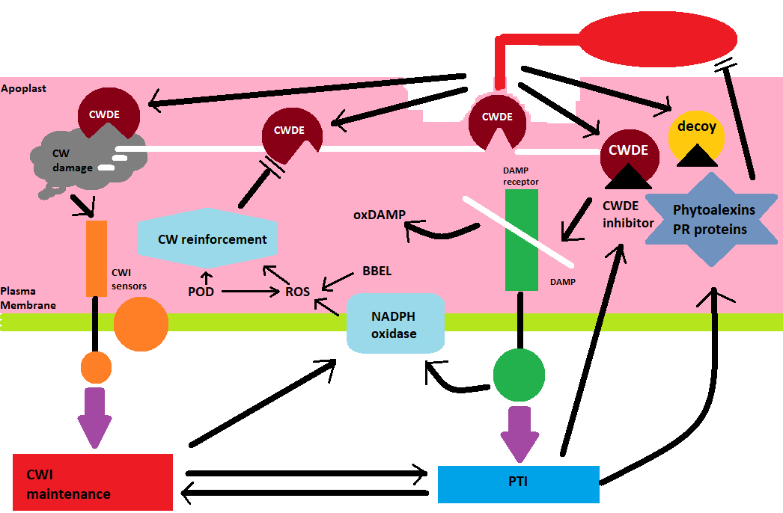

**Figure 1: Schematic representation of molecular mechanism of plant defense**

**Molecular mechanisms of pathogen virulence-** Plant pathogens, such as bacteria, viruses, and fungi, have evolved sophisticated mechanisms to overcome the host plant’s immune system and establish infections. Understanding the molecular mechanisms of pathogen virulence is crucial for developing effective disease management strategies (Jan, et al., 2022). In this essay, we will discuss the strategies that pathogens use to evade or suppress plant immunity, including the secretion of effector proteins that manipulate plant signaling pathways, cell death, or hormone pathways. One of the main ways that pathogens evade or suppress plant immunity is by secreting effector proteins that manipulate plant signaling pathways. These effector proteins are usually delivered into the plant cell through specialized secretion systems. Once inside the plant cell, effector proteins can target various host proteins, such as receptor-like kinases (RLKs) and transcription factors, to manipulate plant signaling pathways and promote infection (Imran et al., 2021). For example, bacterial pathogens such as Pseudomonas syringae produce effector proteins, including HopAI1, that target the plant immune system. HopAI1 can remove phosphate groups from certain plant proteins, including the key immune regulator MPK3/6, leading to the suppression of plant immunity. Similarly, the bacterial effector protein AvrPtoB can target the plant protein kinase BAK1, leading to the suppression of immune signaling and promoting bacterial growth. Another strategy used by pathogens to evade or suppress plant immunity is through the manipulation of cell death pathways. Plants have evolved programmed cell death (PCD) as a defense mechanism against pathogens (Hu, et al., 2021). Pathogens can manipulate PCD pathways to promote their own growth and survival. For example, the fungal pathogen Botrytis cinerea produces an effector protein, BcNLP, which can trigger host cell death by activating a host transcription factor, resulting in the release of nutrients that promote fungal growth. Pathogens can also manipulate host hormone pathways to promote their own growth and survival. For example, the bacterial pathogen Agrobacterium tumefaciens produces an effector protein, VirE2, which can activate the plant hormone auxin signaling pathway. The activation of the auxin pathway promotes the growth of plant cells and increases the availability of nutrients for the pathogen. In addition to these strategies, pathogens can also alter the plant cell wall composition, allowing them to penetrate the plant cell and establish infections (Erayya et al., 2023). For example, the fungal pathogen Fusarium oxysporum secretes an enzyme, xylanase, that breaks down plant cell walls, allowing the pathogen to invade the plant tissue. plant pathogens have evolved a range of strategies to evade or suppress plant immunity and establish infections. These strategies include the secretion of effector proteins that manipulate plant signaling pathways, the manipulation of cell death pathways, the alteration of host hormone pathways, and the modification of the plant cell wall composition. Understanding the molecular mechanisms of pathogen virulence is crucial for developing effective disease management strategies, such as breeding resistant crops and developing novel pesticides (Dutta, et al., 2023).

**Molecular interactions between plants and pathogens:** Plants are constantly exposed to a variety of pathogens, including viruses, bacteria, fungi, and oomycetes, that can cause significant damage to crops and threaten food security (Lawrence et al., 2022). To defend against these pathogens, plants have developed complex immune systems that recognize and respond to molecular signals from the pathogen. In this paper, we will discuss the key molecular interactions that occur between plants and pathogens during infection, with a focus on the recognition of pathogen-associated molecular patterns (PAMPs) by pattern recognition receptors (PRRs) and effectors by resistance (R) proteins. PAMP-triggered immunity (PTI) is the first line of defense in plants against pathogens (Lamichhane et al., 2023). PTI is initiated when PRRs on the plant cell surface recognize conserved molecular patterns from the pathogen, such as flagellin, chitin, or lipopolysaccharides. PRRs are transmembrane receptors that typically have extracellular domains that recognize PAMPs and intracellular domains that initiate downstream signaling pathways. PRRs trigger a cascade of signaling events that lead to the activation of mitogen-activated protein kinases (MAPKs), the production of reactive oxygen species (ROS), the induction of pathogenesis-related (PR) genes, and the reinforcement of the plant cell wall (Kumar et al., 2023). While PTI is an effective defense mechanism, many pathogens have evolved to overcome PTI by secreting effectors, which are small proteins that can manipulate host cell processes. Effectors can be injected into the plant cell by specialized secretion systems, such as the type III secretion system in bacteria or the haustorium in fungi and oomycetes. Effectors can target a variety of host proteins and processes, including transcription factors, hormone signaling, and vesicle trafficking, to promote pathogen growth and suppress plant immune responses (Khursheed et al., 2022). To counteract the effectors, plants have evolved resistance (R) proteins that can specifically recognize the presence or activity of effectors and trigger effector-triggered immunity (ETI). ETI is a more robust and specific immune response than PTI and typically results in the rapid induction of cell death at the site of infection, known as the hypersensitive response (HR). R proteins are cytoplasmic receptors that typically have a nucleotide-binding (NB) domain and a leucine-rich repeat (LRR) domain (Khan et al., 2022). Upon recognition of an effector, the NB domain undergoes a conformational change and activates downstream signaling pathways, including the activation of MAPKs and the production of ROS. The recognition of effectors by R proteins can occur through direct interaction between the effector and the R protein or indirectly through the modification of host proteins by the effector (Khan et al., 2021). Many effectors can modify host proteins through enzymatic activities, such as ubiquitination, proteolysis, or phosphorylation. These modifications can lead to the activation or inhibition of host proteins, which can in turn activate R proteins or suppress plant immunity. The co-evolutionary arms race between plants and pathogens has led to the diversification of both effectors and R proteins, resulting in a complex network of molecular interactions that determine the outcome of the plant-pathogen interaction. The molecular interactions between plants and pathogens during infection involve the recognition of PAMPs by PRRs and effectors by R proteins, leading to the activation of PTI or ETI, respectively (Khadiri, et al., 2023). These interactions are essential for plant defense against pathogens and have significant implications for agriculture and food security. The development of new technologies, such as CRISPR-Cas genome editing and high-throughput sequencing, will enable researchers to further dissect the molecular mechanisms underlying plant-pathogen interactions and develop new strategies for disease management (Kabir et al., 2023).

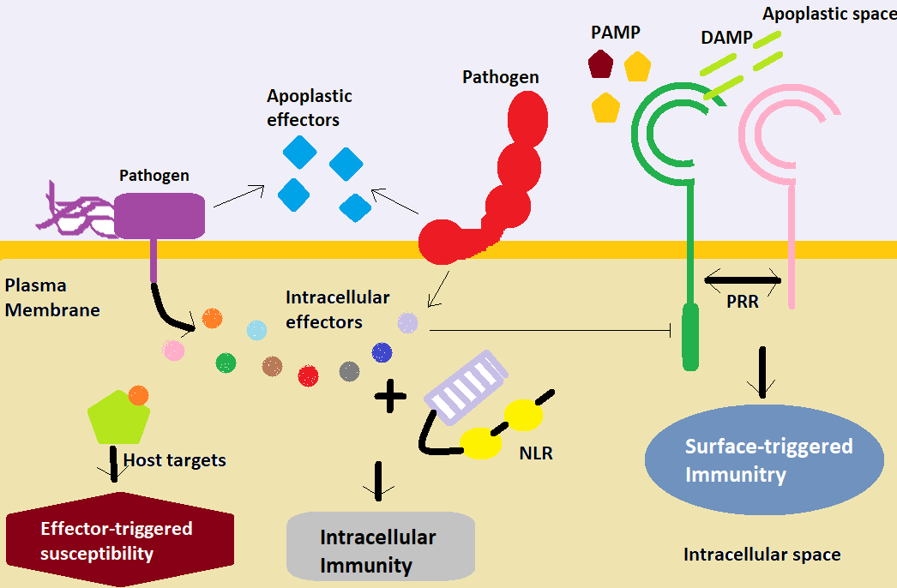

**Figure 2: Molecular mechanism of plant pathogen interaction**

**Omics approaches to studying plant-pathogen interactions:** Plant-pathogen interactions are complex processes that involve various molecular mechanisms. These interactions have a significant impact on plant growth, development, and survival (Pallez-Barthel et al., 2022). Understanding the underlying molecular biology of plant-pathogen interactions is crucial for developing effective disease management strategies (Ngou et al., 2022). Omics approaches have emerged as powerful tools for studying these interactions, and recent advances in high-throughput sequencing and bioinformatics have enabled researchers to identify key genes and pathways involved in plant immunity and pathogen virulence. Transcriptomics is the study of the complete set of transcripts present in a cell or organism (Ngou et al., 2020). Transcriptomic approaches, such as microarray analysis and RNA sequencing, have been used extensively to study gene expression changes in plants during pathogen infection. These studies have identified several genes and pathways involved in plant immunity, including the salicylic acid (SA), jasmonic acid (JA), and ethylene (ET) signaling pathways (Nath, 2021). For example, transcriptomic analysis of Arabidopsis thaliana infected with the bacterial pathogen Pseudomonas syringae identified several genes that were differentially expressed, including those involved in SA and JA/ET signaling pathways. Proteomics is the study of the complete set of proteins present in a cell or organism. Proteomic approaches, such as two-dimensional gel electrophoresis and mass spectrometry, have been used to identify and quantify proteins in plants during pathogen infection (Myers et al., 2021). Proteomic studies have identified several pathogen-responsive proteins, including pathogenesis-related (PR) proteins and enzymes involved in the biosynthesis of phytohormones, such as SA, JA, and ET. For example, proteomic analysis of tomato infected with the fungal pathogen Botrytis cinerea identified several PR proteins that were upregulated, indicating their involvement in plant defense against the pathogen. Metabolomics is the study of the complete set of metabolites present in a cell or organism (Moradinezhad and Ranjbar, 2023). Metabolomic approaches, such as gas chromatography-mass spectrometry and nuclear magnetic resonance spectroscopy, have been used to study changes in plant metabolism during pathogen infection. Metabolomic studies have identified several metabolites that are involved in plant defense against pathogens, including phytohormones, flavonoids, and phenolic compounds (Mooney et al., 2021). For example, metabolomic analysis of Arabidopsis infected with the bacterial pathogen Pseudomonas syringae identified several metabolites that were upregulated, including SA, camalexin, and glucosinolates. Other omics approaches, such as epigenomics, glycomics, and lipidomics, have also been used to study plant-pathogen interactions. For example, epigenomic studies have identified changes in DNA methylation patterns during pathogen infection, indicating their role in regulating plant defense responses (Minina et al., 2021). Glycomic and lipidomic studies have identified changes in the composition of cell wall polysaccharides and lipid membranes, respectively, indicating their involvement in plant defense against pathogens. Recent advances in high-throughput sequencing and bioinformatics have enabled researchers to integrate data from multiple omics approaches, providing a comprehensive view of plant-pathogen interactions (Maurya et al., 2022). For example, integrated transcriptomic and metabolomic analysis of Arabidopsis infected with the fungal pathogen Alternaria brassicicola identified several key genes and metabolites involved in plant defense against the pathogen. Omics approaches have revolutionized our understanding of plant-pathogen interactions by providing a global view of changes in gene expression, protein abundance, and metabolite levels during infection (Lim et al., 2023). Recent advances in high-throughput sequencing and bioinformatics have enabled researchers to identify key genes and pathways involved in plant immunity and pathogen virulence. These findings have important implications for developing effective disease management strategies and improving crop yields (Lee, et al., 2020).

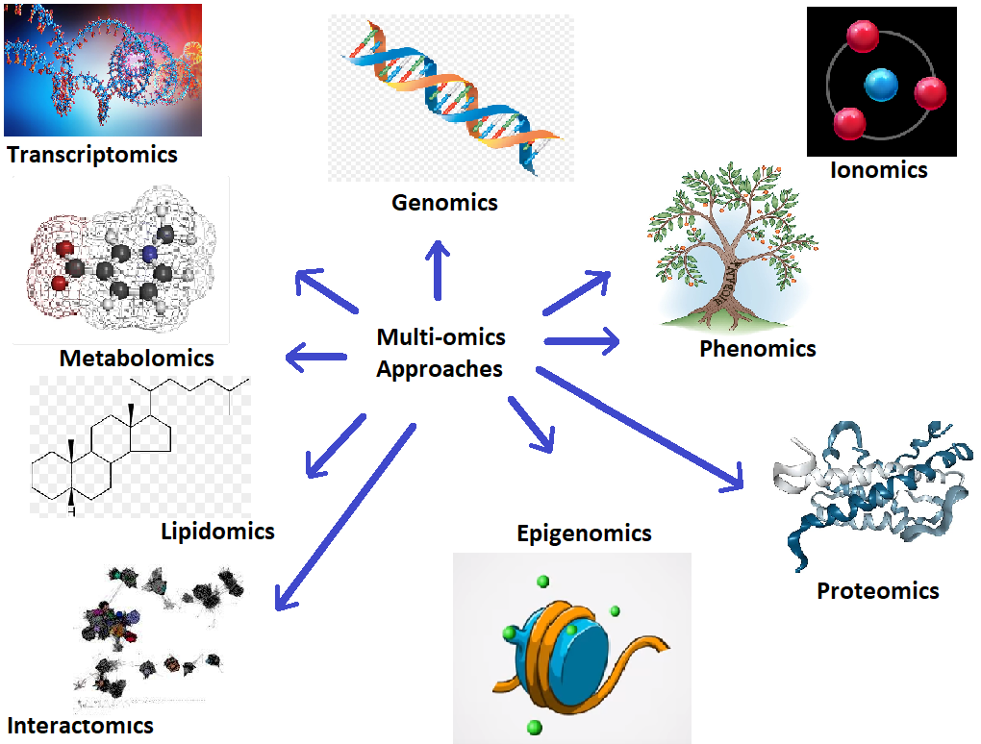

**Figure 3.** **Omics approaches to studying plant-pathogen interactions**

**Applications of molecular biology to plant disease management:** Plant diseases caused by pathogens such as viruses, bacteria, fungi, and nematodes are major threats to global food security, causing significant yield losses and economic damages (Pradhan et al., 2021). The development of novel strategies for plant disease management is critical to ensuring food security, and molecular biology has been instrumental in providing insights into the molecular mechanisms of plant-pathogen interactions that can be exploited for disease control (Pande et al., 2021). In this essay, we will discuss how an understanding of the molecular biology of plant-pathogen interactions can be used to develop new strategies for disease management, such as breeding resistant crops, developing novel pesticides, and engineering plant immune responses (Pande at al., 2022).

**Breeding resistant crops:** The most effective and environmentally sustainable approach to plant disease management is to breed resistant crop varieties that can withstand pathogen attacks. Understanding the molecular basis of plant resistance can help breeders develop crops with enhanced resistance to diseases (Rahim et al., 2022). For example, plant immune receptors called resistance proteins (R proteins) recognize pathogen effectors and trigger an immune response that can halt pathogen infection. Researchers can use molecular techniques to identify R genes in crops and introduce them into susceptible varieties to confer resistance to specific pathogens. Genome editing tools, such as CRISPR/Cas9, can also be used to edit plant genomes to enhance their resistance to pathogens (Raffeiner et al., 2022).

**Developing novel pesticides:** Plant pathogens can be controlled using chemical pesticides; however, the use of traditional pesticides has led to environmental and health problems. Therefore, there is a growing interest in developing novel pesticides that are more environmentally friendly and safer to use. Molecular biology can help in the development of such pesticides (Roussin-Leveillee et al., 2022). For example, RNA interference (RNAi) is a technique that uses small RNA molecules to specifically target and silence pathogen genes. RNAi-based pesticides have been developed that can specifically target pathogen genes, reducing the need for broad-spectrum pesticides that can harm beneficial organisms (Ray and Casteel, 2022).

**Engineering plant immune responses:** Plant immune responses can be engineered to enhance resistance to pathogens. Molecular biology techniques can be used to manipulate the expression of plant immune genes to enhance immunity (Schreiber at al., 2021). For example, researchers can use molecular techniques to overexpress key components of the plant immune system, such as defense-related genes or transcription factors, to enhance the plant's ability to resist pathogens (Tariqjaveed et al., 2021). Additionally, plant-associated bacteria and fungi can also be used to stimulate plant immune responses, leading to enhanced resistance to pathogens. These biocontrol agents can be engineered to express genes that enhance their effectiveness in protecting crops from pathogens (Sarker et al., 2022).

**Conclusion -** Plant-pathogen interactions play a crucial role in plant biology and agriculture, influencing crop yields and food security. Molecular biology has significantly advanced our understanding of these interactions, revealing the intricate mechanisms of plant defense and pathogen attack. Key components of plant immunity, such as PRRs, R proteins, and signaling molecules, work to detect and counteract pathogen effectors. Advances in high-throughput sequencing and bioinformatics have identified essential genes and pathways involved in plant immunity and pathogen virulence. This knowledge aids in breeding resistant crops, developing novel pesticides, and engineering plant immune responses. However, the diversity of plant-pathogen interactions poses challenges for universal disease management strategies. Continued research in this field is essential not only for improving crop protection but also for understanding broader aspects of plant biology, including immune system evolution and plant-microbe interactions. The ongoing exploration of molecular mechanisms in plant-pathogen interactions will contribute to more effective disease management and agricultural sustainability.

Disclaimer (Artificial intelligence)

Option 1:

Author(s) hereby declare that NO generative AI technologies such as Large Language Models (ChatGPT, COPILOT, etc.) and text-to-image generators have been used during the writing or editing of this manuscript.

**References:**

1. Ahmed, N., Alam, M., Saeed, M., Ullah, H., Junaid, M., Kanwal, M., Ahmed, S., 2024. Role of plants in managing diseases. In: € Oztürk, M., Sridhar, K.R., Sarwat, M., Altay, V., Huerta-Martínez, F.M. (Eds.), Ethnic Knowledge and Perspectives of Medicinal Plants. Apple Academic Press, New York, USA, pp. 579–604.
2. Ali, S.; Moon, Y.-S.; Hamayun, M.; Khan, M.A.; Bibi, K.; Lee, I.-J. Pragmatic role of microbial plant biostimulants in abiotic stress relief in crop plants. *J. Plant Interact.* 2022, *17*, 705–718.
3. Bastas, K.K., 2022. Impact of climate change on food security and plant disease. In: Kumar, A. (Ed.), Microbial Biocontrol: Food Security and Post Harvest Management. Springer, Cham, Switzerland, pp. 1–22.
4. Berger, A.; Boscari, A.; Horta Araujo, N.; Maucourt, M.; Hanchi, M.; Bernillon, S.; Rolin, D.; Puppo, A.; Brouquisse, R. Plant nitrate reductases regulate nitric oxide production and nitrogen-fixing metabolism during the *Medicago truncatula*–*Sinorhizobium meliloti* symbiosis. *Front. Plant Sci.* 2020, *11*, 1313.
5. Berkeley Earth, 2024. Global Temperature Anomalies. https://berkeleyearth.org/data/. Beyer, M.,
6. Biella, P., Tommasi, N., Guzzetti, L., Pioltelli, E., Labra, M., Galimberti, A., 2022. City climate and landscape structure shape pollinators, nectar and transported pollen along a gradient of urbanization. J. Appl. Ecol. 59, 1586–1595.
7. Chen, W., Modi, D., Picot, A., 2023. Soil and phytomicrobiome for plant disease suppression and management under climate change: a review. Plants 12, 2736.
8. Chepsergon, J.; Motaung, T.E.; Moleleki, L.N. “Core” RxLR Effectors in Phytopathogenic Oomycetes: A Promising Way to Breeding for Durable Resistance in Plants? *Virulence* 2021, *12*, 1921–1935.
9. Cui, B.; Xu, S.; Li, Y.; Umbreen, S.; Frederickson, D.; Yuan, B.; Jiang, J.; Liu, F.; Pan, Q.; Loake, G.J. The Arabidopsis zinc finger proteins SRG2 and SRG3 are positive regulators of plant immunity and are differentially regulated by nitric oxide. *New Phytol.* 2021, *230*, 259–274.
10. Dixit, S., Sivalingam, P.N., Murali-Baskaran, R.K., Senthil-Kumar, M., Ghosh, P.K., 2023. Plant responses to concurrent abiotic and biotic stress: unravelling physiological and morphological mechanisms. Plant Physiol. Rep. 29, 6–17.
11. Dutta, P., Kumari, A., Mahanta, M., Upamanya, G.K., Heisnam, P., Borua, S., Kaman, P.K., Mishra, A.K., Mallik, M., Muthukrishnan, G., Sabarinathan, K.G., Puzari, K.R., Vijayreddy, D., 2023. Nanotechnological approaches for management of soil-borne plant pathogens. Front. Plant Sci. 14, 1136233. [https://doi.org/10.3389/fpls.2023. 1136233](https://doi.org/10.3389/fpls.2023.%201136233).
12. Dutta, T.K., Vicente, C.S.L., Maleita, C.M.N., Phani, V., 2023. Impact of global climate change on the interaction between plants and plant-parasitic nematodes. Front. Plant Sci. 14, 1195970. <https://doi.org/10.3389/fpls.2023.1195970>.
13. Erayya, S.S., Managanvi, K., Kumar, S., Alipatra, A., 2023. Emerging diseases of vegetables due to changing climate. In: Solankey, S.S., Kumari, M. (Eds.), Advances in Research on Vegetable Production Under a Changing Climate, Vol. 2. Springer, Cham, Switzerland, pp. 323–340.
14. Hu, S.-P.; Li, J.-J.; Dhar, N.; Li, J.-P.; Chen, J.-Y.; Jian, W.; Dai, X.-F.; Yang, X.-Y. Lysin Motif (LysM) Proteins: Interlinking Manipulation of Plant Immunity and Fungi. *Int. J. Mol. Sci.* 2021, *22*, 3114.
15. Imran, M.; Shazad, R.; Bilal, S.; Imran, Q.M.; Khan, M.; Kang, S.-M.; Khan, A.L.; Yun, B.-W.; Lee, I.-J. Exogenous Melatonin mediates the regulation of endogenous nitric oxide in Glycine max L. to reduce effects of drought stress. *Environ. Exp. Bot.* 2021, *188*, 104511.
16. Jan, F.G.; Hamayun, M.; Moon, Y.-S.; Jan, G.; Shafique, M.; Ali, S. Endophytic aspergillus oryzae reprograms Abelmoschus esculentus L. to higher growth under salt stress via regulation of physiochemical attributes and antioxidant system. *Biologia* 2022, *77*, 1–14.
17. Kabir, M., Habiba, U.E., Khan, W., Shah, A., Rahim, S., De los Rios-Escalante, P.R., Farooqi, Z.U.R., Ali, L., Shafiq, M., 2023. Climate change due to increasing concentration of carbon dioxide and its impacts on environment in 21st century; a mini review. J. King Saud Univ. Sci. 35, 102693. https://doi.org/10.1016/ j.jksus.2023.102693.
18. Khadiri, M., Boubaker, H., Askarne, L., Ezrari, S., Radouane, N., Farhaoui, A., El Hamss, H., Tahiri, A., Barka, E.A., Lahlali, R., 2023. Bacillus cereus B8W8 an effective bacterial antagonist against major postharvest fungal pathogens of fruit. Postharvest Biol. Technol. 200, 112315. https://doi.org/10.1016/j.postharvbio.2023.112315.
19. Khan, M.; Al Azzawi, T.N.I.; Imran, M.; Hussain, A.; Mun, B.-G.; Pande, A.; Yun, B.-W. Effects of lead (Pb)-induced oxidative stress on morphological and physio-biochemical properties of rice. *Biocell* 2021, *45*, 1413.
20. Khan, M.; Ali, S.; Manghwar, H.; Saqib, S.; Ullah, F.; Ayaz, A.; Zaman, W. Melatonin function and crosstalk with other phytohormones under normal and stressful conditions. *Genes* 2022, *13*, 1699.
21. Khursheed, A., Rather, M.A., Jain, V., Wani, A.R., Rasool, S., Nazir, R., Malik, N.A., Majid, S.A., 2022. Plant based natural products as potential ecofriendly and safer biopesticides: A comprehensive overview of their advantages over conventional pesticides, limitations and regulatory aspects. Microb. Pathog. 173, 105854. https:// doi.org/10.1016/j.micpath.2022.105854.
22. Kumar, S., Thilagam, P., Shikha, D., Saikanth, D.R.K., Rahmani, U., Huded, S., Panigrahi, C.K., 2023. Adapting plant protection strategies to meet the challenges posed by climate change on plant diseases: a review. Int. J. Environ. Clim. Chang. 13, 25–36. <https://doi.org/10.9734/ijecc/2023/v13i123657>.
23. Lamichhane, J.R., Barbetti, M.J., Chilvers, M.I., Pandey, A.K., Steinberg, C., 2023. Exploiting root exudates to manage soil-borne disease complexes in a changing climate. Trends Microbiol. 32, 27–37.
24. Lawrence, D., Coe, M., Walker, W., Verchot, L., Vandecar, K., 2022. The unseen effects of deforestation: biophysical effects on climate. Front. For. Glob. Change 5, 756115. https://doi.org/10.3389/ffgc.2022.756115.
25. Lee, D.; Lal, N.K.; Lin, Z.-J.D.; Ma, S.; Liu, J.; Castro, B.; Toruño, T.; Dinesh-Kumar, S.P.; Coaker, G. Regulation of reactive oxygen species during plant immunity through phosphorylation and ubiquitination of RBOHD. *Nat. Commun.* 2020, *11*, 1–16.
26. Lim, J.A., Yaacob, J.S., Mohd Rasli, S.R.A., Eyahmalay, J.E., El Enshasy, H.A., Zakaria, M.R.S., 2023. Mitigating the repercussions of climate change on diseases affecting important crop commodities in Southeast Asia, for food security and environmental sustainability-A review. Front. Sustain. Food Syst. 6, 1030540.
27. Maurya, M.K., Yadav, V.K., Singh, S.P., Jatoth, R., Singh, H.K., Singh, D., 2022. Impact of climate change on diseases of crops and their management-a review. J. Agric. Sci. Technol. B 12, 1–15.
28. Minina, E.A.; Dauphinee, A.N.; Ballhaus, F.; Gogvadze, V.; Smertenko, A.P.; Bozhkov, P.V. Apoptosis is not conserved in plants as revealed by critical examination of a model for plant apoptosis-like cell death. *BMC Biol.* 2021, *19*, 1–17.
29. Mooney, B.C.; Mantz, M.; Graciet, E.; Huesgen, P.F. Cutting the Line: Manipulation of Plant Immunity by Bacterial Type III Effector Proteases. *J. Exp. Bot.* 2021, *72*, 3395–3409.
30. Moradinezhad, F., Ranjbar, A., 2023. Advances in postharvest diseases management of fruits and vegetables: a review. Horticulturae 9, 1099.
31. Myers, T.A., Scott, R.C., Zelinka, M.D., Klein, S.A., Norris, J.R., Caldwell, P.M., 2021. Observational constraints on low cloud feedback reduce uncertainty of climate sensitivity. Nat. Clim. Change 11, 501–507.
32. Nath, S., 2021. Dew as source of emerging contaminants in agricultural system. In: Sustainable Agriculture Reviews 50. Springer, Cham, Switzerland, pp. 61–78.
33. Ngou, B.; Ahn, H.-K.; Ding, P.; Jones, J.D.G. Mutual Potentiation of Plant Immunity by Cell-Surface and Intracellular Receptors. *Nature* 2021, *592*, 110–115.
34. Ngou, B.P.M.; Ahn, H.-K.; Ding, P.; Redkar, A.; Brown, H.; Ma, Y.; Youles, M.; Tomlinson, L.; Jones, J.D.G. Estradiol-Inducible AvrRps4 Expression Reveals Distinct Properties of TIR-NLR-Mediated Effector-Triggered Immunity. *J. Exp. Bot.* 2020, *71*, 2186–2197.
35. Ngou, B.P.M.; Ding, P.; Jones, J.D.G. Thirty Years of Resistance: Zig-Zag through the Plant Immune System. *Plant Cell* 2022, *34*, 1447–1478.
36. Pallez-Barthel, M., Dam, D., Hoffmann, L., El Jarroudi, M., 2022. Enhancing septoria leaf blotch forecasts in winter wheat I: the effect of temperature on the temporal distance between critical rainfall periods and the breaking of the control threshold. J. Plant Dis. Prot. 129, 37–44.
37. Pande, A.; Mun, B.-G.; Khan, M.; Rahim, W.; Lee, D.-S.; Lee, G.-M.; Al Azawi, T.N.I.; Hussain, A.; Yun, B.-W. Nitric Oxide Signaling and Its Association with Ubiquitin-Mediated Proteasomal Degradation in Plants. *Int. J. Mol. Sci.* 2022, *23*, 1657.
38. Pande, A.; Mun, B.-G.; Lee, D.-S.; Khan, M.; Lee, G.-M.; Hussain, A.; Yun, B.-W. No network for plant–microbe communication underground: A review. *Front. Plant Sci.* 2021, *12*, 658679.
39. Pradhan, A.; Ghosh, S.; Sahoo, D.; Jha, G. Fungal Effectors, the Double Edge Sword of Phytopathogens. *Curr. Genet.* 2021, *67*, 27–40.
40. Raffeiner, M.; Üstün, S.; Guerra, T.; Spinti, D.; Fitzner, M.; Sonnewald, S.; Baldermann, S.; Börnke, F. The *Xanthomonas* Type-III Effector XopS Stabilizes *Ca* WRKY40a to Regulate Defense Responses and Stomatal Immunity in Pepper (*Capsicum annuum*). *Plant Cell* 2022, *34*, 1684–1708.
41. Rahim, W.; Khan, M.; Al Azzawi, T.N.I.; Pande, A.; Methela, N.J.; Ali, S.; Imran, M.; Lee, D.-S.; Lee, G.-M.; Mun, B.-G. Exogenously Applied Sodium Nitroprusside Mitigates Lead Toxicity in Rice by Regulating Antioxidants and Metal Stress-Related Transcripts. *Int. J. Mol. Sci.* 2022, *23*, 9729.
42. Ray, S.; Casteel, C.L. Effector-Mediated Plant–Virus–Vector Interactions. *Plant Cell* 2022, *34*, 1514–1531.
43. Roussin-Léveillée, C.; Lajeunesse, G.; St-Amand, M.; Veerapen, V.P.; Silva-Martins, G.; Nomura, K.; Brassard, S.; Bolaji, A.; He, S.Y.; Moffett, P. Evolutionarily Conserved Bacterial Effectors Hijack Abscisic Acid Signaling to Induce an Aqueous Environment in the Apoplast. *Cell Host Microbe* 2022, *30*, 489–501.e4.
44. Sarkar, B.; Savita, S.K.; Varalaxmi, Y.; Vanaja, M.; Kumar, N.R.; Sathish, P.; Lakshmi, N.J.; Prabhakar, M.; Shanker, A.K.; Yadav, S.K. Stress Reactions of Maize Genotypes to Drought Stress at Different Phenophases and Recovery. *Russ. J. Plant Physiol.* 2022, *69*, 1–10.
45. Schreiber, K.J.; Chau-Ly, I.J.; Lewis, J.D. What the Wild Things Do: Mechanisms of Plant Host Manipulation by Bacterial Type III-Secreted Effector Proteins. *Microorganisms* 2021, *9*, 1029.
46. Tariqjaveed, M.; Mateen, A.; Wang, S.; Qiu, S.; Zheng, X.; Zhang, J.; Bhadauria, V.; Sun, W. Versatile Effectors of Phytopathogenic Fungi Target Host Immunity. *J. Integr. Plant Biol.* 2021, *63*, 1856–1873.
47. Thordal-Christensen, H. A Holistic View on Plant Effector-Triggered Immunity Presented as an Iceberg Model. *Cell. Mol. Life Sci.* 2020, *77*, 3963–3976.
48. Youssef, K.; Roberto, S.R.; Tiepo, A.N.; Constantino, L.V.; de Resende, J.T.V.; Abo-Elyousr, K.A.M. Salt Solution Treatments Trigger Antioxidant Defense Response against Gray Mold Disease in Table Grapes. *JoF* 2020, *6*, 179.
49. Yuan, M.; Jiang, Z.; Bi, G.; Nomura, K.; Liu, M.; He, Y.; Zhou, J.-M.; Xin, X.-F. Pattern-Recognition Receptors Are Required for NLR-Mediated Plant Immunity. *Nature* 2020, *592*, 105–109.