***Original Research Article***

**Agromorphological characterization of *Solanum aethiopicum* accessions from the «kumba» group, cultivated in Burkina Faso**

**ABSTRACT**

|  |
| --- |
| *Solanum aethiopicum* is one of the leafy vegetables with enormous economic and food potential. Unfortunately, it remains neglected by the breeding programs for *Solanum melongena* to such an extent that few studies have been carried out on its genetic variability in Burkina Faso. The present study is a contribution to a better knowledge of the agromorphological variability of a collection of 47 cultivars of the group «Kumba» from 13 provinces, in order to define strategies for conservation, selection and improvement of this species. The plant material was evaluated using 22 agromorphological descriptors including 16 quantitative and six qualitative. The experiment took place at the station of Gampela in rainy season following a device in blocks of Fisher completely randomized to three repetitions. Data analysis was performed using the software Genstat 2012 and XLstat 7.1 version 2014. The results reveal that 55.32% of accessions have green stems, compared to 25.53% purple and 19.15% purple. The analysis of variance shows that only the diameter of the stem does not show a significant difference at the p < 0,01 threshold. Strong correlations were observed between plant height and length, diameter and fruit weight parameters. The main component analysis also shows that the variable “number of fruits per plant” is opposite to the variables weight and diameter of the fruit. The hierarchical ascending classification allowed to distinguish two types of plants. These are plants with a relatively early cycle, medium vegetative development and producing many small fruits and those that are late with an important vegetative development and producing a small number of large fruits. Thus, hybridization of these two groups of plants could provide opportunities to obtain large-fruited individuals with high yields that meet the needs of producers. |

*Key words: eggplant, agromorphological, accession, Solanum aethiopicum*

**1.INTRODUCTION**

The economy of most African countries is predominantly agricultural. However, in recent decades, an emergence of other sectors of activity including industry, commerce, etc. has been observed. Despite this, the main source of income for millions of farmers is still agriculture. Indeed, this agriculture activity contributes enormously to the socio-economic development of these African countries and makes it possible to combat poverty effectively and achieve food self-sufficiency through the exploitation of food plants, which occupy almost four billion hectares of forests, on about 30% of the world’s land surface (FAOSTAT, 2021). These food plants are valuable resources for a large majority of rural populations in developing countries, especially in Africa where more than 80% of this population uses them to ensure their well-being (Betti, 2013). Like these African countries, Burkina Faso is a very good example of this since 85% of its population is directly linked to the agricultural sector. Among these food plants, *Solanum aethiopicum* from the Kumba group, a vegetable plant belonging to the subgenus Leptostemonum, one of the three cultivars of African eggplants, commonly known as "bitter eggplant", *Solanum melongena*, *Solanum aethiopicum* and *Solanum macrocarpon*, are prominent. Indeed, *Solanum aethiopicum* is one of the most commonly grown and consumed leafy vegetables in tropical Africa. This foodstuff would occupy the fourth place in volume of consumption after tomato, onion and okra (Lester and Seck, 2004). In the absence of reliable statistics, these authors estimate the annual production of *S. aethiopicum* fruits for sub-Saharan Africa at 5,500 t in Burkina Faso, 8,000 t in Senegal and 60,000 t in Côte d’Ivoire. Production is generally carried out by small producers living in rural and urban areas (Fondio et al., 2007). Despite the economic and nutritional potential of Solanum aethiopicum, it has unfortunately been neglected by research and breeding programmes, which are more interested in *Solanum melongena* so that little work has been done to determine its genetic variability. Also, to undertake improvement work of any kind; knowledge of its genetic variability is one of the main conditions for success in order to propose adequate methods of improvement and production techniques of this crop in Burkina Faso. It is in this logic that the present study aims to contribute to a better knowledge of cultivars of *Solanum aethiopicum* in Burkina Faso. It is more specifically (i) to describe the agro-morphological traits of the plant; (ii) to determine the discriminating morphological traits of the different accessions studied and (iii) to establish the level and structuring of the genetic diversity of the species for its sustainable improvement and cultivation.

**2.MATERIALS AND METHODS**

**2.1 Plant material**

The plant material consists of 47 accessions collected in 13 provinces distributed in the three climatic zones of Burkina Faso (figure 1). The choice is made for these provinces, given their strong supply of *Solanum aethiopicum* from the "Kumba" group.

**2.2 Prospecting and collection sites**

The exhaustive collection technique was used to survey the majority of producers in each province surveyed, so the number varies greatly from one province to another. Each harvest is represented by a fruit and is accompanied by a collection sheet containing information on the geographical origin, descriptors farmers, local name, cultural uses and practices. The geographic location of the 13 provinces surveyed is recorded in the map below.

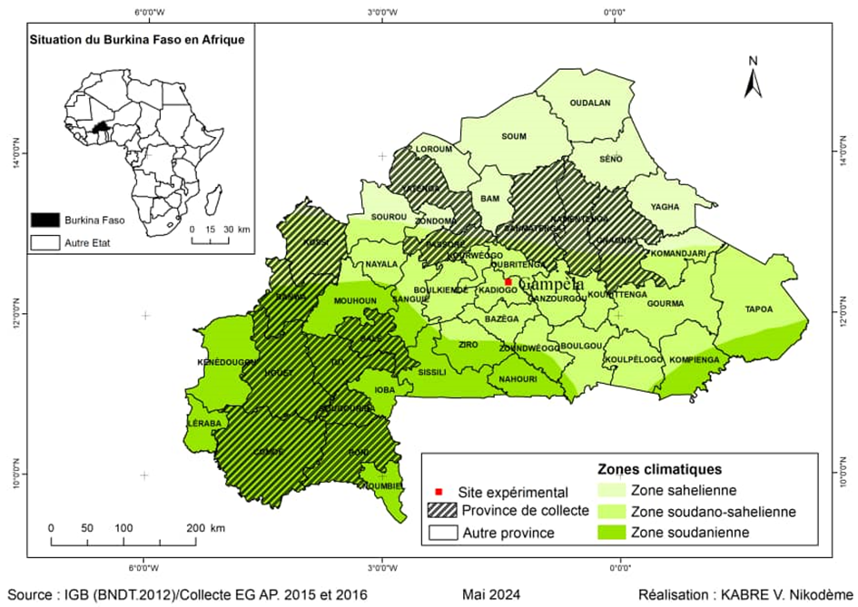

**Fig.1. Map showing the location of the collection areas for accessions of *Solanum aethiopicum* from the «kumba» group in Burkina Faso**

**2.3 Test site**

The study was conducted at the Institute of Rural Development (IDR) experimental station in Gampèla, a locality located 18 km from Ouagadougou on the Ouaga-Fada N'Gourma axis at 12°15’ latitude North and 1°12' longitude West. Soudano-Sahelian climate with a long dry season from November to May and a short-wet season from June to October (Thiombiano and Kampmann, 2010). Rainfall fluctuates from year to year with a general downward trend. In 2022, the experimental station recorded a cumulative rainfall of 988 mm. The soil is sandy-clay with a water pH of 5.20. Analysis of this soil shows that it is composed of total nitrogen (0.028%), total phosphate (192.2 ppm) and total potassium (2172.3 ppm) (BUNASOL,1988).

**2.4 Experimental design**

The experimental device used is device in blocks of Fisher completely randomized to three repetitions. The blocks were spaced 2 m apart and each block was subdivided into four sub-blocks to which samples were randomly assigned. Each sub block consisted of five lines of 3 m with 0.5 m spacing between the lines. On each line, there were seven pointers with 0.5 m spacing between the pointers. The block length was 3 m. The gap between the sub-blocks was 1 m.

**2.5 Cultural practices**

A nursery was established on June 20, 2022. The seeds of each crop were sown in a 10-litre plastic pot filled with potting soil. The pots were covered with straw after sowing. Seedlings for transplanting were collected 37 days after sowing. The amendment was done with organic manure three weeks after the transplanting. The weeding was done as needed. Three phytosanitary treatments at a dose of 1 kg/ha of Decis were applied to the plants from flowering, 45 days after transplanting following an attack by vector insects and gall nematodes causing wilt, dry neck rot. The test was watered twice a week from late September 2022 until the end of the campaign because of prolonged drought pockets. The amount of water used was on average 90 liters per watering.

**2.6 Data collection**

Two categories of variables were evaluated. These are 16 quantitative and 6 qualitative variables. For morphometric measurements, four plants from each accession were randomly selected on each line and labelled with plastic strips each bearing a number. All quantitative data are thus taken from the same plants during the period of the experiment except for the data for the evaluation of the reproductive cycle of the species, which were used on all individuals in the line. The qualitative variables were observed over the whole line.

**2.7 Variables observed**

The phenotypic observations made on all the feet of the 47 accessions concerned six variables: petal colour (CPE); leaf rib colour (CNF); stem colour (COT); fruit cleft depth (PFD); fruit spot colour (CTH) and fruit color (COF). Parameters such as leaf and stem colour and fruit colour and shape were observed with the naked eye in the raised and immature fruit stages on the different accessions. The shape and colour of the fruit were observed at the immature stage. The 16 quantitative variables measured are: flowering date (DFL), number of flowers per inflorescence (NFI), number of sepals (NSE), petals (NPE), leaves (NFL), fruits by inflorescence (NFR), lobes (NLB) by fruit, length of peduncle (LPD), plant height (HPL), petiole length (LOP), limbus length (LOL), limbus width (LAL), stem diameter (DIT), fruit thickness (LFR), fruit weight (PFR) and seed weight (PGR).

**2.8 Data analysis**

The data collected was entered with the Excel 2010 spreadsheet and the analyses of the data were carried out using the software Genstat 2012 and XLstat 7.1 version 2014. The performance of the different accessions was evaluated by determining for each quantitative character the mean, standard deviation, coefficient of variation, minimum and maximum values. The analysis of variances (ANOVA) was used to determine whether or not there were significant differences in the different accessions studied, based on the comparison of the multiple averages of the various quantitative traits. The organization of variability was studied through the hierarchical ascending classification (CAH) and the characterization of the different groups resulting from the CAH by the discriminant factorial analysis (AFD). The principal component analysis (PCA) allowed us to better perceive the association of certain characters and to distinguish the most discriminating characters.

**3.RESULTS AND DISCUSSION**

**3.1 RESULTS**

**3.1.1 Morphological diversity related to qualitative characteristics of *Solanum aethiopicum***

The results of observations on qualitative variables show wide variations in the accessions studied (Table I). In the flowering stage, the flowers presented unique white (10.64%), white with pink stripes (40.43%), or white with violet stripes (48.94%) petals (figure 2). At the fruiting stage, the majority of accessions gave fruits with deep cracks (59.57%), medium cracks (23.40%), shallow cracks (14.89%), very deep cracks (2.13%). The fruit colour was predominantly green (53.19%), but other accessions showed fruits of pale green (19.15%), cream white (12.77%), dark green (8.51%) and zebra green (2.13%). Finally, the spots observed on the fruits are 85.11% green and 14.89% violet (figure 3).

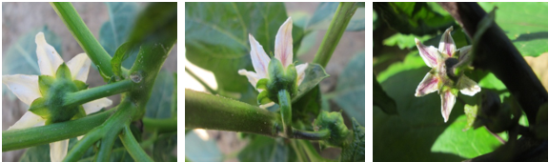

**A**

**B**

**C**

**Fig.2. Single white petal (A), pink striped white petal (B), purple striped white petal (C)**

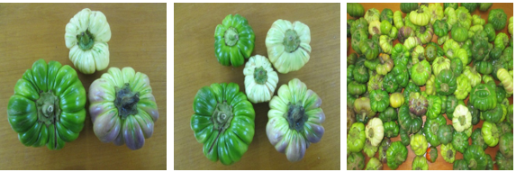

**B**

**C**

**D**

**A**

**Fig.3. Dark green fruit (A), cream white fruit (B), zebra green fruit (C), pale green fruit (D)**

**Table 1. Distribution of the 47 accessions of *Solanum aethiopicum* for the qualitative characteristics studied**

|  |  |  |  |
| --- | --- | --- | --- |
| **Characters** | **Terms** | **Number** | **Frequencies (%)** |
|  | White | 5 | 10,64 |
| CPE | White with purple stripes | 23 | 48,94 |
|  | White with pink stripes | 19 | 40,42 |
| CNF | Green | 34 | 72,34 |
|  | Purple | 13 | 27,66 |
|  | purple | 7 | 14,90 |
| COT | Violet | 12 | 25,53 |
|  | Green | 28 | 59,57 |
|  | Mean | 11 | 23,40 |
| PFD | Shallow | 7 | 14,90 |
|  | Deep | 28 | 59,57 |
|  | Very deep | 1 | 2,13 |
|  | Creamy white | 6 | 12,76 |
|  | Green | 27 | 57,45 |
| COF | Pale green | 9 | 19,15 |
|  | Dark green | 4 | 8,51 |
|  | Zebra green | 1 | 2,13 |
| CTH | Green | 40 | 85,10 |
|  | Violet | 7 | 14,90 |

*Legend: CPE: Petal colour; CNF: Leaf rib colour; COT: Stem colour; PFD: Crack depth; COF: Fruit colour; CTH: Spot colour*

**3.1.2 Morphological diversity related to quantitative traits of *Solanum aethiopicum***

The results of the analysis of variance reveal that only the diameter of the stem (DIT) does not present a significant difference at the 1% threshold (table II). Standard deviations are low for most of the characters except for fruit weight (PFR) which has a relatively high standard deviation value (48.84%). The values of the coefficient of variation are high (> 25%) for fruit weight (PFR), number of fruits per plant (NFR), number of flowers per inflorescence (NFI) and stem diameter (DIT). However, they are lower (CV < 25%) for all other characters.

**Table 2. Mean performance of accessions of *Solanum aethiopicum* from the kumba group**

|  |  |  |  |  |  |  |
| --- | --- | --- | --- | --- | --- | --- |
| **Characters** | **Min** | **Max** | **Mean** | **standard deviation** | **C-V** | **Fobs** |
| DFL | 67,00 | 87,50 | 76,34 | 4,52 | 4,17 | ** |
| NFI | 1,00 | 4,25 | 2,16 | 0,66 | 25,69 | ** |
| NSE | 5,50 | 8,25 | 6,57 | 0,45 | 5,81 | ** |
| NPE | 5,66 | 8,25 | 6,67 | 0,46 | 5,26 | ** |
| LOP | 1,25 | 6,30 | 2,96 | 1,01 | 22,99 | ** |
| LOL | 3,85 | 19,50 | 8,43 | 2,29 | 21,20 | ** |
| LAL | 2,60 | 14,60 | 6,38 | 1,82 | 20,56 | ** |
| HPL | 10,50 | 30,88 | 19,30 | 4,10 | 13,49 | ** |
| NFL | 5,00 | 13,67 | 8,45 | 1,37 | 14,16 | ** |
| DIT | 0,55 | 2,90 | 0,81 | 0,23 | 25,39 | n-s |
| LPD | 0,93 | 3,44 | 1,59 | 0,39 | 14,94 | ** |
| NLB | 4,50 | 7,50 | 5,80 | 0,49 | 6,58 | ** |
| LFR | 4,26 | 15,36 | 7,34 | 1,46 | 12,31 | ** |
| DFR | 2,19 | 12,03 | 3,64 | 0,99 | 21,80 | ** |
| PFR | 21,65 | 329,20 | 100,80 | 48,84 | 26,27 | ** |
| NFR | 1,00 | 12,75 | 4,30 | 2,61 | 37,95 | ** |

*Legend: DFL: Flowering date; NFI: Number of flowers per inflorescence; NSE: Number of sepals; NPE: Number of petals; LOP: Length of petiole; LOL: Length of limbe; LAL: Width of limbe; HPL: Height of plant; NFL: Number of leaves; DIT: Stem diameter; LPD: Peduncle length; NLB: Number of lobes; LFR: Fruit length; DFR: Diameter of the fruit; PFR: Weight of the fruit; NFR: Number of fruits. NS: Non-significant difference at 1% threshold; CV: coefficient of variation; ET: standard deviation; F obs: F observed*

*\*\*: Significant difference at 1% Mini: minimum, Max: maximum*

**3.1.3 Analysis of the relationships between the characters studied**

The correlation matrix between the different characters recorded in table III shows important correlations between the characters, at the threshold of 5% and 1%. The number of flowering days is positively correlated to each of the following traits: plant height (r = 0.552), stem diameter (r = 0.572), limbus width (r = 0.551), limbus length (r = 0.529) and petiole length (r = 0.579). The length of the petiole is positively and very strongly correlated with the length of the limbe (r = 0.844), the width of the limbe (r = 0.887), the height of the plant (r = 0.738) and the diameter of the stem (r = 0.608). The length of the blade is positively and strongly correlated to the following characters: the width of the blade (r = 0.951), the height of the plant (r = 0.609) and the diameter of the stem (r = 0.580). Fruit length is strongly and negatively correlated to the number of fruits (r = - 0.798), but positively and significantly correlated to the diameter of the fruit (r = 0.708) and the weight of the fruit (r = 0.931). The weight of the fruit is negatively correlated to the number of fruits (r = - 0.778).

**Table 3. Correlation matrix between quantitative traits of *Solanum aethiopicum***

|  |  |  |  |  |  |  |  |  |  |  |  |  |  |  |  |  |
| --- | --- | --- | --- | --- | --- | --- | --- | --- | --- | --- | --- | --- | --- | --- | --- | --- |
|  | **DFL** | **NFI** | **NSE** | **NPE** | **LOP** | **LOL** | **LAL** | **HPL** | **NFL** | **DIT** | **LPD** | **NLB** | **LFR** | **DFR** | **PFR** | **NFR** |
| DFL | 1,000 |  |  |  |  |  |  |  |  |  |  |  |  |  |  |  |
| NFI | 0,203 | 1,000 |  |  |  |  |  |  |  |  |  |  |  |  |  |  |
| NSE | **0,392** | 0,051 | 1,000 |  |  |  |  |  |  |  |  |  |  |  |  |  |
| NPE | **0,305** | 0,006 | **0,900** | 1,000 |  |  |  |  |  |  |  |  |  |  |  |  |
| LOP | **0,579** | 0,226 | **0,420** | 0,278 | 1,000 |  |  |  |  |  |  |  |  |  |  |  |
| LOL | **0,529** | 0,129 | **0,426** | 0,277 | **0,844** | 1,000 |  |  |  |  |  |  |  |  |  |  |
| LAL | **0,551** | 0,163 | **0,438** | **0,291** | **0,887** | **0,951** | 1,000 |  |  |  |  |  |  |  |  |  |
| HPL | **0,552** | 0,273 | **0,408** | **0,294** | **0,738** | **0,609** | **0,615** | 1,000 |  |  |  |  |  |  |  |  |
| NFL | -0,028 | 0,184 | 0,009 | -0,010 | 0,032 | -0,116 | -0,088 | 0,045 | 1,000 |  |  |  |  |  |  |  |
| DIT | **0,572** | 0,090 | 0,281 | 0,126 | **0,608** | **0,580** | **0,591** | **0,588** | 0,114 | 1,000 |  |  |  |  |  |  |
| LPD | 0,276 | 0,047 | **0,376** | **0,388** | **0,452** | **0,495** | **0,451** | **0,633** | -0,186 | 0,270 | 1,000 |  |  |  |  |  |
| NLB | 0,120 | 0,235 | -0,069 | -0,127 | -0,157 | -0,129 | -0,023 | -0,197 | 0,138 | 0,143 | **-0,526** | 1,000 |  |  |  |  |
| LFR | 0,083 | -0,102 | **0,299** | **0,399** | 0,124 | 0,241 | 0,179 | **0,411** | -0,242 | 0,134 | **0,651** | **-0,417** | 1,000 |  |  |  |
| DFR | 0,096 | -0,134 | **0,318** | **0,314** | 0,260 | **0,443** | **0,292** | **0,350** | -0,237 | 0,174 | **0,523** | **-0,503** | **0,708** | 1,000 |  |  |
| PFR | 0,123 | -0,151 | 0,256 | **0,328** | 0,182 | 0,282 | 0,229 | **0,465** | -0,247 | 0,126 | **0,671** | **-0,432** | **0,931** | **0,715** | 1,000 |  |
| NFR | -0,221 | 0,130 | **-0,302** | **-0,364** | -0,086 | -0,250 | -0,178 | **-0,421** | 0,270 | -0,163 | **-0,551** | 0,250 | **-0,798** | **-0,692** | **-0,778** | 1,000 |
| *Legend: In bold, significant values (not diagonal) at threshold alpha=0.050 (bilateral test)*  *DFL: Flowering date; NFI: Number of flowers per inflorescence; NSE: Number of sepals; NPE: Number of petals; LOP: Length of petiole; LOL: Length of limbe; LAL: Width of limbe; HPL: Height of plant; NFL: Number of leaves; DIT: Stem diameter; LPD: Peduncle length; NLB: Number of lobes; LFR: Fruit length; DFR: Diameter of the fruit; PFR: Weight of the fruit; NFR: Number of fruits. In bold, significant values (not diagonal) at threshold alpha=5% (bilateral test)* | | | | | | | | | | | | | | | | |

**3.1.4 Organization of variability**

The dendrogram based on quantitative variables divided the 47 accessions into four distinct groups (Figure 4) at a truncation level of 28. The different groups obtained are recorded in table IV

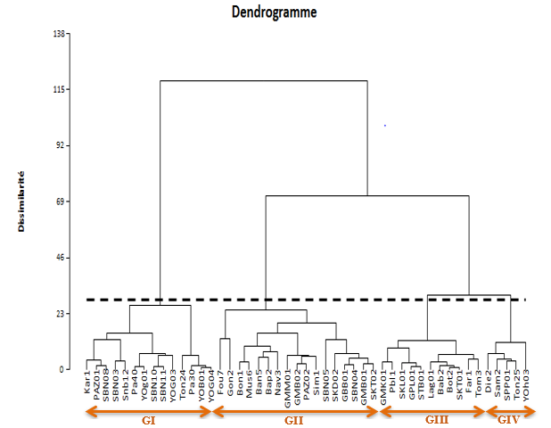

**Fig.4. Dendrogram from the ascending hierarchical classification of *Solanum aethiopicum* accessions**

**Table 4. Composition of groups from the Hierarchical Ascending Classification (CAH)**

|  |  |  |  |  |
| --- | --- | --- | --- | --- |
| **Groups** | **1** | **2** | **3** | **4** |
| **Intra** | **4572,270** | **17308,048** | **5511,044** | **8760,455** |
| **Effectif** | **14** | **17** | **11** | **5** |
|  | Kar1 | Ban5 | Bab2 | Die2 |
|  | Pa30 | Bap2 | Bot2 | Sam2 |
|  | Pa40 | Bon1 | Far1 | SPP01 |
|  | PAZ01 | Fou7 | GMK01 | Ton25 |
|  | SBN03 | GBB01 | GPL01 | YOh03 |
|  | SBN08 | GMB01 | Lag01 |  |
|  | SBN10 | GMB02 | Pbl1 |  |
|  | SBN11 | GMM01 | SKL01 |  |
|  | Snb12 | Gon2 | SKT01 |  |
|  | Ton24 | Mus6 | STB01 |  |
|  | YOB01 | Nav3 | Tom3 |  |
|  | YOg01 | PAZ02 |  |  |
|  | YOG03 | SBN04 |  |  |
|  | YOG04 | SBN05 |  |  |
|  |  | Sim1 |  |  |
|  |  | SKD02 |  |  |
|  |  | SKT02 |  |  |

Analysis of the barycenters of the classes obtained from the CAH, reveals significant differences between the different classes through certain discriminating characters such as date to flowering (DFL); plant height (HPL); fruit weight (PFR) and the number of fruits (NFR). Group 2 accessions have a longer production cycle (approximately 79 days) compared to about 72 days for group 4 accessions. The latter group is composed of accessions with the shortest cycle. Group 2 accessions are larger (22 cm) compared to 18 cm in height for group 4 accessions. Group 2 accessions produce many small fruits; group 4, on the other hand, produces a small number of large fruits (Table V).

**Table 5. Barycentre of groups**

|  |  |  |  |  |  |  |  |  |  |  |  |
| --- | --- | --- | --- | --- | --- | --- | --- | --- | --- | --- | --- |
| **Groups** | **DFL** | **NFI** | **NPE** | **LOL** | **HPL** | **NFL** | **DIT** | **NLB** | **DFR** | **PFR** | **NFR** |
| Group 1 | 75,010 | 2,341 | 6,395 | 7,242 | 16,496 | 8,476 | 0,743 | 6,113 | 2,931 | 57,517 | 6,405 |
| Group 2 | 78,930 | 2,395 | 6,799 | 10,176 | 22,516 | 8,423 | 0,937 | 5,686 | 4,104 | 118,875 | 3,382 |
| Group 3 | 75,730 | 1,790 | 6,854 | 7,699 | 18,467 | 8,901 | 0,785 | 5,808 | 3,507 | 101,217 | 3,909 |
| Group 4 | 72,661 | 1,717 | 6,611 | 7,476 | 18,086 | 7,511 | 0,694 | 5,375 | 4,344 | 159,663 | 2,428 |

*Legend:* *DFL: Date of flowering; NFI: Number of flowers per inflorescence; NPE: Number of petals; LOL: Length of limbe; HPL: Height of plant; NFL: Number of leaves; DIT: Stem diameter; NLB: Number of lobes; DFR: Diameter of fruit; PFR: Weight of fruit; NFR: Number of fruits.*

The results of the factorial discriminant analysis (AFD) performed after the CAH are presented in figure 5. Groups III and IV are negatively correlated to axis F2 (with an inertia rate of 21.31%) compared to groups I and II which are respectively correlated, negative and positive at the F1 axis (with an inertia rate of 70.98%). The axes F1, F2 with an inertia rate of 92.29% indicate a significant difference between the different groups.

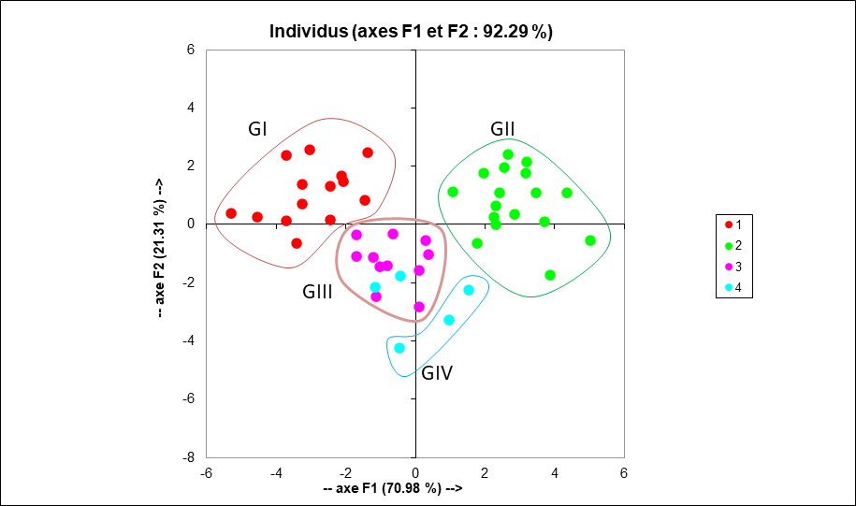

**Fig.5.Representation in the 1⁄2 (92.29% inertia) plane of the discriminant factorial analysis (DFA) of the four groups of *Solanum aethiopicum*.**

Group IV being negatively correlated with the F2 axis, this axis can be said to correspond to the early accession’s axis (figure 6). Group II being positively correlated with the F1 axis, this axis can thus be described as the late accession’s axis. The main component analysis (PCA) of the 47 accessions revealed that stem diameter (DIT), flowering date (DFL), limbus length (LOL) and plant height (HPL) are strongly and positively correlated to the F1 axis (with an inertia rate of 35.19%) and to the F2 axis (with an inertia rate of 20.64%). Fruit diameter (DFR) and fruit weight (PFR) are strongly correlated to the F1 axis, positively and negatively correlated to the F2 axis. On the other hand, the number of fruits (NFR) is positively correlated to axis F2 and negatively correlated to axis F1. Based on this analysis, it can be seen that the number of fruits is in opposition to the diameter and weight of the fruit parameters.

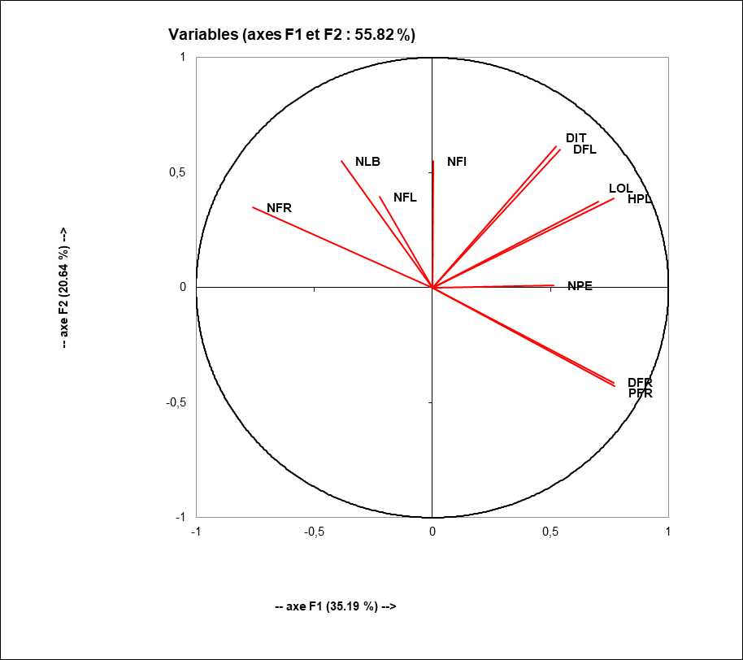

**Fig.6. Principal Component Analysis (CPA)**

The results of the variance analysis performed from the information from the CAH reveal a significant difference between groups for the following traits: plant height (HPL), number of lobes (NLB), length of peduncle (LPD), length of fruit (LFR), fruit diameter (DFR), fruit weight (PFR) and number of fruits (NFR) (Table VI).

Group I is characterized by accessions of large size (24.75 cm), having a low number of fruits, with diameter, length and weight of the fruit high. Group II is distinguished by medium-sized accessions (20.22 cm), with large fruits of high weight as well. Group III is characterized by accessions of very small size (17.48 cm), having fruits with medium peduncle and a higher number. Group IV is distinguished from the others by small accessions (18.44 cm) at flowering and which are characterized by a rather high number of fruits of medium weight.

**Table 6. Mean Performance of Groups from the Hierarchical Ascending Classification (CAH)**

|  |  |  |  |  |  |
| --- | --- | --- | --- | --- | --- |
|  | **Group I** | **Group II** | **Group III** | **Group IV** | **Fobs** |
| **Fréquences** | **03** | **19** | **14** | **11** |  |
| DFL | 79,20a | 76,32a | 75,73a | 76,21a | n-s |
| NFI | 2,27a | 2,09a | 2,23a | 2,17a | n-s |
| NSE | 6,89a | 6,59ab | 6,45b | 6,57ab | n-s |
| NPE | 6,96a | 6,75ab | 6,50b | 6,65ab | n-s |
| LOP | 4,00a | 2,94b | 2,70b | 3,01ab | n-s |
| LOL | 10,10a | 8,62ab | 7,59b | 8,62ab | n-s |
| LAL | 7,96a | 6,39ab | 5,88b | 6,51ab | n-s |
| HPL | 24,75a | 20,22b | 17,48c | 18,44bc | ** |
| NFL | 7,70a | 8,44a | 8,55a | 8,54a | n-s |
| DIT | 0,89a | 0,83a | 0,78a | 0,81a | n-s |
| LPD | 1,91a | 1,78a | 1,26b | 1,57a | ** |
| NLB | 5,66ab | 5,62b | 6,02a | 5,89ab | ** |
| LFR | 9,52a | 8,23b | 5,93d | 6,92c | ** |
| DFR | 4,49a | 4,03a | 2,90c | 3,60b | ** |
| PFR | 194,68a | 128,62b | 54,11d | 83,87c | ** |
| NFR | 2,04c | 2,86c | 6,55a | 4,71b | ** |

*Legend: DFL: Flowering date; NFI: Number of flowers per inflorescence; NSE: Number of sepals; NPE: Number of petals; LOP: Length of petiole; LOL: Length of limbe; LAL: Width of limbe; HPL: Height of plant; NFL: Number of leaves; DIT: Stem diameter; LPD: Peduncle length; NLB: Number of lobes; LFR: Fruit length; DFR: Diameter of the fruit; PFR: Weight of the fruit; NFR: Number of fruits.*

*\*\*: Significant difference at 1% threshold; Fobs: F observed*

*The averages of each class followed by the same letters are not significantly different at the 5% threshold. NS: Non-significant difference at 5% threshold*

**3.2 Discussion**

The agromorphological characterization of *S. aethiopicum* accessions revealed a variability of qualitative and quantitative traits studied. The 47 accessions studied showed inter-accessions variability for fruit color and shape. In Nigeria, a large variability of shape and colour within African aubergines was reported by Chinedu et al. in 2011. The accessions were predominantly fruit with deep lobes (59.57%) ranging in diameter from 2.19 and 12.03 cm. Furthermore, the work of Gisbert et al. (2006); Osei et al. (2010); Chinedu et al. (2011) on accessions of *Solanum aethiopicum* L in Nigeria revealed oval and round shapes of the fruit. This intra-population heterogeneity would be linked to the seed management mode, to the cultural practices used by producers and also to the preferred breeding mode of *S. aethiopicum* which is autogamy but may have an allogeneic rate of around 70%. Indeed, producers keep the seeds mixed and grow several morphotypes on their plots, making possible several combinations of characters. Thus, allogamy that favors the recombination of traits would explain intra-population heterogeneity. Autogamy, by promoting the fixation of different alleles, contributes to inter-population heterogeneity (Bationo-Kando et al., 2015).

The significant differences obtained for most of the characters would reveal the presence of different genotypes of *S. aethiopicum* in the collection studied. The low values of the standard deviation of accessions for most of the characters show that the data are grouped around the average. However, for some characteristics such as the date of flowering, plant height and fruit weight, standard deviation values are relatively high showing a dispersion of variables relative to the average. The coefficient of variation value was high for some variables such as fruit weight, number of fruits per plant, number of flowers per inflorescence and stem diameter. According to Aljane and Ferchichi (2007), a high value of the coefficient of variation reflects the heterogeneity of the material studied. Thus, the accessions studied are heterogeneous for these variables. Significant differences between minimum and maximum values, the high coefficients of variation of certain characters and the presence of two or more modalities in each qualitative character class reflect the existence of a great variability within accessions. According to Lester et al. (1990), the regions with the greatest morphological diversity of S. aethiopicum are in Côte d’Ivoire and neighbouring countries including Burkina Faso. This seems logical in view of the origin of accessions, which are all collected from producers in thirteen provinces designated as major agricultural areas of Burkina Faso. This great morphological diversity would be explained by the way the plant reproduces in relation to peasant practices of management and conservation of this phytogenetic resource; reports Bationo-Kando et al. (2015). In addition, the organization of the morphological diversity of these accessions by multivariate analysis mainly around the characters of the fruit (diameter, weight, number of fruits) and the leaf (width and length of the blade, length of the petiole) is probably also related to the mode of peasant selection. This peasant selection is based on phenotypic traits of perceptible interest such as biomass and yield (Bationo-Kando et al., 2015). The positive correlations observed between the cycle and the traits associated with biomass (HPL, DIT, LOL, LAL and LOP) revealed by the analysis of the barycenters of the classes; suggest that the longer the cycle, plus the plant has a well-developed vegetative apparatus when the water need of the plant is satisfied. Thus, when the supply of water is sufficient, the plant best expresses its physiological and genetic potentialities by developing its different organs. In addition, the strong positive correlation between plant height and traits such as length, diameter and weight of fruit would reflect the existence of a strong proportionality between plant size and fruit size. This means that the plants that have expressed great vigor by their size, foliar area, in short, a good development of the vegetative apparatus, are those that produce large fruits (Bationo-Kando et al., 2015).

The negative correlations between the number of fruits per plant and the morphological traits of the plant such as HPL, DIT, LOL, revealed by the principal component analysis (PCA); indicates that in the collection studied, the accessions to a developed vegetative apparatus are those which produce less fruit compared with accessions having a reduced vegetative apparatus. In addition, the main component analysis reveals that the number of fruits strongly contrasts with the diameter and weight parameters of the fruit, indicating a strong proportionality between the number of fruits produced and their size. However, small fruits are produced in large numbers compared to large fruits which are produced in small numbers. This would be justified by the phenomenon of competition that exists between the vegetative apparatus of the plant (stems and leaves) and fruits maturation for the available nutrient reserves.

The hierarchical ascending classification based on quantitative variables allowed to divide the 47 accessions into four distinct groups. Analysis of variance allowed to specify the characters that discriminate between different groups. However, we can note that there is no specific grouping of accessions from the same province. Each group consists of a mixture of accessions from various sources. This grouping, which is done independently of the collection locality, could be explained by the perpetuation of exchanges of genetic material between farmers from different or neighbouring localities.

Based on the discriminant factor analysis and the analysis of the average performance of the groups resulting from the hierarchical ascending classification in a joint manner; the four groups can be divided into two types of plants. Some relatively early with medium vegetative development and producing many small fruits (plants of the groups III=75 days and IV=76 days) and others late with a strong vegetative development and producing a small number of large fruits (plants of groups I=79 days and II=77 days). The two-to-two approximation of these four groups would be linked on the one hand to the fact that the accessions of two neighboring groups would come from neighboring localities and on the other hand to the perpetuation of exchanges of genetic material between farmers of neighboring localities. Indeed, according to Bationo-Kando et al. (2015), in Burkina Faso, exchanges of *S. aethiopicum* plant material is made by donation or purchase at markets. These exchanges may lead to migrations of plant material from one province to another; this would explain the fact that the same accession is found in many provinces.

Finally, the precocity of the cycle, the height of the plant, the length of the fruit and the number of fruits per plant could be interesting traits for breeders with a view to varietal improvement taking into account mainly organoleptic qualities. Indeed, Bationo-Kando et al. (2015), have shown that the obtaining of cultivars with early cycle and producing many and large fruits, therefore sweeter and more profitable are sought by producers and especially consumers. Danquah and Ofori (2012) reported similar results on eggplant from the gilo group in Ghana.

**4.CONCLUSION**

The agromorphological characterization of *Solanum aethiopicum* revealed a large morphological variability within the accessions studied. The discriminating morphological variables are, among others, the height of the plant, the length and width of the leaf blade, the length, diameter and weight of the fruit. It also established a close link between vegetative development and yield in terms of number of fruits. However, accessions that have expressed great vigor by their size, stem diameter and limbus dimensions are those that produce fewer fruits compared to accessions with a reduced vegetative apparatus. Many correlations were observed between the studied characters. The existence of several discriminating traits and numerous correlations between these traits offer possibilities for varietal selection within *S. aethiopicum* cultivars. Indeed, we note a rapprochement between the plants of groups I and II presenting in common a strong vegetative development and producing a small number of large fruits. Thus, for possible improvement, we suggest that cultivars of groups I and II, presenting interesting performances in terms of weight and diameter of the fruit be taken into account because to obtain a better yield, high-pruning morphotypes, large fruit and short cycle would therefore be the most appropriate. Group III and IV accessions may be hybridized with other accessions that are of interest in terms of fruit weight and diameter for the development of eggplant cultivation in Burkina Faso.

**DISCLAIMER (ARTIFICIAL INTELLIGENCE)**

Author(s) hereby declare that NO generative AI technologies such as Large Language Models (ChatGPT, COPILOT, etc.) and text-to-image generators have been used during the writing or editing of this manuscript.

**REFERENCES**

* - Aljane, F. et Ferchini, A. (2007). Characterization and evaluation of six cultivars of fig tree (Ficus carica L.) in Tunisia. Plant Genetic Resource Newsletter, 151, 22-26.
* - Bationo-Kando, P., Nanema, K.R., Kiébre, Z., Sawadogo B., Kiébre, M., Nébie, B., Sawadogo, N., Traoré, R.E., Sawadogo, M. and Zongo, J.D. (2015b). Genetic diversity of cultivars of Kumba group (Solanum aethiopicum) assessed by EST-SSRS. International Journal of Development Research, Vol. 5, (10) : 5686-5691 pp.
* - Bationo-Kando, P., Sawadogo, B., Nanéma, K. R., Kiébré, Z., Sawadogo, N., Kiébré, M., Traoré, R. E., Sawadogo, M. and Zongo, J.D. (2015a). Characterization of Solanum aethiopicum (Kumba group) in Burkina Faso. International Journal of Sciences and Nature Vol.6 (2): 169-176 ISSN 2278 – 9103 pp.
* - Betty, J.L., Caspa, R., Ambara, J. and Kourogue, R.L. (2013). Ethno-botanical study of plants used for treating malaria in a forest: savanna margin area, east region, Cameroon, Global J Res. Med. Plants & Indigenous. Med., Volume 2(10) : 692–708 pp.
* - BUNASOL (1988). Pedological study of the experimental station of Gampèla, scale 1/5000. No. 59 : 279 p.
* - Chinedu, S.N., Olasumbo, A.J., Eboji, O.K., Emiloju, O.J., Arinola, O.K. and Dania, D.I. (2011). Proximate and Phytochemical Analyzes of Solanum aethiopicum L. and Solanum macrocarpon L. Fruits. Resources Journal of Chemical Sciences1, 63-71.
* - Danquah, J.A. and Ofori, K. (2012). Variation and correlation among agronomic traits in 10 accessions of garden eggplant (Solanum gilo Raddi) in Ghana. International Journal of Science and Nature 3(2), 373-379
* - Fao (2005). The world situation of food and agriculture. FAO Collection : Agriculture N°37, ISBN 978-92-5-205600-3, 189p.
* FAOSTAT (2021). Trade data base, Production data.
* - Fondio, L., Christophe, K., Jean-Claude, N., Adolphe, M., Edith, A. & Hortense D. (2007). Survey of indigenous leafy vegetables in the urban and peri-urban areas of Côte d’Ivoire. Proceedings of the 1st international conference on indigenous vegetables and legumes prospectus for fighting poverty, hunger and malnutrition. December 12-15, 2006. Eds by M.L. Chadha, G. Kuo, C.L.L. Gowda. ISHS. Acta Horticulturae 752: 287-289.
* - Gisbert, J., Prohens, J. & Nuez, F. (2010). Efficient regeneration in two potential new crops for subtropical climates, the scarlet (Solanum aethiopicum) and obuma (S. macrocarpon) eggplants. New Zealand Journal of Crop and Horticulture Science, 34:55-62.
* - Kouassi, A., Eric, B., Tah, Y. T., Oulo A., Abou, B. K., Jean-Claude, N., Assanvo, S.P. N. and Bakary, T. (2014). "Identification of Three Distinct Eggplant Subgroups within the Solanum aethiopicum Gilo Group from Côte d’Ivoire by Morpho-Agronomic Characterization" Agriculture 4, no. 4: 260-273. https://doi.org/10.3390/agriculture4040260
* - Kouassi, K., Kouassi, A., N’zi, J., N’gbesso, M., Akanvou, L., Kouassi, A., Prohens, J.T. and N’guetta, A.S. (2019). Evaluation of agro-morphologic diversity of some accessions of eggplant (Solanum melongena), some wild and cultivated relatives and their interspecific hybrid progenies. Global Journal of Advanced Research 6 (1) : 10-19.
* - Lester, R.N. and Thitai, G.N.W. (1989). Inheritance in Solanum aethiopicum, the scarlet eggplant. Euphytica 40 : 67–74 pp.
* - Lester, R.N & Seck, A. (2004). Solanum aethiopicum L. Record from Protease. Grubben, G.J.H and Denton, O.A. (editors). (Plant Resources of Tropical Africa/ Vegetable Resources of Tropical Africa). Wageningen, Netherlands. Retrieved March 17, 2012, from http://database.prota.org/search.htm.
* - Lester, R.N. and Seck, A. (2004). Solanum aethiopicum L.In: Grubben GJH, Denton OA (Editors). PROTA 2 : Vegetables/Legumes. [CD-Rom]. PROTA, Wageningen, The Netherlands.
* - Ofori, K., Bly, E.T. and Gamedoagbao, D.K. (2012). Inter-relationship between agronomic traits and fruit yield in scarlet eggplant. (Solanum aethiopicum (L.) gilo group). Plant breeding and seed science, 46-53 pp.
* - Osei, M.K., Banfull, B., Osei, J.K. and Oluoch, M.O. (2010). Characterization of African eggplant for morphological characteristics. Journal of Agriculture Science and Technology 4, 33- 37
* - Seck, A. (2004). Research and genetic study of the resistance of African eggplant (Solanum aethiopicum L, spp Kumba) to phytophagous mites. RADHORT- Documents ; FAO ; 12 p.
* - Thiombiano, A. et Kampmann D. (2010). Atlas of West African Biodiversity, Volume II: Burkina Faso. Ouagadougou and Frankfurt/Main.