Original Research Article

A STUDY ON OCCURRENCE OF ANAEMIA ASSOCIATED WITH HAEMOPROTOZOAN DISEASES IN DOGS

Abstract
The present work studies the occurrence of anaemia associated with haemoprotozoan diseases in dogs was done at Veterinary Clinical Complex, College of Veterinary Science and Animal Husbandry, Jabalpur (M.P.) and private pet clinics at Jabalpur from May, 2024 to October, 2024. Out of 2410 screened, 332 were clinically suspected for haemoprotozoan diseases and were subjected to various tests to detect anaemia. Out of 332, 64 dogs were confirmed for haemoprotozoan diseases. Among 64 positive dogs for haemoprotozoa, 58 dogs had anaemia i.e. 17.47% (58/332). The overall occurrence of haemoprotozoan diseases was 2.66% (64/2410) and among the suspected dogs, occurrence was 19.28% (64/332). Among 64 positive cases for haemoprotozoan diseases, the haemoprotozoa found were Ehrlichia spp. in 29 dogs (45.31%), Babesia spp. in 21 dogs (32.82%), Anaplasma spp. in 09 dogs (14.06%), Hepatozoon spp. in 01 dogs (1.56%) and mixed infection in 04 dogs (6.25%). The occurrence of anaemia associated with haemoprotozoan disease was significantly higher in the age group 1-3 years (53.45%), comprising insignificant majority of (60.34%), breed predilection was insignificant, however non-descript dogs had higher occurrence (29.31%).
Key words- Anaemia, Occurrence, Dogs, Haemoprotozoa, Rickettsia, India
INTRODUCTION
Anaemia is the commonly found haematological abnormality in veterinary medicine. It can be defined as lowered red blood cell (RBC) mass and is diagnosed by a packed cell volume (PCV), haematocrit (HCT), haemoglobin (Hb) concentration or erythrocytes count below reference values for that species. It is an important indicator of underlying disease and should be investigated as a routine. It can be classified as regenerative and non-regenerative depending on the presence or absence of compensatory erythropoisis (Vegad and Swamy, 2010). Anaemia may develop due to various factors. There are three main patho-physiological mechanisms for anaemia i.e. blood loss, erythrolysis and decreased production of RBCs (Ettinger et al., 2016).
There are many clinical conditions in dogs that may lead to anaemia and among them haemoprotozoan diseases are of prime importance. Haemoprotozoa pathogens are the organisms that live in the blood and can cause serious life-threatening condition in dogs and are responsible for very high morbidity and mortality in dogs. Haemoprotozoa like Babesia spp., Ehrlichia spp., Anaplasma spp., Theileria spp., Trypanosoma spp., Hepatozoon spp. and Leishmania spp. etc are commonly present in blood of animal body. Among haemoprotozoan diseases, canine babesiosis is an important disease of both domestic and wild canidae across the world (Sahu et al., 2016).
MATERIALS AND METHODS
The proposed work was conducted in the Department of Veterinary Medicine, College of Veterinary Science and Animal Husbandry, Nanaji Deshmukh Veterinary Science University, Jabalpur, Madhya Pradesh from May 2024 to October 2024. Screening of dogs for the presence of anaemia due to haemoprotozoan diseases was done on the basis of history of presence of ticks, clinical signs viz., high body temperature, enlarged peripheral lymph nodes, pale mucous membrane etc. Various tests were performed to detect anaemia and blood smear examination was performed to identify haemoprotozoan pathogens. A total of 2410 dogs were screened over a period of six months. The dogs were screened for the presence of clinical symptoms and signs viz. high body temperature, enlarged lymph nodes, pale mucous membrane, lethargy, decreased appetite, depression, colour of urine, haemoglobinuria, colour of feces, malena, vomiting, weight loss and oedema etc.
Statistical analysis
The data was analysed as per the standard procedures outlined by Snedecor and Cochran (1994). The chi-square test of significance was applied for the qualitative data pertaining to the occurrence of the disease.
RESULTS AND DISCUSSION
Occurrence
A total of 2410 dogs were screened for the haemoprotozoan diseases, out of which 332 dogs showed clinical signs associated with haemoprotozoan diseases. Among 332 suspected dogs, 64 were found positive for haemoprotozoan diseases and 58 dogs were having anaemia associated with haemoprotozoan disease while the other 6 dogs did not have anaemia.
Overall occurrence of haemoprotozoan diseases in dog at VCC Jabalpur
The overall occurrence of haemoprotozoan diseases in dogs at Jabalpur was 2.66 per cent and among the suspected dogs, occurrence was 19.28 per cent. While the overall occurrence of anaemia due to haemoprotozoa was 17.47 per cent (Table 1).
Table 1: Overall occurrence of haemoprotozoan diseases in dogs at Jabalpur

Particulars | No. screened | No. affected | Occurrence (%)
Total dog population | 2410 | 64 | 2.66
Dogs suspected for haemoprotozoan diseases | 332 | 64 | 19.28
Dogs suspected for anaemia due to haemoprotozoa | 332 | 58 | 17.47

Distributions of different haemoprotozoan and rickettsial diseases in dogs at Jabalpur
Among 64 positive cases for haemoprotozoan diseases, the haemoprotozoa found were Ehrlichia spp. in 29 dogs (45.31%), Babesia spp. in 21 dogs (32.82%), Anaplasma spp. in 09 dogs (14.06%), Hepatozoon spp. in 01 dogs (1.56%) and mixed infection in 04 dogs (6.25%) (Table 2; Fig 1).
Table 2: Occurrence of different haemoprotozoan and rickettsial diseases in dogs at Jabalpur

Haemoprotozoa/Rickettsia | No. affected (n=64) | Occurrence (%)
Ehrlichia spp. | 29 | 45.31
Babesia spp. | 21 | 32.81
Anaplasma spp. | 09 | 14.06
Hepatozoon spp. | 01 | 1.56
Mixed infection | 04 | 6.25

Several studies have been conducted to investigate the prevalence of blood parasites. Mahima et al. (2020) reported an overall prevalence of haemoprotozoan diseases as 2.48% at MHOW which correlates well with the findings of present study. However, Gadahi et al. (2008) in Hyderabad and Vonkur et al. (2023) at University of Jos, veterinary teaching hospital, Nigeria reported higher prevalence of blood parasites i.e 11.66% and 54.21%, respectively.
In the present study the, Babesia spp., Ehrlichia spp., Anaplasma spp. and Hepatozoon spp. were common haemoprotozoa identified in dogs at Jabalpur. The results of present study are also in agreement with the findings of Kumar et al. (2009) who reported Babesia gibsoni, Ehrlichia canis, Hepatozoon canis, Babesia canis and Trypanosoma evansi among the haemoprotozoa infection in dogs of Chennai city. Similarly different haemoprotozoan parasites discovered from the study conducted by Vonkur et al. (2023) included Babesia spp., Ehrlichia spp., Haemobartonella canis and some dogs had mixed haemoprotozoan infection
The results of present study indicated the presence of haemoprotozoan diseases in dogs at Jabalpur. Haemoprotozoan are transmitted by arthropod vectors and therefore haemoprotozoan diseases are referred to as canine vector born diseases. Although varying rates of occurrence is reported and these differences might be due to the difference in the environmental condition, which affected the vector population. Difference in the sample size and procedure might have also accounted for the differences in occurrence percentage.
Occurrence of anaemia associated with haemoprotozoa in dogs at Jabalpur
Among 332 dogs suspected for haemoprotozoan diseases, 17.47 per cent dogs had anaemia. Among the dogs affected with haemoprotozoan diseases, 90.62 per cent had anaemia at Jabalpur (Table 3).
Table 3: Occurrence of anaemia associated with haemoprotozoa in dogs at Jabalpur
Particulars | Screened dog | Anaemic dog | Occurrence (%)
Dogs suspected for anaemia due to haemoprotozoa | 332 | 58 | 17.47
Dogs affected with haemoprotozoa | 64 | 58 | 90.62

The specific literature regarding occurrence of anaemia associated with haemoprotozoan diseases is scarce. However, Ombugadu et al. (2021) reported anaemia is 100 per cent dogs affected with blood parasites. However, Liu et al. (2022) reported anaemia in 81.70 per cent of the dogs affected with Babesia gibsoni in Taiwan. Slightly lower occurrence of anaemia was reported by Furlanello et al. (2005) and Abakpa et al. (2023) who reported 74 per cent and 77 per cent anaemia respectively, in canine babesiosis.
In the present study, Babesia spp., Ehrlichia spp., Anaplasma spp. and Hepatozoon spp. were the common haemoprotozoa identified along with mixed infection in dogs at Jabalpur and the anaemia was prevalent in more than 90 per cent dogs detected with haemoprotozoa. Among various haemoprotozoan infections, ehrlichiosis was the most prevalent infection in the present study. The possible cause of anaemia in ehrlichiosis might be due to removal of RBCs from the circulation by the phagocytic mononuclear system and the lysis caused by the compliment system in addition to bone marrow aplasia (Silva et al., 2023).
Another haemoprotozoa predominantly found in the present study was Babesia spp. and canine babesiosis is considered as one of the major causes of anaemia which could be due to the immune response to the infection in affected dogs. This response includes antibody production, erythrophagocytosis, oxidative damage to the RBCs, compliment activation and antibody dependent cellular cyto-toxicity (Zygner et al., 2023).
Age wise occurrence of anaemia associated with haemoprotozoan diseases
The dogs of varying ages included in the study were classified into three categories. The age wise occurrence of anaemia associated with haemoprotozoan disease was higher in age group of 1-3 years i.e. 53.45 per cent (31/58) followed by more than 3 years of age group i.e. 36.21 per cent (21/58) and the minimum occurrence was recorded in 0-1 years of age group i.e. 10.34 per cent (06/58) (Table 4).
Table 4: Age wise occurrence of anaemia associated with haemoprotozoan diseases
Age (Years) | No. screened (n=332) | No. affected (n=58) | Occurrence (%)
0-1 | 78 | 06 | 10.34
1-3 | 134 | 31 | 53.45
>3 | 120 | 21 | 36.21
χ² =8.154** *significant (p<0.01)

Gender wise occurrence of anaemia associated with haemoprotozoan diseases
Gender wise occurrence of anaemia associated with haemoprotozoan disease was studied in 58 anaemic dogs. The occurrence varied non significantly in both male (60.34%) and female dogs (39.66%) (Table 5).
Table 5: Gender wise occurrence of anaemia associated with haemoprotozoan disease
Gender | No. screened (n=332) | No. affected (n=58) | Occurrence (%)
Male | 219 | 35 | 60.34
Female | 113 | 23 | 39.66
χ² =0.988^{NS} non significant (p>0.05)

Breed wise occurrence of anaemia associated with haemoprotozoan diseases
Breed wise occurrence of anaemia associated with haemoprotozoan diseases varied non significantly with the highest occurrence recorded in non-descript dogs (29.31%) followed by Labrador Retriever (27.59%), German Shepherd (18.96%), other breeds (17.24%) and lowest was recorded in both Spitz and Rottweiler (3.45%) (Table 6).
Table 6: Breed wise occurrence of anaemia associated with haemoprotozoan diseases
Breed | No. examined (n=332) | No. affected (n=58) | Occurrence (%)
Rottweiler | 13 | 2 | 3.45
Spitz | 16 | 2 | 3.45
German Shepherd | 63 | 11 | 18.96
Labrador Retriever | 84 | 16 | 27.59
Non-descript | 127 | 17 | 29.31
Other breeds* | 29 | 10 | 17.24
χ² =7.749^{NS} non significant (p>0.05)

(*Other breeds included Deshund, Beagle, Belgian Malinois, Dogo Argentino, French Mastiff, Boxer, Pug, Cocker Speniel, Dobermann, Great Dane, Sent Bernard and Siberian Husky).
No traceable literature has been found regarding age wise, gender wise and breed wise occurrence of anaemia associated with haemoprotozoan diseases. However, few scientists have worked on the prevalence of anaemia in dogs with babesiosis. The findings of present study correlates well with the findings of Abakpa et al. (2023) who reported higher prevalence of anaemia in 1-3 years of dogs affected with babesiosis with non significant variations in gender wise prevalence. Similarly, Vonkur et al. (2023), recorded statistical significance of age in prevalence of haemoprotozoan parasite of dogs, while sex and breed were not statistically significant.
Conclusion
The haemoprotozoan diseases are vector borne diseases and their occurrence depends upon the abundance of vectors and the exposure of dogs to these vectors. Since in the present study, the occurrence of haemoprotozoa in dogs was directly correlated with the occurrence of anaemia in dogs, there for it can be opined that the age, breed and gender might not be the criteria for occurrence of anaemia due to haemoprotozoan diseases but it depends on the exposure of dogs to the transmitting vector.

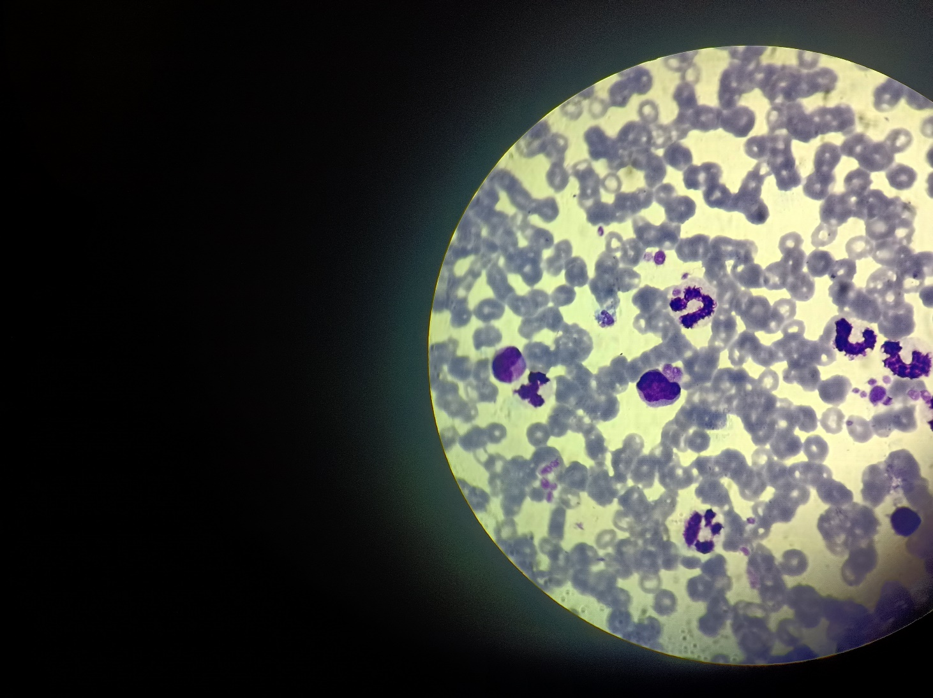
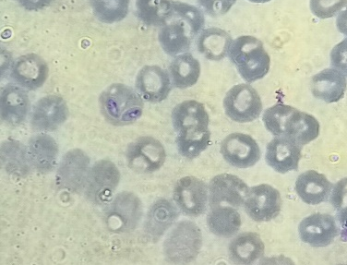

- (b)

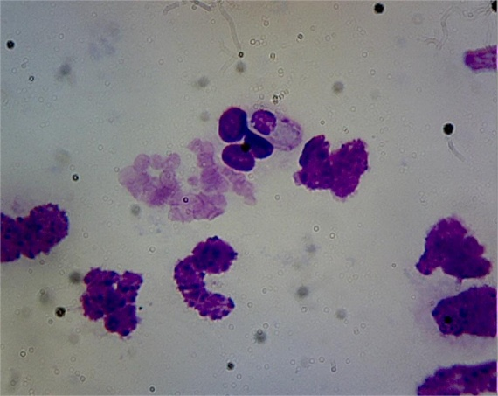
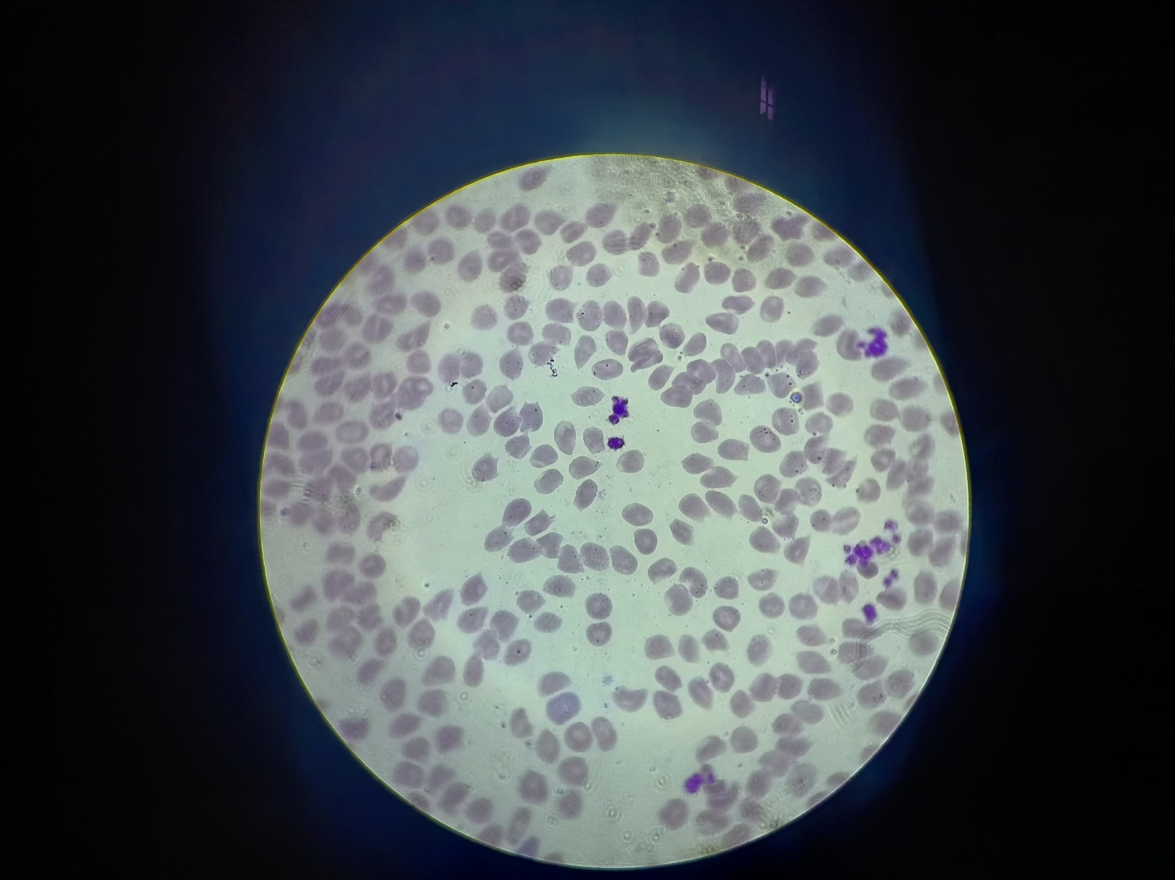

(c) (d)

Fig. 1: Different haemoprotozoa found in blood smear examination
(a) Babesia spp. (b) Ehlrlichia spp.
(c) Anaplasma spp. (d) Hepatozoon spp.

Disclaimer (Artificial intelligence)

Option 1:

Author(s) hereby declare that NO generative AI technologies such as Large Language Models (ChatGPT, COPILOT, etc.) and text-to-image generators have been used during the writing or editing of this manuscript. TO THE BEST OF MY RECOLLECTION, NO AI HAS BEEN USED

Option 2:

Author(s) hereby declare that generative AI technologies such as Large Language Models, etc. have been used during the writing or editing of manuscripts. This explanation will include the name, version, model, and source of the generative AI technology and as well as all input prompts provided to the generative AI technology

Details of the AI usage are given below:
1.
2.
3.

References
Abakpa, S.A.V., Mustapha, E.I., Mshelbwala, F.M., Idowu, K.R., Olasoju, M.I., Akintunde, O.G., Okpe, E.F., Fambegbe, T.J. and Awoyomi, O.J. (2023). Prevalence and role of anaemia in mortalities of dogs with babesiosis. World's Veterinary Journal, 13(3): 373-378.
Ettinger, S.J., Feldman, E.C. and Cote, E. (2016). Textbook of Veterinary Internal Medicine, 8th Edn., Elsevier., Canada, pp 740-749.
Furlanello, T., Fiorio, F., Caldin, M., Lubas, G. and Solano-Gallego, L. (2005). Clinicopathological findings in naturally occurring cases of babesiosis caused by large form Babesia from dogs of northeastern Italy. Veterinary Parasitology, 134(1-2): 77-85.
Gadahi, J.A., Arijo, A.G., Abubakar, M., Javaid, S.B. and Arshed, M.J. (2008). Prevalenceofbloodparasitesin stray and pet dogs in Hyderabad Area: comparative sensitivity of different diagnostic techniques for the detection of microfilaria. Veterinary World, 1(8): 229-232.
Kumar, K.S., Vairamuthu, S. and Kathiresan, D. (2009). Prevalence of haemoprotozoans in canines in Chennai city, Tamilnadu. Journal of Veterinary and Animal Sciences, 5(3): 104-108.
Liu, P.C., Lin, C.N. and Su, B.L. (2022). Clinical characteristics of naturally Babesia gibsoni infected dogs: a study of 60 dogs. Veterinary Parasitology: Regional Studies and Reports, 28(1): e100675.
Mahima, Mehta, H.K., Bagherwal, R.K. and Chaurasia, R. (2020). Prevalence of haemoprotozoan diseases in canines. The Indian Journal of Veterinary Sciences and Biotechnology, 15(3): 69-71.
Ombugadu, A., Maikenti, J.I., Ezenwankwor, F.C., Pam, V.A., Uzoigwe, N.R., Okonta, C.N., Odik, A., Okonkwo, C.B., Hasley, N.L., Echor, B.O., Deme, G.G., Ahmed, H.A., Aimankhu, O.P., Attah, S.A., Samuel, M.D., Kure, M.S., Kambai, C., Francis, M.J., Angbalaga, G.A., Nkup, C.D., Baiyewu, O.O., Atabo, L.O., Anyebe, G.E., Aliyu, A.A., Ayuba, S.O., Odey, S.A., Adejoh, V.A., Ashigar, M.A., Ayim, J.O., Dogo, K.S. and Ameh, S.E. (2021). Prevalence of blood parasites in dogs of federal capital territory, Abuja, Nigeria. Transactions on Science and Technology, 8(4): 673-678.
Sahu, A., Panda, M.R., Mohanty, B.N. and Dehur, M. (2016). Canine tick borne haemoprotozoan diseases; epidemiology, pathogenesis and diagnostic approaches–a review. International Journal of Advanced Research, 4(10): 1134-1141.
Silva, A.C., Gabriel, R.V.C., Roldao, D.R., Silva, I.G.D., Silva, A.F.R.D. and Silva, S.E.L.D. (2023). Hematological changes in dogs infected with Ehrlichia canis as a diagnostic contribution in the clinical routine. Acta Scientific Medical Sciences, 7(7): 40-44.
Snedecor, G.W. and Cochran, W.G. (1994). Statistical Methods. 8th Edn., The Lowa State University press, Ames, USA.
Vegad, J.L. and Swamy, M. (2010). A Textbook of Veterinary Systemic Pathology, 2nd Edn., CBSPD., India, pp 265-316.
Vonkur, G.C., Dogo, A.G., Bukar, B.A.M., Karaye, G.P., Ogbein, K.E. and Odey, M.J. (2023). Prevalence of haemoprotozoan parasites of dogs presented at the Veterinary Teaching Hospital, University of Jos-Nigeria. Applied Veterinary Research, 2(1): e2023002.
Zygner, W., Gojska-zygner, O. and Norbury, L.J. (2023). Pathogenesis of anaemia in canine babesiosis: possible contribution of pro-inflammatory cytokines and chemokines- a review. Pathogens, 12(2): 1-32.

