**Estimation of inter relationship among the important heritable yield attributing traits and identification of promising genotypes of teasle gourd *(Momordica subangulata* Blume subsp. *renigera*) under Terai zone of West Bengal, India**

**Abstract**

The experiment was conducted during summer seasons at instructional field in Department of Vegetable and Spice Crops, Faculty of Horticulture, Uttar Banga Krishi Vidyalaya, Pundibari, CoochBehar. Twenty-five genotypes of teasle gourd *(Momordica subangulata* Blume subsp. *renigera*) were grown in randomized block design with three replications to estimate character association among important heritable traits for establishing the basis of selection and to ascertain promising line for the further crop improvement. Character association and path analysis exhibited that fruits per plant, fruit diameter, fruit length and primary branch could be selection criteria for isolation of germplasm for enhancement of yield. Under this experiment, residual effect was estimated to be 0.18, indicating that the traits under study contributed approximately 78%, which highly supports the incorporation of these traits into the experiment. The Principal Component Analysis minimized the dimension of larger dataset into four components cumulatively contributed to 75.15 % of the variation towards total variation with 29.84 % in PC1 through size of internode, flower and fruit. Whereas, 23.46 % in PC2 through Quantity, yield and early flowering, 12 % in PC3 through plant pigments and 9.84 % in PC4 through growth and delayed harvesting. It was evident for existing of high degree of diversity among the germplasm available in East India. Among the selected genotypes viz., *Nimbong* Local 2, *Pemling* local 1, *Malli Dara* Local 1, *Pedong* Local 1, *Allipurduar* Local 1, *Banshihari* Local 1 which were attributed for early flowering, fruit size and yield, *Pemling* local 1 considered most promising genotype.

**Keywords: Teasel gourd, Germplasm, Phenotypic ,Genotypic**

**1. INTRODUCTION:**

The teasle gourd (*Momordica subangulata* Blume subsp*. renigera*), an allopolyploid belonging to the *Cucurbitaceae* family, developed as a result of hybridization between *M. dioica* (2n=28) and *M. cochinchinensis* (2n=28) followed by spontaneous chromosomal doubling (Mondal *et al.,* 2006). Teasle gourd is believed to have originated from India. It is a perennial, dioecious crop that grows well under warm and humid weather (Rasul *et al*., 2007). Almost all vegetarian and non-vegetarian communities use it for good flavour, aroma, and essential oil (Bhuiya *et al.,* 1977). Teasle gourd is propagated through tuber or root and primarily grown in Assam, West Bengal, Bihar, Orissa, North-eastern States, Maharashtra, Gujarat and Andaman Islands (Naik *et al*., 2014). It is popularly known as *Bhat Karela* in Assam and *kakrol* in West Bengal, is a highly valued and commercially significant vegetable crop grown for its fruits, which is used as vegetable purposed. In addition to having 84.1% moisture, 33 mg Ca, 42 mg P, 4.6 mg Fe, 1620 μg carotene, a high level of ascorbic acid, 3.1 g protein, 3.1 g fat, 3.0 g fiber, and 1.1 g minerals per 100 g of edible fruit, it also shows good nutritional value (Bharathi *et al*., 2014). Although the teasle gourd is a highly nutritious vegetable crop (Ram *et al.,* 2001; Singh *et al.,* 2009), in India it is still considered as minor or underutilized crops.

While organizing hybridization programs and evaluating individual plants in segregating populations, breeders are interested in crop improvement through efficient selection of desired features due to in correlation and path coefficient studies between yield and other parameters (Ram *et al.,* 2004). Principal component analysis is a significant genetic diversity assessment technique used for showing the relative genetic variations in the genotype collections of different crop species. On the other hand, multivariate analysis in Indian *Momordica spp*. genotypes is not often reported, despite the potential medicinal and economic values (Dey *et al.* 2007; Shankar *et al.* 2009 and Singh *et al.* 2014). In this view of many advantages, current study was carried to utilize multivariate analysis to classify a group of teasle gourd genotypes. There was no research thrust made on teasle gourd improvement along with determination of character association and its utilization in breeding programme in North Bengal. Therefore, present experiment was laid out to estimate character association among important heritable traits for establishing the basis of selection and to ascertain promising line for the further crop improvement.

**2. MATERIALS AND METHODS**

In the experiment, there were twenty-five highly diversified germplasm of teasle gourd(*Momordica subangulata* Blume subsp. *renigera*) was collected from different parts of West Bengal and Sikkim Himalayan region. They were evaluated to estimate character association among important heritable traits and to ascertain promising line for the further crop improvement during (March-July) of 2021 and 2022 at instructional field, Department of Vegetable and Spice Crops, Faculty of Horticulture, U.B.K.V., Pundibari, CoochBehar, West Bengal located at 26 º 40’ N latitude and 89 º 38' E longitudes at 43 m above mean sea level.Soil of the experimental site was sandy, clay in texture, having neutral pH and there were no significant differences of weather in both the experimental seasons. However, there was more rainfall during the second year of experiment. During the experiment, the maximum temperature was 34˚C and minimum temperature 19˚C with mean relative humidity of 70-90%. The experiment was laid out in randomized block design with three replications for each treatment maintaining the spacing of 2 m row to row and 1 m plant to plant consisting of total 20 plants per treatment. To ensure normal fruit setting, planting materials (tuber) were planted in field at ratio of 10:1 (female: male). The genotypes were raised over trellises, made up of bamboos and nylon strings. All the recommendedagronomic package (FYM @ 20 t/ha, NPK @ 80: 60: 60 kg/ha) was applied to soil. The N, P and K was supplied in the form of urea, single super phosphate and muriate of potash. Irrigation was given just after planting and followed by fifteen days interval irrigation. Pre-planting weeding was exercised using herbicide, followed by manual weeding after 25-30 days of planting. Around the root zone, at 60 cm radius area soil was raised and mulched; in between two rows, irrigation channel of 50 cm was prepared. Protectivemeasures were followed against pests and diseases with the application of insecticides and fungicides (Bhagat *et al.,* 2017). Thedata on 10 quantitative parameters, namelyvine length (cm), primary branch, internode length (cm), node at first female flower, first harvest, ovary length (cm), fruit length (cm), fruit diameter (cm), number of fruit per plant and yield per plant (kg) were recorded from five healthy random female plants per treatments. Whereas, total chlorophyll content of leaf (mg/100g) and total chlorophyll content of fruits (mg/100g) were estimated from the highly homogenized sample prepared from 3rd leaf and fruits from second harvest collected from 10 randomly selected healthy plants through spectrophotometer. The recorded data of two consecutive years were pooled and was subjected to statistical analysis. Genotypic and phenotypic ccorrelation coefficient and path coefficient for different character combination was performed as per the method reported by Aljibour *et al.,* 1958 and Johnson *et al.,* 1955. Principal component analysis of 25 teasle gourdgenotypes was performed based on twelve yield and its attributing traitsto assess the magnitude of genetic variation.

**3. RESULT AND DISCUSSION:**

Twelve characters from twenty-five diversified genotypes of teasle gourd (*Momordica subangulata* Blume subsp. *renigera*) were statistically evaluated to understand the inter-relationship among these genotypes. Additionally, the yield-related traits were studied to establish the basis of crop breeding and isolation of superior genotypes consisting of desirable yield-contributing traits. As the basis of selection, character association estimation at the genotypic and phenotypic levels was carried to understand the interrelationships among the qualities that contribute to growth and yield (Kushwah and Bandhyopadhya, 2005).

Correlation related to present findings was presented in Figure 1. Yield per plant was significantly and positively correlated in both genotypic and phenotypic level with traits like number of fruits per plant (rg=0.63 and rp=0.62), fruit length (rg=0.48 and rp=0.52) and ovary length (rg=0.33 and rp=0.41), while negatively correlated with node at first female flower (rg=-0.44 and rp=-0.52). Similar findings were reported by Bharathi *et al.,* (2005) and Singh *et al.,* (2016). However, positive significant correlation only at genotypic level was exhibited by vine length (rg=0.37), primary branch (rg=0.28), inter nodal length (rg=0.35) and fruit diameter (rg=0.63). These suggest a significant effect of these parameters on yield at the genotypic level, indicating the presence of strong additive gene action, making them reliable targets for breeding programm. Vine length was significantly and positively correlated with ovary length (rg=0.29 and rp=-0.42), inter nodal length (rg=0.29) and yield (rg=-0.37). Primary branch was significantly and negatively correlated with node at first female flower (rg=-0.38 and rp=-0.53), first harvest (rg=-0.34 and rp=-0.42), inter nodal length (rp= -0.49) and fruit diameter (rp=-0.46). Whereas, number of fruits per plant (rg=0.47 and rp=0.47) was significantly and positively correlated at genotypic and phenotypic level with primary branch. Similar finding were reported by Basumatary *et al*. (2014), where, number of primary branches were positively correlated with number of fruits per plant. Internode length was positively and significantly associated with fruit length (rg=0.51 and rp=0.69), ovary length (rg=0.44 and rp=0.66), fruit diameter (rg=0.49 and rp=0.61) and total chlorophyll content of leaf (rg=0.38 and rp=0.51). At both genotypic and phenotypic level significant and positive association of node first female flower appeared was obtained with first harvest (rg=0.30 and rp=0.44) but was negatively associated with number of fruit per plant (rg=-0.67 and rp=-0.75) and yield per plant (rg=-0.44 and rp=-0.52). Ovary length exhibited significant and positive correlation at both genotypic and phenotypic for total leaf chlorophyll content (rg=0.41 and rp=0.47) and yield (rg=0.33 and rp=0.41). At both genotypic and phenotypic level, significant and positive association of fruit length was observed with fruit diameter (rg=0.50 and rp=0.47), total leaf chlorophyll content (rg=0.49 and rp=0.59), inter nodal length (rg=0.51 and rp=0.69) and yield per plant (rg=0.48 and rp=0.52). Similarly, findings were reported by Rahman *et al.,* (2011); Sinha *et al.* (2024) and Khan *et al.,* (2009), where, yield per plant was significantly positively correlated with fruit length and diameter. However, number of fruits per plant was significantly and negatively correlated to both genotypic and phenotypic correlation with node at first female flower (rg=-0.67 and rp=-0.75) and fruit diameter (rg=-0.33 and rp=-0.57) were reported and it is in accordance with the earlier observations reported by Rahman *et al.,* (2011) and Sinha *et al.,* (2024). Among the biochemical traits, total chlorophyll content of leaf in both genotypic and phenotypic level was significantly and positively associated with total chlorophyll content of fruit (rg=0.63 and rp=0.64), fruit length (rg=0.49 and rp=0.59), inter nodal length (rg=0.38 and rp=0.51) and ovary length (rg=0.41 and rp=0.47). Path analysis is one of the tools that further divides the correlation coefficient with yield into direct and indirect components. It aids to better understand the significance of the effect coefficient (Devi *et al.,* 2020). Path coefficient analysis is a multiple regression-based statistical method used to investigate the causal relationship between two or more independent variables and a dependent variable (Sinha *et al.,* 2024). The magnitude of path matrix (Table 1) from the current experiments exhibited the highest positive direct impact on yield per plant through the number of fruits per plant (1.466) followed by fruit diameter (0.794), fruit length (0.554) and primary branch (0.287). Hence, these traits could be considered as selection basis for the enhancement of yield. Although, significant negative indirect effect of fruit size was observed through fruit quantity on yield and *vice versa*, this suggested existence of strong contrasting attribute. Node at first female flower exhibited high positive direct effect on yield (0.492) had significant and negative genotypic (-0.44) and phenotypic (-0.52) correlation. This is clearly due to association with high negative indirect effect through number of fruits (-1.101) and primary branch (-0.152). Residual effect estimated in this experiment 0.18 implied contribution of the traits under study was approximately 78%. The reported results are probably the consequence of multiple genes influencing these traits working together. Our findings could be related to those of Sharma and Bhutani (2001); Bhave *et al.,* (2003); Dey *et al.,* (2007); khan *et al.,* (2009); Rahman *et al.,* (2011) and Sinha *et al.,* (2024), where, strong direct impact on total fruit yield per vine was influenced by the number of fruits per vine. The Principal Component Analysis reduces the number of factors that account maximum variability out of total variability by minimizing the dimension of larger datasets with minimum loss of information. In present experiment, total 12 Principal Components were computed in the analysis out of which four had eigen values greater than unity as proposed by Kaiser (1960). Those cumulatively explained 75.15% of the variations, suggested first four principal axes were adequate to explain the maximum variation in reduced dimension (Table 2 and Figure 2). The highest variation was explained by PC1 (29.84%) with an eigen value of 3.58. The principal components PC2, PC3 and PC4 explained variation of 23.46%, 12.00% and 9.84%, respectively (Table 2).

The principal component PC1 had maximum loading through size of internode, flower and fruit (Table 2, Figure 3) *viz*., internode length (0.449), fruit length (0.386), fruit diameter (0.362) and ovary length (0.322). Principal component PC2 exhibited maximum loading through quantity, yield and early flowering *viz*., yield per plant (0.521), number of fruits per plant (0.416) and node at first female flower (-0.416). Similarly, principal component PC3 had maximum loading through plant pigments *viz*., total chlorophyll content of mature fruit (0.652) and leaf (0.428). Whereas, principal component PC4 had maximum loading through growth and delayed harvesting *viz*., first harvest (0.631) and vine length (0.354). The outcomes presented here are consistent with the findings of Sanwal *et al.* (2008), Singh *et al.* (2008), Singhal *et al.* (2010), Choudhary *et al*. (2011), Rabbani *et al.* (2012), Singh *et al.* (2014), and Jatav *et al.* (2019), where, PC1 had maximum loading through number of nodes to first male flower followed by days to first female flower and fruit length. The biplot from the principal component analysis (PCA) of twelve traits across twenty-five genotypes is exhibited in Figure 3. The genotypes collected from a similar location had a magnitude of variation almost in a similar direction. However, the germplasm collected from Coochbehar was more diversified. Although the genus Momordica from Southeast Asia was reviewed taxonomically (Bharathi *et al.,* 2013; De Wilde and Duyfjes, 2002), but current study revealed existence of distinct quantitative and high morphological divergence between the teasle gourd accessions available in East India. However, based on the maximum positive magnitude of the loading for different components germplasm, *Pundibari* Local 1, *Dinhatta* Local 1, *Ghoksadanga* local 1 were considered suitable for node, flower and fruit size; *Nimbong* Local 2, *Pemling* local 1, *Malli Dara* Local 1, *Pedong* Local 1, *Allipurdu*Local 1, *Banshihari* Local 1 were considered suitable for quantity, yield and early flowering. *Balarampur* local 1, *Ghoksadanga* local 2, *Kalchini* Local 2 were considered suitable for plant pigment and *Paiyong* Local 1, *Bagracoat* Local 1 were considered suitable for plant growth and delayed harvesting. Although, among all these genotype *Pemling* local 1 found most suitable variety with bigger fruit size and remarkable yield.

**Figure 1:** Genotypic coefficient of correlation (above diagonal) and phenotypic coefficient of correlation (below diagonal) for different traits.

*Concentration of colour is indication for level of significance at 5%

rg= Genotypic correlation coefficient

rp= Phenotypic correlation coefficient

VL-vine length, PB-primary branch, IDL-internode length, NFF-node at first female flower, FH-first harvest, OL-ovary length, FL-fruit length, FD-fruit diameter, NF-number of fruits per plant, TCL-total chlorophyll contents of leaf, TCF-total chlorophyll contents of fruit and YPP-yield per plant.

**Figure 2:** Percentage of variability explained by main principal components

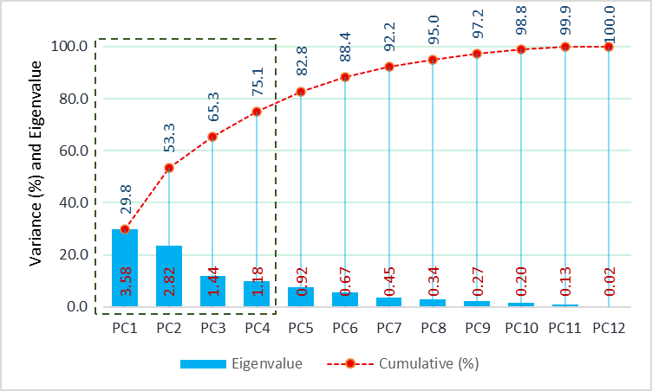

**Figure 3:** Biplot for the 12 quantitative traits with 25 teasle gourd genotypes

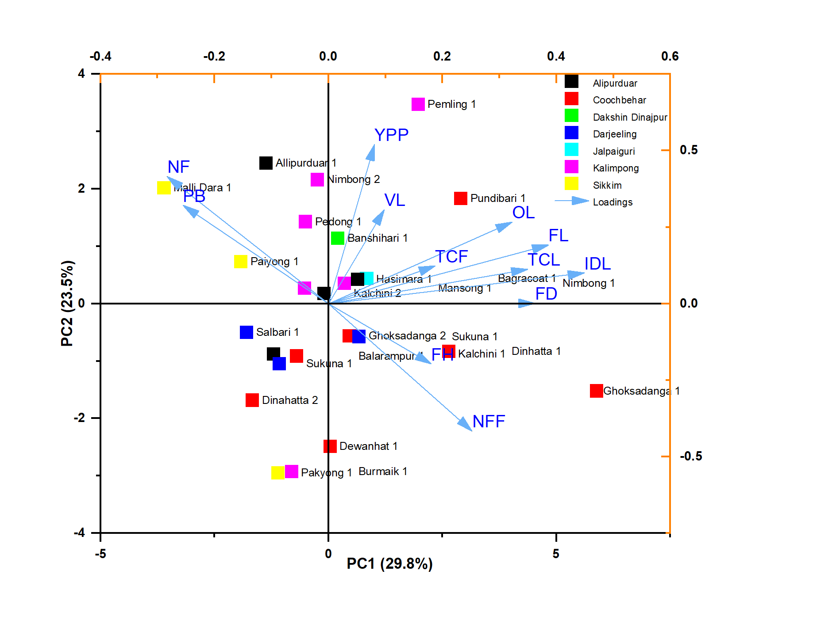

*VL-vine length, PB-primary branch, IDL-internode length, NFF-node at first female flower, FH-first harvest, OL-ovary length, FL-fruit length, FD-fruit diameter, NF-number of fruits per plant, TCL-total chlorophyll contents of leaf, TCF-total chlorophyll contents of fruit and YPP-yield per plant.

**Table 1.** Genotypic Path coefficient of important traits on yield of teasle gourd.

|  |  |  |  |  |  |  |  |  |  |  |  |  |
| --- | --- | --- | --- | --- | --- | --- | --- | --- | --- | --- | --- | --- |
| Charecters | VL | PB | IDL | NFF | FH | OL | FL | FD | NF | TCL | TCF | GenCor  (RYPP) |
| VL | **-0.044** | 0.057 | 0.018 | -0.061 | 0.017 | -0.088 | 0.036 | 0.108 | 0.295 | 0.000 | 0.018 | 0.36 |
| PB | -0.009 | **0.287** | -0.038 | -0.260 | 0.094 | -0.002 | -0.169 | -0.363 | 0.692 | -0.001 | 0.006 | 0.24 |
| IDL | -0.010 | -0.140 | **0.077** | 0.150 | -0.085 | -0.138 | 0.381 | 0.485 | -0.483 | 0.013 | 0.023 | 0.27 |
| NFF | 0.005 | -0.152 | 0.024 | **0.492** | -0.099 | -0.008 | 0.066 | 0.261 | -1.101 | 0.002 | -0.010 | -0.52 |
| FH | 0.003 | -0.120 | 0.029 | 0.218 | **-0.225** | -0.059 | -0.043 | 0.077 | -0.163 | 0.003 | 0.024 | -0.26 |
| OL | -0.019 | 0.002 | 0.051 | 0.018 | -0.063 | **-0.208** | 0.315 | 0.251 | 0.024 | 0.012 | 0.025 | 0.41 |
| FL | -0.003 | -0.088 | 0.053 | 0.059 | 0.017 | -0.119 | **0.554** | 0.375 | -0.348 | 0.015 | 0.009 | 0.52 |
| FD | -0.006 | -0.131 | 0.047 | 0.162 | -0.022 | -0.066 | 0.262 | **0.794** | -0.830 | 0.006 | 0.010 | 0.23 |
| NF | -0.009 | 0.136 | -0.026 | -0.370 | 0.025 | -0.003 | -0.132 | -0.449 | **1.466** | -0.008 | -0.007 | 0.62 |
| TCL | -0.001 | -0.017 | 0.039 | 0.042 | -0.026 | -0.097 | 0.324 | 0.194 | -0.449 | **0.025** | 0.067 | 0.10 |
| TCF | -0.008 | 0.015 | 0.017 | -0.047 | -0.051 | -0.049 | 0.049 | 0.077 | -0.094 | 0.016 | **0.105** | 0.03 |

**\*Residual effect: 0.18.**

*VL-vine length, PB-primary branch, IDL-internode length, NFF-node at first female flower, FH-first harvest, OL-ovary length, FL-fruit length, FD-fruit diameter, NF-number of fruits per plant, TCL-total chlorophyll contents of leaf, TCF-total chlorophyll contents of fruit and YPP-yield per plant.

**Table 2:** Eigen values, percentage of variance and cumulative variance of first four principal components of Teasel gourd

|  |  |  |  |  |
| --- | --- | --- | --- | --- |
| **Eigen components** | **PC1** | **PC2** | **PC3** | **PC4** |
| Eigenvalue | 3.58 | 2.82 | 1.44 | 1.18 |
| Variance (%) | 29.84 | 23.46 | 12.00 | 9.84 |
| Cumulative (%) | 29.84 | 53.30 | 65.30 | 75.15 |
| **Principle components variable** | **PC1** | **PC2** | **PC3** | **PC4** |
| VL | 0.098 | 0.308 | -0.031 | 0.354 |
| PB | -0.255 | 0.321 | 0.181 | -0.148 |
| IDL | 0.449 | 0.100 | -0.101 | 0.173 |
| NFF | 0.252 | -0.416 | -0.084 | 0.130 |
| FH | 0.180 | -0.197 | 0.302 | 0.631 |
| OL | 0.322 | 0.267 | 0.102 | 0.265 |
| FL | 0.386 | 0.192 | -0.241 | -0.283 |
| FD | 0.362 | 0.001 | -0.337 | -0.099 |
| NF | -0.283 | 0.416 | 0.027 | 0.296 |
| TCL | 0.349 | 0.113 | 0.428 | -0.372 |
| TCF | 0.187 | 0.123 | 0.652 | -0.140 |
| YPP | 0.081 | 0.521 | -0.259 | 0.037 |

**Table 3:** First four principal components towards variation with 12 different characters

|  |  |  |  |
| --- | --- | --- | --- |
| **Components** | **Characters** | **Category** | **Maximum contribution** |
| **PC1** | Internode length, ovary length, fruit length and fruit diameter. | Node, flower and fruit size | Pundibari Local 1, Dinhatta Local 1, Ghoksadanga local 1 |
| **PC2** | number of fruits per plant, yield per plant and (-) node at first female flower. | Quantity, yield and early flowering | Nimbong Local 2, Pemling local 1, Malli Dara Local 1, Pedong Local 1, Allipurduar Local 1, Banshihari Local 1, |
| **PC3** | Primary branch, Total chlorophyll contents of leaf and total chlorophyll content of fruit | Plant pigment | Balarampur local 1, Ghoksadanga local 2, Kalchini Local 2 |
| **PC4** | Vine length and first harvest | Growth and delayed harvesting | Paiyong Local 1, Bagracoat local 1 |

**4. CONCLUSION:**

Present experiment was clearly evident for existence of high degree of diversity among the genotypes of teasle gourd collected from eastern India and characters *viz*., fruits per plant, fruit diameter, fruit length and primary branch could be most effective in isolation of germplasm with higher yield. Among the twenty-five genotypes, total six genotypes *viz*., *Nimbong* Local 2, *Pemling* Local 1, *Malli Dara* Local 1, *Pedong* Local 1, *Allipurduar* Local 1, *Banshihari* Local, *Pemling* Local 1 are considered as most promising germplasm with respect to early flowering, fruit size and yield.

Disclaimer (Artificial intelligence)

Option 1: NO

Author(s) hereby declare that NO generative AI technologies such as Large Language Models (ChatGPT, COPILOT, etc.) and text-to-image generators have been used during the writing or editing of this manuscript.

Option 2: NO

Author(s) hereby declare that generative AI technologies such as Large Language Models, etc. have been used during the writing or editing of manuscripts. This explanation will include the name, version, model, and source of the generative AI technology and as well as all input prompts provided to the generative AI technology

Details of the AI usage are given below:

1.

2.

3.

**REFERENCE:**

Bhagat, S., Sinha, S. K., & Tiwari, J. K. (2017). Identification and evaluation of morphophysiological variation in spine gourd (*Momordica dioica* Roxb.). *International Journal of Current Microbial Applied Science.***6**(11): 531-540.

Bharathi, L. K., Naik, G., Singh, H. S., & Dora, D. K. (2005). Correlation and path analysis in spine gourd (*Momordica dioica*Roxb.). *The Orissa Journal of Horticulture*. **33**(2): 105–108.

Bharathi, L.K., Munshi, A. D., Behera, T. K., John, K. J., Bhat, K.V., & Sidhu, A. S. (2013). Morphological relationship among the *Momordica* species of Indian occurrence. *Indian Journal of Genetics and Plant Breeding.***73**(3):278–286.

Bhave, S. G., Bendale, V. W., Pethe, U. B., Berde, S. A., & Mehta, J. L. (2003). Correlation and path analysis in seggregating generations of bitter gourd. *Journal of Soil Crops.***13**(1): 33-40.

Bhuiya, M. R. H., Habib, A. K. M. A., & Rashid, M. M. (1977). Content of loss of Vitamin C in vegetables during storage and cooking. *Bangladesh Horticulture*. **5**:1-16.

Bhagat, S., Sinha, S. K., & Tiwari, J. K. (2017). Identification and evaluation of morphophysiological variation in spine gourd (*Momordica dioica* Roxb.). *International Journal of Current Microbial Applied Science.***6**(11): 531-540.

Bharathi, L. K., Naik, G., Singh, H. S., & Dora, D. K. (2005). Correlation and path analysis in spine gourd (*Momordica dioica* Roxb.). *The Orissa Journal of Horticulture*. **33**(2): 105–108.

Bharathi, L. K., Singh, H. S., Shivashankar, S., Ganeshamurthy, A. N., & Sureshkumar, P. (2014). Assay of nutritional composition and antioxidant activity of three dioecious Momordica species of South East Asia. *Proceedings of the National Academy of Sciences, India Section B: Biological Sciences*. **84**: 31-36.

Bharathi, L.K., Munshi, A. D., Behera, T. K., John, K. J., Bhat, K.V., & Sidhu, A. S. (2013). Morphological relationship among the *Momordica* species of Indian occurrence. *Indian Journal of Genetics and Plant Breeding.***73**(3):278–286.

Bhave, S. G., Bendale, V. W., Pethe, U. B., Berde, S. A., & Mehta, J. L. (2003). Correlation and path analysis in seggregating generations of bitter gourd. *Journal of Soil Crops.***13**(1): 33-40.

Choudhary, B. R., Sudhakar, P., Singh, P. K., & Ramesh, S. (2011). Genetic divergence in hermaphrodite ridge gourd (*Luffa acutangula*). *Vegetable Science.***38** (1): 68-72.

De Wilde, W. J. J. O., & Duyfjes, B. E. E. (2002). Synopsis of *Momordica* (Cucurbitaceae) in South East Asia and Malaysia. *Botanicheskii Zhurnal.* **87**(3): 132-148.

Devi, M. S., Seetharamu, G. K., Patil, B. C., Hanchinamani, C. N., Kukanoor, L., Satish, D., & Nishani, S. (2020). Character Association and Path Co-efficient Analysis for Yield Attributing Traits in Dahlia (*Dahlia variabilis* L.). *International Journal of Current Microbiology and Applied Sciences.* **9**(8): 2944-2950.

Dey, S. S., Behera, T. K., Munshi, A. D., &Sirohi, P. S. (2007). Studies on genetic divergence in bitter gourd (*Momordica charantia* L.). *Indian Journal of Horticulture.* **64** (1): 53-57.

Jatav, V., Singh, D. K., Singh, N. K., &Panchbhaiya, A. (2019). Principal Component Analysis in Bitter Gourd (*Momordica charantia* L.). *Environment and Ecology.* **37** (1A): 287-292.

Kaiser, H. F. (1960). The application of electronic computers to factor analysis. *Educational and Psychological Measurement*, 20, 141-151.

Khan, A. S. M. M. R., Kabir, M. Y., &Alam, M. M. (2009). Variability, correlation path analysis of yield and its components of pointed gourd. *Journal of Agriculture and Rural Development.* **7**(1-2): 93-98.

Khan, A. S. M. R., Rabbani, M. G., Siddique, M. A., & Hossain, M. I. (2008). Study on genetic diversity of pointed gourd using morphological characters. *Bangladesh Journal of Agricultural Research.* **33**(3): 607-616.

Kushwah, S., &Bandhyopadhya, B. B., (2005). Variability and correlation studies in brinjal. *Indian Journal of Horticulture*.  **62**(2): 210-212.

Mondal, A., Ghosh, G. P., &Zuberi, M. I. (2006). Phylogenetic relationship of different kakrol collections of Bangladesh. *Pakistan Journal of Biological. Sciences*. **9**: 1516–1524.

Naik, A., Akhtar, S., Chattopadhyay, A., Thapa, U., & Hazra, P. (2014). Estimates of genetic parameters of fruit quality traits in teasle gourd (*Momordica subangulata* Blume. subsp. *renigera*). *African Journal of Biotechnology*: **13**(2). 257-264

Rabbani, M. G., Naher, M. J., & Hoque, S. (2012). Variability, character association and diversity analysis of ridge gourd (*Luffa acutangula* Roxb.) genotypes. *SAARC* *Journal of Agriculture*. **10** (2): 1-10.

Rahman, M., Chakraborty, L., & Acharyya, P. (2011). Studies on genetic variability and divergence in Sweet Gourd (*Momordica subangulata* ssp. *renigera* [(G. Don) W.J. de Wilde)] accessions collected from West Bengal. *Indian Journal of Plant Genetic Resources*. **24**(1): 67-73.

Ram, D., Banerjee, M. K., Pandey, S., & Srivastava, U. (2001). Collection and evaluation of Kartoli (*Momordica dioica* Roxb.). *Indian Journal of Plant Genetic Resources*. **14** (2):114-116.

Ram, D., Kumar, S., Verma, A., & Rai, M. (2004). Variability analysis of underutilized nutritive vegetable Kartoli: Indian collection. *Cucurbit Genetics Corporative Reports.***27**: 66-68.

Rasul, M. G., Hiramatsu, M., & Okubo, H. (2007). Genetic relatedness (diversity) and cultivar identification by randomly amplified polymorphic DNA (RAPD) markers in teasle gourd (*Momordica dioica* Roxb.). *Scientia horticulturae*. **111**(3), 271-279.

Sandilya, V. K., Ekka, R. E., Sinha, S. K., & Tiwari, J. K. (2020). Genetic variability, correlation and path analysis of fruit yield in spine gourd (*Momordica dioica* roxb.). *Applied Biological Research*.**22**(1): 20-25.

Sanwal, S. K., Yadav, R. K., Singh, P. K., & Rai, N. (2008). Variability and genetic diversity studies in indigenous chow-chow genotypes N of northeast India. *Indian Journal of Horticulture.***65** (2): 167-170.

Shankar, R., Bagle, B. G., & More, T. A. (2009). Diversity analysis of bitter gourd (*Momordica charantia* L.) germplasm from tribal belts of India. *Asian-Australasian Journal of Bioscience and Biotechnology*.**3**: 21-25.

Sharma, L. G. (2015). Evaluation, characterization and diversity Analysis of local genotypes of pointed gourd (*Trichosanthes dioca* roxb.). Introduction: *In Ph. D. Thesis*. Department of Horticulture, Faculty of Agriculture, College of Agriculture, Indira Gandhi Krishi Vishwavidyalaya, Raipur (C.G.).

Sharma, N. K., &Bhutani, R. D. (2001) Correlation and path analysis studies in bitter gourd (*Momordica charantia* L.). *Haryana Journal of Horticulture Science*. **30**: 84–86.

Singh, D. K., Maurya, S. K., Jaiswal, H. R. & Singh, A. (2008). Studies on genetic variability and genetic divergence analysis in ridge gourd (*Luffa acutangula* (Roxb.) L.). *Progressive Horticulture.* **40** (2): 149-154.

Singh, D., Bahadur, V., Singh, D. B., & Ghosh, G. (2009). Spine gourd (*Momordica dioica*): an underutilized vegetable with high nutritional and medicinal values. *Acta Horticulturae*. **809**:241-249.

Singh, H. K., Singh, V. B., Randhir, K., Baranwal, D. K., & Ray, P. K. (2014). Assessment of genetic diversity based on cluster and principal component analysis for yield and its contributing characters in bitter gourd. *Indian Journal of Horticulture.***71** (1): 55-60.

Singh, K. P., Jha, R. N., Krishna, M., & Haque, M. (2007). Correlation and path coefficient analysis in pointed gourd (*Trichosanthes dioica* Roxb.). *The Asian Journal of Horticulture.* **2**(1): 9-11.

Singh, P., Kurrey, V. K., Minz, R. R., &Moharana, D. P. (2016). Correlation coefficient analysis between fruit yield and qualitative traits of pointed gourd (*Trichosanthes dioica* roxb.) in Chhattisgarh region. *The Ecoscan, an International Quarterly Journal of Environmental Sciences* **IX**: 33-38.

Singhal, P., Singh, D. K., Damke, S. R., Choudhary, H. (2010). Genetic diversity in indigenous germplasm of ash gourd. *Indian Journal of Horticulture.* **67**: 208-213.

Sinha, A. K., Bhavana, P., Singh, A. K., Choudhary, H., Ranjan, J. K., Mishra, G. P., Shinde, R., Anjum, N., Ekbal, S., & Mohanty, G. K. (2024). Genetic diversity in pointed gourd (*Trichosanthes dioica*) genotypes for fruit yield and quality traits under eastern plateau and hill region. *Indian Journal of Agricultural Sciences*. **94** (7): 726-731.1