Trait Associations and Path Coefficient Analysis for Yield Improvement in
Advanced Breeding Lines of Rice (Oryza sativa L.)

Abstract
Rice (Oryza sativa L.) is a staple crop critical for global food security. Enhancing grain yield requires an in-depth understanding of trait associations and their direct and indirect effects. This study evaluates 46 advanced breeding lines including five check varieties of rice to assess correlation and path coefficient analysis for key yield components. The biological yield (1.148) and harvest index (1.08) were identified as the most influential traits with strong direct positive effects on grain yield at both phenotypic and genotypic level in path coefficient analysis. Whereas,100 seed weight (0.287), days to 50% flowering (0.245), panicle length (0.130), and spikelet fertility (0.054) also contributed significantly for grain yield per plant. Therefore, in the process of selecting rice genotypes for further breeding programs of yield improvement characters like biological yield and harvest index that had the highest positive association and high direct influence could be primarily used as selection criteria, since improvement of these traits leads to grain yield enhancement.
Keywords: Rice breeding, correlation, path analysis, yield traits, trait association, selection.

1.Introduction
Rice (Oryza sativa L., 2n=24) is a self-pollinated, short-day, monocotyledonous angiosperm belonging to the genus Oryza of the family Poaceae (formerly Gramineae). Rice is a crucial staple crop in India, occupying a significant portion of cultivated land and supporting millions of farmers (Gupta, 2024). Globally, rice production reached 495.78 million tons in recent years, with projections of 525 million tons by 2050 (Salihi et al., 2024). In alignment with a nutritional profile assessment, rice provides 715 calories per individual daily or 27 % of the energy in the diet, 20 % of its protein, and 3 % of its fat in developing countries. In certain regions of South Asia, rice constitutes more than 50% of the energy and protein supply per person in the diet, while accounting for 17–27 % of the fat. (Khamari et al., 2020). Beyond energy, rice is also a good source of essential nutrients like fiber, and minerals such as iron, zinc, potassium, and manganese. Chhattisgarh, known as the "Rice Bowl of India," is a major contributor to the country's rice production, cultivating diverse rice varieties across its 38.93 lakh hectares with a dry tropical sub-humid climate and annual rainfall of 1200-1400 mm, the state produces 150.44 lakh tons of rice with a productivity of 3864 kg/ha (Anonymous, 2024). The enhancement of genetic gain in rice is one of the most important target in recent times. (Sao et al., 2024).
Understanding the relationships among yield-related traits is crucial for designing effective breeding strategies. Correlation analysis helps to estimate the impact of individual traits on yield improvement, aiding breeders in selecting desirable traits. However, correlation alone only evaluates the relationship between two variables, while path coefficient analysis further dissects both direct and indirect effects, providing deeper insight into trait associations for enhanced yield selection (Wright, 1921). This approach enables breeders to make informed decisions when selecting traits that significantly impact grain yield (Ali et al., 2020). Given these considerations, the present study aims to determine the relationship between the traits and their interrelationship through path coefficient analysis for grain yield.
2.Material and Method:
The experiment was carried out at Research cum Instructional Farm, Department of Genetics and Plant Breeding, College of Agriculture, IGKV, Raipur with 46 advanced breeding lines of rice along with 5 checks namely, CG Dhan1919, CG Devbhog, BPT 5204, Dubraj Sel.1 and Badshahbhog Sel.1. These breeding lines were received from rice section of department of Genetics and Plant Breeding I.G.K.V Raipur (C.G.). The experiment was conducted using randomized block design with two replications during kharif, 2023. Observations were recorded for eleven traits viz., days to 50% flowering, plant height (cm), panicle length (cm), number of effective tillers per plant, number of filled grains per panicle, number of unfilled grains per panicle, spikelet fertility (%), grain yield per plant (g), biological yield per plant (g), 100 seed weight (g) and harvest index (%). The statistical studies for the above characters were conducted in accordance with Miller (1958) formula to measure correlation coefficients analysis and Dewey and Lu (1959) for path analysis. Statistical analysis is being carried out by using INDOSTAT software.

3. Result and Discussion

3.1 Correlation studies
Table 1 enlists the genotypic and phenotypic connection between yield and ten metric traits. Figs. 1 and 2 showed the genotypic and phenotypic correlation matrix, respectively. The correlation analysis revealed both positive and negative relationships among various traits, with significant associations that could be utilized for indirect selection in rice breeding programs.

Table 1: Genotypic and phenotypic correlation coefficients of yield and yield contributing characters
1 | 2 | 3 | 4 | 5 | 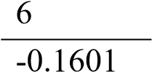 | 7 | 8 | 9 | 10 | 11
1 G | 0.889** | 0.719** | 0.522** | 0.663** |  | 0.571** | -0.870** | 0.694** | -0.737** | -0.1159
P | 0.821** | 0.584** | 0.431** | 0.615** | -0.1541 | 0.426** | -0.804** | 0.626** | -0.663** | -0.0954
2 G |  | 0.778** | 0.291* | 0.582** | -0.228* | 0.566** | -0.831** | 0.561** | -0.760** | -0.342**
P |  | 0.691** | 0.276* | 0.559** | -0.220* | 0.419** | -0.783** | 0.532** | -0.699** | -0.279*
3 G |  |  | 0.162 | 0.657** | -0.0987 | 0.505** | -0.738** | 0.417** | -0.603** | -0.241*
P |  |  | 0.213* | 0.551** | -0.0687 | 0.239* | -0.620** | 0.392** | -0.478** | -0.1044
4 G |  |  |  | 0.395** | -0.0929 | 0.356** | -0.616** | 0.441** | -0.252* | 0.1399
P |  |  |  | 0.349** | -0.0569 | 0.1389 | -0.521** | 0.450** | -0.232* | 0.1945
5 G |  |  |  |  | -0.1163 | 0.660** | -0.816** | 0.513** | -0.343** | 0.1547
P |  |  |  |  | -0.1068 | 0.540** | -0.758** | 0.475** | -0.317* | 0.1472
6 G |  |  |  |  |  | -0.952** | 0.1465 | -0.330* | 0.349** | 0.1117
P |  |  |  |  |  | -0.779** | 0.1534 | -0.300* | 0.327* | 0.1127
7 G |  |  |  |  |  |  | -0.595** | 0.630** | -0.547** | -0.0094
P |  |  |  |  |  |  | -0.463** | 0.417** | -0.382** | -0.0486
8 G |  |  |  |  |  |  |  | -0.630** | 0.569** | 0.0448
P |  |  |  |  |  |  |  | -0.568** | 0.524** | 0.0401
9 G |  |  |  |  |  |  |  |  | -0.666** | 0.335*
P |  |  |  |  |  |  |  |  | -0.644** | 0.366**
10 G |  |  |  |  |  |  |  |  |  | 0.431**
P  11 G P |  |  |  |  |  |  |  |  |  | 0.422**
** Significant at 1%, * Significant at 5%
1-Days to 50% flowering, 2- Plant height (cm), 3- Panicle length (cm), 4- Number of effective tillers 5- Number of filled grains per panicle, 6- Number of unfilled grains per panicle, 7- Spikelet fertility%, 8-100 seed weight (g), 9- Biological yield per plant (g), 10- Harvest index %, 11- Grain yield per plant

The character days to 50% flowering showed positive and highly significant genotypic and phenotypic correlation with plant height (0.889; 0.821), panicle length (0.719; 0.584), biological yield per plant (0.694; 0.626), number of filled grains per panicle (0.663; 0.615), spikelet fertility (0.571;0.426) and number of effective tillers (0.522; 0.431). In contrast, the trait exhibits significant and negative genotypic and phenotypic correlation with 100 seed weight (-0.87; -0.80) and harvest index (-0.73; -0.66). Similar results were found by Mahalakshmi et al. (2024) for plant height and panicle length, Faysal et al. (2022) for number of effective tillers and spikelet fertility.
The plant height had a highly significant positive correlation with panicle length (0.778; 0.691), number of filled grains per panicle (0.582; 0.559), spikelet fertility (0.566; 0.419), and biological yield (0.561; 0.532). The positive association between plant height and yield components suggests that taller plants tend to produce longer panicles and more spikelets. However, excessive plant height (semi dwarf type) can lead to lodging problems, so an optimal plant height should be maintained in breeding programs.
The traits number of filled grains per panicle (0.657; 0.551) and biological yield (0.417; 0.392), showed a positive and highly significant genotypic and phenotypic association with panicle length. In contrast, the trait exhibits highly significant and negative genotypic and phenotypic correlation with 100 seed weight (-0.783; -0.738), and harvest index (-0.603; 0.478). Demeke (2023) reported similar observations for harvest index and Sadimantara (2021) for number of filled grains per panicle.
The number of effective tillers per plant had a significant positive correlation with biological yield (0.441; 0.450) and number of filled grains per panicle (0.395; 0.349). This indicates that higher tillering capacity contributes to greater biomass production and grain yield, this is in accordance with the findings of Sadimantara et al. (2021). Spikelet fertility exhibited positive correlations with biological yield (0.630; 0.417), indicating that higher spikelet fertility enhances total grain production, this observation was in conformity with the findings of Yadav et al. (2024).
The grain trait like, 100-seed weight had a strong negative correlation with biological yield (-0.630; -0.568) and harvest index (-0.595; -0.463). This suggests that higher seed weight is associated with lower biomass production and harvest index this is accordance with the findings of Naik et al., (2005) and Perween et al. (2020).
Biological yield had the strongest positive correlation with grain yield (0.335;0.366), confirming that plants with higher biomass tend to produce more grains, this aligns with the findings of Fentie et al. (2021). This suggests that selection for high biomass-producing genotypes would directly enhance grain yield. Whereas, harvest index showed a negative correlation with number of filled grains per panicle (-0.666; -0.644). This was in conformity with the findings of Singh et al. (2022).
Based on the magnitude of correlation coefficient values, harvest index and biological yield showed significant and positive correlation with grain yield per plant. Hence higher yield could be obtained by exerting selection pressure on any of these traits. A positive correlation between desirable traits is advantageous to the plant breeder since it facilitates the simultaneous improvement of both characters; conversely, a negative correlation will prevent both highvalue characters from expressing themselves simultaneously. Similar results were recorded by Ramchander et al. (2014), Fentie et al. (2021), Faysal et al. (2022), Mandal et al. (2023) and Prasad et al. (2024), Dubey et al. (2018), Singh et al. (2022), Perween et al. (2020), Yadav et al. (2024), Roy et al. (2024) and Bandhe et al. (2023) in their respective study in rice breeding programmes. The path coefficient analysis is further done to ascertain the relative contribution of traits to grain through their direct and indirect contribution.

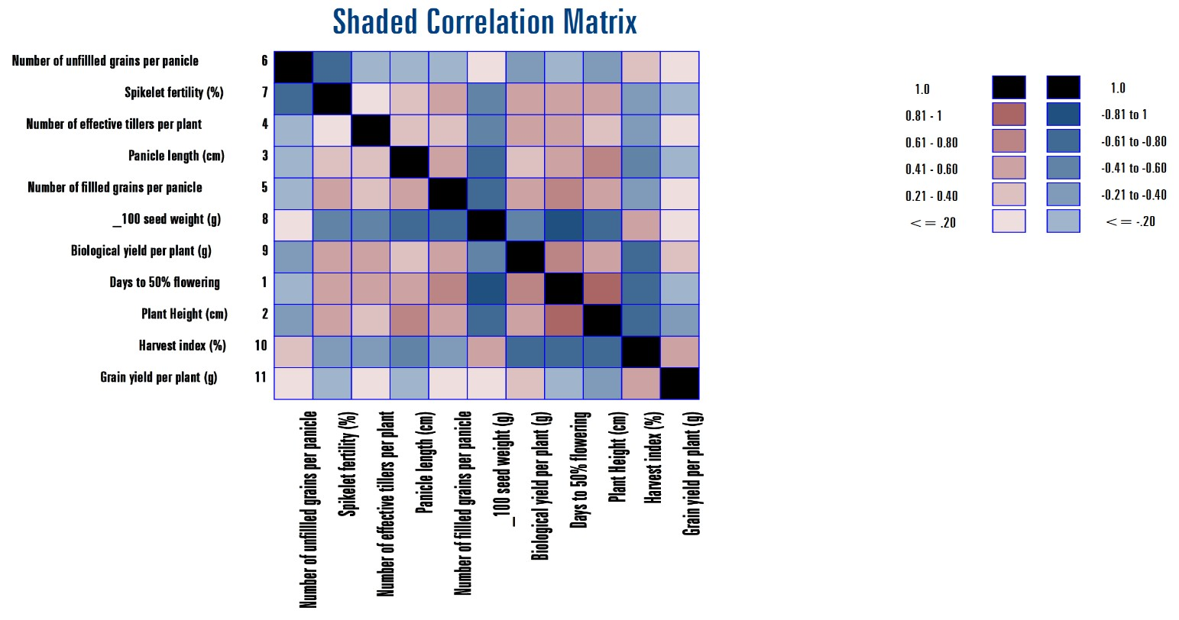
Fig 1: Phenotypic correlation shaded matrix for grain yield per plant.

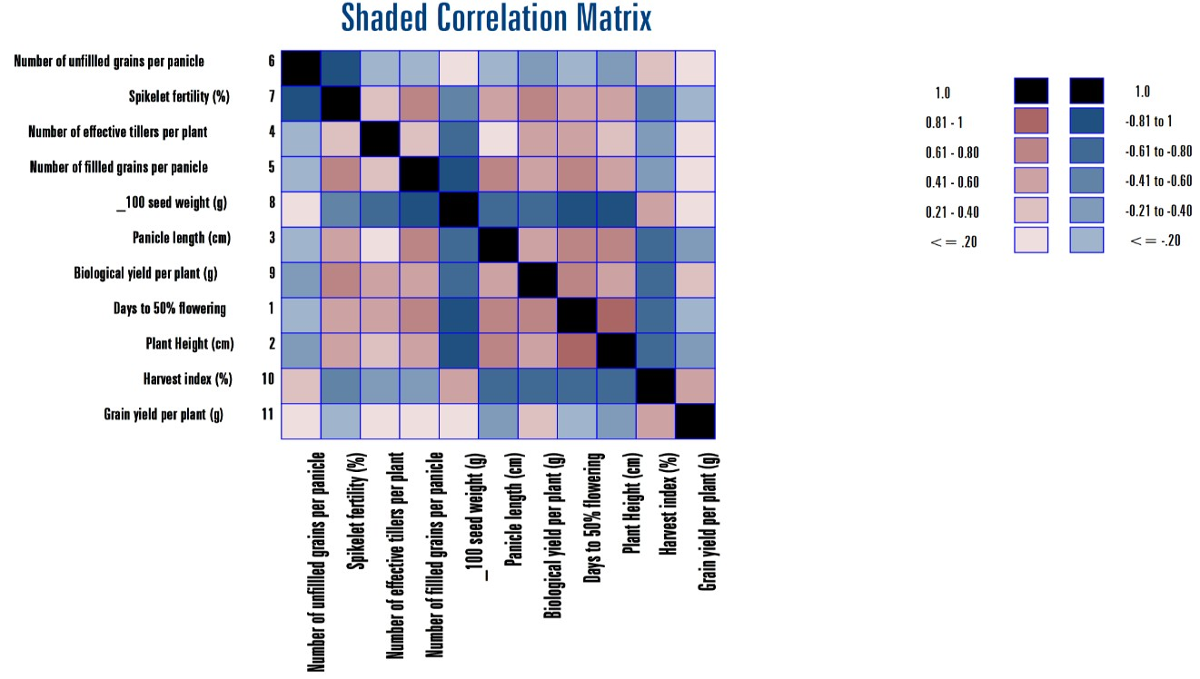
Fig 2: Genotypic correlation shaded matrix for grain yield per plant.

Path Analysis
The results of path analysis revealed significant direct and indirect effects of various traits on grain yield, providing valuable insights for selecting key yield-contributing traits in breeding programs. The direct and indirect values for path analysis are mentioned in Table 2.

Importance of Direct Effects on Grain Yield
The study identified biological yield per plant (1.148) and harvest index (1.08) as the two most influential traits with strong direct positive effects on grain yield. These results align with previous findings by Fentie et al. (2021) and Abd Rahman et al. (2011), who reported that biological yield significantly contributes to final grain production. The harvest index, which represents the efficiency of resource partitioning, was also observed to play a critical role, as supported by Sudeepthi et al. (2020). These two traits can be used as primary selection criteria in breeding programs aiming for higher grain yield.
In addition to biological yield and harvest index, 100 seed weight (0.287) and days to 50% flowering (0.245) exhibited significant direct positive effects on grain yield. A high 100 seed weight indicates enhanced productivity, which was similarly observed by Manivelan et al. (2022). Early flowering traits, as seen in Patil and Sahu (2009) and Saketh et al. (2023), have been linked to improved yield potential by ensuring better environmental adaptation.
These traits should be prioritized in developing early-maturing, high-yielding rice varieties.

Role of Indirect Effects in Yield Determination
Several traits exhibited indirect effects on grain yield through their influence on other yield components. Days to 50% flowering had strong positive indirect effects on grain yield through plant height (0.219), panicle length (0.177), and number of filled grains per panicle (0.163). This suggests that early flowering plants might indirectly enhance yield by promoting better plant architecture and grain filling. Similar indirect contributions were reported by Saketh et al. (2023). Conversely, plant height (-0.284) had a negative direct effect on grain yield, although it positively influenced yield indirectly through 100 seed weight (0.236) and harvest index (0.215). This suggests that taller plants might not always be advantageous for grain yield, as they could lead to lodging, but their positive influence on certain other yield components helps compensate for the negative direct effect. Similar findings were reported by Bagheri et al. (2011).

Table 2: Direct and indirect effects of different yield contributing characters on grain yield
Genotypic Path Matrix
 | Days to  50%  flowering | Plant  Height  (cm) | Panicle length  (cm) | Number of  effective  tillers per plant | Number of filled  grains per panicle | Number of  unfilled  grains per panicle | Spikelet fertility  (%) | 100 seed  weight  (g) | Biological yield per plant (g) | Harvest index  (%) | Grain yield per  plant  (gm)
Days to 50% flowering | 0.2465 | 0.2191 | 0.1774 | 0.1287 | 0.1635 | -0.0395 | 0.1408 | -0.2144 | 0.171 | -0.1818 | -0.1159
Plant Height (cm) | -0.2524 | -0.284 | -0.221 | -0.0825 | -0.1652 | 0.0646 | -0.1606 | 0.2361 | -0.1594 | 0.2157 | -0.342**
Panicle length (cm) | 0.0942 | 0.1019 | 0.1309 | 0.0212 | 0.0861 | -0.0129 | 0.0661 | -0.0967 | 0.0546 | -0.079 | -0.241*
Number of effective tillers per plant | -0.0106 | -0.0059 | -0.0033 | -0.0203 | -0.008 | 0.0019 | -0.0072 | 0.0125 | -0.0089 | 0.0051 | 0.1399
Number of filled grains per panicle | 0.048 | 0.0421 | 0.0476 | 0.0286 | 0.0724 | -0.0084 | 0.0478 | -0.0591 | 0.0372 | -0.0248 | 0.1547
Number of unfilled grains per panicle | -0.0185 | -0.0263 | -0.0114 | -0.0107 | -0.0134 | 0.1154 | -0.1099 | 0.0169 | -0.038 | 0.0403 | 0.1117
Spikelet fertility (%) | 0.0313 | 0.031 | 0.0277 | 0.0195 | 0.0362 | -0.0522 | 0.0549 | -0.0327 | 0.0346 | -0.03 | -0.0094
100 seed weight (g) | -0.2499 | -0.2389 | -0.2122 | -0.177 | -0.2344 | 0.0421 | -0.171 | 0.2873 | -0.181 | 0.1635 | 0.0448
Biological yield per plant (g) | 0.7966 | 0.6447 | 0.4786 | 0.5063 | 0.5897 | -0.3785 | 0.724 | -0.7236 | 1.1487 | -0.765 | 0.335*
Harvest index (%) | -0.8012 | -0.8253 | -0.6553 | -0.2739 | -0.3722 | 0.3792 | -0.5942 | 0.6184 | -0.7237 | 1.0867 | 0.431**
Grain yield per plant (gm) | -0.1159 | -0.342** | -0.241* | 0.1399 | 0.1547 | 0.1117 | -0.0094 | 0.0448 | 0.335* | 0.431**
Residual effectt= 0.277

Complex interactions among yield-contributing traits
The number of effective tillers per plant (-0.023) had a negligible negative direct effect on grain yield. However, it contributed positively through 100 seed weight (0.012) and harvest index (0.005). This suggests that an increase in tiller number does not directly boost yield, it may enhance grain weight and efficiency, leading to an overall positive impact. These findings corroborate previous research by Perween et al. (2020).
Spikelet fertility (0.054) had a small but positive direct effect on yield, as observed in studies by Kumar et al. (2024). This indicates that ensuring high spikelet fertility is crucial for grain set and yield improvement. Similarly, the number of unfilled grains per panicle (0.115) had a positive direct effect but negative indirect effects through spikelet fertility (-0.109) and biological yield (-0.038), suggesting that selecting for filled grains per panicle should be a priority over unfilled grains.

Residual Effect
The residual effect in this study was 0.277, indicating that while the selected traits explain a significant portion of the variation in grain yield, additional unexamined factors also contribute to yield determination. Traits such as root architecture, stress tolerance, and nutrient use efficiency may further explain the remaining variance, as suggested by Sudeepthi et al. (2020). Future studies should explore these factors to develop a better selection strategy.
The findings of this study reinforce the need for a multi-trait selection approach in rice breeding. The traits with strong direct effects (biological yield, harvest index, 100 seed weight, and days to 50% flowering) should be prioritized. Additionally, traits with significant indirect effects (plant height, panicle length, and number of filled grains per panicle) should also be considered to maximize yield improvement. Similar breeding strategies have been successfully applied in rice improvement programs by Babu et al. (2012), Maneesha et al. (2024) and Noatia et al. (2021).

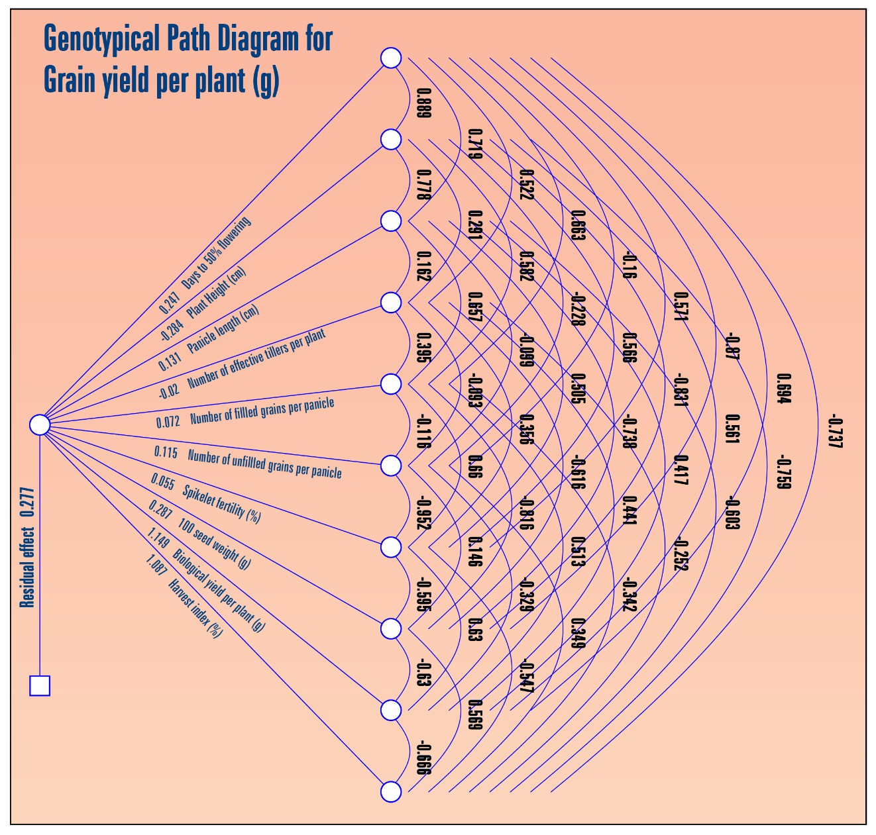
Fig 3: Genotypic path diagram for grain yield per plant

Conclusion
This study highlights the key yield-contributing traits in rice, revealing that biological yield, harvest index, 100 seed weight, days to 50% flowering, panicle length, and spikelet fertility have significant direct and indirect effects on grain yield. Among these, biological yield and harvest index exhibited the strongest direct positive effects, making them crucial selection criteria for breeding high-yielding rice varieties. Correlation analysis further confirmed the positive associations between panicle length, spikelet fertility, and number of filled grains per panicle with grain yield, while 100 seed weight showed a trade-off with biological yield and harvest index. Selection based on the traits such as biomass, harvest index, grain length, days to 50 % flowering, productive tiller, panicle length, and filled grain will therefore, be more beneficial and effective in rice breeding and yield enhancement programs for any activity aiming to increase grain output.
Disclaimer (Artificial intelligence)
Option 1:
Author(s) hereby declare that NO generative AI technologies such as Large Language Models (ChatGPT, COPILOT, etc.) and text-to-image generators have been used during the writing or editing of this manuscript.
Option 2:
Author(s) hereby declare that generative AI technologies such as Large Language Models, etc. have been used during the writing or editing of manuscripts. This explanation will include the name, version, model, and source of the generative AI technology and as well as all input prompts provided to the generative AI technology
Details of the AI usage are given below:
1.
2.
3.

References
Abd Rahman SNB, Razak MSFBA, Othman MRB, Abd Rahim NIB. Screening of Mardi rice accessions for salinity tolerance at seedling stage based on growth performance and molecular analysis. Pak J Bot. 2023; 55:893-902.
Anonymous. Annual Report. Directorate of Agriculture, Government of Chhattisgarh, Raipur. 2024.
Ali S, Khan MA, Ahmed S. Path coefficient analysis for yield and its components in rice (Oryza sativa L.). Pakistan Journal of Agricultural Sciences, 2020; 57(2):463-468.
Babu VR, Shreya K, Dangi KS, Usharani G, Shankar AS. Correlation and path analysis studies in popular rice hybrids of India. International Journal of Scientific and Research Publications, 2012; 2(3):1-5.
Bagheri N, Jelodar NB, Pasha A. Path coefficient analysis for yield and yield components in diverse rice (Oryza sativa L.) genotypes. Bihrrean Biologist, 2011; 5(1):32-35.
Bandhe A, Chaudhari P, Nair SK, Gauraha, D. Character association and path coefficient analysis for rice (Oryza sativa L.) yield and component characteristics. The Pharma Innovation Journal, 2023; 12(9):1734-1736.
Demeke B, Dejene T, Abebe D. Genetic variability, heritability, and genetic advance of morphological, yield related and quality traits in upland rice (Oryza sativa L.) genotypes at pawe, northwestern Ethiopia. Cogent Food & Agriculture, 2023; 9(1):1-20.
Dewey DR, Lu K. A correlation and path‐coefficient analysis of components of crested wheatgrass seed production 1. Agronomy Journal, 1959;51(9):515-518.
Dubey V, Dwivedi D K, Singh A, Chhavi R. Correlation and path coefficient analysis of yield components in rice under drought condition. International Journal of Current Microbiology and Applied Sciences, 2018;7:4116-4122.
Faysal ASM, Ali L, Azam MG, Sarker U, Ercisli S, Golokhvast, KS, Marc, RA. Genetic variability, character association, and path coefficient analysis in transplant Aman rice genotypes. Plants, 2022; 11(21):2952.
Fentie DB, Bayuh BA, Ali HM. “Association of agronomic traits with grain yield of lowland rice (Oryza sativa L.) genotypes.” International Journal of Agricultural Science, 2021; 8.3:2348-3997.
Gupta P. A study of trends in rice production in India: Post Millennium. International Journal of Science and Research, 2024;13(7):349-353.
Khamari B. Grain Discolouration: An Emerging Threat to Rice Crop. Res Biotica., 2020;2(2):80–87.
Kumar S, Vimal SC, Singh J, Gupta R, Yaduvanshi N, Singh YP. Path coefficient analysis of rice (Oryza sativa L.) genotype under laboratory conditions. International Journal of Plant & Soil Science, 2024;36(1):155-162.
Mahalakshmi PJ, Satish Y, Raman JV, Raju MRB. Correlation and path coefficient analysis for yield and its component traits in advanced breeding lines of rice (Oryza sativa L.). Journal of Advances in Biology & Biotechnology, 2024;27(9):769-777.
Mandal A, Lal GM, Lavanya GR. Assessment of genetic variability, correlation and path analysis among rice (Oryza sativa L.) landraces genotypes for grain yield characters under irrigated. International Journal of Environment and Climate Change, 2023; 13(10):55-65.
Maneesha M, Shankar VG, Srinivas B, Hari Y. Correlation and path coefficient analysis for grain yield, head rice recovery and quality traits in rice hybrids (Oryza sativa L.). International Journal of Plant & Soil Science, 2024;36(8):808-816.
Manivelan K, Juliet Hepziba S, Suresh R, Theradimani M, Renuka R, Gnanamalar RP. Inherent variability, correlation and path analysis in lowland rice (Oryza sativa L.). Biological Forum–An International Journal, 2022;14(2): 771-778).
Miller PA, Williams JC, Robinson HF, Comstock RE. Genotypic and environmental variances and covariances in an upland cotton cross of interspecific origin. Agronomy Journal, 1958;50(1):126–131.
Naik D, Sao A, Sarawgi AK. Association analysis for quality and yield components in some indigenous scented rice accessions. Indian J. of Plant Gen. Reso. 2005;18(20):266-268.
Noatia A, Sao A, Tiwari A, Nair SK, Gauraha D. Genetic dissection of yield determinants in advance breeding lines (ABLs) of rice (Oryzae sativa L.) under irrigated condition of Chhattisgarh, India. Intl. J. Plant Soil Sci. 2021;33(20):119-131.
Patil SG, Sahu VN. Correlation and path analysis of rice germplasm accessions. International Journal of Plant Sciences, 2009;4(2):426-428.
Perween S, Kumar A, Adan F, Danish M. The inter-relationship among yield and yield attributing traits of rice (Oryza sativa L.) under irrigated condition through correlation coefficient studies and path analysis. International Journal of Chemical Studies, 2020;8(2):1409-1414.
Prasad S, Nair SK, Gauraha D, Sao A, Sahu M. Genetic association and diversity analysis for yield and yield attributing traits in rice (Oryza sativa L.). International Journal of Advanced Biochemistry Research, 2024;8(9):1216-1218.
Ramchander S, Robin S, Raveendran M. Correlation analysis for physiomorphological traits of drought resistance in advanced backcross population of rice (Oryza sativa L.). Indian Journal of Animal Nutrition, 2014;7(16):2117-2122.
Roy TK, Sannal A, Tonmoy SS, Akter S, Bhagyobandhu, ROY, Rana MM, Zakaria, ALAM. and Hasan MR. Trait analysis of short duration boro rice (Oryza sativa L.) varieties in northern region of Bangladesh: Insights from heatmap, correlation and PCA. Nova Geodesia, 2024;4(2):175-175.
Sadimantara GR, Yusuf DN, Febrianti E. The performance of agronomic traits, genetic variability, and correlation studies for yield and its components in some red rice (Oryza sativa) promising lines. Biodiversitas Journal of Biological Diversity, 2021;22(9):3994-4001.
Saketh T, Gouri Shankar V, Srinivas B, Hari Y. “Correlation and Path Coefficient Studies for Grain Yield and Yield Components in Rice (Oryza sativa L.)”. International Journal of Plant & Soil Science, 2023;35(19):1549-58.
Salihi MS, Ehsanullah F, and Baray Shah M. Climate-smart rice production: a review. International Journal of Biosciences, 2024;139-142.
Sao A, Nair SK, Gauraha, D, Chandel G. Genetic gain and productivity trend analysis for yield of rice varieties in Central India, Journal of Rice Research, 2024;17(1):1-3.
Singh AK, Alok KS, Tarkeshwar AG, Shiv PM. Analysis of correlation and path coefficients for yield and its attributes in CMS lines and their F1’s of rice (Oryza sativa L.). Biol. Forum–An International Journal, 2022;14(4):19-23.
Singh TVJ, Mohan YC, Raju CHD, Jagadeswar R, Balram M. Character association and path coefficient studies in rice (Oryza sativa L.). Journal of Pharmacognosy and Phytochemistry, 2019;8(3):383-387.
Sudeepthi K, Srinivas TVSR, Kumar BR, Jyothula DPB, Umar SN. Assessment of genetic variability, character association and path analysis for yield and yield component traits in rice (Oryza sativa L.). Electronic Journal of Plant Breeding, 2020;11(01):144-148.
Kanwar SS, Nag YK. To Study Correlation and Path Analysis in Rice Breeding Lines. International Journal of Current Microbiology and Applied Sciences, 2019;8(12):2481-2487.
Wright S. Correlation and causation. Journal of Agricultural Research, 1921;20:557-585.
Yadav SPS, Bhandari S, Ghimire NP, Mehata DK, Majhi SK, Bhattarai S, Bhujel S. Genetic variability, character association, path coefficient, and diversity analysis of rice (Oryza sativa L.) genotypes based on agro-morphological traits. International Journal of Agronomy, 2024;1-21.

