**Length-weight relationship and morphometric characters of *Glyptosternon reticulatum* (McClelland, 1842) in Tributaries of River Jhelum, Kashmir, India**

**Abstract**

The present study on the morphometry and length-weight relationship of *Glyptosternon reticulatum* was carried out from May 2022 to April 2023. A total of 360 samples were collected from several tributaries of the Jhelum river for this study. Our specimen measuring (285.31 mm) may be the largest known specimen of *Glyptosternon reticulatum* in the World. Various morphometric characters showed high degree of correlation (r) between them and the value was recorded highest between total length and standard length (0.99) and least between total length and eye diameter (0.67). Coefficient of variation of various morphometric characteristics ranged from 33.07% (body depth) to 43.95% (snout length).

The equations for males were found as Log W = -4.1565 + 2.6304 Log L and for females as Log W = -3.5798 + 2.3647 Log L. Combined equation was recorded as Log W = -4.1361 + 2.6238 log L. The value of ‘b’ obtained for the pooled data was found to be 2.62 which was significantly less than 3 indicating a negative allometric growth in the fish.

***Keywords:*** *Glyptosternon reticulatum, Morphometry, Allometric growth, Length-Weight relationship.*

**1. Introduction**

The fisheries and aquaculture sector is one of the fastest-growing industries globally (Tacon, 2020) and has significantly contributed to economic development. This impact is seen through its roles in enhancing food and nutritional security, boosting national income, creating employment opportunities, and providing various livelihood options (Kumar and Shivani, 2014). It serves as a major source of animal protein for billions of people around the world, with capture fisheries and aquaculture supporting the livelihoods of over 10% of the global population (SOFIA, 2020). Fisheries and aquaculture not only provide essential dietary components for human consumption but also offer significant opportunities for employment and income generation, particularly in economically disadvantaged rural regions (Jayasankar, 2018). In 2018, aquaculture accounted for 82 million tonnes of the world's total fish production of 179 million tonnes (FAO, 2020). Of this, 156 million tonnes were consumed by humans, averaging 20.5 kg per person per year. Additionally, 22 million tonnes of fishmeal and fish oil were utilized for various purposes, including the production of fish feed.

Fisheries sector in India play a significant role in the Indian economy and provide livelihood to millions of fisher folk. India is the 3rd largest fish producing and 2nd largest aquaculture producing nation in the world. The blue revolution in India demonstrated importance of fisheries and aquaculture sector. To improve the quality of life and economic well-being of people in rural areas and to create more livelihood opportunities, a holistic approach has been adopted by the government of India to meet sustainable development goals (SDGs). The public authority of India is at the forefront of changing the fisheries area and achieving monetary transformation through the blue revolution in the country.

India is bestowed with vast and varied cold water resources with valuable indigenous fish germ plasm and pristine water with a range of thermal regimes. Hence the Himalayan states offer a unique value proposition in cold water fisheries. With the aim to harness its potential, the department has focused on increasing current cold water fish production of 52,084 MT to 90 thousand MT by FY 2024-25 boosting current productivity from ~1 ton/Ha to 3 ton/Ha. It is estimated that to achieve the goal, 18.6 lakh fingerling and 5.16 lakhs MT of feed will be required during the course of implementation of PMMSY. Cold water fisheries have also been instrumental in creating 40 thousand employment opportunities and targets at doubling the engagement across the focus States/UTs.

Nestled at an altitude of 5,200 feet above sea level, Kashmir valley boasts a unique climate characterized by temperature extremes ranging from 16°F in winter to 95°F in summer. Kashmir, often referred to as "Paradise on Earth," is renowned for its breathtaking landscapes, serene lakes, and abundant natural resources. Among these resources, the fisheries sector holds a special place, contributing to the socio-economic fabric of the region and providing sustenance to thousands of households. The fisheries sector in Kashmir is diverse, encompassing both freshwater and cold-water fisheries. The region's numerous lakes, rivers, streams, and reservoirs are home to a variety of fish species, including trout, carp, mahseer, and catfish. These aquatic resources not only support local livelihoods but also attract tourists and anglers from far and wide, contributing to the region's tourism industry (Rashid *et al.* 2017). Despite its potential, the kashmir fisheries sector faces several challenges, including habitat degradation, pollution, overfishing, and insufficient infrastructure and institutional support. Conflict and political instability in the region have also impacted fisheries activities, disrupting supply chains and limiting access to markets. Understanding the dynamics of kashmir fisheries requires a nuanced approach that considers the ecological, social, economic, and governance dimensions of the sector. Ecologically, the health of freshwater ecosystems and the conservation of native fish species are essential for sustaining fisheries in the region. Socially and economically, fisheries provide employment and income opportunities for local communities, particularly those living in rural areas. Governance frameworks, including policies, regulations, and management practices, play a crucial role in promoting sustainable fishing practices, conserving fisheries resources, and enhancing the resilience of fishing communities (Malik *et al*, 2018).

The state's major river systems, including the Indus river system in Ladakh, the Jhelum river system in Kashmir, and the Chenab river system in Jammu, play a vital role in shaping the landscape and supporting aquatic life. Among these, the Jhelum river stands out as the principal waterway, coursing through the entire valley from south to north and earning the status of kashmir's lifeline. It ranks as the second-largest fisheries resource in the valley after wular lake, hosting a rich diversity of both indigenous and exotic fish species (Sodhi *et al.,* 2013). The ichthyofauna of kashmir valley primarily comprises species from the central asiatic fauna, with the *Schizothorax* group being particularly prevalent (Sunder *et al.,* 1979). Fish families such as *Cyprinidae, Cobitidae, Siluridae, Poecilidae, Sisoridae*, and *Salmonidae* are well-represented in the valley's waters. However, many of these species face significant pressure from pollution and human activities, highlighting the urgent need for conservation efforts and sustainable management practices (Bhat *et al.* 2010).

The river Jhelum is not just a waterway; it's a lifeline for the region, sustaining both ecosystems and livelihoods. Its journey commences from the verinag spring, traversing a vast catchment area of approximately 12,75,696 hectares, encompassing a network of tributaries that contribute to its richness (Sodhi *et al.,* 2013). One such tributary, the dudganga stream, converges with the jhelum near srinagar city, adding to its diversity and ecological significance. Throughout its course, the river jhelum harbors a rich diversity of fish species, making it a prime location for fisheries. Among the notable inhabitants are *Schizothorax curvifrons* (Satter Gad), *Schizothorax labiatus* (Chush Gad), *Schizothorax esocinus* (Churu Gad), *Schizothorax plagiostomus* (Khont), *Schizothorax niger* (Ale Gad), *Bangana diplostomous* (Ropput), *Crossochielus diplochilus* (Tethur Gad), *Triplophysa marmorata,* *Triplophysa kashmiriensis* (Ara Guran), various *Glyptothorax* species (Nayid), *Glyptosternon* (Anyour), *Nemachielus* species, *Tor putitora* (Mahseer*), Cyprinus carpio var. specularis* (Parim Gad), and *Cyprinus carpio var. communis* (Punjaib Gad). The presence of such a diverse range of fish species highlights the ecological importance and health of the river jhelum. These fish species not only contribute to the biodiversity of the river but also support local fisheries, providing a vital source of food and income for communities along its banks. Furthermore, the river's connection with manasbal lake through a small channel near sumbal town further enhances its ecological connectivity and significance (Sodhi *et al.,* 2013). Understanding the ecology and dynamics of fish populations in the river jhelum is crucial for effective fisheries management and conservation efforts. By studying the distribution, abundance, and behavior of these fish species, researchers can gain valuable insights into the health of the river ecosystem and implement measures to ensure its long-term sustainability.

*Glyptosternon reticulatum* belongs to the family of sucker catfishes and is known for its association with freshwater habitats, typically found dwelling beneath stones and rocks in rivers and streams. Locally referred to as "Anyour" this species boasts a distinctive anatomy. Characterized by a short, wide, and depressed head with a broadly rounded snout, its elongated body is flattened ventrally towards the pelvic fins. The mouth is wide and inferior, with a complete lateral line. Despite minute dorsal eyes, they are dorsally located and subcutaneous. Thick, fleshy, and papillated lips accompany four pairs of barbels: nasal, maxillary, and two mental pairs. Maxillary barbels are notable for their basal thickness and subbasal connection to the cheek by a membrane, tapering distally, with the ventral aspect of the proximal part featuring folded skin forming an adhesive surface. Dental features include pointed teeth, with tooth patches in the upper jaw joined to form a crescent-shaped band posteriorly. Lacking a thoracic adhesive organ, the paired fins are structured to create an adhesive apparatus. Dorsal, anal, and caudal fins are notably short, with a flexible dorsal fin spine and six branched rays in both dorsal and anal fins. The caudal fin is typically truncate or very slightly convex, while the paired fins are broad. The pectoral fin features an unbranched ray, wide with transverse striae on the ventral aspect forming an adhesive surface. Similarly, the pelvic fin boasts an unbranched ray, with the first and second rays displaying transverse striae on the ventral aspect forming an adhesive surface. Additionally, a low adipose fin extending along more than 50% of the dorsum between the dorsal and caudal fins is present, connecting to the keel formed dorsally at the base of the caudal fin, with both pectoral and pelvic fins broad in appearance.

The study of fish morphology has long been a cornerstone of taxonomic and evolutionary research, providing valuable insights into their classification and relationships. It serves as a straightforward and fundamental method for identifying fish species. Morphometric parameters, such as measurements of body shape and proportions, play a crucial role in determining whether variations exist within the same species across different geographic regions (Naeem *et al*., 2012). These morphometric characters are essential as they aid in distinguishing between taxonomic units. Morphometrics, essentially the integration of geometry with biology, offers an empirical approach to understanding the structural features of fish species (Bookstein, 1997).

Length-weight relationships are crucial in fisheries biology as they enable the estimation of a fish's average weight based on its length, establishing a mathematical link between the two (Beyer, 1987). This relationship serves as a morphometric character useful for differentiating between taxonomic units, with variations occurring during developmental stages such as metamorphosis, growth, and maturity onset (Thomas *et al.,* 2003). The weight-length relationship and condition factor are widely used indicators of growth efficiency and overall well-being in fish populations, contributing to effective stock assessment and management practices (Javed *et al*., 1992; Naeem *et al*., 2005; Naeem *et al*., 2010). It holds significance in stock assessments and yield equations, aiding in estimating stock size and guiding management strategies (Le Cren, 1951). Additionally, it facilitates studies on gonad development, feeding rates, metamorphosis, maturity, and overall fish condition (Le Cren, 1951).

The lack of comprehensive research on *Glyptosternon reticulatum* underscores the urgency of understanding its biology in Kashmir waters. This research is not only essential for the sustainable management of this resource but also for preserving the delicate balance of the ecosystem it inhabits. With the documented information from this study, policymakers and fisheries managers will have valuable data to inform conservation strategies and ensure the long-term viability of *Glyptosternon reticulatum* populations in Kashmir waters.

|  |  |
| --- | --- |
| Taxonomic hierarchy | |
| Kingdom | Animalia |
| Phylum | Chordata |
| Class | Actinopterygii |
| Order | Siluriformes |
| Family | Sisoridae |
| Tribe | Glyptosternina |
| Genus | *Glyptosternon* |
| Species | *reticulatum* |

**2. Materials and methods**

The present investigation on *Glyptosternon reticulatum* was conducted at the Fisheries Resource Management (FRM) Laboratory, Faculty of Fisheries, SKUAST-K, Rangil, Ganderbal. The study involved the following steps to meet the various objectives of the study.

2.1 Collection of Fish Specimens:

Specimens of *Glyptosternon reticulatum* were collected from several tributaries of the Jhelum river with the assistance of local fishermen (fig. 1 & fig. 2). They used traditional cast nets or hand nets of varying mesh sizes for collection. In non-commercial sites, an electrofisher was employed to catch the fish. After collection, the samples were placed in jars containing 5% formalin and transported to the FRM laboratory at the Faculty of fisheries in Rangil, Ganderbal. In the laboratory, the fish samples were cleaned under running tap water and dried using a clean cotton cloth. Following cleaning, each individual's total weight was measured using an electronic weighing balance to the nearest 0.5 gram, and the total length was measured with a digital vernier caliper to the nearest 0.01 millimeter.

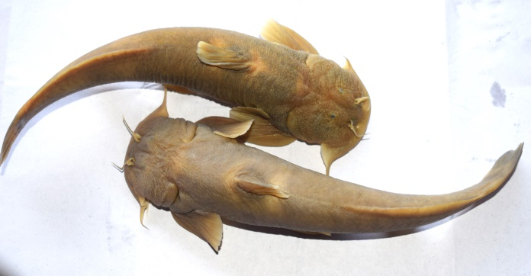

Fig. 1: Specimens of *Glyptosternon reticulatum*

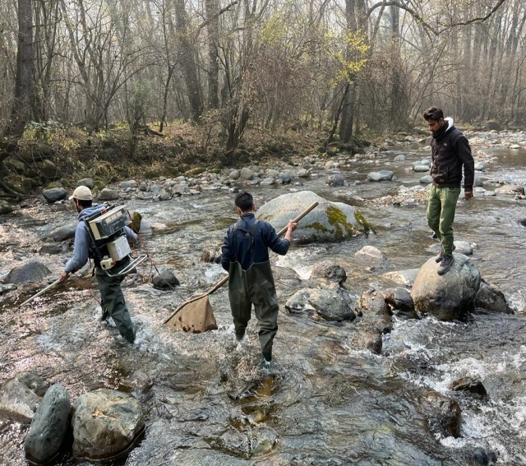

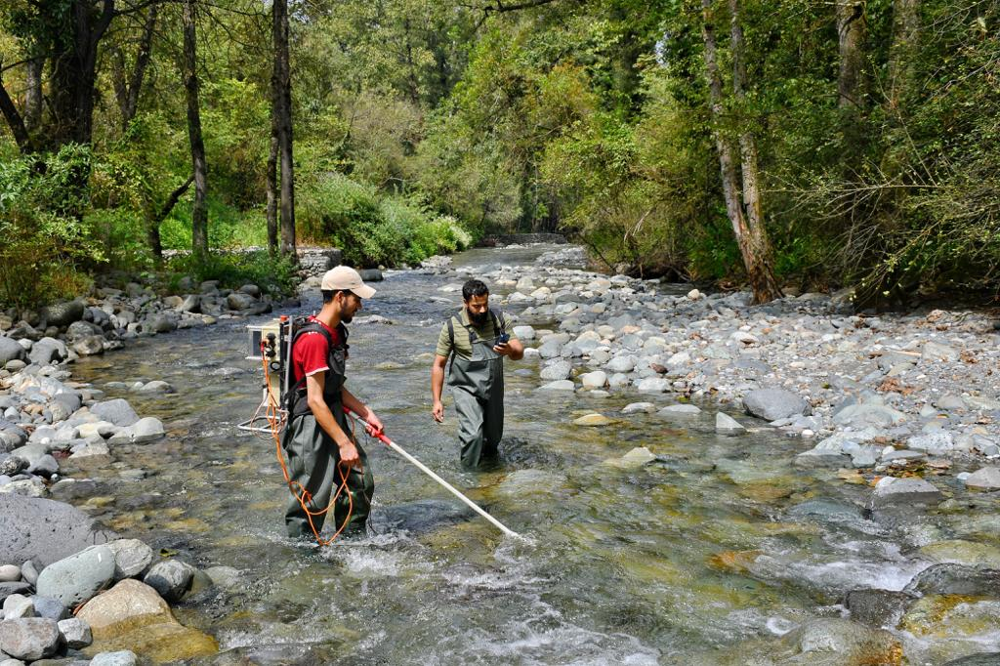

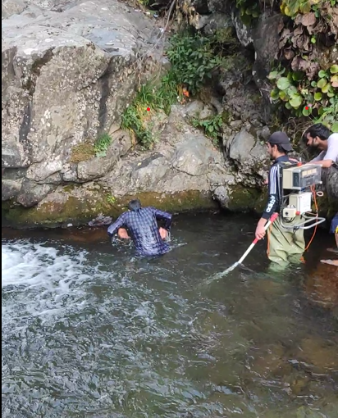

Fig. 2: Collection of fish specimens.

2.2 Conventional Morphometry

Morphometric characteristics were measured using a Vernier caliper, following the methods described by Lagler *et al.* (1962), Laevastu (1965), Dwivedi & Menezes (1974), and Grant & Spain (1977). All measurements were conducted on the left side of each fish by the same individual to minimize potential measurement biases. Twelve specific morphometric traits were measured (fig 3):

**Total Length (TL):** The distance from the tip of the snout to the tip of the caudal fin.

**Standard Length (SL):** The distance from the tip of the snout to the base of caudal fin.

**Pre-Dorsal Length (PDL):** Distance from the tip of the snout to the anterior margin of the base of the dorsal fin.

**Caudal Fin Length (CFL):** Distance from the origin of the caudal fin to its maximum length.

**Pre-Anal Length (PAL):** Distance from the tip of snout to the origin of anal fin.

**Pre-Pelvic Length (PPvL):** Distance from the tip of the snout to the origin of pelvic fin.

**Pre-Pectoral Length (PPcL):** Distance from the tip of the snout to the anterior margin of the base of the pectoral fin.

**Head Length (HL):** The distance from the tip of the snout to the posterior margin of the operculum.

**Body Depth (BD):** Maximum vertical length of body (deepest part of the body).

**Snout Length (SnL):** The distance from the tip of the snout to the anterior margin of the orbit.

**Eye Diameter (ED):** The distance from the anterior margin to the posterior margin of the eye.

**Adipose fin length (AFL**), The distance from the anterior margin of the adipose fin to the posterior margin.

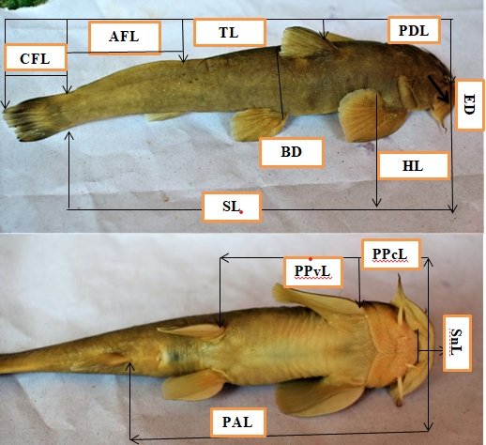

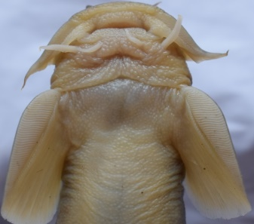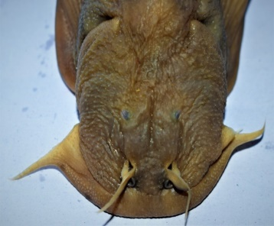

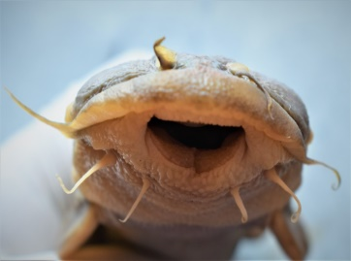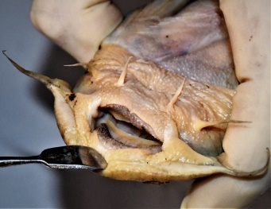

Fig. 3: Specimens of *Glyptosternon reticulatum*

2.3 Length-weight relationship

The length-weight relationship were estimated from the allometric formula proposed by Le-Cren (1951) separately for both sexes and significant differences in the slopes of the regression lines for males and females was ascertained.

W = aLb

Or Log W= Log a + b x Log L (1)

Where, “W” is the total body weight in grams, “L” is the total length in mm, “a” and “b” are the coefficients of the functional regression. “a” and “b” were estimated by the following formulae:

$a=y-bx$ and,

b=[n∑xy-∑x∑y] / [n∑x2-(∑x)2] (2)

The coefficient of correlation “r” was determined to analyse the relationship between the two variables:

r = [n∑xy-∑x∑y]/**√**[n∑x2-(∑x)2] [n∑y2-(∑y)2]

(3)

The analysis of covariance was done to determine variation in ‘b’ values among the sexes at 1% and 5% level of significance by following Snedecor and Cochran (1967). To test “b” value against the value of “3”, student’s t-test were employed to predict any significant deviation. The t-statistics was calculated as follows:

The hypothesis given is,

H0: Growth is isometric i.e. H0: b=3

H1: Growth is not isometric i.e. H1: b≠3

The t statistics used are given by:

t = │b-3│∕Sb  (4)

Where,

Sb=Standard error of “b” and t has (n-2) degrees of freedom.

Sb=√(1/(n-2))* [(Sy/Sx)2-b2] (5)

Where, “Sx” and “Sy” are the standard deviations of x and y respectively. The t-value was compared with t-table value for (n-2) degrees of freedom at 1% and 5% significance level.

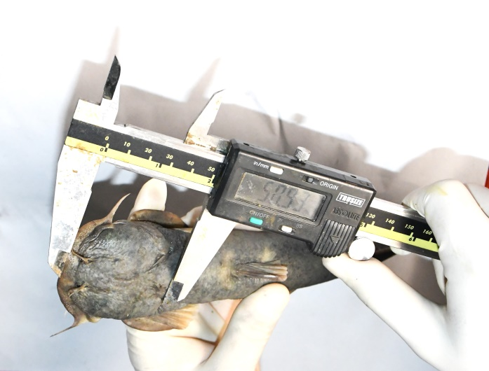

Fig. 4: Measurement of length

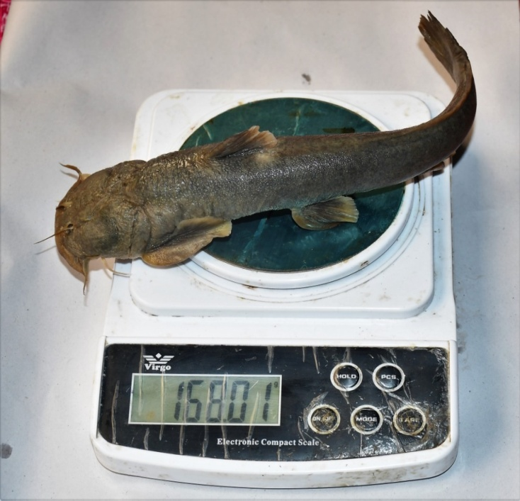Fig. 5: Measurement of weight

**3. Experimental findings**

The results of the present study on morphometry and length-weight relationship, of *Glyptosternon reticulatum* (McClelland, 1842) in tributaries of river Jhelum, Kashmir are as under:

3.1 Morphometry

During the present investigation on morphometry, 360 specimens of *G. reticulatum* were studied. The various morphometric characters of *G. reticulatum* are shown in (Table 1). Coefficient of variation of various morphometric characteristics ranged from 33.07% (body depth) to 43.95% (snout length). The relationship between various characters i.e., total length v/s standard length, total length v/s pre dorsal length, total length v/s pre pectoral length, total length v/s pre pelvic length, total length v/s pre anal length, total length v/s head length, total length v/s snout length, total length v/s body depth, total length v/s caudal fin length, total length v/s Adipose fin length and total length v/s eye diameter are presented in (Table 2) and (Figure 6-16). The correlation coefficient (r2) value was recorded highest between total length and standard length (0.99) and least between total length and eye diameter (0.67), indicating very high degree of relationship between the characters compared (Table 2).

**33**

Fig. 6: Relationship between total length and standard length in *G. reticulatum*

Fig. 7: Relationship between total length and pre-anal length in *G. reticulatum*

Fig. 8: Relationship between total length and pre-dorsal length in *G. reticulatum*

Fig. 9: Relationship between total length and pre-pelvic length in *G. reticulatum*

Fig. 10: Relationship between total length and pre-pectoral length in *G. reticulatum*

Fig. 11: Relationship between total length and eye diameter in *G. reticulatum*

Fig.12: Relationship between total length and caudal fin length in *G. reticulatum*

Fig. 13: Relationship between total length and adipose fin length in *G. reticulatum*

Fig. 14: Relationship between total length and snout length in *G. reticulatum*

Fig. 15: Relationship between total length and head length in *G. reticulatum*

Fig. 16: Relationship between total length and body depth in *G. reticulatum*

Table 1: Statistical estimates of various morphometric characters of *G. reticulatum*

| **Statistical estimates** | **Range (mm)** | | | **Mean (mm)** | **Median (mm)** | | **Standard error** | | **Standard deviation** | | **Coefficcient of variation (%)** |
| --- | --- | --- | --- | --- | --- | --- | --- | --- | --- | --- | --- |
| **Min** | **Max** | |
| Total length (TL) | 36.04 | 285.31 | | 150.37 | 140.68 | | 2.94 | | 55.96 | | 37.21 |
| Standard length (SL) | 32.63 | 261.93 | | 135.49 | 125.9 | | 2.67 | | 50.80 | | 37.49 |
| Head length (HL) | 7.57 | 57.17 | | 29.37 | 27.25 | | 0.57 | | 10.86 | | 36.98 |
| Eye diameter (ED) | 0.54 | 4.84 | | 2.03 | 1.94 | | 0.03 | | 0.68 | | 33.63 |
| Snout length (SnL) | 1.89 | 26.8 | | 11.86 | 10.78 | | 0.27 | | 5.21 | | 43.95 |
| Pre-pectoral length (PPcL) | 5.3 | 48.36 | | 22.98 | 21.03 | | 0.47 | | 9.00 | | 39.18 |
| Pre- pelvic length (PPvL) | 14.51 | 118.9 | | 62.62 | 58.37 | | 1.22 | | 23.22 | | 37.09 |
| Pre-dorsal length (PDL) | 11.41 | 89.38 | | 47.45 | 45.02 | | 0.89 | | 16.98 | | 35.78 |
| Pre-anal length (PAL) | 21.18 | 176.25 | | 90.13 | 83.91 | | 1.75 | | 33.30 | | 36.94 |
| Body depth (BD) | 4.15 | | 36.7 | | | 20.07 | | 19.76 | | 0.34 | | | 6.63 | 33.07 |
| Adipose fin length | 9.55 | | 91.81 | | | 44.33 | | 42.32 | | 0.88 | | | 16.69 | 37.66 |
| Caudal fin length (CFL) | 3.22 | | 32.3 | | | 14.85 | | 14.03 | | 0.29 | | | 5.63 | 37.93 |

Table 2: Relationship between various morphometric characters of *G. reticulatum*

| **Morphometric character** | **Intercept (a)** | **Slope (b)** | **Y= a + b X** | **Correlation (R2)** |
| --- | --- | --- | --- | --- |
| Total Length & Standard Length | 0.0765 | 1.0141 | Y = 0.0765 + 1.0141X | 0.9941 |
| Total Length & Head length (HL) | 0.6275 | 0.9621 | Y = 0.6275 + 0.9621X | 0.9557 |
| Total Length & Eye diameter (ED) | 1.1928 | 0.6882 | Y = 1.1928 + 0.6882X | 0.6722 |
| Total Length & Snout length (SnL) | 1.3295 | 1.1007 | Y = 1.3295 + 1.1007X | 0.9389 |
| Total Length & Pre-pectoral length (PPcL) | 0.7871 | 0.9858 | Y = 0.7871 + 0.9858X | 0.94 |
| Total Length & Pre- pelvic length (PPvL) | 0.3319 | 0.9777 | Y = 0.3319 + 0.9777X | 0.9785 |
| Total Length & Pre-dorsal length (PDL) | 0.4041 | 0.9558 | Y = 0.4041 + 0.9558X | 0.9626 |
| Total Length & Pre-anal length (PAL) | 0.1954 | 0.9876 | Y = 0.1954 + 0.9876X | 0.9829 |
| Total Length & Body depth (BD) | 0.004 | 0.8854 | Y = 0.004 + 0.8854X | 0.8872 |
| Total Length & Adipose fin length | 0.4783 | 0.9753 | Y = 0.4783 + 0.9753X | 0.9256 |
| Total Length & Caudal fin length (CFL) | 0.8244 | 0.9158 | Y = 0.8244 + 0.9158X | 0.8803 |

3.2 Length-Weight Relationship

For the study of length-weight relationship (LWR), 360 samples of *G. reticulatum* ranging in total length from 36.04 - 285.31 mm and body weight from 0.49-175 g were taken and the relationships were estimated separately for both males and females (fig. 4 & fig. 5). The equations for males was found as Log W = -4.1565 + 2.6304 Log L and for females as Log W = -3.5798 + 2.3647 Log L. Combined equation was recorded as Log W = -4.1361 + 2.6238 log L. The coefficient of determination (r2) were found to be 0.9845 for males, 0.8951 for females and 0.9762 for combined data. Our specimen measuring (285.31 mm) may be the largest known specimen of *Glyptosternon reticulatum* in the World (fig. 20).

The scattergram of logarithmic relation of length-weight has been plotted separately for males (Figure 17) and females (Figure 18). The scattergram of logarithmic relation of length-weight data of pooled data is plotted in (Figure 19).

Fig. 17: Scatter diagram showing length-weight relationship of *G. reticulatum* (Male)

Fig. 18: Scatter diagram showing length-weight relationship of *G. reticulatum* (Female)

Fig. 19: Scatter diagram showing combined length-weight relationship of G. reticulatum

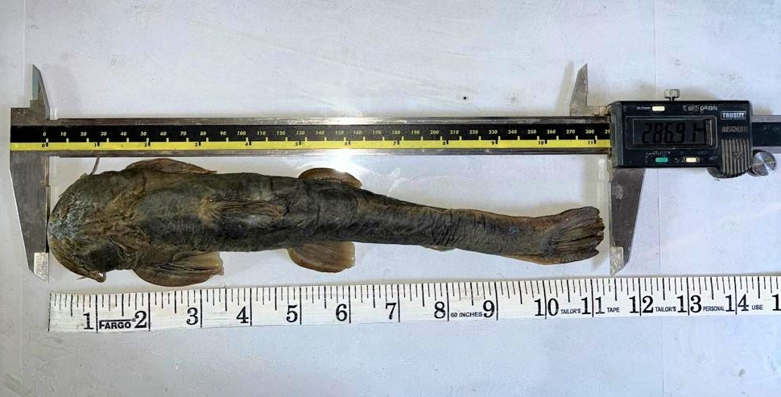

Fig 20: Showing specimen measuring (285.31 mm) the largest known specimen of *Glyptosternon reticulatum* in the World.

**4. Discussion**

4.1. Morphometry

Morphometric analysis serves as a crucial tool for distinguishing closely related species with high similarity indices across various parameters. It is widely recognized that morphometric characters in fishes exhibit significant plasticity in response to environmental factors such as food availability and temperature fluctuations (Agnese *et al*., 1997; Tawwab *et al.*, 2005). Morphometric relationships among different body parts of fish can be utilized to evaluate individual health and discern potential differences between distinct unit stocks of the same species. In the present study, various morphometric characters compared showed high coefficient of correlation (r) values, which indicate that the morphometric characters investigated are highly correlated to each other. The 'b' values obtained revealed the strongest correlation between total length and standard length, and the weakest between total length and eye diameter. Additionally, there was a notable positive correlation observed in the growth of all other parameters relative to total length. The correlation analysis indicates that all morphometric characters change in proportion to the increase in total length of the fish. The strong correlations observed among morphometric traits suggest that the entire body of the fish grows proportionately. Morphometric characters of fishes were found to be of taxonomic importance in sex, race and species identification by many investigators (Nelson, 1984; whitehead *et al*., 1986; Golani, 1994; Harabawy, 1993& 2002; Khalil *et al.,* 1983; Oliveira and Almada, 1995; Osman, 2000; Costa *et al*., 2003; Obady, 2003; Smith and Paulin, 2003; Turan, 2004; Randall and King, 2009; Lawson, 2010; Simon *et al.,* 2010; Elamin *et al*., 2011; Mazlan *et al.,* 2012; Deepti *et al.,* 2013; Sajina *et al*., 2013; Uiblein and Heemstra, 2010 &2011; Safi *et al.,* 2014; Jawad, 2015; Masood *et al*., 2015; Zubia *et al.,* 2015 and Mahmoud *et al*., 2016).

Morphometric analysis plays a pivotal role in fish biology research (Hussain *et al.,* 2012), serving as a crucial tool in fish identification (Kullander *et al*., 1999; Yousuf *et al.,* 2003). In their research on the morphometric characteristics of *Schizothorax spp*. in the River Lidder of Kashmir, Bhat *et al.* (2010) found that standard length exhibited the highest growth rate (0.9080), while body depth showed the least growth (0.1730) relative to total fish length. They also noted positive correlation coefficients between total length and other measured parameters. Sharma *et al.* (2014) examined the association between total length and other morphometric and meristic characteristics of *Botia birdi* in the Indus basin. They found a consistent and significant positive correlation between total length and all measured parameters. In their study on *Triplophysa marmorata,* Bashir *et al*. (2015) observed positive and significant correlations among various morphometric traits. Notably, total length and standard length exhibited the highest correlation coefficient (R2 = 0.98).

The present study identified a strong correlation between total length and standard length (r = 0.972), which is consistent with previous findings in the literature. For instance, Gul (2017) reported a robust correlation between total length and several morphometric measures, including standard length (R² = 0.962) and pre-anal length (R² = 0.932), indicating significant interdependence among these characters. Similarly, Qadri *et al*. (2017) found that standard length exhibited the strongest correlation (R² = 0.88) with total length in *S. curvifrons,* reinforcing the idea that standard length is a critical metric for assessing fish morphology. Further supporting these observations, Wali *et al*. (2019) examined eleven morphometric traits in *Oncorhynchus mykiss* and noted a high degree of correlation among them, particularly with total length (R² = 0.876 for standard length and R² = 0.807 for pre-anal length). Idowu *et al.* (2019) also demonstrated that morphometric traits in *Brycinus macrolepidotus* increased proportionally with fish length, although some variations were unrelated to length, suggesting the complexity of morphometric relationships. Bhat *et al.* (2020) supported this idea by reporting correlation coefficients (R² = 0.4497-0.8264) in *Schizopyge niger*, indicating significant relationships among morphometric characters. Moreover, Arafat *et al*. (2022) observed high correlation coefficients in *Schizothorax labiatus*, ranging from 0.770 to 0.995 in relation to total length (TL), underscoring the strong connections among morphometric features. This is echoed in the findings of Ahmad *et al.* (2020), who reported correlation values ranging from 0.69 to 0.99 in *Triplophysa kashmiriensis,* confirming the high degree of interrelation among various measurable lengths. Lastly, Khalid *et al.* (2023) explored morphometric traits in Nile tilapia *(Oreochromis niloticus)* and noted a significant positive correlation between the logarithm of wet body weight and pelvic fin length, further emphasizing the interdependent nature of morphometric characteristics. Overall, the findings of the present study contribute to the growing body of evidence highlighting the significance of morphometric correlations in fish species, which is essential for ecological assessments and fisheries management.

4.2 Length-weight relationship

Length-weight relationships of fishes play a crucial role in fisheries biology by providing a means to estimate the average weight of fish within specific length categories. This is achieved through establishing mathematical equations that correlate length and weight (Beyer, 1987). These relationships are not only valuable for assessing fish populations but also serve as morphometric indicators that can aid in taxonomic differentiation. Moreover, the length-weight relationship is dynamic, influenced by various developmental stages in a fish's life such as metamorphosis, growth, and the onset of maturity (Thomas *et al.,* 2003). These changes underscore the utility of length-weight data not just in fisheries management but also in understanding the biological transitions that occur throughout a fish's lifespan. LWR are also affected by multiple factors like nutrition, size, sex, condition factor, crude protein levels in feed, season and condition factor (Ashraf *et al*., 2011; Ismat *et al.,* 2013; Ishtiaq and Naeem, 2016; Ishtiaq *et al*, 2021).

The Length-weight relationship of fish holds significant importance in the study of growth, gonadal development, and the overall health of fish populations (LeCren 1951; Pauly, 1993; Nagesh *et al*., 2004). It is also invaluable for comparing the life histories of fish across different geographical locations (Petrakis and Stergion, 1995). Typically, the exponent 'b' in the length-weight equation fluctuates between 2 and 4 (Tesch, 1971), with studies by Hile (1936) and Martin (1949) reporting values of 'b' ranging from 2.5 to 4.0. Antony (1967) recorded 'b' values within a broader range of 2.0 to 5.4, highlighting significant variability. In many cases, the value of 'b' deviates from the theoretical value of 3 (Hile, 1936). Allen (1938) determined that the cube law applies strictly to species maintaining consistent form and specific gravity throughout their lives. However, as fish grow, their shape and form often change, leading to deviations from the cube law in their length-weight relationships. This variability indicates that weight gain in fish does not always follow the cubic relationship with length gain (Rounsefell and Everhart, 1953; Lagler, 1956).

LeCren (1951) noted that variations in the exponent 'b' of the length-weight equation can be attributed to environmental factors, seasonal changes, food availability, sex, life stage, and other physiological factors. Sunder (1984) and Yousuf *et al*. (2001) reported higher 'b' values in males, whereas Hatikakota & Biswas (2004) and Rao & Sreeramullu (2006) found higher 'b' values in females. Additionally, Sunder (1986) and Kulshrestha *et al.* (1993) also observed elevated 'b' values in female fish. These findings underscore the complexity of length-weight relationships and highlight the influence of various factors on fish growth and development.

Kullander *et al.* (1999) documented a specimen measuring 235 mm in standard length (SL), while Talwar and Jhingran (1991) reported a maximum length of 15.8 cm (158 mm). Day (1877b, 1878b) noted the longest specimen at 7 inches, equating to 17.8 cm or 178 mm total length. Hora (1923a) recorded a specimen with a total length of 230 mm. Yousuf *et al* reported maximum length of 250 mm in (2003). Our specimen measuring (285.31 mm) may be the largest known specimen of *Glyptosternon reticulatum* in the World. In this study, the regression coefficients for the length-weight relationship were determined as 0.964 for males, 0.916 for females, and 0.951 for pooled data. These coefficients enable the straightforward calculation of either length or weight when only one parameter is known, by substituting the values of coefficients 'a' and 'b'. Furthermore, the exponent 'b' in the length-weight equation offers insights into the growth patterns of fish species. A value of 'b' equal to 3 signifies isometric growth, where length and weight increase in proportionate increments. Deviations from 'b' = 3 indicate allometric growth: if 'b' > 3, weight increases at a faster rate than length (positive allometry), whereas if 'b' < 3, weight increases more slowly than length (negative allometry). Understanding these relationships helps in interpreting how fish grow and develop over time, providing valuable information for fisheries management and ecological studies.

Pauly (1993) emphasized that the length-weight relationship offers valuable insights into the habitat preferences of fish species. Kulbicki *et al*. (2005) underscored its significance in modeling aquatic ecosystems. Yousuf *et al.* (1992, 2001) provided 'b' values for *Schizothorax niger* from Manasbal, Dal, and Anchar Lakes as 3.014, 2.977, and 2.974, respectively. Bhat *et al*. (2010) reported 'b' values for *S. esocinus* (3.0034), *S. labiatus* (3.0997), and *S. plagiostomus* (2.9467) in the Lidder River of Kashmir. These studies illustrate how the length-weight relationship serves as a fundamental tool for understanding fish ecology, habitat preferences, and ecosystem dynamics, thereby contributing to effective fisheries management and conservation efforts. The present study examined the length-weight relationship of our target fish species, revealing an exponent 'b' value of 2.62, indicative of negative allometric growth (b < 3). This finding aligns with various studies that highlight the variability of growth patterns among different fish species, influenced by a range of biological and environmental factors. Shah *et al*. (2013) investigated rainbow trout (*Oncorhynchus mykiss)* and reported an 'b' value of 2.9618, which did not significantly differ from 3, suggesting that this species adheres closely to isometric growth. In contrast, Soomro *et al.* (2015) found that the Bagrid catfish (*Mystus cavasius*) exhibited negative allometric growth, with 'b' values of 2.51 for males and 2.57 for females. This pattern of slower weight gain compared to length is consistent with our findings and underscores the ecological and physiological differences among species. Mushtaq *et al*. (2018) also noted negative allometric growth in *Triplophysa marmorata* (b = 2.96), demonstrating a strong correlation (r = 0.974) between length and weight. This suggests that, similar to our study, the weight of these fish increases at a slower rate than their length, indicating a trend that may be influenced by environmental factors and the fish’s life stage. Further comparisons can be made with Hussain *et al.* (2018), who reported an allometric coefficient of 2.8391 for male *Schizopygae niger,* which is relatively close to the isometric value, while females exhibited a lower coefficient (b = 2.6). This gender-based difference in growth patterns resonates with our observation that males of *Glyptosternon* are significantly larger than females, a trend also noted by Islam *et al.* (2008) in *Mystus gulio.* Idowu *et al*. (2019) presented regression coefficients for juveniles, sub-adults, and adults of *Brycinus macrolepidotus,* with 'b' values below 3, indicating negative allometric growth across all life stages. These findings emphasize the prevalence of negative allometric growth in various species and life stages. The variability in the exponent 'b' value observed in our study can be attributed to multiple factors, such as habitat differences, sample size, seasonal changes, and biological aspects like sex and health status (Froese, 2006; Jamali *et al*., 2014; Khan and Sabah, 2013). Each of these factors contributes to the complexity of assessing growth patterns and allometric relationships within fish populations. Khalid *et al.* (2023) further corroborated this variability by observing a 'b' value of 2.66 for Nile tilapia (*Oreochromis niloticus*), suggesting negative allometric growth, which is significantly lower than the cube law expectation of 3. This consistency across studies reinforces the idea that many fish species deviate from isometric growth, highlighting the need for careful consideration of ecological and biological influences when interpreting length-weight relationships.

Conclusion

The present study on Glyptosternon reticulatum from the Jhelum river tributaries provides key insights into its morphometric characteristics and length-weight relationship. The largest specimen recorded, measuring 285.31 mm, could be the largest known specimen of this species globally. Strong correlations were found between various morphometric traits, with the highest correlation between total length and standard length (r = 0.99). The length-weight relationship revealed a negative allometric growth pattern, as indicated by the value of ‘b’ (2.62), which is significantly less than 3, suggesting that the fish grows in length more than in weight. Overall, the findings of this study contribute to the understanding of the growth patterns and morphological variations of Glyptosternon reticulatum, offering a basis for further ecological studies and potential conservation efforts of this species.

Acknowledgments

The author would like to express sincere gratitude to the Dean, Faculty of Fisheries, SKUAST Kashmir, J&K, for providing the necessary facilities and resources crucial to the successful completion of this study. Special thanks are also extended to the Director, Fisheries, Jammu and Kashmir, for granting permission to conduct research in the natural waters of the region. Their support and cooperation have been invaluable, and the author greatly appreciates their contribution to this research.

Disclaimer (Artificial intelligence)

Option 1:

Author(s) hereby declare that NO generative AI technologies such as Large Language Models (ChatGPT, COPILOT, etc.) and text-to-image generators have been used during the writing or editing of this manuscript.

Option 2:

Author(s) hereby declare that generative AI technologies such as Large Language Models, etc. have been used during the writing or editing of manuscripts. This explanation will include the name, version, model, and source of the generative AI technology and as well as all input prompts provided to the generative AI technology

Details of the AI usage are given below:

1.

2.

3.

**References**

Abbaspour R, Rahbar M. and Karimi J.M. Comparative Survey of Morphometrics and Meristics of male and female Anjak fish (*Schizocypris brucei*, Annandale and Hora, 1920) of Hamoun Wetland in South East Iran, Middle-East Journal of Scientific Research 2013; 14(5):620-623.

Agnese J.F., Teugels G.G., Galbusera P., Guyomard R., Volckaert F. Morphometric and genetic characterization of sympatric populations of *Clarias gariepinus* and *Clarias anguillaris* from Senegal. Journal of Fisheries Biology 1997; 50: 1143–1157.

Allen, G.R. and Erdmann, M.V. Reef fishes of the East Indies. Perth, Australia: University of Hawai'i Press, Volumes I-III. Tropical Reef Research 2012*.*

Allen, K. R. Some observations on the biology of the trout (*Salmo truta*) in Windermere. Journal of Animal Ecology 1938; (7): 333-349.

Anonymous, 2020. National Fisheries Development Board (NFDB), Department of Fisheries, Ministry of Fisheries, Animal Husbandry & Dairying, Government of India. Accessed in June 2020.

Antony, R.P.T. Length weight relationship in the oil sardine *Sardinella longicepes*. Indian Journal of Fisheries1967; 14: 159-190.

Arafat, M. and Bakhtiyar, Y. Reproductive pattern and maturity phases of indigenous Kunar snowtrout *Schizothorax labiatus* inhabiting Vishav Stream in Kashmir Himalaya, India. Environmental Biology of Fishes2022.

Ashraf, M., Naeem, M., & Zafar, A. (2011). Comparative studies on the seasonal variations in the nutritional values of three carnivorous fish species. International Journal of Agriculture and Biology, 13(5), 701-706.

Bashir, A., Bisht, B.S., Iqbal Mir, J., Kumar, R. and Singh Patiyal, R.. Morphological, molecular characterization and taxonomic status of *Triplophysa marmorata* and *Triplophysa kashmirensis* (Cypriniformes: Nemacheilidae) from Kashmir valley, India*.* Revista de biologia tropical 2015; 64(2): 473-482.

Beyer J.E. On length- weight relationships. Part 1: Computing the mean weight of the fish of a given length class. Fishbyte 1987; 5: 11-13

Bhat, F. A., Yousuf, A. R., Balkhi, M. H., Mahdi, M. D. and Shah, F. A. Length-weight relationship and morphometric characteristics of *Schizothorax spp*. in the River Lidder of Kashmir. Indian Journal of Fisheries 2010; 57 (**2**): 73-76.

Bhat, F.A., Balkhi, M.H., and Yousuf A.R. Fish Biodiversity in Kashmir Himalaya. In: biodiversity, development and poverty alleviation. *Department of botany,* *University of Kashmir* 2010.

Bhat, F.A.,Yousuf A.R. and Balkhi, M.H. . Biodiversity of Fishes in Jammu and Kashmir Pp.859-887. In Biodiversity of Himalaya J & K State (Gh.Hassan dar & Anzar A. Khuroo,Eds) Springer Nature Singapore*, Private Limited* 2020.

Costa, J.L., Almeida, P.R. and Costa M.J. A morphometric and meristic investigation of Lusitanian toadfish *Halobatrachus didactylus* (Bloch and Schneider, 1980): evidence of population fragmentation on Portuguese coast*.* J. Scientia Marina. 2003; 67(2): 219-231.

Day, F. On the fishes of Yarkand. Proceedings of the Zoological Society of London*,* 1876: 781-807.

Day, F.. The Fishes of India: being a Natural History of the Fishes known to inhabit the seas and fresh waters of India, Burma and Ceylon. Reproduced in 1958, London; William Dowen and Sons 1878; pp. 778.

Deepti, V.A.I., Shrikanya, K.V.L. and Sujatha, K. Morphometric studies in Hind Grouper Species of Visakhapatnam, central Eastern Coast of India. International Journal of Science and Research. 2013; 4(3): 2319-7064.

Dwivedi, S. N. and Menezes, M. R. A note on the morphometry and ecology of *Brachirus orientalis* (Bloch and Schneider) in the estuaries of Goa. Geobios1974; 1: 80-83.

Edwin., Thompson, J., & Samuel, D. A comparative study on morphometric and meristic characters of *Nemipterus japonicus* (Bloch, 1791) in the coasts of India. Iranian Journal of Fisheries Sciences 2018; 17(1), 107-117.

Elamin, S.M.; Ambak, M.A.; Samoilys, M.A. and Hamza M.E. Some Morphometric Relationships of Coral Trouts *Plectropomus pessuliferus* and *Plectropomus areolatus* Inhabiting Sudanese Red Sea. Advances in Environmental Biology *J.,* 2011; 5(9): 2860- 2865.

Golani, D. Niche separation between colonizing and indigenous goat fish (Mullidae) along the Mediterranean coast of Israel. Journal of Fish Biology 1994; 45: 503–513.

Grant, C.J. and Spain, A.V. Variation in the body shape of three species of Australian mullets (Pisces: Mugillidae) during the course of development. Australian Journal of Marine and Freshwater Research 1977; 28: 723-738.

Gul, S. Study of morphological differentiation between riverine (Jhelum) and lacustrine (Dal) populations of snow trout *Schizothorax niger.* M.F.Sc thesis, Faculty of Fisheries, SKUAST-Kashmir 2017.

Harabawy, A.S.A. Biological, Biometrics and Electrophoretic Studies on two Bagarid fishes *Bagrus bayad* (Forsskål, 1775) and *Bagrus docmac* (Forsskål, 1775) from the Nile at Assiut, Egypt. M. Sc. Thesis, Assiut University Egypt 1993.

Harabawy, A.S.A. Biological and Taxonomic Studies on Some Fish Species of the Genus Lethrinus (family: Lethrinidae) from the Red Sea, Egypt and the genus Abramis (family: Cyprinidae) from the Baltic drainage*.* Ph. D. Thesis, Assiut University, Egypt2002*.*

Hatikakota, G. and Biswas, S. P. Length-weight relationship and condition factor of *Oreochromis mossambicus,* from a domestic pond, Nazira, Upper Assam. In: Fishery management 2004; 223-232.

Hile, R. Age and growth of the Cisco, *Amloplites rupestris* (Refineseque) in Nebish Lake, Transactions of the Wisconsin Academy of Sciences, Arts, and Letters1936; 33: 189-337.

Hora, S. L. Notes on Fishes in the Indian Museum-On the Composite Genus *Glyptosternon* McClelland. Records of the Zoological Survey of India 1923; 01-44.

Hussain, M.A., Khatun, M.A., Siddique, M.A.B., Flowra, F.A., Alam, M.M. And Sultana, S.. Morphometric characters of fresh water fish *Xenentedon cancila* collected from Rajshahi City, Bangladesh. *Journal of BioScience* 2012; 20: 171-177.

Hussain, S., Bhat, F.A., Maqsood, H.M., Balkhi, M.H. and Najar, A. M.. Morphometric relationships of length-weight and length-length in snow trout *Schizopyge niger* (Heckel, 1838) from Dal Lake, Kashmir. Indian Journal of fisheries 2018; 65(3): 105-109.

Idowu, A., A Adedoyin, I., M Titilayo, O., A Quddus, A., & O Micheal, A. Morphometric and Meristic features and Length-Weight Relationship as indicators of quality of *Brycinus macrolepidotus* in Lower River Ogun, Nigeria. *Egyptian Journal of Aquatic Biology and Fisheries* 2019; 23(2): 433-441.

Ishtiaq, A. and Naeem, M., 2016. Length-weight relationships and condition factor for farmed *Catla catla* (Hamilton, 1822) from southern Punjab, Pakistan. *Punjab University Journal of Zoology*, 31 (2): 209-214.

Ishtiaq, A., Masud, S., Naeem, Z., Naeem, A.D., Ishtiaq, T., Naeem, M., 2021. Length–weight and length-length relationships of a silurid catfish, *Ompok bimaculatus* from Chenab River, Multan, Pakistan. *Sindh University Research Journal (Science Series),* 53(01): 19-24.

Islam, M. A., Begum, M., Pal, H. K., & Alam, M. J. Studies on the gonadosomatic index and fecundity of *Mystus gulio* (Ham.). *Progressive Agriculture* 2008; 19(2), 161-166.

Ismat, N., Ashraf, M., Naeem, M., & Rehman, M. H. U. (2013). Effect of different feed ingredients on growth and level of intestinal enzyme secretions in juvenile Labeo rohita, Catla catla, Cirrhinus mrigala, and Hypophthalmichthys molitrix. International Journal of Aquaculture, 3(16), 85-91.

Jamali, H., Patimar, R., Farhadi, M., Golzarianpour, K. and Daraei, V.. Some aspects of the life history of *Turcinoemacheilus hafezi* (Teleostei: Nemacheilidae) from Beshar River, southwestern Iran. *Iran. Journal of Ichthyol*ogy 2014; 1: 32–38.

Javed, M. Y., Salam, A., Khan, M. N., & Naeem, M. (1992). Weight-length and condition factor relationship of a freshwater wild mahseer, Tor putitora from Islamabad, Pakistan. Proceedings of the Pakistan Congress of Zoology, 12, 335-340.

Jawad, L. A.. Study of the vertebral column of the onion trevally, Carangoides *caeruleopinnatus* (Teleostei: Carangidae) collected from the Sea of Oman. *Italian Journal of Zoology*. 2015; 1–7.

Khalid, M., Naeem, M., Azam, S. M., Ahmad, N., Kausar, S., Mustafa, G. & Khursheed, Z. Morphometric and Length-Weight Relationship of the Nile tilapia (*Oreochromis niloticus* (Linnaeus, 1758) from Head Panjnad, Punjab, Pakistan. *Egyptian Journal of Aquatic Biology & Fisheries* 2023; 27(2).

Khalil, A., Yoakim, E.G. and Mahmoud, U.M. (). Biometric and meristic studies on the Nile cyprinoid fish, *Labeo niloticus,* from Lake Nasser. *Assiut Vet. Med. J*. 1984; 12 (24): 71-78.

Khalil, A., Yoakim, E.G. and Mekkawy, I.A.A. Biometric studies on the Nile charcoid fish, *Alestes baremose* from *Assiut. Assiut Vet. Med. J.* 1983; 11: 53-58.

Kulbicki, M., Guillemot, N. and Amand, M.. Ageneral approach to length-weight relationships for New Caledonian Lagoon fishes*. Cyblum* 2005; 29: 235-252.

Kullander, S. O., Fang, F., Delling, B. and Ahlander, E. The fishes of Kashmir Valley. In: River Jhelum, Kashmir Valley, *Impacts on the Aquatic Environment Lenart Nyman* (Ed.) 1999; 99-163.

Kulshrestha, S.K., Srivastava, M., George, M.P., Saxena, R. and Tieari, A. 1993. Length weight relationship of a major carp *Catla catla* (Ham) from two water bodies of Bhopal. In: Advances in Limnology (Ed. H.R.Singh). *Narendra Publishe, Delhi*, pp 329-392.

Kumar, S.T., Shivani, P. Marine fisheries; its current status, sustainable management and socio-economic status of the marine fishers of Odisha, through Indian Marine Policy: A case study. *Research Journal of Animal, Veterinary and Fishery Sciences* 2014; 2(7), 10−19.

Laevastu, T. Manual of methods in fisheries biology. Research on fish stocks. *FAO manuals in Fisheries science* 1965; 4: 1-51.

Lagler, K.F.. *Freshwater fishery biology*. Wm. C. Brown Co., Dubuque, Iowa. USA. 1956; 421.

Lagler, K.F., Bardach, J.E. and Miller, R.R.. Ichthyology (The study of fishes*) John Wiley, New York*; 1962 545.

Lawson, E.O. Morphometric measurements and meristic count in mudskipper (*periophthalmus papilio*) from mangrove swamps of Lagos lagoon, Nigeria*. J. Applied Bioscience* 2010; 34: 2166-2172.

Le Cren, E. D. The length weight relationship and seasonal cycle in gonad weight and condition in the perch (*Perca fluviatilis*). *Journal of Animal Ecology* 1951; 20(2): 201-219.

Mahmoud, U.M., Mehanna, S.F. and Mohammad, A.S. (). Sexual dimorphism of Morphometrics and Meristics of *Carangoides bajad* (Forsskål, 1775) and *Caranx melapygus* (Cuvier, 1833) from Southern Red Sea, Egypt*. International Journal of Science and Research* 2016; 5(1): 448-456.

Malik, R., Wani, G. B., Hussain, N. & Kirmani, M. M. Post-ﬂood Impacts on Fishing Community of District Bandipora of Kashmir Valley. *Research Council Project Report. Division of Social Sciences, Faculty of Fisheries, SKUAST-K* 2018.

Martin W.R. The mechanism of environmental control of body form in fishes. University of Toronto Studies Biol. 58: *Ontario Fisheries Research Laboratory* 1949; 70:1-91.

Masood, Z.; Yasmeen, R.; Rehaman, F.; Haider, M.S.; Zehra, L.; Hossain, M. Y.; Rehman, H.; Asim U.; Ahmed, W. and Shah, Q.U. Comparative studies on some Morphometric and Meristic Characteristics of the Scales in four Mugilid species of the family Mugilidae for identifying their Significance in Taxonomy. *Biological Forum – An International Journal* 2015; 7(1): 176-184.

Mazlan, A.G., Chung, Y.S., Zaidi, C.C., Samat, A., Arshad, A., Seah, Y.G., Alam, G.M.and Simon, K.D. Meristics, Morphometrics and Length-weight relationship of Tropical Silverside, *Atherinomorus duodeimalis* (Valenciennes in Cuvier and Valenciennes, 1835) in Seagrass and Mangroves Habitats of Tinggi Island, Johor, Malaysia. *Asian Journal of Animal and Veterinary Advances*. 2012; 7 (10): 921-927.

McClelland, J. On the freshwater fishes collected by William Griffith during his travels from 1835 to 1842. *Calcutta Journal of Natural History, Miscellaneous Arts and Sciences in India* 1842; 2: 560–589.

Mehanna, S.F. Egyptian Marine Fisheries and Its Sustainability. In Sustainable Fish Production and Processing. *Academic Press* 2022; (1) 11-140.

Mekkawy, I.A.A and Mohammad, A. S. Morphometrics and Meristics of the three Epinepheline Species: *Cephalopholis argus* (Bloch And Schneider, 1801), *Cephalopholis miniata* (Forsskal, 1775) and *Variola louti* (Forsskal, 1775) from the Red Sea, *Egypt. J. Biological Sciences*, 2011; 11(1): 10-21.

Mekkawy, I.A.A. Taxonomic studies on some Nile Mormyriform fishes*. Ph.D. Thesis, Assiut University, Egypt* 1987.

Mahmoud, U. M. Taxonomic studies on some Nile Siluriform fishes. Ph.D. dissertation, *Assiut University, Egypt* 1988.

Mahmoud, U. M. Bivariate and multivariate size allometry and sexual dimorphism of *Labeohorie* and *Labeoforskalii* from the Nile at Assiut, *Egypt. Bull. Fac. Sci., Egypt,* 1991; 20 (2-E): 39-58.

Mahmoud, U. M. On morphomerics and allometry of *Bagrusbayad* (Forskal, 1775) and *Bagrusdocmac* (Forskal, 1775) from the Nile at Assiut, Egypt. *Vet. Med. J.,* 1993; 28(56):44-70.

Mekkawy, I.A.A. Description of *O. ismailiaensis* sp. n., and its hybrid with *O. n.* (Linnaleus, 1758) Perciformes, Cichlidae from Egypt. *Bull. Fac. Sci., Assiut University*, 1994; 23(2E): 1-27.

Mushtaq, S.T., Mushtaq, S.A., Balkhi, M.H., Bhat, F.A., Abubakr, A., Qadri, S. and Farooq, I.. Length-weight relationship and condition factor of  *Triplophysa marmorata* from Wular Lake, Kashmir. *International Journal of Fisheries and Aquatic Studies* 2018; 6(3): 389-391.

Naeem, M., Salam, A., & Kauser, S. (2005). Weight-length and condition factor relationship of a freshwater wild Puntius chola from Islamabad, Pakistan. Pakistan Journal of Biological Sciences, 8(8), 1112-1114.

Naeem, M., Ishtiaq, A., & Shafique, S. (2010). Length-weight and condition factor relationship of farmed hybrid (Catla catla ♂ × Labeo rohita ♀) from Multan, Pakistan. Sindh University Research Journal (Science Series), 42(2), 35-38.

Nagesh, T.S., Jana, D., Khan, L. and Khongngain, O.. Length-weight relationship and relative condition of Indian major carps from Kuliabeel Nadia, West Bengal. *Aquaculture* 2004; 5(1) 85-88.

Nelson, J.S. Fishes of the World. In: *John Wiley and Sons.* New York, 1984.

Obady, Y.H. Biological and taxonomic studies on some species of Genus *Siganus* (Family: Siganidae) from the Red Sea Egypt. *M.Sc., Thesis, Assiut Univ., Egypt* 2003*.*

Oliveira, R.F. and Almada, V.C. Sexual dimorphism and allometry of external morphology in *Oreochromis mossambicus*. *J. Fish. Biol* 1995; 46:1055–1064.

Osman, A.G.M. Taxonomical and biological studies of some species of genus *Epinephelus* (Family: Serranidae) from the Red Sea, Egypt. *M. Sc. Thesis, Al-Azhar University, Cairo* 2000.

Pauly, D. Editorial Fish byte. *Naga ICLARM Quartely* 1993; 16: 16-26.

Petrakis, G. and Stergion, K.I.. Weight-length relationship of 33 species in Greek waters. *Fisheries Research* 1995; 21:465-469.

Qadri, S., Shah, T. H., Balkhi, M. H., Bhat, F. A., Najar, A. M., Asimi, O. A., Farooq, I. and Aalia, S.. Morphometric and length- weight relationship of *Schizothorax curvifrons* Heckel 1838 in river Jhelum, Kashmir, India. *Indian Journal of Animal Research* 2017; 51(3): 453-458.

Randall, J.E. and King, D.R. *Parupeneus fraserorum*, a new species of goatfish (Perciformes: Mullidae) from South Africa and Madagascar. *Smithiana Bull* 2009; 10: 31-35.

Rao, A.K.V.C.S. and Sreeramullu, K.. Length-weight relationship of the Gobilid fish *Psudocrypts lanceolatus* (Bloch) and Schneider, 1801 of the Vasist Godavari Estuary, East coast in India. In: *Fish Management and Aquatic Environment* 2006, 110-135.

Rashid, I., Romshoo, S. A., Amin, M., Khanday, S. A., & Chauhan, P. Linking human-biophysical interactions with the trophic status of Dal Lake, Kashmir Himalaya, India. *Limnologica* 2017; 62, 84-96.

Rounsenfell, G.A. and Everhart, W.H.. Fishery Science. The Method and Application. *Jhon Wiley and sons, New York,* 1953.

Safi, A., Khan, M.A. and Khan, M.Z.. Study of some morphometric and meristic characters of saddle grunt fish, *Pomadasys maculatus* (Bloch, 1793), off Karachi Coast, Pakistan. *American Journal of Marine Science* 2014; 2(2):38-42.

Sajina, M., Chakraborty, S.K., Jaiswar, A.K. and Sudheesan, D. Morphometric and meristic analyses of Horse Mackerel, *Megalaspis cordyla* (Linnaeus, 1758) Populations along the Indian Coast*. Indian J. Fish*. 2013; 60(4): 27-34.

Shah, T.H., Balkhi, M.H., Asimi, O.A. and Khan, I. Length weight relationship and ponderal index of rainbow trout (*Oncorhynchus mykiss* W., 1792) from Dachigam stream in Kashmir. *African journal of Agricultural Research* 2013; 8(4):1277-1279.

Sharma, N.K., Mir, J.I., Pandey, N. and Singh, R. Morphometric and Meristic characters of Birdi Loach, *Botia birdi* (Chaudhuri, 1909) from a Tributary of Indus Basin, Jammu and Kashmir, India. *World Journal of Fish and Marine Sciences* 2014; 6(3): 262-266.

Simon, K.D., Bakar, Y., Temple, S.E. and Mazlan, A.G. Morphometric and meristic variation in two congeneric archer fishes *Toxotes chatareus* inhabiting Malaysia coastal waters. *J. Zhejiang Univ-Sci. B (Biomed & Biotechnol)* 2010; 11(11): 871-879.

Smith, P.J. and Paulin, C.D. Genetic and morphological evidence for a single species of pink ling (*Genypterus blacodes*) in New Zealand waters. *New Zealand Jornal of Marine and Freshwater Research* 2003*;* 37(1): 183-194.

Snedecor, G.W. and Cochran, W.G.. Statistical Methods (6th Ed.) *Oxford and IBH Publishing Co., New Delhi* 1967*,* 593.

Sodhi, A.S., Saroch, J.D. and Verma, J.. Fisheries Resources Of Kashmir: A case study of River Jhelum. *Journal of Chemical, Biological and Physical Sciences* 2013; 3(2): 1194-1200.

Soomro, A. N., Baloch, W. A., Laghari, Z. A., Palh, Z. K., Lashari, K. H., & Mastomi, G. M. (). Length-weight relationship and condition of *Mystus cavasius* (Hamilton) from lower Indus River at Thatta District, Sindh, southern Pakistan. *International Journal of Emerging Trends in Science and Technology*2015; 2(2), 1875-1879.

Sundar, S.. A review on the biological studies of *Schizothoracids* in J &K state and elsewhere in India and their Cultural possibilities. *Recent Researchers in Coldwater Fisheries,* 1979, 152-171.

Sunder, S. Dietary habits of *Schizothorax curvifrons* from river Jhelum Kashmir Himalaya. *Research and Development* 1984; 3: 17-23.

Sunder, S.. On the breeding biology of snow trout *Schizothorax longipinnis* from River Jhelum Kashmir India. *Indian Journal of Fisheries*, 1986, 201-210.

Tacon, A.G.,. Trends in global aquaculture and aquafeed production: 2000–2017. *Reviews in Fisheries Science & Aquaculture* 2020; 28(1), 43-56.

Talwar, P.K. and Jhingran, A.G.. Inland Fishes of India and Adjacent Countries. *Oxford and IBH Publishing Co. Pvt. Ltd. New Delhi*, Bombay, Calcutta, 1991; 1: 402.

Tawwab M. A. Predation efficiency of Nile catfish, *Clarias gariepinus* (Burchell, 1922) on fry Nile tilapia *Oreochromis niloticus* (Linnaeus, 1758): effect of prey density, predator size, feed supplementation and submerged vegetation. *Turkish Journal of Fisheries and Aquatic Science* 2005; 5: 69–74.

Tesch, F.W.. Age and growth. In : Methods for assessment of fish production in freshwaters, Ricker, W.E (ed). *Blacwell Scientific Publications, Oxford,* 1971, 98-130

Thomas, J., Venu, S. and Kurup, B.M.. Length-weight relationship of some deep-sea fish inhabiting the continental slope beyond 250m depth along the west coast of India. NAGA, *World Fish Center Quarterly,* 2003; 26(2):17-21.

Turan, C. (). Stock identification of Mediterranean horse mackerel (*Tachurus mediterraneus*) using morphometric and meristic characters. *ICES J. Mar. Sci*. 2004; 61: 774-781.

Uiblein, F. and Heemstra, P.C. (). A taxonomic review of the Western Indian goatfishes of the genus *Upeneus* (Family Mullidae) with descriptions of four new species. *Smithiana Bull*. 2010; 11: 35-71.

Uiblein, F. and Heemstra, P.C. (). A new goatfish, *Upeneus seychellensis* *n. sp*. (Mullidae), from the Seychelles Bank, with remarks on *Upeneus guttatus* and a key to Western Indian Ocean Upeneus species. *Marine Biology Research*. 2011; 7: 637-650.

Wali, A., Shah, T. H., Balkhi, M. H., Bhat, B. A., Bhat, F. A., Qadri, S., and Mohamad, I.. Morphometry and length-weight relationship of rainbow *trout Oncorhynchus mykiss* Walbaum, 1792 (Salmoniformes: Salmonidae) from Kashmir 2019.

Yousuf, A.R. and Shafi, S.. Length-weight relationship and condition factor of *Schizothorax niger* (Heckel, 1838) from Dal lake, Kashmir. *International Journal of Scientific and Research Publications* 2012; 2: 1-3.

Yousuf, A.R., Bhat, F.A., Mehdi, D., Ali, S. and Ahangar, M.A. Food and feeding habits of *Glyptosternon reticulatum* (McClleland and Griffth) in torrential streams of Kashmir Himalayas. *Journal of Research and Development*, 2003; 3: 123-133.

Yousuf, A.R., Firdous, G. and Pandit, A.K.. Length-Weight Relationship in  *Schizothorax niger* Heckel, an endemic Lacustrine fish of Kashmir. *J. Res. Dev*. 2001; 1: 54-59.

Yousuf, A.R., Gazala, F., Balkhi, M. H. and Pandit, A.K.. Studies on the length-weight relationship in some cyprinid fish in Manasbal Lake, Kashmir. In: *Current Trends in Fish and Fishery Biology and Aquatic Ecology* (Eds. A.R. Yousuf, M.K. Raina and M.Y. Qadri). *Postgraduate Department of Zoology, the University of Kashmir, Srinagar*,1992, 185-189.

Zubia, M., Rehana, Y.F., Katselis, G., Omer, M.T., Zehra, L., Hossain, Y.M. and Samee, H.M., (). Comparative Survey of Morphometric and Meristic studies of four mullet species of family Mugillidae from Pakistan in relation to total body length. *Indian Journal of Geo-Marine Science* 2015; 44(4): 11p.