**Evaluation of certain granular and foliar insecticides against rice Gall midge, *Orseolia oryzae* (Wood-Mason)**

# ABSTRACT

Among the rice insect pests, gall midge, *Orseolia oryzae* (Wood-Mason) damage the crop during the early vegetative stage. The rice gall midge has been reported as the pest of rice from several Asian countries like Bangladesh, China, India, Indonesia, Myanmar, Nepal, Sri Lanka, Thailand and Vietnam. In India, it is a serious pest of irrigated and shallow water rice ecosystems. It has become imperative to evaluate newer molecules under specific geographic conditions to identify potential alternatives against rice gall midge. The study aimed to evaluate certain granular and foliar insecticides against rice gall midge, *Orseolia oryzae* (Wood-Mason). The study was conducted at Regional Agricultural Research Station, Warangal during *rabi,* 2020-21.Telangana sona was taken as a test cultivar during the course of research.

The selected insecticides for this study, *viz.,* flubendiamide 0.7G, flubendiamide 20 WDG, cartap hydrochloride 4G, cartap hydrochloride 50 SP, chlorantraniliprole 0.4G, chlorantraniliprole 18.5 SC, fipronil 0.3G, fipronil 5 SC and carbofuran 3G (check insecticide) were evaluated against gall midge of rice. The insecticides were applied twice, *i.e,* granular formulations were applied either in the nursery or 25 DAT or both with spray formulations at 60 DAT (at panicle initiation to booting stage).

Among 14 treatments, fipronil 0.3G @ 1000 g/ha in nursery + 20 kg/ha at 25 DAT + 5 SC @ 1000 ml/ha at panicle initiation to booting stage (T12) offered good control of gall midge (in terms of silver shoots incidence) with 82.77% reduction in incidence over control followed by carbofuran 3G @ 2000 g/ha in nursery + 25 kg/ha at 25 DAT (T13) with 76.65% reduction, fipronil 0.3G @ 20 kg/ha at 25 DAT + 5 SC @ 1000 ml/ha at panicle initiation to booting stage (T11), chlorantraniliprole 0.4G @ 500 g/ha in nursery + 10 kg/ha at 25 DAT + 18.5 SC @ 150 ml/ha (T9) with 64.61% reduction over control.

**Key Words:** Evaluation, gall midge, insecticides, management, rice

# INTRODUCTION:

Rice is the staple food for more than 3.5 billion people around the world. Globally, it occupies an area of 162.06 million hectares with a production of about 495.78 million metric tons ([www.statista.com,](http://www.statista.com/) 2019-20). India is the second largest rice producer with 43.66 million hectares of area, 118.87 million metric tons annual production and 2722 kg/ha productivity. Telangana state accounts for 1.63 million hectares of rice area with production and productivity of 5.98 million tons and 3287 kg/ha, respectively ([www.indiastat.com,](http://www.indiastat.com/) 2019-20).

Both biotic and abiotic stresses cause potential yield loss (Wassmann *et al.,* 2009). Among the biotic stresses, insect pests pose major threat to rice crop right from nursery till harvest. Among the rice insect pests, gall midge, *Orseolia oryzae* (Wood-Mason) damage the crop during the early vegetative stage. The rice gall midge has been reported as the pest of rice from several Asian countries like Bangladesh, China, India, Indonesia, Myanmar, Nepal, Srilanka, Thailand and Vietnam. In India, it is a serious pest of irrigated and shallow water rice ecosystem (Lai *et al.,* 1984). It is essentially a monsoon pest and prefers high humidity and moderate temperature, with peak activity extending between the last week of August and first week of October (Kumar *et al*., 2022). The gall formed by gall midge is popularly known as “Silver Shoot” or “Onion Shoot” because of the formation of hollow pink or purple, dirty white or pale green cylindrical tubes bearing at their tips a green reduced leaf blade. It infests the rice even in the nursery but usually tillers are preferred. These pests are of seasonal occurrence and prevail mostly in kharif season, but in off-season, they spend their life in grasses. During kharif (monsoon) season, adults of gall midge start mating and the females start egg-laying 2 days after the completion of the mating process. As soon as the eggs hatch, the tiny maggots start crawling with the help of the thin film of water on the leaf tissue and reach the primordial region, and they puncture the tissue near the crown region and get an entry into it (Sahu *et al*., 2024; Cheng *et al*., 2021). Early infestation results in stunting, bushy appearance of the rice plant. No panicles are formed when rice plants are severely attacked by the insect (Hidaka and Widiarta, 1986). Galls cannot be pulled out of the rice tillers unlike dead hearts caused by stem borer. The loss in yield in a heavily infested crop may be upto 50%. In India, gall midge has been reported in almost all rice growing states causing loss in grain yield 3 to 70%. Though it is a pest of rice in *kharif,* of late, its incidence is also noticed in several parts of Telangana state during *rabi*.

Gall midge biotype 4M is prevalent in Warangal region and resistant varieties against this biotype are not available. Therefore, use of insecticides is the only option available to manage this pest. Use of insecticides for the management of insect pests is one of the important tool because of their efficacy, economy and ease of adoption. Further, carbofuran 3G and phorate 10G which have been a mainstay for a long time for the management of internal feeders of rice, are either banned or in the proposed list of insecticides to be banned. In the light of these developments and availability of molecules of newer chemistries, it is imperative to evaluate newer molecules under specific geographic conditions to identify potential alternatives against rice gall midge.

# MATERIALS AND METHODS

The experiment was carried out at Regional Agricultural Research Station (RARS), Warangal during *rabi*, 2020-21 with Telangana Sona (RNR-15048) variety. The nursery was sown on 28th November, 2020. A total of 18 nursery beds were raised, each bed with 2.4 sq.m. area (1.6 m × 1.5 m), which were well separated by providing bunds to prevent the movement of water and insecticide from one bed to another. Granular insecticides were applied in the nursery, one week before nursery pulling as per protocol (Table 1) and their impact on gall midge was assessed at 25 DAT.

The main field experiment was conducted with 14 treatments and 3 replications in randomized block design (RBD). Granular and spray formulations of flubendiamide, cartap hydrochloride, chlorantraniliprole and fipronil were tested for their efficacy in different combinations, *viz.,* nursery and 25 DAT (Days After Transplantation); 25 DAT and PI to booting; nursery, 25 DAT and PI to booting along with carbofuran as insecticide check. Thirty day old seedlings were transplanted at a spacing of 20 x 15 cm with gross plot size of 26.4 sq.m. (44 hills x 20 rows). Each plot was well separated by providing bunds and irrigation channels, and care was taken to prevent movement of insecticide or water from one field to another. All recommended and standard agronomic practices were followed uniformly in all the plots.

The observations were recorded from 25 DAT at 10-day intervals. The data on gall midge were taken on the number of galls and total number of tillers per each hill from 10 randomly selected hills in each plot. Mean number of galls and tillers were calculated and the per cent of silver shoots is calculated as follows

|  |  |  |
| --- | --- | --- |
|  |  | Number of galls |
| Per cent Silver shoots | = | ------------------------------- X 100 |
|  |  | Total number of tillers |

Data on per cent silver shoots were subjected to arcsine transformation. The transformed data was subjected to statistical analysis using RBD as per Gomez and Gomez (1984). The standard error mean, SE(m) and critical difference (CD) at 5% level of probability were worked out to compare treatment means whenever differences were significant. Non-significant comparison was indicated as ‘NS’.

The data recorded during the course of investigation was analyzed with the help of computer software ‘OPSTAT’ developed by O.P. Sheoran (HAU, Hisar) and subjected to DMRT (Duncan’s Multiple Range Test) for arranging the mean values (Gomez and Gomez, 1984).

# Table 1: Schedule of various insecticidal treatments

|  |  |  |  |  |  |  |
| --- | --- | --- | --- | --- | --- | --- |
| **S. No.** | **Insecticides** | **Treatments** | **Formulation** | **Dosage/ha** | | **Time of application** |
| **a.i./ ha** | **Formulation in g/ml/ ha** |
| 01 | Flubendiamide | T1 | 0.7 G | 87.5 g. a.i./ha | 625 g/ ha (500 m2 area) | Nursery stage |
| 20 WDG | 25 g. a.i./ha | 125 g/ ha | P.I. to Booting stage |
| T2 | 0.7 G | 87.5 g. a.i./ha | 12.5 kg/ ha | 25 DAT |
| 20 WDG | 25 g. a.i./ha | 125 g/ ha | P.I. to Booting stage |
| T3 | 0.7 G | 87.5 g. a.i./ha | 625 g/ ha (500 m2 area) | Nursery stage |
| 12.5 kg/ ha | 25 DAT |
| 20 WDG | 25 g. a.i./ha | 125 g/ ha | P.I. to Booting stage |
| 02 | Cartap hydrochloride | T4 | 4 G | 800 g. a.i./ ha | 1000 g/ ha (500 m2 area) | Nursery stage |
| 50 SP | 500 g. a.i./ha | 1000 g/ ha | P.I. to Booting stage |
| T5 | 4 G | 800 g. a.i./ ha | 20 kg/ ha | 25 DAT |
| 50 SP | 500 g. a.i./ha | 1000 g/ ha | P.I. to Booting stage |
| T6 | 4 G | 800 g. a.i./ ha | 1000 g/ ha (500 m2 area) | Nursery stage |
| 20 kg/ ha | 25 DAT |
| 50 SP | 500 g. a.i./ha | 1000 g/ ha | P.I. to Booting stage |
| 03 | Chlorantraniliprole | T7 | 0.4 G | 40 g. a.i./ ha | 500 g/ ha (500 m2 area) | Nursery stage |
| 18.5 SC | 30 ml. a.i./ ha | 150 ml/ ha | P.I. to Booting stage |
| T8 | 0.4 G | 40 g. a.i./ ha | 10 kg/ ha | 25 DAT |
| 18.5 SC | 30 ml. a.i./ ha | 150 ml/ ha | P.I. to Booting stage |
| T9 | 0.4 G | 40 g. a.i./ ha | 500 g/ ha (500 m2 area) | Nursery stage |
| 10 kg/ ha | 25 DAT |
| 18.5 SC | 30 ml. a.i./ ha | 150 ml/ ha | P.I. to Booting stage |
| 04 | Fipronil | T10 | 0.3 G | 60 g. a.i./ ha | 1000 g/ ha (500 m2 area) | Nursery stage |
| 5 SC | 50 ml. a.i./ ha | 1000 ml/ ha | P.I. to Booting stage |
| T11 | 0.3 G | 60 g. a.i./ ha | 20 kg/ ha | 25 DAT |
| 5 SC | 50 ml. a.i./ ha | 1000 ml/ ha | P.I. to Booting stage |
| T12 | 0.3 G | 60 g. a.i./ ha | 1000 g/ ha (500 m2 area) | Nursery stage |
| 20 kg/ ha | 25 DAT |
| 5 SC | 50 ml. a.i./ ha | 1000 ml/ ha | P.I. to Booting stage |
| 05 | Carbofuran (check) | T13 | 3 G | 750 g. a.i./ ha | 2000 g/ ha (500 m2 area) | Nursery stage |
| 25 kg/ ha | 25 DAT |
| 06 | Untreated Control | T14 | - | - | - | - |

*P.I. = Panicle initiation, a.i. = active ingredient

Note: Carbofuran 3 G recommendation in nursery is 800 g/ 200 m2

**RESULTS AND DISCUSSION**

The efficacy of different granular insecticides applied at nursery stage against rice gall midge was assessed based on silver shoot (SS) incidence at 25 DAT. The influence of applications of granular formulations at 25 DAT were evaluated based on silver shoot incidence from 35 to 60 DAT and the results were presented in Tables 2 and 3.

Perusal of data (Table 2) at 25 DAT revealed that the silver shoot incidence due to gall midge was very low and ranged from 0.00 to 1.49 per cent across treatments and differences between the treatments remained non-significant.

Silver shoot incidence remained low at 35 DAT and varied from 0.00 to 2.46 per cent across the treatments. The treatment differences were found to be non-significant.

Higher incidence of gall midge was observed at 45 DAT and varied from 0.19 to 7.24 per cent among the treatments. Significant lowest silver shoot damage was recorded in Treatment (T12: 0.19% SS) which was on par with carbofuran 3G (T13) with 0.78 per cent silver shoots, followed by fipronil 0.3G @ 20 kg/ha (T11) with 1.40% SS, chlorantraniliprole 0.4 G @ 10 kg/ha treatment (T9) with 2.06% SS and cartap hydrochloride 4 G @ 20 kg/ha treatment (T6) with 2.67% SS. The later treatments were followed by chlorantraniliprole 0.4G @ 500 g/ha (T8), flubendiamide 0.7G @ 12.5 kg/ha (T3 and T2), fipronil (T10), cartap hydrochloride 4G @ 20 kg/ha treatment (T5) with 3.47, 3.76, 4.46, 3.85 and 4.47 per cent silver shoot incidence, respectively. Other treatments, *viz.,* flubendiamide (T1), cartap hydrochloride (T4) recorded highest gall midge incidence among insecticide treatments with silver shoot incidence, 6.08% and 5.70% SS, respectively and were on par with untreated control.

Fipronil 0.3G @ 20 kg/ha (T12) showed 97.37 per cent reduction in gall midge incidence at 45 DAT over untreated control, up to 20 days after application (Table 3). The next best treatments were carbofuran 3G @ 25 kg/ha (T13) with 89.23 per cent reduction in gall midge incidence, closely followed by fipronil 0.3G @ 20 kg/ha (T11) with 80.66%. The other insecticides, *viz.,* cartap hydrochloride 4G @ 20 kg/ha (T6) with 63.12% and chlorantraniliprole 0.4G @ 10 kg/ha (T8) with 52.07% were only moderately effective. The per cent reduction across all other treatments was very low and ranged from 48.07 to 16.02 per cent silver shoots.

At 55 DAT, the silver shoot incidence ranged from 2.19 to 10.25% across the treatments. It was noticed that among the treatments, fipronil 0.3G @ 20 kg/ha (T12) recorded lower per cent silver shoots (2.19%) and was found significantly superior over untreated control (10.25% SS). The above treatment (T12) was followed by carbofuran 3G @ 25 kg/ha (T13) with 3.04% silver shoots which was on par with chlorantraniliprole 0.4G @ 10 kg/ha (T9 and T8) with 4.18 and 4.30%, respectively, fipronil 0.3G @ 20 kg/ha (T11) with 4.69% and cartap hydrochloride 4G @ 20 kg/ha (T6) with 4.70 per cent silver shoots. The treatments chlorantraniliprole 0.4G @ 500 g/ha in nursery (T7), flubendiamide 0.7G @ 12.5 kg/ha (T3), fipronil 0.3G @ 1000 g/ha in nursery and cartap hydrochloride 4G @ 20 kg/ha (T5) followed the above treatments but were on par with each other with 5.33, 5.40, 5.57 and 5.91 per cent silver shoots, respectively. Among all the insecticide treatments, higher silver shoot damage was observed in flubendiamide 0.7G @ 12.5 kg/ha (T1 and T2), cartap hydrochloride 4G @ 1000 g/ha in nursery (T4) with 7.38, 6.27 and 6.17 per cent, respectively and all these treatments remained on par with untreated control.

The perusal of data presented in Table 3 reveals that at 55 DAT, the per cent reduction in gall midge damage (silver shoots) over untreated control ranged from 28.00 to 78.63 per cent across the different treatments. Among these, fipronil 0.3G @ 20 kg/ha treatments (T12) with 78.63 per cent reduction, carbofuran 3G @ 25 kg/ha (T13) with 70.34 per cent reduction exhibited better efficacy in managing rice gall midge, while chlorantraniliprole 0.4G @ 10 kg/ha treatments (T9 and T8) with 59.22 and 58.05 per cent reduction, fipronil 0.3G @ 20 kg/ha treatment (T11) with 54.25 per cent reduction and cartap hydrochloride 4G @ 20 kg/ha (T6) with 54.15 per cent reduction offered moderate control of gall midge.

At 60 DAT, the silver shoot incidence ranged from 3.02 to 10.91 per cent among the treatments. Similar trend was observed with fipronil 0.3G @ 20 kg/ha (T12) and carbofuran 3G @ 25 kg/ha (T13) being significantly superior over untreated control followed by chlorantraniliprole 0.4G @ 10 kg/ha (T9). All these treatments exercised superior control with 72.32, 70.39 and 63.06% reduction in silver shoot damage over untreated control.

The data on overall mean of silver shoot incidence showed that the gall midge damage ranged from 1.08 to 6.47 per cent between the treatments (Table 2 and 3). Fipronil 0.3G @ 1000 g/ha in nursery + 20 kg/ha at 25 DAT + fipronil 5 SC @ 1000 ml/ha at P.I. to booting stage treatment (T12) with 1.08 per cent silver shoots was significantly superior over all the other treatments (1.56 to 8.13% SS) and untreated control (6.47% SS). The carbofuran 3G @ 2000 g/ha at nursery + 25 kg/ha at 25 DAT treatment (T13) was the next best treatment with 1.56% SS incidence. It is evident from overall per cent reduction in silver shoot data that, fipronil 0.3G treatment (T12) with 82.77 per cent and carbofuran 3G @ 25 kg/ha (T13) with 76.65 per cent reduction were the best treatments, while all the other insecticide treatments reduced gall midge damage by 65.38 to 23.17 per cent only over untreated control. Among the cartap hydrochloride treatments, T6 with 56.02%, chlorantraniliprole treatments T9 and T8 (64.61 and 53.72 per cent reduction over control) were the next best treatments.

Fipronil 0.3G application @ 1000 g/ha in nursery + 20 kg/ha at 25 DAT + fipronil 5 SC @ 1000 ml/ha at P.I. to booting stage treatment (T12) recorded lowest per cent silver shoots during 45 to 60 DAT and proved to be significantly superior over the remaining insecticidal treatments. Fipronil being a systemic insecticide, through its unique mode of action by acting as an agonist to GABA gated chloride channels might have aided in effective containment of this pest. The present findings are in concurrence with observations made by Seni and Naik (2017); Archana *et al.* (2012); Kumar *et al.* (2011) who confirmed the superiority of fipronil over the other treatments. Carbofuran 3G applied at nursery + 25 DAT (T13) was found to be next best treatment with 3.23% SS. Similarly, Rani and Padmalatha (2019); Rani and Venkatesh (2018); Mardi *et al.* (2009) reported minimum incidence of gall midge in carbofuran treated plots over other treatments.

However, fipronil 0.3G application @ 1000 g/ha in nursery followed by its application at 20 kg/ha at 25 DAT would be sufficient to control certain gall midge incidence and spraying at panicle initiation to booting may not be required. Further, fipronil can be an alternative to carbofuran in case of banning of this insecticide.

**Table 2: Field efficacy of granular and spray formulations of insecticides on rice gall midge damage during *rabi,* 2020-21**

|  |  |  |  |  |  |  |  |  |  |  |
| --- | --- | --- | --- | --- | --- | --- | --- | --- | --- | --- |
| **Insecticide** | **Tr. No.** | **Time of application $** | **Formulation** | **Formulation dosage g/ml per ha** | **% Mean of Silver Shoots** | | | | | **Overall % Mean of SS** |
| **25 DAT**  **(25/01/21)** | **35 DAT**  **(04/02/21)** | **45 DAT**  **(14/02/21)** | **55 DAT**  **(24/02/21)** | **60 DAT**  **(01/03/21)** |
| Flubendiamide | T1 | N | 0.7 G | 625 g/ ha | 1.22  (6.34) | 2.28  (8.63) | 6.08 d  (14.23) | 7.38 c  (15.74) | 8.13 d  (16.48) | 5.02 f  (12.93) |
| PI to B | 20 WDG | 125 g/ ha |
| T2 | 25 DAT | 0.7 G | 12.5 kg/ ha | 1.58  (7.16) | 1.19  (6.21) | 4.46 cd  (12.17) | 6.27 bc  (14.36) | 6.64 cd  (14.86) | 4.03 e  (11.57) |
| PI to B | 20 WDG | 125 g/ ha |
| T3 | N + 25 DAT | 0.7 G | 625 g/ ha + 12.5 kg/ ha | 0.97  (5.64) | 0.90  (5.37) | 3.76 c  (11.13) | 5.40 bc  (13.29) | 5.79 c  (13.91) | 3.36 de  (10.55) |
| PI to B | 20 WDG | 125 g/ ha |
| Cartap hydrochloride | T4 | N | 4 G | 1000 g/ ha | 1.38  (6.64) | 1.32  (6.44) | 5.70 cd  (13.71) | 6.17 bc  (14.30) | 7.25 cd  (15.58) | 4.36 ef  (12.02) |
| PI to B | 50 SP | 1000 g/ ha |
| T5 | 25 DAT | 4 G | 20 kg/ ha | 1.17  (6.20) | 1.84  (7.76) | 4.47 cd  (12.04) | 5.91 bc  (14.03) | 5.73 c  (13.79) | 3.82 e  (11.26) |
| PI to B | 50 SP | 1000 g/ ha |
| T6 | N + 25 DAT | 4 G | 1000 g/ ha + 20 kg/ ha | 0.00  (0.00) | 1.28  (6.37) | 2.67 bc  (9.39) | 4.70 b  (12.44) | 5.37 bc  (13.38) | 2.80 d  (9.63) |
| PI to B | 50 SP | 1000 g/ ha |
| Chlorantraniliprole | T7 | N | 0.4 G | 500 g/ ha | 0.00  (0.00) | 1.47  (6.81) | 4.99 cd  (12.89) | 5.33 bc  (13.32) | 7.04 cd  (15.36) | 3.76 e  (11.19) |
| PI to B | 18.5 SC | 150 ml/ ha |
| T8 | 25 DAT | 0.4 G | 10 kg/ ha | 1.10  (6.03) | 1.55  (7.04) | 3.47 c  (10.72) | 4.30 b  (11.94) | 5.34 bc  (13.34) | 3.15 de  (10.21) |
| PI to B | 18.5 SC | 150 ml/ ha |
| T9 | N + 25 DAT | 0.4 G | 500 g/ ha + 10 kg/ ha | 0.00  (0.00) | 0.74  (4.93) | 2.06 bc  (8.22) | 4.18 b  (11.77) | 4.03 ab  (11.55) | 2.20 c  (8.53) |
| PI to B | 18.5 SC | 150 ml/ ha |
| Fipronil | T10 | N | 0.3 G | 1000 g/ ha | 0.00  (0.00) | 1.25  (6.35) | 3.85 c  (11.29) | 5.57 bc  (13.47) | 5.73 c  (13.84) | 3.28 de  (10.41) |
| PI to B | 5 SC | 1000 ml/ ha |
| T11 | 25 DAT | 0.3 G | 20 kg/ ha | 1.31  (6.54) | 0.66  (4.64) | 1.40 b  (6.54) | 4.69 b  (12.37) | 4.23 b  (11.87) | 2.46 cd  (9.01) |
| PI to B | 5 SC | 1000 ml/ ha |
| T12 | N + 25 DAT | 0.3 G | 1000 g/ ha + 20 kg/ ha | 0.00  (0.00) | 0.00  (0.00) | 0.19 a  (1.45) | 2.19 a  (8.07) | 3.02 a  (9.95) | 1.08 a  (5.83) |
| PI to B | 5 SC | 1000 ml/ ha |
| Carbofuran | T13 | N | 3 G | 2000 g/ ha | 0.00  (0.00) | 0.76  (4.99) | 0.78 ab  (4.00) | 3.04 ab  (9.87) | 3.23 ab  (10.34) | 1.56 b  (7.17) |
| 25 DAT | 3 G | 25 kg/ ha |
| Untreated control  (Water spray) | T14 | - | - | - | 1.49  (6.97) | 2.46  (8.95) | 7.24 d  (15.50) | 10.25 c  (18.64) | 10.91 e  (19.27) | 6.47 g  (14.72) |
| SE(m) **±** | | | | | - | - | 1.10 | 1.11 | 0.63 | 0.37 |
| C.D(0.05) | | | | | NS | NS | 3.21 | 3.24 | 1.85 | 1.08 |
| C.V. | | | | | - | - | 18.57 | 14.62 | 7.92 | 6.19 |

*Figures in the parenthesis are arc-sine transformed values; $ = Insecticides applied in N: Nursery, at 25 DAT, PI to B : at Panicle initiation to Booting stage

**Table 3: Per cent reduction of rice gall midge incidence over control during *rabi,* 2020-21**

*$ = Insecticides applied in N: Nursery, at 25 DAT, PI to B : at Panicle initiation to Booting stage

|  |  |  |  |  |  |  |  |  |  |  |
| --- | --- | --- | --- | --- | --- | --- | --- | --- | --- | --- |
| **Insecticide** | **Tr.No.** | **Time of application $** | **Formulation** | **Formulation dosage g/ml/ha** | **Silver Shoots** | | | | | **Overall % Mean of SS reduction over control** |
| **25 DAT**  **(25/01/21)** | **35 DAT**  **(04/02/21)** | **45 DAT**  **(14/02/21)** | **55 DAT**  **(24/02/21)** | **60 DAT**  **(01/03/21)** |
| Flubendiamide | T1 | N | 0.7 G | 625 g/ ha | 18.12 | 7.32 | 16.02 | 28.00 | 25.48 | 23.17 |
| PI to B | 20 WDG | 125 g/ ha |
| T2 | 25 DAT | 0.7 G | 12.5 kg/ ha | -6.04 | 51.63 | 38.40 | 38.83 | 39.14 | 38.79 |
| PI to B | 20 WDG | 125 g/ ha |
| T3 | N + 25 DAT | 0.7 G | 625 g/ ha + 12.5 kg/ ha | 34.90 | 63.41 | 48.07 | 47.31 | 46.93 | 47.44 |
| PI to B | 20 WDG | 125 g/ ha |
| Cartap hydrochloride | T4 | N | 4 G | 1000 g/ ha | 7.38 | 46.34 | 21.27 | 39.80 | 33.55 | 31.54 |
| PI to B | 50 SP | 1000 g/ ha |
| T5 | 25 DAT | 4 G | 20 kg/ ha | 21.48 | 25.20 | 38.26 | 42.34 | 47.48 | 42.69 |
| PI to B | 50 SP | 1000 g/ ha |
| T6 | N + 25 DAT | 4 G | 1000 g/ ha + 20 kg/ ha | 100.00 | 47.97 | 63.12 | 54.15 | 50.78 | 56.02 |
| PI to B | 50 SP | 1000 g/ ha |
| Chlorantraniliprole | T7 | N | 0.4 G | 500 g/ ha | 100.00 | 40.24 | 31.08 | 48.00 | 35.47 | 38.18 |
| PI to B | 18.5 SC | 150 ml/ ha |
| T8 | 25 DAT | 0.4 G | 10 kg/ ha | 26.17 | 37.14 | 52.07 | 58.05 | 51.05 | 53.72 |
| PI to B | 18.5 SC | 150 ml/ ha |
| T9 | N + 25 DAT | 0.4 G | 500 g/ ha + 10 kg/ ha | 100.00 | 69.92 | 71.55 | 59.22 | 63.06 | 64.61 |
| PI to B | 18.5 SC | 150 ml/ ha |
| Fipronil | T10 | N | 0.3 G | 1000 g/ ha | 100.00 | 49.19 | 46.82 | 45.66 | 47.48 | 46.65 |
| PI to B | 5 SC | 1000 ml/ ha |
| T11 | 25 DAT | 0.3 G | 20 kg/ ha | 12.08 | 73.17 | 80.66 | 54.24 | 61.23 | 65.38 |
| PI to B | 5 SC | 1000 ml/ ha |
| T12 | N + 25 DAT | 0.3 G | 1000 g/ ha + 20 kg/ ha | 100.00 | 100.00 | 97.37 | 78.63 | 72.32 | 82.77 |
| PI to B | 5 SC | 1000 ml/ ha |
| Carbofuran | T13 | N | 3 G | 2000 g/ ha | 100.00 | 69.10 | 89.23 | 70.34 | 70.39 | 76.65 |
| 25 DAT | 3 G | 25 kg/ ha |
| Untreated control  (Water spray) | T14 | - | - | - | - | - | - | - | - | - |

**CONCLUSIONS:**

The present study clearly disclosed that rice gall midge can be effectively managed by application of fipronil 0.3G @ 1000 g/ha in nursery + fipronil 5SC @ 20 kg/ha at 25 DAT + 5 SC @ 1000 ml/ha at panicle initiation to booting stage (T12) and is followed by carbofuran 3G @ 2000 g/ha in nursery + 25 kg/ha at 25 DAT (T13) due their novel mode of action compared to other insecticides.

Disclaimer (Artificial intelligence)

Option 1:

Author(s) hereby declare that NO generative AI technologies such as Large Language Models (ChatGPT, COPILOT, etc.) and text-to-image generators have been used during the writing or editing of this manuscript.

Option 2:

Author(s) hereby declare that generative AI technologies such as Large Language Models, etc. have been used during the writing or editing of manuscripts. This explanation will include the name, version, model, and source of the generative AI technology and as well as all input prompts provided to the generative AI technology

Details of the AI usage are given below:

1.

2.

3.

**REFERENCES:**

Archana D and Halappa, B. (2012) Management of rice gall midge using botanicals and insecticides under rainfed ecosystem. Annals of plant protection Sciences, 20(1): 4-8.

Area, Production and Productivity of Paddy. (2019-20) Retrieved from <https://www.indiastat.com/data/agriculture/area-under-food-crops/data-year/2019>.

Area, Production and Productivity of Paddy. (2019-20) Retrieved from <https://www.statista.com>.

Gomez, K.A and Gomez, A.A. (1984) Statistical procedures for agricultural research. John Wiley & Sons.

Hidaka, T and Widiarta, N. (1986) Strategy of rice gall midge control. Japan Agricultural Research Quarterly, 20(1): 20-24.

Kumar, L.V., Patil, S.U., Prasannakumar, M.K and Chakravarthy, A.K. (2011) Bioefficacy of insecticides in nursery against Asian rice gall midge, *Orseolia oryzae* (Wood-Mason). Current Biotica, 5(3): 323-329.

Lai, K., Tan, Y and Pan, Y. (1984) Rice gall midge biotypes in Guangdong Province. *International* Rice Research Notes, 9(3): 17-18.

Mardi, G., Pandey, A.C and Kumar, S.S. (2009) Occurrence and management of rice gall midge in transplanted rice (*Orseolia oryzae* Wood Mason). Ecology, Environment and Conservation, 15(2): 361-365.

Rani, D.S and Padmalatha, Y. (2019) Field evaluation of insecticides against gall midge infesting rice. Journal of Entomology and Zoology studies,7(6): 886-889.

Rani, D.S and Venkatesh, M.N. (2018) Relative efficacy of insecticides in the management of Rice Gallmidge, *Orseolia oryzae.* Chemical Science Reviews and Letters, 7(26): 397-401.

Seni, A and Naik, B.S. (2017) Efficacy of some insecticides against major insect pests of rice, *Oryza sativa* L. Journal of Entomology and Zoology studies, 5(4): 1381-1385.

Wassmann, R., Jagadish, S.V.K., Sumleth, K., Pathak, H., Howell, G., Ismail, A., Serraj, R., Redona, E., Singh, R.K and Heuer, S. (2009) Regional vulnerability of climate change impacts on Asian rice production and scope for adaptation. Advances in Agronomy, 102: 91-133.

Kumar, A., Suresh, J., Srinivas, B., Reddy, C. N., & Omprakash, S. (2022). Identification of New Sources of Resistance to Rice Gall Midge Biotype 3 (GMB 3) Prevailing in Jagtial, Telangana, India. *International Journal of Plant & Soil Science*, *34*(20), 764–769.

Sahu, N., Gowda Gadratagi, B., Guru‐Pirasanna‐Pandi, G., Patil, N. B., Basak, N., Rath, P. C., ... & Rath, L. K. (2024). Antixenosis and antibiosis mechanisms of resistance to Asian rice gall midge, Orseolia oryzae (Wood‐Mason) in rice land races. *Annals of Applied Biology*, *185*(2), 183-194.

Cheng, L., Huang, F., Jiang, Z., Lu, B., Zhong, X., & Qiu, Y. (2021). Improved phenotyping procedure for evaluating resistance in rice against gall midge (Orseolia oryzae, Wood-Mason). *Plant Methods*, *17*, 1-11.

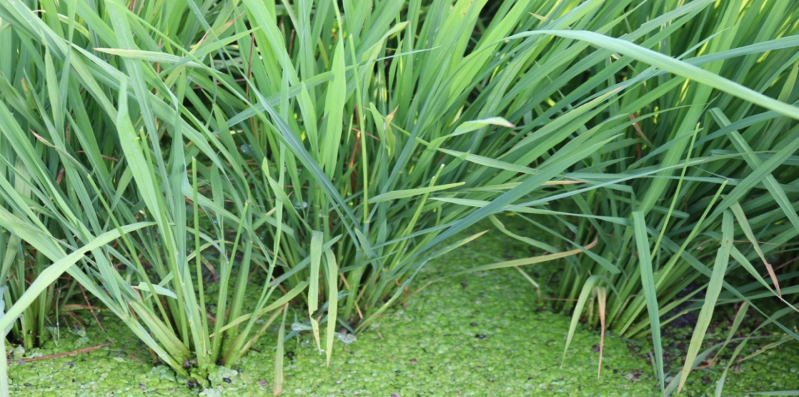

**(a)**

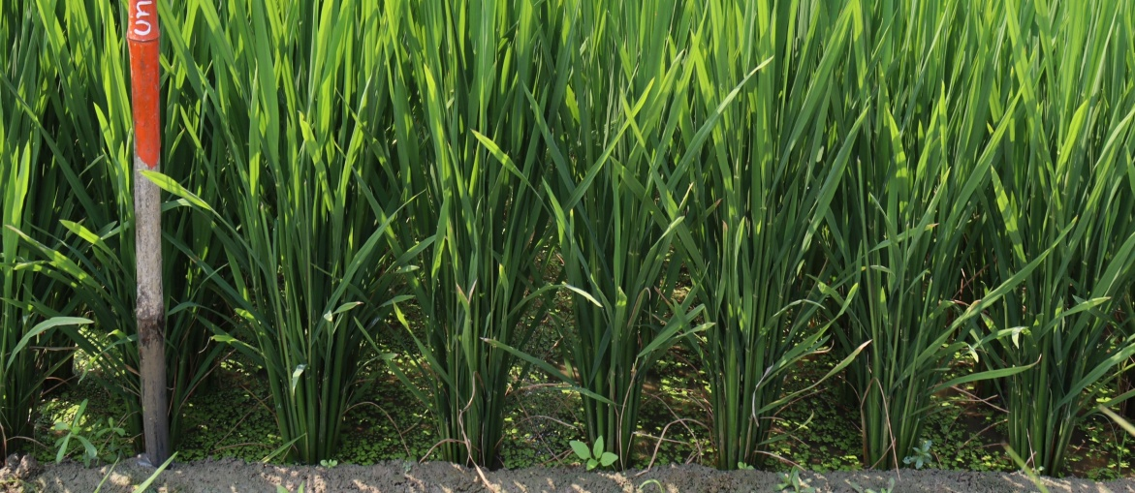

**(b)**

**Fig. 1 (a, b) Galls in untreated control plot**

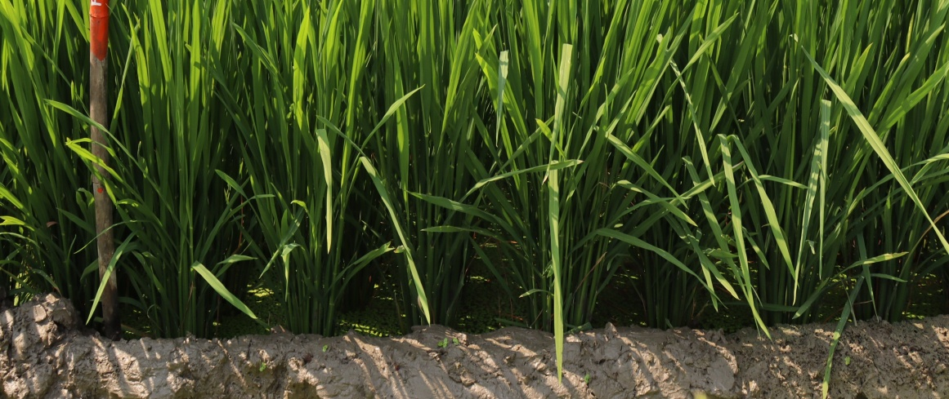

**Fig. 2 Less incidence of galls in fipronil treatment (T12) plot**

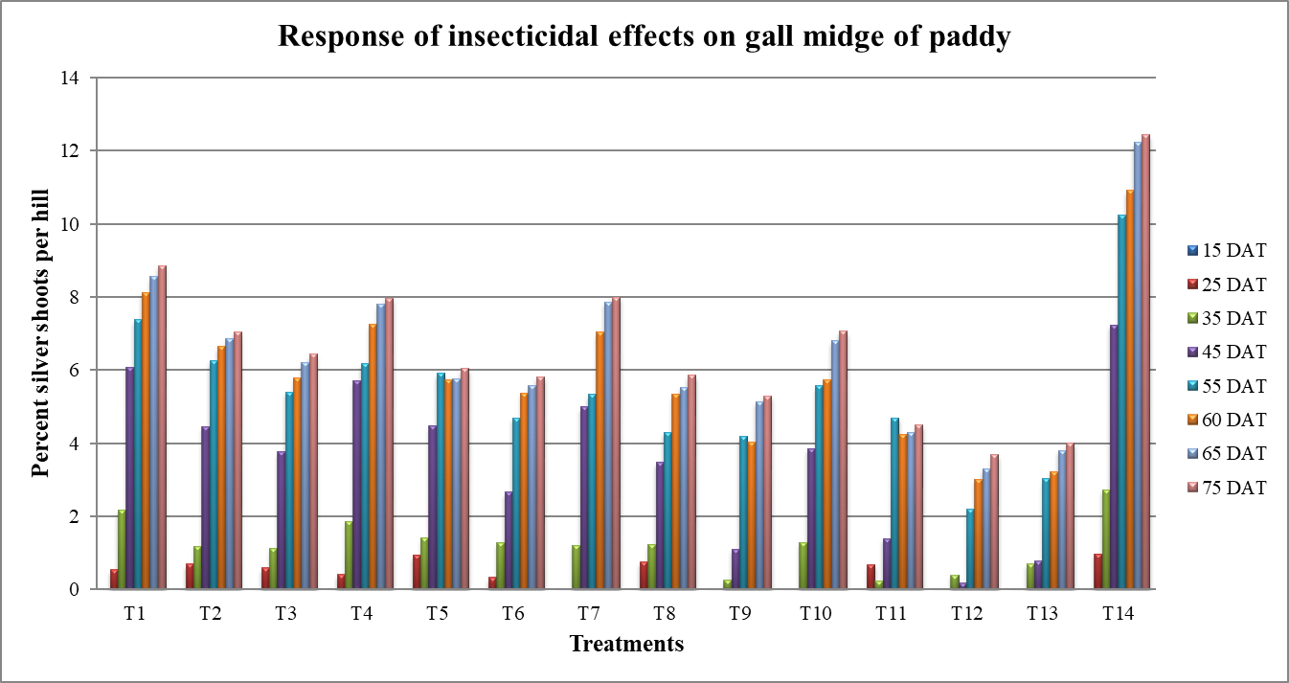

**Fig. 3 Response of insecticidal effects on the Gall midge of paddy**