***Original Research Article***

**Food and Feeding Habits of *Mystus cavasius* (Hamilton, 1822), a Bagrid freshwater catfish from River Burhi Gandak of Bihar, India**

**Abstract:** *Mystus cavasius* (Hamilton, 1822) is a popular food fish found in freshwater habitats. This study assessed diet composition, feeding intensity and Gastro-somatic index (GaSI) analysis of economically important Bagrid catfish, *M. cavasius* collected from six sampling locations in Burhi Gandak River from October 2020 to July 2021. A total of 286 fish specimens were examined of this species and the percentage of occurrence shows that gastropods were the most preferred food items. The result of the gut content analysis revealed that fish have carnivorous diet habits and consume various types of food present in the river. The Gastro-somatic index was recorded maximum in February and minimum in June. The result of the study will be useful for the culture, conservation, management and sustainable utilization of this species.

**Keywords:** *Mystus cavasius,* Gangetic Mystus, carnivorous, Gastro-somatic index, Burhi Gandak River

**INTRODUCTION**

The most essential component for the development and survival of any animal is food. A key requirement for boosting fish production is having proper knowledge of the diet of fish. The diet composition differs according to the time of day, breeding season, fish size, and season (Mamun, 2004). Fish diets are an integration of several ecological elements such as behavior, health, habitat utilization, energy use, and interactions between and within species. Feeding habit studies can therefore be used to achieve a wide range of distinct research goals. In the most basic example, research on feeding habits may be carried out to find out the most popular prey or whether a certain food type is found in fish stomachs (Chipps and Garvey, 2007). Planning and managing fisheries effectively requires an understanding of their biology, which includes a significant amount of information about their food and diet composition. The presence, distribution, and shoal of fish populations mostly depend on food availability. Because it is necessary to build an efficient fisheries management system, research on the diet and feeding habits of fish species is continued (Oronsaye and Nakpodia, 2005). A precise assessment of the diet of the fish gives the basis for studying the interaction between aquatic food web systems (Vander et al., 2000). For a deeper understanding fish life cycle including breeding, functional role, migration and growth in various fish species within aquatic ecosystems it is essential to understand their feeding habits, feeding ecology, and trophic relationships (Chaturvedi and Saksena, 2013).

The temporal and geographical fluctuation of food items in the diet composition is influenced by environmental conditions, which also determine the distribution of food creatures in the ecosystem (Bhakta et al.,2019). The availability of favourable food items, environmental factors, spawning cycle, and stage of maturation all affect the feeding intensity of fish, which typically decreases during the spawning season (Borah et al.,2020). Food and feeding behavior assessment provides us to identify the feeding patterns and intra- or inter-specific relationships of the corresponding species (Bhakta et al.,2019). The study of diet and feeding patterns is crucial to understanding the biology of any fish and the appropriate management strategies for them (Chakraborty et al., 2016).

The bagrid catfish*M. cavasius* is a small indigenous catfish species commonly known as Gangetic mystus andlocally known as ‘Palwa’ in Bihar. This fish has high-priced, high-nutritious value and high-demand food fish in the market. The distribution of *M. cavasius* is in most major river basins of India country and neighboring countries like Nepal, Myanmar, Pakistan, Bangladesh, and Sri Lanka (Talwar and Jhingran, 1991). The fish is generally found in freshwater environments i.e. wetlands, rivers, ponds, canals, flooded areas, lakes, beels and ditches. The peak spawning cycle for this fish occurs in July, while the breeding season takes from April to September (Roy, 2022). Due to its characteristics of rapid growth, short life cycles, high stocking density culture, and strong market demand, *M. cavasius* has been regarded as a desirable cultured fish (Rahman et al. 2013; Hossain et al. 2016). This bagrid catfish is listed as Least Concern (LC) in IUCN conservation status. The population of *M. cavasius* is mainly decreasing due to Fishing and harvesting of aquatic resources (IUCN, 2025) so knowledge of diet composition is essential. It has been noticed that this species of fish, which was originally from our country India, is disseminated as a native aquarium fish and was also classified as an ornamental fish (Gupta & Banerjee, 2014). A study by Kumar et al. (2025) exposed that high sediment in water due to heavy runoff during monsoon season, high pollution load in rivers from major cities (Muzaffarpur Samastipur, and Khagaria), exotic fish species, sand mining, agricultural runoff and no rules and regulation for exploitation of fisheries resources day by day degraded the Burhi Gandak River ecosystem.

Investigating the food and feeding biology of the economically important bagrid catfish species *M. cavasius* is the main objective of this study. A complete knowledge of diet composition, feeding intensity, food availability and prey-predator relationship in the trophic levels play important roles in ecological-based fisheries management models.

**MATERIALS AND METHODS**

**Study Area**

The Burhi Gandak River is a tributary of the River Ganga and runs in a south-easterly direction. About 400 km over the alluvial plain, Burhi Gandak meets River Ganga in the Khagaria of Bihar. The river Basin covers the West Champaran, East Champaran, Muzaffarpur, Samastipur and Khagaria districts of Bihar. Fig. 1 shows the sampling locations in the river.

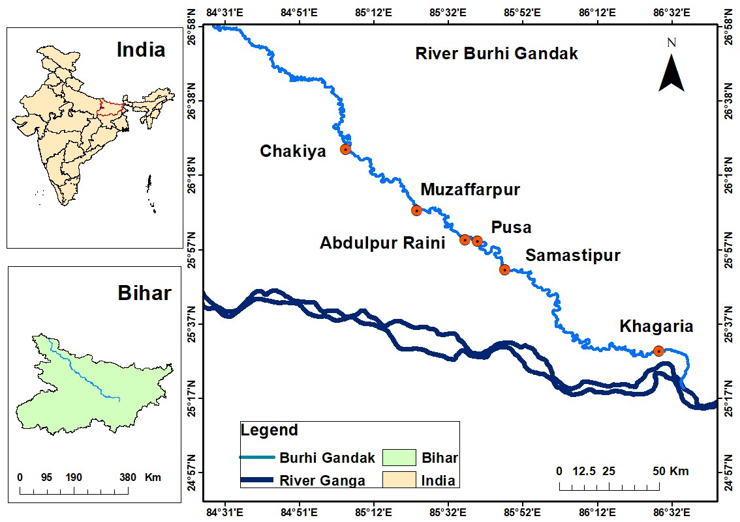

**Figure 1.** Map showing the sampling locations of specimen collection in River Burhi Gandak.

**Sample collection and identification**

Fish specimens were collected from six sampling locations i.e. Chakiya, Muzaffarpur, Abdulpur Raini, Pusa, Samastipur and Khagaria in Bihar. Fish samples were collected directly from local fishermen. Collected specimens were washed with clean water and kept in the ice box for further study. The total length (in cm) has been measured using measuring scales and the total weight (in gm) has been recorded using an electronic balance. After that specimens were dissected and the gut was removed carefully from the body of the fish. The overall length and weight of the gut were measured. Analysis of fish gut was examined in the laboratory using the microscope and every food item was identified.

**Percentage of food items occurrence (Hynes, 1950)**

Analysis of gut contents was done by using the percentage of food item occurrence in the gut of fish. The amount of each type of food in each gut has been recorded and expressed as a percentage of the total number of foods present in the sample being studied or as a percentage of the gut contents of each specimen being examined to determine the total percentage of gut content.

% Oi = Ni / N × 100

Where,

% Oi = available food items in gut (in %)

Ni = particular food items (in number)

N = gut content items (total number)

**Gastro-somatic Index (Desai, 1970)**

The Gastro-somatic Index assessed the feeding intensity of fish using the following formula.

GaSI = overall weight of gut × 100 /overall fish body weight

**RESULTS AND DISCUSSION**

**Gut content Analysis of *M. cavasius***

The diet composition, feeding intensity, and food availability for *M. cavasius* were calculated. 286 specimens of *M. cavasius*were taken from six sampling locations and various identified food items were observed shown in Table 1 and Fig. 2. Overall average gut content analysis (Fig. 3) revealed that gastropods (23.67%) were the most favourable diet of the fish in the Burhi Gandak River followed by prawns (13.007%), mud (12.567%), bivalves (11.258%), fish larvae (10.78%), unidentified species (7.345%), other crustaceans (7.131%), plant materials (5.352%), fish scales and other body parts (4.385%), insects (2.617%) and planktons (1.894%). Identified food items during the study in the gut of*M. cavasius* are shown in Fig. 5. The gut content analysis showed that fish have carnivorous diet habits and consume various types of food present in the river.

The feeding habits of similar fish species reported by Bhatt (1971) the result of the gut content analysis revealed *M. cavasius* was omnivorous feeding habits. This fish mainly feeds on insect larvae and nymph (22.6%) were the most dominant in the gut followed by molluscs (17.5%), higher aquatic plants (16.3%), algae and chironomid larvae (15.1%) and insects (13.3%). According to Rao (2007), *M. cavasius* is a bottom-feeding carnivore that mostly feeds in the littoral zone and is an insectivorous predatory fish. In order of significance, the food items that have been observed in the stomachs include mostly insects and their larvae, molluscs, and ostracods. According to Chaturvedi and Saksena (2013), *M. cavasius* is an eury-omnivorous fish and Bacillariophyceae (28.02 %) were the dominant food items in the diet followed by Cyanophyceae (16.87%), Chlorophyceae (7.93%), and Euglenophyceae (5.38%). A study by Rao (2017) revealed that the gut of *M. cavasius* constituted the highest percentage of crustaceans and insect parts (27.90%), followed by algae and protozoan (24.51%), molluscs (18.64%), plant materials (16.82%) and sand grains (12.13%) with omnivorous feeding habits. Chaturvedi and Parihar (2014) exposed that *M. cavasius* as eury-omnivorous fish and mainly feeds on Bacillariophyceae (the dominant group with 21.94 %) followed by Cyanophyceae (15.25%), Chlorophyceae (11.33 %) Euglenophyceae (8.69 %), Macroinvertebrates (4.71 %), Diptera larva (4.65 %), molluscs (4.59%), Trichoptera (4.26 %), Coleoptera (3.77 %), and roundworms (1.43%) miscellaneous food items (3.80 %).

There have also been observations of other species of Mystus having a carnivorous diet, including *M. tengra* from wetland of South-24-Paraganas, West Bengal(Gupta and Banerjee, 2014), *M. vittatus* from Vadavar River, Tamil Nadu (Victor et al., 2014), *M. gulio* from Shondha bazar fish markets, Khulna region, Bangladesh(Sabbir et al., 2017), *M. armatus* from Godavari River, Aurangabad, Maharashtra (Khillare and Khandare, 2020) and *M. oculatus* from Chalakudy River, Kerala(Renjithkumar and Roshni, 2021)*.*

**Table 1. Percentage of food occurrence of different categories in the gut of *M. cavasius.***

|  |  |  |  |  |  |  |  |  |  |  |  |
| --- | --- | --- | --- | --- | --- | --- | --- | --- | --- | --- | --- |
| **Food Items** | **October** | **November** | **December** | **January** | **February** | **March** | **April** | **May** | **June** | **July** | **Average** |
| **Sand and Mud** | 10.12 | 28.7 | 22.04 | 11.53 | 7.23 | 4.51 | 13.78 | 4.18 | 9.13 | 14.45 | 12.567 |
| **Prawns** | 6.72 | 15.1 | 12.16 | 12.19 | 16.26 | 15.25 | 12.09 | 8.57 | 11.5 | 20.23 | 13.007 |
| **Gastropods** | 23 | 16.7 | 14.28 | 24.23 | 25.03 | 19.17 | 26.18 | 43.73 | 26.4 | 17.92 | 23.664 |
| **Other Crustaceans** | 9.54 | 3.31 | 13.27 | 4.89 | - | 6.5 | 8.13 | - | 10.13 | 15.54 | 7.131 |
| **Planktons** | 2.17 | - | 3.23 | 5.4 | - | 1.23 | - | 2.68 | 1.01 | 3.22 | 1.894 |
| **Fish larvae** | 11.86 | 5.07 | 8.34 | 7.91 | 20.75 | 22.64 | 18.22 | - | 5.37 | 7.64 | 10.78 |
| **Insects** | 6.42 | 1.56 | 3.5 | - | - | 5.24 | - | 9.45 | - | - | 2.617 |
| **Plant materials** | 5.87 | 5.31 | 2.39 | 2.56 | 3.74 | 13.1 | 1.76 | 6.23 | 8.72 | 3.84 | 5.352 |
| **Unidentified species** | 8.18 | 16.34 | 9.04 | 7.01 | 5.12 | 7.12 | 4.31 | 7.16 | 4.05 | 5.12 | 7.345 |
| **Fish scales and other body parts** | 2.47 | 1.78 | 2.51 | 8.64 | 2.18 | 4.1 | - | 7.42 | 9.46 | 5.29 | 4.385 |
| **Bivalves** | 13.65 | 6.13 | 9.24 | 15.64 | 19.69 | 1.14 | 15.53 | 10.58 | 14.23 | 6.75 | 11.258 |

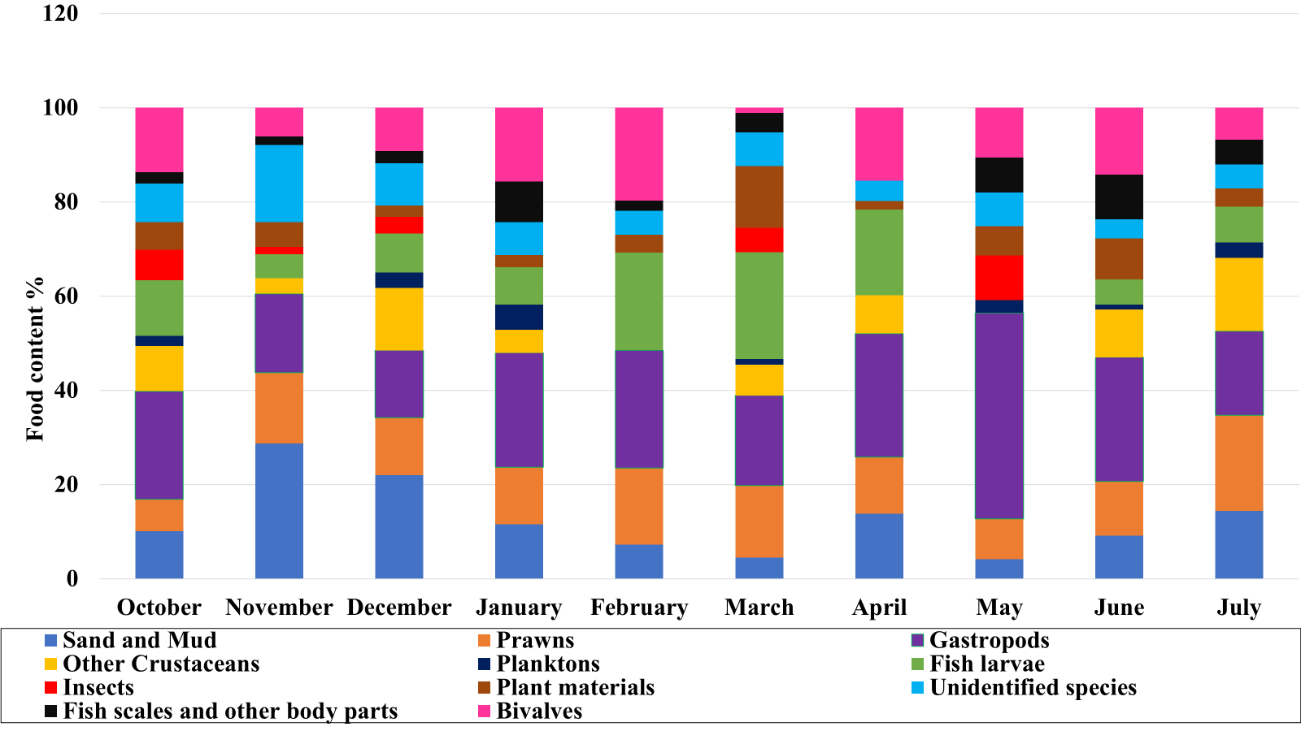

**Figure 2.** The diet composition of *M. cavasius* was observed in different months.

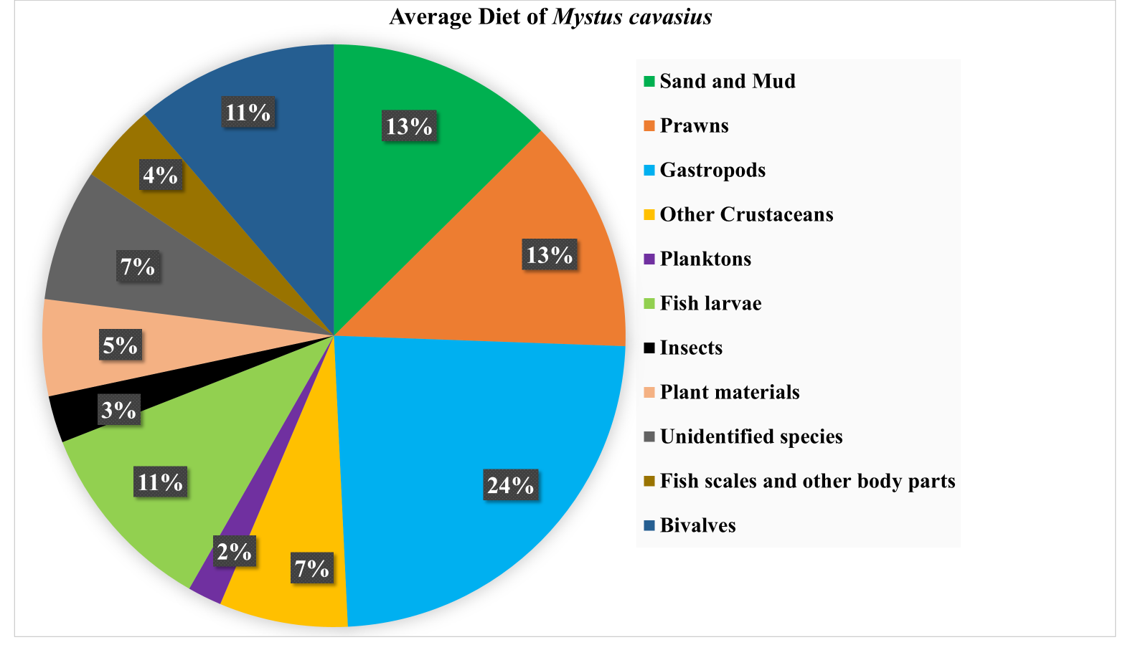

**Figure 3.** Average diet composition of *M. cavasius.*

**Gastro Somatic Index**

Gastro Somatic Index (GaSI) helps in the assessment of the feeding intensity of fish in various months and seasons. The GaSI of *M. cavasius* is given in Fig. 4 The GaSI was recorded as the highest in February and the lowest during the June season. This index is generally low during the peak spawning season due to minimum food intake and highest during the low spawning season of fish because of maximum food intake. The minimum GaSI recorded in June may be due to the breeding month because this fish phase has low feeding while the highest is in February due to pre-spawning month. In June, fish gonads reach the peak of maturity and fish decrease their diet while in February this is the development phase of gonads requiring more food and nutrition. Rao (2007) has also recorded minimum feeding activity during the spawning season in *M. cavasius*. Chaturvedi and Saksena (2013) observed maximum feeding intensity in December and January with high Gastro-somatic index values while minimum in June with low Gastro-somatic index values for *M. cavasius*. Many researchers investigated the gastro-somatic index or feeding intensity of various fish species. Additionally, Renjithkumar and Roshni (2021) also reported the GaSI values were lowest in June and highest in February for *Mystus oculatus*. According to Arthi et al. (2011), *Ompok bimaculatus* and *O. malabaricus* showed decreased feeding intensity in August and June, which may be related to the breeding season of fish rather than a lack of food. Because fish require more food and energy for growth and development, the intensity of food intake increases after spawning. Other catfishes, such as *Mystus tengara*, have previously shown a similar pattern of low GaSI values during the breeding period (Gupta and Banerjee 2014).

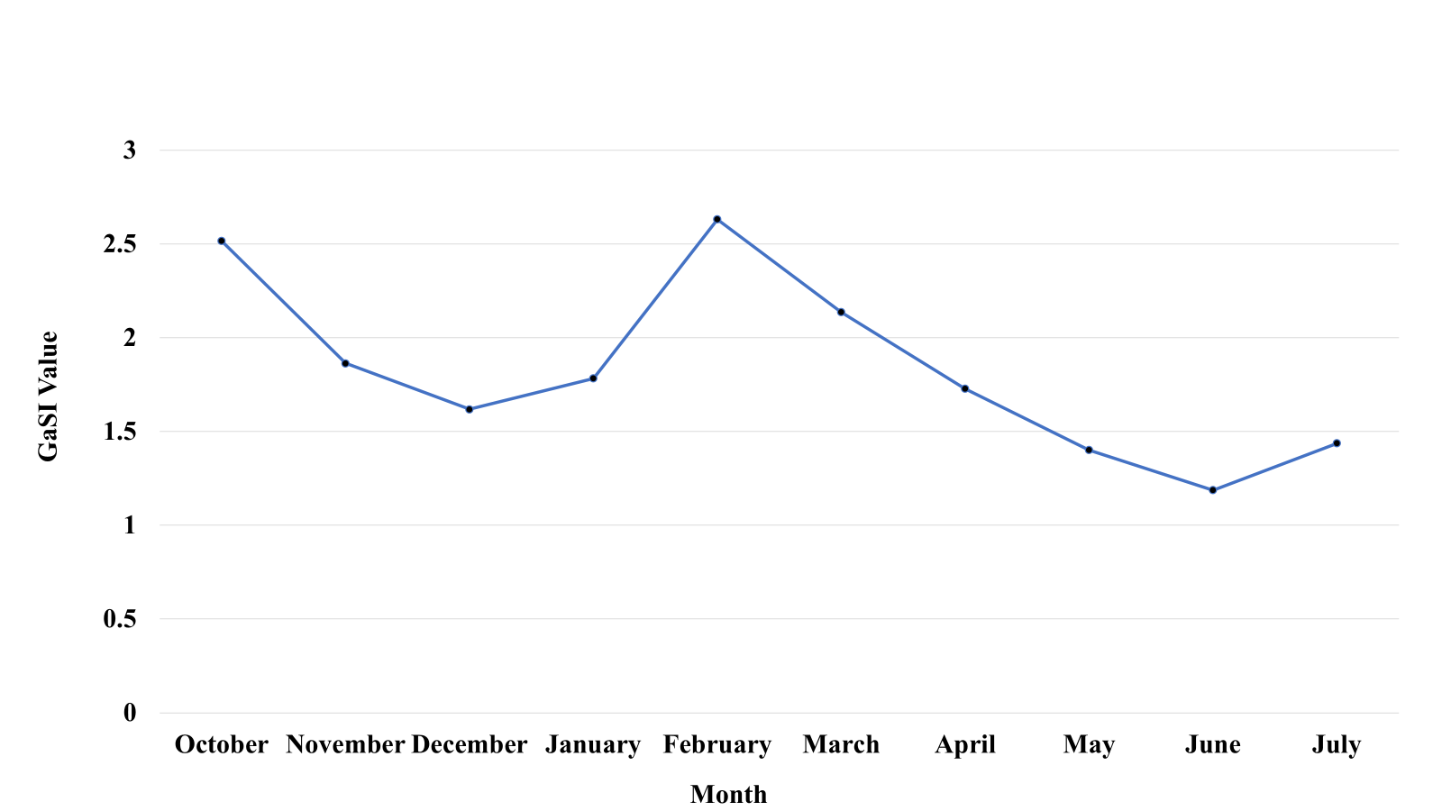

**Figure 4.** Monthly differences in the Gastro-somatic Index of *M. cavasius*

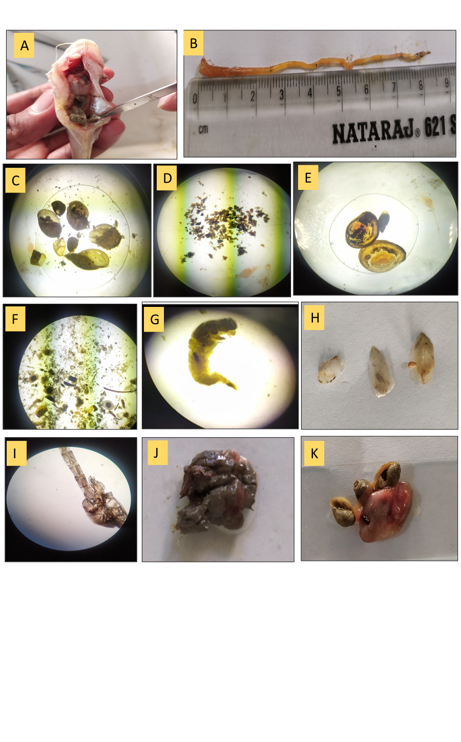**Figure 5.** Identified food items during the study in the gut of*M. cavasius.* **(A:** gastropods (snails) present in the gut; **B:** gut of *M. cavasius* **C:** gastropods viewed by Microscope **D:** unidentified materials **E:** bivalves (mussel) viewed by Microscope; **F:** algae, plant materials, fish scales; **G:** crustaceans (Prawns); **H:** fish scales; **I:** zooplankton; **J:** sand and mud; **K:** five gastropods (snails) examined from one specimen of *M. cavasius*)

**Conclusion**

The study on the gut content analysis of *M.cavasius* based on the percentage of food occurrence methods shows that *M. cavasius* has carnivorous feeding habits and feeds on different types of food items available in the river. The fish mostly feeds on animal as well as plant-origin food items. The results of the study reveal that Gastropods (23.67%) were the most preferred diet in the gut followed by prawns (13.007%), sand and mud (12.567%) and bivalves (11.258%). When we looked into based on biomass, there is a large amount of animal-origin food items in the diet. Therefore, it can be concluded from the findings that *M. cavasius* is a carnivorous fish. The gastro-somatic index (GaSI) of fish was recorded as lowest during the breeding phase (June) and highest during the pre-spawning phase (February), indicating that the feeding intensity of the fish changed seasonally. Throughout the investigation, we find variations in the gastro-somatic index of *M. cavasius*. The result of this study will be useful for conservation, trophic level in ecosystem and diet composition information for culture in captivity of the *M. cavasius.*

**DISCLAIMER (ARTIFICIAL INTELLIGENCE)**

Author(s) hereby declares that NO generative AI technologies such as Large Language Models (ChatGPT, COPILOT, etc.) and text-to-image generators have been used during the writing or editing of this manuscript.

**References**

1. Arthi, T., Nagarajan, S. and Sivakumar, A.A., 2011. Food and feeding habits of two freshwater fishes, *Ompok bimaculatus* and *O. malabaricus* of river Amaravathy, Tamil Nadu. *The Bioscan*, *6*(3), pp.417-420.
2. Bhakta, D., Das, S.K., Das, B.K., Nagesh, T.S. and Behera, S., 2019. Food and feeding habits of *Otolithoides pama* (Hamilton, 1822) occurring from Hooghly-Matlah estuary of West Bengal, India. *Regional Studies in Marine Science*, *32*, p.100860.
3. Bhatt, V.S., 1971. Studies on the biology of some freshwater fishes Part VI. *Mystus cavasius* (Ham.). *Hydrobiologia*, *38*, pp.289-302.
4. Borah, N., Das, S.K. and Bhakta, D., 2020. Temporal changes in feeding and bio-indices of *Polynemus paradiseus* (Linnaeus, 1758) occurring in Hooghly-Matlah estuary, West Bengal.
5. Chakraborty, R., Das, S.K. and Bhakta, D., 2016. Food and feeding habits of *Channa punctatus* (Bloch, 1973) from water bodies of Nadia district, West Bengal. *Journal of the Inland Fisheries Society of India*, *48*(2), pp.88-92.
6. Chaturvedi, J. and Parihar, D.S., 2014. Food and Feeding Habits of Two Freshwater Catfish, *Mystus cavasius* and *Xenentodon cancila* from Chambal River (MP). *International Journal of Science and Research (IJSR)*, *3*(8), pp.639-642.
7. Chaturvedi, J. and Saksena, D.N., 2013. Diet composition, feeding intensity, gastro-somatic index and hepatosomatic index of a catfish, *Mystus cavasius* from Chambal River (near, Rajghat) Morena, Madhya Pradesh. *Int J Recent Sci Res*, *4*(9), pp.1350-1356.
8. Chipps, S.R. and Garvey, J.E., 2007. Assessment of food habits and feeding patterns. *Analysis and interpretation of freshwater fisheries data. American Fisheries Society, Bethesda, Maryland*, pp.473-514.
9. Desai, V. R. 1970. Studies on the fishery and biology of *Tor tor* (Hamilton) from river Narmada. *J. Inland Fish. Soc. India*, 2: 101-112.
10. Froese, R. and D. Pauly. Editors. 2024. FishBase.  
    World Wide Web electronic publication.  
    www.fishbase.org, version (10/2024).
11. Gupta, S. and Banerjee, S., 2014. Food and feeding habit of a freshwater catfish, *Mystus tengara* (Siluriformes: Bagridae). *Journal of Ichthyology*, *54*, pp.742-748.
12. Gupta, S. and Banerjee, S., 2017. *Indigenous ornamental fish trade of West Bengal*. Arts & Science Academic Publishing.
13. Hossain, M.Y., Hossen, M.A., Pramanik, M.N.U., Sharmin, S., Nawer, F., Naser, S.M.A., Bahkali, A.H. and Elgorban, A.M., 2016. Length–weight and length–length relationships of five *Mystus* species from the Ganges and Rupsha rivers, Bangladesh. *Journal of Applied Ichthyology*, *32*(5), pp.994-997.
14. Hynes, H.B.N., 1950. The food of fresh-water sticklebacks (*Gasterosteus aculeatus* and *Pygosteus pungitius*), with a review of methods used in studies of the food of fishes. *The Journal of Animal Ecology*, pp.36-58.
15. Khillare, C. and Khandare, R., 2020. Food and feeding habits, length-weight relationship and condition factor of fresh water fish *Mystus armatus*. *Asian Journal of Fisheries and Aquatic Research*, *6*(3), pp.41-48.
16. Krishna Rao, D.S., 2007. Biology of the catfish, *Mystus cavasius* (Ham.), in the Hemavathi reservoir (Cauvery River system, Karnataka). *Journal of Inland Fisheries Society of India*, *39*(1), pp.35-39.
17. Kumar, V., Sharma, A., Ram, R.K., Kumar, S., and Singh, S.K., 2025. “Assessment of Fish Diversity Associated with Water Quality Parameters of Burhi Gandak River, North Bihar, India”. UTTAR PRADESH JOURNAL OF ZOOLOGY 46 (6):6-17.
18. Mamun, A., Tareq, K.M.A. and Azadi, M.A., 2004. Food and feeding habits of *Amblypharyngodon mola* (Hamilton) from Kaptai Reservoir, Bangladesh. *Pakistan Journal of Biological Sciences*, *7*(4), pp.584-588.
19. Oronsay, C.G. and Nakpodia, F.A., 2005. A comparative study of the food and feeding habits of *Chrysichthys nigrodigitatus* and *Brycinus nurse* in a tropical river. *Biological Sciences-PJSIR*, *48*(2), pp.118-121.
20. Rahman, M.A., Zaher, M., Azimuddin, K.M., Yeasmine, S., Khan, M.M. and Arshad, A., 2013. Stocking density effects on growth and production of the threatened silurid catfish, *Mystus cavasius* (Hamilton) fingerlings in nursery ponds. *Aquaculture Research*, *44*(7), pp.1132-1139.
21. Rao, K.R., 2017. Food and feeding habits of freshwater Catfishes (Siluriformes: Bagridae: *Mystus sp*.). *International Journal of Life-Sciences Scientific Research*, *3*(1), pp.786-791.
22. Renjithkumar, C.R. and Roshni, K., 2021. Feeding habits of an endemic bagrid catfish*, Mystus oculatus* from Western Ghats of India. *Indian Journal of Ecology*, *48*(4), pp.1165-1168.
23. Roy, D., Abedin, A.M.M.K., Sarker, A.K., Sarker, S., Begum, M.H. and Latifa, G.A., 2022. Some biological aspects of pond reared *Mystus cavasius* (Hamilton, 1822) collected from a local fish farm in Mymensingh, Bangladesh. *Aquaculture Studies*, *22*(4).
24. Sabbir, W., Basonti, M., Mukta, D., Md Nuruzzaman, K. and Tania, S., 2017. Biological Aspect of Nona Tengra (*Mystus gulio*) in Khulna Region, South West Bangladesh. *Journal of Biomaterials*, *1*(1), pp.19-24.
25. Talwar, P.K. and Jhingran, A.G., 1991. *Inland fishes of India and adjacent countries* (Vol. 2). CRC press.
26. Vander Zanden, M.J., Shuter, B.J., Lester, N.P. and Rasmussen, J.B., 2000. Within-and among-population variation in the trophic position of a pelagic predator, lake trout (*Salvelinus namaycush*). *Canadian Journal of Fisheries and Aquatic Sciences*, *57*(4), pp.725-731.
27. Victor, R.M., Sivakumar, R. and Mathialagan, R., 2014. Food and feeding habit and length-weight relationship of the Asian striped catfish *Mystus vittatus* (Bloch, 1794) (Siluriformes: Bagridae) in the Vadavar River, Lower Anicut, Tamil Nadu. *Indian Journal of Science*, *8*(20), pp.55-64.