**Investigating the Best Growth Medium for Dragon Fruit Propagation *(Hylocereus polyrhizus)***

**Abstract**

The development of suitable plant growing media is essential to address sustainability concerns in horticultural plant production. Currently, unconventional growing media components with unique physic-chemical properties are being used, but their effects on microbial activity vital for plant growth and development are not well understood. This study was conducted at the horticultural experimental area of Khalsa College, Amritsar, during the 2022-2023. A randomized block design with three replications was employed, with each replication consisting of nine treatments, including soil, sand, vermicompost, cocopeat, sawdust, and their combinations. The study aimed to investigate the impact of different growing media on the rooting, success, and survival of dragon fruit cuttings. Morphological parameters, such as sprouting, plant height, shoot and root length, as well as the fresh and dry weight of shoots and roots, were measured. The results revealed that the combination of soil and vermicompost (1:1) was the most effective in promoting sprouting, plant height, shoot and root length, diameter, and the fresh and dry weight of both shoots and roots, while also enhancing primary and secondary root formation. The study concludes that the combination of soil and vermicompost (1:1) provides the optimal growing media for dragon fruit cuttings, fostering improved growth and root development. This media mix not only supports better morphological growth but also enhances overall plant health, suggesting its potential for sustainable horticultural practices.

**Keywords:** Cuttings, Cocopeat, Growing media, Sprouting, Survival, Vermicompost

**Introduction**

Among exotic fruits dragon fruit (*Hylocereus spp*.) is a superior exotic fruit with cultivation benefits and marketing potential in Indian markets (Wakchaure *et al* 2023). It is a perennial climbing cactus that has a triangular, green, fleshy stem that belongs to the family Cactaceae and genus Hylocereus (Hossain *et al* 2021) and is known by various names, including Thang loy, Pitajava, Tuna, Pitajaya, Junco, and Tasajo and also nicknamed as Pitaya, Strawberry Pear, Night blooming cereus, Belle of the night, Conderella plant and Chintapalli. Its English vernacular name, refers to its prominent scaly spikes on the fruit's exterior (Minz *et al* 2021). Dragon fruit is an evergreen vine of 1.5 to 2.5 m in height with three winged green stems, branched segments with wavy wings and spines. Aerial roots are grown on the underside of the stem which on the absorption of water keep the stem on a vertical surface (Crane and Balerdi 2005; Merten 2003). Dragon fruit has functional, antiradical, anti-proliferative, and nutraceutical properties including vitamins, minerals, complex carbohydrates, antioxidants, and dietary fibers (Wakchaure *et al.* 2021). Consumption of dragon fruit promotes healthy gut bacteria growth and betacyanin (Liaotrakoon 2013) while also having low calories, zero cholesterol and higher antioxidants (Patel and Ishnava 2019). It also acts as a natural probiotic, stimulating the growth of microflora (Lactobacilli and Bifidobacteria) and suppressing the growth of gastro intestinal athogens (Sonawane 2017). Dragon fruit is usually propagated through seed or cuttings. Although seed propagation is very simple but seeds are not true to type and lose their viability after a certain time span (Seran and Thiresh 2015). Propagation through cuttings leads to the production of more plantlets with profuse shoots and roots (Zee *et al*. 2004). According to Ghosh and Bera (2015) stem cuttings form aerial roots which adhere to the surface upon which the vines are grown. Successful propagation of dragon fruit is attributed to the appropriate growing medium. It proved to be more effective for better growth of plants than single material (Shanker *et al*. 2019). Beneficial effect of various growing media on growth of the plants through cuttings has been reported (Markosa *et al.* 2018). Therefore, multiplication of dragon fruit cuttings can be done with an appropriate medium devoid of any fertilizer application (Singh and Kaur 2021).

**Materials and methods:**

**Plant materials and growth conditions:** The investigation was carried out during 2022-2023 at the horticultural experimental block Khalsa College, Amritsar. The experimental area is situated in the central plains of Punjab with an average elevation of 228.86 m above mean sea level representing the sub-tropical humid climatic conditions with an annual rainfall of 735 mm. The dragon fruit cuttings were sourced from one year old healthy mother plants of cv. American Beauty growing at dragon fruit and nursery production at Village- Thullewal, Nangal (Barnala).The cuttings of dragon fruit (*Hylocereus polyrhizus*) were treated in different media *viz.* soil, sand, vermicompost, cocopeat, sawdust and mixtures.

**Growth characters :** To compare the growth of dragon fruit (*Hylocereus polyrhizus)* cuttings affected by different media, the days to sprout initiation , number of sprouts per cutting, plant height, average shoot length, length of longest shoot, average shoot diameter, total chlorophyll, primary roots per cutting, secondary roots per cutting, root thickness, average root length, root volume , fresh and dry weights of shoots and roots per cutting , survival percentage after 120 days of planting were measured.

**Total chlorophyll (mg g-1):** Reagent: Dimethyl sulphoxide (DMSO)

Tissue (0.1g) was taken and dipped in 5 ml DMSO solution. The samples were kept in water bath at 60-70˚C for 1 hr for pigment extraction. The absorbance was recorded at 645 and 663 nm wavelength using spectrophotometer and the total chlorophyll (mg g-1) was quantified by using following formulae which is given by Arnon *et al* (1949):

$$Total Chlorophyll =20.2 \left(A645\right)+ 8.02(A663) \frac{V}{1000 ×W}$$

**Survival percentage (%):** The number of cuttings survived under each treatment in each replication was recorded and the survival percentage of cuttings was worked out with the help of following formula:

$$Survival (\%)=\frac{No. of cuttings survived}{Total no. of cuttings per treatment}×100$$

**Statistical analysis:** The data regarding sprouting and growth parameters of cuttings were collected and processed in MS-Excel. The experiments were laid out in a randomized complete block design with three replications. The statistical analysis was done by using R studio software.

**Results**

The growing media exhibited a significant effect (p≤0.05) on the average days to sprout initiation of cutting (Fig.1). Minimum (13.24) days to sprout initiation was noticed in soil+ vermicompost (1:1). Statistically analysed data (p≤0.05) depicted the vermicompost to be significantly superior with the highest 5.35 sprout formation per cutting.

Significantly the highest number of primary (11.33) and secondary (230.11) roots was produced in the plants grown from the cuttings in vermicompost substrate (Table 1). Rooting medium acts as one of the most important factors affecting the rooting of cuttings. The present study proved evidence regarding effect of the composition of the growth media on the rooting success of dragon fruit cuttings. The soil+ vermicompost (1:1) tended to produce the longer (27.44cm) roots (Fig.2- A), maximum (3.80 mm) root diameter, highest root volume (1.88cm3) , heaviest roots (2.66g) in terms of root fresh weight and maximum (0.84g) root dry weight (Fig.2-B-D).

The data showed that the combination of soil + vermicompost (1:1) tended to produce the maximum average (113.34) plant height, shoot length(23.07 cm) ,longest (30.43cm) shoot, highest (24.85mm) average shoot diameter, heaviest shoot fresh weight (94.74g) and highest (14.24g) shoot dry weight of dragon fruit cuttings.

The results of the study showed that growing media has a significant effect (p≤0.05) on the survival of cuttings. All the plants from cuttings survived in all the growing media having a growth rate of 55-95%. Above 90% survivability was noticed in some of the growing media. The highest survival (95.91%) was noticed in the cuttings sown in the media combination of soil + vermicompost (1:1). The growing media had significant influence (p≤0.05) on the total chlorophyll content of dragon fruit cuttings. Maximum (0.92 mg g-1) was calculated in the cuttings planted under the growing media combination of soil+vermicompost (1:1)**.**

**Fig.1.** Days to sprout initiation (A),and number of sprouts (B) of dragon fruit (*Hylocereus polyrhizus*) cuttings transplants in different types of growing media at 120 days .Vertical bars indicate standard errors of the means calculated by Duncan’s multiple range test at *p* ≤ 0.05.

**Table 1. Effect of various growing media on root characteristics of dragon fruit cuttings**

|  |  |  |  |
| --- | --- | --- | --- |
| **Treatments** | **Primary roots per cutting** | **Secondary roots per cutting** | **Root diameter(mm)** |
| T1 –Soil | 5.37±0.39f | 49.10±0.09h | 0.27±0.02h |
| T2 –Sand | 7.24±0.30e | 86.09±0.08g | 2.05±0.03c |
| T3- Vermicompost | 11.33±0.29a | 230.11±0.09a | 2.94±0.03b |
| T4- Cocopeat | 3.26±0.27g | 37.11±0.09i | 1.64±0.03d |
| T5- Sawdust | 11.22±0.35a | 189.51±0.44b | 1.45±0.03e |
| T6- Soil+ sand(1:1) | 9.17±0.18c | 127.17±0.15d | 2.09±0.02c |
| T7-Soil+vermicompost (1:1) | 7.34±0.30e | 97.09±0.07f | 3.80±0.06a |
| T8- Soil+ cocopeat (1:1) | 8.16±0.16d | 110.15±0.13e | 1.15±0.03f |
| T9- Soil+sawdust (1:1) | 10.28±0.32b | 158.03±0.03c | 1.03±0.03g |
| Mean | 8.15 | 120.48 | 1.82 |
| CD(p≤0.05) | 0.33 | 0.54 | 0.06 |

The subscript letters signify that the treatments means with similar letters are not significantly different at 5% level of significance, while the means with different letters are significantly different at 5%level of significance. These letters have been affixed based on CD-value comparison of treatment means.

**Fig.2** Average root length (cm) (A), root volume(cm3) (B) and root fresh weight (g) and root dry weight (D) of dragon fruit (*Hylocereus polyrhizus*) cuttings transplants in different types of growing media at 120 days. Vertical bars indicate standard errors of the means calculated by Duncan’s multiple range test at *p* ≤ 0.05.

**Table 2. Effect of various growing media on average plant height (cm),shoot length(cm),length of longest shoot (cm) and shoot diameter (mm) of dragon fruit cuttings**

|  |  |  |  |  |
| --- | --- | --- | --- | --- |
| **Treatments** | **Plant height (cm)** | **Average shoot length(cm)** | **Length of longest shoot (cm)** | **Average shoot diameter(mm)** |
| T1 –Soil | 96.54 ±0.24b | 18.37±0.10b | 29.44±0.39b | 21.74±0.02b |
| T2 –Sand | 63.44 ±0.32f | 11.24±0.10g | 20.58±0.19f | 18.35±0.02e |
| T3- Vermicompost | 87.74 ±0.24d | 16.75±0.11d | 26.37±0.39d | 19.34±0.03d |
| T4- Cocopeat | 51.50 ±0.16h | 8.29±0.03i | 18.48±0.08g | 21.06±0.03c |
| T5- Sawdust | 59.73 ±0.29g | 10.49±0.15h | 20.33±0.34f | 15.55±0.04g |
| T6- Soil+ sand(1:1) | 72.37 ±0.15e | 13.63±0.09f | 23.36±0.33e | 17.34±0.04f |
| T7- Soil+vermicompost (1:1) | 113.34 ±0.29a | 23.07±0.07a | 30.43±0.41 a | 24.85±0.02a |
| T8- Soil+ cocopeat (1:1) | 72.54 ±0.35e | 14.31±0.05e | 23.46±0.08e | 14.14±0.04i |
| T9- Soil+sawdust (1:1) | 94.80 ± 0.15c | 17.30±0.06c | 28.23±0.23c | 14.95±0.03h |
| Mean | 79.11 | 14.83 | 24.52 | 18.59 |
| CD(p≤0.05) | 0.45 | 0.16 | 0.46 | 0.45 |

The subscript letters signify that the treatments means with similar letters are not significantly different at 5% level of significance, while the means with different letters are significantly different at 5%level of significance. These letters have been affixed based on CD-value comparison of treatment means.

**Fig.3** Shoot fresh weight (g) (A) and shoot dry weight (g) (B) of dragon fruit (*Hylocereus polyrhizus*) cuttings transplants in different types of growing media at 120 days. Vertical bars indicate standard errors of the means calculated by Duncan’s multiple range test at *p* ≤ 0.05.

**Fig.4.** Survival percentage (A) and Total chlorophyll (mg g-1) (B) of dragon fruit (*Hylocereus polyrhizus*) cuttings transplants in different types of growing media at 120 days. Vertical bars indicate standard errors of the means calculated by Duncan’s multiple range test at *p* ≤ 0.05.

Fig 5: Correlation Heatmap of Root and shoot parameters

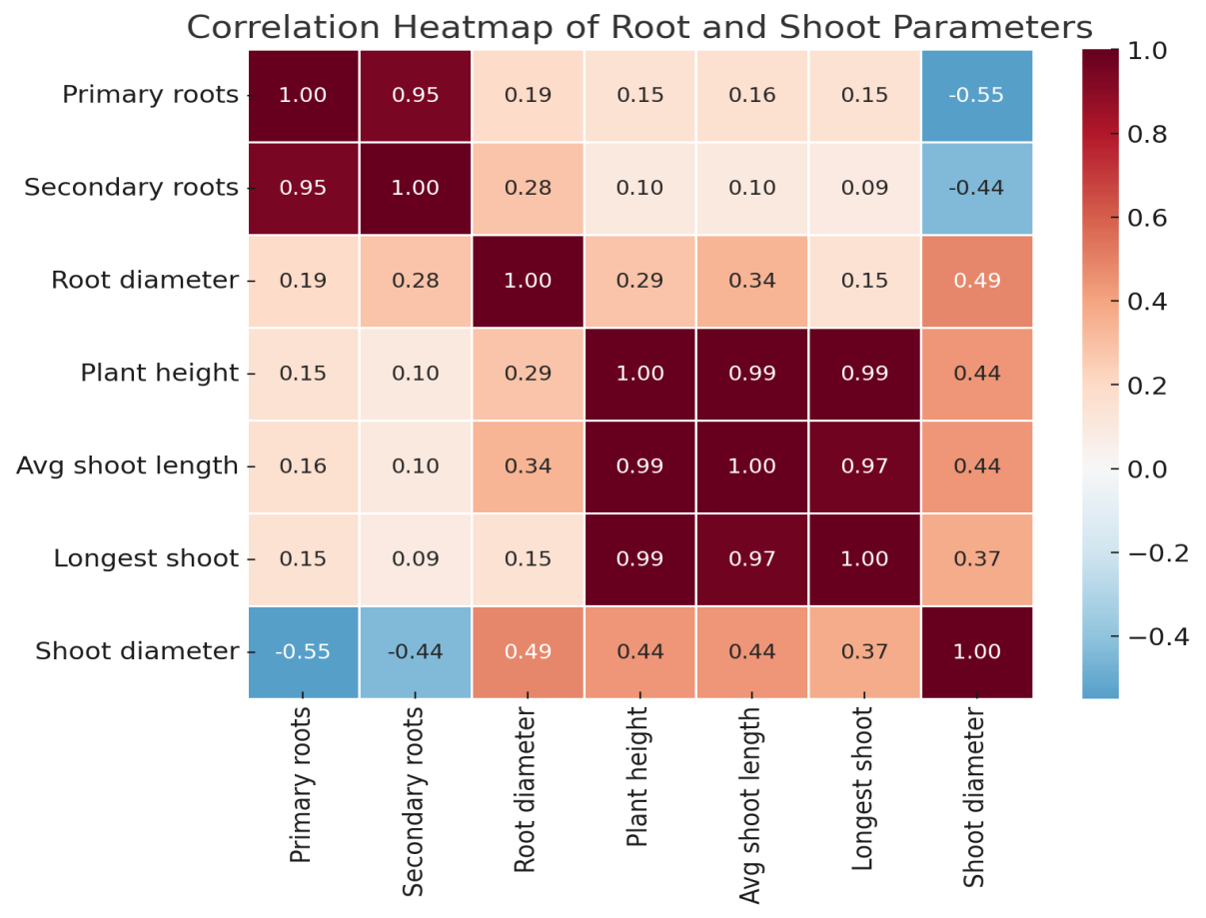

The correlation analysis of various plant growth parameters revealed significant relationships between root and shoot characteristics across different growing media treatments. A strong positive correlation was observed between primary and secondary roots (r = 0.89), while root diameter showed weak positive correlations with both primary (r = 0.13) and secondary roots (r = 0.15). Plant height demonstrated very strong positive correlations with average shoot length (r = 0.98), length of longest shoot (r = 0.97), and average shoot diameter (r = 0.71), indicating synchronized shoot development. However, the root-shoot relationships were more moderate, with root diameter showing a moderate positive correlation with plant height (r = 0.45) and other shoot measurements. Primary and secondary roots exhibited relatively weak correlations with shoot measurements, suggesting somewhat independent development between root and shoot systems. These findings indicate that while shoot growth characteristics develop in a highly coordinated manner, root development may be influenced by different factors in the growing media, which has important implications for optimizing plant growth conditions in various substrates.

**Discussion**

In the current study, favourable compatible conditions provided by vermicompost might be the reason for earlier sprout initiation in cuttings as reported by Tani *et al* (2021) in dragon fruit cuttings. Lesser days taken for sprout initiation due to vermicompost in guava and dragon fruit has also been revealed by Awasthi *et al* (2008) and Minz (2021) which is in agreement with the present findings. The higher organic matter in vermicompost resulting in the increased formation of nitro genic and phosphoric nutrients in the cells might have contributed to the more sprout formation (Sudarjat *et al* 2018). Good water holding capacity and high nutrient levels in the soil also accelerates the growth (Lopez-Bucio *et al* 2003;Norman *et al* 2005).The research results of Panchal *et al* (2014) in sapota, Rashmita *et al* (2016) in pear, Shah *et al* (2021) in grapes and Tani *et al* (2021) in dragon fruit revealed the increased sprout formation with vermicompost medium which supports the present research outcome.

Various factors such as oxygen, water and nutrient availability interacting within a rooting medium affect the rooting success roots (Alikhani *et al* 2011). It can be attributed to the congenial effect of the media. Combination of media supplemented with vermicompost increased porosity and looseness. Also better water holding and retention capacity to prevented desiccation of the cuttings due to increased aeration within the medium thus increasing length of root as reported by Sudarjat *et al* (2018) and Tani *et al* (2021) in dragon fruit cuttings. The root production with more diameter in soil supplemented with vermicompost can be attributed to the crumbled nature of growing media with nutrient availability resulting in root growth. The root acceleration leading to root vascular cambium formed the thickest roots. The present findings are in agreement with Kumar and Sangyan (2015) in cuttings of lemon, Rathwa *et al* (2017) in pomegranate and Tani *et al* (2021) in dragon fruit cuttings. Improvement in the root volume might be due to the better absorption of water and nutrients resulting in higher rate of plant growth (Wilcox *et al* 2004). The seedlings with strong root system due to better rooting media might have possessed higher root volume (Campo *et al* 2008).The present results revealed the linkage of organic amendments with root biomass which resulted in increased root growth Jindo *et al* (2012) reported that humic acid produced in the vermicompost aids in nutrient and water uptake ,cell differentiation and lateral root formation. The phosphorus in the medium is directly correlated with root growth promotion (Barita *et al* 2018) and also increased the root dry weight (Preusch *et al* 2004).The supply of high minerals with humic substances increased the root molecular weight as described by Madhavi *et al* (2021) in strawberry. Khot (2017) reported the highest dry weight with the same media in Bullock’s heart and Tani *et al* (2021) in dragon fruit.

The application of vermicompost as a growing medium improved the chemical properties of the soil.The availability of the nutrients in the soil affected the plant growth and development (Raffo *et al* 2014).As a result of it the increased plant height was the outcome of the research study. The research study of Tani *et al* (2021)in dragon fruit are in support with the present findings. The enhanced plant growth with the addition of vermicompost as the growing media has also been reported by Norman *et al* (2005). Panchal *et al* (2014) revealed the increased plant growth by vermicompost in khirni. Sudarjat *et al* (2018) also stated the vermicompost to be better media than others for plant growth in dragon fruit cuttings. The increased shoot length with media supplemented with vermicompost might be attributed to the nutritional superiority containing sufficient macro and micro nutrients, better water holding capacity, greater aeration, porosity and good drainage than other growing media which helped in forming better root and shoot development. The cuttings of dragon fruit tree respond well to the organic matter which might be the reason for greater shoot length (Antunes *et al* 2021). The enhanced shoot length can also be indirectly related to the hormonal effect that humic substances present in vermicompost exert on the plants (Cordeiro *et al* 2010).

Similar study with a conclusion that soil + vermicompost recorded the longest shoot length as compared to other media conducted by Sudarjat *et al* (2018) in dragon fruit cuttings are in line with the present findings. The better synergistic effect of the growing resulting in increased porosity and along with better water holding and water retention ability might be the reason that vermicompost when mixed with soil produced the maximum length of the shoot. This result is equivalent to result found by Sudarjat *et al*(2018) in dragon fruit which is in agreement with the present results. The availability of higher amount of growth promoting nutrients, proper aeration, improved soil status and ample moisture retention in the media combination might be the reason for higher shoot diameter (Atiyeh *et al* 2002). The similar results have been achieved by Tani *et al* (2021) in dragon fruit. Positive interaction between the media composition enriching nutrients which in turn improved the physical and chemical properties of media might have increased the fresh and dry weight of shoot (Atiyeh *et al* 2002).Presence of humic acid and growth substance properties in vermicompost which when combined with the soil and sand might have resulted in the increased plant growth in terms of heavier shoots (Arancon and Edwards 2005).The researchstudy of Dhakar *et al* (2016) also revealed an increased growth with vermicompost in papaya and Yadav *et al* (2012) in acid lime which is in line with the present findings. Tani *et al* (2021) advocated an increased shoot weight with vermicompost and soil which is also in support with the present investigation results.

Higher survivability can be attributed to the favourable physical soil conditions by vermicompost which resulted in the activation of biochemical processes (Wazir *et al* 2003). The application of vermicompost as a growing media hence improved the soil fertility resulting in the plant survival (Sudarjat *et al* 2018). The research study of Rashmita *et al* (2016) depicting the same results in pear are in agreement with the present results. Increase in survival of dragon fruit plants with vermicompost has also been revealed by Tani *et al* (2021) which are in agreement with the present study. Awasti *et al* (2008) in guava and Minz (2021) in dragon fruit cuttings also reported the same.Chlorophyll synthesis requires nitrogen and phosphorous from soil (Li *et al* 2018). Addition of vermicompost to soil increased the organic matter which in turn increased the plant growth (Sudarjat *et al* 2018). Hence increased amounts of them might be the reason for enhanced chlorophyll content. The literature evidencing the fact is not available.

**Conclusion**

The research study highlights that vermicompost, when combined with soil as a growing medium, offers significant benefits for plant growth. It not only improves mineral nutrition but also produces plant growth hormones and humic acids, which promote healthier and more vigorous plants. Additionally, the increased microbial activity and biomass from vermicomposting enhance root development, further supporting plant growth.This approach reduces the need for artificial hormones and costly inorganic fertilizers, making it both cost-effective and sustainable. Furthermore, the macro-organisms involved, such as earthworms, are readily available at minimal cost, making vermicomposting an economically viable practice.Encouraging the use of vermicomposting can, therefore, lead to more environmentally sustainable and economically efficient agricultural and horticultural practices.

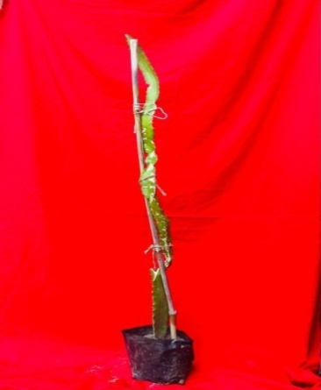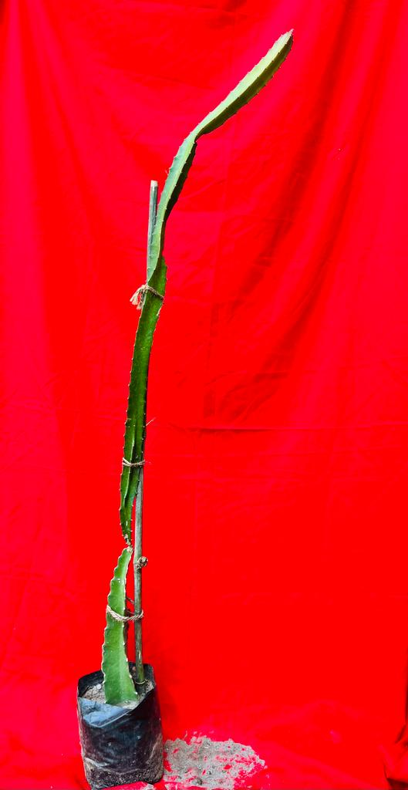

**Fig.6 (a) Vermicompost Fig.6 (b)Soil+Vermicompost(1:1)**

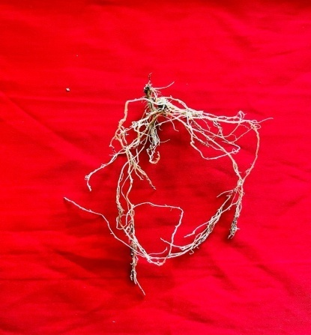

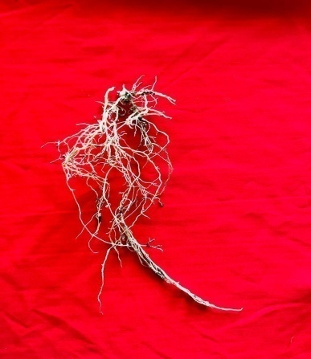

**Fig.6 (c) Vermicompost Fig.6(d) Soil+Vermicompost(1:1)**

**Fig.6 :** Result are depicted in 5(a),5(b),5(c),5(d) under the shoot and root parameters of dragon fruit (*Hylocereus polyrhizus*) cuttings transplants in different types of growing media at 120 days.

Disclaimer (Artificial intelligence)

Option 1:

Author(s) hereby declare that NO generative AI technologies such as Large Language Models (ChatGPT, COPILOT, etc.) and text-to-image generators have been used during the writing or editing of this manuscript.

Option 2:

Author(s) hereby declare that generative AI technologies such as Large Language Models, etc. have been used during the writing or editing of manuscripts. This explanation will include the name, version, model, and source of the generative AI technology and as well as all input prompts provided to the generative AI technology

Details of the AI usage are given below:

1.

2.

3.

**References**

Alikhani L, Anasari K, Jamnezhad M, Tabatabaie Z. Effect of different media and cuttings on growth and rooting of pomegranate cuttings. Iran J Plant Physiol. 2011;1:199-203.

Antunes LFS, Vaz AFS, Silva MSRA, Correia MEF, Cruvinel FF, Martelleto LAP. Millicompost: Sustainable substrate for the production of dragon fruit seedlings (Selenicereus undatus). Cleaner Eng Technol. 2021;4:100-07.

Arancon NQ, Edwards CA. Effects of vermicomposts on plant growth. Soil Ecol Lab, Ohio State Univ, Columbus, OH. 2005;16-18.

Atiyeh RM, Lee SS, Edwards CA, Arancon NQ, Metzager J. The influence of humic acid derived from earthworm processed organic waste on plant growth. Bioresour Technol. [Internet]. 2002;84:7-14.

Awasthi P, Lal S, Singh BC. Influence of stooling time and IBA concentrations on growth attributes of stooled shoots in guava Pant Prabhat. Prog Res.2008;3:154-56.

Barita Y, Prihastanti E, Haryanti S, Subagio A. The influence of granting NPK fertilizer and nanosilic fertilizers on the growth of Ganyong plant (Canna edulis Ker.). J Phys Conf Ser. 2018;1025.

Campo JG, Palacio S, Rontome CP, Marti Gm. Effect of root system morphology on root-sprouting and shoot-rooting abilities in 123 plant species from eroded lands in north-east Spain. Ann Bot. 2008;98:439-47.

Cordeiro F, Fernandes MS, Souza S. Influência dos ácidos húmicos no metabolismo vegetal pode ser considerada uma resposta auxínica? Rev Ciênc Vida.2010 ;30:111-31.

Crane JH, Balerdi CF. Pitaya (Dragonfruit) growing in the Florida home landscape. UF/IFAS Extension, University of Florida. 2005

Dhakar SS, Kaushik RA, Sarolia DK. Influence of growing media and containers on germination and seedling growth of papaya (Carica papaya L.) cv. Pusa Nanha. Green Farming. 2016 ;7:451-54.

Ghosh SN, Bera B. Studies on standardization of propagation methods of some minor fruit crops in India. Int J Minor Fruits Med Aromat Plants.2015;1:31-36.

Hossain FM, Numan SMN, Akhtar S. Cultivation, nutritional value, and health benefits of Dragon fruit (Hylocereus spp.): A review. Int J Hortic Sci Technol.2021;8:259-69.

Jindo K, Martim SA, Navarro EC, Perez-Alfocea F, Hernandez T, Garcia C, Canellas LP. Root growth promotion by humic acids from composted and non-composted urban organic wastes. Plant Soil. 2012;353:209–20.

Khot AA. Effect of different potting media on success and growth of Bullock’s Heart (Annona reticulata L.). M.Sc. Agri. Thesis. Dr. B.S. Konkan Krishi Vidyapeeth, Dapoli, Maharashtra. 2017

Kumar V, Sangyan V. Growing media for healthy seedling production.2015;2:19-20.

Li Y, He N, Hou J, Xu L, Liu C, Zhang J, Wang Q, Zhang X, Wu X. Factors influencing leaf chlorophyll content in natural forests at the biome scale. Front Ecol Evol.2018;6.

Liaotrakoon W. Characterization of Dragon fruit (Hylocereus spp.) components with valorization potential. Ph.D. Thesis. Ghent University, Belgium.2013;217.

Lopez-Bucio J, Ramirez-Cruz A, Herrera-Estrella L. The role of nutrient availability in regulating root architecture. Curr Opin Plant Biol. 2003;6:280-87.

Madhavi BGK, Khan F, Bhujel A, Jaihuni M, Kim NE, Moon BE, Kima HT. Influence of different growing media on the growth and development of strawberry plants. Heliyon. 2021;7:70-71.

Markoska V, Spalevic V, Gulaboski R. A research on the influence of porosity on perlite substrate and its interaction on porosity of two types of soil and peat substrate. Agric For. 2018;64:15-29.

Minz V, Panigrahi KH, Sangeeta. Effect of different plant growth regulators and media on shooting of stem cuttings in dragon fruit. J Pharm Innov. 2021;10:330-32.

Merten S. A review of Hylocereus production in the United States. J Prof Assoc Cactus Dev.2003;59:8-105.

Norman Q, Arancon, Edwards CA. Effects of vermicomposts on plant growth. Int Symp Workshop Vermit Technol Dev Countries, Los Banos, Philippines.2005 ;1-25.

Panchal GP, Parasana JS, Patel SR, Patel MV. Effect of different growing media and levels of IBA on growth and development of khirni (Manilkara hexandra Roxb) seedlings cv. Local. Glob J Bio-Sci Biotechnol. 2014 ;3:379-83.

Patel SK, Ishnava KB. In-vitro antioxidant and antimicrobial activity of fruit pulp and peel of Hylocereus undatus (Haworth) Britton and Rose. Asian J Ethnopharmacol Med Foods. 2019 ;5:30-34.

Preusch PL, Takeda F, Tworkoski TJ. N and P uptake by strawberry plants grown with composted poultry litter. Sci Hortic. 2004 ;102:91-103.

Raffo A, Baiamonte I, Bucci R, D'Aloise A, Kelderer M, Matteazzi A, Moneta E, Nardo N, Paoletti F, Peparaio M. Effects of different organic and conventional fertilizers on flavor-related quality attributes of cv. Golden Delicious apples. LWT-Food Sci Technol. 2014 ;59:964-972.

Rashmita, Misra S, Tudu S, Shanker K. Effect of different media on rooting and survival of pear (Pyrus pyrifolia L.) cuttings cv. Patharnakh. Int J Bio-Res Stress Manag. 2016;7:636-40.

Rathwa AD, Singh V, Patel DD, Patel AH. Influence of propagation media on growth of hardwood and semi-hardwood cuttings of pomegranate cv. Bhagwa. Trends Biosci. 2017;10:6023-27.

Seran HT, Thiresh A. Root and shoot growth of dragon fruit (Hylocereus undatus) stem cutting as influenced by indole butyric acid. J Agric Biol Sci. 2015;1:27-30.

Shah SU, Ayub Q, Hussain I, Khan SM, Ali S, Khan MA. Effect of different growing media on survival and growth of grape (Vitis vinifera) cuttings. J Adv Nutr Sci Technol.2021;1:117-124.

Shanker K, Misra S, Topwal M, Singh VK. Research review on use of different rooting media in fruit crops. J Pharmacogn Phytochem. 2019 ;8:258-61.

Singh D, Kaur A. Response of rooting media on sprouting propagation through cuttings in peach (Prunus persica) cv. Shan-i-Punjab. Res Crops. 2021;22:68-73.

Sonawane MS. Nutritive and medicinal value of Dragon fruit. Asian J Agric Hortic Res. 2017;12:267-71.

Sudarjat I, Wardhani V, Mubarok S. Different growing media effect on the cutting quality of two dragon fruit species (Hylocereus sp.). J Agron. 2018;17:174-79.

Tani M, Panigrahi KH, Sarkar A, Thakur G, Tahelyani. Studies on the effect of different growing media on survivability, root and shoot growth of dragon fruit (Hylocereus polyrhizus L.) cuttings. J Pharm Innov. 2021;10:1497-1503.

Wakchaure GC, Kumar S, Meena KK, Rane J, Pathak H. Dragon fruit cultivation in India: Scope, constraints and policy issues. Tech Bull No. 27. ICAR–National Institute of Abiotic Stress Management, Baramati, Pune, Maharashtra, India.2021;47-50.

Wakchaure GC, Minhas PS, Kumar S, Mane P, Kumar PS, Rane J, Pathak H. Long-term response of dragon fruit (Hylocereus undatus) to transformed rooting zone of a shallow soil improving yield, storage quality and profitability in a drought-prone semi-arid agro-ecosystem. Saudi J Biol Sci. 2023;30:103-06.

Wazir MG, Amin NU, Ishtiaq M, Aziz A, Khan IA. Effects of different soil media on the growth of Dracaena dermensis var. Janet Craige cuttings. Sarhad J Agric.2003;19:31-40.

Wilcox CS, Ferguson JW, Fernandez GCJ, Nowak RS. Fine root growth dynamics of four Mojave Desert shrubs as related to soil moisture and microsite. J Arid Environ. 2004 ;56:129-48.

Yadav RK, Jain MC, Jhakar RP. Effect of media on growth and development of acid lime (Citrus aurantifolia Swingle) with or without Azotobacter. Afr J Agric Res.2012 ;7:6421-26.

Zee F, Yen CR, Nishina M. Pitaya (Dragon fruit, Strawberry pear). Fruit Nuts 9. Coop Ext Serv, College of Tropical Agriculture and Human Resources, Univ of Hawaii at Manoa, Honolulu, Hawaii.2004.