**Effects of Organic Calcium Sources and Calcium nutrition on Growth, Yield, and Quality of Okra (*Abelmoschus esculentus* L Moench)**

ABSTRACT

The field experiments were conducted at the College of Agriculture, Padannakkad and RARS, Pilicode Kerala Agricultural University. The first investigation was performed in a completely randomized design with three treatments - by dissolving egg shells, bone pieces and powdered lime shell in coconut water vinegar replicated five times. The objective was to develop an organic calcium source for foliar spray by studying the physico- chemical characteristics and shelf life. The second experiment aimed to identify the best source and method of calcium nutrition, thereby assessing its impact on the growth, productivity, and profitability of okra [*Abelmoschus esculentus* (L.) Moench]. This experiment was carried out in a randomized block design (RBD) with nine treatments replicated three times. The solution prepared from egg shells can be used as an organic calcium source for foliar sprays. The highest fruit weight was exhibited by T6(KAU POP + foliar spray of 0.5 percent calcium chloride), which was statistically on par with T5(KAU POP + foliar spray of one percent calcium nitrate) and T7 (KAU POP + foliar spray of 0.5 percent calcium acetate). The total fruit yield (24.93 t ha-1) was significantly superior in all treatments where calcium is applied externally. Foliar application of calcium chloride and calcium nitrate along with KAU POP significantly increased fruit and plant dry matter production. The results demonstrate the significant role of calcium nutrition in enhancing yield, quality and economic returns in okra. The application of the recommended dose of nutrients as per KAU POP coupled with foliar spray of either 0.5% calcium chloride or 1.0% calcium nitrate can be suggested for improving calcium nutrition and thereby productivity in Okra.

**Keywords:** Calcium nutrition, Organic calcium, Egg shell, Foliar spray, Okra, Productivity

1 College of Agriculture, Padannakkad (Kerala Agricultural University, Thrissur, Kerala); 2 Professor (Agronomy) & ADR (M&E), Directorate of Research (Kerala Agricultural University, Thrissur, Kerala), *Corresponding author email: vandana.v@kau.in

INTRODUCTION

Okra *(Abelmoschus esculentus* (L.) Moench) belongs to the Malvaceae family and is an important vegetable grown throughout India as a summer crop. It is cultivated year-round in Kerala. Okra is consumed as a fresh vegetable and used in culinary preparations. It is also added for the thickening of gravies and soups. Okra provides carbohydrates, fat, protein, minerals and vitamins that are essential for human nutrition.

Calcium is present as calcium pectate in the middle lamella. It is essential for strengthening the cell wall and plant tissues and thereby provides mechanical support. The proportion of calcium pectate in the cell wall thus determines the sensitivity of tissue to bacterial and fungal infections (Marschner, 2012) and fruit ripening (Ferguson, 1984). This process preserves fruit quality by regulating the respiration rate and minimizes the evolution of ethylene from tender fruits, thereby conserving the moisture content and preserving the freshness of the fruit (Balasubramanian *et al*., 2010). Even a relatively small increase in the concentration of calcium in fruits can be effective in preventing or reducing storage losses and thereby increasing economic returns. Water-soluble calcium extracted from egg shells has been proven to be an efficient and effective natural farming technique in Korea. Water-soluble supplements of calcium available in the market are expensive. Therefore, this study investigated the development and characterization of a water soluble organic calcium source for foliar sprays with locally available inputs.

Calcium deficiency may occur in soils with less base saturation and increased levels of acidic deposition (McLaughlin and Wimmer, 1999). Lime stone and dolomite are commonly used liming materials in acidic soils. Calcium mobility in plants occurs through the xylem rather than the phloem, together with water. The uptake and transport of calcium are passive, and upward movement occurs with transpiration (Epstein, 1972). Therefore, the uptake of calcium is directly related to the transpiration rate. Calcium deficiencies are caused either by decreased availability of calcium or by water stress, which results in low rates of transpiration. Calcium cannot be mobilized from older tissues and redistributed via the phloem. This forces the tissues to lean upon the immediate supply of calcium in the xylem. The transpiration rate is low in young leaves, enclosed tissues and fruits (White and Broadley, 2003). Therefore, it is essential to ensure the constant supply of calcium required for continuous plant growth. The low transpiration rate of fruits in combination with the mobility of calcium in the phloem causes serious problems, enhancing the distribution of the element to the fruit via calcium application to the root system (Bangerth, 1979). Therefore, calcium sprays in the aerial parts of plants are recommended and applied in many fruit production zones of the world (Lurie and Crisosto, 2005), either as a routine application to lessen or prevent the emergence of calcium deficiencies in localized areas or to enhance the quality of commodities in the market (Liebisch *et al*., 2009). When you feed plants through their leaves, the nutrients are quickly taken up and moved to different parts of the plant. This makes it possible to quickly fix nutrient deficits, which increases the production and marketability of the food (Fageria et al., 2009).

MATERIALS AND METHODS

A laboratory study was undertaken to develop and characterize an organic calcium source for foliar sprays. The investigation was performed in a completely randomized design with three treatments replicated five times. The resultant solutions were obtained by dissolving egg shells (T1), bone pieces (T2) and powdered lime shell (T3) in coconut water vinegar as the solvent. Observations of colour, pH, EC, nutrient content and shelf life were recorded at intervals.

The field experiment was conducted at the Regional Agricultural Research Station, Pilicode, to identify the best source and method of calcium nutrition and thereby assess its impact on the growth, productivity and profitability of okra. The experiment was laid out in a randomized block design with nine treatments and three replications. The treatment combinations were, KAU POP @ 110:35:70 kg ha-1 N:P2O5:K2O (T1), Organic POP (T2), KAU POP + lime as soil application (T3), KAU POP + dolomite as soil application (T4), KAU POP + foliar spray of one percent calcium nitrate (T5), KAU POP + foliar spray of 0.5 percent calcium chloride (T6), KAU POP + foliar spray of 0.5 percent calcium acetate (T7), KAU POP + foliar spray of organic calcium extracted from egg shell (T8) and KAU POP + foliar spray of coconut water vinegar (T9). Foliar sprays were applied at 30, 45, 60 and 75 DAS. For plots with T2, 190.4 kg of rock phosphate and 173 kg sulfate of potash along with *Pseudomonas fluorescens* @ 2 kg ha-1 were given as basal doses at the 3-leaf stage, and vermicompost application was performed at 1 t ha-1 after one month of sowing as per the Organic Package of Practices Recommendations (KAU, 2017). The data obtained from the experiment were analysed statistically by following the techniques of analysis of variance (ANOVA) for randomised block design (Panse and Sukhatme, 1995).

RESULTS AND DISCUSSION

In the Korean natural farming technique, the water- soluble form of calcium extracted from eggshells is widely used. The use of brown rice vinegar as a solvent has been proven to be an effective and efficient method. In this study, water-soluble calcium was extracted from three sources of calcium, namely, eggshells, bone pieces and powdered lime shells, using coconut vinegar as the solvent. The different steps followed during the experiment are explained below.

First, the internal membranes in the egg shell were removed, and then the eggshell and lime shell were cleaned, powdered into small pieces and roasted in a frying pan to a light tan colour. The roasted shells were slowly added to a glass container containing natural coconut water vinegar at a weight ratio of 1:10. The shell fragments floated up and down within the vinegar, releasing carbon dioxide bubbles, while the calcium dissolved into the solution. The mouth of the jar was covered with cloth and secured with rubber bands to ensure that it was freed of maggots. The jar was placed in a cool, dark location for a period of 10 days. Since bubbles were not present after 10 days, more roasted shells were not added and were allowed to stand for 1 to 2 days as per the standard procedure available with brown rice vinegar as the solvent. The resultant solution was strained to remove shells and stored in a clean glass jar at room temperature away from direct sunlight. In the case of bone pieces, the collected vertebrate bones were boiled to remove fat and meat. Then, they were pounded into pieces and roasted in the same way as the shells except that they were treated with coconut water vinegar at a ratio of 1:5 by weight. All other steps were the same. The solutions were stored in clean glass containers away from direct sunlight, and the analysis was performed.

The pH of the solutions differed significantly among the treatments. The solutions were acidic in nature after 10 days of preparation and ranged from 3.76 - 4.59. This was in line with the findings of Chang *et al*. (2008) and Dhanalakshami (2017). The acidic nature of the solution might be due to the acetic acid content in the coconut water vinegar. The lowest pH was recorded for the solutions extracted from bone pieces. The pH of coconut water vinegar (3.1) increased after the addition of lime shells, bone pieces and egg shells. This indicates the role of calcium in decreasing the acidity. Kannan (1980) reported that spray solutions should have a pH ranging from 3.0 to 5.5 for nutrient uptake. Blanpied (1979) reported that the maximum absorption of calcium occurred in apple leaves when the pH of the spray solution ranged from 3.3 to 5.2. A cuticle with an isoelectric point of pH 3 will become negatively charged when solutions greater than this pH are sprayed. This results in the easy binding of carboxyl groups of the cuticle with positively charged cations (Schonherr and Huber, 1977). After 30 days of preparation, all the solutions remained acidic and ranged from 4.22-4.29. They did not vary with the treatments. The EC of the solution differed significantly at 10 and 30 days of preparation and varied from 0.05 - 0.13 dS m-1. The highest EC was in the solution prepared from the powdered lime shell.

The nitrogen content in the solution showed no variation with the treatments at 10 and 30 days after preparation. The phosphorus content differed significantly between treatments at 10 and 30 days after preparation and was highest recorded in the solution extracted from bone pieces. The highest phosphorus content in the solution extracted from bone pieces may be due to the dissolution of high amounts of phosphorus present in the bone pieces under the action of acid. The phosphorus content of bones is 18.66% on a dry weight basis (Al Ghuzaili *et al*., 2019).

At ten days after preparation, the potassium content in the solution from the powdered lime shell was at its maximum and the potassium content was on par with that of the bone pieces.

The calcium content in the solutions significantly influenced the treatments at 10 and 30 days after preparation. When calcium sources such as egg shells, bone pieces and lime shells are mixed with a weak acid such as coconut water vinegar, the chemical reaction converts calcium into an available form, creating carbon dioxide that escapes as gas and water (Mitchell, 2005). It was highest in the solution extracted from the powdered lime shell at 10 days after preparation. At 30 days after preparation, the maximum value was recorded for the powdered lime shell (13640 ppm), which was on par with that of the eggshells, and the lowest value was recorded for the bone pieces (3240 ppm). This indicates that more calcium ions are dissociated in the powdered lime shell than in the egg shell and bone pieces under the action of acetic acid, leading to the formation of calcium acetate. The calcium content in dried bones is 38.97% (Al Ghuzaili *et al*., 2019). Nys (2004) reported that approximately 750-800 mg of elemental calcium is present in a medium-sized egg shell. The calcium content increased with increasing storage life from 10 to 30 days of preparation in the case of the eggshell solution. The magnesium content in the different sources did not vary significantly after 10 days. The solutions extracted from the egg shell had the highest magnesium content at 30 DAS, which was on par with that of the powdered lime shell. This indicates that the dissolution of shells in coconut water vinegar can provide magnesium. Approximately 95% of an eggshell is made up of calcium carbonate (CaCO3) crystals, and the remaining mass is made up of calcium phosphate and magnesium carbonate (Nelson *et al*., 1966). This is in agreement with the findings of Taylor (1970) and Shwetha *et al*. (2018).

Maggot development was observed in the solutions prepared from the powdered lime shell and bone pieces after two days of filtering. The solution extracted from egg shell showed maggot formation only 15 days after filtering. The rotten smell was released from solutions prepared from bone pieces 10 days after filtering. This may be due to fermentation resulting in the production of compounds responsible for foul smell. Hence, it is recommended to use solutions prepared from egg shells within 15 days. This indicates the short life span of organic manures. The calcium concentrations in organic solutions prepared from lime shells and egg shells were comparable to those in other spray solutions of calcium fertilizers, such as calcium nitrate, calcium chloride and calcium acetate after five-fold dilution (Table.3).

The solution prepared from egg shell is suggested as a source of calcium for foliar sprays in plants due to its calcium content, ease of availability and comparatively longer period of shelf life. It has the added advantage of providing an appreciable amount of magnesium along with calcium to plants.

The plant height significantly differed among treatments at different stages of growth at 30, 60 and 90 DAS. At 90 DAS, the lowest height was exhibited in T2, followed by T9 and T1. However, all the treatments involving inorganic fertilizers with calcium nutrition resulted in a significant increase in plant height at later stages of growth.

The effect of the treatments significantly varied the fruit dry matter. The dry matter production was greater under T6 (1648.99 kg ha-1), which was on par with that under T5 (1486.64 kg ha-1). A similar trend was observed for the dry matter produced by the plants. The most dry matter accumulated at T6 (2692.84 kg ha-1). This value was statistically on par with that of T5 (2620.49 kg ha-1). Compared with the other treatments, foliar application of calcium chloride and calcium nitrate significantly increased fruit and plant dry matter production. Nutrient uptake of phosphorus and calcium (both in fruits and plants) were relatively greater in these treatments. The availability of these nutrients in the early stages might increase the photosynthetic rate, meristematic activity and build-up of protein molecules (Marschner, 1995).

The girth and weight of the fruit were influenced significantly by the treatments. The fruit girth was the greatest in T5 (5.97 cm) and was on par with that in T6, T4 and T3. The highest fruit weight was exhibited by T6 (25.16 g), which was statistically on par with T5 (24.54 g) and T7 (23.26 g). Foliar application of all inorganic forms of calcium increased fruit weight. Treatment did not significantly influence fruit length.

The highest total fruit yield was recorded in T5 (24.93 t ha-1), and the lowest fruit yield was recorded in T2 (18.17 t ha-1), followed by T1 and T9. T5 was on par with T6, T7, T4, T8, and T3. The percent increase in the yield of these treatments over the recommended dose of nutrients as per the KAU Package of Practices Recommendations -‘Crops’(2016) ranged from 12.38 percent to 25.02 percent. The treatments involving calcium applied either as a soil or foliar spray along with inorganic nutrients produced the greatest fruit yield and total fruit yield. Foliar applications of all inorganic forms of calcium increase fruit weight since calcium is available directly through foliar application and in readily available forms. Fernandez *et al*. (2013) reported that foliar nutrient application was more immediate and target-oriented than soil fertilization since nutrients can be directly delivered to plant tissues during critical stages of plant growth. This indicated the importance of calcium nutrition in increasing total yield. Calcium might influence endogenous growth regulators (Bangerth, 1979), and enhanced cytokinin activity may result in thicker pericarp walls since cytokinins have been associated with cell division and thickening in other plant organs (Leopold and Kriedeman, 1975).

Net returns and the BCR had a significant influence on the treatments. The highest net returns (Rs. 3.38 lakh ha-1) and BCR (3.29) were obtained in T6 and were on par with those in T5, T4, T7 and T3. All the inorganic calcium foliar applications and soil applications of lime and dolomite were significantly superior to the other treatments in terms of the BC ratio and net return. The net returns and BCR were the greatest under foliar spray of calcium chloride and were on par with those under foliar spray of calcium nitrate, dolomite application, and foliar spray of calcium acetate and lime application. Both inorganic calcium foliar application and soil application of lime and dolomite significantly improved the BC ratio and net return. The increased net returns in these treatments are due to higher yields involving calcium nutrition. Moreover, the cost and quantity of inorganic fertilizers are lower than those of organic fertilizers.

The shelf life was highest in T6 (7.33 days) and was on par with that in T5, T7 and T8. The percentage increase in the shelf life of the foliage-treated fruits over the course of soil application ranged from 17.63% to 29.27%. All treatments with foliar application of calcium significantly increased the shelf life of fruits. Similar results were reported by Balasubramanian *et al*. (2012) for okra and Islam *et al*. (2016) for tomato. The increased shelf life may be attributed to the presence of more calcium in the fruit accumulating as calcium pectate through foliar application, thus preventing the loss of turgidity and moisture. This process reduces the evolution of ethylene and the respiration rate and thereby prevents early spoilage of fruits (Kazemi, 2014). The ascorbic acid content was greater in T5 (28.95 mg 100 g-1) than in T6 (26.31 mg 100 g-1) and T8 (25.44 mg 100g -1). The highest value of crude protein (23.80%) was recorded for T5, while the lowest value was observed for T2 (15.68%).The shelf life of fruits increased with treatments involving foliar application of calcium and crude protein content with soil or foliar application of calcium.

The contents of nutrients, such as nitrogen, phosphorus, potassium, calcium, magnesium, and zinc, in the plants significantly influenced the treatments. The highest nitrogen, phosphorus and calcium contents were observed in T5 and were on par with those in T6 and T7. The maximum nitrogen content in the plant was recorded with foliar spray of calcium nitrate, which may be due to the additional supply of nitrogen through foliar application of calcium nitrate. All the treatments receiving inorganic calcium foliar application significantly increased the phosphorus and calcium contents of the plants. The lowest calcium content was recorded in T9 plants. The phosphorus content in the plant was highest in response to the foliar spray of calcium nitrate and was on par with that in response to the foliar spray of calcium chloride and calcium acetate. All the inorganic calcium foliar applications significantly increased the phosphorus in the plants compared with the other treatments. Calcium acts as a co-factor or activator of enzymes such as hydrolases. It activates phospholipase, arginine kinase, amylase and ATPase enzymes (Marschner, 2012). The foliar application of calcium nitrate had the highest calcium content in the plant and was on par with the foliar sprays of calcium chloride and calcium acetate. Compared with the other treatments, foliar application of inorganic calcium significantly increased the calcium content in the plants. This is in agreement with the results of Kaya *et al*. (2002), Dong *et al*. (2004), Dordas *et al*. (2007), Al-Hamzavi (2010) and Heidari *et al*. (2014). The inorganic foliar application of calcium tended to increase the nitrogen content, which was greater than that in the other treatments. Since this calcium is readily available, it might have promoted the translocation of nitrogen. Calcium favours the assimilation of nitrogen into organic constituents, especially proteins (Tejashvini and Thippeshappa, 2017 and Ali *et al*., 2016). The potassium (3.91%) and magnesium (1.21%) contents in the plants were greatest in the T5 treatment and they were greater than those in all the other treatments. The highest values for zinc (71.14 ppm) were observed in T6 and were on par with those in T2 and T5. The results of the agronomic tests showed a positive effect of the combination of inorganic and organic fertilizers on the growth, production and economic efficiency of okra on low soil organic content (Egnime *et.al.,*2023).

The results revealed that the nutrient content of the okra fruits, such as nitrogen, phosphorus, calcium, magnesium and zinc, was influenced by the treatment, whereas the potassium content did not change. The nitrogen (3.81 percent) and phosphorus (0.76 percent) contents in the fruits were greatest in T5. All the calcium treatments significantly increased the nitrogen content of the fruits compared with the other non-calcium treatments. The calcium content was highest in T6 (1.33%), which was on par with that in T7 (1.23%), T8 (1.22 %) and T5 (1.21%). Foliar application of calcium increased the fruit calcium content. The calcium content was the highest with foliar spray of calcium chloride. This was found on par with foliar sprays of calcium acetate, organic calcium extracted from egg shell and calcium nitrate. Compared with the other treatments, foliar application of both organic and inorganic forms of calcium increased the calcium content in plants and fruits. Calcium is an immobile nutrient, and its transfer occurs only through the xylem and transpiration stream (Epstein, 1972). Moreover, the rate of transpiration in fruits is lower (Bangerth, 1979). This indicates that soil application of calcium sources is less efficient at increasing fruit calcium content, whereas foliar fertilization ensures the immediate uptake and translocation of nutrients (Fageria *et al*., 2009), increasing the fruit calcium content. The calcium content was found to be greater in plants than in fruits. This indicates that only a very low amount of calcium is mobilized from sprayed leaves to fruit. Marschner (2012) reported limited rates of calcium distribution from the site of foliar uptake to other plant parts due to phloem mobility. The abundance of negative charges in the apoplast may also restrict calcium movement to other plant parts. The foliar spray of organic calcium extracted from egg shell resulted in the highest magnesium content, which was on par with that resulting from dolomite application. The high magnesium content in the solution extracted from egg shells and dolomite may be the reason for this. The foliar spray of calcium chloride resulted in the highest zinc content in the fruit. This was found on par with foliar sprays of organic calcium from eggshells, dolomite application, and foliar sprays of calcium acetate and calcium nitrate.

CONCLUSION

The solution prepared from egg shells can be used as a source of calcium for foliar sprays, such as calcium nitrate and calcium chloride, which are available in the market as foliar fertilizers. The application of calcium along with the recommended dose of nutrients (110:35:70 kg NPK ha-1) either through soil or as a foliar spray has a significant role in maximizing the yield of okra. However, foliar application of 0.5% calcium chloride or one percent calcium nitrate is beneficial for obtaining higher yields per unit area and maximum economic returns.

Disclaimer (Artificial intelligence)

Option 1:

Author(s) hereby declare that NO generative AI technologies such as Large Language Models (ChatGPT, COPILOT, etc.) and text-to-image generators have been used during the writing or editing of this manuscript.

Option 2:

Author(s) hereby declare that generative AI technologies such as Large Language Models, etc. have been used during the writing or editing of manuscripts. This explanation will include the name, version, model, and source of the generative AI technology and as well as all input prompts provided to the generative AI technology

Details of the AI usage are given below:

1.

2.

3.

REFERENCES

Bangerth, F. 1979. Calcium related physiological disorders of plants*. Annu. Rev. Phytopathol*. 17: 97-122.

Egnime, K. K., Outéndé, T., Atalaèsso, B., & Koffi, T. 2023. Influence of reasoned organic and inorganic fertilization on okra (*Abelmoschus esculentus*) growth, productivity, and profitability on degraded sandy soil in South Togo. *Discover Agriculture*, *1*(1): 9.

Epstein, E. 1972. *Mineral nutrition of plants: Principles and Perspectives.* Wiley, New York. 412 p.

Fageria, N.K., Filho, M.P.B., Moreira, A., and Guimaraes. 2009. Foliar fertilization of crop plant*. J. Plant Nutr*. 32: 1044-1064.

Fernandez, V., Sotiropoulos, T., and Brown, P. 2013. *Foliar fertilization: Scientific principles and field practices*. International Fertilizer Industry Association. 144 pp.

KAU (Kerala Agricultural University). 2016. *Packag*e *of Practices Recommendations: Crops* (15th Ed.). Kerala Agricultural University, Thrissur, 392p.

KAU (Kerala Agricultural University). 2017. *Packag*e *of Practices Recommendations: (ad hoc) for Organic Farming: Crops.* Kerala Agricultural University, Thrissur, 392p.

Leopold, A.C. and Kriedeman, P.E. 1975. *Plant growth and development* (2nd ed). McGrew-Hill, New York. 545pp.

Liebisch, F., Max, J.F.J., Heine, G., and Horst, W.J. 2009. Blossom end rot and fruit cracking of tomato grown in net - covered green houses in central Thailand can partly be corrected by calcium and boron spray*. J. Plant Nutr. Soil Sci.* 172: 140-150.

Lurie, S. and Crisosto, C.H. 2005. Chilling injury in Peach and nectarine: a review. *Postharvest Biol. Tec.* 37: 195-208.

Marschner, H. 1995. *Mineral nutrition of higher plants* (2nd Ed.). Academic press, London, 889 pp.

McLaughlin, S.B. and Wimmer, R. 1999. Calcium physiology and terrestrial ecosystem processes. *New Phytologist.* 142: 373-417.

Panse, V.G. and Sukhatme, P.V. 1995. *Statistical Methods for Agricultural Workers.* Indian Council of Agricultural Research Publication, 359p.

White, P.J. and Broadley, M.R. 2003. Calcium in plants. *An. Bot*. 92(4): 487-511

Table 1: Colour and chemical characteristics after ten days of preparation

|  |  |  |  |  |  |  |  |  |
| --- | --- | --- | --- | --- | --- | --- | --- | --- |
| Treatments | Colour | pH | EC (dS m-1) | N (%) | P (%) | K (%) | Ca (ppm) | Mg (ppm) |
| T1 – Eggshell | Brown | 4.19 | 0.11 | 0.69 | 0.05 | 0.09 | 12480 | 1668 |
| T2 – Bone pieces | Brown | 3.76 | 0.06 | 0.56 | 0.13 | 0.19 | 3660 | 1056 |
| T3 – Powdered lime shell | Brown | 4.59 | 0.13 | 0.54 | 0.04 | 0.20 | 16440 | 1080 |
| Sem (±) |  | 0.040 | 0.001 | 0.048 | 0.017 | 0.013 | 184.932 | 185.580 |
| CD (0.05) |  | 0.120 | 0.004 | NS | 0.054 | 0.041 | 576.145 | NS |

Table 2: Colour and chemical characteristics after 30 days of preparation

|  |  |  |  |  |  |  |  |  |
| --- | --- | --- | --- | --- | --- | --- | --- | --- |
| Treatments | Colour | pH | EC (dS m-1) | N (%) | P (%) | K (%) | Ca (ppm) | Mg (ppm) |
| T1 – Eggshell | Brown | 4.22 | 0.10 | 0.53 | 0.04 | 0.29 | 13440 | 1552.00 |
| T2 – Bone pieces | Brown | 4.16 | 0.05 | 0.54 | 0.12 | 0.30 | 3240 | 690.00 |
| T3 – Powdered lime shell | Brown | 4.29 | 0.11 | 0.49 | 0.03 | 0.24 | 13640 | 1140.00 |
| Sem (±) |  | 0.196 | 0.001 | 0.028 | 0.003 | 0.019 | 424.185 | 198.660 |
| CD (0.05) |  | NS | 0.004 | NS | 0.010 | NS | 1321.522 | 618.929 |

Table 3: Calcium content (ppm) in different calcium sources used for foliar spraying

|  |  |
| --- | --- |
| Calcium compounds | Calcium concentration |
| Calcium nitrate (1%) | 1600 ppm |
| Calcium chloride (0.5%) | 1360 ppm |
| Calcium acetate (0.5%) | 1250 ppm |
| Organic calcium solution from egg shells | 12480 ppm |

|  |  |  |  |  |  |
| --- | --- | --- | --- | --- | --- |
| Treatments | Plant height (cm) | | | Dry matter production (kg ha-1) | |
| 30 DAS | 60 DAS | 90 DAS | Plant | Fruit |
| T 1 - KAU POP 2016 | 22.40 | 114.33 | 153.53 | 2055.93 | 1223.79 |
| T 2 – Organic POP | 25.25 | 105.53 | 149.93 | 2009.97 | 956.02 |
| T3 - T 1+ Lime as soil application | 26.17 | 124.43 | 155.47 | 2283.33 | 1328.10 |
| T 4 - T 1+ Dolomite as soil application | 26.46 | 114.07 | 162.00 | 2177.10 | 1367.46 |
| T 5 - T 1+ Calcium nitrate foliar spray (1%) | 21.71 | 132.07 | 158.17 | 2620.49 | 1486.64 |
| T 6 -T 1+ Calcium chloride foliar spray (0.5%) | 25.54 | 128.33 | 163.13 | 2692.84 | 1648.99 |
| T 7 - T 1+ Calcium acetate foliar spray (0.5%) | 20.80 | 123.87 | 155.07 | 2189.51 | 1309.72 |
| T 8 - T 1+ Organic calcium from Exp.1 | 25.10 | 126.17 | 161.00 | 2189.88 | 1226.05 |
| T 9 - T 1+ Coconut Vinegar | 25.58 | 119.87 | 150.83 | 1794.17 | 1224.05 |
| Sem (±) | 0.893 | 4.171 | 1.663 | 115.803 | 89.750 |
| CD (0.05) | 2.675 | 12.490 | 4.981 | 350.167 | 271.388 |

Table 4: Effect of source and method of calcium application on growth attributes

Table 5: Effect of the source and method of calcium application on the fruit characteristics and yield of okra

|  |  |  |  |  |
| --- | --- | --- | --- | --- |
| Treatments | Fruit girth (cm) | Fruit length (cm) | Fruit weight  (g) | Total fruit yield  (t ha-1) |
| T 1 - KAU POP 2016 | 5.36 | 18.29 | 21.38 | 19.94 |
| T 2 – Organic POP | 5.27 | 17.88 | 19.11 | 18.17 |
| T3 - T 1+ Lime as soil application | 5.57 | 18.84 | 22.47 | 22.41 |
| T 4 - T 1+ Dolomite as soil application | 5.58 | 19.13 | 21.45 | 23.85 |
| T 5 - T 1+ Calcium nitrate foliar spray (1%) | 5.97 | 20.05 | 24.54 | 24.93 |
| T 6 - T 1+ Calcium chloride foliar spray (0.5%) | 5.81 | 19.60 | 25.16 | 24.88 |
| T 7 - T 1+ Calcium acetate foliar spray (0.5%) | 5.44 | 18.55 | 23.26 | 24.17 |
| T 8 - T 1+ Organic calcium from Exp.1 | 5.39 | 19.19 | 22.60 | 22.48 |
| T 9 - T 1+ Coconut Vinegar | 5.35 | 18.02 | 20.56 | 20.14 |
| Sem (±) | 0.135 | 0.609 | 0.783 | 1.085 |
| CD (0.05) | 0.410 | NS | 2.348 | 3.280 |

Table 6: Effect of the source and method of calcium application on the economics of okra cultivation

|  |  |  |
| --- | --- | --- |
| Treatments | Net Returns (Rs. lakh ha-1) | B:C ratio |
| T 1 - KAU POP 2016 | 2.50 | 2.81 |
| T 2 – Organic POP | 1.56 | 1.78 |
| T3 - T 1+ Lime as soil application | 2.90 | 2.97 |
| T 4 - T 1+ Dolomite as soil application | 3.20 | 3.20 |
| T 5 - T 1+ Calcium nitrate foliar spray (1%) | 3.35 | 3.21 |
| T 6 - T 1+ Calcium chloride foliar spray (0.5%) | 3.38 | 3.29 |
| T 7 - T 1+ Calcium acetate foliar spray (0.5%) | 3.19 | 3.09 |
| T 8 - T 1+ Organic calcium from Exp.1 | 2.39 | 2.20 |
| T 9 - T 1+ Coconut Vinegar | 1.94 | 1.97 |
| Sem (±) | 0.212 | 0.137 |
| CD (0.05) | 0.640 | 0.414 |

Table 7: Effect of the source and method of calcium application on the quality of okra fruit

|  |  |  |  |
| --- | --- | --- | --- |
| Treatments | Shelf life  (days) | Ascorbic acid content (mg 100 g-1) | Crude protein content (%) |
| T 1 - KAU POP 2016 | 5.33 | 21.05 | 19.83 |
| T 2 – Organic POP | 5.33 | 20.72 | 15.68 |
| T3 - T 1+ Lime as soil application | 5.67 | 23.68 | 22.63 |
| T 4 - T 1+ Dolomite as soil application | 5.67 | 18.42 | 22.40 |
| T 5 - T 1+ Calcium nitrate foliar spray (1%) | 7.00 | 28.95 | 23.80 |
| T 6 - T 1+ Calcium chloride foliar spray (0.5%) | 7.33 | 26.31 | 23.33 |
| T 7 - T 1+ Calcium acetate foliar spray (0.5%) | 7.00 | 23.68 | 21.93 |
| T 8 - T 1+ Organic calcium from Exp.1 | 6.67 | 25.44 | 21.93 |
| T 9 - T 1+ Coconut Vinegar | 5.33 | 23.68 | 19.83 |
| Sem (±) | 0.412 | 1.459 | 1.289 |
| CD (0.05) | 1.235 | 4.375 | 3.865 |

Table 8: Effect of the source and method of calcium application on the nutrient content of plants at harvest

|  |  |  |  |  |  |  |
| --- | --- | --- | --- | --- | --- | --- |
| Treatments | N (%) | P (%) | K (%) | Ca (%) | Mg (%) | Zn (ppm) |
| T 1 - KAU POP 2016 | 2.28 | 0.35 | 1.77 | 2.31 | 0.72 | 59.13 |
| T 2 – Organic POP | 1.83 | 0.30 | 2.70 | 1.83 | 0.73 | 69.27 |
| T3 - T 1+ Lime as soil application | 1.90 | 0.33 | 2.21 | 2.04 | 0.75 | 53.70 |
| T 4 - T 1+ Dolomite as soil application | 2.46 | 0.29 | 2.55 | 2.14 | 0.77 | 61.70 |
| T 5 - T 1+ Calcium nitrate foliar spray (1%) | 2.61 | 0.43 | 3.91 | 2.77 | 1.21 | 68.60 |
| T 6 - T 1+ Calcium chloride foliar spray (0.5%) | 2.24 | 0.38 | 2.91 | 2.75 | 0.99 | 71.14 |
| T 7 - T 1+ Calcium acetate foliar spray (0.5%) | 2.58 | 0.38 | 3.27 | 2.57 | 0.88 | 63.62 |
| T 8 - T 1+ Organic calcium from Exp.1 | 1.83 | 0.34 | 2.79 | 2.25 | 0.87 | 58.40 |
| T 9 - T 1+ Coconut Vinegar | 1.79 | 0.33 | 2.20 | 1.47 | 0.83 | 51.67 |
| Sem (±) | 0.141 | 0.021 | 0.143 | 0.111 | 0.038 | 1.907 |
| CD (0.05) | 0.423 | 0.064 | 0.428 | 0.333 | 0.113 | 5.717 |

Table 9: Effect of the source and method of calcium application on the nutrient content of okra fruits at harvest

|  |  |  |  |  |  |  |
| --- | --- | --- | --- | --- | --- | --- |
| Treatments | N (%) | P (%) | K (%) | Ca (%) | Mg (%) | Zn (ppm) |
| T 1 - KAU POP 2016 | 3.17 | 0.72 | 3.12 | 1.07 | 1.03 | 29.49 |
| T 2 – Organic POP | 2.51 | 0.70 | 3.14 | 1.03 | 0.97 | 29.30 |
| T3 - T 1+ Lime as soil application | 3.62 | 0.69 | 3.21 | 1.13 | 0.94 | 32.19 |
| T 4 - T 1+ Dolomite as soil application | 3.58 | 0.71 | 3.16 | 1.11 | 1.13 | 34.73 |
| T 5 - T 1+ Calcium nitrate foliar spray (1%) | 3.81 | 0.76 | 3.25 | 1.21 | 1.07 | 33.83 |
| T 6 - T 1+ Calcium chloride foliar spray (0.5%) | 3.73 | 0.69 | 3.27 | 1.33 | 1.06 | 36.74 |
| T 7 - T 1+ Calcium acetate foliar spray (0.5%) | 3.51 | 0.75 | 3.16 | 1.23 | 1.07 | 33.85 |
| T 8 - T 1+ Organic calcium from Exp.1 | 3.51 | 0.72 | 3.12 | 1.22 | 1.24 | 34.81 |
| T 9 - T 1+ Coconut Vinegar | 3.17 | 0.61 | 3.08 | 1.04 | 0.98 | 30.92 |
| Sem (±) | 0.206 | 0.028 | 0.207 | 0.052 | 0.041 | 1.058 |
| CD (0.05) | 0.618 | 0.084 | NS | 0.155 | 0.124 | 3.171 |

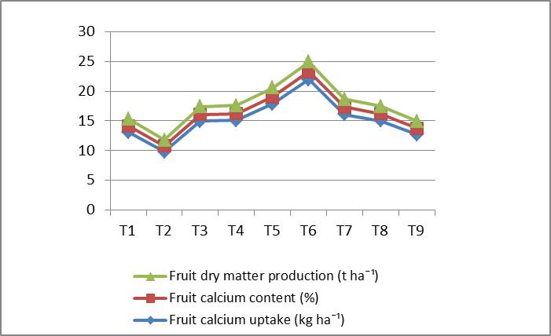

Fig 1: Relationship between fruit dry matter production, calcium content and calcium uptake influenced by treatment

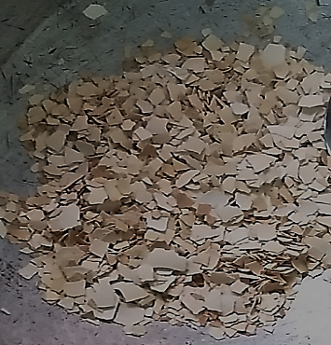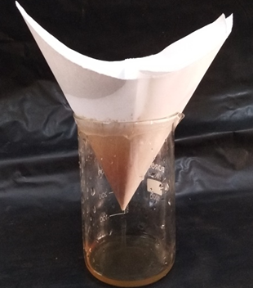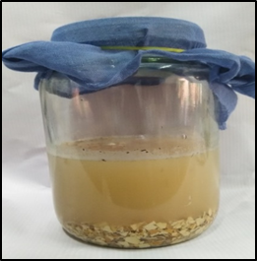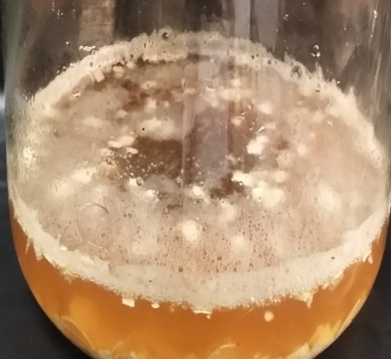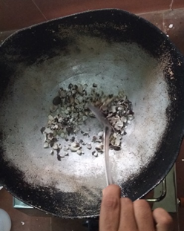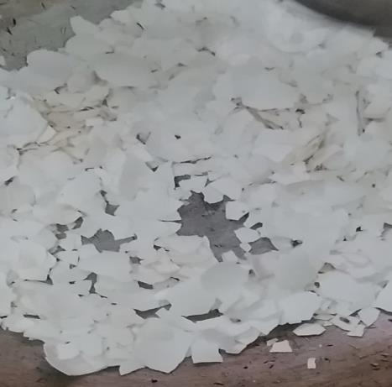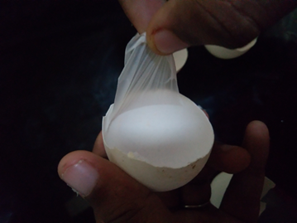

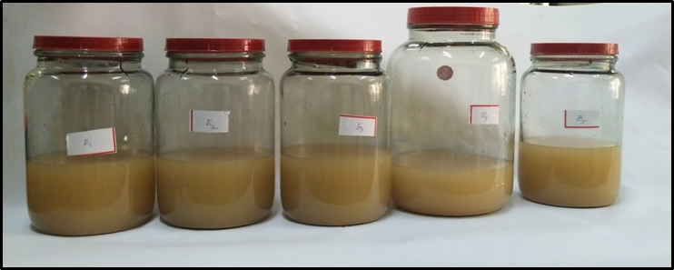

Plate 1. Steps in preparation of organic calcium foliar spray from egg shells