## **The Emergence of Rice (Oryza sativa L.) Genotypes Under Varying Water Depths**

**ABSTRACT**

Rice (*Oryza sativa* L.) is the way of life for thousands of farmers across the coastal plain of Guyana and has recently advanced toward the highland Regions. However, there are many challenges facing the rice industry: such as flood water and water management which causes crop losses during the early growth stage, cost of mechanical irrigation during and after the reproductive stage, and flash flood during harvesting.

In Guyana, pre-germinated seeds are sown in puddle fields that are drained within three to five days. Heavy rains coupled with a challenged drainage system and sometimes the additional cost of mechanical irrigation forces farmers to delay drainage after sowing. Further, the common practice of maintaining 7.6 to 15.2 cm of water after sowing to suppress red rice populations also adds to the cultivation challenges.

This study aims to investigate the emergence of five rice genotypes (FG12-259, G18-110, G18-124, G17-109 and Aromatic gold), and two cultivated varieties (GRDB FL 10 and GRDB FL 15) under three different depths of standing water (7.6 cm, 15.2 cm and 22.8 cm), under control environment (bucket trial). The experiment was conducted during the second cropping season of 2020 using pre-germinated seeds in a three factorial completely randomized design.

Differences in the rate of emergence among genotypes were observed when subjected to varying depths of water. Excellent (over 80 %) emergence was observed at 7.3 cm water for all genotypes at between 7 to 13 DAS. It was established that all rice genotypes studied can provide good seedling establishments in fields under 15.2 cm of water.

Strain FG12-259 shows the best emerged under 22.8 cm depths of water with 76.3% establishment followed by GRDB 15 (68.7%), GRDB 10 (62.7%) and G 18-124 (61.3%). These genotypes could provide good crop establishment in flooded conditions of up to 22.8 cm (9 inch) under Guyana ecosystem.

**Keywords:** genotype, seedlings, flood, establishment, water depths, pre-germinated seeds and emergence

**1.0. Introduction**

Rice (*Oryza sativa* L.) is the primary source of food globally, that provides livelihood and food security to half (about 3.5 billion) of the world's population (Samal, R. et al*.* 2018). It is a grass-type grain cultivated in a wide range of environments, ranging from tropical to temperate climates, including aerobic soil type in uplands to wet lowlands with uncontrolled flooding, example flood-prone and deep-water areas (Khush, 1984). The rice plant is subjected to diverse biotic and abiotic stresses throughout its life cycle. Among abiotic stresses, flooding is one of the major constraints for rice production particularly in rainfed lowland areas, which threatens global food security; therefore, it is becoming a more serious issue concerning global climate change as the improved rice varieties are susceptible to flooding (Khush, 1984). Hence, for the rice plants to survive, water plays a pivotal role in the management of rice ecosystems/ and the different rice agroecosystems are mostly classified based on hydrology and the extent of water availability (Khush, 1984). The rice plants require more water than most other crops. Most rice varieties achieve better growth and produce higher yields when grown under flooded conditions than in water aerobics conditions (Humphreys et al*.*, 1994). Although rice plants require a large amount of water during growth, in an anaerobic environment flooding stress results in severe crop loss. The crop loss may be more severe due to unpredictable climatic conditions such as flooding (Panda et al*.*, 2021).

In rice-producing countries, coastal and lowland areas, flooding is one of the most catastrophic natural disasters and a major stress constraint to rice production worldwide, resulting in huge economic losses (Panda et al*.,* 2021). Due to seasonal flooding, approximately ¼ of the global rice crop (± 40 million hectares) is grown in rainfed lowland plots. As a result, 22 million hectares of the world’s rice fields are unfavorably submerged annually, affecting the livelihood of more than 100 million people (Panda et al*.*, 2021).

Traditionally, rice farmers prefer to drain their fields after sowing, but draining the fields encourages the proliferation of ‘red rice’ (weedy rice). This has been a serious constraint to rice production in Guyana over the years. ‘Red rice’ cannot grow through 7.6 cm (3”) of water; furthermore, many farmers are unable to drain their fields after sowing due to a much-challenged drainage system, as a result, they are forced to establish their crop in standing water.

In rice cultivation, weed control contributes up to 30% of total production cost in Asia and other rice growing regions around the world. Despite many rice weeds being well adapted to lowland conditions, flooding has a major effect on the emergence of most rice weeds and has long been used as an effective measure for weed control in transplanted and water-seeded rice. *F. milacea* and *F. colona* are two examples of weeds without any dormancy period; they show little or no innate or induced dormancy and germinate rapidly on the surface of saturated soils but can be suppressed by shallow water. Whereas *Leptochloa chinensis* is strongly suppressed by standing water of ≥15mm and was found to be inhibited by water depths greater than 50 mm (Kim et al., 1989). The rice plant was also used as model specimen for weed control and a mechanism for flood tolerance at different growth stage (Kaspary et a., 2020).

In Guyana, if rice varieties can grow through 7.6 cm or more depths of water, this enables framers to effectively reduce ‘red rice’ populations at no extra cost. It also allows those in problem-prone areas to establish a good crop in standing water and concomitantly combat the current flooded conditions during (prolonged rainfall) the planting seasons (mid-November to mid-December & mid-May to mid-June). Developing varieties that emerge well under flooded conditions in the field has become a priority in the local rice breeding program and it is therefore crucial to evaluate the ability of advanced breeding genotypes to emerge from different depths of water before these genotypes reaches the farmer field for testing.

**2.0. Methodology**

This experiment was conducted during the second cropping season of 2020 at the Rice Research Station, Burma, Mahaicony, latitude 6.49o and longitude -57.76o, to evaluate advanced breeding genotypes emergence through different water depths. Seven advanced breeding strains *viz,* FG12-259 (FL10919-10P-5P-3P-1P-M), G18-110 (GR1767-11-22-1-2-3-2-1-1-1), G18-124 (GR1798-23-37-2-1-2-1-1), G17-109 (GR1611-15-9-1-1-1-1-1-1-1-2-2-2), G17-116 (GR1636-40-4-1-1-1-1-1-1-1-2-2-3), G17-135 (GR1660-6-10-2-2-1-1-2-1-1-1-1), and Aromatic Gold, along with two cultivated varieties as checks: GRDB 10and GRDB 15 were studied at three different depths of water (Treatments=T): T1 = 7.6cm (3 inches), T2 =15.2 (6 inches) and T3 =22.8cm (9 inches). This experiment was a three factorial Completely Randomized Design (CRD) with three replications.

Buckets of ten liters capacity werefilled with fresh soil collected from the rice seed fields at Rice Research Station, each bucket was filled with the appropriate level of soil to accommodate the various water depths. The soil in each bucket were treated with Fentin Acetate 60% WP as a preventative measure for early-season pests- such as snails (*Pomacea sp*.) which can cause damage to the pre-germinated seeds and seedlings just after sowing. Each bucket was labelled according to its replication, treatment, and strain.

Two hundred grams of seeds for each variety were weighed, cleaned (removal of inert matter) and placed into transparent perforated plastic bags (7" x 14"). The seeds were placed into a clean bucket containing tap water, soaked for 24 hours, then drained and incubated (pressing) for 48 hours (standard pre-germination process). Following germination, 100 pre-germinated seeds (with established radicle and plumule) were selected for each treatment and sown into each bucket. Seeds were uniformly spaced using forceps. The buckets were brimmed with tap water, without causing displacement or damage to the pre-germinated seeds, to achieve the desirable flood water level.

The days data were collected the following weather parameters were observes and recorded at the Rice Research Station, Burma using appropriated instruments: for the month of February 25th – 29th, 2020 - average Relative Humidity (RH) morning 89.1%, RH evening 77.4, Rainfall 1.2mm and Bright Sunshine (BSS) 9.8 hours. While in March 1st to 17th, 2020, the average RH morning 85.6%, RH evening, 78.5%, Rainfall 0.0mm and BSS 7.1 hours. Buckets were checked daily and refilled, if necessary, to the required depth during the experiment. Seedlings that emerged above the water surface were enumerated daily for twenty-one days and removed from the experiment (Figure 01). Data was collected at 8:00 am every day after sowing. Water lost due to evaporation was replaced daily before records were made and refill to the brim periodically, (every two hours during the day-from 7:00am until 16:00hrs).

Data collected was analyzed using Statistix 10 – Analyses of Variance with LSD of 0.05%.

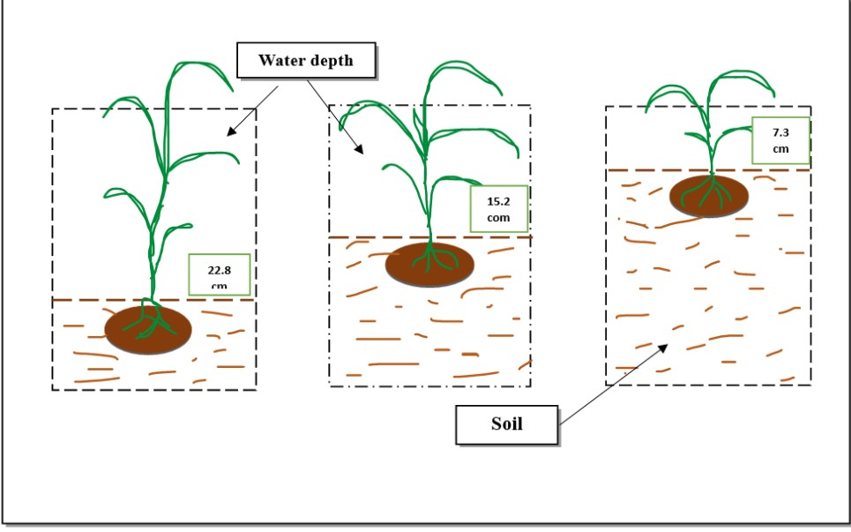

## **Figure 01: Diagram depicting a pictorial representation of the seedling's emerging through the various depths of g water in the buckets.**

## **3.0. Results and Discussions**

Seedling emerging from varying water depths is one of the most important phenological events that influence the success of any plant species in which water serves as a protective measure from environmental factors such as weeds, insects, birds, and other pests etc. Also, early flooding due to uneven land can cause low seedling density and hinder crop establishment. Nevertheless, advancing knowledge on the mechanisms of flooding tolerance during germination and early growth in rice and weeds could facilitate the development of improved rice varieties and effective weed management practices for direct seeded rice cultivation in Guyana and other countries with similar conditions.

Emergence of seedling from varying water depths is a highly desirable character of rice varieties for Guyana’s ecosystem. Strains or varieties which are able to emerge through varying depths of water are highly preferred. Those that indicate an emergence of 80% and over can be considered as excellent for the specific water depth. Similarly, 70-79% emergence can be noted as very good, 60-69% as good, 50-59% as fair, and less than 50% as poor.

The results from the investigation of the emergence of five rice genotype (FG12-259, G18-110, G18-124, G17-109, Aromatic gold), and two cultivated varieties (GRDB FL 10 and GRDB FL 15) under three different depths of water (7.6 cm, 15.2 cm and 22.8 cm), are highlighted in Tables 01-03 and Figure 02 hereunder.

**Table 01: Seedlings Emerging from 7.6 cm (3 inches) depths of water for 0 to 15 days at two-days interval.**

|  |  |  |  |  |  |  |
| --- | --- | --- | --- | --- | --- | --- |
| **Genotype** | **Seedlings Emergence at 7.6 cm depth of standing water (%)** | | | | | |
| ***Day 5*** | ***Day 7*** | ***Day 9*** | ***Day 11*** | ***Day 13*** | ***Day 15*** |
| FG12-259 | 42.33ab | 64.67c | 77.67ab | 90.67ab | 99.33a | 100.00a |
| G18-110 | 52.33a | 87.00a | 93.00a | 96.33a | 97.67a | 98.00a |
| G18-124 | 33.67bc | 81.33ab | 84.33ab | 89.00ab | 91.00ab | 91.33ab |
| G17-109 | 34.00bc | 63.33cd | 76.33ab | 88.00ab | 90.67ab | 91.67ab |
| G17-116 | 23.00cd | 61.67cde | 87.67ab | 88.67ab | 94.67a | 96.33a |
| G17-135 | 14.67cd | 48.33de | 74.00b | 79.33b | 96.67a | 96.67a |
| Aromatic gold | 0.67e | 46.33e | 54.67c | 79.00b | 82.33b | 82.33b |
| GRDB FL 10 | 14.00de | 69.00bc | 81.33ab | 81.33b | 94.67a | 94.67a |
| GRDB FL 15 | 17.33cde | 88.67a | 91.00ab | 93.00ab | 93.00a | 93.00a |
| **Mean** | **25.78** | **67.82** | **80.00** | **87.26** | **93.44** | **93.77** |
| **CV%** | **38.61** | **13.31** | **12.80** | **9.14** | **6.19** | **6.03** |
| **P-value** | **0.00** | **0.00** | **0.01** | **0.08** | **0.07** | **0.06** |
| **F-value** | **7.88** | **8.72** | **3.75** | **3.42** | **2.32** | **2.51** |
| **SEM** | **5.75** | **5.21** | **5.96** | **4.74** | **3.33** | **3.26** |
| **SEM (dif)** | **8.12** | **7.37** | **8.42** | **6.70** | **4.72** | **4.62** |

**Table 02: Seedlings Emerging from 15.2 cm (6 inches) depths of water for 0 to 15 days at two-days interval.**

|  |  |  |  |  |  |  |
| --- | --- | --- | --- | --- | --- | --- |
| **Genotype** | **Seedlings Emergence at 15.2 cm depth of standing water (%)** | | | | | |
| ***Day 5*** | ***Day 7*** | ***Day 9*** | ***Day 11*** | ***Day 13*** | ***Day 15*** | |
| FG12-259 | 0.00b | 0.00d | 43.67bc | 73.00ab | 85.33ab | 91.00ab | |
| G18-110 | 0.00b | 35.33a | 71.33a | 84.33a | 93.00a | 93.00a | |
| G18-124 | 0.00b | 20.3bc | 41.00bc | 55.00bc | 62.33bc | 63.33c | |
| G17-109 | 0.00b | 0.00d | 26.67c | 38.67c | 59.00c | 63.67c | |
| G17-116 | 4.33a | 8.67cd | 30.33c | 39.33c | 65.33bc | 69.00abc | |
| G17-135 | 0.00b | 17.67bc | 47.00bc | 63.67ab | 70.00abc | 72.00abc | |
| Aromatic gold | 0.00b | 24.67ab | 35.33c | 57.67bc | 65.33bc | 67.00bc | |
| GRDB FL 10 | 0.00b | 10.00bcd | 62.00ab | 64.00ab | 64.00bc | 66.67c | |
| GRDB FL 15 | 0.00b | 12.00bcd | 32.67c | 64.33ab | 66.00bc | 69.67abc | |
| **Mean** | **0.48** | **14.29** | **43.33** | **60.00** | **70.04** | **72.81** | |
| **CV%** | **35.32** | **60.35** | **30.83** | **21.43** | **20.99** | **19.30** | |
| **P-value** | **0.09** | **0.00** | **0.01** | **0.00** | **0.15** | **0.13** | |
| **F-value** | **2.14** | **5.23** | **3.73** | **3.91** | **1.80** | **19.30** | |
| **SEM** | **0.99** | **4.98** | **7.71** | **7.42** | **8.49** | **8.11** | |
| **SEM (dif)** | **1.39** | **7.04** | **10.91** | **10.49** | **12.00** | **11.48** | |

**Table 03: Seedlings Emerging from 22.8 cm (9 inches) depths of water for 0 to 15 days at two-days interval.**

|  |  |  |  |  |  |  |
| --- | --- | --- | --- | --- | --- | --- |
| **Genotype** | **Seedlings Emergence at 22.8 cm depth of standing water (%)** | | | | | |
| ***Day 5*** | ***Day 7*** | ***Day 9*** | ***Day 11*** | ***Day 13*** | ***Day 15*** |
| FG12-259 | 0.00 | 0.00b | 18.33b | 48.33abc | 50.00a | 65.00a |
| G18-110 | 0.00 | 0.00b | 10.67bc | 29.67.00cd | 58.33a | 59.33ab |
| G18-124 | 0.00 | 5.00a | 17.33b | 33.00bcd | 60.00a | 61.33a |
| G17-109 | 0.00 | 0.00b | 10.00bc | 11.67bc | 20.33b | 40.00bc |
| G17-116 | 0.00 | 0.00b | 0.00c | 18.33d | 18.33b | 28.00c |
| G17-135 | 0.00 | 0.00b | 0.00c | 48.33abc | 53.00a | 56.00ab |
| Aromatic gold | 0.00 | 4.67a | 15.33bc | 26.67cd | 46.33a | 48.33abc |
| GRDB 10 | 0.00 | 0.00b | 51.33a | 57.00a | 57.00a | 61.67a |
| GRDB 15 | 0.00 | 0.00b | 3.33bc | 54.67ab | 59.33a | 67.67a |
| **Mean** | **0.00** | **1.07** | **14.22** | **36.26** | **46.96** | **54.18** |
| **CV%** | **0.00** | **175.10** | **64.28** | **37.94** | **29.57** | **22.34** |
| **P value** | **0.00** | **0.01** | **0.00** | **0.01** | **0.01** | **0.01** |
| **F value** | **0.00** | **3.86** | **8.74** | **4.36** | **4.14** | **3.48** |
| **SEM** | **0.00** | **1.08** | **5.28** | **7.94** | **8.02** | **6.98** |
| **SEM (dif)** | **0.00** | **1.54** | **7.46** | **11.23** | **11.33** | **9.87** |

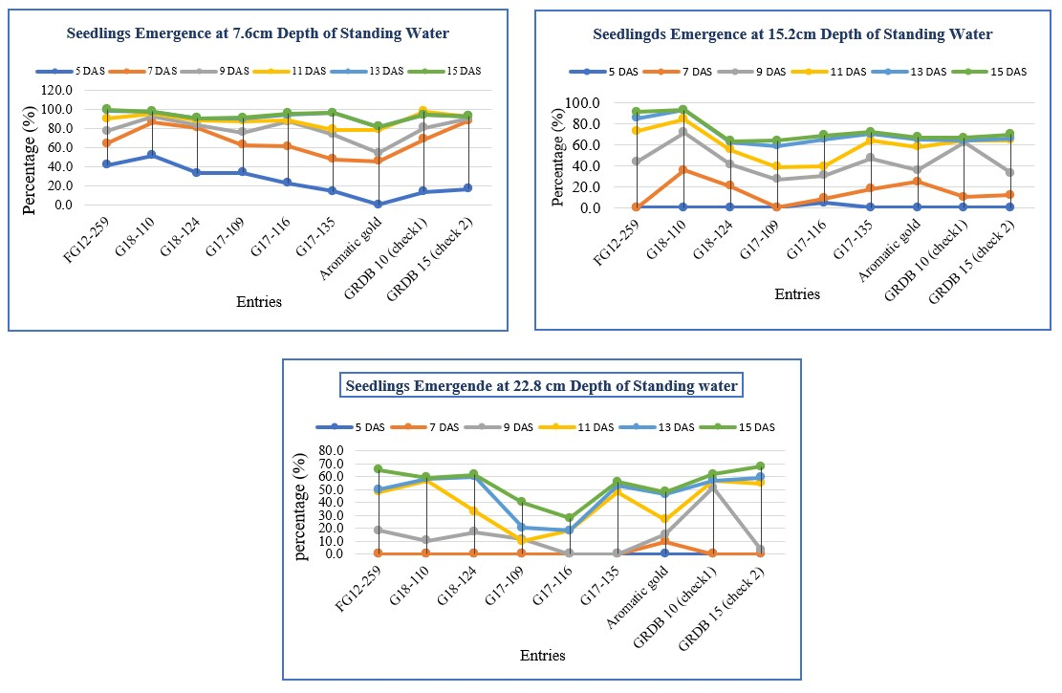**Figure 02*: Graphs showing seedlings emerging for the three depths of water from 0-15 days***

***Emergence at 7.6 cm depth of water.***

Regarding the percentage of seedlings that emerged for each genotype when submerged under 7.6 cm of varying water depths, data showed that within the first five days after sowing an average of 25.78% of seedlings emerged was recorded, with G18-110 recorded the highest (52.3%) which was statistically similar to FG12-259 (42.3%). Talpur et al. (2013) recorded similar results (at 5 cm and 10 cm water depth), where according to the research pronounced 5 cm is said to be optimum water depth for rice in the vegetative stage.

At seven days after sowing (DAS) the data collected showed a significant increase in the number of seedlings emerged, with seven entries recording over 60% emergence, while two entries recorded below 50%. Also, at 7 DAS the check variety GRDB 15 recorded the highest emergence (88.7%), statistically similar results were obtained with G18-110 (87.0%) and G18-124 (81.3%).

Genotypes FG12-259 and G17-135 recorded an increase of 13.7% and 26.3% emergence respectively within two days (from 7 DAS to 9 DAS) recording an average of 77.7 % and 74.0% correspondingly. Excellent emergence was observed from check variety GRDB 10 (81.1%) along with breeding line G17-116 (87.7%) at 9 DAS. Genotype FG12-259 showed 90% emergence on the 11 DAS while G17-135 and Aromatic Gold reached 96.7 % and 82.3% respectively on the 13th day after sowing. Sen et al., 2022, achieved lower emergence when compared to the current study with similar water depths (6-8 cm). However, [Khakwani](https://pubmed.ncbi.nlm.nih.gov/?term=Khakwani%20AA%5BAuthor%5D) et al*.* (2005) indicated that rice seedlings of all ages performed well in shallow water while older seedlings performed acceptably well in submerged conditions.

Overall, all genotypes tested showed excellent (80% and over) emergence from 7.5 cm of standing water, however the variation was in the number of days each genotype took to emerge. GRDB 15, G18-110 and G18-124 achieve 80% emergence in only 7 DAS while genotype G17-135 and Aromatic Gold took the longest (13 days) to emerged for the varying water depths. Check variety GRDB 10 and breeding line G17-116 achieve this at 9 DAS and FG12-269 on 11 DAS

***Emergence at 15.2 cm depth of water***

It was observed that after the seven genotypes and two commercial varieties were subjected to 15.2 cm depths of water, only one genotype (G17-116) started to emerged at 5 DAS with an average of 4.3 %.

At 7 DAS there was an overall increase in emergence to 14.3%. Strain G18-110 recorded the highest emergence at 35.3% which was statistically similar to Aromatic gold (24.7%). Genotype G17-135 (17.7 %), G18-124 (20.3 %), Aromatic Gold, G17-116 (8.67 %), and the two check varieties showed significantly lower emergence, while FG12-259 and G17-109 did not emerge from 15.2 cm at 7 DAS.

As the seedlings continued to be submerged, the mean percentage of seedlings emerging increased to 43.3% at 9 DAS with G18-110 recording the highest emergence of 71.3%, and GRDB 10 at par with 62.0%, while G17-109 recorded the poorest emergence of 26.7%. All other genotypes were withing this range.

Genotype G18-110 continue to progress well as it showed excellent emergence (84.3%) on the 11 DAS while FG12-259 attained this mark at 13 DAS. Breeding line G17-135 record very good (70 %) emergence at 13 DAS while all the other genotypes express good emergence (ranged 63.3 to 69.0 %) at 15 DAS. Notably there was minimal increase in the mean emergence from 13 to 15 DAS.

These two genotypes (G18-110 and FG12-259) seem to possess excellent early vigor as they emerged through 7.6 and 15.2 cm depths of water. Maximum emergence was observed between 9 to 13 DAS at both 15.2 cm depths and 7.6 cm depths of water (Table 02). Studies conducted by

Liberty et al, (2022) using *Oryza sativa spontanea, at* varying flooding depths (0,5,10, and 15 cm) and burial depths (1.3, 2.5, 5 and 10 cm) and found that flooding depth up to 15 cm level did not affect the total emergence.

***Emergence at 22.8 cm depths of water***

The data showed that when the advanced rice genotypes were exposed to 22.8 cm depths of water, seedlings emergence between 5 DAS and 7 DAS were only 0 to 5.0% with G18-124 and Aromatic Gold showing signs of emergence. At 9 DAS the emergency of seedlings ranged from 17.3% (G18-124) to 3.3% (GRDB 15 check). On the 11DAS all the genotypes showed some level of emergence ranging from 11.7% (G17-109) to 48.3% (FG12-259 & G17-135).

At thirteen days after sowing the emergency percentage of seedlings increased significantly with six genotypes recording over 50% emergency with a mean of 46.9%. Genotype such as G18-124 recorder the highest percentage (60.0%), this was on par with the other entries except G17-109, and G17-116.

Genotype FG12-259 and G18-124 showed good emergence with 65.0% and 61.33 % respectively at 15 DAS which was statistically similar to the check varieties GRDB 10 and GRDB 15 with ‘61.67 % each. The aforementioned genotypes have shown good extra early vigor and resilience in 22.8 cm (nine inches) depths of water. Strains G18-110, G17-135 which recorded emergence of 59.3% and 56.0% respectively, seem to be promising under deep flooding. Documentation of rice genotypes emerging from 22.8 cm depths of water.

# 

# **4.3 Overall Seedling Emerging from three depths of water 15 DAS**

There is different reaction in the emergence of the genotypes when subjected to varying depths of water, since water plays a pivotal role in seedling development. When seedling are submerged in water, they can evade the low-oxygen stress (LOS) by triggering altercation at a cellular level and organs structure, therefore stimulating access to diffusing oxygen (Bailey-Serres et al., 2008), leading to excellent (> 80 %) emergence at 7.3 cm water for all genotypes between 7 to 13 DAS. The flooded environment arouses the elongation rate of the petioles, stem and or leaves causing them to emerged, but this process can also lead to death of the seedling before emergence caused by excess energy loss (Bailey-Serres et al., 2008). Where genotypes G18-110, G18-124 and check variety GRDB 15 emerged well within 7 days after sowing demonstrating excellent elongation of the leaves. This was followed by G18-116 and GRDB 10 (check) at 9 DAS and FG12-259 and G17-109 on the 11th day, with G17-135 and Aromatic gold on the 13th day. Toru Sato et al, (2002) also obtained excellent results (0-10mm water depth) but used coated rice seed (CaO2). The results suggested that all these genotypes can emergence under 7.3 cm flooding condition and therefore can provide a good crop establishment in irrigated lowland ecosystem like Guyana where pre- germinated seeds are sown on puddled soil in varying water depths, (Guyana Rice Development Board. September. 2016. [Water-Management-in-Rice-cultivation.pdf (grdb.gy)](https://grdb.gy/wp-content/uploads/2016/09/Water-Management-in-Rice-cultivation.pdf).

The rice plant over time has develops traits such as, gas film retention and aerenchyma formation at the internodes of the stem and roots cortex – confirming the tolerance to flooding conditions (Lin et al., 2022), causing seedling to emerged through water depths of 15.2 cm and 22.8 cm. Lin et al. (2022) states the developed aerenchyma inside the roots, causing enhancement of O2 diffusion from the shoot to the roots, while restricting the loss of molecular O2 created by the radial oxygen loss (ROL). Data showed seedlings took longer to emerge, where percentage of emergence was low for all genotypes, at water depth of 15.2 cm, the first genotype to express more than 80% emergence was G18-110 at 11 days. This underscores the genotype vigor and resilient under flooded conditions; where the hyponastic growth is a trait relevant for re-orientation of the seedling leaves above the water (Colmer et al., 2009). Genotype FG12-259 also shows similar results at 13 DAS. Ismail et al. (2012), established that rice genotypes has the capacity to germinate and strive like no other plant/grass/grain crop in flooded soils for direct seed. These two genotypes (G18-110 & FG12-259) have demonstrated superior performance at a water depth of 15.2 cm while the other genotypes have shown good emergence under this level of flooded condition, since possesses of elongation trait allows the seedling survival under deepwater condition (Colmer et al., 2009). These rice genotypes can provide good seedling establishments in fields under 15.2 cm of water.

With flooding of 22.8 cm the mean seedling emergence of all genotypes was 54% with FG12-159 (65%) and G18-124 (61.3%) showing the best performance at 15 DAS which was statistically similar to the two check varieties (GRDB 10- 61.7% & GRDB 15- 67.7%). Breeding line G18-110 (59.3%) and G17-135 (56.0%) showed good promise at 15 DAS. These genotypes could provide good crop establishment in flooded conditions of up to 22.8 cm (9 inch) under Guyana ecosystem. Studies by Chamara et al*.* (2018), indicated that rice plants reached maximum emergence 9 to 13 days later under flooding compared with saturated conditions.

Identification of rice genotypes that can emerge well from varying levels of water depths is key for good crop establishment and weed management in Guyan. It is crucial for varieties to be able to withstand some level of flooding as rice is grown along the coastal belt which is below the sea level and the drainage system is challenged, particularly in times where there is high intensity of rainfall. Genotypes with that showed good emergence from varying water depths of more than 15 cm can certainly possess the excellent early vigor and could perform well under the tough Guyanese farming conditions; where farmers will be advised on water management, availability and cost of production during the seedling stage and throughout the crop cycle (tillering, panicle inhiation, flowering and grain filling), creating a positive impact on water scarcity and food security in the near future (Sadhukhan et al., 2024).

**5.0 Conclusions**

Advance breeding genotypes can emerge excellently from a 7.6 cm (3 inches) depth of varying water depths within the first seven days after sowing with over 68% establishment, and over 90% establishment between eight (8) to thirteen (13) days after sowing. Seedlings of all the different genotypes and varieties emerged well when sown in 15.2cm (6 inches) of varying water depths with over 60% establishment between eight to fifteen days after sowing. Strain FG12-259 shows the best emerged under 22.8 cm of varying water depths with 76.3% establishment followed by GRDB 15 (68.7%), GRDB 10 (62.7%) and G 18-124 (61.3%). These genotypes have excellent early seedling vigor and will do well under the directed seeded system of Guyana.

**6.0 General Recommendation**

It is recommended that further studies be conducted on these genotypes to identify site-specific genes/quantitate trait loci that could be responsible for the activation of an enzyme/protein that allows seedling (s) to emerge at a faster rate from varying water depths.

**Disclaimer (Artificial intelligence):**

The author (s) desires to clarify, that NO artificial intelligence (AI) language models such as NLP, ML, Deep Learning, Generative AI and or Elicit were used in the generation of this research article. All text and data analysis were conducted exclusively by the author (s).

**References**

1. Samal, R., Roy, P. S., Sahoo, A., Kar, M. K., Patra, B. C,. Marndi, B. C, et.al. 2018. Morphological and Molecular dissection of wild rice from eastern India suggests district separation between O. rufipogon and O. nivora populations. Sci. Rep., 8 (1): 2773.

2. Khush G S. 1984. Terminology of Rice growing environments. Manila, Philippines. International Rice Research Institute.

3. Humphreys, E., Van Der Lely, A., Muirhead, W., & Hoey, D., 1994. The development of on-farm restrictions to minimize recharge from rice in New South Wales. Australian Journal of Soil and Water Conservation. 7(10 11-20).

4. Panda, D., & Barik, J. 2021. Flooding Tolerance in Rice: Focus on Mechanism and Approaches. (Development of Biodiversity and Conservation of Natural Resources, Central University of Odisha, Koraput 764021 Odisha India), Rice Science Journal 28.

5. Kim, S, C., & Moody, K. Germination of two rice cultivars and several weeds’ species. 1989. Korean Journal of Weeds Science. 9: 116-122.

6. Kaspary, T. E., Roma-Burgos, N., & Merotto Jr, A. 2020. Snorkeling Strategy: Tolerance to flooding in Rice and Potential Application for Weed Management. National Library of Medicine: National Center for biotechnology Information.

7. Talpur, M. A., 1, Changying, J.,1 *, Junejo, S. A.,2 Tagar, A. A.,1 & Ram, B. K.3. 2013. Effect of different water depths on growth and yield of rice crop. 1Department of Agricultural Mechanization, College of Engineering, Nanjing Agricultural University, Nanjing, P. R. China.

8. Sen L. T. H., Ranamukhaarachchi, S. L., Zoebisch, M. A., Hasan, M. M., & Meskuntavon, W. 2002. Effects of early inundation and water depth of weeds competition and grain yield of rice in the content plains of Thailand. Asian Institute of technology, Thailand.

9. [Khakwani](https://pubmed.ncbi.nlm.nih.gov/?term=Khakwani%20AA%5BAuthor%5D), A.A.,1 [Shiraishi](https://pubmed.ncbi.nlm.nih.gov/?term=Shiraishi%20M%5BAuthor%5D), V.,2 [Zubair](https://pubmed.ncbi.nlm.nih.gov/?term=Zubair%20M%5BAuthor%5D), M., †,1  [Baloch](https://pubmed.ncbi.nlm.nih.gov/?term=Baloch%20MS%5BAuthor%5D), M.S., 1 [Naveed](https://pubmed.ncbi.nlm.nih.gov/?term=Naveed%20K%5BAuthor%5D), K.,1 & [Awan](https://pubmed.ncbi.nlm.nih.gov/?term=Awan%20I%5BAuthor%5D), I3. 2005. Effect of seedling age and water depth on morphological and physiological aspects of transplanted rice under high temperature. J. Zhejaing Univ. Sci. Biotechnology. V (6) 389-395.

10. Liberty, B. G., Inci, D., Mesgaran, M., Brim-DeForest, W., & Al Khatib, K. 2022. Flooding depths and burial effects on seedling emergence at 5 California weedy rice (*Oryza sativa spontanea*) accessions. Cambridge University Press.

11. Bailey-Serres and Voesenek, J. A. C. Y. 2008. Flooding Stress Acclimation and Genetic Diversity. Annual -Review of Plant Biology. 59(1):313-39.

12. Sato, T., & Maruyama, S. 2002. Seedlings emergence and establishment under Drained conditions in Rice direct-sown into Puddled and Level soil- Effect of Calcium peroxide seed coating and sowing depth. Plant Production Science Journals, 5:1, 71-76, DOI: 10, 1626/pps.5.71

13. Lin, C., Zhu, T., Leon, L., Ogorek, P., Wang, Y., Sauter, M., Pedersen, O. 2022. The Pyramiding of Three Key Root Traits Aid Breeding of Flood – Tolerant Rice. PMCID: PMC 9370703 PMD: 35956512. Plant (Basel) Journal.

14. Colmer, T. D., Voesenek, L. A. C. J. 2009. Flooding Tolerance: Suites of Plant Traits in Variable Environments. PMID: 32688679. DOI: [10.1071/FP09144](https://doi.org/10.1071/fp09144). Functional Plant Biology.

15. Ismail, A. M., Johnson, D. E., Ella, E.S., Vergara, G. V., & Baltazar. A. M. 2012. Adaptation to flooding during emergence and seedling growth in rice and weeds, and implications for crop establishment. *AoB PLANTS*, Volume, pls019, <https://doi.org/10.1093/aobpla/pls019> .

16. Chamara, B. S., Marambe, B., Kumar, V., Ismail, A. M., Septiningsih, E.M., & Chauhan, B. S. 2018. Optimizing Sowing and Flooding Depth for Anaerobic Germination-Tolerant Genotypes to Enhance Crop Establishment, Early Growth, and Weed Management in Dry-Seeded Rice (*Oryza sativa* L.). *Front. Plant Sci.* 9:1654. DOI: 10.3389/fpls.2018.01654

17. Sadhukhan, D., Mukherjee, T., Sarkar, A., Devi, N. D., Bisarya*, D., Kumar, V., et al. 2024. Comprehensive Analysis of Drought Stress Response in Rice (*Oryza sativa* L.): Insights into Developmental Variations from Germination of Grain Filling. International Journal of Environment and Climate Change. Volume 14. DOI: [10.9734/ijecc/2024/v14i74260](https://doi.org/10.9734/ijecc/2024/v14i74260).

**12.0 List of Tables and Figures**

12.1Seedlings Emergence rate from various depths of water after *seven-day* intervals.

12.2 The total Percentage of Seedling Emergence from three depths of standing water over 21 DAS

## 12.3Diagram depicting a pictorial representation of the seedling’s emergence in the buckets.

### 12.4 Summary of seedling emerging from standing water.

**13.0 Abbreviation:** DAS- days after sown/sowing