***Original Research Article***

**"Technology for the development of functional Greek yogurt enriched with millet and curcumin and its impact on sensory attributes".**

**Abstract:**

This study aimed to develop a scientifically significant functional Greek yogurt enriched with foxtail millet (*Setaria italica*) and curcumin, highlighting its relevance to the food industry and potential health benefits for consumers. Foxtail millet, known for its high fiber and low glycemic index, and curcumin, recognized for its antioxidant and anti-inflammatory properties, were selected based on their documented health benefits in previous studies. However, limited research exists on their effects in dairy products. This study seeks to fill that gap by assessing their impact on texture, taste, and acceptability. Three levels of foxtail millet (2%, 4%, and 6%) and curcumin (0.5%, 0.7%, and 1%) were added to optimize sensory and textural attributes. The Greek yogurt was prepared following standard protocols, including incubation with *Streptococcus thermophilus* and *Lactobacillus delbrueckii* spp. *bulgaricus* at 45°C for 4 hours. Sensory evaluation using a 9-point hedonic scale involved a trained panel of 25 judges, and results were statistically analyzed using ANOVA. Furthermore, physicochemical and microbiological properties, including pH, protein content, curcumin stability, and lactic acid bacteria viability, were examined to ensure product stability and probiotic potential. The study underscores the commercial viability of this functional yogurt, emphasizing its practical implications for consumer health and food industry advancements.

**Keywords:** Greek yogurt, foxtail millet (*Setaria italica*), curcumin, sensory evaluation, functional food.

**Introduction:**

New product development and continuous innovation in food industry has been partially a reflection of the changing needs of consumer for health, nutrition and convenience. There has been a consistent effort to increase functionality of cereals-based foods by enriching them with higher protein, phenolics, dietary fibre and mineral content so to qualify them as functional foods.. A serving of 50 g of yoghurt is claimed to offer 41% of the daily calcium requirement for a 5-year-old. Yoghurt is a rich source of calcium in bio-available form. Lactose intolerant people can get all the benefits of milk products from yoghurt without experiencing the discomforts of hypolactasia. The casein in yohgurt is a complete protein because it contains all nine essential amino acids: methionine, lysine, isoleucine, histidine, valine, tryptophan, threonine, phenylalanine and leucine. (Mckinley, 2005)

Foxtail millet (*Setariaitalica Italica*) ranks second in the total world production of millets and continues to have an important position. In china foxtail millet is important as rice, providing about 15-17% of total food consumed. Millet contains high protein, carbohydrates and is a rich source of dietary fiber. It contains Polymers of hexose’s, pentoses, cellulose and pectinacious material constitute the major portion of its dietary fiber. Like other millets foxtail millet is highly nutritious and even superior to rice and wheat. Grains of foxtail millet have low glycemic index (GI) and high fiber content. Appropriate policy interventions and cultivation can enhance the profitability (Hariprasanna, 2016).

A significant number of nutritious components, particularly protein, carbohydrates, vitamins, and minerals, are included in foxtail millet. Because foxtail millet grains are coarse, approximately 79% of the grain is digestible, with the remaining portion that cannot be digested including some anti-nutritional elements and comparatively high fiber content. Like most millets, foxtail millet has a high crude fiber content, aids in digestion, and promotes bowl movement, all of which have a laxative impact that is good for a healthy digestive system.Apart from its nutritional qualities, foxtail millet has demonstrated a number of health advantages, including the ability to prevent cancer and have hypoglycemic and hypolipidemic effects. (Zhang, A *et al*., 2015)

The primary naturally occurring polyphenol in the rhizome of Curcuma longa, or turmeric, as well as other Curcuma species, is curcumin . Asian nations have long utilized curcuma longa as a medicinal herb for a variety of ailments because of its anti-inflammatory, anti-mutagenic, antibacterial, antioxidant, and anticancer qualities. (Pulido *et al.,* 2016)   
Regarding its solubility characteristics, curcumin dissolves in alkali or highly acidic solutions . It is utilized as a food coloring since it is a crystalline substance with a vivid orange-yellow hue. This keto-enol tautomeric molecule has good qualities as a metal ion chelator, with the enol-form predominating in alkalis solutions and the keto-form predominating in acidic or neutral solutions. (Rao *et al.,* 2011)

The bioactive, non-volatile curcuminoids found in turmeric rhizome are among its many components. Turmeric's ability to strengthen the immune system is due to the polyphenol phytochemical curcumin, which is found in curcuminoids. The European Union has approved curcumin as a food additive and it is used as an orange-yellow colour. It serves as a colouring agent for a variety of culinary products .Turmeric contains yellow polyphenolic pigment called as Curcumin used in various culinary dishes. Phytochemical analysis of turmeric rhizome revealed wide variety of bioactive components such as volatile compounds, curcuminoids etc.The curcuminoids percentage in turmeric ranges from 2.50-8.00% in which curcumin shares 71.50-94.00%, dimethoxycurcumin (6.00 **–** 19.40%), bisdemethoxycurcumin (0.30 **–** 9.10%) (Sharif *et al*., 2021).

**Materials and Methods:**

Fresh cow milk was procured from the student’s experimental dairy plant (SEDP) Dairy Science College, Hebbal, Bengaluru and milk was used for yoghurt preparation. Yoghurt Culture was procured from Danisco pvt ltd. Good quality desiccated Curcumin was procured from TRINATH, Hyderabad.

**Sensory evaluation:** A 9-point hedonic scale was used by the selected panel of 6 judges to evaluate the generated study samples for sensory qualities, including colour and appearance, body and texture, flavour, and overall acceptability. The product was given 3

times for panel of 25 judges for fulfilling the objective finally average score was taken for further

statistical analysis. The highest-scoring output was further used for statistical analysis using R

software (R. version 4.0.3).)

Cow Milk (Fat 3.5%, SNF 8.5%)

Heating (90˚C/5 min) & Cooling (45˚C)

Addition of WPC (**2.0%)**

Addition of Yoghurt culture (0.20% freeze dried DVS culture)

(*Streptococcus thermophilus* and *Lactobacillus delbrueckii spp. bulgaricus*)

Addition of Foxtail Millet ( 2, **4**, 6 %)

Addition of curcumin (0.5%, **0.7%** and 1.0%)

Incubation at 45 0C 4h

Packaging in PET cups (200ml)

Storage at refrigeration temperature (7±1°C)

**Functional Greek yoghurt**

**Results and Discussion:**

**Effect of Curcumin on the sensory attributes Greek Yoghurt**

The sensory scores with respect to the effect of curcumin (0.5%, 0.7% and 1.0 percent) on the sensory attributes of functional Greek yoghurthas been depicted in Table 1 and Figure 1.The result showcases that the curcumin has greater influence on the product. The sensory acceptance indicates the effect .The control sample's mean score was 8.08, 7.55, 7.85, and 7.90 for flavor, colour and appearance, body and texture and overall acceptability. Whereas the developed product had a better score when it was enriched with curcumin. The score being 8.35, 8.45, 8.50, 8.50 respectively for flavor, colour and appearance, body and texture and overall acceptability. The functional Greek yoghurt based on curcumin with 0.7 percent had a maximum overall acceptability respectively. Statistical analysis indicated that curcumin had a significant effect on the overall acceptability of functional Greek yoghurt. The result is complimenting with the work conducted by Maurya *et al*., (2020) for curcumin fortified lasi and similar result was observed by Akande and Adegoke (2018) which were in line with experimental sample, spiced Yogurt that has been spiced with turmeric and clove had a custard-like yellow hue because to the inclusion of curcumin, and also it is stated that curcumin also has influence on flavour which is highly acceptable.The results indicate that it could be explained by the higher solubility of curcumin in yoghurt suspension which forms an emulsion .The dichloro fluromethane content of curcumin is responsible for the yellowish colour observed in the final product.

**Table 1: Effect of Curcumin on the sensory attributes of Functional Greek Yoghurt**

|  |  |  |  |  |
| --- | --- | --- | --- | --- |
| **Curcumin (%)** | **Flavour** | **Colour and appearance** | **Body and texture** | **Overall acceptability** |
| Control | 8.08a | 7.55a | 7.85a | 7.90a |
| 0.3 | 8.05a | 8.00b | 8.09b | 8.20b |
| 0.5 | 8.10b | 8.05ab | 8.20c | 8.35c |
| 0.7 | 8.35c | 8.45c | 8.50d | 8.50d |
| **CD(*P*=.05)** | **0.20** | **0.40** | **0.30** | **0.17** |

**Figure 1: Effect of Curcumin on the sensory attributes of Functional Greek Yoghurt**

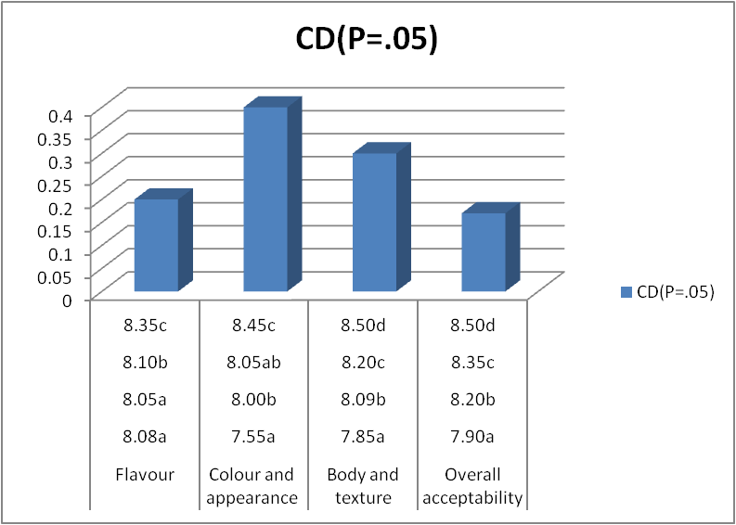

**Note:**

All the values are average of three trials

Similar superscripts indicate non - significance at the corresponding critical difference

Sensory analysis – 9-point hedonic scale

**Effect of Foxtail Millet on the sensory attributes Functional Greek Yoghurt**

The sensory scores with respect to the effect of foxtail millet (2 %, 4 % and 6 per cent) on the sensory attributes of functional Greek yoghurthas been projected in Table 2 and Figure 2.The result showcases that the foxtail millet has greater influence on the product. The sensory acceptance reveals the outcome of study .The control sample's mean score was 8.00,7.50 7.55 and 7.59 for flavor, colour and appearance, body and texture and overall acceptability. Whereas the developed product had a better score when it was enriched with foxtail millet. The score being 8.00, 7.50, 7.55, 7.59 for flavor, colour and appearance, body and texture and overall acceptability. The functional Greek yoghurt based on foxtail millet with 0.7 percent had a maximum overall acceptability respectively. Statistical analysis compliments the result which had a significant effect on the overall acceptability of functional Greek yoghurt. The result is in accordance with the work conducted by Challa *et al* 2025 who emphasized on the contribution of foxtail millet probiotic beverage on sensory parameters and insisted that the product developed good sensory acceptance upon addition of foxtail millet which ia an indication that millets can be effectively used in formulations. The dietary fiber present in foxtail millet adds to the better binding capacity which increases the body and texture value.

**Table 2: Effect of Foxtail Millet on the sensory attributes of Functional Greek Yoghurt**

|  |  |  |  |  |
| --- | --- | --- | --- | --- |
| **Foxtail millet (%)** | **Flavour** | **Colour and appearance** | **Body and texture** | **Overall acceptability** |
| Control | 8.00a | 7.50a | 7.55a | 7.59a |
| 2 | 8.00a | 8.00b | 8.02b | 8.00b |
| 4 | 8.50b | 8.45b | 8.60c | 8.70c |
| 6 | 7.00c | 7.00b | 7.13d | 7.00d |
| **CD(*P*=.05)** | **0.18** | **0.16** | **0.09** | **0.17** |

**Figure 2: Effect of Foxtail Millet on the sensory attributes of Functional Greek Yoghurt**

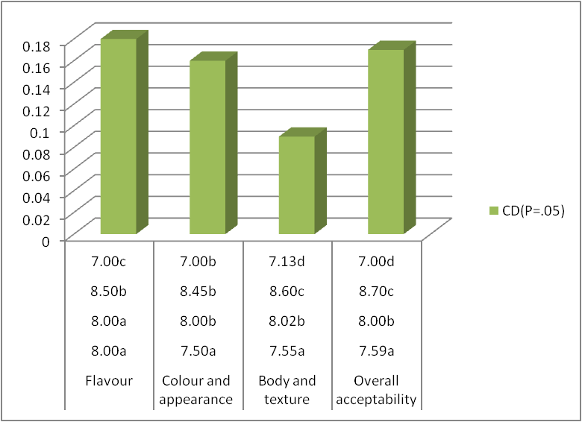

**Note:**

All the values are average of three trials

Similar superscripts indicate non - significance at the corresponding critical difference

Sensory analysis – 9-point hedonic scale

**Conclusion:**

Nutritional well-being is a sustainable force for health, development and maximization of human genetic Yoghurt is regarded as a nutrient-dense diet because it provides vital components for growth, including protein, vitamins, and minerals. The generation trend to have nutritional and therapeutic foods is prime time issue. In this regard developing a product which can address all consumer groups including lactose intolerants is challenging. The developed research product foxtail millet based Greek yoghurt enriched with curcumin not only contributes the priority besides it also makes way for commercialization.The incorporation of foxtail millet (*Setaria italica*) and curcumin in Greek yogurt resulted in a product with enhanced sensory properties, including improved body, texture, and flavor. The optimized formulation of 4% foxtail millet and 0.7% curcumin was found to offer the best balance between taste, texture, and overall acceptability. Moreover, the yogurt exhibited stable physicochemical and microbiological properties, supporting its commercial viability. This study highlights the potential of using foxtail millet and curcumin in dairy formulations to develop functional foods with enhanced health benefits. Future research should focus on long-term stability, bioavailability of curcumin, and consumer acceptability in diverse markets to further substantiate the product’s viability in the food industry.

Disclaimer (Artificial intelligence)

Option 1:

Author(s) hereby declare that NO generative AI technologies such as Large Language Models (ChatGPT, COPILOT, etc.) and text-to-image generators have been used during the writing or editing of this manuscript.

Option 2:

Author(s) hereby declare that generative AI technologies such as Large Language Models, etc. have been used during the writing or editing of manuscripts. This explanation will include the name, version, model, and source of the generative AI technology and as well as all input prompts provided to the generative AI technology

Details of the AI usage are given below:

1.

2.

3.

**References**

Akande, A.A. and Adegoke, G.O. (2018). Production, microbiological and quality evaluation of low‐fat spiced yoghurts with low glycemic loads. *African Journal of Food, Agriculture, Nutrition and Development*, 18(2), 13287–13303.

Challa, M., Kuna, A., Kata, L. and Dsa, D. (2025). Probiotic foxtail millet beverage—formulation and evaluation of nutritional, physicochemical and sensory parameters. *International Journal of Food Science and Technology*, 28(5), 248–250.

Dipalma G, Inchingolo AM, Latini G, Ferrante L, Nardelli P, Malcangi G, Trilli I, Inchingolo F, Palermo A, Inchingolo AD. The effectiveness of curcumin in treating oral mucositis related to radiation and chemotherapy: A systematic review. Antioxidants. 2024 Sep 25;13(10):1160.

Hariprasanna, K. (2016). Foxtail millet: Nutritional importance and cultivation aspects. *Indian Farming Special Issue on Small Millets*, 65(1), 25–29.

Maurya, N., Kaushik, K. and Prasad, W. (2020). Preparation and stability evaluation of curcumin fortified Lassi, a fermented dairy beverage. *International Journal of Fermented Foods*, 9(1), 19–30.

McKinley, M.C. (2005). The nutrition and health benefits of yoghurt. *International Journal of Dairy Technology*, 58(1), 1–1.

Pulido-Moran, M., Moreno-Fernandez, J., Ramirez-Tortosa, C. and Ramirez-Tortosa, M. (2016). Curcumin and health. *Molecules*, 21(3), 264.

Rao, E.V. and Sudheer, P. (2011). Revisiting curcumin chemistry part I: A new strategy for the synthesis of curcuminoids. *Indian Journal of Pharmaceutical Sciences*, 73(3), 262.

Pradeep, P.M. and Sreerama, Y.N. (2015). Impact of processing on the phenolic profiles of small millets: Evaluation of their antioxidant and enzyme inhibitory properties associated with hyperglycemia. *Food Chemistry*, 169, 455–463.

Sachdev N, Goomer S, Singh LR. Foxtail millet: a potential crop to meet future demand scenario for alternative sustainable protein. Journal of the Science of Food and Agriculture. 2021 Feb;101(3):831-42.

Sharif, J., Rayess, Y.E., Risk, A.A., Sadaka, C. and Raviella (2020). Turmeric and its major compound curcumin on health: Bioactive effect and safety profiles for food, pharmaceutical, biotechnological and medicinal applications. *Frontiers in Pharmacology*, 11(2), 1–17.

Zhang, A., Liu, X., Wang, G., Wang, H., Liu, J., Zhao, W. and Zhang, Y. (2015). Crude fat content and fatty acid profile and their correlations in foxtail millet. *Cereal Chemistry*, 92(5), 455–459.

**ANNEXURE**

**DAIRY SCIENCE COLLEGE, KVAFSU, BENGALURU-24**

**DEPARTMENT OF DAIRY TECHNOLOGY**

**Score card for Sensory Evaluation Using 9-Point Hedonic Scale**

**Name of the Judge: Date:**

You are requested to assess the product in terms of general acceptability on a 9-point hedonic scale score system.

**score system:**

Like extremely 9

Like very much 8

Like moderately 7

Like slightly 6

Neither like nor dislike 5

Dislike slightly 4

Dislike moderately 3

Dislike very much 2

Dislike extremely 1

|  |  |  |  |  |  |  |
| --- | --- | --- | --- | --- | --- | --- |
| **Sensory Characteristics** | **Sample Code** | | | | | |
|  |  |  |  |  |  |
| Color and Appearance |  |  |  |  |  |  |
| Body and Texture |  |  |  |  |  |  |
| Flavour |  |  |  |  |  |  |
| Overall Acceptability |  |  |  |  |  |  |

**Comments: Signature**