*Original Research Article*

SYNTHESIS, STRUCTURE ELUCIDATION AND ANTIBACTERIAL ACTIVITY OF

Ni(II)-2-Acetoxybenzoic Acid Complex

.

ABSTRACT

|  |
| --- |
| 2-acetoxybenzoic acid, also known as aspirin, is one of the most widespread and important pharmaceutical compound used in the treatment of pain, inflammation, and febrile conditions. In addition to its well-known therapeutic properties, 2-acetoxybenzoic acid is increasingly being investigated in the context of its interactions with metals, leading to new insights into potential applications in medicine, chemistry, and biotechnology. Among the metals that form complex compounds with 2-acetoxybenzoic acid, nickel is one of the most interesting due to its specific electrochemical properties and biological activity. The study of the 2-acetoxybenzoic acid-nickel complex plays a significant role in understanding the molecular mechanisms of interaction between drugs and metal ions, as well as the potential therapeutic benefits of these compounds. This research thoroughly examines the structural, chemical, and biological aspects of the 2-acetoxybenzoic acid-nickel complex, with particular emphasis on its potential application in the pharmaceutical industry and medicine. The structure of this complex was determined by various spectroscopic and analytical techniques, including Fourier transform infrared spectroscopy (FTIR), ultraviolet-visible spectroscopy (UV), mass spectrometry (MS), melting point methods, and optical microscopy. These methods contributed to the understanding of the interaction mechanisms between the ligand and the nickel ion center, opening the possibility for further investigation of the pharmacological properties and potential therapeutic applications of this complex. The antibacterial and antifungal activity of the synthesized Ni(II) complex with 2-acetoxybenzoic acid was investigated, and it was found that the metal complex exhibits varying degrees of inhibitory effects on bacteria. |

*Keywords: 2-acetoxy benzene carboxylic acid. drug-metal complex. aspirin. nickel (II) complex.*

1. INTRODUCTION

Acetylsalicylic acid (ASA), chemically known as 2-acetoxybenzoic acid, is an organic compound with the formula C₉H₈O₄. Its structure consists of a benzene ring to which two functional groups are attached: a carboxyl group (-COOH) and an acetoxy group (-OCOCH₃).



**Figure 1. Structure of 2-acetoxy benzene carboxylic acid**

2-acetoxybenzoic acid is an acetyl derivative of salicylic acid. Based on its structural characteristics, it belongs to the ester group and can react with bases and other chemical agents, resulting in the formation of various derivatives. Acetylsalicylic acid is a weak acid, meaning that it partially dissociates in aqueous solutions, producing a hydrogen ion (H⁺) and an acetylsalicylate ion (C₉H₇O₄⁻). This allows acetylsalicylic acid to influence biological processes, as it can alter pH and reactivity within the body. The structure of 2-acetoxybenzoic acid enables a broad range of biological activities. 2-acetoxybenzoic acid is a non-steroidal anti-inflammatory drug (NSAID) that is orally effective in treating fever, pain, and inflammation, although gastrointestinal side effects have been observed. It has been shown that aspirin use reduces the incidence and mortality of cancer in humans, particularly colorectal cancer. Oral administration of aspirin requires high and frequent dosing due to extensive presystemic metabolism. Additionally, long-term and chronic oral aspirin use is associated with serious gastrointestinal side effects (Huremović et al, 2023).

In addition to its usual analgesic and antipyretic effects, acetylsalicylic acid demonstrates the ability to bind to metal ions, forming complex compounds. Synthesis of complexes derived from two or more ligands that are known as pharmaceutically active medications is a very good strategy to improve both the pharmacokinetic and pharmacodynamics properties of the parent drug (Renfrew, 2014). The complexation of 2-acetoxybenzoic acid (ASA) with metal ions has become increasingly significant in contemporary research, as this interactive behavior can influence biological activity, pharmacological properties, and the stability of the drug. Metal ions such as nickel, zinc, iron, copper, and others can bind to the functional groups of acetylsalicylic acid, particularly the carboxyl and phenolic groups, resulting in the formation of stable complex compounds. This complexation process has the potential to modify the properties of acetylsalicylic acid in various ways, which is important both in medicine and industrial applications. Nickel (Ni), as a transition metal, can form complex compounds with various types of ligands, including carboxylic acids, amino acids, and other organic molecules. Nickel is an essential element in biology, as it is present in the active sites of certain enzymes, such as urease. However, nickel complexes with organic ligands not only may have biological significance, but they can also exhibit notable therapeutic activity, including antimicrobial (Das et al, 2021), antifungal (del Campo et el, 2002), antibacterial (Alshater et el, 2023) and antitumor (Ay et al, 2020) properties.

Nickel can form various types of coordination complexes, in which the central metal ion (Ni²⁺) coordinates with one or more ligands. The ligands can be monodentate or bidentate, depending on their ability to donate electron pairs to the central metal. In nickel complexes, the metal ion typically has a coordination number ranging from 4 to 6, with square planar or octahedral geometry being the most common.

In reactions with organic ligands, such as 2-acetoxybenzoic acid, nickel coordinates with the oxygen atoms of functional groups, such as carboxyl groups (-COOH), hydroxyl groups (-OH), or ester groups (-OCOCH₃), which can donate electron pairs and form stable complexes ( Lambi et al, 2023) .



**Figure 2. Chemical structure of metal complexes of 2-acetoxy benzene carboxylic acid with Ni (II) -ion**

Carboxylic acids are particularly important in this context due to their ability to form stable complex structures with metal ions, which enhances the solubility of the complex and its bioavailability and bioactivity. Furthermore, bidentate ligands such as 2-acetoxybenzoic acid often provide greater selectivity in interactions with biological structures, which can increase the therapeutic potential of the complex compared to complexes with monodentate ligands. The central metal ions in complexes of pharmaceutical active ligands (or even mixed ligands) increase the biological activity of the ligand and the efficacy of the drug molecule therapeutic agents (Siddiqi, Z. A. et al., 2010)

The use of metals in combination with drugs enables the development of new therapeutic strategies that may be more effective in combating infections caused by bacteria and fungi, while simultaneously reducing the risk of resistance development. There is a dire need for new antimicrobial compounds to combat the growing threat of widespread antibiotic resistance (Frei A et al., 2020). The antibacterial and antifungal activity of drug-metal complexes represents a significant research direction in the pharmaceutical and medical industries, given the growing problem of microorganism resistance to existing therapies. This study investigates the antibacterial and antifungal activity of the Ni(II) complex of 2-acetoxybenzoic acid, with the aim of evaluating its potential application in the treatment of infections caused by resistant pathogens.

2. material and methods

For the experimental research, the following chemicals were used:

• 2-acetoxybenzoic acid (acetylsalicylic acid, ASA) (Thermo Scientific),

• Nickel chloride hexahydrate (Kemika),

• Ethanol (Merck), and

• Demineralized water.

All used chemicals are of analytical grade.

**2.1. Characterisation metohods**

Various methods of analysis and characterization were applied in this study to obtain precise information about the properties of the resulting complex of 2-acetoxybenzoic acid with Ni(II) ions:

• Infrared Spectroscopy (FTIR) – Infrared spectroscopy is a key technique in organic analysis as it allows for the identification of functional groups in molecules, the study of chemical bond types, and the detection of changes during chemical reactions. This method provides a comprehensive understanding of the chemical structure of substances. The infrared spectrum of 2-acetoxybenzoic acid and its complex with Ni(II) ions was recorded on a Thermo Scientific Nicolet IS10 spectrophotometer, with a resolution of 2 cm⁻¹, in the wavelength range of 4000 to 400 cm⁻¹, which allowed for a detailed analysis of the functional groups and structural details present.

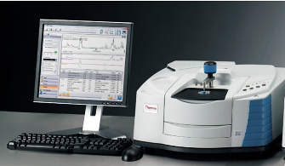

**Figure 3.** *FTIR spektrophotometry - Thermo Scientific Nicolet IS10*

• UV/VIS Spectrophotometry – This method is used to characterize the complex based on its ability to absorb light in the UV and visible regions of the spectrum. UV/VIS spectrophotometry was applied to examine the absorption of the 2-acetoxybenzoic acid complex with Ni(II) ions at a wavelength of 226 nm. A Perkin Elmer Lambda 25 UV/VIS spectrophotometer was used for the analysis, which enabled precise absorbance measurements, providing insights into the electronic transitions in the molecule and confirming the formation of the complex.

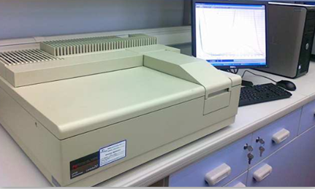

**Figure 4.** *UV/VIS spektrophotometry Perkin Elmer Lambda 25*

• Mass Spectrometry (LC-MS/MS) – For a more detailed analysis of the composition and structure, high-resolution liquid chromatography combined with mass spectrometry (LC-MS/MS) was used. This method allows for high precision in detecting and quantifying components in samples, as well as understanding their molecular mass and structure. The mass spectrum of the samples was recorded using a system that includes an Agilent 1200 series HPLC with a DAD detector and an Agilent Technologies 6420 Triple Quadrupole mass spectrometer with electrospray ionization in both positive and negative modes. The samples were dissolved in methanol to a concentration of approximately 100 μg/mL and injected into the system, with elution using 50% methanol, enabling detailed mass spectrum analysis and component identification.

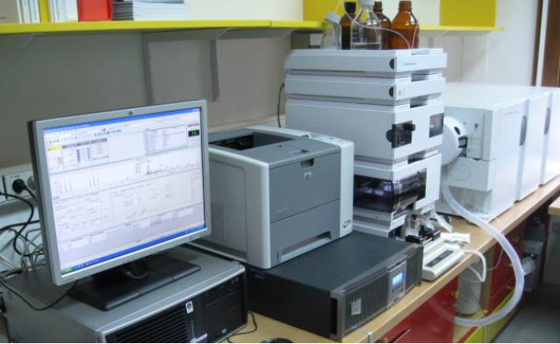

**Figure 5**. LC-MS/MS ( Agilent Technologies)

• Optical Microscopy – Optical microscopy was used to visualize the morphology of the complex crystals. Microscopic investigations were performed under transmitted polarized light using a Leica DM 2500P polarizing binocular microscope with crossed nicols. The samples of 2-acetoxybenzoic acid with metals were treated with DMSO and left to crystallize overnight at room temperature. Subsequently, the crystals of the complex were carefully transferred to a glass slide, and microphotographs were taken to assess the shape and size of the crystals. Objectives with magnifications of 4x / 0.10 and 10x / 25 were used, and the microscope lamp provided "white" light for illumination. This method allows insights into the crystal structure of the complex and can indicate the type of crystallization.

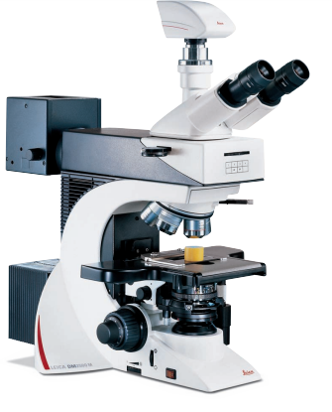

**Figure 6.** *Optical microscopy Leica DM2500P*

• Melting Point – The melting point of the metal complexes of 2-acetoxybenzoic acid was determined using the A.KRUSS Automatic Melting Point Meter – Semi-auto Version. This device enables gradual heating with precise monitoring of crystal melting under a microscope, which visualizes the melting process. This method was used to obtain information about the stability of the complex at different temperatures and its thermal stability.



**Figure 7.** *A.KRUSS Automatic Melting Point Meter – Semi-auto Version*

**2.2. Examination of bacterial activity of the complex**

The antibacterial activity of the complex samples was assessed using the well diffusion assay, which was carried out against six different bacterial strains and Candida albicans (table 1).

**Table 1. Bacterial strains used**

|  |  |
| --- | --- |
| Refeence strain | Reference number |
| *Bacillus subtilis* | WDCM00003 |
| *Candida albicans* | WDCM00054 |
| *E. coli* | WDCM00012 |
| *Pseudomonas aeruginosa* | WDCM00025 |
| *Listeria monocytogenes* | WDCM00109 |
| *Staphylococus aureus* | WDCM00034 |
| *Salmonella Enteritidis* | WDCM00030 |

The concentration of the tested complex samples (0,1 mg/mL) was carefully prepared, with dimethyl sulfoxide (DMSO) serving as the inert solvent for dilution.

To prepare the bacterial inoculum, suspensions of 0.5 McFarland turbidity were made from overnight cultures of each bacterial strain. A sterile inoculation was then applied to Mueller-Hinton agar plates, each with a thickness of 4 mm. Using a sterilized cork borer, five wells of 8 mm diameter were created in the agar surface. In each well, 100 μL of the respective complex sample was added. The plates were left at room temperature for 15 minutes to allow for proper diffusion of the sample into the agar.

Subsequently, the plates were incubated at 37°C for 24 hours. After this incubation period, the inhibitory zones around each well were carefully measured for each bacterial strain and complex sample, providing a clear indication of the antibacterial activity.

3. results and discussion

synthesis of Ni-complex of acetyl salycylic acid

The complexes were synthesized by adding an aqueous solution of metal chloride (0.01 mol) to an ethanol solution of the ligand, 2-acetoxybenzoic acid (3.604 g, 0.02 mol). The mixture was then placed in a flask, where it was subjected to refluxing with continuous stirring for 3 hours at a temperature of 60°C. During this process, the metal ion coordinates with the ligands, leading to the crystallization of the complex from the solution. Once the crystals formed, the complex precipitate was carefully filtered and then dried for several days in a desiccator to ensure complete dehydration and stability of the product. The acetylsalicylic acid (ASA) complex with the metal ion is formed in a 2:1 stoichiometric ratio. The obtained complex was then characterized using UV/VIS, FTIR, and MS spectroscopy methods, as well as melting point measurement and optical microscopy.

The FTIR spectrum of this complex, in comparison to the spectrum of free acetylsalicylic acid, shows a shift in wave numbers due to the interaction between the metal ion and the functional groups of the 2-acetoxybenzoic acid molecule. The absorption band at 3411 cm-1 in the spectrum of free 2-acetoxybenzoic acid has been attributed to O-H group. These bands undergo hypsochromic shift to 3237 cm-1 in the metal complexe indicating coordination of the metal ion with the oxygen atom in the hydroxyl group (-OH). The shifting of these (O-H) stretching vibrational band provide evidence that this group is one of the coordination sites of 2-acetoxybenzoic acid (Lawal and Obaleye, 2007).

The bands at 1749 cm-1 and 1679 cm-1 have been assigned to C=O of ester and carboxylic acid respectively, these bands also undergoes a shift in the spectra of the complexes.

Additionally, the wavenumber at 1751 cm-1 related to the vibrations of the carbonyl group (-C=O) shows a shift, suggesting that the metal ion also coordinates with the oxygen atom in the carbonyl group. Interactions between the metal ion and acetylsalicylic acid are also manifested through the shift in the bending vibrations (-OH) out of plane and (-C=O) bending, which are directly related to metal-ligand coordination. Based on these shifts in the spectrum, it can be concluded that the metal ion coordinates with acetylsalicylic acid through the oxygen atom in the hydroxyl group (-OH) and the oxygen atom in the carbonyl group (-C=O), confirming that acetylsalicylic acid functions as a bidentate ligand. These results are in agreement with existing literature data that describe acetylsalicylic acid as a bidentate ligand in interaction with metal ions (Chohan et al., 2002).

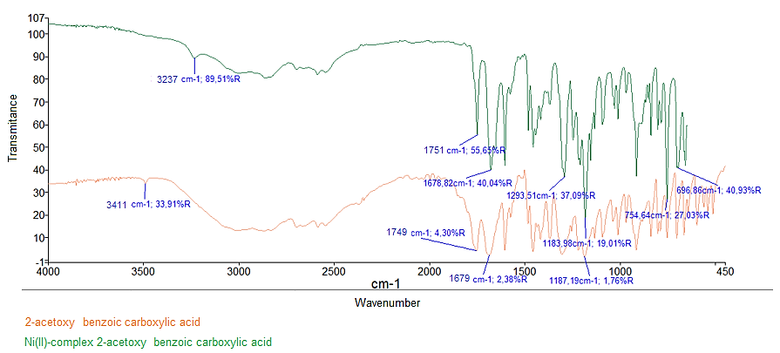

**Figure 8. IR spectrum free 2-acetoxy benzoic acid and complexed with Ni(II)-ion**

The analysis of the UV spectrum obtained for the resulting complex confirmed the formation of metal complexes of 2-acetoxybenzoic acid with the Ni(II) ion. In the case of pure 2-acetoxybenzoic acid, the absorption maximum was recorded at a wavelength of 226 nm. By comparing the spectrum of the free acid with the spectrum of the metal complex, changes were observed that indicate the coordination of the metal with 2-acetoxybenzoic acid as an O-donor ligand. The complex spectra show a shift of the absorption maximum to longer wavelengths, representing a bathochromic or red shift. This phenomenon is the result of the interaction between the metal and the ligand molecule. Additionally, a hypsochromic effect was observed in the complex spectrum, i.e., an increase in absorption intensity, which indicates a change in the electronic structure of the complex due to metal binding. The UV spectrum of the 2-acetoxybenzoic acid complex with nickel is shown in the figure 4. The compound that produces a spectrum with multiple absorption bands extending into the visible region indicates the presence of a conjugated aromatic or polycyclic aromatic chromophore.

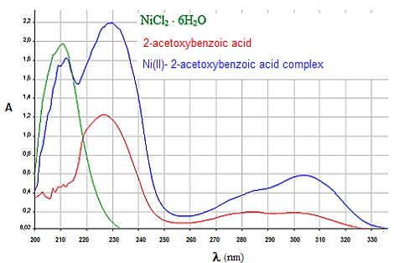

**Figure 9. UV spectrum free 2-acetoxy benzoic acid and complexed with Ni(II)-ion**

Mass spectrometry was used during the analysis and confirmation of the obtained metal complexes of 2-acetoxybenzoic acid. The mass spectrum of the Ni(II) ion complex with 2-acetoxybenzoic acid is shown in the figure, where the present peaks indicate the possible formation of the complex.The obtained mass spectrum shows a lower intensity peak corresponding to the parent ion at m/z = 455, which originates from the formed complex (2:1 in favor of the ligand) of 2-acetoxybenzoic acid with Ni(II) ion and two water molecules. The loss of one water molecule from the resulting complex gives rise to a peak at m/z = 437. After removal of nickel from the complex, a peak at m/z = 378 appears. Further fragmentation of the complex, with the loss of another water molecule, leads to a peak at m/z = 360. Peaks at m/z = 219 and m/z = 203 are present, which are assumed to originate from impurities (ASA + Na)⁺ and (ASA + K)⁺. A low intensity peak corresponding to the molecular mass of 2-acetoxybenzoic acid was observed at m/z = 180. The peaks at m/z = 153 and m/z = 139 probably correspond to molecular ions formed due to fragmentation of 2-acetoxybenzoic acid.

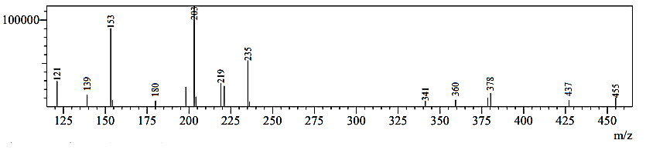

**Figure 10. Mass spectrum of Ni(II)2-acetoxy benzene carboxylic acid complex in positive ionization**

The synthesized Ni(II) complex with 2-acetoxybenzoic acid exhibits a distinctive light green color, which is likely the result of the interaction between the metal ion and the ligand, involving a mutual electron transfer. This color may indicate specific electro-oxidative processes occurring within the complex. The melting point of the synthesized complex is lower than that of pure 2-acetoxybenzoic acid, and it is measured at 114.6°C.

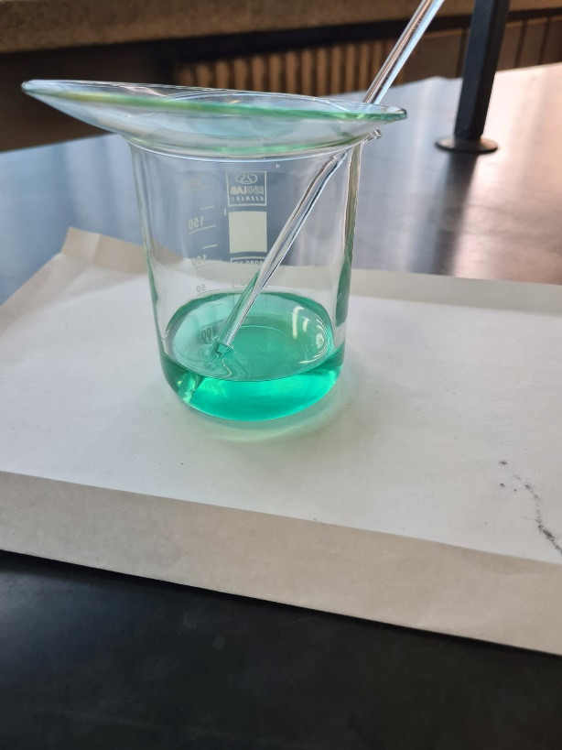 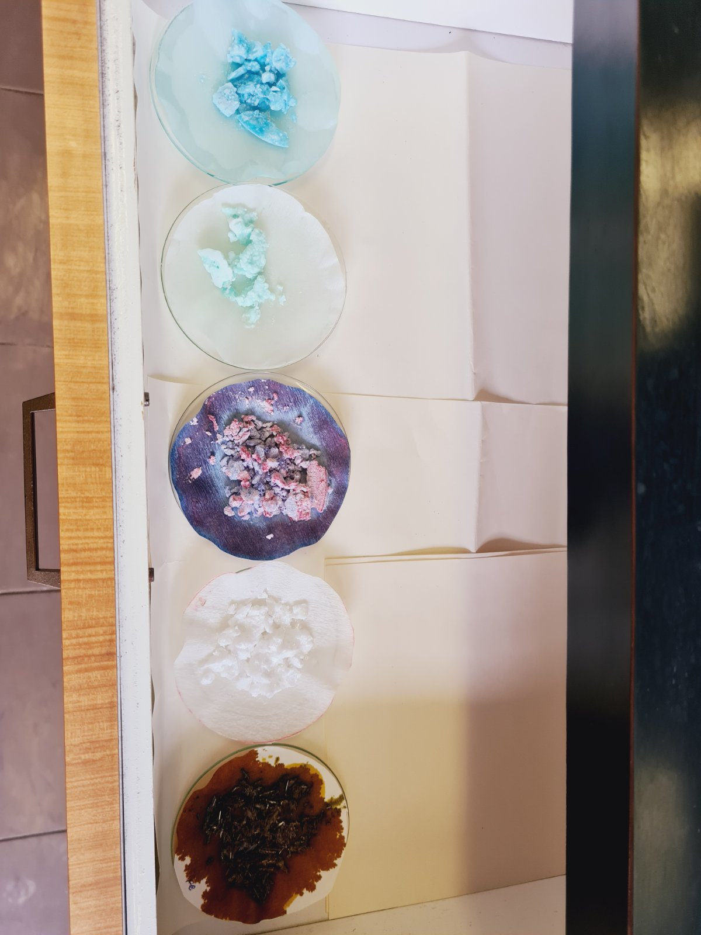

**Figure11. Synthesized complex of 2-acetoxy benzene carboxylic acid with Ni (II) ion**

By examining the morphological characteristics of metal complexes, insights into the structural aspects of these compounds can be obtained. Microphotographs displaying crystals with various shapes and sizes provide valuable information for understanding the mechanisms of crystal growth and the interactions between molecules in the crystal lattice. This information can be used to precisely control crystallization parameters, with the aim of optimizing the pharmaceutical properties and bioavailability of these substances. The crystallization of these molecules, as well as the ability to control their morphology, directly affect their physicochemical profile, including crystal growth, size, shape, and dispersion. Therefore, understanding the mechanisms of crystal growth and the factors that shape their appearance is crucial for optimizing pharmaceutical formulations.

The morphological appearance of the 2-acetoxybenzoic acid complex with Ni(II) ion is shown in the figure. Morphologically, the complex of 2-acetoxybenzoic acid with nickel exhibits an interesting surface topography. The microphotograph shows crystals that appear in radial-feathered forms, some of which have dendritic tips. Pleochroism is evident in vivid colors. The crystal length ranges from 0.6 to 2.5 mm.

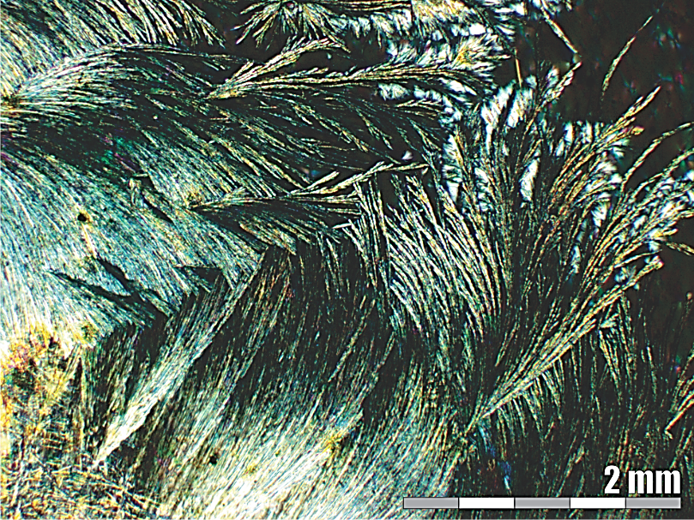

**Figure 12. Morphological appearance of the 2-acetoxy benzene carboxylic acid complex with NiCl2**

The results of testing the antibacterial and antimicrobial activity of the synthesized complex Ni(II)-2-acetoxy benzoic carboxylic acid are shown in the table 2.

**Table 2. Result of antibacterial and antifungal test**

|  |  |
| --- | --- |
| **Refeence strain** | **Inhibition zones and sensitivity of analyzed**  **Ni (II)2-acetoxy benzene carboxylic acid complex* (mm)** |
| ***Bacillus subtilis*** | 11 |
| ***Candida albicans*** | 23 |
| ***E. coli*** | 11 |
| ***Pseudomonas aeruginosa*** | 11 |
| ***Listeria monocytogenes*** | 12 |
| ***Staphylococus aureus*** | 12 |
| ***Salmonella Enteritidis*** | - |

The results of the antibacterial and antifungal analysis of the Ni(II) complex with 2-acetoxybenzoic acid demonstrate the activity of this complex against various microorganisms, including bacteria and fungi. The results refer to the inhibition zones, which indicate the effectiveness of the complex in suppressing the growth of these microorganisms.

**Bacteria:**

* ***Escherichia coli* (11 mm):** An inhibition zone of 11 mm means that the Ni(II) complex with 2-acetoxybenzoic acid has a moderate antibacterial effect against this strain. *E. coli* is a frequently tested strain for antibacterial agents, as it is known for its resistance but also its susceptibility to various antimicrobial substances.
* ***Staphylococcus aureus* (12 mm):** An inhibition zone of 12 mm suggests that the complex has a similar effectiveness as against E. coli, with a slightly higher effect against *Staphylococcus aureus*, a well-known pathogenic bacterium that can cause numerous infections, including hospital-acquired infections.
* ***Bacillus subtilis* (11 mm):** An inhibition zone of 11 mm indicates moderate effectiveness against this strain. *Bacillus subtilis* is often used as a model organism in microbiology, and this shows that the complex can also act on the spores of this strain, although not with a very strong effect.
* ***Listeria monocytogenes* (12 mm):** Similar to *Staphylococcus aureus*, an inhibition zone of 12 mm shows that the complex has a moderate to good effect on Listeria, which is known to cause serious infections, particularly in pregnant women, newborns, and immunocompromised individuals.
* ***Salmonella enteritidis:*** The complex did not exhibit significant inhibition of the growth of this bacterium.
* ***Pseudomonas aeruginosa* (11 mm):** This bacterium is known for its resistance to many antibiotics, but the Ni(II) complex with 2-acetoxybenzoic acid still shows a moderate effect in suppressing its growth, which could be useful in the context of infections caused by *P. aeruginosa*.

**Fungi:**

* ***Candida albicans* (23 mm):** An inhibition zone of 23 mm is quite large and indicates a very strong antifungal effect of the complex. *Candida albicans* is a common cause of fungal infections, particularly in immunocompromised individuals, so the strong effect of this complex on *C. albicans* could suggest its potential in the treatment of fungal infections.

4. Conclusion

Using FTIR, MS, UV/VIS, and optical spectroscopy methods, structural characterization was performed, and the formation of a complex between the 2-acetoxybenzoic acid molecule and the Ni(II) ion was confirmed. The obtained 2-acetoxybenzoic acid complexes with metals are colored, which is a result of charge transfer between the ligand and the metal, i.e., from the ligand to the metal and vice versa.

The structural characterization of the investigated metal complexes of 2-acetoxybenzoic acid shows that 2-acetoxybenzoic acid coordinates as a bidentate ligand through the carbonyl group of the carboxylic acid and ester group. The 2-acetoxybenzoic acid complex with Ni(II) ions exhibits weak antibacterial activity against various bacterial strains. The Ni(II) complex with 2-acetoxybenzoic acid shows a moderate effect against bacterial strains such as *Escherichia coli, Staphylococcus aureus, Bacillus subtilis, Listeria monocytogenes, and Pseudomonas aeruginosa*. The greatest effect of the complex was observed against *Candida albicans*, with a significant inhibition zone, suggesting its potential as an antifungal agent. These results indicate the possibility of applying this complex in the treatment of infections caused by both bacteria and fungi.

Competing interests

Authors have declared that no competing interests exist.

Disclaimer (Artificial intelligence)

Option 1:

Author(s) hereby declare that NO generative AI technologies such as Large Language Models (ChatGPT, COPILOT, etc.) and text-to-image generators have been used during the writing or editing of this manuscript.

Option 2:

Author(s) hereby declare that generative AI technologies such as Large Language Models, etc. have been used during the writing or editing of manuscripts. This explanation will include the name, version, model, and source of the generative AI technology and as well as all input prompts provided to the generative AI technology

Details of the AI usage are given below:

1.

2.

3.

References

1. Melita Huremovic, M., Huseinovic, E., Srabovic M., Catovic, B., Horozic, E. (2023). Solubilization of 2-Acetoxy-Benzencarboxylic Acid Using Beta Cyclodextrins. Open Journal of Applied Sciences, 13, 1982-1995

Available: https://doi.org/[10.4236/ojapps.2023.1311155](https://doi.org/10.4236/ojapps.2023.1311155)

1. Renfrew, A. K. (2014). Transition metal complexes with bioactive ligands: mechanisms for selective ligand release and applications for drug delivery. Metallomics, 6(8), 1324-1335.

Available: <https://doi.org/10.1039/c4mt00069b>

1. Das, A., Rajeev, A., Bhunia,S., Arunkumar, M., Chari, N., Sankaralingam, M., (2021).Synthesis, characterization and antimicrobial activity of nickel(II) complexes of tridentate N3 ligands. Inorganica Chimica Acta, 526, 120515

Available: <https://doi.org/10.1016/j.ica.2021.120515>

1. del Campo, R., Criado, J.J., García, E., Hermosa, M.R., Jiménez-Sánchez, A., Manzano, J.L., Monte, E., Rodríguez-Fernández, E., Sanz, F. (2002). Thiourea derivatives and their nickel(II) and platinum(II) complexes: antifungal activity. J Inorg Biochem. 10;89(1-2):74-82.

Available:<https://doi.org/10.1016/S0162-0134(01)00408-1>

1. Alshater, H., Al-Sulami, A.I., Aly, S.A., Abdalla, E.M., Sakr, M.A., Hassan, S.S. (2023). Antitumor and Antibacterial Activity of Ni(II), Cu(II), Ag(I), and Hg(II) Complexes with Ligand Derived from Thiosemicarbazones: Characterization and Theoretical Studies. Molecules 28, 2590.

Available:<https://doi.org/10.3390/molecules28062590>

1. Burak Ay, B., Ilyas Gönül, I., Burcu Saygıdeğer Demir, B.D., Yasemin Saygideger, Y., Ibrahim Kani, I. (2020).

Synthesis, structural characterization and in vitro anticancer activity of two new nickel complexes bearing imine bonds.Inorganic Chemistry Communications 114(6):107824

Available: <https://doi.org/10.1016/j.inoche.2020.107824>

1. Lambi J.N., Nsehyuka A.T., Egbewatt N., Cafferata L.F.R., Arvia A.A. (2003). Synthesis, spectral properties and thermal behaviour of zinc(II) acetylsalicylate. Thermochimica Acta. 398(1–2) 145-151.

doi:10.1016/S0040-6031(02)00354-4

1. Siddiqi, Z. A., Khalid, M., Kumar, S., Shahid, M., & Noor, S. (2010). Antimicrobial and SOD activities of novel transition metal complexes of pyridine-2, 6-dicarboxylic acid containing 4- picoline as auxiliary ligand. European journal of medicinal chemistry, 45(1), 264-269

Available:<https://doi.org/10.1016/j.ejmech.2009.10.005>

1. Frei, A., Zuegg, J., Elliott, A.G., Baker, M., Braese, S., Brown, C., Chen, F., Dowson C.G., Dujardin, G., Jung, N., King, A.P., Mansour, A.M., Massi, M., Moat, J., Mohamed, H.A., Renfrew, A.K., Rutledge, P.J., Sadler, P.J., Todd, M.H., Willans, C.E., Wilson, J.J., Cooper, M.A., Blaskovich, M.A.T. (2020). Metal complexes as a promising source for new antibiotics. Chem Sci. 11(10):2627-2639.

doi: 10.1039/c9sc06460e.

1. Lawal, A., Joshua A. Obaleye, J.A. (2007). Synthesis, characterization and antibacterial activity of aspirin and paracetamol-metal complexes. Biokemistri, 19 (1), 9-15

doi:10.4314/biokem.v19i1.56417

1. Chohan, H.Z., Iqbal, M.S., Iqbal, H.S., Scozzafava, A., Claudiu T. Supuran, C. T. (2002). Transition Metal Acetylsalicylates and Their Antiinflammatory Activity, Journal of Enzyme Inhibition and Medicinal Chemistry, 17:2, 87-91

Available: : https://doi.org/10.1080/14756360290030734