Removal of hydrogen sulfide from biogas by adsorption on activated carbon derived from cashew tree branches

Abstract
In the context of the energy transition, Côte d'Ivoire aims to increase the share of renewable energies in its energy mix, particularly by utilizing biogas. However, the presence of hydrogen sulfide (H₂S) in biogas poses technical and environmental challenges, necessitating its removal. This study explores the use of activated carbon derived from cashew tree branches as an adsorbent for biogas desulfurization. Cashew tree branches, an abundant byproduct of the cashew nut industry, were used as a precursor to produce activated carbon. The process involved chemical impregnation with different activating agents (H₃PO₄, NaOH, KOH), followed by carbonization at 500-550°C. The obtained activated carbon was characterized by determining its ash content, yield, pH at the point of zero charge, and iodine index.
The results show that activation with KOH produced activated carbon with the highest adsorption capacity, achieving an iodine index of 923 mg/g and an average yield of 35.28%. The H₂S filtration test revealed an initial near-total removal of the gas (≈100%), with an efficiency maintained at 90.9% after 8 hours. The activated carbon did not reach its breakthrough time during the experiment, confirming its prolonged effectiveness.
In conclusion, this study demonstrates that activated carbon derived from cashew tree branches is an effective adsorbent for biogas desulfurization. Its use could enable the local valorization of agricultural waste while contributing to the reduction of greenhouse gas emissions and the improvement of biogas quality.
Keywords: Activated carbon; Hydrogen sulfide (H₂S); Biogas desulfurization; Cashew tree branches; Adsorption

1. Introduction
The Ministry of Petroleum, Energy, and Renewable Energy Development of Côte d'Ivoire has committed to making the country the leading energy market in West Africa by 2030 [1]. With a population of over 26 million, Côte d'Ivoire also aims to reduce its greenhouse gas emissions by 28 % by 2030 by increasing the share of renewable energies in its energy mix [1, 2]. In this context, the country targets achieving 42% renewable energy in its energy mix by 2030 [1]. Among these renewable energy sources, biogas stands out as a promising alternative. Consequently, several biogas production projects based on organic waste have been launched in the country [1-5].
Biogas is primarily composed of methane (CH₄), carbon dioxide (CO₂), and trace compounds such as water (H₂O) and hydrogen sulfide (H₂S) [3]. H₂S is an odorous, toxic, and corrosive gas. Its presence in biogas can lead to corrosion, particularly when it condenses. Moreover, H₂S dissolved in water makes condensates acidic, which can damage steel, copper, and aluminum equipment [6]. Therefore, the removal of H₂S from biogas is essential for technical, environmental, and health reasons. Several industrial desulfurization techniques exist, based on chemical, biological, or physical principles, such as biological desulfurization, chemical absorption, water scrubbing, membranes, and adsorption on adsorbent materials [1]. However, these processes can be complex and costly, especially in developing countries. Hence, exploring alternative solutions such as the use of locally available, accessible, and cost-effective materials is crucial. In this context, several studies have investigated the use of activated carbon as an adsorbent material for H₂S removal [1-3].
Furthermore, Côte d'Ivoire, as the world's leading cashew producer with an annual production of over 1.2 million tons in 2023 [7], generates a large quantity of byproducts, particularly cashew tree branches, which are often underutilized. These branches, considered agricultural waste, hold significant potential for industrial applications. Their valorization, particularly for activated carbon production, not only reduces waste and prevents open burning but also contributes to environmental protection. Indeed, cashew tree branches possess interesting physicochemical properties that make them particularly suitable for activated carbon production. They are rich in lignin and cellulose, two essential components that provide activated carbon with an ideal porous structure for gas adsorption. Additionally, the ash content in cashew tree branches is relatively low, improving the quality of the produced carbon and its adsorption capacity. These properties, combined with their abundant availability, make cashew tree branches a strategic resource for activated carbon production.
In this context, this study proposes using cashew tree branches as a precursor for activated carbon production, thereby contributing to the sustainable management of this abundant resource and creating local added value while supporting environmental and industrial objectives.
The primary objective of this study is to contribute to biogas desulfurization using activated carbon produced from cashew tree branches. More specifically, this study aims to both determine the physicochemical characteristics of activated carbon derived from cashew tree branches, and evaluate the efficiency of this activated carbon in the removal of H₂S from biogas.

2. Materials and methods
2.1. Production of activated carbon
In this study, cashew tree branches used as a precursor for activated carbon production were sourced from Yaokokoroko, a locality in the northeast of Côte d'Ivoire, within the Bondoukou region. The hydrogen sulfide (H₂S) removal tests from biogas were conducted on-site at a poultry farm equipped with a biodigester (Photo 1).
The preparation of raw materials began with a thorough cleaning of the cashew tree branches to remove visible impurities such as dirt and dust. The branches were then cut into thin pieces to increase their surface area, facilitating the activation process (Photo 2).
For the activation step, a 1000 ppm solution of the activating agent (phosphoric acid, sodium hydroxide, or potassium hydroxide) was prepared. Branch pieces weighing 3.5 g were immersed in 20 mL of this solution and left to soak for 24 hours to ensure complete absorption of the chemical agent (Table 1). After impregnation, the branch pieces were separated from the solution by filtration and thoroughly rinsed with water to remove any residual traces of the activating agent.
The impregnated pieces were then subjected to carbonization in a furnace at a temperature between 500°C and 550°C for 6 hours. This step transformed the pieces into carbon by eliminating volatile components while preserving the carbonaceous structure. After carbonization, the charcoal was cooled to room temperature in a dry and ventilated environment to prevent any residual combustion. Finally, the charcoal was rinsed again to remove any remaining chemical residues and then dried for 24 hours at 30°C to ensure its stability and effectiveness.

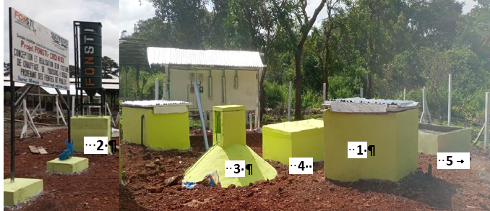
Photo 1: The Biodigester at Fondation Brin Poultry Farm. 1-Manual feeding pit;2-Mechanical feeding tower;3-Anaerobic digester;4-Expansion pit;5-Digestate storage basin
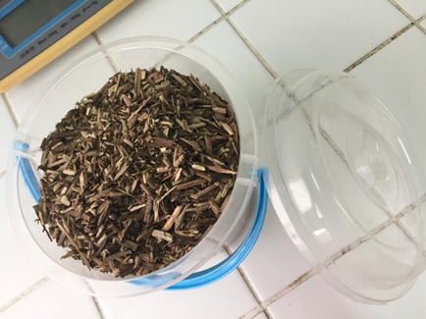
Photo 2: Precursor Material.

Table 1: Activation conditions of the precursor with different activating agents (H₃PO₄, NaOH, and KOH)
Activating agent | Concentration | Impregnation ratio | Impregnation time
H₃PO₄ (Phosphoric acid) | 1000 ppm | 3.5 g / 20 mL | 24 h
NaOH (Sodium hydroxide) | 1000 ppm | 3.5 g / 20 mL | 24 h
KOH (Potassium hydroxide) | 1000 ppm | 3.5 g / 20 mL | 24 h

2.2. Characterization of activated carbon
2.2.1. Ash content (Tc)
The ash content is used to assess the mineral richness of the material, including elements such as silica, aluminum, iron, magnesium, and calcium. This content is expressed as the percentage of ash relative to the dry mass of the charcoal (ash mass / dry charcoal mass). The following method was used to determine this parameter [8]: First, 0.5 g of activated carbon was placed in a crucible and dried in an oven at 80°C for 24 hours. After drying, the crucible and its contents were heated in a furnace set to 650°C for 3 hours. Once cooled to room temperature, the crucible and its contents were weighed again. The ash content ($T_{C}$) is calculated using the following formula:
$T_{C}\left(\%\right)=\frac{m_{3}-m_{2}}{m_{1}}×100$ (1)
Where:
$m_{1}$ : mass of the charcoal before treatment;
$m_{2}$: mass of the crucible and charcoal after heating in the furnace;
$m_{3}$ : mass of the crucible and charcoal after drying.
2.2.2. pH at the point of zero charge (pHpcn)
To determine the point of zero charge (PCN) of activated carbon, a series of 0.01 M NaCl solutions were prepared, adjusted to initial pH values between 2 and 12 using 0.1 M HCl or NaOH. A mass of 0.1 g of activated carbon was added to 50 mL of each solution, and the mixtures were stirred for 24 hours at room temperature. After stirring, the final pH of the solutions was measured, and ΔpH, defined as the difference between the final pH and the initial pH, was calculated. Finally, a ΔpH vs. initial pH curve was plotted to identify the PCN, which corresponds to the pH at which ΔpH = 0, indicating an electrically neutral surface of the activated carbon [9].
2.2.3. Yield
The yield represents the ratio between the amount of precursor used and the amount of activated carbon produced. To determine this, the mass of the precursor before carbonization (m₀) is measured, and after the process in the furnace, the mass of the produced charcoal (m₁) is determined. The yield (%) is calculated using the following formula [9]:
$R(\%)=\frac{m_{1}}{m_{0}}×100$ (2)
2.2.4. Iodine Index (Id)
The iodine index measures the ability of activated carbon to adsorb small molecules and provides an indication of its microporosity [2]. The method used to determine the iodine index follows the procedure applied by Kouakou et al., [2].
In a 100 mL beaker, 0.05 g of activated carbon is introduced. Using a pipette, 15 mL of 0.1 N iodine solution is added, and the mixture is stirred for 5 minutes before being filtered. A volume of 10 mL of the filtered iodine solution is then taken and placed in a conical flask. A 0.1 N sodium thiosulfate solution is added drop by drop to the solution until complete decolorization occurs. A starch paste is used as an indicator, with 3 drops added before the start of the thiosulfate addition. The volume of thiosulfate required to decolorize the iodine solution is noted. A blank test is carried out under the same conditions without activated carbon.
The iodine index (Id), expressed in mg/g, and is calculated using the following formula:
$I_{d}=\frac{(V_{b}-V_{s})×N×M(I)×1,5}{m}$ (3)
Where:
Vₛ: Volume of thiosulfate used for the test with charcoal (mL)
$V_{b}$: Volume of thiosulfate used for the blank test (mL)
N: Normality of the sodium thiosulfate solution
M(I): Atomic mass of iodine (126.99 g/mol)
m: Mass of charcoal used (0.05 g)

2.3. H₂S Removal test in biogas
The process of hydrogen sulfide (H₂S) removal by activated carbon relies on the principle of adsorption. The biogas is introduced into a filter containing 20 g of activated carbon, where H₂S molecules are trapped in the pores of the charcoal due to the attractive forces between the H₂S molecules and the active sites on the carbon. The concentration of H₂S is measured at both the inlet and outlet of the filtration column using a portable biogas detector. Throughout the test, the biogas flow rate was maintained constant at a value of 0.146 m³/min, or 0.00244 m³/s. Figure 1 below shows the setup used for the adsorption test.
The removal efficiency (RE) of H₂S was calculated using the following equation (4):
$RE=\frac{C_{i}-C}{C_{i}}×100$ (4)
Where Cᵢ and C represent the initial and final concentrations of H₂S, respectively [2].
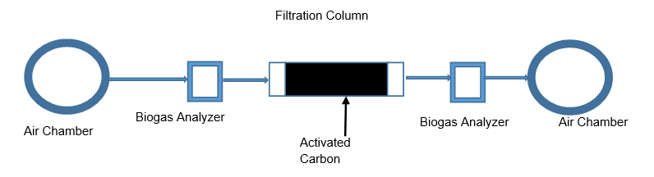
Figure 1: Schematic of the H₂S Adsorption Setup on Activated Carbon Made from Cashew Tree Branches

3. Results and Discussion
3.1. Characterization of Activated Carbon
3.1.1. Iodine Index
Table 2 presents the iodine index (Id) of the activated carbon produced using three different activating agents: phosphoric acid (H₃PO₄), sodium hydroxide (NaOH), and potassium hydroxide (KOH). The iodine index is a key indicator of the adsorption capacity of activated carbon, which is a crucial parameter in applications such as gas purification, water treatment, and pollutant removal.
The use of phosphoric acid as an activating agent results in activated carbon with a moderate adsorption capacity (758 mg/g). This performance is comparable to that observed in other studies where phosphoric acid demonstrated its effectiveness in creating a porous structure while being less aggressive than some other chemical agents, making it suitable for applications requiring moderate adsorption [10].

The activated carbon produced from NaOH has an iodine index of 814 mg/g, slightly higher than that of phosphoric acid. Sodium hydroxide is known to promote better porosity in the carbon, which can offer advantages in specific applications. However, although its iodine index is higher than that of phosphoric acid, its performance in terms of adsorption of small molecules is slightly lower than that of potassium hydroxide, which is generally more effective in this area [11].
Activated carbon produced with KOH shows the highest iodine index (923 mg/g), indicating exceptional adsorption capacity. Potassium hydroxide is often preferred in activated carbon production due to its ability to create a highly developed microporous structure, which optimizes the adsorption of small molecules, such as gases [12]. This property makes KOH the best choice among the three activating agents studied.
The activated carbon obtained with KOH stands out as the most efficient, with an iodine index of 923 mg/g, confirming previous studies that highlighted the effectiveness of potassium hydroxide in creating a microporous structure conducive to small molecule adsorption [12].
Although phosphoric acid (H₃PO₄) is less effective, it remains a good choice for applications where moderate adsorption performance is sufficient, with an iodine index of 758 mg/g [10]. As for sodium hydroxide (NaOH), although effective, its iodine index of 814 mg/g reveals a slightly lower performance compared to KOH, which may be linked to the lower creation of fine pores in the carbon structure, thus affecting its effectiveness in small molecule adsorption [11].
In the present study, the work continued with activated carbon obtained by impregnation with KOH.
Table 2: Iodine index (Id) of activated carbon based on activating agents
Activating agent | Iodine index (Id) [mg/g]
H₃PO₄ (Phosphoric acid) | 758
NaOH (Sodium hydroxide) | 814
KOH (Potassium hydroxide) | 923

3.1.2. Yield
Table 3 presents the yields of activated carbon obtained by impregnation with KOH. The average yield of 35.28% gives an overall idea of the average effectiveness of the tests conducted. The standard deviation of 1.70 indicates the variability of the yields relative to this average. The standard deviation (1.70) indicates that the yields are closely clustered around the average, demonstrating moderate variability in this case [1]. The coefficient of variation (CV), which is 4.81%, is relatively low [1]. This means that the yields are not widely dispersed around the average, indicating stability of the results from one test to another. A low CV is generally a good indicator of reproducibility and reliability of the tests, which is desirable in any manufacturing or experimental process [1].
In summary, the yields obtained are quite consistent, with low dispersion around the average of 35.28%. This suggests that the impregnation process was relatively stable throughout the trials. The yield of 35.28% means that 35.28% of the initial mass of cashew tree branches was converted into activated carbon after the activation process. This yield is relatively moderate, which is expected for the activation of lignocellulosic biomasses such as cashew tree branches. These biomasses are primarily composed of cellulose and lignin, compounds that require specific conditions to be effectively transformed into activated carbon, such as high temperatures and appropriate chemical impregnation, in this case with KOH [13].
The yield of activated carbon production is influenced by several key factors, including the quality of the raw material, the carbonization temperature (maintained for 6 hours), the impregnation time (24 hours), and the concentration of KOH (1000 ppm). The low ash content of cashew tree branches (only 2.34%) plays a crucial role, contributing to the production of high-quality activated carbon with a high specific surface area, which is essential for optimizing adsorption capacity [14].
These results align with those obtained in the study by Islam et al. (2012), which reported a yield of 35% for activated carbon production from oil palm biomass [15]. This similarity in yields highlights the consistency of results in the field of lignocellulosic biomass activation, confirming that cashew tree branches present a comparable potential to other biomasses for activated carbon production.
Table 3: Yield of Activated Carbon Obtained by Impregnation with KOH
Trial | Trial 1 | Trial 2 | Trial 3 | Trial 4
Initial mass | 274 g | 194 g | 15 g | 15 g
Final mass | 89 g | 71 g | 5.5 g | 5.3 g
Yield | 32.50% | 37% | 36.66% | 35.30%

3.1.3. pH at the Point of Zero Charge (pHpcn)
Figure 2 illustrates the graphical determination of the pH at the point of zero charge (pHpcn) of the activated carbon.
In this figure, ΔpH represents the difference between the final and initial pH values. The point of zero charge (PZC) is identified where ΔpH = 0, which occurs at approximately pH 6.8. This value signifies the pH at which the surface of the activated carbon is electrically neutral [2]. When the pH of the biogas is lower than 6.5, which is often the case due to the presence of H₂S, CO₂, and moisture, the surface of the activated carbon becomes positively charged. This positive charge promotes the adsorption of HS⁻ and S²⁻ species through electrostatic attraction, making this activated carbon effective for capturing dissolved H₂S.
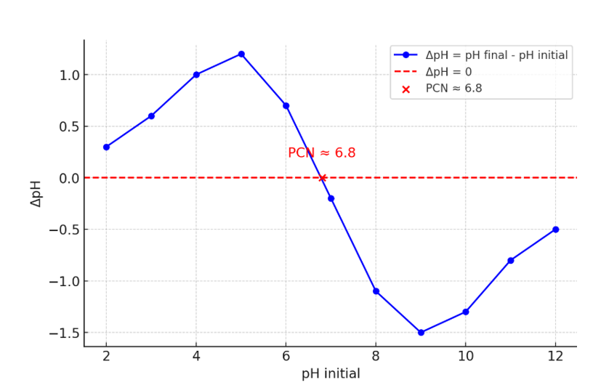
Figure 2: Graphical determination of the pH at the point of zero charge (pHpcn) of activated carbon

3.2. Removal of hydrogen sulfide (H₂S) from biogas using activated carbon derived from cashew tree branches (CAA)
3.2.1. Biogas Composition
Digester produces biogas primarily composed of methane (CH₄), carbon dioxide (CO₂), carbon monoxide (CO), and hydrogen sulfide (H₂S). To assess the stability of the H₂S concentration before adsorption, measurements were taken at different points during the process (Table 4). Results show that no significant variation in the initial H₂S concentration was observed. This indicates that the initial concentration of H₂S in the biogas remains constant before the adsorption step.
Table 4: Biogas composition
Constituent | Measurement 1 | Measurement 2 | Measurement 3 | Measurement 4
CH₄ (Methane) | 85-90% | 85-90% | 85-90% | 85-90%
CO₂ (Carbon Dioxide) | 10-15% | 10-15% | 10-15% | 10-15%
CO (Carbon Monoxide) | 0.1 - 0.5% | 0.1 - 0.5% | 0.1 - 0.5% | 0.1 - 0.5%
H₂S (Hydrogen Sulfide) | 80-100 ppm | 80-100 ppm | 80-100 ppm | 80-100 ppm

3.2.2. Hydrogen Sulfide (H₂S) Removal from Biogas
3.2.2.1. Evolution of H₂S concentrations at the outlet of a filtration column containing 30 g of CAA over time
Figure 3 presents the evolution of H₂S concentrations at the outlet of a filtration column containing 30 g of CAA over time.
At the beginning of the filtration (0 to 100 minutes), the H₂S concentration is low and almost negligible (approximately 2 ppmV). This initial phase can be attributed to the effectiveness of cashew tree branch-based activated carbon, which, due to its high porosity and adsorption properties, rapidly captures the H₂S molecules present in the biogas. The low initial concentration indicates the good adsorption capacity of the activated carbon, which is typical when the adsorption sites are not yet saturated.
From 100 minutes to around 160 minutes, the H₂S concentration gradually increases, reaching a value of 7.25 ppmV. This rise can be interpreted as the gradual saturation of the available adsorption sites on the activated carbon. The activated carbon starts becoming saturated with H₂S, limiting its ability to capture new gas molecules. This phenomenon indicates that the activated carbon begins to lose its adsorption capacity as the active sites are occupied by H₂S molecules. After 160 minutes, the concentration of H₂S stabilizes around 7.25 ppmV and remains constant until 600 minutes (8 hours). This suggests that the activated carbon has reached a saturation point, where the adsorption of H₂S is minimal, and its adsorption capacity is limited by the remaining active sites. The stabilization of the concentration also indicates that no additional H₂S is being adsorbed, as the activated carbon is saturated and can no longer efficiently remove the gas.
It is important to note that despite the rise in concentration, the measured H₂S values remain well below the tolerance limits. The maximum concentration of 7.25 ppmV is below the 10 ppmV limit for prolonged exposure over 8 hours and much lower than the critical threshold of 16 ppmV, recommended to prevent damage to methanation equipment [16]. This demonstrates that CAA remains effective for treating biogas even after 8 hours of operation. A notable point is that the activated carbon did not reach its breakthrough time during the 10-hour experiment. The breakthrough time is defined as the point when the H₂S concentration at the outlet of the filter reaches half of the initial concentration (approximately 40-50 ppmV). The absence of breakthrough time indicates that the activated carbon continued to capture H₂S effectively throughout the entire duration of the experiment without the gas escaping the filtration system.
3.2.2.2. H₂S Removal efficiency over time for 30 g of CAA
Figure 4 presents the removal efficiency (RE) of H₂S over time for 30 g of cashew tree branch-based activated carbon (CAA). This figure shows an initially very high removal efficiency, close to 100% at the beginning of the filtration, but with a rapid decline in efficiency after the first few minutes. From 100 minutes, the efficiency drops significantly to around 91% at 200 minutes. This decrease in removal efficiency indicates that the activated carbon begins to saturate and its adsorption capacity diminishes.
From 200 minutes, the removal efficiency stabilizes around 91% and remains constant until the end of the experiment (700 minutes). This suggests that, although the carbon is saturated and the adsorption capacity decreases, it continues to adsorb a significant amount of H₂S, maintaining a high removal rate even after a long period of filtration. The removal efficiency of H₂S by the CAA remains very high, at 90.9% over the 8-hour duration. This level of efficiency demonstrates the ability of the activated carbon to effectively remove a large amount of H₂S, even after several hours of filtration. This is attributed to the high quality of the cashew tree branch-based activated carbon, which has an optimal porous structure allowing for prolonged adsorption [17; 18].

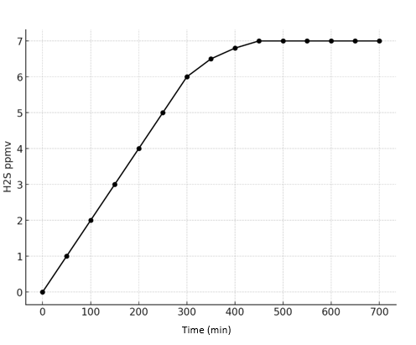
Figure 3: Variation of H₂S concentration over time for a mass of 30 g of CAA
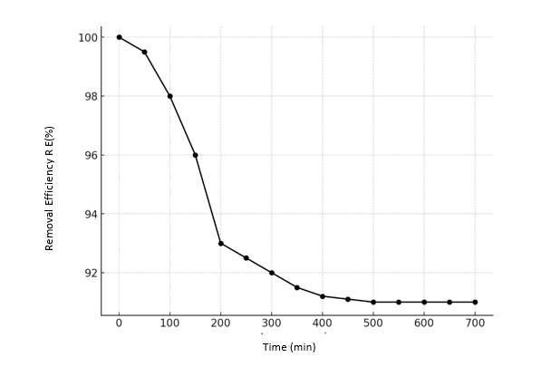
Figure 4: H₂S Removal Efficiency (RE) Over Time for 30 g of CAA

4. Conclusion
This study explored the use of activated carbon derived from cashew tree branches for the removal of hydrogen sulfide (H₂S) in biogas. The objective was to develop a local, effective, and economically viable solution for biogas desulfurization while valorizing an abundant byproduct in Côte d'Ivoire.
The production of activated carbon was carried out through chemical impregnation with three activating agents (H₃PO₄, NaOH, and KOH), followed by high-temperature carbonization. The analyses showed that carbon activated with KOH exhibited the best properties, with an iodine index of 923 mg/g and an average yield of 35.28%, indicating strong microporosity and good adsorption capacity.
The H₂S removal tests revealed an initial efficiency close to 100%, which was maintained at 90.9% after 8 hours of filtration, without reaching the breakthrough time. These performances demonstrate that activated carbon derived from cashew tree branches is an efficient adsorbent material, capable of sustainably treating biogas and reducing the environmental impact associated with H₂S emissions.
After use, activated carbon becomes saturated with adsorbed H₂S and other impurities, which may limit its effectiveness. However, it can be regenerated through thermal treatment, chemical washing, or steam activation to restore its adsorption capacity. The extent of regeneration depends on the degree of contamination and the regeneration method applied. While multiple regeneration cycles are possible, repeated treatments can alter the carbon structure, reducing its efficiency over time. Regeneration also poses certain risks, including the potential release of toxic gases during thermal treatment and the environmental impact of chemical regenerants. Proper handling, emissions control, and sustainable disposal methods are necessary to minimize these risks. Despite these challenges, the regeneration and reuse of activated carbon can enhance cost-effectiveness and sustainability in biogas purification processes.
The use of this activated carbon offers several advantages: an economic alternative to imported materials, valorization of agricultural waste, and a contribution to the country's energy transition..
Disclaimer (Artificial intelligence)
Option 1:
Author(s) hereby declare that NO generative AI technologies such as Large Language Models (ChatGPT, COPILOT, etc.) and text-to-image generators have been used during the writing or editing of this manuscript.
Option 2:
Author(s) hereby declare that generative AI technologies such as Large Language Models, etc. have been used during the writing or editing of manuscripts. This explanation will include the name, version, model, and source of the generative AI technology and as well as all input prompts provided to the generative AI technology
Details of the AI usage are given below:
1.
2.
3.

Reference
[1] Gbangbo, K. R., Kouakou Adjoumani Rodrigue., Ehouman, A. D., Yao, B., Goli Lou, G. V. E., Gnaboa, Z., & Bailly, G. C. (2023). Influence of Water Content on Hydrogen Sulfide Adsorption in Biogas Purification with Musa Paradisiaca Biochar. Chemistry Africa, 1-9.
[2] Kouakou Adjoumani Rodrigue, K. A., Donatien, E. A., Sylvie, K. A. T., Joachim, K. N., Ouattara, K. D., Eric, A. K., ... & Tchirioua, E. (2022). Removal of Hydrogen Sulfide from Biogas by the Acacia Auriculeaformis Activated Carbon. Science, 10(5), 170-176.
[3] Ehouman Ahissan Donatien, KONAN Affoué Tindo Sylvie, KOUAKOU Adjoumani Rodrigue, OUATTARA Taniky Sy Hamed1, ADOU Kouakou Eric, KONAN Gbangbo Remis, KONE Horo, EKOU Lynda and EKOU Tchirioua (2022). Removal of Hydrogen Sulphide from Biogas by Activated Carbon Based on Borassus Aethiopum (Ivory Coast). Journal of Chemical, Biological and Physical Sciences, 13 (1), 041-050.
[4] Karidio Daouda Idrissa, O. K., Tsuanyo, D., Kouakou, A. R., & Yao Kouassi, B. (2022). The Effect of pH Variation in Biogas Production: Impact of Cocoa Pods and Empty Palmyra Palm Bunches. Waste and Biomass Valorization, 1-8.
[5] Kouadio Marc Cyril, Kouakou Adjoumani Rodrigue, Kra Essi., Trokourey Albert, & Akichi Agboue. (2018). Biochemical Methane Potential of Food Wastes from Akouedo Landfill, Côte d’Ivoire. Green and Sustainable Chemistry, 8(03), 288.
[6] Kra Essi Kouadio Francis, Kouakou Adjoumani Rodrigue, Kouadio Marc Cyril, & Akichi Agboue. (2020). Landfill’s solide waste management: life cycle assessment and gas potential generation of Akouedo in Abidjan. Australian Journal of Basic and Applied sciences, 14 (07), 14-22.
[7] Cabinet du Premier Ministre de Côte d'Ivoire. (2025, février 16). Transformation de l’anacarde : Le Premier Ministre Robert Beugré Mambé inaugure une usine à Boundiali. Primature de Côte d’Ivoire. https://www.primature.ci/actualite/?pm=12118
[8] Koné, H., Kouassi, K. E., Assémian, A. S., Adouby, K., Yao, K. B., & Drogui, P. (2021). Investigation of breakthrough point variation using a semi-industrial prototype packed with low-cost activated carbon for water purification. Journal of Materials and Environmental Science, 12, 224-243.
[9] Kra, D. O., Atheba, P., Drogui, P., & Trokourey, A. (2019). Preparation and characterization of activated carbon based on wood (Acacia auriculeaformis, Côte d’Ivoire). Journal of Encapsulation and adsorption Sciences, 9(02), 63.
[10] Oginni, O., Singh, K., Oporto, G., Dawson-Andoh, B., McDonald, L., & Sabolsky, E. (2019). Effect of one-step and two-step H3PO4 activation on activated carbon characteristics. Bioresource Technology Reports, 8, 100307.
[11] Guo, Z., Han, X., Zhang, C., He, S., Liu, K., Hu, J., ... & Duan, G. (2024). Activation of biomass-derived porous carbon for supercapacitors: A review. Chinese Chemical Letters, 35(7), 109007.
[12] Hui, T. S., & Zaini, M. A. A. (2015). Potassium hydroxide activation of activated carbon: a commentary. Carbon letters, 16(4), 275-280.
[13] Correa, C. R., Otto, T., & Kruse, A. (2017). Influence of the biomass components on the pore formation of activated carbon. Biomass and bioenergy, 97, 53-64.
[14] Gani, A., Munawar, E., Mamat, R., & Rosdi, S. M. (2023). Investigation of the potential biomass waste source for biocoke production in Indonesia: A review. Energy Reports, 10, 2417-2438.
[15] Islam, M. S., & Rouf, M. A. (2012). Waste biomass as sources for activated carbon production-A review. Bangladesh Journal of Scientific and Industrial Research, 47(4), 347-364.
[16] Promnuan, K., & Sompong, O. (2017). Biological hydrogen sulfide and sulfate removal from rubber smoked sheet wastewater for enhanced biogas production. Energy Procedia, 138, 569-574.
[17] Chen, S., Guo, Y., Zhang, J., Guo, Y., & Liang, X. (2022). CuFe2O4/activated carbon adsorbents enhance H2S adsorption and catalytic oxidation from humidified air at room temperature. Chemical Engineering Journal, 431, 134097.
[18] Mao, D., Griffin, J. M., Dawson, R., Fairhurst, A., Gupta, G., & Bimbo, N. (2021). Porous materials for low-temperature H2S-removal in fuel cell applications. Separation and Purification Technology, 277, 119426.

