***Original Research Article***

**ACCESSING ONLINE HEALTH-RELATED INFORMATION BY PARENTS OF CHILDREN WITH NEUROLOGIC DISORDERS IN PORT HARCOURT, NIGERIA**

**ABSTRACT**

**Background**

Parental use of online search engines to get information about their children’s illnesses is a common practice in developed countries. This online search is becoming part of our society, especially in the face of chronic disorders.

**Objectives**

This study was undertaken to ascertain the proportion of parents of children with neurological disorders browsing the internet for medical information and factors associated with this behaviour.

**Methods**

This cross-sectional descriptive study was carried out in the paediatric neurology clinic of the Rivers State University Teaching Hospital, where 106 child-parent pairs were consecutively recruited. A questionnaire was used to collect information on biodata and their use of the internet to access information on their children’s diseases. Data was analysed with SPSS 23, with statistical significance set at P value < 0.05.

**Result**

The mean ages of the children, mothers and fathers were 5.5±4.6 years, 37.2±6.9 years and 44.6±6.9 years respectively. Most mothers (63.2%) and fathers (61.3%) had attained tertiary education and were of middle socioeconomic class. Of the 54(50.9%) parents who had browsed the internet, 49(90.7%) used Google, and 50(92.6%) browsed with their phones.

Among those who searched for information online, only 11(20.4%) discussed such information with a physician. Tertiary education among parents and middle socioeconomic status were significantly associated with browsing the internet.

**Conclusion**

A good proportion (50.4%) of educated parents are browsing the internet for more medical information on their children’s illnesses but few are verifying such information with physicians. There is therefore a need to counsel parents on the proper websites to get accurate information.

**Keywords:** counsel, Neurologic disorders, Paediatric Parents, physician,

**INTRODUCTION**

**BACKGROUND**

The internet is a key source of information in today’s society, with two-thirds of the global population having an internet access and the 25-34 years age group being the highest users. (1) In early 2023, there were approximately 122 million active internet users in Nigeria, (1) which corresponds to about half of the total population, a constant increase from 97.2 million in 2017.

Parental use of online search engines to get information on diagnosis and treatment options of their children’s illnesses, is a common practice all around the world. The frequency is more in developed countries. (2, 3, 4, 5, 6,7). It is becoming increasingly frequent in our society, especially in the face of chronic and life-threatening illnesses (8) The use of the internet as a source of information on medical conditions demonstrates a willingness to learn and, in itself, is a positive and commendable practice. (9) A study done in the University of Kansas America found out that parents there trust internet artificial Intelligence more than they trust their doctors for medical information. (10) Kostagiolas et al. (2012) reported that, in Greece, parents used the internet as the second most common source of information about their children's health. (5) A study done in Iran in 2018, established that 31.8% of parents within 7 days, checked online at least twice and up to five times for solutions concerning their children’s health. (4) Online searches potentially provide answers and can even provide social support in the form of online support groups for parent of children with similar illnesses. (2) Parents have expressed a need to get more information from their paediatricians (3) and tend to search more when their questions and concerns were not satisfactorily answered during a hospital appointment. (8,11). Use of internet can be harnessed and expanded to include social media platforms. A study carried out in 2012 among the African American Minority group of parents in three primary health care centers in Washington America found out that 74.2% of parents who were mainly single mothers, were interested in being part of an online support group. (12) This may be gender related as women are more communal than their male counterparts. There are different reasons why parents search the internet for information and they include but are not limited to, limited access to experts, the cost of seeing the experts, time spent waiting at clinics, as well as the fact that it is more convenient to use the readily available smartphone. (13) There is an unquantified amount of information online, this makes it easy to get minute details about uncommon diseases using popular search engines. (14)

Health-related information on the internet is largely unregulated and disease-specific information accessed online may be difficult to understand and assimilate by parents making it needful to crosscheck such information with the child’s healthcare provider.

This practice of sourcing for additional information online has both risks and benefits. It could guide parental decisions and ultimately influence the outcome of management of ill children and those with neurologic disorders. (3) When properly utilized, it can aid in improving outcomes, however when the wrong information is acted upon, it can be counterproductive. This study will provide the necessary information for designing more informed interventions for doctor -parent collaboration,

The objectives of the study were to determine the proportion of parents of children with neurologic disorders browsing the internet for medical information and to determine if there are any socio-demographic factors associated with this behaviour among parent-child pairs attending the Paediatric Neurology Clinic (PNC) in the Rivers State University Teaching Hospital (RSUTH), Port Harcourt, Nigeria.

**METHODOLOGY**

This was a cross-sectional, descriptive study conducted in the PNC of the RSUTH. The RSUTH is a 500-bedded tertiary government-owned hospital located in the South-South geographic region of Nigeria. It is a centre of excellence that manages patients referred to it from private and public hospitals within and outside the State. The Paediatrics department is manned by consultants of different specialties such as neurology, neonatology, cardiology, haemato-oncology, respiratory, infectious, nephrology, endocrinology and community paediatrics. There are daily outpatient clinics from Monday to Friday; children emergency room as well as the children’s wards where patients are managed. This study was carried out in the first six months of 2024.

A total of 106 parents of children with neurological disorders attending the PNC and who gave consent, were consecutively recruited until the end of the study using a convenience sampling method. Parents of children who were not diagnosed with neurologic disorders as well as parents who did not give consent were excluded. Ethical clearance was obtained from the Rivers State Hospitals Management board. A self administered questionnaire was used to collect information on biodata and their use of the internet to assess information on their children’s diseases. The socioeconomic classes of the families were determined using the Oyedeji classification of socioeconomic classes. (15). They were classified as high, middle and low socio-economic classes using parental educational level and occupation. The different neurologic disorders diagnosed among the children were also documented on the proforma. Data were analysed using SPSS 23 and statistical significance set at p-value <0.05 at 95% confidence interval. Results are presented as tables, graphs and charts.

**RESULTS**

A total of 106 parent-child pairs were recruited into the study. The mean ages of the children, mothers and fathers were 5.5±4.6 years, 37.2±6.9 years and 44.6±6.9 years respectively. Most mothers (63.2%) and fathers (61.3%) attained tertiary education and were of middle socioeconomic class (50.9%)

Of the 54(50.9%) parents who had browsed the internet for their children’s sicknesses, 50(92.6%) used their phones, while 4 of the parents did so on their laptops. A total of 49(90.7%) parents used Google, two persons used an online medical journal while others used a hospital-based website to search for medical information.

Parental tertiary education and middle socioeconomic status were significantly associated with internet browsing for health-related information on childhood neurologic disorders. Only 11(20.4%) of the respondents discussed information obtained with a physician.

Table 1: Fathers’ occupation and internet search for child’s condition.

|  |  |  |  |  |
| --- | --- | --- | --- | --- |
|  | |  | | Total |
| NO | YES |
| FATHER'S OCCUPATION 2 | ARTISAN | 17 | 8 | 25 |
| BUSINESS | 21 | 21 | 42 |
| CIVIL SERVANT | 5 | 14 | 19 |
| CLERGY | 3 | 0 | 3 |
| ENGINEER | 2 | 5 | 7 |
| LAWYER | 0 | 1 | 1 |
| PUBLIC SERVANT | 3 | 1 | 4 |
| UNEMPLOYED | 1 | 4 | 5 |
| Total | | 52 | 54 | 106 |

Yes is for those who searched the internet and no is for those who did not. The fathers’ occupation was significantly associated with internet search as businessmen and civil servants searched the internet more, with p value of 0.029

Table 2: Diagnosis and internet search

|  |  |  |  |  |
| --- | --- | --- | --- | --- |
| CLINICAL DIAGNOSIS | | HAVE YOU SEARCHED THE INTERNET REGARDING YOUR CHILD'S CONDITION | | Total |
| NO | YES |
|  | ATTENTION DEFICIT HYPERACTIVITY DISORDER | 1 | 1 | 2 |
| ANXIETY DISORDER | 1 | 0 | 1 |
| AUTISM SPECTRUM DISORDER | 1 | 1 | 2 |
| CEREBRAL PALSY | 15 | 12 | 27 |
| DOWNS | 2 | 2 | 4 |
| EPILEPSY | 24 | 27 | 51 |
| HEAD INJURY | 0 | 1 | 1 |
| HYDROCEPHALUS | 0 | 1 | 1 |
| INTELLECETUAL DISABILITY | 3 | 1 | 4 |
| MICROCEPHALY | 0 | 1 | 1 |
| MIGRAINE | 0 | 2 | 2 |
| MOTOR TICS | 0 | 1 | 1 |
| SPEECH AND LANGUAGE DISABILITY | 4 | 3 | 7 |
| VISUAL IMPAIRMENT | 1 | 1 | 2 |
| Total | | 52 | 54 | 106 |

The type of diagnosis did not significantly affect the use of the internet to search for more medical information (p-value 0.801)

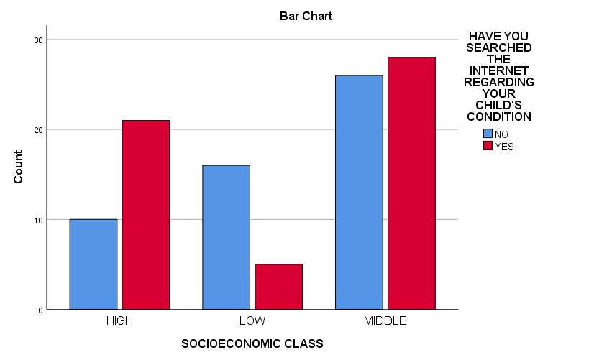

**Figure 1: socioeconomic status and internet search**

**Table 3. SOCIOECONOMIC CLASS OF PARENT AND INTERNET REGARDING CHILD'S CONDITION**

|  |  |  |  |  |
| --- | --- | --- | --- | --- |
|  | | HAVE YOU SEARCHED THE INTERNET REGARDING YOUR CHILD'S CONDITION | | Total |
| NO | YES |
| SOCIOECONOMIC CLASS | HIGH | 10 | 21 | 31 |
| LOW | 16 | 5 | 21 |
| MIDDLE | 26 | 28 | 54 |
| Total | | 52 | 54 | 106 |
|  | |  |  |  |

The p-value for socioeconomic class and internet search for medical information had a p value of 0.008 hence those from the middle socioeconomic classes were more likely to search for medical information.

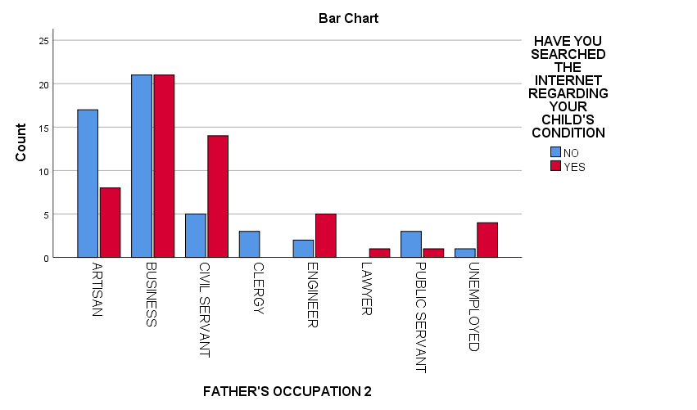

|  |  |  |  |  |
| --- | --- | --- | --- | --- |
| **Figure 2. Father’s Occupation** | | | | |
|  | | | | |
|  | | HAVE YOU SEARCHED THE INTERNET REGARDING YOUR CHILD'S CONDITION | | Total |
| NO | YES |
| MOTHER'S OCCUPATION2 | ARTISAN | 8 | 8 | 16 |
| BUSINESS | 23 | 22 | 45 |
| CIVIL SERVANT | 2 | 6 | 8 |
| CLERGY | 2 | 0 | 2 |
| ENGINEER | 0 | 1 | 1 |
| LATE | 1 | 0 | 1 |
| LAWYER | 0 | 1 | 1 |
| MED LAB SCIENTIST | 0 | 1 | 1 |
| NURSE | 2 | 1 | 3 |
| PUBLIC SERVANT | 2 | 3 | 5 |
| TEACHER | 5 | 6 | 11 |
| UNEMPLOYED | 7 | 5 | 12 |
| Total | | 52 | 54 | 106 |

**Table 4. Mother’s occupation.**

The mother’s occupation was not significantly associated with internet search for the child’s diagnosis with a P value = 0.627

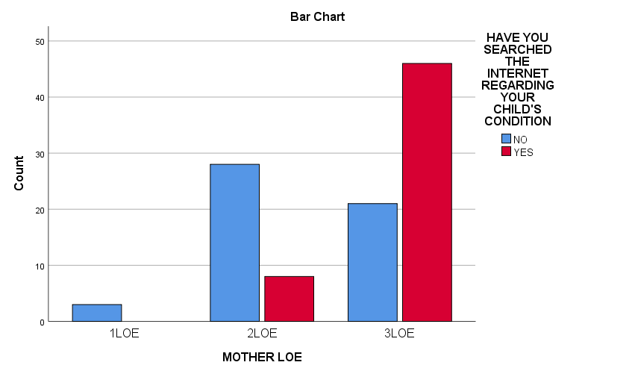

Figure 3. Mother’s level of education.

Figure 3 mother’s level of education and internet search

1LOE = primary level of education

2LOE = secondary level of education

3LOE = tertiary level of education

Mothers who had a tertiary level of education significantly searched the internet for the child’s illness (P value of 0.000)

|  |  |  |  |  |
| --- | --- | --- | --- | --- |
| **Table 5: FATHER'S LOE AND INTERNET SEARCH** | | | | |
|  | | | | |
|  | | HAVE YOU SEARCHED THE INTERNET REGARDING YOUR CHILD'S CONDITION | | Total |
| NO | YES |
| FATHER'S LOE | 1LOE | 3 | 0 | 3 |
| 2LOE | 22 | 13 | 35 |
| 3LOE | 25 | 40 | 65 |
| NONE | 1 | 1 | 2 |
| UNKNOWN | 1 | 0 | 1 |
| Total | | 52 | 54 | 106 |

P -value for father’s LOE is 0.045 which is not significant

**Table 6: Percentage of parents with internet enabled phones.**

|  |  |  |  |  |
| --- | --- | --- | --- | --- |
|  | | HAVE YOU SEARCHED THE INTERNET REGARDING YOUR CHILD'S CONDITION | | Total |
| NO | YES |
| DO YOU HAVE AN INTERNET ENABLED PHONE | NO | 15 | 0 | 15 |
| YES | 37 | 54 | 91 |
| Total | | 52 | 54 | 106 |

1. Value = 0.000 which is significant hence parents who have an internet- enabled phone would more likely search the internet for information on the child’s clinical condition compared to those without an internet-enabled phone.

**Table 7. Proportion of parents with laptops**

|  |  |  |  |  |
| --- | --- | --- | --- | --- |
|  | | HAVE YOU SEARCHED THE INTERNET REGARDING YOUR CHILD'S CONDITION | | Total |
| NO | YES |
| DO YOU HAVE A LAPTOP | NO | 39 | 16 | 55 |
| YES | 13 | 38 | 51 |
| Total | | 52 | 54 | 106 |

P -VALUE = 0.000

**DISCUSSION**

This study highlights the utilization of the internet to search for medical information concerning the diagnosis and treatment of neurologic disorders of children in the locality. The mean ages for parents fell within the age of the millennial generation and they were the first generation to be exposed to online media. (11). This stage represents the reproductive and early parenting phase, during which parents who are still having children or raising young ones are eager to obtain information about their children's growth and development.

This study showed that 50.4% of parents had searched the internet for information concerning their children with neurological disorders. This was similar to an earlier report of 52% in Melbourne Australia (17). However, it is higher than the report for Lagos where only 40% of respondents had used search engines or social media for information on their children’s clinical condition (13). Our reported rate is lower than the 91% reported by Jaks et al in Switzerland in 2019 (17) as well as the 96% by Yardi et al in 2018 and the 89 by Yundianto in 2023 both in Australia (18, 19), and the 80% in Florida by Knapps et al(20). The higher rate reported in Switzerland may be due to the fact that the parents were those who had children between 0-2 years which is an age bracket where a lot of development is ongoing and parents are curious to know if these are within the normal limit in addition to being a more developed country with better internet access and educational status. Knapps et al (20) was among children with life threatening conditions which may partly account for the higher rate. Our study involved parents of children with various degrees of prognosis and the diagnosis did not show a statistical difference. The population in Florida were also majorly educated with tertiary education.

The most commonly used search engine in this study was google. This was similar to what was reported in studies in Austria, (3, 21) where almost all the parents used google. Similar reports of 80%, 75% and 96% utilization of google respectively were reported from Lagos (8), United Kingdom(22) and Norway (23) and this may be due to the fact that google is the most popular and fastest search engine.(24). The study showed that parents with a tertiary level of education and middle socioeconomic class significantly carried out health-related online searches which is different from the study in Vienna where educational level and socioeconomic class did not significantly affect internet searching and aligns with what Knapps et al found. (20, 21). In Switzerland as well, 75% of those who did an internet search had tertiary level of education (17).

In this study most parents used their phones for internet search similar to the report in Australia by Yardi et al where 63% used their smart phones (18). The phones are readily available and can be used on the go.

Parents rarely discussed their findings on the internet with physicians in this study similar to the findings in a systematic review of 33 studies by Kubb and Foran in 2020. Yundiato et al and Wainstein et al concurred as well that the majority of parents did not share the information with their doctors. (3, 6, 19). This is however different from the report by Jaks et al in Switzerland (16) where up to 67% of parents asked for guidance from their paediatricians after internet search. Yudianto et al in a study done in Australia established that most parents used the internet to search for health information, however, what they did with the information when it conflicted with what the pediatrician said depended on their level of trust in the doctor in question. (19) Sharing findings from internet searches can help build a trusting parent-doctor relationship, which is a key determinant of treatment outcomes, with doctors playing a role in moderating the information shared. This thought was corroborated by Meyers et al that found out that parents were willing to use the internet as a way of communication between them and health care providers. (25)

Overall, most of the parents were millennials, half utilized the internet for information, most used their phones as a device and google as the search engine. The diagnosis of the children did not play a strong role and most parents did not discuss their finding with the doctors**.**

Qualified doctors can meet the parents online by increasing their own online presence through use of videos, PowerPoint presentations, academic and scientific papers. These can also be put on social media platforms like TikTok, Instagram, Facebook and WhatsApp. Social groups can be formed online to increase the useful information in the public domain.

**CONCLUSION**

This study highlighted the fact that 50.4% of Nigerian parents of children with neurologic disorders are searching the internet for health related-information like their counterparts worldwide and this behaviour is likely to be on the increase. Pediatricians can utilize this to their benefit to maximize management outcomes.

**RECOMMENDATIONS**

Conduct a national survey to assess internet use for searching health-related information on children and its impact on treatment uptake and follow-up visits.

Raise awareness about the importance of verifying online health information by encouraging parents to share their findings with their physicians.

Conduct follow-up studies to provide parents with guidance on effectively using the internet to access and verify health-related information.

Consent

As per international standards, parental written consent has been collected and preserved by the author(s).

Disclaimer (Artificial intelligence)

The Authors hereby declare that NO generative AI technologies such as Large Language Models (ChatGPT, COPILOT, etc.) and text-to-image generators have been used during the writing or editing of this manuscript.

**REFERENCES**

1. Yazi. Nigeria’s Digital statistics 2023. Data rerports.com 2023. Obtained online on the 8th of Jan. 2024.

https://www.askyazi.com/useful-data-sources-for-africa/nigerias-digital-statistics-2023#:~:text=Key%20Figures,percent%20of%20the%20total%20population.

1. Nicholl H, Tracey C, Begley T, King C, Lynch AM. Internet Use by Parents of Children With Rare Conditions: Findings From a Study on Parents' Web Information Needs. J Med Internet Res. 2017;19(2):e51. doi:10.2196/jmir.5834
2. Kubb C, Foran MH. Online Health Information Seeking by Parents for Their Children: Systematic Review and Agenda for Further Research. J Med Internet Res 2020;22(8):e19985. doi:10.2196/19985
3. Ravanshad Y, Azarfar A, Khademi G, Mohammadzadeh A, Sezavar M, Naseri M. Evaluating the Information Seeking Behavior of Parents with Sick Children about Health and Medical Issues. Int J Pediatr. 2021;9(2):13031-13040.
4. Kostagiolas P, Martzoukou K, Georgantzi G, Niakas D. Information seeking behaviour of parents of paediatric patients for clinical decision making: the central role of information literacy in a participatory setting. Info Res. 2012;18(3):590-611.
5. Wainstein BK, Sterling-Levis K, Baker SA, Taitz J, Brydon M. Use of the internet by parents of paediatric patients. J Paediatr Child Health. 2006;42(9):528–32.
6. Bernhardt JM, Felter EM. Online pediatric information seeking among mothers of young children: results from a qualitative study using focus groups. J Med Internet Res. 2004;6(1):e7.
7. Adekunle AA, James O, Adeyemo WL. Health Information Seeking Through Social Media and Search Engines by Parents of Children with Orofacial Cleft in Nigeria. The Cleft Palate Craniofacial Journal. 2019;57(4):444-447 <https://doi.org/10.1177/1055665619884447>
8. Harvey S, Memon A, Khan R, Yasin F. Parent’s use of the Internet in the search for healthcare information and subsequent impact on the doctor–patient relationship. Irish Journal of Medical Science 2017;186(4):1-6
9. Gordon S. New Study Says Parents Trust ChatGPT for Health Advice Over Doctors. Parents. 2024 18th August. e4pages. Accessed online Jan 2025. <https://www.parents.com/parents-trust-chatgpt-for-health-advice-8730085>
10. Baumann I, Jaks R, Robin D, Juvalta S, Dratva J. Parents’ health information seeking behaviour –does the child’s health status play a role? Research Square. 2020:1-18
11. Mitchell FJ, Godoy L, Shabazz K, Horn IB. Internet and Mobile Technology Use Among Urban African American Parents: Survey Study of a Clinical Population. J Med Internet Res. 2014;13:16(1):e9. doi: 10.2196/jmir.2673
12. Olowu AA, Olawuyi T. Internet-based health-seeking behavior among parents in Nigeria: A cross-sectional survey. Afric J Healt Infor Sys. 2023;18(4):275–290.
13. Whyte KL, Hunter I. Internet access, utilisation and perception by parents. Archives of Disease in Childhood. 2008;93:448-449.
14. Oyedeji GA. Socio-economic and cultural background of hospitalized children in Ilesha. Nig J Paediatr. 1985;12:111-117.
15. Khoo K, Bolt P, Babl FE, Jury S, Goldman RD. Health information seeking by parents in the Internet age. J Paedial Child Healt. 2008;44:419-423. <https://doi.org/10.1111/j.1440-1754.2008.01322.x>
16. Jaks R, Baumann I, Juvalta S, Dratva J. Parental digital health information seeking behavior in Switzerland: a cross-sectional study.*BMC Public Health*. 2019;19:225. <https://doi.org/10.1186/s12889-019-6524-8>
17. Yardi S, Caldwell PH, Barnes EH, Scott KM. Determining parents' patterns of behaviour when searching for online information on their child's health. J Paediatr Child Health. 2018;54(11):1246-1254. doi: 10.1111/jpc.14068. PMID: 29864197.
18. Yudianto B, Caldwell PHY, Nanan R, Barnes EH, Scott KM. Patterns of parental online health information-seeking behaviour. J Pead Child Healt. 2023;59(5):743-752
19. Knapp C, Madden V, Marcu M, Wang H, Curtis C, Sloyer P et al.. Information seeking behaviors of parents whose children have life‐threatening illnesses. Pediatric Blood &Amp; Cancer 2010;56(5):805-811. <https://doi.org/10.1002/pbc.22674>
20. Sebelefsky C, Karner D, Voitl J, Klein F, Voitl P, Böck A. Internet health seeking behaviour of parents attending a general paediatric outpatient clinic: A cross-sectional observational study. J Telemed Telecare. 2015;21(7):400-407. doi:10.1177/1357633X15583431
21. Skranes LP, Løhaugen GC, Botngård A, Skranes J. Internet use among mothers of young children in Norway—a survey of internet habits and perceived parental competence when caring for a sick child. J Public Health. 2014;22(5):423–31.
22. Sim NZ, Kitteringham L, Spitz L, Pierro A, Kiely E, Drake D, et al. Information on the world wide web—how useful is it for parents? J Pediatr Surg. 2007;42(2):305–312
23. Davies D. Meet the 7 most popular search engines in the world. Search Engine Journal. <https://www.searchenginejournal>.com. Accessed 20/02/2025
24. Meyers N, Glick AF, Mendelsohn AL, Parker RM, Sanders LM, Wolf MS et al. Parents’ Use of Technologies for Health Management: A Health Literacy Perspective. Acad Pediar. 2020;20(1):23-33