**Posterior Dorsal Epidural Abscess in a Pregnant Woman**

**Abstract**

Epidural abscesses were once a rare condition, but their incidence appears to be increasing due to population aging, the use of broad-spectrum antibiotics, the development of spinal procedures and the use of immunosuppressants. Epidural abscesses result from hematogenous spread of an infectious agent. The most common location is the posterior dorsolumbar region. The outcome can be fatal if diagnosis is delayed, especially as clinical signs are often insidious. Spinal MRI remains the key to radiological diagnosis, and surgical decompression is necessary in the absence of abscess compartmentalization.

Keywords :abscesses, epidural, pregnancy

**Introduction** :

A Posterior epidural abscess is an infection of the central nervous system that classically presents with midline back pain, fever, and neurologic deficits. It is difficult to diagnose and requires a high index of suspicion. When left untreated spinal epidural abscess can cause significant morbidity and mortality. Thus any clinical concern for this diagnosis requires prompt evaluation and treatment. Diagnosing and managing spinal epidural abscesses are greatly aided by the advent of modern radiological techniques, including computerized tomography and magnetic resonance imaging (MRI) [16]. Risk factors for spinal epidural abscess include an immunosuppressed state (i.e., diabetes mellitus, alcoholism, cirrhosis, end-stage renal disease, HIV infection), intravenous drug abuse, direct instrumentation (i.e., acupuncture, paraspinal or epidural injection, lumbar puncture, CNS surgery), and bacteremia. Diabetes mellitus is the most common risk factor associated with spinal epidural abscess. However, intravenous drug use and epidural catheter placement are becoming increasingly important and frequent risk factors in the development of this disease process [17]. This review discuss about Posterior Dorsal Epidural Abscess in a Pregnant Woman.

**Case Report**

We report the case of an 18-year-old woman, five months pregnant, with no particular medical history, who presented with intracranial hypertension symptoms over a week, including headaches and vomiting, followed by progressively ascending sensory-motor deficits, frequent falls, and bedridden status for several days. Initial clinical examination revealed lumbar radicular syndrome (paravertebral dorsal pain, paraplegia with sensory level below the umbilicus), sphincter disturbances, and a fever of 39°C.

Biological workup revealed an inflammatory syndrome with leukocytosis of 13,700 elements/dL, and a C-reactive protein level of 133.4 mg/L. A lumbar puncture was strictly normal, and cytobacteriological examination of urine and blood cultures was sterile. Obstetric ultrasound showed a 20-week viable singleton pregnancy.

Given the suspicion of spinal cord compression, spinal MRI revealed a compartmentalized mass occupying the posterior epidural space along the dorsal spinal cord, extending for 17 cm. It showed contrast enhancement limited to the granulomatous shell, causing spinal compression, with T2 hyperintense foci, and no vertebro-disc lesions or lumbar involvement (Figures 1, 2).

Emergency surgical decompression was indicated. Under general anesthesia with endotracheal intubation, the patient was positioned in a knee-chest posture. A median incision centered on the ninth thoracic vertebra was made, and a laminectomy was performed at four levels without fluoroscopic guidance, revealing greenish pus in the posterior epidural space, with suspicious epiduritis appearance (Figure 3).

A double parenteral antibiotic therapy regimen was initiated, comprising third-generation cephalosporins and imidazoles, along with corticosteroids. Culture of the pus obtained during surgery revealed methicillin-sensitive *Staphylococcus aureus*. The rapid HIV test was negative. Fever abated, and inflammation markers decreased. Paralysis slightly improved after two months of rehabilitation, and the pregnancy remained viable.

The diagnosis was a dorsal abscess caused by *Staphylococcus aureus*, resulting in spinal compression and paraplegia in the context of delayed medical consultation.

**Discussion**

Since the advent of MRI and CT, spinal epidural abscess diagnosis has become significantly more effective, and the mortality rate has decreased from 34% in the 1960s to approximately 7% today (1, 2, 3, 4, 5). Its incidence is on the rise; recent estimates indicate about 2 to 3 cases per 10,000 hospital admissions (6, 7, 8). This is a condition that primarily affects men over 30 years old; a meta-analysis by Reihsaus et al. identified that over 70% of abscesses occur in men and women between 31 and 70 years, with men more likely to be affected (5, 9).

The incidence of epidural abscesses has been growing since 1988. Many authors attribute this rise to increasing risk factors, the main one being intravenous drug use, identified in 17.5 to 31.7% of cases in U.S. studies (5). Other risk factors include broad-spectrum antibiotic use, increased use of immunosuppressants, long-term drug abuse, population aging, diabetes mellitus, renal failure, alcoholism, malignancies, trauma, epidural anesthesia, corticosteroid use, and immunosuppression, as seen in our patient due to pregnancy (2, 4, 5, 10, 11).

Septic spread mainly occurs through hematogenous inoculation from a bacteremia, originating from cutaneous, pulmonary, urinary, or other sources, and in our case, the genital tract, as our patient had untreated fetid leukorrhea (2, 12, 13). The entry point is identified in 80% of cases in published series, while in 24.4% of cases, the source is not found (2, 4, 14, 15).

*Staphylococcus aureus* is the most common pathogen, responsible in 60 to 63% of cases, as seen in our young patient (10, 2). This predominance is likely due to its ubiquitous nature and its ability to infect both healthy and immunocompromised individuals (12).

The triad of fever, dorsal pain, and neurological deficit described by Heusner in 1948 is often indicative of this condition and is observed in most cases (2, 5). The most frequent location is the dorsolumbar region, explained by the epidural space surface area, which measures 0.5 to 0.75 cm² at this level compared to only 0.1 cm² at the cervical level; additionally, the dorsolumbar region is rich in epidural venous plexuses (2, 12).

Epidural space infections have become better understood and more accurately diagnosed in recent years, thanks to advancements in imaging, particularly MRI. MRI with gadolinium injection is the key diagnostic examination, with a sensitivity of 91 to 92% (5); it enables complete examination of the spinal cord and offers a distinct advantage over CT, which is ineffective for soft tissue, and over myelography, which may cause iatrogenic infection (2). Gadolinium injection in T1-weighted sequences usually shows diffuse and homogeneous enhancement of the abscess, although peripheral enhancement around a necrotic abscess, as in our patient, can also occur (2).

The standard therapeutic approach for epidural abscess treatment involves surgical decompression followed by intravenous antibiotic therapy for 2 to 6 weeks, adjusted based on bacteriology results (2, 3, 5, 9). Surgical treatment entails urgent posterior laminectomy for

abscess drainage. Any delay in diagnosis or treatment can result in permanent paralysis or even death. Baker and colleagues, as well as Danner and Hartman, showed in their series that

the severity of neurological symptoms, particularly a complete deficit before surgery, is a significant prognostic predictor (15, 5). Unfortunately, our patient falls into this category, as the deficit was already present several days before admission, which did not allow for any recovery.

Despite recent improvements in diagnosing and treating this condition, mortality and morbidity rates remain high.

**Conclusion**

Epidural abscesses can sometimes present with misleading clinical signs. It is essential to consider this diagnosis in cases with neurological signs suggesting spinal or radicular compression in an infectious context. MRI with contrast agent injection enables diagnosis. Surgical decompression followed by antibiotic therapy, tailored to bacteriology results, allows for near-complete recovery if there is no diagnostic delay.

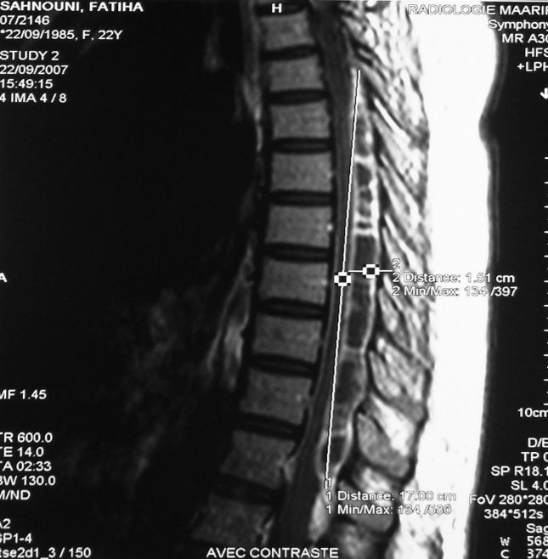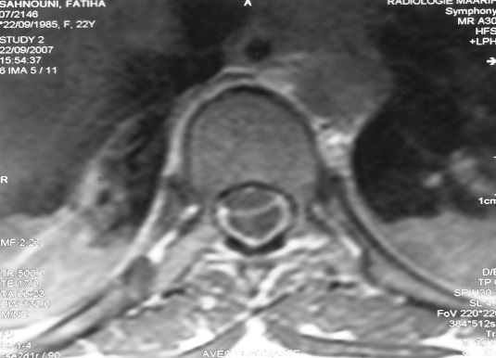

**FIG 1,2 : MRI of the spinal cord, collections occupying the posterior epidural space extending over 17 cm of the dorsal cord with cystic cavities and contrast uptake of only the granular shell.**

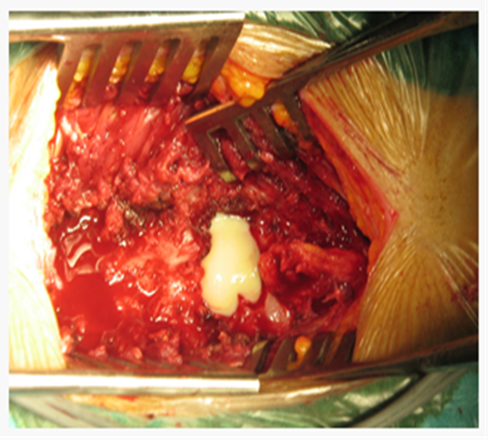

**FIG 3: Midline incision centered on the ninth thoracic vertebra, laminectomy of the four levels, greenish pus emerging in posterior epidural.**

Ethical Approval:

As per international standards or university standards written ethical approval has been collected and preserved by the author(s).

Consent

As per international standards or university standards, patient(s) written consent has been collected and preserved by the author(s).

Disclaimer (Artificial intelligence)

Option 1:

Author(s) hereby declare that NO generative AI technologies such as Large Language Models (ChatGPT, COPILOT, etc.) and text-to-image generators have been used during the writing or editing of this manuscript.

Option 2:

Author(s) hereby declare that generative AI technologies such as Large Language Models, etc. have been used during the writing or editing of manuscripts. This explanation will include the name, version, model, and source of the generative AI technology and as well as all input prompts provided to the generative AI technology

Details of the AI usage are given below:

1.

2.

3.

**Pour les auteurs :** Disclaimer (Artificial intelligence)

Option 1:

**References**

1. Vakili M, Crum-Cianflone NF. Spinal epidural abscess: a series of 101 cases. Am J Med. 2017;130:1458–1463. doi: 10.1016/j.amjmed.2017.07.017.
2. Duc C, Grange L, Gaudin P, et al. Extensive primary epidural abscess. Joint Bone Spine. 2002;69:312-5.
3. Murphy DR, Morris NJ. Cervical epidural abscess in an afebrile patient: a case report. J Manipulative Physiol Ther. 2006;29(8):672-675.
4. Brookman CA, Rutledge MLC. Epidural Abscess: Case Report and Literature Review. Reg Anesth Pain Med. 2000;25(4):428-431.
5. Curry WT Jr, Hoh BL, Amin-Hanjani S, Eskandar EN. Spinal epidural abscess: clinical presentation, management, and outcome. Surg Neurol. 2005;63:364–371.
6. Adogwa O, Karikari IO, Carr KR, et al. Spontaneous spinal epidural abscess in patients 50 years and older. J Neurosurg Spine. 2014;20:344–349.
7. Darouiche RO. Spinal epidural abscess. N Engl J Med. 2006;355:2012–2020.
8. Siddiq F, Chowfin A, Tight R, et al. Medical vs surgical management of spinal epidural abscess. Arch Intern Med. 2004;164:2409–2412.
9. Kim SD, Melikian R, Ju KL, et al. Independent predictors of failure of nonoperative management of spinal epidural abscesses. Spine J. 2013.
10. Huang PY, Chen SF, Chang WN, et al. Spinal epidural abscess in adults caused by *Staphylococcus aureus*: clinical characteristics and prognostic factors. Clin Neurol Neurosurg. 2012;114:572–576.
11. Wang TC, Lu MS, Yang JT, et al. Motor function improvement in patients undergoing surgery for spinal epidural abscess. Neurosurgery. 2010;66:910–916.
12. Lu CH, Chang WN, Lui CC, et al. Adult spinal epidural abscess: clinical features and prognostic factors. *Clin Neurol Neurosurg.* 2002;104:306–310.
13. Zimmerer SM, Conen A, Müller AA, et al. Spinal epidural abscess: aetiology, predisponent factors and clinical outcomes in a 4-year prospective study. *Eur Spine J.* 2011;20:2228–2234.
14. Sethna N, Zurakowski D, Clendenin D, Solodiuk J. Risks of epidural abscess in children. *Children’s Hospital Boston.*
15. Pereira CE, Lynch JC. Spinal epidural abscess: an analysis of 24 cases. *Surg Neurol.* 2005;63(Suppl 1):S1:26–S1:29.
16. Reihsaus E, Waldbaur H, Seeling W. Spinal epidural abscess: a meta-analysis of 915 patients. Neurosurgical review. 2000 Dec;23:175-204.
17. Fotaki A, Anatoliotaki M, Tritou I, Tzagaraki A, Kampitaki M, Vlachaki G. Review and case report demonstrate that spontaneous spinal epidural abscesses are rare but dangerous in childhood. Acta Paediatr. 2019 Jan;108(1):28-36.