**Stress-Reduced Restoration of Endodontically Treated Teeth Using Fiber-Reinforced Direct Composite Resin: A Case Series**

**ABSTRACT**

**Background**

Restoration of badly broken endodontically treated teeth (ETT) presents a significant challenge in dentistry. Traditional approaches typically involve posts, crowns, or indirect restorations. However, the use of fiber-reinforced composite resin (FRC) for direct restorations has gained traction due to its ability to provide structural support while maintaining a more conservative treatment approach.

**Objective**

This case series aims to demonstrate the effectiveness of stress-reduced direct composite restorations using the "wallpapering technique" as an alternative to full-coverage indirect restorations, particularly in young patients under 18 years of age.

**Case Presentation**

Three cases involving the restoration of anterior and posterior ETT were performed using a combination of continuous glass fiber (Interlig, Angelus), discontinuous short fiber-reinforced composite (EverX Posterior, GC), and nanohybrid composite resin (Tetric N Ceram, Ivoclar). These cases are still under follow up and the outcome after six months is presented in this report.

**Conclusion**

The wallpapering technique, combined with FRC materials, provides a reliable and conservative approach for restoring badly broken ETT. It offers a functional, esthetic, and durable solution, particularly for patients who are not yet candidates for full-coverage restorations

**Keywords:** Endodontically treated teeth, fiber-reinforced composite, wallpapering technique,

**INTRODUCTION**

Traditionally, restoring structurally compromised endodontically treated teeth involved using a combination of prefabricated or custom-made metallic post and cores along with full-coverage restorations [1]. While these techniques provide sufficient retention and reinforcement, they often necessitate extensive removal of sound coronal and radicular dentin. This invasive preparation increases the risk of root perforation, predisposes the tooth to fracture, and compromises the longevity of the restoration [2].

Tooth-colored fiber posts, introduced in the 1990s, offer several advantages over traditional metal posts. They provide improved aesthetics, bond effectively to tooth structure, and have a modulus of elasticity similar to dentin However, despite these advantages, fiber posts still require preparation of the root canal to fit the post within the space, and their long-term performance remains dependent on factors such as bonding integrity and occlusal load distribution [3].

Recently, fiber reinforcement systems have been developed to enhance the durability and damage tolerance of resin-bonded composites (RBC). These systems conform to the root canal walls without necessitating additional enlargement following endodontic treatment [4]. They utilize glass fibers embedded within resin composites to provide strength while preserving as much remaining dentin as possible. With a modulus of elasticity comparable to dentin, they are designed to form a monobloc dentin-post-core system, ensuring even distribution of forces along the entire root [5].

The Wallpapering technique aims to achieve a uniform distribution of functional loads, thereby reducing stress concentration at the interface between the restoration and the remaining tooth structure. This method mimics the natural biomechanics of dentin by reinforcing weakened walls and preventing crack propagation, which is a major cause of composite restoration failure. Unlike conventional post-and-core restorations, which may create stress points leading to catastrophic failures, Wallpapering reinforces the residual walls without requiring additional canal preparation, preserving structural integrity [6]

Two promising materials for this approach are:

1. **Interlig (Angelus, Brazil)** – A Braided, continuous glass fiber with high flexural strength. These resin pre-impregnated fibers are easy to adapt to the cavity walls without requiring additional preparation of the fiber.
2. **EverX Posterior (GC Corporation, Tokyo, Japan)** – A resin based material designed to be used as dentin replacement. The manufacturer claims that everX posterior’s short discontinuous and randomly oriented glass fibers structure reinforces restorations in large cavities by avoiding crack formation through the restoration, which is considered to be the main cause of composite failures.

This case series highlights the clinical application of fiber-reinforced composites using the Wallpapering technique in the restoration of structurally compromised endodontically treated teeth. By focusing on stress reduction and preservation of dentin, this approach aims to enhance functional longevity and durability, offering a biomimetic solution to a long-standing restorative challenge.

**PRESENTATION OF CASE**

**Case no. 1**

A 16-year-old male patient presented to the department of conservative dentistry and endodontics at Sri Hasanamba dental college and hospital, Hassan with a root canal treated upper left maxillary first molar. A permanent restoration was planned using fiber reinforced composite until he attains the age of 18 years. Temporary restoration was removed and rubber dam isolation was achieved. Sharp angles were rounded with a flame shaped bur. Total Etching was done using 37% phosphoric acid (3M Scotchbond Multi-Purpose Etchant, USA) for 30 seconds, thoroughly rinsed with water spray and blot dried. 5th gen bonding agent (3M Adper Single Bond 2, USA) was applied, gently air-thinned and light cured for 10 seconds at 1000 mW/cm2 using an LED curing light (Woodpecker ILED plus). 2 pieces of required length of Interlig glass fiber **(**Angelus, Brazil) was cut and embedded in to a layer of flowable composite (Tetric N Flow, Ivoclar) on the walls of the cavity according to ‘wallpapering technique’(i.e concept of covering the cavity walls with overlapping closely adapted pieces of fibers) (Figure 1A) [6] and light cured for 20 seconds. Proximal contact area was built with the help of a piece of mylar strip and rest of the cavity was built with nanohybrid composite resin (Tetric N Ceram, Ivoclar) using oblique incremental technique. Occlusion was checked, Finishing and polishing were done using Shofu composite polishing kit (Shofu, Japan) and postoperative radiograph was taken (Figure 1B).

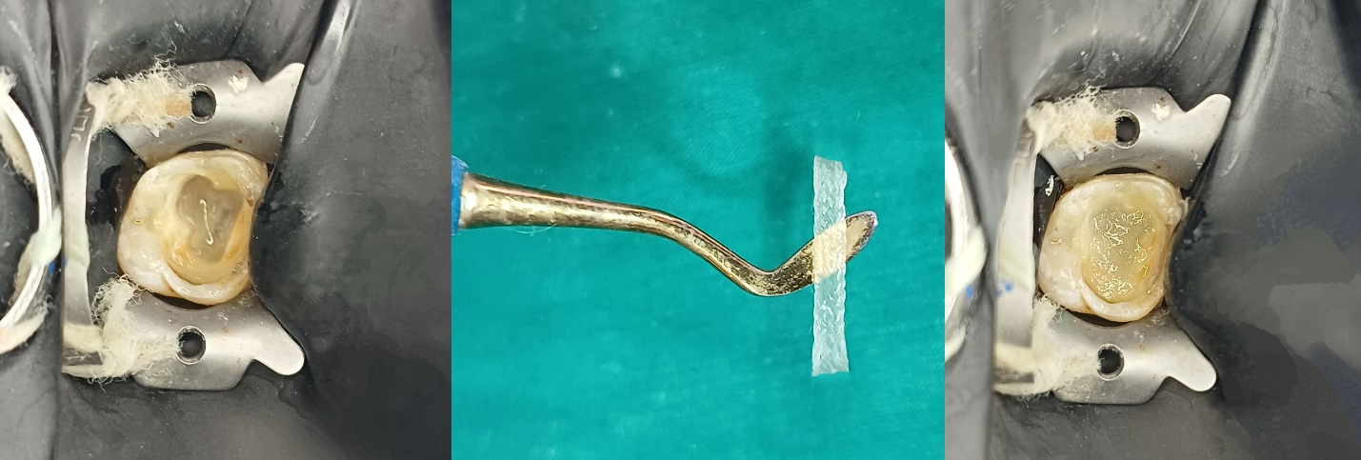

Figure 1A: Incorporation of glass fiber according to ‘wallpapering technique’

Figure 1B: case 1 post-op

**Case no. 2**

A 14-year-old female patient presented to the department with a root canal treated lower right mandibular first molar. After achieving rubber dam isolation, etching and bonding steps were done. Fiber reinforcement protocols were followed as described in case 1. Additionally, a layer of short fiber reinforced composite resin (EverX Posterior, GC) was placed on the floor (Figure 2A). Rest of the cavity was built with nanohybrid composite using oblique incremental technique. Occlusion was checked, Finishing and polishing were done and postoperative radiograph was taken (Figure 2B).

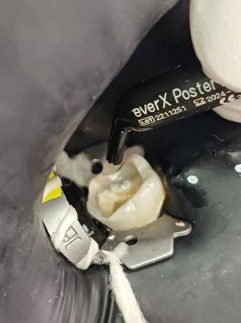Figure 2A: Incorporation of short fiber reinforced composite resin

Figure 2B: case 2 post-op

**Case no. 3**

A 14-year-old female patient presented to the department with a fractured nonvital upper right lateral incisor (Figure 3A). Root canal treatment was done and recalled for permanent restoration. After achieving rubber dam isolation, coronal 3-4 mm GP was removed. Etching and bonding protocols were followed as described in case 1. Palatal wall was built using mylar strip. Interlig glass fibers were incorporated into the space created by removal of GP (Figure 3B) and crown structure was built using nanohybrid composite resin. Final finishing and polishing of the restoration were completed using shofu super-snap kit (Shofu, Japan) and postoperative radiograph was taken (Figure 3C).

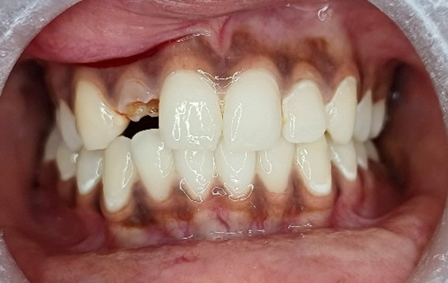

Figure 3A: case 3 pre-op

Figure 3B: Glass fiber incorporation

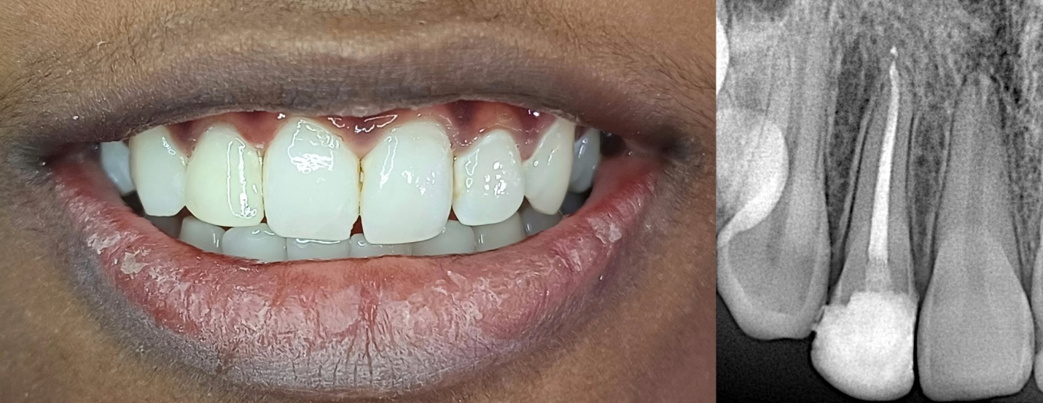

Figure 3C: case 3 post- op

**FOLLOW UP FINDINGS**

Despite being used to restore structurally compromised molars and an anterior tooth, the direct fiber-reinforced composite resin restorations showed promising clinical performance at the six-month follow-up (Figure 4).

Figure 4: sixth month followup

**DISCUSSION**

Advancements in dental composite resins now enable their use in stress-bearing areas of the mouth. The integration of modern filler systems and innovative monomer designs has significantly enhanced the physical properties of composite restorations [7,8]. However, volumetric shrinkage during monomer polymerization remains a challenge, limiting their long-term clinical durability [9].

When a composite resin is bonded to a hard dentinal substrate, volumetric shrinkage generates stresses at the restoration-tooth interface. If these stresses exceed the adhesive strength of the bonding system, marginal gaps may form, resulting in leakage and eventual bond failure. Conversely, if the polymerization stresses remain below the adhesive strength, they are transferred to the tooth structure, potentially causing cuspal deflection and leading to the fracture of either the restoration or the tooth itself [10,11].

To overcome the inherent limitations of resin-bonded composites (RBCs), incorporating fibers with resin composite has emerged as a promising approach for restoring structurally compromised endodontically treated teeth (ETT).

Fiber-reinforced composite (FRC) restorations optimize stress distribution at the restoration-tooth interface, significantly enhancing the mechanical properties of resin-bonded composites (RBCs). The incorporation of fibers increases fracture toughness and flexural strength, while their interconnected design serves as a crack-arresting mechanism, effectively preventing failure [12].

Selvaraj H et al [13] conducted a systematic review on the fracture resistance of endodontically treated posterior teeth restored with fiber reinforced composites.  A total of 18 studies were considered for qualitative analysis.According to the research, using fiber-reinforced composites instead of conventional hybrid composites improves the fracture resistance of endodontically treated teeth.

Another effective strategy for reducing shrinkage stress is the use of flowable composite resins as an elastic intermediate layer. This layer acts as a stress absorber, mitigating polymerization shrinkage from the overlying resin composite and minimizing stress at the tooth-restoration interface, ultimately enhancing bond durability and restoration longevity [14].

Belli et al [15] reported that positioning fibers against the dentinal wall significantly enhances fracture strength while minimizing cusp movement. Furthermore, fibers play a crucial role in reducing the C-factor and improving microtensile bond strength.

The wallpapering technique, as described by S. Deliperi et al [6] involves placing fibers circumferentially in contact with the vertical walls, enabling them to absorb lateral forces generated during occlusal loading. This technique not only reduces the risk of failure but also ensures that, in the event of a failure, the damage remains non-catastrophic and is often repairable. These fibers when closely adapted to the tooth structure significantly reduces the composite volume between them, helping to protect the weakened residual walls from both polymerization shrinkage stress and occlusal forces.

Fibers possess the ability to modify stress by creating a monoblock effect, which helps distribute the stress along the long axis of the tooth [16]. Additionally, they can prevent crack formation by transferring stress from the polymer matrix to the fibers [17,18].

EverX posterior is a material having multidirectional and discontinuous fibers which help to increase the load-bearing capacity, act as a dentin substitute, prevent the crack formation and increase its strength. Unlike continuous fiber composites, where fibers run in a specific direction (providing strength mainly along that axis), EverX Posterior's short fibers reinforce the material in multiple directions, mimicking the natural load-bearing function of dentin [19,20].

Shah EH et al [21] conducted a systematic review to evaluate the effect of fibre-reinforced composite (FRC) as a post-obturation material on fracture resistance of endodontically treated teeth. A total of 25 articles were included in the study. Results revealed that FRC as a core material increases fracture resistance of endodontically treated teeth but they do not have the fracture resistance similar to the intact tooth. Both polyethylene and short fibre-reinforced composites showed greater fracture resistance when compared to glass FRC and restoration without reinforcement.

Researchers have recommended the incremental layering technique for composite buildup to reduce polymerization shrinkage stresses and cuspal deflection. Compared to the bulk technique, incremental layering offers superior shrinkage control, as it allows for a more complete degree of cure and progressively reduces the amount of bonded cavity surface at each layer, resulting in lower stress buildup [22].

Based on these findings, there has been a paradigm shift in the restorative approach for endodontically treated teeth. Clinicians are moving away from invasive, non-bonded techniques toward minimally invasive, adhesive, postless, and crownless restorations, prioritizing tooth preservation and biomechanical integrity [23]. Soares et al[24] highlighted the effectiveness of the fiber reinforcement technique in managing structurally compromised teeth, employing a crownless and postless approach, with promising results observed over a 20-month follow-up period. Further, Castro Klenner & Lazari[23] presented a case of minimally invasive postless approach by the use of fiber reinforcement approach in badly broken endodontically treated teeth.

S Deliperi et al in 2008 presented three-year clinical results following reconstruction of a severely damaged endodontically treated molar using Ribbond fiber-reinforced resin composite systems. After a three-year evaluation period, excellent clinal results were observed.

Similarly, in our case 3, traditional post and core were avoided considering the patient's age (14 years). Moreover, posts do not enhance the strength of endodontically treated teeth and are mainly employed for retaining the coronal restoration [25]. Post preparation can compromise healthy tooth structure and carries an increased risk of root perforation.

At the six-month follow-up visit, no signs of recurrent caries, chipping, or fracture were observed. However, further in vitro and long-term clinical studies are needed to fully support this treatment approach.

The primary advantage of this report is its emphasis on a biomimetic and minimally invasive approach to restoring endodontically treated teeth using the Wallpapering technique. By reinforcing structurally compromised teeth with fiber-reinforced composites, the technique preserves dentin, distributes occlusal forces evenly, and reduces stress concentrations, thereby minimizing the risk of failure. The inclusion of materials such as Interlig and EverX Posterior, known for their high flexural strength and crack resistance, provides valuable insight into their clinical application. Additionally, the report highlights the clinical relevance of fiber-reinforced restorations, presenting real-world case applications that can guide practitioners in adopting this method. The focus on stress reduction and direct restorability aligns with contemporary trends favoring conservative, adhesive-based restorations over traditional post-and-core systems, which often compromise the remaining tooth structure.

Despite these advantages, the report has several limitations that warrant further exploration. It lacks long-term clinical data comparing the Wallpapering technique to traditional post-and-core restorations, making it difficult to draw definitive conclusions about longevity and success rates. The operator-dependent nature of fiber placement and adhesion techniques is another challenge, as improper handling could lead to bonding failures, polymerization shrinkage, or compromised restoration strength.

**CONCLUSIONS**

Effective use of fiber-reinforced composite resin in restoring endodontically treated teeth can potentially eliminate the need for traditional post-and-core or full-coverage restorations, postponing the need for more invasive indirect alternatives. However, long-term clinical studies, material advancements, and digital integration are necessary to optimize their application. The future of fiber-reinforced composites lies in nanotechnology, 3D printing, bioactive materials, and improved bonding techniques, paving the way for stronger, more biomimetic, and long-lasting restorations.

**FURTHER SCOPE AND FUTURE POSSIBILITIES**

1. Future research should focus on clinical trials with long follow-up periods to evaluate survival rates, fracture resistance, and patient satisfaction.
2. Comparative studies between Wallpapering, traditional post-core, and indirect CAD/CAM restorations could provide stronger clinical recommendations.
3. Development of next-generation fibers with nanotechnology enhancements and improved bonding interfaces could further improve longevity.
4. Smart biomaterials that release antibacterial agents or remineralizing compounds could reduce secondary decay risks.
5. 3D printing of customized fiber-reinforced restorations could allow precise adaptation to tooth morphology and reduce manual handling errors.

**ABBREVIATIONS**

ETT- Endodontically treated teeth

FRC- Fiber-reinforced composite

RBC- Resin-bonded composites

**CONSENT**

Written informed consent was obtained from the parents/guardians of the patients for publication of this case report and accompanying images

**DISCLAIMER (ARTIFICIAL INTELLIGENCE)**

Author(s) hereby declare that generative AI technology ‘Grammer checker’ has been used during the editing of manuscript.

Details of the AI usage are given below:

1.Quillbot v17.0.4

**REFERENCES**

1. Shillingburg HT, Hobo S, Whitsett LD, Jacobi R, Brackett SE. Fundamentals of fixed prosthodontics. Chicago: Quintessence; 1997.
2. Fuss Z, Lustig J, Katz A, Tamse A. An evaluation of endodontically treated vertical root fractured teeth: impact of operative procedures. J Endod. 2001;27(1):46-8. doi:10.1097/00004770-200101000-00011.
3. Qualtrough AJ, Mannocci F. Tooth-colored post systems: a review. Oper Dent. 2003;28(1):86-91.
4. Eskitascioglu G, Belli S. Use of bondable reinforcement fiber for post-and-core buildup in an endodontically treated tooth: a case report. Quintessence Int. 2002;33(7):549-51.
5. Newman MP, Yaman P, Dennison J, Rafter M, Billy E. Fracture resistance of endodontically treated teeth restored with composite posts. J Prosthet Dent. 2003;89(4):360-7. doi:10.1067/mpr.2003.50.
6. Deliperi S, Alleman D, Rudo D. Stress-reduced direct composites for the restoration of structurally compromised teeth: fiber design according to the “wallpapering” technique. Oper Dent. 2017;42(3):233-43. doi:10.2341/16-105-T.
7. Ástvaldsdóttir Á, Dagerhamn J, van Dijken JW, et al. Longevity of posterior resin composite restorations in adults – a systematic review. J Dent. 2015;43(8):934-54. doi:10.1016/j.jdent.2015.04.006.
8. da Veiga AM, Cunha AC, Ferreira DM, et al. Longevity of direct and indirect resin composite restorations in permanent posterior teeth: a systematic review and meta-analysis. J Dent. 2016;54:1-12. doi:10.1016/j.jdent.2016.09.003.
9. Song YX, Inoue K. Linear shrinkage of photo-activated composite resins during setting. J Oral Rehabil. 2001;28(4):335-41. doi:10.1046/j.1365-2842.2001.00666.x.
10. Braga RR, Ballester RY, Ferracane JL. Factors involved in the development of polymerization shrinkage stress in resin-composites: a systematic review. Dent Mater. 2005;21(10):962-70. doi:10.1016/j.dental.2005.04.018.
11. Giachetti L, Scaminaci Russo D, Bambi C, Grandini R. A review of polymerization shrinkage stress: current techniques for posterior direct resin restorations. J Contemp Dent Pract. 2006;7(4):79-88.
12. Sadr A, Bakhtiari B, Hayashi J, et al. Effects of fiber reinforcement on adaptation and bond strength of a bulk-fill composite in deep preparations. Dent Mater. 2020;36(4):527-34. doi:10.1016/j.dental.2020.01.017.
13. Selvaraj H, Krithikadatta J, Shrivastava D, Onazi MAA, Algarni HA, Munaga S, Hamza MO, Saad Al-Fridy T, Teja KV, Janani K, Alam MK, Srivastava KC. Systematic review fracture resistance of endodontically treated posterior teeth restored with fiber reinforced composites- a systematic review. BMC Oral Health. 2023 Aug 13;23(1):566. doi: 10.1186/s12903-023-03217-2.
14. Mantri SP, Mantri SS. Management of shrinkage stresses in direct restorative light-cured composites: a review. J Esthet Restor Dent. 2013;25(5):305-13. doi:10.1111/jerd.12044.
15. Belli S, Cobankara FK, Eraslan O, Eskitascioglu G, Karbhari V. The effect of fiber insertion on fracture resistance of endodontically treated molars with MOD cavity and reattached fractured lingual cusps. J Biomed Mater Res B Appl Biomater. 2006;79(1):35-41. doi:10.1002/jbm.b.30519.
16. Ayna B, Celenk S, Atakul F, Uysal E. Three-year clinical evaluation of endodontically treated anterior teeth restored with a polyethylene fibre-reinforced composite. Aust Dent J. 2009;54(2):136-40. doi:10.1111/j.1834-7819.2009.01106.x.
17. Garoushi S, Vallittu PK, Lassila LV. Direct restoration of severely damaged incisors using short fiber-reinforced composite resin. J Dent. 2007;35(9):731-6. doi:10.1016/j.jdent.2007.05.001.
18. Garoushi S, Vallittu PK, Lassila LV. Short glass fiber reinforced restorative composite resin with semi-interpenetrating polymer network matrix. Dent Mater. 2007;23(11):1356-62. doi:10.1016/j.dental.2006.10.013.
19. Vallittu PK. High-aspect ratio fillers: fiber-reinforced composites and their anisotropic properties. Dent Mater. 2015;31(1):1-7. doi:10.1016/j.dental.2014.05.002.
20. Tekçe N, Pala K, Tuncer S, Demirci M, Serim ME. Influence of polymerisation method and type of fibre on fracture strength of endodontically treated teeth. Aust Endod J. 2017;43(3):115-22. doi:10.1111/aej.12185.
21. Shah EH, Shetty P, Aggarwal S, Sawant S, Shinde R, Bhol R. Effect of fibre-reinforced composite as a post-obturation restorative material on fracture resistance of endodontically treated teeth: A systematic review. Saudi Dent J. 2021 Nov;33(7):363-369. doi: 10.1016/j.sdentj.2021.07.006.
22. Park J, Chang J, Ferracane J, Lee IB. How should composite be layered to reduce shrinkage stress: incremental or bulk filling? Dent Mater. 2008;24(11):1501-5. doi:10.1016/j.dental.2008.03.013.
23. Castro Klenner JA, Lazari-Carvalho PC, Labarca Galecio TF, de Carvalho MA. A 1-year follow-up case report of a biomimetic no post/no crown fiber-reinforced restoration of a structurally compromised tooth. Int J Adv Eng Res Sci. 2022;9(4):17-23. doi:10.22161/ijaers.94.1
24. Soares R, de Ataide IN, Fernandes M, Lambor R. Fibre reinforcement in a structurally compromised endodontically treated molar: a case report. Restor Dent Endod. 2016;41(2):143-7. doi:10.5395/rde.2016.41.2.143.
25. Stockton LW, Lavelle CL, Suzuki M. Are posts mandatory for the restoration of endodontically treated teeth? Dent Traumatol. 1998;14(2):59-63. doi:10.1111/j.1600-9657.1998.tb00810.x.