**HEAMATOLOGY AND HISTOLOGICAL ASSESSMENT OF METHANOL LEAVE EXTRACT OF *LANTANA CAMARA* IN ALBINO WISTAR RATS**

**Abstract**

**Background:** Exposure of animals to xenobiotics may or may not trigger adverse response at cellular levels. The study examined the toxicological properties of methanol leave extract of *Lantana camara* with a view to elucidating its toxic nature. **Methodology:** Forty eight adult wistar albino rats were used, grouped and dosed as follows: Group one (control)was given 5ml/kgbw of normal saline , group two , three and four were given 100, 200 and 500 mg/kgbw of methanol extract of lantana camara respectively. The extract was given orally for a period of four weeks (28 days). Three rats from each group were sacrificed at weekly (7th, 14th, 21st, and 28th day) interval from each group for the haematology assessment and the histological examination was carried out after the 28th day. **Results:** The haematological result revealed that there was significant increase (p < 0.05) in PCV of rats in all the test groups (2, 3 and 4) at weeks one and two. A significant decrease (p < 0.05) was observed in the PCV of group 4 rats when compared to the rats in control group. There was a significant increase (p < 0.05) in haemoglobin and white blood cell (WBC) count of rats in all the groups except in group 2, where there was relative increase though not significant in week one. All the test groups significantly reduced (p < 0.05) in week four (chronic phase) when compared to the rats in control group. The histopathology results showed various effects on the organs; liver and kidney. The massive influx of lymphocytes at the central vein with Kupfer cells lining the sinusoids with swollen or enlarged hepatocytes were observed in the liver of rats while the kidneys of rats showed change in glomerular structure, degeneration of glomerular contents with enlargement of the renal tubules compared to the control group . Although, the oral administration of methanol leaves extract of *lantana camara* proved safe during acute toxicity phase, while chronic phase revealed enlargement of hepatocytes and kidney damage. **Conclusion :** Pathological alterations were observed in the organs of rats exposed to the methanol leaf extract of *Lantana camara***.**

*Keywords*: *Lantana Camara,* Heamatology, histological examination, Methanol extract

**1.0 Introduction**

Nature has provided an excellent source of remedies to cure all the ailments of mankind. In ancient days, almost all the medicine used was from natural sources, particularly from plants. Herbal medicine provides a foundation for various traditional medicine systems worldwide. Today, these herbs contribute approximately 25% of currently used crude drugs and another 25% is derived from chemically offered natural products [1]. In the last few decades, many of traditionally known plants have been extensively studied by advanced scientific techniques and reported for various medicinal properties which include: anticancer activity, antioxidant activity, anti-inflammatory activity, anti-diabetic activity, antihelmintic, antibacterial activity, antifungal activity, hepato-protective activity[2- 4] The importance of biological, chemical, and pharmacological evaluation of plant derived agents used in the treatment of human ailments has been increasingly recognized in the last decades [5]. *Lantana camara* Linn, (Verbenaceae) is an ornamental weed with aromatic leaves, orange, blue, yellow and bright red flowers with dark blue and black fruits (drupes). It is a low, erect vigorous shrub which can grow up to 2 - 4 meters in height. Many lantana varieties are poisonous to livestock. It is difficult to tell which varieties are toxic so it is better to treat all forms as potentially poisonous [6]. The toxins in lantana include the triterpene acids {lantadeneA (rehmannic acid), lantadene B, and their reduced forms [7]. Reports of *Lantana camara* toxicity have been reported across various countries. However, the toxicity occurs only on the consumption of high amount of the plant material [8- 9]. *Lantana camara* leave is a powerful febrifuge [10], the leaves and some other parts of lantana are poisonous, and care must be taken when it is used medicinally [11]. Pharmacological investigations indicated that extracts of leaves of *Lantana camara* exhibited strong antioxidant activities [12], healing potential against gastric ulcer in humans [13]. antimicrobial, fungicidal, insecticidal and nematicidal properties [14]. *Lantana camara* oil is sometimes used for the treatment of skin itches, as an antiseptic for wounds and externally for leprosy and scabies [15]. Lantana camara is also referred to as "Spanish flag" or "Red Sage," It is an ornamental plant with fragrant leaves and colorful flowers of several hues[16] It is regarded as a "ornamental weed" and produces black and dark blue fruits. L. camara's roots are used to cure ailments like rheumatism, skin rashes, and malaria, while its leaves are utilized for their anti-tumor, antibacterial, and anti-hypertensive activities [17] The leaves of the plant are also used to make anti-inflammatory infusions, which are frequently added to baths to relieve rheumatism. It is also frequently used in herbal medicine to treat malaria, fever, cough, influenza, stomach problems, and wounds[18] Additionally, L. camara exhibits analgesic, anti-inflammatory, anti-fungal, anti-diabetic, and antioxidant properties[19]. The quest of mankind coupled with modern technological and scientific advancements making progress in the discovery of synthetic medicines has helped greatly in the treatment or prevention of several acute, chronic and life threatening diseases but it has been observed that most of the problems associated with the use of traditional and herbal medicines arise from overconsumption and prolonged use of these plants in most countries. This study was, therefore, aimed at investigating the effect of methanol extract of *lantana camara* leaves on haematological parameters and the histology of organs (liver and kidneys) in order to ascertain its toxicity on these organs.

**MATERIALS AND METHODS**

**2.0 Plant material:** The leaves of *Lantana Camara* were collected from Amokwe village Nsukka and identified by Mr. Alfred Ozioko of the Bioresources Development and Conservation Programme (BDCP) Research Centre Nsukka, Enugu State.

**2.1 Animals**

Fourty eight (48) adult albino rats were used for the studies. All the animals used were purchased from the Animal house of the Faculty of Biological Sciences, University of Nigerian, Nsukka. The rats were fed for 28 days with standard grower’s mash pellets and water.

**2.2 Experimental design**

Fourty eight (48) Wistar albino rats weighing 155-200g were used for the study. They were acclimatized for seven (7) days with free access to feed and water. After acclimatization, they were evenly distributed into four groups of twelve rats each. The route of administration of the extract was done orally for 28 days and 3 rats were sacrificed from each group for every 7 days, that is 7, 14, 21 and 28th day of the experiment.

**2.3 Histology:**

The organ specimen (kidneys and liver) were removed from the visceral cavity and fixed with formalsaline (10% formaladehyde in normal saline). They were allowed to stay for 3-4 days in 10 times (10x) the volume of the specimen. Dehydration followed using ethanol. The alcohols were changed after steeping the organs in them for 1.5-2 hrs. The organs were cleared in chloroform and impregnated with paraffin wax and sectioned at 5 micros thickness using rotary microtome. The sections were floated on a water bath maintained at 2-3 0C above the midpoint of the paraffin wax used. When dried (15-30 mins) they were stained with haematoxylin and eosin (H& E), dehydrated, cleared and mounted. Magnification of 400 was employed.

**Results**

**3.1** **Effect of the methanol extract of *Lantana camara* leaves on Packed Cell Volume (PCV) of rats .**

The effect of methanol leaf extract of *Lantana camara* on haematological parameters showed increases in packed cell volume (PCV) of ratsin all the test groups (2, 3 and 4) at weeks one and two (acute phase). Meanwhile, there is significant decrease (p < 0.05) in the PCV of group 4 rats in week four when compared to the rats in control group.

Fig 1; Effect of the methanol extract of *Lantana camara* leaves on Packed Cell Volume (PCV) of rats

**3.2 Effect of the methanol extract of *Lantana camara* leaves Heamoglobin concentration of rats**

The effect of methanol leaf extract of *Lantana camara* on haematological parameters showed increases in haemoglobin concentration of ratsin all the test groups (2, 3 and 4) at weeks one and two (acute phase). A significant decrease (p < 0.05) was observed in the haemoglobin of the treated groups when compared with the positive control.

Fig 2; Effect of the methanol extract of *Lantana camara* leaves Haemoglobin concentration of rats

**3.3 Effect of the methanol extract of *Lantana camara* leaves on White blood cell (WBC) count of rats**

There was a significant increase (p < 0.05) in white blood cells (WBC) count of rats in all the test groups in weeks one and two (chronic phase) with a corresponding significant increase (p < 0.05) in all the test groups in weeks three and four, when compared with control group

**Fig 3; Effect of the methanol extract of *Lantana camara* leaves on White blood cell (WBC) count of rats.**

**3.4 : Effect of the methanol extract of *Lantana camara* leaves on Histopathological Analysis of rats .**

Plate 1 Photomicrograph of normal morphology of liver lobules of group 1 (control), Plate 2: Photomicrograph of the liver of group 2 (100 mg/kgbw) showing massive influx of lymphocytes at the central vein with Kupfer cells lining the sinusoids (Black thin arrow) with enlarged hepatocytes, Plate 3: Photomicrograph of the rat liver group 3 (200mg/kgbw) showing a severe submassive necrosis with cellular proliferation, Plate 4: The photomicrograph of the liver of group 4 (500mg/kgbw) showing massive proliferation and hypertrophy of the hepatocytes, Plate 5: Photomicrograph of the kidney of group 1 (control) showing glomerular contents were intact with podocytes and mesengial cells seen in the cortex, Plate 6: Photomicrograph of the kidney group 2 **(**100 mg/kgbw) showing disruption of the cell boundaries thereby making the cells indistinct, Plate 7: Photomicrograph of the kidney group 3 (200 mg/kgbw)-The glomeruli changed in structure due to the rupture of the glomerular contents. In some glomeruli, the swelling and proliferation of the endothelial cells was marked and completely obstructed the capillaries, the glomeruli thus becoming bloodless, Plate 8: Photomicrograph of the kidney group 4 (500mg/kgbw) -There was degeneration of glomerular content with enlargement of the renal tubules. Rim of leukocytic infiltrates was evident (black arrows).

Plate 1-8 : **Effect of the methanol extract of *Lantana camara* leaves on Histopathological Analysis of rats.**

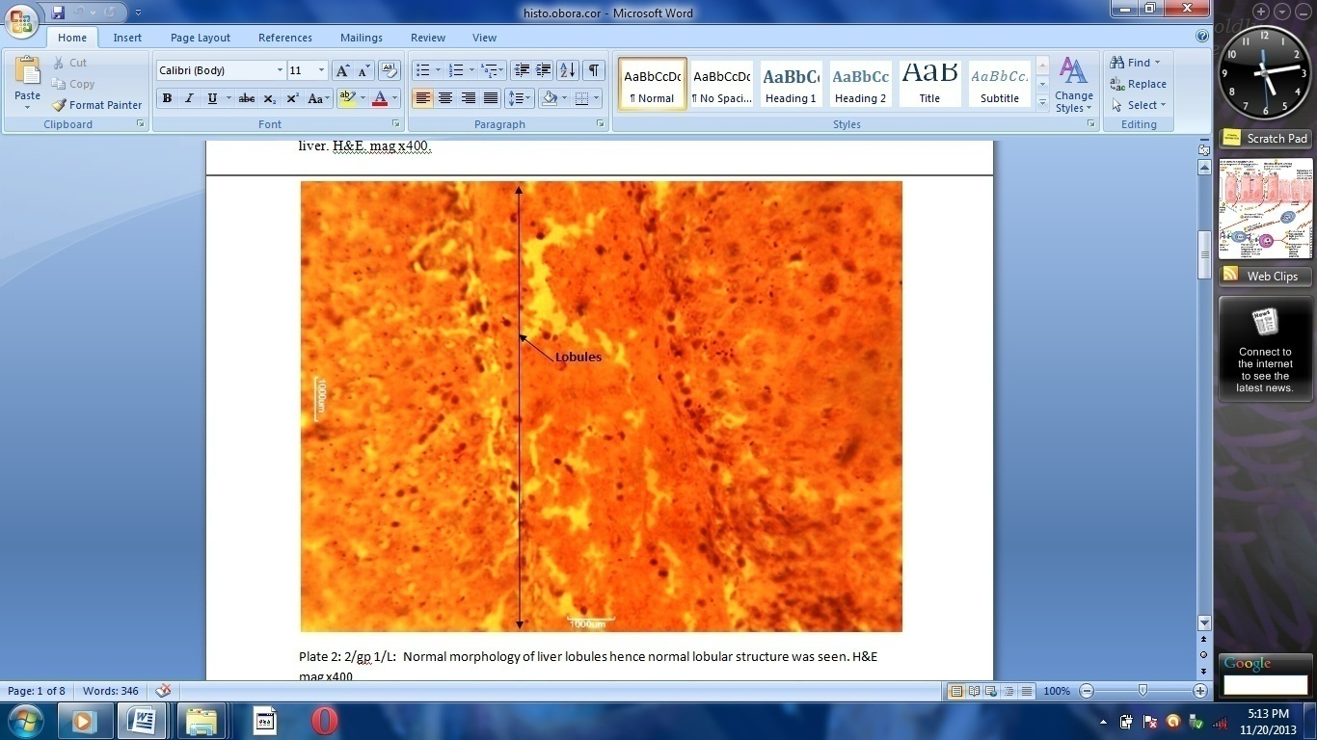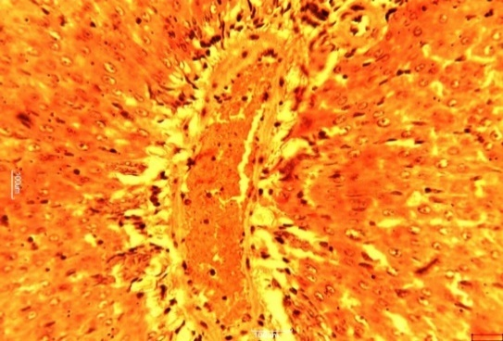

Plate 1 plate 2

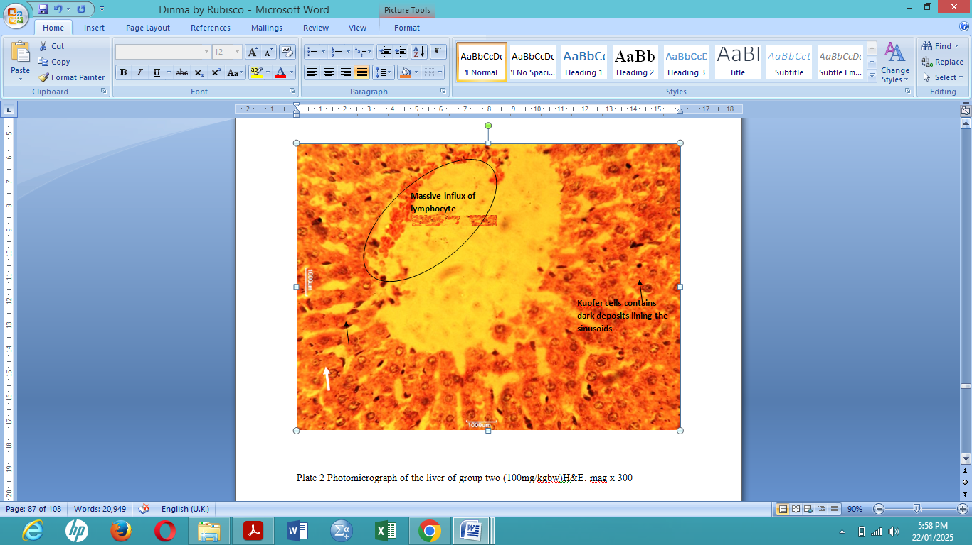 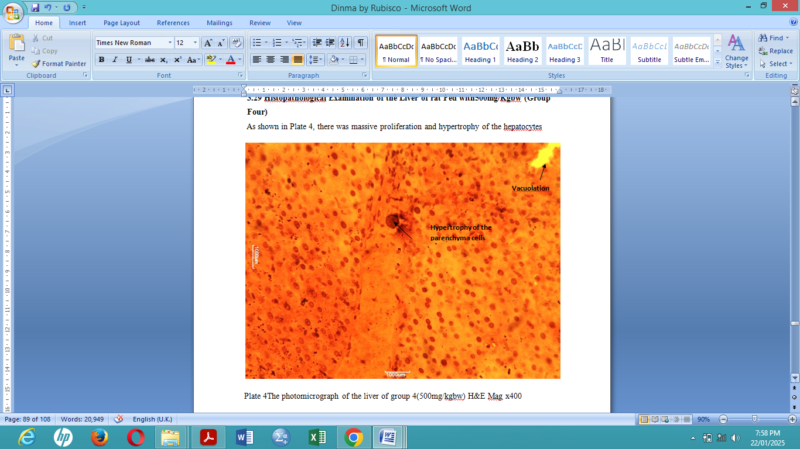

Plate 3 plate 4

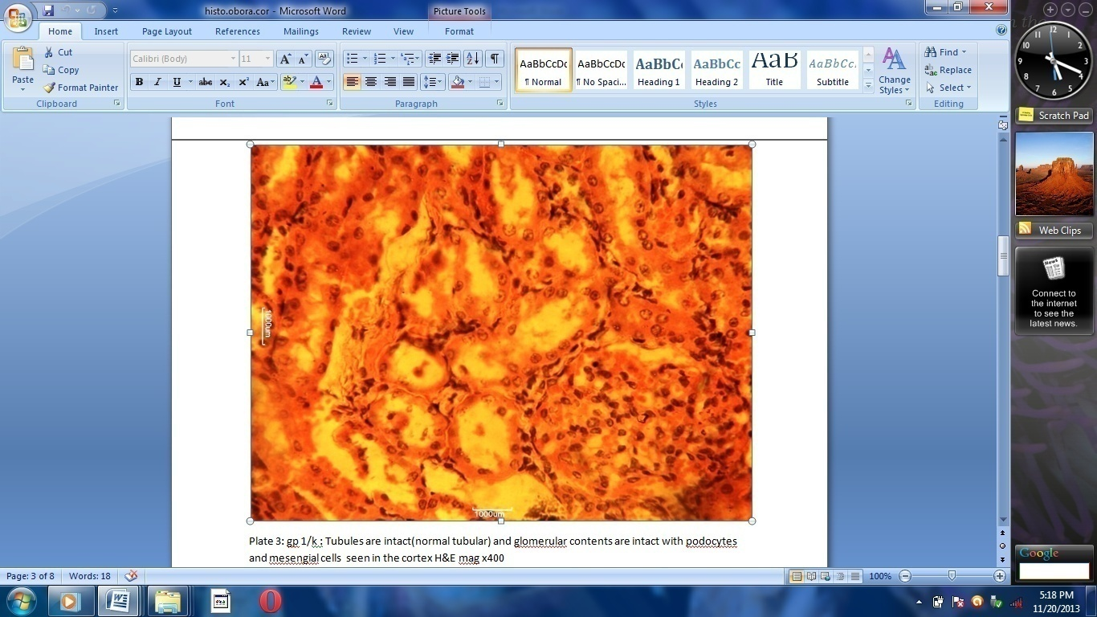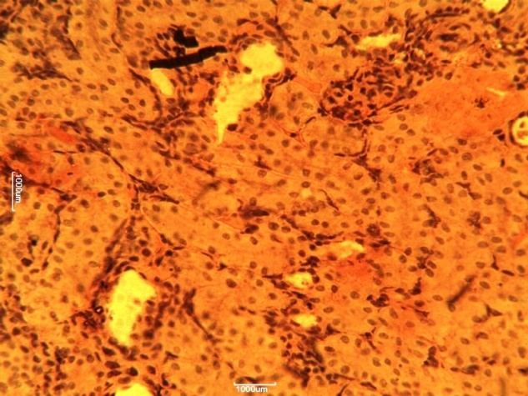  
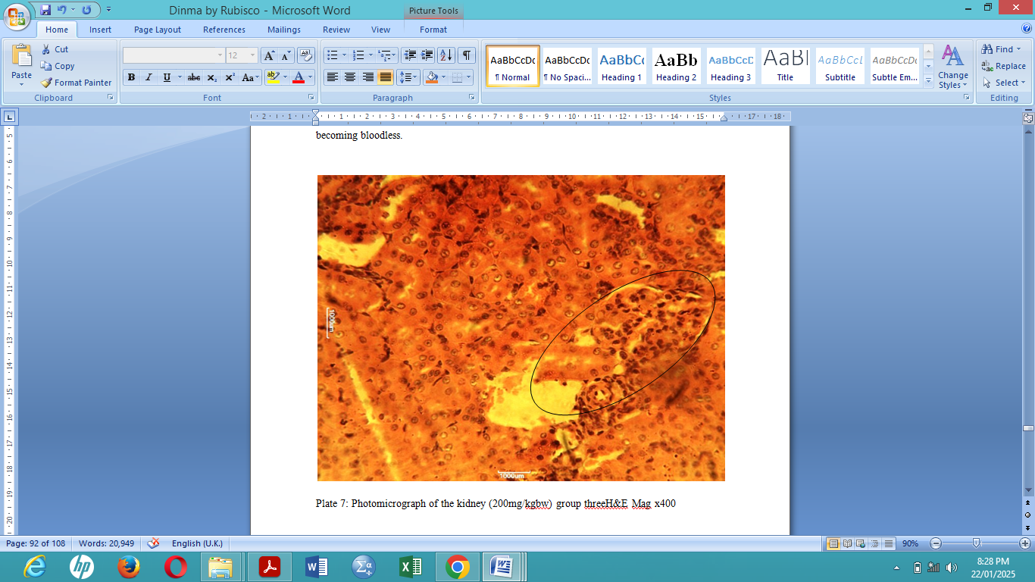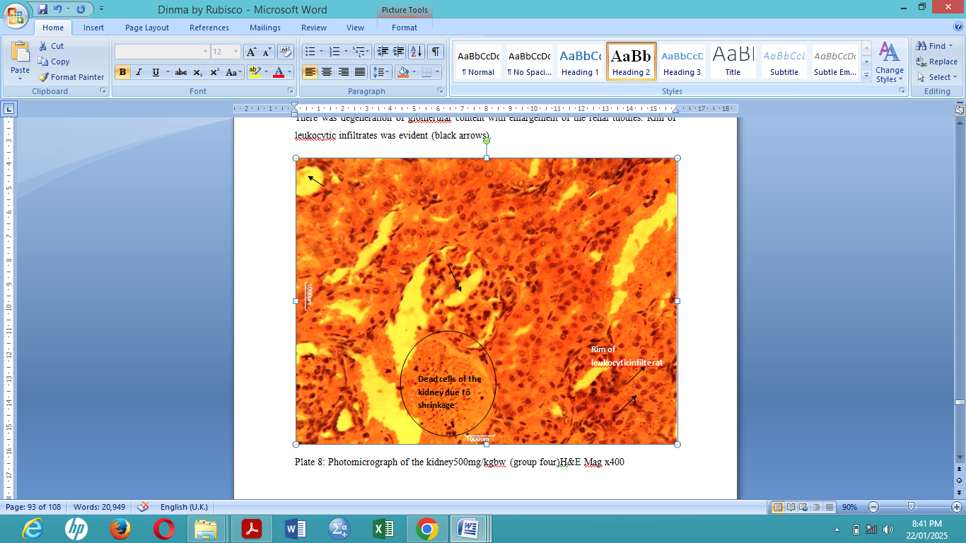

Plate 5

plate 6

Plate 7 Plate 8

**4.0 Discussion**

Notwithstanding being natural and biological, the phytoconstituents in this plant exert unexpected toxicities that aimed at visceral organs that are loaded with metabolic activities like the liver and the kidney [20]. *L. camara* has such phytochemicals as alkaloids, tannins, terpenoids, saponins, and flavonoids, which have been reported to be toxic.[21] The results of this study indicated that administering L. *camara* in a single oral dose of up to 500 mg/kg body weight did not result in any fatalities among the test rats. However, when given single doses of 1000 mg/kg body weight or more, the rat displayed more pronounced signs of toxicity including weakness, reduced activity, lack of appetite and lethargy.Thesignificant (p < 0.05) reduction in haematological parameters in week four when compared to the rats in control group, suggested that the extract may have a stimulatory effect on the haematopoietic mechanism. Also, the test groups significantly reduced (p < 0.05) in week four when compared to the rats in control group, suggesting that the extract might have haemolytic effect on the red blood cells at this stage. The increased breakdown of haemoglobin at this phase could result in increased concentration of bilirubin since it is a product of heme degradation [22] (fig 1 and 2). It has been known that WBC counts increase rapidly following foreign attack by pathogens on the system [23]. The system’s normal physiological response will be to boost the defence mechanism, which would decrease on prolonged administration making the WBC count decrease after the cells of the rats had adapted to the extract at the chronic phase of the study. The Histopathology results showed various effects on the organs; liver and kidney. The massive influx of lymphocytes at the central vein with Kupfer cells lining the sinusoids with swollen or enlarged hepatocytes were observed in the liver of rats fed with 200 and 500 mg/kg bw (Plate 3 and 4) compared to the control group (Plate 1). The kidneys of rats fed 200 and 500 mg/kg bw showed change in glomerular structure, degeneration of glomerular contents with enlargement of the renal tubules compared to the control group (plate 5) that was intact. These injuries on the liver and kidneys might be because of the prolonged administration and toxic phytochemicals ({lantadeneA (rehmannic acid), lantadene B) present in the plant. The enlarged liver seen could lead to diseases. The immune system helps the body to fight off infections, however, with certain diseases; the immune system attacks healthy cells instead [24]. Many of these diseases are caused by changes in the body’s immune system that can damage kidney. Degeneration of glomerular contents with enlargement of the renal tubules can cause the kidney to lose their ability to remove wastes and extra water [26]. Blood and protein can also be lost in urine [27].

**CONCLUSION:**

The oral administration of the leaf extract of *Lantana camara* showed damage to both liver and kidneys of the rats, which might be as a result of the duration of administration and the dosage used. In as much as the health benefit is enormous, lower doses and shorter duration can be employed so that the plant’s benefit can be maximized while reducing the side effect drastically.

**COMPETING INTERESTS DISCLAIMER:**

Authors have declared that they have no known competing financial interests or personal relationships that could have appeared to influence the work reported in this paper.

Author(s) hereby declares that NO generative AI technologies such as Large Language Models (ChatGPT, COPILOT, etc.) and text-to-image generators have been used during the writing or editing of this manuscript.

**COMPETING INTERESTS DISCLAIMER:**

Authors have declared that they have no known competing financial interests OR non-financial interests OR personal relationships that could have appeared to influence the work reported in this paper.

**REFERENCE**

1. Giannenas, I., Sidiropoulou, E., Bonos, E., Christaki, E and Florou-Paneri, P. (2020). The history of herbs, medicinal and aromatic plants, and their extracts: Past, current situation and future perspectives. In *Feed additives* (pp. 1-18). Academic Press.
2. Mahdi, A. A., Rathore, B., Das, S.K. and Paul, B.N. (2005). Comparative studies of different organs of N. arbortristis in modulation of lipid peroxide levels, anti-oxidant content, cytokines and effect on hepatic and renal marker enzymes in experimental rheumatoid arthritis. Book of abstract, 3rd International Symposium on natural antioxidants molecular mechanisms and health effects.
3. Siriwatanametanon, N., Fiebich, B. L., Efferth, T., Prieto, J. M and Heinrich, M. (2010). Traditionally used Thai medicinal plants: in vitro anti-inflammatory, anticancer and antioxidant activities. *Journal of ethnopharmacology*, *130*(2), 196-207.
4. Roleira, F. M., Tavares-da-Silva, E. J., Varela, C. L., Costa, S. C., Silva, T., Garrido, J and Borges, F. (2015). Plant derived and dietary phenolic antioxidants: Anticancer properties. *Food Chemistry*, *183*, 235-258.
5. Süntar, I. (2020). Importance of ethnopharmacological studies in drug discovery: role of medicinal plants. *Phytochemistry Reviews*, *19*(5), 1199-1209.
6. Ntalo, M., Ravhuhali, K. E., Moyo, B., Hawu, O and Msiza, N. H. (2022). Lantana camara: poisonous species and a potential browse species for goats in southern Africa—a review. *Sustainability*, *14*(2), 751.
7. Asadu, C. L., Abonyi, O., Anosike, C. A., Uzoegwu, P. N and Uroko, R. I. (2015). In vivo toxicological studies on methanol leaf extract of Lantana Camara. *American-Eurasian Journal of Toxicological Sciences 7 (2): 115*, *122*.
8. Kumar, R., Katiyar, R., Kumar, S., Kumar, T and Singh, V. (2016). Lantana camara: An alien weed, its impact on animal health and strategies to control. *Journal of Experimental Biology*, *4*, 3S.
9. Musinya, I. R. (2022). *Antimicrobial Activity, Toxicity and Phytochemical Screening of Lantana Trifolia Leaf Extracts* (Doctoral dissertation, University of Nairobi).
10. Lonare, M. K., Sharma, M., Hajare, S. W and Borekar, V. I. (2012). Lantana camara: overview on toxic to potent medicinal properties. *International Journal of Pharmaceutical Sciences and Research*, *3*(9), 3031.
11. Jamloki, A., Trivedi, V. L., Nautiyal, M. C., Semwal, P and Cruz-Martins, N. (2022). Poisonous plants of the Indian Himalaya: an overview. *Metabolites*, *12*(6), 540.
12. Sandhya, A and Roy, A. (2019). Pharmacological and toxicological effects of Rubia cordifolia-A review. *Drug Invention Today*, *12*(8).
13. Zhou, D., Yang, Q., Tian, T., Chang, Y., Li, Y., Duan, L. R and Wang, S. W. (2020). Gastroprotective effect of gallic acid against ethanol-induced gastric ulcer in rats: Involvement of the Nrf2/HO-1 signaling and anti-apoptosis role. *Biomedicine & Pharmacotherapy*, *126*, 110075
14. Grauso, L., Cesarano, G., Zotti, M., Ranesi, M., Sun, W., Bonanomi, G and Lanzotti, V. (2020). Exploring Dittrichia viscosa (L.) Greuter phytochemical diversity to explain its antimicrobial, nematicidal and insecticidal activity. *Phytochemistry Reviews*, *19*, 659-689.
15. D’Addabbo, T., Argentieri, M. P., Laquale, S., Candido, Vand Avato, P. (2020). Relationship between chemical composition and nematicidal activity of different essential oils. *Plants*, *9*(11), 1546.
16. Naphade, V., Bhamre, J. S., Avaghade, M. M., Kale, M. S., Bendale, A. R., Borse, S. L and Borse, L. B. Phytochemical and Pharmacological Potential of Lantana Camara Linn.(2023). *Int. J. Life Sci. Pharma Res*, *13*(4), P70-P80.
17. Negi, G. C., Sharma, S., Vishvakarma, S. C., Samant, S. S., Maikhuri, R. K., Prasad, R. C and Palni, L. M. (2019). Ecology and use of Lantana camara in India. *The Botanical Review*, *85*(2), 109-130.
18. Nyawira, K. S. (2023). *Phytochemical Profiles and Bioefficacy of Methanol Extracts of Cissampelos Pareira L., Lantana Camara L., and Ocimum Gratissimum L. Against Inflammation, Pain And Fever* (Doctoral dissertation, Kenyatta University).
19. Chitapalli, G. S and Kemisetti, D. (2024). Exploration of Pharmacognostic and Pharmacological actives on Lantana camara. *Research and Reviews in Plant Science Volume IV*, *8*, 118.
20. Debjit B, Pawan D, Margret C, Kumar K. Herbal drug toxicity and safety evaluation of traditional medicines. Arch Appl Sci Res. 2009;1(2):32–56
21. Shah, M., Alharby, H. F and Hakeem, K. R. (2020). Lantana camara: a comprehensive review on phytochemistry, ethnopharmacology and essential oil composition. *Letters in applied nanobioscience*, *9*(3), 1199-1207.
22. Doig, K. (2019). Introduction to increased destruction of erythrocytes. *Rodak's Hematology-E-Book: Rodak's Hematology-E-Book*, 316.
23. Hansen, T. W., Wong, R. J and Stevenson, D. K. (2020). Molecular physiology and pathophysiology of bilirubin handling by the blood, liver, intestine, and brain in the newborn. *Physiological reviews*, *100*(3), 1291-1346.
24. Agnello, L., Giglio, R. V., Bivona, G., Scazzone, C., Gambino, C. M., Iacona, A and Ciaccio, M. (2021). The value of a complete blood count (CBC) for sepsis diagnosis and prognosis. *Diagnostics*, *11*(10), 1881.
25. Radi, Z. A. (2019). Kidney pathophysiology, toxicology, and drug-induced injury in drug development. *International journal of toxicology*, *38*(3), 215-227.
26. Malhotra, R., Craven, T., Ambrosius, W. T., Killeen, A. A., Haley, W. E., Cheung, A. K and SPRINT Research Group. (2019). Effects of intensive blood pressure lowering on kidney tubule injury in CKD: a longitudinal subgroup analysis in SPRINT. *American Journal of Kidney Diseases*, *73*(1), 21-30.