***Original Research Article***

**Identification and Distribution of *Meloidogyne incognita* in Common Bean Cultivation: A Case Study from Eastern Dry Zone of Karnataka,India**

**ABSTRACT**

**Aims:** This study aimed to identify and characterize the *Meloidogyne* species affecting common bean (*Phaseolus vulgaris* L.) fields in the Eastern Dry Zone of Karnataka, India and to assess the relationship between nematode population and environmental factors influencing their distribution.

**Study Design:** A field survey-based study with morphological, molecular and ecological analysis.

**Place and Duration of Study:** The study was conducted in sixteen locations across the Eastern Dry Zone of Karnataka, India, over a one-year period (2023).

**Methodology:** A roving survey was carried out in common bean fields and root and soil samples were collected from rhizosphere of the common bean plants. Nematode populations were quantified and species identification was conducted using morphological traits of second-stage juveniles (J2) and adult females, including the perennial pattern technique. Molecular validation was performed using 18S rRNA primers, followed by sequencing and phylogenetic analysis. Correlations between nematode populations and factors such as plant age, soil moisture, pH, electrical conductivity and temperature were analysed.

**Results:** The highest nematode infestation was recorded in Nandi (NAD) village, with populations of 112.6 J2/200 cc soil and 65 J2/5 g root. Morphological characterization confirmed the presence of *Meloidogyne incognita*, which was further validated through molecular analysis, showing more than 97.94% sequence identity with *M. incognita*. Phylogenetic analysis confirmed the evolutionary relationship of isolates from NAD, GTH, DNH, GKVK_PB, HDH, and ARH villages with *M. incognita*. A positive correlation was observed between plant age, nematode populations and gall formation, indicating increased reproduction with plant maturity. Soil moisture and pH significantly influenced nematode abundance, while electrical conductivity and temperature had minimal or negative effects.

**Conclusion:** The study highlights the widespread distribution of *M. incognita* in common bean fields, emphasizing its potential to cause significant economic losses. These findings underscore the need for targeted nematode management strategies to mitigate yield losses in common bean production.

**Keywords**

Root-knot nematode, Common bean, Perineal patterns, *Meloidogyne* spp., Legume crops, perineal patterns, *Phaseolus vulgaris* L., plant-parasitic nematodes.

1. **INTRODUCTION**

The common bean (*Phaseolus vulgaris* L.) is one of the most important legume crop globally, serving as a staple food and a vital source of protein, fiber and micronutrients for millions of people. It is cultivated across diverse agroecological regions, with significant production occurring in Latin America, Africa, and parts of Asia (Thompson *et al*., 2017; Viguiliouk *et al.,* 2017). Common bean plays a critical role in food security and economic stability, particularly in developing countries.

Despite its agricultural significance, common bean production faces considerable challenges from biotic stresses encompassing fungal, bacterial and viral diseases, as well as damage caused by insects and plant-parasitic nematodes. Among these, nematode infestations have emerged as a major threat, contributing to substantial yield losses and adversely impacting global bean production (Schwartz *et al*., 2005; Singh & Schwartz*.,* 2010).

Under favourable conditions, nematode infestations suppress root development, disrupt water and nutrient transport from roots to shoots and inhibit biological nitrogen fixation. By feeding on plant nutrients, nematodes cause symptoms such as root lesions, necrosis, stunted growth, wilting, leaf drop and reduced pod development, ultimately leading to yield losses ranging from 60 percent to 80 percent (de Jesus *et al.,* 2001). These losses are influenced by factors such as bean cultivar, temperature, moisture, soil texture, nematode species, and their virulence (Mullin, 1990; Srivastava & Gaur, 2023).

A wide variety of plant-parasitic nematodes are associated with common bean production; however, root-knot nematodes (*Meloidogyne* spp.) are particularly noteworthy due to their significant economic impact. Root-knot nematodes form giant cells or galls within the roots, obstructing nutrient and water uptake, impairing root function, and consuming plant resources (Basavaraj *et al.,* 2023). This leads to reduced plant growth, decreased productivity, plant death in severe cases. (Karssen *et al.,* 2013; Barker, 1998).

Previous studies have shown that root-knot nematodes are more prevalent in sandy loam soils with moderate porosity and slightly acidic to neutral pH (Karssen *et al.,* 2013). Excessive soil moisture and high temperatures create favourable conditions for nematode egg hatching and juvenile penetration into roots, leading to severe crop damage (Jones *et al.,* 2013). Conversely, compacted or poorly structured soils can restrict nematode mobility but may also stress plants, making them more vulnerable to infection (Kim *et al.,* 2016).

In light of these challenges, the present study was conducted to identify the *Meloidogyne* species associated with common bean under field conditions and relationship between soil structure, porosity, moisture content, temperature and pH to assess their prevalence across different locations.

1. **MATERIAL AND METHODS**

**2.1 Sample collection**

Root and soil samples were collected from major common bean-growing villages in the eastern dry zone of Karnataka, India, including GKVK, Rajanukunte, IIHR of Bengaluru urban, Hadonahalli, Timmasandra of Bengaluru rural, Nandi, Guttenahalli, Dinnenahalli, Cheemanahalli, Devareddihalli, Beedaganahalli, Vaizakuru, Settikere of Chikaballapur and Srinivaspura, Arahalli, Chinnapura of Kolar (Fig. 1).

Root and soil samples from each field were taken from 3 to 5 random spots within the rhizosphere or plant basin. Subsequently, a composite sample consisting of 200 cc of soil and 5 g of roots was prepared and placed in labelled polythene bags. The collected samples were transported to the laboratory for analysis of root-knot nematode populations and were processed within 24 hours to ensure the accuracy and reliability of results. The root-knot index for each location was determined based on the number of galls observed (Table. 1) and the nematode infestation rate was also calculated. Each isolate was coded according to the sampling location, followed by a numerical series for identification (Nyaku *et al.,* 2018)

**2.2 Analysis of nematode population from soil samples**

A 200 cc soil sample underwent a two-stage extraction process to quantify the nematode population (Ayoub, 1977). Firstly, a modified Cobb's decanting and sieving method was employed, involving thorough mixing with water, settling of heavy particles, and sequential sieving through 100, 250, 325 and 400-mesh sieves. Secondly, the residue retained by the 325 and 400-mesh sieves was subjected to a modified Baermann funnel technique. The funnel was maintained at a constant water level, and the suspension collected after 48 hours of incubation was brought to a final volume of 200 mL. A 10 mL aliquot was then extracted and examined for nematode counts. The total nematode population in the original 200 cc soil sample was determined following formula (Rathod *et al.,* 2023):

$$Total nematode population \left(200 cc soil\right) = \frac{Total volume of suspension ×Number of nematode in 10 ml}{10 ml of suspensioon}$$

**2.3 Analysis of nematode population from root samples**

Root samples weighing 5 g were processed for the extraction of active nematodes using the maceration method combined with the modified Baermann funnel technique (Ayoub, 1977; Mannaa & Seo, 2023). Following an incubation period of 48 hours, the nematode suspension was adjusted to a final volume of 200 mL. A 10 mL aliquot was pipetted from the suspension and used to count root-knot nematodes. The nematode population was then extrapolated to represent the total population in the 5 g root sample. Estimation of frequence of occurrence of *M. incognita* (Boag, 1993).

$$Prevalence = \frac{Number of samples infested with root-knot nematode }{Number of samples examined} ×100$$

**2.4 Morphological identification of Root knot nematodes**

The common bean samples were collected from highly infested fields showing typical symptoms of nematode infestations with characteristic root galls were subjected for staining by the sodium hypochlorite acid fuschin method (Byrd, 1983). From the stained roots, galls were dissected out and the females were collected and morphological identification of root-knot nematode was carried out (Yang and Eisenback, 1983). The species confirmation was done based on the perineal pattern technique described by (Chitwood, 1949; Eisenback, 2010).

**2.5 Molecular characterization of Rootknot nematode**

To validate the species, molecular characterization was carried out to highly infested fields, from the infested roots, galls were dissected out and the females as well as egg masses were collected in clean vials. Those eggs were allowed to hatch at room temperature. Later, the females and juveniles were collected and used for total DNA extraction.

The DNA extraction was performed by a modified minipreparation method (Karajeh *et al*., 2010; Wijekoon *et al.,* 2021). Briefly, 10-15 adult females, 15-20 egg masses, or several hundred second-stage juveniles of the nematode were transferred to a 1.5 mL microcentrifuge tube and lysed in 400 μL of extraction buffer (250 mM Tris-HCl, 250 mM NaCl, 50 mM EDTA, 0.5% SDS) supplemented with 10 μL of 2.5% β-mercaptoethanol followed by centrifugation at 5000 rpm for 2 min. Subsequently, an equal volume of pre-chilled 3M sodium acetate (pH 5.2) was added, and the mixture was incubated at -20°C for 20 min. After centrifugation at 13,000 rpm for 2 min, the supernatant was transferred to a new tube and precipitated with two volumes of pre-chilled absolute ethanol. The mixture was incubated at -20°C for one hour and then centrifuged at 14,000 rpm for 5 min. The ethanol was removed, and the DNA pellet was washed with chilled 70% ethanol and allowed to air-dry at 25°C. Finally, the DNA pellet was resuspended in 50 μL of Tris-EDTA buffer (pH 8). The quality of the isolated DNA was verified by 1% agarose gel electrophoresis.

Further, amplification of the 18S rRNA gene, by using universal primers 18SF: 5′-CGCGAATRGCTCATTACAACAGC-3′ and 18SR: 5′-GGGCGGTATCTGATCGCC-3′. PCR mixture prepared contained 1x Taq buffer (10 µL), dNTP mix (4µL), forward and reverse primer (2 µL each) template DNA (1 µL) and Taq polymerase (1 µL) and final volume is adjusted to 50 µL of sterile water. The PCR was conducted using a Proflex PCR thermal cycler (Carlsbad, California, United States). The amplification protocol included an initial denaturation at 94°C for 3 min, followed by 30 cycles of denaturation at 94°C for 1 min, annealing at 52°C for 1 min and extension at 72°C for 2 min, with a final extension at 72°C for 7 min. The amplified products were verified *via* electrophoresis on a 1 % (w/w) agarose gel to confirm the specific region's amplification (Floyd *et al.,* 2005; Nakamura & Okuda, 2018).

The PCR products were submitted to Medauxin for sequence analysis. Following sequencing, the obtained sequences were compared against those available in the GenBank database using the Basic Local Alignment Search Tool (BLASTn) provided by NCBI (Altschul *et al.,* 1997). Sequences exhibiting the highest similarity to our isolates were selected and sequence identity matrices were created using the BioEdit Sequence Alignment Editor (Version 5.0.9) (Hall, 1999). Additionally, a phylogenetic tree was constructed using MEGA X software (Kumar *et al.,* 2008) to elucidate the evolutionary relationships between our target isolates and other related sequences.

* 1. **Soil physio-chemical properties and root-knot nematode population**

To further explore how soil properties, affect nematode populations, various soil characteristics were analyzed following standardized procedures (Nishantha *et al.,* 2020). Soil pH was measured using a pH meter, while a TDR-150 soil moisture meter was used to assess soil temperature and moisture levels. Electrical conductivity (EC) was recorded with an EC meter to better understand the soil environment influencing nematode distribution (Shokoohi & Masoko, 2024).

**2.7 Statistical analysis**

Pearson correlation analysis was conducted to assess how plant age influences root-knot nematode (*Meloidogyne* spp.) infestations in common bean (*Phaseolus vulgaris* L.) and how soil properties affect nematode populations. Statistical significance was set at 1% (p ≤ 0.01) to determine the strength and direction of these relationships (Al-Ghamdi, 2021).

1. **RESULTS AND DISCUSSION**

**3.1 Prevalence of root-knot nematode in common bean**

The result of the survey revealed that common beans were predominantly affected by root-knot nematodes, which exhibited characteristic symptoms such as yellowing, stunted growth, wilting (Fig. 2a) and the development of galls on roots (Fig. 2b).

The survey revealed that root-knot nematode infestations are widespread across the major common bean-growing regions in the Eastern Dry Zone of Karnataka, India (Table 2). Among the surveyed districts, the highest infestation was recorded in Nandi (NAD) village of the Chikaballapur district, where nematode populations reached 112.6 J2 per 200 cc of soil and 65 J2 per 5g of root, corresponding to a Root-Knot Index (RKI) of 4.00. In contrast, the lowest infestation was observed in the Arahalli (ARH) village of Kolar district, with a population of 23 J2 per 200 cc of soil and 8 J2 per 5g of root, resulting in an RKI of 2.00. The data also highlighted significant variations in nematode infestation levels across different districts (Table 2).

The differences in root-knot nematode population considering nematode population in both 200cc soil and 5g root (Table 2) levels could be influenced by various soil physio-chemical properties. Areas with high infestation likely had favourable conditions, including Red Sandy Soil, a soil moisture level of 19.61 percent, a pH of around 5.90, an EC of 0.1330, and a soil temperature of 27.5 °C, all of which may have supported nematode proliferation. On the other hand, villages with lower infestation levels may have had less favourable conditions, such as red loamy soil, lower soil moisture at 10.02 percent, a more acidic pH of 4.71, a slightly higher EC of 0.1450, and a higher soil temperature of 32 °C (Nishantha *et al.,* 2020). Previous studies have shown that nematode incidence and severity can vary depending on soil physio-chemical properties and environmental conditions, which may create favourable or unfavourable conditions for nematode development (Dutta *et al.,* 2023).

**3.2 Correlation between mean age of common bean and root-knot nematode population**

A Pearson correlation analysis was conducted to assess the relationship between the mean age of common bean plants, nematode populations in 200 cc of soil and 5 g of root samples, and the number of galls per root system (Table 3). The results indicated a positive correlation (*r* = +0.47) between the mean age of the plant and the nematode population in 200 cc of soil. Similarly, a positive correlation (*r* = +0.33) was observed between the mean age of the plant and the nematode population in 5 g of roots. Additionally, a positive correlation (*r* = +0.25) was found between the mean age of the plant and the number of galls per root system. These findings align with the biology of *M. incognita*, which exhibits greater reproduction and gall formation as host plants mature. Similar positive correlations have been reported in other crops (Di Vito *et al.,* 2004), where older plants accumulate higher nematode populations due to prolonged exposure and enhanced galling, which serves as a conducive environment for nematode reproduction (Khanal *et al.,* 2023).

**3.3 Soil physio-chemical properties and root-knot nematode population**

The correlation analysis between the total nematode population and soil physio-chemical properties across four districts in the Eastern Dry Zone of Karnataka (Table. 4 & 5) revealed strong associations, particularly with soil moisture and pH. For nematodes in 200 cc of soil, soil moisture showed a highly positive correlation (*r* = +0.97), indicating that higher moisture levels create favourable conditions for nematode survival and movement, as also noted in previous studies (Karuri *et al.,* 2017). Similarly, soil pH (*r* = +0.83) exhibited a strong positive relationship, suggesting that nematodes thrive better in neutral to slightly acidic soils (Nyaku *et al.,* 2017). However, electrical conductivity (EC) (*r* = +0.10) and soil temperature (*r* = +0.09) had weak correlations, implying a minimal direct impact on nematode abundance (Al-Ghamdi, 2021).

A similar trend was observed for nematodes in 5g of root samples, where soil moisture (*r* = +0.9908) and soil pH (*r* = +0.8687) had strong positive correlations, reinforcing the importance of adequate moisture and suitable pH for root invasion (Coyne *et al.,* 2018). Interestingly, EC (*r* = -0.0426) and soil temperature (*r* = -0.0500) showed slight negative correlations, suggesting that higher conductivity and temperature may slightly reduce nematode infection levels, possibly due to increased plant defence responses or reduced nematode viability (Wallace, 2019).

**3.4 Distribution and population density of other plant-parasitic nematodes across surveyed locations**

Data about distribution and population density of other plant parasitic nematodes which matches the original morphological description (Fig. 4.a,b,c,d,e,f,g,h,i,j,k,l) the distribution and population density of different plant-parasitic nematodes varied across locations (Table. 6), likely influenced by soil properties, cropping systems and environmental conditions. The spiral nematode (*Helicotylenchus* sp.) was most abundant in Nandi village, Chikaballapur district, with a population of 38/200 cc of soil, whereas the lowest count (9.1/200 cc) was recorded in Arahalli village, Kolar district. Previous studies have shown that *Helicotylenchus* sp. thrives in well-drained soils and its population density is often associated with soil texture and moisture levels (Ye *et al.,* 2013). The reniform nematode (*Rotylenchulus* sp.) had the highest population density in Hadonahalli village, Bengaluru Rural district (25.2/200 cc of soil), while the lowest population was observed in Rajanukunte village, Bengaluru Urban district (6.6/200 cc). These findings align with previous research indicating that *Rotylenchulus* sp. prefers sandy loam soils and is commonly associated with high soil moisture, which favor its reproduction and survival (Robinson, 2007). The lesion nematode (*Pratylenchus* sp.) was recorded in the highest numbers in GKVK, Bengaluru Urban district (15.6/200 cc of soil) and the lowest in Vaijakuru village, Chikaballapur district (5.5/200 cc). *Pratylenchus* sp. is known for its ability to penetrate root tissues, leading to necrotic lesions and its population is often correlated with soil temperature and moisture fluctuations (Duncan *et al*., 1999). The stunt nematode (*Tylenchorhynchus* sp.) showed the highest population in Dinnenahalli village, Chikaballapur district (31.6/200 cc of soil) and the lowest in GKVK campus, Bengaluru Urban district (10.5/200 cc). Previous studies have reported that *Tylenchorhynchus* sp. is widely distributed in agricultural soils, particularly in regions with moderate soil temperatures (Koshy *et al*., 2001). Overall, the observed variations in nematode populations highlight the influence of soil physio-chemical properties and agroecological conditions in different districts.

**3.5 Morphological and Molecular Identification of *Meloidogyne* *incognita.***

Among the sixteen examined locations, the field with the highest infestation rate was selected for species identification, namely Nandi (NAD), Guttenahalli (GTH) and Dinnenahalli (DNH) from Chikaballapur district and GKVK (GKVK_PB) from Bengaluru urban and Hadonahalli (HDH) from Bengaluru rural and Arahalli (ARH) from Kolar. The study aimed to identify the *Meloidogyne* species responsible for root-knot nematode infestation in common bean fields.

**3.5.1 Morphological Identification of *Meloidogyne* *incognita.***

Morphological characterization of the six most infested *Meloidogyne* isolates (NAD, GTH, DNH, GKVK_PB, HDH and ARH) confirmed their identification based on female traits (Fig. 4a) and perineal pattern technique. After staining, the 20 female nematodes were teased out from well-developed galls on the roots with the help of a needle under a stereo binocular microscope described by (Chitwood, 1949). The species confirmation was done based on the perineal pattern technique exhibited an oval to rounded shape, a high, square-shaped dorsal arch and no discernible lateral lines (Fig. 4c), morphological features that match the established descriptions of *M. incognita* (Eisenback, 1985; Uysal *et al.,* 2017).

**3.5.2 Molecular Confirmation of Common Bean Root-Knot Nematode**

To validate the morphological identification of the root-knot nematode isolates (NAD, GTH, DNH, GKVK_PB, HDH and ARH) PCR analysis was performed using universal 18S rRNA primers. The DNA sequences from the Nandi (NAD), Guttenahalli (GTH), Dinnenahalli (DNH), GKVK campus (GKVK_PB), Hadonahalli (HDH) and Arahalli (ARH) isolates exhibited a remarkable degree of similarity, with more than 97.94 per cent identity shared with sequences originating from *M. incognita* (accession numbers-ON123406, MF177716, HE667742 and KP9010641) and particularly high degree of identity of 99.53 per cent was observed between the NAD isolate and *M. incognita*. Similarly, the GTH isolate demonstrated 98.87 percent identity, while the DNH isolate displayed 99.62 percent identity. And GKVK_PB isolate exhibited 99.64 percent identity and Hadonahalli (HDH) isolate displayed 99.90 percent identity. Finally, ARH isolate showed 99.52 percent within the aligned region. To explore the evolutionary relationships further, a phylogenetic tree was constructed, incorporating selected reference sequences and including *Heterodera glycines* as an outgroup (Ye *et al.,* 2015).

Further phylogenetic analysis was conducted to assess the evolutionary relationship of the NAD, GTH, DNH, GKVK_PB, HDH and ARH isolates (Fig. 1). A phylogenetic tree was constructed using selected *Meloidogyne* reference sequences, with *Heterodera glycines* included as an outgroup. The clustering pattern in the phylogenetic tree provided strong support for the classification of NAD, GTH, DNH, GKVK_PB, HDH and ARH as *M. incognita*, reinforcing the findings from morphological identification. These findings confirm *Meloidogyne incognita* as the primary cause of root-knot nematode infestations in common bean fields across the eastern dry zone of Karnataka, India.

The molecular analysis using 18S rRNA markers further strengthened the morphological identification, demonstrating a high sequence identity (99.90 %) with *M. incognita* from the NCBI database. Molecular tools have become essential in nematode taxonomy, particularly when morphological differentiation is challenging due to overlapping traits among *Meloidogyne* species (Alvarez-Ortega *et al.,* 2019). The confirmation of *M. incognita* through phylogenetic analysis aligns with previous studies that utilized molecular techniques for nematode species validation, emphasizing the reliability of DNA-based identification methods.

1. **Conclusion**

The current study conclusively identifies *M. incognita* as the predominant root-knot nematode species affecting common bean cultivation in villages of eastern dry zone districts of Karnataka, India. The combination of morphological and molecular analyses provided robust evidence for species identification. The widespread prevalence of root-knot nematodes underscores the urgent need for region-specific management strategies to minimize crop losses and ensure sustainable common bean production. Future research should focus on exploring resistant common bean varieties and integrating eco-friendly control measures to manage nematode infestations effectively.

**ACKNOWLEDGEMENTS**

We convey our thanks to the All-India Co-ordinated project (AICRP) on Nematodes, Department of Plant Pathology, UAS, GKVK, Bengaluru for providing facilities for conducting research work and for their encouragement and cooperation.

**COMPETING INTERESTS**

The authors have declared that no competing interests exist.

**AUTHORS’ CONTRIBUTIONS**

‘Author 1’ designed the study, performed the statistical analysis, wrote the protocol, and wrote the first draft of the manuscript. ‘Author 3’ and ‘Author 4’ managed the analyses of the study. ‘Author 2’ managed the literature searches All authors read and approved the final manuscript.”

**Disclaimer (Artificial intelligence)**

Author(s) hereby declares that NO generative AI technologies such as Large Language Models (ChatGPT, COPILOT, etc.) and text-to-image generators have been used during the writing or editing of this manuscript.

**References**

Al-Ghamdi, A. A. M. (2021). Relationship between nematodes and some soil properties in the rhizosphere of banana plants. International Letters of Natural Sciences, 82, 1–12.

Altschul, S. F., Madden, T. L., Schäffer, A. A., Zhang, J., Zhang, Z., Miller, W., & Lipman, D. J. (1997). Gapped BLAST and PSI-BLAST: a new generation of protein database search programs. Nucleic Acids Research, 25(17), 3389–3402.

Alvarez-Ortega, S., Brito, J. A., & Subbotin, S. A. (2019). Multigene phylogeny of root-knot nematodes and molecular characterization of Meloidogyne nataliei Golden, Rose & Bird, 1981 (Nematoda: Tylenchida). *Scientific Reports, 9*(1), 11788.

Ayoub, S. M. (1997). *Plant Nematology on agricultural training aid.* Nema Aid Publications, Sacramento, CA, p. 199.

Barker, K. R. (1985). Nematode extraction and bioassays. *Journal Name*, *Volume* (Issue), 19-35.

Barker, K. R. (1998). Introduction and synopsis of advancements in nematology. *Journal of Nematology, 36*(11), 1-20.

Basavaraj, V., Mahesh, H. M., Sharada, M. S., & Sampathkumar, M. R. (2023). Survey for Root-Knot Nematode Infestation in Bean (Phaseolus vulgaris L.) Fields in Mysore District of Karnataka, India. Journal of Plant Pathology, 35(2), 123-130.

Boag B., 1993. Standardization of ecological terms in Nematology. Fundamental and Applied Nematology, 16: 190-191.

Byrd, D. W., Kirkpatrick, J. R. T., & Barker, K. R. (1983). An improved technique for cleaning and staining plant tissues for detection of nematodes. *Journal of Nematology, 15*, 142-143.

Chitwood, B. G. (1949). Root-knot nematodes, part I. A revision of the genus *Meloidogyne Goeldi*, 1887. *Proceedings of the Helminthological Society of Washington, 16*(2), 90-104.

Coyne, D. L., et al. (2018). Understanding root-knot nematode ecology in smallholder farming systems. *Nematology, 20*(5), 497–508.

De Jesus, W. C., Do Vale, F. X. R., Coelho, R. R., Hau, B., Zambolim, L., Costa, L. C., & Filho, A. B. (2001). Effects of angular leaf spot and rust on yield loss of *Phaseolus vulgaris*. *Phytopathology, 91*(11), 1045-1053.

Di Vito, M., Vovlas, N., & Castillo, P. (2004). Host–parasite relationships of Meloidogyne incognita on spinach. *Plant Pathology, 53*(4), 508-514.

Duncan, L. W., et al. (1999). Spatial pattern and sampling of *Pratylenchus spp*. in citrus orchards. *Journal of Nematology, 31*(4), 415-423.

Dutta, T. K., & Phani, V. (2023). The pervasive impact of global climate change on plant-nematode interaction continuum. *Frontiers in Plant Science, 14*, 1143889.

Eisenback, J. D., Sasser, J., & Carter, C. (1985). Diagnostic characters useful in the identification of the four most common species of root-knot nematodes (*Meloidogyne* spp.). *An Advanced Treatise on Meloidogyne, 1*, 95-112.

Eisenback, J.D. (2010). A new technique for photographing perineal patterns of root-knot nematodes. Journal of Nematology, 42(1), 33-34.

Floyd, R. M., Rogers, A. D., Lambshead, P. J. D., & Smith, C. R. (2005). Nematode‐specific PCR primers for the 18S small subunit rRNA gene. *Molecular Ecology Notes, 5*(3), 611-612.

Hall, T. A. (1999). BioEdit: a user-friendly biological sequence alignment editor and analysis program for Windows 95/98/NT. Nucleic Acids Symposium Series, 41, 95–98.

Jones, J. T., Haegeman, A., Danchin, E. G., Gaur, H. S., Helder, J., Jones, M. G., et al. (2013). Top 10 plant‐parasitic nematodes in molecular plant pathology. *Molecular Plant Pathology, 14*(9), 946-961.

Karajeh, M. R., Abu-Gharbieh, W. I., & Masoud, S. A. (2010). DNA extraction and PCR-based diagnosis of the root-knot nematodes (*Meloidogyne* species and races) of Jordan. *Jordan Journal of Agricultural Sciences, 6*(3), 342-352.

Karssen, G., Wesemael, W., & Moens, M. (2013). Root-knot nematodes. *Nematology, 2*, 73-108.

Karuri, H. W., et al. (2017). Soil properties influencing root-knot nematode infestation. *Applied Soil Ecology, 121*, 142–150.

Khanal, C., & Land, J. (2023). Study on two nematode species suggests climate change will inflict greater crop damage. *Scientific Reports, 13*(1), 14185.

Kim, D. G., Riggs, R. D., & Kim, K. S. (2016). Effects of soil textures on infectivity of root-knot nematodes on carrot. *Journal of Nematology*, 48(1), 1-7.

Koshy, P. K., et al. (2001). Occurrence of *Tylenchorhynchus* spp. in different cropping systems. *Indian Journal of Nematology, 31*(2), 128-134.

Kumar, S., Nei, M., Dudley, J., & Tamura, K. (2008). MEGA: A biologist-centric software for evolutionary analysis of DNA and protein sequences. Briefings in Bioinformatics, 9(4), 299–306.

Mannaa, M. and Seo, Y.S., 2023. Improved and simplified method for aseptic isolation of nematodes and nematode-endosymbiotic bacteria from pine seedlings. MethodsX, 11, p.102421.

Mullin, B. A. (1990). Ecology and host-parasite relationships of root-knot nematodes (*Meloidogyne* spp.) infecting dry edible beans (*Phaseolus vulgaris* L.). *Ph.D. Dissertation, Columbia University, Peru*.

Nakamura, K., & Okuda, H. (2018). Design of new universal PCR primers for detecting 18S rRNA genes of bacterivorous protozoa in the environment. Journal of Japan Society of Civil Engineers, Ser. G (Environmental Research), 74(7), III_239-III_245.

Nishantha, K. M. D. W. P., et al. (2020). Soil types and their physio-chemical properties for population development of root-knot nematode (*Meloidogyne* spp.) in tomato (*Solanum lycopersicum*). *European Journal of Agriculture and Food Sciences, 2*(6).

Nyaku, S. T., et al. (2017). The effect of soil pH on nematode populations in different cropping systems. *Plant Pathology Journal, 33*(4), 409–418.

Nyaku, S.T., Lutuf, H. and Cornelius, E., 2018. Morphometric characterisation of root-knot nematode populations from three regions in Ghana. The plant pathology journal, 34(6), p.544.

Rathod, A., Sarkar, S., Hore, J., Singh, K., Majumder, T., & Roy, K. (2023). Prevalence of nematode population in two different rice cultivation systems and its impact on crop growth. *Journal of Survey in Fisheries Sciences, 10*(1S), 6921-6932.

Robinson, A. F. (2007). Reniform in U.S. cotton: When, where, why, and some remedies. *Annual Review of Phytopathology, 45*, 263-288.

Schwartz, H. F., Steadman, J. R., Hall, R., & Forster, R. L. (2005). Compendium of bean diseases. *Proceedings of the American Phytopathological Society, 68*(3), 56-67.

Shokoohi, E., & Masoko, P. (2024). Association of plant-parasitic nematodes and soil physicochemical properties in tomatoes in Turfloop, Limpopo Province, South Africa. Horticulturae, 10(4), 328.

Singh, S.P. and Schwartz, H.F., 2010. Breeding common bean for resistance to diseases: a review. Crop Science, 50(6), pp.2199-2223.

Srivastava, P. and Gaur, H.S., 2023. Damage potential of root-knot nematode and mungbean yellow mosaic virus alone and together on the growth characteristics of mungbean plant. *Vegetos*, pp.1-12.

Thompson, H. J., McGinley, J. N., Neil, E. S., & Brick, M. A. (2017). Beneficial effects of common bean on adiposity and lipid metabolism. *Nutrients, 9*(9), 998.

Uysal, G., Sogut, M. A., & Elekcioglu, I. H. (2017). Identification and distribution of root-knot nematode species (*Meloidogyne* spp.) in vegetable growing areas of Lakes Region in Turkey. *Turkish Journal of Entomology, 41*(1), 105-122.

Viguiliouk, E., Blanco Mejia, S., Kendall, C. W., & Sievenpiper, J. L. (2017). Can pulses play a role in improving cardiometabolic health? Evidence from systematic reviews and meta‐analyses. Annals of the New York Academy of Sciences, 1392(1), 43-57.

Wallace, H. R. (2019). *Nematodes in Soil Ecosystems.* Cambridge University Press.

Wijekoon, W.M.S.U.K., Nishantha, K.M.D.W.P. and De Costa, D.M., 2021. Comparison of DNA extraction protocols for molecular identification of root knot nematode (Meloidogyne Spp.) using egg masses. Tropical Agricultural Research, 32(3).

Yang, B., & Eisenback, J. D. (1983). *Meloidogyne enterolobii* n.sp. (*Meloidogynidae*), a root-knot nematode parasitizing pacara earpod tree in China. *Journal of Nematology, 15*(3), 381-391.

Ye, W., et al. (2013). Morphological and molecular characterization of *Helicotylenchus* species from agricultural soils. *Journal of Nematology, 45*(3), 251-263.

Ye, W., Zeng, Y., & Kerns, J. (2015). Molecular Characterisation and Diagnosis of Root-Knot Nematodes (Meloidogyne spp.) from Turfgrasses in North Carolina, USA. PLoS ONE, 10(11), e0143556.

**Table 1: Root-knot index for *Meloidogyne* spp. (Barker, 1985)**

|  |  |  |
| --- | --- | --- |
| **Number of galls** | **Scale (based on number of**  **root-knot galls/root)** | **Reaction** |
| 0 | 1 | HR (Highly Resistant) |
| 1-10 | 2 | R(Resistant) |
| 11-30 | 3 | MR (Moderately Resistant) |
| 31-100 | 4 | S(Susceptible) |
| 101 and above | 5 | HS (Highly Susceptible) |

|  |  |  |  |  |  |  |  |  |  |  |  |  |
| --- | --- | --- | --- | --- | --- | --- | --- | --- | --- | --- | --- | --- |
| **District** | **Taluk** | **Village** | **Age of the plants (DAS)** | **No. of samples collected** | **No. of samples infested** | **Final nematode population in 200 cc soil** | **Final nematode population in 5g root** | **No. of galls/ root system** | **Nematode infestation rate** | **Root-Knot Index** | **Location** | |
| **Latitude** | **Longitude** |
| Bengaluru urban | Bengaluru North | GKVK campus | 45-50 | 10 | 5 | 84.4  (9.1) | 56.2  (7.4) | 35.1  (5.9) | 50 | 4 | 13.08°N | 77.57°E |
| Rajanukunte | 35-40 | 10 | 3 | 43.3  (6.5) | 22.6  (4.7) | 17  (4.1) | 30 | 3 | 13.16°N | 77.56°E |
| IIHR | 45-50 | 10 | 0 | 0 | 0 | 0 | 0 | 1 | 13.13°N | 77.57°E |
| Bengaluru rural | Doddaballapura | Hadonahalli | 55-60 | 10 | 3 | 34.9  (5.9) | 21.3  (4.6) | 16.8  (4) | 30 | 3 | 13.37°N | 77.54°E |
| Timmasandra | 55-60 | 10 | 0 | 0 | 0 | 0 | 0 | 1 | 13.32°N | 77.56°E |
| Chikaballapur | Chikaballapur | Nandi | 55-65 | 10 | 6 | 112.6  (10.6) | 65 (8) | 42.5 (6.5) | 60 | 4 | 13.39°N | 77.70°E |
| Gauribidanur | Guttenahalli | 50-55 | 10 | 4 | 71.5  (8.4) | 30.5 (5.5) | 29.5 (5.4) | 40 | 3 | 13.56°N | 77.61°E |
| Gauribidanur | Dinnenahalli | 55-65 | 10 | 3 | 62.6  (7.9) | 25.6 (5) | 21.3 (4.6) | 30 | 3 | 13.55°N | 77.62°E |
| Chintamani | Cheemanahalli | 35-40 | 10 | 0 | 0 | 0 | 0 | 0 | 1 | 13.38°N | 78.11°E |
| Gauribidanur | Devareddihalli | 45-50 | 10 | 2 | 39.5  (6.2) | 15.5  (3.9) | 14  (3.7) | 20 | 3 | 13.56°N | 77.62°E |
| Chikaballapur | Beedaganahalli | 40-45 | 10 | 2 | 33.5  (5.7) | 14  (3.7) | 9.5  (3) | 20 | 2 | 13.37°N | 77.72°E |
| Chintamani | Vaizakuru | 55-65 | 10 | 0 | 0 | 0 | 0 | 0 | 1 | 13.29°N | 77.96°E |
| Sidhlaghatta | Settikere | 50-55 | 10 | 0 | 0 | 0 | 0 | 0 | 1 | 13.39°N | 77.86°E |
| Kolar | Srinivaspur | Srinivaspura | 35-40 | 10 | 0 | 0 | 0 | 0 | 0 | 1 | 13.15°N | 78.13°E |
| Kolar | Arahalli | 35-40 | 10 | 1 | 23  (4.7) | 8  (2.8) | 5  (2.2) | 10 | 2 | 13.17°N | 78.12°E |
| Kolar | Chinnapura | 35-40 | 10 | 0 | 0 | 0 | 0 | 0 | 1 | 13.16°N | 78.15°E |

**Table 2: Incidence and population of *Meloidogyne* spp. in soil and roots of common bean growing villages in Eastern Dry zone of Karnataka**

Note: *Figures in parenthesis are square root transformation values

**Table 3: Correlation between age of the common bean plant and nematode population in both 200 cc and 5g root system and number of galls/root system.**

|  |  |  |  |  |  |  |
| --- | --- | --- | --- | --- | --- | --- |
| **District** | **Taluk** | **Village** | **Average age of the plants**  **(DAS** | **Final nematode population in**  **200 cc soil** | **Final nematode population in**  **5g root** | **Final no. of galls/ root system** |
| Bengaluru urban | Bengaluru North | GKVK campus | 45-50 | 84.4  (9.1) | 56.2  (7.4) | 35.1  (5.9) |
| Rajanukunte | 35-40 | 43.3  (6.5) | 22.6  (4.7) | 17  (4.1) |
| IIHR | 45-50 | 0 | 0 | 0 |
| Bengaluru rural | Doddaballapura | Hadonahalli | 55-60 | 34.9  (5.9) | 21.3  (4.6) | 16.8  (4) |
| Timmasandra | 55-60 | 0 | 0 | 0 |
| Chikaballapur | Chikaballapur | Nandi | 55-65 | 112.6  (10.6) | 65  (8) | 42.5  (6.5) |
| Gauribidanur | Guttenahalli | 50-55 | 71.5  (8.4) | 30.5  (5.5) | 29.5  (5.4) |
| Gauribidanur | Dinnenahalli | 55-65 | 62.6  (7.9) | 25.6  (5) | 21.3  (4.6) |
| Chintamani | Cheemanahalli | 35-40 | 0 | 0 | 0 |
| Gauribidanur | Devareddihalli | 45-50 | 39.5  (6.2) | 15.5  (3.9) | 14  (3.7) |
| Chikaballapur | Beedaganahalli | 40-45 | 33.5  (5.7) | 14  (3.7) | 9.5  (3) |
| Chintamani | Vaizakuru | 55-65 | 0 | 0 | 0 |
| Sidhlaghatta | Settikere | 50-55 | 0 | 0 | 0 |
| Kolar | Srinivaspur | Srinivaspura | 35-40 | 0 | 0 | 0 |
| Kolar | Arahalli | 35-40 | 23  (4.7) | 8  (2.8) | 5  (2.2) |
| Kolar | Chinnapura | 35-40 | 0 | 0 | 0 |
| **Pearson correlation** | | | - | **+0.47** | **+0.33** | **+0.25** |

**Note: *Figures in parenthesis are square root transformation value**

**Table. 4: Soil Physio-chemical properties in relation to root-knot nematode population in 200 cc soil**

|  |  |  |  |  |  |  |
| --- | --- | --- | --- | --- | --- | --- |
| **District** | **Total nematode population in**  **200 cc soil** | **Soil type** | **Soil moisture**  **(%)** | **Soil pH** | **EC**  **(dS/m)** | **Soil temperature**  **(oC)** |
| Bengaluru urban | **127.7** | Red Loamy Soil | **15.34** | **5.44** | **0.0270** | **29.4** |
| Bengaluru rural | **34.9** | Red Sandy Soil | **12.21** | **5.39** | **0.0930** | **31.2** |
| Chikaballapur | **319.7** | Red Sandy Soil | **19.61** | **5.90** | **0.1330** | **27.5** |
| Kolar | **23** | Red Loamy Soil | **10.02** | **4.71** | **0.1450** | **32** |
| **Pearson correlation** | | **-** | +0.970304 | +0.837368 | +0.103764 | +0.093166 |

**Table. 5: Soil Physio-chemical properties in relation to root-knot nematode population in 5g root**

|  |  |  |  |  |  |  |
| --- | --- | --- | --- | --- | --- | --- |
| **District** | **Total nematode population in**  **5g root** | **Soil type** | **Soil moisture**  **(%)** | **Soil pH** | **EC**  **(dS/m)** | **Soil temperature**  **(oC)** |
| Bengaluru urban | **78.8** | Red Loamy Soil | **15.34** | **5.44** | **0.0270** | **29.4** |
| Bengaluru rural | **21.3** | Red Sandy Soil | **12.21** | **5.39** | **0.0930** | **31.2** |
| Chikaballapur | **150.6** | Red Sandy Soil | **19.61** | **5.90** | **0.1330** | **27.5** |
| Kolar | **8** | Red Loamy Soil | **10.02** | **4.71** | **0.1450** | **32** |
| **Pearson correlation** | | **-** | +0.990846 | +0.868657 | -0.04264 | -0.04997 |

**Table. 6: Population of other plant parasitic nematodes in 200 cc soil of common bean growing villages in Eastern Dry Zone of Karnataka**

|  |  |  |  |  |  |  |
| --- | --- | --- | --- | --- | --- | --- |
| **District** | **Taluk** | **Village** | ***Helicotylenchus* sp.** | ***Rotylenchulus sp.*** | ***Pratylenchus sp.*** | ***Tylenchorynchus sp.*** |
| Bengaluru urban | Bengaluru North | GKVK campus | 31.8  (5.5) | 18.5  (4.3) | 15.6  (3.9) | 10.5  (3.2) |
| Rajanukunte | 0 | 6.6  (2.5) | 0 | 0 |
| IIHR | 17.5  (4.1) | 14  (3.7) | 0 | 23.6  (4.8) |
| Bengaluru rural | Doddaballapura | Hadonahalli | 0 | 25.2  (5) | 0 | 28.3  (5.3) |
| Timmasandra | 0 | 0 | 13.7  (3.7) | 0 |
| Chikaballapur | Chikaballapur | Nandi | 38  (6.1) | 16.6  (4.1) | 11.5  (3.3) | 0 |
| Gauribidanur | Guttenahalli | 19.8  (4.3) | 0  (0) | 0 | 0 |
| Gauribidanur | Dinnenahalli | 30.6  (5.5) | 20.8  (4.5) | 9.5  (3) | 31.6  (5.6) |
| Chintamani | Cheemanahalli | 0 | 12.5  (3.5) | 0 | 16.5  (4) |
| Gauribidanur | Devareddihalli | 23.6  (4.8) | 0 | 0 | 0 |
| Chikaballapur | Beedaganahalli | 0 | 0 | 0 | 0 |
| Chintamani | Vaizakuru | 22.5  (4.7) | 10.5  (3.2) | 5.5  (2.3) | 0 |
| Sidhlaghatta | Settikere | 0 | 0 | 0 | 0 |
| Kolar | Srinivaspur | Srinivaspura | 0 | 0 | 0 | 0 |
| Kolar | Arahalli | 9.1  (3) | 0 | 0 | 16.2  (4) |
| Kolar | Chinnapura | 0 | 0 | 0 | 0 |

Note: *Figures in parenthesis are square root transformation values

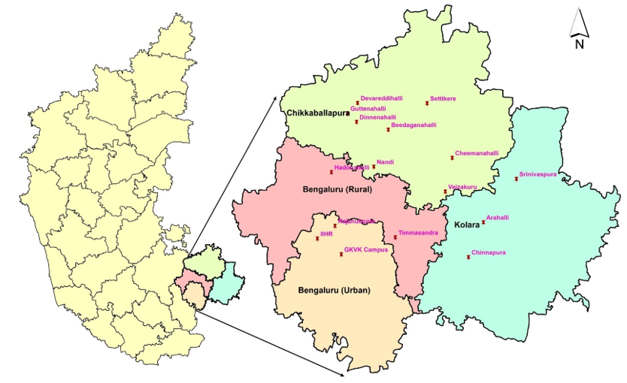

**Fig. 1. Map indicates locations of different villages surveyed in the eastern dry zone of Karnataka (ARC GIS)**

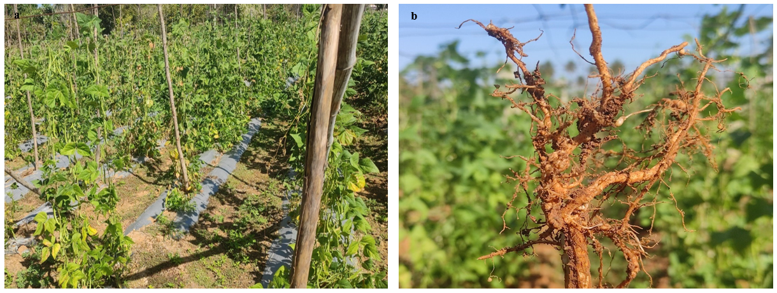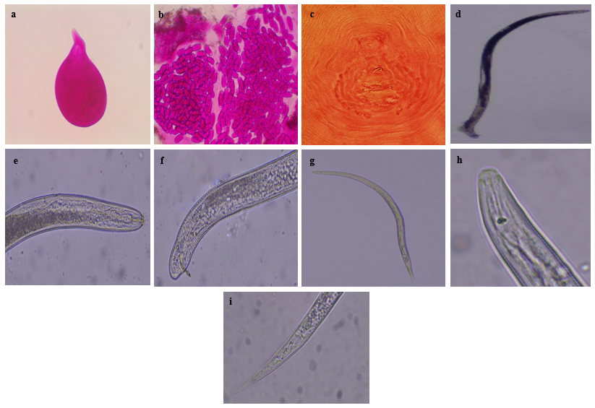

**Fig. 2. (a) Infested common bean field showing above-ground symptoms (yellowing, stunting, wilting). (b) Infested common bean plant below ground (galls on roots)**

**Fig. 3. Morphological identification of *M. incognita* by different characteristics (a) Female nematode (b) Eggs inside egg masses (c) Perineal pattern of *M. incognita* (d) male (e) Anterior Part-Head of male (f) Posterior Part-Tail of male (g) second stage juvenile (h) Anterior Part-Head of second stage juvenile (i) Posterior Part-Tail of second stage juvenile**

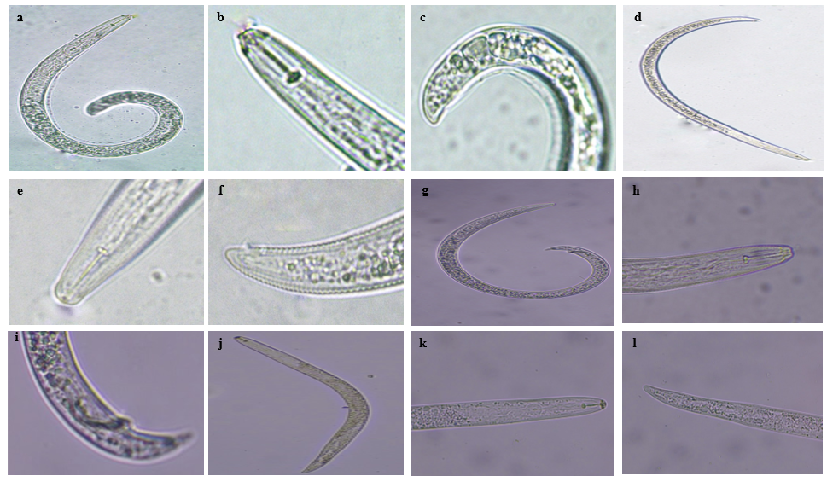

**Fig. 4. Morphological characters of plant-parasitic nematodes(a) *Helicotylenchus sp.* (b) Anterior Part-Head of *Helicotylenchus sp.* (c) Posterior Part-Tail of *Helicotylenchus sp.* (d) *Tylenchorhynchus sp.* (e) Anterior Part-Head of *Tylenchorhynchus sp.* (f) Posterior Part-Tail of *Tylenchorhynchus sp.* (g) *Rotylenchulus sp.* (h) Anterior Part-Head of *Rotylenchulus sp.* (i) Posterior Part-Tail of *Rotylenchulus sp.* (j) *Pratylenchus sp. (k)* Anterior Part-Head of *Pratylenchus sp.* (l) Posterior Part-Tail of *Pratylenchus sp.***

**Fig. 7 Morphological characters of *Helicotylenchus sp.* (A) Body (B)Anterior Part-Head (C)Posterior Part-Tail**

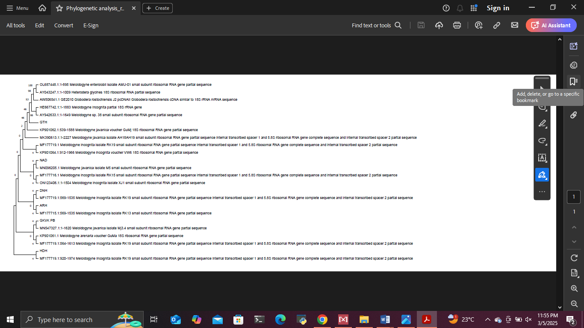**Fig. 5 Phylogenetic tree of *M. incognita* (NAD, GTH, DNH, GKVK_PB, HDH and ARH isolates)**

**C**

**B**

**A**

**B**