Optimizing NPKS Fertilization for Onion Yield and Soil Health in Dinajpur, Bangladesh

### ****Abstract****

To optimize the combination of major nutrients (N, P, K, S) for maximum yield of onion (*Allium cepa* L.) and profitable return without degrading the soil fertility, a field experiment was executed during the winter season of 2023–2024 at the HSTU Central Farm in Sadar Upazila, Dinajpur, Bangladesh. The experiment was performed in a completely randomized design with ten treatments: T1 = control (no fertilization); T2 = 0-60-80-30 kg NPKS ha⁻¹; T3 = 50-60-80-30 kg NPKS ha⁻¹; T4 = 100-60-80-30 kg NPKS ha⁻¹; T5 = 100-0-80-30 kg NPKS ha⁻¹; T6 = 100-20-80-30 kg NPKS ha⁻¹; T7 = 100-40-80-30 kg NPKS ha⁻¹; T8 = 100-60-0-30 kg NPKS ha⁻¹; T9 = 100-60-40-30 kg NPKS ha⁻¹; and T10 = 100-60-80-0 kg NPKS ha⁻¹. The findings showed that the greatest plant height (63.0 cm) and leaf length (55.9 cm), as well as superior metrics for bulb development and yield—bulb diameter (18.3 cm), single bulb weight (59.3 g), fresh leaf weight (9.95 g), fresh bulb yield (10.71 t ha⁻¹), and biological yield (20.7 t ha⁻¹) were obtained with the treatment T8. The maximum harvest index occurred with T9, suggesting that the extra quantity of potassium (40 kg K ha⁻¹) in this treatment T9 promoted sulfur acquisition and increased the partition of biomass to the bulbs. Treatment T8 had the highest residual sulfur in post-harvest soil, indicating that lower rates of sulfur than the currently recommended dose may be enough for subsequent crops. On the other hand, reduced residual sulfur in treatment T9 suggested effective sulfur uptake, when potassium was applied with sulfur. Results suggests that balanced application of potassium with nitrogen and phosphorus plays crucial role in not only improving harvest index but also maximizing the overall nutrient uptake efficiency.

**Keywords:** NPKS, Fertilization, Yield optimization, Soil nutrients, Onion

### ****Introduction****

Onion (*Allium cepa*), belongs to the family of Alliaceae and is the most widely cultivated species of the genus Allium. In fact, it is grown in more than 130 countries around the world, with China and India ranking as the biggest producers, followed by the United States, Netherlands, Egypt, and Iran (FAO, 2019). Onion is used as a spice to improve the taste of food. They are a vital ingredient in a number of spicy foods and are rich in vital minerals and vitamins. Onion is used as a spice in most of the traditional and continental cuisine in Bangladesh; the lower stem section and bulbs are often used. Besides this, in some countries onion leaves also used as condiments. In addition to their culinary value, onions have very potent medicinal properties. Compounds found in onions have been linked to multiple health benefits, such as anti-carcinogenic properties, anti-platelet and antithrombotic effects, and antibiotic effects.

The onion yield is low due to sub-optimal agronomic practices, unavailable high-yielding genotype, unavailability of good soil fertility management practices, pest and disease pressure, and unsuitable environmental conditions. Onions have a shallow rooting system so they need high soil fertility for optimal growth, development and yield. The onion yield in Bangladesh national average is very low (6.91 tons per hectare) than the total world average (near to 17 tons per hectare; Hanci, 2018).

Onion is the second most cultivated spice crop and the highest-produced spice in Bangaldesh. Nevertheless, production from within the country (about 2.5 million metric tons) is insufficient to meet the country's requirement of around 2.8 million metric tons (Prothom Alo, 2020). Onions are a good source of vitamins A, C, iron, and calcium; they help lower blood sugar.

Onions have a shallower root system compared to other crops and their growth period is also shorter which gives them a very unique nutrient requirement. Nitrogen (N), phosphorus (P), potassium (K), and sulfur (S) supply is needed in sufficient quantities for vigorous plant growth, bulb development, and ultimately, high marketable yield. Sulfur (S) is important nutrient affecting bulb quality, pungency, and storability. But, in Bangladesh, about 44% of cultivated soils have been tested and declared S-deficiency due to low availability of S which restrict crop growth and productivity (Rizk et al., 2012). It is well known that NPK fertilizer helps in improving the growth and development of onion (Allium cepa) sap of vegetable-type onion and crown onion from the bulb size, which is an important factor for the marketable yield (Nasreen et al, 2008; Amare, 2020; Mandal, et al., 2020) you are Please use the new format. Moreover, its importance in enzyme functions and chlorophyll formation has been well recognized in works who contributed to the improvement of crops (Khan et al., 2019).

Being a sulfur-loving plant, application of sulfur positively affects yield of bulb, pungency, flavor, storageability, and resistance to pests and diseases (Reddy et al., 2023). Sulfur is crucial for the synthesis of sulfur-containing amino acids, which are important for protein synthesis, vegetative growth, and bulb development (Gnanasundari et al., 2022). As a result, fertilizer application is one of the key agronomic practices for increasing onion yields. The response of the crop to the fertilizers is very much dependent on the existing status of the soil to be fertile.

However, specific target fertilizer needs for maximizing onion yield under certain agro-climatic conditions still needs more scientific attention. Onion productivity was greatly enhanced when site-specific nutrient management approaches were implemented (Boyhan et al. 2007; Verma and Singh, 2012). Therefore, systematic evaluation of NPKS fertilization under the soil scenario of Dinajpur is necessary to formulate effective and sustainable fertilization strategies. Therefore, the present study was undertaken to investigate the growth, yield and soil nutrient status of onion as influenced by varying NPKS fertilizer regimes and to determine suitable fertilizer management to improve onion productivity and soil fertility in Dinajpur Sadar Upazila.

### ****Materials and Methods****

**Experimental Site and Design**

The field experiment was carried out at the Hajee Mohammad Danesh Science and Technology University (HSTU) Central Research Farm, Dinajpur Sadar Upazila, Bangladesh in the winter season of 2023-2024. Average annual temperature is 24.6 °C, and annual rainfall is around 1800 mm. The soil type is sandy loam under the old Himalayan Piedmont Plain and contains moderate amount of organic matter. The experiment was designed using Randomized Complete Block Design (RCBD) with three replications where onion (Allium cepa L., variety BARI Piaz-4) was used as a test crop. All plots were 3.0 m × 2.0 m; the root plant distance was 15 cm × 10 cm.

#### ****Fertilizer Treatments and Application****

Ten fertilizer treatments were evaluated:

* **T1**: Control (No fertilization)
* **T2**: 0-60-80-30 kg NPKS ha⁻¹
* **T3**: 50-60-80-30 kg NPKS ha⁻¹
* **T4**: 100-60-80-30 kg NPKS ha⁻¹
* **T5**: 100-0-80-30 kg NPKS ha⁻¹
* **T6**: 100-20-80-30 kg NPKS ha⁻¹
* **T7**: 100-40-80-30 kg NPKS ha⁻¹
* **T8**: 100-60-0-30 kg NPKS ha⁻¹
* **T9**: 100-60-40-30 kg NPKS ha⁻¹
* **T10**: 100-60-80-0 kg NPKS ha⁻¹

Nitrogen was used in two equal splits, and phosphorus, potassium, and sulfur were basal doses before transplantation. Fertilizer sources included urea, triple super phosphate (TSP), muriate of potash (MoP), and gypsum.

**Data Collection and crop management**

Onion seedlings were transplanted at 45 days after sowing (DAS). Other agronomic practices such as irrigation, weeding and pest control were conducted uniformly across all treatments. Neck-fall harvest was performed 90 days after transplanting (DAT) when 75% of the plants exhibited neck fall.

**Soil Sample Analysis**

Pre land preparation and post harvesting, soil samples (0–15 cm depth) were collected using a soil auger. Samples were air-dried, ground and sieved into 2 mm before laboratory analysis. The subsequent parameters were evaluated according to established protocols. Soil pH was measured with a glass electrode pH-meter at a 1:2.5 (v/v) soil-water suspension (Jackson, 1973). Soil organic carbon was determined by the Walkley and Black (1934) wet oxidation method, and organic matter was derived using van Bemellen factor. Total nitrogen content was determined according to the Kjeldahl digestions and distillation method (Bremner & Mulvaney, 1982). The extractable phosphorus, which is available phosphorus, was extracted and quantified according to Olsen’s method (Olsen et al., 1954) using molybdenum blue spectrophotometry. Exchangeable potassium extracted using 1N ammonium acetate extraction and flame photometry (Jackson, 1973). Accessible sulfur was determined in accordance with the turbidimetric process using calcium phosphate extractant (Fox et al., 1964).

**Plant Sampling and Analysis**

At 45 and 90 DAT, growth parameters were recorded for height, leaf length and number of leaf per plant. Yield parameters such as bulb diameter, bulb length, single bulb weight, fresh yield, and biological yield were determined.

**Statistical Analysis**

Data were analyzed by analysis of variance (ANOVA) (R software version 4.1.2; The R Foundation for Statistical Computing, Vienna, Austria). To determine significance between treatments, Least Significant Difference (LSD) was performed at p ≤ 0.05 to separate treatment means.

### ****Results & Discussion****

**Growth Parameters**

The height of the plant, length of the leaf, and bulb's diameter are important pointers and growth parameters that provide an idea about the response of different fertilizer treatments. These parameters are highly influenced by nitrogen, phosphorus, potassium, and sulfur (NPKS) fertilizers, which govern vegetative growth and the final yield of onions.

The highest plant height (63.07 cm) and leaf length (55.88 cm) were found for treatment T8 in this study, which was a balanced application of nitrogen, phosphorus, and sulfur, but no potassium was applied. These results imply that nitrogen and sulfur play essential roles in vegetative growth. Nitrogen is essential for cell division and extension, increasing plant height. Simultaneously, sulfur is key for activating enzymes and producing chlorophyll, which promotes plant growth through photosynthesis. Contrastingly, treatment with distinct element levels, such as potassium in T9, which corresponds to NPKS at 100-60-40-30 kg ha⁻¹, significantly reduced plant heights and leaf lengths. When they get too high, potassium levels can interfere with nitrogen uptake, leading to nutrient imbalances that can restrict vegetative growth.

As a secondary, sulfur improves plants' nitrogen utilization. This leads to poor formation of amino acids (e.g., cysteine), vital for protein synthesis and its overall growth. Thus, with its presence treatment, T8 considerably enhanced leaf length and plant height. However, plant height and leaf length were decreased for excessive potassium, e.g., treatment T9. Research by Rizk et al. (2012) highlighted that increased potassium concentration can lead to antagonistic effects among nutrients, such as phosphorus and nitrogen, which, upon close proximity, can restrict nutrient absorption and plant growth.

Leaf length is a key determinant of photosynthetic efficiency. Generally, longer leaves and larger leaf areas improve a plant's capacity to capture light and convert it into energy used for growth. The T8 treatment produced the longest leaves and the highest fresh bulb yield. Balanced NPK fertilization enhances vegetative growth and photosynthetic activity, which is vital for bulb formation and yield.

Reddy et al. (2023) demonstrated that sulfur's elevation of chlorophyll in plants is associated with the activation of sulfur-containing amino acids that serve as precursors in protein and enzyme biosynthesis. Such an application mechanism may be the reason for the increased leaf length and plant growth in T8.

Moreover, the growth of onion bulbs, which can be described using bulb diameter and weight, is crucial for yield determination. The largest diameter of the bulb reported was observed for treatment T10 (100-60-80-0 kg NPKS ha⁻¹), which was (7.95 cm) followed by treatment T5 and T4, which was (7.78 cm). This indicates that using more phosphorus promotes bulb elongation and development. Phosphorus is important for energy transfer, developing roots, and aiding cell division, all essential for bulb formation.

Numerous crops, including onions, have shown phosphorus stimulates bulb formation during vegetative growth. A study by Piri and Naserin (2020) found that phosphate, as a major factor in root system development tones in the uptake and transport of nutrients and water, has been shown to substantially enhance bulb size and weight. They also showed that the integrated application of nitrogen with balanced irrigation can increase plant height and leaf area of onion plants since S participates in nitrogen metabolism and increases nutrient uptake efficiency.

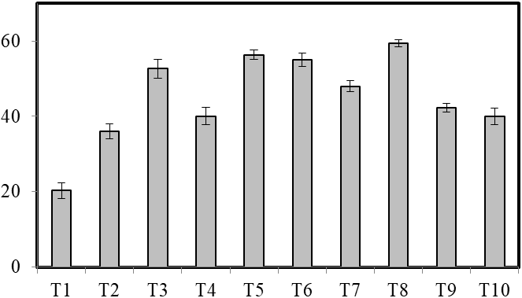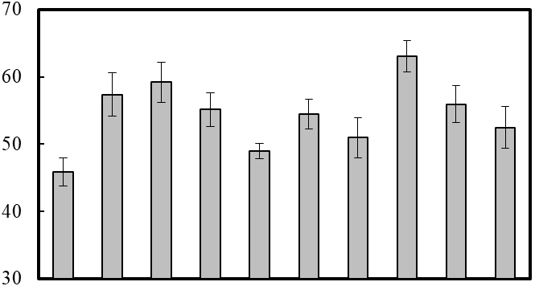

A

Plant height (cm)

d

b

ab

bc

cd

bc

c

a

bc

c

a

ab

ab

ab

b

c

c

c

d

e

C

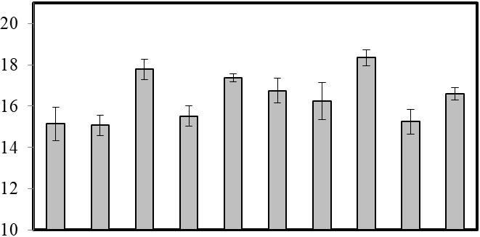

a

ab

ab

ab

b

b

c

c

c

c

B

Bulb diameter (cm)

Single bulb weight (g)

Treatments

**Figure 1: Plant height (A), bulb diameter (B) and single bulb weight (C) of the treatments. Bar indicates mean ± SE. Bars having same letters do not differ significantly at 5% level of significance.**

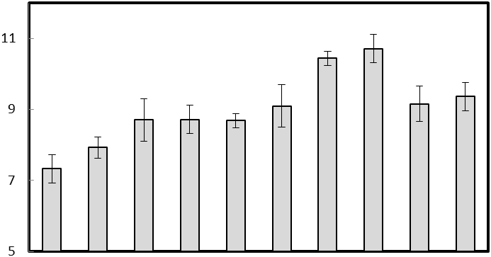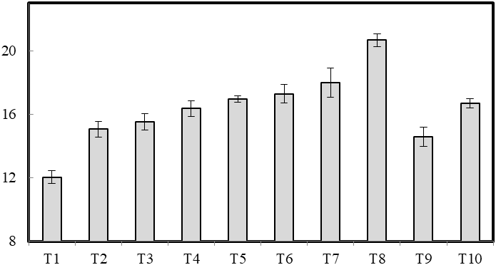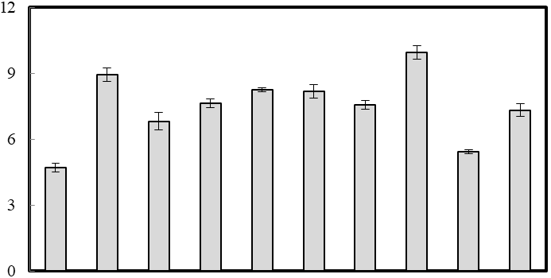

Treatments

A

B

C

Fresh leaf weight (g)

Fresh bulb yield (g)

Biological yield (g)

d

a

a

b

b

b

bc

bc

bc

c

a

b

g

d

e

c

c

d

de

f

e

a

b

c

d

bc

c

cd

d

d

**Figure 2: Fresh leaf weight (A), fresh bulb yield (B) and biological yield (C) of the treatments. Bar indicates mean ± SE. Bars having same letters do not differ significantly at 5% level of significance.**

Treatments

Harvest index (%)

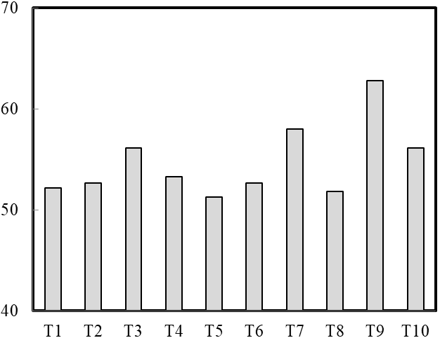

#### **Figure 3: Harvest index (%) of the treatments. Harvest index is the grain yield/biological yield × 100.**

**Yield & Harvest Index**

Fertilizer application profoundly influenced bulb characteristics. The greatest bulb length (7.95 cm) was recorded for T10, followed by T5 and T4 (7.78 cm) (Figure 2), highlighting the importance of phosphorus and nitrogen for bulb elongation. In these treatments, phosphorus acted in energy transfer and root development, which had positive effects on bulb expansion (Kumar et al., 2020). Similarly, T8 (10.71 t ha-1) in the fertilized conditions indicated a highest yield potential in terms of fresh bulb yield. Biological yield also responded significantly with a peak in T8 (20.66 t ha-1) highlighting the role of synergistic interaction between the two nutrients (N and S) regarding biomass accumulation and the increased metabolic efficiency (Naserin et al., 2008). The harvest index (HI), which measures economic yield in relation to total biomass, reached maximum value (0.62) in T9. This implies that bulb forming is enhanced by potassium application together with nitrogen and phosphorus, which contributed to dry matter partitioning towards bulb differentiation and resulted in maximum productivity (Boyhan et al., 2007). This balance of these two macronutrients may have made an important contribution to carbon assimilation and allocation, leading to a greater harvest index.

**Soil Nutrient Status after Harvest**

Well after harvest, we performed a soil analysis that showed wide differences between the treatments where it came to nutrient retention. T8 recorded the highest total nitrogen at 0.22% with high uptake efficiency and moderate residual availability for subsequent cropping cycles (Table 1). The available phosphorus content, on the other hand, increased in all of the treatments that were fertilized, where T4 (16.95 ppm) (Table 1) had the highest accumulation, which could enhance nutrient availability in future crop cycles (Gnanasundari et al., 2022). Potassium replaced in exchange therapy showed little change across treatments, indicating minimal losses to leaching. Sulfur availability is important for vegetative growth in plants, which explains the highest level in this treatment but also indicates its potential for carryover into subsequent crop cycles. This indicates that lower S application in subsequent seasons can still maintain high productivity at a relatively low input cost (El-Morsy et al. 2016). Previous research in Bangladesh highlighted the importance of balanced NPKS fertilization. Khan et al. Long-term intensive fertilization, particularly long-term CK treatment, changed the soil physicochemical properties, which affected the crop. Phosphorus sorption studies by Khan et al. (2001) emphasized the role of organic and inorganic fertilizer amendments in enhancing nutrient availability. These results highlight the importance of site-specific, practice-specific nutrient management strategies for onion production.

**Table 1: Total nitrogen, available phosphorus, exchangeable potassium and available sulphur in different treatments.**

|  |  |  |  |  |
| --- | --- | --- | --- | --- |
| **Treatment** | **N**  **(%)** | **P**  **(ppm)** | **K**  **(meq/100g)** | **S**  **(ppm)** |
| T1 | 0.08 e | 6.74 h | 1.27 b | 6.53 e |
| T2 | 0.21 ab | 7.34 g | 1.27 b | 6.26 e |
| T3 | 0.15 c | 8.36 f | 1.27 b | 6.71 e |
| T4 | 0.12 d | 16.95 a | 1.27 b | 9.03 d |
| T5 | 0.08 e | 6.31 i | 1.27 b | 5.50 f |
| T6 | 0.21 ab | 11.85 c | 1.27 b | 9.27 d |
| T7 | 0.21 ab | 5.51 j | 1.27 b | 4.37 g |
| T8 | 0.22 a | 13.27 b | 1.27 b | 17.70 a |
| T9 | 0.20 b | 9.17 d | 1.58 a | 10.28 c |
| T10 | 0.15 c | 8.72 e | 1.27 b | 13.05 b |
| SE | 6.58 | 5.97 | 4.5 | 0.2 |
| CV % | 6.9 | 0.11 | 0.6 | 4.06 |

The present study represents the first report of an important sulfur role in plants, as its interaction with phosphorus (P) impacts multiple aspects of onion development. Data on sulfur content in the soil and the plant tissues were significantly higher in all the treatments where sulfur was added (T8 (100 kg sulfur) and T9 (120 kg sulfur)), which believed to be a potent factor to augment the growth parameters like length of leaf and bulbing. Sulfur has also been well known to interact with phosphorus in regulating their uptake and perform metabolic functions (Boyhan et al. 2007, de Resende & Costa, 1014). An appropriate ratio of sulfur and phosphorus creates conducive conditions to chorophyll synthesis and increasesbound phosphorus through chemical modification, which is necessary for root formation and bulb development in the tuber.

The antagonistic (or synergistic) effects between sulfur and phosphorus in plant growth have been pointed out from several studies (Table 3). Higher sulfur applications, for example, tend to enhance phosphorus availability in the rhizosphere by competing with phosphate ions for sorption sites, thus increasing phosphorus availability (Amare, 2020). On the other hand, high levels of sulfur can bind with phosphorus, forming insoluble complexes that hinder plant growth, especially in alkaline soils. The decrease in leaf length and bulb diameter compared to those with balanced sulfur application was observed in treatments with excess sulfur (T10).

Moreover, potassium (K) also affected sulfur uptake. Potassium fertilizers, especially T9 (100-60-40-30 kg NPKS ha⁻¹), significantly enhanced the sulfur uptake. This supports previous studies showing that potassium plays a role in sulfur mobilization in plants, which shows that it helps plants utilize nutrients efficiently (Bose et al., 2017). The beneficial role of potassium along with sulfur which has been reflected in the highest fresh bulb yield and biological yield observed in T8 & T9 treatments.

Phosphorus uptake efficiency is enhanced by sulfur through the effects of sulfur on development of root system and expression of nutrient transporters, which in turn improves the overall nutrient uptake efficiency (Jatav et al., 2018). The fact that balanced application of NPKS was found beneficial in quieting onion yield suggests that the similar levels of sulfur are persistent in the soil at sufficient amounts for the next crop that helps and supports sustainable soil fertility management.

**Conclusion:**

The result indicates that balanced NPKS fertilization significantly improves onion yield and soil fertility in Dinajpur, Bangladesh. The maximum yield was provided by T8 treatment (100-60-0-30 kg NPKS ha⁻¹) while maximum harvest index was achieved by T9 treatment (100-60-40-30 kg NPKS ha⁻¹). The findings highlight the critical role of potassium and sulfur in improving nutrient uptake and productivity. The sustainable production of onion bulbs must be accompanied by its proper nutrient management; which requires site-specific fertilization strategies to optimize production and soil health. This study provides the basis for future exploration of long-term soil nutrients dynamics for improvement in fertilization practices.

Acknowledgement: This research was funded by the Institute of Research and Training, Hajee Mohammad Danesh Science and Technology University, Dinajpur, Bangladesh to the first author.

Disclaimer (Artificial intelligence)

I hereby declare that NO generative AI technologies such as Large Language Models (ChatGPT, COPILOT, etc.) and text-to-image generators have been used during the writing or editing of this manuscript.

### ****References****

Al-Fraihat Ahmad H and Ahmad H. 2009. Effect of different nitrogen and sulphur fertilizer levels on growth, yield and quality of onion (*Allium cepa* L.). Jordan Journal of Agricultural Sciences. 5(2): 155-166.

Amare, G. (2020). Review on mineral nutrition of onion (*Allium cepa* L.). The Open Biotechnology Journal. 14: 134-144. DOI: 10.2174/1874070702014010134

Boyhan, G.E., Torrance, R.L., & Hill, C.R. (2007). Effects of nitrogen, phosphorus, and potassium rates and fertilizer sources on yield and leaf nutrient status of short-day onions. Hort Science. 42(3): 653-660. <https://doi.org/10.21273/HORTSCI.42.3.653>

de Resende G.M., & Costa, N.D. (1014). Effects of levels of potassium and nitrogen on yields and post-harvest conservation of onions in winter. Soil Science and Plant Nutrition. 61 (4): 572-577. <https://doi.org/10.1590/0034-737X201461040018>

El-Morsy, A., ElKasas, A., & El-Tantawy, A. (2016). Onion plant growth and yield as affected by nitrogen, potassium and sulphur combinations under elarish region conditions. Sinai J Appl Sci 2016; 5: 345-62. <http://dx.doi.org/10.21608/sinjas.2016.78657>

FAO (Food and Agriculture Organization). Production year book 2019.

Gnanasundari, K., Srivignesh, S., Rama Krishna, K., Kumar, M., & Kumar, A.R. (2022). Integrated nutrient management in onion-A Review. Eco. Env. & Cons. 28 (November Suppl. Issue): pp. S182-S192. <http://doi.org/10.53550/EEC.2022.v28i07s.030>

Hanci F. 2018. A comprehensive overview of onion production: Worldwide and Turkey. IOSR Journal of Agriculture and Veterinary Science. 11( 9): 17-27. DOI: 10.9790/2380-1109011727

Khan, M. S. H., Abedin Mian, M. J., & Ahammed, M. S. (2001). Phosphorus sorption behaviour of soils amended with organic and inorganic fertilizers. *Indian Journal of Surface Science and Technology, 17*, 141-148.

Khan, M. S. H., Abedin Mian, M. J., Akhter, A., & Khosruzzaman, M. (2006). Physico-chemical changes of paddy soils under long-term intensive fertilization. *Asian Journal of Plant Science, 5*, 105-111. <https://doi.org/10.3923/ajps.2006.105.111>

Khan, T. R., Alam, M. Z., & Sarker, M. (2019). Role of sulfur in enzymatic functions and chlorophyll synthesis in crop improvement. *Journal of Plant Science, 12*(3), 210-225. <https://doi.org/10.21525/jps.2019.12.3.210>

Mandal, J., Acharyya, P., Bera, R., & Mohanta, S. (2020). Response of Onion to NPK, S and Micronutrients. *Int J Curr Microbiol Appl Sci*. 9: 1137-44. <http://dx.doi.org/10.20546/ijcmas.2020.906.141>

Nasreen, S., Haque, M., Hossain, M., & Farid, A. (2008). Nutrient uptake and yield of onion as influenced by nitrogen and sulphur fertilization. *Bangladesh Journal of Agricultural Research*, *32*(3), 413–420. <https://doi.org/10.3329/bjar.v32i3.543>

Piri, H., & Naserin, A. (2020). Effect of different levels of water, applied nitrogen and irrigation methods on yield, yield components and IWUE of onion. Scientia Horticulturae. 2020 Jun 27;268:109361. <https://doi.org/10.1016/j.scienta.2020.109361>

Prothom Alo. (2020). Onion production and demand in Bangladesh. *The Daily Prothom Alo*. (on 17.09.2020). Dhaka.

Reddy MV, Umajyothi K, Reddy PSS, Sasikala K. (2023). Yield and economics of onion as influenced by pre and post emergence herbicdes. Int. J. Environ. Clim. Change. 13(8): 359-364. <https://journalijecc.com/index.php/IJECC/article/view/1961>

Rizk, F.A., Shaheen, A.M., Abd El-Samad, E.A., & Sawan, O.M. (2012). Effect of different nitrogen plus phosphorus and sulphur fertilizer levels on growth, yield and quality of onion (*Ailium cepa* L.). J Appl Sci Res. 8: 3353-3361.

Shock, C.C., Feibert, B.G., Saunders, L.D. (2004). Plant population and nitrogen fertilization for subsurface drip-irrigated onion. HortScience. 39(7): 1722-1727. <http://dx.doi.org/10.21273/HORTSCI.39.7.1722>

Verma, D., & Singh, H. (2012). Response of varying levels of potassium and sulphur on yield and uptake of nutrients by onion. *Ann. Pl. Soil Res.* 14(2):143-146. <https://gkvsociety.com/control/uploads/responce-of-varying-level-of-potassium.pdf>