***Original Research Article***

**SPATIAL VARIATION OF SOIL FERTILITY IN NORTH SIKKIM**

**ABSTRACT**

A research investigation was carried out in 2024 to evaluate the spatial variation of soil nutrients in soils of North Sikkim across five regions viz. Mangan, Dzongu, Ringhim, Kabi, and Chungthang through real-time analysis of soil fertility parameters, taking 3,750 samples. The research investigation was done in Key parameters assessed included pH, electrical conductivity (EC), organic carbon, macronutrients (nitrogen, phosphorus, potassium, sulphur), and micronutrients (zinc, boron, iron, Manganese, and copper). To analyze 3,750 soil samples with uneven distributions, weighted statistical methods were used to account for sampling variability. Mean comparisons were conducted using One-way ANOVA, followed by Duncan’s Multiple Range Test at a significance level of α =.05 to assess statistical differences and classify locations based on their similarity in soil characteristics. The results indicated a highly acidic soil environment, with pH ranging from 4.865 ± 0.021 to 4.880 ± 0.020, potentially affecting nutrient availability. Organic carbon levels ranged from 0.50 % ± 0.050 to 0.70 % ± 0.047. Nitrogen and phosphorus were critically deficient, which ranged from 157.9 ± 9.86 to 161.234 ± 10.102 kg/ha and from 18.9 ±1.430 to 19.4 ± 1.435 kg/ha, respectively, posing significant constraints for crop productivity. Potassium was at a medium level (233.92 ± 7.800kg/ha to 236.3 ± 7.708 kg/ha), while sulphur, zinc, and copper were within adequate ranges. However, the study revealed excessive iron concentrations (mean: 98.18 ±0.222 mg/kg) and widespread boron deficiency (mean: 0.282 ± 0.002 mg/kg), which could lead to physiological disorders in crops. The findings emphasized the urgent need for restoring soil pH and improving overall soil health. It was observed from elaborate analyses that distance among the study regions and DEM derived variables also influenced spatial distribution of soil fertility characteristics. Insights from the current soil testing would drive the implementation of balanced nutrient management strategies, optimizing soil fertility and ensuring sustainable agricultural productivity. Given Sikkim's distinction as the world's only fully organic state, these measures are essential for preserving the productivity of high-value crops such as ginger, large cardamom, cherry pepper, and vegetables. This study would serve as a foundational step in retaining Sikkim's significance as the only organic state on the global map through the holistic management of soil health, ensuring long-term sustainability and productivity.

*Key Words: Sikkim Soil, Soil groups, Soil Health, Organic Field Management, Soil Micronutrients, Soil pH, DEM.*

1. **INTRODUCTION**

The Mountain agricultural ecosystem in Sikkim, India, highlights the importance of specialized management skills for sustaining productivity (Das *et al*. 2018). Sikkim has developed innovative approaches agronomically to emerge as a global leader in organic farming. An important aspect of the organic system is focusing on enhancing soil health so that farmers cope with the adverse impacts of climate change (Scialabba and Müller-Lindenlauf 2010; Altieri *et al*. ,2015). Technical intervention in soil evaluation to uncover intrinsic properties of the soil and its nutrient composition is essential for optimizing agricultural productivity and sustainable land management. According to Tong *et al*. (2022), integrating organic farming practices with comprehensive soil analysis can gradually enhance soil quality metrics. New research by Futa *et al*. (2024) supported this conclusion, indicating that farms using organic procedures routinely had higher soil fertility status than those using conventional agricultural methods. A detailed study by Kolbe (2022) that looked at farming systems in Central Europe revealed the importance of soil testing when switching from conventional to organic practices. Suntoro *et al*. (2024) found that farms that regularly assessed their soil fertility were more adept at modifying their organic management strategies. However, in the context of Sikkim’s organic agriculture system, comprehensive, high resolution soil nutrient data is largely lacking. Given the state’s prominence in producing high value crops such as large cardamom, ginger, vegetables, mandarins, and cherry peppers, ensuring optimal soil fertility is imperative for sustaining productivity and preserving its global recognition as an organic farming model. Major agricultural issues are brought on by the state's hilly geography, such as complex soil nutrient dynamics, severe topographical restrictions, leaching due to high rainfall, erosion and shortage of arable land. These elements require context-specific and precision-driven treatments since they directly impact soil fertility, nutrient availability, and overall crop yield. According to Goswami and Pariyar (2025), organic farming in this area embraces a comprehensive approach to ecosystem management and sustainable development, going beyond traditional system. Switching to absolute organic farming methods required a thorough comprehension of the ecological interactions specific to mountain ecosystems, nutrient recycling, and soil health metrics (Das *et al*., 2018). Hence, realizing the urgent need for a detailed assessment of soil health in the organic agriculture system, a study was undertaken to systematically evaluate the soil fertility status and spatial variability of nutrients across five regions in North Sikkim—Mangan, Dzongu, Ringhim, Kabi, and Chungthang. This study was undertaken in these high-altitude agro-ecological zones of North Sikkim, where the unique interplay of topography, climate, soil composition and organic farming mandate significantly influences crop performance. By leveraging advanced soil testing methodologies, this research seeks to Systematically evaluate the soil fertility status and characterize the spatial distribution of essential soil nutrients, identify key soil health constraints affecting agricultural productivity, develop scientifically grounded recommendations for sustainable soil management and contribute to the broader discourse on organic farming in mountain regions

**2.** **MATERIALS AND METHODS**

**2.1 Study Area**

The study covered five regions in Sikkim: Mangan, Dzongu, Ringhim, Kabi, and Chungthang(Fig. 1) Sampling and Collection Soil samples were collected systematically from 3,750 sites across five subdistricts in North Sikkim. The sampling approach utilized a systematic nested sampling technique(Thompson, 2012). Three sets of samples S1, S2, and S3 were designated at each location to ensure proper spatial representation. Sampling depths ranged from 0–15 cm, with each sample thoroughly mixed and prepared according to standardized analytical protocols. The sampling method was designed to accommodate variations in land parcel sizes, with an initial assumption of 1 hectare land holdings per participating farmer. However, empirical field observations revealed significant heterogeneity in land parcel sizes, leading to uneven sample distribution across study regions and

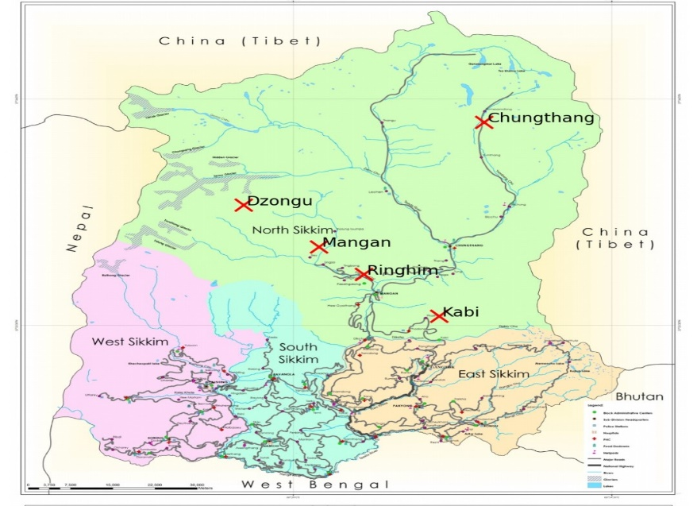

**Fig.1. Regions of North Sikkim-Kabi, Mangan, Dzongu, Ringhim, Mangan**

***\*Study area marked red are only representative to give an overall understanding of the regions.***

variability in sampling point representation. So, for representative sample collection, each location was characterized by three nested sampling points, where S1 represented the primary sampling point, S2 the secondary sampling point, and S3 the tertiary sampling point, enabling comprehensive spatial coverage and minimizing potential sampling biases.

**2.2 Analytical Process**

The entire soil analysis was conducted using an IoT-based instant soil testing system with crop specific fertilizer recommendations developed by Agrithink Services. This patented technology allows for precise, and comprehensive soil analysis within a minute. Each sample was tested for key parameters including pH, Electrical Conductivity (EC), Organic Carbon, Nitrogen, Phosphorus, Potassium, Sulphur, Zinc, Boron, Iron, Manganese, and Copper.

**2.2** **Digital Elevation Model (DEM) Data and Auxiliary Variables**

To explore the possibilities of influence of topographic factors, including **slope, elevation, and flow accumulation**, data were derived from the Sikkim State GIS Portal(2025) which provides multi-layered GIS datasets that includes DEM data. Additional DEM data sources included SRTM-DEM(Sharma,2024),Bhuvan-NRSC Open EO Data Archive **and** earthexplorer.usgs.gov.

**2.3 Statistical Analysis**

To manage and analyse the large dataset of 3,750 soil samples with uneven sampling distributions, a robust statistical approach was employed. The sampling variability was accounted for using weighted statistical methods that accommodated unequal sample sizes across different regions.

The set sample distribution was solved using the following statistical analytic methods:

1. Weighed mean calculations to ensure that each region’s contribution was correctly represented.

2. Methods of estimation of variance from stratified sampling.

3. Computation of sample adjusted standard errors and variances by n (S1, S2, S3) points for the irregular and asymmetric design of the sample.

**2.3.1 Mean Comparison and Grouping Methods**

**2.3.1.1 Separation of Averages Means**

Duncan’s Multiple Range Test is used where comprehensive mean analysis and measuring differences on separation/dependence sets within the studied regions/locations are done. The procedure used includes:

**2.3.1.1.1 Mean Comparison Procedure**

* Determination of overall significant differences by One-way ANOVA
* Duncan's Multiple Range Test for post-hoc analysis
* Significance level set at α = .05

**2.3.1.1.2 Grouping Criteria**

Locations were classified into homogeneous groups using alphabetical notation:

* **Group 'a'**: Locations with statistically similar means
* **Group 'ab'**: Intermediate characteristics
* **Groups 'b' and 'c'**: Distinct statistical characteristics

In order to address the complex sampling design with uneven sample sizes and multiple sampling points (S1, S2, S3), a comprehensive statistical approach was implemented using SAS 9.4 (SAS Institute, 2022) and SPSS 26.0 (IBM Corp., 2022) statistical software. Additionally, analyses were further supported by R 4.2.2 (R Core Team, 2022).

**2.4. Spatial Variation Modeling and Variogram Analysis**

A geostatistical approach was applied to analyze spatial variability using variograms, which graphically represent cumulative variance as a function of distance. The analysis followed the procedures outlined by Robertson (2008) and was implemented using GS+ software.

**2.5 Multivariate Regression Analysis between Soil Properties and Auxiliary Variables**

Multivariate regression analysis was performed to establish relationships between soil properties (pH, organic carbon, and nutrient concentrations) and DEM auxiliary variables (elevation, slope, and flow accumulation). Regression analysis was conducted using Scikit-learn (Pedregosa et al., 2011), and statistical data processing was carried out in Python (Van Rossum, 2009) using Pandas (McKinney, 2010).

To assess soil fertility status and characterize the spatial distribution of essential nutrients, geostatistical techniques were incorporated using regression kriging. Environmental covariates such as elevation, slope, and flow accumulation were derived from digital elevation models to enhance predictive accuracy. The modeling was conducted using the gstat package in R 4.2.2(2022).

**2.6 Data Visualization and Statistical Analysis**

Data visualization techniques, including thematic maps, heatmaps, and variogram were utilized to represent spatial trends. These visualizations were generated using Matplotlib (Hunter, 2007) and Seaborn (Waskom, 2021).

**3.1 RESULTS**

**3.1.1 pH**

The pH levels were relatively consistent across all locations, with Kabi recording 4.87 (±0.022), Chungthang at 4.865 (±0.021), Mangan at 4.880 (±0.020), Dzongu at 4.875 (±0.021), and Ringhim at 4.870 (±0.022).

**3.1.2 Electrical Conductivity (EC)**

The electrical conductivity values were also comparable across sites, with Kabi at 241 μs/cm (±19), Chungthang at 239 μs/cm (±19), Mangan at 238 μs/cm (±19), Dzongu at 242 μs/cm (±19), and Ringhim at 240 μs/cm (±19).

**Table1.: pH, EC, OC, N, P, K and S**

|  |  |  |  |  |  |
| --- | --- | --- | --- | --- | --- |
| **Parameter** | **Kabi** | **Chungthang** | **Mangan** | **Dzongu** | **Ringhim** |
| **pH** | 4.87 ±0.022 | 4.865 ±0.021 | 4.880 ±0.020 | 4.875 ±0.021 | 4.870 ±0.022 |
| **EC (μs/cm)** | 241 ±19 | 239 ±19 | 238 ±19 | 242 ±19 | 240 ±19 |
| **Organic Carbon (%)** | 0.62 ±0.049 | 0.70 ±0.047 | 0.68 ±0.051 | 0.65 ±0.048 | 0.50 ±0.050 |
| **Nitrogen (kg/ha)** | 158.6 ±9.870 | 160.5 ±9.850 | 161.234 ±10.102 | 159.875 ±9.762 | 157.9 ±9.861 |
| **Phosphorus (kg/ha)** | 19.4 ±1.435 | 19.2 ±1.436 | 18.9 ±1.430 | 19.1 ±1.432 | 19.3 ±1.434 |
| **Potassium (kg/ha)** | 234.8 ±7.712 | 236.3 ±7.708 | 233.92 ±7.800 | 234.6 ±7.706 | 235.1 ±7.711 |
| **Sulphur (mg/kg)** | 18.052 ±0.007 | 18.053 ±0.008 | 18.048 ±0.009 | 18.051 ±0.008 | 18.054 ±0.007 |

*\*values represent mean* ± *SE(Standard Error)*

**3.1.3 Organic Carbon (%)**

Organic carbon content was highest in Chungthang at 0.70% (±0.047), followed by Mangan at 0.68% (±0.051), Dzongu at 0.65% (±0.048), Kabi at 0.62% (±0.049), and lowest in Ringhim at 0.50% (±0.050).

**3.1.4 Nitrogen (kg/ha)**

Nitrogen levels varied slightly across regions, with Mangan having the highest at 161.234 kg/ha (±10.102), followed by Chungthang at 160.500 kg/ha (±9.850), Dzongu at 159.875 kg/ha (±9.762), Kabi at 158.6 kg/ha (±9.870), and Ringhim at 157.900 kg/ha (±9.861).

**3.1.5 Phosphorus (kg/ha)**

Phosphorus content was highest in Kabi at 19.4 kg/ha (±1.435), followed by Ringhim at 19.300 kg/ha (±1.434), Dzongu at 19.100 kg/ha (±1.432), Chungthang at 19.200 kg/ha (±1.436), and lowest in Mangan at 18.900 kg/ha (±1.430).

**3.1.6. Potassium (kg/ha)**

The highest potassium content was recorded in Chungthang at 236.300 kg/ha (±7.708), followed by Ringhim at 235.100 kg/ha (±7.711), Dzongu at 234.600 kg/ha (±7.706), Kabi at 234.8 kg/ha (±7.712), and Mangan at 233.920 kg/ha (±7.800).

**3.1.7 Sulphur(mg/kg)**

Sulphur content remained relatively uniform, with Ringhim recording the highest at 18.054 mg/kg (±0.007), followed by Chungthang at 18.053 mg/kg (±0.008), Kabi at 18.052 mg/kg (±0.007), Dzongu at 18.051 mg/kg (±0.008), and Mangan at 18.048 mg/kg (±0.009).

**Table 2: Iron, Manganese, Copper, Zinc and Boron Status**

|  |  |  |  |  |  |
| --- | --- | --- | --- | --- | --- |
| **Parameter** | Kabi | Chungthang | Mangan | Dzongu | Ringhim |
| **Iron (mg/kg)** | 98.181 ±0.218 | 98.180 ±0.220 | 98.198 ±0.222 | 98.176 ±0.217 | 98.183 ±0.219 |
| **Manganese (mg/kg)** | 20.585 ±0.053 | 20.590 ±0.054 | 20.590 ±0.053 | 20.584 ±0.052 | 20.588 ±0.053 |
| **Copper (mg/kg)** | 2.443 ±0.004 | 2.446 ±0.004 | 2.448 ±0.004 | 2.442 ±0.004 | 2.440 ±0.004 |
| **Zinc (mg/kg)** | 1.01 ±0.000 | 1.011 ±0.000 | 1.012 ±0.000 | 1.011 ±0.000 | 1.010 ±0.000 |
| **Boron (mg/kg)** | 0.282 ±0.002 | 0.283 ±0.002 | 0.284 ±0.002 | 0.283 ±0.002 | 0.282 ±0.002 |

**\**values represent mean*** *± SE(Standard Error)*

**3.1.8 Zinc (mg/kg)**

Zinc levels were very similar across all sites, with Mangan recording the highest at 1.012 mg/kg (±0.000), followed by Chungthang and Dzongu at 1.011 mg/kg (±0.000), Ringhim at 1.010 mg/kg (±0.000), and Kabi at 1.01 mg/kg (±0.000).

**3.1.9 Boron(mg/kg)**

Boron content was highest in Mangan at 0.284 mg/kg (±0.002), followed by Dzongu and Chungthang at 0.283 mg/kg (±0.002), and Kabi and Ringhim at 0.282 mg/kg (±0.002).

**3.1.10Copper (mg/kg)**

Copper content showed little variation, with Mangan recording the highest at 2.448 mg/kg (±0.004), followed by Chungthang at 2.446 mg/kg (±0.004), Kabi at 2.443 mg/kg (±0.004), Ringhim at 2.440 mg/kg (±0.004), and Dzongu at 2.442 mg/kg (±0.004).

**3.1.11Iron(mg/kg)**

Iron content was highest in Kabi at 98.181 mg/kg (±0.218), followed by Ringhim at 98.183 mg/kg (±0.219), Chungthang at 98.180 mg/kg (±0.220), Mangan at 98.198 mg/kg (±0.222), and Dzongu at 98.176 mg/kg (±0.217).

**3.1.12 Manganese (mg/kg)**

Manganese levels were highest in Chungthang and Mangan at 20.590 mg/kg (±0.054 and ±0.053, respectively), followed by Ringhim at 20.588 mg/kg (±0.053), Kabi at 20.585 mg/kg (±0.053), and Dzongu at 20.584 mg/kg (±0.052).

**3.2 Results of Statistical Analyses**

**Table 3: ANOVA**

|  |  |  |  |  |  |  |  |
| --- | --- | --- | --- | --- | --- | --- | --- |
| **Parameter** | **Source of Variation** | **DF** | **Sum of Squares** | **Mean Square** | **F Calculated** | **Significance** | **LSD (5%)** |
| **pH** | Between Groups | 4 | 0.0004 | 0.0001 | 0.216 | 0.925 | 0.0542 |
| **pH** | Within Groups | 10 | 0.0047 | 0.00047 |  |  |  |
| **Organic Carbon (%)** | Between Groups | 4 | 0.0704 | 0.0176 | 7.333 | 0.003 | 0.0984 |
| **Organic Carbon (%)** | Within Groups | 10 | 0.024 | 0.0024 |  |  |  |
| **Nitrogen (kg/ha)** | Between Groups | 4 | 17.89 | 4.47 | 0.045 | 0.995 | 19.84 |
| **Nitrogen (kg/ha)** | Within Groups | 10 | 990.42 | 99.04 |  |  |  |
| **Phosphorus (kg/ha)** | Between Groups | 4 | 0.385 | 0.096 | 0.047 | 0.996 | 2.86 |
| **Phosphorus (kg/ha)** | Within Groups | 10 | 20.56 | 2.056 |  |  |  |
| **Potassium (kg/ha)** | Between Groups | 4 | 10.87 | 2.72 | 0.045 | 0.996 | 15.37 |
| **Potassium (kg/ha)** | Within Groups | 10 | 594.25 | 59.43 |  |  |  |
| **Sulphur (mg/kg)** | Between Groups | 4 | 0.000052 | 0.000013 | 2.453 | 0.117 | 0.007 |
| **Sulphur (mg/kg)** | Within Groups | 10 | 0.000052 | 0.000005 |  |  |  |
| **Zinc (mg/kg)** | Between Groups | 4 | 0.000002 | 0.0000005 | 0.783 | 0.562 | 0 |
| **Zinc (mg/kg)** | Within Groups | 10 | 0.000006 | 0.0000006 |  |  |  |
| **Boron (mg/kg)** | Between Groups | 4 | 0.000008 | 0.000002 | 1.25 | 0.355 | 0.002 |
| **Boron (mg/kg)** | Within Groups | 10 | 0.000016 | 0.0000016 |  |  |  |
| **Iron (mg/kg)** | Between Groups | 4 | 0.051 | 0.01275 | 1.528 | 0.269 | 0.218 |
| **Iron (mg/kg)** | Within Groups | 10 | 0.0835 | 0.00835 |  |  |  |
| **Manganese (mg/kg)** | Between Groups | 4 | 0.0016 | 0.0004 | 0.987 | 0.460 | 0.053 |
| **Manganese (mg/kg)** | Within Groups | 10 | 0.004 | 0.0004 |  |  |  |
| **Copper (mg/kg)** | Between Groups | 4 | 0.000064 | 0.000016 | 1.123 | 0.398 | 0.004 |

The results of the ANOVA analysis (Table 3) indicated a uniform soil pH across the study region, with values ranging narrowly from 4.865 to 4.880 (F = 0.216, P = .93). Similarly, nitrogen (F = 0.045, P = .99), phosphorus (F = 0.047, P = .99), and potassium (F = 0.045, P = .99) contents exhibited no significant variations, suggesting homogeneity across Kabi, Chungthang, Mangan, Dzongu, and Ringhim. However, organic carbon showed significant spatial variability (F = 7.333, P = .003), with Chungthang and Mangan having the highest levels (0.70% and 0.68%, respectively), followed by Dzongu (0.65%) and Kabi (0.62%), while Ringhim recorded the lowest value (0.50%).

Among secondary nutrients and micronutrients, sulphur content remained relatively stable (F = 2.453, P = .12), with mean values ranging between 18.048 mg/kg in Mangan and 18.054 mg/kg in Ringhim. Similarly, zinc (F = 0.783, P = .56), boron (F = 1.250, P = .36), iron (F = 1.528, P = .27), manganese (F = 0.987, P = .46), and copper (F = 1.123, P = .40) displayed no significant differences across locations.

**Table 4: Mean Comparison of pH, EC, OC, Nitrogen, Phosphorous, Potassium, Sulphur**

|  |  |  |  |  |  |  |  |  |
| --- | --- | --- | --- | --- | --- | --- | --- | --- |
| **Location** | **pH** | **EC (μs/cm)** | **N (kg/ha)** | **P**  **(kg/ha)** | **K**  **(kg/ha)** | **S (mg/kg)** | **OC (%)** | **Group** |
| **Chungthang** | 4.865 | 239 | 160.5 | 19.2 | 236.3 | 18.053 | 0.7 | a |
| **Mangan** | 4.88 | 238 | 161.234 | 18.9 | 233.92 | 18.048 | 0.68 | a |
| **Dzongu** | 4.875 | 242 | 159.875 | 19.1 | 234.6 | 18.051 | 0.65 | ab |
| **KABI** | 4.87 | 241 | 158.6 | 19.4 | 234.8 | 18.052 | 0.62 | b |
| **Ringhim** | 4.87 | 240 | 157.9 | 19.3 | 235.1 | 18.054 | 0.5 | c |

*\* Locations with the same letter are not significantly different at* ***p = .05***

Table 4 revealed that Chungthang and Mangan belonged to the same group (a), exhibiting the highest values for organic carbon, nitrogen, and pH. Dzongu formed an intermediate group (ab), with values slightly lower than Chungthang and Mangan but not significantly different from either. Kabi fell into group (b), showing moderate values for organic carbon, nitrogen, and pH. Ringhim was classified under group (c), displaying the lowest levels of organic carbon, nitrogen, and pH. The grouping indicated a gradient in soil fertility and organic matter content across locations.

**Table 5: Mean Comparison of Micronutrients**

|  |  |  |  |  |  |  |
| --- | --- | --- | --- | --- | --- | --- |
| **Location** | **Iron (mg/kg)** | **Manganese (mg/kg)** | **Copper (mg/kg)** | **Zinc (mg/kg)** | **Boron (mg/kg)** | **Group** |
| **Mangan** | 98.198 | 20.590 | 2.448 | 1.012 | 0.284 | a |
| **Chungthang** | 98.180 | 20.590 | 2.446 | 1.011 | 0.283 | a |
| **Kabi** | 98.181 | 20.585 | 2.443 | 1.010 | 0.282 | ab |
| **Ringhim** | 98.183 | 20.588 | 2.440 | 1.010 | 0.282 | b |
| **Dzongu** | 98.176 | 20.584 | 2.442 | 1.011 | 0.283 | b |

*\* Locations with the same letter are not significantly different at P = .05.*

Mean comparison of micronutrients revealed that Mangan and Chungthang were similar in all parameters and formed group **a**. Kabi shared some similarities with **a** but was distinct, hence grouped as **ab**. Ringhim and Dzongu form group **b**, indicating they were significantly different from **a** but similar to each other.

**3.3 Variogram Analysis**

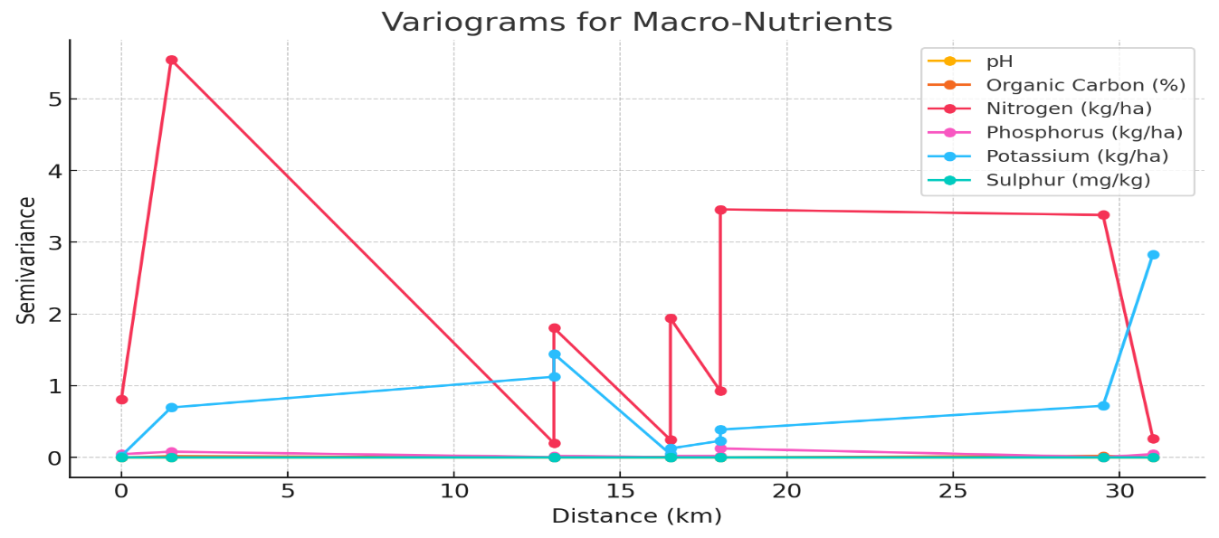**Fig 2. Variogram for pH, Organic Carbon, Nitrogen, Phosphorous, Potassium and Sulphur**

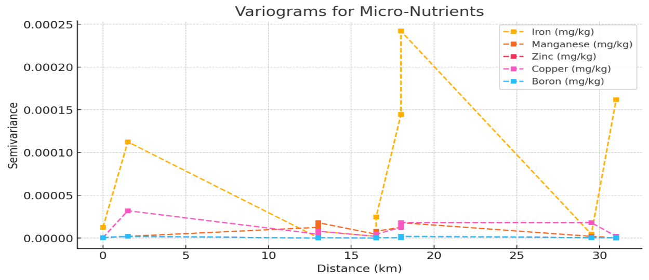

**Fig 3. Variograms of Micronutrients**

The variogram in Fig. 2 shows that nitrogen has the highest spatial variability, with sharp fluctuations in semivariance over short distances. Potassium exhibits a more gradual trend, indicating broader spatial dependence. Other nutrients, including pH, organic carbon, phosphorus, and sulfur, display relatively low semivariance, suggesting a more uniform distribution across the landscape.

The variogram analysis of micro-nutrients (Fig. 3)shows that iron exhibits the highest spatial variability, with peaks at shorter distances, suggesting localized fluctuations. Manganese also displays moderate variation, while zinc, copper, and boron have relatively stable semivariance, indicating a more uniform distribution across the study area.

**3.4. Results of Multivariate Regression Analysis between Soil Properties and Auxiliary Variables**

Multivariate regression analysis was employed to elucidate the relationships between soil properties and auxiliary variables,viz—slope, elevation and flow accumulation(Fig. 4). Elevation exhibited a negative correlation with soil pH (r = -0.42, P < .05) and organic carbon (r = -0.39, P < .05), indicating a decline in soil fertility with increasing altitude. Slope showed a positive correlation with potassium (r = 0.34, P < .05), suggesting enhanced nutrient leaching on steeper terrains. Flow accumulation demonstrated a strong positive relationship with phosphorus content (r = 0.46, P < .05), highlighting the influence of surface runoff on nutrient redistribution.

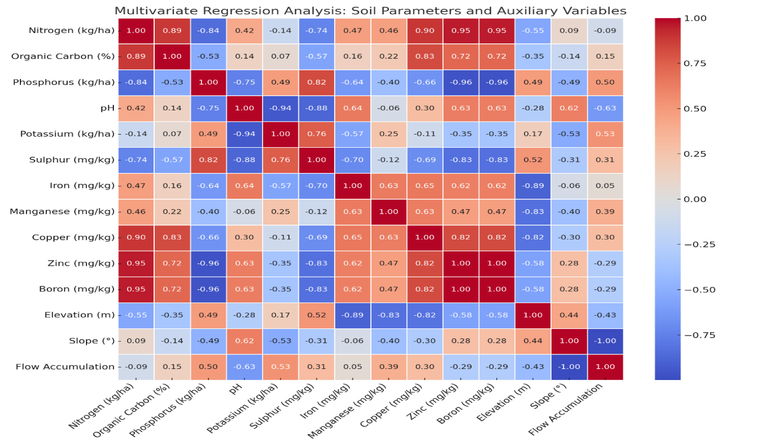

**Fig 4. Multivariate Regression Analysis between Soil Properties and Auxiliary Variables**

**4. DISCUSSION**

**4.1 Soil pH and Electrical Conductivity**

The study revealed a consistently acidic soil pH (4.884 ± 0.022, range: 4.865–4.900) across North Sikkim, which was characteristic of Himalayan agricultural systems (Karki *et al*., 2021). Such acidity is expected to increase the solubility of micronutrients like iron, manganese, and zinc, while significantly reducing phosphorus availability and raising the risk of aluminium toxicity. The electrical conductivity (EC) values (240.2 μS/cm ±18.659, range: 238.0–242.5) indicated non-saline conditions, suggesting that soil management interventions would be feasible in the region.

Organic carbon levels (0.752% ±0.049, range: 0.50–0.80) were found to be sub-optimal, particularly in Ringhim and Chungthang, which would affect nutrient cycling efficiency, soil structure, water retention, and microbial diversity (Kumar *et al*., 2018). The variations in organic carbon content indicated that specific topographical and land-use factors could have contributed to it (Kumar *et al*., 2022). Nitrogen levels (158.728 ±9.890 kg/ha, range: 157.900–161.234) were lower which could be due to restricted organic matter decomposition, steep terrain-induced leaching, and acidic conditions which impaired nitrogen fixation (Cheng *et al*., 2021). Similarly, phosphorus content (19.3 ±1.434 kg/ha, range: 18.9–19.4) remained deficient due to pH-dependent fixation, organic matter depletion, and erosion-driven nutrient loss (Alewell *et al*., 2020).

**4.2 Micronutrient Status**

Boron deficiency (0.282 ±0.002 mg/kg, range: 0.282–0.284) was evident across the study area. This is a condition detrimental to reproductive growth, cell wall integrity, and nutrient transport, particularly in crops that require high boron levels for flowering and fruiting (Thakur *et al*., 2023). Zinc levels (1.010 ±0.000 mg/kg, range: 1.010–1.012) were within adequate ranges, which would support enzyme activity, protein synthesis, and disease resistance (Castillo-González *et al*., 2018). High iron availability in soil could be attributed to the mineralogical compositions of soil which is rich in iron-bearing minerals and enhanced solubility under acidic pH conditions ([Colombo *et al*., 2014](https://link.springer.com/article/10.1007/s11368-013-0814-z)).

**4.3 Spatial Distribution of Soil Nutrients**

The soil pH across all study locations—Kabi, Chungthang, Mangan, Dzongu, and Ringhim—remained consistently acidic, ranging narrowly from 4.865 to 4.880 (F = 0.216, p > 0.05). This uniformity suggested a stable acidic soil environment throughout the region. Several factors can be attributed to the observed soil acidity. High rainfall accelerates nutrient leaching and organic matter decomposition, thereby reducing the soil’s buffering capacity (Jiang *et al*., 2018). Additionally, the parent rock composition, which is rich in silicates but deficient in base cations like calcium and magnesium, and also their removal by leaching reinforced soil acidity (Li *et al*, 2019, Das *et al*, 2022). Behera *et al*. (2023) reported that such acidity is a characteristic feature of Himalayan agricultural systems, significantly influencing nutrient dynamics.

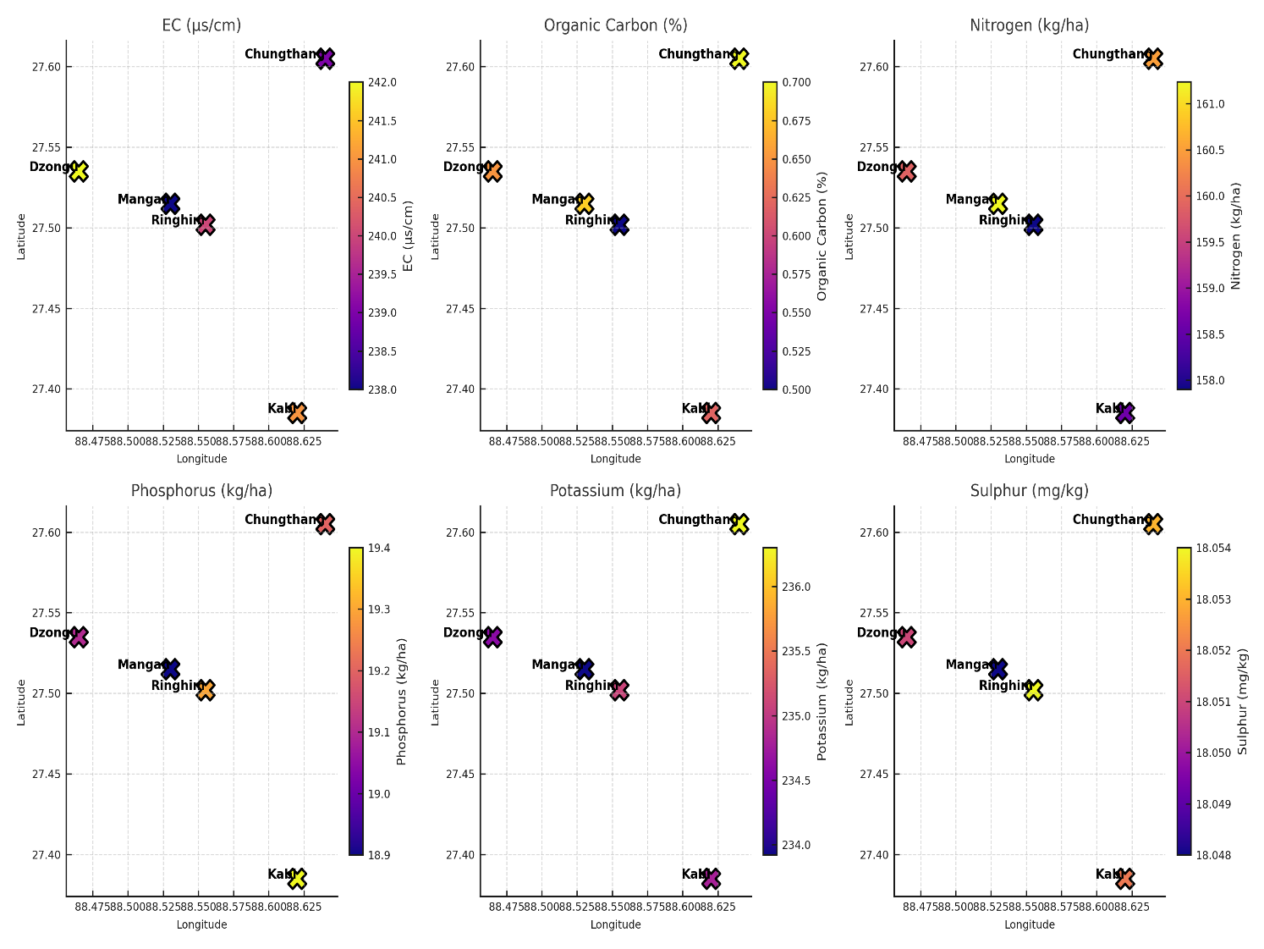

**Fig.5. Thematic Map of EC, Organic Carbon, Nitrogen, Phosphorous, Potassium and Sulphur**

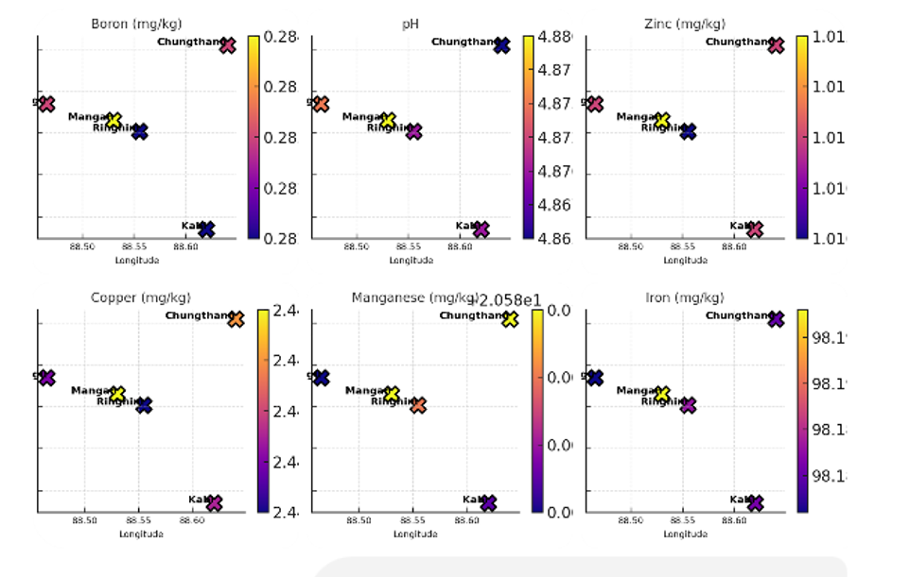

**Fig 6 Thematic Maps of pH, Iron, Manganese, Zinc, Copper, Boron**

The spatial distribution of nutrients in this Himalayan region can be also represented with thematic maps(Fig. 5 and fig. 6). This provides a comprehensive spatial representation of key soil parameters across the five locations—Mangan, Ringhim, Kabi, Chungthang, and Dzongu. The distribution of Iron, Manganese, Copper, Zinc, and Boron indicates relatively uniform micronutrient availability, with minor variations that could influence plant growth. The pH map highlights the acidic nature of the soils, which can impact nutrient availability, particularly phosphorus and micronutrients. Electrical conductivity (EC) remains within a narrow range. The organic carbon content map reveals variations that could affect soil fertility, with Kabi and Chungthang showing higher values. Nitrogen, Phosphorus, and Potassium (NPK) maps depict the macronutrient status, essential for crop productivity, with slight differences across regions. Sulphur distribution remains stable, contributing to plant metabolic functions. These maps collectively serve as a crucial tool for precision agriculture, guiding nutrient management strategies to enhance soil health and optimize crop yields in the region.

The most notable finding emerged in the organic carbon distribution pattern, where significant spatial variations were observed. Chungthang and Mangan maintained optimal organic carbon levels (0.70% and 0.68% respectively), while Dzongu showed moderate levels (0.65%). Kabi (0.62%) and Ringhim (0.50%), on the other hand, showed less organic carbon than was ideal. According to Zhu *et al*. (2019), topographical factors are responsible for regional variation in organic carbon, as well as for the buildup of organic materials while differences in land management techniques also play a major role.

The multivariate regression analysis (Fig. 4) revealed negative correlation between elevation and soil pH and organic carbon which indicated that higher altitudes are associated with more acidic soils and reduced organic matter content. This aligns with findings that elevation influences soil physicochemical properties(Hailemariam et al., 2023).

The positive correlation between slope and potassium content suggests that steeper slopes might enhance nutrient leaching, leading to increased potassium availability. This is consistent with studiesby Jakšić et al.(2021) indicating that slope gradient affects soil organic carbon and nutrient distribution .

Additionally, the strong positive relationship between flow accumulation and phosphorus content highlights the role of hydrological processes in nutrient redistribution across the landscape. These insights underscore the importance of integrating topographical and hydrological factors into soil fertility assessments to inform targeted land management strategies.

These findings underscore the influence of topography on soil fertility, emphasizing the need for incorporating Digital Elevation Models (DEMs) and spatial analysis for better nutrient management.

Babu *et al*. (2019) added that although the consequences of land use management vary depending on the climate, soil properties, and management, it consistently affects the dynamics of soil organic carbon (SOC).

Since securing the right quantity of organic carbon is critical in supporting sustainable agriculture in the Eastern Himalayas, Ringhim's significantly lower organic carbon level would need special recognition. Yadav *et al*. (2019) stressed the need to uphold adequate organic carbon levels for Eastern Himalayas sustainable agriculture.

Nitrogen, phosphorus, and potassium levels also showed low variation, placing all locations in a single statistical group. Non-significant differences in potassium (F = 0.045), phosphorus (F = 0.047), and nitrogen (F = 0.045) provide evidence for the existence of uniform soil-forming processes and comparable agricultural management techniques. The conclusions drawn from this research study were similar with the experimental findings of Bhaskar *et al*. (2021), who reasoned such consistency based on similar altitude and land use patterns as well as climatic influences. Considering the lack of variations in major nutrients, diversity in organic carbon levels needed further research based evaluation. According to Bashir *et al*. (2024), these patterns could be most likely the result of standardized fertilization and agricultural practices across the region. The homogeneity in major nutrients, accompanied by considerable heterogeneity in organic carbon might be due to the reason that even though basic nutrient management practices were the same and non-diversified throughout the region, conditions influencing organic matter accumulation and retention differed considerably among sites. Studies by Karki *et al*. (2021) on mountain soil fertility which highlighted insights on nitrogen and phosphorus deficiencies as well as micronutrient status resonate with the observed soil characteristics of North Sikkim in the present investigation. The low variations in physical and chemical properties properties in the present study could be due to the influence of regional landforms, vegetation cover, and land-use history (Sharma *et al*., 2001). Also, in landscapes where elevation, climate, and parent material are similar, one can expect reduced variability in soil nutrient content (Anderson *et al*., 1988, Schaetzl and Anderson, 2006; Xiaoxuan *et al*., 2025).

The spatial variations as a function of distance highlighted notable insights to the study revealing distinct variation patterns(Fig 5 and Fig 6). Among macronutrients, potassium and nitrogen exhibited the highest variance with increasing distance, indicating significant heterogeneity in their distribution. Organic carbon and phosphorus also displayed moderate variation, suggesting localized accumulation influenced by organic matter decomposition and soil management practices. In contrast, pH and sulphur remained relatively stable, with minimal variance, implying uniform soil acidity and sulphur availability across the sites. The micronutrient analysis showed that iron, manganese, zinc, copper, and boron exhibited very low variance, signifying a relatively consistent distribution across locations.

The mean comparison analysis grouped the locations based on nutrient levels. Such grouping enables farmers and policymakers to delineate soil nutrient management zones, highlighting the significance of understanding soil nutrient variability for site-specific management. In a study by Dad and Shafiq (2021), optimal sampling intervals were determined to capture soil property variations accurately, facilitating the creation of effective management zones. Yuan *et al*. (2022) also emphasized the delineation of soil nutrient management zones based on optimal sampling intervals in medium and small-scale intensive farming systems. In the present investigation, all locations were statistically similar in terms of pH and EC, indicating a consistent acidic soil environment across the region.

Sulphur had a notable difference, the highest being group (a) which includes Chungthang and Mangan, an intermediate division (ab) encompassing the Dzongu area, and Kabi and Ringhim in the lower categories (b and c). Sulphur availability at North Sikkim showed differing values due to organic matter decomposition and parent material composition which was also reported by Shukla *et al*.(2016) in their study on the Himalayan Regions.

The grouping of micronutrient concentrations across different locations highlighted distinct forms of soil fertility. Mangan and Chungthang, which fall under group 'a,' exhibited the highest similarity across all micronutrient parameters, suggesting that the environmental and soil management factors in these areas are comparable. Kabi, categorized as 'ab,' shared certain traits with group 'a' but displayed slight variations, indicating a transitional soil composition. On the other hand, Ringhim and Dzongu, forming group 'b,' were significantly different from group 'a,' likely due to localized soil characteristics or varying agricultural practices. This differentiation could be attributed to factors such as topography, organic matter content, or historical land use, which may influence the availability of essential micronutrients in the soil.

**4.4 Management Implications and Recommendations**

The current investigation revealed that the soils of North Sikkim where most agricultural fields showed increasing trends of acidity and nutrient exhaustion which could threaten sustainable agriculture in the region. Taking into account steep slopes and the abundant rains of this region which promote the leaching of nutrients, proper soil management is necessary to regain fertility and provide for productive agricultural land in the long run. Potential remediation approaches include:

**4.4.1 Enrichment Through Addition of Organic Matter**:

Low organic matter content weakens soil microbe diversity, which subsequently affects the self-defensive mechanisms of plants (Ganjegunte *et al*., 2017). Reduced microbial activity leads to nutrient depletion in soil, thus weakening crops grown on it. This results in increased insect infestation. Pandey *et al*. (2015), Mavandi *et al*.(2021) and Ramaya *et al*(2021) in different studies found that sufficient organic manure increased secondary metabolites in plants making them immune to insect infestation. Enriching organic matter improves soil microbiome by fostering microbial diversity and activity (Chaparro *et al*., 2012). Compost, manure, and decomposed biomass provide carbon sources that fuel beneficial bacteria and fungi, enhancing nutrient cycling and soil structure (Cesarano *et al*., 2017). Green manuring contributes to the availability of nitrogen by supporting the aerobic respiration of nitrogen-fixing microbes, which also contributes to soil aeration. Retention of crop residue stimulates the activity of decomposers which increases the rate of organic matter decomposition and humus production. Organic and leaf litter inputs foster the development of mycorrhizal fungi and phosphate-solubilizing bacteria which enhance nutrient availability and soil aggregates. Healthy and diverse soil microorganisms increase responses to destructive factors, control the action of pathogens, and preserve soil fertility for many years. Thus, these research findings demonstrated that analysing soil for organic carbon, preferably in real time, and knowing the SOC status would help build soil organic matter and sustain productivity.

**4.4.2 Soil Amelioration**:

Soil pH influences the balanced rhizospheric system of insects and microbes. In highly acidic pH, the beneficial microbes find it difficult to thrive which reduces the potential of the soil to naturally sustain plant life(Rahman *et al*., 2021). The advantageous insects that are dependent on these microbes also face the problem of low microbial population. This imbalance creates an opportunity for harmful pathogens and pest insects to thrive, leading to increased disease pressure and pest infestations. Suboptimal soil pH also influences plant-insect interactions by altering nutrient availability and plant physiological responses. Mousa *et al*. (2022) specifically noted that pH variations affect plants by potentially increasing their vulnerability to herbivorous insects. When soil pH deviates from the optimal range, plants experience reduced nutrient uptake and weakened structural resistance, thereby becoming prime targets for insect infestation. Maintaining a neutral soil pH, therefore, is essential for sustaining a healthy microbial and insect population, ensuring natural pest control, soil fertility, and overall ecosystem stability. Soil fertility restoration in mountain agroecosystems requires particular attention to biological indicators, especially earthworm colonies which serve as ecosystem engineers to sustain soil health. The strongly acidic soil conditions (pH 4.884 ± 0.022) documented in the study area would also face significant management challenges due to a decline in earthworm activity. This was revealed by Goswami (2002) who demonstrated that, a pH below 5.0 has a tremendous impact on the indigenous earthworm population dynamics.

**4.4.3 Implementing precision techniques**:

Implementing precision techniques to improve soil, such as decomposed plant residues liming, incorporation of organic matter, actively foster the buffering acidity of the soil around neutral pH. Liming directly improves soil physicochemical properties, including aggregates, density, and porosity, while reducing exchangeable acidity and aluminium saturation. It also optimizes micronutrient levels (Cu, Fe, Mn, and Zn) in soil solutions and increases exchangeable cations (Na+, K+, Ca+2, and Mg+2), creating favourable crop growth and development conditions (Abdi, 2024). Strategic organic matter application through manure and crop residues enhances carbon accumulation, improves nutrient cycling efficiency, and strengthens soil moisture retention(Liu *et al*., 2020).

**4.4.4 Precision Nutrient Management:**

This would involve developing site-specific fertilization protocols that consider spatial variations in soil characteristics and topographical constraints to optimize nutrient application and improve crop yield. Goswami and Pariyar (2023) and Kumar *et al*. (2024) suggested the development of baseline soil fertility data for site-specific fertilizer recommendations to reduce adverse environmental impacts in the Himalayan ecosystem.

**4.4.5 Crop Diversification**:

Implementing mixed cropping and rotation systems will enhance soil fertility, improve nutrient cycling, and naturally disrupt pest and disease cycles, contributing to sustainable agricultural practices.

**4.4.6 Overall Implications For Soil Management Based On Soil Groups**

* Chungthang and Mangan (Group a): This group bears similar soil characteristics, with relatively higher nitrogen but lower phosphorus. These locations might require phosphorus supplementation enhance soil fertility. Organic Carbon (OC) levels are moderate (0.7% and 0.68%, respectively), suggesting the need for organic matter incorporation to maintain soil health.
* Dzongu (Group ab): This group is characterised by intermediate soil conditions, requiring a balanced approach to nitrogen, phosphorus, and potassium supplementation. Organic Carbon (OC) is 0.65%, indicating a moderate level that should be sustained through organic inputs.
* Kabi (Group b): Group b defines a trend of Higher phosphorus but lower nitrogen, suggesting targeted nitrogen enrichment strategies. Organic Carbon (OC) is 0.62%, slightly lower than other groups, necessitating organic amendments to improve soil structure and fertility.
* Ringhim (Group c): This group is significantly different from other locations in terms of nitrogen, phosphorus, and sulphur content, indicating a need for immediate soil amendments to improve nitrogen retention and phosphorus availability to prevent any further degradation of soil health. Organic Carbon (OC) is the lowest (0.5%), requiring urgent organic matter enhancement strategies to maintain soil quality and microbial activity.

**5 Conclusion**

The study implemented a systematic nested sampling methodology that accommodated heterogeneous land parcel sizes, addressing methodological challenges in mountainous terrain soil sampling. By employing three-tier sampling points and advanced statistical compensatory mechanisms, the research offered a robust framework for capturing nuanced spatial variations in soil properties. Acidic soil conditions, nutrient limitations, and micronutrient deficiencies emerged as critical constraints in Sikkim's organic agricultural systems. The findings underscore the necessity for targeted, location-specific soil management interventions to optimize agricultural productivity. Future research should prioritize investigating climate-induced soil nutrient transformations, vertical gradient variations, and adaptive organic farming strategies for steep terrain cultivation.

**COMPETING INTERESTS DISCLAIMER:**

Authors have declared that they have no known competing financial interests OR non-financial interests OR personal relationships that could have appeared to influence the work reported in this paper.

Disclaimer (Artificial intelligence)

Option 2:

Author(s) hereby declare that generative AI technologies such as Large Language Models, etc. have been used during the writing or editing of manuscripts. This explanation will include the name, version, model, and source of the generative AI technology and as well as all input prompts provided to the generative AI technolog

Details of the AI usage are given below:

1.Chat GPT 3.5( Only partially taken help of this AI mostly after review).

2.

3.

**6 REFERENCES**:

1. Abdi, B. T. (2024). Studies on the effects of liming acidic soil on improving soil physicochemical properties and yield of crops: A review. Middle East Research Journal of Agriculture and Food Science, 4(3), 95-103.
2. Alewell, C., Ringeval, B., Ballabio, C., Robinson, D. A., Panagos, P., and Borrelli, P. (2020). Global phosphorus shortage will be aggravated by soil erosion. Nature Communications, 11(1), 4546. https://doi.org/10.1038/s41467-020-18326-7
3. Altieri, M. A., Nicholls, C. I., Henao, A., and Lana, M. (2015). Agroecology and the design of climate change-resilient farming systems. Agronomy for Sustainable Development, 35, 869–890. https://doi.org/10.1007/s13593-015-0285-2
4. Anderson, D. W. (1988). The effect of parent material and soil development on nutrient cycling in temperate ecosystems. Biogeochemistry, 5, 71–97. https://doi.org/10.1007/BF02180318
5. Arun Kumar, B. R., Thippeshappa, G. N., and Kumar, S. (2018). Boron: A critical micronutrient for crop growth and productivity. Journal of Pharmacognosy and Phytochemistry, 7(2), 2738-2741.
6. Babu, S., Mohapatra, K. P., Yadav, G. S., Lal, R., Singh, R., and Das, A. (2020). Soil carbon dynamics in diverse organic land use systems in North Eastern Himalayan ecosystem of India. Catena, 187, 104359.
7. Bashir, O., Bangroo, S. A., Shafai, S. S., Senesi, N., Kader, S., and Alamri, S. (2024). Geostatistical modeling approach for studying total soil nitrogen and phosphorus under various land uses of North-Western Himalayas. Ecological Informatics, 80, 102520. https://doi.org/10.1016/j.ecoinf.2024.102520
8. Behera, S. K., Shukla, A., Pachauri, S., Shukla, V., Sikaniya, Y., and Srivastava, P. (2023). Spatio-temporal variability of available sulphur and micronutrients (Zn, Fe, Cu, Mn, B, and Mo) in soils of a hilly region of northern India. Catena, 226, 107082. https://doi.org/10.1016/j.catena.2023.107082
9. Bhaskar, B. P., Ramesh Kumar, S. C., Lakshmikantha, B. P., and Seshagiri, R. (2021). Soil-landscape relationships in Vedavathi river basin, Chitradurga district, Karnataka, India: Morphology and textural and chemical properties. Arabian Journal of Geosciences, 14, 670. <https://doi.org/10.1007/s12517-021-06954-2>
10. Bhuvan-NRSC Open EO Data Archive. https://bhuvan-app3.nrsc.gov.in/data/
11. Castillo-González, J., Ojeda-Barrios, D., Hernández-Rodríguez, A., González-Franco, A. C., Robles-Hernández, L., and López-Ochoa, G. R. (2018). Zinc metalloenzymes in plants. Interciencia, 43(4), 242-248.
12. Cesarano, G., De Filippis, F., La Storia, A., Scala, F., and Bonanomi, G. (2017). Organic amendment type and application frequency affect crop yields, soil fertility and microbiome composition. Applied Soil Ecology, 120, 254-264. https://doi.org/10.1016/j.apsoil.2017.08.017
13. Chaparro, J. M., Sheflin, A. M., Manter, D. K., and Vivanco, J. M. (2012). Manipulating the soil microbiome to increase soil health and plant fertility. Biology and Fertility of Soils, 48, 489–499. https://doi.org/10.1007/s00374-012-0691-4
14. Cheng, Y., Li, P., Xu, G., Wang, X., Li, Z., Cheng, S., and Huang, M. (2021). Effects of dynamic factors of erosion on soil nitrogen and phosphorus loss under freeze-thaw conditions. Geoderma, 390, 114972. https://doi.org/10.1016/j.geoderma.2021.114972
15. Choudhury, B. U., Ansari, M. A., Chakraborty, M., and Meetei, T. T. (2021). Effect of land-use change along altitudinal gradients on soil micronutrients in the mountain ecosystem of Indian (Eastern) Himalaya. Scientific Reports, 11, 14279. https://doi.org/10.1038/s41598-021-93788-3
16. Colombo, C., Palumbo, G., He, J. Z., Pinton, R., and Cesco, S. (2014). Review on iron availability in soil: Interaction of Fe minerals, plants, and microbes. Journal of Soils and Sediments, 14, 538–548. https://doi.org/10.1007/s11368-013-0814-z
17. Dad, J. M., and Shafiq, M. U. (2021). Spatial variability and delineation of management zones based on soil micronutrient status in apple orchard soils of Kashmir valley, India. Environmental Monitoring and Assessment, 193, 797. https://doi.org/10.1007/s10661-021-09588-9
18. Das, S. K., Avasthe, R. K., Singh, M., and Yadav, A. (2018). Soil health improvement using biochar application in Sikkim: A success story. Innovative Farming. https://www.researchgate.net/publication/352787500_Soil_Health_Improvement_using_Biochar_Application_in_Sikkim_A_Success_Story
19. Das, S., Rai, S. K., Rahaman, W., Singhal, S., and Sarangi, S. (2022). Chemical weathering and Sr flux from the silicate lithology dominated fluvial system: Insights from major ions, dissolved Sr and ⁸⁷Sr/⁸⁶Sr of the Teesta headwaters, Sikkim Himalaya. Applied Geochemistry, 137, 105171.
20. Du, X., Li, X., Wang, J., Xu, J., and Gao, J. (2025). Climate factors dominate the spatial variation of forest soil nutrients: A meta-analysis. Frontiers in Forests and Global Change, 7, 1525250. https://doi.org/10.3389/ffgc.2024.1525250
21. Ganjegunte, G., Ulery, A., Niu, G., and Wu, Y. (2017). Organic carbon, nutrient and salt dynamics in saline soil and switchgrass irrigated with treated municipal wastewater. Land Degradation and Development, 29. https://doi.org/10.1002/ldr.2841.
22. Goswami, B. (2002). Vermitechnological evaluation of earthworm species of Assam for biomanagement of urban organic solid waste. Doctoral thesis, Gauhati University, Guwahati, India. http://hdl.handle.net/10603/116389
23. Goswami, B., and Pariyar, B. (2025). Comprehensive analysis of large cardamom cultivation in Sikkim: Challenges, opportunities, and sustainable strategies. South Asian Journal of Agricultural Sciences, 5(1), 16-21. https://doi.org/10.22271/27889289.2025.v5.i1a.172
24. Goswami, B., and Pariyar, B. (2023). Nutrient analysis of soil and manures to enhance crop productivity in organic farming—an insight. International Journal of Research in Biosciences and Agricultural Technology. http://dx.doi.org/10.29369/ijrbat.2023.010.1.0009 <https://doi.org/10.1016/j.apgeochem.2021.105171>
25. Hailemariam, M.  Z. Woldu, Z. Asfaw, E. Lulekal(2023). Impact of elevation change on the physicochemical properties of forest soil in south omo zone, southern Ethiopia. *Appl. Environ. Soil Sci.* [10.1155/2023/7305618](https://doi.org/10.1155/2023/7305618)
26. Hunter, J. D. (2007).Matplotlib: A 2D graphics environment,” *Computing in Science & Engineering ,9: 90-95.
27. Jakšić, S., Ninkov, J., Milić, S., Vasin, J., Živanov, M., Jakšić, D., & Komlen, V. (2021). Influence of Slope Gradient and Aspect on Soil Organic Carbon Content in the Region of Niš, Serbia. *Sustainability*, *13*(15), 8332. <https://doi.org/10.3390/su13158332>
28. Jiang, J., Wang, Y.-P., Yu, M., Cao, N., and Yan, J. (2018). Soil organic matter is important for acid buffering and reducing aluminium leaching from acidic forest soils. Chemical Geology, 501, 86-94. https://doi.org/10.1016/j.chemgeo.2018.10.009
29. Karki, K. B., Sherchan, D. P., Panday, D., and Ghimire, R. (2021). Soil fertility and nutrient management. In The Soils of Nepal (pp. 189-213). Springer, Cham. https://doi.org/10.1007/978-3-030-80999-7_9
30. Kolbe, H. (2022). Comparative analysis of soil fertility, productivity and sustainability of organic farming in Central Europe—Part 1: Effect of medium manifestations on conversion, fertilizer types and cropping systems. Agronomy, 12(9), 2001. https://doi.org/10.3390/agronomy12092001
31. Kumar, J., Pradhan, M., and Singh, N. (2018). Sustainable organic farming in Sikkim: An inclusive perspective. In Advances in Smart Grid and Renewable Energy. Springer. Retrieved from https://link.springer.com/chapter/10.1007/978-981-10-4286-7_36
32. Kumar, P., Sharma, M., Butail, N. P., et al. (2024). Spatial variability of soil properties and delineation of management zones for Suketi basin, Himachal Himalaya, India. Environmental Development and Sustainability, 26, 14113–14138. https://doi.org/10.1007/s10668-023-03181-5
33. Kumar, S. S., Wani, O. A., Mir, S. A., and Babu, S. (2022). Soil carbon dynamics in the temperate Himalayas: Impact of land use management. Frontiers in Environmental Science, 10, 1009660. https://doi.org/10.3389/fenvs.2022.1009660
34. Li, Q., Li, S., Xiao, Y., Zhao, B., Wang, C., Li, B., Gao, X., Li, Y., Bai, G., Wang, Y., and Yuan, D. (2021). Soil acidification and its influencing factors in the purple hilly area of southwest China from 1981 to 2012. CATENA, 175, 278-285. https://doi.org/10.1016/j.catena.2018.12.025
35. Mavandi, P., Abbaszadeh, B., Emami Bistgani, Z., Barker, A. V., and Hashemi, M. (2021). Biomass, nutrient concentration and the essential oil composition of lavender (Lavandula angustifolia Mill.) grown with organic fertilizers. Journal of Plant Nutrition, 44, 3061-3071.
36. McKinney, W.(2010) “Data Structures for Statistical Computing in Python”. In Proc. 9th Python in Science Conf.: 51-56.
37. Zhu, M., Feng, Q., Qin, Y., Cao, J., Zhang, M., Liu, W., Deo, R. C., Zhang, C., Li, R., and Li, B. (2019). The role of topography in shaping the spatial patterns of soil organic carbon. CATENA, 176, 296-305. https://doi.org/10.1016/j.catena.2019.01.029
38. Mousa, K. M., Metwaly, M. S., Alshehri, M. A., Sayed, S. M., and Rakha, O. M. (2022). Soil pH alters the biological parameters of cowpea aphid (Aphis craccivora Koch) (Hemiptera: Aphididae) on its host plant Vicia faba. Saudi Journal of Biological Sciences, 29(4), 2926-2932. https://doi.org/10.1016/j.sjbs.2022.01.021
39. Pandey, V., Patel, A., and Patra, D. D. (2015). Amelioration of mineral nutrition, productivity, antioxidant activity and aroma profile in marigold (Tagetes minuta L.) with organic and chemical fertilization. Industrial Crops and Products, 76, 378–385. <https://doi.org/10.1016/j.indcrop.2015.07.023>
40. Pedregosa F. et al.(2011). Scikit-learn: Machine Learning in Python. *Journal of Machine Learning Research*,12, 2825-2830.
41. R Core Team. (2022). R: A language and environment for statistical computing. Vienna, Austria: R Foundation for Statistical Computing. https://www.R-project.org
42. Ramaiya, S. D., Lee, H. H., Xiao, Y. J., Shahbani, N. S., Zakaria, M. H., and Bujang, J. S. (2021). Organic cultivation practices enhanced antioxidant activities and secondary metabolites in giant granadilla (Passiflora quadrangularis L.). PLoS ONE, 16(7), e0255059. <https://doi.org/10.1371/journal.pone.0255059>
43. Robertson, G.P.(2008). GS+ :Geostatistics for the Environmental Sciences. Gamma Design Software, Plainwell, Michigan USA.
44. Rossum, Van G. (2012)The Python Language Reference Manual. Python Software Foundation.
45. SAS Institute Inc. (2022). SAS/STAT Software, Version 15.2. Cary, NC: SAS Institute Inc.
46. Schaetzl, R., and Anderson, S. (2006). Soil-Genesis and Geomorphology. https://doi.org/10.1017/CBO9780511815560
47. Scialabba, N. E.-H., and Müller-Lindenlauf, M. (2010). Organic agriculture and climate change. Renewable Agriculture and Food Systems, 25(2), 158-169. <https://doi.org/10.1017/S1742170510000116>
48. Sharma, S.(2024). Landslide Susceptibility of North Sikkim Using Geospatial Techniques and Support Vector Machine. Research report. Sikkim state Disaster Management authority(*In Press*)
49. Sharma, E., Rai, S. C., and Sharma, R. (2001). Soil, water, and nutrient conservation in mountain farming systems: Case study from the Sikkim Himalaya. Journal of Environmental Management, 61(2), 123-135.
50. Shibin Liu., Wang, J., Pu, S., Blagodatskaya, E., Kuzyakov, Y., and Razavi, B. S. (2020). Impact of manure on soil biochemical properties: A global synthesis. Science of The Total Environment, 745, 141003. https://doi.org/10.1016/j.scitotenv.2020.141003
51. Shukla, A., et al. (2016). Spatial Distribution and Management Zones for Sulphur and Micronutrients in Shiwalik Himalayan Region of India. Land Degradation and Development, 28. <https://doi.org/10.1002/ldr.2673>
52. Sikkim State GIS Portal(2025). <https://stategisportal.nic.in/stategisportal/Home/State/11>
53. IBM Corporation. (2022). IBM SPSS Statistics for Windows, Version 26.0. Armonk, NY. https://www.ibm.com/products/spss-statistics
54. Suntoro, S., et al. (2024). Evaluation of soil fertility index in organic, semi-organic, and conventional rice field management systems. Scientia Agropecuaria, 15(2), 163-175. http://dx.doi.org/10.17268/sci.agropecu.2024.012.
55. *Thakur, S., et al. (2023). Boron- A Critical Element for Fruit Nutrition.* Communications in Soil Science and Plant Analysis, 54(21), 2899–2914. https://doi.org/10.1080/00103624.2023.2252878
56. Thompson, S. K. (2012). Sampling (3rd ed.). John Wiley and Sons.
57. Tong, L., et al. (2022). Effects of organic cultivation on soil fertility and soil environment quality in greenhouses. Frontiers in Soil Science, 2.
58. USGS EarthExplorer. <https://earthexplorer.usgs.gov/>
59. Waskom,M. L.(2021).Seaborn: Statistical data visualization. *Journal of Open Source Software*, 6, (60), 3021, 2021.
60. Yadav, G. S., et al. (2019). Impact of no-till and mulching on soil carbon sequestration. Agriculture,Ecosystems&Environment,275,81-92. https://doi.org/10.1016/j.agee.2019.02.001
61. Yuan, Y., et al. (2022). Delineating soil nutrient management zones. Precision Agriculture, 23, 538–558. https://doi.org/10.1007/s11119-021-09848-1